Date: June 21, 2019
Time: 1500 PST

Press Release
A signing ceremony on the Minutes of Discussions on the project “Installation of Weather Surveillance Radar at Sukkur in the Islamic Republic of Pakistan” was held in Pakistan Meteorological Department, today at 11.00 am on 21-06-2019. The ceremony was attended, besides JICA Expert Team, by officials from NDMA, FFC. The project would be funded by Government of Japan through grant.

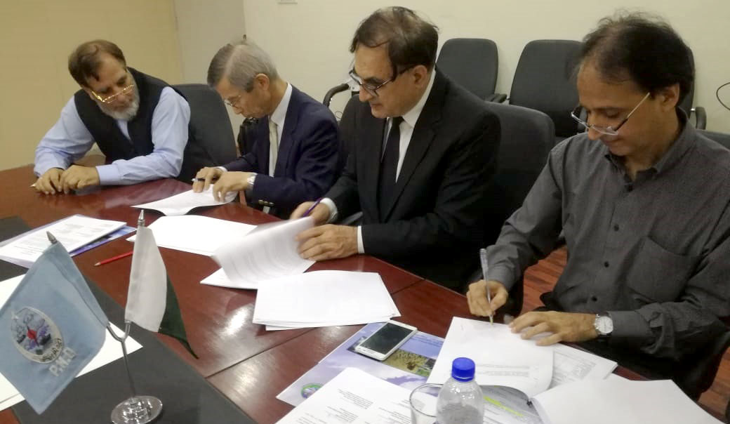
It worth to mention that Government of Japan is assisting Pakistan Meteorological Department through provision of grant-in-aid for the last three decades. Some of the projects currently in progress are:
- Recently completed project, titled, “Establishment of Specialized Medium Range Weather Forecasting Center (SMRFC) and Strengthening of Weather Forecasting System in The Islamic Republic of Pakistan” with worth Pak Rs. 2.50 billion. The project is comprises state-of-the-art technology Weather Radar, High Powered Computing System and Wind Profilers at Islamabad and Multan.

- Ongoing project, titled, “Installation of Weather Surveillance Radar at Multan in Islamic Republic of Pakistan” worth Pak Rs. 1848.650 million.

- Another project, “Installation of Weather Surveillance Radar at Karachi in Islamic Republic of Pakistan” would likely to start by the end of this year. The total project worth is Pak Rs. 1848.650 million.

These projects after completion would ultimately strengthen the capabilities of Pakistan Meteorological Department in issuing Early Warning on Floods.
Spokesman

Date: June 17, 2019
Time: 2100 PST

