PART – A
CHAPTER 1
SALIENT FEATURE OF PANJNAD HEADWORKS

1.1 LOCATION

Panjnad Headworks is situated just below the confluence point of Sutlej and Chenab Rivers in the South - Eastern part of Muzaffargarh District. The Barrage was constructed during 1927-1932. The Barrage structure has Maximum Designed flood passing capacity of 7.0 Lac Cusecs and now the project rehabilitation of Panjnad Barrage has been started by PMO Barrages Lahore by which its capacity is being enhanced upto 765000 Cs by activation of 3 No. additional bays in between gate No. 33-34 and ultimately up to 865000 Cs by raising of LGB, RGB, LMB and RMB accordingly.

The Chenab joins at right side of Panjnad Headworks with the combined effect of its Tributaries i.e. Rivers Ravi and Jehlum.

The Chenab originates in Kulu and Kangra of Himachal PerdeshProvince of India. The river enters Pakistan territory in Sialkot District near DiavaraVillage. The ChenabRiver flows through the alluvial plain of PunjabProvince for a distance of 633 K.M. It is joined by JehlumRiver upstream of Trimmu, and 64 K.M. further downstream by the River Ravi and ultimately meets Sutlej just upstream of Panjnad Headworks.

River Sutlej meets the Barrage on left side of said Barrage which is originating from Kailas mountain range of Western Tibbet near the source of the Indus, the Gangas and BarmaPutraRiver. It travels through the Punjab and Siwalik mountain ranges and enters the plains of Indian Punjab. The flows of this river alongwith its tributaries enter Pakistan boundary near FerozePur andjoins the Chenab River 5 K.M. upstream of Panjnad Headworks. After passing through Panjnad Headworks, the flows ultimately join IndusRiver at downstream of Taunsa and just upstream of Guddu Barrage.

1.2 GENERAL DESCRIPTION

Objective of the flood fighting plan is to develop a framework to pass flood from Panjnad Headworks safely and to react against any contingency with a view to:

- Protect Panjnad Headworks along with its allied structures as it is the life line for the agriculture of Districts Bahawalpur and Rahimyarkhan.

- ProtectFlood Bunds against gushing effect of flood water to safeguard population and agriculture areas from flood inundation.
- Protect River Trainings Works to train the river within river Khadir.

- Save precious lives and properties.
- Minimize human miseries and sufferings.

OFF TAKING CANALS AT PANJNAD HEADWORKS

- PanjnadCanal
Panjnad Canal off-takes left bank of Panjnad Barrage having Maximum authorized discharge of 10484 Cs which has been reduced to 7769 Csdue to induction of Abbasia Link Canal. Panjnad Canal Irrigates vast area of District Bahawalpur and District Rahimyarkhan. Its length for RD. 0+000 to 10+000 lies in jurisdiction of Panjnad Headworks.

- AbbasiaCanal

Abbasia Canal is the 2nd off-take from left side of Panjnad Headworks, its maximum authorized discharge capacity is 1394 Cs which has been reduced to 1064 Cs due to induction of Abbasia Link Canal. Abbasia Canal Irrigates area of Bahawalpur & Rahimyarkhan District. Its length for RD. 0+000 to 02+000 lies inthe jurisdiction of Panjnad Headworks.

- AbbasiaLinkCanal

Abbasia Link Canal is the 3rd off-take from left side of Panjnad Headworks, its capacity is 5600 Cs. It carries perennial supply of District Rahimyarkhan and flood supplies to Cholistan area in Tehsil LiaquatPur. Its length for RD. 0+000 to 10+000 lies in the jurisdiction of Panjnad Headworks.

SALIENT FEATURES OF PANJNAD HEADWORKS

1. | Total length of the weir |  | = | 3400 Ft.
2. | No. of gates |  | = | (47 Nos.+3 additional  Depressed gates which are under construction)
3. | Crest R.L. |  | =  = | 325.0 of old 47 No.gates 322 of new 03 No. additional bays
4. | Span of each gate |  | = | 60.0 Ft.
5. | Designed max. pond level |  | = | 338.50
6. | H.F.L. upstream |  | = | 342.40
7. | Afflux level upstream |  | = | 341.50
8. | Length of Main weir |  | = | 2219 Ft.
9. | Length of Annexe weir |  | = | 931 Ft.
10. | Additional 03 Nos. gates |  | = | 250 Ft.
11. | Total No. of gates of Main weir |  | = | 33 No.
12. | Additional depressed bays |  | = | 03 Nos
13. | Total No. of gates of Annexe weir |  | = | 14 No.
14. | Capacity of Main weir |  | = | 4.5Lac Cs.
15. | Capacity of Annexe weir |  | = | 2.5Lac Cs.
16. | Capacity of depressed 03 Nos. bays |  | = | 1.65 Lac Cs.
17. | Permissible Head across of Barrage |  | = | 18.50Ft.
18. | Upstream floor level |  | = | 320
19. | Downstream floor level |  | = | 316
 | Total length of Divide Wall | Initially + Extended Portion, 850+160 | = | 1010 Ft.
20. | Length of divide wall depressed bays downstream |  | = | 150Ft

1.3 ADMINISTRATIVE SETUP

Administratively Panjnad Headworks Division consists only one Sub Division and five nos. Sub Engineers with their establishment.
- Panjnad Headworks Division.
ORGANIZATION CHART

1.4 Rehabilitation and Upgrading of Panjnad Barrage Project
(Project Brief)

Report On Impact of Rehabilitation& UPGRADING Works of Panjnad Barrage on Flood Fighting

Introduction:

Panjnad Barrage is the last Barrage constructed on River Chenab, downstream of the confluence point of River Sutlej. It is located about 13 Km south East of Alipur Tehsil, District Muzaffargarh on Alipur- Uch Sharif Road.

The barrage is ensuring safe and sustainable irrigation supplies to 1.8 million acres of fertile land of Bahawalpur and Rahimyar Khan Districts by diverting 8,833 cusec through two off-taking Panjnad and Abbasia Canals.

Another canal namely Abbasia link canal was constructed in 1992, little U/S of the existing head regulator of Abbasia canal. This canal was commissioned in the year 2003-2004. The existing designed capacity of Barrage is 700,000 cusec but the peak flood discharge that it experienced in year 1992 is 812,000 cusecs. The additional water passing through breached section of River training works caused heavy damages in the form of loss of lives, damage to private and public property, communication infrastructure besides damages to the barrage floor and its ancillary works.

Above prevailing situation has justified expansion of Barrage span and extension of D/S Barrage floor. With the current addition of 03 Depressed bays at Junction Groyne area, the flood capacity of the barrage will be enhanced up to 865,000 cusec.

Scope of Work:

- Rehabilitation of Existing Barrage and Deck Slab.
- Strengthening of Left and Right Guide Banks.
- Provision of three Additional Depressed Bays.
- Rehabilitation of Head Regulator of Panjnad Canal, Abbasia Canal and Abbasia Link Canal.
- Rehabilitation of Infrastructure and Buildings.
- Instrumentation, Control and Telecommunication System Works.
- Extension of D/s Barrage floor.
- Mechanical and Electrical Works.
- Construction of u/s New Divide Wall thus shifting it two bays to the right.

Impacts of Rehabilitation Works of Panjnad Barrage on Flood Fighting:
Additional Depressed Bays:

The existing discharge carrying capacity of Panjnad Barrage is 700,000 cusec. With the addition of three depressed bays, the discharge carrying capacity of the barrage will be enhanced up to 865,000 cusec by adding 165,000 cusec to the present discharge carrying capacity. This additional discharge capacity has been thoroughly calculated by the Hydraulic Design Experts of TPBC Team based on past yearsflood data. This additional discharge carrying capacity will facilitate during the flood season. Further the High Flood Level (HFL) of Panjnad Barrage has been raised up to1 feet keeping in view the previous record of the floods at Panjnad Barrage. Furthermore, the addition of depressed bays will also facilitate in bela removal in future which will also provide a clear waterway and uniform flow during anticipated high floods.
U/s Existing New Divide Wall
The left pocket of Panjnad Barrage has no under sluice due to same level of crest. The elevation of u/s floor (El. 320.00) and crest (El. 325.00) is same as rest of the Existing Barrage. The existing new upstream divide wall located between Bay # 04 and Bay # 05 is solely responsible for the diversion of water from left pocket into the off-taking canals.
After the addition of three bays whose crest level has been depressed (El. 322.00) as compared to the rest of the barrage (El. 325.00), the flow would be diverted towards the lower elevation i.e El. 322 and the existing u/s divide wall will not be able to divert enough water to the canals as a result of which canals would not be fed properly.
In order to resolve this issue, the design team of “Engineer” has shifted the divide wall further towards right side of the barrage and proposed to build a new divide wall between Bay #6 and Bay #7.

Impact of New U/s Divide Wall on Flood Fighting

The newly constructed divide wall would create a pond hence diverting the required amount of discharge to the off-taking canals. The u/s new divide wall will cater the high discharges during the flood season due to increase in size of the L/s upstream pocket created due to the shifting of U/s Divide Wall to the right.
Strengthening of Left and Right Guide Banks

The left and right guide banks of Panjnad Barrage will be strengthened and raised in Stage-03 works of Panjnad Barrage up to 2 feet height i.e El. 353.00 to cater the flux due to HFL El. 346.0. This will also prove to be blessing during the high flood season minimizing the chances of breach and overtopping with consequent destruction to the surrounding inhabitants.
IMPORTANT TELEPHONE NUMBERS.
COSULTANTS:
Name | Designation | Contact Number
Waqar Hussnain | Chief Resident Engineer | 0300-5396659
Javaid Asad | Resident Engineer | 0300-6747097
CONTRACTORS:
Name | Designation | Contact Number
Mr. Ali Hassan | Project Manager | 0300-2662801
Mr. Rizwan Sandhu | HSE Manager | 0322-6267459
Mr. Nazir Khan | Administration Manager | 0304-9800520
CHAPTER 2
FLOOD PROTECTION AND RIVER TRAINING WORKS

2.1 DESIGN PARAMETERS OF RIVER TRAINING WORKS

L-Section of Left Marginal Bund, Right Marginal Bund and downstream Colony Protection Bund are attached to give complete data of these Bunds. Remodeling of Left Marginal Bund and Right Marginal Bund was carried out about 10 years back with 6 Ft. (Free board) above H.F.L. of flood 1973. The wetting channels were restored as per design parameters. The Colony Protection Bund has been also rehabilitated to the latest design as 6 Ft,free board above H.F.L of Flood 1973 during the year 2003.

S. No. | Description
1. | Designed Capacity of barrage. = 7.00 +1.65 = (8.65) Lacs Cs
a | Capacity of Main Weir = 4.5 Lac.
b | Capacity of Annexe Weir = 2.5 Lac.
c | Capacity of Depressed weir = 1.65 Lac Cs.
2 | Total Length of Weir. = 3400 ft.  (Width of Barrage) including width of pier = 7 ft.
a | No. of gates x span) + Width of Pier x No. of Pier  Length of Main Weir. = 2219 ft. (33x60)+(7’x32) =1980+224+15 (Divide Wall)= 2219 ft.
b | Length of Annexe Weir = 931 ft (14x60)+(7’x13) = 840+91 = 931 ft.
3 | Total Length of Divide Wall = 850+110+50(Initially Constructed + Extended portion + fish ladder) = 1010 ft. with top R.L=346.0 (New divide wall is under construction between the bay No. 6 & 7 under rehabilitation of barrages project)
4 | Total Nos. gates of Barrage = 47+3 = 50 No.
a | No. of Gates of Main Weir. = 33
b | No of Gates of Depressed Weir. = 3 (Gate No. 34-36)
c | No of Gates of AnnexeWeir. = 14 (Gate No. 37-50)
8 | Span of Each gate. =60’
9 | Crest Level = 325.0’ of old weir and 322.0’ of depressed weir
10 | Upstream Floor Level. = 320’
11 | Downstream Floor Level. = 316’ for Main weir & 315for Annexie weir.
12 | Designed Maximum Pond Level = 338.50’. Normal Barrage Operation Pond Level = 337.50.
13 | Permissible Head Across of Barrage. = 338.5-320 =18.50’.  Afflux = 3.00’.
14 | Afflux Level Upstream Pond Level + Afflux = 338.5+3 = 341.5’.
15 | H.F.L upstream of flood 1973 = 342.40’
16 | Pond Area of Barrage is = 6868 Acres.
17 | Length of upstream pervious floor. = 24+4+28+3+28+4 = 91’.  Total Length of glacis upstream = 26.  Length of Downstream pervious floor (Main Wire) = 4+32+48 =84’.  Downstream concrete block (6x6x2.5) = 26 ft.
18 | Length of Right Guide Bund (Upstream & Downstream) = 3600 ft.  Top width =60 ft.  Length of Left Guide Bund (Upstream & Downstream) = 3600 ft.  Top width =60 ft.  Length of Right Marginal Bund= 70554 ft.(Hamzay Wali).  Top Width = 20 ft. river side slope = 3:1 country side slope 2:1. RD:0 351/439- RD: Tail 358/490  2:1  3:1  20’  Length of Retired Right Embankment (R.R.E) 25230 ft.  Retired Left Embankment (R.L.E) at RD:32+000, 44+000 and 55+000.  3:1  20’  Length of Left Marginal Bund. = 65169 ft.  2:1  Top Width = 20 ft. river side slope = 3:1 country side slope 2:1. RD:0 350/441- RD: Tail 344/414  Length of Colony Protection Bund. = 15000 ft.  Top Width = 25 ft. river side slope = 3:1 country side slope 2:1. RD:0 340/470- RD: Tail 338/444  3:1  25’  2:1  Free board (1973)=6 ft.  No of spur on R.M.B. = 14 No. L=6.873 Mile  No of spur on L.M.B. = 1 No. L=1.42 Mile  No of spur on C.P.B. = 6 No. L=0.3294 Mile  Note:-Rehabilitation of LMB & RMB Panjnad Headworks being executed under DCRIP Project controlled / supervised by project implementation unit (PIU)
19 | Jurisdiction of Panjnad Headworks for 3 No. Off-taking Channels  Panjnad Main Line (RD:0-10000) i-e Length=2.0 Mile,  Abbasia Canal (RD:0-1500) i-e Length=0.3 Mile and  Abbasia Link Canal. (RD: 0-10000)i-e Length =2.0 Mile.
20 | Panjnad Main Line Designed Discharge. 7769/10484 Cs. Crest level=332.50 GCA/CCA=1564797/1374526  No. of gates = 12 Nos. (10 gates = 26 ft. span) 2 No. gates = 18 ft. span (Right to left).
21 | Abbasia Canal Designed Discharge. = 1064/1394 Cs. Crest level =330 ft.  No. of gates. = 2 No. Span of each gate = 20 ft.
22 | Abbasia Link Canal Designed Discharge = 5600 Cs. Crest level =330 ft.  No. of gates = 6 No. span of each gate 25 ft.

2.2 LOCATION MAP

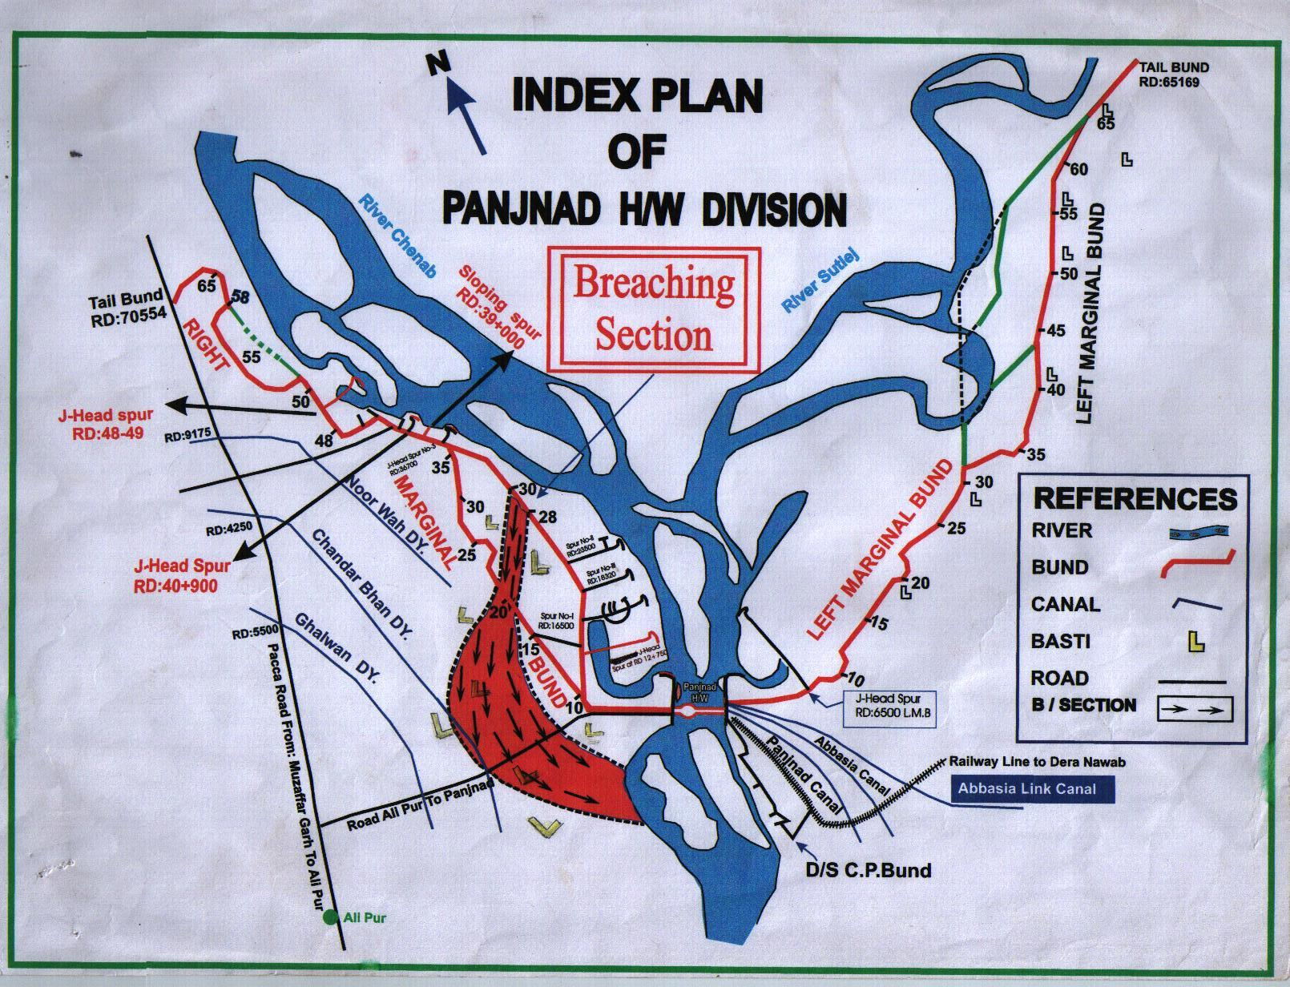

CHAPTER 3
BRIEF HISTORY OF PAST FLOOD EVENTS

The river highest discharge at Panjnad Headworks was 812152 Csreceived during flood 1992. The breaching sections at RD: 28-30 at RMB and RD: 19-21 of RRE were operated. During flood 1973, a discharge of 802516 Cs was received. This discharge caused breaches in RMB and LMB. 3 No. breaches occurred at RD. 9-10, 19-20 and 34-35 of LMB causingheavy damages to the Panjnad Main Line and Abbasia Canal as well as public property and area upto Rahimyarkhan District was inundated causing valuable loss to the precious Public / Privateproperty. The discharge exceeded 5.0 lac Cs during the years 1950, 1955, 1957, 1988, 1995, 1996 and 1997. During flood 2014 when a discharge of 453570 Cspassed through the barrage,the spur at RD: 48-49 of RMB was damaged at its J-Head and the same was restored. During flood 2015, when a discharge of 139366 Cs passed, the spur at RD: 23+500 of RMB experienced damages of apron and pitching at J-Head. The work of restoration of damages was takenup and completed before flood 2016. It has also been observed that the capacity of barrage hasreduceddue to raising of D/S water level. The capacity worked out in the latest model study is 625000 Cs instead of 7.00 Lac Cs. This capacity has been worked out on the basis of latest model study conducted by the IRI for the implementation of Rehabilitation and Modernization of Panjnad Headworksand report was issued vide IRR-1311vide No. 75/868/PROCH dated 09/04/2015, whereas the present water levels are higher than the water levels during 1992 at the corresponding discharges.

CHAPTER 4
DESIGN DATA, HISTORIC PEAK FLOOD DATA AND PREVIOUS FIVE YEARS FLOOD DATA OF HEADWORKS / BARRAGES ANDOTHER CONTROL POINTS

4.1 FLOOD LIMITS

Flood Limits at Panjnad Headworks fixed in the 55th meeting of the Punjab Flood Commission are as under:-

Sr. No. | Flood Stage. | Discharge.
1. | Low Flood. | Above 1.5 Lac. Cs:
2. | Medium Flood. | Above 2.00 Lac. Cs:
3. | High Flood. | Above 3.00 Lac. Cs:
4. | Very High Flood. | Above 4.50 Lac. Cs:
5. | Exceptionally High Flood. | Above 6.00 Lac. Cs:

4.2 TIME LAGS OF FLOODS

The distances and time lags for different stages of floods from U/S Headworks up toPanjnad Headworks are tabulated below:-

REACH | TRIMU TO PANJNAD | SIDHNAI TO PANJNAD | ISLAM TO PANJNAD
Distance in  Canal Miles. | 165 Miles. | 145 Miles. | 130 Miles.
STAGE OF FLOOD
Low Supplies. | 160 Hrs. | 100 Hrs. | 93 Hrs.
Low Floods. | 93 Hrs. | 90 Hrs. | 75 Hrs.
Medium Flood. | 80 Hrs. | 75 Hrs. | 60 Hrs.
High Flood. | 60 Hrs. | 55 Hrs. | 44 Hr.
Very High Flood. | 55 Hrs. | 50 Hrs. | 36 Hrs.
Supper Flood as in 1973. | 50 Hrs. | 45 Hrs. | 30 Hrs.
Supper Flood as in 1992. | 78 Hrs. | 60 Hrs. | 30 Hrs.
Very High Flood 2014 | 121 Hrs. | 82 Hrs. | -

4.3 HIGHEST FLOODS

Prior to 1992, the highest discharge recorded at Panjnad Headworks was 8.02 Lacs Cs. in 1973 but in 1992, a Super Flood of 8.12 Lac Cs. was received at Panjnad, out of which 7.44 Lac Cs. passed through the barrage and the balance forced its way down through breaching section. The histogram of previous years shows that the floods at Panjnad Headworks rarely exceeded 5.00 Lac Cs.
Sr.No | Flood Category | Year | Date | Discharge
1 | Super Flood | 1973. |  | 8.03 Lac. Cs:
2 | Super Flood | 1992. | 21/10/1992 | 8.12 Lac. Cs:
3 | High Flood | 2010. | 14/08/2010 | 3.12 Lac. Cs.
4 | Low Flood | 2011 | 23/09/2011 | 1.53 Lac. Cs
5 | High Flood | 2013 | 26/08/2013 | 3.17 Lac Cs
6 | Very High Flood | 2014 | 16/09/2104 | 4.53 Lac Cs

4.4 PEAK DISCHARGES

Sr. No. | Year | Discharge
1 | 2005 | 1.02 Lacs Cs.
2 | 2006 | 2.3 Lacs Cs.
3 | 2007 | 1.53 Lacs Cs.
4 | 2008 | 0.53 Lacs Cs.
5 | 2009 | 0.33 Lacs Cs.
6 | 2010 | 3.12 Lacs Cs.
7 | 2011 | 1.53 Lacs Cs.
8 | 2012 | 0.65 Lacs Cs.
9 | 2013 | 3.17 Lacs Cs.
10 | 2014 | 4.53 Lacs Cs.
11 | 2015 | 1.39 Lacs Cs.
12 | 2016 | 1.30 Lacs Cs.
13 | 2017 | 0.78 Lacs Cs.
14 | 2018 | 0.57 Lacs Cs
15 | 2019 | 0.87 Lacs Cs

CHAPTER 5
FLOOD FIGHTING STRATEGY

The aim for flood fighting is to pass any flood safely without causing any damage to the hydraulic structure (Barrage) and river training works. Flood Fighting is also carried out against any river action detrimental to the safety of flood bunds and other river training works. The flood fighting may also be required to check river erosive action near to flood protection bunds. Such flood fighting is aimed out to control advancement of the river towards flood bunds / structures.
In order to effectively handle any flood related situation,the day and night watching of total length of flood bunds and river training infrastructure is carried out.
Teams at each stage of flood will remain present in the area of their responsibility for day and night watching of flood bunds as per duty roaster attached. These teams will have strong coordination with each other in work of safety of bunds and flood infrastructure.
This watching establishments may be hired through Govt. contractor because in flood emergency labour may not be arranged departmentally as local people become busy to save their own properties, families and other belongings. Each item of the watching and protection operation is discussed below:-

i) CAMP SITES

Shelter huts and store rooms already constructed havebecome deteriorated. Temporary camps/tents/sholdarieswill be fixed at site with lighting arrangements. Detail as under:

a) LEFT SIDE L.M.B.

RD 5, 10, 15, 20, 25, 30, 35, 40, 45, 50, 55, 60 & 65. =13 Nos.

b) RIGHT SIDE R.M.B.
RD 5, 10, 15, 20, 25,30, 35, 40, 45, 50, 55, 60, 65 &70
Site RD: 30 falls on breaching section.
Temporary shouldari will be provided at this place=14 Nos.

c) R.R.E.

RD 20 temporary camp at breaching section= 1 Nos.

d) DOWN STREAM PROTECTION BUNDS

Temporary camp at RD: 5&10 of colony protection bund = 2 Nos.

- Spur at RD: 48-49, RD: 42+200, RD: 40+900, RD:39+000, RD:36+700, 23500 and RD: 12+750 of RMB= 7 No.

- RGB, LGB, Divide wall = 3 No.

- Spur RD: 6+500 of LMB = 1 No.

- Spur RD:2+700 D/S Headworks at CP Bund =1 No.

G.Total:- =42Nos.

CHAPTER 6
FLOOD DAMAGES RESTORATION WORKS

EXISTING INFRASTRUCTURE

i) BARRAGE AND CANAL HEAD REGULATORS

Panjnad Headworks is situated just below the confluence point of Chenab and Sutlej in the South-Eastern part of District Muzaffargarh. The barrage was constructed to cater for a discharge of 7.00 Lacs Cs. The project rehabilitation and up gradation of Panjnad Barrage is under execution stage and capacity is being enhanced upto 865000 Cs. Three (03) Canals namely Panjnad Main Line, Abbasia Canal and Abbasia Link Canal are off-taking from left side of this barrage to irrigate the area of Bahawalpur and Rahimyar Khan Districts.

ii) RIGHT GUIDE BUND

At present, the River Chenab is the only active part at Panjnad Headworks and its Sutlej component is totally dead. The main thrust of River Chenab is at Right Guide Bund. During the year 2005, the stone apron of this structure hasbeen launched at the discharge of 101655 Cs. and the nose of R.G.B became under direct hit of river supplies. For the safety of the structure and to check parallel flow, the structure has been rehabilitated to its original design. As per enhanced capacity of barrage, the design parameter of RGB will be changed accordingly in the rehabilitation project.

iii) LEFT GUIDE BUND

There is a shore formation from Abbasia Link Canal Head Regulator to X-Section No.II on Sutlejupto line No. zero of Left Guide Bund. Site situation is safe upto this point and the remaining portion is also intact and safe. As per enhanced capacity of barrage, the design parameter of LGB will be changed accordingly in the rehabilitation project.

iv) RIGHT MARGINAL BUNDS
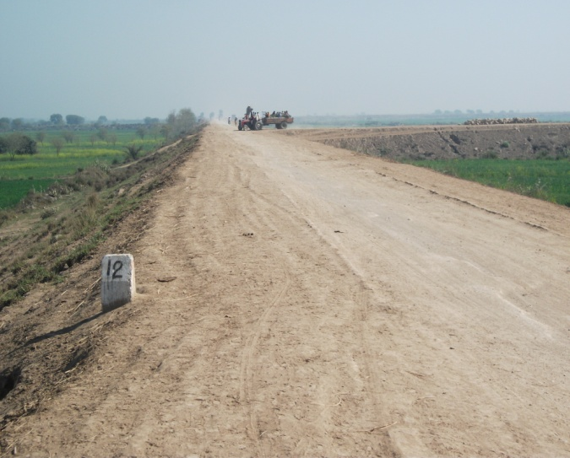
Right Marginal Bund of Panjnad Headworks is under persistence stresses of the river flow / current. River Chenab has a tendency of shifting towards right. Due to construction of flood bunds and the allied structures in the Muzaffargarh Canal Division, the river has reached very closeand has taken dangerous loop in reach RD: 36-44 R.M.B. The only second defence line available in the reach RD: 10-35 of R.M.B. Portion of R.M.B. having 2nddefence line at R.R.E is safe from river erosion. The reach RD: 35-43 is under direct hit of river flow. Necessary provision of stone pitching will be provided in this reach. As the main creek of River Chenab is hardly at distance of 90 feet at RD: 39+000 of R.M.B.

However the raising and strengthening of RMB has been taken by the implementation unit (PIU) under DCRIP is in progress.

R.M.B in between the spur at RD: 36+700 and at RD: 40+900 is in a very dangerous condition. The main current after crossing spur at RD: 40+900 of R.M.B, returns back and forms a gullet parallel to reach RD: 36+700 to 40+900 of R.M.B. Itnot only impinges upon the nose of spur at
RD: 36+700 but also erodes the venerable reach of R.M.B. The minimum ordinate of the foreshore left is 90 ft at RD: 39+000 from the river edge. Howeverrestoration of apron upto 20ft width at J-Head spur 36+700, 40+900 & 48-49will be completed uptoJune- 2020. The raising / strengthening of RMB has been taken by the project implementation unit (PIU) under DCRIP Project is in progress.

v) LEFT MARGINAL BUNDS

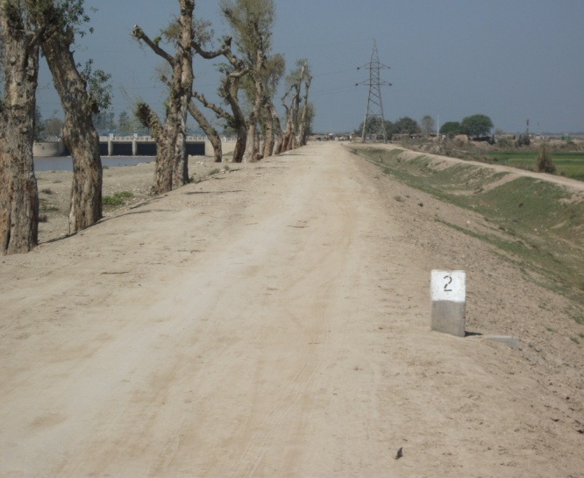
Under FPSP-II, a work of raising and strengthening of R.M.B and L.M.B upstream Panjnad H/Works has been completed with the provision of 6 ft. free board from H.F.L of 1973 and wetting channel has been set in operation for the safety of bunds. The retired bund at RD: 32+000, 44+0000 and 55+000 in front of X-Section V-S on line No.4 and in front of X-Section VI-S between line No.3 and 4 partly, exists at site, which was washed away during flood of 1988. However raising of L.M.B has been taken by the Project Implementation Unit (PIU) under DCRIP is in progress.

vi) DOWNSTREAM COLONY PROTECTION BUND
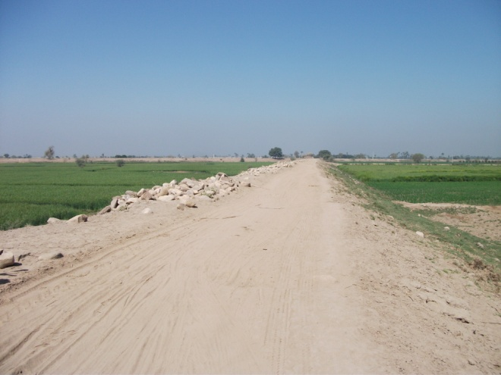
The condition of downstream colony protection bund is satisfactory, this bund was firstly designed with freeboard of 5.00ft and top width 20ft, re-designed with the free board of 6.00ft. and 25.00ft top width. During the flood 2006, no damage occurred to this colony bund which is in satisfactory condition. However the river creek has developed severe loop downstream to spur RD 2750 and has attacked CP Bund in reach RD 4-5. In month of March 2015, there was erosion up to toe of CP Bund just upstream Spur RD 5500. The matter wasreported to IRI for the Model Study, upon the recommendations of Expert Committee Meeting held on 05/01/2015. As per the result of the model study, the PIU constructed the guide wall as proposed in model study and handed over to Irrigation Department during the year 2018.
vii) J-HEAD SPUR AT RD: 12+750 R.M.B (Newly Constructed)
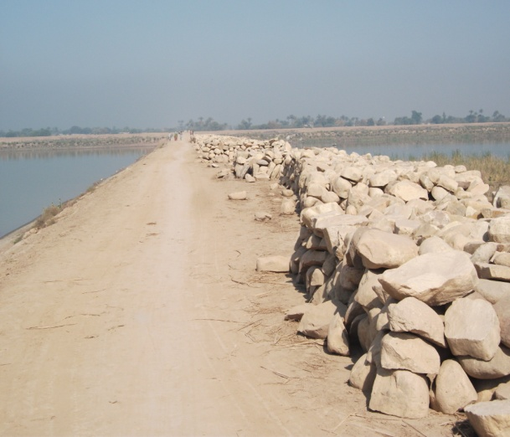
Hydraulic Model Study was conducted at Nandipur Research Institute. In the research report, this structure was recommended / proposed to divert the river flow away from the bank.It was constructed during the year 2008-09 and this spur is in satisfactory condition.

viii) J-HEAD SPUR AT RD; 16+500 R.M.B (OLD)
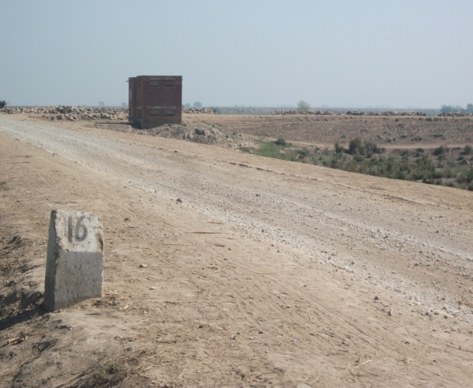
During the freshet of March 2007, the earthen shank of J-Head Spur atRD: 16+500 was damaged. To mitigate the situation at site, the restoration of damaged site was done in 2008.Now Spur is in satisfactory condition.

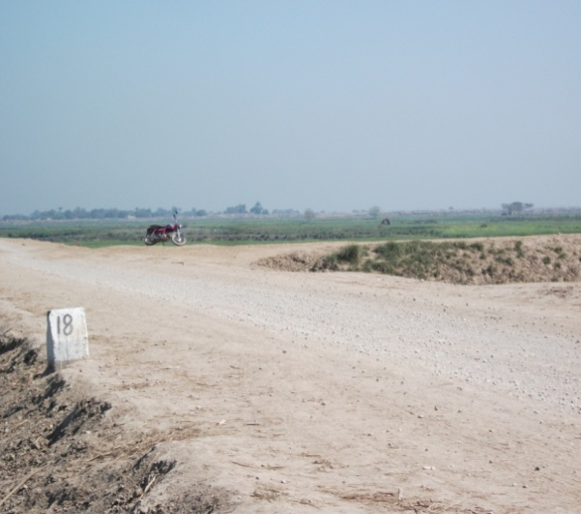
ix) J-HEAD SPUR AT RD; 18+320 R.M.B

During the freshet of March 2007, the earthen shank of J-Head Spur at RD: 18+320 was damaged.To mitigate the situation at site, the restoration of damaged site was carriedout in 2008.Now Spur is in satisfactory condition.

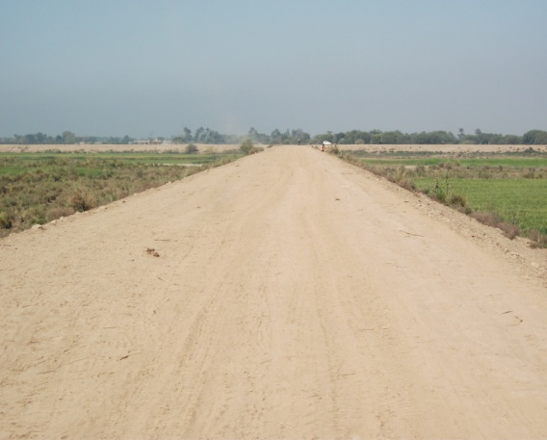
x) J-HEAD SPUR AT RD. 23+500 R.M.B

The shank and J-Head of this spur became under direct hit of river. The parallel flow has caused damage to this structure during the freshet of march 2007,Its prong was damaged and supplies crossed the prong and divided it into two parts. Restoration workhas beencompleted in June 2007.The J-Head Portion of the spur came under attack of the river. The apron was launched and pitching was damaged. Restoration work was completed in 2016. However the spur is sensitive and may come under attack again. Special watching will be arranged.
xi) RIVER TRAINING WORKS IN THE REACHRD. 32 TO 44 R.M.B
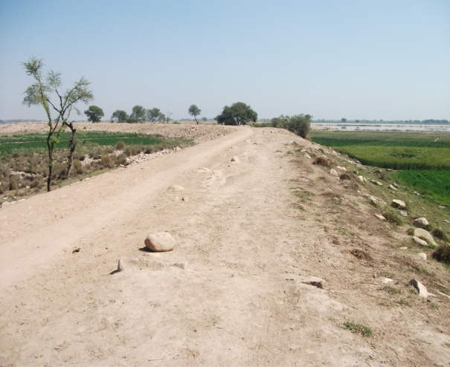
The reach RD: 32-44 R.M.B is considered to be the most vulnerable reach. Hydraulic Model for the reach was run at Nandipur research institute.These structures as detailed belowhave been constructed on the recommendation of Model Study Report during 2003.
  - J-Head spur at RD: 48-49.
  - Correcting Alignment of J-Head Spur at RD: 40+900
  - Sloping spur at RD: 39+000
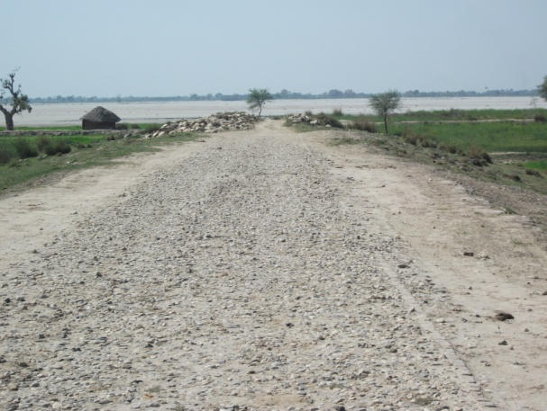
xii) SLOPING SPUR AT RD: 2750 DOWNSTREAM COLONY PROTECTION BUND
The river after crossing the barrage has now adopted an oblique route towards left and has direct hit upon Colony Protection Bund on left flank. The Model Study of the problem was conducted during 2008 in IRI Lahore. In the study report, a Concavo-Convex Guide Wall Spur of 1000 Ft length was constructed in front of 2+750 sloping spur.
xiii) MOLE HEAD SPUR AT RD: 5500 D/S COLONY PROTECTION BUND
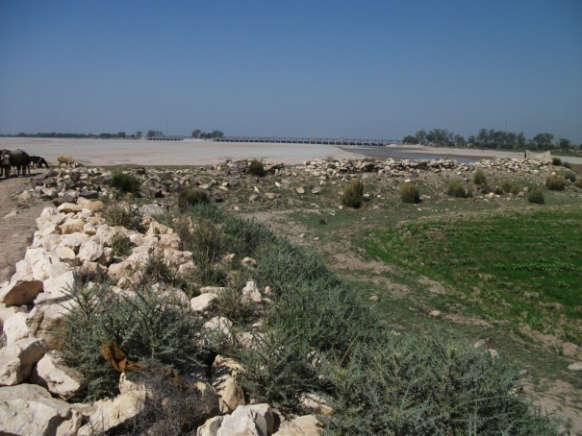
In fact, this spur bears the main current of the river attack after the flow crosses the barrage below spur atRD: 2750, So for it is functioning properly. But during the High Flood of 2013, apron and stone pitched slopes of the structure was damaged. Repair of these damages was carried out and was completed in month of June 2014 before flood. Now the condition is satisfactory and watching arrangement will be made as per flood stages.
xiv) SLOPING SPUR AT RD: 6700 D/S COLONY PROTECTION BUND
This was constructed in 1982 to correct the adverse river approach downstream the barrage and it is functioning properly.

xv) SPUR NO. 9500 & 8500 DOWNSTREAM COLONY PROTECTION BUND
The spur at RD 9500 being situated in the shadow of spur at RD 8500 does not come under action.
xvi) SPUR RD: I0+000 DOWNSTREAM COLONYPROTECTION BUND
This is the last spur in series of spurs along Colony Protection Bund downstream Panjnad Headworks. The sloping spurs are very effective in pushing the main Current away from the fore shore. As the river has created a deep channel in the middle of the course, there was no damage to this spur upto 2018. Over all condition is good.
xvii) DETAIL OF BUNDS AND RIVER TRAINING WORKS TO BE PROTECTED

Location of Bunds and other River Training Works to be protected duringthe coming floods has been shown in the plan.The reachesare mentionedbelow:-

a) RIGHT SIDE

i) Right Marginal Bund RD: 0-70554 = 14.11 Miles

ii) Old Right Marginal Bund RD: 10-35230 = 5.046 Miles

b) STRUCTURES ALONG R.M.B

Sr. No. | RD | Type of spur | Length
Sr. No. | RD | Type of spur | RD | Miles
1 | 12+750 (R.M.B) | J-Head Spur | 0-7700 | 1.54
2 | 16+500 (R.M.B) | J-Head Spur | 0-5500 | 1.1
3 | 18+320 (R.M.B) | J-Head Spur | 0-5000 | 1.0
4 | 23+500 (R.M.B) | J-Head Spur | 0-5000 | 1.0
5 | 36+700 (R.M.B) | J-Head Spur | 0-1900 | 0.38
6 | 39+000 (R.M.B) | Sloping Spur | 0-431 | 0.0862
7 | 40+900 (R.M.B) | J-Head Spur | 0-1500 | 0.30
8 | 41+500 (R.M.B) | Stone Stud | 0-1500 | 0.30
9 | 42+200 (R.M.B) | Mole Head Spur | 0-435 | 0.47
10 | 43+000 (R.M.B) | Stone Stud | 0-565 | 0.113
11 | 48-49 (R.M.B) | J-Head Spur | 0-5600 | 1.15
12 | 53+600 (R.M.B) | Stone Stud | 0-950 | 0.19
13 | 55+000 (R.M.B) | Sloping Spur | 0-900 | 0.18
14 | 56+000 (R.M.B) | Sloping Spur | 0-1300 | 0.26
c) LEFT SIDE.

i) Left Marginal Bund RD: 0 - 65169 = 13.00 Miles
ii) Old Left Marginal Bund RD: 45-65 = 4.00 Miles

d) STRUCTURES ALONG L.M.B

Sr. No. | RD | Type of spur | Length
Sr. No. | RD | Type of spur | RD | Miles
1 | 6+500 (L.M.B) | J-Head Spur | 0-7100 | 1.42

e) COLONY PROTECTION BUND (DOWNSTREAM SIDE)

i) D/S Colony Protection Bund RD: 0 - 15000 = 3.00 Miles

f) STRUCTURES ALONG C.P.B

Sr. No. | RD | Type of spur | Length
Sr. No. | RD | Type of spur | RD | Miles
1 | 2+750 (C.P.B) | Guide wall spur | 0-1580’ | 0.299
2 | 5+500 (C.P.B) | Mole Head | 0-320’ | 0.064
3 | 6+700 (C.P.B) | Sloping Spur | 0-88’ | 0.0176
4 | 8+500 (C.P.B) | Sloping Spur | 0-150’ | 0.03
5 | 9+500 (C.P.B) | Sloping Spur | 0-176’ | 0.0352
6 | 10+000(C.P.B) | Sloping Spur | 0-270’ | 0.054

CHAPTER 7
FLOOD FIGHTING WATCHING ARRANGEMENT

7.1 PRE-FLOOD ARRANGEMENT

Wireless station at Panjnad Headworks is available for communication which is connected with Flood Warning Center at Lahore.After knowing flood forecasting, necessary pre flood arrangements will be ensured by the Executive Engineer, Panjnad Headworks Division. The flood fighting material will be made available at the shelter huts / temporary camps established by the Panjnad Headworks Division. All establishment of the Division will be deputed on the flood embankments to ensure watching around the clock.

7.2 WATCHING ESTABLISHMENT

a) Phase- I

The phase will be operativewhen the discharge at Panjnad Headworks will be in the range 1.50 to 3.0 Lac Cs.

i) Watching Establishment

Watching establishment will be provided at 2 men per mile per shift for three shifts of 8 hours each. Where water touches the bund, one mate will head 8 to 16 beldars and one mistry will head 2 mates and its gang in their reach depending upon the concentration of establishment required per 8 hours shift.44.6 x 2 =89.00 men and 8 mates and 4 Mysteries Extra Establishment for the most dangerous reaches will be as under:-
Left Guide Bank outside 2 men per 8 hours shift.
Breaching sites RD.9-11 LMB 2 men per 8 hours shift.
Breaching sites RD.19-21 LMB 2 men per 8 hours shift.
Breaching sites RD.31-33LMB 2 men per 8 hours shift.

RMB
- Breaching Section RD: 28-30 of RMB 2 men per 8 hours shift.
- Breaching Section RD: 19-21 of RRE2 men per 8 hours shift.
- Reach RD: 32-45 of RMB2 men per 8 hours shift.
- Spur RD: 48-49, 42200, 39000, 36700, 23500, 12750 of RMB 12 men per 8 hour shift for spurs
So total establishment required per 8 hours shift will be 78 men.

ii) Emergency Gangs

At important and dangerous sites, emergency gangs in strength of 20 beldars with one or two mates may be maintained from the time the river rises above 3.50 Lac Csfinally drops below that discharge. These gangs will be used fullyon bunds and will shift to portions where leakage, slips or wave wash is giving trouble for emergent action as deemed necessary.
In addition to the above, the Executive Engineer, Panjnad Headworks Division will employ additional labour locally as and when required in emergency keeping in view the site situation during flood season.Deployment of Supervisory staff will be as under:-

a) Sub Divisional Officer, Panjnad Headworks Sub- Division will be incharge of the Entire watching operations.

b) Duties of Sub-Engineers will be as under:-

1) Sub-Engineer, Hydraulic Section RD 0-70 R.M.B. includingSpurs No.I, II, III.

2) Sub-Engineer, Headworks at Headworks.

3) Sub-Engineer, Station Area reach RD 0-65/LM.B.

4) Sub-Engineer, Workshop RD 0-15 Downstream Colony protection bund.

b) Phase- II

The phase will be operative when the discharge exceeds 3.0 Lac and upto 4.50 Lac.

i) Watching establishment

Watching Establishment will be doubled i.e. 04 men per mile and 52 Nos. for sensitive sites so workout total length of the embankments (44.6x4=178) and total 178+52=230 beldars, 16-Mates and 8 Nos. Mysteries will be required per 8hours shift. The additional requirement will have to be met with by Panjnad Headworks Division by local requirement.

ii) Supervisory Staff
The deployment of supervisory staff i.e. Sub Engineers and Sub Divisional Officer will be the same as per Phase-II.

C) Phase- III

This phase will operative whenthe discharge exceeds 4.50 Lac and up to 6.50 Lac Cs.

i) Watching Establishment

The watching establishment in this phase will be 5 men per mile which works out as per total length of embankment (44.6x5=223No.) 30 Mates and 15 Mistaries. Watching, establishment for the most vulnerable reaches will be doubled that of phase-II. 96 men will be required for these sites. In addition, strength 8 men per shift will be deployed on every dangerous reach referred to above as per 8 hours shift. 83 additional men with 8 mates & 5 mistaries will be deployed in these reaches in one shift of 8 hours.

Total establishment required 223+96+83 =402 Men
Mate per 8 hours shift 30+8 = 38 Men
Mistry 15+5 = 20 Men
Total:- =460 Men

The additional establishment required for phase-III will be trained beldars of the department because watching operations during this phase will be very crucial.
ii) Supervisory Staff

Entire supervisory staff will be summoned from other divisions. The set up will be as under:-

1) Executive Engineer

One Executive Engineer will be in charge of Left Marginal Bund and one of Right Marginal Bund. Their Headquarters will preferably be at RD: 20 L.M.B and at RD: 28 RMB.

2) Sub Divisional Officer

08 No. SDO,s will be deputed in this phase. Each Sub Divisional Officer will perform duties for 12 Hours in two shifts of 6 hours each. Their Headquarters and reaches have been shown on the organizational charts.

3) Sub Engineers

16 Sub-Engineers will be required. Each Sub-Engineer will perform duty for 12 Hours in two shifts of 6 hours each. Their Headquarters and reaches have been shown on the organizational charts.
Note:- Chief Engineerand Superintending Engineer, Bahawalpur Canal Circle, Bahawalpur will earmark watching establishment and supervisory staff required for phase-III from different divisions. This staff will be ready to move to Panjnad Headworks at one day's notice.
D) PHASE-IV

This phase starts as discharge exceeds 6.5 lacs cusecs. Under this phase DCs of Districts Muzaffargarh and Bahawalpur will be requested to provide 400 volunteers for watching while Army authorities will also be requested to depute 700 army men at bunds and Headworks for flood fighting purpose.
7.3 ARRANGEMENT AT SENSITIVE SITES

All sensitive sites on Flood Embankments / Structures will be given special attention and all necessary arraignments regarding watching of the structures will be ensured for flood fighting.

7.4 (i) WATCHING MATERIAL

Sr.No. | Items | Quantity Required | Quantity Available
1 | Lanterns | 635 Nos. | 635 Nos.
2 | Kerosene Oil | 1600 gallons | 1600 gallons
3 | Wicks | 480 yards | 480 yards
4 | Lantern Chimneys | 635 Nos. | 635 Nos.
5 | Gas lamp | 50 Nos. | 50 Nos.
6 | Mentals | 400 Nos. | 400 Nos.
7 | Washers for gas lamp. | 100 Nos. | 100 Nos.
8 | Nozzles for gas lamp. | 100 Nos. | 100 Nos.
9 | Chimneys for gas lamps | 100 Nos. | 100 Nos.
10 | Torches of 2 cells | 40 Nos. | 40 Nos.
11 | Cell for Torches | 240 Nos. | 240 Nos.
12 | Gunney bags | 4100 Nos. | 4100 Nos.
13 | Suttli | 121 Lbs. | 121 Lbs.
14 | E.C. Bags/Jute Bags | 8000 Nos. | 8000 Nos.
15 | Sewing needles | 18 Doz. | 18 Doz.
16 | Axes | 37 Nos. | 37 Nos.
17 | Kassies with Handles | 1000 Nos. | 1000 Nos.
18 | Handle of Kassies | 1000 Nos. | 1000 Nos.
19 | Killas | 2000 Nos. | 2000 Nos.
20 | Ballies | 200 Nos. | 200 Nos.
21 | Baskets | 9900 Nos. | 9900 Nos.
22 | Khaji Mats | 400 Nos. | 400 Nos.
23 | Spirite | 50 Bottle | 50 Bottle
24 | Match Box | 1300 Nos. | 1300 Nos.
25 | Oil extractor | 1300 Nos. | 1300 Nos.
26 | Munj Ban | 11 Mds. | 11 Mds.
27 | Wooden mallets | 200 Nos: | 200 Nos:
28 | Funnels | 72 Nos. | 72 Nos.
29 | Trangers | 1000 Nos. | 1000 Nos.
30 | Tents | 10 Nos. | 10 Nos.
(ii) DETAIL OF RESERVE STOCK STONE
S. No. | Name of structure |  |  | Quantity in (lac Cft.)
S. No. |  |  | Sanctioned Reserve Stock Limit | Minimum Requirements 70% of Reserve stock | Available | Deficient  Qty | Remarks
1 | J-Head spur RD:16500 R.M.B. |  | 2.65 | 1.855 | 2.65 | - | Over all quantity is greater than minimum requirement 70% of reserve stock
2 | J-Head spur RD:18320 R.M.B. |  | 0.131 | 0.0917 | 0.131 | -
3 | J-Head spur RD:23500 R.M.B. |  | 1.85 | 1.295 | 1.523 | 0.327
4 | RD:0-3000 R.M.B. |  | 0.62 | 0.434 | 0.62 | -
6 | J-Head spur RD:36700 R.M.B. |  | 0.5 | 0.35 | 0.5 | -
7 | J-Head spur RD:40900 R.M.B. |  | 0.4 | 0.28 | 0.4 | -
8 | RD:41000, 43000 R.M.B. |  | 0.55 | 0.385 | 0.55 | -
9 | Sloping spur RD:41500 R.M.B. |  | 0.09 | 0.063 | 0.09 | -
10 | Stone Stud RD:43000 R.M.B. |  | 0.06 | 0.042 | 0.06 | -
11 | Stone Stud RD:53600 R.M.B. |  | 0.355 | 0.2485 | 0.355 | -
12 | RD:53000, 55000 R.M.B. |  | 0.15 | 0.105 | 0.15 | -
13 | Stone Stud RD:55000 R.M.B. |  | 0.33 | 0.231 | 0.33 | -
14 | RD:55000, 56000 R.M.B. |  | 0.46 | 0.322 | 0.46 | -
15 | Stone Stud RD:56000 R.M.B. |  | 0.78 | 0.546 | 0.78 | -
16 | L.G.B u/s Panjnad Headworks. |  | 1.38 | 0.966 | 1.38 | -
17 | L.G.B d/s Panjnad Headworks. |  | 0.09 | 0.063 | 0.09 | -
18 | Junction Groyne u/s Panjnad Headworks. |  | 0.51 | 0.357 | 0.51 | -
19 | Junction Groyne d/s Panjnad Headworks. |  | 0.19 | 0.133 | 0.19 | -
20 | R.G.B U/S Panjnad Headworks. |  | 1.84 | 1.288 | 1.84 | -
21 | Stack Yard NalkaAdda + near new regulation colony |  | 7.66 | 5.362 | 7.66 | -
22 | J-Head spur RD:6+500 L.M.B. |  | 2.74 | 1.918 | 2.74 | -
23 | Mole Head spur RD:5+500 C.P.B. |  | 0.145 | 0.1015 | 0.145 | -
24 | Stack Yard Colony Area. |  | 2.65 | 1.855 | 2.65 | -
25 | RD:37-39 R.M.B. |  | 0.58 | 0.406 | 0.58 | -
26 | J-Head Spur at RD:48-49. |  | 1.5 | 1.05 | 1.5 | -
27 | J-Head Spur at RD: 12+750 |  | 1.24 | 0.868 | 1.24 | -
 |  | Total | 29.451 | 20.616 | 29.124 | 0.327

7.5 ARRANGEMENT FOR SOUNDING & PROBING

Allequipments including Boats, Sounding Rods, Leveling Instruments, Arrows etc. will be made available to perform Sounding and Probing during the flood.

7.6 LIGHTING ARRANGEMENT

Necessary Lighting arrangements will also bemade on LMB / RMB of Panjnad Headworks and on other critical infrastructures for flood fighting.
7.7 RATION ARRANGEMENT

Ration arrangements for the deployed labour are the responsibility of Irrigation Department, Panjnad Headworks Division Panjnad. However, this activity will also be taken into account at all levels during the floods.

7.8 POL ARRANGEMENT FOR VEHICLE

Necessary arrangements to facilitate earth moving machinery including POL will also be ensured by PID as well as by the Civil Department.

7.9 TRANSPORTATION

There is only one truck in Panjnad Headworks Division which is out of order. Three trucks will have to be requisitioned through Deputy Commissioner, Muzaffargarh and Bahawalpur for working during phase-I & II.In phase III-IV, 6 Nos. Trucks/Tractor Trolleys and 2 Nos. Pick-ups will be required.

7.10 LAW AND ORDER

1. Deputy Commissioner, Bahawalpur / Muzaffargarh Districts (DC BWP/MZG) will provide adequate police assistance in all sectors /relief centers/flood affected areas, during any flood related emergency, for security purposeand maintenance of law & order.
2. The DC BWP/MZGwill render operational support to assist XEN, SDO and SBEs of Panjnad Headworks and will also ensure maintenance of law and orderin flood hit areas/relief centers.
3. The DC BWP/MZGwill deploy adequate police force at Panjnad Headworks as well asRiverChenab and Sutlej for evacuation of people / livestock from lowlying areas along the River bed in collaboration with revenue departmentas well as military authorities.
4. The DC BWP/MZGwill put all District Police force in state of high alert and instruct them to collect and disseminate any flood related information to higher authorities as well as general public.

5. The District Police Officer MZG / BWP will make alternate arrangements for traffic, in case of suspension of normalroutes, on account of floods.

6. Executive Engineer Panjnad Headworks will keep inform the Deputy CommissionerBWP/MZGabout any flood relatedsituation.

7. The DC BWP/MZGshall issue directions for use of public wireless system, for communication purposes, during the emergency.

7.11 MEDICAL ARRANGEMENT FOR LABOUR

CEO (H) MZG / BWP will perform the following functions inter alia:

1. Provision of first aid /Medicare facilities during flood related emergency in District Muzaffargarh.

2. Extensive preventive vaccination/inoculation before, during and after the flood season.

3. Provision of necessary medicines, antibiotic, drug, ORS and anti-snake biting and other necessary vaccines, in adequate quantities in addition to necessary first aid articles.

4. Planning and organization of Emergency centers and establishment of emergency cells as well as special medical teams, for centralized planning and coordination, during actual emergency and carrying out mass inoculations/vaccination of the affected population, in targeted areas/relief centers.

5. Provision of clean sanitary conditions in affected areas. Activation of mobile units with medical officer and staff, for provision of medical facilities in remotely located areas.

7.12 LIAISON WITH OTHER DEPARTMENT

ADC (R) Muzaffargarh / Assistant Commissioner Alipur shall be responsible for:

- Collection and distribution of relief foods/donations.

- Motivating the general public, including Trade Association i.eAnjuman-e-Tajran&Shehriyan, Rice Sheller Association, petrol pump association, Brick Kiln (Bhatta) association, private Schools association, Private Hospital association, Bus Stand operators, Contractor association and the philanthropists, for donations in cash or kind, for relief related operations.

- Distribution of blankets, clothes and other relief articles to the affected population. Priority amongst effected people will be focused to widows, orphans and landless tenants.

- Maintaining a central inventory of all items collected through private sources or B.O.R.

- Maintaining proper accounts pertaining to distribution of relief items.

SE Highway M&R

SE (M&R) MZG / BWPwill ensure all possible precautionary measures prior to onset of flooding season. He will make arrangements of protection and repair of bridges/roads and necessary infrastructure. He will be responsible inter alia, for:

1. Mobilization of all resources of District works Department including machinery and manpower, in aid and assistance of District Government /Irrigation Department.

2. Tabulating data of all excavator /trolleys in the District during the flood season required for repair of breach.

3. Improving road breaches/cuts on directions of competent authority, in order to facilitate discharge of water and to prevent larger damages / losses.

4. Repair and rehabilitation of damaged roads, bridges or essential infrastructure, ensuring swift restoration of communication infrastructure, particularly to be used for relief operations.

XEN PROVINCIAL HIGH WAY DEPARTMENT M&R

Provincial Highway Department and M&R Divisionwill muster up all resources in aid of District Government in order to ensure that:

1. Roads are in satisfactory state and normal flow of traffic is maintained before and after flood emergency situation.

2. Comprehensive survey of damaged roads is conducted and repair works start immediately as soon as flood is over.

3. Any other operation as the District Government authorities may direct, in aid and assistance of XEN Highways (M&R) and XEN Irrigation.

CEO (HEALTH).

CEO (H) will be expected to perform the following functions inter alia:

1. Provision of first aid /Medicare facilities during flood related emergency in District Muzaffargarh.

2. Extensive preventive vaccination/inoculation before, during and after the flood season.

3. Provision of necessary medicines, antibiotic, drug, ORS and anti snake biting and other necessary vaccines, in adequate quantities in addition to necessary first aid articles.

4. Planning and organization of Emergency centers and establishment of emergency cells as well as special medical teams, for centralized planning and coordination, during actual emergency and carrying out mass inoculations/vaccination of the affected population, in targeted areas/relief centers.

5. Provision of clean sanitary conditions in affected areas. Activation of mobile units with medical officer and staff, for provision of medical facilities in remotely located areas.

6. Mobilization of disaster management unit and provision of essential articles e.g blankets, stoves, tents in the relief centers, upon advice of District Government.

CEO (AGRICULTURE).

CEO Agriculture MZG / BWP are expected to perform following functions inter alia:

1. He will ensure that /equipment of agriculture department is in well maintained condition and upon requisitions of XEN Panjnad, he will shift it to required site.

2. The supply of fodder for cattle during emergency is properly managed, by the Agriculture Department.

3. He will launch a rigorous campaign in the District through loudspeaker announcements, regarding time and points of availability of fodder and wheat bhoosa/hay. Farmers will be educated as to how they can protect their crops from flood/rain water.

4. He will ensure that at least three mobiles teams headed by the DDOAEs Muzaffargarh, Ali Pur and Uch Sharif, Ahmadpur East may remain available throughout the flood seasons for monitoring of flood sectors and provision of assistance in targeted areas.

5. He will manage the workforce in order to effectively combat any natural calamity and render assistance in all Flood Sectors/Relief Camps on need basis.
DIRECTOR LIVESTOCK

It has been noticed that many people prefer to stay back to protect their livestock even in desperate times. Such a dispensationnot only endangers their own lives but also makes it extremely difficult for the rescue teams to be able to extract the marooned in case situation aggravates. In view therefore, DO Livestock will be expected to perform the following functions?

1. A Relief Cell at the District level is established under supervision of District Livestock Officer MZG in their offices, which is manned round the clock.

2. DO (Livestock) will be responsible for vaccination of animals of flood affected areas. For this purpose, banners regarding flood relief activities will be displayed at conspicuous places in all flood relief centers, in order to apprise flood affecters about facilities available for vaccination and treatment of animals.

3. In case of flood emergency, emergency field units will be activated for necessary measures pertaining to mass vaccination against spread of diseases. For this purpose, DO (Livestock) will organize sector wise mobile teams, for the purpose of providing treatment and vaccination. The teams will maintain active presence in flood-affected areas and render all possible assistance to the affected communities.

4. DO (Livestock) shall report to emergency centers about the extent of damages to live stock, after flood emergency is over.

CEO (EDUCATION)

The CEO (Edu) MZG / BWP shall be expected to perform the following functions inter alia:

1. He will make available all school premises along the vulnerable areas for establishment of relief camps, in order to be able to accommodate displaced people. He will detainin requisite staff and will ensure that all school buildings remain readily available round the clock, for the purpose of accommodating the displaced people, throughout the entire flooding season.

2. He will ensure presence of boy scouts and senior class students at relief camps and will be overall in charge and focal person for this activity.

EDO (COMMUNITY DEVELOPMENT)

He shall assist in collection of donations in cash/kind of arranging relief activities within and outside the District. He will also motivate local philanthropists/volunteers as well as NGOs in integrating their efforts with those of the status apparatus. He will maintain a complete record of volunteers/philanthropists, keen to extend assistance in relief activities and will also maintain an inventory of all articles collected and distributed in this regard.

DISTRICT FLOOD CONTROLLER

District Food Controller will ensure that:

1. In case of emergency, sufficient stocks of wheat /sugar remains available in flood affected areas.

2. Will prepare a scheme for opening of temporary ration depots in the areas likely to be affected by flood /rain

3. Will depute requisite staff with District Flood relief Officer, during and after flood emergency.

4. Will arrange for emergency ration packets comprising of necessary available food items.

5. Will arrange for immediate supply and distribution of food through ADC (R) concerned.

6. Will immediately setup a centralized cell for affective coordination.

XEN WAPDA /MEPCO

WAPDA Officer at Alipur / Ahmadpur Eastwill prepare necessarycontingency plan to ensure that:-

1. No breakdown in electricity is allowed to happen in flood affected areas.

2. A Survey of electrical installation is conducted, particularly in flood /rain affected areas and appropriate arrangements are made for uninterrupted supply of electricity.

3. Uninterrupted electricity is supplied to sector offices, relief camps, as well as important installations.

DIVISIONAL ENGINEER, PTCL

He will ensure uninterrupted communication in the District and will provide telephone lines immediately. He will also be responsible for immediate restoration of telephonic linkages in case of damage to any PTCL installation, during and after flooding season.

INCHARGE RESCUE 1122

Incharge Rescue 1122 will maintain close liaison with District Flood Rescue Operation and will promptly dispatch his rescue teams, at the call of District Flood Relief Officer, for rescue of marooned people. The 1122 service will remain in a state of high alert throughout the flooding season and will be fully equipped with all gadgets as well as first aid equipments. Rescue 1122 will provide specialist swimmers, for extractingpeople from flood affected areas.

DISTRICT OFFICER (CIVIL DEFENCE)

1. The Civil Defense Officer in consultation with District Flood Rescue Operation, shall formulate a plan for rescue and relief operation in case of any contingency.

2. Arrange for training of Civil Defense contingent staff in handling any flood related situation.

3. Provide adequate number of volunteers for coordination of rescue activities and management of relief centers.

4. Will provide for motorboat and flood fighting equipment, on emergency basis.

5. Will setup an emergency cell for coordination amongst all departments, in case there is a high flood warning.

6. Will make available requisite number of Civil Defense personnel/volunteers & material/equipment with District Flood relief officer Muzaffargarh, for performance of duties during and after flood situation.

7. Will monitor and train volunteers, for meaningful assistance in flood fighting operations.

8. Will arrange training workshops for staff of different departments, for meaningful assistance in flood fighting operations.

DISTRICT POLICE OFFICER

1. Will provide adequate police assistance in all sectors /relief centers/flood affected areas, during any flood related emergency, for security purpose and maintenance of law & order.
2. Will render operational support to assist DFO/DFRO/TFRO/sector officers in discharging of their duties and maintenance of law order in flood hit areas/relief centers.
3. Will deploy adequate police force at Panjnad Headworks as well as River Chenab and Sutlej for evacuation of people / livestock from low lying areas along the River bed in collaboration with revenue department as well as military authorities.

4. Put all District Police force in state of high alert and instruct them to collect and disseminate any flood related information to higher authorities as well as general public.

5. Make alternate arrangements for traffic, in case of suspension of normal routes, on account of floods.

6. Will keep the Deputy Commissioner abreast of any flood related situation.

7. Will issue directions for use of public wireless system, for communication purposes, during the emergency.

7.13 ROLE OF THE ARMY

Constitution of Islamic Republic of Pakistan imposes upon the armed forces, to aid and assist the civil administration in times of need. Accordingly, army may be requisitioned for aid of civil administration, as and when necessary, depending upon the nature and gravity of the situation. Headquarter 2 Corps Multan / 31Corps Bahawalpur 8 Div. shall nominate liaison Officers, who will coordinate with the Deputy Commissioner and the DFRO Muzaffargarh / Bahawalpur, during times of emergency. The military officers will be expected to maintain constant liaison with the District Govt. and to provide troops as well as flood fighting equipment/boats, to the District Government. Upon requisition,the District Government will arrange for accommodation of Army Troops and will provide all necessary facilities e.g. telephone lines etc. for communication/ operational purposes forward requests through proper channel and secure requisite number of TMO Muzaffargarh, Ali Pur and Ahmadpur East will be responsible for transportation of boats. In addition to troops from 2 Corps 8 Div, already deputed at Muzaffargarh / Bahawalpur, may also be called to further assist the civil administration, during all rescue, relief and rehabilitation operations.
1. Will provide adequate police assistance in all sectors /relief centers/flood affected areas, during any flood related emergency, for security purpose and maintenance of law & order.

2. Will render operational support to assist DFO/DFRO/TFRO/sector officer incharge of their duties and maintenance of law order in flood hit areas/relief centers.

7.14 DUTIES OF TELEPHONE ATTENDANT

Dak Running

Six Dak Runners will be appointed 3 for Left Marginal Bund and 3 for Right Marginal Bund. A pair of Dak Runners will run on each bund for fetching morning and evening gauges of bunds. They will also carry dak too from supervisory staff on bunds.The other two dak runners will remain at Headworks and will be utilized for emergency message, in any emergency, they will be running between Colony and Headworks.

Telephone Attendants

6 Nos. Telephone attendants will be required, 3 for Telephone Office in Colony & 3 for telephone at Headworks so that telephone line may be run round the clock. These telephone attendants will have to be called from other divisions or recruited locally. There is one telephone attendant at Panjnad whose Headquarter will be at Headworks for compiling morning and evening gauges of bunds and Headworks.

Signalers

At present, there are 3 Signalers at Panjnad. It will require two additional signalers from other divisions to help the existing establishment because the work load during flood season is very much.

7.15 Wireless Arrangements

Wireless station at Panjnad Headworks is out of order since 8 yearsand not connected with Flood Warning Center at Lahore and barrages on the rivers upstream of Panjnad Headworks. Flood warnings are received through the mobile phones. However, Executive Engineer, Panjnad Headworks will be facilitated with wireless mounted on Jeep supplied by the Police Headquarters and District Civil Administration Muzaffargarh.
CHAPTER 8
DETAIL OF ENCROACHMENT

The list of encroachment have been reported to civil administration for its removal vide this office letter No.2864-we dated.15/10/2018 and No.273-we dated 12/02/2020.
- LEFT MARGINAL BUND

Sr. No. | RD | Name of Encroacher | Area Encroached |  | Category | Remarks
1 | 0-1 | Tanveer Hussain S/O Nazir Hussain | 3 | Marla | Commercial
2 |  | KhudaBux S/O Allah Bux | 3 | Marla | Commercial
3 |  | Muhammad Bux S/O Allah Bux | 3 | Marla | Commercial
4 |  | Ghulam Yasin | 3 | Marla | Commercial
5 |  | JavedJabail | 3 | Marla | Commercial
6 |  | Javed Kakis | 3 | Marla | Commercial
7 |  | Jaleel Ahmad | 3 | Marla | Commercial
8 |  | Fiyaz Hussain S/O Bashir Ahmad | 3 | Marla | Commercial
9 |  | Allah Ditta S/O Muhammad Bux | 3 | Marla | Commercial
10 |  | MuhamamdRafiq S/o Rahim Bux | 3 | Marla | Commercial
11 |  | Muhammad Akram S/O Ahmad Bux | 3 | Marla | Commercial
12 |  | Ghulam Qadir S/O Allah Ditta | 3 | Marla | Commercial
13 |  | Muhammad Tahir S/O Muhammad Ramzan | 3 | Marla | Commercial
14 | 6-7 | Peer Bux | 5 | Marla | Residential
15 |  | MunshiRasoolBux S/O Ahmad Bux | 5 | Marla | Residential
16 |  | Abdul Majeed S/O Peer Bux | 5 | Marla | Residential
17 |  | Muhammad Nawaz S/O ElahiBux | 5 | Marla | Residential
18 |  | Allah Diwaya S/O ElahiBux | 5 | Marla | Residential
19 |  | HazoorBux S/O Allah Diwaya | 5 | Marla | Residential
20 | 21-22 | Bashir Ahmad S/O Muhammad Ramzan | 5 | Marla | Residential
21 | 22-23 | Altaf Hussain S/O Ghulam Qadir | 5 | Marla | Residential
22 |  | Bashir Ahmad S/O Ghulam Qadir | 5 | Marla | Residential
23 |  | Mukhtar Ahmad S/O M. Ramzan | 5 | Marla | Residential
24 |  | Ajmal Khan S/O Nobat Khan | 5 | Marla | Residential
25 |  | Kaly Khan S/O Jalal Khan | 5 | Marla | Residential
26 |  | Musheer Khan S/O Allah Wasaya | 5 | Marla | Residential
27 |  | Bagu Khan S/O Mahiwal Khan | 5 | Marla | Residential
28 |  | Ghulam Sarwar Khan S/O Fazal Khan | 5 | Marla | Residential
29 |  | Bashir Khan S/O Jalal Khan | 5 | Marla | Residential
30 |  | Bangal Khan S/o Nooran Khan | 5 | Marla | Residential
31 |  | Bashir Ahmad S/O Allah Ditta | 5 | Marla | Residential
32 |  | Naseer Khan S/O Allah Ditta | 5 | Marla | Residential
33 |  | Allah Ditta Khan S/O Manzoor Khan | 5 | Marla | Residential
34 |  | Javaid Khan S/O Mithy Khan | 5 | Marla | Residential
35 |  | Muhammad Aslam Khan S/O Shary Khan | 5 | Marla | Residential
36 |  | Mithy Khan S/O Shary Khan | 5 | Marla | Residential
37 |  | Mithy Khan S/O Shary Khan | 5 | Marla | Residential
38 |  | Aslam Khan S/o Mithy Khan | 5 | Marla | Residential
39 |  | Beelu Khan S/O Allah Ditta | 5 | Marla | Residential
40 |  | Kaly Khan S/O Jalal Khan | 5 | Marla | Residential
41 |  | Nazir Ahmad Khan S/o Qadin Khan | 5 | Marla | Residential
42 |  | Ali Khan S/O Nazir Khan | 5 | Marla | Residential
43 |  | Iqbal Khan S/O Lal Khan | 5 | Marla | Residential
44 |  | Maloo Khan S/O Mureed Khan | 5 | Marla | Residential
45 |  | Mushir Khan S/o Allah Wasaya | 5 | Marla | Residential
46 |  | Ameer Bux S/O Ghulam Sarwar Khan | 5 | Marla | Residential
47 | 32-33 | Bagu S/O FaizBux | 5 | Marla | Residential
48 |  | Rasheed S/O FaizBux | 5 | Marla | Residential
49 |  | Shabbir S/o Abdullah | 5 | Marla | Residential
50 | 56-57 | Muhammad Ramzan S/O Khandu Khan | 5 | Marla | Residential
51 |  | Ghulam Akbar S/O Abdul Sattar | 5 | Marla | Residential
52 |  | Ameer Bux S/O Karim Bux | 5 | Marla | Residential
53 |  | Muhamamd Aslam S/O QadirBux | 5 | Marla | Residential
54 |  | Muhammad Akram S/O Imam Bux | 5 | Marla | Residential
55 |  | KhudaBux S/O Karim Bux | 5 | Marla | Residential
56 |  | Abdul Latif S/o Allah Ditta | 5 | Marla | Residential
57 | 57-58 | Muhammad Younas S/O Ghulam Hassan | 5 | Marla | Residential
58 | 58-59 | Shah Nawaz S/o Rahim Bux | 5 | Marla | Residential
59 |  | Shahid S/o Muhammad Iqbal | 5 | Marla | Residential
60 |  | Muhammad Nawaz S/O Rahim Bux | 5 | Marla | Residential
61 | 63-64 | Muhammad Saeed S/O Rahim Bux | 10 | Marla | Residential
62 |  | Jaleel Ahmad S/O Ghulam Rasool | 10 | Marla | Residential

- RIGHT MARGINAL BUND

Sr. No. | RD | Name of Encroacher | Area Encroached |  | Category | Remarks
1 | 0-1 | Ghulam Rasool S/O Ameer Bux | 3 | Marla | Residential
2 |  | Nazeer Ahmed S/O Walo | 5 | Marla | Residential
3 |  | Rajab Ali S/O Noor Muhammad | 5 | Marla | Residential
4 |  | Muhammad Ashraf S/O Mahiwal | 8 | Marla | Residential
5 |  | Darvaish Hussain S/O Karim Bux | 10 | Marla | Residential
6 | 1-2 | Ameer Bux S/O Allah Ditta | 15 | Marla | Residential
7 | 2-3 | Peer Bux S/O Hussain Bux | 3 | Marla | Residential
8 | 3-4 | Muhammad Abbas S/O Ghulam Hussain | 6 | Marla | Residential
9 |  | Abdul Aziz S/O Nazar | 7 | Marla | Residential
10 |  | Muhammad Hussain S/O Gaman | 9 | Marla | Residential
11 |  | Javed S/O Khadim Hussain | 3 | Marla | Residential
12 |  | HazoorBux S/O PeerinDitta | 20 | Marla | Residential
13 | 51-52 | Saleem S/O Ahmad Bux | 5 | Marla | Residential
14 |  | Ashiq Hussain Malana | 10 | Marla | Residential
15 |  | Haji Nawaz Malana | 12 | Marla | Residential
16 |  | HazoorBuxMalana | 20 | Marla | Residential
17 |  | Dildar Hussain Malana | 10 | Marla | Residential
18 |  | FaqirBuxMalana | 15 | Marla | Residential
19 |  | Altaf Hussain Malana | 12 | Marla | Residential
20 |  | PeerinDittaMalana | 14 | Marla | Residential
21 |  | Muhamamd Bilal S/O Ghulam Sadiq | 9 | Marla | Residential
22 |  | Kaora S/O Ameer Bux | 7 | Marla | Residential
23 |  | HazoorBuxMalana | 12 | Marla | Residential
24 |  | Ghulam Haidar S/O RasoolBux | 15 | Marla | Residential
25 |  | Ghulam Abbas S/O Ghulam Nabi | 20 | Marla | Residential
26 | 55-56 | Allah Ditta Dung | 5 | Marla | Residential
27 |  | RamzanSial | 8 | Marla | Residential
28 | 56-57 | Ghulam Akbar S/O Hayat Muhammad | 2 | Marla | Commercial
29 |  | Rasheed Hajam S/O Hussain Bux | 10 | Marla | Residential
30 |  | Hussain BuxKhulung | 2 | Marla | Commercial
31 |  | Ghulam Hussain Dung | 15 | Marla | Residential
32 | 58-59 | Jam Allah Ditta Dung | 3 | Marla | Commercial
33 |  | Jam Allah Ditta Dung | 1 | Marla | Commercial
34 |  | Jam UmerWadda Dung | 2 | Marla | Commercial
35 |  | Saifal Dung | 2 | Marla | Commercial
36 | 65-66 | Nazeer Hussain Balouch | 10 | Marla | Residential
37 |  | Haji Allah BuxBalouch | 8 | Marla | Residential
38 |  | Ghulam NazikBalouch | 15 | Marla | Residential
39 | 70-70+500 | Abudul Latif Balouch | 20 | Marla | Residential
40 |  | Ahmad YarBalouch | 2 | Marla | Commercial
41 |  | Sajjad Khan Balouch | 5 | Marla | Residential
42 |  | Mumtaz Khan Balouch | 10 | Marla | Residential
43 |  | Allah DittaBalouch | 12 | Marla | Residential
44 |  | Fida Hussain Balouch | 10 | Marla | Residential
45 |  | Zulfiqar S/O Fida Hussain Balouch | 15 | Marla | Residential
46 |  | Ghafar S/O Fida Hussain | 8 | Marla | Residential
47 |  | MuktarBhindi Wala | 20 | Marla | Residential
48 |  | Tahir Hussain S/O Allah Wasaya | 15 | Marla | Residential
49 |  | Nazar Hussain S/O Allah Wasaya | 12 | Marla | Residential
50 |  | Ashiq Hussain S/O Bagu Khan | 10 | Marla | Residential
51 |  | Fazlu Khan Bhindi Wala | 8 | Marla | Residential
52 |  | Amir Khan S/O Fazlu Khan | 9 | Marla | Residential
53 |  | Imdad Khan S/O Fazlu Khan | 14 | Marla | Residential
54 |  | Mulazim Hussain S/O Fazlu Khan | 10 | Marla | Residential

- HEADWORKS

Sr. No. | Location | Name of Encroacher | Cast | Category | Remarks
1 | Main Road Alipur to Trandah | Muhammad Saleem S/O Abdul Rahim | Machi | Khokah
2 | Main Road Alipur to Trandah | Muhammad Atiq S/O Abdul Rehman | Machi | Khokah
3 | Main Road Alipur to Trandah | Muhammad Ali S/O Abdul Sattar | Gopang | Khokah
4 | Main Road Alipur to Trandah | Muhammad Fiyaz S/O Faiz Muhammad | Gopang | Khokah
5 | Main Road Alipur to Trandah | Ghulam Shabir S/O Abdul Aziz | Gopang | Khokah
6 | Main Road Alipur to Trandah | Mehboob Ahmad S/O Abdul Karim | Lashari | Khokah
7 | Main Road Alipur to Trandah | Abdul Majeed S/O Allah Ditta | Lashari | Khokah
8 | Main Road Alipur to Trandah | Mushtaq Ahmad S/O Munir Ahmad | Jhabail | Khokah
9 | Main Road Alipur to Trandah | Muhammad Shahid S/O Nazeer Ahmad | Lashari | Khokah
10 | Main Road Alipur to Trandah | Khalil Ahmad S/O AzeemBux | Gopang | Khokah
11 | Main Road Alipur to Trandah | Muhammad Nazim | Lashari | Khokah
12 | Abbasial Canal and Abbasia Link Canal | Muhammad Usman S/O HazoorBux |  | Khokah
13 | Abbasial Canal and Abbasia Link Canal | Muhammad Saqlain S/O HazoorBux |  | Khokah
14 | Abbasial Canal and Abbasia Link Canal | Muhammad Pervaiz S/O Abdul Sattar | Gopang | Khokah
15 | Abbasial Canal and Abbasia Link Canal | Muhamamd Kahlil S/O Abdul Aziz | Gabol | Khokah
16 | Abbasial Canal and Abbasia Link Canal | Umer Hayat S/O Muhammad Aslam | Doli | Khokah
17 | Abbasial Canal and Abbasia Link Canal | Abdul Razaq S/O Majeed Khan | Gopang | Khokah
18 | Abbasial Canal and Abbasia Link Canal | Abdul Qayoom S/o Irshad Hussain | Doli | Khokah
19 | Abbasial Canal and Abbasia Link Canal | Muhammad Akhtar S/o Irshad Hussain | Doli | Khokah
20 | Abbasial Canal and Abbasia Link Canal | Muhammad Usman S/o Abdul Ghafar | Gopang | Khokah
21 | Abbasial Canal and Abbasia Link Canal | Munir Ahmad S/O AzeemBux | Gopang | Khokah
22 | Abbasial Canal and Abbasia Link Canal | Ghulam Ali | Mohana | Khokah
23 | Abbasial Canal and Abbasia Link Canal | Muhammad Zaffar | Billimar | Khokah
24 | Abbasial Canal and Abbasia Link Canal | Abdul Shakor | Machi | Khokah
25 | Abbasial Canal and Abbasia Link Canal | Muhammad Javed S/O Khadim Hussain | Machi | Khokah
26 | Left Guide Bank | Muhammad Husssain S/O Janu Khan | Lashari | Khokah
27 | Left Guide Bank | Muhammad Waseem S/O M. Ilyas | Lashari | Khokah
28 | Left Guide Bank | Muhammad Waseem S/O Ghulam Yasin | Lashari | Khokah
29 | Left Guide Bank | Muhammad Nasir S/O Ammanullah | Lashari | Khokah
30 | Left Guide Bank | Muhammad Shahid S/O Allah Diwaya | Lashari | Khokah
31 | Left Guide Bank | Muhammad Bux S/O Allah Bachaya | Lashari | Khokah
32 | Left Guide Bank | KhudaBux S/O Allah Bachaya | Lashari | Khokah
33 | Left Guide Bank | Muhammad Sami | Lashari | Khokah
34 | Left Guide Bank | Muhammad Ajmal | Lashari | Khokah
35 | Left Guide Bank | Muhamamd Zafar S/O Ammanullah | Lashari | Khokah
36 | Left Guide Bank | M. Ejaz S/O Manzoor Hussain | Lashari | Khokah
37 | Left Guide Bank | Allah Ditta | Mallah | Khokah
38 | Left Guide Bank | Muhammad Shahid | Gabol | Khokah
39 | Left Guide Bank | Ghulam Yasin |  | Khokah
40 | Left Guide Bank | Muhammad Rafique | Jhabail | Khokah
41 | Left Guide Bank | Mulazim Hussain | Jhabail | Khokah
42 | Left Guide Bank | Muhammad Saleem S/O Abdul Majeed | Gabol | Khokah
43 | Left Guide Bank | Fiyaz Hussain S/O Bashir Ahmad |  | Khokah
44 | Left Guide Bank | Muhammad Farhan S/O Haji Muhammad | Mallah | Khokah
45 | Left Guide Bank | Muhammad Ramzan S/O Muhammad Zman | Mallah | Khokah
46 | Left Guide Bank | Ejaz Hussain S/O Bashir Hussain Shah | Shah | Khokah
47 | Left Guide Bank | Muhammad Hussasin S/O Ghulam Hussain | Mallah | Khokah

Detail of normal encroachment

Total No. of encroachments | Removed | Balance | Action to be taken
116 | 15 | 101 | Several letter / reminders has been sent to DC MZG and AC Alipur for removing these encroachments

Detail of critical encroachment

Total No. of encroachments | Removed | Balance | Action to be taken
47 | 47 | 0 | All encroachments have been removed.

Several letters / reminders to DCMuzaffargarh and Assistant Commissioner Alipur for removing above mentioned encroachment, the operation was started but after issued the letter No.PS/S-Minister(LG&CD)/2018/212 dated 17/10/2018 of Senior Minister Punjab and Chief Secretary Punjab No.PS/CS/1417/2018 dated27/10/2018 the operation is postponed temporarily. Now once again requested to remove the encroachment vide this office letter No.273-we dated 12/02/2020.

CHAPTER 9
DUTY ROSTER / FLOOD FIGHTING PROGRAM
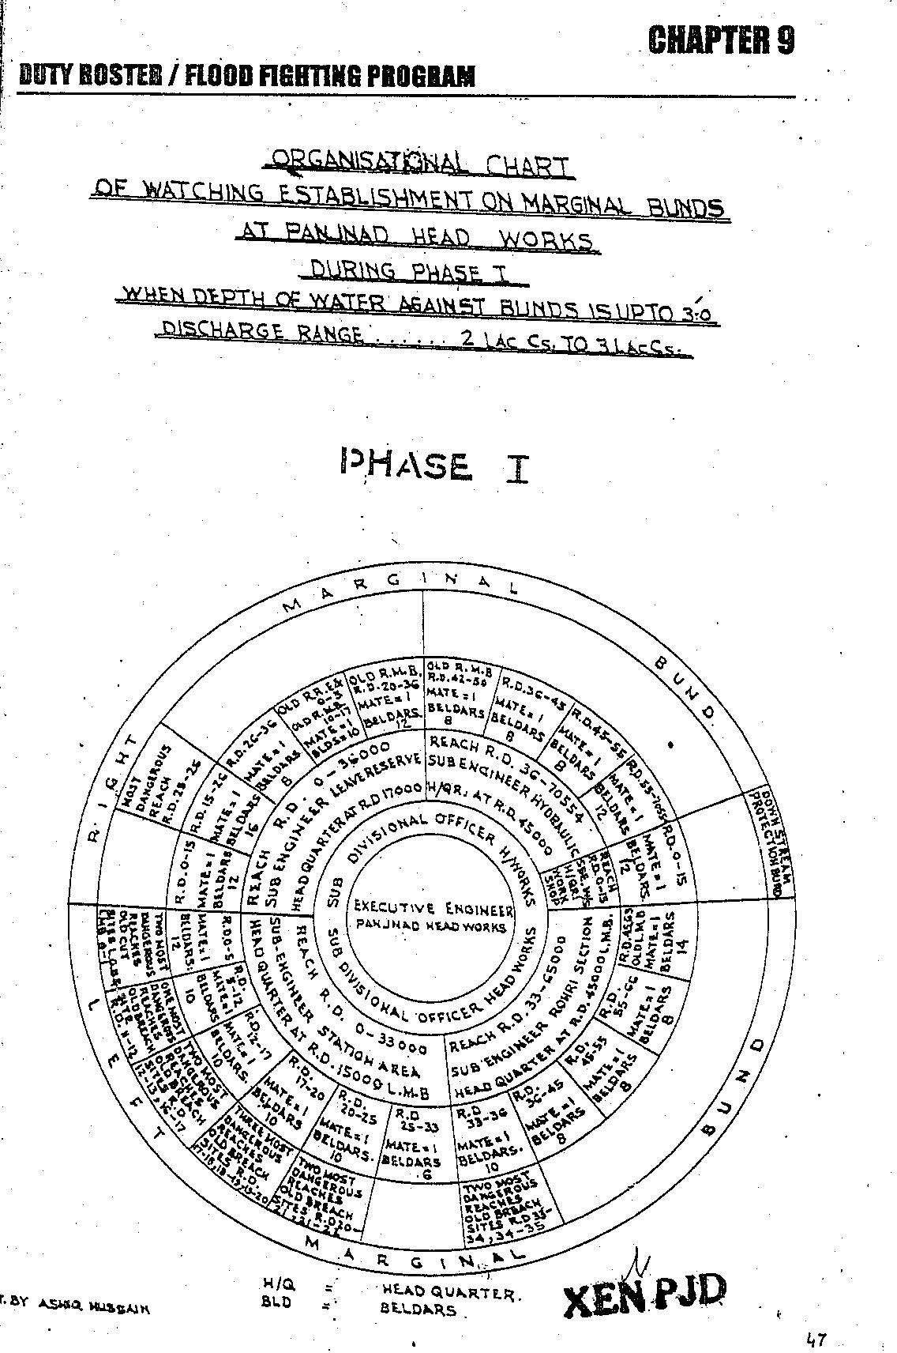

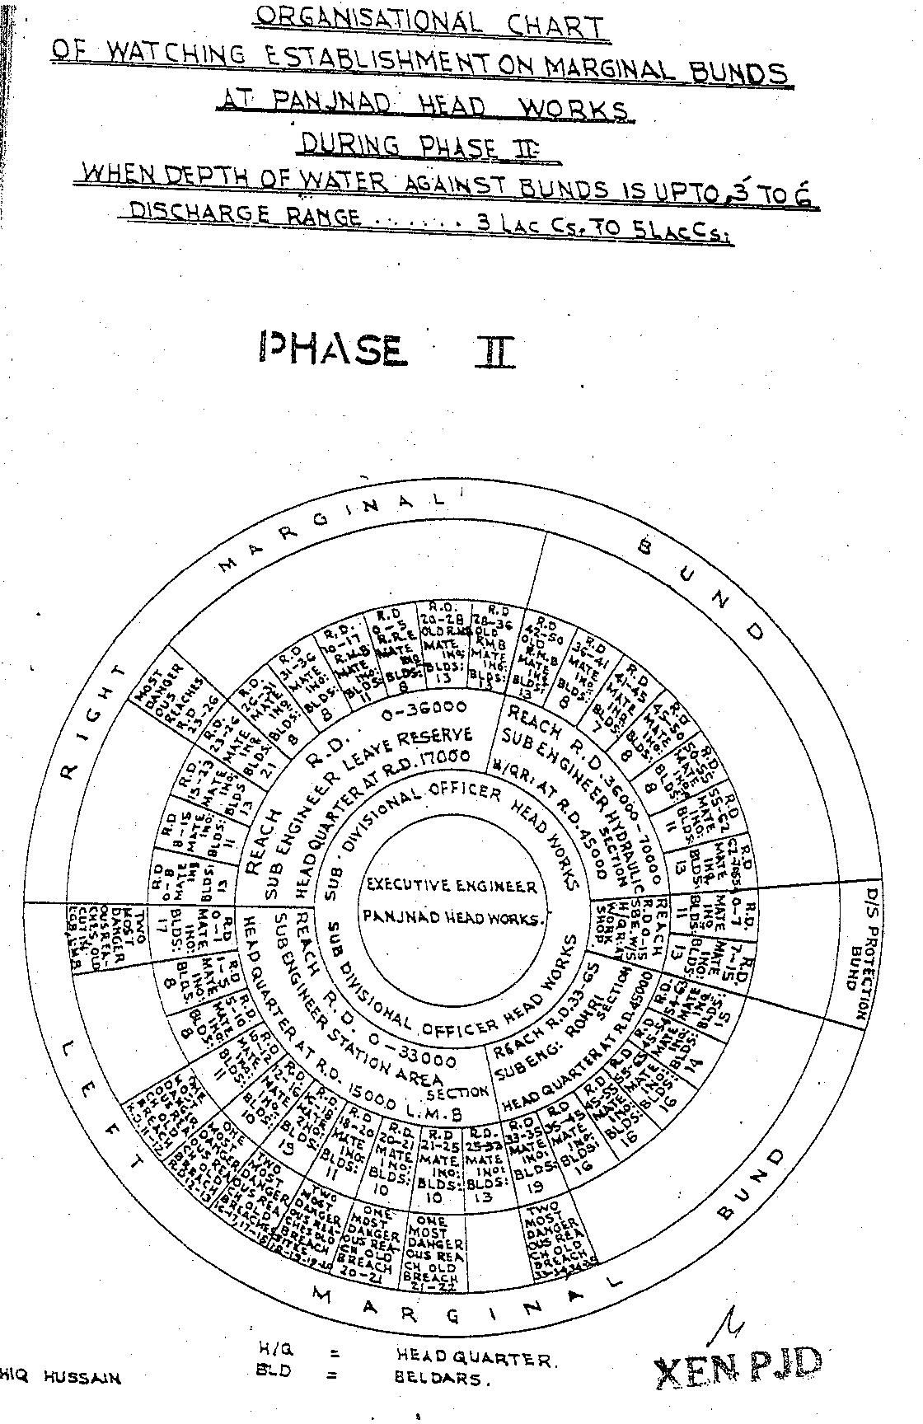
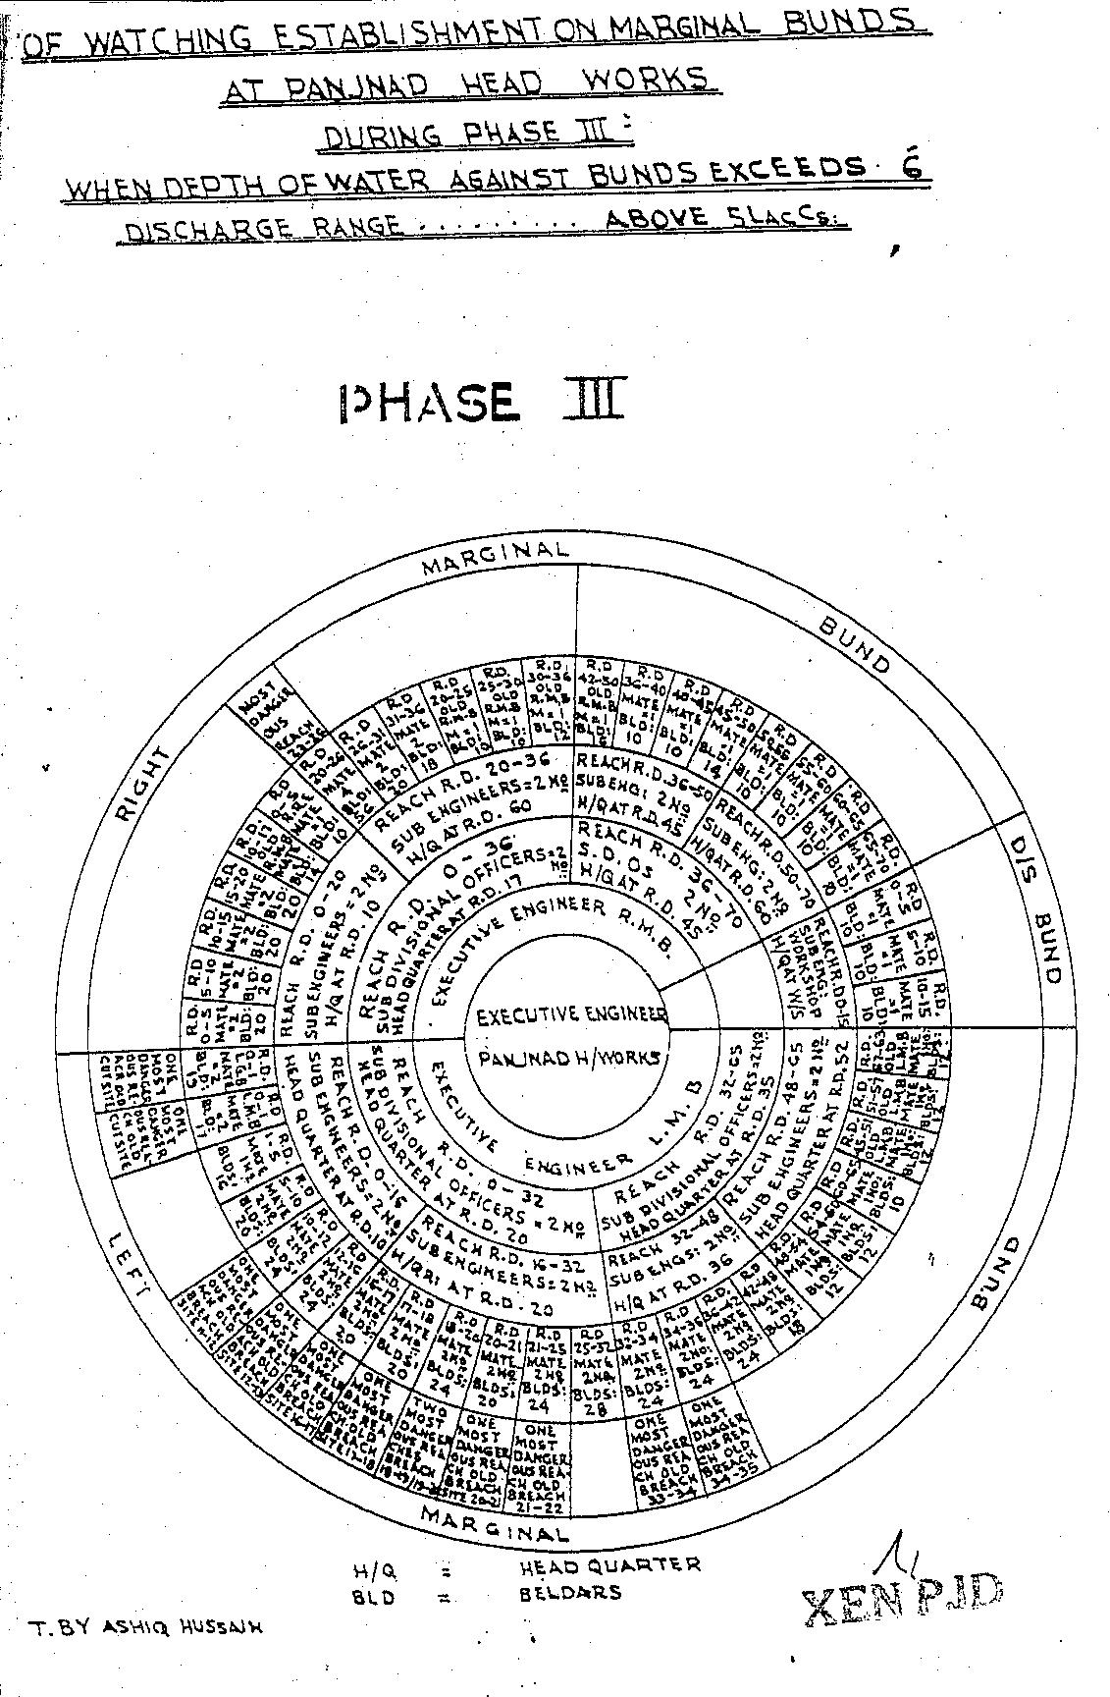
CHAPTER 10
EMERGENCY TELEPHONE NOS.

SR.No. | Designation. | Office | Residence.
1. | Secretary I&P Deptt: Lahore. | 042-99212117 042-99212118 | 042-99200228
2. | Chief Engineer Drainage & flood Zone  I&P Deptt: Lahore. | 042-99230602  Fax #  042-99230731 | -
3. | Director Flood / Secretary  Punjab Flood Commission Lahore. | 042-99231614 | -
4. | Chief Engineer, Irrigation, Bahawalpur. | 062-9250333 | 062-9250333
 | Head PMO / Project Director PMO Barrages Lahore |  | Cell#  0322-4003849
 | Deputy Project Director PMO Barrages Lahore |  | Cell#  0300-9670067
5. | Superintending Engineer, Bahawalpur Canal Circle. | 062-9250300 | 062-9250300
6. | Flood Emergency Officer, Bahawalpur (XEN Operation). | 062-9250265 | 062-9250275
7. | Executive Engineer, Panjnad Headworks Division, Panjnad. | Cell#  0300-7291010 | Cell#  0300-7291010
8. | District Coordination Officer, Bahawalpur. | 062-9250061 062-9260063 | 062-9250062
9. | Deputy Commissioner,  Dera Ghazi Khan. | 064-9260340 | 064-9260341
10. | Deputy Commissioner, Muzaffargarh. | 066-9200251  066-9200252  066-9250254 | -
11. | Superintendent of Police, Muzaffargarh. | 066-9200311 | -
12. | S.H.O. Police Sadar, Alipur. | 066-2700639 | -
13. | Flood warning centreLahore. | 042-997572091 0429-97572093 | Fax:  042-997572092
14. | Head PMO Lahore | 042-99250351 | 0300-4003849
15. | DPD (Tech) PMO Lahore | 042-99250351 | 0300-9670067
CHAPTER 11
STANDARD OPERATING PROCEDURES (SOP) FOR BREACHING SECTIONS

In order to ensure timely flood fighting and relief measures / activities Irrigation & Power Department and other agencies as Civil Administration, Police, Army, etc, strictly adhere to their functions delineated in the SOP, which explicitly indicates the roles and responsibilities of each functionary of the concerned Department.

RESPONSIBILITIES OF EXECUTIVE ENGINEER, PANJNAD HEADWORKS DIVISION.

The Flood Protection arrangements at Flood Bunds/ infrastructure of Panjnad Headworks fall under the administrative jurisdiction of Executive Engineer, Panjnad Headworks Division, Sub Divisional Officer, Panjnad Headworks Sub Division. Primarily, it is their responsibility to maintain and supervise the all Flood Infrastructure during Flood. However, the following will also be taken in to account as Standard Operating Procedures.

1. Periodic Review of structural integrity of Flood Protection Infrastructures on Panjnad Headworks, in order to ensure that no breach occurs in the event heavy discharge of water. It will be expected that being Incharge of the Flood Bund, Executive Engineer may share his observations with his supervisory officers for necessary action to be taken in case of any emergency.

2. Identification of vulnerable points on protective embankments (Bunds) where breach could occur and specification of location for positioning of requisite machinery / material near the vulnerable points.

3. Maintenance and repair of protective bunds / embankments, well before commencement of flood season.

4. Joint Inspection of flood protection infrastructure with the Army and Administration Authorities well before the flood season.

5. Collection and sharing of information on discharge of water at Panjnad Headworks on daily basis.

6. Improvement of existing instruments / gauges used for determination of water discharge at Panjnad Headworks.
7. Development of more affective Early Warning Station.
8. Liaison with IRSA Authorities, Ministry Water and Power as well as Flood Forecasting Lahore for collection of flood related information.

9. Briefing of Authorities concerned on flood protection arrangements and development of an integrated strategy, to be able to combat any situation during floods.

10. Stockpiling of essential articles to combat any flood related contingency and arrangement of sufficient funds before hand for such purposes.

11. Arrangement of labour alongwith machinery / equipment for proper maintenance of the vulnerable points, on flood protection arrangements.

12. Identification of points on roads or otherwise, where breaches / cuts are required to be made, to further facilitate discharge of water, in order to avert larger catastrophe.

13. Ascertainment of extent of damaged cost to the protection bunds and other installation, after flood water subsides.

14. Initiation of criminal proceeding against elements involved in willful breach in flood protection arrangements without consent of competent authority.

15. Assistance and coordination in emergency repairs in public services.

11.1 HISTORY OF THE BREACHING SECTION

The explosive store for breaching section was constructed at RD.16+500 on Right Marginal Bund upstream of the barrage during 1976 to safeguard Panjnad Headworks structure.The explosive store is abundant now a days. The explosive material is in the custody of the 22-Engineer Company at Bahawalpur. In 1973 and 1992 the breaching section was operated when the flood level was exceed the critical gauge at RD.15 LMB. Breaching section is operated by the committee as per Notification No.1806/59/Engr-1-RPA2W dated 27/11/2014.

11.2 LOCATION, DESIGN, QUANTITY AND VARIETY OF THE EXPLOSIVE REQUIRED FOR DETONATION.

The total quantity of explosive material with all accessories have been stored in Army ammunition stores at Bahawalpur Cant 90Kms apart from Panjnad Headworks.The explosive material is also stored in ammunition depot Bahawalpur in custody of Engineer Corps 31Bahawalpur. Upon requisition of XEN Panjnad, Engineering 31 Corps Bahawalpur is responsible to shift this all explosive material to site, of breaching section. PVC liner 4” dia with the length of 9ft and 7ft install with interval of 7ft. Three (03) lines 9ft long pipe fixed on top of bund and two (02) lines 7ft long pipe fixed on both side slopes.
DETAIL OF EXPLOSIVE MATERIAL FOR THE BREACHING SECTIONS

Sr. No | Items | AU | Required Qty | Available Qty | Deficient Qty | Remarks
1 | PE3A (450 gm) | Kg | 2667.381 | 2667.381 | Nil
2 | PE3A (225 gm) | KG | 1199 | 1199 | Nil
3 | Wabo cord | Mtr | 3563 | 3563 | Nil
4 | Primer E1OZ | Nos | 997 | 997 | Nil
5 | Safety Fuze No.11 | Mtr | 143 | 143 | Nil
6 | Det elec Inst | Nos | 177 | 177 | Nil
7 | Det Elec MSDelay | Nos | 614 | 614 | Nil | Un-serviceable
8 | Wabox | Mtr | 5129 | 5129 | Nil | The amount RS.___ is deposited to Pak Army for recope the same
9 | TwinJute | Kg | 3.6 | 3.6 | Nil
10 | El Cable | Mtr | 1000 | 1000 | Nil
11 | Blasting Machine | Nos | 01 | 01 | Nil
12 | Det No.8 non Elec | Now | 868 | 868 | Nil

11.3 ARRANGEMENT OF EXPLOSIVES AND SECURITY OF EXPLOSIVE STORES

The explosive material is in the custody of PAK ARMY and they are responsible of the security of explosive material.
11.4 LIST OF SECURITY STAFF ALONGWITH DETAIL OF THEIR TRAINING ETC.

The liners at the breaching section site are fixed by skilled Irrigation Staff and on the alarming condition, the site is taken over by the PAK Army and they fill the explosive material for any emergency and will activate breaching section in case of emergency. They are responsible of the security of explosive material.

11.5 DETAIL OF MECHANICAL MEANS AS A STANDBY ARRANGEMENTS IN CASE OF DETONATION FAILURE

In case of failure of explosive material, two No. dozers and two No excavators (long boom) at each breaching section either from agriculture / irrigation Department or private source will remain available at site for breaching operation.

11.6 DUTY ROSTER IN CASE OF CRITICAL SITUATION

The detail of duty roster of officers / officials and establishment has been mentioned in Chapter No. 9

11.7 BREACHING COMMITTEE WITH THEIR ACTION PLAN

Breaching Operating committee consists of the following members vide Notification No.1806/59/Engr-1-RPA2W dated 27/11/2014amendedas per latest notification.

- Deputy Commissioner concerned final authority to decide activation of breaching section.(Convener)

- Executive Engineer, Barrages / Headworks / Flood Bund.(Member)

- Representative of respective Army Corps not below Lt: Col. (Member)

- Representative of Highway Department / Railway not below the
rank of BS-18.(Member)

ACTION PLAN

S.# | Name of Infrastructure | Action to be taken | Action to be taken by
1. | Breaching section at RD 28-30 of R.M.B and at  RD 19-20 R.R.E. | Before the operation of breaching section 2 No. dozers are to be made available by the District Administration Muzaffargarh and explosive material is to be provided by the Army. Decision regarding operation of the Breaching Section is to be taken by the Vigilant / Breaching Operating Committee. | 1) | When the information regarding expected high flood i.e. 3.0 Lac Cs. is received (72 Hrs. before the actual receipt of flood at Panjnad Headworks), the Vigilant / Breaching Operating Committee will meet and issue the 1st warning to all concerned Departments / Agencies will become alert, vigilant and remain in contact with the committee to receive the next warning at any moment.
 |  |  | 2) | When the information regarding expected very high flood i.e. 4.5 Lac Cs. is received (72 Hrs. before the actual receipt of flood at Panjnad Headworks), the Vigilant / Breaching Operating Committee will again meet and issue the second warning to concerned Departments / Agencies to complete all the arrangements as laid down in the Contingency Plan to receive flood water consequent upon the operation of the breaching section.
 |  |  | 3) | When the information regarding expected exceptionally High flood i.e. 5.0 Lac Cs. is received (72 Hrs. before the actual receipt of flood at Panjnad Headworks), the Committee will issue the final warning to all the concerned Departments / Agencies. This warning will warrant for making cuts in the K.L.P. Road, disconnecting 11-K.V. Distribution Power Line and evacuation of the expected in-undated area. The decision of the activation of the breaching section shall then be taken by the committee at any time and announced through available communication system. Time for operating the breaching section will also be communicated to all the concerned.  2 Number Dozers will be made availableby Agriculture Department / District Administration Muzaffargarh and explosive material will be arranged by Army Authorities.
2. | K.L.P Road. | K.L.P Road Panjnad Alipur Section will be cut at two places at K.M. 3.0 and 6.25 from Panjnad Headworks to drain-out the flood water coming from the Breaching Section back into the River Chenab. 2 No. dozers will be provided by the District Administration. | District Officer Roads, Muzaffargarh.
3. | 11-K.V.  Distribution Power Line. | After issue of the 2nd warning by the Committee, MEPCO authorities will immediately disconnect the supply of 11-K.V. Distribution Line to safe any mishap in the in-undated area. | Executive Engineer Distribution Division, MEPCO Alipur / Bahawalpur.

11.8 LIST OF THE VILLAGES LIKELY TO BE INUNDATED IN CASE OF BREACH

The following villages / public property can be effected due to activation of Breaching Section RD. 28-30 RMB of Panjnad Headworks in extreme emergency

Sr. No. | Villages | Houses |  | Population
1. | Darkhan | 8 | Nos. | 30 | Nos.
2. | Ghajan | 35 | Nos. | 200 | Nos.
3. | Jalbani | 35 | Nos. | 175 | Nos.
4. | Jattuwala | 40 | Nos. | 250 | Nos.
5. | Arain | 6 | Nos. | 50 | Nos.
6. | Chandie | 11 | Nos. | 75 | Nos.
7. | Pauli | 20 | Nos. | 140 | Nos.
8. | Mochi and Nai | 9 | Nos. | 43 | Nos.
9. | Baluch | 28 | Nos. | 300 | Nos.
10. | Lashari Baluch | 17 | Nos. | 250 | Nos.
11. | Moger | 8 | Nos. | 60 | Nos.
12. | Chandie | 8 | Nos. | 66 | Nos.
13. | Lashari | 15 | Nos. | 150 | Nos.
14. | Baluch | 20 | Nos. | 120 | Nos.
15. | Oalak | 8 | Nos. | 60 | Nos.
16. | Gazer | 8 | Nos. | 60 | Nos.
17. | Makwal | 25 | Nos. | 400 | Nos.
18. | Rongha | 45 | Nos. | 400 | Nos.
19. | Shah | 10 | Nos. | 60 | Nos.
20. | Mahesar | 10 | Nos. | 60 | Nos.
21. | Gopang | 70 | Nos. | 600 | Nos.
22. | Larr | 50 | Nos. | 430 | Nos.
23. | Ghallu | 35 | Nos. | 400 | Nos.
24. | Bobore | 30 | Nos. | 180 | Nos.
25. | Muhajir | 8 | Nos. | 48 | Nos.
26. | Babbare | 40 | Nos. | 224 | Nos.
27. | Kakreji | 10 | Nos. | 60 | Nos.
28. | Chot | 10 | Nos. | 60 | Nos.
29. | Nag | 20 | Nos. | 120 | Nos.
30. | Johr | 20 | Nos. | 120 | Nos.
31. | Billimar | 40 | Nos. | 160 | Nos.
32. | Chajan | 25 | Nos. | 100 | Nos.
33. | Ronghe | 25 | Nos. | 100 | Nos.
34. | Mohana | 20 | Nos. | 120 | Nos.
35. | Moochi | 7 | Nos. | 35 | Nos.
Total:- |  | 766 | Nos. | 5636 | Nos.

11.9 ANNOUNCEMENT AND DETAIL OF EVACUATION ARRANGEMENTS

Civil authorities will make the announcement of flood hazard and plan to evacuate the area with help of its lower formation and Civil Defense Department.

11.10 DETAILS OF COORDINATION WITH CIVIL / ARMY AUTHORITIES

When the flood warning received, Civil Administrations / Army authorities will coordinate for handling of any critical situation.

11.11 PARALLEL COMMUNICATION ARRANGEMENTS

Wireless station at Panjnad Headworks is out of order since 8 yearsand not connected with Flood Warning Center at Lahore and barrages on the rivers upstream of Panjnad Headworks. Flood warnings are received through the mobile phones. However, Executive Engineer, Panjnad Headworks will be facilitated with wireless mounted on Jeep supplied by the Police Headquarters and District Civil Administration Muzaffargarh

FLOOD CONTROL CENTERS

This centre will be opened at Headworks. One Sub Engineer will be incharge of this centre. He will work under the supervision of Executive Engineer, Headworks. Copy of daily flood situation report and other orders by the authoritieswill beavailable at flood control centre, where it will be properly recorded. This centre will also help the people coming from outside as they need information about flood etc.
FLOOD WARNING SYSTEM

Sr. No. | Name Flood Warning Centre | Center Incharge | Sources of Information
1 | Headworks | Ch. Khalid Mehmood  Sub Divisional Officer  Panjnad Headworks  Cell # 0300-6702694 | Imran Rafi  Sub Engineer  Headworks Section.  Cell # 0300-4908438
2 | Mudwala | Ch. Khalid Mehmood  Sub Divisional Officer  Panjnad Headworks  Cell # 0300-6702694 | Muhammad Hamza Ali  Sub Engineer  Hydraulic Section  Cell # 0300-6818101
3 | Dhoor Kot | Ch. Khalid Mehmood  Sub Divisional Officer  Panjnad Headworks  Cell # 0300-6702694 | Muhammad Hamza Ali  Sub Engineer  Station Area Section  Cell # 0300-6818101
4 | Tele Office Panjnad Headworks | Head Signaler  Telegraph Office Panjnad Headworks | Divisional Flood Control Room
5. | Tele Office Bahawalpur | Nazir Ahmad Bhatti  Head Signaler  Telegraph Office Bahawalpur | Zonal Flood Control Room  062-9250273

11.12 INDEX PLAN

Executive Engineer
Panjnad Headworks Division
Panjnad
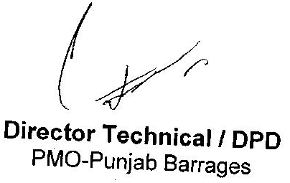 |  | 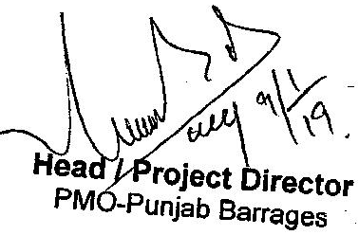

PART – B
CHAPTER 12
VULNERABLE SITES ON FLOOD BUND / STRUCTURES

12.1 APPREHENDED BREACHES IN FLOOD BUNDS / STRUCTURES

- RD. 32-45 RMB of Panjnad Headworks.

- RD. 11-34 LMB of Panjnad Headworks.

12.2 OPERATION OF BREACHING SECTIONS.

On the alarming by the flood warning center Lahore the Executive Engineer Panjnad Headworks will arrange the meeting of breaching committee notified by the Govt. No. 1806/59/Engr:IRPA-2w dated 27/11/2014 and in the case of necessity the matter is handed over to PAK Army who is already responsible for explosive material for breaching section. The breaching section operation will depend upon the peak flow at Trimu where the time log is 50 hours in exceptionally high flood.

12.3 BREACHES DUE TO RISING OF FLOOD WATER, DETERORATION OF FLOOD BUNDS ETC.

In the history of Panjnad Headworks due to rising of flood water the LMB was breached in 1973. The flood bunds were raised in 2004 with 6ft free board maximumflood level of 1973. The wetting channel along the LMB and RMB are soaked annually to check the any borrowing hole. The condition of LMB is not good. It requires rehabilitation, it is satisfactory against the high flood. However in case of the exceptionally high flood,Machinery &labour will be arranged on daily basis as per approved yard stick in flood fighting plan.
CHAPTER 13
EMERGENCY CONTINGENCY PLAN FOR VULNERABLE SITE (SITES) LISTED ABOVE.

VULNERABLE SITE – 1- RD: 32-45 R.M.B RIVER CHENAB

13.1 PLAN SHOWING ROUTE OF FLOOD WATER COMING OUT OF THE BREACH SUPPORTED WITH LEVELS AT RD. 32-45 OF RMB PANJNAD HEADWORKS

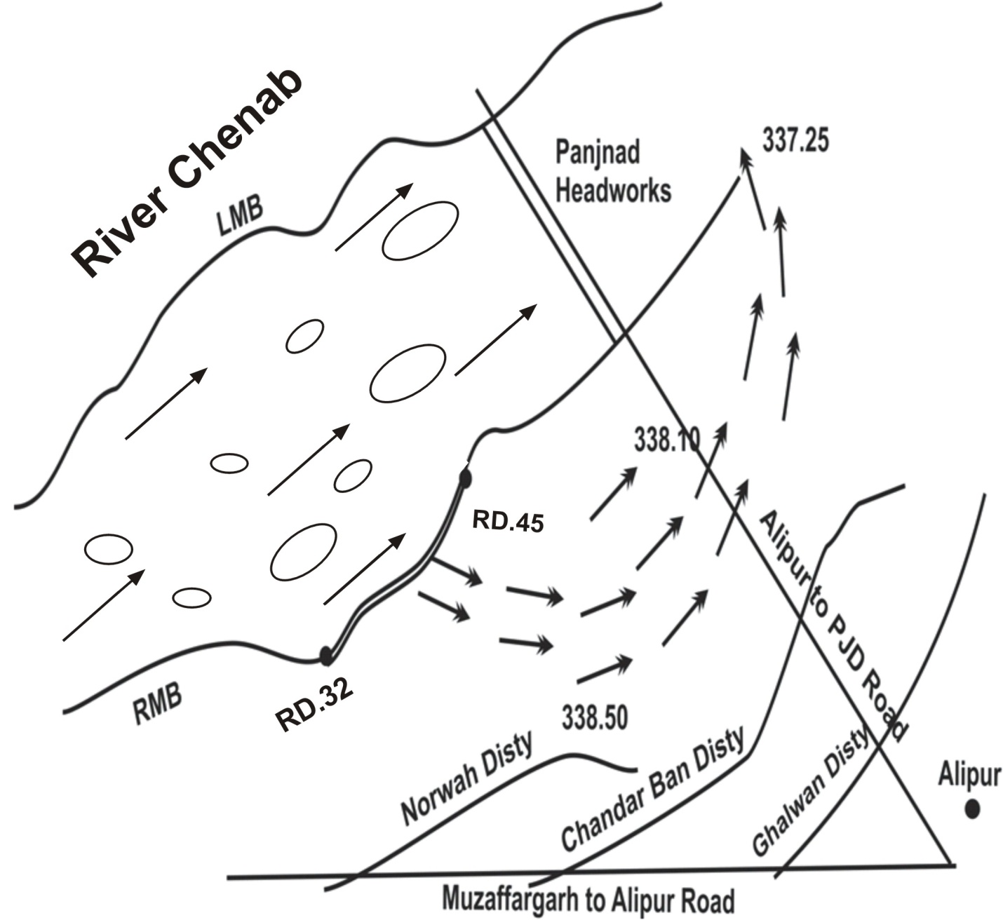

13.2 DETAIL OF VILLAGES /ABADIES LIKELY TO BE AFFECTED AND THIS SHOULD ALSO BE SHOWN ON THE PLAN.
32

LIST OF VILLAGES LIKELY TO BE INUNDATED IN CASE OF BREACHES

The following villages / public property can be affected if breach occurs between RD. 32-45 of RMB of Panjnad Headworks.

Sr. No. | Villages | Houses  (Nos.) | Population  (Nos.)
 | Basti Madwala | 200 | 15000
 | Basti Mahser | 98 | 8000
 | Basti Ubaichar | 30 | 200
 | Basti Dumber | 150 | 9000
 | Basti Dino | 45 | 2000
 | Darkhan | 8 | 300
 | Ghajan | 35 | 2000
 | Jalbani | 35 | 1750
 | Jattuwala | 40 | 2500
 | Arain | 6 | 500
 | Chandie | 11 | 750
 | Pauli | 20 | 1400
 | Mochi and Nai | 9 | 430
 | Baluch | 28 | 3000
 | Lashari Baluch | 17 | 2500
 | Moger | 8 | 600
 | Chandie | 8 | 660
 | Lashari | 15 | 1500
 | Baluch | 20 | 1200
 | Oalak | 8 | 600
 | Gazer | 8 | 600
 | Makwal | 25 | 450
 | Rongha | 45 | 490
 | Shah | 10 | 600
 | Mehesar | 10 | 600
 | Gopang | 70 | 600
 | Larr | 50 | 430
 | Ghallu | 35 | 400
 | Bobore | 30 | 180
 | Muhajir | 8 | 48
 | Babbare | 40 | 224
 | Kakreji | 10 | 60
 | Chot | 10 | 60
 | Nag | 20 | 120
 | Johr | 20 | 120
 | Billimar | 40 | 160
 | Chajan | 25 | 100
 | Ronghe | 25 | 100
 | Mohana | 20 | 120
 | Moochi | 7 | 35
Total:- |  | 1299 | 59387

Location Plan of Villages
RD.32
RD.45

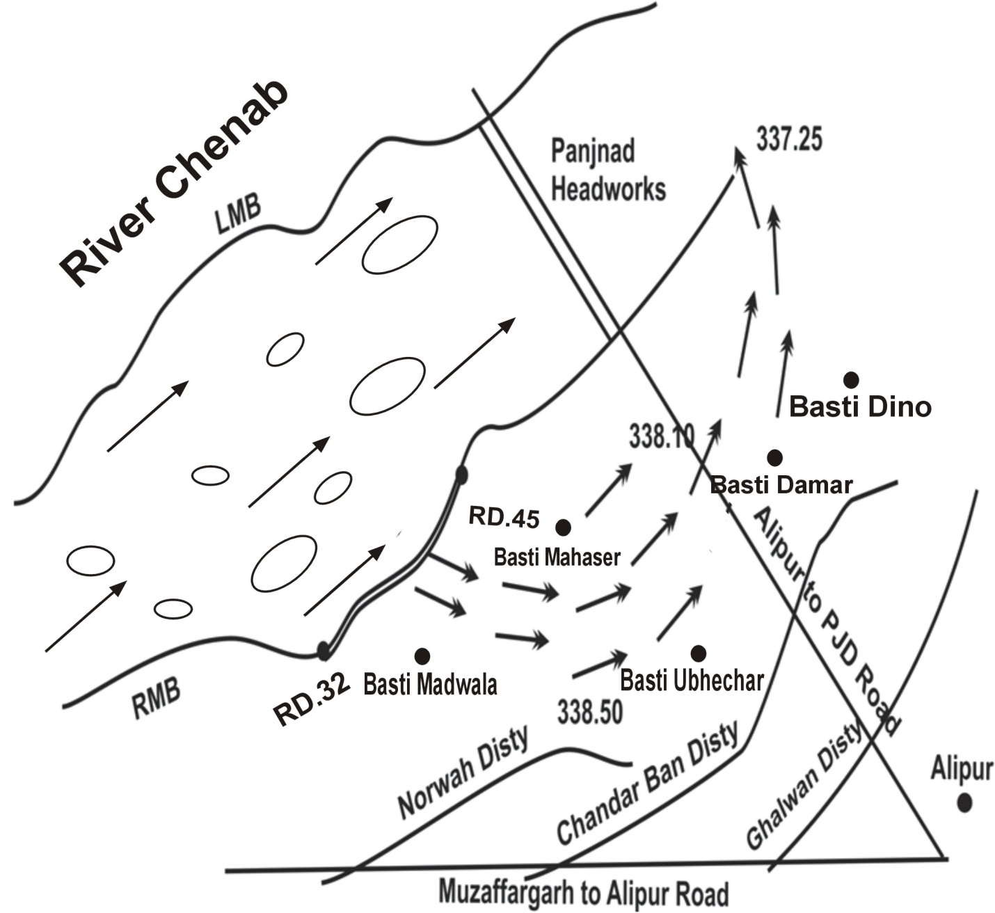
13.3 STRATEGY AND ACTION TAKEN BE EXPLAINED IN DETAIL. THIS MAY INCLUDE

13.3.1 ARRANGEMENTS

PANJNAD HEADWORKS DIVISION PANJNAD

13.3.2 ESTABLISHMENT OF FLOOD FIGHTING CAMPS

Started at low flood
Flood Fighting Camps at vulnerable site i.e. RD. 32-45 of RMB Panjnad Headworks will be established for watching round the clock.

13.3.3 DUTIES OF OFFICERS / OFFICIALS AND THEIR CAMP SITES

Sr. No. | Name of camp | CampSupervisor | CampIncharge | Overall Incharge
1 | RD. 34 | Muhammad Hamza Ali  Sub Engineer Hydraulic Section  Cell# 0300-6818101 | Ch. Khalid Mehmood  Sub Divisional Officer  Panjnad Headworks  Cell # 0300-6702694 | Muhammad Farooq Khan  Executive Engineer  Panjnad Headworks Division  Cell # 0303-6667000
2 | RD. 35
3 | RD. 42 | Muhammad Hamza Ali  Sub Engineer Hydraulic Section  Cell# 0300-6818101
4 | RD. 43

13.3.4 DEPARTMENTAL MACHINERY AVAILABLE

Tractor with trolley = 2 No

13.3.5 Machinery available from private sources

Nearest cities are Alipur and Uchsharif. Heavy machinery is available from contractors of Irrigation Department and from private personals.
Also a Project for Rehabilitation and upgrading of Panjnad Barrage is in progress. SWEG-RSL (joint Venture) are the main contractors having sufficient machinery available at Head Works. The detail of machinery available is given in the following table:
Sr. | Machinery Type | No.
1 | Excavators | 2
2 | Long Boom Excavator | 1
3 | Cranes | 2
4 | Dumpers | 10
5 | Tractor Trolleys | 5
6 | Graders | 2
7 | Dozer | 1
8 | Rollers | 2
9 | Water Tanker | 2
10 | Ambulance | 1
11 | Generators | 2

13.3.6 FLOOD FIGHTING MATERIAL REQUIRED(Vulnerable site No.1)

Sr.No. | Items | Required  Qty |  | Available  Qty |  | Deficient  Qty | Remarks
1 | Lanterns | 30 | Nos. | 30 | Nos. | Nil
2 | Kerosene Oil | 100 | Gallons | 100 | Gallons | Nil
3 | Wicks | 180 | Yards | 180 | Yards | Nil
4 | Lantern Chimneys | 35 | Nos. | 35 | Nos. | Nil
5 | Gas lamp | 20 | Nos. | 20 | Nos. | Nil
6 | Mentals | 200 | Nos. | 200 | Nos. | Nil
7 | Washers for gas lamp. | 50 | Nos. | 50 | Nos. | Nil
8 | Nozzles for gas lamp. | 40 | Nos. | 40 | Nos. | Nil
9 | Chimneys for gas lamps | 30 | Nos. | 30 | Nos. | Nil
10 | Torches of 2 cells | 15 | Nos. | 15 | Nos. | Nil
11 | Cell for Torches | 100 | Nos. | 100 | Nos. | Nil
12 | Gunney bags | 1000 | Nos. | 1000 | Nos. | Nil
13 | Suttli | 121 | Lbs | 121 | Lbs | Nil
14 | E.C. Bags/Jute Bags | 8000 | Nos. | 8000 | Nos. | Nil
15 | Sewing needles | 8 | Doz. | 8 | Doz. | Nil
16 | Axes | 7 | Nos. | 7 | Nos. | Nil
17 | Kassies with Handles | 100 | Nos. | 100 | Nos. | Nil
18 | Handle of Kassies | 100 | Nos. | 100 | Nos. | Nil
19 | Killas | 2000 | Nos. | 2000 | Nos. | Nil
20 | Ballies | 200 | Nos. | 200 | Nos. | Nil
21 | Baskets | 100 | Nos. | 100 | Nos. | Nil
22 | Khaji Mats | 100 | Nos. | 100 | Nos. | Nil
23 | Spirite | 10 | Bottle | 10 | Bottle | Nil
24 | Match Box | 100 | Nos. | 100 | Nos. | Nil
25 | Oil extractor | 100 | Nos. | 100 | Nos. | Nil
26 | Munj Ban | 11 | Mds. | 11 | Mds. | Nil
27 | Wooden mallets | 100 | Nos. | 100 | Nos. | Nil
28 | Funnels | 72 | Nos. | 72 | Nos. | Nil
29 | Trangers | 1000 | Nos. | 1000 | Nos. | Nil
30 | Tents | 10 | Nos. | 10 | Nos. | Nil
31 | Generator | 2 | Nos. | 2 | Nos. | Nil
32 | POL for generator | 650 | Liters | 650 | Liters | Nil
33 | Flood lights with cables | 6 | Nos. | 6 | Nos. | Nil

13.3 (B) VULNERABLE SITE – 2 – RD: 11-34 L.M.B RIVER SUTLEJ

13.3.7 PLAN SHOWING ROUTE OF FLOOD WATER COMING OUT OF THE BREACH SUPPORTED WITH LEVELS AT RD. 11-34 OF LMB PANJNAD HEADWORKS

In August 1973, a highest ever recorded flood of 802516 Cfs was experienced due to combined high flood conditions in all rivers i.e the River Chenab and Sutlej. It caused breaches in the left marginal bunds at various locations between RD. 11-34 of LMB which was the main reason for immense losses to human life and property, irrigation system, roads and railways. To save the important city of Khanpur, Rahimyarkhan, cuts were made in the main railway line, Sadiq Branch and other distributaries to spread the flood water in comparatively less developed areas. The flood water damaged the entire D/S floor of Abbasia Canal regulator, the divide wall and bays No. 9 to 12 of Panjnad Canal Head Regulator due to the swirling action of backflow. Above mentioned situation was created only during 1973.

- Location plan of the Inundated

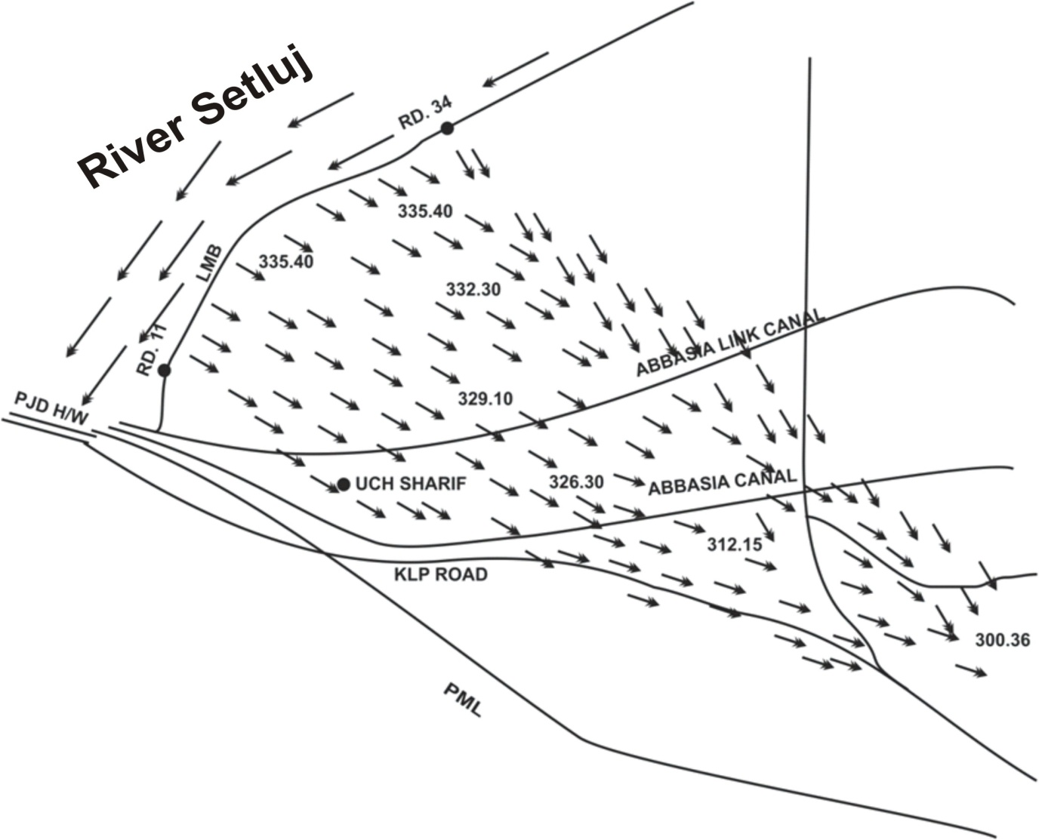

13.3.8 DETAIL OF VILLAGES / ABADIES LIKELY TO BE AFFECTED AND THIS SHOULD ALSO BE SHOWN ON THE PLAN.

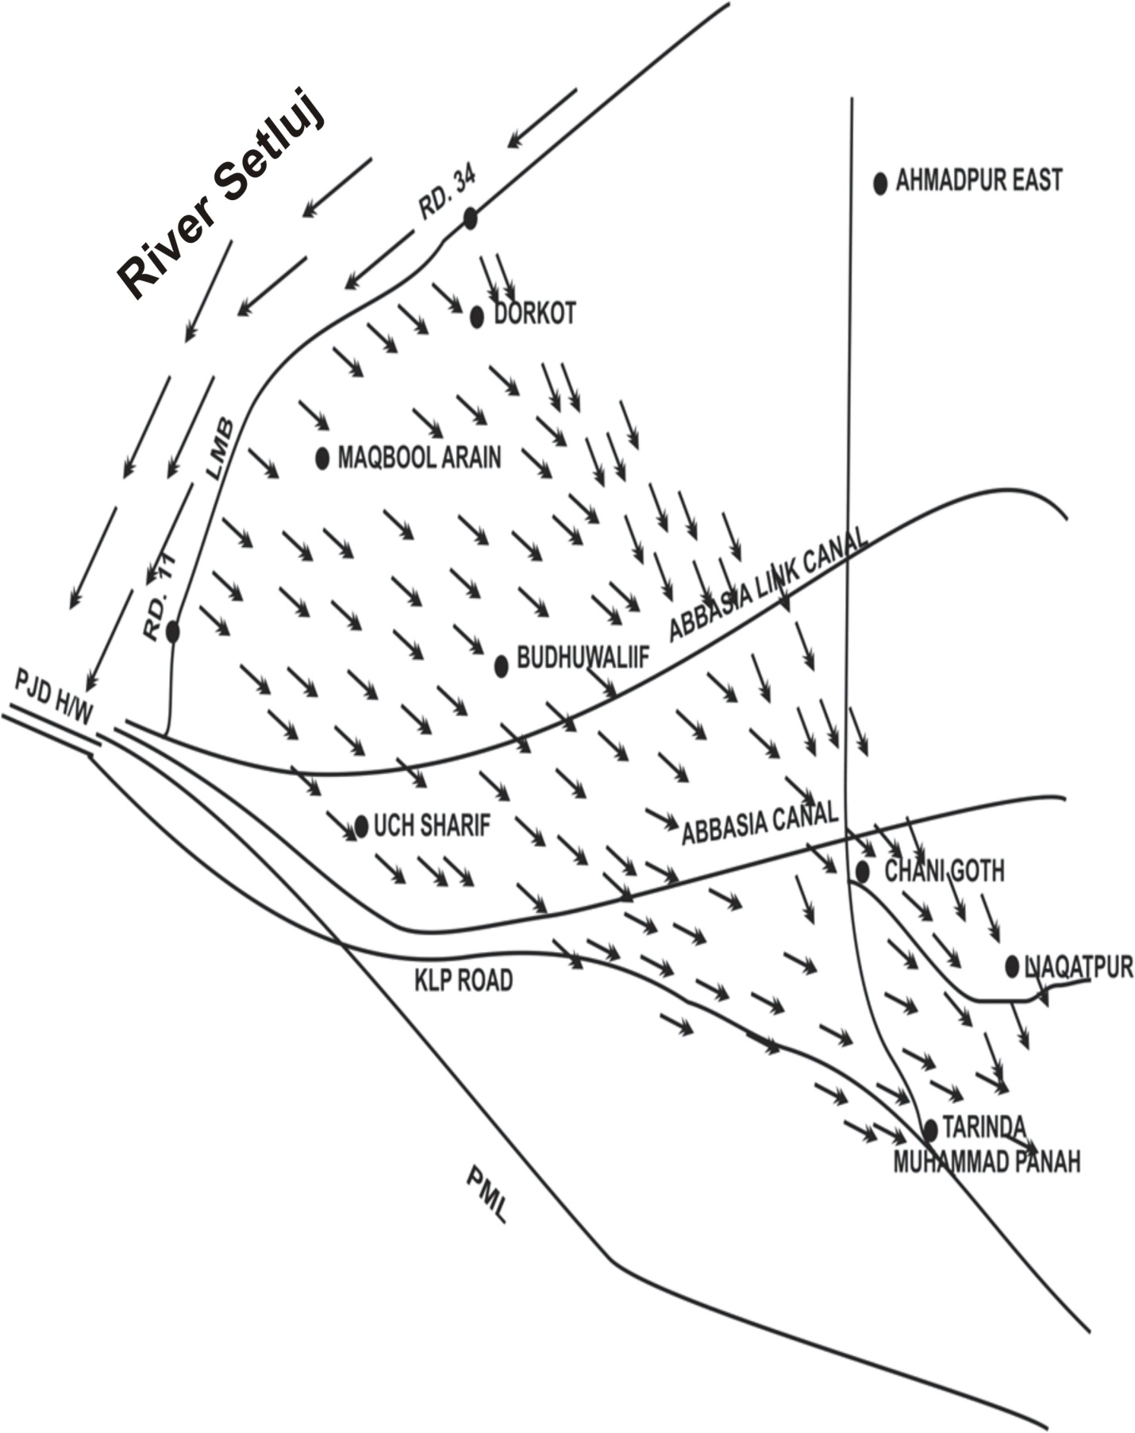

13.3.9 ARRANGEMENTS PANJNAD HEADWORKS DIVISION PANJNAD STARTED AS LOW FLOOD

13.3.10 ESTABLISHMENT OF FLOOD FIGHTING CAMPS

Flood Fighting Camps at vulnerable site i.e. RD. 11-34 of LMB Panjnad Headworks will be established for watching round the clock.

13.3.11 DUTIES OF OFFICERS / OFFICIALS AND THEIR CAMP SITES

Sr. No. | Name of camp | CampSupervisor | CampIncharge | Overall Incharge
1 | RD. 11 | Imran Raffi  Sub Engineer Headworks Section  Cell# 0300-4908438 | Ch. Khalid Mehmood  Sub Divisional Officer  Panjnad Headworks  Cell # 0300-6702694 | Muhammad Farooq Khan  Executive Engineer  Panjnad Headworks Division  Cell # 0303-6667000
2 | RD. 18
3 | RD. 25 | Muhammad Hamza Ali Sub Engineer Hydraulic Section  Cell# 0300-6818101
4 | RD. 34

13.3.12 DEPARTMENTAL MACHINERY AVAILABLE

Tractor with trolley = 2 No

13.3.13 MACHINERY AVAILABLE FROM PRIVATE SOURCE

Nearest cities areAlipur and Uchsharif private machineries are available to handle any critical situation as well as heavy machinery of contractor of the project.

13.3.14 FLOOD FIGHTING MATERIAL REQUIRED (Side No. 2)

Sr.No. | Items | Required Qty |  | Available  Qty |  | Deficient  Qty | Remarks
1 | Lanterns | 40 | Nos. | 40 | Nos. | Nil
2 | Kerosene Oil | 150 | Gallon | 150 | Gallon | Nil
3 | Wicks | 100 | Yards | 100 | Yards | Nil
4 | Lantern Chimneys | 70 | Nos. | 70 | Nos. | Nil
5 | Gas lamp | 20 | Nos. | 20 | Nos. | Nil
6 | Mentals | 200 | Nos. | 200 | Nos. | Nil
7 | Washers for gas lamp. | 25 | Nos. | 25 | Nos. | Nil
8 | Nozzles for gas lamp. | 40 | Nos. | 40 | Nos. | Nil
9 | Chimneys for gas lamps | 30 | Nos. | 30 | Nos. | Nil
10 | Torches of 2 cells | 30 | Nos. | 30 | Nos. | Nil
11 | Cell for Torches | 200 | Nos. | 200 | Nos. | Nil
12 | Gunney bags | 1000 | Nos. | 1000 | Nos. | Nil
13 | Suttli | 100 | Lbs. | 100 | Lbs. | Nil
14 | E.C. Bags/Jute Bags | 8000 | Nos. | 8000 | Nos. | Nil
15 | Sewing needles | 8 | Doz. | 8 | Doz. | Nil
16 | Axes | 7 | Nos. | 7 | Nos. | Nil
17 | Kassies with Handles | 100 | Nos. | 100 | Nos. | Nil
18 | Handle of Kassies | 100 | Nos. | 100 | Nos. | Nil
19 | Killas | 1500 | Nos. | 1500 | Nos. | Nil
20 | Ballies | 200 | Nos. | 200 | Nos. | Nil
21 | Baskets | 100 | Nos. | 100 | Nos. | Nil
22 | Khaji Mats | 100 | Nos. | 100 | Nos. | Nil
23 | Spirite | 10 | Bottle | 10 | Bottle | Nil
24 | Match Box | 100 | Nos. | 100 | Nos. | Nil
25 | Oil extractor | 100 | Nos | 100 | Nos | Nil
26 | Munj Ban | 11 | Mds. | 11 | Mds. | Nil
27 | Wooden mallets | 100 | Nos. | 100 | Nos. | Nil
28 | Funnels | 72 | Nos. | 72 | Nos. | Nil
29 | Trangers | 1000 | Nos. | 1000 | Nos. | Nil
30 | Tents | 10 | Nos. | 10 | Nos. | Nil

13.4 DETAIL OF OTHER INFRASTRUCTURE LIKE ELECTRIC, SUI GAS, TELEPHONE INSTALLATIONS, ROAD NETWORK, OTHER BUILDINGS, CANALS AND DRAINAGE NETWORKS.

- ROADS / INFRASTRUCTURES LIKELY TO BE AFFECTED IN CASE OF BREACHES

1. Noorwah Disty (MuzaffargarhCanal Division)
2. Chandarban Disty (MuzaffargarhCanal Division)
3. Ghalwan Disty (MuzaffargarhCanal Division)
4. Pacca Road from Muzaffargarh to Alipur
5. Pacca Road from Alipur to Panjnad

- SCHOOLS / COLLEGES / OTHER EDUCATIONAL INSTITUTIONS

1. GovernmentHigh SchoolChangan
2. GovernmentHigh SchoolMudwala
3. Government Primary School Ubaicharr
4. GovernmentPrimary SchoolNazroowali Hatti
5. Government Primary School Masser

- OTHER BUILDING ETC.

- RHC Mudwala
- VeterinaryHospitalMudwala
- BHU Changan
- VeterinaryHospitalChangan
- VeterinaryHospitalNazroowali Hatti
- Electric Pools 11KVA
- Communication Towers
- 66000 highly transmission

13.5 DETAIL OF OTHER INFRASTRUCTURE LIKE ELECTRIC, SUI GAS, TELEPHONE INSTALLATIONS, ROAD NETWORK, OTHER BUILDINGS, CANALS AND DRAINAGE NETWORKS.

- LIST OF VILLAGES LIKELY TO BE INUNDATED IN CASE OF BREACHES

The following villages / public property can be affected if breach occurs between RD. 11-34 of LMB of Panjnad Headworks.

Sr. No. | Villages | Houses  (Nos.) | Population  (Nos.)
 | Dhorkot | 250 | 16000
 | Basti Maqbool Arain | 50 | 1800
 | Basti Budhuwali | 30 | 250
 | Uch Sharif | 5100 | 149500
 | Chani Goth | 1000 | 5800
 | Tarinda Muhammad Panah | 2260 | 65000
 | Liaqatpur | 34500 | 204000
Total:- |  | 43190 | 442350

- ROADS / INFRASTRUCTURES LIKELY TO BE AFFECTED IN CASE OF BREACHES

1. Pacca RoadUch Sharif to KhairpurDhaha
2. Pacca RoadUch Sharif to Ahmadpur
3. Pacca RoadAlipur to Tarinda (KLP)
4. Pacca RoadAhmadpur to Tarinda. (N.5)
5. AbbasiaCanal
6. AbbasiaLinkCanal
7. Uch Disty

- SCHOOLS / COLLEGES / OTHER EDUCATIONAL INSTITUTIONS

1. GovernmentBoysHigh SchoolDhorkot
2 GovernmentGirlsHigh SchoolDhorkot
3. GovernmentBoysHigh SchoolBastiMaqboolArain
4. GovernmentGirlsHigh SchoolBastiMaqboolArain
5. Government Boys Degree Collage Uch Sharif
6. Government Girls Degree Collage Uch Sharif
7. GovernmentBoysHigh SchoolUch Sharif
8. GovernmentGirlsHigh SchoolUch Sharif
9. GovernmentBoysHigh SchoolChanni Goth
10. GovernmentGirlsHigh SchoolChanni Goth
11. GovernmentBoysHigh SchoolTarinda
12. GovernmentGirlsHigh SchoolTarinda
13. Government Boys Degree Collage Liaqatpur
14. Government Girls Degree Collage Liaqatpur
15 GovernmentBoysHigh SchoolLiaqatpur
16. GovernmentGirlsHigh SchoolLiaqatpur

- OTHER BUILDINGS ETC.

- Basic Health Unit Dhorkot
- VeterinaryHospitalDhorkot
- BHU Budhuwali
- RHC Uch Sharif
- VeterinaryHospitalUch Sharif
- Telephone Exchange Uch Sharif
- High Pressure Asphalt Coating Plant Sui Gas
- VeterinaryHospitalChanni Goth
- BHU Channi Goth
- Railway Station Channi Goth
- Telephone Exchange Tarinda
- VeterinaryHospitalTarinda
- BHU Tarinda
- THQHospitalLiaqatpur
- Railway Station Liaqatpur
- Electric Pools 11KVA
- CommunicationTowers
- Cotton Factories
- 66 KVA and 132 KVA Grid Stations.

ACTION PLAN Chapter 14

14.1 Re-shuffling / Recouping plan of reserve stone departmentally

S. No. | Name of structure | Quantity in (lac Cft.) |  | Remarks
S. No. | Name of structure | Requirement | Available | Remarks
1 | J-Head spur RD:16500 R.M.B. | 2.65 | 2.65 | The stock is as per approved yard stick. There is 0.327Lac Cft stone needs to re-shuffling / recouping of reserve stone.
2 | J-Head spur RD:18320 R.M.B. | 0.131 | 0.131
3 | J-Head spur RD:23500 R.M.B. | 1.85 | 1.523
4 | RD:0-3000 R.M.B. | 0.62 | 0.62
5 | J-Head spur RD:36700 R.M.B. | 0.5 | 0.5
6 | J-Head spur RD:40900 R.M.B. | 0.4 | 0.4
7 | RD:41000, 43000 R.M.B. | 0.55 | 0.55
8 | Sloping spur RD:41500 R.M.B. | 0.09 | 0.09
9 | Stone Stud RD:43000 R.M.B. | 0.06 | 0.06
10 | Stone Stud RD:53600 R.M.B. | 0.355 | 0.355
11 | RD:53000, 55000 R.M.B. | 0.15 | 0.15
12 | Stone Stud RD:55000 R.M.B. | 0.33 | 0.33
13 | RD:55000, 56000 R.M.B. | 0.46 | 0.46
14 | Stone Stud RD:56000 R.M.B. | 0.78 | 0.78
15 | L.G.B u/s Panjnad Headworks. | 1.38 | 1.38
16 | L.G.B d/s Panjnad Headworks. | 0.09 | 0.09
17 | Junction Groyne u/s Panjnad Headworks. | 0.51 | 0.51
18 | Junction Groyne d/s Panjnad Headworks. | 0.19 | 0.19
19 | R.G.B U/S Panjnad Headworks. | 1.84 | 1.84
20 | Stack Yard NalkaAdda + near new regulation colony | 7.66 | 7.66
21 | J-Head spur RD:6+500 L.M.B. | 2.74 | 2.74
22 | Mole Head spur RD:5+500 C.P.B. | 0.145 | 0.145
23 | Stack Yard Colony Area. | 2.65 | 2.65
24 | RD:37-39 R.M.B. | 0.58 | 0.58
25 | J-Head Spur at RD:48-49. | 1.5 | 1.5
26 | J-Head Spur at RD: 12+750 | 1.24 | 1.24
Total:- |  | 29.451 | 29.124

  - DETAIL OF INLET AND OUTLET CROSSING ALONGWITH CLOSING METHODOLOGY.

There is no any outlet or inlet in all the flood bunds of Panjnad Headworks.

  - DEPLOYMENT OF MACHINERY (MEDIUM TO HIGH FLOOD)

Sr. No. | Name of structure | Vulnerable site | Camp Location | Site Incharge Name and Cell No. | Machinery will be Deployed |  |  |  | Labour
 |  |  |  |  | Excavator | Dumper | Trolleys/ Dumpers | Tractor with front blade | Mate&Beldar
1 | 2 | 4 | 5 | 6 | 7 | 8 | 9 | 10 | 11
1 | Right Marginal Bund including 14 Nos. Spurs and studs | RD 36+000 to 43+000 | RD 17000 | Sub Engineer Leave Reserve (Vacant) | 2 | 5 | 5 | 1 | Mate=02  Beldar=18
1 | Right Marginal Bund including 14 Nos. Spurs and studs | RD 36+000 to 43+000 | RD 45000 | Muhammad Hamza Ali  Sub Engineer Station Area (additional charge) | 1 | 2 | 2 | 1 | Mate=01  Beldar=08
2 | Left Marginal Bund including J-Head Spur RD 6+500 | RD 11+000 to 34+000 | RD 15+000 | Muhammad Hamza Ali  Sub Engineer Station Area | 1 | 3 | 3 | 1 | Mate=01  Beldar=11
2 | Left Marginal Bund including J-Head Spur RD 6+500 | RD 11+000 to 34+000 | RD 43+000 | Muhammad Hamza Ali  Sub Engineer Station Area | 1 | 3 | 3 | 1 | Mate=01  Beldar=11
3 | Colony Protection Bund including 6 Nos. Spurs & Studs | RD 4+000 to 5+500 | RD 5+500 | Imran Rafi  Sub Engineer Headworks (additional charge of workshop)  03004908438 | 1 | 2 | 2 | 1 | Mate=01  Beldar=08
4 | Left Guide Bund |  | Headworks | Imran Rafi  Sub Engineer Headworks  03004908438 | 1 | 2 | 2 | 1 | Mate=01  Beldar=08
5 | Right Guide Bund |  | Headworks | Imran Rafi  Sub Engineer Headworks  03004908438 | 1 | 2 | 2 | 1 | Mate=01  Beldar=08

  - DEPLOYMENT MACHINERY (HIGH TO VERY HIGH FLOOD)
Sr. No. | Name of structure | Vulnerable site | Camp Location | Site In charge Name and Cell No. | Machinery will be deployed |  |  |  | Labour
 |  |  |  |  | Excavator | Dumper | Trolleys/ Dumper | Tractor with front blade | Mate & Beldar
1 | 2 | 4 | 5 | 6 | 7 | 8 | 9 | 10 | 11
1 | Right Marginal Bund including 14 Nos. Spurs and studs | RD 36+000 to 43+000 | RD 17000 | Sub Engineer Leave Reserve  (Vacant) | 2 | 6 | 6 | 3 | Mate=02  Beldar=23
1 | Right Marginal Bund including 14 Nos. Spurs and studs | RD 36+000 to 43+000 | RD 45000 | SBE Hydraulic Section (additional charge) Sub Engineer Development Circle | 2 | 6 | 6 | 3 | Mate=02  Beldar=23
2 | Left Marginal Bund including J-Head Spur RD 6+500 | RD 11+000 to 34+000 | RD 15+000 | SBE Station Area Sub Engineer Musaferkhana | 2 | 6 | 6 | 2 | Mate=02  Beldar=22
2 | Left Marginal Bund including J-Head Spur RD 6+500 | RD 11+000 to 34+000 | RD 43+000 | Sub Engineer  Abbasia Link Canal | 2 | 6 | 6 | 2 | Mate=02  Beldar=22
3 | Colony Protection Bund including 6 Nos. Spurs & Studs | RD 4+000 to 5+500 | RD 5+500 | Sub Engineer  Workshop (additional charge Headworks Section) | 1 | 3 | 3 | 1 | Mate=01  Beldar=11
4 | Left Guide Bund |  | Headworks | Sub Engineer Headworks | 1 | 3 | 3 | 1 | Mate=01  Beldar=11
5 | Right Guide Bund |  | Headworks | Sub Engineer Headworks | 1 | 3 | 3 | 1 | Mate=01  Beldar=11

14.5 DEPLOYMENT MACHINERY (HIGH TO EXCEPTIONALLY HIGH FLOOD)
Sr. No. | Name of structure | Vulnerable site | Camp Location | Site In charge Name and Cell No. | Machinery will be deployed |  |  |  | Labour
 |  |  |  |  | Excavator | Dumper | Trolleys/ Dumper | Tractor with front blade | Mate & Beldar
1 | 2 | 4 | 5 | 6 | 7 | 8 | 9 | 10 | 11
1 | Right Marginal Bund including 14 Nos. Spurs and studs | RD 36+000 to 43+000 | RD 17000 | Sub Engineer Leave Reserve  (Vacant) | 2 | 6 | 6 | 3 | Mate=02  Beldar=23
1 | Right Marginal Bund including 14 Nos. Spurs and studs | RD 36+000 to 43+000 | RD 45000 | Muhammad Hamza Ali  SBE Hydraulic Section  SBE Development Circle | 2 | 6 | 6 | 3 | Mate=02  Beldar=23
2 | Left Marginal Bund including J-Head Spur RD 6+500 | RD 11+000 to 34+000 | RD 15+000 | Muhammad Hamza Ali  SBE Station Area Sub Engineer Musaferkhana | 2 | 6 | 6 | 2 | Mate=02  Beldar=22
2 | Left Marginal Bund including J-Head Spur RD 6+500 | RD 11+000 to 34+000 | RD 43+000 | Sub Engineer  Station Area Section  Sub Engineer | 2 | 6 | 6 | 2 | Mate=02  Beldar=22
3 | Colony Protection Bund including 6 Nos. Spurs & Studs | RD 4+000 to 5+500 | RD 5+500 | Muhammad Hamza Ali  Sub Engineer  Workshop  03006818101  Sub Engineer Ahmadpur Division | 1 | 3 | 3 | 1 | Mate=01  Beldar=11
4 | Left Guide Bund |  | Headworks | Imran Rafi  Sub Engineer Headworks  03004908438 | 1 | 3 | 3 | 1 | Mate=01  Beldar=11
5 | Right Guide Bund |  | Headworks | Imran Rafi  Sub Engineer Headworks  03004908438 | 1 | 3 | 3 | 1 | Mate=01  Beldar=11

  - POLICE DEPLOYMENT PLAN
Traffic Police will be required for smooth traffic flow at Barrages during flood
Sr. No. | Name of Barrage | Concerned Canal Division | Concerned Police Station & District | Traffic Police to be deployed |  | Remarks  (if any)
 |  |  |  | Inspector / SI / ASI | Constables | Remarks  (if any)
1 | Panjnad Headworks | Panjnad Headworks Division | AlipurSadar / Muzaffargarh | SI =02  ASI = 04 | 10 No. | Police required at Headworks
1 | Panjnad Headworks | Panjnad Headworks Division | Uch / Bahawalpur | SI =02  ASI = 04 | 10 No. | Police required at Left Marginal Bund

  - DETAIL OF PLASTIC BAGS WITH CAPACITY OF 500 Kg AND 1000 Kg.

Sr. No | No. of Bags required  1000 Kg Capacity | Available | No. of Bags required  500 Kg Capacity | Available
 | 5000 | Nil | 10000 | 400

Note:- The balance required plastic bags of 500 kg and 1000 kg shall be procured before coming flood.

14.8 DETAIL OF POLYTHENE SHEETS OF BLACK COLOUR TO PROTECT U/S SLOPES AGAINST WAVE ACTION AND TO CONTROL SEEPAGE THROUGH EMBANKMENT

Polythene sheet of black colour 824000 sft in quantity will be required to protect river side slope of bunds in 20000 ft length.

Chapter 15

BACK UP DIVISION (IN CASE OF BREACH)

The Executive Engineer Ahmadpur Canal Division Ahmadpur East and Executive Engineer Development Division Bahawalpur will work as back up division on LMB and RMB respectively.

Executive Engineer
Panjnad Headworks Division
Panjnad

