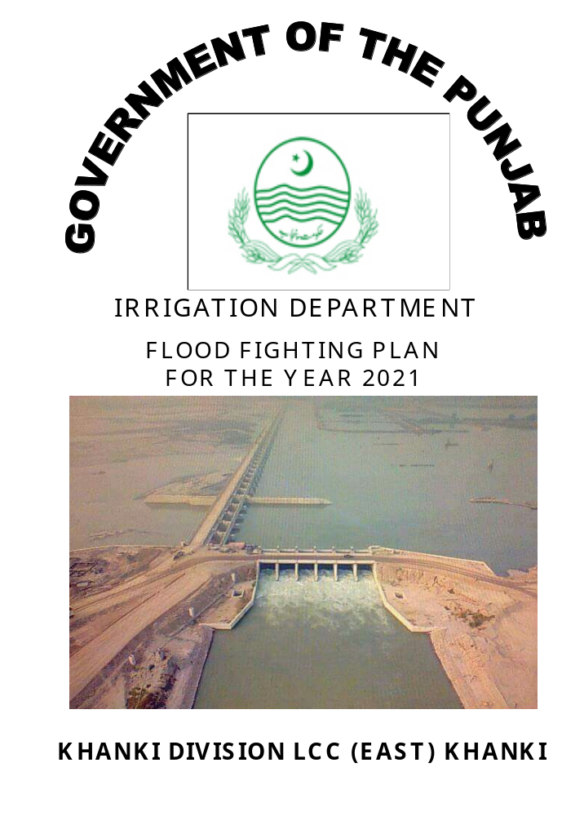
Chapter-1

SALIENT FEATURES OF KHANKI DIVISION

  - Location
New Khanki Barrage is located on River Chenab about 16 KM Downstream from Alexandra Bridge and 56 KM from Marala for feeding Lower Chenab Canal off taking from its left flank. Prior to construction of New Khanki Barrage, Lower Chenab Canal (Inundation Canal) had been used to off take from Ghari Gola about 6 KM Downstream of New Khanki Barrage.
1.2 General Description
The designed capacity of new Khanki Barrage is 1,100,000 cusecs and revised designed discharge of off taking canal LCC is 11507 cusecs. This barrage is recently completed in August, 2017. Khanki Division is responsible for maintenance of New Khanki Barrage & Lower Chenab Canal from RD 0+000 to RD 141+436 (Sagar Head) under administrative control of Superintending Engineer, Lower Chenab Canal (East) Circle, Faisalabad and Chief Engineer, Irrigation Zone Faisalabad. This Division comprises of two Sub Divisions i.e. Head works Sub Division at Khanki and Sagar Canal Sub Division at Killa Ram Kaur (Hafizabad). The jurisdiction of Head works Sub Division consists of New Khanki Barrage, River Training Works and Lower Chenab Canal from RD 0+000 to RD 78+000 along with its off takes i.e. High Level Channel, Mancher Disty System, Mancher High Level Channel System, Vanike Disty System, while Sagar Sub Division is fully an operational canal Sub Division having the control of Lower Chenab Canal from RD 78+000 to RD 141+436 and its off-taking channels i.e Gajar Gola Disty System, Hafizabad Disty System and Kot Nikka Disty System.

- HEAD WORKS SUB DIVISION

This Sub Division is headed by Sub Divisional Officer; Head works Sub Division with Headquarter at Khanki Head works. There are 7 No. Sub Engineer Sections in Khanki Head works Sub Division which are as under: -
- Head works section with Headquarter at Khanki Head works.
- Station Area section with Headquarter at Canal Colony Khanki.
- Right Marginal Bund section with Headquarter at RD 0-RMB.
- Mechanical section with Headquarter at Canal Colony Khanki.
- Hydraulic section with Headquarter at Khanki Head works.
- Chenawan Section with Headquarter at Chenawan.
- Alipur Section with Headquarter at Alipur.

- SAGAR SUB DIVISION

The Sagar Canal Sub Division is administratively controlled by Sub Divisional Officer; Sagar Sub Division at Killa Ram Kaur (Hafizabad) This Sub Division was originally further sub-divided into 5 No. Engineering Sections. The detail is as under: -
- Sagar Section with Headquarter at Sagar Head.
- Chak Kharl with Headquarter Chak Kharal.
- Killa Ram Kaur with Headquarter Killa Ram Kaur.
- Kot Chian with Headquarter Kot Chian.
- Jandoki with Headquarter Jandoki.

After suspension of F.O System by Government of Punjab, the operation and maintenance of all channels of Sagar Canal Sub Division was again transferred to the Department. This transfer of off-taking system has caused acute shortage of staff.

iii. REVENUE ESTABLISHMENT

All the activities regarding operation / maintenance of Distys and Minors of the Division and all revenue matters of the Division are being dealt by the 12 No. Farmer Organizations now headed by Administrators / Executive Engineers working under Executive Area Water Board LCC (East) Faisalabad / PIDA.

No Zilladar / Canal Patware is attached with Khanki Division to deal with the general revenue matters / issues relating to Khanki Division.
iv. Detail of Channels of Khanki Division

Sr. No. | Name of Channels | Off Taking RD | Length in Miles | Discharge  (Cusecs)
1 | High Level Channel | 500-R LCC | 9.32 | 100
1 | 1-R Minor | 23105-R | 1.42 | 11.8
1 | 2-R Minor | 35560-R | 1.69 | 10.4
1 | 3-R Minor | 43046-R | 0.80 | 4.40
2 | Mancher Disty | 40200-R | 7.56 | 93.73
2 | Alipur Minor | 17533-R | 4.21 | 18.06
2 | Ram Nagar Minor | 17533-R | 4.21 | 34.49
2 | Kot Hara Sub Minor | 29146-L | 8.04 | 6.79
2 | Ram Nagar Truncated Minor | 12830-R | 5.01 | 26.68
3 | Mancher High Level Channel | 43800-R | 3.90 | 34.72
3 | 1-R Minor | 7545-R | 1.42 | 9.14
Sr. No. | Name of Channels | Off Taking RD | Length in Miles | Discharge  (Cusecs)
4 | Vanike Disty | 76200-R | 19.10 | 245.77
 | Dhilwan Minor | 7630-L | 3.13 | 23.69
 | Chak Ghazi Minor | 35446-L | 1.76 | 18.25
 | Ramke Minor | 32000-L | 3.68 | 38.44
 | Kharak Sub Minor | 10270-R | 0.81 | 8.21
 | Mehdiabad Minor | 84900-R | 2.00 | 8.50
5 | Gajar Gola Disty | 76223-R | 23.93 | 287.64
5 | Kot Said Muhammad Minor | 93100-L | 7.30 | 59.60
5 | Dauloo Minor | 71500-R | 1.07 | 9.95
5 | Wazira Minor | 63148-R | 0.64 | 5.24
5 | Baura Minor | 63200-L | 0.80 | 8.27
5 | Dhiranke Minor | 42459-R | 3.60 | 23.80
6 | Muradian Disty | 119888-R | 0.85 | 4.60
7 | Kot Nikka Disty | 119850-R | 18.01 | 221.00
8 | Shah Jamal Minor-I | 36475-L | 3.86 | 3.83
8 | Shah Jamal Minor-II | 64850-L | 1.60 | 4.55
9 | Prem Kot Minor | 36500-R | 3.04 | 11.60
10 | Kot Minor | 53700-R | 9.35 | 24.12
10 | Gunjianwala Sub Minor | 19750-L | 1.70 | 3.56
11 | Jalalpur Minor | 75000-R | 10.57 | 35.34
11 | Fatehpur Sub Minor | 18100-R | 1.76 | 6.60
12 | Dohatta Minor | 86496-L | 5.78 | 12.30
13 | Madhora Minor | 90615/R | 12.86 | 33.96
14 | Jandoki Minor | 90615/R | 12.45 | 34.64
14 | Kassisa Sub Minor | 38250-R | 5.48 | 8.60
15 | Jaggawnala Disty | 120200-R | 1.71 | 5.00
16 | Sagar Disty-1 | 131411-R | 0.60 | 2.54
17 | Sagar Disty-2 | 136417-R | 0.25 | 5.10
18 | Chak Chatta Disty | 139986-L | 1.77 | 6.00
19 | Hafizabad Disty | 139000-R | 5.32 | 26.00
19 | Batera Minor | 8475-R | 3.25 | 7.00
19 | Killa Sahib Singh Minor | 21965-R | 0.94 | 4.50
19 | Lakhia Minor | 26445-R | 3.89 | 7.00
19 | Kariala Minor | 26445-L | 0.82 | 4.30
20 | Channi Disty | 181888-L | 6.73 | 17.00

1.3 Administrative setup

MOHIB ULLAH ALI
EXECUTIVE ENGINEER
KHANKI DIVISION LCC (EAST)
0341-3256906
ARIF ALI KHAN
SUB DIVISIONAL OFFICER
HEADWORKS SUB DIVISION
0300-7247086
ARIF ALI KHAN
SUB DIVISIONAL OFFICER (Add:)
SAGAR SUB DIVISION
0300-7247086

SIBT-UL-HASSAN
SUB ENGINEER (Add:)
HEADWORKS SECTION
0345-6229396

ABDUL GHAFFAR
SUB ENGINEER (Add:)
MECHANICAL SECTION
0300-7685049

SIBT-UL-HASSAN
SUB ENGINEER (Add:)
ST: AREA SECTION
0345-6229396

SHAHID NADEEM
SUB ENGINEER
RIGHT BANK SECTION
0346-6498370

HYDRAULIC SECTION
VACANT

CHENAWAN SECTION
VACANT

SHERAZ QADEER
SUB ENGINEER
SAGAR SECTION
0333-5935710
M. HUSSAIN
SUB ENGINEER (Add:)
JANDOKI SECTION
0343-6252419

QASIR PARVEZ
SUB ENGINEER
CHAK KHARL SECTION
0345-7033125

MUHAMMAD AKBAR
SUB ENGINEER
KOT-CHIAN SECTION
0300-7523834
M. HUSSAIN
SUB ENGINEER
Q. RAM KAUR SECTION
0343-6252419

SIBT-UL-HASSAN
SUB ENGINEER
ALIPUR SECTION
0345-6229396

Chapter-2

FLOOD PROTECTION AND RIVER TRAINING WORKS

  - Design parameter of Training works

- Khanki Barrage

Location | River Chenab 16 KM downstream of Alexandra Bridge on G.T Road near Wazirabad
Year of Construction | 2013-2017 (Complete in August, 2017)
Design Discharge | 11.00 Lac cusec
Width of weir from abutment to abutment | 4386.00 Ft.

Name of Bays | Clear water way of Bay (Ft.) | Crest Level R.L | No. of Gates | Height  of Gates (Ft.) | Top Level of  Gates R.L
Left Under Sluice | 300.00 | 719.00 | 5 | 16.50 | 735.50
Bay No.1 (6-60) | 3300.00 | 721.50 | 55 | 14.00 | 735.50
Right Under Sluice | 300.00 | 719.00 | 5 | 16.50 | 735.50
Total | 3900.00 |  | 65

- LOWER CHENAB CANAL

Location | Left side of Barrage with main Regulator working during low and high supplies.
Full Supply Discharge | Kharif = 9000 cusecs. (Revised 11506 cusecs)  Rabi = 7000 cusecs.
Full Supply Level at Head | = 724.88 (original) 725.10 (Revised)
Designed Bed Level at Head | = 710.48 710.48
Bed Width | = 250.00 250.00
Bed Slope | = 0.11 per 1000 Ft. 0.11 per 1000 Ft.
Designed Depth | = 12.00 14.62
Characteristics of Main Regulator
No. of Bays | 6
Width of Bays | 30.00’
Crest Level | 725.00’
Upstream Floor Level | 725.00’
Downstream Floor Level | 710.48’
Size of Gates | 30 x 11.50

- DATA OF RIVER TRAINING WORKS

Name of works | Off Taking RD | Length (Ft.) | Top Width (Ft.) | Designed apron of Bund / T. Head | Thickness
1. GUIDE BUNDS
i. U/S Left Guide Bund | KNK Barrage | 2874 | 20 | 40 | 4.0
ii. U/S Right Guide Bund | KNK Barrage | 5412 | 20 | 40 | 4.0
iii.D/S Right Guide Bund | KNK Barrage | 1048 | 20 | 40 | 5.0
iv. D/S Left Guide Bund | KNK Barrage | 1003 | 20 | 40 | 5.0
2. MARGINAL BUNDS
i. Left Marginal Bund | KNK Weir | 21000 | 20 | - | -
ii. Right Marginal Bund | KNK Weir | 33650 | 20 | - | -

- SPURS

A. UPSTREAM KHANKI WEIR.
1. Palkhu Spur | 6200 LMB | 2650 | 15 | 105.00 | 9.50
2. Spur “B” | 4500 | 4110 | 20 | 80.00 | 6.00
3. Spur “E” | 11800 RMB | 10720 | 20 | 80.00 | 6.00
4. Spur “G.H” | 15700 RMB | 9077 | 20 | - | -
5. Spur “G.H” Upper | 9077 GHM | 3200 | 15 | 30.00 | 6.00
6. Spur “G.H” Lower | 9077 GHM | 4500 | 15 | 80.00 | 6.00
7. Spur “X.X” | 22835 RMB | 5242 | 15 | - | -
8. Spur “I” | 25370 RMB | 9000 | 15 | - | -
9. Spur “I” Middle | 4164 Spur I | 2500 | 15 | 76.00 | 8.00
10. Spur “I” Lower | 4936 Spur I | 5464 | 15 | 60.00 | 5.00
11. Spur Main Bund | 439880 UJC | 7590 | 15 | - | -
12. Spur B-1 | 2391 MB | 1170 | 15 | 60.00 | 5.00
13. Spur B-2 | 4378 MB | 1050 | 15 | 60.00 | 5.00
14. Spur B-3 | 6364 MB | 1070 | 15 | 80.00 | 5.00
15. Spur B-4 | 7590 MB | 650 | 15 | 80.00 | 5.00
TOTAL: - |  | 67993

- ABSTRACT
Sr. No. | Name of Bund | No. | Length
Sr. No. | Name of Bund | No. | Feet | Miles
1 | Guide Bund | 4 | 10337 | 2.06
2 | Marginal Bund | 2 | 54650 | 10.93
3 | Spurs | 15 | 67993 | 13.59
 | G. TOTAL: - | 21 | 132980 | 26.58

Note: ** These statistics are based on the best available data as rehabilitation process of barrage is still in process.

2.2 Location Map attached

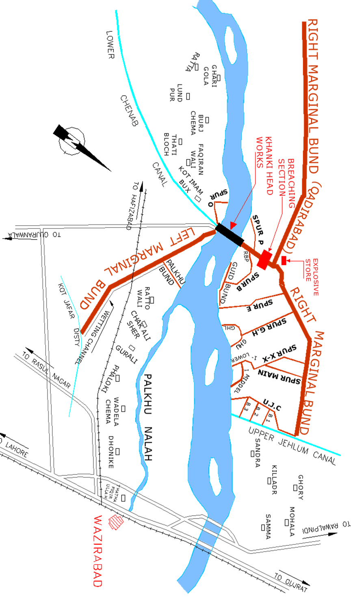

Chapter-3

BRIEF HISTORY OF PAST FLOOD EVENTS

After occurrence of exceptionally high floods in 1957, 1959, 1996-97 and during 2013-14 no significant flood has passed through Khanki Headworks so far. Since after year 2000 few of the river training works vis-à-vis partition bund, U/S left groyne and U/S right guide bund were partially damaged by the hazards of past floods. Partition bund restored beyond its original alignment in 1998 could not sustain against high flood in 1999 and was badly damaged. Repairs to partition bund (Curved portion only) were carried out during the year 2003-04 and 2005-06.

During floods of 2006-07, the curved portion of partition bund was again damaged where as the damage to straight portion of partition bund was aggravated. Restoring of both portion (straight and curved) was carried out under the project "Emergent repair of Punjab Barrages" during fiscal year 2007-2008. During years 2008 & 2011 freshets of flood in months July – August resulted in further increase of severe embayment along left flank of River at about 4.5 K.M D/S Khanki Head works. To check this embayment on permanent basis, PC-I for the scheme “Protective measures to save mettled road, abadies of village Thathi Bloach and burj Cheema from erosive action of river Chenab at downstream Khanki Head works” has already been cleared by P&D Punjab vide his letter No. 12(9)RO (cood) P&D/2008 dated 17-03-2008 and its approval from Federal Flood Commission could not be accorded. New fresh survey is being carried out to check the erosive action and scheme will be submitted after the model study and completion of New Khanki Barrage.

All the weir bays and under sluices were operated successfully as per regulation rules to pass the exceptionally high flood in September, 2014 but the existence of new Coffer Dam and sheet piles in the regime of river just downstream of Head works executed by the contractor of New Khanki Barrage Project caused obstruction in water way which further contributed towards raising of exceptionally high water levels upstream old Khanki Headworks resulting in few flood damages.

Chapter-4

Design data, Historic peak flood data and previous five year flood data of Headworks/Barrages and or other control points

4.1 Flood Limits
Sr. No. | Discharge  (Lac Cusecs) | Flood Classification
1 | 1.0 to 1.5 | Lower flood
2 | 1.5 to 2.0 | Medium flood
3 | 2.0 to 4.0 | High flood
4 | 4.0 to 6.0 | Very High flood
5 | 6.0 to above | Exceptionally High flood

  - Time Lags of Floods

Limit | Range  (Lac. Cusec) | Time Lag from Marala (Hours.)
Low | 1.0-1.5 | 12.00
Medium | 1.5-2.0 | 10.00
High | 2.0-4.0 | 09.00
Very High | 4.0-6.0 | 08.00
Exceptionally High | above 6.0 | 07.00

  - Highest Flood
Sr. No. | From |  | To |  | Peak Duration  (Hours) | U/S Gauge | U/S Discharge  (Cusecs) | Remarks
Sr. No. | Date | Time | Date | Time
1 | 27-08-57 | 03.00 | 27-08-57 | 04.00 | 01.00 | 739.00 | 1086416 | Exceptionally High Flood
2 | 06-07-59 | 05.00 | 06-07-59 | 06.00 | 01.00 | 738.70 | 1021081 | -do-
3 | 10-08-73 | 05.00 | 10-08-73 | 08.00 | 03.00 | 740.00 | 856296 | -do-
4 | 17-07-75 | 02.00 | 17-07-75 | 03.00 | 01.00 | 737.00 | 666241 | -do-
5 | 02-08-76 | 18.00 | 02-08-76 | 19.00 | 01.00 | 737.50 | 615043 | -do-
6 | 26-09-88 | 12.00 | 26-09-88 | 13.00 | 01.00 | 739.30 | 864220 | -do-
7 | 10-09-92 | 22.00 | 11-09-92 | 06.00 | 08.00 | 738.00 | 910512 | -do-
8 | 28-07-95 | 21.00 | 28-07-95 | 07.00 | 10.00 | 737.10 | 650517 | -do-
9 | 24-08-96 | 05.00 | 24-08-96 | 11.00 | 06.00 | 738.50 | 851269 | -do-
10 | 28-08-97 | 12.00 | 28-08-97 | 15.00 | 03.00 | 738.20 | 847650 | -do-
11 | 05-03-98 | 07.00 | 05-03-98 | 08.00 | 01.00 | 732.00 | 220298 | High Flood
12 | 23-07-00 | 18.00 | 23-07-00 | 22.00 | 04.00 | 732.00 | 309253 | High Flood
13 | 07-08-01 | 23.00 | 07-08-01 | 24.00 | 01.00 | 732.00 | 162848 | Medium Flood
14 | 14-08-02 | 23.00 | 07-08-01 | 24.00 | 02.00 | 732.50 | 240389 | High Flood
15 | 19-02-03 | 17.00 | 19-02-03 | 20.00 | 03.00 | 734.00 | 371788 | -do-
16 | 17-08-04 | 22.00 | 17-08-04 | 23.00 | 02.00 | 732.00 | 151134 | Low Flood
17 | 08-07-05 | 10.00 | 08-07-05 | 15.00 | 06.00 | 735.00 | 368078 | High Flood
18 | 04-09-06 | 06.00 | 04-09-06 | 09.00 | 3.00 | 735.60 | 422740 | Very High Flood
19 | 13-03-07 | 17.00 | 13-03-07 | 22.00 | 5.00 | 733.70 | 302197 | High Flood
20 | 01-08-08 | 3.00 | 01-08-09 | 4.00 | 2.00 | 732.00 | 215412 | High Flood
21 | 29-07-09 | 0.60 | 29-07-09 | 09.00 | 4.00 | 732.00 | 105358 | Low Flood
22 | 07-08-10 | 0.50 | 07-08-10 | 0.70 | 3.00 | 734.80 | 334437 | High Flood
23 | 17-09-11 | 5.00 | 17-09-11 | 08.00 | 4.00 | 732.00 | 166383 | Medium Flood
24 | 04-08-12 | 23.00 | 04-08-12 | 24.00 | 1.00 | 732.10 | 186413 | Medium Flood
25 | 15-08-13 | 10.00 | 15-08-13 | 14.00 | 4.00 | 736.10 | 410332 | Very High Flood
26 | 07-09-14 | 7.00 | 07-09-14 | 8.00 | 2.00 | 743.20 | 947099 | Exceptionally High Flood
27 | 23-09-15 | 13.00 | 23-09-15 | 14.00 | 2.00 | 732.30 | 164498 | Medium Flood
28 | 07-08-16 | 24.00 | 08-08-16 | 05.00 | 6.00 | 735.50 | 418736 | Very High Flood
29 | 19-07-17 | 08.00 | 19-07-17 | 09.00 | 2.00 | 733.50 | 192670 | Medium Flood
30 | 13-08-18 | 24.00 | 14-08-18 | 01.00 | 2.00 | 734.00 | 189820 | Medium Flood
31 | 01-08-19 | 24.00 | 01-08-19 | 04.00 | 4.00 | 733.50 | 189238 | Medium Flood
32 | 28-08-20 | 7.00 | 28-08-20 | 22.00 | 5.00 | 735.50 | 292093 | High Flood

  - Peak Discharges

Sr. No. | From |  | To |  | Peak Duration  (Hours) | U/S Gauge | U/S Discharge  (Cusecs) | Remarks
Sr. No. | Date | Time | Date | Time
1 | 27-08-57 | 03.00 | 27-08-57 | 04.00 | 01.00 | 739.00 | 1086416 | Exceptionally High Flood
2 | 06-07-59 | 05.00 | 06-07-59 | 06.00 | 01.00 | 738.70 | 1021081 | -do-
3 | 10-08-73 | 05.00 | 10-08-73 | 08.00 | 03.00 | 740.00 | 856296 | -do-
4 | 17-07-75 | 02.00 | 17-07-75 | 03.00 | 01.00 | 737.00 | 666241 | -do-
5 | 02-08-76 | 18.00 | 02-08-76 | 19.00 | 01.00 | 737.50 | 615043 | -do-
6 | 26-09-88 | 12.00 | 26-09-88 | 13.00 | 01.00 | 739.30 | 864220 | -do-
7 | 10-09-92 | 22.00 | 11-09-92 | 06.00 | 08.00 | 738.00 | 910512 | -do-
8 | 28-07-95 | 21.00 | 28-07-95 | 07.00 | 10.00 | 737.10 | 650517 | -do-
9 | 24-08-96 | 05.00 | 24-08-96 | 11.00 | 06.00 | 738.50 | 851269 | -do-
10 | 28-08-97 | 12.00 | 28-08-97 | 15.00 | 03.00 | 738.20 | 847650 | -do-
11 | 07-09-14 | 7.00 | 07-09-14 | 8.00 | 2.00 | 743.20 | 947099 | Exceptionally High Flood

Chapter-5

Flood fighting strategy

STAGE – 1

River Discharge Limit | 1-2 Lac cusecs.  The River water is entirely contained within its natural course.
Operational In-charge. | Sub Divisional Officer, Head works Khanki.

SUPERVISORY STAFF

i) | Sub Engineer, Head works. | Main weir Head Regulators and Training works on downstream left of weir.
ii) | Sub Engineer, Station Area. | Training works on upstream of Left side of River
iii) | Sub Engineer, Right Bank | Training works on Right side of River.
iv) | Flood season establishment. | Two Beldars per mile will be employed at the start of Flood Season in addition to the existing establishment for repairing the rain cut and maintaining bunds. This labour is kept available round the clock for any emergency.

STAGE – 2

River Discharge Limit | 2-4 lac cusecs.
Operational In-charge. | Sub Divisional Officer, Headworks Khanki.

SUPERVISORY STAFF

i) | Sub Engineer Headworks | Main weir Head Regulators and Training works on downstream left of weir.
ii) | Sub Engineer Station Area. | Training works on upstream of Left side of River.
iii) | Sub Engineer Hydraulic. | R.M.B RD1+000 to RD 16+000 upstream Right Bells bund, Guide bund, Spur ‘B” “E” and “G.H” (Main Upper and Lower).
iv) | Special watching. | The strength of watching establishment to be increased to 3 men per mile. The watching establishment has to be employed on staunching of bunds as spill water touches the bund in this phase.

Stage – 3

River Discharge Limit. | 4.00 to 6.00 Lac cusecs.
Operational In-charge. | Executive Engineer, Khanki.  Sub Divisional Officer, Headworks Khanki.
Controlling Officers. | - Sub Divisional Officer, Head woks Khanki to be In-charge of Headworks and protection works on Left side River.  - Sub Divisional Officer (Farooqabad) of Upper Gugera Division with all staff / establishment will be the overall in-charge of LMB RD.0+000 to RD.21+000.  - Sub Divisional Officer Pacca Dhalla of Upper Gugera Division with all staff / establishment will be the overall in-charge of RMB from RD.0+000 to RD.33+650.

SUPERVISORY STAFF

Sr. No. | Designation | Reach | Site of Camp
i) | Sub Engineer, Head works. | Head works | Head works
ii) | Sub Engineer, Station Area. | LMB RD 0+000 to 15+000 & Palkhu Spur. | At start of the Left U/S Guide Bank
iii) | Sub Engineer, Right Bank. | RMB RD 0+000 to 16+000 U/S & D/S Right Bells Bunds, Spurs B, E, G.H. | Right Marginal Bund RD 0+000
iv) | Sub Engineer, Chenawan. | LMB RD 15+000 to 21+000 | Crossing of Mansoorwali Wazirabad Railway at LMB.
v) | Sub Engineer, Hydraulic. | RMB RD 16+000-33+650 Spur-I, XX, B-1, B-2 &B-4 | Right Marginal Bund RD 15+000
vi) | Controlling Officer | Sub Divisional Officer (Farooqabad) of Upper Gugera Division with all staff / establishment will be the overall in-charge of LMB from RD.0+000 to RD.21+000.
vii) | Special watching. | - The establishment will be increased 4 men per mile. Eight men at every dangerous site will be deputed.  - Civil Authorities will be called to help the establishment in watching the dangerous sites as soon as discharge exceeds five Lac cusecs. The Police and Military guards may also be called to take the position at vulnerable points.

NOTE: - When the discharge at Khanki Barrage reaches to 6 Lac and above, the Executive Engineer Upper Gugera (Sheikhupura) will shift his camp at Khanki Barrage with all staff/establishment to assist Executive Engineer Khanki Division.

Chapter-6

Flood Damages restoration Works

- No major damage occurred during flood season 2020.

Chapter-7

Flood Fighting Arrangement

  - Pre-Flood Arrangement

Sr. No. | Activities | Target Dates
I. | Preparation of Flood Fighting Plans
I. | - Submission of Draft Divisional Plans by Zonal Chiefs to Chief Engineer, D&F (after scrutiny by SEs/CEs) | Done
I. | - Review by Chief Engineer D&F | ---
I. | - Final submission of Flood Fighting Plans | Will be circulated as  per schedule
II. | Inspection of Flood Infrastructure
II. | - By XENs. | -
II. | - By SEs/CEs | -
II. | - By Departmental & Army Teams | -
III. | Indication of Encroachments on bunds and spurs to the Civil Administration | List provided to civil administration
IV. | Painting Gauges, RD Marks, Data Boards and Repairs to Flood Bunds etc. | In progress
V. | Replenishment of Reserve Stock of Stone and Flood Fighting Material
V. | - Identification of needs | -
V. | - Funding / Procurement Arrangements | Underway
V. | - Procurement, stacking prescribed field checks | Underway
VI. | Installation of Wireless Sets | Will be done
VII. | Opening of Zonal Flood Cells
VII. | - Duty Roster | ---
VII. | - Operative | ---

  - Watching Establishment

The watching establishment on flood protection bunds is required to be employed as scale & as per Govt. policy. Deployment of watching establishment as given in Chapter No.5.

7.3 Arrangement at Sensitive sites

- In case of emergency at sensitive sites, arrangements to establish flood camps will be ensured and sufficient quantity of flood fighting material and equipment will be procured before time for watching during flood season. The flood fighting material will be kept in stores which are located in the premises of stores under the control/custody of the Sub Engineers concerned.

  - Watching Material
Watching material, which will be placed at different sites, most of which is yet to be procured, further an additional material will also be required in order to meet with extraordinary worst situation & cope/handle the site situation. Hence the following material will be kept ready most of it has yet be procured on headquarters of this purpose.
- During flood season on sensitive sites to meet with any emergency the detail of Reserve stock of stone is given below:-

Reserve Stock Stone available.

> No reshuffling / recouping of reserve stone are required as available quantity is more than 70 % which is sufficient.
> Flood fighting camps along with the flood fighting material will be established at sensitive sites. Departmental machinery will be deployed at sensitive sites according to the action plan as water level rises from low to medium and medium to high accordingly. Detail of action plan at sensitive.

Sr. No. | Site | Approved Reserve Stock Limit (Lac Cft) | Available  (Lac Cft) | Balance Required (Lac Cft)
1 | Upstream Left Bells Bund (Stone Yard) | 1.500 | 3.649 | -2.149
2 | U/S Right Bells Bund | 0.500 | 0.834 | -0.334
3 | Right Guide Bund | 0.500 | 0.226 | 0.274
4 | Palkhu Spur | 1.000 | 0.228 | 0.772
5 | Spur "E" | 0.500 | 0.037 | 0.463
6 | Spur G.H Upper | 0.250 | 0.159 | 0.091
7 | G.H Lower | 0.500 | 0.184 | 0.316
8 | "I" Middle | 0.250 | 0.154 | 0.096
9 | "I" Lower | 0.250 | 0.309 | -0.059
10 | "B" 1 | 0.250 | 0.085 | 0.165
11 | "B" 2 | 0.250 | 0.040 | 0.210
12 | "B" 3 | 0.250 | 0.078 | 0.172
13 | "B" 4 | 0.250 | 0.112 | 0.138
14 | Spur "P"  (Remove at site) | 0.500 | 0.000 | 0.500
15 | Partition Bund  (Remove at site) | 0.500 | 0.020 | 0.480
16 | G.H Main | 0.250 | 0.067 | 0.183
Total |  | 7.500 | 6.182 | 1.318

Consolidated Reserve Stock of Stone

Sr. No. | Canal Division | Sanctioned Reserve Stock Limit (Lac Cft) | Minimum Quantity Required (Lac Cft) (60%) | Stone Available at Site  (Lac Cft) | %age Stone Available w.r.t Sanctioned Limit | Balance Required  (Lac Cft) | Remarks
1 | Khanki | 7.500 | 4.500 | 6.182 | 82% | 1.318 | Available stone sufficient

  - Watching Material

The detail of watching material is as under:-
FLOOD FIGHTING MATERIAL KHANKI HEADWORKS.
Sr. No. | Name of Items | Unit | Approved quantity | Quantity available | Balance quantity required | Remarks
1 | K.Oil | Ltr | 1000 | 1000 | -
2 | Gas Lamp | No. | 30 | 30 | -
3 | Mantles | No. | 100 | 100 | -
4 | Washers for Gas Lamps | No. | 50 | 50 | -
5 | Nozzles for Gas Lamp | No. | 50 | 50 | -
6 | E. Gunny bags | No. | 3000 | 2785 | 225 | Procurement is under process.
7 | Sutli | Kg | 25 | 25 | -
8 | Sewing needles | No. | 50 | 50 | -
9 | Bamboos | No. | 400 | 400 | -
10 | Toot Baskets | No. | 500 | 410 | 90 | Procurement is under process.
11 | Khaji Mat | No. | 200 | 200 | -
12 | Trunger (S.W. Wire) | No. | 250 | 250 | -
13 | Shouldries | No. | 30 | 18 | 12
14 | Driving Pegs | No. | 500 | 350 | 150
15 | Steel wire rope ½ “ | Lft | 1500 | 1500 | -
16 | Hand Saw | No. | 36 | 36 | -
17 | Manila rope of sorts | Kg | 100 | 100
18 | G.I .Wire | Kg | 500 | 500 | -
19 | G.I. Buckets | No. | 200 | 200 | -
20 | Plastic bags | No. | 5000 | 3000 | 2000 | Procurement is under process.
21 | Chairs | No. | 32 | 24 | 8
22 | Tables | No. | 5 | 4 | 1
23 | Generator | No. | 3 | 1 | 2 | Procurement is under process.
24 | Petrol | Ltr | 900 | 900 | -
25 | M. Oil | Ltr | 18 | 18 | -
26 | Wires 7x0.0029” | Ft | 700 | 700 | -
27 | Wooden Boards (10x12) | No. | 5 | 5 | -
28 | Torch Chargeable | No. | 15 | 15 | -
29 | Sword | No. | 25 | 15 | 10 | Procurement is under process.
30 | U.P.S 1000 Watt with Batteries | No. | 2 | 2 | - | Procurement is under process.
31 | Energy Saver | No. | 35 | 25 | 10
32 | Energy Saver Holders | No. | 15 | 15 | -

7.5 Arrangement for Sounding & Probing

Arrangement for sounding and probing will be managed if needed. The facilities available for sounding and probing are:
- Boat
- Sounding Rod
- Probing Rod

  - Lighting Arrangement

Sub Engineer, Mechanical will keep all the Flood Lights and other Lighting arrangements in working condition with the help of Electrician and other staff. In case of failure of electricity supply from WAPDA generators are available in SCADA Office at Barrage.

  - Ration Arrangements

The establishment and the Supervisory staff will have their own food arrangement. The Civil Authorities will be ready to arrange the supply of ration for at least 500 men when required during emergency.

  - P.O.L Arrangement for Vehicle

In order to close & strengthen the breach / cut sites & operate breaching sections, some reserves of petrol and diesel are required for use in excavators, dozers & generators. Before the start of flood season, the District Coordination Officer, Gujranwala will get 2500 liters of petrol and 500 liters of High Speed Diesel Oil reserved at any petrol pump in close vicinity of Khanki Head works at Wazirabad Alipur Road. Similarly District Coordination, Gujrat will get 1500 liters of petrol and 2000 liters of diesel reserved at Gujrat, Shahdiwal Road Executive Engineer, Khanki will be informed of the arrangement.

  - Transportation

Khanki Division has one Tractor Trolly and One Pick up. Tractor Trollies are also available with the local contractors who will arrange these on call in emergency for transportation of labour and materials. The Civil Administration of Gujranwala and Gujrat Districts will be requested to provide transport for carriage of emergent material if not available from local sources in case of emergency.
  - Law and Order
Police Guard is deputed on left & right side of the Barrage. Additional strength is to be posted to guard against any miscreant cutting the left and right marginal bunds during very high flood. District Coordinator Officer, Gujranwala and Gujrat have to arrange such guards when flood at Khanki is 5.00 Lac cusecs or above.

  - Medical Arrangement for Labour
Basic Health unit is available in Khanki Canal Colony. Moreover this District Health Officer is requested to make arrangements during the flood season.

  - Liaison with other Department
Executive Engineer, Khanki and Sub Divisional Officer, Head works will keep liaison with their counter parts in other departments. Higher Authorities of other Departments will be approached, if needed through Superintending Engineer Lower Chenab Canal (East) Circle Faisalabad and Chief Engineer, Irrigation Zone Faisalabad.

  - Role of Army
At least strength of about 300 Army men are required to deal with any emergency when the discharge exceeds 500000 Cusecs. On request of Executive Engineer, Khanki Division the Commander, Headquarter 30 Engineers Corp Gujranwala Cantonment, shall be obliged to arrange this assistance.

  - Duties of Telephone Attendant
Phone at Telegraph office Khanki is attended by the Signaller on duty and they are avaiale round the clock during flood season. The Head Jamadar with mobile phone will be available in flood office similarly. All the officers / officials are informed to use their mobile phones during emergency and will not switch off.

  - Wireless Arrangements
The wireless station in the flood warning centre located in observatory building at Head works is installed by the Telecommunication wing of the Punjab Police Department before the flood season. Two mobile wireless set will be fixed in the vehicles of Executive Engineer & Sub Division Officer of Khanki Head works. The flood warnings, flood gauges, discharge and other information regarding flood are received and transmitted by the flood warning station at Lahore. The mobile units in the vehicle help the touring / inspecting officials to remain in touch constantly with the flood offices.

Chapter-8

Detail of Encroachment.

Ordinary Encroachment
Sr. No. | Total Ordinary Encroachment | Removed | Remaining | Action to be Taken
1. | 73 | 48 | 25 | Noticed issued to encroachers to vacate the Govt. Land.

critical Encroachment
Sr. No. | Total Critical Encroachment | Removed | Remaining | Action to be Taken
1. | There is no Critical Encroachment on Flood Embankments  in Khanki Division.

Chapter-9

Duty Roster/Flood Fighting Program

Phase I - (Pre Flood Period)
This phase covers the pre flood period starting from start of the flood season upto the time the flood water raises upto 1 foot above general Natural Surface Level (NSL) along the flood bunds.

WATCHING

Flood watching establishment will be arranged through Government contractor on hire & fire basis according to flood scales / stages and other essential needs at site. 0020
Stage | Strength
Water level is 1 foot above NSL or below along the flood bund | 1 watchman per mile per shift in two shifts during 24 hours on Marginal and other flood bunds
Water level is more than1 foot above NSL along the flood bund | 1 watchman per mile per shift in three shifts during 24 hours on Marginal and other flood bunds

During this phase the Sub Divisional officer of the bunds and respective Sub Engineers of the sections of the bunds will be the controlling officers under the overall supervision of the Executive Engineer, Khanki Division.
Phase II – (Low Flood i.e. 1.0 to 2.0 Lac cusecs)

This phase starts when the discharge at the Khanki Head works is between 1 to 2 Lac cusecs. The details of the actions to be taken during this phase are as follows:
Activity | Action
Shifting of watching & necessary flood material to watching huts. | SDO Head works and Sub Engineers

Stage | Strength
The discharge ranges between 1.0 to 2.0 lac cusecs | 2 persons per mile per shift in three shifts during 24 hours on Marginal and other flood bunds.  1 Chowkidar per watching hut for round the clock duty till the time watching material is taken back from the watching huts after recession of the flood to a level 1 foot above NSL.

Supervisory Staff

The duty roster during this phase of the officers/officials is tabulated below. The officials under the overall control of the sub-divisional officer concerned will perform the duties.

Sr. No. | Location | Duty of Officer / Official
1 | Barrage as a whole | Sub Engineer, Head works
2 | R.M.B RD 0+16+000 U/S & D/S Right Bells Bund Spur P.B.E and G.H | Sub Engineer, R.M.B
3 | L.M.B RD 0+000 15+000 with Palkhu Spur under Sub Divisional officer, Head works. | Sub Engineer Station Area
4 | R.M.B RD 16+000-33+650 Spurs I, B-1, B-2 and B-4. | Sub Engineer Hydraulic

Phase III – (Medium Flood i.e. 2.0 to 4.0 Lac cusecs)

This phase starts when the discharge at the Khanki Headworks crosses the medium level and is upto high level flood i.e. between 2.0 to 4.0 Lac cusecs. The details of the actions to be taken during this phase are as follows:

Stage | Strength
The discharge ranges between 2.0 to 4.0 lac cusecs. | 4 persons per mile per shift in three shifts during 24 hours on Marginal and other flood bunds  1 Chowkidar per watching hut for round the clock duty till the time watching material is taken back from the watching huts after recession of the flood to a level 1 foot above NSL.

Supervisory Staff

The duty roster during this phase of the officers/officials is tabulated below. The officials under the overall control of the concerned Sub Divisional Officers will perform the duties.
Sr. No. | Location | Duty of Officer / Official
1 | Head works as a whole | Sub Divisional Officer, Head works  Sub Engineer, Head works
2 | R.M.B RD 0+16+000 U/S & D/S Right Bells Bund Spur P.B.E and G.H | Sub Engineer, R.M.B
3 | L.M.B RD 0+000 15+000 with Palkhu Spur under Sub Divisional officer, Head works. | Sub Divisional Officer, Head works  Sub Engineer Station Area
4 | R.M.B RD 16+000-33+650 Spurs I, B-1, B-2 and B-4. | Sub Engineer Hydraulic

Phase IV – (High Flood i.e. 4.0 to 6.0 Lac cusecs)

This phase starts when the discharge at the Khanki Division is between 4.0 to 6.0 Lac cusecs. The details of the actions to be taken during this phase are as follows:

Activity | Action
Requisition for 100 Army Jawans | XEN

Stage | Strength
The discharge ranges between 4.0 to 6.0 lac cusecs | 6 persons per mile per shift in three shifts during 24 hours on Marginal and other flood bunds  1 Chowkidar per watching hut for round the clock duty till the time watching material is taken back from the watching huts after recession of the flood to a level 1 foot above NSL.

Breach Closing Squad

When the discharge will exceed 4.00 Lac cusecs, two units will be kept on Left Marginal Bund and three at Right Marginal Bund and one unit will be kept at Sagar Sub Division for closing any kind of leakage / breach.
Supervisory Staff
The duty roster during this phase of the officers/officials is tabulated below. The officials under the overall control of the sub divisional officers concerned will perform the duties.
Sr. No. | Location | Duty of Officer/Official
1 | Head works as a whole | Executive Engineer, Khanki  Sub Divisional Officer, Head works  Sub Engineer, Headworks
2 | R.M.B RD 0+16+000 U/S & D/S Right Bells Bund Spur P.B.E and G.H | Sub Divisional Officer, Farooqabad, Upper Gugera Division  Sub Engineer, R.M.B  Sub Engineer, Sagar
3 | L.M.B RD 0+000 21+000 with Palkhu Spur under Sub Divisional officer, Head works. | Executive Engineer, Khanki  Sub Divisional Officer, Headworks  Sub Engineer, Station Area  Sub Engineer, Chenawan
4 | R.M.B RD 16+000-33+650 Spurs I, B-1, B-2 and B-4. | Sub Divisional Officer, Pacca Dhalla of Upper Gugera Division  Sub Engineer Hydraulic  Sub Engineer, Chenawan

Phase VI – (Exceptionally High Flood i.e. more than 6.0 Lac cusecs)

This phase commences when the discharge at the Khanki Headworks is in exceptionally high flood stage i.e. more than 6.0 Lac cusecs. The details of the actions to be taken during this phase are as follows:
Activity | Action
Deputy Commissioner is to be informed to make arrangement for the evacuation of the marooned public within LMB and RMB.  Military Authorities to keep ready for emergent operation  Police to watch that no un authorized cut is made by public especially all along LMB and RMB.  Engineers 4 Corps for energizing the breaching section, when water level approaches R.L 742.00 mark at the emergency.  Gauge installed at RD 5+000 of LMB.  Arrangement for 200 Volunteers to cut RMB at Breaching section in case the blasting arrangement doesn’t work. | Executive Engineer  Executive Engineer  Executive Engineer  Executive Engineer  District Administration & Head Clerk Khanki Division.

Watching

Stage | Strength
The discharge more than 6.0 Lac cusecs | 8 persons per mile per shift in three shifts during 24 hours on Marginal and other flood bunds  1 Chowkidar per watching hut for round the clock duty till the time watching material is taken back from the watching huts after recession of the flood to a level 1 foot above NSL.

Supervisory Staff

The duty roster during this phase of the officers/officials is tabulated below. The officials under the overall control of the Sub Divisional Officers concerned will shift their headquarters and will perform the duties.
Sr. No. | Location | Duty of Officer/Official
1 | Barrage as a whole | Executive Engineer, Upper Gugera Division  Sub Divisional Officer, Barrage  Sub Engineer, Barrage
2 | R.M.B RD 0+16+000 U/S & D/S Right Bells Bund Spur P.B.E and G.H | Executive Engineer, Khanki  Sub Divisional Officer, Farooqabad, Upper Gugera Division  Sub Engineer, R.M.B  Sub Engineer, Sagar
3 | L.M.B RD 0+000 21+000 with Palkhu Spur under Sub Divisional officer, Head works. | Executive Engineer, Upper Gugera Division  Sub Divisional Officer, Headworks  Sub Engineer, Station Area  Sub Engineer, Chenawan
4 | R.M.B RD 16+000-33+650 Spurs I, B-1, B-2 and B-4. | Executive Engineer, Khanki  Sub Divisional Officer, Pacca Dhalla of Upper Gugera Division  Sub Engineer Hydraulic  Sub Engineer, Chenawan

Chapter-10
Emergency Telephone Numbers

Sr. No. | Designation | Code | Office
1 | Secretary Irrigation Department  Fax No. | 042  042 | 99212117-18  99212116
2 | Chief Engineer Irrigation Faisalabad  Fax No.  Cell No. | 041  041  0300 | 9200268  9200277  9650355
3 | Chief Engineer Draining and Flood Lahore  Fax No | 042  042 | 99230602  35862081
4 | Superintending Engineer LCC (E) Circle FSD | 041 | 9200273
5 | Superintending Engineer LCCW Faisalabad | 041 | 9200272
6 | Executive Engineer operation Faisalabad | 041 | 9200270
7 | Flood Emergency Officer Irrigation Zone Faisalabad | 041 | 9200270
8 | Tele Office Irrigation Faisalabad | 041 | 9200774
9 | Director Flood/Secretary Punjab Flood Commission | 042 | 99231614
10 | Director Flood fore-casting and warning Center 46 Jail Road Lahore. | 042 | 9200208
11 | Headquarter Engineer 30 Corp GRW Cantt. | 055  055 | 269-2353  269-2360
12 | 106 Engineer/Military Emergency Batn. Gujranwala Cantt. | 055 | 269-5175
13 | Executive Engineer Khanki Head Works  Mobile No. | 055  0341 | 6266327  3256906
14 | Tele Office Khanki Head Works | 055 | 6266239
15 | Sub Divisional Office Khanki Head Works  Mobile No. | 0347 | 1146970
16 | Tele Office Head Sagar  Mobile No. | 0346 | 7454934
17 | Distt: Coordination Officer Gujranwala. | 055 | 9200051-2
18 | Distt: Coordination Officer Hafizabad. | 0547 | 521784  521075
19 | Distt: Coordination Officer Gujrat. | 053 | 9260010-12
20 | District Police Office Gujranwala | 055 | 9200602-03
21 | District Police Officer Gujrat | 053 | 9260026
22 | District Police Officer Hafizabad | 0547 | 523337
23 | Flood Warning Center Wazirabad | 055 | 6603400  6608566
24 | Deputy District Officer (Rev) Wazirabad | 055 | 6608577  6608566
25 | Assistant Engineer Railway Wazirabad | 055 | 660369
26 | Deputy District Officer (Rev) Hafizabad | 0547 | 525460
27 | Executive Engineer Qadirabad Barrage  Fax No. | 0547  0547 | 550198  550190
28 | Executive Engineer Upper Gugera Division Sheikhupura | 056 | 9200256
29 | Executive Engineer Hafizabad Division Faisalabad | 041 | 9200473
30 | Executive Engineer Gujrat Division UJC Gujrat | 053 | 3525298
31 | Executive Engineer Marala Divn: UCC Marala  Fax No. | 052  052 | 3502102  3502120
32 | Resident Engineer Power House Shadiwal | 053 | 3524144

Note: All telephone Nos. are updated.
Chapter-11

Standard operating procedure (SOP) for Breaching Sections

  - History of the breaching section

Khanki head works was constructed during the year 1889-92. At that time, there was no concept of breaching section. After the devastation of 1973 Flood, Flood commission was created who decided to construct breaching section on every structure. In compliance to that, a breaching section of Khanki Head works was constructed between RD. 3+000 to 4+000 of Right Marginal Bund. During exceptionally high flood in September, 2014 it has been operated to ensure the safety of structure, Public life and property.
Moreover the charging material will be arranged by the Army and is stored in the Explosive Store at Right Marginal Bund RD 5. When the discharge D/S Marala exceeds 7.00 Lac cusecs and River is rising, the charging material will be lowered into the pipes. When the flood water touches R.L 742.00 at RD 5+000 Left Marginal Bund and continues to rise, orders will be given by the Executive Engineer Khanki or his representative at critical point or by the Senior Most Irrigation Officers present at site. The explosive material inspection is carried out by Army Officer.

The breaching site will be activated by Army during flood season. An Army unit will be engaged from Gujranwala Cantt: and remains ready to operate the breaching site when asked for. Breaching Section was constructed after flood 1973 and it has been operated during exceptionally high flood in September, 2014.

11.2 Location, Design, Quantity and Variety of the Explosive required for detonation
The site of breaching sections is located between RD. 3+000 to 4+000 of Right Marginal Bund.

It has been designed in three sections of 100 feet in length and 200 feet apart. Each section consists of five rows, three on top of bund i.e. central, left and right and two rows are on slope, each row consists of 15 liners, 6 feet long liners of P.V.C. have been used on top of bund and 4 feet at the slope. Each section consists of 30, 4 feet liner and 45, 6 feet liner. For one section, 28 Lbs Wabox, 1290 Lbs Wabonite, two 2 No. detonators, two 4 No. and One 6 No. detonators are required.

Status of Explosive
Sr.  No. | Name of explosive | unit | Quantity Required | Quantity Available | Deficit Quantity
1 | Wabox 80 % 25 MM | Kg | 1215 | 1215 | Nil
2 | Wabonite,Bulk | Kg | 2430 | 2430 | Nil
3 | Firing Cable | Meter | 2200 | 2200 | Nil
4 | Wabocard (10 gms) /meter | Meter | 1440 | 1440 | Nil
5 | Safety Fuse | Meter | 177 | 177 | Nil
6 | Detonator Non Elec No 8 | No | 120 | 120 | Nil
7 | Delonaor Delay Elec 3.5 MS | No | 280 | 280 | Nil
8 | Wabonite | Kg | 1510 | 1510 | Nil
9 | Primer CE 1 OZ | No | 225 | 225 | Nil

Note: There is no pending liability for purchase of explosive /accessories.
11.3 Arrangement of explosives and security of explosive stores

Explosive store for storages of explosive has been constructed at Qadirabad Barrage during 2003-04. All the required explosive was shifted to this store. Pre-flood and post-flood Survey board inspects the explosives every year. The unserviceable explosive is destroyed and fresh explosive is recouped as the shelf life of Wabox and Wabonite is one year. During flood season 2014 breaching section was operated during exceptionally high flood and all explosive was used. For flood season 2020 all the required explosive material/accessories is available and protected in at Qadirabad barrage in explosive store watching by the Pak Army 30 Core-Engineer Gujrat.
11.4 List of the security staff with detail of their training etc

Three ex-military men security guard have been deployed for security of explosive store at Head Qadirabad.
11.5 Detail of mechanical means as a stand by arrangements in case of detonation failure

One No. dozer from Agriculture Department Gujrat is engaged at the breaching section as a standby arrangement in case of detonation failure.

11.6 Duty Roster in case of critical situation

Independent Sub Divisional Officer and Sub Engineer will be deputed at the breaching section.

  - breaching committee with their action plan

BREACHING COMMITTEE

- Responsibility for the maintenance and operation of each breaching section shall rest upon the department owning the structure at which the breaching section is located.
- Breaching section shall be operated on the orders of following committee:-
- District Coordination Officer of the district in which the breaching section is located, who shall also be the convener of the committee;
- District Coordination Officer of the district likely to be effected by the operation of breaching section or his representative (in case the area affected falls outside the district in which the breaching section is located);
- Representative of the department owing the structure at which the breaching section is located (not less than the rank of an Executive Engineer or equivalent);
- Representative from C&W Department not below the rank of an Executive Engineer;
- Executive Engineer concerned of the Irrigation Department;
- Representative from Pakistan Army not below the rank of Lt. Colonol.
- The decision to operate a breaching section shall be taken by the committee keeping in view the technical advice of the Executive Engineer concerned of the Irrigation Department. In case of any difference opinion among the members, the final decision shall rest with the District Coordination Officer.
- In case of unavailability of the District Coordination Officer or his inability to take decision, or in case of a difference of opinion between the District Coordination Officers of the District in which the breaching section is located and the district which is likely to be affected by the operation of the breaching section, the decision to operate a breaching section shall be taken by the respective Commissioner;
- Breaching section shall be operated when one or more of the following conditions are met:-
- The discharge capacity of the structure for which breaching section is located is exceeded and the safety of structure is threatened;
- The critical gauge as indicated in the relevant Flood Fighting Plan is achieved or exceeded and is rising;
- The safety of major population center-(s) is threatened due to high flood levels and in view of the Executive Engineer concerned of the Irrigation Department, operation of breaching section can help in reduction of flood levels.
- Where, in view of the Executive Engineer concerned of the Irrigation Department or the representative of the department owing the structure at which the breaching section is located, the aforesaid criteria is expected to be met after due consideration of all available technical and hydrological conditions, the aforesaid committee may operate the breaching section before the critical gauge is achieved or exceeded. In every such case, the view of the Executive Engineer concerned of Irrigation Department or the representative of the department owning the structure shall be expressed in writing and shall be based on flood forecast by Pakistan Meteorological Department or other reliable sources, the trend of discharges in the relevant river at upstream locations, the lag times, estimated attenuation and expected inflows from tributaries, nullahs and streams en-route. Where advance breaching is planned, the committee may also consult professional experts and seek advice from the Superintending Engineer or the Chief Engineer concerned of the Irrigation Department.
- Breaching section shall be operated by the contingent deputed by the Engineering-in-Chief, Pakistan Army as indicated in the Flood Fighting Plan, Explosive method shall be preferred method for operation of breaching section. However, the department owning the structure on which the breaching section is located, and in case of their failure to do so, Irrigation Department shall make available, in advance, necessary earth moving machinery and other equipment for affecting the breach through mechanical means in the shortest possible time.
- The District Coordination Officer concerned and all other relevant agencies shall ensure all necessary arrangements for the safety and if required evacuation of population likely to be effected by the operation of breaching section.

action plan

The breaching section is located between RD 3+000 to RD 4+000 of Right Marginal Bund. There are three sections each of 100 Ft. length at 200 Ft. interval. It is activated when critical gauge at RD 5+000 Left Marginal Bund attains RL 742.00. No population area is likely to be affected due to operation of breaching section.
OPERATION OF THE BREACHING SECTIONS

- When the flow down of Marala exceeds 6.00 Lac & rising, the explosive material will be shifted to breaching section from flood relief explosive store Qadirabad.

- When the discharge downstream Marala Head works exceeds 7.00 Lac & raising, the charging material will be lowered into the pipes by the Army Unit.

- When the flood water touches R.L 742.00 at RD 5+000 Left Marginal Bund and is still rising, orders will be given by the Executive Engineer Khanki or his representative available at the critical point or the senior most Irrigation officer present at site for breaching.

- Executive Engineer Khanki, his representative available at the critical point or the Higher Irrigation Officer will have the discretion to make relief cuts even earlier for the safety of the Head works and the Marginal Bund.

- District Coordination Officer, Gujrat will be informed about the breaching operation and the relief cuts for necessary action.

- The above mentioned arrangements for breaching operation have been approved by the Punjab Flood Commission in its powered meeting held on 12-07-1989 which was communicated by the Relief Department vide No.1664-89/1896-CR-IV dated 07-08-1989.

  - List of the villages likely to be inundated in case of breach

Left Side of Khanki Headworks |  |  |  | Right Side of Khanki Headworks
Sr. No. | Name of Village | No. of Houses | Population | Sr. No. | Name of Village | No. of Houses | Population
1 | Gorali | 400 | 1800 | 1 | Kot Mauj Din | 210 | 990
2 | Chak Ali Sher | 100 | 550 | 2 | Kot Kutab Din | 520 | 2800
3 | Kot Kahlwan | 80 | 410 | 3 | Kot Tali Sahib | 95 | 450
4 | Ratowali North | 45 | 320 | 4 | Qasimabad | 351 | 1352
5 | Ranike | 420 | 1400 | 5 | Nathu Kot | 65 | 350
6 | Ratowali South | 80 | 800 | 6 | Mangat Nicha | 1000 | 15000
7 | Khanki Head | 700 | 3200 | 7 | Ahmad Pur | 450 | 1500
8 | Islamabad | 525 | 1800 | 8 | Sagar Kalan | 500 | 2000
9 | Saeedabad | 180 | 800
10 | Faqiranwali | 50 | 350
Total:- |  | 2375 | 9250 |  |  | 3191 | 24442

11.9 Announcement and details of evacuation arrangements

The time lag between Marala Barrage and Khanki Head works is about 9 hurs. Thus Irrigation department has sufficient time to inform Civil Administration and other concerned agencies about the flood situation for warning the civil population, arranging their evacuation and adopting necessary protective measures. A critical gauge stand fixed at RD 5+000 of Left Marginal Bund depicting the trend of the flood heights. Moreover when the critical gauge will attain RL 742.00 besides the river is still in rising position, the situation will be brought to the notice of Army, Civil Administration and other relevant agencies for further intimation to the public about the quantum of flood water and its effect for making arrangement of evacuation. The operation of the breaching section will be intimated to the Army at least 12 hours in advance for making arrangements to shift the explosive to the breaching site. Similarly Civil Administration is to be informed about the operation of breaching section at least 12 hours in advance.

- The District Coordination Officer, Gujranwala to make arrangement for the evacuation of the public within Left Marginal Bund. Similarly the District Coordination Officer, Gujrat to make arrangement for the evacuation of the public within Right Marginal Bund and the population likely to be affected in the route of spill water.

- Concerned Military authorities to keep ready for emergency operation.

- Concerned Police authorities to watch that no unauthorized cuts be made by public especially along Left Marginal Bund and Right Marginal Bund.

- Headquarters, 30-Engineers Corps, Gujranwala Cantonment for energizing the breaching section, when water level approaches to 742.00 mark at the critical gauge.

11.10 Details of coordination with Civil Army authorities

In case of high flood, hourly flood gauges will be passed to Civil as well as Army. These three Departments will remain in touch through Telephone and wireless system.

11.11 Parallel Communication arrangements

Telephone and wireless system are the parallel arrangements for communication.

11.12 Index Plan

Index Plan of breaching section is attached at page No.7.

Executive Engineer Superintending Engineer Chief Engineer
Khanki Division LCC (E) Lower Chenab Canal East Circle Irrigation Faisalabad Zone
Khanki Faisalabad Faisalabad

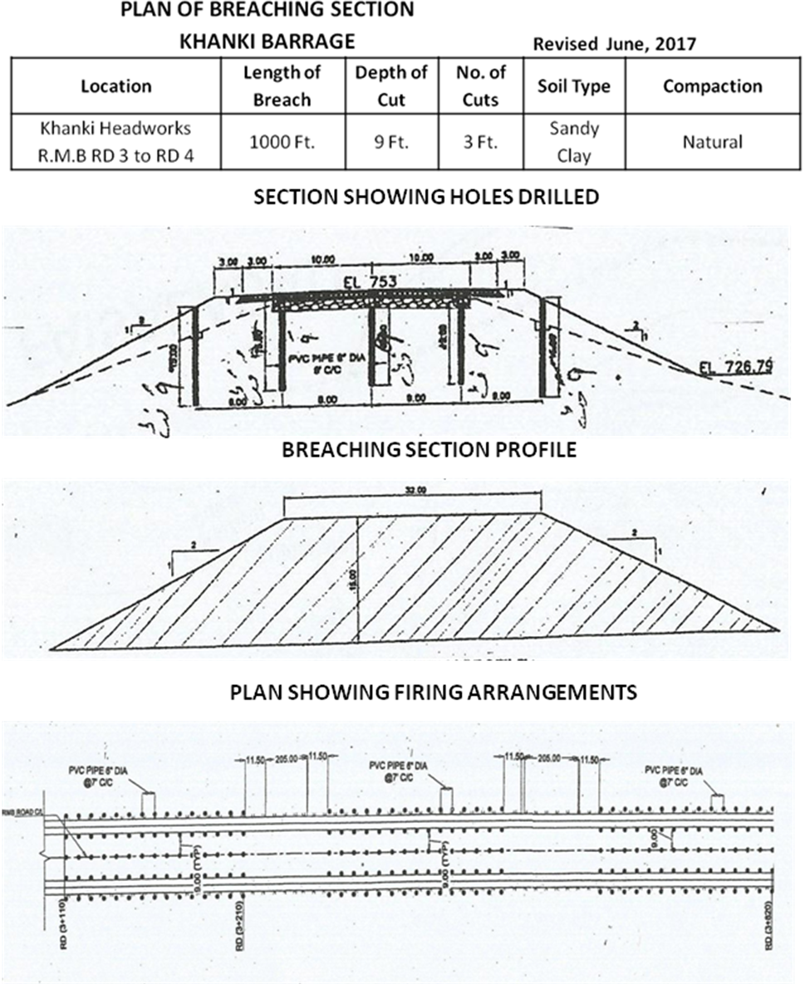

Chapter-12

Vulnerable sites on Flood Bunds/Structures

  - Apprehended breach sites in Flood Bunds / Structures
The following reaches there are very likelihood under the direct hit of flow that requires extra arrangements of watching and flood fighting material at the following sites in case of discharge at Khanki Head works above 6 Lac.
- Right Marginal Bund
RD.0+000, RD.15+700,
(II) Left Marginal BUNND
RD.0+000, 15+500
Route map of vulnerable reaches in case of breaches to LMB or RMB is attached as under for reference.
  - Operation of breaching sections
In 2020, no flood of significant amount passed through Khanki Headworks, because of that breaching section was not operated.
  - Breaches due to rising of flood water, deterioration of flood bunds
No breach occurred in last year flood.

Location Map Attached
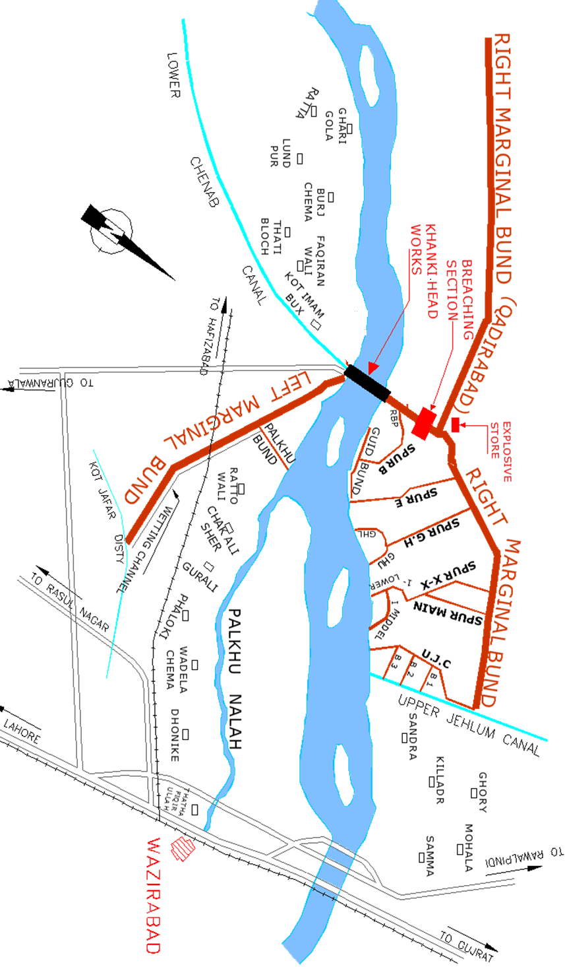
Chapter-13

emergency Contingency Plan for vulnerable sites

SITE no. 1

Right Marginal Bund
RD 0+000, rd 15+700
  - Plan showing route of Flood Water coming out of the breach supported with levels

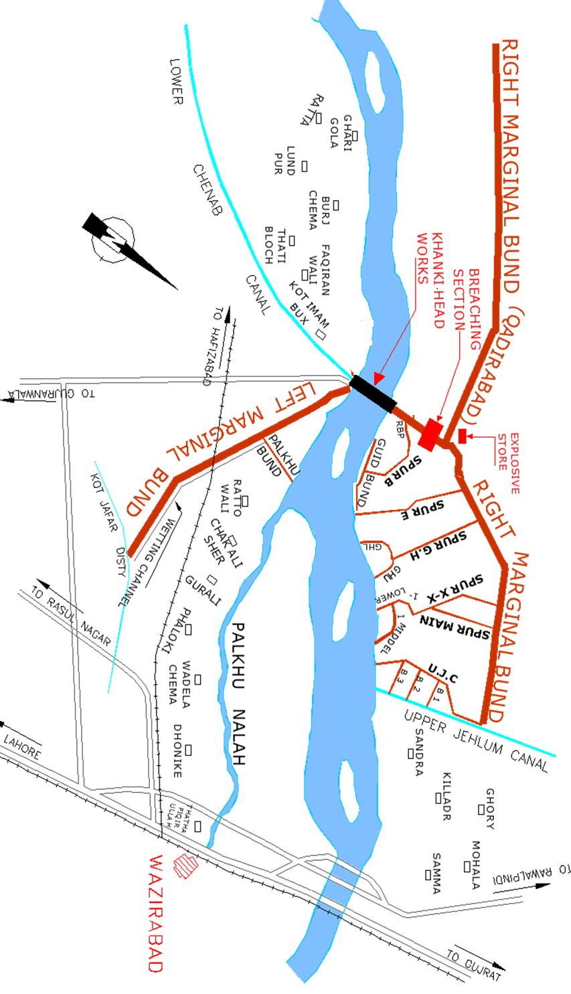
  - Detail of villages abadies likely to be affected
The Following infrastructures like electric, telephone installations, abadies, roads, buildings etc. will be effected for such breach / relief cut.
- Villages
Kot Muj Din, Kot Qatib Din, Kot Tali Sahib, Qasimabad and Nathu Kot etc.
Provision of list of evacuees to civil administration
Right Side of Khanki Headworks
Sr. No. | Name of Village | Location | No. of Houses | Population
1 | Kot Muj Din | Left side of RMB | 210 | 990
2 | Kot Kutab Din | Left side of RMB | 520 | 2800
3 | Kot Tali Sahib | Left side of RMB | 95 | 450
4 | Qasimabad | Left side of RMB | 351 | 1352
5 | Nathu Kot | Right side of RMB | 65 | 350

- Towns.
Left Side of Khanki Headworks
Shadiwal
  - strategy and action taken
13.3.1 Arrangements
The following arrangements will be made:-
    - Establishment of Flood Fighting Camps
Following are the camps sites at Right Marginal Bund:-
- RD 0+000
- RD 15+700 (During exceptionally High Flood only).
13.3.3 Duties of Officers/Officials and their camp sites
Camp No. | Location | Officer (Name/Designation /Mobile No) | Official (Name/Designation /Mobile No)
1 | RD; 0+000 of RMB | Shahid Nadeem, Sub Engineer, 0346-6498370 | Muhammad Afzal, Mate, 0332-8327102
2 | RD; 15+700 of RMB | Sibtul Hassan, Sub Engineer, 0345-6229396 | Ghulam Nabi, Mate, 0345-1015806

    - Departmental Machinery available
Khanki Division has 2 No. Tractor and Machinery of Excavator Division Faisalabad / Lahore.
    - Machinery available from private Source
Tractor Trollies are available with local contractors who will arrange on the call of in emergency for transportation of labour and material. The Civil Administration of Gujranwala District will be asked for requisite transport for carriage of emergent material if not available from local sources in case of emergency.
    - Flood Fighting Material required for site NO.1
Sr.  No. | Name of Items | Unit | Approved  quantity
1 | K.Oil | Ltr | 500
2 | Gas Lamp | No. | 15
3 | Mantles | No. | 50
4 | Washers for Gas Lamps | No. | 25
5 | Nozzles for Gas Lamp | No. | 25
6 | E. Gunny bags | No. | 1500
7 | Sutli | Kg | 13
8 | Sewing needles | No. | 25
9 | Bamboos | No. | 200
10 | Toot Baskets | No. | 250
11 | Khaji Mat | No. | 100
12 | Trunger (S.W. Wire) | No. | 100
13 | Shouldries | No. | 15
14 | Driving Pegs | No. | 250
15 | Steel wire rope ½ “ | Lft | 750
16 | Hand Saw | No. | 18
17 | Manila rope of sorts | Kg | 50
18 | G.I .Wire | Kg | 250
19 | G.I. Buckets | No. | 100
20 | Plastic bags | No. | 2500
21 | Chairs | No. | 16
22 | Tables | No. | 3
23 | Generator | No. | 2
24 | Petrol | Ltr | 450
25 | M. Oil | Ltr | 9
26 | Wires 7x0.0029” | Ft | 350
27 | Wooden Boards (10x12) | No. | 3
28 | Torch Chargeable | No. | 8
29 | Sword | No. | 13
30 | U.P.S 1000 Watt with Batteries | No. | 1
31 | Energy Saver | No. | 20
32 | Energy Saver Holders | No. | 8

    - Flood Fighting Material available.
Sr. No. | Name of Items | Unit | Approved quantity | Quantity available | Balance Qty Required | Remarks
1 | K.Oil | Ltr | 500 | 500 | - | -
2 | Gas Lamp | No. | 15 | 15 | - | -
3 | Mantles | No. | 50 | 50 | - | -
4 | Washers for Gas Lamps | No. | 25 | 25 | - | -
5 | Nozzles for Gas Lamp | No. | 25 | 25 | - | -
6 | E. Gunny bags | No. | 1500 | 1275 | 225 | Procurement is under process.
7 | Sutli | Kg | 13 | 12.5 | - | -
8 | Sewing needles | No. | 25 | 25 | - | -
9 | Bamboos | No. | 200 | 200 | - | -
10 | Toot Baskets | No. | 250 | 205 | - | -
11 | Khaji Mat | No. | 100 | 100 | - | -
12 | Trunger (S.W. Wire) | No. | 100 | 125 | 75 | Procurement is under process.
13 | Shouldries | No. | 15 | 12 | 3 | Procurement is under process.
14 | Driving Pegs | No. | 250 | 200 | 50 | Procurement is under process.
15 | Steel wire rope ½ “ | Lft | 750 | 750 | - | -
16 | Hand Saw | No. | 18 | 18 | - | -
17 | Manila rope of sorts | Kg | 50 | 50 | - | -
18 | G.I .Wire | Kg | 250 | 250 | - | -
19 | G.I. Buckets | No. | 100 | 100 | - | -
20 | Plastic bags | No. | 2500 | 1900 | 600 | Procurement is under process.
21 | Chairs | No. | 16 | 12 | 4 | Procurement is under process.
22 | Tables | No. | 3 | 2.5 | - | -
23 | Generator | No. | 2 | - | 2 | Procurement is under process.
24 | Petrol | Ltr | 450 | 450 | - | -
25 | M. Oil | Ltr | 9 | 9 | - | -
26 | Wires 7x0.0029” | Ft | 350 | 350 | - | -
27 | Wooden Boards (10x12) | No. | 3 | 3 | - | -
28 | Torch Chargeable | No. | 8 | 8 | - | -
29 | Sword | No. | 13 | 8 |  | -
30 | U.P.S 1000 Watt with Batteries | No. | 1 | 1 | - | -
31 | Energy Saver | No. | 20 | 20 | - | -
32 | Energy Saver Holders | No. | 8 | - | 8 | Procurement is under process.
13.4 Detail of other infrastructure like electric, Sui Gas, Telephone installations, road network, other building, Canals and drainage network
There is no other infrastructure like electric, Sui Gas, Telephone installations, road network, other building, Canals and drainage network in way of water coming through proposed breach site.
SITE no. 2
Left Marginal Bund
rd 0+000 – 1+000
  - Plan showing route of Flood Water coming out of the breach supported with levels
  - Detail of villages abadies likely to be affected
The Following infrastructures like electric, telephone installations, abadies, roads, buildings etc. will be effected for such breach / relief cut.
- Villages
Mansoorwali, Ranike, Ratowali, Khanki Head, Islamabad and Saeedabad etc.
Provision of list of evacuees to civil administration
Left Side of Khanki Headworks
Sr. No. | Name of Village | Location | No. of Houses | Population
1 | Mansoorwali | Right side of LMB | 400 | 2200
2 | Ranike | Right side of LMB | 420 | 1400
3 | Ratowali | Right side of LMB | 80 | 800
4 | Khanki Head | Right side of LMB | 700 | 3200
5 | Islamabad | Right side of LMB | 525 | 1800
6 | Saeedabad | Right side of LMB | 180 | 800

- Towns
Left Side of Khanki Headworks
Saroki
  - strategy and action taken
13.3.1 Arrangements
The following arrangements will be made:-
    - Establishment of Flood Fighting Camps
The following camps are at various places:-
TEMPORARY CAMP SITES

Following are the camps sites at Left Marginal Bund.

- RD 0+000
- RD 15+500 (During exceptionally High Flood only).

    - Duties of Officers/Officials and their camp sites
Camp No. | Location | Officer (Name/Designation /Mobile No) | Official (Name/Designation /Mobile No)
1 | RD; 0+000 of LMB | Sibtul Hassan , Sub Engineer,0345-6229396 | Muhammad Irfan, Head Mali, 0344-4429867
2 | RD; 15+500 of LMB | Abdul Ghaffar, Sub Engineer, 0300-7685049 | Muhammad Riaz, Mate, 0344-6270665

13.3.4 Departmental Machinery available
Khanki Division has 2 No. Tractor and Machinery of Excavator Division Faisalabad / Lahore.
    - Machinery available from private Source
Tractor Trollies are available with local contractors who will arrange on the call of in emergency for transportation of labour and material. The Civil Administration of Gujranwala District will be asked for requisite transport for carriage of emergent material if not available from local sources in case of emergency.
    - Flood Fighting Material required for site NO.2
Sr.  No. | Name of Items | Unit | Approved  quantity
1 | K.Oil | Ltr | 500
2 | Gas Lamp | No. | 15
3 | Mantles | No. | 50
4 | Washers for Gas Lamps | No. | 25
5 | Nozzles for Gas Lamp | No. | 25
6 | E. Gunny bags | No. | 1500
7 | Sutli | Kg | 12
8 | Sewing needles | No. | 25
9 | Bamboos | No. | 200
10 | Toot Baskets | No. | 250
11 | Khaji Mat | No. | 100
12 | Trunger (S.W. Wire) | No. | 150
13 | Shouldries | No. | 15
14 | Driving Pegs | No. | 250
15 | Steel wire rope ½ “ | Lft | 750
16 | Hand Saw | No. | 18
17 | Manila rope of sorts | Kg | 50
18 | G.I .Wire | Kg | 250
19 | G.I. Buckets | No. | 100
20 | Plastic bags | No. | 2500
21 | Chairs | No. | 16
22 | Tables | No. | 2
23 | Generator | No. | 1
24 | Petrol | Ltr | 450
25 | M. Oil | Ltr | 9
26 | Wires 7x0.0029” | Ft | 350
27 | Wooden Boards (10x12) | No. | 2
28 | Torch Chargeable | No. | 7
29 | Sword | No. | 12
30 | U.P.S 1000 Watt with Batteries | No. | 1
31 | Energy Saver | No. | 15
32 | Energy Saver Holders | No. | 7
    - Flood Fighting Material available
Sr. No. | Name of Items | Unit | Approved quantity | Quantity available | Balance Qty Required | Remarks
1 | K.Oil | Ltr | 500 | 500 | - | -
2 | Gas Lamp | No. | 15 | 15 | - | -
3 | Mantles | No. | 50 | 50 | - | -
4 | Washers for Gas Lamps | No. | 25 | 25 | - | -
5 | Nozzles for Gas Lamp | No. | 25 | 25 | - | -
6 | E. Gunny bags | No. | 1500 | 1500 | - | -
7 | Sutli | Kg | 12 | 12 | - | -
8 | Sewing needles | No. | 25 | 25 | - | -
9 | Bamboos | No. | 200 | 200 | - | -
10 | Toot Baskets | No. | 250 | 205 | 150 | Procurement is under process.
11 | Khaji Mat | No. | 100 | 100 | - | -
12 | Trunger (S.W. Wire) | No. | 150 | 150 | - | Procurement is under process.
13 | Shouldries | No. | 15 | 10 | 5 | Procurement is under process.
14 | Driving Pegs | No. | 250 | 200 | - | -
15 | Steel wire rope ½ “ | Lft | 750 | 750 | - | -
16 | Hand Saw | No. | 18 | 18 | - | -
17 | Manila rope of sorts | Kg | 50 | 50 | 250 | Procurement is under process.
18 | G.I .Wire | Kg | 250 | 250 | - | -
19 | G.I. Buckets | No. | 100 | 100 | - | -
20 | Plastic bags | No. | 2500 | 2000 | 500 | Procurement is under process.
21 | Chairs | No. | 16 | 12 | 4 | Procurement is under process.
22 | Tables | No. | 3 | 2 | 1 | Procurement is under process.
23 | Generator | No. | 1 | 1 | - | -
24 | Petrol | Ltr | 450 | 450 | - | -
25 | M. Oil | Ltr | 9 | 9 | - | -
26 | Wires 7x0.0029” | Ft | 350 | 350 | - | -
27 | Wooden Boards (10x12) | No. | 3 | 2 | 1 | -
28 | Torch Chargeable | No. | 7 | 7 | - | -
29 | Sword | No. | 12 | 7 | 10 | Procurement is under process.
30 | U.P.S 1000 Watt with Batteries | No. | 1 | 1 | -
31 | Energy Saver | No. | 15 | 15 | - | -
32 | Energy Saver Holders | No. | 8 | 8 | - | -

13.4 Detail of other infrastructure like electric, Sui Gas, Telephone installations, road network, other building, Canals and drainage network
There is no other infrastructure like electric, Sui Gas, Telephone installations, road network, other building, Canals and drainage network in way of water coming through proposed breach site.

Chapter-14
action plan

14.1 Re-shuffling/recouping plan of reserve stone departmentally
Sr. No. | Name of Structure | Sanctioned Limit of Reserve Stock of Stone (Lac Cft) | Stone Available at Site  (Lac Cft) | Balance  Stone Required  (Lac Cft)
Total |  | 8.500 | 6.182 | 2.318
1 | Upstream Left Bells Bund (Stone Yard) | 1.500 | 3.649 | -2.149
2 | U/S Right Bells Bund | 0.500 | 0.834 | -0.334
3 | Right Guide Bund | 0.500 | 0.226 | 0.274
4 | D/S Right Bell Bund | 0.500 | 0.000 | 0.500
5 | Groynes and Weir | 0.500 | 0.000 | 0.500
6 | Palkhu Spur | 1.000 | 0.228 | 0.772
7 | Spur "E" | 0.500 | 0.037 | 0.463
8 | Spur G.H Upper | 0.250 | 0.159 | 0.091
9 | G.H Lower | 0.500 | 0.184 | 0.316
10 | "I" Middle | 0.250 | 0.154 | 0.096
11 | "I" Lower | 0.250 | 0.309 | -0.059
12 | "B" 1 | 0.250 | 0.085 | 0.165
13 | "B" 2 | 0.250 | 0.040 | 0.210
14 | "B" 3 | 0.250 | 0.078 | 0.172
15 | "B" 4 | 0.250 | 0.112 | 0.138
16 | Spur "P" | 0.500 | 0.000 | 0.500
17 | Partition Bund | 0.500 | 0.020 | 0.480
18 | G.H Main | 0.250 | 0.067 | 0.183

- No reshuffling / recouping of reserve stone are required as available quantity is more than 70 % which is sufficient.

14.2 Detail of inlet/outlet crossing along with closing methodology
There is one inlet between RD 2+000 – 3+000 of Right Marginal Bund and will be closed during flood.
14.3 Deployment of Machinery (medium to high flood)
Attached at Page No.43.
14.4 Deployment of Machinery (high to very high flood)
Attached at Page No.43.
14.5 Deployment of Machinery (high to exceptionally high flood)
Attached at Page No.44.
14.6 Police deployment plan
Sr. No. | Vulnerable sites used for illegal cuts during floods | Concerned Canal Division | Concerned Police Station and District | Police Personnel to be deployed |  | Remarks (If any)
 |  |  |  | Inspection / SI/ASI | Constables | Remarks (If any)
1. | RD 4-5 Left Marginal Bund | Khanki Division | Ahmad Nagar Distt: Gujranwala | ASI 1 No. | 4 No. | In case of high flood

14.7 DETAIL OF SYNTHETIC BAGS WITH CAPACITY OF 500 KG AND 1000 KG
1. Synthetic Bags with capacity 500 KG =3000 No
2. Synthetic Bags with capacity 1000 KG =1500 No.
1000 kg |  |  | 500 kg
Required  (No.) | Available | Balance | Required (No.) | Available | Balance
1500 | Nil | 1500 | 3000 | Nil | 3000

Note. The balance quantity will be procured on subject to availability of funds before on set of flood season

14.8 DETAIL OF POLYTHENE SHEETS OF BLACK COLOUR TO PROTECT UPSTREEM SLOPE AGAINST WAVE ACTION AND TO CONTROL SEEPAGE THROUGH EMBANKMENT.

Polythene sheets of black color for protecting upstream slopes
Waves and control to seepage (Average 20 FT Width) 21000 Rft

Polythene sheets of black color for protecting upstream slopes
Waves and control to seepage (Average 20 FT Width)
Required  Rft | Available  Rft | Balance  Rft
21000 | Nil | 21000

Note. The balance quantity will be procured on subject to availability of funds before on set of flood season
Chapter-15
backup divisions

When the discharge at Khanki Barrage reaches to 6 Lac and above, the Executive Engineer Upper Gugera Division (Sheikhupura) will shift his camp at Khanki Barrage with all staff/establishment to assist Executive Engineer Khanki Division.

Executive Engineer Superintending Engineer Chief Engineer
Khanki Division LCC (E) Lower Chenab Canal East Circle Irrigation Faisalabad Zone
Khanki Faisalabad Faisalabad

14.3 Deployment of Machinery (medium to high flood)
Sr. No. | Name of Structure | Length  (In Mile) | Vulnerable Reach | Camp Location | Site In-charge by Name and Cell. # | Machinery / Labour Deployed |  |  |  |  | Availability of Stone  Lac Cft
 |  |  |  |  |  | Excavator | Dozers | Trolleys / Dumpers | Tractor with Front Blade | Labour  Beldar + Mate | Availability of Stone  Lac Cft
1 | 2 | 3 | 4 | 5 | 6 | 7 | 8 | 9 | 10 | 11 | 12
1 | Right Marginal Bund including breaching section. | 6.73 | RD 15+700 | RD 0+000 | Shahid Nadeem Sub Engineer R.M.B Section  (0346-6498370) | 1 | - | 2 | 1 | 60+5  for 3 shifts | 0.834  U/S R.M.B  RD; 0-1000
2 | Left Marginal Bund | 4.20 | RD; 0+000 – 1+000 | RD 0+000  RD 15+500 | Sibtul Hassan  Sub Engineer  Station Area Section  (0345-6229396) | 1 | - | 2 | 1 | 38+3  for 3 shifts | 3.649  U/S L.M.B  RD; 0-1000
 |  |  |  |  | TOTAL: | 2 | - | 4 | 2

14.4 Deployment of Machinery (high to very high flood)
Sr. No. | Name of Structure | Length  (In Mile) | Vulnerable Reach | Camp Location | Site In-charge by Name and Cell. # | Machinery / Labour Deployed |  |  |  |  | Availability of Stone  Lac Cft
 |  |  |  |  |  | Excavator | Dozers | Trolleys / Dumpers | Tractor with Front Blade | Labour  Beldar + Mate | Availability of Stone  Lac Cft
1 | 2 | 3 | 4 | 5 | 6 | 7 | 8 | 9 | 10 | 11 | 12
1 | Right Marginal Bund including breaching section. | 6.73 | RD; 15+700 | RD; 0+000 | Shahid Nadeem Sub Engineer R.M.B Section  (0346-6498370) | 2 | - | 3 | 1 | 80+6  for 3 shifts | 0.834  U/S R.M.B  RD; 0-1000
1 | Right Marginal Bund including breaching section. | 6.73 | - | -
2 | Left Marginal Bund | 4.20 | RD; 0+000 – 1+000 | RD 0+000  RD 15+500 | Sibtul Hassan  Sub Engineer  Station Area Section  (0345-6229396) | 1 | - | 2 | 1 | 50+4  for 3 shifts | 3.649  U/S L.M.B  RD; 0-1000
 |  |  |  |  | TOTAL: | 3 | - | 5 | 2
14.5 Deployment of Machinery (high to exceptionally high flood)
Sr. No. | Name of Structure | Length  (In Mile) | Vulnerable Reach | Camp Location | Site In-charge by Name and Cell. # | Machinery / Labour Deployed |  |  |  |  | Availability of Stone Cft
 |  |  |  |  |  | Excavator | Dozers | Trolleys / Dumpers | Tractor with Front Blade | Labour  Beldar + Mate | Availability of Stone Cft
1 | 2 | 3 | 4 | 5 | 6 | 7 | 8 | 9 | 10 | 11 | 12
1 | Right Marginal Bund including breaching section. | 6.73 | RD 0+000 | RD 0+000 | Shahid Nadeem Sub Engineer R.M.B Section  (0346-6498370) | 2 | 1 | 4 | 2 | 121+7  for 3 shifts | 0.834  U/S R.M.B  RD; 0-1000
1 | Right Marginal Bund including breaching section. | 6.73 | RD 15+700 | RD 15+700
2 | Left Marginal Bund | 4.20 | RD 0+000 – 1+000 | RD 0+000  RD 15+500 | Sibtul Hassan  Sub Engineer  Station Area Section  (0345-6229396) | 2 | 1 | 4 | 2 | 75+6  for 3 shifts | 3.649  U/S L.M.B  RD; 0-1000
 |  |  |  |  | TOTAL: | 4 | 2 | 8 | 4

