**DRFAT FLOOD FIGHTING PLAN 2023**



**OKARA CANAL DIVISION, LBDC**

**OKARA**

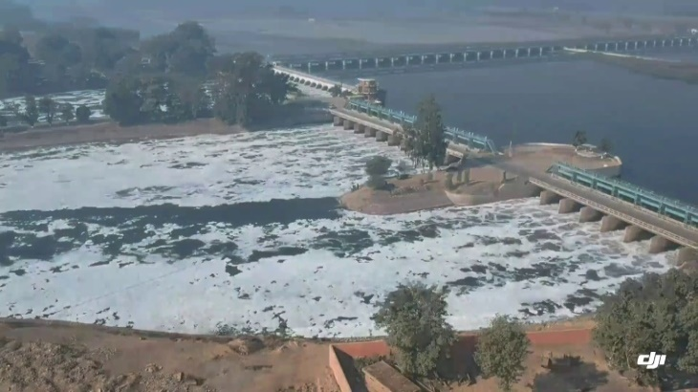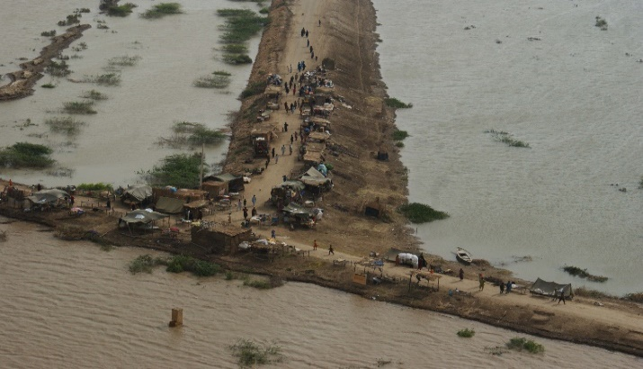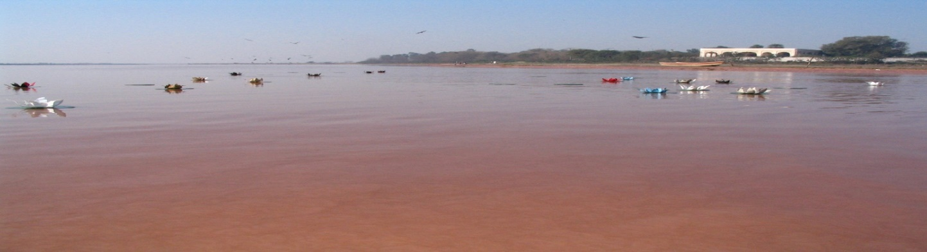

**PUNJAB IRRIGATION DEPARTMENT**

**Contents**

**PART - A**

1 SALIENT FEATURES 1

1.1 Location 1

1.2 General Description 1

1.3 Administrative Setup 2

2FLOOD PROTECTIOB AND RIVER TRAINING WORKS OF OKARA CANAL DIVSION 3

2.1 Design Parameter of River Training Works 3

2.2 Location Map/Index Plan 4

3BRIEF HISTORY OF PAST FLOOD EVENTS 5

4DESIGN DATA, HISTORIC PEAK FLOOD DATA AND PREVIOUS FIVE YEARS FLOOD DATA OF HEAD WORKS/BARRAGES AND OR OTHER CONTROL POINTS 6

4.1 Flood Limits 6

4.2 Time Lags of Floods 6

4.3 Highest Floods 6

4.4 Peak Discharges 7

5FLOOD FIGHTING STRATEGY FOR RIVER RAVI D/S BALLOKI IN OKARA 9

6FLOOD DAMAGES RESTORATION WORKS 10

7FLOOD WATCHING ARRANGEMENT 11

7.1 Pre-Flood Arrangements 11

7.2 Watching Establishment 12

7.3 Arrangement at Sensitive Sites 13

7.4 Watching Material 14

7.5 Arrangement for sounding & probing 14

7.6 Lighting Arrangement 15

7.7 Ration Arrangement 15

7.8 P.O.L Arrangement for Vehicle 15

7.9 Transportation 15

7.10 Law and Order 15

7.11 Medical Arrangement for labor 15

7.12 Liaison with other Departments 15

7.13 Role of the Army 15

7.14 Duties of Telephone Attendant 15

7.15 Wireless Arrangements 16

8DETAIL OF ENCROACHMENTS 17

9DUTY ROSTER/FLOOD FIGHTING PROGRAM 18

10EMERGENCY TELEPHONE NUMBERS 19

11STANDARD OPERATING PROCEDURE (SOP) FOR BREACHING SECTIONS 21

11.1 History of Breaching Section 21

11.2 Location, Design, Quantity and Variety of the explosive required for detonation 21

11.3 Arrangement of explosives and security of explosive stores 21

11.4 List of The Security Staff Along with Detail of Their Training Etc. 21

11.5 Detail of Mechanical Means as a Stand by Arrangements in Case of Detonation Failure 21

11.6 Duty Roster in Case of Critical Situation 21

11.7 Breaching Committee with Their Action Plan 21

11.8 List of The Villages Likely to Be Inundated in Case of Breach 21

11.9 Announcement and Detail of Evacuation Arrangements 21

11.10 Details of Coordination with Civil/Army Authorities 21

11.11 Parallel Communication Arrangements 22

11.12 Index Plan of Breaching Sections 22

**PART - B**

12VULNERABLE SITES ON FLOOD BUND/STRUCTURES 23

12.1 Apprehended Breaches in Flood bund/structures 23

12.2 Operation of breaching sections 23

12.3 Breaches Due to Rising of Flood Water, Deterioration Of Flood Bunds Etc. 23

13EMERGENCY CONTINGENCY PLAN FOR VULNERABLE SITE (SITES) 24

13.1 Plan Showing Route of Flood Water Coming Out of the Breach Supported with Levels 24

13.2 Detail of villages/ abadies likely to be affected and this should also be shown on the plan 24

13.3 Strategy and action 24

13.3.1 Arrangements 24

13.3.2 Establishment of Flood Fighting Camps 24

13.3.3 Duties of Officers/Officials and their Camp Sites 24

13.3.4 Available Departmental Machinery 25

13.3.5 Machinery Available from Private Source 25

13.3.6 Flood Fighting Material Required & Available (Camp/Site Wise) 25

13.4 Detail of other infrastructure like Electric, Sui Gas, Telephone installations, road network other buildings, Canals and drainage network 26

14ACTION PLAN 27

14.1 Re-Shuffling / Recouping Plan of Reserve Stone Departmentally 27

14.2 Detail of Inlet / Outlet Crossing Along with Closing Methodology 27

14.3 Deployment of Machinery (Medium to high flood) 27

14.4 Deployment of Machinery (High to very high flood) 27

14.5 Deployment of Machinery (High to exceptionally high flood) 27

14.6 Police Deployment Plan 27

14.7 Details of Synthetic Bags with Capacity of 500 Kg and 1000 Kg 28

14.8 The Details of Polythene Sheet of Black Color to Protect Upstream Slope Against Wave Action and to Control Seepage Through Embankments 28

15BACK UP DIVISIONS (IN CASE OF BREACH) 29

# (CHAPTER#1)

# SALIENT FEATURES

## Location

The Concerned area lies in District Okara from latitude 300 -18’ to 310 - 08’ North and Longitudes 730-14’ to 740 – 09’ East.

## General Description

Okara Canal Division was created during 1995 vide Government of the Punjab notification No. SO (OPI&P) 10-3/90-9 dated 17-01-1995. The area of responsibilities is as under: -

* LBDC Canal = RD 111+800 to RD 255+000 with its off takes.
* Gugera Branch = RD 32+500 to RD 88+250 with its off takes.
* Gugera Disty = RD 88+250 to RD 224+500 with its off takes.

The Lower Bari Doab Canal off takes from left bank of Ravi River at Balloki Headwords LBDC which was constructed in 1911-17 as a part of triple canal project. The canal was originally designed for a discharge 6500 Cs. This canal was remodeled from time to time for a discharge 6900 Cs, 7670 Cs, 8740 Cs and finally 9841 Cs during 1984, Salient features of Okara Canal Division are as under:

### The Total Mileage of Canals

|  |  |
| --- | --- |
| **Type / Category** | **Length (Miles)** |
| Main Canal (LBDC) | 29.21 |
| Branch Canal (Gugera) | 11.15 |
| Escape Channels | 0.00 |
| Distributaries | 176.84 |
| Minor & Sub Minor | 126.23 |
| **Total** | 343.43 |
| Lined Channels | 32.55 |
| Unlined Channels | 310.88 |
| **Total** | 343.43 |

### Detail of GCA / CCA, Water Allowance etc.

|  |  |
| --- | --- |
| **Type / Category** | **Length (Miles)** |
| GCA | 3, 82,168Acres |
| CCA | 3, 48,836 Acres |
| Discharge | 1583 Cs. |
| Water Allowance   1. Channel Other than Gugera Branch 2. Gugera Branch | 3.33 Cs Per 1000 acres  3.0 Cs Per 1000 acres |

### Detail of Structures

|  |  |
| --- | --- |
| **Type** | **No.** |
| Outlets | 768 |
| Falls | 87 |
| Bridges | 204 |

### Rest Houses

There are 09 Nos Rest houses in the Command of Okara Canal Division.

## Administrative Setup

Okara Canal Division with its head quarter at Okara is headed by an Executive Engineer. There are following three Sub Divisions.

* Okara Sub Division at Okara
* Renala Sub Division at Renala
* Gugera Sub Division at Okara

**An organizational Chart given further details is as under: -**

**Organizational Setup**

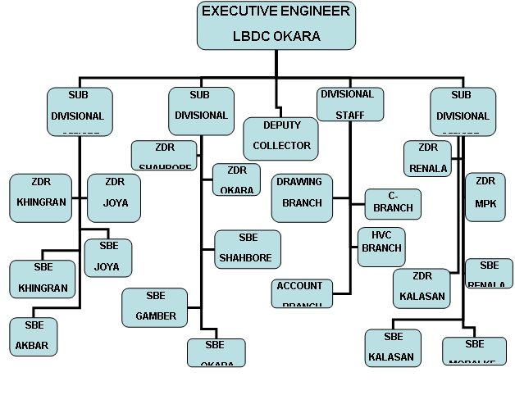

# (CHAPTER#2)

# FLOOD PROTECTION AND RIVER TRAINING WORKS OF OKARA CANAL DIVSION

## 2.1 Design Parameter of River Training Works

|  |  |  |  |  |  |  |  |
| --- | --- | --- | --- | --- | --- | --- | --- |
| **Sr.**  **No.** | **Type Of Work** | **Structure** | **Design Data** | | | | |
| **Length**  **(mile)** | **Top Width**  **(ft)** | **FREE BOARD**  **(ft)** | **Side slope** | |
| **River** | **Country** |
| A. | Flood Protection works | Jandraka Flood Bund. | 18.05 | 20.0 | 6.0 | 3:1 | 2:1 |
| B. | River Training Works | Jandraka  J – Head Spur | 0.75 | 25.0 | 5.0 | 3:1 | 2:1 |
| Kund Bohar  J- Head spur  No .1 | 0.60 | 25 | 5.0 | 3:1 | 2:1 |
| Kund Bohar  J- Head spur  No .2 | 0.50 | 25 | 5.0 | 3:1 | 2:1 |
| Mari Pattan  J-Head Spur | 1.07 | 25 | 5.0 | 3:1 | 2:1 |
| Nota Khichi  J- Head Spur | 0.50 | 25 | 5.0 | 3:1 | 2:1 |
| Miran shah  J- Head Spur | 1.42 | 25.0 | 5.0 | 3:1 | 2:1 |
| C. | Stone Stud | 8 Nos solid stone stud | 2.52 | -- | -- | -- | -- |
|  |  | Armed stone stud |  |  |  |  |  |
| D. | Stone Stud | 11 NOS STONE STUD NEAR VILLAGE CHAKERKEY |  |  |  |  |  |
|  |  | **Total** |  | -- | -- | -- | -- |

## 2.2 Location Map/Index Plan

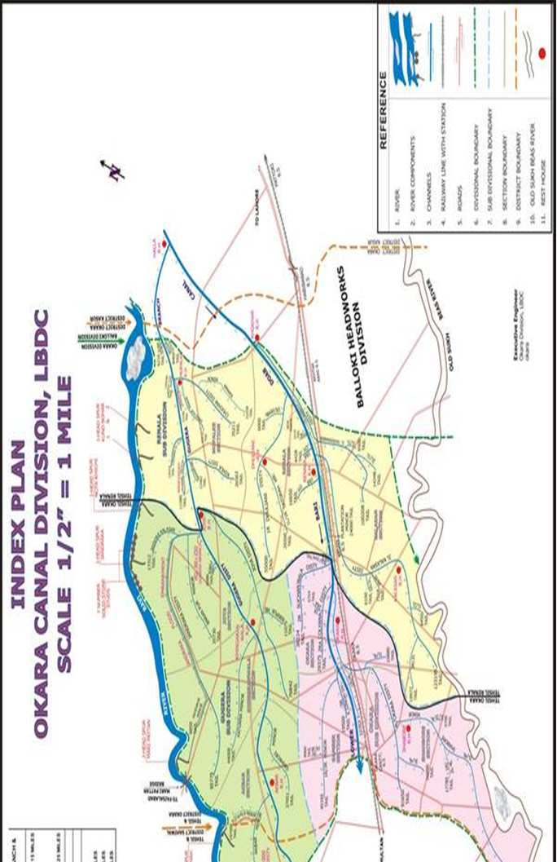

# (CHAPTER#3)

# BRIEF HISTORY OF PAST FLOOD EVENTS

Flood damages in this area have an old history which starts from the year 1955. During the year 1955, a heavy flood in river Ravi at Balloki Headwords was recorded as 204360 Cs. A huge area and infrastructure was damaged in Okara and Renala Tehsils.

Similarly, in 1975, the river Ravi with its discharge of 180205 Cusecs at Balloki badly affected various villages in Okara District. Again in 1988, an unprecedented discharge of about 389345 Cusecs in Ravi at Balloki Headworks caused heavy damages to human, animal lives, crops and houses. The town of Renala and Basti Lal Shah were also affected due to breach in LBDC.

In 2010, 2011 & 2012 no flood damages occurred. In 2013 the river Ravi with its discharge of 1,17,770Cs,at D/S Balloki Head Works affected many villages/abadies& damaged the river training structures i.e. Kund Bohar Spur No.2 & Miran shah J-Head Spur.

Similarly, in 2014, the river Ravi with its discharge of 131800 Cs at D/S Balloki Head Works affected various villages and damaged the Miran shah J-Head Spur.

# (CHAPTER#4)

# DESIGN DATA, HISTORIC PEAK FLOOD DATA AND PREVIOUS FIVE YEARS FLOOD DATA OF HEAD WORKS/BARRAGES AND OR OTHER CONTROL POINTS

## 4.1 Flood Limits

|  |  |  |  |  |  |
| --- | --- | --- | --- | --- | --- |
| **Point** | **Low Flood (Cs)**  **1st Stage** | **Medium Flood (Cs)**  **2nd Stage** | **High Flood (Cs)**  **3rd Stage** | **VERY High Flood (Cs)**  **4th Stage** | **Exceptionally High Flood (Cs)**  **5th Stage** |
| Jassar | 50000-75000 | 75000-100000 | 100000-150000 | 150000-200000 | Above 200000 |
| Shahdra | 40000-65000 | 65000-90000 | 90000-135000 | 135000-180000 | Above 180000 |
| Balloki | 40000-65000 | 65000-90000 | 90000-135000 | 135000-180000 | Above 180000 |

## 4.2 Time Lags of Floods

|  |  |  |  |  |
| --- | --- | --- | --- | --- |
| **Location** | | **Distance (Miles)** | **Time Lag ( Hours)** | |
| **From** | **To** | **Low** | **High** |
| Balloki | Jandraka | 40 | 12 Hours | 10 Hours |
| Jandraka | Miran shah | 17 | 8 Hours | 1. Hours |

## 4.3 Highest Floods

|  |  |  |
| --- | --- | --- |
| **Year** | **U/S Discharge at Balloki**  **Head Works** | **D/S Discharge at Balloki**  **Head Works** |
| 1973 | 298000 Cs | 183000 Cs |
| 1975 | 180205 Cs | 180205 Cs |
| 1976 | 255974 Cs | 234474 Cs |
| **1988** | **389345 Cs** | **240854 Cs** |
| 1995 | 222800 Cs | 222800 Cs |
| 1996 | 222000 Cs | 220000 Cs |

## 4.4 Peak Discharges

|  |  |  |
| --- | --- | --- |
| **Year** | **U/S Discharge at Balloki**  **Head Works** | **D/S Discharge at Balloki**  **Head Works** |
| 1950 | 275540 Cs | 125540 Cs |
| 1954 | 175000 Cs | 175000 Cs |
| 1955 | 204360 Cs | 144360 Cs |
| 1957 | 168700 Cs | 168700 Cs |
| 1973 | 298000 Cs | 183000 Cs |
| 1975 | 180205 Cs | 180205 Cs |
| 1976 | 255974 Cs | 234474 Cs |
| **1988** | **389345 Cs** | **240854 Cs** |
| 1996 | 222000 Cs | 220000 Cs |
| 1997 | 173500 Cs | 173500 Cs |
| 1998 | 90470 Cs | 68470 Cs |
| 1999 | 74780 Cs | 43980 Cs |
| 2000 | 71530 Cs | 46400 Cs |
| 2001 | 76240 Cs | 61020 Cs |
| 2002 | 54880 Cs | 54880 Cs |
| 2003 | 64440 Cs | 40237 Cs |
| 2004 | 70045Cs | 38145 Cs |
| 2005 | 48275Cs | 16125 Cs |
| 2006 | 55020Cs | 22020 Cs |
| 2007 | 64145Cs | 36645 Cs |
| 2008 | 81285Cs | 57735 Cs |
| 2009 | 45500Cs | 14000 Cs |
| 2010 | 62155Cs | 33455 Cs |
| 2011 | 72642Cs | 43942 Cs |
| 2012 | 60764 Cs | 29264 Cs |
| 2013 | 117770 Cs | 97970 Cs |
| 2014 | 131800 Cs | 118000 Cs |
| 2015 | 70650 Cs | 53650 Cs |
| 2016 | 60425 Cs | 27325 Cs |
| 2017 | 68140 Cs | 35345 Cs |
| 2018 | 53595 Cs | 21995 Cs **(Low flood)** |
| 2019 | 53200 Cs | 34900 Cs |
| 2020 | 63250 Cs | 37250 Cs |
| 2021 | 60879 Cs | 32200 Cs |
| 2022 | 52435 Cs | 35235 Cs |

# (CHAPTER#5)

# FLOOD FIGHTING STRATEGY FOR RIVER RAVI D/S BALLOKI IN OKARA

## STAGE-I: Discharge from 0.40 LAC CS to 0.65 LAC. Cs.

During low flood, watching staff & Sub Engineer concerned section will supervise operation of the left flank of river in this jurisdiction Sub Divisional Officer concerned will act as the officers in charge of watching operation.

## STAGE-II: Discharge from 0 .65 LAC Cs to 0.90 LAC Cs.

During medium flood, watching staff shall be deployed one man per mile. Supervisory staff shall be the regular and work charge as per limits same as in Stage-I.

## STAGE-III: Discharge from 0.90 LAC Cs to 1.35 LAC Cs.

Watching establishment shall be increased to three times than that of Stage-2 i.e. all establishment of respective Sub Division and work charge establishment shall be engaged at site as required.

Sub Divisional Officer Renala and Gugera will be the officer in-charge of watching operation on the left flank.

## STAGE-IV: Discharge from 1.35 LAC Cs to 1.80 LAC Cs.

At this stage watching establishment will be increased to five time than that of stage No. 2 i.e. all establishment of concerned Sub Division and work charge establishment shall engaged at site for requirements. Sub Divisional Officer Renala and Gugera will be the office in charge pending of watching operation on left flank, over all supervision of all operations will be done by the Executive Engineer Okara.

## STAGE-V: Discharge Exceeding 1.80 LAC Cs.

At this stage including regular work charge month volunteer labors brought by civil administration Army will also help in watching operation. Police guards will be deputed on vulnerable points to guard against any mishap/sabotage. Overall the engineer in charge Executive Engineer Okara will supervise this operation.

# (CHAPTER#6)

# FLOOD DAMAGES RESTORATION WORKS

No damages during flood season 2022.

# (CHAPTER#7)

# FLOOD WATCHING ARRANGEMENT

All the flood works have been checked and found in satisfactory condition. Camp sites have been identified available flood fighting material has also been checked. Request for fund to replenishing the flood fighting material has been placed.

## 7.1 Pre-Flood Arrangements

## Updated Status of Reserve Stock of Stone

|  |  |  |  |
| --- | --- | --- | --- |
| **Sanctioned Reserve Stock of stone** | **Available Quantity** | **deficient Quantity** | **Remarks** |
| 4.600 Lac cft | 4.058 Lac cft | 0.590 Lac cft | Will be arranged in current financial year |

## Reserve Stock Limits

|  |  |  |  |  |  |  |
| --- | --- | --- | --- | --- | --- | --- |
| **Sr.**  **No.** | **Description** | **Designed Approved** | **Total Quantity Required During YEAR**  **2021-22** | **Available Quantity of Reserve Stock** | **Balance Quantity  Required** | **Remarks** |
| 1 | 11Nos Solid Stone Studs near Village Chaker Key | 1.100 Lac Cft | 1.100 Lac Cft | 1.100 Lac Cft | 0 Lac Cft |  |
| 2 | J-Head spur Kund Bohar (Old) | 0.500 Lac Cft | 0.500 Lac Cft | 0.475 Lac Cft | 0.025 Lac Cft. | Required restacking not accountable |
| 3 | J-Head spur Kund Bohar (New) | 0.500 Lac Cft | 0.500 Lac Cft | 0.447 Lac Cft | 0.053 Lac Cft. |  |
| 4 | J-Head spur Nota Khichi | 0.500 Lac Cft. | 0.500 Lac Cft | 0.548 Lac Cft | 0.000 Lac Cft | Required restacking not available |
| 5 | J-Head spur Jandraka | 0.500 Lac Cft | 0.500 Lac Cft | 0.496 Lac Cft | 0.004 Lac Cft | Required restacking not available |
| 6 | J-Head spur Mari Pattan | 0.500 Lac Cft. | 0.500 Lac Cft. | 0.376 Lac Cft. | 0.124 Lac Cft | Required restacking not available |
| 7 | J-Head spur Miran Shah | 1.000 Lac Cft.. | 1.000 Lac Cft | 0.616 Lac Cft. | 0.384 Lac Cft |  |
|  | **Total** | **4.600 Lac Cft.** | **4.600 Lac Cft.** | **4.058 Lac Cft** | **0.590 Lac Cft** | 88% |

## 7.2 Watching Establishment

|  |  |  |  |  |  |  |  |  |  |  |
| --- | --- | --- | --- | --- | --- | --- | --- | --- | --- | --- |
| **Site** | **Flood Limits** | | | | | | | | | |
| **Low** | | **Medium** | | **High** | | **Very High** | | **Exceptionally high** | |
| **Men** | **Shift** | **Men** | **Shift** | **Men** | **Shift** | **Men** | **Shift** | **Men** | **Shift** |
| 11Nos Solid Stone Studs near Village Chaker Key |  |  |  |  |  |  |  |  |  |  |
| Kund Bohar # 1 | 4 | 2 | 6 | 3 | 8 | 3 | 10 | 3 | 12 | 3 |
| Kund Bohar # 2 | 4 | 2 | 6 | 3 | 8 | 3 | 10 | 3 | 12 | 3 |
| 8 Nos Solid Stone Stud, 3 No. armed stone stud | 3 | 2 | 4 | 3 | 6 | 3 | 8 | 3 | 10 | 3 |
| J- Head Spur Nota Khichi | 4 | 2 | 6 | 3 | 8 | 3 | 10 | 3 | 12 | 3 |
| J – Head Jandraka Spur | 4 | 2 | 6 | 3 | 8 | 3 | 10 | 3 | 12 | 3 |
| Jandraka Flood Bund. | 8 | 2 | 12 | 3 | 14 | 3 | 16 | 3 | 30 | 3 |
| J-Head Spur Mari Pattan | 6 | 2 | 8 | 3 | 6 | 3 | 10 | 3 | 12 | 3 |
| J- Head Spur Miran Shah | 6 | 2 | 8 | 3 | 6 | 3 | 10 | 3 | 14 | 3 |

***Note:***

1. *The Executive Engineer Okara Division may employ further work charge establishment as per site situation.*
2. *S.D.O Gugera and Renala will employ watching establishment as per strength mentioned above subject to approval from competent authority.*
3. *In case of very high flood, the strength of establishment will be increased with the permission of Executive Engineer.*

## 7.3 Arrangement at Sensitive Sites

1. Camp site has been identified as under and necessary watching material will be placed at each camp sites

|  |  |  |  |
| --- | --- | --- | --- |
| **Structure** | **Reach** | **Length (Miles)** | **Camp Site** |
| Jandraka flood bund. | RD 0+000-RD 90+250 | 18.05 | At RD 54+000 |
| J – Head Jandraka Spur | RD 0+000-RD 3+770 | 0.75 | At RD 3+500 |
| Kund Bohar No.1 | RD 0+000-RD 3+000 | 0.60 | At RD 3+000 |
| Kund Bohar No. 2 | RD 0+000-RD 2+500 | 0.50 | At RD 2+500 |
| J-Head Spur Mari Pattan | RD 0+000-RD 5+360 | 1.07 | At RD 4+360 |
| J- Head Spur Nota Khichi | RD 0+000-RD 2+500 | 0.50 | At RD 2+500 |
| J- Head Spur Miran shah | RD 0+000-RD 7+500 | 1.42 | At RD 7+500 |
| 11 Nos solid stone stud | -- | 1.00 |  |

1. The Sub Divisional officer Renala Sub Division will be over all In-charge of all operation on river training works in his jurisdiction.
2. J-Head Spur Kund Bohar No. 1
3. J-Head Spur Kund Bohar No. 2
4. 11 Nos stone studs
5. The Sub Divisional officer Gugera Sub Division will be the overall In-charge of all operation on river training work in this jurisdiction.
6. Nota Khichi J-Head Spur
7. Stone Stud
8. J-Head Spur Jandraka
9. Jandraka Flood Bund
10. J-Head Spur Mari Pattan
11. J-Head Spur Miran Shah
12. There will be the provision for engagement of work charge establishment to supplement the efforts through regular establishments.
13. Sub Divisional Officers will remain in touch with flood control officer at Okara & Renala during flood period.
14. S.D.O Okara, with his Sub Engineers, will be ready to associate the S.D.O Gugera for assistance in case of emergency.
15. The Executive Engineer Okara is fully competent to change duty of any officer/officials.
16. The Executive Engineer Okara Division will be overall In-charge and will stay at Head Quarter during flood days. He will take appropriate action according to the severity of the emergency.

## 7.4 Watching Material

|  |  |  |  |  |  |  |
| --- | --- | --- | --- | --- | --- | --- |
| **Sr. No.** | **Name of Articles** | **Required** | **Available** | **Balance** | **Location** | **Remarks** |
| 1 | Kassies with handle | 40 No. | 10 No. | 30 No. | All material is Available at Joya Canal Rest house. | Balance Material will be arranged before the starting of Flood Season 2023 |
| 2 | Buckets | 25 No. | 0 No. | 25 No. |
| 3 | Torches | 30 No. | 08 No. | 22 No. |
| 4 | Dry Batteries | 10 Dozens | - | 10 Dozen |
| 5 | Lanterns | 20 No. | 12 No. | 08 No. |
| 6 | Toot Basket | 100 No. | 0 No. | 100 No. |
| 7 | Chimney for lanterns | 44 No. | 06 No. | 38 No. |
| 8 | Gunny bags/Jute | 500 No. | 0 No. | 500 No. |
| 9 | Hammer with handle | 06 No. | 0 No. | 06 No. |
| 10 | K-oil | 200 Liters | - | 200 No. |
| 11 | Motor Boats | 02 No. | - | 02 No. |
| 12 | Tents | 6 No. | - | 06 No. |
| 13 | Manila Rope | 300 Meters | - | 300 Meters |
| 14 | Sounding Rod | 04 No. | - | 04 No. |
| 15 | Tables | 10 No. |  | 10 No |
| 16 | Chairs | 20 No. |  | 20 No. |
| 17 | Generator with petrol | 1 No |  | 1 No. |
| 18 | Diesel | 1000 Letr |  | 1000 Letr |

## 7.5 Arrangement for sounding & probing

Necessary arrangement for Sounding and probing will be made accordingly before the start of coming flood season.

## 7.6 Lighting Arrangement

Two No Generators are already available and will be shifted at sites according to the requirement lanterns for each camp site have also been purchased and will be shifted as per requirement.

## 7.7 Ration Arrangement

Necessary arrangement will be made at site for establishment as per requirement during the emergency period.

## 7.8 P.O.L Arrangement for Vehicle

Grant under Head POL has already been received from the Higher Office for running Government Jeeps but it is insufficient for extensive touring/watching in flood days.

## 7.9 Transportation

All the watching Labor will be engaged locally as well as through contractor. The entire regular establishment will be mobilized be motor cycles. All officers have their own Government Vehicles, which are in good running condition. If more transport is required, the Civil Administration will be requested to arrange the transport.

## 7.10 Law and Order

Maintenance of law and order is the core responsibility of District Administration and Police, for which both the agencies requested to Law and Order situation will be to match.

## 7.11 Medical Arrangement for labour

District Health Officer will be requested to establish a medical camp for the labor during the flood season as per site condition.

## 7.12 Liaison with other Departments

Necessary liaison with all the District Heads will be made during flood situation. Telephone Nos. of all Departments are attached at page No. 19.

## 7.13 Role of the Army

All the evacuation plans will be executed by the Army during flood emergency. The flood bunds have also been checked by the army before the coming flood season.

## 7.14 Duties of Telephone Attendant

Detail of Telephone attendants are as under: -

|  |  |  |  |  |
| --- | --- | --- | --- | --- |
| **Sr.**  **No.** | **Name of Person** | **Period** | **Time** | |
| **From** | **To** |
| 1 | Muhammad Khaliq and Shamaila Yousaf T.A, with Shahbaz Ahmed Naib Qasid. | 15-06-2023 TO15-10-2023 | 6:00 A.M | 3:00 P.M |
| 2 | Muhammad Afzal T.A | 01-07-2023 TO 31-07-2023 | 3:00 P.M | 6:00 A.M |
| 3 | Muhammad Arif T.A | 01-08-2023 TO 31-08-2023 | 3:00 P.M | 6:00 A.M |
| 4 | Abdul Ghaffar T.A Shahbore | 01-09-2023 TO 30-09-2023 | 3:00 P.M | 6:00 A.M |
| 5 | Muhammad Aslam T.A Kalassan | 01-10-2023 TO 15-10-2023 | 3:00 P.M | 6:00 A.M |

## 7.15 Wireless Arrangements

Wireless sets will be installed in the Officers vehicles i.e. Executive Engineer, Sub Divisional Officers before the commencement of flood seasons by Police Department i.e. during 1st week of June.

# (CHAPTER#8)

# DETAIL OF ENCROACHMENTS

|  |  |  |  |
| --- | --- | --- | --- |
| **Total Encroachments** | **Removed** | **Remaining** | **Action to be taken** |
| Nil | Nil | Nil | Nil |

# (CHAPTER#9)

# DUTY ROSTER/FLOOD FIGHTING PROGRAM

The flood area, under the control of this Division, is divided into three sectors. Each sector is assigned to one Sub Divisional officer who will shift his headquarter in field. Detail of sectors is given below: -

|  |  |  |  |
| --- | --- | --- | --- |
| **Sector** | **Officer incharge** | **Staff** | **Reach to be controlLed** |
| 1 | Sub Divisional Officer Renala Sub Division. | Sub Engineers of Renala Sub Division | J- Head Spur Kund Bohr No.1.  J- Head Spur Kund Bohr No.2.  11 Nos stone stud |
| 2 | Sub Divisional Officer Gugera Sub Division. | Sub Engineers of Gugera Sub Division | Jandraka Flood Bund.  J- Head Spur Jandraka.  J- Head Spur Nota Khichi.  J- Head Spur Mari Pattan  J- Head Spur Miran Shah. |
| 3 | Sub Divisional Officer Okara Sub Division. | Sub Engineers of Okara Sub Division | Will assist Sub Divisional Officer Gugera Sub Division, if required. |

The Sub Divisional Officer Gugera Sub Division, Sub Divisional Officer Renala Sub Division, Sub Engineer Mopalke, Sub Engineer Renala, Sub Engineer Joya, Sub Engineer Khingranwala and Sub Engineer Akbar Section will be the representatives of Department in the field and are entrusted with the job of supervision of flood works. The Sub Divisional Officer Okara Sub Division, with his headquarter at Okara, will be responsible to implement the instructions received from the higher authorities for flood protection measures during flood. He will give the information from telegraph office Okara and through police wireless at Okara to the following officers stationed at Sahiwal, Okara and Lahore.

* Superintending Engineer LBDC Circle Sahiwal.
* District Coordination Officer Okara.
* Flood emergency officer, Office of the Chief Engineer Irrigation Department, Sahiwal Zone, Sahiwal.

**(CHAPTER#10)**

# EMERGENCY TELEPHONE NUMBERS

## Irrigation Department

|  |  |  |  |  |  |
| --- | --- | --- | --- | --- | --- |
| **Sr. No.** | **Designation** | **Office** | **Telephone** | | |
| **Office** | **Residence** | **Mobile** |
| 1 | Chief Engineer | Sahiwal | 040-9200221 |  | 0300-8416196 |
| 2 | Chief Engineer | Multan | 061-9200144 |  | 0300-5532280 |
| 3 | Superintending Engineer | LBDC Circle Sahiwal | 040-9200210 | 040-9200212 | 0300-5459697 |
| 4 | Executive Engineer | Okara Division | 044 -9330009 |  | 0303-4937504 |
| 5 | Flood Emergency Officer | SDO Gugera | 044 -9330009 |  | 0311-3356484 |
| 6 | Sub Divisional Officer | Renala Sub Division | 044 -9330009 |  | 0345-7490533 |
| 7 | Sub Divisional Officer | Gugera Sub Division | 044 -9330009 |  | 0300-5019395 |
| 8 | Sub Divisional Officer | Okara Sub Division | 044 -9330009 |  | 0344-6399447 |
| 9 | Sub Engineer | Mopalkey Section | 044 -9330009 |  | 0300-7954630 |
| 10 | Sub Engineer | Renala Section | 044 -9330009 |  | 0304-4467197 |
| 11 | Sub Engineer | Joya Section | 044 -9330009 |  | 0300-7954630 |
| 12 | Sub Engineer | Khingranwala Section | 044 -9330009 |  | 0300-4156345 |
| 13 | Sub Engineer | Akbar Section | 044 -9330009 |  | 0349-4787707 |
| 14 | Sub Engineer | Gamber Section | 044 -9330009 |  | 0303-7703952 |
| 15 | Sub Engineer | Shahbore Section | 044 -9330009 | 0344-6811147 | 0344-6811147 |

## Civil Administration

|  |  |  |  |  |  |
| --- | --- | --- | --- | --- | --- |
| **S.No** | **Designation** | **Office** | **Telephone** | | |
| **Office** | **Residence** | **Mobile** |
| 1 | D.C. Okara | D.C. Okara | 044-9200025 | 044-9200026 | 0341-0922063 |
| 2 | A.C Okara | D.D.O (R) OKR | 044-9200252 | 0442-521929 | 0322-4921371 |
| 3 | D.P.O Okara | D.P.O Okara | 044-9200351 | 044-9200353 | 0332-1600777 |
| 4 | Inspector | Wireless Control Okara | 044-9200093 |  | 0345-7015027 |

## Army Authority

|  |  |  |
| --- | --- | --- |
| **Sr.No.** | **Designation** | **Office** |
| 1 | Okara Cantt | 61117 |
| 2 | 14-Division Okara Cantt | 61117-3127 |
| 3 | 40- Division | 61117-3227 |
| 4 | 105- Brigade Okara Cantt | 61117-4164 |
| 5 | 116-Engineer Okara | 61117-5184 |

# (CHAPTER#11)

# STANDARD OPERATING PROCEDURE(SOP) FOR BREACHING SECTIONS

## 11.1 History of Breaching Section

There is no breaching section on any site of the flood infrastructure in Okara Canal Division LBDC. Hence no need any arrangements.

## 11.2 Location, Design, Quantity and Variety of the explosive required for detonation

Not relevant

## 11.3 Arrangement of explosives and security of explosive stores

Not relevant

## 11.4 List of The Security Staff Along with Detail of Their Training Etc.

Not relevant

## 11.5 Detail of Mechanical Means as a Stand by Arrangements in Case of Detonation Failure

Not relevant

## 11.6 Duty Roster in Case of Critical Situation

Not relevant

## 11.7 Breaching Committee with Their Action Plan

Not relevant

## 11.8 List of The Villages Likely to Be Inundated in Case of Breach

Not relevant

## 11.9 Announcement and Detail of Evacuation Arrangements

Not relevant

**11.10** **Details of Coordination with Civil/Army Authorities**

Not relevant

## 11.11 Parallel Communication Arrangements

Not relevant

## 11.12 Index Plan of Breaching Sections

Not relevant

***Executive Engineer Superintending Engineer Chief Engineer***

*Okara Division LBDC Lower Bari Doab Canal Circle Irrigation Sahiwal Zone,*

*Okara Sahiwal Sahiwal*

# (CHAPTER#12)

# VULNERABLE SITES ON FLOOD BUND/STRUCTURES

## 12.1 Apprehended Breaches in Flood bund/structures

Jandraka Flood Bund may breach in reach RD 75+000 to RD 90+250 during exceptionally high flood

## Operation of breaching sections

NIL

## 12.3 Breaches Due to Rising of Flood Water, Deterioration Of Flood Bunds Etc.

There is no vulnerable site on Flood Bunds in Canal Division Okara and all the flood works are in satisfactory condition during medium-high flood. However, Jandraka Flood Bund may breach in reach RD 75+000 to RD 90+250 during exceptionally high flood.

# (CHAPTER#13)

# EMERGENCY CONTINGENCY PLAN FOR VULNERABLE SITE (JANDRAKA FLOOD BUND RD 75+000 to RD 90+250)

## 13.1 Plan Showing Route of Flood Water Coming Out of the Breach Supported with Levels

Plan showing route of water coming out of the breach is attached at Page No. 04 water Level at breach site will be 580.00 during the exceptionally high flood.

## 13.2 Detail of villages/ abadies likely to be affected and this should also be shown on the plan

Details of villages and abadies is as under: -

ThathaChannu, Faisalabad Road KM 92-93, Jandraka Disty, Thatha Tahir, Shareen, Mari, Baig Key.

## Strategy and action

### 13.3.1 Arrangements

All Flood Fighting Material along with watching establishments will be arranged before the commencement of flood period.

### 13.3.2 Establishment of Flood Fighting Camps

Special Flood Fighting camp will be established during high flood along with necessary flood fighting material and watching arrangements as under: -

|  |  |  |  |  |  |  |  |  |  |  |
| --- | --- | --- | --- | --- | --- | --- | --- | --- | --- | --- |
| **Site** | **Flood Limits** | | | | | | | | | |
| **Low Flood** | | **Medium Flood** | | **High Flood** | | **Very High Flood** | | **Exceptionally high Flood** | |
| **Men** | **Shift** | **Men** | **Shift** | **Men** | **Shift** | **Men** | **Shift** | **Men** | **Shift** |
| Jandraka flood bund. | 30 | 2 | 40 | 3 | 45 | 3 | 50 | 3 | 60 | 3 |

### 13.3.3 Duties of Officers/Officials and their Camp Sites

Sub Engineer Khingranwala along with regular establishment will reside at this camp. Sub Divisional Officer and Executive Engineer will watch this camp site regularly along with other camp site duties of Officers/Officials is as under: -

|  |  |  |  |
| --- | --- | --- | --- |
| **Sector** | **Officer In-charge** | **Staff** | **Reach to be controlled /Location** |
| 1 | **Muhammad Saeed**  SDO Gugera Sub Division.  Cell: 0300-5019395 | **Muhammad Anwar Lashari**  Sub Engineer of Mopalkey Section.  Cell: 0300-7954630 | 19 Nos stone stud |
| **Muhammad Anwar Lashari**  Sub Engineer of Joya Section.  Cell: 0300-7954630 | Jandraka flood bund  J-Head spur Nota Khichi |
| **Zaheer Ahmed Baber**  Sub Engineer of Khingranwala Section.  Cell: 0300-4156345 | Jandraka flood bund.  J- Head spur Mari Pattan |
| **M. Mustafa**  Sub Engineer of Akbar Section.  Cell: 0349-4787707 | J- Head spur Miran Shah |

### 13.3.4 Available Departmental Machinery

No departmental machinery is available but on request it can be arranged from Agriculture Department and Army with the help of Civil Administration.

### 13.3.5 Machinery Available from Private Source

Tractor Trolley, Excavators, Front blade Tractors etc. can be arranged from the private source.

### 13.3.6 & 13.3.7 Flood Fighting Material Required & Available (Camp/Site Wise)

Detail of flood fighting material required is as under: -

|  |  |  |  |  |  |  |
| --- | --- | --- | --- | --- | --- | --- |
| **Sr. No.** | **Name of Articles** | **Required** | **Available** | **Balance** | **Location** | **Remarks** |
| 1 | Kassies with handle | 40 No. | 10 No. | 30 No. | All material is Available at Joya Canal Rest house. | Balance Material will be arranged before the starting of Flood Season 2023 |
| 2 | Buckets | 25 No. | 0 No. | 25 No. |
| 3 | Torches | 30 No. | 08 No. | 22 No. |
| 4 | Dry Batteries | 10 Dozens | - | 10 Dozen |
| 5 | Lanterns | 20 No. | 12 No. | 08 No. |
| 6 | Toot Basket | 100 No. | 0 No. | 100 No. |
| 7 | Chimney for lanterns | 44 No. | 06 No. | 38 No. |
| 8 | Gunny bags | 500 No. | 0 No. | 500 No. |
| 9 | Hammer with handle | 06 No. | 0 No. | 06 No. |
| 10 | K-oil | 200 Liters | - | 200 No. |
| 11 | Motor Boats | 02 No. | - | 02 No. |
| 12 | Tents | 6 No. | - | 06 No. |
| 13 | Manila Rope | 300 Meters | - | 300 Meters |
| 14 | Sounding Rod | 04 No. | - | 04 No. |

## 13.4 Detail of other infrastructure like Electric, Sui Gas, Telephone installations, road network other buildings, Canals and drainage network

Detail of other infrastructure is as under: -

The major installations like electric transmission lines,Sui gas, telephone lines, road networks, other buildings, canals and drainage network, Jandraka Distributary and system, Okara-Faisalabad Road, Electric poles, Telephone, Petrol Pumps, Schools, Dispensaries, private houses etc in flood area.

***Executive Engineer Superintending Engineer Chief Engineer***

*Okara Division LBDC Lower Bari Doab Canal Circle Irrigation Sahiwal Zone,*

*Okara Sahiwal Sahiwal*

# (CHAPTER#14)

# ACTION PLAN

## 14.1 Re-Shuffling / Recouping Plan of Reserve Stone Departmentally

No re-shuffling/Recouping Plan of reserve stone departmentally as the stone is available on flood bund / spurs.

## 14.2 Detail of Inlet / Outlet Crossing Along with Closing Methodology

There is no inlet / outlet crossing with closing methodology in this Division**.**

## 14.3 Deployment of Machinery (Medium to high flood)

|  |  |  |  |  |
| --- | --- | --- | --- | --- |
| **Machinery Deployed** | | | | |
| **Excavator** | **Dozer** | **Trolleys / Dumpers** | **Tractor with front blade** | **Labour (Beldar + Mate)** |
| 1 | -- | 1 | 1 | 12+1 |

## 14.4 Deployment of Machinery (High to very high flood)

|  |  |  |  |  |
| --- | --- | --- | --- | --- |
| **Machinery Deployed** | | | | |
| **Excavator** | **Dozer** | **Trolleys / Dumpers** | **Tractor with front blade** | **Labour (Beldar + Mate)** |
| 2 | -- | 2 | 2 | 24+2 |

## 14.5 Deployment of Machinery (High to exceptionally high flood)

|  |  |  |  |  |
| --- | --- | --- | --- | --- |
| **Machinery Deployed** | | | | |
| **Excavator** | **Dozer** | **Trolleys / Dumpers** | **Tractor with front blade** | **Labour (Beldar + Mate)** |
| 4 | 2- | 4 | 4 | 36+3 |

## Note: Payment for machinery and work charge employing subject to verification by TPM / Department.

## Police Deployment Plan



## 14.7 Details of Synthetic Bags with Capacity of 500 Kg and 1000 Kg

Not required to this Division.

## 14.8 The Details of Polythene Sheet of Black Color to Protect Upstream Slope Against Wave Action and to Control Seepage Through Embankments

Not required to this Division.

# (CHAPTER#15)

# BACK UP DIVISIONS (IN CASE OF BREACH)

In case of Breach and any mishap **Balloki Division** will be back up Division.