GOVERNMENT OF THE PUNJAB

IRRIGATION DEPARTMENT

FLOOD FIGHTING PLAN
2023

BALLOKI HEADWORKS DIVISION BALLOKI.
LOWER BARI DOAB CANAL CIRCLE SAHIWAL.
SAHIWALIRRIGATION ZONESAHIWAL.

INDEX

FLOOD FIGHTING PLAN2022

PART – A
Chapter | Description | Page No
1 | Salient feature of Balloki Headworks Division | 1-3
1.1 | Location
1.2 | General Description
1.3 | Administrative setup
2 | Flood Protection and River Training Works
2.1 | Design Parameter of Training Works | 4-5
2.2 | Location Map
3 | Brief History of Past Flood Events. | 6
4 | Designed Data, Historic Peak Flood Data and PreviousFive Years Flood Data of Headworks / Barrages and other Control Points.
4.1 | Flood Limits | 7-8
4.2 | Time lags of floods
4.3 | Highest Floods
4.4 | Peak Discharges
5 | Flood Fighting Strategy | 9-10
6 | Flood Damages Restoration Works | 11
7 | Flood Fighting Watching Arrangements, | 12-15
7.1 | Pre – Flood Arrangement
7.2 | Watching Establishment
7.3 | Arrangement at sensitive sites
7.4 | Watching Material
7.5 | Arrangement for Sounding &Probing
7.6 | Lighting Arrangement
7.7 | Ration Arrangements
7.8 | P.O.L Arrangement for Vehicle
7.9 | Transportation
7.10 | Law and Order
7.11 | Medical Arrangement for Labour
7.12 | Liaison with other Department
7.13 | Role of the Army
7.14 | Duties of Telephone Attendant
7.15 | Wireless Arrangements
8 | Detail of Encroachments | 16
9 | Duty Roster / Flood Fighting Programme | 17-20
10 | Emergency Telephone Nos. | 21

Chapter | Description | Page No
11 | Standard Operating Procedure (SOP) for Breaching Sections | 22-29
11.1 | History of the Breaching Section
11.2 | Location, Design, Quantity, and Variety of the Explosive required for detonation
11.3 | Arrangement of Explosives and Security of Explosive Stores
11.4 | List of the Security Staff alongwith Detail of their training etc.
11.5 | Detail of Mechanical Means as a Standby Arrangements in case of Detonation Failure
11.6 | Duty Roster in case of Critical Situation
11.7 | Breaching Committee with their Action Plan
11.8 | List of the villages likely to be inundated in case of breach.
11.9 | Announcement and Detail of Evacuation Arrangements
11.10 | Details of coordination with Civil/Army Authorities.
11.11 | Parallel Communication Arrangements
11.12 | Index Plan

PART – B
Chapter | Description | Page No
12 | Vulnerable sites on flood Bund /Structures: | 30-40
12.1 | Apprehended breaches in Flood Bunds/Structures.
12.2 | Operation of Breaching Sections.
12.3 | Breaches due to rising of flood water, deterioration of Flood Bunds etc.
13 | Emergency Contingency Plan for Vulnerable Sites
13.1 | Plan showing route of flood water coming out of the breach supported with levels
13.2 | Detail of Villages abadies likely to be affected and this should also be shown on the plan
13.3 | Strategy and action taken be explained in detail. This may include:
13.3.1 | Arrangements
13.3.2 | Establishment of Flood Fighting Camps
13.3.3 | Duties of officers/officials and their camp sites
13.3.4 | Departmental Machinery available.
13.3.5 | Machinery available from private source
13.3.6 | Flood fighting material required
13.3.7 | Flood fighting material available
13.4 | Detail of other infrastructure like Electric, Sui Gas, Telephone installations, Road Network, other Building, Canal and Drainage network
 | ADDITIONAL INFORMATION
14 | ACTION PLAN | 41-44
14.1 | Re-shuffling / Recouping plan of Reserve Stock Stone Departmentally
14.2 | Detail of inlet/outlet crossing alongwith Closing Methodology
14.3 | Deployment Machinery(Medium to High Flood)
14.4 | Deployment Machinery(High to very High Flood)
14.5 | Deployment Machinery(High to Exceptionally High Flood)
14.6 | Police Deployment Plan
14.7 | Detail of synthetic bags with capacity of 500kg and 1000kg
14.8 | Detail of polythene sheet of black colour to protect upstream slope against wave action and control seepage through embankments
15 | Back up Division (In case of breach) | 45

PART –A

XEN/BLK

CHAPTER -1

SALIENT FEATURE OF BALLOKI HEAD WORKS

  - LOCATION:

BallokiHeadworks is located at about 42 Miles South-West of Lahore.

  - GENERAL DESCRIPTION:

River Ravi originates from the Himalayan Mountains at the basin of BadaBhangal Hill and then flows through the valley into the state Himachal Pardesh near Chamba District. It flows into South-West near Dallhousie before entering the Punjab plain near Modhupur, Pathankot and Gurdaspur Districts. It then flows along the Indo-Pak border for 80 km before entering Pakistan. River Ravi enters Pakistan territory at Shakargarh of District Sialkot. It enters Sheikhurpura District near Village Burj and then again enters Amritsar District of India After running ten miles in India, it again enters Pakistan territory near the Village Auliapur. River Ravi reaches at Shahdara, after travelling 72 miles from Jassarand then after running for few miles’ parallel to Lahore-Multan Road, it reaches Balloki Headworks with travelling distance of 54 miles. River Ravi passes through Okara, Sahiwal & Khanewal Districts and reaches at Sidhnai Barrage. Ultimately it falls into River Chenab downstream Sidhanai Barrage in Multan District.

TRIBUTARIES OF RIVER RAVI:
The River has following tributaries which contribute to its floods.
Sr.# | Name of Tributary | Length in  Miles | Average Slope 100 Ft. | Catchment Area in Sq. Miles | Likely Maximum in cusecs.
 | The Ujh. | 80 | 31.6 | 675 | 249,000
 | The Besin. | 48 | 5.9 | 346 | 128,000
 | Basanter. | 45 | 6.4 | 224 | 83,000
 | DegNallah. | 160 | 7.4 | 458 | 100,000
 | Hodiara Drain. | 62 | 0.25 | 583 | 10,000

XEN/BLK
1

BALLOKI HEADWORKS:
Balloki Headworks was constructed on River Ravi during the year 1911-13 as a component of Triple Canal Project to transfer water from Upper Chenab Canal (U.C.C)to Headworks for feeding the L.B.D.C due to insufficient flow of River Ravi. The Headworks was originally constructed for a designed capacity 1,39,000 Cs but later on it was remodeled during 1963-65 for design discharge of 2,25,000 Cs. Now the Headworks has been redesigned for 3,80,000 Cs by providing sixteen additional bays under the supervision of Project Director LBDCIP Lahore. Lower Bari Doab Canal and Balloki-Sulemanki Link off-take from left bank of Balloki Barrage.
Lower Bari Doab Canal was originally constructed for a discharge of 6900 Cs subsequently raised to 8640 Cs and in 1985-88 remodeled to 9,841 Cs. It irrigates 1.88 million acres fertile land of Kasur, Okara, Sahiwal and Khanewal Districts. Balloki-Sulemanki Link was constructed in 1952-54 with a designed capacity of 15,182 Cs to feed channels off-taking from Sulemanki Headworks due to stoppage of supplies in River Sutlej by Indian Government. B.S. Link was remodeled to 18,550 Cs in 1962-63 subsequently to 22,000 Cs capacity in 1987-88.This canal has been further remodeled to 24,500 Cs during the year 2004-2005. B.S Link is the source of supply for Pakpattan Canal, Fordwah Canal and Eastern Sadiqia Canal in Pakpattan, Vehari, Lodhran, Bahawalnagar and Bahawalpur Districts.
L.B.D.C system and B.S. Link Canal System Irrigates directly or indirectly about 4.7 million acres fertile lands of Kasur, Pakpattan, Sahiwal, Okara, Multan, Khanewal, Bahawalnagar, and Bahawalpur Districts. Balloki Barrage is thus serving about 23% of total Culturable Command Area (CCA) of Punjab (20.11 million acres) and 12.36 % of entire CCA of the country (38 Million acres) so this barrage contributes a lot in the agricultural production and economy of Pakistan.
SPILL WAY
Spillway is constructed on right side of main Barrage to enhance the discharge capacity of Balloki Headworks. Its construction was carried out during the year 2010 – 2019. It consists of 16 No. Bays having design discharge capacity of 1,20,000 Cusecs. Now the total designed capacity of the Barrage including spillway is about 3,80,000 Cusecs which is approximately equal to maximum flood discharge during 1988.

XEN/BLK
2
  - ADMINISTRATIVE SET UP

3 XEN/BLK
CHAPTER -2
FLOOD PROTECTION AND RIVER TRAINING WORKS

  - DESIGN PARAMETER OF TRAINING WORKS:

S. No. | Name of Bund | Off Take RD | Type | Length | Top Width | Side Slopes | Free Board
 | TEHSIL NANKANA
1 | Right Marginal Bund |  |  | 26,500 ft. | 25’ | 2:1/3:1 | 5’ above HFL 1988
2 | Right Guide Bund |  |  | 2,250 ft | 25’ | 2:1/3:1 | 5’ above HFL 1988
a | Spur No. 3 | 3400 RMB | T-Headed Now hockey | 1,300 ft. | 25’ | 2:1/3:1 | 5’ above HFL 1988
b | Spur No. 4 | 5900 RMB | J-Head | 2,300 ft. | 25’ | 2:1/3:1 | 5’ above HFL 1988
c | Prong Spur No. 4 |  | Mole Headed | 325 ft | 25’ | 2:1/3:1 | 5’ above HFL 1988
d | Spur No. 6 | 9250 RMB | -do- | 4,800 ft. | 25’ | 2:1/3:1 | 5’ above HFL 1988
e | Spur No. 5 | 17750 RMB | -do- | 5,360 ft. | 25’ | 2:1/3:1 | 5’ above HFL 1988
f | Spur No. 11 | 21600 RMB | -do- | 400 ft | 25’ | 2:1/3:1 | 5’ above HFL 1988
 | TEHSIL PATTOKI
3 | Left Marginal Bund |  |  | 28,350 ft | 25’ | 2:1/3:1 | 5’ above HFL 1988
4 | Left Guide Bund |  |  | 2,950 ft | 25’ | 2:1/3:1 | 5’ above HFL 1988
g | Spur No. 1 | 3220 LMB | T-Head | 4,064 ft | 25’ | 2:1/3:1 | 5’ above HFL 1988
h | Spur No. 2 | 8700 LMB | -do- | 3,380 ft | 25’ | 2:1/3:1 | 5’ above HFL 1988
i | Spur No. 8 | 12750 LMB | -do- | 2,800 ft. | 25’ | 2:1/3:1 | 5’ above HFL 1988
j | Spur No. 9 | 19825 LMB | Mole Headed | 3,265 ft | 25’ | 2:1/3:1 | 5’ above HFL 1988
k | Prong Spur No. 9 | 2000/spur 9 | J-Head | 2,800 ft. | 25’ | 2:1/3:1 | 5’ above HFL 1988
l | Spur No. 12 | 24100 LMB | Mole Headed | 1,500 ft | 25’ | 2:1/3:1 | 5’ above HFL 1988
m | Spur No.7 | 9000/R LBDC | T-Headed | 6,200 ft. | 25’ | 2:1/3:1 | 5’ above HFL 1988
n | Spur No. 7-A | 19500/R LBDC | Mole Headed | 5,400 ft | 25’ | 2:1/3:1 | 5’ above HFL 1988
o | Spur No. 7-B | 22-23/LBDC | J-Head | 9,200 ft | 25’ | 2:1/3:1 | 5’ above HFL 1988
 | TOTAL |  |  | 1,13,114 ft
 | SAY |  |  | 22.63 Mile

XEN/BLK

4

  - LOCATION MAP:

Color, Legend, Boundary

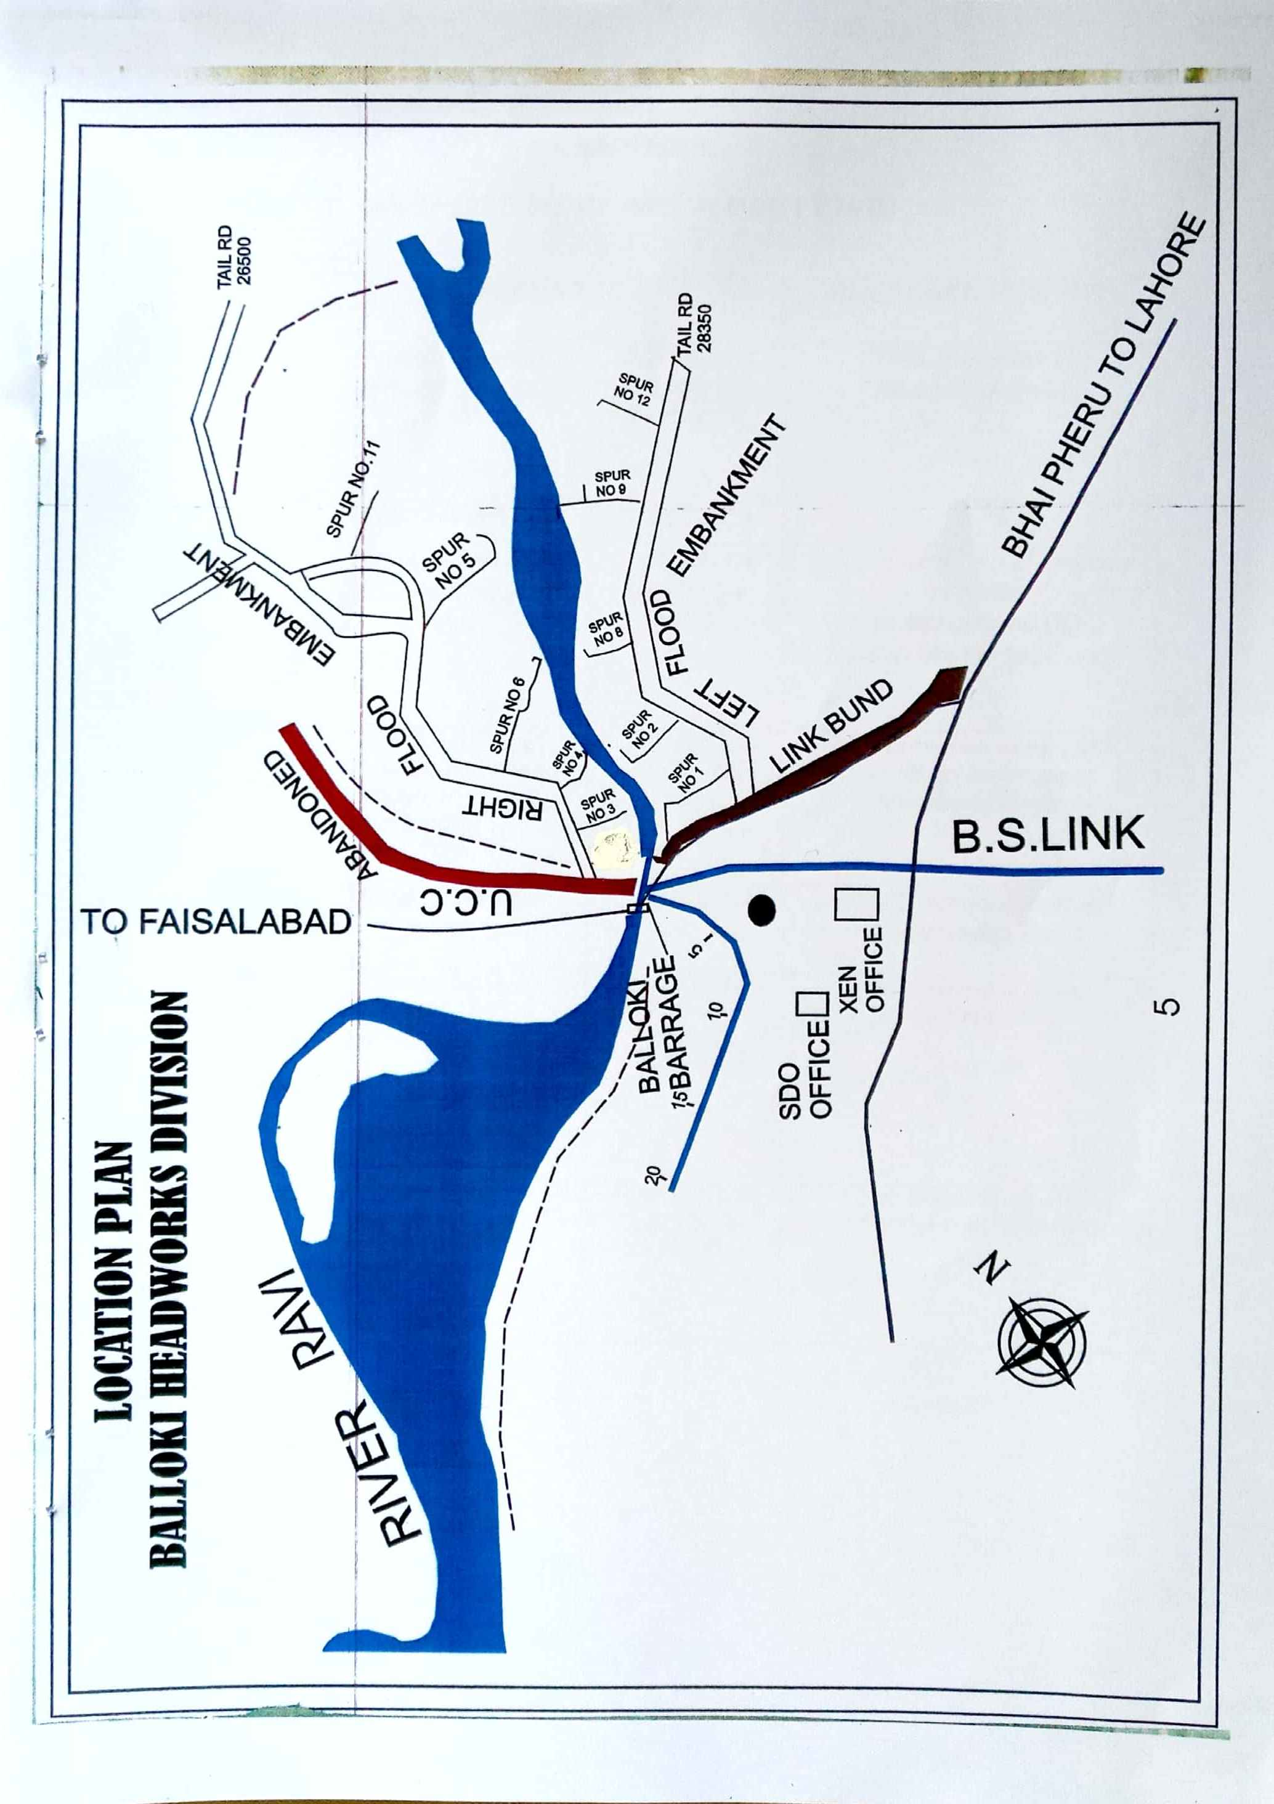

5

CHAPTER -3

BRIEF HISTORY OF PAST FLOOD EVENTS

YEAR | DISCHARGE |  | BREACHED REACHES
1950 | Through Barrage  Through Breaches  Total | 2,25,540 Cs  50,000 Cs  2,75,540 Cs | 7 No Breaches in  Madhudas Bund
1954 | Through Barrage | 1,75,000Cs
1955 | Through Barrage  Through Breaches  Total | 1,44,360 Cs  60,000 Cs  2,04,360 Cs | Breach occurred at junction of RMB and Abandoned UCC; and in Madhudas Bund.
1973 | Through Barrage  Through Breaches  Through Madhudas Bund  Total | 1,83,000 Cs  40,000 Cs  75,000 Cs  2,98,000 Cs | 7 No Breaches along LMB  and 10 No Breaches in Madhudas Bund.
1975 | Through Barrage | 1,80,205 Cs | 9 No Braches occurred  in Madhudas Bund
1978 | Through Barrage  Through LBDC  Through B.S.Link  Total | 2,34,474 Cs  2000 Cs  19,500 Cs  2,55,974 Cs | 7 No Breaches occurred  in Madhudas Bund
1988 | Through Barrage  Through Breaches  Total | 2,40,845 CS  1,40,000 Cs  3,80,845 Cs | 12 No Breaches occurred  in Reach RD 0-4500/RMB

XEN/BLK

6

CHAPTER -4

DESIGNED DATA, HISTORIC PEAK FLOOD DATA AND PREVIOUS 05 YEARS FLOOD DATA OF HEADWORKS AND OTHER CONTROL POINTS:

  - FLOOD LIMITS:

Since there is a Headworks / Barrage in the jurisdiction of Balloki Headworks Division. Therefore, this Division has to become active with respect to discharge upstream and downstream Balloki Headworks in River Ravi. The terminology of different kinds of flood is Low, Medium, High, Very High and Exceptionally High will be taken as under.

Site | Flood Limits in Lac Cs.
 | Low | Medium | High | Very High | Exceptionally High
River Ravi
Jassar Bridge | 0.50 | 0.75 | 1.00 | 1.50 | 2.00
Ravi Syphon | 0.40 | 0.65 | 0.90 | 1.35 | 1.80
Shahdara Bridge | 0.40 | 0.65 | 0.90 | 1.35 | 1.80
Balloki H/W | 0.40 | 0.65 | 0.90 | 1.35 | 1.80
Sidhnai Barrage | 0.30 | 0.40 | 0.65 | 0.90 | 1.20

  - TIME LAGS:
Sr. No. | Site | Distance  (Miles) | Time Lag  (Hours)
1 | Jassar to Shahdara | 72 | 36
2 | Shahdara to Balloki Barrage | 54 | 19
3 | Head Q.B Link to Balloki Barrage | 80 | 24
4 | Outfall of DegNullah | 35 | 16

XEN/BLK

7
  - HIGHEST FLOODS:

Year | Flood level |  | Through  Headworks | Through Breaches in Embankments |  | Through Canals |  | Total
 | U/S | D/S
 |  |  |  | Left Side | Right Side | LBDC | B.S.  Link
 |  |  | Cusecs | Cusecs | Cusecs | Cusecs | Cusecs | Cusecs
1950 | 636.50 | 634.70 | 2,25,540 | - | 50,000 | - | - | 2,75,540
1955 |  |  | 1,44,360 |  | 60,000 |  |  | 2,04,360
1973 | 636.50 | 633.70 | 1,83,000 | 40,000 | 75,000 |  |  | 2,98,000
1976 | 636.90 | 633.90 | 2,34,476 | - | 19,500 | 2,000 | - | 2,55,976
1988 | 638.00 | 636.50 | 2,40,845 | - | 1,40,000 | - | - | 3,80,845

4.4 PEAK DISCHARGE:
YEAR | DATE | DISCHARGE
 |  | U/S | D/S
2000 | 30.07.2000 | 71,530 | 46,530
2001 | 17.08.2001 | 76,240 | 46,940
2002 | 15.08.2002 | 57,710 | 28,110
2003 | 06.08.2003 | 74,000 | 44,700
2004 | 21.08.2004 | 71,825 | 40,425
2005 | 09.07.2005 | 53,285 | 25,185
2006 | 03.09.2006 | 67,530 | 41,280
2007 | 02.07.2007 | 65,365 | 37,865
2008 | 18.08.2008 | 90,740 | 67,190
2009 | 31.07.2009 | 46,000 | 14,000
2010 | 23.08.2010 | 69,935 | 41,235
2011 | 15.08.2011 | 72,642 | 43,942
2012 | 25.08.2012 | 62,165 | 30,565
2013 | 19.08.2013 | 1,17,770 | 97,970
2014 | 09.09.2014 | 1,31,800 | 1,18,000
2015 | 25.09.2015 | 73,740 | 57,740
2016 | 05.09.2016 | 43,465 | 29,740
2017 | 11.08.2017 | 69,890 | 36,790
2018 | 26.09.2018 | 67,560 | 39,310
2019 | 20.08.2019 | 53,200 | 34,900
2020 | 29.08.2020 | 63,250 | 37,250
2021 | 22.07.2021 | 59479 | 33,200
2022 | 03.08.2022 | 52435 | 35235

XEN/BLK
8
CHAPTER -5

FLOOD FIGHTING STRATEGY

Though all precautionary measures are adopted before flood season to face any alarming situation at Balloki Headworks, even then arrangements are necessary to avoid heavy damages and flood fighting strategy is adopted in such a way that flood water passes safely through Barrage, up to its limit.
LOW FLOOD
In low flood, river water remains within the deep channel and does not cause any problem, if regulation of gates is done as per rules. Watching establishment employed for this purpose will remain busy in removing jungle, filling gharas and porcupine holes if any.
MEDIUM FLOOD
When water increases beyond sixty thousand cusecs, it will start spreading on adjoining area and also touching the toe of bunds. Then it becomes necessary to be vigilant and watching of bunds will be started to avoid any leakage from bunds. Sub Engineers will shift their camps to sites as per duty roaster. Hourly gauges and discharges will be conveyed to civil administration and flood warning centers to inform public accordingly
HIGH FLOOD
When river water enters into high flood range, Sub Divisional Officer Akhtarabad will shift his camp at Balloki to supervise staff working on LMB and D/S spurs. In whole period, regulation will be done in such a way that silt deposit in front of canals may be washed D/S of the river to minimize silt entry in to canals. Silt contents in water will be checked thrice a day and if it exceeds the permissible limit, canals will be closed accordingly.
VERY HIGH FLOOD/EXCEPTIONALLY HIGH FLOOD
Gauges of different sites especially at RD:24+100 of LMB will be noted regularly and recorded. Executive Engineer will inform all agencies especially civil administration as well as Army about flood situation in rising position. In case of very high flood or exceptionally high flood, meeting will be held in field office with Army and Civil Administration to face the situation.

XEN/BLK

9

Two dozers will be kept ready at RD:17+750 RMB and RD:19+825/LMB for making cuts and closing breaches as and when required according to the circumstances When watertouches the level 644.50 of RD:24+100/LMB and is found in rising position, it will be the duty of Deputy Commissioner concerned to request Army for operation of breaching section for the safety of Headworks. When water subsides, the breaching sections will be closed (if operated) as soon as possible.

ARRANGEMENTS FOR MACHINERY FOR DIFFERENT STAGES OF FLOOD
FLOOD STAGE | MACHINERY REQUIRED | SITE OF DEPLOYMENT | REMARKS
Low Flood | NIL | NIL
Medium Flood | Excavator = 1 No.  Front Blade Tractor = 1 No.  Hydraulic Trolley = 3 No. | RD:17+750 RMB | Machinery will be hired through contractor
High Flood | Excavator = 2 No.  Front Blade Tractor = 2 No.  Hydraulic Trolley = 5 No. | RD:17+750 RMB  RD:19+825 LMB | -do-
Very High Flood | Excavator = 2 No.  Front Blade Tractor = 2 No.  Hydraulic Trolley = 5 No. | RD:17+750 RMB  RD:19+825 LMB | -do-
Exceptionally High Flood | Excavator = 2 No.  Front Blade Tractor = 2 No.  Hydraulic Trolley = 5 No. | RD:17+750 RMB  RD:19+825 LMB | -do-

Note: Payment will be made after verification of TPM / Departmental Committee.

XEN/BLK

10

CHAPTER -6

FLOOD DAMAGES RESTORATION WORKS

Project of rehabilitation and up gradation of flood embankments including LMB, RMB & their allied Spurs in Balloki Headworks Division has been carried out under LBDCIP.

XEN/BLK

11
CHAPTER -7
FLOOD FIGHTING / WATCHING ARRANGEMENT
  - PRE-FLOOD ARRANGEMENT:

- Soaking of wetting channels along LMB and RMB
- Painting data boards and gauges along LMB and RMB
- Strengthening weak sites of wetting channels and main embankments
- Installation of liners at approved breaching sites

ADDITIONAL INFORMATION REGARDING RESERVE STOCK OF STONE

S. No. | Name of Site | Sanctioned Reserve Stock of Stone  (Lac Cft) | Minimum Required  (Lac Cft) | Available Quantity  (Lac Cft) | Balance Quantity  (Lac Cft) | Remarks
1 | Near LGB U/S old RMB | 0.50 | 0.35 | 0.378 |  | Quantity of Reserve Stock of Stone available is 84% of sanctioned quantity while minimum requirement of Reserve Stock of Stone is 70%. So there is no need of purchasing Reserve Stone.
2 | Left Guide Bund D/S | 0.50 | 0.35 | 0.584
3 | Right Guide Bank U/S (Stone Yard) | 0.50 | 0.35 | 0.500
4 | RGB D/S | 0.50 | 0.35 | 0.500
5 | Spur No.3 | 0.30 | 0.21 | 0.208 | 0.002
6 | Spur No.4 | 1.00 | 0.70 | 0.742
7 | Spur No.4 Prong | 0.50 | 0.35 | 0.400
8 | Spur No.5 | 0.50 | 0.35 | 0.531
9 | Spur No.6 | 0.50 | 0.35 | 0.526
10 | Spur No.11 | 0.30 | 0.21 | 0.300
11 | Spur No.1 | 0.30 | 0.21 | 0.300
12 | Spur No.2 | 0.30 | 0.35 | 0.498
13 | Spur No.8 | 0.50 | 0.35 | 0.449
14 | Spur No.8 Prong Spur No.9 | 0.60 | 0.42 | 0.746
15 | Spur No.12 | 0.30 | 0.21 | 0.296
16 | Spur No.7 | 0.30 | 0.21 | 0.437
17 | Spur No.7A | 1.00 | 0.70 | 0.086 | 0.614
18 | Spur No.7B | 1.00 | 0.70 | 0.558 | 0.142
 | Total | 9.60  Lcft | 6.72  Lcft | 8.039  Lcft | 0.758  Lcft
7.2 WATCHING ESTABLISHMENT:
The watching establishment on marginal bunds is required to be employed in accordance with the approval given by Chief Engineer Irrigation Multan vide his letter No. 16746-49 dated 31-05-79.
XEN/BLK
12
7.3 ARRANGEMENTS AT SENSITIVE SITES:
i. The normal strength for watching at sensitive sites along flood protection and River training works will be doubled during high flood/ exceptionally high flood.
ii. The establishment can be increased after consultation with Executive Engineer Balloki Headworks Division Balloki in accordance with site requirements.
The same establishment will be responsible for maintenance of flood bunds and spurs. It will arrange minor repairs to bank top, side slopes, removal of Sarkanda etc. as shanks and on pitched part of spurs. Establishment will also be responsible for filling gharas / porcupine holes / rain cuts etc. as occurred due to rains during the monsoon season.
7.4 WATCHING MATERIAL:
Watching material, which will be placed at different hut sites, an additional material will also be required in order to meet with extraordinary worst situation and to recoup the site situation. Hence the following material will be kept ready in the Workshop for this purpose.
S.No. | MATERIAL | REQUIRED | AVAILABLE | BALANCE
1 | Kassies with Handles | 160 No. | 160 No. | NIL
2 | Shovels | 30 No. | 30 No. | NIL
3 | Axes with Handles | 100 No. | 100 No. | NIL
4 | Kerosene Oil. | 1000 GLN | 1000 GLN | NIL
5 | Ballies | 200 No. | 200 No. | NIL
6 | Sutli | 20 KG | 20 KG | NIL
7 | Buckets | 200 No. | 200 No. | NIL
8 | Needles | 20 DOZEN | 20 DOZEN | NIL
9 | Manila rope | 150 KG | 150 KG | NIL
10 | Hand Saw | 10 No. | 10 No. | NIL
11 | Hand Pumps | 6 No. | 6 No. | NIL
12 | Steel wire rope | 200 LFT | 200 LFT | NIL
13 | Munj Trungers | 200 No. | 200 No. | NIL

7.5 ARRANGEMENT FOR SOUNDING & PROBING:
The arrangement for sounding and probing will be taken up with the motor boat.
7.6 LIGHTING ARRANGEMENT:
To avoid all the chances of electricity break down, additional light arrangements parallel to existing system i.e. WAPDA will be arranged. For generating power, there will be very reliable generating set, with 2 No. standby units. At present we have got arrangements of sodium lights. All along the Barrage and Head Regulators of the canals, our own generating set is not in a position to generate such voltage, so the only alternative left with the system is to have separate ordinary lights / circuits at the Barrage. Generating set will be arranged through MIW Division and lightening arrangement will be done after its approval.
13 XEN/BLK

7.7 RATION PROGRAMME:
Ration will be arranged by the local agencies and through NGO’s etc.
7.8 P.O.L ARRANGEMENT FOR VEHICLE:
The stock of the POL will be arranged in workshop at Balloki Headworks for the vehicles of the Department.
  - TRANSPORTATION:

During flood when the discharge is likely to increase 1,35,000 Cs. All staff will be alert to face any emergent situation. The position of Transportation is as under.
Name of Vehicle | Demanded | Available | Balance Requirement
- Jeep | 6 | 3 | 3
- Pick up | 6 | 2 | 4
- Truck | 4 | - | 4
- Tractor and Trolleys | 4 | 1 | 3
- Motor Boat | 3 | 1 | 2

Sub Engineer Workshop (Mechanical) will be the Inchargeof this unit and all vehicles will be kept ready in the compound of Workshop. Balance requirement of vehicles will be arranged with the help of Deputy Commissioner.
7.11 LAW AND ORDER
The Deputy Commissioner has to make arrangement for the evacuation of the Public within LMB and RMB and the population coming on route of spill water. Military Authorities keeps ready for emergency operation. Police has to watch that no unauthorized cuts are made by public especially along LMB & RMB. Engineers 4-Corpsis responsible for energizing the Breaching Section, when water Level approaches 644.50 mark at the emergency/critical gauge installed at RD 24+100 LMB.

  - MEDICAL ARRANGEMENT FOR LABOUR:

During flood season there is very possibility of falling sick and incidents of snake bites are of common occurrence. To control all this, an equipped medical centre with adequate medicines and vaccine for the snake bites will be made available at site. There will be two M.B.B.S Doctors with 4 Dispensers out of which one Doctor and 2 Dispensers will perform the duty for 12 hours (with six hours interval). Their camp will be fixed at the Barrage. The Health Department arrange medical facilities when the discharge increases the limit of 135,000 Cs.
7.13 LIAISON WITH OTHER DEPARTMENT:
Executive Engineer, Balloki Headworks Division will keep liaison with the Civil and Army Authorities and will also keep the Superintending Engineer, LBDC, Sahiwal and Chief Engineer, Irrigation, Sahiwal Zone, Sahiwal fully apprised of the flood situation at Balloki Headworks.

XEN/BLK
14

  - ROLE OF ARMY:
There are two Breaching Sections located at RD 11-12 Right Marginal Bund and at RD 48-49 Madhudas Bund approved vide the Secretary Irrigation & Power Department Lahore Memo No.110/F-C-75/410-15/64/75.There is a critical gauge fixed at RD 24+100 of LMB when its level reaches to 644.50 and is in rising position, the breaching sections will be operated. These will be operated with the help of Army Headquarter 4-Corps as per standing instructions laid down in the above-mentioned letter. The floodwater escaping through breaching section will flow through the old course of the River and rejoin D/S Balloki Barrage.

  - DUTIES OF TELEPHONE ATTENDANT:
S.No. | NAME OF PERSON | PERIOD | TIME
1 | Rao Muhammad Shahid | 15.06.2023 to 15.10.2024 | 6.00 | 11.00
2 | Muhammad Nisar | 15.06.2023 to 15.10.2024 | 11.00 | 16.00
3 | Muhammad Iqbal | 15.06.2023 to 15.10.2024 | 16.00 | 21.00
4 | Muhammad Faizan | 15.06.2023 to 15.10.2024 | 21.00 | 2.00
5 | FaizRasool | 15.06.2023 to 15.10.2024 | 2.00 | 6.00

The Telephone attendants will remain present round the clock turn wise. They will receive gauges from all related stations and pass on to concerned quarters for necessary action.
  - WIRELESS ARRANGEMENTS:
The wireless sets will be provided by the Deputy Commissioner or Superintendent Police, Kasur before the coming flood season.

XEN/BLK

15
CHAPTER -8

DETAIL OF ENCROACHMENTS

The flood bunds and spurs are constructed to train the river and to ensure safe passage of the flood water. During flood season, inhabitants of riverian area will evacuate their houses and take shelter on the flood bunds alongwith their animals. However, no encroachments exist on the river training works / flood bunds in Balloki Headworks Division. A certificate is added in this respect.
CERTIFICATE

Certified that no encroachment exist on flood protection works in Balloki Headworks Division.
Executive Engineer
Balloki Headworks Division
Balloki
Sub Divisional Officer
Headworks Sub Division
Balloki

Superintending Engineer
Lower Bari Doab Canal Circle
Sahiwal
Chief Engineer
Irrigation, Sahiwal Zone
Sahiwal

16
CHAPTER -9
DUTY ROSTER / FLOOD FIGHTING PROGRAMME
Duty roaster for establishment required for watching arrangements in 3 shifts round the clock will be under the control of Incharge Sub Engineer Headworks Section & Sub Engineer Dhaya Section. S.D.O Headworks will be the overall Incharge and will exercise/surprise/check in their respective jurisdiction.
DUTY ROASTER FOR WATCHING OF BUNDS AND SPURS AT
BALLOKI HEADWORKS
(Left Marginal Bund and Allied Spurs)
- Reach A RD: 0- 13000 Spur No. 1,2& 8. = 4.6 Miles
- Reach B RD: 13000-19825 Spur No. 9 &Prong Spur RD:2000 = 4.0 Miles
- Reach C Spur No. 7, Spur No. 7-A and Spur No. 7-B = 4.2 Miles
=12.8 Miles
Sub Divisional Officer | Sub Engineer H/Quarter | Mate/  Mistary | Reach | LOW FLOOD 40000-65000 Cs
 |  |  |  | Watching Gang (Pt= permanent) (TY= Temporary)
 |  |  |  | 1st Shift |  |  |  |  |  | 2nd Shift |  |  |  |  | 3rd Shift
 |  |  |  | Pt: | Ty | Total |  |  | Pt: |  | Ty: | Total |  | Pt: |  | Ty: |  | Total
Sub Divisional Officer  H/works Sub Division. | Sub Engineer  Dhaya Section. | MistaryDhaya Section | Camp (i) | 1 | 5 |  | 6 | 1 |  |  | 5 | 6 |  | 1 |  |  | 5 |  | 6
 |  |  | Camp (ii) | 1 | 4 |  | 5 | 1 |  |  | 4 | 5 |  | 1 |  |  | 4 |  | 5
 |  |  | Camp (iii) | 1 | 4 |  | 5 | 1 |  |  | 4 | 5 |  | 1 |  |  | 4 |  | 5
Sub Divisional Officer  H/works Sub Division. | Sub Engineer  Dhaya Section. | MistaryDhaya Section | MEDIUM FLOOD 65000-90000 Cs
 |  |  | Camp (i) | 1 | 10 |  | 11 | 1 |  |  | 10 |  | 11 | 1 |  |  | 10 |  | 11
 |  |  | Camp (ii) | 1 | 8 |  | 9 | 1 |  |  | 8 |  | 9 | 1 |  |  | 8 |  | 9
 |  |  | Camp (iii) | 1 | 8 |  | 9 | 1 |  |  | 8 |  | 9 | 1 |  |  | 8 |  | 9
Sub Divisional Officer  H/works Sub Division | Sub Engineer  HallahSection. | MistaryDhaya Section | HIGH FLOOD 90000-135000 Cs
 |  |  | Camp (i) | 1 | 20 |  | 21 | 1 |  |  | 20 |  | 21 | 1 |  |  | 20 |  | 21
 |  |  | Camp (ii) | 1 | 16 |  | 17 | 1 |  |  | 16 |  | 17 | 1 |  |  | 16 |  | 17
 |  |  | Camp (iii) | 1 | 16 |  | 17 | 1 |  |  | 16 |  | 17 | 1 |  |  | 16 |  | 17

17 XEN/BLK

Sub Divisional Officer | Sub Engineer H/Quarter | Mate/  Mistary | Reach | VERY HIGH FLOOD 135000-180000 Cs.
 |  |  |  | Watching Gang (Pt= permanent) (TY= Temporary)
 |  |  |  | 1st Shift |  |  |  |  |  | 2nd Shift |  |  |  |  | 3rd Shift
 |  |  |  | Pt: | Ty | Total |  |  | Pt: |  | Ty: | Total |  | Pt: |  | Ty: |  | Total
Sub Divisional Officer  Akhtarabad Sub Division | SBE H/Plot Section  SBE Hallah Section  SBE Pakhi Section | MistaryDhaya Section | Camp (i) | 1 | 30 |  | 31 | 1 |  |  | 30 | 31 |  | 1 |  |  | 30 |  | 31
 |  |  | Camp (ii) | 1 | 24 |  | 25 | 1 |  |  | 24 | 25 |  | 1 |  |  | 24 |  | 25
 |  |  | Camp (iii) | 1 | 24 |  | 25 | 1 |  |  | 24 | 25 |  | 1 |  |  | 24 |  | 25
Sub Divisional Officer  Akhtarabad Sub Division | SBE H/Plot Sec:  HQ: RD:8750  SBE Hallah Sec:  HQ: RD:12750  SBE Pakhi Sec:  HQ: RD:19750  SBE Atkerian Sec:  HQ: Spur No.7-B |  | EXCEPTIONALLY HIGH FLOOD ABOVE 180000 Cs.
 |  |  | LMB RD:8750 | 1 | 40 |  | 41 | 1 |  |  | 40 |  | 41 | 1 |  |  | 40 |  | 41
 |  |  | LMB RD:12750 | 1 | 32 |  | 33 | 1 |  |  | 32 |  | 33 | 1 |  |  | 32 |  | 33
 |  |  | LMB RD:19750 | 1 | 32 |  | 33 | 1 |  |  | 32 |  | 33 | 1 |  |  | 32 |  | 33
 |  |  | Spur No.7B | 1 | 32 |  | 33 | 1 |  |  | 32 |  | 33 | 1 |  |  | 32 |  | 33

Note: Payment to work charge establishment hired for flood emergency will be made after verification by TPM / Departmental Committee.

XEN/BLK

18

DUTY ROASTER FOR WATCHING OF BUNDS AND SPURS AT
BALLOKI HEADWORKS
(Right Marginal Bund and Allied Spurs)
Reach A RD:15000 Spur No. 10,3 & 4. = 5.00 Miles
Reach B RD:15000-29500 Spur No. 6 & 5 = 5.58 Miles
= 10.58 Miles
Sub Divisional Officer | Sub Engineer H/Quarter | Mate/Mistry  H/W Section | Reach | Watching gangs.  (Pt= permanent Ty=Temporary )
 |  |  |  | 1st Shift |  |  | 2nd Shift |  |  |  |  | 3rd Shift
 |  |  |  | Pt: | Ty: | Total | Pt: | Ty: | Total |  |  | Pt: | Ty: |  |  | Total
Sub Divisional Officer  H/works Sub Division. | SBEH/works Section. | Mate/Mistry  H/W Section | LOW FLOOD 4000-6500 Cs.
 |  |  | A | 1 | 5 | 6 | 1 | 5 | 6 |  |  | 1 | 5 |  |  | 6
 |  |  | B | 1 | 5 | 6 | 1 | 5 | 6 |  |  | 1 | 5 |  |  | 6
Sub Divisional Officer H/works Sub Division. | SBE H/works Section. | Mate/Mistry  H/W Section | MEDIUM FLOOD 65000-90000 Cs.
 |  |  | A | 1 | 10 | 11 | 1 | 10 | 11 |  |  | 1 | 10 |  |  | 11
 |  |  | B | 1 | 10 | 11 | 1 | 10 | 11 |  |  | 1 | 10 |  |  | 11
Sub Divisional Officer H/works Sub Division. | H/W Sub Divn:SBEKhokhar Section | Mate/Mistry  H/W Section | HIGH FLOOD 90000-135000 Cs.
 |  |  | A | 1 | 20 | 21 | 1 | 20 |  | 21 |  | 1 |  | 20 |  | 21
 |  |  | B | 1 | 20 | 21 | 1 | 20 |  | 21 |  | 1 |  | 20 |  | 21
Sub Divisional Officer  Akhtarabad Sub Division | SBE Khokhar Sec:  SBE Bellewla Sec:  SBE H.Plot Sec: | Mate/Mistry  H/W Section | VERY HIGH FLOOD 135000-180000 Cs.
 |  |  | A | 1 | 20 | 21 | 1 | 20 |  |  | 21 | 1 |  |  | 20 | 21
 |  |  | B | 1 | 20 | 21 | 1 | 20 |  |  | 21 | 1 |  |  | 20 | 21

19XEN BLK
Sub Divisional Officer | Sub Engineer H/Quarter | Mate/Mistry  H/W Section | Reach | Watching gangs.  (Pt= permanent Ty=Temporary )
 |  |  |  | 1st Shift |  |  | 2nd Shift |  |  | 3rd Shift
 |  |  |  | Pt: | Ty: | Total | Pt: | Ty: | Total | Pt: | Ty: | Total
Sub Divisional Officer  Akhtarabad Sub Divn:  HQ at Field Office | SBE Khokhar Sec:  HQ at RD:5900  SBE Bellewala Sec:  HQ at RD:9250  SBE H/Plot Sec:  HQ at RD:17750  SBE Bellewala Sec:  HQ at RD:19750 |  | EXCEPTIONALLY HIGH FLOOD ABOVE 180000 Cs.
 |  |  | RMB RD:5900 | 1 | 40 | 41 | 1 | 40 | 41 | 1 | 40 | 41
 |  |  | RMB RD:9250 | 1 | 40 | 41 | 1 | 40 | 41 | 1 | 40 | 41
 |  |  | RMB RD:17750 | 1 | 40 | 41 | 1 | 40 | 41 | 1 | 0 | 41
Note:-
- All the Sub Engineers will perform their duties assigned above alongwith their establishment and necessary T & P.

- Executive Engineer, Balloki Headworks Division will be the overall Incharge of the whole operation during very high and exceptionally high flood.

- However the duties of remaining Sub Engineers of Balloki Headworks Division with their establishment will be called any time anywhere and at any point as desired and required by the SDO Incharge under intimation to Executive Engineer, Balloki Headworks Division; the Incharge of whole operation.
- Payment to work charge establishment hired for flood emergency will be made after verification by TPM / Departmental Committee.

Sub Divisional Officer , Executive Engineer,
Headworks Sub Division, Balloki Headworks Division
Balloki Balloki
20
CHAPTER -10
EMERGENCY TELEPHONE NUMBERS
S.# | Description | Mobile | Office/Residence
A | LAHORE D.D.CODE -042
 | Secretary IRR: Lahore |  | 99212118  99212117
 | Additional Secy: Admin: |  | 99212119  99212120
 | Chief Engineer Drainage &Flood |  | 99230602
 | Director Flood Lahore |  | 99231614  5431649
 | Flood Warning Centre |  | 99205368  9900139,153
B | SAHIWAL (DD CODE 040)
 | Chief Engineer, Irrigation, Sahiwal Zone, Sahiwal. | 0313-9190684 | 040-9200221
 | Executive Engineer (OP), Sahiwal Irrigation Zone,Sahiwal. | 0342-7670732
C | KASUR (DD CODE 049)
 | Executive Engineer, Headworks Balloki | 0336-6061655 | 4610300  4610399
 | S.D.O. Headworks Sub Division | 0333-4218413
 | Deputy Commissioner, Kasur |  | 9250143
 | Superintendent Police , Kasur |  | 9250137
 | Add. District Commissioner : (G) |  | 9250099
 | Superintendent D.C. Office |  | 9250120
 | Executive Engineer Irrigation Kasur |  | 9250201
 | Assistant Commissioner, Pattoki |  | 4424646
D | NANKANA DD CODE -056
 | Deputy Commissioner, Nankana |  | 2877018
 | Assistant Commissioner, Nankana |  | 2877117
 | Superintendent Police Nankana |  | 2870101
 | Superintendent D.C. Office |  | 2877043
 | District Officer (Rev) |  | 2875582
E | OKARA DD CODE- 044
 | Deputy Commissioner, Okara |  | 9200028
 | Assistant Commissioner, Okara |  | 9200255
 | Superintendent Police, Okara |  | 9200353
 | Superintendent D.C. Office |  | 9200257
 | District Flood Relief Officer |  | 9200251
 | Executive Engineer LBDC Okara Division irrigation |  | 9200147
F | MISCELLANEOUS
 | Chief Engineer Irrigation Multan |  | 061-9200144
 | S.E, LBDC, Circle Sahiwal | 0300-5459697 | 040-9200210
 | Executive Engineer, Sidhnai |  | 065-2441041
 | SDO Akhtarabad at Renala | 0300-4376225 | 0442-636018
21 XEN/BLK
CHAPTER -11

STANDARD OPERATING PROCEDURES (SOP) FOR BREACHING SECTIONS

  - HISTORY OF THE BREACHING SECTION:

There are two number of approved breaching sections. First one located between RD:48-49 of Madhudas Bund and 2nd at RD 11-12 of R.M.B. 2 No Sections having a length of 50 Ft at 200 Ft interval is to be ballast at each Breaching Section and will be breached when water level at RD:24+100 of LMB reaches 644.50 with reference to mean sea level and in rising position. There is shattered populated area just opposite the Breaching Section up to the outfall into River Ravi.

The operation of Breaching Section has to be done very carefully with prior warning to the inhabitants of the area. These breaching sections were operated during the year 1950, 1955, 1973, 1975, 1978 and 1988.First of all, the spill water passing through the breaching section will cross through the existing cut made in abandoned UCC, then it will cross Balloki-More Khunda Road at 3-4 places in reach RD 0-1, 1-2 and 2-3 Km. The top RL of this road is higher than the R.L of N.S.L varying from 8-10 feet.
The following strategy is proposed to combat the flood situation in case the breaching section is operated:
  - LOCATION, DESIGN, QUANTITY, AND VARIETY OF THE EXPLOSIVE
REQUIRED FOR DETONATION:

Design of Breaching Section has been revised due to rehabilitation work on Right Marginal Bund and Madhudas Bund. Available and required quantity as per new revised breaching scheme is as under: -
Sr. NO. | Name of Explosive/Accessories | Unit | QTY Required | QTY Available | Balance QTY required | Remarks
1 | Wax box | Kg | 4124 | 4124 | 0 | Departmental procedure for purchasing balance required quantity of explosive and accessories is in progress and will be completed before start of flood season 2023.
2 | EI Cable | Mtr | 6400 | 5750 | 650
3 | Detonator No.8( Plain ) | No. | 36 | 34 | 02
4 | Delay Detonator MS 5M | No. | 12 | 04 | 08
5 | Lehr Detonator GD /MS 5M | No. | 16 | 16 | 0
6 | Safety FuseNo.11 | Mtr | 455 | 0 | 455
7 | Detonating Cord | Mtr | 4400 | 0 | 4400
8 | Blasting machine | No. | 02 | 02 | 0

ARRANGEMENT OF EXPLOSIVES AND SECURITY OF EXPLOSIVE STORES:
Explosive store is located at Lahore in the supervision of Army Authority, which will be shifted at site (Balloki Headworks) during the flood season as per schedule.
22 XEN/BLK
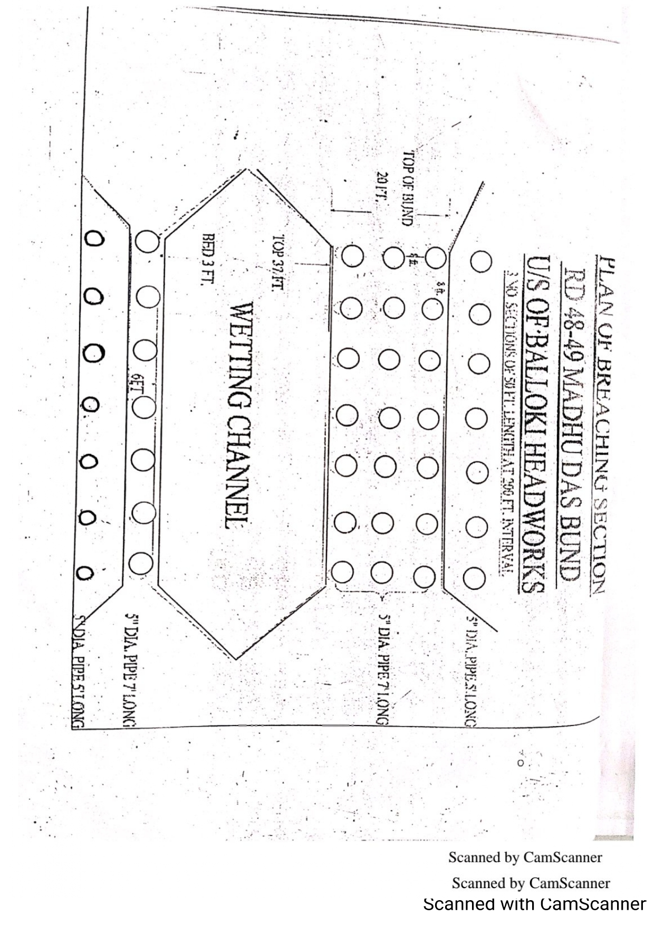
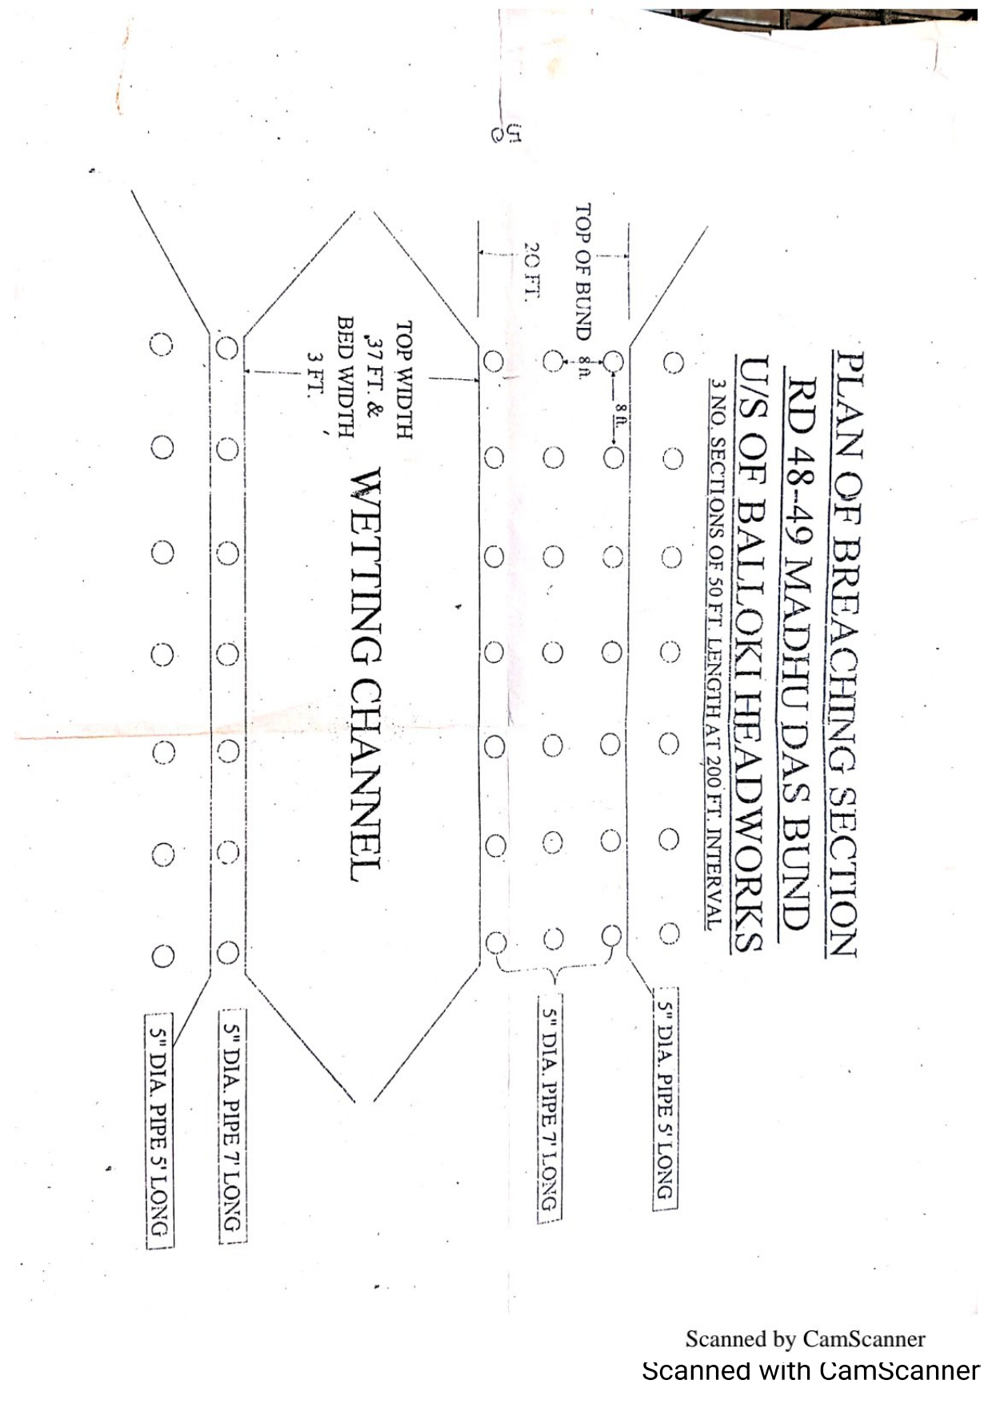
11.4 LIST OF SECURITY STAFF ALONGWITH DETAIL OF THE TRAINING ETC.
Sub Divisional Officer, Headworks Sub Division alongwith Sub-Engineer; Headworks Section has got the training for the operation of Breaching section.
  - DETAIL OF MECHANICAL MEANS AS A STANDBY ARRANGEMENTS IN CASE OF DETONATION FAILURE:

2 Nos. Mechanics and 4 No Helpers will be engaged when the discharge increases, beyond 1,35,000 Cs for as under machineries.
Name of Vehicle | Demanded | Available | Remarks
Excavator | 2 | 2 | Available through contractor
Tractor with front blade | 2 | 2
Hydraulic trolleys Truck | 6 | 6

11.6 DUTY ROSTER IN CASE OF CRITICAL SITUATION:
As above chapter No.9
11.7 BREACHING COMMITTEE WITH THEIR ACTION PLAN:
For the activation of Breaching Section, critical gauge is fixed at RD 24+100 of LMB when the water level reaches the level of 644.50 and is in rising position. The first breaching section at Madhudas bund located at RD:48-49 is operated. If the first breach fails to give the relief then 2nd breaching section located at RD 11-12 of R.M.B is operated.
- It is estimated that a discharge of about 1.0 Lac Cs will pass through the breaching sections if operated.
- These breaching sections were operated during the year 1950, 1955, 1973, 1975, 1978 and 1988.
The committee comprising of the following members vide Notification No. SO(FLOODS)VI-33/97 Dated 15.07.2015 will give the signal to activate the Breaching Section.
- Deputy Commissioner (Convener)
- Representative of the Army. (Member)
- Executive Engineer Irrigation (Balloki Headworks Division) (Member)
- Executive Engineer C&W (Member)

XEN/BLK
23
This committee on attaining the critical level i.e. 644.50 at RD:24+100 LMB will inform the Zonal Committee constituted as under for activation of Breaching Section:
- Chief Engineer, Irrigation, Sahiwal Zone, Sahiwal (Chairman)
- Commander Engineer 4-Corps (Member)
- Deputy Commissioner, District Nankana Sahib (Member)

On receipt of Signal from Zonal Committee, the Breaching Operating Committee will implement the decision.

11.8 LIST OF THE VILLAGES LIKELY TO BE INUNDATED IN CASE OF BREACH:

Name of village | District | Tehsil | Area in Acres | Population
Maliwal | Nankana Sahib | Nankana Sahib | 1392 | 1027
Haft Madar | Nankana Sahib | Nankana Sahib | 4801 | 3678
Wazir Pur | Nankana Sahib | Nankana Sahib | 663 | 1829
Khakh | Nankana Sahib | Nankana Sahib | 997 | 1207
Dhuddian | Nankana Sahib | Nankana Sahib | 1133 | 1518
Shouket Abad | Nankana Sahib | Nankana Sahib | 997 | 927
Qilla Noor Pur | Nankana Sahib | Nankana Sahib | 1310 | 1539
Jatri | Nankana Sahib | Nankana Sahib | 1565 | 2327
Kot Tahir | Nankana Sahib | Nankana Sahib | 4351 | 3056
Chained pur | Nankana Sahib | Nankana Sahib | 4804 | 4540
 |  | Total | 21,903 | 21,048

11.9 ANNOUNCEMENT AND DETAIL OF EVACUATION ARRANGEMENTS:
Executive Engineer, Balloki Headworks Division will inform
- The D.C’s to make arrangement for the evacuation of the Public within LMB and RMB and the population coming on route of spill water.

- Military Authorities to keep ready for emergency operation.
- Police Authorities to watch that no unauthorized cuts are made by public especially along LMB & RMB.

- Engineers 4-Corps for energizing the Breaching Section, when water
Level approaches 644.50 Mark at the emergency gauge installed at
RD 24+100 LMB
XEN/BLK
24

11.10 DETAILS OF COORDINATION WITH CIVIL/ARMY AUTHORITIES:
There are two no. of breaching sections located at RD:11-12 Right Marginal Bund and at RD:48-49 Madhudas Bund approved vide the Secretary Irrigation & Power Department Lahore Memo No.110/F-C-75/410-15/64/75.There is a critical gauge fixed at RD:24+100 of LMB when its level reaches to 644.50 and is in raising position, the breaching sections will be operated. These will be operated with the help of Army as per standing instructions laid down in the above-mentioned letter. The floodwater escaping through breaching section will flow through the old course of the River and rejoin D/S Balloki Barrage. With the operation of Breaching Section following communication will be disrupted.
- Metaled Road linking Balloki Headworks to More Khunda will be dis-connected. Lahore – Sharqpur – Jaranwala and Faisalabad Road can be disconnected.
- Towers of High Transmission Lines are likely to be affected.
- Telephones in between Balloki Headworks to More Khunda are likely to be disrupted.
First priority for operation of Breaching Sections will be given to Site at RD:48-49 Madhudas Bund and then Breaching Site at RD:11-12 of R.M.B will be operated.
It is the duty of the Executive Engineer, Balloki Division to inform the following Officers before operating the Breaching Section: -
- The Secretary, Government of the Punjab, Irrigation Department, Lahore.
- The Project Director, PMU, LBDC-IP Lahore.
- The Chief Engineer, Irrigation, Sahiwal Zone, Sahiwal.
- The Chief Engineer, Irrigation, Multan Zone, Multan.
- The Chief Engineer, Irrigation, Lahore Zone, Lahore.
- The Chief Engineer, Irrigation, Faisalabad Zone, Faisalabad.
- The Flood Relief Commissioner, Lahore.
- The Chief Engineer, Drainage and Flood Zone, Lahore.
- The Commander, Headquarter Engineers, 4- Corps, Lahore.
- The Commanding Officer, 173- Engineers, Lahore Cantt.
- The Director Floods, Lahore.

XEN/BLK
25

- The D.C, Kasur.
- The D.C, Nankana.
- The D.C, Okara.
- The D.P.O, Kasur.
- The D.P.O, Sheikhupura.
- The D.P.O, Okara.
- The A.C, Pattoki.
- The A.C, Nankana Sahib.
- The A.C, Jaranwala.
- The Executive Engineer, Okara Division LBDC, Okara.
- The Executive Engineer, Sahiwal Division LBDC, Sahiwal.
- The Executive Engineer, Khanewal Division LBDC, Khanewal.
- All Sub Divisional Officers, on watching.
- All Sub Engineers on duty at Balloki Headworks.
- The Executive Engineer, Electricity (LESCO), Chunian.
- The Executive Engineer, Highway Division Bridges,Okara.
- Telephone and Telegraph Department, Kasur.
- The District Health Officer, Kasur.
- Pakistan Broadcasting Corporation.

XEN/BLK

26

11.11 PARALLEL COMMUNICATION ARRANGEMENTS:

In addition to installation of Wireless Set at Balloki Headworks, some temporary connection will be arranged at right side of the Barrage as well as at field office where all the Officers/Officials generally will meet together to chalk out further programs. One supervisor of T & T Department will remain available at the site for proper control and operation of all this system.
TIME LAG FROM BREACHING SECTIONS FOR SPILLING OUT OF WATER:
There are two number of breaching sections. One at RD:48-49 of Madudas Bund and second at RD:11-12 of RMB. Firstly, the Breaching Section of Madudas Bund is operated and then the second at R.M.B will be operated as per requirement. Time Lag from first Breaching Section is about 2 Hours and from second it is almost 1 hour.

Sub Divisional Officer , Executive Engineer
Headworks Sub Division Balloki Headworks Division
Balloki. Balloki.

27

11.12 INDEX PLAN:

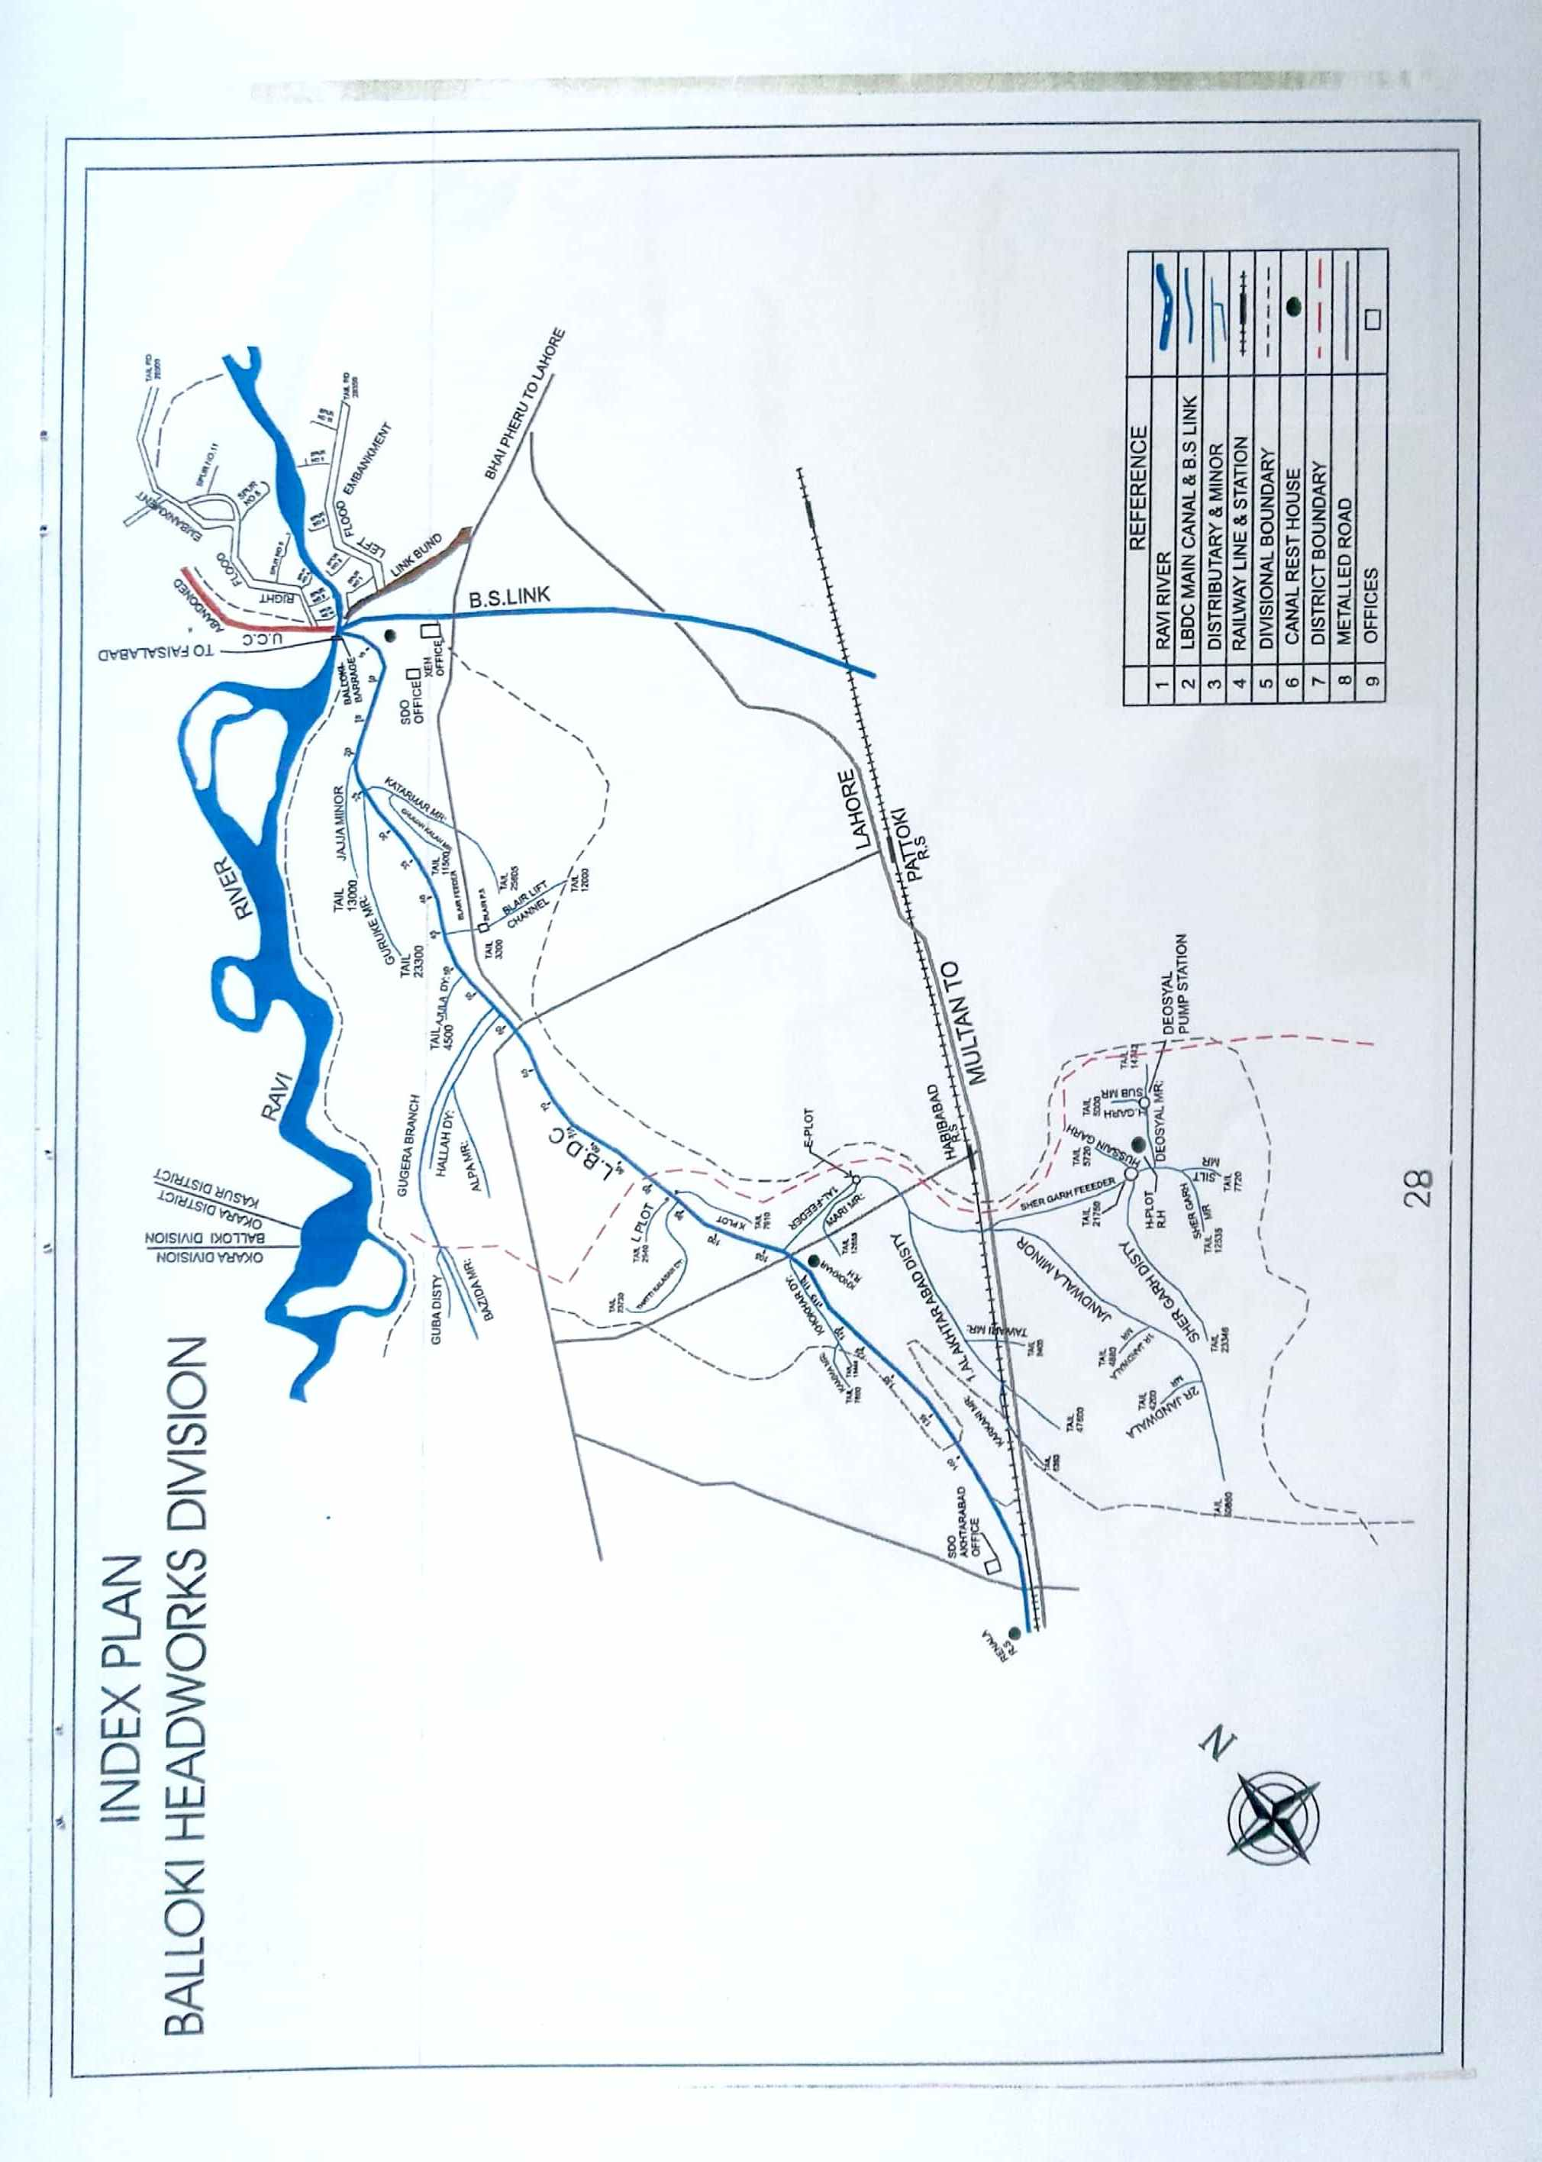

28

PART - B

XEN/BLK

29

CHAPTER-12

VULNERABLE SITES ON FLOOD BUNDS /STRUCTURES

12.1 APPREHENDED BREACHES IN FLOOD BUNDS/STRUCTURES:

The following are the vulnerable sites of Balloki Headworks
1. RD 11000-12000 OF RMB
2. RD 24000-25000 OF RMB
3. RD 12000-13000 OF LMB

12.2 OPERATION OF BREACHING SECTION

Breaching section will be operated by Engineers 4 Corps.

12.3 BREACHES DUE TO RISE OF FLOOD WATER, DETERIORATION OF FLOOD BUNDS

Breaches due to rise of Flood of water, deterioration of flood bunds will be controlled and maintained by the Department.

XEN/BLK

30

CHAPTER-13
EMERGENCY CONTINGENCY PLAN FOR VULNERABLE SITES LISTED ABOVE.
PLAN NO 1
RD 11000-12000 OF RMB
13.1 PLAN SHOWING ROUTE OF FLOOD WATER COMING OUT OF THE BREACH SUPPORTED WITH LEVELS:
PLAN ATTACHED
13.2 DETAIL OF VILLAGES ABBADEIS LIKELY TO BE AFFECTED AND THIS SHOULD ALSO BESHOWN ON THE PLAN:
- Showkatabad colony
- Jatri
- Thatta
- chitti
13.3 STRATEGY AND ACTION TAKEN BE EXPLAINED IN DETAIL THIS MAY INCLUDE:
The following arrangements /strategy will be adopted. Though all precautionary measures are adopted before flood season to face any alarming situation at Balloki Headworks, even then arrangements are necessary to avoid heavy damages and flood fighting strategy is adopted in such a way that flood water passes safely through Barrage, up to its limit. In low flood, river water remains within the deep channel and do not cause any problem, if regulation of gates is done as per rules. Watching establishment employed for this purpose will remain busy in removing jungle, filling gharas and porcupine holes if any. When water increases beyond sixty thousand cusecs it will start spreading on adjoining area and also touching the toe of bunds. Then it becomes necessary to be vigilant and watching of bunds will be started to avoid any leakage from bunds. Sub Engineers will shift their camps to sites as per duty roaster. Hourly gauges and discharges will be conveyed to civil administration and flood warning centers to inform public accordingly.

XEN/BLK
31
When river water enters into high flood range, Sub Divisional Officer Akhtarabad will shift his camp at Balloki to supervise staff working on LMB and D/S spurs. In whole period regulation will be done in such a way that silt deposit in front of canals may be washed D/S of the river to minimize silt entry in to canals. Silt contents in water will be checked thrice a day and if it exceeds the permissible limit, canals will be closed accordingly. Gauges of different sites especially gauge at RD: 24+100 of LMB will be noted regularly and recorded. Executive Engineer, Balloki Headworks Division will inform all agencies especially civil administration as well as Army about flood situation in rising position. In case of very high flood or exceptionally high flood, meeting will be held in field office with Army and Civil Administration to face the situation. 2 Nos. dozers will be kept ready each site at RD 11-12, 24-25 RMB and RD 12-13/LMB for making cuts and closing breaches as and when required according to the circumstances.
    - ARRANGEMENTS:
The following arrangements will be made
13.3.2 ESTABLISHMENT OF FLOOD FIGHTING CAMPS:
Flood fighting camp will be established at RD 10+000-11+000 of RMB.
13.3.3 DUTIES OF OFFICERS/OFFICIALS AND THEIR CAMP SITES:
Sub Engineer Headworks section will be Incharge of the camp site. The following staff will be at the camp site
Camp No. | Location | Officer Name & Designation | Official Name & Designation
1 | RMB RD:11-12 | Adnan Hayat ,SDO H/W Sub Divn: Balloki  Contact No. (0303-8838025) | Tariq Mehmood SBE at H/W Section  (0345-7516082)
2 | RMB RD:24-25 | Adnan Hayat ,SDO H/W Sub Divn: Balloki  Contact No. (0303-8838025) | Tariq Mehmood SBE at H/W Section  (0345-7516082)
3 | LMB RD:12-13 | Adnan Hayat ,SDO H/W Sub Divn: Balloki  Contact No. (0303-8838025) | Shahzad Umar SBE Dhaya Section  (0345-6405013)

13.3.4 DEPARTMENTAL MACHINERY AVAILABLE:
Not available

13.3.5 MACHINERY AVAILABLE FROM PRIVATE SOURCE:

The following machinery can be made available Jamshed Construction Company maintaining his office at Balloki village. The detail of machinery isas under:-
A: Excavator
B: Tractors with Trolleys
C: Dozers
13.3.6 FLOOD FIGHTING MATERIAL REQUIRED
13.3.7 FLOOD FIGHTING MATERIAL AVAILABLE
Sr.# | Name of Article | Total QTY Required | QTY available | Deficient QTY | Remarks
1 | Lantern | 18 Nos. | 18 Nos. | - | All required Flood Fighting material available and stored in Workshop of Balloki Headworks
2 | K.Oil | 1 Tin. | 1 Tin. | -
3 | Wicks | 4 Yards. | 4 Yards. | -
4 | Chimneys | 24 Nos. | 24 Nos. | -
5 | Torches | 4 Nos. | 4 Nos. | -
6 | Cells | 12 Nos. | 12 Nos. | -
7 | E.C. Bags/Gunny Bags | 200 Nos. | 200 Nos. | -
8 | Sutli | 2 Lbs. | 2 Lbs. | -
9 | Sewing Needles | 6 Nos. | 6 Nos. | -
10 | Axes | 5 Nos. | 5 Nos. | -
11 | Kassies | 100 Nos. | 100 Nos. | -
12 | Killas | 24 Nos. | 24 Nos. | -
13 | Ballies | 10 Nos. | 10 Nos. | -
14 | Steal Baskets | 24 Nos. | 24 Nos. | -
15 | Match Boxes | 2 No. | 2 No. | -
16 | Oil Extractor | 1 Dozen | 1 Dozen | -
17 | MunjTrangers | 100 Nos. | 100 Nos. | -
18 | Torches Chargeable | 10 No. | 10 No. | -
19 | Rubber Gum Shoes | 2 Nos. | 2 Nos. | -
20 | Rain Coats | 3 Pairs. | 3 Pairs. | -
21 | Mosquito Nets | 3 Nos. | 3 Nos. | -
22 | Bamboos for Mosquito Nets | 4 Nos. | 4 Nos. | -
23 | Life Jackets | 16 Nos. | 16 Nos. | -
24 | Bucket | 4 Nos. | 4 Nos. | -

XEN/BLK

PLAN NO 1

Color

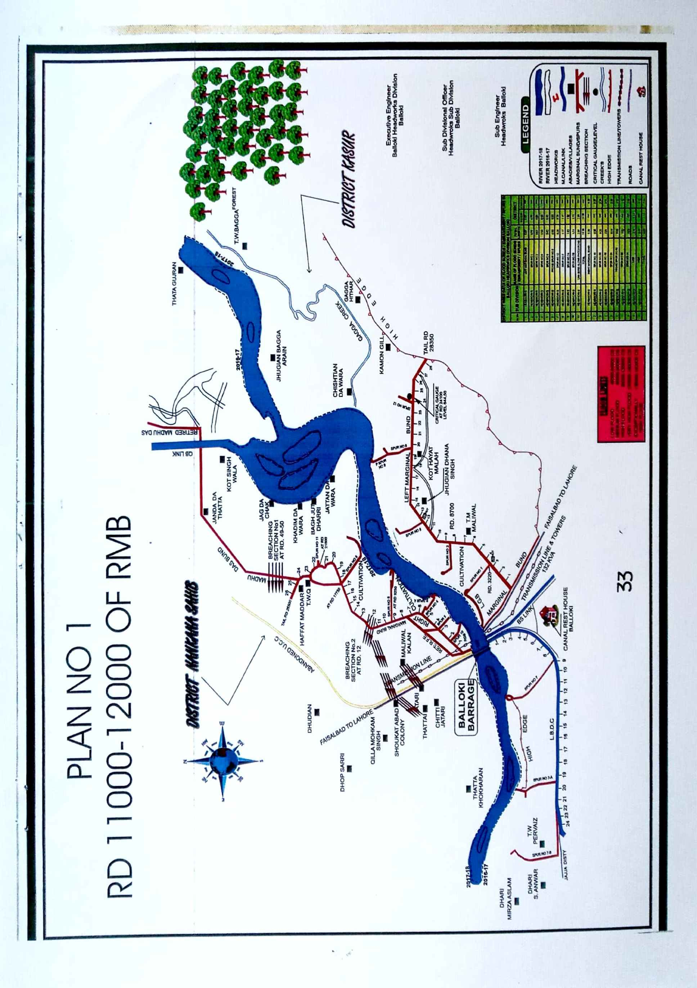
33

PLAN NO 2
RD 24000-25000 OF RMB
13.1 PLAN SHOWING ROUTE OF FLOOD WATER COMING OUT OF THE BREACH, SUPPORTED WITH LEVELS:

PLAN ATTACHED

13.2 DETAIL OF VILLAGES ABBADEIS LIKELY TO BE AFFECTED AND THIS SHOULD ALSO BE SHOWN ON THEPLAN:
- Dhudian
- KillamohkamSingh
- HafatMaddar

13.3 STRATEGY AND ACTION TAKEN BE EXPLAINED IN DETAIL. THIS MAY INCLUDE:
The following arrangements /strategy will be adopted. Though all precautionary measures are adopted before flood season to face any alarming situation at Balloki Headworks, even then arrangements are necessary to avoid heavy damages and flood fighting strategy is adopted in such a way that flood water passes safely through Barrage, up to its limit. In low flood, river water remains within the deep channel and do not cause any problem if regulation of gates is done as per rules. Watching establishment employed for this purpose will remain busy in removing jungle, filling gharas and porcupine holes if any. When water increases beyond sixty thousand cusecs it will start spreading on adjoining area and also touching the toe of bunds. Then it becomes necessary to be vigilant and watching of bunds will be started to avoid any leakage from bunds. Sub Engineers will shift their camps to sites as per duty roaster. Hourly gauges and discharges will be conveyed to civil administration and flood warning centers to inform public accordingly.

XEN/BLK
34
When river water enters into high flood range, Sub Divisional Officer Akhtarabad will shift his camp at Balloki to supervise staff working on LMB and D/S spurs. In whole period regulation will be done in such a way that silt deposit in front of canals may be washed D/S of the river to minimize silt entry in to canals. Silt contents in water will be checked thrice a day and if it exceeds the permissible limit, canals will be closed accordingly. Gauges of different sites especially gauge at RD:24+100 of LMB will be noted regularly and recorded. Executive Engineer, Balloki Headworks Division will inform all agencies especially civil administration as well as Army about flood situation in rising position. In case of very high flood or exceptionally high flood, meeting will be held in field office with Army and Civil Administration to face the situation. 2 Nos dozers will be kept ready each site at RD:11-12, 24-25 RMB and RD:12-13/LMB for making cuts and closing breaches as and when required according to the circumstances.

13.3.1 ARRANGEMENT:
The following arrangements will be made
13.3.2 ESTABLISHMENT OF FLOOD FIGHTING CAMPS:
Flood fighting camp will be established at RD 23000-24000 of RMB.

13.3.3 DUTIES OF OFFICERS / OFFICIALS AND THEIR CAMP SITES:

Sub Engineer Headworks Section will be Incharge of the camp site. The following staff will be at the camp site: -

Sr. No. | Designation | No.
1 | Sub Engineer | 1 No.
2 | Mate | 1 No.
3 | Beldar | 40 No’s

13.3.4 DEPARTMENTAL MACHINERY AVAILABLE:
Not available

13.3.5 MACHINERY AVAILABLE FROM PRIVATE SOURCE:

The following machinery can be made available Jamshed Construction Company maintaining his office at Balloki village. The detail of machinery is as under:-
A: Excavator
B: Tractors with Trolleys
C: Dozers
13.3.6 FLOOD FIGHTING MATERIAL REQUIRED:
13.3.7 FLOOD FIGHTING MATERIAL AVAILABE:
Sr.# | Name of Article | Total QTY Required | QTY available | Deficient QTY | Remarks
1. | Lantern | 18 Nos. | 18 Nos. | - | All required Flood Fighting material available and stored in Workshop of Balloki Headworks.
2. | K.Oil | 1 Tin. | 1 Tin. | -
3. | Wicks | 4 Yards. | 4 Yards. | -
4. | Chimneys | 24 Nos. | 24 Nos. | -
5. | Torches | 4 Nos. | 4 Nos. | -
6. | Cells | 12 Nos. | 12 Nos. | -
7. | E.C. Bags/Gunny Bags | 200 Nos. | 200 Nos. | -
8. | Sutli | 2 Lbs. | 2 Lbs. | -
9. | Sewing Needles | 6 Nos. | 6 Nos. | -
10. | Axes | 5 Nos. | 5 Nos. | -
11 | Kassies | 100 Nos. | 100 Nos. | -
12. | Killas | 24 Nos. | 24 Nos. | -
13. | Ballies | 10 Nos. | 10 Nos. | -
14. | Steal Baskets | 24 Nos. | 24 Nos. | -
15. | Match Boxes | 2 No. | 2 No. | -
16. | Oil Extractor | 1 Dozen | 1 Dozen | -
17 | Munj Trangers | 100 Nos. | 100 Nos. | -
18 | Torches Chargeable | 10 No. | 10 No. | -
19 | Rubber Gum Shoes | 2 Nos. | 2 Nos. | -
20 | Rain Coats | 3 Pairs. | 3 Pairs. | -
21. | Mosquito Nets | 3 Nos. | 3 Nos. | -
22 | Bamboos for Mosquito Nets | 4 Nos. | 4 Nos. | -
23 | Life Jackets | 16 Nos. | 16 Nos. | -
24 | Bucket | 4 Nos. | 4 Nos. | -

XEN/BLK
35

PLAN NO 2

Color

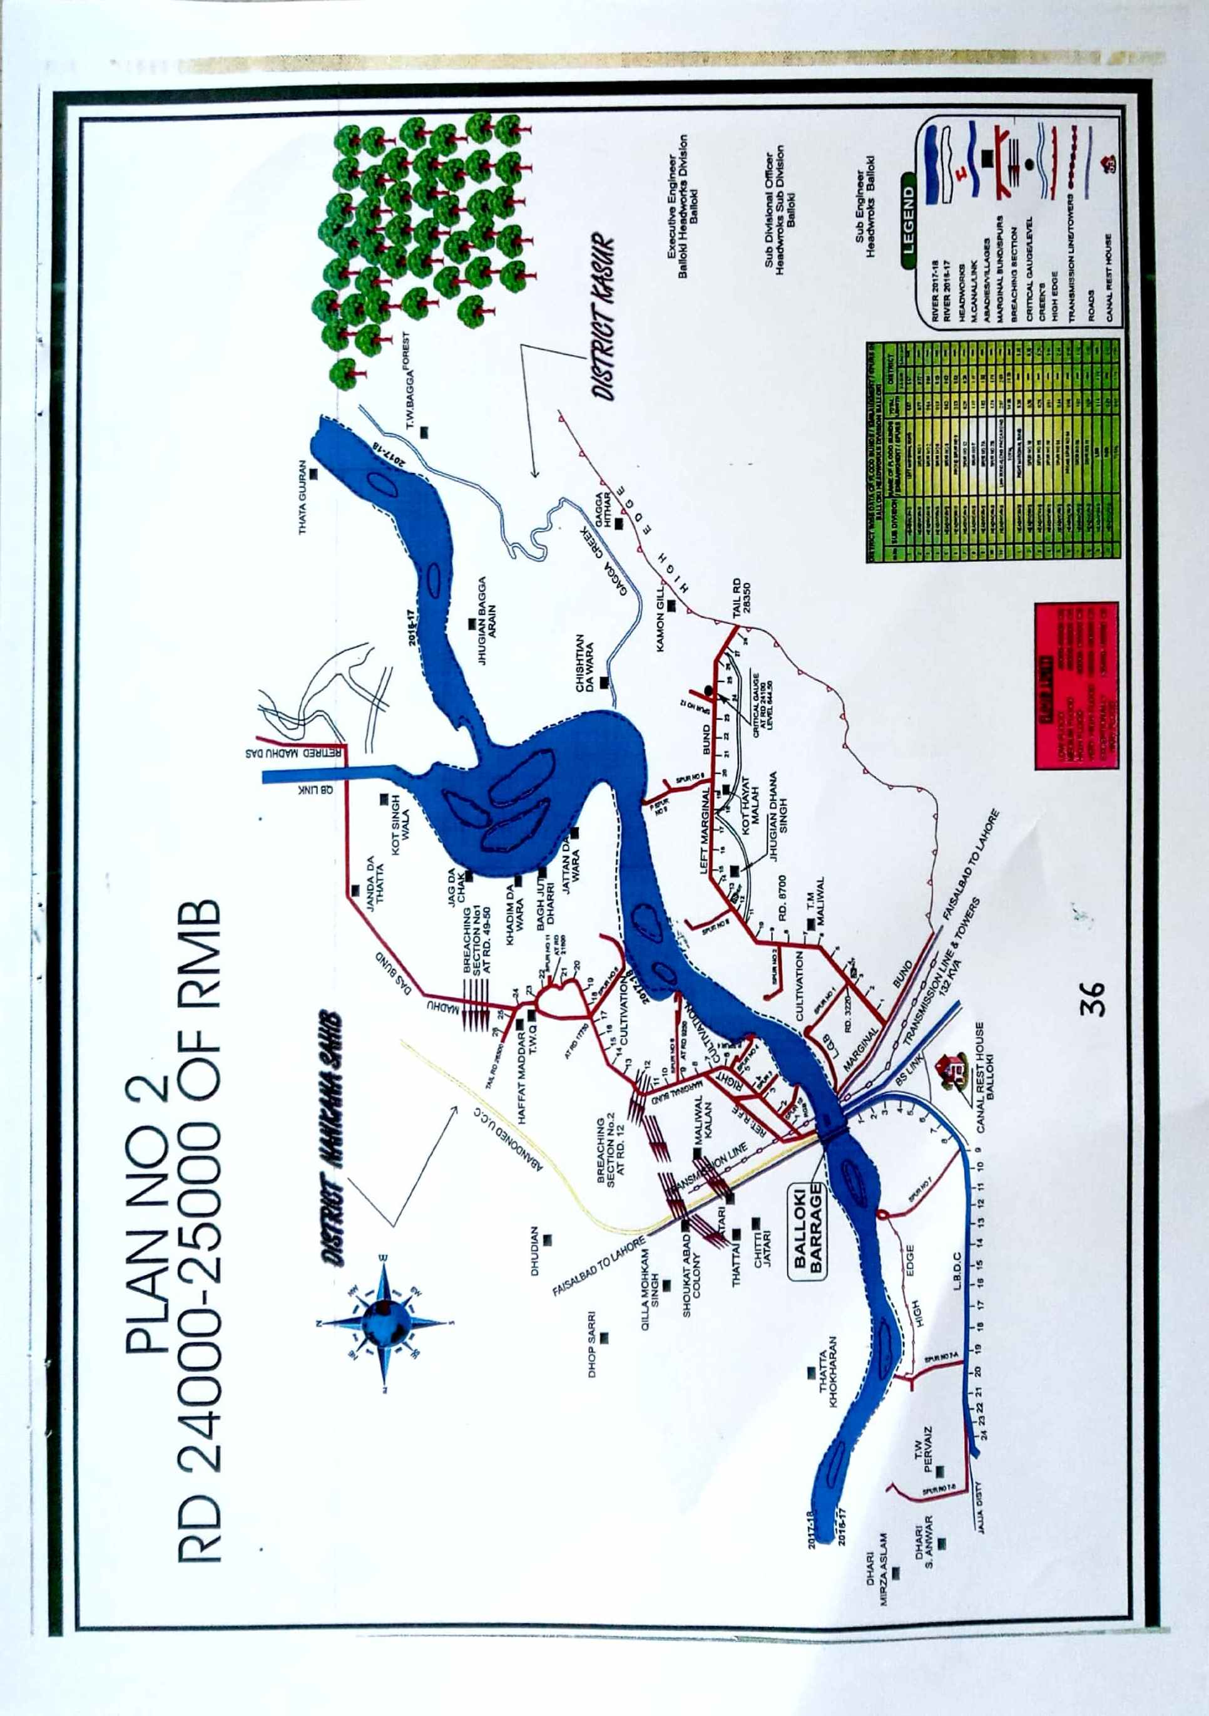36

PLAN NO.3
RD 12000-13000 OF LMB

13.1 PLAN SHOWING ROUTE OF FLOOD WATER COMING OUT OF THE BREACH, SUPPORTED WITH LEVELS:
PLAN ATTACHED

13.2 DETAIL OF VILLAGES ABBADEIS LIKELY TO BE AFFECTED AND THIS SHOULD ALSO BE SHOWN ON THE PLAN:
- Kot Hayat Malah
- Jhugian Dhanasingh
- Maliwal

13.3 STRATEGY AND ACTION TAKEN BE EXPLAINED IN DETAIL. THIS MAY INCLUDE:
The following arrangements /strategy will be adopted. Though all precautionary measures are adopted before flood season to face any alarming situation at Balloki Headworks, even then arrangements are necessary to avoid heavy damages and flood fighting strategy is adopted in such a way that flood water passes safely through Barrage, up to its limit. In low flood, river water remains within the deep channel and do not cause any problem if regulation of gates is done as per rules. Watching establishment employed for this purpose will remain busy in removing jungle, filling gharas and porcupine holes if any. When water increases beyond sixty thousand cusecs it will start spreading on adjoining area and also touching the toe of bunds. Then it becomes necessary to be vigilant and watching of bunds will be started to avoid any leakage from bunds. Sub Engineers will shift their camps to sites as per duty roaster. Hourly gauges and discharges will be conveyed to civil administration and flood warning centers to inform public accordingly.

XEN/BLK
37

When river water enters into high flood range, Sub Divisional Officer Akhtarabad will shift his camp at Balloki to supervise staff working on LMB and D/S spurs. In whole period regulation will be done in such a way that silt deposit in front of canals may be washed D/S of the river to minimize silt entry in to canals. Silt contents in water will be checked thrice a day and if it exceeds the permissible limit, canals will be closed accordingly. Gauges of different sites especially gauge at RD:24+100 of LMB will be noted regularly and recorded. Executive Engineer, Balloki Headworks Division will inform all agencies especially civil administration as well as Army about flood situation in rising position. In case of very high flood or exceptionally high flood, meeting will be held in field office with Army and Civil Administration to face the situation. 2 Nos dozers will be kept ready each site at RD 11-12,24-25 RMB and RD:12-13/LMB for making cuts and closing breaches as and when required according to the circumstances.
    - ARRANGEMENT:
The following arrangements will be made.
13.3.2 ESTABLISHMENT OF FLOOD FIGHTING CAMPS:
Flood fighting camp will be established at RD 23000-24000 of RMB.
13.3.3 DUTIES OF OFFICERS / OFFICIALS AND THEIR CAMP SITES:
Sub Engineer Halla Section will be Incharge of the camp site.
The following staff will be at the camp site
Sr. No. | Designation | No.
1 | Sub Engineer | 1 No.
2 | Mate | 1 No.
3 | Beldar | 40 No’s
13.3.4 DEPARTMENTAL MACHINERY AVAILABLE:
Not available
13.3.5 MACHINERY AVAILABLE FROM PRIVATE SOURCE:
The following machinery can be made available Jamshed Construction Company maintaining his office at Balloki village. The detail of machinery is as under:-
A: Excavator
B: Tractors with Trolleys
C: Dozers
13.3.6 FLOOD FIGHTING MATERIAL REQUIRED/AVAILABLE:
13.3.7 FLOOD FIGHTING MATERIAL AVAILABE:
Sr.# | Name of Article | Total QTY Required | QTY available | Deficient QTY | Remarks
1. | Lantern | 18 Nos. | 18 Nos. | - | All required Flood Fighting material available and stored in Workshop of Balloki Headworks.
2. | K.Oil | 1 Tin. | 1 Tin. | -
3. | Wicks | 4 Yards. | 4 Yards. | -
4. | Chimneys | 24 Nos. | 24 Nos. | -
5. | Torches | 4 Nos. | 4 Nos. | -
6. | Cells | 12 Nos. | 12 Nos. | -
7. | E.C. Bags/Gunny Bags | 200 Nos. | 200 Nos. | -
8. | Sutli | 2 Lbs. | 2 Lbs. | -
9. | Sewing Needles | 6 Nos. | 6 Nos. | -
10. | Axes | 5 Nos. | 5 Nos. | -
11 | Kassies | 100 Nos. | 100 Nos. | -
12. | Killas | 24 Nos. | 24 Nos. | -
13. | Ballies | 10 Nos. | 10 Nos. | -
14. | Steal Baskets | 24 Nos. | 24 Nos. | -
15. | Match Boxes | 2 No. | 2 No. | -
16. | Oil Extractor | 1 Dozen | 1 Dozen | -
17 | MunjTrangers | 100 Nos. | 100 Nos. | -
18 | Torches Chargeable | 10 No. | 10 No. | -
19 | Rubber Gum Shoes | 2 Nos. | 2 Nos. | -
20 | Rain Coats | 3 Pairs. | 3 Pairs. | -
21. | Mosquito Nets | 3 Nos. | 3 Nos. | -
22 | Bamboos for Mosquito Nets | 4 Nos. | 4 Nos. | -
23 | Life Jackets | 16 Nos. | 16 Nos. | -
24 | Bucket | 4 Nos. | 4 Nos. | -

XEB/BLK
38

PLAN NO 3
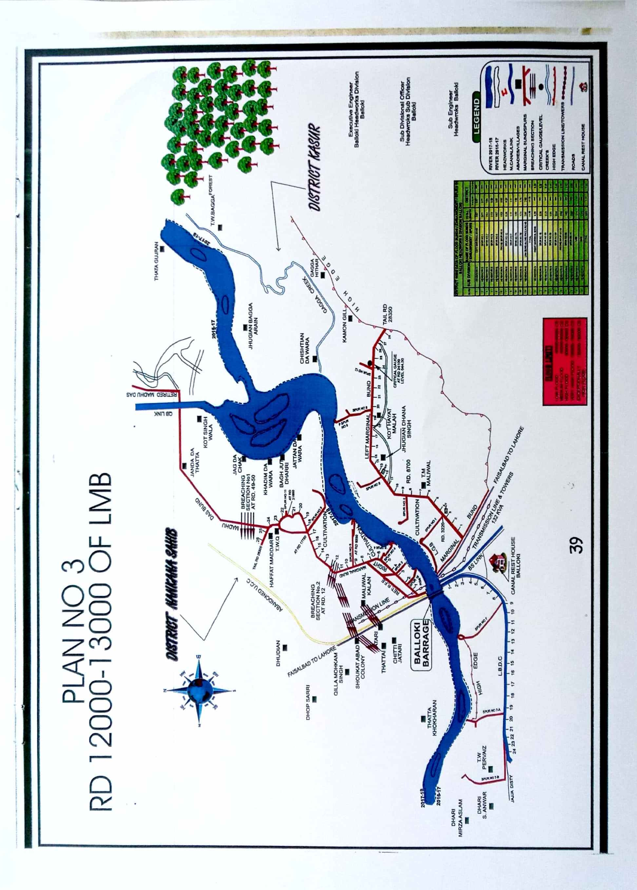

39

13.4 DETAIL OF OTHER INFRASTRUCTURE LIKE ELECTRIC, SUIGAS, TELEPHONE INSTALLATION, ROAD NETWORK, OTHER BUILDING, CANAL AND DRAINAGE NETWORK:

ROUTE PLAN NO. 1
RD:11000-12000 OF RMB

i Phool Nagar –More Khunda Road
ii. Electric Transmission Line
. iii Pipeline of Sui Gas

ROUTE PLAN NO. 2
RD:24000-25000 OF RMB

i Phool Nagar –More Khunda Road
ii. Electric Transmission Line
. iii Pipeline of Sui Gas

ROUTE PLAN NO. 3
RD:12000-13000 OF LMB

i Phool Nagar –More Khunda Road
ii. Electric Transmission Line = 02 Nos.
. iii Pipeline of Sui Gas 36” = 02 Nos.

Executive Engineer
Balloki Headworks Division
Balloki
Sub Divisional Officer
Headworks Sub Division
Balloki

Superintending Engineer
Lower Bari Doab Canal Circle
Sahiwal
Chief Engineer
Irrigation, Sahiwal Zone
Sahiwal

40

Chapter-14
ACTION PLAN
14.1 Re-shuffling/Recouping plan of reserve stone departmentally
Detail of Re-shuffling/Recouping plan is as under:
S.No | NAME OF SITE | SANCTIONED RESERVE STOCK OF STONE | MINIMUM REQUIRED | AVAILABLE QTY | DEFICIENT QTY | REMARKS
1 | 2 | 3 | 4 | 5 | 6 | Quantity of reserve Stock of stone available is 79% of sanctioned quantity while minimum requirement of reserve stock of stone is 70% so there is no need of purchasing reserve stone.
1 | Near LGB U/s old RMB | 0.5 | 0.35 | 0.378
2 | Left guide Bank D/S | 0.5 | 0.35 | 0.584
3 | Right guide Bank U/S (Stone Yard) | 0.5 | 0.35 | 0.5
4 | RGB D/S | 0.5 | 0.35 | 0.5
5 | Spur No 3 | 0.3 | 0.21 | 0.208 | 0.002
6 | Spur No 4 | 1 | 0.7 | 0.742
7 | Spur No Prong | 0.5 | 0.35 | 0.4
8 | Spur No 5 | 0.5 | 0.35 | 0.531
9 | Spur No. 6 | 0.5 | 0.35 | 0.526
10 | Spur No 11 | 0.3 | 0.21 | 0.3
11 | Spur No 1 | 0.3 | 0.21 | 0.3
12 | Spur No 2 | 0.5 | 0.35 | 0
13 | Spur No 8 | 0.5 | 0.35 | 0.449
14 | Spur No 8 Prong Spur No.9 | 0.6 | 0.42 | 0.746
15 | Spur No 12 | 0.3 | 0.21 | 0.296
16 | Spur No 7 | 0.3 | 0.21 | 0.437
17 | Spur No 7A | 1 | 0.7 | 0.086 | 0.614
18 | Spur No 7B | 1 | 0.7 | 0.558 | 0.142
 | Total | 9.60  LAC Cft | 6.72  LAC Cft | 7.541  LAC CFT | 0.758 LAC CFT

14.2 Detail of inlet/outlet crossing alongwith closing methodology

There is no inlet/outlet crossing in River Training works of Balloki Headworks Division

XEN/BLK
41

14.3 Deployment Machinery (Medium to high flood)

Sr.No | Name of Structure | Length in mile | Vulnerable Reach | Camp Location | Site Incharge by Name & Cell No | Excavator | Dozer | Trolleys/  Dumpers | Tractor with Front Blade
1 | Right Marginal Bund | 5.30 | 11000-12000 | RD 11000 | Tariq Mehmood 0345-7516082 | 1 | 1 | 2 | 1
2 | -Do- |  | 24000-25000 | RD 24000 | Tariq Mehmood 0345-7516082 | 1 | 1 | 2 | 1
3 | Left Marginal Bund | 5.67 | 12000-13000 | RD 13000 | .  Shehzad Umer 0345-6405013 | 1 | - | 1 | 1
Total |  |  |  |  |  | 3 | 2 | 5 | 3
14.4 Deployment Machinery (High to very high flood)
Sr.No | Name of Structure | Length in mile | Vulnerable Reach | Camp Location | Site Incharge by Name & Cell No | Excavator | Dozer | Trolleys/  Dumpers | Tractor with Front Blade
1 | Right Marginal Bund | 5.30 | 11000-12000 | RD 11000 | Tariq Mehmood 0345-7516082 | 2 | 2 | 5 | 4
2 | -Do- |  | 24000-25000 | RD 24000 | Tariq Mehmood 0345-7516082 | 2 | 2 | 5 | 4
3 | Left Marginal Bund | 5.67 | 12000-13000 | RD 13000 | .  Shehzad Umer 0345-6405013 | 2 | 1 | 5 | 4
Total |  |  |  |  |  | 6 | 5 | 15 | 12
14.5 Deployment Machinery (Very High to exceptionally high flood)
Sr.No | Name of Structure | Length in mile | Vulnerable Reach | Camp Location | Site Incharge by Name & Cell No | Excavator | Dozer | Trolleys/  Dumpers | Tractor with Front Blade
1 | Right Marginal Bund | 5.30 | 11000-12000 | RD 11000 | Tariq Mehmood 0345-7516082 | 3 | 2 | 5 | 4
2 | -Do- |  | 24000-25000 | RD 24000 | Tariq Mehmood 0345-7516082 | 3 | 2 | 5 | 4
3 | Left Marginal Bund | 5.67 | 12000-13000 | RD 13000 | .  Shehzad Umer 0345-6405013 | 3 | 1 | 5 | 4
Total |  |  |  |  |  | 9 | 5 | 15 | 12

Note: Payment for Machinery will be made after verification by TPM / Departmental Committee

14.6 Police deployment plan.
A request will be made to the District Police Officer Kasur for providing adequate services of police Department in all Sectors/Relief Centers/Flood affected areas, during any flood emergency, for security purpose and to maintain any law and order situation as per following plan:

S.No | NAME OF SPUR | VOULNERABLE REACH | REQUIRED No. OF POLICEMAN |  | REQUIRED No. OF RANGER
1 | RIGHT MAGINAL BUND | 11000-12000 | ASI =1 No  Constable =10 | SHO =1 No | 10 No
2 | RIGHT MAGINAL BUND | 24000-25000 | ASI =1 No  Constable =10 |  | 10 No
3 | LEFT MAGINAL BUND | 12000-13000 | ASI =1 No  Constable =10 |  | 10 No

42 XEN/BLK

14.7 Detail of synthetic bags with capacity of 500 Kg and 1000 Kg.

Sufficient quantity of synthetic bags will be managed / purchased as per site requirements, if needed.

14.8 Details of polythene sheet of black color to protect upstream slope against wave action and to control seepage through embankments.

Polythene sheet of black color will be purchased for upstream protection against waving action and controlling the seepage, if needed.

XEN/BLK

43

Chapter-15

Back up Divisions (in case of breach)

Okara Canal Division LBDC will work as Back up Division for Balloki Headworks Division in case of breach.

Executive Engineer,
Balloki Headworks Division,
Balloki.
Sub Divisional Officer,
Headworks Sub Division,
Balloki.

Superintending Engineer,
Lower Bari Doab Canal Circle,
Sahiwal.
Chief Engineer,
Irrigation, Sahiwal Zone,
Sahiwal.

44

