IRRIGATION DEPARTMENT

SARGODHA IRRIGATION ZONE SARGODHA

FLOOD FIGHTING PLAN 2023

MIANWALI CANAL DIVISION MIANWALI

THAL CANAL CIRCLE MIANWAL

INDEX
Sr. No. Description Page
PART A
Chapter:- 1
SALIENT FEATURES OF DIVISION
1.1 LOCATION. 1
1.2 GENERAL DESCRIPTION 1
1.3 ADMINISTRATIVE SET UP 2
Chapter:- 2
FLOOD PROTECTION & RIVER TRAINING WORKS 4
2.1 DESIGN PARAMETER OF TRAINING WORKS 4
2.2 LOCATION MAP 5
CHAPTER:- 3.
BRIEF HISTORY OF PAST FLOOD EVENTS 6-8
CHAPTER :-4
DESIGNED DATA, HISTORIC PEAK FLOOD DATA AND PREVIOUS FIVE YEARS
OLD DATA OF HEADWORKS/ BARRAGES AND OR OTHER CONTROL POINTS
4.1 FLOOD LIMITS. 9
4.2 TIME LAGS OF FLOODS 9
4.3 HIGHEST FLOODS. 9-11
4.4 PEAK DISCHARGE 12
CHAPTER:- 5.
  - FLOOD FIGHTING STRATEGY FOR RIVER INDUS DOWNSTREAM
CHASHMA BARRAGE
13-14
CHAPTER:- 6.
FLOOD DAMAGES RESTORATION WORKS. 15

CHAPTER:- 7.
FLOOD FIGHTING WATCHING ARRANGEMENT
7.1 Pre- Flood Arrangement 16-17
  - Watching Establishment 18
  - Arrangement at Sensitive sites. 19
  - Watching Material. 19
  - Arrangement for sounding & Probing. 19
  - Lighting Arrangement. 19
  - Ration Arrangement. 20
  - P.O.L Arrangement for Vehicle. 20
  - Transportation 20
  - Law and order 20
  - Medical Arrangement for Labour 20
  - Liaison with other Department 20
  - Role of the Army 21
  - Duties of Telephone Attendant 21
  - Wireless Arrangements 21
CHAPTER:- 8
Detail of Encroachment 22
CHAPTER:- 9
Duty Roster/ Flood Fighting Program 23
CHAPTER:- 10
Emergency Telephone No 24-25
CHAPTER:- 11
Standard operating procedure (SOP) for Breaching Sections 26
  - History of the breaching Section 26
  - Location, Design, Quantity and Variety of the explosive required for detonation (26)
  - Arrangement of explosives and security of explosive stores 26
  - List of the security staff along-with detail of their training etc 26
  - Detail of machinery means as standby arrangements in case of detonation failure (26)
  - Duty Roster in case of critical situation 26
  - Breaching Committee with their action plan 26
  - List of villages likely to be inundated incase of breach 26
  - Announcement and detail of evacuation arrangement 26
  - Details of coordination with Civil/ Army Authorities 26
  - Parallel communication arrangements 26
  - Index Plan 26
PART-B
CHAPTER:- 12
Vulnerable sites on Flood Bund/ Structures 27
  - Apprehended breaches in Flood Bunds/ Structures 27
  - Operation of breaching section 27
  - Breaches due to rising of Flood Water, Detoriation of Flood Bund. 27
CHAPTER:- 13
Emergency Contingency Plan for vulnerable sites 28
Alluwali Guide Spur (Site No. 1)

  - Plan showing route of Flood Water coming out of the expected
Breaching point supported with levels 28

  - Detail of villages abadies likely to be affected and this should
also be shown on the plan 28
  - Strategy and action taken be explained in detail this may include 28
13.3.1 Arrangements 28
13.3.2 Establishment of Flood fighting camps 28
13.3.3 Duties of officers / officials and their camp sites 28
13.3.4 Departmental machinery available 29
13.3.5 Machinery available from private source 29
13.3.6 Flood fighting material required 29
13.3.7 Flood fighting material available 29
  - Detail of other infrastructure like electric, Sui gas, Telephone Installations,
Road network, other buildings, canals and drainage network 30

Alluwali Guide Spur and Guide Head Spur RD 29+000 Dhingana (Site No. 2)
  - Plan showing route of Flood Water coming out of the breach
supported with levels 32
  - Detail of villages abadies likely to be affected and this should
also be shown on the plan 32
  - Strategy and action taken be explained in detail this may include 32
13.3.1 Arrangements 32
13.3.2 Establishment of Flood fighting camps 32
13.3.3 Duties of officers / officials and their camp sites 32
13.3.4 Departmental machinery available 32
13.3.5 Machinery available from private source 33
13.3.6 Flood fighting material required 33
13.3.7 Flood fighting material available 33
  - Detail of other infrastructure like electric, Sui gas, Telephone Installations,
Road network, other buildings, canals and drainage network. 33

J-Head Spur RD 35+600 Doaba (Site No. 3)
  - Plan showing route of Flood Water coming out of the breach
Supported with levels 35
  - Detail of villages abadies likely to be affected and this should
also be shown on the plan 35
  - Strategy and action taken be explained in detail this may include 35
13.3.1 Arrangements 35
13.3.2 Establishment of Flood fighting camps 35
13.3.3 Duties of officers / officials and their camp sites 35
13.3.4 Departmental machinery available 35
13.3.5 Machinery available from private source 35
13.3.6 Flood fighting material required 36
13.3.7 Flood fighting material available 36
13.4 Detail of other infrastructure like electric, Sui gas, Telephone Installations,
Road network, other buildings, canals and drainage network. 36
J-Head Spur at Piplan (SITE No. 4)
  - Plan showing route of Flood Water coming out of the breach
supported with levels 38
  - Detail of villages abadies likely to be affected and this should
also be shown on the plan 38
  - Strategy and action taken be explained in detail this may include 38
13.3.1 Arrangements 38
13.3.2 Establishment of Flood fighting camps 38
13.3.3 Duties of officers / officials and their camp sites 38
13.3.4 Departmental machinery available 38
13.3.5 Machinery available from private source 39
13.3.6 Flood fighting material required 39
13.3.7 Flood fighting material available 39

  - Detail of other infrastructure like electric, Sui gas, Telephone Installations,
Road network, other buildings, canals and drainage network. 41

CHAPTER:- 14
Action plan .
  - Re-shuffling /Recouping plan of reserve stone departmentally 42
  - Detail of inlet /outlet crossing along with closing mythology 42
  - Deployment machinery (Medium to High Flood) 42
  - Deployment machinery (High to very High Flood) 43
  - Deployment machinery (High to exceptionally High Flood) 44
  - Police deployment plan 45
  - Detail of synthetic bags with capacity of 500-KG and 1000-KG. 46
  - Detail of polythene sheet of black colour to protect upstream slope
against wave action and to control seepage through embankments. 47

CHAPTER:- 15
Back up Division (In case of breach) 48

CHAPTER-1

SALIENT FEATURES OF MIANWALI CANAL DIVISION MIANWALI.

  - LOCATION
Mianwali Canal Division is situated at District Head Quarter Mianwali.

1.2 GENERAL DESCRIPTION

Mianwali Canal Division has been established since 01.07.2012 due to splitting of Khushab Canal Division into two Divisions.
1:- Mianwali Canal Division Mianwali.
2:- Khushab Canal Division Khushab.
From 01.10.2012, Kundian Canal Sub Division of Kalabagh Division has been attached with this Division. Mianwali canal division is responsible for regulation of Thal Canal Main Line Lower, Escape Channel, Mohajir Branch, Dullewala Branch, Kundian Disty & Tibbi Disty off-taking from at RD: 157+662 (Tail) of Thal Canal Main Line Upper. Moreover maintenance and repair of 4-No. Lift Irrigation Schemes, Namal Dam and River Training Works Downstream Chashma Barrage to Mussiwali village are also under the control of Executive Engineer, Mianwali Canal Division. It comprises of following Four Sub Divisions as under:-
- Dullewala Canal Sub Division, Mianwali.
- Tubewell Sub Division, Mianwali.
- Kundian Canal Sub Division, Kundian.
- Namal Canal Sub Division, Mianwali.
Main infrastructure of Mianwali Canal Division comprises of:-

- River Training Works D/S Chashma in District Mianwali. 13-No.
- Thal Canal (Main Line Lower). 26.20 Canal Miles
- Dullewala Branch 21.60 Canal Miles
- Escape channel 3.85 Canal Miles
- Distys, Minors & Sub Minors. 457.14 Canal Miles
- Nos. of Outlets. 1103 Nos.
- G.C.A. 5.04 Lac acre
- C.C.A. 4.34 Lac acre

1.3 ADMINISTRATIVE SETUP

A. DULLEWALA SUB DIVISION

This Sub Division controls:

- Dullewala Branch RD: 0+000-108+019 (Tail) and its System.
- Tibbi Disty.

- KUNDIAN SUB DIVISION

  - 13-No. River Training Works on Left side of river Indus D/S Chashma Barrage to Mussiwali village (Tehsil Piplan).

  - Thal Canal Main Line Lower RD 0+000 to RD 131+000 and its off takes.
  - Escape Channel RD: 0+000-19+250 (Tail).
  - Kundian Disty system.

- TUBEWELL SUB DIVISION

  - Pumping Machinery of Samandwala Lift Irrigation Scheme.
  - Pumping Machinery at Pump House “A” and Pump House “B” of Mianwali Lift Irrigation Scheme.
  - Pumping Machinery of Gulmiri Lift Irrigation Scheme.
  - Pumping machinery of Mochh Lift Irrigation scheme.
  - 40-No. Tubewells along C.J Link.
      - Village Adhi Kot = 25-No.
      - Village Chan = 15-No.

- NAMAL CANAL SUB DIVISION

i. Namal Dam and Canal System.
ii. Channels of Samandwala Lift Irrigation Scheme.
iii. Channels of Mianwali Lift Irrigation Scheme.
iv. Channels of Gulmiri Lift Irrigation Scheme.

E. ORGANIZATION CHART
Copy attached.

CHAPTER-2

FLOOD PROTECTION AND RIVER TRAINING WORKS

The river training works on Indus River Downstream Chashma Barrage are as under:-

RIVER TRAINING WORKS ON INDUS RIVER.
1 | J-Head spur at Village Kahloon
2 | J-Head Spur at Bhakra
3 | Guide Spur at Alluwali
4 | Guide Head Spur at Alluwali (shank portion)
5 | Guide Head Spur at RD: 29+000 village Dhingana
6 | J-Head Spur at RD: 35+600 near village Doaba
7 | J-Head Spur at Piplan
8 | Guide wall Piplan
9 | Guide Spur at Mussiwali
11 | Protection wall at Alluwali
11 | Solid stone stud near village Doaba
12 | Protection wall at Dhingana
13 | Protection Wall village Bhakra, Ding and Shah Nawaz Wala

2.1 DESIGN PARAMETERS OF TRAINING WORKS

Sr. No. | Name of Structure | Length | Designed Top R.L. | Top Width.  (Ft). | Side Slopes
1 | J-Head spur at Village Kahloon | 2120-Ft | 636.00 | 30-Ft | 1:3 Country side  1:2 River side
2 | J-Head Spur at Bhakra | 2500-Ft | 634.00 | 30-Ft | 1:3 Country side  1:2 River side
3 | Guide Spur at Alluwali | 2200-Ft | 634.00 | 30-Ft | 1:3 Country side  1:2 River side
4 | Guide Head Spur at Alluwali (shank portion) | 1400-Ft | 630.00 | 30-Ft | 1:3 Country side  1:2 River side
5 | J-Head Spur at Piplan | 3514-Ft | 631.00 | 30-Ft | 1:3 Country side  1:2 River side
6 | Guide wall Piplan | 1410-Ft | 631.00 | 30-Ft | 1:3 Country side  1:2 River side
7 | Guide Spur at Mussiwali | 2000-Ft | 630.00 | 30-Ft | 1:3 Country side  1:2 River side
8 | Protection wall at Alluwali | 2250-Ft | 616.00 | 10-Ft | 1:1 River side
9 | Solid stone stud near village Doaba | 1840-Ft | 627.00 | 15-Ft | 1:1 River side
10 | Protection wall at Dhingana | 1000-Ft | 610.00 | 20-Ft | 1:1 River side
11 | Guide Head Spur at RD: 29+000 village Dhingana | 3514-Ft | 630.00 | 30-Ft | 3:1 Country side  2:1 River side
12 | J-Head Spur at RD: 35+600 near village Doaba | 3400-Ft | 630.00 | 30-Ft | 3:1 Country side  2:1 River side
13 | Protection Wall village Bhakra, Ding and Shah Nawaz Wala | 4400-Ft | 625.00 | 20-Ft | 2:1 River side

LOCATION MAP OF TRAINING WORKS

Location of river training works is marked on index plan of Mianwali Canal Division at page 05.

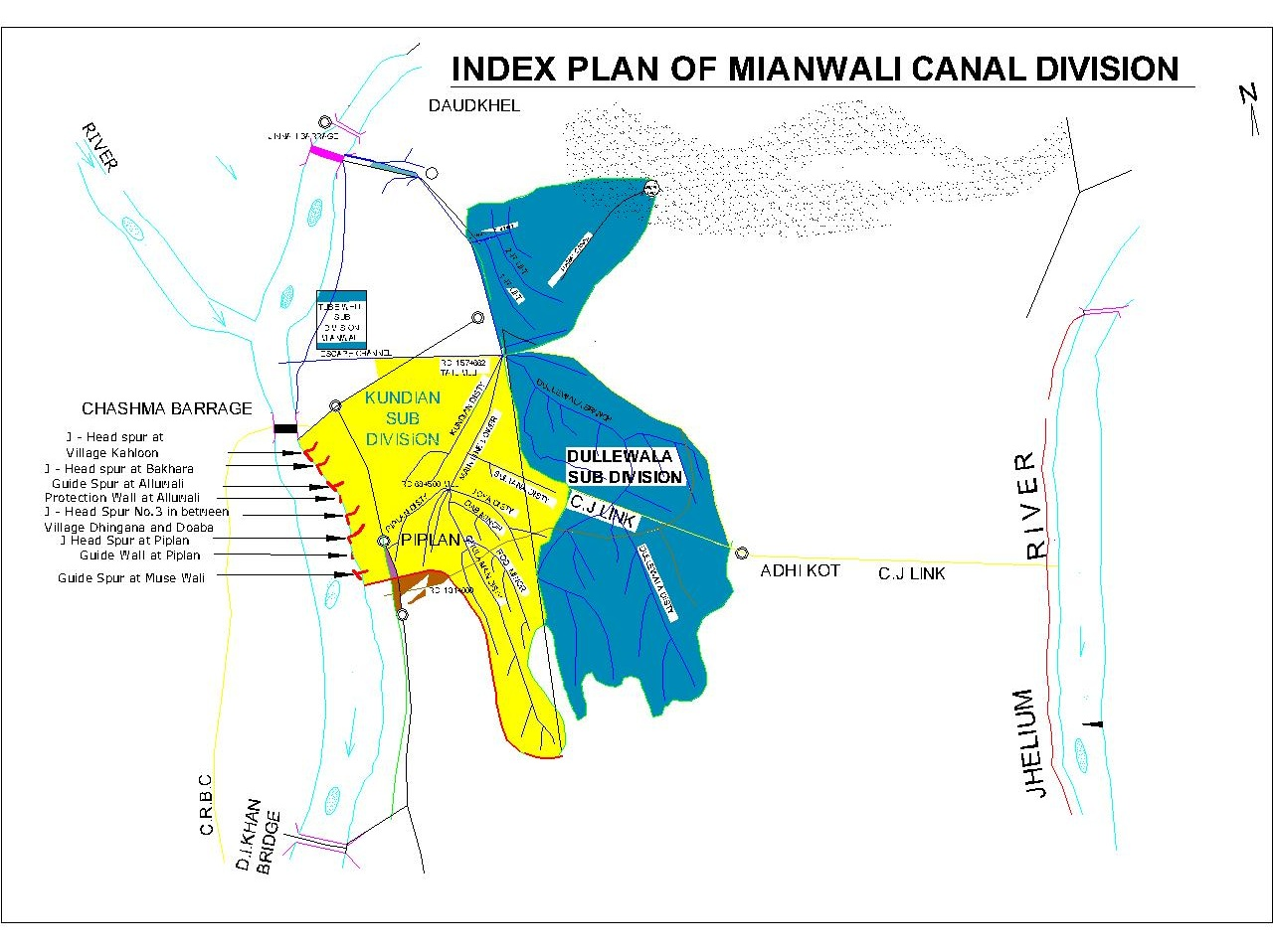

CHAPTER-3
BRIEF HISTORY OF PAST FLOOD EVENTS.
During flood season 2022 high flood has been observed in river Indus and maximum discharge downstream Chashma Barrage developed 523937-Cs: (high flood) on 28.08.2022. In flood season 2019 river changed its course D/S Chashma Barrage right side near village Bhakkra Tehsil Piplan.
- The inhabitants of Mouza Bhakkra, Ding, Balochi Khel, Shah Nawazwala, Kholaah, Katcha Gujrat and adjoining abadies at Chashma, Noshera Billote Road Tehsil Piplan District Mianwali on right bank of river Indus approached to the District Administration for protection of their houses, agricultural land and other infrastructure from river erosion during the month of august 2019.
- On direction of Deputy Commissioner Mianwali Technical Committee of Irrigation Zone Sargodha visited erosion site on 01.09.2019 and matter was referred to Departmental Expert Committee of Irrigation Department for suitable technical remedial measures to be adopted at site to avoid any untoward situation.
- Meeting of Departmental Expert Committee of irrigation Department was held on 25.09.2019 (“The committee suggested / recommended that revetment may be used for the protection of Local abadies along the problematic right side of Indus river just D/S Chashma Power House”). The length of stone revetment from 8+800 to 13+200 (4400-ft) was suggested / recommended by Departmental Expert Committee.
- The detailed estimate amounting to Rs. 109.695-Million was prepared by Irrigation Department Mianwali in light of recommendation of Expert Committee and accordingly submitted to the Deputy Commissioner, Mianwali vide No. 1274/49-W(Bhakra) dated 10.10.2019 and updated cost estimate is submitted to Deputy Commissioner Mianwali on 25.01.2021 for Rs. 116.422-Million.
- Scheme namely "Flood Protection Walls at Villages Bhakra, Ding, Shah Nawaz wala and Blochi Khel Right Side of River Indus D/S Chashma Barrage " was included in Annual Development Program for the year 2021-22 at General Sr. No. 5519.
- Scheme Administratively approved vide Government of the Punjab Secretary Irrigation No. SO(FLOODS)VI-10/2021 dated 06.09.2021for Rs. 116.484-Million.
- Estimate technically sanction vide Chief Engineer Sargodha No. 18189/W-II/XI-2 date 29.10.2021 for Rs: 114.066-Million.
- Tender for the work opened on 30.11.2021 and the work physically 100% completed at site in June 2022.
- During flood season 2022 due to parallel flow of water in between RD 7+000 to 15+000 the abadies and infrastructures like Government schools and HT Lines etc of Mouza Shah Nawaz Wala and Mouza Bhakra remained under threat. Due to construction of Guide wall in financial year 2021-22 Mouza Bhakra abadies and infrastructures remained well protected. However in between RD 13+000 to 15+000 and 7+000 to 9+000 erosive action of river Indus were noticed. The Executive Engineer Mianwali Canal Division inspected the site on 12.08.2022 and reported the alarming site condition of river Indus as the abadies and infrastructures of Mouza Bhakra and Shah Nawaz Wala were under threat due to erosive action of river Indus. The site was inspected by Superintending Engineer Thal Canal Circle Mianwali on 23.08.2022 and the report was submitted to Deputy Commissioner Mianwali and Chief Engineer, Sargodha Irrigation Zone on 25.08.2022 with clearly reported that there is no irrigation infrastructure is under threat due to river erosive action.
- The Chief Engineer, Irrigation Sargodha Zone referred the case to Secretary Irrigation Punjab for arranging the Departmental Expert Committee.
- Departmental Expert Committee meeting held on 02.09.2022 and decided that "The members of Departmental Expert Committee unanimously suggested that the stone revetment in a length of 1000 ft on Upstream side in between RD 7+800 to 8+800 and Three No's solid stone in a length of 50ft may constructed in between RD 13+000 to 15+000 to deflect the river flow away from end protection of river erosive action at downstream as per flood policy. However, the concerned Chief Engineer may change the length of solid stone studs according to site prevailing condition".
- The Chief Engineer, Sargodha Irrigation Zone, Sargodha along with Superintending Engineer, Thal Canal Circle, Mianwali, Resident Engineer NESPAK Consultants and Executive Engineer, Mianwali Canal Division, Mianwali visited the site on 09.09.2022 and vide canal wire No. 2241 dated 10.09.2022 keeping in view the decision of Departmental Expert Committee dated 02.09.2022 and current prevailing river site conditions directed that in addition of Departmental Expert Committee decision to place the 03-Nos Solid Stone Studs with Top R.L 620.00-Ft with Side Slopes 1:1, Sloping Nose 1:5 having Top width 15-Ft and key length 25-Ft Solid Stone of 50-Ft length may be placed at RD 13+600, whereas 2nd & 3rd Solid Stone Studs of 75-Ft length may be placed at RD 14+100 and 14+800, respectively at deflecting angle to protect the river bank as temporary measure.
- On recommendation of Departmental Expert Committee Irrigation Department and direction of Chief Engineer Sargodha irrigation Zone the estimate amount to Rs: 136.046-Million has been framed and submitted through proper channel to PDMA Punjab.
- Funds amounting to Rs: 136.046-Million required for execution of work.

CHAPTER-4
DESIGNED DATA, HISTORIC PEAK FLOOD DATA AND PREVIOUS FIVE YEAR FLOOD DATA OF HEAD WORKS / BARRAGES AND OR OTHER CONTROL POINTS

Not applicable.

4.1 FLOOD LIMITS OF RIVER INDUS AT CHASHMA BARRAGE

Limits of flood fixed by the Punjab Flood Commission are as under:-
Normal. = up to 2.5 Lac Cs.
Low Flood = 2.5 to 3.75 Lac Cs.
Medium Flood = 3.75 to 5.0 Lac Cs.
High Flood = 5.0 to 6.50 Lac Cs.
Very High Flood = 6.50 to 8.0 Lac Cs.
Exceptionally High Flood = 8.00 to 10.0 Lac Cs.
Super Flood = above 10.0 Lac Cs.

4.2 TIME LAGS OF FLOODS
DISTANCE |  | TIME LAG
From Attock to Jinnah Barrage. | = 106 Miles | 48 Hours
From Jinnah Barrage to Chashma Barrage. | = 41 Miles | 18 Hours
From Chashma Barrage to D.I.Khan / Darya Khan Bridge | = 71 Miles | 30 Hours

4.3 HIGHEST FLOODS AT JINNAH BARRAGE

Histogram of highest floods at Jinnah Barrage is given below:

Year | Date | U/s gauges | D/s gauges | D/s discharge | Remarks
1947 | 9/8/47 | 690.20 | 686.0 | 526799 | High
1948 | 14/8/48 | 691.45 | 690.65 | 769262 | Very High
1949 | 20/7/49 | 689.95 | 689.6 | 698166 | Very High
1950 | 2/8/50 | 691.25 | 690.75 | 743757 | Very High
1951 | 12/8/51 | 690.80 | 688.95 | 445973 | Medium
1952 | 21/7/52 | 691.50 | 6.88.90 | 463038 | Medium
1953 | 12/7/53 | 692.05 | 691.25 | 689661 | Very High
1954 | 3/8/54 | 691.50 | 686.3 | 416768 | Medium
1955 | 19/8/55 | 692.10 | 687.75 | 520622 | High
1956 | 18/7/56 | 691.90 | 688.15 | 566657 | High
1957 | 20/7/57 | 691.60 | 687.2 | 443088 | Medium
1958 | 16/7/58 | 693.30 | 690.4 | 776311 | Very High
1959 | 4/7/59 | 692.00 | 688.4 | 598304 | High
1960 | 13/7/60 | 692.00 | 689.1 | 529400 | High
1961 | 30/7/61 | 692.00 | 688.3 | 523144 | High
1962 | 22/7/62 | 692.00 | 685.55 | 422239 | Medium
1963 | 31/7/63 | 692.10 | 687.1 | 463718 | Medium
1964 | 16/7/64 | 691.60 | 690 | 555933 | High
1965 | 27/7/65 | 691.20 | 687.9 | 466850 | Medium
1966 | 26/6/66 | 691.50 | 689.2 | 500099 | High
1967 | 30/7/67 | 692.00 | 688.85 | 541835 | High
1968 | 15/8/68 | 692.00 | 687.05 | 476166 | Medium
1969 | 13/8/69 | 692.0 | 687.2 | 465346 | Medium
1970 | 13/8/70 | 692.50 | 685 | 408067 | Medium
1971 | 29/6/71 | 692.50 | 686.25 | 428431 | Medium
1972 | 20/7/72 | 692.50 | 686.3 | 397700 | Medium
1973 | 30/8/73 | 692.50 | 689.2 | 545917 | High
1974 | 2/8/74 | 693.00 | 685.7 | 373854 | Low
1975 | 2/8/75 | 692.60 | 689.1 | 602541 | Very High
1976 | 2/8/76 | 693.00 | 690.7 | 861965 | Exceptionally High
1977 | 17/7/77 | 692.50 | 688.25 | 574391 | High
1978 | 6/8/78 | 692.50 | 689 | 639790 | High
1979 | 10/8/79 | 692.50 | 684.65 | 456840 | Medium
1980 | 26/8/80 | 692.50 | 683.7 | 331197 | Low
1981 | 3/7/81 | 692.50 | 683.8 | 369944 | Low
1982 | 17/8/82 | 692.50 | 684.8 | 474231 | Medium
1983 | 4/9/83 | 692.50 | 685.2 | 499793 | Medium
1984 | 15/8/84 | 692.50 | 683.9 | 491280 | Medium
1985 | 2/8/85 | 692.50 | 682.1 | 313340 | Low
1986 | 5/8/86 | 692.50 | 684.3 | 471073 | Medium
1987 | 28/7/87 | 692.50 | 683.3 | 351268 | Low
1988 | 2/8/88 | 692.50 | 684.3 | 598303 | High
1989 | 1/8/89 | 692.50 | 685.65 | 557811 | High
1990 | 10/8/90 | 692.50 | 685.1 | 546260 | High
1991 | 15/7/91 | 692.50 | 682.8 | 445847 | Medium
1992 | 10/9/92 | 692.50 | 688.4 | 846040 | Exceptional High
1993 | 23/7/93 | 692.50 | 680.6 | 355569 | Low
1994 | 13/7/94 | 692.50 | 683.4 | 491375 | Medium
1995 | 27/7/95 | 692.50 | 684 | 544663 | High
1996 | 16/8/96 | 692.50 | 682 | 441410 | Medium
1997 | 28/8/97 | 692.00 | 684.9 | 654179 | Very High
1998 | 14/7/98 | 692.50 | 682.1 | 473221 | Medium
1999 | 10/8/99 | 692.50 | 682.1 | 456146 | Medium
2000 | 2/8/2000 | 692.50 | 678.3 | 261141 | Low
2001 | 24/7/2001 | 693.00 | 681.7 | 412238 | Medium
2002 | 14/8/2002 | 693.00 | 681.3 | 395589 | Medium
2003 | 3/8/2003 | 692.50 | 683 | 399352 | Medium
2004 | 11/7/2004 | 693.00 | 679.7 | 245067 | Normal
2005 | 2/7/2005 | 693.00 | 685.8 | 515073 | High
2006 | 6/8/2006 | 692.50 | 684.50 | 489606 | Medium
2007 | 16/8/2007 | 693.00 | 682.10 | 359912 | Low
2008 | 5/8/2008 | 693.00 | 681.00 | 336530 | Low
2009 | 17/8/2009 | 693.50 | 681.20 | 348320 | Low
2010 | 30/7/2010 | 695.50 | 690.10 | 937453 | Super flood
2011 | 26/7/2011 | 692.50 | 668.80 | 306983 | Low
2012 | 19/7/2012 | 693.00 | 679.10 | 252169 | Low
2013 | 13/8/2013 | 694.00 | 682.50 | 472403 | Medium
2014 | 25/7/2014 | 694.00 | 681.00 | 249992 | Normal
2015 | 2/8/2015 | 692.00 | 685.30 | 528698 | High
2016 | 17/7/2016 | 693.00 | 681.70 | 343962 | Low
2017 | 3/8/2017 | 693.00 | 684.40 | 419460 | Medium
2018 | 15/8/2018 | 693.00 | 681.60 | 311154 | Low
2019 | 15/8/2019 | 693.00 | 683.80 | 354830 | Low
2020 | 03/09/2020 | 693.00 | 685.20 | 453212 | Medium
2021 | 31/07/2021 | 693.00 | 682.00 | 290354 | Low
2022 | 28/08/2022 | 693.50 | 683.60 | 433910 | Medium

CHAPTER-5
  - FLOOD FIGHTING STRATEGY FOR RIVER INDUS DOWNSTREAM CHASHMA BARRAGE

STAGE-1
DISCHARGE FROM 3.75 LAC CS to 5.0 LAC. CS (MEDIUM FLOOD).

When river discharge ranges between these limits, watching establishment will be deployed at the rate of one man per thousand feet. Sub Engineer, Kundian & Piplan Sections will supervise the entire watching operation of the Left flank of river Sub Divisional Officer Kundian and will act as the officer in charge of watching operation.
Establishment of Kundian section comprising 1 Mate with 6 beldars will be available round the clock. The Sub Engineer, Kundian & Piplan Sections will not leave the River Training Works area without permission of S.D.O. Kundian. He will be authorized by the Divisional Officer to employee 6 seasonal coolies to make up deficiency caused by stationing 6 regular beldars coolies at River Training Works so that normal operations may not suffer.

STAGE II
DISCHARGE FROM 5.0 LAC Cs TO 6.50 LAC Cs (HIGH FLOOD).
When the discharge range between these limits, the watching establishment will be increased to three times of that provided in stage-1. Supervisory staff will be the same as in stage 1. In addition, Sub Engineer Joya Section will shift his headquarter at site.

STAGE III
DISCHARGE FROM 6.50 LAC Cs TO 8.0 LAC Cs (VERY HIGH FLOOD).
Watching establishment shall be increased to six times that of stage-1. All establishment of Kundian Sub Division will be summoned to the River Training Works and deployed as detailed below:-
Sub Divisional Officer, Kundian Sub Division will be the officer in-charge of watching operation on the left flank. Sub Engineer of Kundian & Piplan Sections will supervise the relevant River Training Works:-

Sub Engineer, Kundian Section | J-Head Spur Kahloon, J-Head Spur Bakhara, Guide Spur Alluwali and protection wall Alluwali.
Sub Engineer, Ghulaman Section | J-Head spur Alluwali and Protection wall Alluwali RD: 23+500 to 24+500.
Sub Engineer, Randhore Section | J-Head Spur No. 3 Dhingna & Doaba.
Sub Engineer, Piplan Section | J-Head Spur Piplan, Guide Wall Piplan and Guide Spur Musewali.
Sub Divisional Officer, Kundian Sub Division Kundian. | Sub Divisional Officer Kundian shall be Officer In charge of watching operation on the left flank of River Indus D/S Chashma Barrage to Musewali.

STAGE-IV

DISCHARGE EXCEEDING 8.0 LAC CS (EXCEPTIONALLY HIGH FLOOD)
At this stage, volunteer labour arranged by Civil Administration and Army will help the watching operation. Police guards will be deputed on vulnerable points such as critical reaches between Alluwali Guide Spur & Doaba Dhingana J-Head Spur to safe guard against any Mishap/sabotage.

CHAPTER-6
FLOOD DAMAGE RESTORATION WORKS

The detail of flood damages restoration works proposed after flood 2022 are as under:-

Sr. No. Name of works
- Scheme namely "Flood Protection Walls at Villages Bhakra, Ding, Shah Nawazwala and Blochi Khel Right Side of River Indus D/S Chashma Barrage" Administratively approved vide Government of the Punjab Secretary Irrigation No. SO(FLOODS)VI-10/2021 dated 06.09.2021for Rs. 116.484-Million.
- Estimate technically sanction vide Chief Engineer Sargodha No. 18189/W-II/XI-2 date 29.10.2021 for Rs: 114.066-Million. Work 100% physically completed on 30.06.2022.
- In light of recommendations of Departmental Expert Committee the estimate for "Flood Protection Walls and Construction of 03 Nos. Stud at villages Blochi Khel & Shah Nawaz wala Right Side of River Indus D/S Chashma Barrage Tehsil Piplan District Mianwali" has been prepared for Rs: 136.046-Million and submitted to Deputy Commissioner Mianwali for arranging the funds from PDMA.

CHAPTER-7

FLOOD FIGHTING / WATCHING ARRANGEMENTS

During floods, Sub Divisional officers, in absence of Executive Engineer will not hesitate to adopt protective measures for the safety of the River Training Works in real emergency, under intimation to higher hierarchy, through quickest means of Communication. Similarly, Sub Engineers in the absence of the Sub Divisional Officer will act accordingly.

  - PRE FLOOD ARRANGEMENTS

During the month of June, the watching establishment will work for making pre-flood arrangements till the river spills out.
For River Training Works in the 2nd defence line the same pre-flood arrangements will continue throughout the flood season unless any of these River Training Works come under action.
Flood watching material will be arranged in sample quantities. Particular care will be taken to ensure that adequate quantity of the required material is distributed and placed at all the watching huts especially at all dangerous sites and that all the articles / material are in good condition. The scale of watching material is given in duty roster.
The Sub Engineers will inspect all the structures under their charge on foot. They will walk along the river side toe of the structures and locate the rat or porcupine holes on the slope and get it opened, refilled and compacted in his presence. Similarly SDO will inspect all the vulnerable reaches of the Spurs/Studs on foot and act in similar manner. Executive Engineer is also expected to see certain reaches of the Spurs/Studs here and there on foot to ensure that no rat / porcupine hole is left un-attended. The SDO will personally check that:

- All lamps, actuator and torches, kassies and baskets etc. are in good working condition and lightening arrangements at important points of the Spurs/Studs and at vulnerable reaches of the structures are satisfactory.
- Adequate arrangements are made for communication of urgent messages from any part of the Spur or Stud to the Executive Engineer in case of any emergency. If there is no telephonic, telegraphic or wireless link, special messenger will be kept ready at all time for this purpose.

- The entire watching establishment will be properly trained. Dry rehearsals for flood fighting by the end of June will be carried out and any short coming noticed will immediately be got rectified.

During pre-flood period, the watching staff will be engaged on the following works:-
- All jungle growth from the outer and inner toe of all Spurs up to five feet width will be cleared.
- Rats/porcupines, and other burrowing animals through fumigation and closing their holes after opening and paddling them thoroughly.
- Repairing temporary watching huts.

CONSOLIDATED STATUS OF RESERVE STOCK OF STONE

Sanction Quantity | Available Quantity | Balance Quantity | Remarks
7.50 Lac Cft | 7.00 Lac Cft | 0.50 Lac Cft | Sufficient quantity availed to meet with any emergency.

Structure wise detail of reserve stock stone is as under:-
Sr. No. | Name of Structure | Sanctioned limit of reserve stock  (Lac Cft:) | Qty of stone available as site  (Lac Cft:) | Balance qty of stone required  (Lac Cft:) | Remarks
1. | J-Head Spur at village Kahloon | 1.25 | 0.75 | 0.50 | Total reserve stock stone limit for all structures is 7.50 Lac Cft. 7.00 Lac Cft qty of stone is available at site which is sufficient to meet with any emergency.
2. | J-Head Spur at village Bhakra | 1.25 | 1.25 | -
3. | Guide Spur at village Alluwali | 1.50 | 1.50 | -
4. | J-Head Spur at Piplan | 1.50 | 1.50 | -
5. | Guide wall Spur at Piplan | 1.00 | 1.00 | -
6. | Guide Spur at village Musewali. | 1.00 | 1.00 | -
Total:- |  | 7.50 | 7.00 | 0.50

  - WATCHING ESTABLISHMENT
The Scale of watching establishment, in addition to regular establishment will be as under.
  - During low flood, one man per 1000 feet will be deployed in 3-shift of 8 hours.
  - During medium flood, strength will be increased by 3 times.
  - During high flood, strength will be increased by 6 times.
  - During exceptionally high flood, strength of man power will be at the discretion of Executive Engineer, Mianwali Canal Division, Mianwali.
Detail of watching Establishment is as under:-
Site | Flood Limits
 | Medium  (3.75 to 5.0 Lac) |  | High  (5.0 to 6.50 Lac) |  | Very High  (6.50 to 8.0 Lac) |  | EXCP: high  (8.0 to 9.50 Lac)
 | Men  Mate + Beldar | Shift | Men  Mate + Beldar | Shift | Men  SDO+ SEN+Mate + Beldar | Shift | Men  SDO+ SEN+Mate + Beldar | Shift
J-Head Spur Kahloon | 0 + 2 | Per Shift | 1 + 6 | Per Shift | 1+1+1+10 | Per Shift | 1+1+1+12 | Per Shift
J-Head Spur Bhakra | 0 + 3 | Per Shift | 1 + 9 | Per Shift | 1+1+2+15 | Per Shift | 1+1+2+18 | Per Shift
Guide Spur Alluwali | 0 + 2 | Per Shift | 1 + 6 | Per Shift | 1+1+1+10 | Per Shift | 1+1+1+12 | Per Shift
Protection Wall Alluwali | 0 + 2 | Per Shift | 1 + 6 | Per Shift | 1+1+1+4 | Per Shift | 1+1+1+6 | Per Shift
Protection Wall Alluwali Dhingana | 0 + 2 | Per Shift | 1 + 6 | Per Shift | 1+1+1+4 | Per Shift | 1+1+1+6 | Per Shift
Guide Head Spur at RD: 29+000 village Dhingana | 0 + 2 | Per Shift | 1 + 6 | Per Shift | 1+1+1+10 | Per Shift | 1+1+1+12 | Per Shift
J-Head Spur near village Doaba | 0 + 2 | Per Shift | 1 + 6 | Per Shift | 1+1+1+10 | Per Shift | 1+1+1+12 | Per Shift
Solid Stone Stud Doaba | 0 + 2 | Per Shift | 1 + 6 | Per Shift | 1+1+1+4 | Per Shift | 1+1+1+6 | Per Shift
J-Head Spur Piplan | 0 + 4 | Per Shift | 1 + 6 | Per Shift | 1+1+2+20 | Per Shift | 1+1+2+24 | Per Shift
Guide Wall Piplan | 0 + 2 | Per Shift | 1 + 6 | Per Shift | 1+1+1+10 | Per Shift | 1+1+1+12 | Per Shift
Guide Spur Musawali | 0 + 2 | Per Shift | 1 + 6 | Per Shift | 1+1+1+10 | Per Shift | 1+1+1+12 | Per Shift
Protection Wall village Bhakra, Ding and Shah Nawaz Wala | 0 + 2 | Per Shift | 1 + 6 | Per Shift | 1+1+1+10 | Per Shift | 1+1+1+12 | Per Shift
  - ARRANGEMENTS AT SENSITIVE SITES
At all vulnerable reaches / sites such as from Alluwali Guide
Spur to Doaba Dhingana J-Head Spur on the left bank of River Indus,10 beldars, and one mate will be available round the clock when river rises above low flood level. A reason able quantity of machinery will be readily available at this place throughout the flood season to combat any sort of emergency.

  - WATCHING MATERIAL
The detail of watching material is as under:-
Sr. No. | Name of article | Quantity required | Quantity available | Balance Quantity | Remarks
1 | Kassies with Handle | 40-No. | 40-No. | - | Balance Quantity will be purchased before coming Flood season 2023.
2 | Shawl | 40-No. | 40-No. | -
3 | Basket (Toot) | 400-No. | 260-No. | 140-No.
4 | Jute Bag (4-5 Cft) | 900-No. | 900-No. | -
5 | Polly propylene Bag (2-3 Cft) | 1950-No. | 695-No. | 1255-No.
6 | Bamboo | 550-No. | 525-No. | 25-No.
7 | Soldiery | 4-No. | 4-No. | -
8 | Axes | 33-No. | 33-No. | -
9 | Torch Electric | 37-No. | 37-No. | -
10 | Life Jacket | 37-No. | 37-No. | -
11 | Umbrella small | 32-No. | 32-No. | -
12 | Umbrella large | 22-No. | 10-No. | 12-No.
13 | Seba | 32-Kg. | 12-Kg. | 20-Kg.
14 | Emergency light | 16-No. | 16-No. | -
15 | Generator | 1-No. | - | 1-No.
16 | Petrol for Generator | 300-Litre | - | 300-Litre
17 | Cable 7/29 | 150-Meter | - | 150-Meter
18 | Energy Sever | 10-No. | - | 10-No.
19 | Electric Board | 2-No. | - | 2-No.

  - ARRANGEMENT FOR SOUNDING AND PROBING
For every spur/stud site and vulnerable serious location the arrangements will be made for sounding/probing, on need basis.
  - LIGHTING ARRANGEMENT
For lighting arrangements generators will be fixed on need basis.
  - RATION ARRANGEMENT
The establishment and supervisory staff will make their own food arrangement. Deputy Commissioner Mianwali and District Food Controller, Mianwali will be requested to keep a reserve stock of the articles at Alluwali village for supply to the labourers whenever flood emergency occurs.
  - POL ARRANGEMENTS FOR VEHICLES
2-No.Petrol Pumps (one at Chashma/Kundian and other at Alluwali) are located at the distance of 10-km and 01-Km respectively. Supply order will be placed on start of flood season. However POL will be brought to site on need basis.
  - TRANSPORTATION ARRANGEMENTS
Mianwali Canal Division has 01-No. Jeep, 03-No. Double Cabin Pickup and 01-No. Tractor with Trolley/ front blade loader as well as sand bag filler machine. During emergency, 3 Pick Ups will be hired on receipt of information of discharge above the range of low flood. During acute emergency, Deputy Commissioner Mianwali and DPO Mianwali will be requested to arrange vehicles as per requirements.
7.10 LAW AND ORDER
Law and order situation may arise if erosion occurs between critical reaches on left bank of River Indus from Alluwali Guide Spur to Doaba Dhingana Spur (God forbid) and right side of river Indus in between RD 6+000 to 15+000. In such a situation, Civil Administration and Police will provide the necessary cover.
7.11 MEDICAL ARRANGEMENTS FOR LABOUR
District Health Officer, Mianwali will set up a mobile dispensary at the Alluwali village with sufficient medical staff and medicines required against epidemics, snake bites, cholera, Dysenteries etc. In case of any eventuality, a mobile dispensary will be kept on wheels at short notice. Executive Engineer, Mianwali Canal Division will inform Civil Administration as well as District Health Officer in such case.
  - LIAISON WITH OTHER DEPARTMENTS
Executive Engineer, Mianwali Canal Division, Sub Divisional Officers, Kundian Sub Division and Dullewala Sub Division will keep liaison with their counter parts in other Departments. Higher Authorities of other Departments will be approached if needed through Superintending Engineer, Thal Canal Circle Mianwali. At site, Sub Engineers, Kundian & Piplan Sections will coordinate inspections of visiting officers of Civil and Army if no other higher officer is available at spot.
7.13 ROLE OF THE ARMY
In case of extreme emergency, on request by Executive Engineer, the Deputy Commissioner, Mianwali will be obliged to call the Army for immediate help and rescue. It will also be appropriate to ask for 100 Army men to station at the Barrage as and when discharge exceeds 6.50 lac Cusecs.

7.14 DUTIES OF TELEPHONE ATTENDANT AND SIGNALLERS
Telephone & Telegraph offices are located in the Canal Colony, Mianwali and in Canal Colony Kundian. Telegraph Office at canal colony Mianwali is facilitated with PTCL No. 0459-920130. Telephone Attendants and Signallers shall be available round the clock in order to collect and provide information regarding flood situation.
Detail of duties are as under:-
Sr. No. | Name of Employee | Period | Time
 |  |  | From | To
1 | Ishtiaq Ahmad Signaller  0306- 7810698 | Flood Season  2023 | 08:00 | 16:00
2 | Rafi Ullah Telephone Attendant  0303- 7522981 | Flood Season  2023 | 08:00 | 16:00
3 | Hamza Khan Signaller  0331-7232407 | Flood Season  2023 | 16:00 | 12:00
4 | Imran Khan Signaller  0307-4777955 | Flood Season  2023 | 12:00 | 08:00

  - COMMUNICATION/WIRELESS ARRANGEMENTS
All concerned officers and officials will be facilitated with mobile sets. This arrangement will be ensured before onset of forth coming flood. All the official vehicles will also be equipped with the mobile / wireless sets. In addition to above1 Thuraya set (Satellite phone) lies with Executive Engineer, Mianwali Canal Division. These units will help the officers while on tour to remain in touch with flood situation.

CHAPTER-8

DETAIL OF ENCROACHMENT

There is no encroachment along spurs of Mianwali Canal Division. A certificate is added in this respect.
Detail of Encroachments:
Sr. No. | Total Encroachments | Removed | Remaining | Remarks
NIL | NIL | NIL | NIL | NIL

Detail of Critical Encroachments:
Sr. No. | Total Encroachments | Removed | Remaining | Remarks
NIL | NIL | NIL | NIL | NIL

CERTIFICATE

Certified that no encroachment exist on River Training Works in the Jurisdiction of Mianwali Canal Division, Mianwali.

Sub Divisional Officer  Kundian Canal Sub Davison  Kundian |  | Executive Engineer  Mianwali Canal Division  Mianwali

CHAPTER-10

EMERGENCY TELEPHONE NUMBERS
Sr. No. | Name of post/Designation | Station/ Headquarter | Telephone No
 |  |  | Office | Residence | Mobile
LAHORE
1 | Flood warning Center | Lahore | 042/3752091-93 | -
2 | Deputy Secretary (Op) | Lahore | 042/99212126  042/99212127 | -
3 | Secretary Irrigation Department | Lahore | 042/99212117-18 | 042/99200951
4 | Chief Engineer, Drainage & Flood. | Lahore | 042/99230602 | 042/35900049
5 | Director Flood. | Lahore | 042/99231614 | 042/36653943
6 | Deputy Director Flood. | Lahore | 042/35880700 | 042/99230282
7 | Telegraph Office | Lahore | 042/99212166 | -
8 | Director Regulation. | Lahore | 042/99212147 | -
SARGODHA
1 | Chief Engineer, Irrigation Zone, | Sargodha | 048/9230445 | 048/9230451 | 0333-4445706
2 | Flood emergency office | Sargodha | 048/9230456 | -
3 | Executive Engineer Operation Irrigation | Sargodha | 048/9230446 | 048/9230414 | 0302-9079639
MIANWALI
1 | Superintending Engineer, Thal Circle | Mianwali. | 0459/920181 | 0459/920183 | 0333-5901500
2 | Executive Engineer, Mianwali | Mianwali | 0459/920137 | 0459/920154 | 0300-7291010
3 | Sub Divisional Officer, Dullewala | Mianwali | 0459/920137 | - | 0306-0108696
4 | Sub Divisional Officer, Kundian | Kundian | 0459/242544 | - | 0300-1675188
5 | Deputy Commissioner Office Mianwali | Mianwali. | 0459/234300 | 0459/232595
6 | Project Director Chashma Barrage | Chashma Barrage | 0459 /923285  0459/241473 | 0459 /923285
7 | Canal Telephone Officer | Mianwali. | 0459 /920130 | - | 0306-7810698
8 | Assistant Engineer Agriculture | Mianwali. | 0459 /920219-20 | -
9 | District Police Office | Mianwali. | 0459/232704  0459 /920092 | -
10 | Flood Emergency of D.C. Office | Mianwali. | 0459/230360  0459/920152 | 0459/232555
11 | D.H.O. Mianwali. | Mianwali. | 0459 /920128  0459-920111 | -
12 | Medical Superintendent. | Mianwali. | 0459/232888  0459/920128 | -
13 | District Flood Controller. | Mianwali. | 0459 /233641 | -
14 | Sub Divisional officer, Telephone. | Mianwali. | 0459 /232260  0459 /920000 | 0459/920000-18

MISCELLANEOUS
1 | Executive Engineer, Kalabagh | Daudkhel | 0459/236969 | 0459/388036 | 0345-7787618
2 | Executive Engineer, Khansar | Kallur Kot | - | - | 0321-6636904
3 | Executive Engineer Bhakkar | Bhakkar | 0453/9200016 | - | 0300-4436614
4 | Executive Engineer Layyah | Layyah | 0606/412435 | - | 0301-4585765
5 | SDO, Headworks | Daudkhel | 0301-3315402 | - | 0301-3315402

CHAPTER-11

STANDARD OPERATING PROCEDURE FOR BREACHING SECTION

11.1 HISTORY OF THE BREACHING SECTION
There is no breaching section exist in Mianwali Canal Division.
11.2 LOCATION, DESIGN, QUANTITY AND VARIETY OF THE EXPLOSIVE REQUIRED FOR DEFORMATION

Not applicable.
11.3 ARRANGEMENT OF EXPLOSIVES AND SECURITY OF EXPLOSIVE STORES
Not Applicable.
11.4 LIST OF THE SECURITY STAFF WITH DETAIL OF THEIR TRAINING ETC

Not Applicable.
11.5 DETAIL OF MECHANICAL MEANS AS A STAND BY ARRANGEMENTS IN CASE OF DETONATION FAILURE

Not Applicable.
11.6 DUTY ROSTER IN CASE OF CRITICAL SITUATION

Not Applicable.
11.7 BREACHING COMMITTEE WITH THEIR ACTION PLAN
Not Applicable.
11.8 LIST OF VILLAGES LIKELY TO BE INUNDATED IN CASE OF BREACH
Not Applicable.
11.9 ANNOUNCEMENT & DETAIL OF EVACUATION ARRANGEMENTS
Not Applicable
1110 DETAIL OF COORDINATION WITH CIVIL/ARMY AUTHORITIES
Not Applicable
11.11 PARALLEL COMMUNICATION ARRANGEMENT
Not Applicable.
11.12 INDEX PLAN

Not Applicable.

Executive Engineer  Mianwali Canal Division  Mianwali | Superintending Engineer  Thal Canal Circle  Mianwali | Chief Engineer  Sargodha Irrigation Zone  Sargodha
CHAPTER-12

VULNERABLE SITES ON FLOOD BUND / STRUCTURES.
Emergencies and disasters of any type can be experienced by any infrastructure anywhere, anytime and it is therefore essential to have an emergency preparedness plan available to start corrective / supportive works immediately on occurrence of forestalling uncertainties and indecision to minimize the damaging effects of an emergency and to avoid irreparable losses through catastrophes generated by uncontrolled emergencies. The magnitude and seriousness of an emergency is directly related to the causative natural elements and the type / importance / sensitivity of the structure.
The following are the vulnerable sites.
- Alluwali Guide Spur (site No. 1)
- Reach between Alluwali Guide Spur and Guide Head Spur RD 29+000 Dhingana. (site No. 2)
- J-Head Spur RD 35+600 Doaba. (site No. 3)
- J-Head Spur at Piplan (Site No. 4)

12.1 APPREHENDED BREACH SITES IN FLOOD BUNDS / STRUCTURES.
Not applicable, as there is no breach section situated in the jurisdiction of Mianwali Canal Division.
12.2 OPERATION OF BREACHING SECTION.

Not applicable, as there is no breach site situated in the jurisdiction of Mianwali Canal Division.

12.3 BREACHES DUE TO RISING OF FLOOD WATER, DETORIATION OF FLOOD BUND ETC.
Not applicable, as the N.S.L of the left bank of River Indus from D/S Chashma Barrage to Musewali village is very high from the abadi.

CHAPTER-13

EMERGENCY CONTINGENCY PLAN FOR VULNERABLE SITES
Emergencies and disasters of any type can be experienced by any infrastructure anywhere, anytime and it is therefore essential to have an emergency preparedness plan available to start correactive / supportive works immediately.
ALLUWALI GUIDE SPUR (SITE NO. 1).

13.1 PLAN SHOWING ROUTE OF FLOOD WATER COMING OUT OF THE BREACH SUPPORTED WITH LEVELS

Plan showing route of water coming out of breach from Alluwali Guide Spur site # 1 is attached at page # 31.

13.2 DETAIL OF VILLAGES ABADIES LIKELY TO BE AFFECTED AND THIS SHOULD ALSO BE SHOWN ON THE PLAN
A) NAME OF ABADIES / VILLAGES EFFECTED ALSO SHOWN ON THE PLAN
Name of Village
Alluwali
The village abadies likely to be effected due to breach has been shown on the plan attached at page # 31.
13.3 STRATEGY AND ACTION TAKEN BE EXPLAINED IN DETAIL THIS MAY INCLUDE ARRANGEMENTS.

Such situation may not arise, as all abadies exist on high edge of the River Indus.
13.3.1 ARRANGEMENTS.
Necessary arrangements will be done on need basis.
13.3.2 ESTABLISHMENT OF FLOOD FIGHTING CAMPS.
Field Office at Alluwali village
13.3.3 DUTIES OF OFFICERS / OFFICIALS AND THEIR CAMP SITES

Camp No | Location | Officer Name / Designation / Mobile No. | Official Name / Designation / Mobile No.
Camp No. 1 | Field Office at Alluwali Village | Ghulam Murtaza / SDO Kundian / 0300-1675188 | Muhammad Aftab / SEN Kundian / 0301-6095990

13.3.4 DEPARTMENTAL MACHINERY AVAILABLE
Mianwali Canal Division has No machinery, however Machinery will be arranged on need basis from Machinery Circle of Irrigation Department.
13.3.5 MACHINERY AVAILABLE FROM PRIVATE SOURCE
PAEC & WAPDA located about 10-K.M away from Alluwali village will be requested for logistic support and to provide Machinery in any emergency.
13.3.6 FLOOD FIGHTING MATERIAL REQUIRED.
13.3.7 FLOOD FIGHTING MATERIAL AVAILABLE.
Sr. No. | Name of article | Total required Qty | Available Qty | Balance Qty | Remarks
1 | Kassies with Handle | 10-No. | 10-No. | - | Balance Quantity will be purchased before coming Flood season 2023.
2 | Shawl | 10-No. | 10-No. | -
3 | Basket (Toot) | 100-No. | 65-No. | 35-No.
4 | Jute Bag (4-5 Cft) | 200-No. | 200-No. | -
5 | Polly propylene Bag (2-3 Cft) | 500-No. | 175-No. | 325-No.
6 | Bamboo | 135-No. | 130-No. | 5-No.
7 | Soldiery | 1-No. | 1-No. | -
8 | Axes | 10-No. | 10-No. | -
9 | Torch Electric | 10-No. | 10-No. | -
10 | Life Jacket | 10-No. | 10-No. | -
11 | Umbrella small | 10-No. | 10-No. | -
12 | Umbrella large | 5-No. | 3-No. | 2-No.
13 | Seba | 8-Kg. | 3-Kg. | 03-Kg.
14 | Emergency light | 4-No. | 4-No. | -

13.4 DETAIL OF OTHER INFRASTRUCTURE LIKE ELECTRIC, SUI GAS TELEPHONE INSTALLATIONS, ROAD NETWORK, OTHER BUILDINGS, CANALS AND DRAINAGE NETWORK

A) IN CASE OF SEVERE EROSIVE ACTION ON LEFT BANK OF RIVER INDUS NEAR ALLUWALI VILLAGE. FOLLOWING INFRASTRUCTURE WILL BE EFFECTED.
i Abadies.
ii Sher shah soori metalled road from Alluwali to Piplan.
iii Veterinary Hospital Alluwali
iv Girls High School Alluwali
v Boys High School Alluwali
vi Railway Station Alluwali
vii Communication System Alluwali
viii Rural Health Centre Alluwali
ix Water Supply Scheme/ Electric Supply Scheme Alluwali.

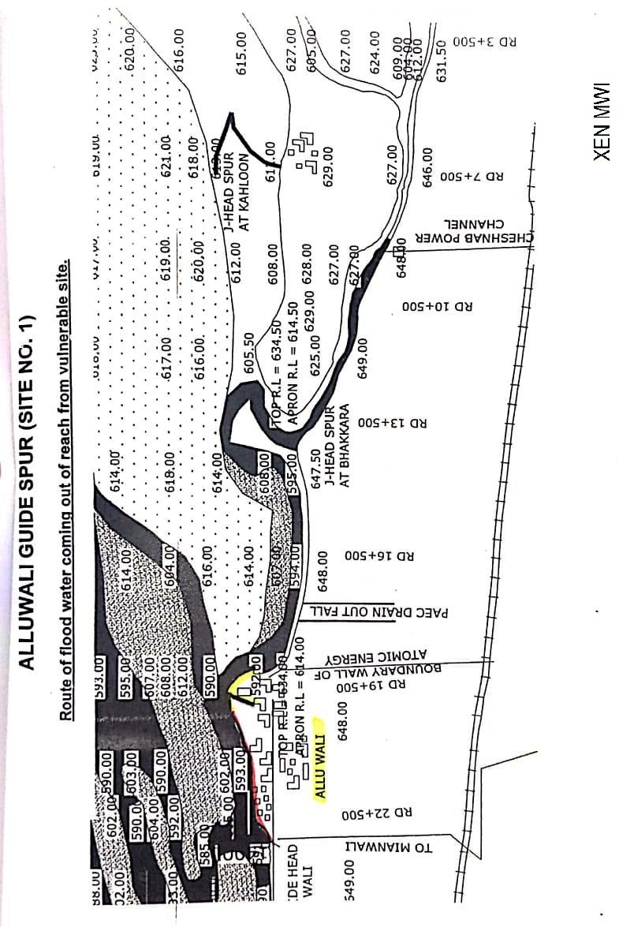

ALLUWALI GUIDE SPUR AND GUIDE HEAD SPUR RD 29+000 DHINGANA. (SITE NO. 2)

13.1 PLAN SHOWING ROUTE OF FLOOD WATER COMING OUT OF THE BREACH SUPPORTED WITH LEVELS.

Plan showing route of water coming out of breach from reach between Alluwali Guide Spur and Guide Head Spur RD 29+000 Dhingana is attached at page # 34.
13.2 DETAIL OF VILLAGES ABADIES LIKELY TO BE AFFECTED AND THIS SHOULD ALSO BE SHOWN ON THE PLAN
A) NAME OF ABADIES / VILLAGES EFFECTED ALSO SHOWN ON THE PLAN
Name of Village
Alluwali, Dhingana, Doaba & Jal
The village abadies likely to be effected due to breach has been shown on the plan attached at page # 34.

13.3 STRATEGY AND ACTION TAKEN BE EXPLAINED IN DETAIL THIS MAY INCLUDE ARRANGEMENTS.

Such situation may not arise, as all abadies exist on high edge of the River Indus.
13.3.1 ARRANGEMENTS.
[[[ Necessary arrangements will be done on need basis.
13.3.2 ESTABLISHMENT OF FLOOD FIGHTING CAMPS.
Field Office at Alluwali village

13.3.3 DUTIES OF OFFICERS / OFFICIALS AND THEIR CAMP SITES

Camp No. | Location | Officer Name / Designation / Mobile No. | Official Name / Designation / Mobile No.
Camp No. 2 | Field Office at Guide Head Spur RD 29+000 | Ghulam Murtaza / SDO Kundian / 0300-1675188 | Malik Aman Ullah Khan / SEN Joya / 0300-7605605
13.3.4 DEPARTMENT MACHINERY AVAILABLE
Mianwali Canal Division has No machinery, however Machinery will be arranged on need basis from Machinery Circle of Irrigation Department.
13.3.5 MACHINERY AVAILABLE FROM PRIVATE SOURCE
PAEC & WAPDA located about 10-K.M away from Alluwali village will be requested for logistic support and to provide Machinery in any emergency.
13.3.6 FLOOD FIGHTING MATERIAL REQUIRED.
13.3.7 FLOOD FIGHTING MATERIAL AVAILABLE.

Sr. No. | Name of article | Total required Qty | Available Qty | Balance Qty | Remarks
1 | Kassies with Handle | 10-No. | 10-No. | - | Balance Quantity will be purchased before coming Flood season 2023.
2 | Shawl | 10-No. | 10-No. | -
3 | Basket (Toot) | 100-No. | 65-No. | 35-No.
4 | Jute Bag (4-5 Cft) | 200-No. | 200-No. | -
5 | Polly propylene Bag (2-3 Cft) | 500-No. | 175-No. | 325-No.
6 | Bamboo | 135-No. | 130-No. | 5-No.
7 | Soldiery | 1-No. | 1-No. | -
8 | Axes | 10-No. | 10-No. | -
9 | Torch Electric | 10-No. | 10-No. | -
10 | Life Jacket | 10-No. | 10-No. | -
11 | Umbrella small | 10-No. | 10-No. | -
12 | Umbrella large | 5-No. | 3-No. | 2-No.
13 | Seba | 8-Kg. | 3-Kg. | 5-Kg.
14 | Emergency light | 4-No. | 4-No. | -

13.4 DETAIL OF OTHER INFRASTRUCTURE LIKE ELECTRIC, SUI GAS TELEPHONE INSTALLATIONS, ROAD NETWORK, OTHER BUILDINGS, CANALS AND DRAINAGE NETWORK

A) IN CASE OF SEVERE EROSIVE ACTION ON LEFT BANK OF RIVER INDUS NEAR ALLUWALI VILLAGE. FOLLOWING INFRASTRUCTURE WILL BE EFFECTED.
i Abadies.
ii Sher Shah Soori metalled road from Alluwali to Piplan.
iii Communication System Dhingana
iv Electric Supply system Dhingana
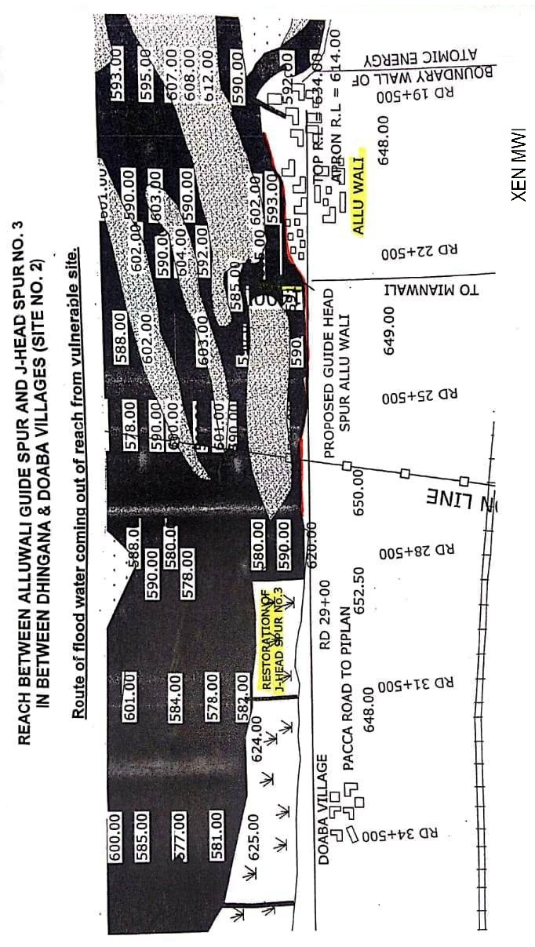
J-HEAD SPUR RD 35+600 DOABA (SITE NO. 3)

13.1 PLAN SHOWING ROUTE OF FLOOD WATER COMING OUT OF THE BREACH SUPPORTED WITH LEVELS
Plan showing route of water coming out breach from J-Head Spur RD 35+600 Doaba is attached at page # 37.

13.2 DETAIL OF VILLAGES ABADIES LIKELY TO BE AFFECTED AND THIS SHOULD ALSO BE SHOWN ON THE PLAN

A) NAME OF ABADIES / VILLAGES EFFECTED ALSO SHOWN ON THE PLAN
Name of Village
Dhingana & Doaba.
The village abadies likely to be effected due to breach has been shown on the plan attached at page # 37.

13.3 STRATEGY AND ACTION TAKEN BE EXPLAINED IN DETAIL THIS MAY INCLUDE ARRANGEMENTS.

Such situation may not arise, as all abadies exist on high edge of the River Indus.
13.3.1 ARRANGEMENTS.
Necessary arrangements will be done on need basis.
13.3.2 ESTABLISHMENT OF FLOOD FIGHTING CAMPS.
Field Office at J-Head Spur No.3
13.3.3 DUTIES OF OFFICERS / OFFICIALS AND THEIR CAMP SITES

Camp No | Location | Officer Name / Designation / Mobile No. | Official Name / Designation / Mobile No.
Camp No. 3 | Field Office at  J-Head Spur RD 35+600 Doaba | Ghulam Murtaza / SDO Kundian / 0300-1675188 | Faheem / SEN Randhore / 0302-4820197
13.3.4 DEPARTMENTAL MACHINERY AVAILABLE
Mianwali Canal Division has No Machinery however; Machinery will be arranged on need basis from Machinery Circle of Irrigation Department.
13.3.5 MACHINERY AVAILABLE FROM PRIVATE SOURCE
PAEC & WAPDA located about 10-K.M away from Alluwali village will be requested for logistic support and to provide Machinery in any emergency.

13.3.6 FLOOD FIGHTING MATERIAL REQUIRED.
13.3.7 FLOOD FIGHTING MATERIAL AVAILABLE.
Sr. No. | Name of article | Total required Qty | Available Qty | Balance Qty | Remarks
1 | Kassies with Handle | 10-No. | 10-No. | - | Balance Quantity will be purchased before coming Flood season 2023.
2 | Shawl | 10-No. | 10-No. | -
3 | Basket (Toot) | 100-No. | 65-No. | 35-No.
4 | Jute Bag (4-5 Cft) | 300-No. | 300-No. | -
5 | Polly propylene Bag (2-3 Cft) | 500-No. | 175-No. | 325-No.
6 | Bamboo | 135-No. | 130-No. | 5-No.
7 | Soldiery | 1-No. | 1-No. | -
8 | Axes | 7-No. | 7-No. | -
9 | Torch Electric | 10-No. | 10-No. | -
10 | Life Jacket | 10-No. | 10-No. | -
11 | Umbrella small | 6-No. | 6-No. | -
12 | Umbrella large | 5-No. | 3-No. | 2-No
13 | Seba | 8-Kg. | 3-Kg. | 5-Kg.
14 | Emergency light | 4-No. | 4-No. | -
15 | Generator | 1-No. | - | 1-No.
16 | Petrol for Generator | 300-Litre | - | 300-Litre
17 | Cable 7/29 | 150-Meter | - | 150-Meter
18 | Energy Sever | 10-No. | - | 10-No.
19 | Electric Board | 2-No. | - | 2-No.

13.4 DETAIL OF OTHER INFRASTRUCTURE LIKE ELECTRIC, SUI GAS TELEPHONE INSTALLATIONS, ROAD NETWORK, OTHER BUILDINGS, CANALS AND DRAINAGE NETWORK

A) IN CASE OF SEVERE EROSIVE ACTION ON LEFT BANK OF RIVER INDUS NEAR ALLUWALI VILLAGE. FOLLOWING INFRASTRUCTURE WILL BE EFFECTED.
i Abadies.
ii Sher shah soori metalled road from Alluwali to Piplan.
iii Communication System Dhingana / Doaba
iv Electric Supply system Dhingana / Doaba

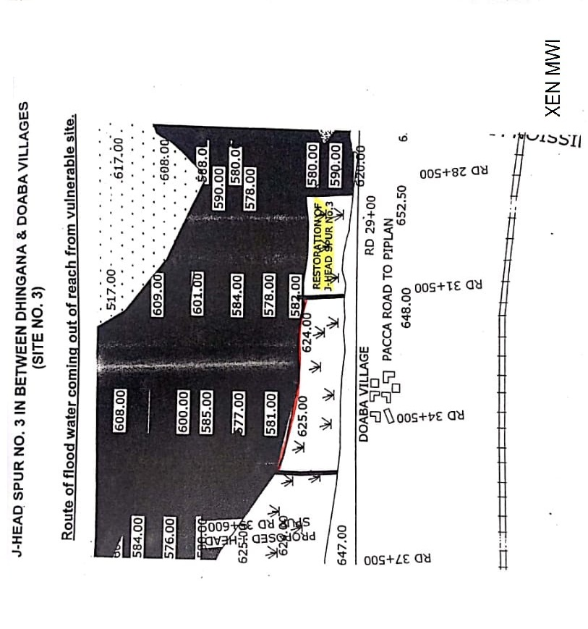

J-HEAD SPUR AT PIPLAN (SITE NO. 4).

13.1 PLAN SHOWING ROUTE OF FLOOD WATER COMING OUT OF THE BREACH SUPPORTED WITH LEVELS

Plan showing route of water coming out of breach from J-Head Spur Piplan site # 4 is attached at page # 40.

13.2 DETAIL OF VILLAGES ABADIES LIKELY TO BE AFFECTED AND THIS SHOULD ALSO BE SHOWN ON THE PLAN
A) NAME OF ABADIES / VILLAGES EFFECTED ALSO SHOWN ON THE PLAN
Name of Village
Piplan
The village abadies likely to be effected due to breach has been shown on the plan attached at page # 40.

13.3 STRATEGY AND ACTION TAKEN BE EXPLAINED IN DETAIL THIS MAY INCLUDE ARRANGEMENTS.

Such situation may not arise, as all abadies exist on high edge of the River Indus.
13.3.1 ARRANGEMENTS.
[[[ Necessary arrangements will be done on need basis.
13.3.2 ESTABLISHMENT OF FLOOD FIGHTING CAMPS.
Field Office at J-Head Spur Piplan

13.3.3 DUTIES OF OFFICERS / OFFICIALS AND THEIR CAMP SITES

Camp No. | Location | Officer Name / Designation / Mobile No. | Official Name / Designation / Mobile No.
Camp No. 4 | Field Office at J-Head Spur at Piplan | Ghulam Murtaza / SDO Kundian / 0300-1675188 | Malik Abdul Aziz / SEN Piplan / 0301-8790231

13.3.4 DEPARTMENTAL MACHINERY AVAILABLE
Mianwali Canal Division has No machinery, however Machinery will be arranged on need basis from Machinery Circle of Irrigation Department.

13.3.5 MACHINERY AVAILABLE FROM PRIVATE SOURCE
Machinery will be arranged from private sources on need basis.
13.3.6 FLOOD FIGHTING MATERIAL REQUIRED.
13.3.7 FLOOD FIGHTING MATERIAL AVAILABLE.
Sr. No. | Name of article | Total required Qty | Available Qty | Balance Qty | Remarks
1 | Kassies with Handle | 10-No. | 10-No. | - | Balance Quantity will be purchased before coming Flood season 2023.
2 | Shawl | 10-No. | 10-No. | -
3 | Basket (Toot) | 100-No. | 65-No. | 35-No.
4 | Jute Bag (4-5 Cft) | 200-No. | 200-No. | -
5 | Polly propylene Bag (2-3 Cft) | 500-No. | 175-No. | 35-No.
6 | Bamboo | 135-No. | 130-No. | 5-No.
7 | Soldiery | 1-No. | 1-No. | -
8 | Axes | 6-No. | 6-No. | -
9 | Torch Electric | 7-No. | 7-No. | -
10 | Life Jacket | 7-No. | 7-No. | -
11 | Umbrella small | 6-No. | 6-No. | -
12 | Umbrella large | 5-No. | 1-No. | 4-No.
13 | Seba | 8-Kg. | 3-Kg. | 5-Kg.
14 | Emergency light | 4-No. | 4-No. | -

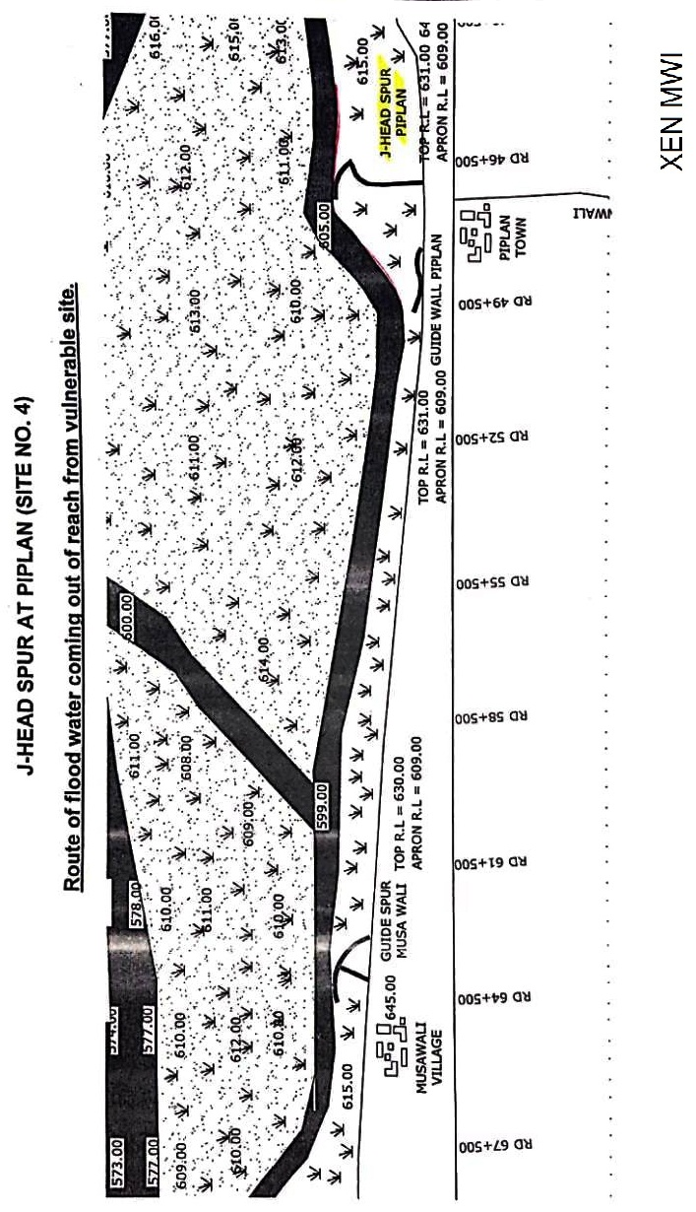

13.4 DETAIL OF OTHER INFRASTRUCTURE LIKE ELECTRIC, SUI GAS TELEPHONE INSTALLATIONS, ROAD NETWORK, OTHER BUILDINGS, CANALS AND DRAINAGE NETWORK

A) IN CASE OF SEVERE EROSIVE ACTION ON LEFT BANK OF RIVER INDUS NEAR ALLUWALI VILLAGE. FOLLOWING INFRASTRUCTURE WILL BE EFFECTED.
i Abadies.
ii Sher shah soori metalled road from Piplan to Musewali.
iii Communication System Piplan to Musewali.
iv Electric Supply system Piplan to Musewali.

Executive Engineer  Mianwali Canal Division  Mianwali | Superintending Engineer  Thal Canal Circle  Mianwali | Chief Engineer  Sargodha Irrigation Zone  Sargodha

14.6 Police Deployment Plan
Sr. No. | Name of Site. | Concerned Police Station | Police personal to be deployed.
1 | Base Camp # 1 at Guide Spur Alluwali | Piplan District Mianwali | Constable=2 No.
2 | Base Camp # 1 at Guide Spur Alluwali | Piplan District Mianwali | Constable=2 No.
3 | Base Camp # 1 at Guide Spur Alluwali | Piplan District Mianwali | Constable=2 No.  ASI =1 No.
4 | Base Camp # 2 at Village Dhingana | Piplan District Mianwali | Constable=2 No.  ASI =1 No.
5 | Base Camp # 2 at Village Dhingana | Piplan District Mianwali | Constable=2 No.  ASI =1 No.
6 | Base Camp # 3 at  J-Head Spur Doaba | Piplan District Mianwali | Constable=2 No.
7 | Base Camp # 3 at  J-Head Spur Doaba | Piplan District Mianwali | Constable=2 No.
8 | Base Camp # 4 at  J-Head Spur Piplan | Piplan District Mianwali | Constable=2 No.
9 | Base Camp # 4 at  J-Head Spur Piplan | Piplan District Mianwali | Constable=2 No.  ASI =1 No.
10 | Base Camp # 4 at  J-Head Spur Piplan | Piplan District Mianwali | Constable=2 No.

CHAPTER-15

Back up Division (In case of breach)

Kalabagh Headworks Division will be backup Division in case of any damaged of structure/bund.

Sub Divisional Officer  Kundian Canal Sub Division  Kundian |  | Executive Engineer  Mianwali Canal Division  Mianwali

