FLOOD FIGHTING
PLAN- 2024.
PART – A.
PART – A.
CHAPTER-1
Salient feature of Shahpur Division
1.1 Location
Shahpur Canal Division LJC Sargodha with its office at Sargodha controls the canal network of Shahpur Branch. Shahpur Branch Canal system originating from Head Regulator RD: 141460/R of Lower Jhelum Canal located in Tehsil & District M.B.Din and extends upto the canal boundary of Sargodha Canal Division near Sultanpur Canal Rest House. The area under jurisdiction of Shahpur Canal Division LJC Sargodha, located on left bank of River Jhelum between Rasul to Trimmu i.e part D/S of Malikwal – Harn pur Railway line bridge to D/S of Demontomorency Bridge at Sargodha – Khushab Road.
1.2 General Description
Shahpur Branch off-takes from RD: 141460/R of Lower Jhelum Canal and runs parallel to River Jhelum irrigating areas along River belt. The system being very close to the river is suspected to damages even from a short spill of River Jhelum. The system was previously running through inundation channels belonging to private landlords. Remodeling of this in-undation system was carried out during 1952 by Government of Punjab in the public interest and for benefit of small farmers. The inauguration was held on 19/04/1952 and till to date the system is serving irrigation in four Tehsils (i.e Bhera, Shahpur, Sargodha & Sahiwal) of District Sargodha. The system being close to the river remains under threat and requires special vigilance. On the right bank of Shahpur Branch, vulnerable reaches have been converted into flood embankment. During the flood season 1992, 1997, 2010, 2014 & 2015 Shahpur Branch and its off-takes were badly damaged. Similarly the right banks of Shahpur Disty: and Western Feeder Disty: (both off taking from Shahpur Branch) have been converted into flood bund. The bund along Shahpur Disty is under direct hit of River Jhelum in the reach RD: 44-51. Another important flood protection structure is near village Megha Kadhi where a guide wall and sloping spur was constructed during the year 2007 to protect village abadi and other important infrastructure.
XEN SHP
  - Administrative setup
Shahpur Division consists of three Sub Divisions, and is responsible for operation of Shahpur Branch and Sikhanwala Quarry. Sub Divisional Officers Miani/Shahpur are responsible for operation and maintenance of Shahpur Branch System, whereas Sub Divisional Officer Quarry Sub Division looks after the affairs of Quarry Sub Division based at Sikhanwala near 119 S.B Sargodha.

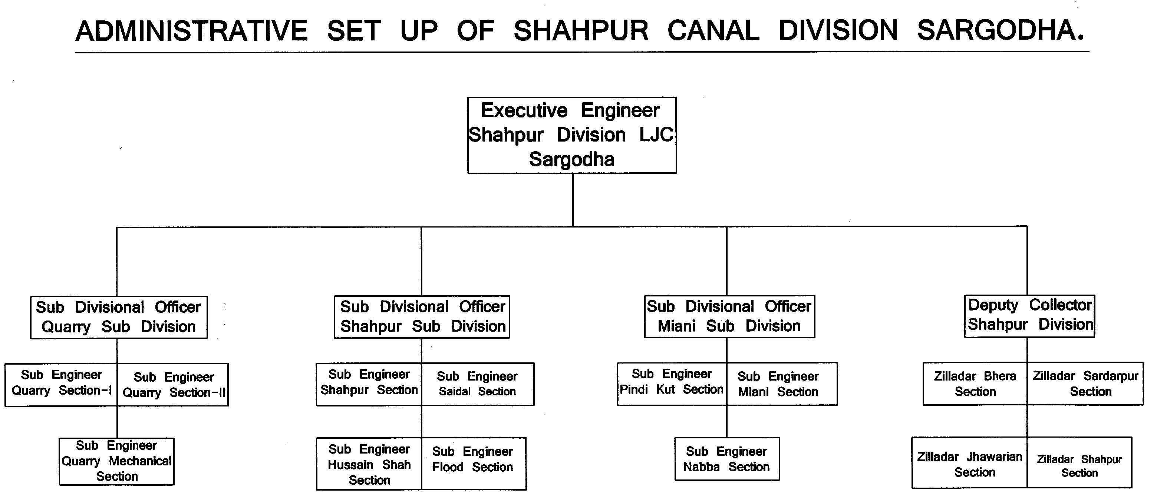
XEN SHP
CHAPTER-2
Flood Protection and River Training Works
2.1 Design parameter of Training Works
The detail of flood bunds with their designed parameters, which falls in the jurisdiction of Shahpur Division is reflected in the below statement.

Sr. No. | Name of Flood Bund | Length  (in Ft:) | Top width | Side Slope | Free Board
1 | 2 | 3 | 4 | 5 | 6
1 | Flood Bund along  Western Feeder Disty:  RD: 2000 – 15000/R  (along with 8 No. Studs) | 13000 | 20.0’ | 3:1/R  2:1/L | 6.0’
2 | Flood Bund along  Shahpur Branch  RD: 30000 – 35000/R | 5000 | 20.0’ | 2:1/R  1.5:1/L | 5.0’
3 | Flood Bund along  Shahpur Branch  RD: 75500 – 81000/R | 5500 | 20.0’ | 2:1/R  1.5:1/L | 5.0’
4 | Flood Bund along  Shahpur Branch  RD: 130000 – 202800/R | 72800 | 20.0’ | 2:1/R  1.5:1/L | 5.0’
5 | Flood Bund along  Shahpur Branch  RD: 246000 – 261500/R | 15500 | 20.0’ | 2:1/R  1.5:1/L | 5.0’
6 | Flood Bund along  Shahpur Disty:  RD: 16000 – 56900/R | 40900 | 20.0’ | 3:1/R  1.5:1/L | 3.0’
TOTAL LENGTH |  | 152200 = 30.44 Miles

7 | Guide wall & Sloping Spur at Megha Kadhi  i). Guide Wall  ii). Sloping Spur | 1400’  (1250’+150 Sloping Portion)  250’  (100’ + 150’ sloping Portion) | 30.0”  25.0’ | 2:1 /L&R  2:1 /L&R | 5.0’  5.0’

XEN SHP
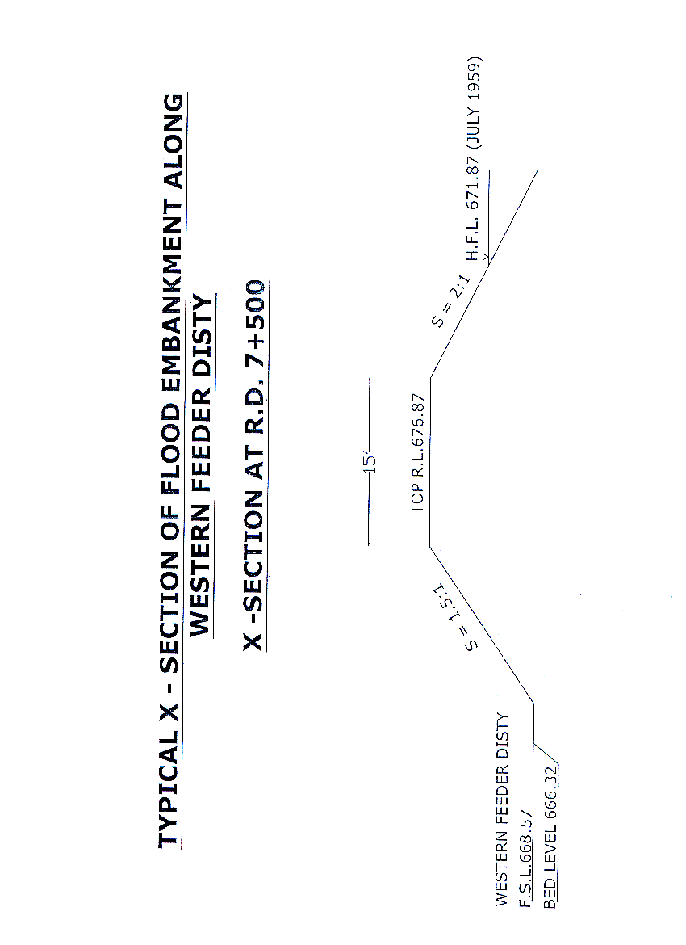
XEN SHP
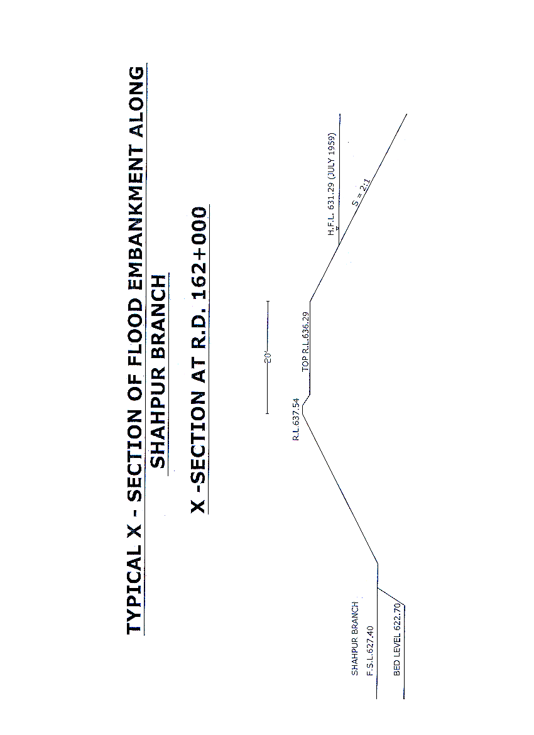
XEN SHP
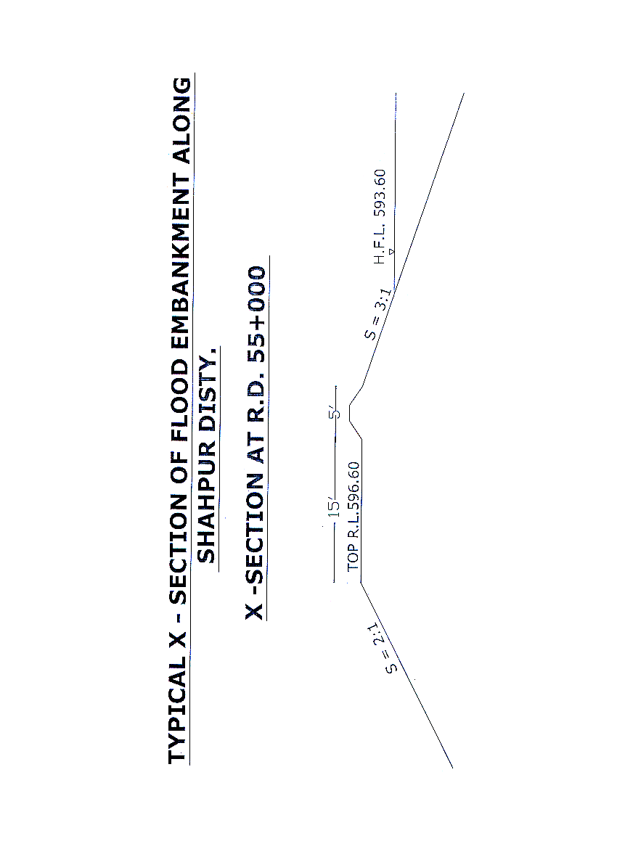
XEN SHP
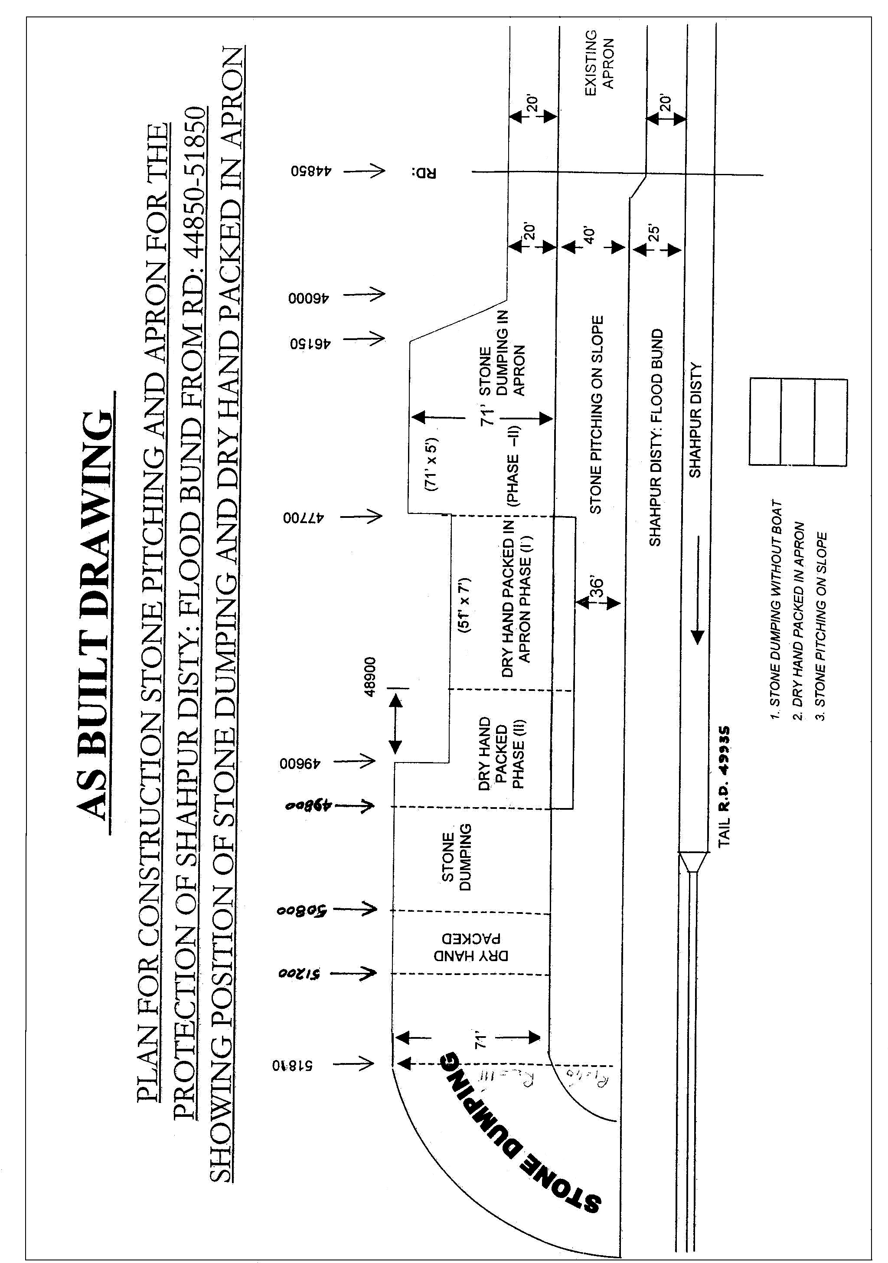
XEN SHP
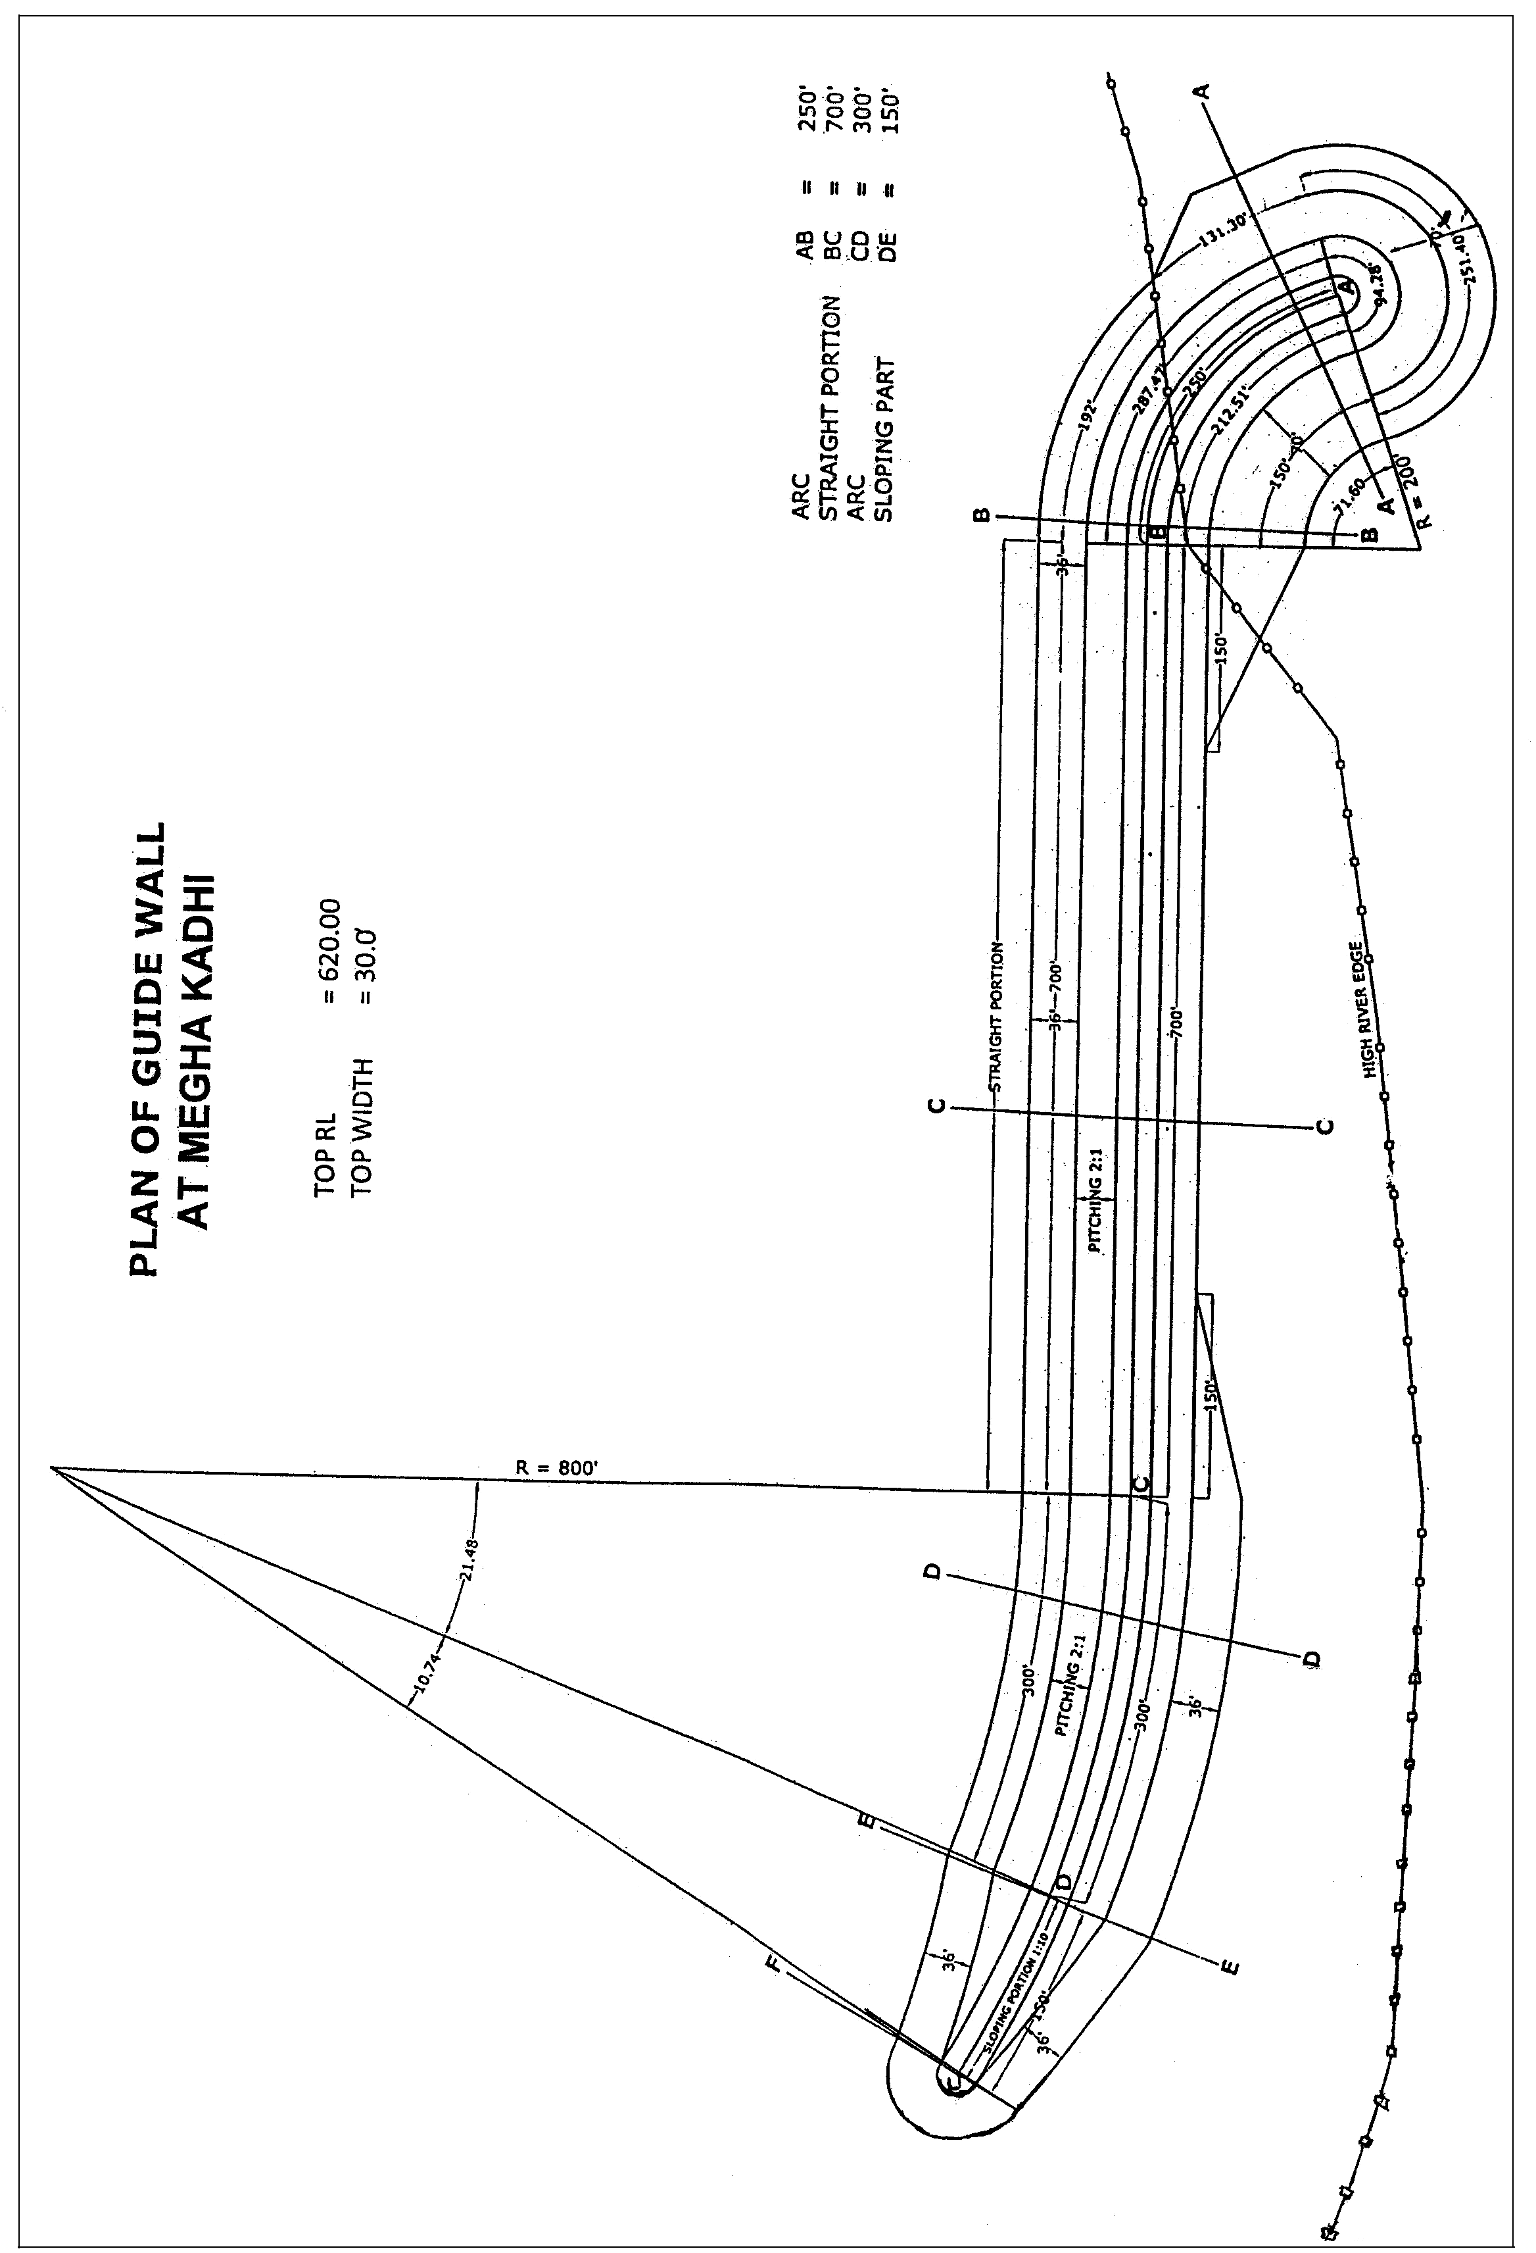
XEN SHP
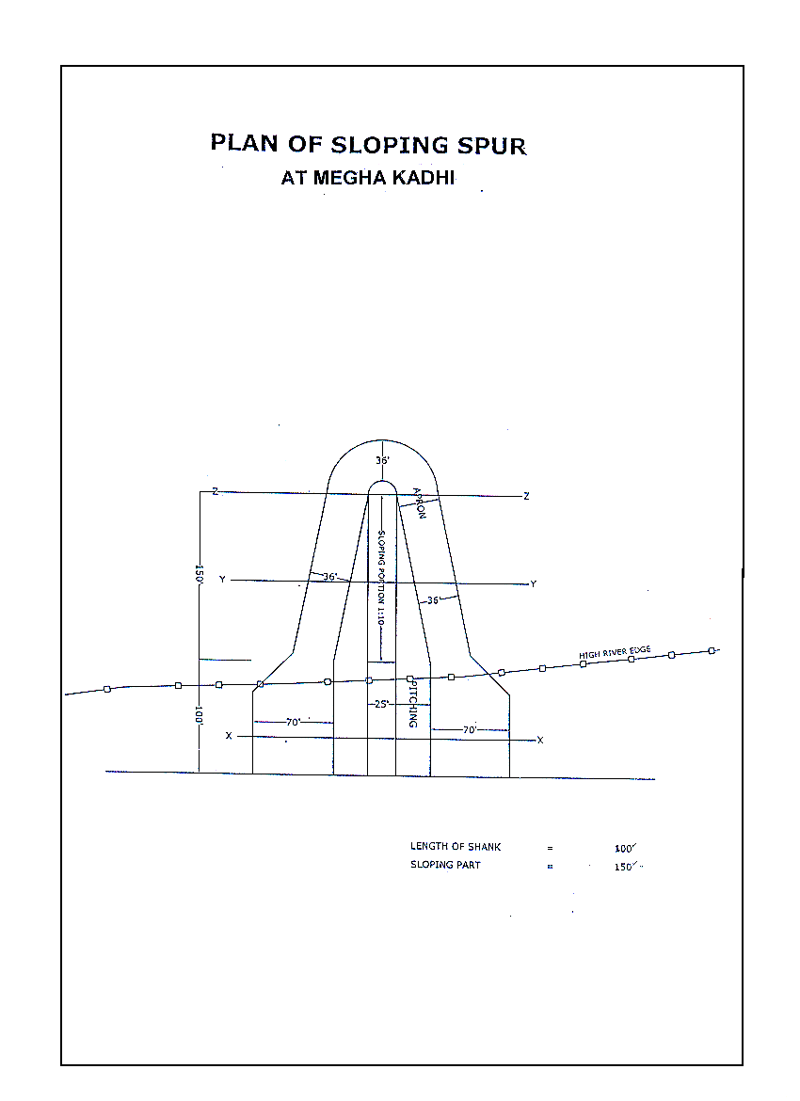
XEN SHP

  - Location Map
Location map / Index Plan of Shahpur Division LJC Sargodha is attached at page # 61.

XEN SHP

CHAPTER-3
Brief history of past flood events (1959 – 2023)
Exceptionally high flood was experienced in River Jhelum during 1959 (8.70 Lac Cs) and 1960 (8.60 Lac Cs) (i.e. pre Mangla period). These floods caused havoc in the Shahpur Canal area and resulted in colossal damages to public and private assets.
Again exceptionally high floods were experienced during September 1992 and August 1997, August 2010 & September 2014 with discharges of 9.52 Lac Cs. , 5.48 Lac Cs, 2.63 Lac Cs & 5.16 Lac Cs respectively in River Jhelum D/S Rasul Barrage (post Mangla stage). These floods hit flood bunds and channels of Shahpur Division, which caused breaches at several places, loss of human lives, public property and standing crops etc. A medium flood was experienced during July 2015 in river Jhelum D/S Bhalwal barrage (post Mangla stages). This flood did not cause any loss to human lives, public property and standing crops etc.
(i) SYPHON AT RD: 6300 WESTERN FEEDER.
There is a syphon under Western Feeder Disty: at the above noted site which is to be closed with karries as soon as the River Jhelum enters low flood limit down stream Rasul Barrage. The syphon is to be opened only on the subsidence of floods for drainage of entrapped water. Residents of villages Kalyanpur living on the riverside always attempt to prevent it from being closed.
(ii) PLUGGING SITE AT RD: 14900 AND RD: 16000 RD: BRIDGE SHAHPUR DISTY:
Shahpur Disty: was damaged due to super flood 1992. The cuts/breach sites have been repaired. Shahpur Disty: is closed from head when the River Jhelum enters high flood and is plugged by sand filled bags at RD: 14900 and RD: 16000 as the case may be so that in case, flood water enters Shahpur Disty in reach RD: 14900 and RD: 0-7000 by over topping or cuts and may not damage Shahpur city and works on Shahpur Disty: down stream this point Residents of village Jalapur Syedan, Kotla Syedna and Jhuggian on the Riverside of the Disty: always obstruct this plugging. Also after subsidence of floods, upper side public attempts to cut Shahpur Disty: in reach RD: 0-7000 to drain off entrapped water, which causes submergence of area and even blocking of approaches to the above mentioned villages. It is also necessary to check this practice as disruption of irrigation system by breaches is experienced, which causes loss to agriculture area.
XEN SHP

ii) DETAIL OF VILLAGES LIKELY TO BE INUNDATED WITH DIFFERENT FLOOD STAGES
The following villages are likely to be inundated with different flood stages. As such the action for timely intimation, requisite evacuation, and safety/relief measures are to be taken by Civil Authority, accordingly.

Low Flood  (75000 Cs to 110000 Cs D/S RSL) | Medium Flood  (110000 Cs to 150000 Cs D/S RSL) | High Flood  (150000 Cs to 225000 Cs D/S RSL) | Very High Flood  (225000 Cs to 300000 Cs D/S RSL) | Exceptionally High Flood  (Above 300000 Cs D/S RSL)
 | Achran | Achran | Achran | Achran | Thatti Walana
 | Chiler | Chiler | Chiler | Chiler | Rangpur
 |  | Kot Mukaram | Kot Mukaram | Kot Mukaram | Allayar
 |  | Gaga | Gaga | Gaga | Ghangowal
 |  | Chak Gangadas | Chak Gangadas | Chak Gangadas | Jhanwarian
 |  | Dhall | Dhall | Dhall | Kot Bhai Khan
 |  | Chak Ramdas | Chak Ramdas | Chak Ramdas | Gujranwala
 |  | Kotli Ali Ahmed | Kotli Ali Ahmed | Kotli Ali Ahmed | Shahpur City
 |  | Bharth Gharbi | Bharth Gharbi | Bharth Gharbi | Bhera
 |  | Mega | Mega | Mega | Ali Pur
 |  | Tarki Wala | Tarki Wala | Tarki Wala | Vazuadi
 |  | Kandan | Kandan | Kandan | Saidal
 |  | Nunga jhumat | Nunga jhumat | Nunga jhumat | Mavly
 |  | Bunga Sighwal | Bunga Sighwal | Bunga Sighwal | Kahalian
 |  | Thatti Ubai | Thatti Ubai | Thatti Ubai | Aqal Shah
 |  | Thatti Nika | Thatti Nika | Thatti Nika | Kasopur
 |  |  | Wadhan | Wadhan
 |  |  | Hajka | Hajka
 |  |  | Jhamat Ranjha | Jhamat Ranjha
 |  |  | Kot Maghrib | Kot Maghrib | XEN SHP
Low Flood  (75000 Cs to 110000 Cs D/S RSL) | Medium Flood  (110000 Cs to 150000 Cs D/S RSL) | High Flood  (150000 Cs to 225000 Cs D/S RSL) | Very High Flood  (225000 Cs to 300000 Cs D/S RSL) | Exceptionally High Flood  (Above 300000 Cs D/S RSL)
 |  |  | Noon Jagir | Noon Jagir
 |  |  | Khichi Jagir | Khichi Jagir
 |  |  | Juggian | Juggian
 |  |  | Mangril | Mangril
 |  |  | Thatti Dhakwan | Thatti Dhakwan
 |  |  | Mangowal Khurd | Mangowal Khurd
 |  |  | Hamoka | Hamoka
 |  |  | Sabowal | Sabowal
 |  |  | Shahpur City | Shahpur City
 |  |  | Kalan | Kalan
 |  |  | Kot Phelwan | Kot Phelwan

XEN SHP
XEN SHP
CHAPTER-4
Design Data, Historic peak flood data and previous five years flood data of Head Works / Barrages and or other control points

  - Flood Limits
The intensity of flood is measured with regard to the discharge designated in certain ranges as low, Medium, High, very high and exceptionally high and they will be taken as such in the light of any wireless message received from respective warning centers.
FLOOD LIMITS (IN CUSECS)

River | Control Point | Low Flood | Medium Flood | High Flood | Very High Flood | Exceptionally High Flood
Jhelum | Mangla | 75,000  to 1,10,000 | 1,10,000 to  1,50,000 | 1,50,000 to  2,25,000 | 2,25,000 to  3,00,000 | Above 3,00,000
Jhelum | Rasul | 75,000  to 1,10,000 | 1,10,000 to  1,50,000 | 1,50,000 to  2,25,000 | 2,25,000 to  3,00,000 | Above 3,00,000

  - Time Lags of Floods
The following are the time lags for average flood flows in the River Jhelum.
RIVER | FROM | TO | DISTANCE | TIME LAGE
Jhelum | Mangla | Rasul | 45 Mile | 9 Hours
Jhelum | Rasul | Demontomorency Bridge Khushab | 80 Mile | 22 Hours
  - Highest Floods
The following are the important highest flood discharges (in cusecs) recorded downstream Rasul during last five years.
YEAR | D/S RASUL
2017 | 39230 Cs
2018 | 43135 Cs
2019 | 91904Cs
2020 | 126951Cs
2021 | 31420 Cs
2022 | 21050 Cs
2023 | 35325

XEN SHP
  - Peak discharges
HISTORIC PEAK FLOOD DATA
XEN SHP
Date | Discharges (Cs.) | Pond level (ft.)
02/07/1959 | 8,70,000 | 719.90
11/07/1960 | 8,60,000 | 721.80
16/08/1973 | 2,69,976 | 716.80
04/08/1975 | 2,69,330 | 716.00
30/08/1975 | 1,25,579 | 715.00
11/08/1982 | 2,41,248 | 716.00
17/07/1986 | 2,61,664 | 717.00
17/07/1988 | 2,61,664 | 716.00
10/09/1992 | 9,52,170 | 721.00
23/08/1994 | 1,29,392 | 717.00
28/07/1995 | 2,85,071 | 715.00
26/06/1996 | 1,33,192 | 716.00
27/08/1997 | 5,49,598 | 716.00
17/07/1998 | 70,674 | 719.00
11/05/1999 | 46,160 | 719.00
22/07/2000 | 39,222 | 718.00
24/07/2001 | 30,270 | 718.10
14/08/2002 | 49,170 | 718.00
05/09/2003 | 49,170 | 718.00
30/04/2004 | 31,422 | 719.00
17/07/2005 | 92,246 | 719.00
13/07/2006 | 1,65,947 | 720.85
07/07/2007 | 39,898 | 718.00
03/05/2008 | 27,518 | 719.00
16/08/2009 | 69,952 | 719.10
30/08/2010 | 2,63,000 | 718.00
17/09/2011 | 96,864 | 718.00
05/08/2012 | 43,135 | 719.00
24/07/2013 | 35,325 | 719.00
06/09/2014 | 5,16,387 | 720.40
27/07/2015 | 99,103 | 718.00
24/06/2016 | 43135 | 701.30
23/07/2017 | 39230 | 719.00
02/10/2018 | 43135 | 700.90
18/06/2019 | 91904 | 705.50
28/8/2020 | 126951 | 717
30-06-2021 | 31420 | 700.30
22-06-2022 | 23210 | 590.50
08-09-2023 | 35325 | 699.30

CHAPTER-5

Flood Fighting Strategy
RIVER JHELUM
The following channels are directly affected by RIVER spills and their right bank acts as Flood embankment and protection to the abadies, crops and other infrastructure, against the Flood. The main towns/villages protected by canal embankment are Villages Achran, Chiler, Kot Mukaram, Gaga, Chak Gangadas, Jhawrian, Dhall, Chak Ramdas, Kot Bhai Khan, Mega, Shahpur City, Bhera, Tarki Wala, Kandan, Saidal, Bunga Sahiwal, Thatti Ubai, Thatti Nika, Wadhan, Hajika, Jhamat Ranjha, Kot Maghrib, Aqal Shah, Kasorpur, Allahyar, Noon Jagir, Sabowal, Hamoka, Kot Phelwan, and Kalan etc.
The reaches of channels which are affected by .River spills and where the right bank of channels acts as flood protection embankments are:-
S.NO. | CHANNEL | REACH | LENGTH
1. | Flood Bund along Western Feeder Disty ( alongwith 4-NO Studs) | RD. 2000-15000/R. | 2.6 mile
2. | Flood Bund along Shahpur Branch | RD: 30000-35000/R | 1.00 mile
3. | Flood Bund along Shahpur Branch | RD: 75500-81000/R | 1.10 mile
4. | Flood Bund along Shahpur Branch . | RD: 130000-202800/R | 14.56 mile
5. | Flood Bund along Shahpur Branch . | RD: 246000-261500/R | 3.1 mile
6 | Flood Bund along Shahpur Disty . | RD. 16000-56900/R | 8.18 mile.
On Spur river training works.
Sr.No | Description | Reach RD | Length ( in mile )
1 | Guid Wall and sloping Spur at Megha Kadhi
I | Guid Wall | RD:1400 ft | 0.28
Ii | Sloping Spur | RD:250 ft | 0.05

- On receipt of flood warning of the low flood at Rasul Barrage, Sub Divisional Officer, Miani Sub Division will take charge of the flood bunds along Western Feeder, Shahpur Branch and its channels from head to RD: 158000 and Sub Divisional Officer Shahpur will be in charge of the flood bunds along Shahpur Branch from RD: 158000 to 261500 as well as along Shahpur Distributory from RD: 16000 to 56900 and other channels.
XEN SHP

- The Sub Divisional Officer Shahpur / Miani Sub Divisions as well as their Sub Engineers will immediately move to their places of duty as described and will establish flood emergency stations when low and medium flood is passing downstream Rasul Barrage.
- Sub Engineer Miani will be responsible for the watching of the bunds along Western Feeder and Shahpur Branch in his section, Zilladar Bhera Section along with his Patwaries will assist Sub Engineer, Miani Section for proper watching of flood bunds.
- Sub Engineer Nabba Section will camp at RD: 157000 Shahpur Branch and will be incharge of the flood embankment RD: 130000 – 158000. Zilladar Sardarpur Section along with his Patwaries will assist the Sub Engineer.
- Sub Divisional Officer, Miani Sub Division will keep constant liaison with Dy. District Officer (Revenue) and Deputy Superintendent of Police Bhalwal to seek their help as and when required and will be constantly on move along Western Feeder Disty: and Shahpur Branch in his Sub Division to ensure proper watching.
- Sub Engineer Saidal Section will be incharge of the flood embankment along Shahpur Branch from RD: 158000 - 202800 & Guide wall and sloping spur at Megha Kadhi. Zilladar Jhawarian Section and Zilladar along with concerned Patwaries will assist the Sub Engineer, Saidal Section.
- Sub Engineer Shahpur Section will be incharge of the flood embankment along Shahpur Disty: from RD: 16000 to 56900. The concerned Patwaries will assist Sub Engineer Shahpur Section.
- Sub Engineer, Flood Section will be responsible for the watching of flood embankment along Shahpur Branch RD: 246000 - 261500/R and Shahpur Disty in reach RD: 0 -16000. He will also assist Sub Divisional Officer, Shahpur Sub Division.
- When the River Jhelum D/S Rasul is in high flood, the Sub Divisional Officer Miani and Shahpur Sub Division will keep close liaison with Dy. Distt. Officer (Revenue) and Deputy Superintendent of Police Bhera / Shahpur Tehsil to procure additional labour for watching of the bund as well as repairs to any damage done to the channels and the Sub Engineer will keep close liaison with the Station House Officer and the Tehsildar of the respective Police Station / Tehsil and keep themselves available and alert at the places of their duties as assigned in the plan.
In view of vulnerable location of channels, because of being in the flood plain, it is essential to take up flood preparedness activities like strengthening weak and ghat sites, clearance of jungle, shrubs from banks and slopes and making them fit to face the ensuing floods. Therefore a gang of one man per mile is employed from 1st June to 30TH September, in addition to existing establishment of one beldar in six miles length of canal.
XEN SHP

- LOW FLOOD DISCHARGE 75000 – 110000 Cs.
No extra labour will be employed. The labour arranged for preparedness will continue as such.
- MEDIUM FLOOD DISCHARGE 110000 – 150000 Cs
The flood water flows within river bank. No extra labour will be employed. The labour arranged for preparedness will continue as such.
- HIGH FLOOD DISCHARGE 150000 – 225000 Cs.
The flood water spills out and inundates the low lying areas and touches the flood bund. The watching is necessary to be arranged. Therefore, two men for day & night for one mile are employed, including the existing gang, for watching purposes.
- VERY HIGH FLOOD DISCHARGE 225000 – 300000 Cs.
All activities will remain as such. The watching establishment will be raised to two men per mile on channels and three men per mile per shift for three shifts on Flood Bund Spurs.
v. EXCEPTIONALLY HIGH FLOOD ABOVE 300000 Cs.
This stage warrants alarming situation. The watching labour will be raised to three men per mile per shift on channels and four men per mile per shift for three shifts on bund. On receipt of exceptionally high flood warning, Deputy Collector, Shahpur alongwith concerned Zilladars and Canal Patwaries will shift on camps.

XEN SHP

CHAPTER-6
Flood Damages Restoration Works

No flood damages restoration works executed during last financial year
2022-23.However machinery was deployed to meet with any kind of emergency during flood 2022-23
The detail of works is as under.

Sr No | Name of Sub Division | Amount
1 | Shahpur | Nil
2 | Miani | Nil
Total |  | Nil

XEN SHP
CHAPTER-7
Flood Fighting Watching Arrangement
  - Pre-Flood Arrangement
The schedule for pre – flood activities is as under:-
Sr.# | Activity | Target Dates | Compliance Report
I. | Preparation of Flood Fighting Plans
 | a) Submission of Draft Divisional Plans by Zonal Chiefs to Chief Engineer Drainage and Flood (After scrutiny by SEs/CEs). | 01.03.2024 | .
 | b) Review by Chief Engineer D&F. | 31.03.2024
 | c) Final submission of Flood Fighting Plans. | 15.04.2024 | Will be completed within target date.
II. | Inspection of flood infrastructure.
 | a) By XEN's | 15.03.2024
 | b) By SE's/CEs) | 31.03.2024
 | c) By Departmental & Army Teams. | 15.04.2024 | Will be completed within target date.
III. | Indication of encroachments on bunds and spurs to the Civil Administration. | 31.03.2024 | No encroachment exist on flood bunds / spurs in Shahpur Division.
IV. | Painting Gauges, RD Marks, Data Boards and repairs to Flood Bunds etc. | 31.05.2024 | Will be completed within target date.
V. | Replenishment of Reserve Stock of Stone and Flood fighting materials.
 | a) Identification of needs. | 28.02.2024 | Reserve Stock Limit Sanctioned vide C.E No. 11192-94 dated 22/07/2015
 | b) Funding/Procurement Arrangements. | 15.03.2024 | No funding required.
 | c) Procurement, Stacking, Prescribed field checks. | 31.05.2024 | -
VI. | Installation of wireless sets | 15.06.2024 | Will be completed within target date.
VII. | Opening of Zonal Flood Cells
 | a) Duty Rosters. | 01.06.2024 | Will be completed within target date.
 | b) Operative. | 15.06.2024 | Will be completed within target date.
STATUS OF RESERVE STOCK OF STONE
XEN SHP
Sr.No | Name of Structure | Sancd: limit of Reserve Stock  (Lac Cft) | Minimum Qty: Required  (Lac Cft) | Stone Available at site  (Lac Cft) | Balance Quantity Required  (Lac Cft) | Remarks
1 | Guide wall & sloping spur at Megha Kadhi | 1.00 | - | 0.400 | - | Sanctioned limit of reserve stock of stone at Megha Kadhi is 1.0 lac Cft. The available quantity of stone at site is 0.40 lac Cft which is sufficient and there is no further place at structure site to stack the stone..

7.2 Watching Establishment
The details of watching establishment / labour required at different flood stages are as under:-(15 June to 15 October)

Sr. No | Name of Flood Bund | Length | Top width | Side Slope | Free Board | Watching Establishment per Mile
 |  |  |  |  |  | Low |  | Medium Flood |  | High Flood |  | Very High Flood |  | Exceptionally High Flood
1 | 2 | 3 | 4 | 5 | 6 | 7 |  | 9 |  | 10 |  | 11 |  | 12
 |  |  |  |  |  | Men | Shift | Men | Shift | Men | Shift | Men | Shift | Men | Shift
1 | Flood bund along Western Feeder Disty RD: 2000-15000/R(Along with 04 No. studs) | 13000 | 20.0’ | 3:1/R  2:1/L | 6.0’ | 1 No. Beldar | 1 | 2 No. Beldar | 2 | 4 No. Beldar | 2 | 6 No. Beldar | 3 | 8 No. Beldar | 4
2 | Flood Bund along Shahpur Branch RD: 30000 – 35000/R | 5000 | 20.0’ | 2:1/R  1.5:1/L | 5.0’ | 1 No. Beldar | 1 | 2 No. Beldar | 2 | 4 No. Beldar | 2 | 6 No. Beldar | 3 | 8 No. Beldar | 4
3 | Flood Bund along Shahpur Branch RD: 75500 – 81000/R | 5500 | 20.0’ | 2:1/R  1.5:1/L | 5.0’ | 1 No. Beldar | 1 | 2 No. Beldar | 2 | 4 No. Beldar | 2 | 6 No. Beldar | 3 | 8 No. Beldar | 4
4 | Flood Bund along Shahpur Branch RD: 13000 – 158000/R | 28000 | 20.0’ | 2:1/R  1.5:1/L | 5.0’ | 1 No. Beldar | 1 | 2 No. Beldar | 2 | 4 No. Beldar | 2 | 6 No. Beldar | 3 | 8 No. Beldar | 4
5 | Flood Bund along Shahpur Branch RD:158000 – 202800/R | 44800 | 20.0’ | 2:1/R  1.5:1/L | 5.0’ | 2 No’s Beldar | 1 | 2 No. Beldar | 2 | 4 No. Beldar | 2 | 6 No. Beldar | 3 | 8 No. Beldar | 4
6 | Flood Bund along Shahpur Branch RD: 246000 – 261500/R | 15500 | 20.0’ | 2:1/R  1.5:1/L | 5.0’ | 1 No’s Beldar | 1 | 2 No. Beldar | 2 | 4 No. Beldar | 2 | 6 No. Beldar | 3 | 8 No. Beldar | 4
7 | Flood Bund along Shahpur Disty RD: 16000 – 56900/R | 40900 | 20.0’ | 3:1/R | 3.0’ | 4 No’s Beldar | 2 | 4 No. Beldar | 2 | 6 No. Beldar | 3 | 8 No. Beldar | 4 | 10 No. Beldar | 5
TOTAL |  | 152200 = 30.44 Miles
8 | Guide Wall and sloping Spur at Megha Kadhi |  |  |  |  |  |  | Watching Establishment
I | Guide wall | 1400 | 30 | 2:1/L&R | 5.0’ | 1 No: Beldar | 1 | 1 No: Beldar | 1 | 2 No: Beldar | 2 | 4 No: Beldar | 2 | 6 No: Beldar | 3
Ii | Sloping Spur | 250 | 25.0’ | 2:1/L&R | 5.0’

- The above flood embankments are marked on Index Plan enclosed.
- Flood embankments at serial No. 1 to 6 above are designed to provide 5.0 ft free board over the high flood level recorded on 02/07/1959 i.e. during pre-Mangla period. Flood work at serial No. 7 has 3.0 ft free board over high flood level of 08/1976 i.e. for a discharge of 2.69 lac Cs: D/S Rasul Barrage. Free board for this flood work is quite inadequate.
- Flood embankment mentioned at Sr. No. 7 runs parallel to Shahpur Disty: from RD: 16000 – 56900. Bund is mainly to protect village kandan and allied abadies of Tehsil Shahpur.
- Typical X-Sections of bunds are attached. The words ‘R’ and ‘L’ as shown for “side slope” for River Side and Land Side respectively.
- For medium flood stage one beldar per mile per site for two shifts (day & night).
XEN SHP

- For High, Very High and Exceptionally High Flood stages, the strength of watching establishment increases to 2, 3 and 4 beldars per mile per site for three shifts.
7. One mate will be employed against strength of 8 beldars
7.3 Arrangement at Sensitive sites
Following are the main Flood structure where watching camps will be 3established on temporary basis:-
- RD: 9500 Western Feeder Disty:
- RD: 157000 Shahpur Branch.
- RD: 166580 Shahpur Branch..
- RD: 184950 Shahpur Branch.
- RD: 16000 Shahpur Disty:
- RD: 48500 Shahpur Disty:
Note:- One Chowkidar will be employed for each camp site.
7.4 Watching Material
Quantity for flood fighting camp/ hut
Sr. No. | Name of Item | Unit | Total Required | Total available | Balance | Remarks
1 | Tent | No. | 4 | 4 | 0 | The deficient Quantity of Flood fighting material will be procured before commencement of flood season.
2 | Khaji Mats | No. | 60 | 2 | 58
3 | Axes | No. | 20 | 20 | 0
4 | Bamboos 8' to 10' (for Lighting arrangements) | No. | 40 | 30 | 10
5 | Baskets | No. | 120 | 120 | 0
6 | Buckets (Plastic) | No. | 8 | 8 | 0
7 | Cell for Torches | No. | 96 | 48 | 48
8 | Chimneys for Lamps | No. | 32 | 14 | 18
9 | Chouldaries | No. | 4 | 4 | 0
10 | E.G. Bags / Gunny Bags | No. | 2000 | 1100 | 900
11 | Energy Savers | No. | 20 | 10 | 10
12 | Folding Chair | No. | 16 | 12 | 4  XEN SHP
Sr. No | Name of Item | Unit | Total Required | Total available | Balance | Remarks
13 | Folding Table | No. | 4 | 3 | 1 | The deficient Quantity of Flood fighting material will be procured before commencement of flood season.
14 | Funnels | No. | 8 | 6 | 2
15 | G.I. Buckets | No. | 16 | 12 | 4
16 | Gas Mentles | No. | 40 | 30 | 10
17 | Generator | No. | 4 | 3 | 1
18 | Hand Saws | No. | 4 | 4 | 0
19 | Handle for Kassi / Axes | No. | 40 | 30 | 10
20 | Holder for Lamp | No. | 20 | 10 | 10
21 | Kassi with Handles | No. | 100 | 100 | 0
22 | Kerosene Oil | Liter | 120 | 63 | 57
23 | Killas | No. | 400 | 125 | 275
24 | Lanterns | No. | 20 | 20 | 0
25 | Life Belt | No. | 12 | 9 | 3
26 | M. Oil | Liter | 40 | 20 | 20
27 | Manila Rope | Kg | 80 | 70 | 10
28 | Match Boxes | No. | 16 | 12 | 4
29 | Munj / Patha / Trungers | No. | 200 | 5 | 195
30 | Needles | No. | 20 | 13 | 7
31 | Oil Extractors | No. | 4 | 2 | 2
32 | Patromax | No. | 8 | 8 | 0
33 | Petrol | Liter | 200 | 50 | 150
34 | Rain Coats | No. | 16 | 4 | 12
35 | Steel Charpoy | No. | 8 | 1 | 7
36 | Sutli | Kg | 20 | 20 | 0
37 | Switch / Plugs | No. | 40 | 30 | 10
38 | Torches 3 cells | No. | 24 | 24 | 0
39 | Umbrella | No. | 16 | 12 | 4
40 | Wicks | Packet | 8 | 4 | 4
41 | Wires 7/29 | Meter | 200 | 100 | 100
42 | Wooden Boards 10" x 12" | No. | 8 | 4 | 4
43 | Wooden Hammers | No. | 20 | 20 | 0
7.5 Arrangement for Sounding & Probing
The plan will be prepared and checked by officers before commencement of flood season.

XEN SHP

7.6 Lighting Arrangement
Sufficient number of emergency lights, lanterns and patromax lamps has already been provided. Petrol generators has been arranged and made available for lighting arrangements. Detail at Pages No.33 to 52.
7.7 Ration Arrangement
The establishment and supervisory staff will make their own food arrangements. However in the event of dearth of commodities, the Civil Authorities will be approached to store sufficient ration at Shahpur and Chak Qazi Rest Houses.
7.8 P.O.L. Arrangement for Vehicle
Respective Deputy District Officer (Revenue) will be requested by the Sub Divisional Officer incharge to provide help some reserve at the nearest Petrol Pumps to keep the vehicles in running condition . Any obstruction found there, will be pointed out by the Sub Divisional Officer.
7.9 Transportation
In general Civil Authorities have never been able to spare any vehicle for us, but we have no other cushion available to depend upon. It is therefore urged that the District Coordination Officer concerned may please ensure availability of dependable vehicle from the pool of the District.
7.10 Law and order
There is no likelihood of any interruption by any one except cutting of banks of channels to reduce heading up. In case of necessity, District Coordination Officer Sargodha will be contacted by the Executive Engineer, Shahpur Canal Division LJC to take decision at site and SDO Miani / Shahpur will seek the help of Deputy District Officer, Revenue / Assistant Commissioner Bhera & Shahpur in case of any emergency.
7.11 Medical Arrangement for Labour
It will be responsibility of District Government to provide Medical Facilities in flood areas.
7.12 Liaison with other Department
Executive Engineer, Shahpur Canal Division will keep liaison with the Civil and Army Authorities and will keep the Superintending Engineer L.J.C, Sargodha fully apprised of the flood situation in Shahpur Canal Division.
XEN SHP

7.13 Role of the Army
Liaison with the Army Authorities will be maintained during floods and if required necessary help will be sought at appropriate level.

7.14 Duties of Telephone Attendant
The system remains usually dead and if not, it goes out of operation, when the rivers are in floods. District Coordination Officer Sargodha will be requested to commence meeting and to impress upon Divisional Engineer, Telephone and Telegraph Sargodha, for making fool proof arrangements.
Name of Office / Officials | Telephone No. / Cell | Time
Name of Office / Officials | Telephone No. / Cell | From | To
Shahpur Canal Division Sargodha (Jaweria) Telephone attendant | 048-9230447  (0300-4312366) | 24 Hours
Telegraph Office Sargodha | 048-9230408 | 24 Hours
Sub Divisional Officer Miani Sub Division (Mustaq Ahmad Nasir) | 0300-8699866 | 24 Hours
Sub Divisional Officer Shahpur Sub Division (Arshad Hayat) | 03001-4482384 | 24 Hours

7.15---Wireless Arrangements
Wireless system will be installed on 15.06.2021 in the vehicle of XEN Shahpur No.GBA 456, SDO Shahpur Jeep No:BKA 8700 and SDO Miani Jeep No.SGC-2121.
XEN SHP
XEN SHP

CHAPTER-8
Detail of Encroachment

Sr. No. | Total Encroachment | Removed | Remaining | Remarks
--------------- N I L ---------------

Detail of critical encroachment on flood structure
Sr. No. | Total Encroachment | Removed | Remaining | Remarks
--------------- N I L ---------------
XEN SHP
XEN SHP
CHAPTER-9
9. Duty Roster/Flood Fighting Program
DUTY ROSTER/BATTLE STATIONS OF KEY PERSONNEL DURING HIGH FLOOD FLOW.

Key Personal | Battle Stations | Canals | Sub Division
Sub Divisional Officer, Miani & Sub Engineer Miani Section | RD: 13500 | Western Feeder | Miani Sub Division
Sub Engineer, Nabba Section | RD: 157000 | Shahpur Branch | Miani Sub Division
Zilladar Shahpur Section | RD: 166580 | Shahpur Branch | Shahpur Sub Division
Sub Engineer, Saidal Section and Sub Divisional Officer, Shahpur Sub Division | RD: 184950 | Shahpur Branch | Shahpur Sub Division
Sub Engineer, Flood Section. | RD: 16+000 | Shahpur Disty: | Shahpur Sub Division
Sub Engineer, Shahpur Section | RD: 48500 | Shahpur Disty: | Shahpur Sub Division

XEN SHP

CHAPTER-10
Emergency Telephone Nos.
Sr. No. | Designation | Code No. | Office | Residence / Cell
 | Minister Irrigation & Power Department, Punjab Lahore | 042 | 99212809  99211761  Fax 99212810
1 | Secretary Irrigation Department Punjab Lahore. | 042 | 99212117  99212118  Fax 99212116 | 042-99200286
2 | Chief Engineer, Irrigation Sargodha. | 048 | 9230445  Fax 048-9230414 | 0333-6941690  0489230451
3 | Flood Emergency Officer Sargodha Irrigation Zone Sargodha. | 048 | 9230446  Fax 9230414 | 03  006363739
4 | Chief Engineer, Drainage and Flood Zone Lahore. | 042 | 99233551  Fax 99230731 | 03006999490
5 | Director Flood Lahore, Drainage & Flood Zone Lahore. | 042 | 99230282  Fax 35862081 | 0323-4864378
6 | Deputy Director Flood, Drainage & Flood Zone Lahore. | 042 | 99230282 | 0300-6362154
7 | Flood Warning Center Jail Road Lahore. | 042 | 99205371  Fax99205372
8 | Superintending Engineer, L.J.C, Circle Sargodha. | 048 | 9230413  Fax 9230832 | 9230463
9 | Superintending Engineer, Drainage Circle Sargodha. | 048 | 9230450 | 0333-8161746
10 | Executive Engineer, Sargodha Division | 048 | 9230409  Fax 9230918 | 0300-0147499
11 | Executive Engineer, Kirana Division | 048 | 9230399  Fax 9230649 | 0302-4844342
12 | Executive Engineer, Shahpur Division | 048 | 9230447 | 0344-4132393
13 | Executive Engineer, Bhalwal Division | 048 | 9230406 | 0300-6363739
14 | Executive Engineer, Drainage Division Sargodha. | 048 | 9230453 | 0333-8899931
15 | District Co-ordination Officer Sargodha. | 048 | 9230025  9230026 | 0304-0920074
16 | Sub Divisional Officer, Miani Sub Division |  |  | 0300-8699866
17 | Sub Divisional Officer, Shahpur Sub Division | 0486 | 310793 | 0301-4482384
18 | Sub Divisional Officer, Quarry Sub Division |  |  | 0343-1760422
19 | Telegraph Office Sargodha (Flood Emergency center Sargodha) | 048 | 9230408

XEN SHP

CHAPTER-11
Standard operating procedure (SOP) for Breaching Sections.

11.1 History of the breaching section
11.2 Location, Design, Quantity and Variety of the explosive required for detonation.
11.3 Arrangement of explosives and security of explosive stores
11.4 List of the security staff alongwith detail of their training etc
11.5 Detail of mechanical means as a standby arrangements in case of detonation failure
11.6 Duty Roster in case of critical situation
11.7 Breaching Committee with their action plan
11.8 List of the villages likely to be inundated in case of breach
11.9 Announcement and detail of evacuation arrangements
11.10 Details of coordination with Civil/Army Authorities
11.11 Parallel communication arrangements
11.12 Index Plan
There is no breaching section in Shahpur Canal Division LJC Sargodha. Therefore above mentioned Para 11.1 to 11.12 does not relate.

Sub Divisional Officer, Sub Divisional Officer, Executive Engineer,
Miani Sub Division L.J.C, Shahpur Sub Division LJC, Shahpur Division L.J.C,
At Chak Qazi. . At Shahpur Saddar. Sargodha.

Superintending Engineer, Chief Engineer,
Lower Jhelum Canal Circle Sargodha Irrigation Zone,
Sargodha. Sargodha.

PART – B

CHAPTER-12
Vulnerable sites on Flood Bund/Structures:

12.1 Apprehended breaches in Flood Bunds/Structures
Based upon history of floods,
There are following critical sites of flood bunds where there is apprehension of any mishap due to floods in River Jhelum.
- Flood Bund along Western Feeder Disty between RD:6000 - 14500/R
- Flood Bund along Shahpur Branch between RD: 166000 - 202800/R.
- Flood Bund along Shahpur Branch between RD:246000 - 261500/R
- Flood Bund along Shahpur Disty between RD:44000 – 56900/R
12.2 Operation of breaching sections.
There is no breaching section.
12.3 Breaches due to rising of flood water, deterioration of flood bunds etc.
No Such

XEN SHP

CHAPTER-13
Emergency Contingency Plan for vulnerable site (sites) listed above. Emergency Contingency Plan must include:-
PLAN FOR SITE NO: 1
13.1 Plan showing route of Flood Water coming out of the breach supported with levels.
A plan showing the route of expected flood water coming out of mishap site on Flood Bund along Western Feeder Disty between RD:6000 - 14500/R in Tehsil Bhera, District Sargodha is given as under:-

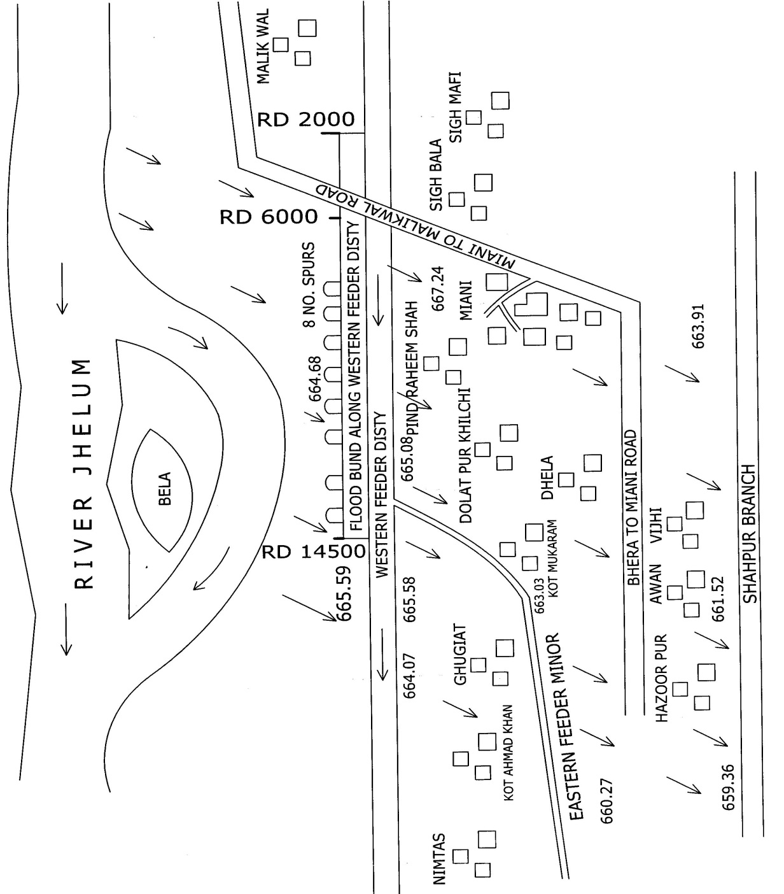
XEN SHP

13.2 Detail of villages abadies likely to be affected and this should also be shown on the plan
The detail of villages likely to be affected is as under:-
Miani, Pind Raheem Shah, Doulat Pur Khilchi, Dhela, Kot Mukaram, Vijhi, Awan, Ghugiat, Hazoor Pur, Kot Ahmad Khan, Nimtas etc
13.3 Strategy and action taken be explained in detail. This may include:-
13.3.1 Arrangements.
Arrangements for emergency are discussed below.
13.3.2 Establishment of Flood Fighting Camps
Flood fighting camp will be setup at RD: 13500 Western Feeder Disty.
13.3.3Duties of Officers / Officials and their camp sites
Camp No. | Location | Officer | Official
01 | RD: 15000 Western Feeder Disty | Mustaq Ahmad Nasir  Sub Divisional Officer, Miani Sub Division 0300-8699866 | Adil Shazeel  (Sub Engineer) 0300-6023839

- Executive Engineer, Shahpur Division LJC, Sargodha.

Executive Engineer will be overall incharge of flood activities in the
Jurisdiction of Shahpur Division LJC, Sargodha. The flood protection works falling in the part areas of District Sargodha in the administrative control of Executive Engineer. He is responsible for maintenance and supervision of flood protection / watching arrangement during flood season. He will also keep liaison with the civil / army authorities and Superintending Engineer L.J.C, Sargodha regarding the situation.
- Sub Divisional Officer, Miani Sub Division.

Sub Divisional Officer Miani Canal Sub Division will be the incharge of flood activities in the jurisdiction of his Sub Division. The flood protection works and Canal Network falling in the part areas of Tehsil Bhera and Tehsil Shahpur of District Sargodha are under the administrative control of SDO Miani. He will also be responsible for maintenance and supervision of flood protection / watching arrangement and keep close liaison with the Executive Engineer, Shahpur Division LJC, Sargodha.
XEN SHP

- Deputy Collector, Shahpur Division Sargodha.
Deputy collector Shahpur Division LJC alongwith Concerned Zilladar / Patwaries taking the cognizance of situation will make liaison with the Civil Administration and Police Department for necessary help. He also arranges the following:-
- Proclamation on loudspeakers etc for evacuation of abadies inside the flood bunds.
- Prepare maps for the areas inundated and carry out immediate survey for damages to crops and other properties.
- Keep a close liaison with Sub Divisional Officers, Miani / Shahpur and assist them in procurement of labour and other camping arrangements.
- Sub Engineer, Miani Section.
Sub Engineer, Miani Section will be incharge of Western Feeder Flood Bund from RD: 2000 - 15000 and flood bund along Shahpur Branch RD: 30000 - RD: 35000. He will shift his camp at RD: 15000 Western Feeder Disty and watch all flood activities and remain present round the clock with a gang of labour of his Section.
13.3.4 Departmental Machinery available
There is no departmental machinery available with Shahpur Canal Division LJC Sargodha. However Excavator Division Sargodha & Agriculture Department will be requested in case of any emergency.
13.3.5 Machinery available from Private Source
If Machinery is needed it will be arranged / hired from private source such as Tractor, Excavator Machine and these are easily available in this area.

XEN SHP

13.3.6 Flood Fighting Material required
Detail of Flood Fighting Material required for each flood camp is as under:-
Sr. No. | Name of Item | Unit | Total Required Quantity | Available Quantity | Balance Quantity | Remarks
1 | Tent | No. | 1 | 1 | 0 | Sufficient Flood Fighting material is available at site of Miani Canal Rest house
2 | Khaji Mats | No. | 15 | 0 | 15
3 | Axes | No. | 5 | 5 | 0
4 | Bamboos 8' to 10' (for Lighting arrangements) | No. | 10 | 0 | 10
5 | Baskets | No. | 30 | 30 | 0
6 | Buckets (Plastic) | No. | 2 | 2 | 0
7 | Cell for Torches | No. | 24 | 0 | 24
8 | Chimneys for Lamps | No. | 8 | 0 | 8
9 | Chouldaries | No. | 1 | 1 | 0
10 | E.G. Bags / Gunny Bags | No. | 500 | 200 | 300
11 | Energy Savers | No. | 5 | 0 | 5
12 | Folding Chair | No. | 4 | 4 | 0
13 | Folding Table | No. | 1 | 1 | 0
14 | Funnels | No. | 2 | 2 | 0
15 | G.I. Buckets | No. | 4 | 4 | 0
16 | Gas Mentles | No. | 10 | 10 | 0
17 | Generator | No. | 1 | 0 | 1
18 | Hand Saws | No. | 1 | 1 | 0
19 | Handle for Kassi / Axes | No. | 10 | 10 | 0
20 | Holder for Lamp | No. | 5 | 0 | 5
21 | Kassi with Handles | No. | 25 | 25 | 0
22 | Kerosene Oil | Liter | 30 | 0 | 30
23 | Killas | No. | 100 | 0 | 100
24 | Lanterns | No. | 5 | 5 | 0
25 | Life Belt | No. | 3 | 3 | 0
26 | M. Oil | Liter | 10 | 0 | 10
27 | Manila Rope | Kg | 20 | 20 | 0
28 | Match Boxes | No. | 4 | 4 | 0
29 | Munj / Patha / Trungers | No. | 50 | 5 | 45
30 | Needles | No. | 5 | 0 | 5
31 | Oil Extractors | No. | 1 | 0 | 1
32 | Patromax | No. | 2 | 2 | 0
33 | Petrol | Liter | 50 | 0 | 50
34 | Rain Coats | No. | 4 | 0 | 4
35 | Steel Charpoy | No. | 2 | 0 | 2
36 | Sutli | Kg | 5 | 5 | 0
37 | Switch / Plugs | No. | 10 | 0 | 10
38 | Torches 3 cells | No. | 6 | 6 | 0
39 | Umbrella | No. | 4 | 4 | 0
40 | Wicks | Packet | 2 | 0 | 2
41 | Wires 7/29 | Meter | 50 | 0 | 50
42 | Wooden Boards 10" x 12" | No. | 2 | 0 | 2
43 | Wooden Hammers | No. | 5 | 5 | 0

XEN SHP
13.3.7 Flood Fighting Material available
Detail of flood fighting material available and stored at Miani Canal Rest house is given as page No. 36 (Sr # 13.3.6)

13.4 Detail of other infrastructure like electric, Sui gas, Telephone installations, road network, other buildings, Canals and Drainage network
The detail of Infrastructure likely to be affected is as under:-
a) Govt: Buildings: - Telephone Exchange Miani, Govt: Degree College Miani, Public Health Center Miani, and Police Station Miani.
b) Road Network: - Bhera to Miani & Miani to Malikwal Roads.
c) Canal Network: Western Feeder Disty, Eastern Feeder Minor, Shahpur Branch.
XEN SHP
PLAN FOR SITE NO: 2
13.1 Plan showing route of Flood Water coming out of the breach supported with levels.
A plan showing the route of expected flood water coming out of mishap site on Flood Bund along Shahpur Branch between RD:166000 - 202800/R in Tehsil Shahpur, District Sargodha is given as under:-
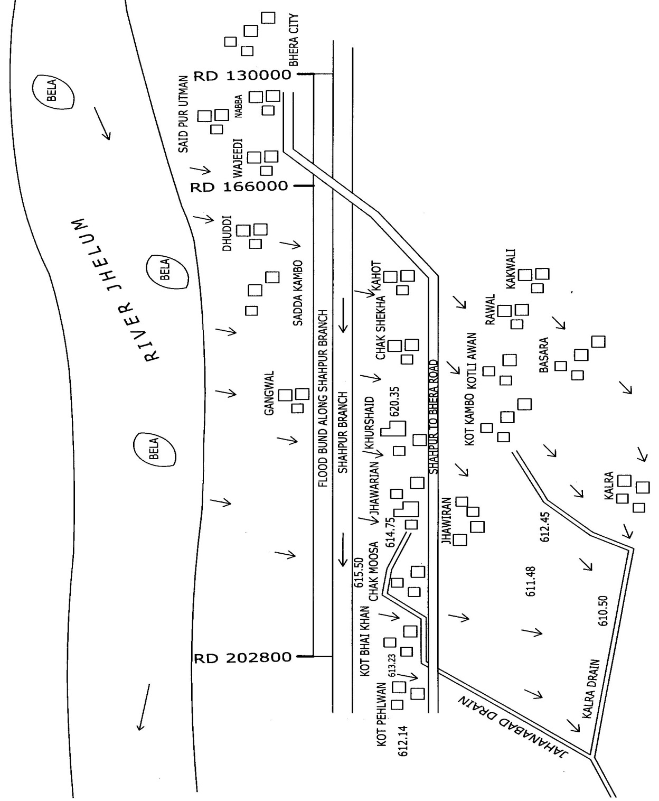
XEN SHP
13.2 Detail of villages abadies likely to be affected and this should also be shown on the plan
The detail of villages likely to be affected is as under:-
Kahot, Chak Sheikha, Kakwali, Rawal, Basra, Kotli Awan, Kot Kambo, Khurshaid, Jhawarian, Chak Mousa, Kot Bhei Khan, Kot Pehlwan, Kalra etc
13.3 Strategy and action taken be explained in detail. This may include:-
13.3.1 Arrangements.
Arrangements for emergency are discussed below.
13.3.2 Establishment of Flood Fighting Camps
Already explained in paragraph 7.3
13.3.3 Duties of Officers / Officials and their camp sites
Camp No. | Location | Officer | Official
02 | RD: 166580 Shahpur Branch | Nasar Iqbal  Zilladar Shahpur 0343-4164739
03 | RD: 184950 Shahpur Branch | Konain shah Sub Engineer 0345-9087732

Detail Description of duties to be performed by the staff is as under:-

- Executive Engineer, Shahpur Division LJC, Sargodha.

Executive Engineer will be overall incharge of flood activities in the
jurisdiction of Shahpur Division LJC, Sargodha. The flood protection works falling in the part areas of District Sargodha in the administrative control of Executive Engineer. He is responsible for maintenance and supervision of flood protection / watching arrangement during flood season. He will also keep liaison with the civil / army authorities and Superintending Engineer L.J.C, Sargodha regarding the situation.
- Sub Divisional Officer, Shahpur Canal Sub Divisions.
Sub Divisional Officer Shahpur Canal Sub Division will be the incharge of flood activities in the jurisdiction of his Sub Division. The flood protection works & Canal Network falling in the part areas of Tehsil Shahpur District Sargodha are under the administrative control of SDO Shahpur. He will also responsible for maintenance and supervision of flood protection / watching arrangement and keep close liaison with the Executive Engineer, Shahpur Division LJC, Sargodha.
XEN SHP
- Deputy Collector, Shahpur Division Sargodha.
Deputy collector Shahpur Division LJC alongwith Concerned Zilladar / Patwaries taking the cognizance of situation will make liaison with the Civil Administration and Police Department for necessary help. He also arrange the following:-
1. Proclamation on loudspeakers etc for evacuation of abadies inside the flood bunds.
2. Prepare maps for the areas inundated and carry out immediate survey for damages to crops and other properties.
3. Keep a close liaison with Sub Divisional Officers, Miani / Shahpur and assist them in procurement of labour and other camping arrangements.
- Sub Engineer, Saidal Section / Zilladar Jhawarian and Shahpur Section.

Sub Engineer, Saidal Section will be incharge of Flood Bund along Shahpur Branch RD: 158000 - 202800 and guide wall and sloping spur at Megha Kadhi. He will shift his camp at RD 184950 and watch all flood activities and remain present round the clock with a gang of labour of his Section. Zilladar Shahpur Section along with concerned patwaries will shift his camp at RD: 166580. Zilladar Jhawarian Section alongwith his Patwaries will shift his headquarter at Megha Kadhi to assist the Sub Engineer, Saidal Section.

13.3.4 Departmental Machinery available
There is no departmental machinery available with Shahpur Canal Division LJC Sargodha. However Excavator Division Sargodha & Agriculture Department will be requested in case of any emergency.
    - Machinery available from Private Source
If Machinery is needed it will be arranged / hired from private source such as Tractor, Excavator Machine and these are easily available in this area.

XEN SHP

    - Flood Fighting Material required
Detail of Flood Fighting Material required is as under:-
Sr. No. | Name of Item | Unit | Total Required Quantity | Available Quantity | Balance Quantity | Remarks
1 | Tent | No. | 1 | 1 | 0 | Sufficient Flood fighting material is available at site of Saidal Canal Rest House.
2 | Khaji Mats | No. | 15 | 2 | 13
3 | Axes | No. | 5 | 5 | 0
4 | Bamboos 8' to 10' (for Lighting arrangements) | No. | 10 | 10 | 0
5 | Baskets | No. | 30 | 30 | 0
6 | Buckets (Plastic) | No. | 2 | 2 | 0
7 | Cell for Torches | No. | 24 | 24 | 0
8 | Chimneys for Lamps | No. | 8 | 8 | 0
9 | Chouldaries | No. | 1 | 1 | 0
10 | E.G. Bags / Gunny Bags | No. | 500 | 500 | 0
11 | Energy Savers | No. | 5 | 5 | 0
12 | Folding Chair | No. | 4 | 4 | 0
13 | Folding Table | No. | 1 | 1 | 0
14 | Funnels | No. | 2 | 2 | 0
15 | G.I. Buckets | No. | 4 | 4 | 0
16 | Gas Mentles | No. | 10 | 10 | 0
17 | Generator | No. | 1 | 1 | 0
18 | Hand Saws | No. | 1 | 1 | 0
19 | Handle for Kassi / Axes | No. | 10 | 10 | 0
20 | Holder for Lamp | No. | 5 | 5 | 0
21 | Kassi with Handles | No. | 25 | 25 | 0
22 | Kerosene Oil | Liter | 30 | 30 | 0
23 | Killas | No. | 100 | 25 | 75
24 | Lanterns | No. | 5 | 5 | 0
25 | Life Belt | No. | 3 | 3 | 0
26 | M. Oil | Liter | 10 | 10 | 0
27 | Manila Rope | Kg | 20 | 20 | 0
28 | Match Boxes | No. | 4 | 4 | 0
29 | Munj / Patha / Trungers | No. | 50 | 0 | 50
30 | Needles | No. | 5 | 5 | 0
31 | Oil Extractors | No. | 1 | 1 | 0
32 | Patromax | No. | 2 | 2 | 0
33 | Petrol | Liter | 50 | 50 | 0
34 | Rain Coats | No. | 4 | 4 | 0
35 | Steel Charpoy | No. | 2 | 1 | 1
36 | Sutli | Kg | 5 | 5 | 0
37 | Switch / Plugs | No. | 10 | 10 | 0
38 | Torches 3 cells | No. | 6 | 6 | 0
39 | Umbrella | No. | 4 | 4 | 0
40 | Wicks | Packet | 2 | 2 | 0
41 | Wires 7/29 | Meter | 50 | 50 | 0
42 | Wooden Boards 10" x 12" | No. | 2 | 2 | 0
43 | Wooden Hammers | No. | 5 | 5 | 0

XEN SHP

    - Flood Fighting Material available
Detail of flood fighting material available and stored at Saidal Canal Rest House given as page No. 41 (Sr # 13.3.6).

13.4 Detail of other infrastructure like electric, Sui gas, Telephone installations, road network, other buildings, Canals and Drainage network
The detail of Infrastructure likely to be affected is as under:-
- Govt: Buildings:- Govt: College Jhawarian, Public Health Unit Jhawarian, Telephone Exchange Jhawarian, Agriculture Office Jhawarian, Wapda office Jhawarian Govt: P.S Khurshaid, P.S Kotli Awan, P.S Rawal, P.S Kakawali, P.S Kot Kombo, P.S Basra, Govt: High School Jhawarian, Govt: High School Kalra.
- Canal Networks: - Saddar Disty, Jalal Minor, Maken Minor, Bachera Minor.
- Drainage Network: - Jahanabad Drain, Kalra Drain, Further detailes can be checked from flood fighting plan of Drainage, Division Sargodha.

XEN SHP

PLAN FOR SITE NO: 3
13.1 Plan showing route of Flood Water coming out of the breach supported with levels.
A plan showing the route of expected flood water coming out of mishap site on Flood Bund along Shahpur Branch between RD:246000 - 261500/R in Tehsil Shahpur, District Sargodha is given as under:-

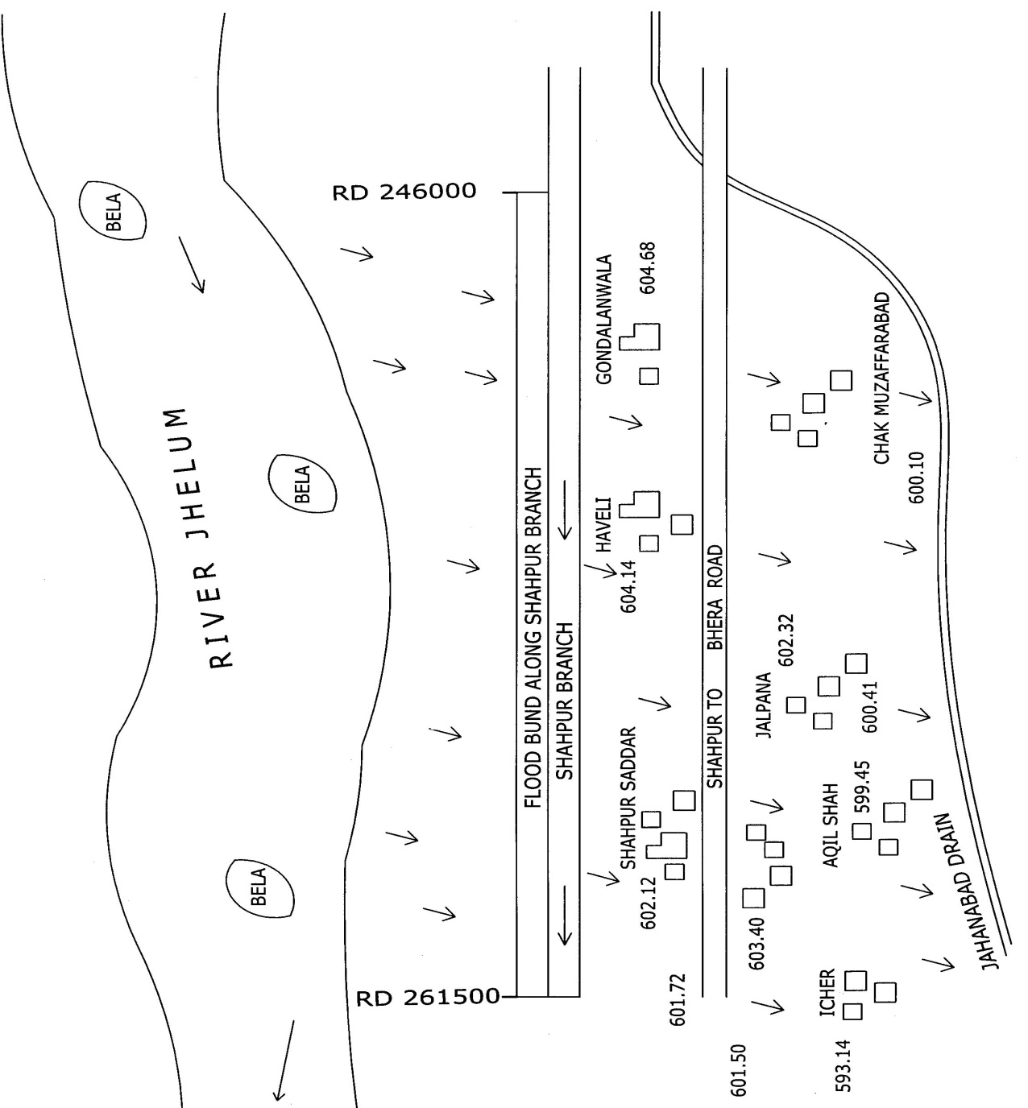
XEN SHP
XEN SHP

13.2 Detail of villages abadies likely to be affected and this should also be shown on the plan
The detail of villages likely to be affected is as under:-
Gondlanwala, Haveli, Shahpur Saddar, Chak Muzaffarabad, Jalpana, Aqil Shah, Icher etc.
13.3 Strategy and action taken be explained in detail. This may include:-
13.3.1 Arrangements.
Arrangements for emergency are discussed below.
13.3.2 Establishment of Flood Fighting Camps
Flood fighting camps established at RD:184950 Shahpur Branch and at RD:16000 Shahpur Disty by SDO Shahpur Sub Division and Sub Engineer, Flood section will also monitor this reach
13.3.3 Duties of Officers / Officials and their camp sites
Camp No. | Location | Officer | Official
03 | RD: 184950 Shahpur Branch | Konain Shah Sub Engineer 0303-8148488 | Muhammad Khan Mate 0344-5744780
04 | RD: 16000 Shahpur Disty | Liaqat Jaspal Sub Engineer 0300-6098401 | Muhammad Nawaz Mate 0303-8591063
Detail Description of duties to be performed by the staff is as under:-
- Executive Engineer, Shahpur Division LJC, Sargodha.
Executive Engineer will be overall incharge of flood activities in the
jurisdiction of Shahpur Division LJC, Sargodha. The flood protection works falling in the part areas of District Sargodha in the administrative control of Executive Engineer. He is responsible for maintenance and supervision of flood protection / watching arrangement during flood season. He will also keep liaison with the civil / army authorities and Superintending Engineer L.J.C, Sargodha regarding the situation.
- Sub Divisional Officer, Shahpur Canal Sub Divisions.
Sub Divisional Officer Shahpur Canal Sub Division will be the incharge of flood activities in the jurisdiction of his Sub Division. The flood protection works & Canal Network falling in the part areas of Tehsil Shahpur District Sargodha are under the administrative control of SDO Shahpur. He will also responsible for maintenance and supervision of flood protection / watching arrangement and keep close liaison with the Executive Engineer, Shahpur Division LJC, and Sargodha.
XEN SHP

- Deputy Collector, Shahpur Division Sargodha.
Deputy collector Shahpur Division LJC alongwith Concerned Zilladar / Patwaries taking the cognizance of situation will make liaison with the Civil Administration and Police Department for necessary help. He will also perform following activities.
  - Proclamation on loudspeakers etc for evacuation of abadies inside the flood bunds.
  - Prepare maps for the areas inundated and carry out immediate survey for damages to crops and other properties.
Iii Keep a close liaison with Sub Divisional Officers, Miani / Shahpur and to assist them in procurement of labour and other camping arrangements.
- Sub Engineer, Flood Section.
Sub Engineer, Flood Section will be incharge of Flood Embankment along Shahpur Branch RD: 246000 to 261500/R & Shahpur Disty RD: 0000 -16000. He will shift his camp at RD: 16+000 Shahpur Disty. He will be responsible for flood activities in said reach of Shahpur Disty and will also assist the Sub Divisional Officer, Shahpur.
13.3.4 Departmental Machinery available
There is no departmental machinery available with Shahpur Canal Division LJC Sargodha. However Excavator Division Sargodha & Agriculture Department will be requested in case of any emergency.

    - Machinery available from Private Source
If Machinery is needed in case of emergency, it will be arranged / hired from private source such as Tractor, Excavator Machine and these are easily available in this area from the enlisted contractors of Punjab Irrigation Department.

XEN SHP

13.3.6 Flood Fighting Material required
Detail of Flood Fighting Material required is as under:-
Sr. No. | Name of Item | Unit | Total Required Quantity | Available Quantity | Balance Quantity | Remarks
1 | Tent | No. | 1 | 1 | 0 | Sufficient Flood Fighting material is available at site of Shahpur Canal Rest House.
2 | Khaji Mats | No. | 15 | 0 | 15
3 | Axes | No. | 5 | 5 | 0
4 | Bamboos 8' to 10' (for Lighting arrangements) | No. | 10 | 10 | 0
5 | Baskets | No. | 30 | 30 | 0
6 | Buckets (Plastic) | No. | 2 | 2 | 0
7 | Cell for Torches | No. | 24 | 0 | 24
8 | Chimneys for Lamps | No. | 8 | 0 | 8
9 | Chouldaries | No. | 1 | 1 | 0
10 | E.G. Bags / Gunny Bags | No. | 500 | 0 | 500
11 | Energy Savers | No. | 5 | 0 | 5
12 | Folding Chair | No. | 4 | 0 | 4
13 | Folding Table | No. | 1 | 0 | 1
14 | Funnels | No. | 2 | 0 | 2
15 | G.I. Buckets | No. | 4 | 0 | 4
16 | Gas Mentles | No. | 10 | 0 | 10
17 | Generator | No. | 1 | 1 | 0
18 | Hand Saws | No. | 1 | 1 | 0
19 | Handle for Kassi / Axes | No. | 10 | 0 | 10
20 | Holder for Lamp | No. | 5 | 0 | 5
21 | Kassi with Handles | No. | 25 | 25 | 0
22 | Kerosene Oil | Liter | 30 | 3 | 27
23 | Killas | No. | 100 | 50 | 50
24 | Lanterns | No. | 5 | 5 | 0
25 | Life Belt | No. | 3 | 0 | 3
26 | M. Oil | Liter | 10 | 0 | 10
27 | Manila Rope | Kg | 20 | 10 | 10
28 | Match Boxes | No. | 4 | 0 | 4
29 | Munj / Patha / Trungers | No. | 50 | 0 | 50
30 | Needles | No. | 5 | 3 | 2
31 | Oil Extractors | No. | 1 | 0 | 1
32 | Patromax | No. | 2 | 2 | 0
33 | Petrol | Liter | 50 | 0 | 50
34 | Rain Coats | No. | 4 | 0 | 4
35 | Steel Charpoy | No. | 2 | 0 | 2
36 | Sutli | Kg | 5 | 5 | 0
37 | Switch / Plugs | No. | 10 | 0 | 10
38 | Torches 3 cells | No. | 6 | 6 | 0
39 | Umbrella | No. | 4 | 0 | 4
40 | Wicks | Packet | 2 | 0 | 2
41 | Wires 7/29 | Meter | 50 | 0 | 50
42 | Wooden Boards 10" x 12" | No. | 2 | 0 | 2
43 | Wooden Hammers | No. | 5 | 5 | 0

XEN SHP

13.3.7 Flood Fighting Material available
Detail of Flood fighting material available and stored at Shahpur Canal Rest House is given as page No. 46 (Sr # 13.3.6).

13.4 Detail of other infrastructure like electric, Sui gas, Telephone installations, road network, other buildings, Canals and Drainage network
The detail of Infrastructure likely to be affected is as under:-
- Govt: Buildings:- Govt: College for women Shahpur Saddar, Govt: College for Boys Shahpur Saddar. Govt: P.S Havaili, P.S Chak Muzaffar, Govt: High School Jalpana, P.S Jalpana, P.S Aqil Shah, P.S Ichher, T.H.Q Shahpur Saddar, B.H.U Aqil Shah, B.H.U Ichher, Canal Rest House Shahpur Saddar.
- Offices:- Telephone Exchange Shahpur Saddar, SDO Canal Office Shahpur Saddar, SDO Wapda Office Shahpur Saddar, A.C Office Shahpur Saddar, DSP Office Shahpur Saddar, AEO Office Shahpur Saddar, PMO Office Shahpur Saddar, Police Station Shahpur Saddar, District Jail Shahpur Saddar, Tehsil Courts Shahpur Saddar.
- Grid Station: - Shahpur Saddar.
- Canal Network: - Hussain Shah disty, Lower Saddar Disty, Sherpur Minor, Muzaffarabad Minor, Ichher Minor, Sat Chak Minor.
e) Drainage Network: - Jahanabad Drain, Wadhi Drain, Shehzad Pur Drain.
XEN SHP
XEN SHP
XEN SHP
PLAN FOR SITE NO: 4
13.1 Plan showing route of Flood Water coming out of the breach supported with levels.
A plan showing the route of expected flood water coming in case of breach/mishap site on Flood Bund along Shahpur Disty between RD:44000 - 56900 in Tehsil Shahpur, District Sargodha is given as under:-
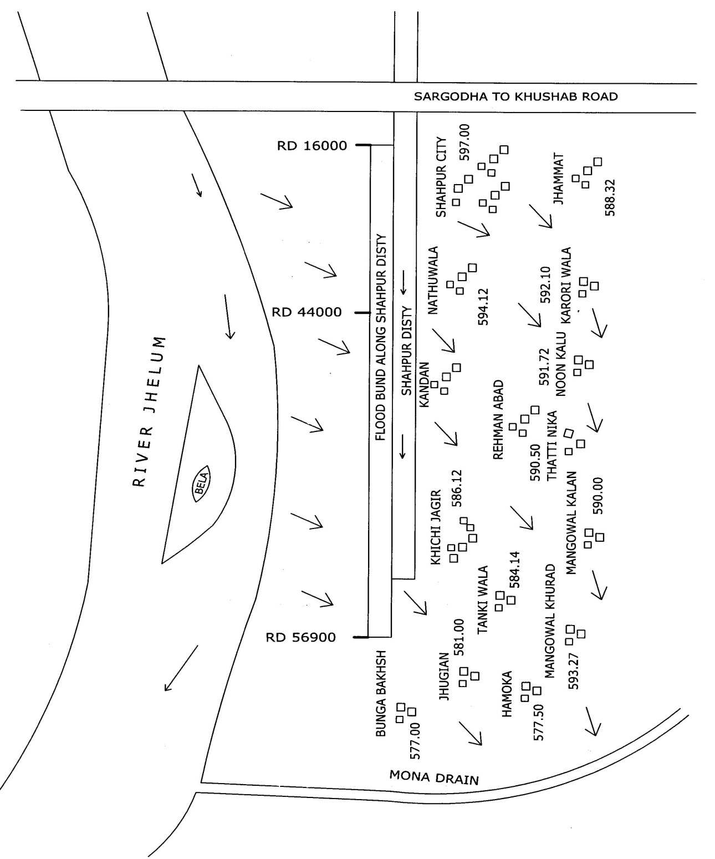
XEN SHP

13.2 Detail of villages abadies likely to be affected and this should also be shown on the plan
The detail of villages likely to be affected is as under:-
Shahpur City, Nathuwala, Kandan, Midh, Khichi Jagir, Tanki Wala, Jhugian, Hamoka Jhamat, Karoriwala, Noon Kalu, Thatti Nika, Mangowal Kalan, Mangowal Khurd etc
13.3 Strategy and action taken be explained in detail. This may include:-
    - Arrangements.
Arrangements for emergency are discussed below.
13.3.2 Establishment of Flood Fighting Camps
Flood fighting camp will be setup at RD: 48500 Shahpur Disty
13.3.3 Duties of Officers / Officials and their camp sites
Camp No. | Location | Officer | Official
05 | RD: 48500 Shahpur Disty | Sub Divisional Officer Shahpur Sub Division (Arshad Hayat)  0301-4482384 | Muhammad Nawaz (Mate) 0303-8591063

Detail Description of duties to be performed by the staff is as under:-

- Executive Engineer, Shahpur Division LJC, Sargodha.
Executive Engineer will be overall incharge of flood activities in the
Jurisdiction of Shahpur Division LJC, Sargodha. The flood protection works falling in the part areas of District Sargodha in the administrative control of Executive Engineer. He is responsible for maintenance and supervision of flood protection / watching arrangement during flood season. He will also keep close liaison with the civil / army authorities and Superintending Engineer L.J.C, Sargodha regarding the updated situation.
- Sub Divisional Officer, Shahpur Canal Sub Divisions.
Sub Divisional Officer Shahpur Canal Sub Division will be the incharge of flood activities in the jurisdiction of his Sub Division. The flood protection works & Canal Network falling in the part areas of Tehsil Shahpur District Sargodha are under the administrative control of SDO Shahpur. He will also responsible for maintenance and supervision of flood protection / watching arrangement and keep close liaison with the Executive Engineer, Shahpur Division LJC, Sargodha.
XEN SHP

3. Deputy Collector, Shahpur Division Sargodha.
Deputy collector Shahpur Division LJC alongwith Concerned Zilladar / Patwaries taking the cognizance of situation will make close liaison with the Civil Administration and Police Department for necessary help. He will also perform following activities in case of flood warning.
I Proclamation on loudspeakers etc for evacuation of abadies inside the flood bunds.
Ii Prepare maps for the areas inundated and carry out immediate survey for damages to crops and other properties.
Iii Keep a close liaison with Sub Divisional Officers, Miani / Shahpur and assist them in procurement of labour and other camping arrangements.
- Sub Engineer, Shahpur Section.
Sub Engineer, Shahpur Section will be incharge of Flood Bund along Shahpur Disty RD: 16000 - 56900. He will shift his camp at RD: 48500 Shahpur Disty and watch all flood activities and remain present round the clock with a gang of labour of his Section.
13.3.4 Departmental Machinery available
There is no departmental machinery available with Shahpur Canal Division LJC Sargodha. However Excavator Division Sargodha & Agriculture Department will be requested in case of any emergency.
    - Machinery available from Private Source
If Machinery is needed it will be arranged / hired from private source such as Tractor, Excavator Machine and these are easily available in this area from the enlisted contractors of Punjab Irrigation Department.

XEN SHP

13.3.6 Flood Fighting Material required
Detail of Flood Fighting Material required is as under:-
Sr. No. | Name of Item | Unit | Total Required Quantity | Available Quantity | Balance Quantity | Remarks
1 | Tent | No. | 1 | 1 | 0 | Sufficient Flood Fighting material is available at site Shahpur Canal Rest House.
2 | Khaji Mats | No. | 15 | 0 | 15
3 | Axes | No. | 5 | 5 | 0
4 | Bamboos 8' to 10' (for Lighting arrangements) | No. | 10 | 10 | 0
5 | Baskets | No. | 30 | 30 | 0
6 | Buckets (Plastic) | No. | 2 | 2 | 0
7 | Cell for Torches | No. | 24 | 24 | 0
8 | Chimneys for Lamps | No. | 8 | 6 | 2
9 | Chouldaries | No. | 1 | 1 | 0
10 | E.G. Bags / Gunny Bags | No. | 500 | 400 | 100
11 | Energy Savers | No. | 5 | 5 | 0
12 | Folding Chair | No. | 4 | 4 | 0
13 | Folding Table | No. | 1 | 1 | 0
14 | Funnels | No. | 2 | 2 | 0
15 | G.I. Buckets | No. | 4 | 4 | 0
16 | Gas Mentles | No. | 10 | 10 | 0
17 | Generator | No. | 1 | 1 | 0
18 | Hand Saws | No. | 1 | 1 | 0
19 | Handle for Kassi / Axes | No. | 10 | 10 | 0
20 | Holder for Lamp | No. | 5 | 5 | 0
21 | Kassi with Handles | No. | 25 | 25 | 0
22 | Kerosene Oil | Liter | 30 | 30 | 0
23 | Killas | No. | 100 | 50 | 50
24 | Lanterns | No. | 5 | 5 | 0
25 | Life Belt | No. | 3 | 3 | 0
26 | M. Oil | Liter | 10 | 10 | 0
27 | Manila Rope | Kg | 20 | 20 | 0
28 | Match Boxes | No. | 4 | 4 | 0
29 | Munj / Patha / Trungers | No. | 50 | 0 | 50
30 | Needles | No. | 5 | 5 | 0
31 | Oil Extractors | No. | 1 | 1 | 0
32 | Patromax | No. | 2 | 2 | 0
33 | Petrol | Liter | 50 | 0 | 50
34 | Rain Coats | No. | 4 | 0 | 4
35 | Steel Charpoy | No. | 2 | 0 | 2
36 | Sutli | Kg | 5 | 5 | 0
37 | Switch / Plugs | No. | 10 | 10 | 0
38 | Torches 3 cells | No. | 6 | 6 | 0
39 | Umbrella | No. | 4 | 4 | 0
40 | Wicks | Packet | 2 | 2 | 0
41 | Wires 7/29 | Meter | 50 | 50 | 0
42 | Wooden Boards 10" x 12" | No. | 2 | 2 | 0
43 | Wooden Hammers | No. | 5 | 5 | 0

XEN SHP

13.3.7 Flood Fighting Material available
Detail of Flood fighting material available and stored at Shahpur Canal Rest House is given as page No. 51 (Sr # 13.3.6).

13.4 Detail of other infrastructure like electric, Sui gas, Telephone installations, road network, other buildings, Canals and Drainage network
The detail of Infrastructure likely to be affected is as under:-
  - Govt: Buildings: B.H.U / Hospital Shahpur City, Govt: Dispensary Kandan, High School Shahpur City, Girls High School Shahpur City, P.S Nathuwala, P.S Karorawala, P.S Kandan, P.S Rehman Abad, P.S Noon Kalu, P.S Khichi Jageer, P.s Tanki Wala, P.S Thatti Naika, P.S Mangowal Kalan, P.S Mangowal Khurd, P.S Jhugian, P.S Hamoka.
b) Offices:- Town Committee Shahpur City, Police Station Shahpur City,
c) Canal Networks:- Shahpur Disty, Ichher Minor, Mangowal Minor, Sanika Minor, Muzaffar Minor, Sabowal Minor.
- Drainage Network:- Jahanabad Drain, Sabowal Drain, Mona Drain, Sulki Drain, Sulki Creek Drain.
Note:-
Bhalwal Division LJC Bhalwal will act as sister Division in case of emergency.

Sub Divisional Officer, Sub Divisional Officer, Executive Engineer,
Miani Sub Division L.J.C, Shahpur Sub Division LJC, Shahpur Division L.J.C,
At Chak Qazi. . At Shahpur Saddar. Sargodha.

Superintending Engineer, Chief Engineer,
Lower Jhelum Canal Circle, Sargodha Irrigation Zone,
Sargodha. Sargodha.

CHAPTER-14
14. ACTION PLAN
14.1 Re-shuffling/ recouping plan of reserve stone departmentally.
Reshuffling of stone is not required as there is only one structure namely Megha Khadi Guide Wall Spur where reserve stock of stone is proposed. With respect to recouping of reserved stone it will be purchased after calling tender before start of flood season 2023.
14.2 Detail of inlet/outlet crossing along with closing methodology.
Following are the Out lets on Flood bund along Shahpur Branch & Shahpur Disty in Shahpur Canal Division.
Sr. No | RD of Out lets  Shahpur Branch | Closing Methodology.
1 | RD 253315/R | Out Let”s will be plugged by making necessary arrangement to be made by concerned SDO / Sub Engineer when required.
2 | RD 255200/R
3 | RD 258900/R
4 | RD 260846/R
5 | RD 261295/R
Sr. No | RD of Out lets  Shahpur Disty
1 | RD 17200/R
2 | RD 32593/R
3 | RD 41500/R
XEN SHP
14.3 DEPLOYMENT OF MACHINERY (MEDIUM TO HIGH FLOOD) RIVER JHELUM.

Sr.No. | Name of Structure | Length  in Mile | Vulnerable  Reach | Camp  Location | Site Incharge by name & Cell No. | Machinery Deployed |  |  |  |  |  | Labour  Beldar + Mate | Availability of Stone Cft
 |  |  |  |  |  | Excavator |  | Dozer |  | Trolleys/  Dumpers | Tractor with front blade | Labour  Beldar + Mate
1 | 2 | 3 | 4 | 5 | 6 | 7 |  | 8 |  | 9 | 10 | 11 | 12
FLOOD BUNDS ALONG RIVER JHELUM IN SHAHPUR CANAL DIVISION LJC SARGODHA
1 | Flood Bund along Western Feeder Disty: RD: 2000 – 15000/R (along with 8 No. Studs) | 2.60 | RD: 6000-14500 | RD: 13500 | Sub Engineer Maini Section  Adil Shazell  0341-0103920 |  | 1 |  | - | 2 | 1 | 6+0=6  Per Shift | Not Required
2 | Flood Bund along Shahpur Branch  RD: 130000 – 202800/R | 14.56 | RD: 166000-202800 | RD: 184950 | Sub Engineer Saidal Kounain Shah  (0303-8148488) |  | 2 |  | - | 4 | 1 | 30+4=34  Per Shift | Not Required
3 | Flood Bund along Shahpur Branch  RD: 246000 – 261500/R | 3.10 | RD: 246000-261500 | RD: 16000 Shahpur Disty. | Sub Engineer Flood Section Liaqat Jaspal  ( 0300-6098401) |  | 1 |  | - | 2 | 1 | 6+0=6  Per Shift | Not Required
4 | Flood Bund along Shahpur Disty:  RD: 16000 – 56900/R | 8.18 | RD: 44000-56900 | RD: 48500 | Sub Engineer Shahpur Section Taskeen Abbas Shah  ( 0300-6071585) |  | 1 |  | - | 2 | 1 | 16+2=18  Per Shift | Not Required
Total |  |  |  |  |  |  | 5 |  | - | 10 | 4

Payment for machinery and work charge employees subject to verification by TPM.
XEN SHP

14.4 DEPLOYMENT OF MACHINERY (HIGH TO VERY HIGH FLOOD) RIVER JHELUM.
Sr.No. | Name of Structure | Length  in Mile | Vulnerable  Reach | Camp  Location | Site Incharge by name & Cell No. |  | Machinery Deployed |  |  |  |  |  |  | Labour  Beldar + Mate | Availability of Stone Cft
 |  |  |  |  |  |  | Excavator | Dozer |  | Trolleys/  Dumpers |  | Tractor with front blade |  | Labour  Beldar + Mate
1 | 2 | 3 | 4 | 5 | 6 |  | 7 | 8 |  | 9 |  | 10 |  | 11 | 12
FLOOD BUNDS ALONG RIVER JHELUM IN SHAHPUR CANAL DIVISION LJC SARGODHA
1 | Flood Bund along Western Feeder Disty: RD: 2000 – 15000/R (along with 8 No. Studs) | 2.60 | RD: 6000-14500 | RD: 13500 |  | Sub Engineer Maini Section  Adil Shazell  0341-0103920) | 1 | - | 3 |  | 1 |  | 6+0=6  Per Shift |  |  | Not Required
2 | Flood Bund along Shahpur Branch  RD: 130000 – 202800/R | 14.56 | RD: 166000-202800 | RD: 184950 |  | Sub Engineer Saidal Kounain Shah  (0303-8148488) | 2 | - | 5 |  | 1 |  | 30+4=34  Per Shift |  |  | Not Required
3 | Flood Bund along Shahpur Branch  RD: 246000 – 261500/R | 3.10 | RD: 246000-261500 | RD: 16000 Shahpur Disty. |  | Sub Engineer Flood Section Liaqat Jaspal  ( 0300-6098401) | 1 | - | 2 |  | 1 |  | 6+0=6  Per Shift |  |  | Not Required
4 | Flood Bund along Shahpur Disty:  RD: 16000 – 56900/R | 8.18 | RD: 44000-56900 | RD: 48500 |  | Sub Engineer Shahpur Section Taskeen Abbas Shah  ( 0300-6071585)) | 1 | - | 2 |  | 1 |  | 16+2=18  Per Shift |  |  | Not Required
Total |  |  |  |  |  |  | 5 | - | 12 |  | 4
Payment for machinery and work charge employees subject to verification by TPM.
XEN SHP
14.5 DEPLOYMENT OF MACHINERY (HIGH TO EXCEPTIONALLY HIGH FLOOD) RIVER JHELUM.

Sr.No. | Name of Structure |  | Length  in Mile | Vulnerable  Reach | Camp  Location | Site Incharge by name & Cell No. | Machinery Deployed |  |  |  | Labour  Beldar + Mate |  | Availability of Stone Cft
 |  |  |  |  |  |  | Excavator | Dozer | Trolleys/  Dumpers | Tractor with front blade |  |  | Availability of Stone Cft
1 | 2 |  | 3 | 4 | 5 | 6 | 7 | 8 | 9 | 10 | 11 |  | 12
FLOOD BUNDS ALONG RIVER JHELUM IN SHAHPUR CANAL DIVISION LJC SARGODHA
1 |  | Flood Bund along Western Feeder Disty: RD: 2000 – 15000/R (along with 8 No. Studs) | 2.60 | RD: 6000-14500 | RD: 13500 | Sub Engineer Maini Section  Adil Shazell  0341-0103920 | 1 | - | 4 | 1 | 12+1=13  Per Shift | Not Required
2 |  | Flood Bund along Shahpur Branch  RD: 130000 – 202800/R | 14.56 | RD: 166000-202800 | RD: 184950 | Sub Engineer Saidal Kounain Shah  (0303-8148488) | 2 | - | 6 | 2 | 60+8=68  Per Shift | Not Required
3 |  | Flood Bund along Shahpur Branch  RD: 246000 – 261500/R | 3.10 | RD: 246000-261500 | RD: 16000 Shahpur Disty. | Sub Engineer Flood Section Liaqat Jaspal  ( 0300-6098401) | 1 | - | 3 | 1 | 12+1=13  Per Shift | Not Required
4 |  | Flood Bund along Shahpur Disty:  RD: 16000 – 56900/R | 8.18 | RD: 44000-56900 | RD: 48500 | Sub Engineer Shahpur Section Taskeen Abbas Shah  ( 0300-6071585)) | 1 | - | 3 | 1 | 32+4=36  Per Shift | Not Required
Total |  |  |  |  |  |  | 5 | - | 16 | 5 | XEN SHP
Payment for machinery and work charge employees subject to verification by TPM.

14.6 Police deployment plan.
Sr.No. | Vulnerable sites for illegal cuts during floods. | Concerned Canal Division. | Concerned Police Station & District. | Police personnel to be deployed. |  | Remarks (If any)
 |  |  |  | Inspector/SI/ASI | Constables. | Remarks (If any)
1 | Syphon at RD: 6300 Western Feeder Disty. | Shahpur | M  \iani & Distt: Sargodha. | SI= 1No.  ASI= 1No. | 10 Nos. | -
2 | Reach RD: 14000-16000 Shahpur Disty. | Shahpur | Shahpur city & Distt: Sargodha. | SI= 1No.  ASI= 1No. | 10 Nos. | -

Note: The request will be made to DPO Sargodha in case of Flood Warning to deploy the staff for smooth working of irrigation department officials at above quoted critical sites.
XEN SHP
14.7 DETAILS OF SYNTHETIC BAGS WITH CAPACITY OF 500 KG AND 1000 KG.
MEDIUM TO HIGH FLOOD STAGE, RIVER JHELUM
Sr.No. | Name of Structure | Length  in Mile | Vulnerable  Reach | Camp  Location | Site Incharge by name & Cell No. | No. of Synthetic bags required |  | Available |  | Plastic Sheet (Sft)
 |  |  |  |  |  | 500 Kg | 1000 Kg | 500 Kg | 1000 Kg | Plastic Sheet (Sft)
1 | 2 | 3 | 4 | 5 | 6 | 7 | 8 | 9 | 10 | 11
FLOOD BUNDS ALONG RIVER JHELUM IN SHAHPUR CANAL DIVISION LJC SARGODHA
1 | Flood Bund along Western Feeder Disty: RD: 2000 – 15000/R (along with 8 No. Studs) | 2.60 | RD: 6000-14500 | RD: 13500 | Sub Engineer Maini Section  Adil Shazell  0341-0103920 | 50 | 25 | 0 | 0 | 25
2 | Flood Bund along Shahpur Branch  RD: 130000 – 202800/R | 14.56 | RD: 166000-202800 | RD: 184950 | Sub Engineer Saidal Kounain Shah  (0303-8148488) | 100 | 50 | 0 | 0 | 50
3 | Flood Bund along Shahpur Branch  RD: 246000 – 261500/R | 3.10 | RD: 246000-261500 | RD: 16000 Shahpur Disty. | Sub Engineer Flood Section Liaqat Jaspal  ( 0300-6098401) | 30 | 20 | 0 | 0 | 20
4 | Flood Bund along Shahpur Disty:  RD: 16000 – 56900/R | 8.18 | RD: 44000-56900 | RD: 48500 | Sub Engineer Shahpur Section  Taskeen Abbas Shah  ( 0300-6071585)) | 50 | 25 | 0 | 0 | 25

XEN SHP
VERY HIGH TO EXCEPTIONALLY HIGH STAGE IN SARGODHA ZONE.
Sr.No. | Name of Structure | Length  in Mile | Vulnerable  Reach | Camp  Location | Site Incharge by name & Cell No. | No. of Synthetic bags required |  | Available |  | Plastic Sheet(Sft)
 |  |  |  |  |  | 500 Kg | 1000 Kg | 500 Kg | 1000 Kg | Plastic Sheet(Sft)
1 | 2 | 3 | 4 | 5 | 6 | 7 | 8 | 9 |  | 10
FLOOD BUNDS ALONG RIVER JHELUM IN SHAHPUR CANAL DIVISION LJC SARGODHA
1 | Flood Bund along Western Feeder Disty: RD: 2000 – 15000/R (along with 8 No. Studs) | 2.60 | RD: 6000-14500 | RD: 13500 | Sub Engineer Maini Section  Adil Shazell  0341-0103920) | 100 | 50 | - |  | 2000
2 | Flood Bund along Shahpur Branch  RD: 130000 – 202800/R | 14.56 | RD: 166000-202800 | RD: 184950 | Sub Engineer Saidal Kounain Shah  (0303-8148488) | 150 | 100 | - |  | 3000
3 | Flood Bund along Shahpur Branch  RD: 246000 – 261500/R | 3.10 | RD: 246000-261500 | RD: 16000 Shahpur Disty. | Sub Engineer Flood Section Liaqat Jaspal  ( 0300-6098401) | 50 | 25 | - |  | 2000
4 | Flood Bund along Shahpur Disty:  RD: 16000 – 56900/R | 8.18 | RD: 44000-56900 | RD: 48500 | Sub Engineer Shahpur Section  Taskeen Abbas Shah  ( 0300-6071585)) | 100 | 50 | - |  | 2000

Executive Engineer,
Shahpur Division L.J.C,
Sargodha.
14.8 Details of polythene sheets of black colour to protect upstream slope against wave action and to control seepage through embankments.
Required Polythene Sheet | Available Polythene Sheet | Remarks
10,000 Sft | Nil | Arrangement will be made for provision of polythene sheets before coming flood season.

XEN SHP

CHAPTER-15
15. Back up Divisions (in case of breach).
In case of breach or during emergency, Bhalwal Canal Division LJC, Sargodha and his field staff will act as sister Division.
Executive Engineer,
Shahpur Division L.J.C,
Sargodha.

