FLOOD FIGHTING PLAN 2024
PART-A
CHAPTER – 1
SALIENT FEATURE OF THE SARGODHA DRAINAGE DIVISION SARGODHA.
INTRODUCTION
1.1 LOCATION
Sargodha District is surrounded by District Mandi Bhauddin, Chackwal,Khushab,Jhang and Hafiz Abad. District Sargodha lies in between two main rivers which are called as River chanab on east side and River jhelum on North west side, which means the District is part of Chaj Doab. Chaj Doab is combination of two wards. chaj stands for Chanab and Jhelun , where as Doab means two rivers/ waters. The main populations inhabitated near River Jhelum are Malakwal, Chak Saida,Miani, Hazoor Pur, Bhera,Chak Mubarak Abad,Jhawervian,Shah pur Sahiwal, Nehang, Seyal Sharif Havaily Nathoka and Havely Majhokah. On the other Hand the populations of Taheli Adda, Halal Pur, Takhat Hazara, Midh Ranjha, Talib Wala,and Jallah Makhdoom are existed on the right bank of river Chanab. At its down stream Districts Chiniot and District Jhang are situated.
1.2 General Description
TOPOGRAPHY.
The area of District Sargodha is generally leveled but divided in three small patches or bowls. Mainly it is a lot river terrace influenced by Chanab river deposit. Natural elevation ranges from 550 Ft above sea level near to the confluences of River Chanab and Jhelum and 650 Ft near the boundary of Mandi Bahauddin. However the area is divided into pockets if to be seen on contour sheet, around the Sargodha city. The area of Northern Branch can be separated as one, the area of Tehsil Bhalwal and North Western area can be divided into three non proper Drainage ranges/ pockets. The areas situated near the banks of the rivers have also changed their natural topography which is quite clear from the Difference of old and new survey work.

WEATHER
The climate of the Sargodha and its allied Districts is characterized by large seasonal factual of both temperature and precipitation except the Mandi Bahauddin which is to be considered as to have an effect of environmental impact of climatic conditions analogical to the situation of Jhelum and Azad Kashmir, having the joint climatic boundary.
The temperature in winter ranges between 60 to 80 Degree F During the day whereas it varies from 35 to 45 during night. The annual average rain fall in Sargodha District ranges from 47mm to 60mm. the Major rain fall occur in Moon Soon i.e.70%
SOIL
The geological condition of the soil in general in almost all the entity is to be seen as alluvial sediment. The particle size varies from medium sand to clay. The meandering braiding and flooding activities of the rivers resulted in strong and stratification of sediments which is more or less uniform within the limits of land farm.
The ground water table also ranges from surface to 30Ft below the ground level with seasonal fluctuation and flows from north to south with a general gradient of 2.0 Ft per Mile. in drought seasons water table becomes lower but it increases during Moon Soon. More over both the Rivers along with their irrigation system in the area causes to maintain this level and also plays a pivotal roll not only to maintain it but also a reason of its purity and cleanliness.
DRAINAGE FICILITIES IN SARGODHA DISTRICT.
Most of the head works of inundation canals net work in the area were constructed / completed during late 19th century or early 20th century. The impact of regular assured supply in channels of the area( Sargodha)became visible as early as 1935, when ponds of the area started spreading water over the surface of the areas of the district.
It was after 1940, when a proper attention was given to the construction of regular Drainage system in the canal constructed areas. A scarp system was later on developed to overcome the salinity problem. The drainage system in Sargodha District of Chaj Doab was the first link of the chain which was constructed and completed just after independence.
Since then the present Sargodha Drainage Division Sargodha. Remained attach under the control of different circles during different periods. Prior to 31.05.1974, it was attached with loyal purr drainage circle, But on creation new Sargodha irrigation zone at Sargodha w.e.f. 01.06.1974.
Owing to acute Drainage problems, to establish an independent Drainage circle at Sargodha became necessitated. Hence Drainage circle Sargodha was opened at Sargodha and present Sargodha Drainage Division Sargodha was attached with the circle on 01.06.1976.
METHODOLOGY OF DRAINAGE
There are two recognized methods of drainage
    - First one is vertical drainage.
    - Second one is surface Drainage.
Sargodha Drainage Division Sargodha has been assigned the task of surface Drainage.
The Faqirian Sillanwali, L.B.N.,Jhang Abad and Mona drainage system were constructed as pilot projects to save the home of citruses. Other Drains in Sargodha Districts were constructed by WAPDA During 1978 to 1983.
Total 12 systems were constructed in the district and are functioning well.
FLOOD PROTECTION WORKS IN DRAINAGE DIVISION SARGODHA.
Some of Major drainage systems fall directly in both of the river side’s, The River Chanab and River Jhelum detailed as under.
- F.S Outfall Drainage system
- Raniwah Drainage system
- Sulki Drainage system
- Sobhaga Drainage system
- Terkhanawala Drainage system
- Sahiwal Drainage system
- Auttuana Drainage system
- Shahjewana Drainage system
- Hadda Drainage system
Each outfall drains has some of its portion which lies under direct influence of flood in both the rivers. So these reaches which are effected from the direct thrust of flood water are declared as flood embankments and flood fighting arrangements are required to be maintained at site for the best interest of public and are discussed in detail as under:-
FLOOD EMBANKMENTS
F.S OUTFALL DRAINAGE SYSTEM.
The Faqrian Sillanwali Outfall Drainage System start from RD: 0+000 of F.S Drain downstream of Sillanwali city. It outfalls in river Chenab just upstream of village kull. The flood water of river Chenab directly hits the left bank of above noted drain and destroys not only the populated areas but also effects badly the animals, gardens, green fodder and cash crops. Sometimes the flood water enters in the drain and destabilized the banks of drain or sometime over tops the banks in shape of sheet flow in the reach RD: 0+000 to RD:25+000. The Field staff has always been deployed during flood season to control the situation and flood camp is also maintained at site to protect the adjacent cultivated lands, abadies and Dera jats. Even some times it affects the local earthen and mettle roads.
RANIWAH DRAINAGE SYSTEM
The Rani wah Drainage System start from RD: 0+000 to 266+000.this system falls in to two different Sub-Divisions I,e; from RD0+000 to 176 falls in Rani wah Sub Division whereas the remaining portion from RD176+000 to RD 286+000 lies with Shahjewena Drainage Sub-Division. The drain directly falls in River Jhelum. During Flood season most of the water of river Jhelum splits up from its banks and spreads in the area and dose not only effects the cultivated lands, crops and live stocks in large scale but at the same times it also effects the population of Chhatta Bukhsha,Kirn Mazari, Denar, Doaabah and kot Issa Shah. The Field staff has always been deployed during flood season to control the situation and flood camp is also maintained at site to protect the adjacent cultivated lands, abadies and Dera jats. Even some times it affects the local earthen and matt led roads.
SAHIWAL DRAIN.
Sahiwal drain starts from a point located near Sargodha Jhang road towards river Jhelum. The excess from Sargodha Jhang road to Sial Shareef crosses the drain at RD 21+000, Whereas the other main abadies of Havaily Majowka, Havaily Nathowka , Adda Bagga Balocha, Polah, Muhib Pur & Bora Ladial including roads, kacha tracks lies in the area which not only provide linkage between these small territories but also work as a supply chain for the inhabitants of the area. These are also only source for linkage between farm and market due to which farmers are able to have an excess to main road towards market. Children of the area also uses these tracks for schools and colleges.
On the other hand lush green fields covering an area near about 90sq km is lying in influence of high level water table.
During the era of sixties a net work of seepage drains was laid in the area under Chaj Doab drainage project ,launched, taken over and completed by WAPDA. Whole the activities from surveying, designing and execution were performed by the WAPDA at that time. But it is pertinent to mention here that a free board of 0.70 ft was provided at L-Section. Whereas side slopes of the mostly drains were taken as 2:1. Due to very high water table, swear seepage took place and caused of huge sloughing. With the passage of time width of bed and top opening of the drains became wider and wider. The excavator's bucket played also a pivotal role to increase the width of the drains in general. In case of Sahiwal drainage system it works smoothly throughout the year but performs a reverse roll during Moon Soon Due to different reasons which are narrated as under.It seems like dunes containing area,(as it is adjoining tribute of Jaura kalan, khushab and Bora Ladhyal), in which the Sahiwal drain was constructed. It reveals from previous L section that a side drain was constructed in response to block and dispose it off the field water coming from adjoining rooms. More over it can also be imagined that the free board provided in existing L section is only 8 inches, which means that surroundings / NSL was higher than back water effect, as the drain was falling in river Jhelum directly. But with the passage of time, condition was adversely changed, due to unloading of sandy tracks and uneven to make the land fertile or due to lifting of dug out material the banks became in level with NSL or even below of that due to one or both of the above narrated reasons. During some of the past Moon Soon seasons it was observed/practically faced not only by the inhabitants of the area but also by the irrigation department Sargodha that back water effect comes in the drain where the NSL and bank levels of drain are lower than the old right edge of river Jhelum (as mentioned in map attached as Annexure A). The flood water enters in Sahiwal drain and comes out as sheet flow which doesn't only fill the crop lands but all kacha and pacca tracks are drowned under water due to which population of Eight villages along with Live stock has become struck. The banks were raised during financial year 2020-21 after the visit of Worthy Chief Engineer Irrigation Zone Sargodha superintending Engineer along with Assistant commissioner Sahiwal. After his decision, the Estimate regarding strengthening bank of sahiwal Drain from RD 8+000 to 13+000 was sanctioned and work was executed at site.
TERKHANWALA AND 1-L TERKHANWALA DRAIN
The Drain starts from the adjoining areas of adda boori at Sargodha Jhang road. The 13th RDs of the drain coming from left side of road are bank less. The water from the drain comes out in nearby field and becomes disastrous for the inhabitants of the area. Moreover vehicle cannot move along the drain either in dry or vet season.
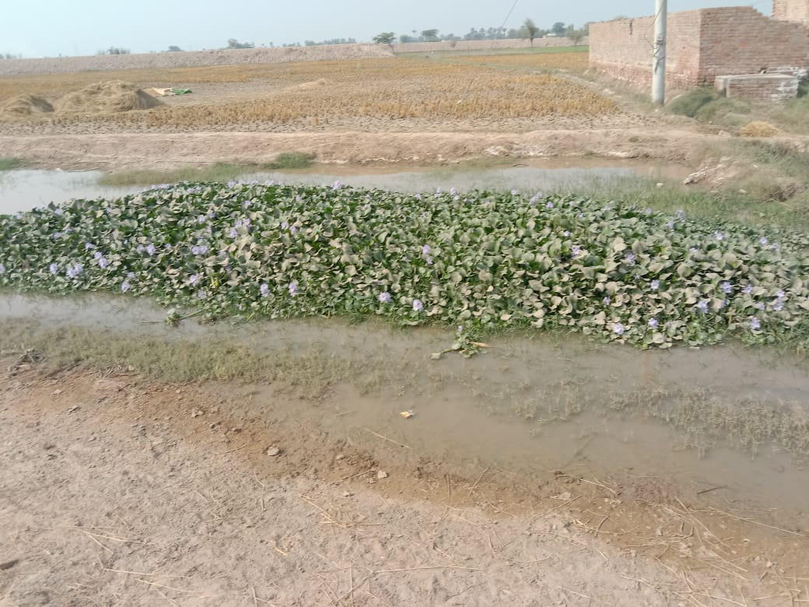
SHAHJEWENA DRAIN
Shahjewena Drain starts from adjoining areas of villages Ratta, Punj Grian, dosera and Wadden.after passing nearby Shahjewena Mandi, it enters in Shahjewena city and falls out directly in River Chanab in south west of Shahjewena city.
It crosses Sargodha-jhang road at RD 8+200, then it enters in flood range of River Chanab. River chanab has washed it's 3 RDs, which doesn't exist now.
During flood season, even at low level flood in river Chanab, back water effect reaches up to RD 8+200 and a flood protection situation has been created there.
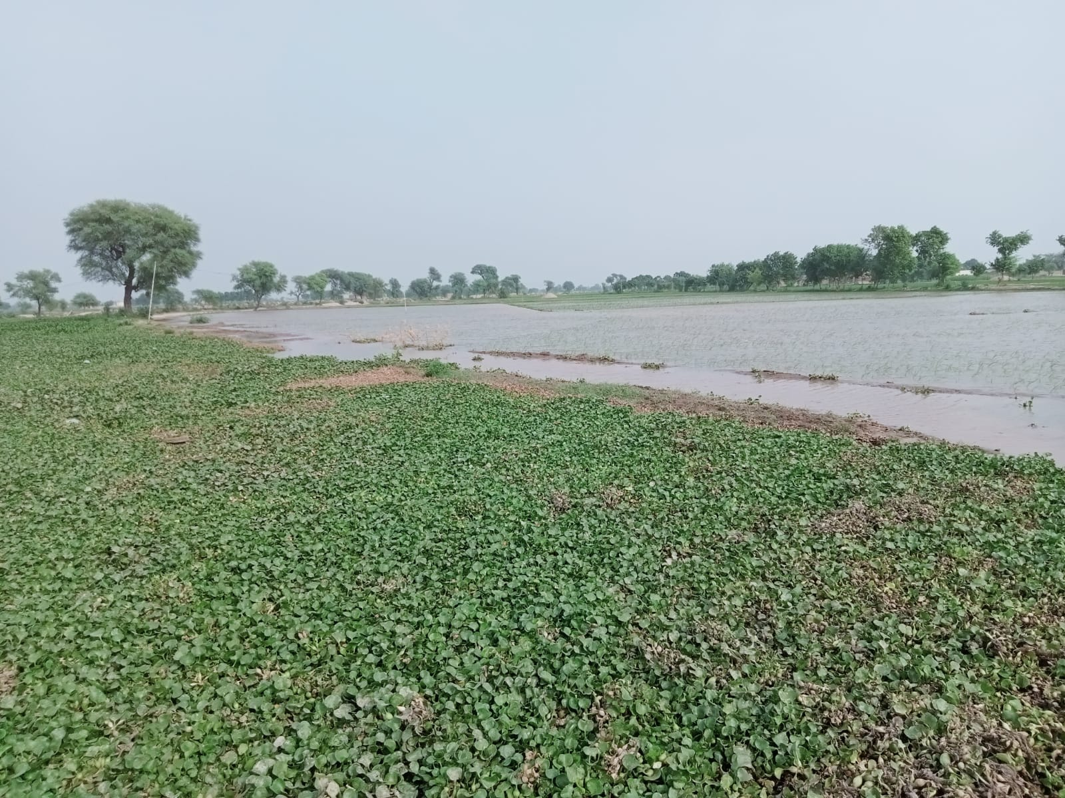
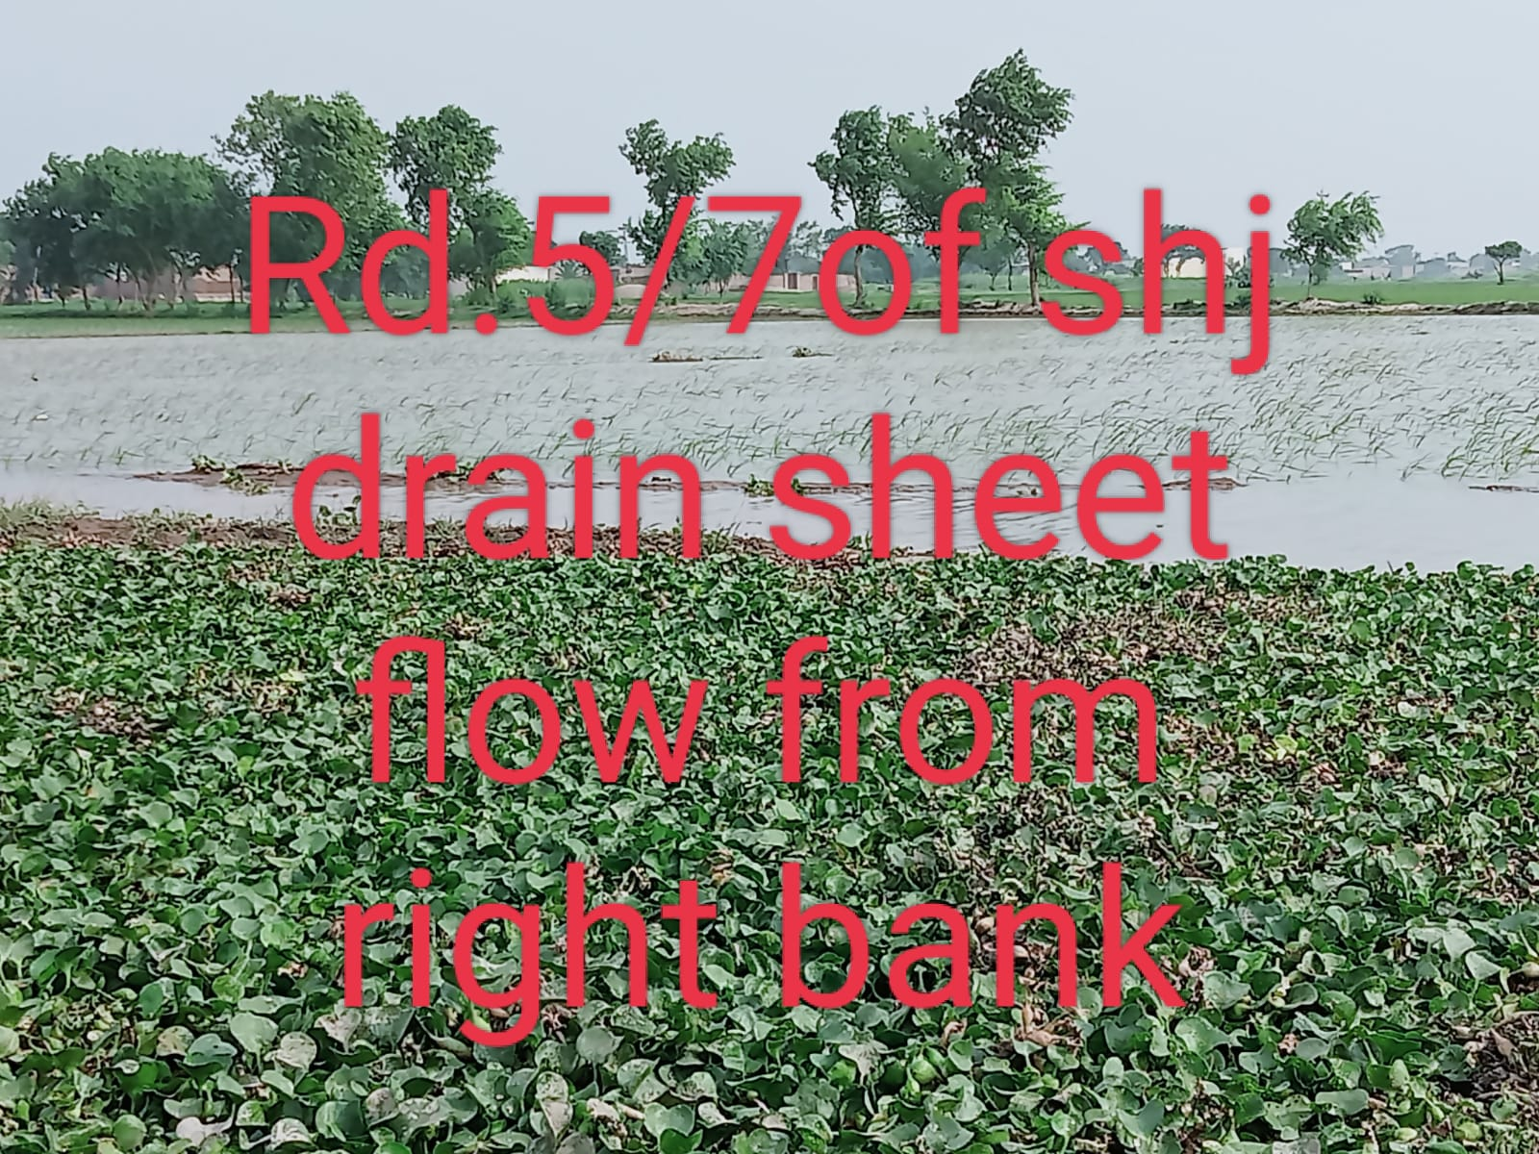
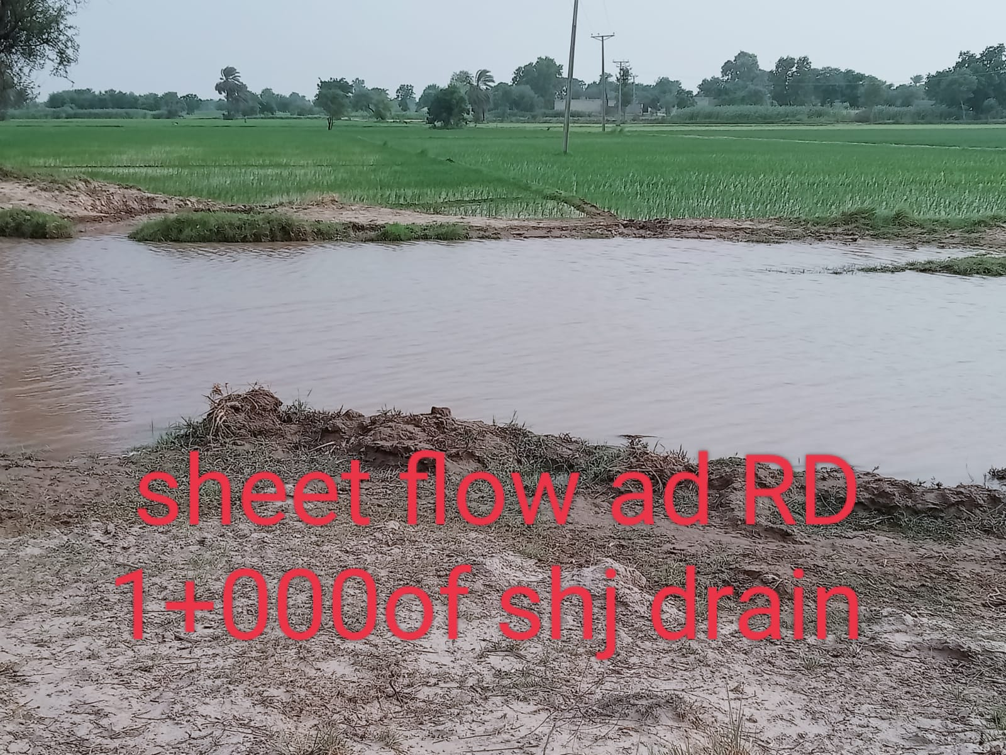
SOME PICTORIAL EVIDENCES DURING FLOOD SEASON 2023-24.
Infect the banks of the drain in this reach i.e. from RD0+000 to RD8+200 have become now the flood protection bunds for both sides, The upstream and downstream. The right bank (from D/S to U/S) especially not only protect the adjoining abadies , vegetation but also work as first defense line for safety of Sargodha - Jhung road which is the last hope for whole Shahjewena city and all other abadies up to river Jhelum without any obstacle.
Present situation:
The right bank has been deeply scratched out in between different RD,s and the edge of drain Has become either lower or equal to natural surface level. Which causes sheet flow. As a result all the area come under water. People of the area become aidless to be migrated along with their children and animals.
PROPOSAL:
During flood season every year it is observed that:
1. Whole the field staff along with their incharge is required to be bounded at site for full time.
2. For an emergency at least one excavator machine, front blade tractor ,trolly, wheel barrow, tentage at site, jute bags ,kassis ,long pegs, ropes etc. But at site departmental people are idols as they could no bought these articles from head of flood fighting.
3. Day and night watching is necessary to protect the adjoining crops, Abadies, vegetation, public infrastructures and animals of the people's. For which additional staff is required which can only be fulfilled by hiring seasonal personals. For which use of flood fighting head is necessary.
The only technical solution to overcome the problem was to
1: Follow the suggestions provided in MIP(revised edition). Which states that banks of the drain should be minimum 3ft higher than NSL OR FSL? Whichever is higher.
2. To declare these reaches, as flood embankments after revision their L-Sections.
L-Sections of these drains have been revised by the competent authority as specified in revised MIP. It is further added that a flood fighting hut is necessitated at site during Moon Soon because to serve not only the flood fighting staff but also be used as camouflage for the flood fighting material. This practice has already been exercised in Drainage Division Mandi Bha-u-Din in Malakwal Section at Mona Bhera DrainRD 6-7.

Administrative Set-up

Administratively, setup plan of Drainage Division is as under.
Executive Engineer,
Drainage Division Sargodha
Sub Divisional Officer,
Shahjewana Sub Division
Sub Divisional Officer,
Raniwah Sub Division

Sub Divisional Officer,
Mona Sub Division

Sub Engineer
Sobhaga Section
Sub Engineer
Sahiwal Secton
Sub Engineer
Sillanwali Secton
Sub Engineer
Hussain Shah Section
Sub Engineer
Nurawala Section
Sub Engineer
Farooqa Section
Sub Engineer
Vij Section

Sub Engineer
Mona Section
Sub Engineer
Mari Section
Sub Engineer
Kalara Section

Sub Engineer
Hadda Section
Sub Engineer
Chawa Section

XEN DRG SGD

CHAPTER – 2
FLOOD PROTECTION AND RIVER TRAINING WORKS.
2.1 Design Parameter of Training Works.

The Sargodha Drainage Division is affected by two Rivers, the Chenab and the Jhelum Rivers.

The Chenab runs on its East while the Jhelum flows along its West. The kacha area along the sides of the two rivers is usually in the principal hit of the floods. In addition to flood water, the drains during rainy season are also prone to over flow and cause much damage to life and property, as is the case for river flood. Thus constant vigilance and supervision over Drainage systems becomes necessary during rainy season. The catchment areas located near out-fall reaches of the drain is badly affected due to backwater flows and spills during flood in the rivers.
The Division is responsible for maintenance of Drainage Systems, Flood Protection Works and River Training Works.
PARAMETERS OF FLOOD EMBANKMENTS & RIVER TRAINING WORKS.

Description | Total length Miles | Discharge Cs | Top width (Feet) | Top R.L (Feet) | Side Slop
 |  |  |  |  | River Side | Country Side
a) Flood Embankments
Flood embankments along F.S Outfall Drain RD 0+0000 to 25+750. | 5.15 | 2200 | 25’.0 | 560.20 | 1.5:1 | 1:5:1
Flood embankments along Hadda Extension Bund RD:0+000 to 30+655 | 6.131 | 1100 | 25’ | 573.43 | 2:1 | 2:1
Flood Embankments of Shahjewana Drain RD 0+000 to 8+125 | 1.625 | 200 | 20 | 530.90 | 2:1 | 2:1
Flood Embankments of Sahiwal Drain RD 0+000 to 25+000 | 5.0 | 425 | 20’ | 553.18 | 2:1 | 2:1
Flood Embankments of Tarkhanwala Drain RD 0+000 to 21+000 | 4.20 | 55 | 20’ | 542.31 | 2:1 | 2:1

XEN DRG SGD

DRAINAGE SYSTEMS

Sr.  No. | Name of Drainage System | Drains likely to be over spilled | Total mile  length | Discharge Cs | Out falling points
1 | F.S Drainage system | F.S. Drain RD 0-42 & RD 100-150 | 69.15 | 1040 | F.S. Out fall Drain
1 | F.S Drainage system | 2R F.S. Drain 0-13500 | 17.90 | 110 | F.S. Drain RD 197
2 | F.S. Outfall Drain | F.S. Outfall Drain RD 0-76 | 15.00 | 2200 | River Chenab
3 | Lower Raniwah Drainage System | Lower Raniwah Drain RD 0-60 & RD 176-280 | 53.25 | 450 | River Jhelum
4 | Mona Drainage system | Mona Drain RD 120-124 | 56.20 | 1547 | Sulki escape
5 | Sulki Drainage System | Sulki Drain / RD 0-10 | 5.80 | 1554 | Sulki Creek
5 | Sulki Drainage System | Additional Outfall Mona Drain RD 19-20 | 4.40 | 2.52 | RD 19- Sulki escape
6 | Sobhaga Drainage system | Sobhaga Drain RD 0-34 | 32.12 | 760 | River Jhelum
7 | Terkhanawala Drainage System | Tirkhanawala Drain RD 0-34 | 18.50 | 250 | River Jhelum Creek
8 | Sahiwal Drain | Sahiwal Drain RD 0-22 | 10.10 | 425 | River Jhelum
9 | Hadda Drainage System | Hadda Drain RD 30-45 | 22.27 | 720 | River Chenab
10 | Turtipur Khan Muhammad Walla Drain | Turtipur Khan Muhammad wala Drain RD 0-10 | 11.34 | 96 | River Jhelum

2.2 LOCATION MAP.
Map has been attached for Sargodha Drainage Division Sargodha on page 14.

XEN DRG SGD
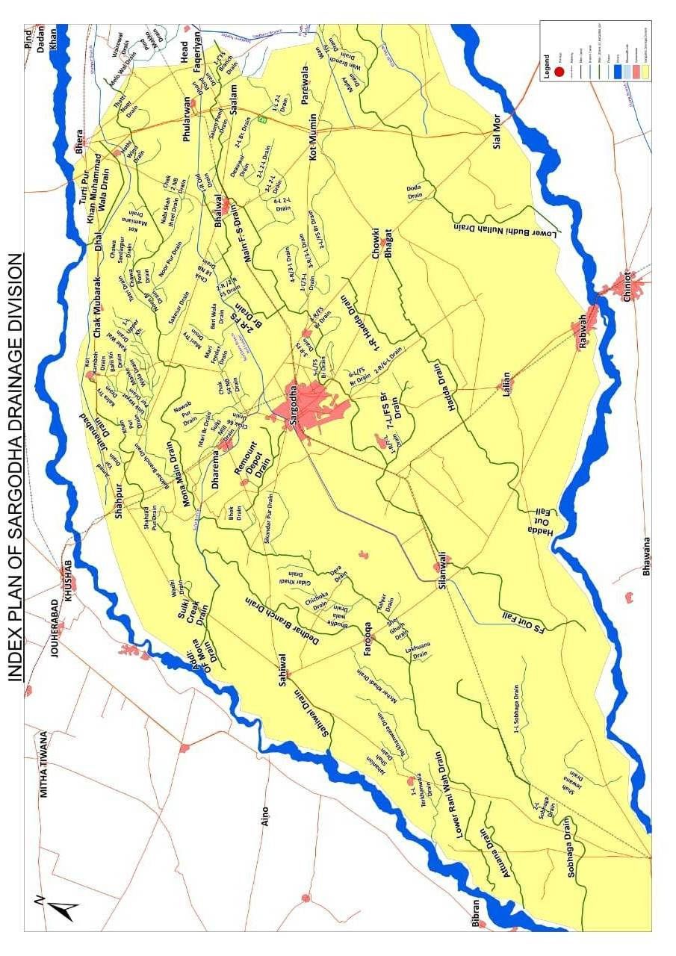
CHAPTER – 3
BRIEF HISTORY OF PAST FLOOD EVENTS

Flood causes enormous economic losses to both urban & rural communities throughout the Sargodha Drainage Division. In 1997, torrential rains and flood in the River affected the whole Drainage Network, Flood Embankments and River Training Works. Bhalwal, Shahpur, Sahiwal and Sargodha Tehsils were badly affected by floods in the two rivers and heavy rainfall during monsoon season. Bhalwal Town was cut off from east of the District by hit of flood and rain water. A large number of villages were inundated and remained in deplorable condition for over six months till depletion of the accumulated water as result of which colossal damage was caused to livestock. Houses, infrastructures and other properties. Means of communication were disrupted and roads were badly damaged.
The rain water accumulated in the area during 1997, and made its flow into drains. The drains were flooded. Four main Drainage system i.e Mona, F.S (Faquirian-Sillanwali), Hadda and Raniwah posed immense threat due to rise in water levels in drains, causing damage to systems as well as to the areas of their influence as a whole.
The outfall reaches of F.S. Mona, Raniwah, Sahiwal, Sulki and L.B.N drains were badly affected due to backwater effect.
In 1997, the river Chenab was at its peak on 28-08-1997 and due to its effect, flood embankments along L.B.N Drain (RD 0-20), Guide Wall Spur and Tie Bund remained under threat of spill from River Chenab.
However, the strenuous and zealous efforts of the department reduced the losses to the flood hit area.
In 2002, a discharge of 2.26 lac Cs was recorded downstream Qadirabad Barrage in River Chenab in 08/2002. a freshet of 3.22 lac Cs was also experienced downstream Qadirabad Barrage in River Chenab during 02/2003, whereas river Jhelum remained clam as usual. No measurable erosion/ damage was detected this year along the bunds or around the training woks.
In 2003, a maximum discharge of 1.58 lac Cs was registered down side Qadirabad Barrage.
In 2004, a maximum discharge of 90043 Cs was recorded D/S Qadirabad Barrage.
In 2005, maximum discharge recorded D/S Qadirabad Barrage on 08-07-2005, was 369847 Cs. Only 1.00 ft free board was left on Flood Embankment along L.B.N Drain and all existing bridges were submerged.
During 2006 maximum discharge was recorded D/S Quadirabad Barrage as 443206 Cs. At the same duration two number deliberate cuts were made by the inhabitants of villages situated on the country side in between RD 7000 to 8000 & 13000 to 14000 of Flood Embankment along LBN drain, which were repaired just after the passing of freshet.
In 2007 maximum discharge recorded D/S Quadirabad Barrage was 311382 & there was no mentionable damage.

In 2008 maximum discharge 31,419 Cs and 190,438 Cs were passed D/S Rasul Barrage and D/S Quadar Abad Barrage respectively and as no reportable damages were occurred there. No abnormal situation was observed during flood season 2008, as almost all drains of Sargodha Drainage Division, have flowed with very normal discharge or remained dry.
In 2009, no significant event took place due to lesser rainfall in the country.
In 2010 maximum discharge recorded D/S Quadirabad Barrage was 3, 19, 733 Cs and D/S Rasul Barrage was 2, 63, 795 Cs during July and August 2010 due to the heavy rain fall and flood the rain water accumulated in the area and made its flow into the Drains. The drains were flooded. Five main Drainage System i.e. Mona Drainage System. F.S. Drainage System, Hadda, Raniwah and Bola Drainage System due to rise in water levels in drains caused damage to the system.
In 2011, a maximum discharge of D/S Qadirabad Barrage was 164604 Cs and D/S Rasul Barrage 96864 & there was no flood damage.
In 2012, a maximum discharge of D/S Qadirabad Barrage was 180789 Cs and D/S Rasul Barrage 27515 Cs & there was no flood damage.
In 2013, a maximum discharge of D/S Qadirabad Barrage was 403403 Cs and D/S Rasul Barrage 98449 Cs & there was no flood damage.
In 2014, a maximum discharge of D/S Qadirabad Barrage was 903504 Cs and D/S Rasul Barrage 516387 Cs during September 2014 exceptionally high flood passed in river Chenab, Guide Wall J-Head Spur at Madokana, Tie Flood Bund and LBN Flood Bund were directly under threat of Flood. The flood water rose up to top of flood bund in many reaches. Horizontal creeks were developed on the top of bund all along its length. The drain over flowed between RD 20-50, due to back water in drain.
In 2015 a maximum discharge of D/S Qadirabad Barrage was 161054 Cs and D/S Rasul Barrage 99103 Cs and there were no flood damages.
In 2016 a maximum discharge of D/S Qadirabad Barrage was 405542 Cs and D/S Rasul Barrage 43135 Cs and there were no flood damages.
In 2017 a maximum discharge of D/S Qadirabad Barrage was 154420 Cs and D/S Rasul Barrage 39230 Cs and there were no flood damages.
In 2018 a maximum discharge of D/S Qadirabad Barrage was 172031 Cs and D/S Rasul Barrage 43135 Cs and there were no flood damages.
In 2019 a maximum discharge of D/S Qadirabad Barrage was 159544 Cs and D/S Rasul Barrage 91904 Cs and there were no flood damages.
In 2020 a maximum discharge of D/S Qadirabad Barrage was 258954 Cs and D/S Rasul Barrage 126915 Cs and there were no flood damages.
In 2021 a maximum discharge of D/S Qadirabad Barrage was 167812 Cs and D/S Rasul Barrage 31420 Cs and there were no flood damages.
In 2022 a maximum discharge of D/S Qadirabad Barrage was 154420 Cs and D/S Rasul Barrage 21050 Cs and there were no flood damages.
In 2023 a maximum discharge of D/S Qadirabad Barrage was approx 185749 Cs and D/S Rasul Barrage 23090 Cs However No serious flood damages were there except sheet flow at different RD, s of Shahjewena Drain.

XEN DRG SGD
CHAPTER - 4
DESIGN DATA, HISTORIC PEAK FLOOD DATA AND PAST FIVE YEARS DATA OF HEAD WORKS / BARRAGES AND OTHER CONTROL POINTS.

The terminology of different kinds of floods i.e. Low, Medium, High and exceptionally high and they will be taken as such in the light of any wireless message received from respective warning centers.
4.1 FLOOD LIMITS (ABOVE) CUSECS.

River | Control Point | Low | Medium | High | Very High | Exceptionally High
Jhelum | Mangla | 75000 | 110000 | 150000 | 225000 | 300000
Jhelum | Rasul | 75000 | 110000 | 150000 | 225000 | 300000
Chenab | Khanki | 100000 | 150000 | 200000 | 400000 | 600000
Chenab | Qadirabad | 100000 | 150000 | 200000 | 400000 | 600000

  - TIME LAGS OF FLOODS
As per statement the following are the time lags for average flood flows in the two Rivers.

River | From | To | Distance  (in Miles) | Time lag  (Hours)
Jhelum | Mangala | Rasul | 45 | 12
Jhelum | Rasul | Demontomorencey  Bridge (Khushab) | 80 | 22
Chenab | Marala | Qaidrabad | 58 | 14
Chenab | Qadirabad | Miana Hazara | 40 | 12
Chenab | Qadirabad | Madokana Spur | 70 | 20

  - HIGHEST FLOOD.

The following are the important highest floods discharges recorded downstream Rasul and Qadirabad during last five years.

Year | D/S Rasul Barrage  (in Cs) | D/S Qadirabad  Barrage (in Cs)
2018 | 43135 | 172031
2019 | 91532 | 159544
2020 | 126951 | 258954
2021 | 31420 | 167812
2022 | 21050 | 202149
2023 | 35325 | 185749

XEN DRG SGD
4.4 PEAK DISCHARGES (HISTORICAL PEAK FLOOD DATA)
Date | Discharge | Pond Level
DOWN STREAM RASUL BARRAGE (RIVER JHELUM)
11.05.1999 | 46160 | 719.00
22.07.2000 | 39222 | 718.00
27.07.2001 | 30270 | 718.00
14.08.2002 | 49170 | 718.00
05.09.2003 | 49170 | 718.00
30.04.2004 | 31422 | 719.00
17.07.2005 | 92246 | 719.00
13.07.2006 | 165947 | 720.00
07.07.2007 | 34098 | 719.00
14.11.2008 | 20678 | 719.00
17.08.2009 | 56794 | 719.00
01-02/08/2010 | 263000 | 719.00
17-09-2011 | 96864 | 719.00
04-07-2012 | 27515 | 719.00
31-07-2013 | 98449 | 719.60
06-09-2014 | 516387 | 714.00
27-7-2015 | 99103 | 607.90
27-7-2016 | 43135 | 701.30
23-7-2017 | 39230 | 719.00
02-10-2018 | 43135 | 718.00
22-06-2019 | 91532 | 705.40
28-8-2020 | 126951 | 717.00
30-06-2021 | 31420 | 700.30
22-06-2022 | 23210 | 590.50
08.09.2023 | 35325 | 699.30 P
DOWN STREAM QADIRABAD BARRAGE (RIVER CHENAB)
08.08.1999 | 122447 | 691.60
23.07.2000 | 291349 | 693.70
08.08.2001 | 136575 | 697.70
14.08.2002 | 226398 | 694.60
19.02.2003 | 367408 | 696.20
18.08.2004 | 90043 | 691.50
06.07.2005 | 369847 | 697.00
04.09.2006 | 443206 | 699.10
14.03.2007 | 289002 | 697.00
01.08.2008 | 190438 | 697.00
17.08.2009 | 55535 | 697.00
07.08.2010 | 298961 | 697.00
17-09-2011 | 164604 | 691.85
5-7-2012 | 180789 | 691.97
15-8-2013 | 403403 | 697.30
07-09-2014 | 903504 | 701.70
13-7-2015 | 161054 | 694.50
08-08-2016 | 405542 | 696.95
03-08-2017 | 154420 | 694.00
14.08.2018 | 172031 | 697.00
01-08-2019 | 159544 | 684.70
29.08.2020 | 258954 | 694.00
29-07-2021 | 167812 | 688.25
12.08.2022 | 202149 | 694.00
2023 | 185749 | 692.70

XEN DRG SGD
CHAPTER – 5

FLOOD FIGHTING STRATEGY

In view of the experience of the past flood history, constant watch is required to meet the on slaughts of floods in rainy season.

Constant vigilance and caution will be required at all levels particularly on spots for relief and flood fighting on Drains, Flood Embankments and River Training works.

BATTLE STATIONS
The department proposes to install the following battle stations for protection of irrigation structures, flood fighting and watching to minimize the losses.

THE PROPOSED CAMPS SITES ON DRAINS.

(Low Flood)
Drains | Reach | Length  in Mils | Battle  Station
F.S. Outfall | 0-26 | 5.20 | RD- 05
L.R Drain | 0-60 | 12.0 | RD-225
Addl; outfall Mona Drain | 19-20 | 0.2 | RD- 19
Turtipur Khan Muhammad  Wala Drain | 0-10 | 2.0 | RD- 9
Sahiwal Drain | 0-22 | 4.40 | RD- 12
Tarkhanwala Drain | 0-21 | 4.20 | RD-12
Shahjewana Drain | 0-8 | 1.625 | RD-8
Hadda outfall Drain | 0-18 | 3.25 | RD-06

XEN DRG SGD

THE PROPOSED CAMPS SITES ON DRAINS.

(Medium Flood)
Drains | Reach | Length  in Mils | Battle  Station
Turtipur Khan Muhammad  Wala Drain | 0-10 | 2.0 | RD- 19
Addl; outfall Mona Drain | 19-20 | 0.2 | RD- 19
L.R Drain | 0-60 | 12.0 | RD- 225
F.S. Outfall | 0-26 | 5.20 | RD- 11
Sahiwal Drain | 0-22 | 4.40 | RD- 5
L.B.N Drain | 20-34 | 2.8 | RD- 24
Shahjewana Drain | 0-8 | 1.625 | RD-8
Hadda outfall Drain | 0-18 | 3.25 | RD -6

THE PROPOSED CAMPS SITES ON DRAINS.
(High Flood)
Drains | Reach | Length  in Mils | Battle  Station
F.S. Outfall Drain | 0-26 | 5.20 | RD- 11
Turtipur Khan Muhammad  Wala Drain. | 0-10 | 2.0 | RD- 19
Sahiwal Drain. | 0-22 | 4.40 | RD- 20
L.R Drain. | 0-60 | 12.0 | RD- 225
Terkhan wala Drain | 0-12 | 2.22 | RD 12
Addl; outfall Mona Drain. | 19-20 | 0.2 | RD- 19
Shahjewana Drain | 0-8 | 1.625 | RD-8
Hadda out fall Drain | 0-18 | 3.25 | RD -6

THE PROPOSED CAMPS SITES ON DRAINS.

(Exceptionally High Flood)
Drains | Reach | Length  in Mils | Battle  Station
F.S. Outfall Drain | 0-26 | 5.20 | RD- 11
Turtipur Khan Muhammad  Wala Drain | 0-10 | 2.0 | RD- 19
Terkhan wala Drain | 0-12 | 2.22 | RD 12
Sahiwal Drain | 0-22 | 4.40 | RD- 20
L.R Drain | 216-266 | 10.0 | RD- 225
Addl; outfall Mona Drain | 19-20 | 3.80 | RD- 19
Shahjewana Drain | 0-8 | 1.625 | RD-8
Hadda out fall Drain | 0-18 | 3.25 | RD -6

XEN DRG SGD

The above mentioned camps will be installed on above sites for controlling the protection activities during emergency. For all spots, sufficient quantity of flood fighting material with manpower will be made available in all these camps.
Engagement of work charge establishment to supplement the efforts through regular establishment will be made in accordance with the demand of the situation.
At the stage of very high flood, the strength of watching establishment will be enhanced. Executive Engineer, will be authorized to engage labour and purchase material up to any requirement in consultation with the Superintending Engineer.

The following Sub Divisional Officers will supervise all the operations in their Respective Sub Divisions.

Designation of Officer | Sub Division
Sub Divisional Officer | Shahjewana Drainage Sub Division
Sub Divisional Officer | Mona Drainage Sub Division
Sub Divisional Officer | Raniwah Drainage Sub Division

The Executive Engineer is fully competent to assign and change duty of the Officer/ Officials working under him.
A flood emergency Sub Office will be established within the Divisional Office, which will become operative with effect from 15-06-2024, and remain functional through the flood season till 15-10-2024. A duty clerk along with a messenger would be available and deliver messages about flood warning emergency and any eventuality, which may arise.

- LOW FLOOD DISCHARGE 100000 – 150000 Cs.

No extra labour will be employed. The labour arranged for preparedness will continue as such.

- MEDIUM FLOOD DISCHARGE 150000 – 200000 Cs

The flood water flows within river bank. No extra labour will be employed. The labour arranged for preparedness will continue as such.

- HIGH FLOOD DISCHARGES 200000 – 400000 Cs.

The flood water spills out and inundates the low lying areas and touches the flood bund. The watching is necessary to be arranged. Therefore, four men for day & night for two mile are employed, including the existing gang, for watching purposes.

iv VERY HIGH FLOOD DISCHARGES 400000 – 600000 Cs.

All activities will remain as such. The watching establishment will be raised to two men per mile on Drains and three men per mile per shift for three shifts on Flood Bund.

- EXCEPTIONALLY HIGH FLOOD ABOVE 600000 Cs.

This stage warrants alarming situation. The watching labour will be raised to three men per mile per shift on Drains and five men per mile per shift for three shifts on bund. On receipt of exceptionally high flood warning, Sub Divisional Officer, Shahjewena along with concerned Sub Engineer will shift their camp at Suitable location which will be intimated to all concerned at once.

XEN DRG SGD

CHAPTER – 6
Flood Damages Restoration works for the year 2023-24
No Flood damages occurred during the flood season 2023-24 in Sargodha Drainage Division Sargodha.
XEN DRG SGD
CHAPTER – 7

FLOOD FIGHTING WATCHING ARRANGEMENTS
  - Pre-Flood Arrangements.
Sr.# | Activity | Target Dates | Compliance Report
I. | Preparation of Flood Fighting Plans
 | a) Submission of Draft Divisional Plans by  Zonal Chief to Chief Engineer Drainage  And Flood (After scrutiny by SE/CE). | 01-03-2024 | within target date
 | b) Review by Chief Engineer D&F. | 31-03-2024 | Reviewed
 | c) Final submission of Flood Fighting Plan. | 15-04-2024 | within target date
II. | Inspection of Flood Works.
 | a) By XEN's |  | -
 | b) Checking / Inspection by SE's/CE) |  | -
 | c) Inspection by Departmental & Army Team. |  | -
III. | Identification of encroachment’s on bunds and spurs to the Civil Administration. | 31-03-2024 | No encroachment on flood bund / spur
IV. | Painting Gauges, RD Marks, Data Boards and repair to Flood Bunds etc. | 31-05-2024 | within target date
V. | Replenishment of Reserve Stock of Stone and Flood fighting materials.
 | a) Identification of needs. | 28-02-2024 | -
 | b) Funding/Procurement Arrangements. | 15-03-2024 | Sanction of estimate is under progress.
 | c) Procurement, Stacking, Prescribed field  Checks. | 31-05-2024 | It will be completed within target date
VI. | Installation of wireless sets | 15-06-2024 | It will be completed within target date
VII. | Opening of Zonal Flood Cells
 | a) Duty Rosters. | 01-06-2024 | It will be opened on target date
 | b) Operative. | 15-06-2024 | It will be operated on target date

XEN DRG SGD

  - WATCHING ESTABLISHMENT
Following are the main spots where watching Huts will be established on temporary basis. During medium floods for embankments and high floods for adjoining abadies, the tents/shouldaries will be erected and Flood .watching material will be shifted in the huts. One Chowkidar for each Hut will be employed from the report of receipt of medium Flood and will remain employed till end of flood season. The scale / engagement of work charge labour on flood bunds and Drains will be required on work charge basis.
In addition to the existing field establishment, extra manpower will be engaged during the flood season on work charge basis for watching and general maintenance of banks of drains, flood embankments, and River Training works in whole of the Division. The engagement of labour would however will be subject to the intensity of rains / flood as the situation could warrant.
Flood Limits
Site | Low |  | Medium |  | High |  | Very High |  | Exceptionally High
Site | Men | Shift | Men | Shift | Men | Shift | Men | Shift | Men | Shift
F.S out fall Drain  0-25 | No extra labour will be required at the stage. |  | 10 | 02 | 15 | 03 | 15 | 03 | 17 | 03
Turtipur Khan Muhammad  Wala Drain0-10 |  |  | 10 | 02 | 12 | 03 | 12 | 03 | 12 | 03
Sahiwal DrainRD 0-25 |  |  | 12 | 02 | 15 | 03 | 15 | 03 | 17 | 03
L.R Drain.  RD 216-266 |  |  | 15 | 02 | 30 | 03 | 30 | 03 | 35 | 03
Terkhan wala DrainRD 0-12 |  |  | 06 | 02 | 06 | 03 | 06 | 03 | 08 | 03
Addl; outfall Mona Drain.RD0-19+150 |  |  | 09 | 02 | 11 | 03 | 11 | 03 | 13 | 03
Shahjewana Drain RD 0-8 |  |  | 4 | 2 | 06 | 03 | 06 | 03 | 08 | 03
Hadda Out Fall Drain  RD 0-18 |  |  | 4 | 02 | 12 | 03 | 12 | 03 | 14 | 03

XEN DRG SGD

7.3 Arrangement at Sensitive Sites.
The total 183 RDs Flood effecting banks exist in Sargodha Drainage Division, Sargodha for which watching lengths and location of site cam/ flood fighting camps have been mentioned above in tabular form
The above mentioned camps will be installed on above sites for controlling the protection activities during emergency. For all spots, sufficient quantity of flood fighting material with manpower will be made available in all these camps. However construction of a flood fighting hut at RD8+000 of Shahjewena Drain is proposed through this flood fighting plane.
Engagement of work charge establishment to supplement the efforts through regular establishment will be made in accordance with the demand of the situation.
At the stage of very high flood, the strength of watching establishment may be enhanced. Executive Engineer, will be authorized to engage labour and purchase material upto any requirement in consultation with the Superintending Engineer.

7.4 WATCHING MATERIAL
There will be two No. watching centers on flood embankment along all Drains at mentioned RDs or where suitable as per site situation which will be shared to all concerned at once in case of any change,. Flood material will be arranged and stored at Shahjewena Flood fighting Hut.. The material will be shifted to flood fighting camp as soon as the intimation of medium / high flood limit is received.

Sr # | Items | Unit | Total Required Qty | Available Qty | Balance | Remarks
01 | Gunney Bages | No | 2500 | 0 | 2500
02 | Chouldari | No | 8 | 0 | 8
03 | Kassies | No | 210 | 0 | 210
04 | Baskets | No | 210 | 0 | 210
05 | Bamboos/ Killas | No | 1350 | 0 | 1350
06 | Torche | No | 43 | 0 | 43
07 | Lantern | No | 53 | 0 | 53
08 | K-Oile(ten) | Ten | 14 | 0 | 14
09 | Cell of torches (Dozen) | Dozen | 23 | 0 | 23
10 | Folding Chairs | No | 30 | 0 | 30
11 | Folding Table | No | 09 | 0 | 09
12 | G.I.wire | No | 25 | 0 | 11
13 | G.I.Buckets | No | 10 | 0 | 0
14 | Hand Saw | No | 02 | 0 | 0
15 | Handle for Kassis | No | 25 | 0 | 25
16 | Killas | No | 30 | 0 | 30
17 | Life Jecket | No | 40 | 0 | 40
18 | M.Oil | Ltr | 25 | 0 | 25
19 | Manale Rope | No | 10 | 0 | 10
20 | Match Boxes dozen | Dozen | 01 | 0 | 01
21 | Munj / Patha/ Trungers | No | 50 | 0 | 50
22 | Axes | No | 05 | 0 | 05
23 | Needles | No | 0 | 6 | 0
24 | Petrol | Ltr | 300 | 0 | 300
25 | Steel charpai | No | 34 | 0 | 34
26 | Solti (KG) | Kg | 50 | 0 | 50
27 | Umbrella | No | 12 | 0 | 12
28 | Wooden Hammer | No | 08 | 0 | 08
29 | Steel Hammer | No | 08 | 0 | 08
30 | Snake kit | NO | 24 | 0 | 24

7.5 Arrangement for Sounding & Probing.
This item relates to barrage / Head works Canal Divisions.
7.6 Lighting Arrangement.
Sufficient numbers of emergencies lights, lanterns and have been provisioned.
7.7 Ration Arrangement.
The establishment and supervisory staff will make their own food arrangements. However in the event of dearth of commodities, the Civil Authorities will be approached to store sufficient ration.
7.8 P.O.L. Arrangement for Vehicle.
Respective Deputy District Officer (Revenue) will be requested by the Sub Divisional Officer in-charge to provide help for reserve at the nearest petrol pumps to keep the vehicles on. Any obstruction found there will be pointed out by the Sub Divisional Officer.
7.9 Transportation.
Vehicles will available for transportation during flood season.
7.10 Law and order.
There is no likelihood of any interruption by anyone except cutting of banks of F.S out fall drain between RD 0-11 near Ahmad Walla VILLAGE . In case of necessity. District Coordination Officer Chiniot will be contacted by the Executive Engineer, Drainage Division Sargodha to take decision at site.
7.11 Medical Arrangement for Labour.
It will be responsibility of District Government to provide Medical Facilities in flood areas where will required.
7.12 Liaison with other Department.
Executive Engineer, Sargodha Drainage Division Sargodha will keep liaison with the Civil and Army Authorities and will keep the Superintending Engineer Drainage Circle Sargodha fully apprised of the flood situation in Sargodha Drainage Division.
7.13 Role of the Army.
Role of the Army is very important in case of any emergent situation arising due to high floods. A continuous liaison with the Army Authorities will be maintained during floods and if required necessary help will be sought.
7.14 Duties of Telephone Attendant.
Sr # | Name of Office / Officials | Period | Time
Sr # | Name of Office / Officials | Period | From | To
01 | Sub Divisional Officer Shahjewana Drainage Sub Division (M Zaheer Ahmad) | 15.06.2024  to  15.10.2024 | 8:00 AM | 4:00 Pm
02 | Sub Engineer Sillanwali Section  (Muhammad Saeed). | 15.06.2024  to  15.10.2024 | 4:00 PM | 12:00 AM
03 | Sargodha Drainage Division Sargodha (M Saeed ) SDC | 15.06.2024  to  15.10.2024 | 12:00 AM | 8:00 AM
04 | Telegraph Office Sargodha | 15.06.2024  to  15.10.2024 | 8:00 AM | 8:00 AM

  - Wireless Arrangements.
Wireless system will be installed w.e.f 01.06.2024 in the vehicle of XEN Drainage Sargodha No. GBA 526, SDO Shahjewana Drainage Sub Division Jeep No. MBB 4383, SDO Rani wah Sub- Division Jeep No 5335.

XEN DRG SGD

CHAPTER – 8
DETAIL OF ENCROACHMENT
DETAILS OF ENCROACHMENTS ON FLOOD WORKS

Presently there is no encroachment exists on any flood works of Sargodha Drainage Division, Sargodha.

Sr #. | Total Encroachment | Removed | Remaining | Remarks
------NIL------

- Detail of Critical Encroachment.
Sr #. | Total Encroachment | Removed | Remaining | Remarks
------NIL------

XEN DRG SGD

CHAPTER – 9

1. DUTY ROSTER /FLOOD FIGHTING PROGRAMME

Key personal | Battle Station | Drains | Sub Division
Sub Engineer, Hadda | RD- 6 | F.S Outfall | Shahjewana  Sub Division
Sub Engineer, Vijh | RD- 25 | Raniwah Drain | Raniwah Sub Division
Sub Engineer, Sahiwal | RD- 225 | Raniwah Drain | Raniwah Sub Division
Sub Engineer, Hussain Shah | RD- 19 | Add out fall Mona Drain | Raniwah Sub Division
Sub Engineer, Chawa | RD- 9 | Turtipur Khan  Muhammad  wala Drain | Mona Sub Division
Sub Engineer, Sahiwal | RD- 12 | Sahiwal Drain | Shahjewana  Sub Division
Sub Engineer, Sillanwali | RD- 11 | F.S out fall Drain | Shahjwena Sub Division
SubEngineer, Shahjewena | RD-8 | Shahjewena Drain | Shahjwena Sub Division

XEN DRG SGD

Duty Roster/Flood Fighting Program
DUTY ROSTER OF KEY PERSONAL DURING FLOOD SEASON 2021
SITE | LENGTH  In Miles | STAGE-I DISCHARGE | LABOUR  REQUIRED | LABOUR FOR WATCHING BE DEPUTED  (PER SHIFT) |  | STAGE-II  DISCHARGE | LABOUR REQUIRED | LABOUR FOR WATCHING BE DEPUTED  (PER SHIFT) |  | STAGE-III  DISCHARGE | LABOUR REQUIRED | ESTABLISHMENT TO BE DEPUTED  (PER SHIEFT) |  |  |  | STAGE-IV  DISCHARGE  EXCEEDING  8 LAC Cs.
 |  |  |  | MATE | BELDAR | STAGE-II  DISCHARGE | LABOUR REQUIRED | MATE | BELDAR | STAGE-III  DISCHARGE | LABOUR REQUIRED | SDO | SUB ENGINEER | MATE | BAILDAR | STAGE-IV  DISCHARGE  EXCEEDING  8 LAC Cs.
F.S out fall Drain  0-25 | 5 | 2.0 lac Cs  to  4.0 lac Cs. | Four men for day & night  for two mile | 2 | 10 | 4.0 lac Cs  to  6.0 lac Cs. | Three men per mile per shift for Three shifts on Flood Bund. | 3 | 45 | 6.0 lac Cs.  To  8.0 lac Cs. | Three men per mile per shift on Drains and five men per mile per shift for three shifts on bund. On receipt of exceptionally high flood warning, Sub Divisional Officer, Shahjewena alongwith concerned Sub Engineer will shift their camp. | Zaheer Ahad Sub Divisional Officer  0306-0561786 | Muhammad Saeed  Sub Engineer,  0347-2006000 | 3 | 45 | Establishment will be deputed as per stage-III
Turtipur Khan Mohammad Wala Drain  RD 0-10 | 4 | 2.0 lac Cs  to  4.0 lac Cs. | Four men for day & night  for two mile | 2 | 08 | 4.0 lac Cs  to  6.0 lac Cs. | Three men per mile per shift for Three shifts on Flood Bund. | 3 | 18 | 6.0 lac Cs.  To  8.0 lac Cs. |  | Zaheer Ahad Sub Divisional Officer  0306-0561786 | Muhammad Amir  Sub Engineer,  0340.1482022 | 3 | 18 | Establishment will be deputed as per stage-III
Sahiwal Drain  RD 0-22 | 4.40 | 2.0 lac Cs  to  4.0 lac Cs. | Four men for day & night  for two mile | 2 | 9 | 4.0 lac Cs  to  6.0 lac Cs. | Three men per mile per shift for Three shifts on Flood Bund. | 3 | 45 | 6.0 lac Cs.  To  8.0 lac Cs. |  | Zaheer Ahad Sub Divisional Officer  0306-0561786 | Muhammad Rahim  Sub Engineer,  0306-5201213 | 3 | 45 | Establishment will be deputed as per stage-III
LR Drain RD 216-266 | 10 | 2.0 lac Cs  to  4.0 lac Cs. | Four men for day & night  for two mile | 2 | 20 | 4.0 lac Cs  to  6.0 lac Cs. | Three men per mile per shift for Three shifts on Flood Bund. | 3 | 90 | 6.0 lac Cs.  To  8.0 lac Cs. |  | Zaheer Ahad Sub Divisional Officer  0306-0561786 | Muhammad Rahim  Sub Engineer,  0306-5201213 | 3 | 90 | Establishment will be deputed as per stage-III
XEN DRG SGD

Duty Roster/Flood Fighting Program
DUTY ROSTER OF KEY PERSONAL DURING FLOOD SEASON 2021
SITE | LENGTH  In Miles | STAGE-I DISCHARGE | LABOUR  REQUIRED | LABOUR FOR WATCHING BE DEPUTED  (PER SHIFT) |  | STAGE-II  DISCHARGE | LABOUR REQUIRED | LABOUR FOR WATCHING BE DEPUTED  (PER SHIFT) |  | STAGE-III  DISCHARGE | LABOUR REQUIRED | ESTABLISHMENT TO BE DEPUTED  (PER SHIEFT) |  |  |  | STAGE-IV  DISCHARGE  EXCEEDING  8 LAC Cs.
 |  |  |  | MATE | BELDAR | STAGE-II  DISCHARGE | LABOUR REQUIRED | MATE | BELDAR | STAGE-III  DISCHARGE | LABOUR REQUIRED | SDO | SUB ENGINEER | MATE | BAILDAR | STAGE-IV  DISCHARGE  EXCEEDING  8 LAC Cs.
Terkhanwala Drain BankRD 0-12 | 2.22 | 2.0 lac Cs  to  4.0 lac Cs. | Four men for day & night  for two mile | 2 | 6 | 4.0 lac Cs  to  6.0 lac Cs. | Three men per mile per shift for Three shifts on Flood Bund. | 3 | 27 | 6.0 lac Cs.  To  8.0 lac Cs. | Three men per mile per shift on Drains and five men per mile per shift for three shifts on bund. On receipt of exceptionally high flood warning, Sub Divisional Officer, Shahjewena alongwith concerned Sub Engineer will shift their camp. | Zaheer Ahad Sub Divisional Officer  0306-0561786 | Muhammad Rahim  Sub Engineer,  0306-5201213 | 3 | 27 | Establishment will be deputed as per stage-III
Addl; outfall Mona Drain  RD 0-19+150 | 3.80 | 2.0 lac Cs  to  4.0 lac Cs. | Four men for day & night  for two mile | 2 | 8 | 4.0 lac Cs  to  6.0 lac Cs. | Three men per mile per shift for Three shifts on Flood Bund. | 3 | 36 | 6.0 lac Cs.  To  8.0 lac Cs. |  | Zaheer Ahad Sub Divisional Officer  0306-0561786 | Muhammad Nabeel  Sub Engineer,  03017133054 | 3 | 36 | Establishment will be deputed as per stage-III
Shahjewena Drain  RD 0- 8+125 | 1.62 | 2.0 lac Cs  to  4.0 lac Cs. | Four men for day & night  for two mile | 2 | 6 | 4.0 lac Cs  to  6.0 lac Cs. | Three men per mile per shift for Three shifts on Flood Bund. | 3 | 42 | 6.0 lac Cs.  To  8.0 lac Cs. |  | Zaheer Ahad Sub Divisional Officer  0306-0561786 | Javed Iqbal  Sub Engineer, | 3 | 42 | Establishment will be deputed as per stage-III
Hadda Out Fall Drain RD 0-18 | 3.25 | 2.0 lac Cs  to  4.0 lac Cs. | Four men for day & night  for two mile | 2 | 8 | 4.0 lac Cs  to  6.0 lac Cs. | Three men per mile per shift for Three shifts on Flood Bund. | 3 | 30 | 6.0 lac Cs.  To  8.0 lac Cs. |  | Zaheer Ahad Sub Divisional Officer  0306-0561786 | Muhammad Rahim  Sub Engineer,  0306-5201213 | 3 | 30 | Establishment will be deputed as per stage-III

XEN DRG SGD
CHAPTER – 10
Emergency Telephone Nos.
Sr. No. | Designation | Telephone / Cell. No.
Sr. No. | Designation | Office | Residence
1 | Minister of Irrigation Punjab Lahore. | 042-99212809  042-99211761
1 | Minister of Irrigation Punjab Lahore. | Fax 042-99212810 | -
2 | Secretary Irrigation Department, Punjab Lahore. | 042-99212117 | 042-99200286
2 | Secretary Irrigation Department, Punjab Lahore. | 042-99212118 | 042-99200286
2 | Secretary Irrigation Department, Punjab Lahore. | Fax 042-99212116 | 042-99200286
3 | Chief Engineer, Irrigation Sargodha Zone. | 048-9230445 | 03336941690
3 | Chief Engineer, Irrigation Sargodha Zone. | Fax 048-9230414 | 048-9230451
4 | Flood Emergency Officer Sargodha Irrigation Zone Sargodha. | 048-9230446 | 03006363739
4 | Flood Emergency Officer Sargodha Irrigation Zone Sargodha. | Fax 048-9230414
5 | Chief Engineer Drainage and Flood Zone Lahore. | 042-99233551 | 0300-6999490
5 | Chief Engineer Drainage and Flood Zone Lahore. | Fax 042-35291304 | 0300-6999490
6 | Director, Flood Drainage and Flood Zone Lahore. | 042-99231614  Fax-042-35862081 | 0323-4864373
7 | Deputy Director, Drainage and Flood Lahore. | 042-99230282 | 0300+6362154
8 | Flood Warning Center Jail Road Lahore. | 042-99230282 | -
9 | Superintending Engineer Lower Jhelum Canal Circle Sargodha. | 048-9230413 | 048-9230463
9 | Superintending Engineer Lower Jhelum Canal Circle Sargodha. | Fax 048-9230832
10 | Superintending Engineer Drainage Circle Sargodha. | 048-9230450 | 03338161746
11 | Executive Engineer, Sargodha Division L.J.C, Sargodha. | 048-9230409 | 03000147499
11 | Executive Engineer, Sargodha Division L.J.C, Sargodha. | Fax 048-9230918 | 03000147499
12 | Executive Engineer, Kirana Division L.J.C, Sargodha. | 048-9230399 | 0302-4844342
12 | Executive Engineer, Kirana Division L.J.C, Sargodha. | Fax 048-9230649 | 0302-4844342
13 | Executive Engineer, Shahpur Division L.J.C, Sargodha. | 048-9230447 | 0344-4132393
13 | Executive Engineer, Shahpur Division L.J.C, Sargodha. | Fax 048-9230836 | 0344-4132393
14 | Executive Engineer, Bhalwal Division L.J.C, | 0489230406 | 03006363739
15 | District Coordination Officer Sargodha. | 048-9230025 | 0333-8899931
15 | District Coordination Officer Sargodha. | 048-9230026 | 0333-8899931
16 | District Coordination Officer Chiniot. | 0476-330071-2 | -
17 | District Coordination Officer Jhang | 047-9200081 | -
18 | Executive Engineer, Drainage Division Sargodha. | 048-9230453 | 03338899931
19 | Incharge Vigilance Cell Irrigation & Power Department Punjab Lahore. | 042-9213157 | -
20 | Telegraph Office Sargodha (Flood Emergency Center Sargodha). | 048-9230408 | -
21 | Sub Divisional Officer, Raniwah Drainage Sub Division. | 048-9230453 | 0300-8876005
22 | Sub Divisional Officer, Mona Drainage Sub Division. | 048-9230453 | 0306-0561786
23 | Sub Divisional Officer, Shahjewana Drainage Sub Division. | 048-9230453 | 0306-0561786
XEN DRG SGD

CHAPTER – 11

Standard operating procedure (SOP) for Breaching Sections
11.1 History of the breaching section.

No breaching section in Sargodha Drainage Division Sargodha.

11.2 Location, Design, Quantity and Variety of the explosive required for detonation.
Does not relate.
11.3 Arrangement of explosives and security of explosive stores.
Does not relate.
11.4 List of the security staff along with detail of their training etc
Does not relate.
11.5 Detail of mechanical means as a standby arrangements in case of detonation failure.
Does not relate.
11.6 Duty Roster in case of critical situation.
Does not relate.
11.7 Breaching Committee with their action plan.
Does not relate.
11.8 List of the villages likely to be inundated in case of breach.
Does not relate.
11.9 Announcement and detail of evacuation arrangements.
Does not relate.
11.10 Details of coordination with Civil/Army Authorities
Does not relate.
11.11 Parallel communication arrangements.
Does not relate.
11.12 Index Plan.
Does not relate.

Sub Divisional Officer,
Shahjewana Drainage Sub Division
Sargodha
Executive Engineer,
Sargodha Drainage Division
Sargodha

CHAPTER - 12
Vulnerable sites on flood bunds/Structures.
12.1 Apprehended breach sites in Flood Bunds/Structures
The vulnerable sites on flood protection works are under:-
Sr. No. | Name of Flood Bund | Reach RD |  | No. of Sites
Sr. No. | Name of Flood Bund | From | To | No. of Sites
1 | F.S.OUT FALL DRAIN | 0+000 | 25+750 | 1
2 | TURTIPUR KHAN MOHAMMAD WALA DRAIN | 4+000 | 20+000 | 1
3 | SAHIWAL DRAIN | 7+000 | 12+000 | 1
4 | L.R DRAIN. | 216+000 | 266+000 | 1
5 | TERKHANWALA DRAIN | 0+000 | 12+000 | 1
6 | Addl; OUT FALL MONA DRAIN | 0+000 | 19+150 | 1
7 | SHAHJEWENA DRAIN | 0+000 | 8+125 | 1
8 | HADDA OUT FALL DRAIN | 0+000 | 18+000 | 1

12.2 Operation on breaching section
There is no breaching section in Drainage Division Sargodha.
12.3 Breaches due to rising of flood water deterioration of flood bund etc.
No such case.
XEN DRG SGD
CHAPTER – 13
Emergency Contingency Plan for vulnerable sites listed below.
13.1 Detail of villages abadies likely to be affected mentioned as under(to be shown on the plan).
S.NO | NAME OF DRAIN | RD | VILLAGES
1 | F.S OUT FALL DRAIN | 6+000 to 11+000 | Ahmad wala,Kull etc
2 | TURTI PUR KHAN MOHAMMAD WALA | 4+000 to 20+000 | Dhal,Hafiz Abad, Nabi Shah Khurd,Turti Pur, Jadha, Chak Missran, Kot Mamyana and Pindi koot
3 | SAHIWAL DRAIN | 6+000 TO 12+000 | Sayal sharif, Havaily Nathoka,Havaily Majoka,Poloha , Boora Ladheyal, Meta Salika etc
4 | L,R. DRAIN | 260 T0 266 | Chhatta Bukhsha,kiren Mazari,Dinar etc
5 | TERKHANWALA DRAIN | 7+000 TO 12+000 | Nadda GHAR,Sheikh jalil,Chak qureshi,Sava Majoka,Sargana and Charagh wala
6 | ADDL;OUT FALL MONA DRAIN
7 | Shahjewena DRAIN | 0+000 TO 8+125 | Shahjewena City, Dera mehmood etc
 | HADDA OUT FALL DRAIN | 6+000 to 18+000 | Taroosahmbel, Haji usman, Colony etc

XEN DRG SGD

FLOOD FIGHTING CAMP SITES.
Drains | Reach | Length  in Mils | Battle  Station
F.S. Outfall Drain | 0-26 | 5.20 | RD- 11
Turtipur Khan Muhammad  Wala Drain | 0-20 | 4.0 | RD- 9
Terkhan wala Drain | 0-12 | 2.22 | RD 12
Sahiwal Drain | 0-22 | 4.40 | RD- 20
L.R Drain | 216-266 | 10.0 | RD- 225
Addl; outfall Mona Drain | 19-20 | 3.80 | RD- 19
Shahjewana Drain | 0-8 | 1.625 | RD-8
Hadda out fall Drain | 0-18 | 3.25 | RD -6

XEN DRG SGD

FLOOD FIGHTING CAMP SITES.
Drains | Reach | Length  in Mils | Battle  Station
F.S. Outfall Drain | 0-26 | 5.20 | RD- 11
Turtipur Khan Muhammad  Wala Drain | 0-20 | 4.0 | RD- 9
Terkhan wala Drain | 0-12 | 2.22 | RD 12
Sahiwal Drain | 0-22 | 4.40 | RD- 20
L.R Drain | 216-266 | 10.0 | RD- 225
Addl; outfall Mona Drain | 19-20 | 3.80 | RD- 19
Shahjewana Drain | 0-8 | 1.625 | RD-8
Hadda out fall Drain | 0-18 | 3.25 | RD -6

XEN DRG SGD
As explained above at Sr. No. 13.4, there are no vital installations in this area like oil refineries, power houses and other important infrastructure
    - Arrangements.
The incharge of Sub Sector, Sub Divisional Officer, Shahjewana Drainage Sub Division Sargodha & Executive Engineer Drainage Division Sargodha taking the cognizance of situation will make liaison with the civil administration and police department and also arrange.
- Proclamation on loudspeakers etc for evacuation of abadies inside the route of flood water.
- Flood hut has been proposed to be established at RD 8+000 of Shahjewena Drain high level to monitor the emergent flood situation. If any obstruction found coming out in the way of flood water, it would be removed by deploying establishment and machines such like tractors excavator machine and bulldozers as per situation prevailing at site. Efforts would be made that flood water may not stand in crops as well as abadies, to minimize the loss/ damages and ultimately fall again the same way in river Chenab and River Jhelum from the shortest possible time.
- Keep a close liaison with Civil Administration Public Representatives. Army authorities. List of phone numbers of above authorities have been mentioned in this flood fighting plan (chapter No. 10)

    - Establishment of Flood Fighting Camps.
Drains
Drains | Reach | Length  in Mils | Battle  Station
F.S. Outfall | 0-26000 | 5.20 | RD- 11
L.R Drain | 0-60000 | 12.0 | RD- 225
Add outfall Mona Drain | 19000-20000 | 0.2 | RD- 19
Turtipur Kham Muhammad  Wala Drain | 0-20000 | 4.0 | RD- 9
Sahiwal Drain | 0-22000 | 4.40 | RD- 20
Shahjewena Drain | 0-8+125 | 1.625 | RD-8
Terkhanwala Drain | 0-12 | 2.22 | RD 12
Hadda Out Fall Drain | 0-18 | 3.25 | RD6

CAMP SITES ON FLOOD EMBANKMENT AND RIVER TRAINING WORKS.

As mentioned above on page No 42.
XEN DRG SGD

13.3.3 Duties of Officers/Officials and their camp sites.
Camp No. | Location | Officer’s Name , Designation & Cell # | Official’s Name,  Designation & Cell #
01 | Drainage Sub-Divisions Shahjewena & Mona | M Zaheer Ahmad,  Sub Divisional Officer  03060561786 | 1.Muhammad Saeed  Sub Engineer,Sillanwali & Hadda Section  0347-2006000  2.Mohammad Raheem  Sub-Engineer  Sahiwal Section  030665201213  3. Mohammad Javed  Sub-Engineer  Sobagha Section  03023167113  4. Malik Mohammad Amir  Sub-Engineer  Chawa Section  03401482022  5.Mohammad Nabeel Gondal  Sub-Engineer  Mona Section  0301 7133054
02 | Drainage Sub-Division Raniwah | Malik Mohammad Nasir  Sub-Divisional Officer | - Khawar Azam  Sub Engineer.  Farooka Shah Section  0341-8780569  - Arif Abbas Jafri  Sub Engineer,  Vijh Section,  0301-8657514  - Muhammad Usman  Sub Engineer,  Hussain Shah Section  0303-5046431  - Gulam Raza  Sub Engineer,  Norewala Section  0302-8146305.

XEN DRG SGD

13.3.4 Departmental Machinery available.
There is no any kind of machinery available in the control of Sargodha Drainage Division Sargodha.
13.3.5 Machinery available from Private Source.
If machinery is needed, it will be arranged / hired from private source. (The machinery can be hired in case of emergency).
13.3.6 Flood Fighting Material Required.
13.3.7 Flood Fighting Material Available.
No any kind of flood fighting material has already been available at site or in store.
Strategy and action taken be explained in detail.
As explained above at Sr. No. 13.4, there are no vital installations in this area like oil refineries, power houses and other important infrastructure
    - Arrangements.
The incharge of Sub Sector, Sub Divisional Officer, Shahjewana Drainage Sub Division Sargodha,Mona and Raniwah & Executive Engineer Drainage Division Sargodha taking the cognizance of situation will make liaison with the civil administration and police department and also arrange.
- Proclamation on loudspeakers etc for evacuation of abadies inside the route of flood water.
- Flood hut has been proposed to be established at RD 8+000 of Shahjewena Drain at high level to monitor the emergent flood situation. If any obstruction found coming out in the way of flood water, it would be removed by deploying establishment and machines such like tractors excavator machine and bulldozers as per situation prevailing at site. Efforts would be made that flood water may not stand in crops as well as abadies, to minimize the loss/ damages and ultimately fall again the same way in river Chenab from the shortest possible time.
- Keep a close liaison with Civil Administration Public Representatives. Army authorities. List of phone numbers of above authorities have been mentioned in this flood fighting plan.

XEN DRG SGD

    - Establishment of Flood Fighting Camps.
Drains
Drains | Reach | Length  in Mils | Battle  Station
F.S. Outfall | 0-25000 | 15.0 | RD- 11
L.R Drain | 216-266 | 12.0 | RD- 225
Add outfall Mona Drain | 0-19+150 | 0.2 | RD- 19
Turtipur Kham Muhammad  Wala Drain | 0-20 | 4.0 | RD- 9
Sahiwal Drain | 0-22 | 4.40 | RD- 12
Terkhanwala Drain | 0-12 | 2.22 | RD-12
Shahjewena Drain | 0-8+125 | 1.625 | RD 8

13.3.3 Duties of Officers/Officials and their camp sites.
Camp No. | Location | Officer’s Name , Designation & Cell # | Official’s Name,  Designation & Cell #
01 | F.S.Outfall  RD: 6+000 | M Zaheer Ahmad,  Sub Divisional Officer  03060561786 | Muhammad Saeed  Sub Engineer,  0347-2006000
02 | L.R Drain RD: 25+000 | Malik Nasir Mehmod,  Sub Divisional Officer  03008876005 | Muhammad Raheem  Sub Engineer  0306-5201213
03 | Add outfall Mona Drain  RD: 19+000 | M Zaheer Ahmad,  Sub Divisional Officer  03060561786 | Muhammad Usman  Sub Engineer  0301-7133054
04 | Turtipur Kham Muhammad  Wala Drain RD: 9+000 | M Zaheer Ahmad,  Sub Divisional Officer  03060561786 | Muhammad Amir  Sub Engineer,  0340.1482022
05 | Sahiwal Drain RD: 12+000 | M Zaheer Ahmad,  Sub Divisional Officer  03060561786 | Muhammad Raheem  Sub Engineer  0306-5201213
06 | Terkhanwala Drain RD: 8+000 | M Zaheer Ahmad,  Sub Divisional Officer  03060561786 | Muhammad Raheem  Sub Engineer  0306-5201213
07 | Shahjewena Drain RD: 8+000 | M Zaheer Ahmad,  Sub Divisional Officer  03060561786 | Muhammad Javed  Sub Engineer  03023167113

XEN DRG SGD

13.3.4 Departmental Machinery available.
There is one no. Tractor with front lodar & Trolly available in the control of Sargodha Drainage Division Sargodha.
13.3.5 Machinery available from Private Source.
If machinery is needed, it will be arranged / hired from private source. (The machinery can be hired in case of emergency).
13.3.6 Flood Fighting Material Required.
Sr. No. | Name of Item | Unit | Total Required Quantity | Available Quantity | Balance Quantity | Remarks
01 | Gunney Bages | No | 300 | 300 | 0 | Sufficient material available at site Hambuwana
02 | Chouldari | No | 01 | 01 | 0 | Sufficient material available at site Hambuwana
03 | Kassies | No | 05 | 05 | 0 | Sufficient material available at site Hambuwana
04 | Baskets | No | 05 | 05 | 0 | Sufficient material available at site Hambuwana
05 | Gas Lamps | No | 01 | 00 | 01 | Sufficient material available at site Hambuwana
06 | Torche | No | 02 | 02 | 0 | Sufficient material available at site Hambuwana
07 | Lantern | No | 05 | 0 | 05 | Sufficient material available at site Hambuwana
08 | K-Oile(ten) | Ten | 01 | 0 | 01 | Sufficient material available at site Hambuwana
09 | Cell of torches (Dozen) | Dozen | 01 | 0 | 01 | Sufficient material available at site Hambuwana
10 | Handle for Kassis | No | 5 | 0 | 5 | Sufficient material available at site Hambuwana
11 | Killas | No | 10 | 0 | 10 | Sufficient material available at site Hambuwana

13.3.7 Flood Fighting Material Available.
Detail No any kind of flood fighting material has already been available at site or in store.
XEN DRG SGD

  - Detail of other infrastructure like electric, Sui gas, Telephone Installations, Road Network, other buildings, Canals and Drainage network.

The details of infrastructure which may be affected.
- Pacca Roads from Sargodha to jhang
- Electric installation of villages.
There is no such huge infrastructure like Grid station, Sui Gas station exists in this area. It is expected that minor damages may occur.

 | Sub Divisional Officer,  Shahjewana Drainage Sub Division,  Sargodha |  | Executive Engineer,  Sargodha Drainage Division,  Sargodha

CHAPTER – 14
14.1 Re-shuffling /recouping plan of reserve stone departmentally.
Reshuffling of stone not required as there is no reserve stock exists in premises of Sargodha Drainage Division Sargodha.
14.2 DETAIL OF INLET/OUTLET CROSSING ALONG WITH CLOSING METHODOLOGY.
_______Nil________
XEN DRG SGD
14.3 DEPLOYMENT OF MACHINERY.
MEDIUM TO HIGH FLOOD IN SARGODHA DRAINAGE DIVISION SARGODHA.
Sr.No. | Name of Structure | Length  in Mile | Vulnerable  Reach | Camp  Location |  | Site Incharge by name & Cell No. | Machinery Deployed |  |  |  |  | Labour  Beldar + Mate | Availability of Stone (Lac Cft)
 |  |  |  |  |  |  | Excavator |  | Dozer | Trolleys/  Dumpers | Tractor with front blade | Labour  Beldar + Mate | Availability of Stone (Lac Cft)
1 | 2 | 3 | 4 | 5 |  | 6 | 7 |  | 8 | 9 | 10 | 11 | 12
FLOOD BUND ALONG RIVER CHENAB IN DRAINGE DIVISION SARGODHA
1 | F.S Out fall Drain | 5.0 | RD: 0+000- 25+000 |  | RD: 11+000 | Muhammad Saeed  Sub Engineer  0301-4995306 | 1 | - |  | 3 | 2 | 12+2 | -
2 | Turti Pur Khan Mohammad wala Drain | 4.0 | 0+000 to 10+000 |  | 9+000 | Muhammad Amir  Sub Engineer,  0340.1482022 | 1 | - |  | 1 | 1 | 8+1 | -
3 | Sahiwal Drain | 4.4 | 0+000 to 22+000 |  | 12+000 | Muhammad Raheem  Sub Engineer  0306-5201213 | 1 | - |  | - | - | 10+1 | -
4 | L.R.Drain | 10.0 | 216 to 266 |  | 225 | Muhammad Raheem  Sub Engineer  0306-5201213 | 1 | - |  | 1 | 2 | 16+1 | -
Total |  |  |  |  |  |  | 4 | 0 |  |  | 5 | 46+5 | 0
Payment for machinery and work charge employees subject to verification by TPM/Consultant.

SDO SHJ XEN DRG
14.3 DEPLOYMENT OF MACHINERY.
MEDIUM TO HIGH FLOOD IN SARGODHA DRAINAGE DIVISION SARGODHA.
Sr.No. | Name of Structure | Length  in Mile | Vulnerable  Reach | Camp  Location |  | Site Incharge by name & Cell No. | Machinery Deployed |  |  |  | Labour  Beldar + Mate | Availability of Stone (Lac Cft)
 |  |  |  |  |  |  | Excavator | Dozer | Trolleys/  Dumpers | Tractor with front blade | Labour  Beldar + Mate | Availability of Stone (Lac Cft)
1 | 2 | 3 | 4 | 5 |  | 6 | 7 | 8 | 9 | 10 | 11 | 12
FLOOD BUND ALONG RIVER CHENAB IN DRAINGE DIVISION SARGODHA
5 | Terkhanwala Drain | 2.2 | RD: 0+000- 12+000 |  | RD: 12+000 | Muhammad Raheem  Sub Engineer  0306-5201213 | 1 | - | 2 | 2 | 10+2 | -
6 | Add; Out Fall Mona Drain | 3.8 | 0+000 to 19+150 |  | 19+000 | Muhammad Usman  Sub Engineer  0301-7133054 | 1 | - | 2 | 2 | 8+1 | -
7 | Shahjewena Drain | 1.625 | 0+000 to 38+125 |  | 8+000 | Muhammad Javed  Sub Engineer  03023167113 | 1 |  | - | - | 12+1
8 | Hadda Out Fall Drain | 3.25 | 0-18+000 |  | 6+000 | Muhammad Saeed  Sub Engineer  0301-4995306 | 1 | - | 1 | 2 | 12+1 | -
Total |  |  |  |  |  |  | 4 | 0 | 5 | 6 | 42+5
Payment for machinery and work charge employees subject to verification by TPM/Consultant .
SDO SHJ XEN DRG SGD
14.4 DEPLOYMENT OF MACHINERY.
HIGH TO VERY HIGH FLOOD IN SARGODHA DRAINAGE DIVISION SARGODHA.
Sr.No. | Name of Structure | Length  in Mile | Vulnerable  Reach | Camp  Location |  | Site Incharge by name & Cell No. | Machinery Deployed |  |  |  |  | Labour  Beldar + Mate | Availability of Stone (Lac Cft)
 |  |  |  |  |  |  | Excavator |  | Dozer | Trolleys/  Dumpers | Tractor with front blade | Labour  Beldar + Mate | Availability of Stone (Lac Cft)
1 | 2 | 3 | 4 | 5 |  | 6 | 7 |  | 8 | 9 | 10 | 11 | 12
FLOOD BUND ALONG RIVER CHENAB IN DRAINGE DIVISION SARGODHA
1 | F.S Out fall Drain | 4 | RD: 0+000- 11+000 |  | RD: 11+000 | Muhammad Saeed  Sub Engineer  0301-4995306 | 2 | - |  | 3 | 3 | 12+2 | -
2 | Turti Pur Khan Mohammad wala Drain | 4 | 4+000 to 20+000 |  | 9+000 | Muhammad Amir  Sub Engineer  03401482022 | 2 | - |  | 2 | 2 | 8+1 | -
3 | Sahiwal Drain | 1.355 | 12 +000 to 20+00 |  | 12+000 | Muhammad Raheem  Sub Engineer  0306-5201213 | 2 | - |  | 1 | 1 | 10+1 | -
4 | L.R.Drain | 1.0 | 225 to 266 |  | 225 | Muhammad Raheem  Sub Engineer  0306-5201213 | 2 | - |  | 2 | 2 | 16+1 | -
Total |  |  |  |  |  |  | 8 | 0 |  | 8 | 8 | 46+5 | 0
Payment for machinery and work charge employees subject to verification by TPM/Consultant

SDO SHJ XEN DRG SGD

14.4 DEPLOYMENT OF MACHINERY.
HIGH TO VERY HIGH FLOOD IN SARGODHA DRAINAGE DIVISION SARGODHA.
Sr.No. | Name of Structure | Length  in Mile | Vulnerable  Reach | Camp  Location |  | Site Incharge by name & Cell No. | Machinery Deployed |  |  |  | Labour  Beldar + Mate | Availability of Stone (Lac Cft)
 |  |  |  |  |  |  | Excavator | Dozer | Trolleys/  Dumpers | Tractor with front blade | Labour  Beldar + Mate | Availability of Stone (Lac Cft)
1 | 2 | 3 | 4 | 5 |  | 6 | 7 | 8 | 9 | 10 | 11 | 12
FLOOD BUND ALONG RIVER CHENAB IN DRAINGE DIVISION SARGODHA
5 | Terkhanwala Drain | 2.2 | RD: 0+000- 12+000 |  | RD: 12+000 | Muhammad Raheem  Sub Engineer  0306-5201213 | 2 | - | 2 | 2 | 10+2 | -
6 | Add; Out Fall Mona Drain | 3.8 | 0+000 to 19+150 |  | 19+000 | Muhammad Nabeel  Sub Engineer  0301-7133054 | 1 | - | 2 | 2 | 8+1 | -
7 | Shahjewena Drain | 1.625 | 0+000 to 38+125 |  | 8+000 | Muhammad Javed  Sub Engineer  03023167113 | 1 |  | - | - | 12+1
8 | Hadda Out Fall Drain | 3.25 | 0-18+000 |  | 6+000 | Muhammad Saeed  Sub Engineer  0301-4995306 | 1 | - | 1 | 2 | 12+1 | -
Total |  |  |  |  |  |  | 5 | 0 | 5 | 6 | 42+5
Payment for machinery and work charge employees subject to verification by TPM/Consultant
SDO SHJ XEN DRG SGD
14.5 DEPLOYMENT OF MACHINERY.
VERY HIGH TO EXCEPTIONAL FLOOD IN SARGODHA DRAINAGE DIVISION SARGODHA.
Sr.No. | Name of Structure | Length  in Mile | Vulnerable  Reach | Camp  Location |  | Site Incharge by name & Cell No. | Machinery Deployed |  |  |  |  | Labour  Beldar + Mate | Availability of Stone (Lac Cft)
 |  |  |  |  |  |  | Excavator |  | Dozer | Trolleys/  Dumpers | Tractor with front blade | Labour  Beldar + Mate | Availability of Stone (Lac Cft)
1 | 2 | 3 | 4 | 5 |  | 6 | 7 |  | 8 | 9 | 10 | 11 | 12
1 | F.S Out fall Drain | 4 | RD: 0+000- 15+000 |  | RD: 11+000 | Muhammad Saeed  Sub Engineer  0301-4995306 | 2 | - |  | 3 | 3 | 12+2 | -
2 | Turti Pur Khan Mohammad wala Drain | 4 | 4+000 to20+0 |  | 6+000 | Muhammad Amir  Sub Engineer  03401482022 | 2 | - |  | 2 | 2 | 8+1 | -
3 | Sahiwal Drain | 1.355 | 2+500 to 12+000 |  | 12+000 | Muhammad Raheem  Sub Engineer  0306-5201213 | 2 | - |  | 1 | 1 | 10+1 | -
4 | L.R.Drain | 1.0 | 225-266 |  | 225 | Muhammad Raheem  Sub Engineer  0306-5201213 | 2 | - |  | 2 | 2 | 16+1 | -
Total |  |  |  |  |  |  | 8 | 0 |  | 8 | 8 | 46+5 | 0 |  |  |  |  | 46+5
Payment for machinery and work charge employees subject to verification by TPM/Consultant

SDO SHJ XEN DRG SGD

14.5 DEPLOYMENT OF MACHINERY.
VERY HIGH TO EXCEPTIONAL FLOOD IN SARGODHA DRAINAGE DIVISION SARGODHA.
Sr.No. | Name of Structure | Length  in Mile | Vulnerable  Reach | Camp  Location |  | Site Incharge by name & Cell No. | Machinery Deployed |  |  |  | Labour  Beldar + Mate | Availability of Stone (Lac Cft)
 |  |  |  |  |  |  | Excavator | Dozer | Trolleys/  Dumpers | Tractor with front blade | Labour  Beldar + Mate | Availability of Stone (Lac Cft)
1 | 2 | 3 | 4 | 5 |  | 6 | 7 | 8 | 9 | 10 | 11 | 12
FLOOD BUND ALONG RIVER CHENAB IN DRAINGE DIVISION SARGODHA
5 | Terkhanwala Drain | 2.2 | RD: 0+000- 12+000 |  | RD: 12+000 | Muhammad Raheem  Sub Engineer  0306-5201213 | 2 | - | 2 | 2 | 10+2 | -
6 | Add; Out Fall Mona Drain | 3.8 | 0+000 to 19+150 |  | 19+000 | Muhammad Nabeel  Sub Engineer  0301-7133054 | 2 | - | 2 | 2 | 8+1 | -
7 | Shahjewena Drain | 1.625 | 0+000 to 38+125 |  | 8+000 | Muhammad Javed  Sub Engineer  03023167113 | 2 |  | - | - | 12+1
8 | Hadda Out Fall Drain | 3.25 | 0-18+000 |  | 6+000 | Muhammad Saeed  Sub Engineer  0301-4995306 | 2 | - | 1 | 2 | 12+1 | -
Total |  |  |  |  |  |  | 8 | 0 | 5 | 6 | 42+5
Payment for machinery and work charge employees subject to verification by TPM/Consultant.
SDO SHJ XEN DRG SGD

14.6 POLICE DEPLOYMENT PLAN.
Sr.  No. | Vulnerable sites used for illegal cuts during floods | Concerned Canal Division | Concerned Police Station & Distt | Police Persons Deployed |  | Remarks  ( if any)
 |  |  |  | Inspector/ Sub Inspector/ASI | Constable | Remarks  ( if any)
01 | F.S OUT FALL DRAIN  RD0+000 TO 11+000 | Drainage Division Sargodha | Distt Chiniot | SI = 01  ASI=01 | 05 | -
02 | SAHIWAL DRAIN  RD 7-12 | Drainage Division Sargodha | Distt Srgodha | Sub Inspector = 01 | 04 | -
03 | HADDA OUT FALL  RD 0-+000 TO16+000 | Drainage Division Sargodha | Distt Chiniot | Sub-Inspector = 01 | 04 | -
04 | TERKHANWALARDRAIN:5+000 TO RD 12+000 | Drainage Division Sargodha | Distt Jhang | Sub-Inspector = 01 | 04 | -

Whole the Drains falls within the administrative jurisdiction of district Sargodha, Jhang and Chaniot Proportionately, In case of observing any sort of law and order situation from the public sides; it shall immediately be contacted by the Sub Divisional Officer, concerned with the respective authority of civil administration to maintain the situation at site to avoid any mishap.

SDO SHJ XEN DRG SGD

14.7 DETAIL OF SYNTHETIC BAGS WITH CAPACITY OF 500 KG AND 1000 KG.
Sr.No. | Name of Structure |  | Length  in Mile | Vulnerable  Reach | Camp  Location | Site Incharge by name & Cell No. | No. of Synthetic bags |  |  |  |  | Remarks
 |  |  |  |  |  |  | 500 Kg |  |  | 1000 Kg |  | Remarks
1 | 2 |  | 3 | 4 | 5 | 6 | 7 |  |  | 8 |  | 9
1 | F.S Out fall Drain | 5 |  | RD: 0+000- 15+000 | RD: 9+000  0+000 | Muhammad Saeed  Sub Engineer  0301-4995306  Muhammad Amir  Sub Engineer  03401482022 |  | Required | Available | Required | Available | Not available at stock and will be procured in emergency.
 |  |  |  |  |  |  |  | 80 | Nil | 30 | Nil | Not available at stock and will be procured in emergency.
2 | Turti Pur Khan Mohammad wala Drain | 4 |  | 4+000 to 20+00 | 0+000 | Muhammad Raheem  Sub Engineer  0306-5201213 |  | 80 | Nil | 30 | Nil | Not available at stock and will be procured in emergency.
3 | Sahiwal Drain | 5 |  | 2+00 to 12+000 | - | Muhammad Raheem  Sub Engineer  0306-5201213 |  | 80 | Nil | 30 | Nil | Not available at stock and will be procured in emergency.
4 | L.R.Drain | 10.00 |  | 250-266 | - | Khawar Azam  Sub Engineer.  Farooka Shah Section  0341-8780569 |  | 35 | Nil | 15 | Nil | Not available at stock and will be procured in emergency.
SDO SHJ XEN DRG SGD

14.8 . DETAIL OF SYNTHETIC BAGS WITH CAPACITY OF 500 KG AND 1000 KG
S No. | Name of Structure | Length  in Mile | Vulnerable  Reach | Camp  Location | Site Incharge by name & Cell No. | Plastic Sheet(Sft |  | Remarks
1 | 2 | 3 | 4 | 5 | 6 | 7 | 8 | 9
5 | Terkhanwala Drain | 2.22 | 4+000 to 20+000 | 9+000 | Muhammad Raheem  Sub Engineer  0306-5201213 | Required | Available | Not available at stock and will be procured in emergency.
 |  |  |  |  |  | 130 | Nil | Not available at stock and will be procured in emergency.
6 | Add; Out Fall Mona Drain | 3.8 | 0+000 to 19+150 | 0+000 | Muhammad Nabeel  Sub Engineer  0301-7133054 | 130 | Nil | Not available at stock and will be procured in emergency.
7 | Shahjewena Drain | 1.625 | 0+000 to 8+125 | 8+000 | Muhammad Javed  Sub Engineer  03023167113 | 130 | Nil | Not available at stock and will be procured in emergency.
8 | Hadda Out Fall Drain | 3.25 |  | 6+000 | Muhammad Saeed  Sub Engineer  0301-4995306 |  |  | Not available at stock and will be procured in emergency.
SDO SHJ XEN DRG SGD

14.8 DETAIL OF POLYTHENE SHEETS OF BLACK COLOR TO PROTECT UPSTREAM SLOP AGAINST WAVW ACTION AND TO CONTROL SEEPAGE THROUGH EMBANKMENTS.
S No. | Name of Structure | Length  in Mile | Vulnerable  Reach | Camp  Location | Site In charge by name & Cell No. | Plastic Sheet(Sft |  | Remarks
1 | 2 | 3 | 4 | 5 | 6 | 7 | 8 | 9
FLOOD BUNDS ALONG RIVER CHENAB IN DRAINGE DIVISION SARGODHA
1 | Terkhanwala Drain  Add; Out Fall Mona Drain | 4 | 0+000 to 15+000 | 9+000 | Muhammad Raheem  Sub Engineer  0306-5201213 | Required | Available | Not available at stock and will be procured in emergency.
 |  |  |  |  |  | 130 | Nil | Not available at stock and will be procured in emergency.
2 | Shahjewena Drain | 0.97 | 2+000 to 4+850 | 0+000 | Muhammad Javed  Sub Engineer  03023167113 | 130 | Nil | Not available at stock and will be procured in emergency.
3 | Hadda Out Fall Drain | 1.355 | 2+500 to 3+500 | 0+000 | Muhammad Saeed  Sub Engineer  0301-4995306 | 130 | Nil | Not available at stock and will be procured in emergency.

SDO SHJ XEN DRG SGD

CHAPTER-15
15. BACK UP DIVISIONS (IN CASE OF BREACH).
In case of breach or during emergency, Kirana Canal Division LJC, Sargodha and his field staff will act as sister Division

Sub Divisional Officer,  Shahjewana Drainage Sub Division, Sargodha. |  |  | Executive Engineer,  Sargodha Drainage Division,  Sargodha



