Chapter - 1

SALIENT FEATURE OF SHEIKHUPURA DIVISION UCC

  - Location
Sheikhupura Canal Division UCC is the tail end Division of Upper Chenab Canal Circle of Lahore Irrigation Zone, Lahore. Its jurisdiction starts from RD 200+000 of Main Line Lower (UCC), Sheikhupura, Gujranwala Road to Link Baig Pur to Sadhoki road near Kingriali Village District Gujranwala and ends up to right bank of Ravi River from Sharqpur Sharif to Syedwala Town District Nankana Sahib. The Upper portion of the Division falls in District Gujranwala, whereas the middle and lower portion falls in District Sheikhupura and Nankana Sahib. The total length of the channels is 386.74 miles and Flood Embankments / bunds is 28.16 miles along with 8 Nos. spurs. However, DDC bund along with hockey spur, Noor pur Arrayian have been transferred to Rachna Drainage Division, Sheikhupura vide Chief Engineer Lahore Zone office order No 2131/Works. (II)LHR/2023/19976-95/173/84 dated 09 August 2023. Now Sheikhupura Division UCC has total 10.24 miles of Flood Embankments & 07 Nos. Spurs / River training works.
  - General Description
There are several surface drains and natural Nullahs in the jurisdiction of Sheikhupura Division UCC, which provide drainage to the area and outfall into Ravi River U/S Balloki Headworks. Major Nullah is known as Deg Nullah. It out falls into Deg Diversion Channel about 5 km D/S tail Main Line Lower (UCC) in District Sheikhupura. Deg Diversion channel falls into Ravi River 10 km D/S Sharqpur Sharif. Ravi River runs almost 140 km along south-eastern boundary of Sheikhupura Division.
Agricultural lands along the River are quite fertile and popular for growing export quality Rice, which contributes major share in earning foreign exchange for the Mother land. Very delicious and export quality Guava orchards also exist in this belt of land. Concentration of human settlement along River in District Sheikhupura & Nankana Sahib is high. Ravi River from Village Nawan Kot near Mandi Faizabad to Syedwala (upto Madho Village, District Nankana Sahib) falls under the Jurisdiction of Sheikhupura Division UCC. Sikhanwala, Khakh (Both Non-perennial channels) and Syedwala Disty system (Perennial) flows along right side of Ravi River and provide irrigation water to the lands included in UCC command. One major bund (MDD) and 07 Nos. spurs were constructed to save the town, village abadies, Irrigation Network and other vital infrastructures of the area like schools, colleges, hospitals, public / private buildings, electric, roads, water supply, and sewerage networks, factories and precious agriculture lands from major inundation in case of occurrence of medium to high floods as well as to avoid direct hit of the River to the inhabitants settled along the right bank.
Detail of total agriculture command area, Irrigation intensity, water allowances and No. of outlets with length of Main Canal, Branch Canal and Disty / Minors have been explained as under: -

S# | Canal System | Length of Main Canal | Length of Branch | Length of Disty/Minor | Supply Escape channel | CCA | Irrigation intensity | Water Allowance %0 Acres | No. of outlets
S# | Canal System | Canal / Mile | Canal / Mile | Canal / Mile | Canal / Mile
1 | Perennial Channel | 16.62 | 25.7 | 243.94 | - | 291885 | 60% | 2.73 | 681
2 | Non-Perennial Channel | - | 6.48 | 113.50 | - | 95802 | 25% | 3.79 | 244
 | Total = | 16.62 | 32.18 | 357.44 | - | 387687 |  |  | 925

Deg Diversion Bund alongwith 2 No. cross spurs and Hockey spur falls in the boundary of District Sheikhupura whereas Maddodass bund and other 8 Nos. spurs fall in the boundary of District Nankana Sahib. However, the Deg Diversion Bund along with 2 no cross spurs and Hockey spur have been transferred to Rachna Drainage Division Sheikhupura vide Chief Engineer Lahore Zone office order No 2131/Works.(II)LHR/2023/19976-95/173/84 dated 09 August 2023. The reserve stock available at these structures have also been handed over to Rachna Drainage Division.

Detail of Flood Protection Bunds and River Training Works of Sheikhupura Division UCC are as under:

- Maddodass Bund RD 0+000 to 51+180. (District Nankana Sahib)
- J-Head spur Nawan Kot near Mandi Faizabad. (District Nankana Sahib)
- Mole Head spur RD 17+630/Left of Madhodass Bund. (District Nankana Sahib)
- Protection works opposite RD 121+000 of Syedwala Disty. (District Nankana Sahib)
- J-head spur near village Faridabad. (District Nankana Sahib)
- J-head spur near village Kund Qasim. (District Nankana Sahib)
- Concavo Convex guide wall spur near village Kund Reham shah. (District Nankana Sahib)
- J-Head spur near old SyedwalaTown. (District Nankana Sahib)
- J-Head spur opposite SyedwalaTown. (District Nankana Sahib)
- Solid stone stud 3 Nos. (Opposite abadi Old SyedwalaTown). (District Nankana Sahib)
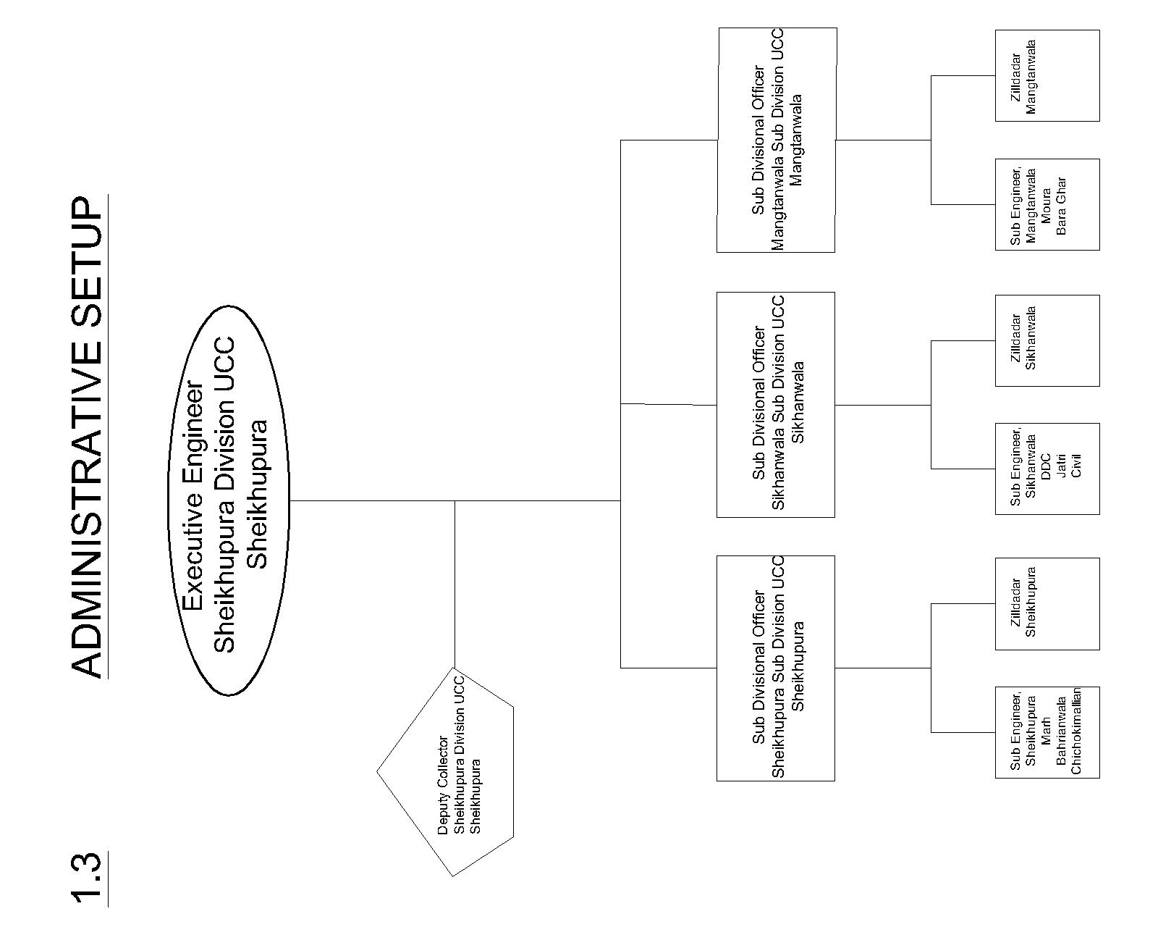

Executive Engineer,
Sheikhupura Division UCC,
Sheikhupura

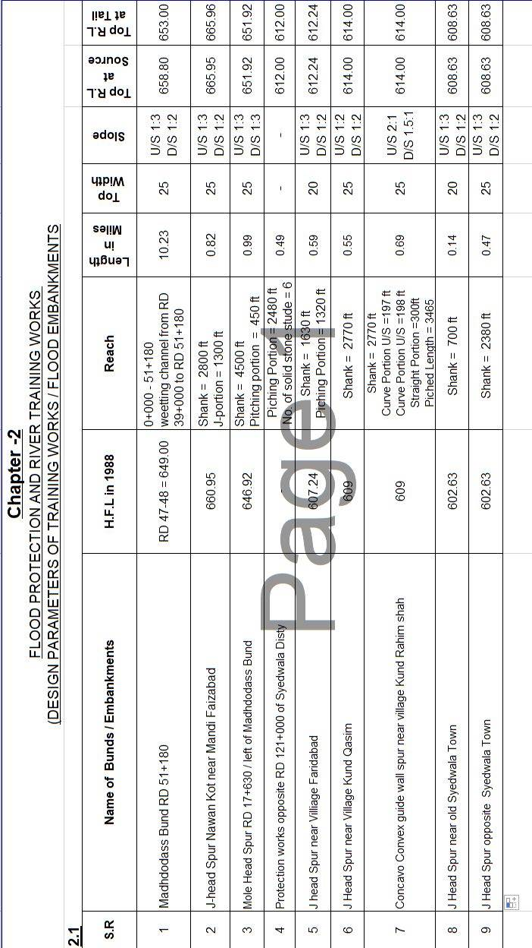

2.2 LOCATION MAP

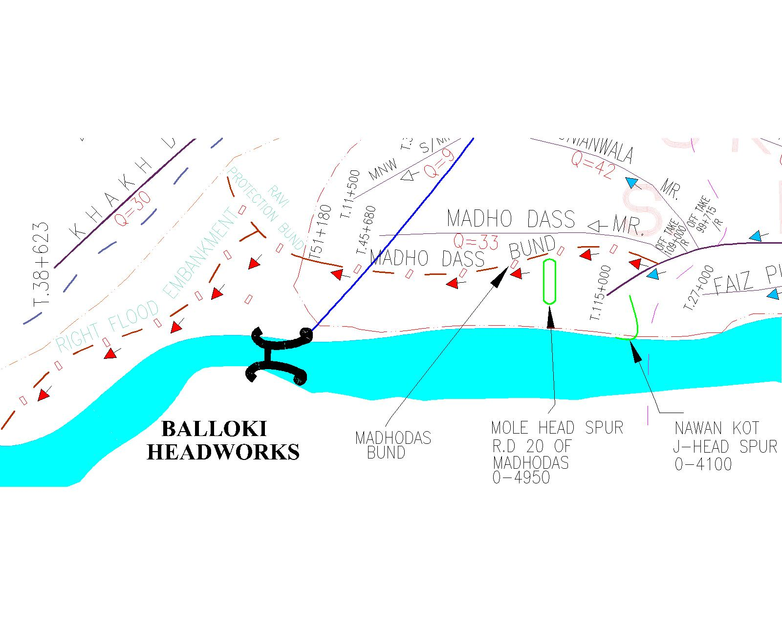
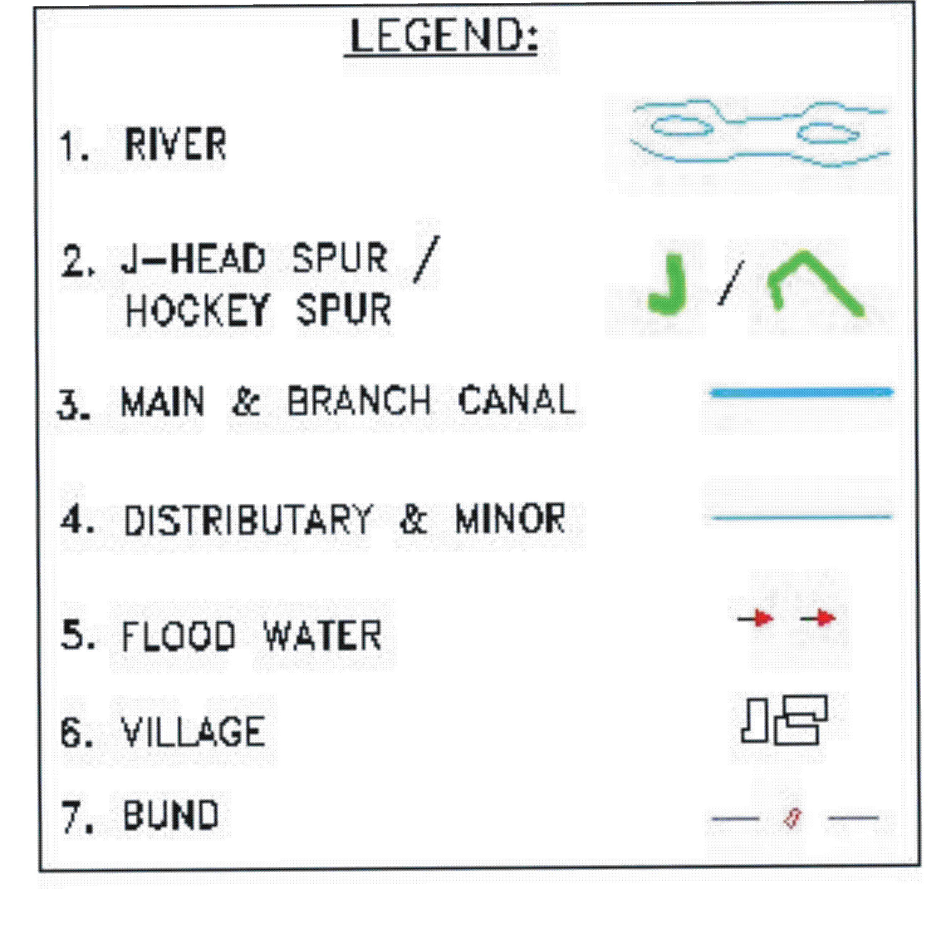
MADDODASS BUND, MOLE HEAD SPUR RD 17+630, J-HEAD SPUR NAWAN KOT

2.2 LOCATION MAP

J-HEAD SPUR FARIDABAD, J-HEAD SPUR KUND QASIM, CONCAVO-CONVEX GUIDE WALL, KUND RAHIM SHAH, J-HEAD SPUR SYEDWALA OLD, J-HEAD SPUR SYEDWALA NEW AND SIDE PROTECTION RD 121+000 SYEDWALA DISTY

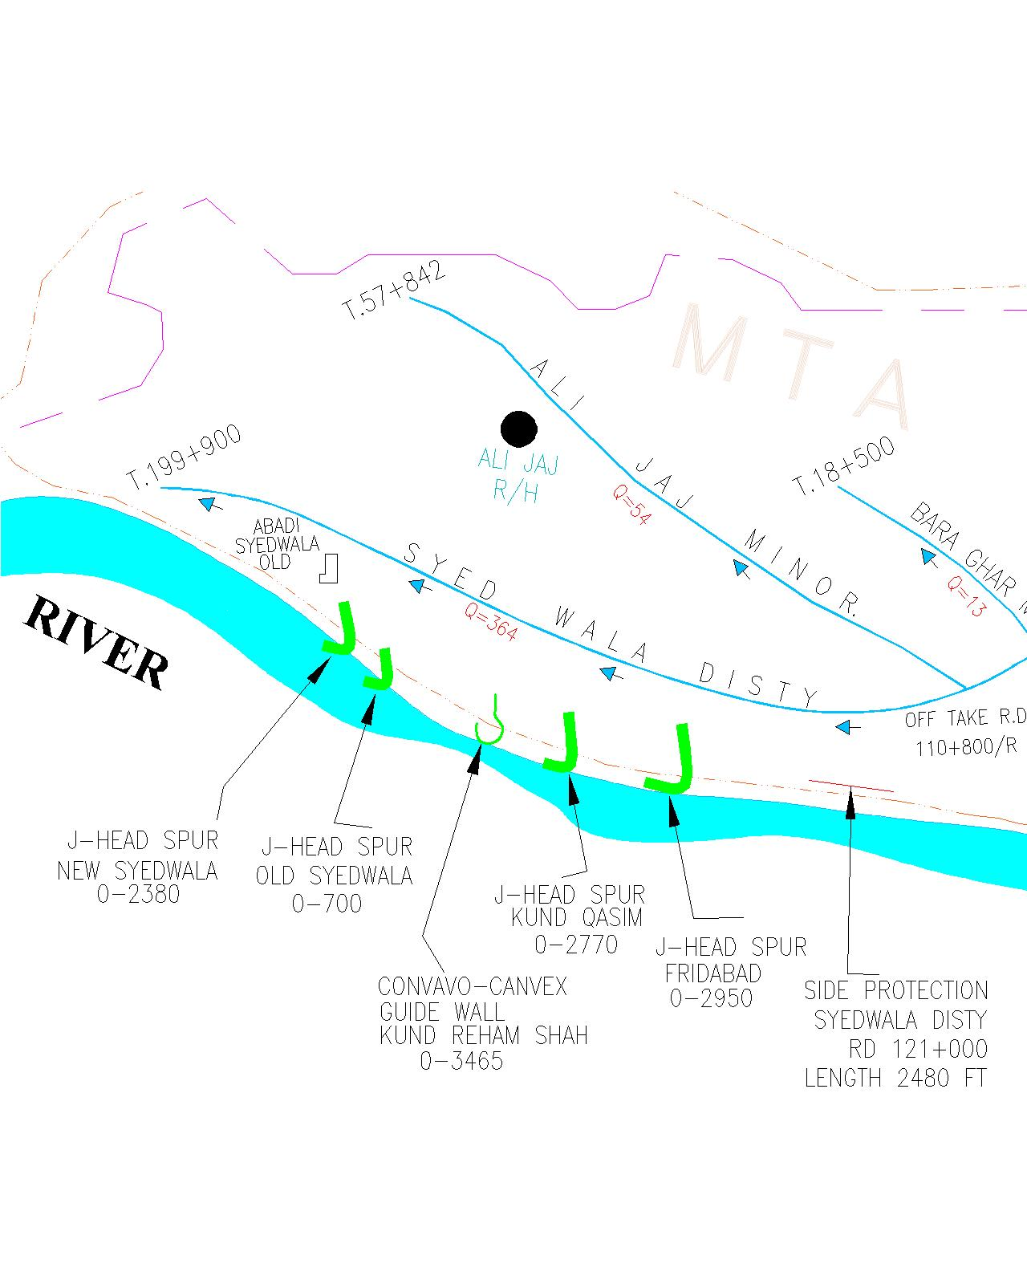

2.2 LOCATION MAP

MAIN LINE LOWER UCC RD 200+000 TO RD 283+100
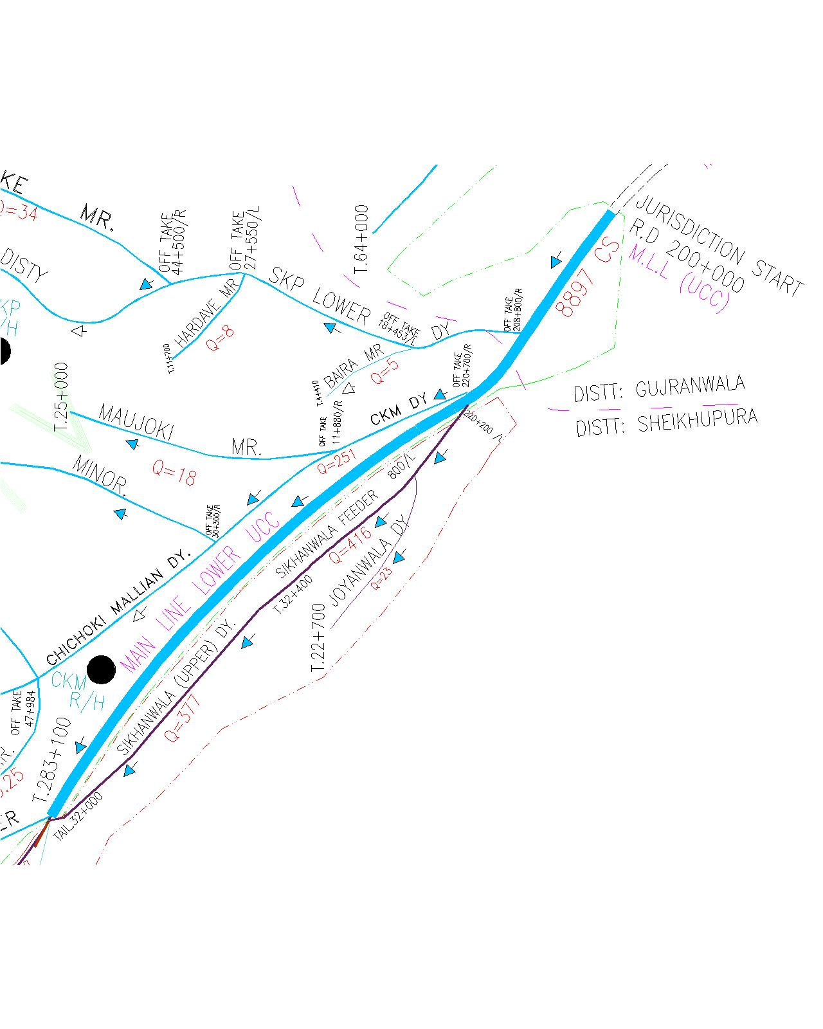

Executive Engineer,
Sheikhupura Division UCC,
Sheikhupura
Chapter - 3

BRIEF HISTORY OF PAST FLOOD EVENTS

In addition to the Irrigation network, Sheikhupura Division UCC is also responsible for the maintenance of River Training works along right side of Ravi River. Ravi River running parallel in the jurisdiction of this division is about 75 km length. Detail of Flood Embankments / River Training works is given in chapter.

Flood protection works were constructed by the Irrigation Department. During the Exceptional High Floods of 1988 & 1992, the entire river regime was changed and main River creek meandered towards right. Resultantly, it eroded wide spread fertile land and damaged near by villages. The inhabitants lost their houses and fertile lands. From the past flood behaviour and experiences, following River Training and Protection works were constructed along right bank of Ravi River in the jurisdiction of Sheikhupura Division UCC. Brief past flood history structure-wise is described below:-
- Madhodaas Bund:
The Madhodas bund is about 10 miles long and runs almost parallel to River Ravi at a varying distance of ½ to 1 mile from main creek along maddhodas minor. It starts from near village Ganeshpur and extends upto village Haftmadar and is tied up with the right flood embankments of balloki Headworks at RD 24. The design section of bund is as under:
Top width= 25’
Side Slope= 3:1 and 2:1 on river and country side.
This flood bund has been subjected to River action and breaches almost every high flood during the past years.. This bund has remained under direct hit of floods during the past years and breached at number of places during 1950, 1954, 1955, 1973, 1975 and 1976.
During 1988 the flood water spilling out on right side of River Ravi in lower reach, D/S of Deg Diversion channel bund was contained by Madodass bund. The flood water level was raising rapidly and a free board of bund against flood level was noted to be only 1'-2' at several places. As it has been experienced reach RD 37000 to 51180 (Old River Ravi protection bund) has remained vulnerable to breaches during super flood of 1988.
This flood bund plays a vital role for the safety of local infrastructure and important irrigation network e.g. Madhodas Minor, Munianwala Minor, Munianwala sub minor and local abadies. Due to super flood of 1988 this bund breached at 34 points and caused colossal damages to public and private properties. In anticipation of 2003 super flood during moon soon season 2023, a detail field survey of the said bund was done by field formation by Sikhanwala Sub Division and found the bund is in a deteriorated condition. Due to non-repairing of flood bund and no M&R work from past 6 years, huge Gharas and rain cuts were developed. The highest flood level of 1988 recorded is 655 at the source and 649.00 at the tail end. The top of bund along with other design parameters.
The flood season 2023 was in full swing and in order to cope with worst situation, it was inevitable to maintain the flood bund as per design parameters. Keeping in view the importance of bund and flood history, the worthy Chief Engineer Lahore and Superintending Engineer UCC inspected the Madhodaas Bund on 30-07-2023 and finalized the following proposal to raise the Flood Bund as per design parameters. The alignment of the bund has been proposed and shifted to river side slightly in reaches RD 39+000 to 51+180. The dowel of 6’ top has been provided at river side in reaches between RD 2+000 to 10+000 and 33+000 to 38+000, starting from edge of metal road with 2:1 slope, where metal road exists at site. The estimate was sanctioned by Competent Authority named as “Raising/Maintaining Design Parameters of Flood Structures as Per Flood Levels of 1988 on Maddhodas Flood Bund Rd:0+000 To 51+180”.
The 95 % work have been completed at site as per the provision of estimate in accordance with Approved L-section Design Parameters. Now presently the condition of Madhodaas bund is quite satisfactory to cope up for the flood season 2024.

J-HEAD SPUR NAWANKOT

The earthen shank was eroded on the D/S side due to generation of parallel flow in old River Creek during Flood 1999. Protection of slope was done with bamboo bushing, which proved successful. Construction of stud opposite village Chak Doger on left bank of Ravi River activated the old creek along earthen shank on D/S side during flood 2000 and further damaged the shank. Protection work was taken up under emergency and shank was protected. The creek on the D/S side was plugged at its mouth as per recommendations of the Expert Committee. Permanent solution of the problem is construction of Mole Head Spur along earthen shank, Prevailing scenario of site needs immediate implementation of proposal to protect thickly populated adjoining abadies of the villages and erosion of Agricultural Land. To fight against un-predictable River Morphology and aggression, the matter was referred to Irrigation Research Institute Lahore for carrying out model study and provision of permanent remedial measures to all Flood affected sites. A model study was conducted by IRI at Nandipur research station and construction of Mole Head spur was recommended for protection of Nawan Kot village and other infrastructure. The requisite estimate amounting to Rs 182.069 million has been sanctioned by the competent authority and work was awarded to the lowest bidder “Rana Traders”. The work is stopped due to land acquisition dispute. However, water level of river raised but no serious threat has been observed during flood season 2023.
J-HEAD SPUR KUND QASIM

The earthen shank of J-Head Spur Kund Qasim was eroded on the D/S side due to direct hit of Main creek of Ravi River during year 2005. This action was checked by providing stone studs and other flood fighting arrangements. Due to change in pattern of flow, both sides have become river sides The shank of this spur was badly damaged during flood 2012. This damaged shank had been repaired and protected by providing stone pitching during 2013-14.

CONCAVO - CONVEX GUIDE WALL SPUR AND TIE BUND KUND REHAM SHAH.

During flood 2007, Ravi River main creek started drifting towards the village abadi of Kund Reham Shah. It eroded considerable strip of Agricultural land. This erosion was very aggressive at low supply. For providing protection against this action, various proposals were discussed with higher ups along with Principal Research Officer of Irrigation Research Institute, Lahore (PRO of IRI). The expert committee paid visit at site and construction of concavo-convex guide wall spur at affected site was finalized. After observing codal formalities under Para 2.89 of PWD code, the work stand completed at site in 2007. In recent past, even at low supply during Flood in 2008 and 2009, D/S curved part of guide wall became under sever threat of flow currents and resulted damage to pitching and apron. This aggressive situation was reported to higher ups. The expert committee comprising, Principal Research Officer, IRI, Lahore, Superintending Engineers, Link and Upper Chenab Canal Circles, Executive Engineer, Chak Bandi and Sheikhupura Division UCC visited the site on 12-4-2009 for finalization / recommendation of the necessary protection measures to be adopted before the next flood season for protection of village abadies and flood works etc. As per expert committee recommendations / proposals, the estimates amounting to Rs. 2.548-Million- was sanctioned by the Chief Engineer, Irrigation Lahore Zone, Lahore. The work was got completed in June, 2010. During flood in 2010, River main creek again shifted its course and started hitting at tie bund between concavo- convex guide wall and Kund Qasim Spur and on D/S side of wall by developing swirling action. At low supply, this erosive action remained more aggressive. It caused serious damage on D/S of guide wall and school building.
- CONCAVO - CONVEX GUIDE WALL SPUR

- The damages were tackled through Flood Fighting etc by launching of Trees and making studs of Plastic and Gunny bags. District Administration, Nankana Sahib provided full co-operation and their help. Chief Engineer, Irrigation Lahore Zone, Lahore also paid visits to site and proposed remedial measures. The detail estimate for restoration was sanctioned by Chief Engineer, Irrigation Lahore Zone, Lahore. The work for restoration have been completed during 2011-2012.
- The guide wall of the Concavo-convex was rehabilitated in the year 2021 as per approved design parameters.
- During flood season 2023 apron of thsis structure has been damage in the length about 350 ft. The estimate for ‘’RESTORATION OF ERODED NOSE OF CONCAVE - O - CONVEX GUIDE WALL AT KUND REHAM SHAH ‘’ has been submitted for approval to S.E U.C.C.

- TIE BUND KUND REHIM SHAH.

Tie bund was constructed in the year 2007 to protect the village abadies of Kund Rehim Shah located at river edge in between J-head spur Kund Qasim and concave-e-convex Guide wall spur. During flood 2011 even at low supply at D/S Balloke Head works, River drifted its main threat towards tie bund and the bund between RD 0+450 to 1+300 washed away. It also eroded about 20 No. houses of village abadi of Kund Rehim Shah.
Keeping in view above narrated critical position the work namely “Restoration of Tie Bund and concave-o-Convex Guide wall at Kund Reham Shah damaged during flood 2011 at Ravi River” was taken up under Para 2.89 of the PWD code during the month October 2011 as recommended and proposed by the expert committee. This work has been executed. The tie bund was again damaged during 2012 near junction with J-Head spur Kund Qasim, which has been repaired during 2013-14. This tie bund further has been protected by providing stone pitching on entire river side slope.
F. J-HEAD SPUR SYEDWALA.
This spur was constructed for protection of Old Syedwala Town. Apron of the spur have been damaged due to direct hit of flow of River, due to construction of bridge at River downstream. This structure has been dismantled, length upto 1500ft and transferred to highway Department
The work “Construction of 3 No. solid stone studs in front old Syedwala Town was completed during financial year 2010-11 which has played well against the river action.

Chapter – 4
Design Data, Historic peak flood data and previous five years flood data of Head Works / Barrages and or other control points

4.1 FLOOD LIMITS

Ravi River enters into Pakistan territory near Kot Naina District Narowal. There are 5 important hydraulic structures in reach from Kot Naina to Sidhnai barrage. The flood limits at different flow conditions from low flood to exceptional high flood is detail below at different structures.

Sr No. | Category of Flood | Jassar Old Bridge  (in Cs) | Ravi Syphon at BRBD Link Canal  (in Cs) | Shahdara Railway Bridge  (in Cs) | Balloki Head Works  (in Cs) | Sidhnai Barrage  (in Cs)
1 | Low Flood | Upto 50000 | Upto 40000 | Upto 40000 | Upto 40000 | Upto 40000
2 | Medium Flood | 50000 to 75000 | 40000 to 65000 | 40000 to 65000 | 40000 to 65000 | 40000 to 65000
3 | High Flood | 75000 to 100000 | 65000 to 90000 | 65000 to 90000 | 65000 to 90000 | 65000 to 90000
4 | Very High Flood | 100000 to 150000 | 90000 to 135000 | 90000 to 135000 | 90000 to 135000 | 90000 to 135000
5 | Exceptionally High Flood | 200000& Above | 180000& Above | 180000& Above | 180000& Above | 180000& Above
6 | Critical Gauge R.L |  | 722.00 | 698.50 | 644.50 | 478.00
7 | Zero R.L of gauge | 775.5 | 688.0 | 676.30 | 616.00 | 437.00
8 | Designed capacity | 275000 | 400000 | 250000 | 225000 | 175000

4.2 TIME LAGS OF FLOODS

Sr. No | RAVI RIVER REACH | DISTANCE IN MILES | TIME LAG IN HOURS
1 | MADHUPUR TO JASSAR | 96 | 8
2 | JASSAR TO RAVI SYPHON | 73 | 18
3 | RAVI SYPHON TO SHAHDARABRIDGE | 24 | 8
4 | SHAHDARA TO BALLOKI HEAD WORKS | 63 | 24
5 | BALLOKI HEAD WORKS TO SIDHNAI HEAD WORKS | 198 | 78

  - HIGHEST FLOODS

Sr. No | Year | Discharge in Cs
Sr. No | Year | SHAHDARA BRIDGE | BALLOKE HEAD WORKS
1 | 21.09.1950 | 193000 | 243000
2 | 06.10.1955 | 527315 | 580324
3 | 11.08.1973 | 237380 | 291000
4 | 27.09.1988 | 326100 | 389000

Executive Engineer,
Sheikhupura Division UCC,
Sheikhupura

  - PEAK DISCHARGES

(Discharge in Cs.)
Maximum Recorded | Jassar | Ravi Syphon | Shahdara Railway Bridge | Balloki Head Works | Sidnahi Barrage
2017 | 37184 | 39853 | 36740 | 68145 | -
2018 | 66645 | 37936 | 37587 | 68030 | 24157
2019 | 28040 | 37936 | 37200 | 53200 | -
2020 | 11494 | 19124 | 19498 | 43450 | -
2021 | 19500 | 34531 | 38407 | 63250 | -
2022 | 48630 | 30553 | 29969 | 32435 | -
2023 | 49680 | 43103 | 38060 | 75070

Executive Engineer,
Sheikhupura Division UCC,
Sheikhupura

Chapter – 5

FLOOD FIGHTING STRATEGY

The pre flood inspection of flood protection and river training works of Sheikhupura Division UCC will be carried out by the Departmental, Inspection Team during March, 2024.
PROPOSED CAMPS TO FIGHT BACK ANY EVENTUALITY
The detail of camps to be established by Sheikhupura Division UCC along with SOP is discussed below
S.  NO | Description | Incharge of Camp | Location of Camp | Contact No:
1 | CAMP No. 1 | Muaaz Bashir Sub Divisional Officer Sikhanwala | J-Head Spur near Village Nawan Kot | 0305-6123892
2 | CAMP No. 2 | Muaaz Bashir Sub Divisional Officer Sikhanwala | MADDODAS BUND RD 43+500 | 0305-6123892
3 | CAMP No. 3 | Munawar Hussain (S.D.O)  MAGTANWALA | AT KUND REHAM SHAH SPUR | 0300-8313930
4 | CAMP No. 4 | Rauf Aslam (S.D.O)  SHEIKHUPURA | AT RD 220+000 MAIN LINE LOWER (UCC) | 0306-6393198

CAMP NO. 1
INCHARGE OF CAMP MUAAZ BASHIR
Sub Divisional Officer, Sikhanwala alongwith his Sub Engineers will be in-charge at camp no 1 at J-Head Spur near Village Nawan kot, Nankana Sahib. He will camp at said structure and will keep close liaison with his Executive Engineer and District Administration, Nankana sahib. He will keep up-dating about all flood activities, in his area of responsibility. He will fix the sub camps of his Sub Engineers according to need and necessity of the site. Probable sub camp of Sub Engineer shall be at following vulnerable sites;-

Detail of Sub – Camps
S. No | Description | Incharge of Sub – Camp | Location of Sub – Camp | Contact No. | Area of Responsibility
1 | Sub Camp  – 1 | Mr. Zaheer Qaiser Naz Sub Engineer DDC Section | J-Head spur Nawan Kot | 0301-4739476 | - J-Haed Spur Nawan Kot

This sub camp site can be changed by the Sub Divisional Officer, Incharge according to flood situation. Incharge Sub Divisional Officer shall be responsible to ensure all requisite flood fighting check all the material at flood camps in his charge and he will maintain a register of all vulnerable sites / points along with road maps, major villages/ towns and addresses of all notable from whose volunteers shall be available to him. Further, he will work out requirement of machinery according to critical points and shall ensure addresses of Govt departments with contact No. and kind of machinery available with them. Further, he will prepare list of excavator and tractors available in his area of charge with address and contact No. of locals, so as same may be called upon on urgency. He shall be responsible for prompt delivery of flood related activities at main flood camp established at Executive Engineer Sheikhupura Division UCC Office and higher ups of the Department as well as District Administration. He will also submit proposals for any change be observed in his area for best interest in Govt and public.

CAMP NO: 2
INCHARGE OF CAMP MUAAZ BASHIR

Sub Divisional Officer, Sikhanwala Sub Division UCC, alongwith his one Sub Engineers will be incharge of watching operation for Madhodass bund, Mole head spur,. He will camp at Madhadass bund RD 43+500. He will keep close liaison with Executive Engineer and District Administration, Nankana Sahib for updating them regarding flood situation in his area of control. He will further establish Sub Camps of his Sub Engineers at following vulnerable points:-
Sr. No. | Description | Incharge of Sub – Camp | Location of Sub – Camp | Contact No. | Area of Responsibility
1 | Sub Camp  – 1 | Sheikh Kashif Chichoki Mallian Section | Madhodaas Bund, Mole head spur RD 16+700 Madhodass Bund | 0321-4352557 | - RD 0+000 – 40+000 Madhodass bund and Mole Head Spur.
2 | Sub Camp  – 3 | Mr. Zaheer Qaiser Sub Engineer Sikhanwala Section | Madhodass Bund RD 47+000 | 0301-4739476 | RD 40+000 to 51+180 Madhodass bund

The camp sites can be liable to change by Sub Divisional Officer, Sikhanwala as deemed fit according to situation. He will further make arrangements as described in duties of in-charge of camp.

CAMP NO: 3
INCHARGE OF CAMP Mr. Rana Munawar Hussain
Sub Divisional Officer, Mangtanwala will camp at J-Head Spur Kund Reham Shah and will be responsible for the watching and protection of Canal System. Vulnerable sites like Kund Qasim and Kund Rahim Shah etc, especially the spurs at Faridabad and Syedwala Town shall also be watched by him. Sub Divisional Officer, Mangtanwala Sub Division will also be responsible for prompt communication of flood situation and substantial damages to all the concerned quarters. He will also keep liaison with Executive Engineer Sheikhupura and District Administration, Nankana Sahib. His 3 Sub Engineers, will be camping at following 3 Sub Camps:-
Sr. No. | Description | Incharge of Sub – Camp | Location of Sub – Camp | Contact No. | Area of Responsibility
1 | Sub Camp – 1 | Mr. Atta ullah  Sub Engineer Bara Ghar Section | RD 101+000 to 121+000 Syedwala disty | 0309-4245049 | - Syedwala Disty RD 101+000 to 199+900  - Mangutaru Minor RD: 0+000 to Tail
2 | Sub Camp – 2 | Ali Raza  Sub Engineer Moura Section | J-Head Spur Kund Qasim | 0311-7572357 | - J-Head spur Faridabad  - J-head spur Kund Qasim  - Concave-O-Convex guide wall Kund Reham Shah
3 | Sub Camp – 3 | Mian Younis  Sub Engineer MTA section | J-Head spur Syedwala (New) | 0305-5172069 | - J-head spur Syedwala (New)  - J-head spur Syedwala (Old)  - Syedwala Disty RD: 101+000 to 199+900 tail

CAMP NO: 4
INCHARGE OF CAMP Mr. Rauf Aslam
Sub Divisional Officer, Sheikhupura Sub Division will be incharge of watching MLL form RD 200+000 to 283+000 and Off-Takes of MLL Sheikhupura Sub Division. He will camp at RD 220+000 Joyanwala. He will keep close liaison with Executive Engineer, Sheikhupura Division UCC. He will also watch the canal communication system.
GENERAL
All the Sub Divisional Officers, will keep a close liaison with the Executive Engineer, Sheikhupura Division UCC. They being responsible for respective Jurisdiction will take proper action to cope with the alarming situation. They will arrange communication of flood position. The flood gauges will be regularly recorded under their direct supervision for which the gauge reader will be employed on work charge basis as per requirement. The Sub Engineer will shift their camps alongwith their establishment, keeping in view the supply of channels in their respective sections.

Executive Engineer,
Sheikhupura Division UCC,
Sheikhupura

Chapter – 6

Flood Damages Restoration Works

- Detail of works for which PC-1s have been approved and estimates have also been sanctioned. Works are under execution.

S.No | Name | Cost | Physical progress | Remarks
1 | Construction of Mole Head Spur for Protection of Nawan Kot Village and other Infrastructure | 182.069 (M) | 12% | Work stopped at site since 2016
2 | Maintaining Design Parameters of Flood Structures as per Flood level of 1988 of Madhodass Flood Bund Rd 0+000 to 51+180 | 129.490 | 95 % | Work in progress

Executive Engineer
Sheikhupura Division UCC
Sheikhupura.

Chapter – 7

Flood Fighting Watching Arrangement

7.1 Pre-Flood Arrangement

1. A flood control center will be established in canal telegraph office Sheikhupura and responsible staff will be available round the clock. One base high range wireless set be installed at canal Telegraph Office, Sheikhupura by the Police Department. 3 Nos. mobile Motorola sets of 30 kilometer range will be provided for installing in the vehicles of Executive Engineer, Sheikhupura Division UCC, Sub Divisional Officer, Sikhanwala and Sub Divisional Officer, Mangtanwala to keep them vigilant all the time.
Three Nos. Mobile wirelesses set (hand set) shall be provided under acute emergency during very high flood to be used at different vulnerable points.
These arrangements should be made well in time by the Telecommunication of Police Department.
- FLOOD WARNING SYSTEM

The flood warning gauges will be received from the following centers: -

- Maddho Pur (India)
- Jassar
- Ravi (Syphon)
- Shahdara
- Balloki Head Works

Police wireless control is responsible to collect these gauges 3 hourly in case of high flood and above and 6 hourly in case of low flood to medium flood. These gauges will be conveyed to Irrigation flood warning center at Sheikhupura Canal Office and will be supplied promptly to Executive Engineer, Sheikhupura.

LIST OF LOCAL CONTRACTORS FALLING IN BREACH AFFECTED AREA, HOLDING EARTH MOVING MACHINERY WHOSE SERVICES CAN BE AVAILED IN WAKE OF IMMEDIATE FLOOD EMERGENCY AND DETAIL OF STONE

Name of Govt. Contractor | Contact Number
Ch. Shafqat & Co | 0300-8424228
Muhammad Arif Associates | 0321-7991892
Ch: Muhammad Bashir | 0300-7432434
Azeem Akbar | 0306-4740173

Detail of Stone

S# | Name of structure | Sanctioned Limit (Lac) | Available Qty | Balance / Deficient | Remarks
1 | Mole Head Spur RD 20+000 of MDD Bund | 1.0 | 0.267 | 0.733
2 | J-Head spur Nawan Kot | 1.20 | 0.354 | 0.846
3 | J-Head spur Old Syedwala | 0.50 | - | 0.50
4 | J-Head spur Syedwala Town | 1.0 | - | 1.0
5 | J-Head spur Kund Qasim | 1.0 | - | 1.0
6 | J-Head spur Faridabad | 1.0 | - | 1.0
Watching Arrangements
During rainy / monsoon season, the organization of Sheikhupura Division UCC has to be very vigilant throughout the monsoon season. Staff of the Division will be set on alert during day and night from 15th June to 15th September. Consequently, flood / watching camps will be established at vulnerable points.ve Engineer,
Sheikhupura Division UCC,
  - WATCHING ESTABLISHMENT
Flood watching establishment will be employed as per limit of floods already fixed for various Magnitude of discharge in the river from 16-06-2023 to 30-09-2023 as per following:-
A MADHODASS BUND

1. RD 0-29200 (Q.B. Link) 2 Nos. per mile during day & night (Per shift
i.e. for 8 hours)

2. RD 31+800-51+180 4 Nos. per mile day & night per shift (This
Part of the bund is under the direct hit of floods & breaches at a No. of places during previous floods.

Normal reach RD: 0-29+200 (Q.B. Link) = 5.84 Miles
Dangerous reach RD: 31+800-51+180 = 4.0 Miles
Establishment required for 3 shifts (during flood)
Normal reach = 5.84x2x3 = 35 Nos.
Dangerous reach = 4x4x3 = 48 Nos.
TOTAL = 83 No.

3. Mate required = One for 8 beldar
83/8 = 10 Nos.
4 Gauge Reader = One No. for per shift
Gauge site = 3 Nos.
Gauge Reader required 3x3 = 9 Nos.
5 Dak Runner One No per shift
Camp site 9 Nos.
Dak Runner required = 27 Nos.
6 Chowkidars One No. per site for day & one for night
Chowkidars required 2x9 = 18 Nos.

7 Watching Establishment for spurs will be arranged at the following scale.

Period Flood range | Nawan Kot J-Head spur |  | Mole spur at RD 20 of MD Bund |  | J-Head spur at Faridabad |  | J-Head spur at Syedwala |  | RD 121 Syedwala Disty |  | Kund Qasim & Kund Reham Shah
Period Flood range | Stg: | Shift | Stg: | Shift | Stg: | Shift | Stg: | Shift | Stg: | Shift | Stg: | Shift
Low flood | 3 | 3 | 3 | 3 | 6 | 3 | 6 | 3 | 3 | 3 | 6 | 3
Medium flood | 4 | 3 | 4 | 4 | 6 | 3 |  | 3 | 4 | 3 | 6 | 3
High flood | 6 | 3 | 6 | 3 | 8 | 3 | 8 | 3 | 6 | 3 | 8 | 3
Very high flood | 8 | 3 | 8 | 3 | 12 | 3 | 12 | 3 | 8 | 3 | 12 | 3
Exceptional high flood | 12 | 3 | 12 | 3 | 16 | 3 | 16 | 3 | 12 | 3 | 16 | 3

Executive Engineer,
Sheikhupura Division UCC
Sheikhupura.

  - ARRANGEMENT AT SENSITIVE SITES

- The normal strength for watching at sensitive sites along flood protection and River training works will be doubled during high flood / exceptionally high flood.
(ii) The establishment can be increased after consultation with Executive Engineer, Sheikhupura Division UCC / Superintending Engineer, Upper Chenab Canal Circle, Lahore in emergency & in accordance with site requirements.

The same establishment will be responsible for maintenance of flood bunds and Spurs Shank etc during flood season. It will arrange minor repairs to bank top, side slopes, removal of Sarkanda etc on shanks and on pitched part of spurs. Establishment will also be responsible for filling gharas / rain cuts etc as occurred due to rains during the monsoon season

Executive Engineer,
Sheikhupura Division UCC,
Sheikhupura.

  - Watching Material

ENGINEERING / EMERGENCY STORES WILL BE STOCKED AT EACH CAMP AS UNDER.

Sr. No | Item | Required Qty
1 | Kassies with handles | 20 Nos.
2 | Baskets | 50 Nos.
3 | Gunny Bage | 1000 Nos.
4 | Torches three cells | 5 Nos.
5 | Lanterns | 12 Nos.
6 | Wick for lanterns | 4 Nos.
7 | Sutli | 5 Kg.
8 | Axes | 5 Nos.
9 | Killas | 150 Nos.
10 | Wodden Ballies | 10 Nos.
11 | Partroman Lamps | 4 Nos.
12 | Briefing Board | 1 No
13 | Needles | 1 Dozen
14 | Spirit | 1 No.
15 | Kerosene oil | 46 Liters.
16 | Stone | 50000 Cft
17 | Shouldari | 1 No.
18 | Handles for Kassies (Extra) | 15 Nos.
19 | G.I. Buckets | 6 Nos.
20 | Tents | 2 Nos.
21 | Bamboos | 500 Nos.
22 | Iron Charpies | 4 Nos.
23 | Plastic Chairs | 6 Nos.
24 | Table | 1 No.
25 | Generator | 1 No.
26 | Plastic Bags (1.25 – 1.5) Capacity | 3000 No
27 | Petrol for generator | 50 Liters

Executive Engineer,
Sheikhupura Division UCC,
Sheikhupura.
  - Arrangement for Sounding and Probing

In case of any situation on flood protection and River training works, sounding and probing arrangement will be made.

  - Lighting Arrangement

Details given in the list of watching material at Sr. No 7.4 above.

  - P.O.L arrangement for Vehicle

P.O.L facilities / arrangement will be made by the Irrigation Department for their vehicles.

  - Transportation

Transportation facilities will be provided by the Civil Authorities

  - Law and order

Law and order situation will be tackled by the Civil Administration with the help of Police Department.

  - Medical arrangement for Labour

Health Department should be responsible for mobilizing their sources for carrying out necessary operation for providing medical facilities to the labour.

  - Liaison with other Department

All the flood protection and river training works are required to be inspected during the month of May so as to identify weak points and if necessary after repairing such sites, the certificate regarding hydraulic fitness of bunds is to be submitted. The Flood embankments are inspected by a Committee constituted by the Secretary Irrigation Department in May every year. Fitness of bunds is ensured before the flood season, keeping in view the priorities are fixed according to resources.

The Executive Engineer, Sheikhupura Division UCC, Sheikhupura to perform following functions within his administrative jurisdiction: -
- Joint inspection of Flood protection infrastructure with District Administration.

- Collection and sharing of information on discharge of water in Ravi as well as Nullah, with the Military Authorities as well as District Administration on daily basis.

- Collection of information on discharge of water, from monitoring check points on Nulah as well as control centre at Jassar, Shahdara & Balloki.

- Improvement of existing instruction / gauges used for determination of water discharge (Cs) in Ravi and Nullahs.

- Development of more effective early warning system.

Liaison with flood forecasting centre Lahore, for collection of flood related information.

- Initiation of criminal proceeding against elements involved in will full breach in flood protection arrangements on any canal, with consent of competent authority.

  - Role of the Army

173-Engineer Regiment Lahore will perform activities to fight flood emergency during flood season.

  - Duties of Telephone Attendant

The duties of telephone attendant for appraising the Department / Civil Administration about the flood situation during the rain / flood season i.e. 16 June to 15 September.

  - Wireless Arrangements

Wireless system / arrangement will be made for the vehicles under use of Officers of Sheikhupura Division UCC during the period of 16 June to 15 September.

Executive Engineer,
Sheikhupura Division UCC,
Sheikhupura.

CHAPTER-8

Detail of Encroachment

There is no encroachment on flood protection works and river training works in the jurisdiction of Sheikhupura Division UCC Sheikhupura which may hinder the transportation during any flood emergency.

Total No. of Encroachment | Removed | Balance | Action to be Taken
Nil | - | - | -

Executive Engineer,
Sheikhupura Division UCC,
Sheikhupura.

Chapter-9

Duty Roster / Flood fighting Program

1-Duty Roster for main Flood control center Telegraph office at Sheikhupura.

S# | Shift | Duty staff | Time
1 | General shift | Rana Iqbal Head Signaler | 8.0 AM to 3.0 PM
2 | Shift No. 1 | Zahid Iqbal Signaler | 3.0PM to 10.0 PM
3 | Shift No. 2 | Zulifqar Ahmed Signaler | 10.0PM to 8.0 AM

Staff of Sheikhupura Division UCC Sheikhupura, looking after flood protection/ River training works and canal network falling in the jurisdiction of Sheikhupura Division UCC, has to be very vigilant throughout the monsoon season and set on alert during day and night from 16 June up to 15 September. Since the flood watching camps are to be established with the onset of monsoon season at vulnerable points with adequate materials and arrangements to cope with any flood/rain emergency. The concerned Sub Divisional officers are responsible for reporting about any mishaps to the Executive Engineer, Superintending Engineer, Chief Engineer and Secretary Irrigation and Power. It is also the duty of Sub Divisional officer to deliver written messages well in time, to the District Administration concerned about the flood/ weather forecast, flood situation and any other mishaps.

S.NO | Description | Incharge of Camp | Location of Camp | Contact No:
1 | CAMP No. 1 | Muaaz Bashir Sub Divisional Officer Sikhanwala | J-Head Spur near Village Nawan Kot | 0305-6123892
2 | CAMP No. 2 | MR. Muaaz Bashir (S.D.O)  SIKHANWALA | MADDODAS BUND RD 43+500 | 0305-6123892
3 | CAMP No. 3 | Munawar Hussain  (S.D.O)  MAGTANWALA | AT KUND REHAM SHAH SPUR | 0300-8313930
4 | CAMP No. 4 | MR. Rauf Aslam  (S.D.O) Sheikhupura | AT RD: 220+000 MAIN LINE LOWER (UCC) | 0306-6393198

Additional daily labour will be employed as and when necessary according to requirement. Sub Engineers will assist the Sub Divisional Officers at their area of responsibility mentioned above.
An additional strength of nearly 300 voluntary labour is required to be made available by the concerned assistant Commissioner in case of emergency on each bund / river training works.
These labours will be arranged from adjoining cities, town, villages & abadies. One Assistant Sub Inspector of Police with four Constables are required to be made available for arranging voluntary labours on above mentioned sites and to assist in watching operation as and when required. Sub Divisional Officers Sheikhupura, Sikhanwala, & Mangtanwala will maintain close liaison with Civil Administration District Sheikhupura & Nankana Sahib and keep them informed about the rain / flood position on bunds / spurs and channels and ask them for voluntary labour as and when required. They will also make arrangement for the stores required at comp sites.
Sub Divisional Officer, will also inform the Civil Administration for any flood / rain emergency and damages. Civil administration and revenue field staff will be required for facilitating evacuation of the area likely to be submerged due to spillage of River Ravi.
Similarly, health and live stock and Dairy Development Department will also mobilize their resources for carrying out necessary operation for the health hazard likely to be created by the rains / flood for human and live stock. Food Department will be responsible to cater for food requirement of flood / rain affected people. Police and Revenue staff will coordinate the staff of Sheikhupura Division UCC, for the purpose of timely evacuation of the public.
Communication & Works Department (Highways Division Sheikhupura & Nankana Sahib) will also be required to control over the bridges and other road network well before the set of monsoon season to provide free without interruption, speedy disposal of storm / flood eater.
WAPDA staff will also be required to be very vigilant in case of floods / rains to take care against accidents and break downs in the affected areas.
Agriculture will be responsible to provide dozers and other heavy Machinery.

Executive Engineer
Sheikhupura Division UCC
Sheikhupura

Chapter – 10
Emergency Telephone Nos.

S.No: | NAME OFOFFICER/OFFICE |  | OFFICE | RESIDENCE
DISTRICT GOVERNMENT SHEIKHUPURA
1 | District Coordination Officer, Sheikhupura |  | 056-9200150-51 | 056-9200153
2 | District Police Officer, Sheikhupura |  | 056-9200104 | 056-9200105
3 | D.D.O. Assistant Commissioner Ferozwala |  | 042-7930777
4 | D.D.O. Sheikhupura |  | 056-9200165 | 0333-5218940
5 | ADC Sheikhupura |  | 056-9200163 | 056-9200189
6 | District Head Quarter Hospital, Sheikhupura |  | 056-9200234
7 | Medical Superintendent, DHQ Sheikhupura |  | 056-9200231
8 | Executive Engineer, Public Health Sheikhupura |  | 056-3793938 | 0300-8405538
9 | Executive Engineer, Highway Sheikhupura |  | 056-9200058 | 056-9200192
10 | Executive Engineer, Wapda Sheikhupura |  | 056-9200244
11 | Executive Engineer, Building Sheikhupura |  | 056-9200061
12 | Sub Divisional Officer, Sikhanwala (Flood Officer) |  | 0305-6123892
13 | Wireless Control, Sheikhupura |  | 056-9200110 | 15
DISTRICT GOVERNMENT NANKANA SAHIB

14 | District Coordination Officer, Nankana Sahib |  | 056-2877117 | 056-9201011
15 | District Police Officer, Nankana Sahib |  | 056-2877101
16 | D.O. (Rev)Nankana Sahib |  | 056-2875582
17 | D.D.O. (Rev)Nankana Sahib |  | 056-2877849
18 | District Head Quarter Hospital, Nankana Sahib |  | 056-2876110
21 | Medical Superintendent, DHQ Nankana Sahib |  | 056-2875110
23 | Wireless Control, Nankana Sahib |  | 056-2877114
24 | Executive Engineer, Public Health Nankana Sahib |  | 056-2876747
25 | Executive Engineer, Wapda Nankana Sahib |  | 056-3023507
26 | Executive Engineer, Building Nankana Sahib |  | 056-2877022
IRRIGATION DEPARTMENT

27 | Secretary Irrigation Department | 042-99212117-18  Fax No.042-99212116 |  | 042-99200954
28 | Director Flood / Secretary Flood Commission Lahore | 042-99231614 |  | 042-36653943
29 | Chief Engineer, Irrigation Lahore Zone, Lahore | 042-99212085-86  Fax No.042-99212084 |  | 042-35182339
30 | Chief Engineer, D & F Zone, Lahore | 042-99230602 |  | 0300-4877257
30 | Chief Engineer, D & F Zone, Lahore | Fax_042-35862081 |  | 0300-4877257
31 | Superintending Engineer, Upper Chenab Canal Circle, Lahore | 042-99250333
32 | Executive Engineer, Sheikhupura Division, UCC | 056-9200253 |  | 056-9200252
33 | Flood Warning Centre, Irrigation Deptt; Sheikhupura | 056-9200252
34 | Flood warning centre, Lahore | 042-7572091
35 | Sub Divisional Officer, Sikhanwala Sub Division, UCC | 0305-6123892 |  | 0305-6123892
36 | Sub Divisional Officer, Mangtanwala Sub Division, UCC | 0300-8313930 |  | 0300-8313930
37 | Sub Divisional Officer, Sheikhupura Sub Division, UCC | 0306-6393198 |  | 0306-6393198

Executive Engineer
Sheikhupura Division UCC
Sheikhupura
Chapter – 11
Standard operating procedure (SOP) for breaching sections.

11.1 HISTORY OF THE BREACHING SECTION

The reach of Madhodass bund, as it has been experienced from RD 32+000 to RD 51+180 (Old Ravi River Protection Bund) has remained vulnerable to breaching during supper flood in 1988. Breaching section has been approved by the Federal Flood Commission at RD 47+500 of Madhodass Bund.
STRATEGY FOR ACTIVATION
The activation of breaching section is, however, under the charge of Executive Engineer Balloki Head Works. They will operate breaching section in acute emergency after consultation with Military and Civil Authorities in addition to concerned Chief Engineer of Irrigation Department.

11.2 Location, Design, Quantity and Variety of the explosive required for detonation.

Not Related to Sheikhupura Division UCC.

11.3 Arrangement of Explosives and security o explosive stores.

Not Related to Sheikhupura Division UCC.

11.4 List of security staff alongwith detail of their training etc.

Not Related to Sheikhupura Division UCC.

11.5 Detail of Mechanical means as a stand by arrangement in case of detonation failure.

Not Related to Sheikhupura Division UCC.

11.6 Duty Roster in case of critical situation.

Not Related to Sheikhupura Division UCC.

11.7 Breaching committee with their action plan.

Not Related to Sheikhupura Division UCC.
11.8 List of the village likely to be inundated in case of breach.

There is only one breaching section at RD: 47+500 of Madhodass Bund. It is maintained and operated by Balloki Headworks Division. However, in case of operation of breaching section under emergency. The following main villages shall be affected: -
“Qila Omar Singh, Basadarpur, Kotosinghwala, Pinjnawala, Karrianwala, Haftmadar, Khakh, Chandpur, Masoo, Dodhian, Goraya”.

11.9 Announcement and detail of evacuation arrangements.

Not Related to Sheikhupura Division UCC.

11.10 Details of coordination with Civil / Army Authorities.

Not Related to Sheikhupura Division UCC.

11.11 Parallel Communication arrangements.

Not Related to Sheikhupura Division UCC.

11.12 Index Plan

Index plan of the Sheikhupura Division UCC is attached.

Superintending Engineer,
Upper Chenab Canal Circle,
Lahore
Superintending Engineer,
Upper Chenab Canal Circle,
Lahore
Executive Engineer
Sheikhupura Division UCC
Sheikhupura.

Chief Engineer
Irrigation Lahore Zone,
Lahore

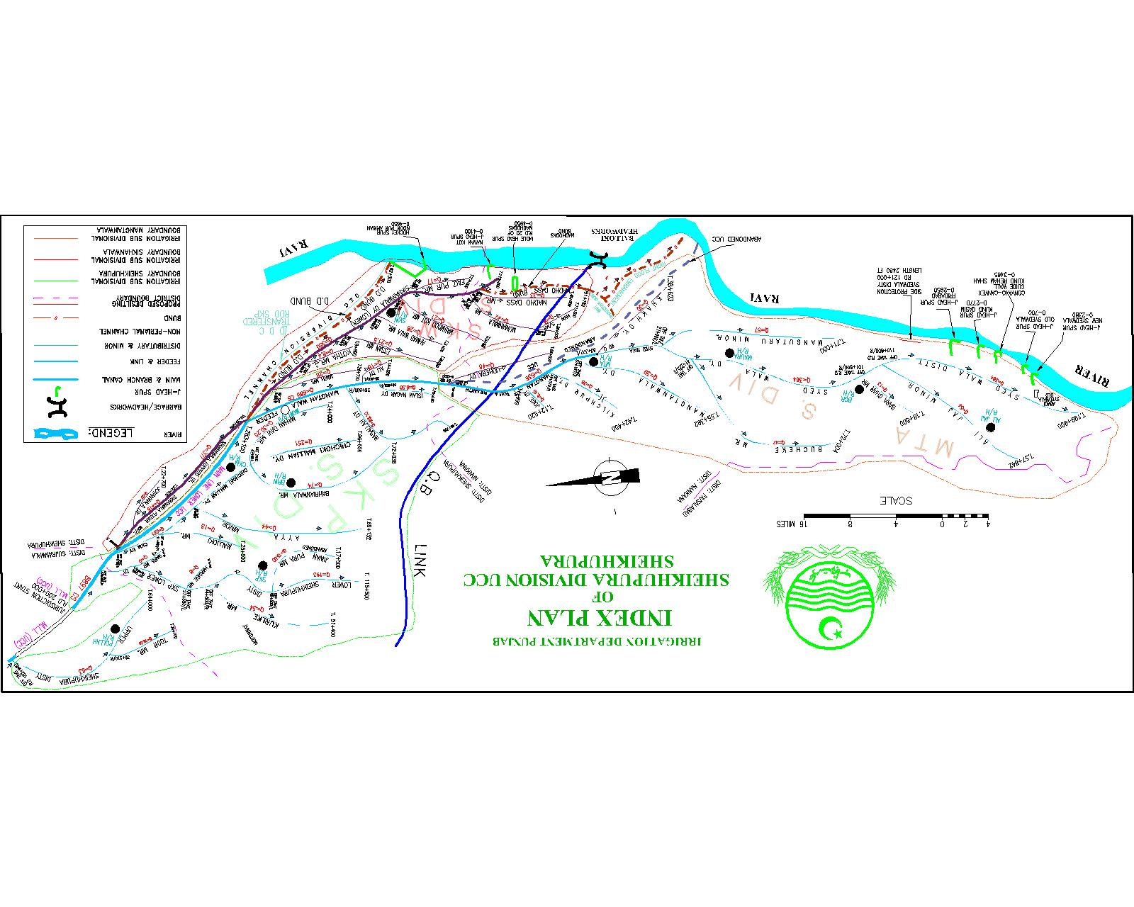

PART – B
Chapter – 12
Vulnerable sites on flood bund/ structures

12.1 Apprehended breaches in flood bunds / structures
Detail given as under:-

- Maddhodass Bund reaches from RD 37+000to RD 40+000.

- Maddhodass Bund reaches from RD 47+000 to RD 51+180.

- J-Head Spur at village Kund Qasim

- Concavo – convex guide wall with Tie bund Kund Reham Shah

12.2 Operation of Breaching Section

Breaching section exist in UCC Division at RD 47000 to 48+000 of Madho Dass bund but Balloki Division control / operate this Breaching section

12.3 Breaches due to rising of flood water, deterioration of flood bunds
etc.

Not relates.

Executive Engineer
Sheikhupura Division UCC
Sheikhupura.

Chapter – 13

EMERGENCY CONTINGENCY / PLAN FOR VULNERABLE SITE (SITES) LISTED ABOVEEMERGENCY CONTINGENCY PLAN FOR SITE NO. 1

13.1 Maddhodass Bund reach from RD 37+000 to RD 40+000.

During super flood in 1988 the spill of Maddhodass Bund was breached in between RD 37+000 to 40+000 due to which the Irrigation and Road Network was damaged. The Abadi of adjoining Villages was also affected and the area was in undated.

13.1.1 Detail of village abadies likely to be affected and this should also
be shown on the plan.
Sr# | Name of Village | Abadies | Tehsil
1 | Kotosinghwala | 4100 Persons | Nankana Sahib
2 | Ghangapur | 4960 Persons | Nankana Sahib
3 | Pinjanawala | 2500 Persons | Nankana Sahib
4 | Karianwala | 2764 Persons | Nankana Sahib
5 | Rati Tibi | 1646 Persons | Nankana Sahib
6 | Kila Main singh | 2865 Persons | Nankana Sahib
7 | Biharipur | 4230 Persons | Nankana Sahib

13.1.2 Strategy and action taken be explained in detail
The main Flood camp will be established at RD 43+500 Maddhodass Bund under the supervision of Sub Divisional Officer, Sikhanwala Sub Division.
Sub Camp will be established at RD 0+000 TO 30+000 under the charge of Sub Engineer, CKM Section for monitoring the flood situation and to make the protective measures against the flood. Similarly, sub camp No 2 will be established at RD 37+000 under the charge of sub engineer DDC Section. Third sub camp will be established by Sub Engineer SKW section at RD 47+000 of Madhodaas bund and will be responsible to look after the entire reach between RD 40+000 to 51+180.
13.1.3 Arrangements
To control over critical situation if arises during flood 2024, all arrangements as providing flood fighting material, watching establishment shall be made available from available resources.

13.1.4 Establishment of flood fighting camps
Flood watching establishment will be employed as per limit of floods already fixed for various Magnitude of discharge in the river from 16-06-2024 to 30-09-2024 as already mentioned in chapter 7 section 7.2.

13.1.5 Duties of officer / Officials and Detail of sub – Camp

Sr. No | Description | In-charge of Sub-Camp | Location of Sub- Camp | Contact No. | Area of Responsibility
1 | Sub Camp | Mr Zaheer Qaisar Sub Engineer DDC Section along with watching establishment. | Maddodass Minor RD 37000 | 0301-4739476 | RD 31+000 to 40+000 Maddodass Bund

Duties
- Sub Divisional Officer
Sub Divisional Officer, will keep close liaison with the Executive Engineer, Sheikhupura and District Administration Sheikhupura. He will keep updating about the flood activities in his area of responsibility. He will be responsible to communicate the gauges as well as other data regarding flood to higher ups. He will also be responsible to arrange the fighting through available recourse against flood.
- Sub Engineer
Sub Engineer will assist Sub Divisional Officer and will remain present at Camp round the clock. He will also supervise the River Training work by watching establishment, and taking remedial measures in the area of responsibility.
13.1.6 Departmental machinery available.
Not Available.
13.1.7 Machinery available from private source.
Machinery will be arranged if required form private source.
13.1.8 Flood Fighting Material required
To control over critical situation if arises during flood in 2024, following material will be available at main camp. The material required during emergency at reach of sub camp shall be arranged from the main camp.

13.1.9 Flood Fighting available
Sr. No | Item | Required Qty | Available Qty | Balance | Remarks
1 | Kassies with handles | 20 Nos. | - | 20 | Balance required Material Will be purchased as per actual requirements
2 | Baskets | 50 Nos. | - | 50
3 | Gunny Bage | 1000 Nos. | - | 1000
4 | Torches three cells | 5 Nos. | 04 | 01
5 | Lanterns | 12 Nos. | - | 12
6 | Wick for lanterns | 4 Nos. | - | 04
7 | Sutli | 5 Kg. | - | 05
8 | Axes | 5 Nos. | - | 05
9 | Killas | 150 Nos. | - | 150
10 | Wodden Ballies | 10 Nos. | - | 10
11 | Partroman Lamps | 4 Nos. | - | 04
12 | Briefing Board | 1 No | 01 | -
13 | Needles | 1 Dozen | - | 01
14 | Spirit | 1 No. | - | -
15 | Kerosene oil | 46 Liters. | - | 46
16 | Stone | 50000 Cft | - | 50000
17 | Shouldari | 1 No. | 01 | -
18 | Handles for Kassies (Extra) | 15 Nos. | - | 15
19 | G.I. Buckets | 6 Nos. | - | 06
20 | Tents | 2 Nos. | 01 | 01
21 | Bamboos | 500 Nos. | - | 500
22 | Iron Charpies | 4 Nos. | - | 04
23 | Plastic Chairs | 6 Nos. | 06 | -
24 | Table | 1 No. | 01 | -
25 | Generator | 1 No. | - | 1 No
26 | Plastic Bags (1.25 – 1.5) Capacity | 3000 No | 1000 | 2000
27 | Petrol for generator | 50 Liters | - | -

13.1.10 Detail of other infrastructure like Electric, Sui Gas, Telephone installations, Road network, other Buildings, Canals and Drainage network.
On breaching of River Training / Flood Protection Works in the reach of Sub camp No. 3 the following Irrigation and roads networks shall be affected.
- Main Irrigation Net work
- Khakh disty
- Mangutaru minor
- Syedwala Disty
- Madhodass Minor
- Main Road Network

- Mandi Faizabad – Sheikhupura Road
- Lahore – Jahranwala Raod

Executive Engineer
Sheikhupura Division UCC
Sheikhupura

EMERGENCY CONTINGENCY PLAN FOR SITE NO. 02

13.2 Maddhodass Bund reach from RD 47+000 to RD 51+180.

During super flood in 1988 the spill of Maddhodass Bund was breached in between RD 48+000 to 49+000 due to which the Irrigation and Road Network was damaged. The Abadi of adjoining Villages was also affected and the area was in undated.
13.2.1 Detail of village abadies likely to be affected and this should also
be shown on the plan.

Sr# | Name of Village | Abadies | Tehsil
1 | Basdhirpur | 4960 Persons | Nankana Sahib
2 | Haftmaddar | 2180 Persons | Nankana Sahib
3 | Khakh | 1400 Persons | Nankana Sahib
4 | Wazirpur | 1670 Persons | Nankana Sahib
5 | Gangapur | 1350 Persons | Nankana Sahib

13.2.2 Strategy and action taken be explained in detail
The main Flood camp will be established at RD 43+500 Maddhodass Bund under the supervision of Sub Divisional Officer, Sikhanwala Sub Division. Similarly, sub camp No 2 will be established at RD 37+000 under the charge of sub engineer DDC Section. Third sub camp will be establish by Sub Engineer SKW section at RD 47+000 of Madhodaas bund and will be responsible to look after the entire reach between RD 40+000 to 51+180.
13.3.1 Arrangements
To control over critical situation if arises during flood 2024, all arrangements as providing flood fighting material, watching establishment shall be made available from available resources.
13.2.3 Establishment of flood fighting camps
Flood watching establishment will be employed as per limit of floods already fixed for various Magnitude of discharge in the river from 16-06-2024 to 30-09-2024 as already mentioned in chapter 7 section 7.2.

13.2.4 Duties of officer / Officials and

Detail of sub – Camp.
Sr. No | Description | In-charge of Sub-Camp | Location of Sub- Camp | Contact No. | Area of Responsibility
1 | Sub Camp | Mr Zaheer Qaisar Sub Engineer SKW Section along with watching establishment. | Maddodass Minor RD 47000 | 0301-4739476 | RD 40+000 to 51+180 Maddodass Bund

Duties

- Sub Divisional Officer
Sub Divisional Officer, will keep close liaison with the Executive Engineer, Sheikhupura and District Administration Sheikhupura. He will keep updating about the flood activities in his area of responsibility. He will be responsible to communicate the gauges as well as other data regarding flood to higher ups. He will also be responsible to arrange the fighting through available recourse against flood.
- Sub Engineer.
Sub Engineer will assist Sub Divisional Officer and he will remain present at camp round the clock. He will also supervise the River Training work by watching establishment, and taking remedial measures in the area of responsibility.
13.2.5 Departmental machinery (available)
Not Available.
13.2.6 Machinery available from private source.
Machinery will be arranged if required from private source.
13.2.7 Flood Fighting Material (required)
To control over critical situation if arises during flood 2023, following material will be available at main camp. The material required during emergency at reach of sub camp shall be arranged from the main camp.

13.2.8 Flood Fighting available
Sr. No | Item | Required Qty | Available Qty | Balance | Remarks
1 | Kassies with handles | 20 Nos. | - | 20 | Balance required Material Will be purchased as per actual requirements
2 | Baskets | 50 Nos. |  | 30
3 | Gunny Bage | 1000 Nos. |  | 1000
4 | Torches three cells | 5 Nos. | 04 | 01
5 | Lanterns | 12 Nos. |  | 8
6 | Wick for lanterns | 4 Nos. |  | -
7 | Sutli | 5 Kg. |  | 4
8 | Axes | 5 Nos. |  | 3
9 | Killas | 150 Nos. |  | 120
10 | Wodden Ballies | 10 Nos. |  | -
11 | Partroman Lamps | 4 Nos. |  | -
12 | Briefing Board | 1 No | 01 | -
13 | Needles | 1 Dozen |  | 6 No
14 | Spirit | 1 No. |  | -
15 | Kerosene oil | 46 Liters. |  | -
16 | Stone | 50000 Cft |  | 50000
17 | Shouldari | 1 No. | 01 | -
18 | Handles for Kassies (Extra) | 15 Nos. |  | 5
19 | G.I. Buckets | 6 Nos. |  | 4
20 | Tents | 2 Nos. | 01 | 01
21 | Bamboos | 500 Nos. |  | -
22 | Iron Charpies | 4 Nos. |  | -
23 | Plastic Chairs | 6 Nos. | 06 | -
24 | Table | 1 No. | 01 | -
25 | Generator | 1 No. |  | 1 No
26 | Plastic Bags (1.25 – 1.5) Capacity | 3000 No | 1000 | 2000
27 | Petrol for generator | 50 Liters | - | -

13.2.9 Detail of other infrastructure like Electric, Sui Gas, Telephone installations, Road network, other Buildings, Canals and Drainage network.
On breaching of River Training / Flood Protection Works in the reach of Sub campNo. 3 the following Irrigation and roads networks shall be effected.
- Main Irrigation Net work.
- Khakh Disty
- Maddhodass Minor
- Q.B Link
- Main Road Network

- Balloki – More Khunda Road
- Lahore – Jahranwala Raod

Executive Engineer
Sheikhupura Division UCC
Sheikhupura
EMERGENCY CONTINGENCY PLAN FOR SITE NO. 03

13.3 J-Head Spur at village Kund Qasim and Tie Bund Kund Reham Shah

Since flood of 1992, Ravi River drifted main creek along J-Head Spur Kund Qasim, the shank of the spur was under threat of Ravi River and Tie Bund was also damaged during flood 2012.

13.3.1 Detail of village abadies likely to be affected and this should also
be shown on the plan
Sr# | Name of Village | Abadies | Tehsil
1 | Kund Qasim | 2603 Persons | Nankana Sahib
2 | Kund Reham Shah | 2950 Persons | Nankana Sahib
3 | Faridabad New | 1806 Persons | Nankana Sahib
13.3.2 Strategy and action taken be explained in detail
The main flood camp will be established at Kund Qasim Spur under the supervision of Sub Divisional Officer, Mangtanwala Sub Division. Sub Camp will be established at J-Head Spur Faridabad under the charge of Sub Engineer, Mora Section for monitoring the flood situation in said reach and to make the protective measures against the flood.
13.3.3. Arrangements
To control over critical situation if arises during flood 2024, all arrangements as providing flood fighting material, watching establishment shall be made available from available resources.
13.3.4 Establishment of flood fighting camps
Flood watching establishment will be employed as per limit of floods already fixed for various Magnitude of discharge in the river from 16-06-2024 to 30-09-2024 as per following:-
A J-HEAD SPUR KUND QASIM AND TIE BUND
Watchman required
(for three shift) (16 x 3 x 3) = 144 No.
Mate required
1 No. per 8 Beldar 144/ 8 = 18 No.

13.3.5 Duties of officer / Officials and Detail of sub – Camp.
Sr. No | Description | In-charge of Sub-Camp | Location of Sub- Camp | Contact No. | Area of Responsibility
1 | Sub Camp | Atta-Ullah  Sub Engineer Bara ghar Section along with watching establishment. | J-Head Spur Kund Qasim | 0309-4245049 | J-Head Spur Faridabad, J-Head Spur Kund Qasim, Concave-o-Convex Guide wall and Tie Bund Kund Rehim Shah

Duties

- Sub Divisional Officer
Sub Divisional Officer, will keep close liaison with the Executive Engineer, Sheikhupura and District Administration Sheikhupura. He will keep updating about the flood activities in his area of responsibility. He is responsible to communicate the gauges as well as other data regarding flood to higher ups. He will also be responsible to arrange the fighting through available recourse against flood.
- Sub Engineer
Sub Engineer will assist Sub Divisional Officer and he will remain present at camp round the clock. He will also supervise the River Training work by watching establishment and taking remedial measures in the area of responsibility.
13.3.6 Departmental machinery (available)
Not Available.
13.3.7 Machinery available from private source
Machinery will be arranged if required form private source.
13.3.8 Flood Fighting Material (required)
To control over critical situation if arises during flood 2024, following material will be available at main camp. The material required during emergency at reach of sub camp shall be arranged from the main camp

.
13.3.9 Flood Fighting available
Sr. No | Item | Required Qty | Available Qty | Balance | Remarks
1 | Kassies with handles | 20 Nos. | - | 20 | Balance required Material Will be purchased as per actual requirements
2 | Baskets | 50 Nos. | - | 50
3 | Gunny Bage | 1000 Nos. | - | 1000
4 | Torches three cells | 5 Nos. | 04 | 01
5 | Lanterns | 12 Nos. | - | 12
6 | Wick for lanterns | 4 Nos. | - | 04
7 | Sutli | 5 Kg. | - | 05
8 | Axes | 5 Nos. | - | 05
9 | Killas | 150 Nos. | - | 150
10 | Wodden Ballies | 10 Nos. | - | 10
11 | Partroman Lamps | 4 Nos. | - | 04
12 | Briefing Board | 1 No | 01 | -
13 | Needles | 1 Dozen | - | 01
14 | Spirit | 1 No. | - | -
15 | Kerosene oil | 46 Liters. | - | 46
16 | Stone | 50000 Cft | - | 50000
17 | Shouldari | 1 No. | 01 | -
18 | Handles for Kassies (Extra) | 15 Nos. | - | 15
19 | G.I. Buckets | 6 Nos. | - | 06
20 | Tents | 2 Nos. | 01 | 01
21 | Bamboos | 500 Nos. | - | 500
22 | Iron Charpies | 4 Nos. | - | 04
23 | Plastic Chairs | 6 Nos. | 06 | -
24 | Table | 1 No. | 01 | -
25 | Generator | 1 No. | - | 1 No
26 | Plastic Bags (1.25 – 1.5) Capacity | 3000 No | 1000 | 2000
27 | Petrol for generator | 50 Liters | - | 20

13.3.10 Detail of other infrastructure like Electric, Sui Gas, Telephone installations, Road network, other Buildings, Canals and Drainage network
On breaching of River Training / Flood Protection Works in the reach of Sub campNo.2 the following Irrigation and roads networks shall be effected.
- Main Irrigation Net work
- Syedwala Disty
- Main Road Network
- Bucheki – Syedwala Road

Executive Engineer
Sheikhupura Division UCC
Sheikhupura

EMERGENCY CONTINGENCY PLAN FOR SITE NO. 04

Syedwala Disty RD 101+000 to 199+900 and Mangutaru Minor RD 0+000 to tail

Since flood 1992, Ravi River drifted its main creek along Syedwala Disty and Mangutaru Minor was under threat of Ravi River. For protection of Syedwala Disty, a side protection was constructed, resultantly the main creak has been shifted towards the center (away from protection work) and no flood like situation has been observed from last couple of years.

EMERGENCY CONTINGENCY PLAN FOR SITE NO. 05

J-head Spur Syedwala (New) J-head Spur Syedwala Old

Since Flood 1992, Ravi River drifted its main creek towards J-Head Spur Syedwala old as well as Syedwala Town and endangered the abadies and infrastructures. For protection measures the new syedwala spur was constructed and no flood like situation has been observed from last couple of years.

Chapter - 14

ACTION PLAN

14.1 RE-SHUFFLING / RECOUPING PLAN OF RESERVE STOCK OF STONE

CURRENT STATUS OF RESEVE STOCK STONE
Zone:-___LAHORE _______
Sr.  No | Name of  Structure | Reserve stock limit  ( as per yard stick) | Minimum requirments  70 % | Quantity  available | Balance quantity  required | Remarks
1 | 3 | 4 | 5 | 6 | 7 | 9
1 | Deg Diversion bund+ Hockey Spur | 1.4 | 0.98 | 0.491 | 0.489 | Transferred to Rachna Drainage Division, Sheikhupura
2 | Mole Head Spur RD 20+000 of MDD Bund | 1 | 0.7 | 0.267 | 0.433
3 | J-Head spur Nawan Kot | 1.2 | 0.84 | 0.354 | 0.486
4 | J-Head spur Old Syedwala | 0.5 | 0.35 | 0.0474 | 0.30262
5 | J-Head spur Syedwala Town | 1 | 0.7 |  | 0.7
6 | J-Head spur Kund Qasim | 1 | 0.7 | 0.378 | 0.322
7 | J-Head spur Faridabad | 1 | 0.7 |  | 0.7
Total in Lac Cft |  | 7.1 | 4.97 | 1.53738 | 3.43262
14.2 DETAIL OF INLET / OUTLET CROSSING ALONGWITH CLOSING METHODOLOGY

Sr. | Name of Bund / Spur | RD | Outlet / Inlet | Existing position | Closing Methodology
Nil

STAGES
14.3 DEPLOYMENT OF MACHINERY (Low to High Flood)

Name of Structure | Length in Mile | Vulnerable Reach | Camp Location | Site In-charge by name & Cell No. | Machinery Deployed
 |  |  |  |  | Excavator | Dozer | Trolleys / Dumpers | Tractor with front blade | Labour (Beldar + Mate) | Availability of Stone Lac
2 | 3 | 4 | 5 | 6 | 7 | 8 | 9 | 10 | 11 | 12
Madhodass Bund | 10.23 | - | RD 43+500 | i) MuaazBashir Sub Divisional Officer Sikhanwala Sub Division UCC  0305-6123892 | 1 | 1 | 2 | 10 | 15 | -
J-head Spur Nawan Kot | 0.82 |  |  | do | 1 | 0 | 2 | 01 | 02
Concave o convex Guide wall , Kund Reham shahh | 0.69 |  |  | ii)  Rana Munwar Hussain,  Sub Divisional Officer Mangtanwala Sub Division UCC  03008313930 | 1 | 0 | 2 | 03 | 02
Total | 11.74 |  |  |  | 3 | 1 | 4 | 14 | 19

14.4 DEPLOYMENT OF MACHINERY (High to Very High Flood)
Name of Structure | Length in Mile | Vulnerable Reach | Camp Location | Site In-charge by name & Cell No. | Machinery Deployed
 |  |  |  |  | Excavator | Dozer | Trolleys / Dumpers | Tractor with front blade | Labour (Beldar + Mate) | Availability of Stone Lac
2 | 3 | 4 | 5 | 6 | 7 | 8 | 9 | 10 | 11 | 12
Madhodass Bund | 10.23 | - | RD 43+500 | i) MuaazBashir Sub Divisional Officer Sikhanwala Sub Division UCC  0305-6123892 | 2 | 1 | 4 | 10 | 25
J-head Spur Nawan Kot | 0.82 |  |  | do | 1 | 1 | 3 | 02 | 03
Concave o convex Guide wall , Kund Reham shahh | 0.69 |  |  | Munwar Hussain, Sub Divisional Officer Mangtanwala Sub Division UCC  03008313930 | 1 | 1 | 4 | 03 | 03
Total | 11.74 |  |  |  | 4 | 3 | 11 | 15 | 31

14.5 DEPLOYMENT OF MACHINERY (Very High to Exceptionally High Flood)
Name of Structure | Length in Mile | Vulnerable Reach | Camp Location | Site In-charge by name & Cell No. | Machinery Deployed
 |  |  |  |  | Excavator | Dozer | Trolleys / Dumpers | Tractor with front blade | Labour (Beldar + Mate) | Availability of Stone Lac
2 | 3 | 4 | 5 | 6 | 7 | 8 | 9 | 10 | 11 | 12
Madhodass Bund | 10.23 | - | RD 43+500 | MuaazBashir Sub Divisional Officer Sikhanwala Sub Division UCC  0305-6123892 | 4 | 2 | 6 | 15 | 25
J-head Spur Nawan Kot | 0.82 |  |  | do | 2 | 1 | 4 | 5 | 07
Concave o convex Guide wall , Kund Reham shahh | 0.69 |  |  | Sub Divisional Officer Mangtanwala Sub Division UCC  03008313930 | 2 | 1 | 4 | 05 | 05
Total | 11.74 |  |  |  | 8 | 4 | 14 | 25 | 37

LIST OF LOCAL CONTRACTORS

Name of Govt. Contractor | Contact Number | Remarks
(Warraich Brothers) Rashid Warriach | 0300-4884062 | Excavators and other machinery may be made available through these contractors.
(Arrain Brothers & CO) Mohammad Tariq | 0343-4129807
Ch: Muhammad Bashir | 0300-7432434
Azeem Akbar | 0302-4546677

14.6 POLICE DEPLOYMENT PLAN
Proforma – 1
Sr. | Site of Breaching Section | Concerned Canal Division | Concerned Police Station and District | Police Persons Deployed |  | Remarks (if any)
 |  |  |  | Inspector / Sub Inspector / A.S.I | Constable | Remarks (if any)
- | - | - | - | - | - | --

Proforma – 2
Sr. | Vulnerable sites used for illegal cuts during floods | Concerned Canal Division | Concerned Police Station and District | Police Persons Deployed |  | Remarks (if any)
 |  |  |  | Inspector / Sub Inspector / A.S.I | Constable | Remarks (if any)
1 | MDDS RD 37+000 to 40+000 | Sheikhupura | Faizabad  District Nankana Sahib | ASI=1 | 2 | --
2 | MDDS RD 47+000 to 51+180 | Sheikhupura | Faizabad  District Nankana Sahib | ASI=1 | 2 | --
3 | J-Head Spur at Village Kund Qasim & Tie Bund Kund Reham Shah | Sheikhupura | Syedwala  District Nankana Sahib | ASI=1 | 2 | --

Proforma – 3
Sr. | Name of Barrage | Concerned Canal Division | Concerned Police Station and District | Police Persons Deployed |  | Remarks (if any)
 |  |  |  | Inspector / Sub Inspector / A.S.I | Constable | Remarks (if any)
1 | - | - | - | - | - | --

14.7 DETAIL OF SYNTHETIC BAGS WITH CAPACITY OF 500 KG AND 1000 KG
1. Synthetic Bags with capacity 500 KG
Sr.# | Item | Required | Available
1 | Synthetic Bags with capacity 500 KG | 500 No | Nil
2 | Synthetic Bags with capacity 1000 KG | 250 No | Nil

2. Synthetic Bags with capacity 1000 KG

14.8 DETAIL OF POLYTHENE SHEETS OF BLACK COLOUR TO PROTECT UPSTREAM SLOPE AGAINST WAVE ACTION AND TO CONTROL SEEPAGE THROUGH EMBANKMENT

Sr.# | Item | Required | Available
1 | Polythene sheets of black colour for protecting upstream slopes waves and control to seepage Average 20 FT Width) | 4500 Rft | Nil
Chapter – 15

BACK UP DIVISION (in case of Breach)

Shahdra Canal Division UCC will act as Back up Division in case of any emergency.

Superintending Engineer,
Upper Chenab Canal Circle,
Lahore
Executive Engineer
Sheikhupura Division UCC
Sheikhupura.

Chief Engineer
Irrigation Lahore Zone,
Lahore

GOVERNMENT OF THE PUNJAB

IRRIGATION DEPARTMENT

FLOOD FIGHTING PLAN
FOR THE YEAR 2024

SHEIKHUPURA DIVISION UCC

UPPER CHENAB CANAL CIRCLE, IRRIGATION LAHORE ZONE
LAHORE LAHORE

