IRRIGATION DEPARTMENT


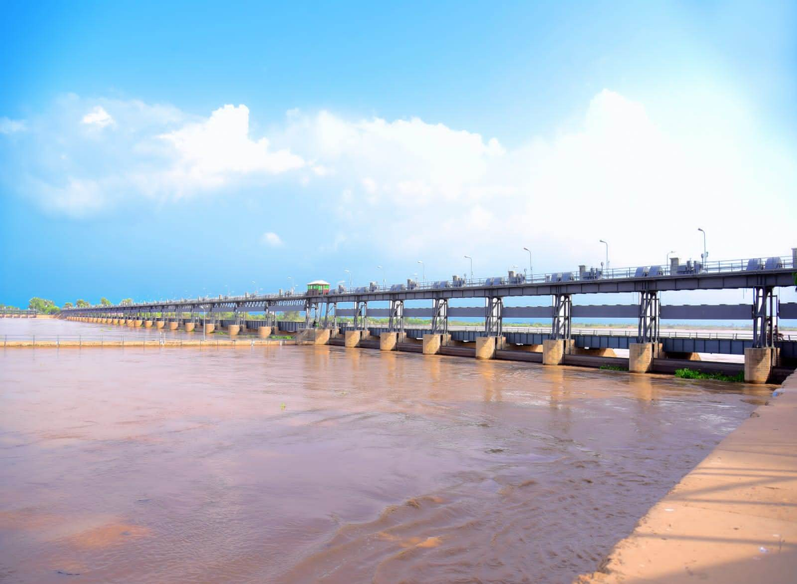
SULEIMANKI HEADWORKS DIVISION

FLOOD FIGHTING PLAN 2024
SULEIMANKI HEADWORKS

I N D E X

FLOOD FIGHTING PLAN 2024

Chapter | PART-A | Page No
1 | Salient Feature of Suleimanki Headwork Division | 1
1.1 | Location | 1
1.2 | General Description | 2-4
1.3 | Administrative Setup | 5
2 | Flood Protection and River Training Works | 6
2.1 | Design parameter of Training works | 6-10
2.2 | Location Map | 11
3 | Brief History of Past Flood Events | 12-15
4 | Design Data, Historic Peak flood data and previous Five Years Flood Data of Headwork/ Barrages and or other control points | 16
4.1 | Flood Limits | 17
4.2 | Time Lags of Flood | 17
4.3 | Highest Floods | 18
4.4 | Peak Discharges | 18
5 | Flood Fighting Strategy | 19-20
6 | Flood Damages Restoration Works | 21-22
7 | Flood Fighting Watching Arrangements | 23
7.1 | Pre Flood Arrangements | 23
7.2 | Watching Establishment | 24
7.3 | Arrangements at sensitive sites | 24-25
7.4 | Watching Material | 26
7.5 | Arrangement for sounding and probing | 27
7.6 | Lighting Arrangement | 27
7.7 | Ration Arrangements | 27
7.8 | POL Arrangement for Vehicle | 27
7.9 | Transportation | 27
7.10 | Law and Order | 27
7.11 | Medical Arrangement for Labour | 28
7.12 | Liaison with other Departments | 28
7.13 | Role of Army | 29
7.14 | Duties of Telephone Attendant | 29
7.15 | Wireless Arrangements | 29
8 | Detail of Encroachment | 30
9 | Duty Roster / Flood Fighting Program | 31-32
10 | Emergency Telephone Nos. | 33-34
11 | Standard Operating Procedure (SOP) for Breaching Section | 35
11.1 | History of the Breaching Section | 35-36
11.2 | Location, Design, Quantity and Verity of the Explosive required for detonation | 37
11.3 | Arrangement of Explosive and security of Explosive Store | 38
11.4 | List of the Security Staff along with detail of their Training etc. | 39
11.5 | Detail of Mechanical Means as a Standby Arrangement in case of Detonation Failure. | 39
11.6 | Duty roster in case of critical situation | 39-40
11.7 | Breaching committee with their action plan | 41
11.8 | List of the villages likely to be inundated in case of breach | 42-45
11.9 | Announcement and detail of evacuation arrangements | 46
11.10 | Detail of coordination with civil / army authorities | 46
11.11 | Parallel communication arrangement | 46
11.12 | Index Plan | 47

Chapter | PART-B |  | Page No
12 | Vulnerable Sites of Flood Bund / Structures |  | 49
12.1 | Apprehended breaches in Flood Bunds / Structures |  | 49
12.2 | Operation of Breaching Sections |  | 49
12.3 | Breaches due to rising of flood water, deterioration of flood bunds etc. |  | 49
13-A | Emergency Contingency Plan For Vulnerable sites |  | 50
13.1 | Plan Showing Route of Flood Water coming out the breach supported with levels |  | 51
13.2 | Detail of Villages, Abadies likely to be affected and this should also be shown on plan. |  | 52
13.3 | Strategy and action taken, explained in detail this may include |  | 52
 | 13.3.1 | Arrangements | 52
 | 13.3.2 | Establishment of Flood Fighting Camps | 52
 | 13.3.3 | Duties of Officers/ Officials at their camp sites | 53
 | 13.3.4 | Departmental Machinery available | 53
 | 13.3.5 | Machinery available from private sources | 53
 | 13.3.6 | Flood Fighting Material required | 54
 | 13.3.7 | Flood Fighting Material available | 54
13.4 | Detail of other infrastructure like electricity, Sui Gas, Telephone Installation, Road network, Other Building, Canal and Drainage Network. |  | 55-56
13-B | Emergency Contingency Plan For Vulnerable sites |  | 57
13.1 | Plan Showing Route of Flood Water coming out the breach supported with levels |  | 58
13.2 | Detail of Villages, Abadies likely to be affected and this should also be shown on plan. |  | 59
13.3 | Strategy and action taken, explained in detail this may include |  | 59
 | 13.3.1 | Arrangements | 59
 | 13.3.2 | Establishment of Flood Fighting Camps | 59
 | 13.3.3 | Duties of Officers/ Officials at their camp sites | 60
 | 13.3.4 | Departmental Machinery available | 60
 | 13.3.5 | Machinery available from private sources | 60
 | 13.3.6 | Flood Fighting Material required | 61
 | 13.3.7 | Flood Fighting Material available | 61
13.4 | Detail of other infrastructure like electricity, Sui Gas, Telephone Installation, Road network, Other Building, Canal and Drainage Network. |  | 62
14 | ADDITIONAL INFORMATION Action Plan |  | 63
14.1 | Re-shuffling / recouping plan of reserve stock of stone departmentally |  | 63
14.2 | Detail of inlet and outlet crossing along with closing methodology. |  | 64-65
14.3 | Deployment of machinery (Medium to high flood) |  | 66
14.4 | Deployment of machinery (High to very high) |  | 67
14.5 | Deployment of machinery (High to exceptionally high flood) |  | 67
14.6 | Police deployment plan. |  | 68
14.7 | Detail of synthetic bags with capacity of 500 Kg and 1000 Kg. |  | 69
14.8 | Detail of Polythene sheets of black colour to protect upstream slope against wave action and to control seepage through embankment. |  | 69
15 | Back up of Divisions (In case of breach) |  | 70

CHAPTER – 1

SALIENT FEATURE OF SULEIMANKI DIVISION

LOCATION

Suleimanki Headwork Division is one of three Canal Division of Nili Bar Circle Sahiwal, Sahiwal Irrigation Zone. The Division manages the regulation of Canal supplies of Suleimanki Barrage, maintenance of Barrage structure, Flood Routing and up-keeping it’s allied River Training Works. Suleimanki Headwork was constructed under the Sutlej Valley Project, during 1921-26 to provide Canal Irrigation to vast fertile tract of barren land. The design capacity of this barrage is 325000 Cs.
Three Main Canals namely Eastern Sadiqia (6327-Cs), Fordwah Canal (3447-Cs) and Pakpattan Canal (6594-Cs) off-takes from Suleimanki Headwork. The Headwork is located 20-KM from Haveli Lakha Town of Tehsil Depalpur District Okara and is very important for its irrigation as well as strategic value.

1.2 GENERAL DESCRIPTION

Suleimanki Head works is located on River Sutlej at a distance of 20 KM East of Haveli Lakha Town in the Tehsil Depalpur District Okara. The origin of the River Sutlej is situated in TIBBET near MANASAR-OWAR LAKE. The major tributary of the River is BEAS having its confluence near HARIKE Head works which is 40 miles upstream of FEROZEPUR Head works. The Sutlej River enters in Pakistan territory just downstream of FEROZEPUR Head works and travels 127 Km to reach Suleimanki Head works. This Headwork is located only 1Km from Indo-Pak International Border and has vital role in defence of Pakistan for Suleimanki sector. The Irrigation Boundary of this Division upto Sahuka in Districts Vehari.
The river supply was cut off by India in 1960 according to Indus Water Treaty between Pakistan & India. A link Canal system was constructed from Mangla Reservoir to Suleimanki Headwork to feed the off taking canals of Suleimanki Headwork. The normal river supply was disconnected by the Indian Government after construction of storage dams on the upper reach of Sutlej River. The limited / restricted supply at Suleimanki Headwork started shoaling upstream Headwork resulting bela formation.
A huge and firm bela was formed all along the upstream left guide bund on the left side of Headwork. This bela had chocked almost two third water way upstream of Headwork and due to low discharges, the size of bela was increasing gradually. This bela was excavated mechanically under the mega project of “Rehabilitation and Up-gradation of Suleimanki Headwork”. Now the approach of river is direct and sufficient ponding volume is available to feed off-taking channels up to their indents.
All the flood protection works are safe and sound to cope Flood Emergency. The Pak Army base bund was constructed along River Sutlej from nose of left Guide bund to RD.12+000 upstream. The construction of this base bund will act as defence line against LMB.

Design Capacity of Suleimanki Headwork. =325000-Cs.
Total Length of Bunds and Spurs. =44-Miles.
Total length of Main Canals. =25-Miles.
Total length of Branch Canal. =48-Miles.
Total length of Disty & Minor. =168-Miles.
G.Total=241-Miles.

Suleimanki Division comprises two Sub Divisions namely Headwork Sub Division Suleimanki and Pakpattan Sub Division which are headed by the Sub Divisional Officers stationed at Suleimanki and Pakpattan respectively.
Headwork Sub Division is responsible for regulation of the Barrage, Canals off taking from Suleimanki Headwork along with their maintenance up to 6000 feet each of Left side Canals as well as 112350 feet of Pakpattan Canal on right sides with its off takes. This Sub Division also maintains the Barrage allied structures and River training works.
Pakpattan Sub Division is responsible for maintenance of Khadir Branch up to 241000 feet along with its off taking Channels. Khadir Branch extends its Irrigation between the River Sutlej and Pakpattan Canal.
Three main Canals off takes from Suleimanki Headwork with total discharge of 16368-Cusecs and Irrigates 28 Lac Acres of land. Pakpattan Canal off takes from the Right flank which Irrigates the area in Okara, Pakpattan and Vehari Districts. Eastern Sadiqia and Fordwah Canals off take from the Left side and Irrigate the area of Bahawalnagar and Bahawalpur Districts. After partition of Indo-Pak and as consequence of Indus Water treaty, the supply at Suleimanki Head works is maintained through Balloki Suleimanki Link (B.S.L). This Link Canal joins the Sutlej with its out fall structure 25 Kilometers upstream of Suleimanki Head works.
Area irrigated by the Suleimanki Headwork Division falls in the 3 Districts as under:-.

District | G.A (Acres) | C.C.A (Acres)
Okara | 18113 | 16237
Pakpattan | 167482 | 155973
Vehari | 9901 | 8314
TOTAL | 195496 | 180524
Major Crops in the command area are wheat, Sugar Cane, Cotton & Rice etc. Zamindars are taking keen interest in laser leveling of land and making Pacca water courses to bring more area under command by using modern techniques and as a result irrigation is increasing day by day.
Right Marginal Bund & Left Marginal Bund with allied spurs have been raised 5.0 ft above the highest flood level of 1988. Pak Army has constructed pacca bunkers on the top of Left Marginal Bund for defense purpose. The Left Marginal Bund strengthened by providing ring bunds around the bunkers to cope the stress flood water.
INFRASTRUCTURES UNDER CONTROL OF SULEIMANKI HEADWORK

Headwork | 1.No.Suleimanki Headwork
Main Canals | 3.No
i. Pakpattan Canal (Upper)  ii. Sadiqia Canal  iii. Fordwah Canal | 22.47 Canal Miles  01.20 Canal Miles  01.20 Canal Miles
Total: - | 24.87 Canal Miles
Branches | 1.No
i. Khadir Branch | 48.20 Miles
Distributaries | 27.No 140.74 Miles
Minors | 6. No 27.10 Miles
Total No. of Channels | 27. No
Total Length of Channels  (Main Canals, Branches Disties and Minors) | 241 Miles
Water Allowance i. Non-perennial | 5.50 Cs Per 1000 Acres
Designed Intensity i. Non Perennial | 60%
Total GCA | 0.195 Million Acres
Total CCA | 0.181 Million Acres
Total No. of Tails | 27. No.
Total No of Outlets | 419 No.
Total length of Flood Bunds | 17.24 Miles

DISTRICT WISE LENGTH OF CHANNELS

Name of District | Main Canal  (Canal Miles) | Branch  (Canal Miles) | Disty  (Canal Miles) | Minor  (Canal Miles) | Total  (Canal Miles)
Okara | 18.40 | - | 14.90 | 1.20 | 34.50
Pakpattan | 6.47 | 44.20 | 111.10 | 25.95 | 187.72
Vehari | - | 4.0 | 14.75 | - | 18.75
Total | 24.87 | 48.20 | 140.75 | 27.15 | 240.97
SALIENT FEATURES OF SULEIMANKI HEADWORK
1 | Design discharge of main weir. | 2.10 | Lac Cs
2 | Design discharge of under sluices. | 1.15 | Lac Cs
3 | Total design capacity of Headwork. | 3.25 | Lac Cs
4 | Design discharge of Pakpattan Canals. | 6594 | Cusecs
5 | Design discharge of Sadiqia Canals. | 6327 | Cusecs
6 | Design discharge of Fordwah Canals. | 3447 | Cusecs
7 | Normal Pond Level | 569.00 | Feet
8 | Highest flood level of 1988. | 572.50 | Feet.
9 | Crest / Floor level of under sluices. | 552.00 | Feet.
10 | Crest level of Head Regulator of Pakpattan Canal. | 559.50 | Feet.
11 | Downstream floor level of weir. | 549.75 | Feet.
12 | Upstream floor level of weir. | 552.00 | Feet.
13 | Crest level of weir. | 560.00 | Feet.
14 | Length of floor Upstream | 20.00 | Feet.
15 | Length of stone apron upstream | 30.00 | Feet
16 | Length of Floor Downstream | 33.25 | Feet.
17 | Crest level of head Regulator of Eastern Sadiqia Canal. | 559.50 | Feet.
18 | Crest level of head Regulator of Fordwah Canal. | 561.50 | Feet.
19 | Length of the Headwork between abutments. | 2223 | Feet.
20 | Water Way. | 1920 | Feet.
21 | Number of bays of main weir. | 24 | Nos.
22 | Width of each bay. | 60 | Feet.
23 | Numbers of bays/gates with LCPs of under sluices (Left & Right). | 16 | Nos.
24 | Width of Each Bay of under sluice | 30 | Feet.
25 | Width of Pier of Under Sluice | 5 | Feet.
26 | Width of Pier of Main Weir. | 7 | Feet.
27 | Divide Wall Width | 5 | Feet.
28 | Divide Wall Length. | 700 | Feet.
29 | Number of bays / gates with LCPs of Pakpattan canal upper) | 8 | No.
30 | Number of bays / gates with LCPs of Eastern Sadiqia canal | 7 | No.
31 | Number of bays / gates with LCPs of Fordwah canal | 5 | No.
32 | Width of Gates of Off-taking canals | 20 | Feet

1.3 ADMINISTRATIVE SETUP

EXECUTIVE ENGINEER
SULEIMANKI

SUB DIVISIONAL OFFICER
Pakpattan Sub Division

SUB DIVISIONAL OFFICER
Headworks Sub Division

Sub Engineers 6-No

Mechanical, Station, Headworks, Discharge, Ghumariwala,
Leave Reserve

Sub Engineers 4-No

Pakpattan, Warsin, Hamarath, Jamlera

Regulation staff &
Other Field Staff
CHAPTER – 2

FLOOD PROTECTION AND RIVER TRAINING WORKS

2.1 DESIGN PARAMETER OF TRAINING WORKS / FLOOD EMBANKMENTS.

Sr. | Name of Bund / Embankment | H.F.L in 1988 |  | Reach | Length in Miles | Top Width | Slope | Top RL at source | Top RL at Tail
Sr. | Name of Bund / Embankment | At Head | At Tail
1 | Upstream Left Guide Bank | 575.50 | 573.50 | 0-3500 | 0.70 | 30-56 | 1:2  1:3 | 579.50 | 582.00
2 | Upstream Right Guide Bank | 575.50 | 573.50 | 0-3500 | 0.70 | 30-56 | 1:2  1:3 | 579.00 | 582.00
3 | Downstream Left Guide Bank | 575.50 | 572.00 | 0-1000 | 0.20 | 30 | 1:2  1:3 | 578.00 | 574.00
4 | Downstream Right Guide Bank | 575.50 | 572.00 | 0-1000 | 0.20 | 30 | 1:2  1:3 | 578.00 | 574.00
5 | Left Marginal Bund | 577.10 | 585.20 | 0-47500 | 9.50 | 25 | 1:2  1:3 | 582.10 | 590.20
6 | T.T. Bund | 577.10 | 577.10 | 0-6000 | 1.20 | 20 | 1:2  1:2 | 582.10 | 582.10
7 | Jhanger Spur | 577.10 | 577.10 | Shank =0-3300  Pitching Portion =400 | 0.74 | 20 | 1:3  1:3 | 582.30 | 582.20
8 | New Hasta Spur | 585.20 | 585.20 | Shank =0-13000  Pitching portion =500 | 2.70 | 25 | 1:3  1:3 | 590.20 | 590.20
9 | Right Marginal Bund | 579.50 | 583.50 | 0-63000 | 12.60 | 25.20 | 1:3  1:2 | 584.50 | 588.50
10 | Station Spur | 529.50 | 579.50 | Shank =0-4950  Pitching portion =1050 | 1.20 | 20 | 1:2  1:2 | 584.50 | 584.50
11 | Dharanga Spur | 580.60 | 580.60 | Shank =0-11000  Pitching portion =525 | 2.31 | 20 | 1:2  1:2 | 585.60 | 585.60
12 | Suleimanki Spur | 569.50 | 569.50 | Shank =0-1300  Pitching portion =200 | 0.30 | 20 | 1:2  1:2 | 574.50 | 574.50
13 | Malleki Spur | 568.00 | 568.00 | Shank =0-1000  Pitching portion =200 | 0.24 | 20 | 1:2  1:2 | 573.00 | 573.00
14 | Sujeki Spur | 561.50 | 561.50 | Shank =0-2700  Pitching portion =300 | 0.60 | 20 | 1:2  1:2 | 566.5 | 566.5
15 | Jodheki Spur | 567.00 | 567.00 | Shank =0-1200  Pitching portion =300 | 0.30 | 20 | 1:2  1:2 | 572.00 | 572.00
16 | Tulleki Spur | 559.50 | 559.50 | Shank =0-3770  Pitching portion =330 | 0.82 | 20 | 1:2  1:2 | 564.50 | 564.50
17 | Ferozepur Flood Bund | 530.17 | 523.76 | 0-28672 | 5.73 | 20 | 1:2  1:2 | 535.17 | 535.17
18 | New Mari Amb Flood Bund | 522.87 | 518.62 | 0-16035 | 3.20 | 20 | 1:2  1:2 | 527.82 | 527.82
19 | Jamlera flood Bund | 593.85 | 587.21 | 0-41500 | 8.30 | 25 | 1:2  1:3 | 498.85 | 498.85

DETAIL OF FLOOD PROTECTION AND RIVER TRAINING WORKS ALONGWITH THE DESIGN PARA METERS AND LOCATION MAPS

The list of Flood Protection and River Training Works marked on the location plan is attaches. The detail of Flood Protection / Training works is as under:-

DETAIL OF RIVER TRAINING WORKS

NAME | Type | Off-Take  RD | TOP WIDTH | LENGTH | TOP  R.L | Slope
Upstream Right &  Left Guide Bank. | J Head | Suleimanki Barrage | 56 | 3500 | 579.50  582.00 | 1:2/1:3
Downstream Right and Left Guide Bank. | J Head | Suleimanki Barrage | 30 | 1000 | 578.00  574.00 | 1:2/1:3
Right Marginal Bund | Earthen | Suleimanki Barrage | 25/20 | 63000 | 584.50  588.50 | 1:3/1:2
Station Spurs | Armored Head | 6000/RMB | 20 | 6000 | 582.50 | 1:2/1:2
Dharang Spurs | T Head | 16000/RMB | 20 | 11525 | 583.50 | 1:2/1:2
Left Marginal Bund. | Earthen | Suleimanki  Barrage | 25 | 47500 | 582.10  590.20 | 1:3/1:2
T.T. Bund | Earthen | 2000/LMB | 20 | 6000 | 582.10 | 1:2/1:2
Jhangar Spurs. | Armored Head | 13282/LMB | 15 | 3700 | 580.85 | 1:2/1:2
New Hasta Spurs. | Armored Head | 47500/LMB | 25 | 13500 | 590.20 | 1:2/1:2
Suleimanki Spurs. | J Head | Opposite 5000/PC | 20 | 1500 | 574.50 | 1:2/1:2
Malleki Spurs. | T Head | Opposite 15000/PC | 20 | 1200 | 573.00 | 1:2/1:2
Jodheki Spurs. | T Head | Opposite 22000/PC | 20 | 1500 | 572.00 | 1:2/1:2
Sujeiki Spurs. | T Head | Opposite 28000/PC | 20 | 3000 | 566.50 | 1:2/1:2
Tulleki Spurs. | T Head | Opposite 38130/PC | 20 | 4100 | 564.50 | 1:2/1:2
Ferozepur Flood Protection Bun | Earthen | 40000/L of Ferozepur | 20 | 28672 | 531.36 | 1:2 /1:3
New Mari Amb Flood Protection Bund | Earthen | 68672/L of Ferozepur | 25 | 16035 | 525.02 | 1:2 /1:3
Jamlera Flood Protection Bund | Earthen | Opposite  228000/L of KB | 25 | 41500 | 495.33 | 1:2 /1:3

DETAIL OF LEFT GUIDE BUND UPSTREAM AT SULEIMANKI HEADWORK.

Length of Guide Bund 3500 Ft.  Top R.L. of Apron 558.0 Ft.  Width of Apron 30 Ft  Side Slopes 1 : 2 - 1 : 3 | It is an earthen bund with river side stone pitched and is in satisfactory condition existing bund is as per design parameters.  6 in thick shingle is placed on top of bund up to RD 1+050=18ft & 1+050–3+500=10ft
DETAIL OF LEFT GUIDE BUND DOWNSTREAM AT SULEIMANKI HEADWORK.

Length of Guide Bund 1000 Ft.  Top R.L. of Apron 549/555 Ft.  Width of Apron 30 Ft  Side Slopes 1: 2 - 1:3 | It is an earthen bund with river side stone pitched and is in satisfactory condition existing bund is as per design parameters.
DETAIL OF RIGHT GUIDE BUND UPSTREAM AT SULEIMANKI HEADWORK.

Length of Guide Bund 3500 Ft.  Top R.L. of Apron 558.0 Ft.  Width of Apron 30 Ft  Side Slopes 1: 2 - 1:3 | It is an earthen bund with river side stone pitched and is in satisfactory condition existing bund is as per design parameters.  6 in thick shingle is placed on top of bund up to RD.1+500=18ft & 1+500–3+500 =10ft
DETAIL OF RIGHT GUIDE BUND DOWNSTREAM AT SULEIMANKI HEADWORK.

Length of Guide Spur 1000 Ft.  Top R.L. of Apron 549/554 Ft.  Width of Apron 40 Ft  Side Slopes 1: 2 - 1:3 | It is an earthen bund with river side stone pitched and is in satisfactory condition existing bund is as per design parameters.
DETAIL OF RIGHT MARGINAL FLOOD PROTECTION BUND

Length of Bund 63000 Ft.  To width 25-20 Ft.  Free board 5.00 Ft  Side slopes 1:2 - 1:3 | Overall condition is satisfactory.

DETAIL OF ARMORED STATION SPUR
Length of spur 6000 Ft.  Free Board 5.0 Ft  Top width 20.0 Ft  Apron width 80 Ft  Pitching length of spur 1150 Ft  Side slopes 1:2 – 1:2. | The work for provision of stone pitching as well as apron (Stone) from RD. 0+500 to RD. 1+500 has been taken up next financial year.
DETAIL OF T-HEAD DHRANGA SPUR
Length of spur 11525 Ft.  Free Board 5.0 Ft  Top width 20.0 Ft  Apron width 80 Ft  Pitching length of spur 600 Ft  Side slopes 1:2 – 1:2 | Overall condition is satisfactory.

DETAIL OF LEFT MARGINAL FLOOD PROTECTION BUND

Length of Bund 47500 Ft.  To width 25.00 Ft.  Free board 5.00 Ft  Side slopes 1:2 – 1:3 | There are 82-Nos of Bunkers constructed by Pak Army for defense purpose, these places of bunkers was vulnerable. During the financial year 2023-24 the bund was protected by providing ring bunds around bunkers to cope the flood.
DETAIL OF T.T BUND

Length of Bund 6000 Ft.  To width 20.00 Ft.  Free board 5.00 Ft  Side slopes 1:2 – 1:2 | Overall condition is satisfactory.
DETAIL OF ARMORED JHANGAR SPUR

Length of spur 3700 Ft.  Free Board 5.0 Ft  Top width 25.0 Ft  Apron width 80 Ft  Pitching length of spur 600 Ft  Side slopes 1:2 – 1:2 | Overall condition is satisfactory.
DETAIL OF ARMORED NEW HASTA SPUR

Length of spur 13500 Ft.  Free Board 5.0 Ft  Top width 20.0 Ft  Apron width 30 Ft  Pitching length of spur 1500 Ft  Side slopes 1:2 – 1:2 | Overall condition is satisfactory.

DETAIL OF ARMORED SULEIMANKI SPUR

Length of spur 1500 Ft.  Free Board 5.0 Ft  Top width 25.0 Ft  Apron width 50 Ft  Pitching length of spur 200 Ft  Side slopes 1:2 & 1:2 | Overall condition is satisfactory.

DETAIL OF ARMORED MALLEKE SPUR

Length of spur 1200 Ft.  Free Board 5.0 Ft  Top width 20.0 Ft  Apron width 50 Ft  Pitching length of spur 200 Ft  Side slopes 1:2 & 1:2 | Overall condition is satisfactory.

DETAIL OF T-HEAD JODHEKE SPUR

Length of spur 1500 Ft.  Free Board 5.0 Ft  Top width 20.0 Ft  Apron width 45 Ft  Pitching length of spur 200 Ft  Side slopes 1:2 & 1:2 | Overall condition is satisfactory.

DETAIL OF T-HEAD SUJEKE SPUR

Length of spur 3000 Ft.  Free Board 5.0 Ft  Top width 20.0 Ft  Apron width 50 Ft  Pitching length of spur 200 Ft  Side slopes 1:2 & 1:2 | Overall condition is satisfactory.

DETAIL OF T-HEAD TULLEKE SPUR

Length of spur 4100 Ft.  Free Board 5.0 Ft  Top width 20.0 Ft  Apron width 80 Ft  Pitching length of spur 600 Ft  Side slopes 1:2 & 1:2 | Overall condition is satisfactory.

DETAIL OF FEROZEPUR FLOOD PROTECTION BUND

Length of Bund 28672 Ft.
To width 20 Ft.
Free board 5.00 Ft
Side slopes 1:2 – 1:3

DETAIL OF NEW MARI AMB FLOOD PROTECTION BUND

Length of Bund 16035 Ft.
To width 25 Ft.
Free board 5.00 Ft
Side slopes 1:2 – 1:3

DETAIL OF JAMLERA FLOOD PROTECTION BUND

Length of Bund 41500 Ft.
To width 25 Ft.
Free board 5.00 Ft
Side slopes 1:2 – 1:3

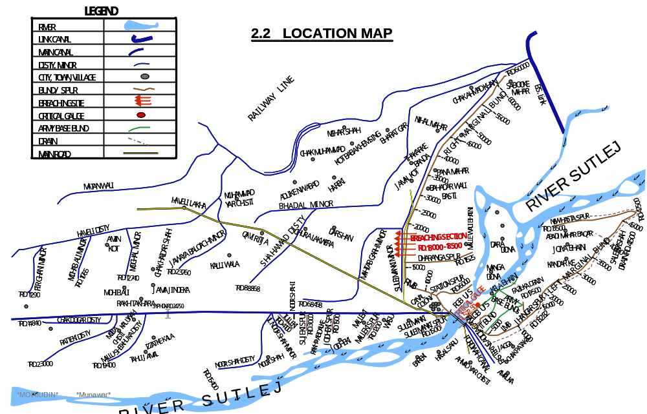
PAKPATTAN CANAL UPPER
CHAPTER – 3

BRIEF HISTORY OF PAST FLOOD EVENTS

Three number exceptionally high floods have been experienced in River Sutlej at Suleimanki Headwork after partition of Indo-Pak 1947.
During 1955 an unprecedented flood was experienced when 4.22 Lac Cusecs passed through the Suleimanki Headwork at RL. 572.50 against the design high flood level of 572.00. In flood 1955, RMB breached at RD.20 and the area pocketed by Shahmad Disty, Pakpattan Canal and RMB was inundated. About 14 No breaches / cuts occurred on Pakpattan Canal and the water was disposed off into the Sutlej River Downstream to Suleimanki Headwork.
During 1988, flood of 4.0 Lac Cusecs passed through barrage while 1.0 Lac Cusecs through breaching section at RD.20+000 to 20+500 of RMB. In spite of operating breaching section RMB breached at RD. 16+000 to 17+000 and RD. 33+000 to 35+000 and the area pocketed by Shahamad Disty, Pakpattan Canal and RMB were inundated. About 20 No breaches / cuts were made on Pakpattan Canal and the water was disposed off into the Sutlej River. The LMB breached at RD.8+000 to 10+000, flood water entered in Eastern Sadiqia Canal and Fordwah Canal. This water was disposed off in River Sutlej by breaching both of canals at RD.14+000 and 17+000. The proposed breaching section of RMB has been changed offer the flood 1988 and approved at RD. 18+000 to 18+500 instead of RD.20+000 to 20+500 of RMB.
During 1995 i.e. 3.0 Lac CS passed through barrage and no allied structure was damaged in 1995 upstream but downstream abadies / villages were affected and huge loss of crops, residential buildings, animals was experienced during flood 1995.
During 2023, the flood was started during the month of July –August with first peak during July and second peak during August which was also unusual as per previous record, river rises only one time but during 2023 river rises two times in same period of flood, 2023.
First flood peak of 114,260 cusecs reached at Ganda Singh Wala on 13th July 2023 and first flood peak of 83,570 cusecs reached at Suleimanki barrage at 16th July 2023. Second flood peak of 278,297 cusecs reached at Ganda Singh Wala on 19th August 2023 and likewise second flood peak of 191,053 cusecs reached at Suleimanki barrage on 22nd August 2023. This pattern shows that peak discharge remained sustained for similar time i.e. 03:00 hours at both points Ganda Singh Wala and Suleimanki barrage.
However lag time was 72 hours which was considered 48 hours before this flood 2023. This early filling of Indian dams not resulted in early flood flows in Sutlej River but it also produced continuous flows for period of two months which was not happened after construction of Indian Dams on Sutlej & Beas Rivers.

DISCHARGE AT SULEIMANKI HEADWORK FROM 1925 TO DATE
Date / Year | Maximum Discharge In Lac CS. | Condition
1925 | 1.90 | High Flood
1926 | 2.07 | Very High Flood
1927 | 1.76 | High Flood
1928 | 1.35 | High Flood
1929 | 2.67 | Exceptionally High Flood
1930 | 2.71 | Exceptionally High Flood
1931 | 1.41 | High Flood
1932 | 2.40 | Exceptionally High Flood
1933 | 2.02 | Very High Flood
1934 | 1.74 | High Flood
1935 | 1.95 | Very High Flood
1936 | 2.07 | Very High Flood
1937 | 1.55 | High Flood
1938 | 2.14 | Very High Flood
1939 | 1.24 | High Flood
1940 | 1.16 | Medium Flood
1941 | 1.72 | High Flood
16.8.1942 | 3.25 | Exceptionally High Flood
18.8.1943 | 3.09 | Exceptionally High Flood
1944 | 2.05 | Very High Flood
30.9.1945 | 2.57 | Very High Flood
1946 | 2.10 | Very High Flood
30.9.1947 | 3.60 | Exceptionally High Flood
23.8.1948 | 1.70 | High Flood
19.09.1949 | 1.29 | High Flood
27.8.1951 | 2.86 | Exceptionally High Flood
1952 | 2.62 | Exceptionally High Flood
8.8.1953 | 2.72 | Exceptionally High Flood
30.9.1954 | 2.39 | Exceptionally High Flood
8.10.1955 | 5.97 | Exceptionally High Flood
15.8.1956 | 1.76 | Very High Flood
7.9.1957 | 2.10 | Very High Flood
10.8.1958 | 2.44 | Very High Flood
24.9.1959 | 1.52 | High Flood
6.9.1960 | 2.68 | Exceptionally High Flood
24.8.1961 | 2.65 | Exceptionally High Flood
Date / Year | Maximum Discharge In Lac Cs. | Condition
27.9.1962 | 2.26 | Exceptionally High Flood
16.8.1963 | 1.52 | High Flood
22.8.1964 | 1.71 | High Flood
30.7.1965 | 0.92 | Medium Flood
13.9.1966 | 2.03 | Very High Flood
30.8.1967 | 1.90 | Very High Flood
1.8.1968 | 1.01 | High Flood
23.8.1969 | 1.51 | High Flood
17.8.1970 | 1.09 | Medium Flood
14.8.1971 | 2.28 | Exceptionally High Flood
15.7.1972 | 0.93 | Medium Flood
15.8.1973 | 1.77 | Very High Flood
27.8.1974 | 0.17 | No Flood
21.9.1975 | 0.49 | No Flood
7.9.1976 | 1.18 | Medium Flood
24.9.1977 | 0.53 | Low Flood
26.8.1978 | 1.70 | High Flood
8.10.1979 | 0.14 | No Flood
19.7.1980 | 0.78 | Low Flood
22.7.1981 | 0.11 | No Flood
14.8.1982 | 0.17 | No Flood
15.9.1983 | 0.67 | Low Flood
6.9.1984 | 0.54 | Low Flood
26.7.1985 | 0.36 | No Flood
11.8.1986 | 0.21 | No Flood
1987 | - | -
1988 | 4.99 | Exceptionally High Flood
1989 | - | -
13.9.1990 | 1.62 | High Flood
19.9.1991 | 0.36 | No Flood
09.1992 | 1.97 | Very High Flood
01.07.1993 | 1.60 | High Flood
27.08.1994 | 1.38 | High Flood
11.09.1995 | 3.018 | Exceptionally high Flood
27.08.1996 | 0.625 | Low Flood
31.08.1997 | 0.448 | No Flood
27.08.1998. | 0.91 | Low Flood
Date / Year | Maximum Discharge In Lac Cs. | Condition
16.08.1999 | 0.23 | No Flood
05.08.2000 | 0.15 | No Flood
04.08.2001 | 0.06 | No Flood
17.08.2002 | 0.01 | No Flood
02.10.2003 | 0.20 | No Flood
16.10.2004 | 0.19 | No Flood
13.08.2005 | 0.18 | No Flood
10.09.2006 | 0.23 | No Flood
09.09.2007 | 0.04 | No Flood
19.08.2008 | 1.02 | Medium Flood
27-08-2009 | 0.05 | No Flood
30.09.2010 | 0.58 | Low Flood
29.08.2011 | 0.70 | Low Flood
23.09.2012 | 0.21 | No Flood
22.08.2013 | 0.78 | Low Flood
07.09.2014 | 0.21 | No Flood
18.08.2015 | 0.49 | No Flood
29.08.2016 | 0.24 | No Flood
15.08.2017 | 0.21 | No Flood
28.09.2018 | 0.35 | No Flood
24.08.2019 | 0.67 | Low Flood
24.07.2020 | 0.12 | No Flood
15.09.2021 | 0.072 | No Flood
20.07.2022 | 0.178 | No Flood
22.08.2023 | 1.911 | Very High Flood

CHAPTER – 4

DESIGN DATA, HISTORIC PEAK FLOOD DATA AND PREVIOUS FIVE YEARS FLOOD DATA OF HEADWORKS / BARRAGES AND OR OTHER CONTROL POINTS

1 | Design discharge of main weir. | 2.10 | Lac Cs
2 | Design discharge of under sluices. | 1.15 | Lac Cs
3 | Total design capacity of Head works. | 3.25 | Lac Cs
4 | Design discharge of Pakpattan Canals. | 6594 | Cusecs.
5 | Design discharge of Sadiqia Canals. | 6327 | Cusecs.
6 | Design discharge of Fordwah Canals. | 3447 | Cusecs.
8 | Highest flood level of 1988. | 575.0 | Feet.
9 | Floor level of under sluices. | 552.00 | Feet.
10 | Crest level of Head Regulator of Pakpattan Canal. | 559.50 | Feet.
11 | Downstream floor level of weir. | 549.00 | Feet.
12 | Upstream floor level of weir. | 552.00 | Feet.
13 | Crest level of weir. | 560.00 | Feet.
16 | Length of floor Upstream | 20.00 | Feet.
17 | Length of Floor Downstream | 33.25 | Feet.
18 | Crest level of head Regulator of Eastern Sadiqia Canal. | 559.50 | Feet.
19 | Crest level of head Regulator of Fordwah Canal. | 561.50 | Feet.
20 | Total width of the Head works between abutments. | 2223 | Feet.
21 | Water Way. | 1920 | Feet.
22 | Number of bays of main weir. | 24 | Nos.
23 | Width of each bay. | 60 | Feet.
24 | Numbers of bays of under sluices (Left & Right). | 16 | Nos.
25 | Type of Gate (Vertical Stony Gates) | -- | --
26 | Width of Pier of Under Sluice | 5 | Feet.
27 | Width of Pier of Main Weir. | 7 | Feet.
28 | Divide Wall Width | 5 | Feet.
29 | Divide Wall Length. | 700 | Feet.
4.1 FLOOD LIMITS

Flood limits of Suleimanki Head works as approved by the technical committee during meeting held on 15.05.1989 are tabulated as under:-

Up to 50000 Cs Normal
50000 Cs to 80000 Cs Low Flood.
80000 Cs to 120000 Cs Medium Flood.
120000 Cs to 175000 Cs High Flood.
175000 Cs to 225000 Cs Very High Flood.
225000 Cs and above Exceptionally High Flood.

4.2 TIME LAGS OF RIVER SUTLEJ

The time lag depends on many factors such as flood intensity; weather conditions etc. however approximate time lags for the main stations on River Sutlej which experienced in past are given as below.

REACH | DISTANCE  (Mile/Km) | TIME LAG (Hour)
Bhakra Dam to Ropper Barrage | 51/ | 24
Ropper Barrage to Harike Barrage | 80/128 | 48
Harike Headworks to Feroze Pur Headworks | 40/64 | 24
Feroze Pur Headworks to Suleimanki Headworks | 79/127 | 72
Suleimanki Headworks to Islam Headworks | 121/193 | 72
Islam Headworks to Punjnad Headworks | 149/238 | 72
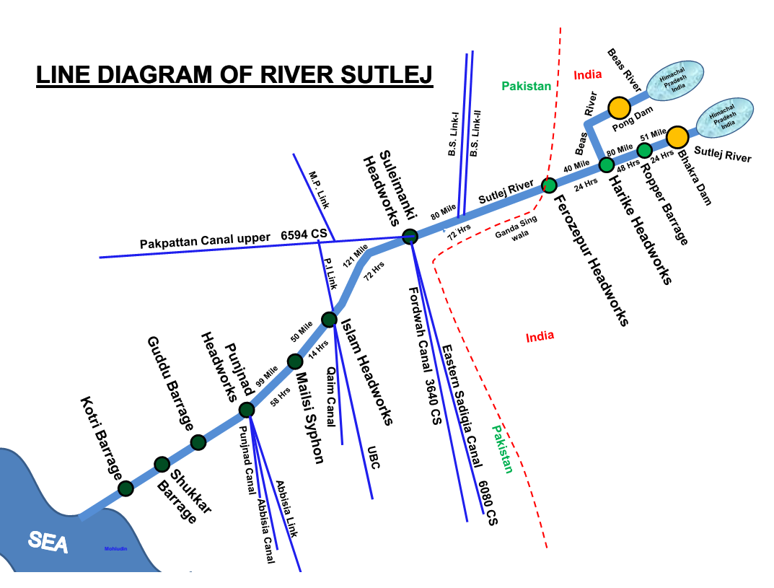
4.3 HIGHEST FLOODS

Year | Through Weir  (Cusecs) | Through Breaches  in flood embankments (Cusecs) | Total (Cusecs)
1955 | 422000 | 175000 | 597000
1988 | 400000 | 100000 | 500000
1947 | 360000 | NIL | 360000
1950 | 332000 | NIL | 332000
1942 | 325000 | NIL | 325000
1943 | 309000 | NIL | 309000
1995 | 302000 | NIL | 302000

4.4 PEAK DISCHARGE (LAST FIVE YEARS)

Sr. | Year | Discharge in Cusecs.
1 | 2019 | 66459
2 | 2020 | 11897
3 | 2021 | 7212
4 | 2022 | 17876
5 | 2023 | 191053

CHAPTER – 5

FLOOD FIGHTING STRATEGY

Flood Fighting Strategy is framed for Suleimanki Headworks by keeping in view basic principles mentioned in “RULES & REGULATION OF SULEIMANKI HEADWORKS” with main aim / object to pass any quantum of flood safely through barrage. Following flood fighting strategy will be adopted at Suleimanki Headworks.
In low flood, river water remains within the deep channel and does not cause any problem, if regulation of gates is done as per rules. Watching establishment employed for this purpose will remain busy in removing jungle, filling gharas and porcupine holes, if any.
When water increases beyond 80,000 cusecs, it will start spreading on adjoining area. Then it becomes necessary to be vigilant and watching of bunds will be started to avoid any leakage from bunds. Sub Engineers will shift their camps to sites as per duty roaster. Hourly gages and discharges will be conveyed to Civil Administration and Flood Warning Centers to inform public accordingly
When river water enters into high flood range (1,20,000 CS – 1,75,000 CS) Sub Divisional Officer Headworks will shift his camp at Suleimanki Headworks to supervise staff working on LMB and downstream spurs. In whole period, regulation will be done in such a way that silt deposit in front of canals may be washed downstream of the river. Silt contents in water will be checked thrice a day and if it exceeds the permissible limit, canals will be closed accordingly.
Gauges of different sites especially gauge at Nose of LGB will be noted regularly and recorded. Executive Engineer will inform all agencies especially civil administration as well as Army about flood situation in rising position. In case of very high flood or exceptionally high flood (Beyond 1,75,000 CS), meetings will be held in Executive Engineer’s office with Pak Army and Civil Administration to face the situation.
Two dozers will be kept ready at RD 18000 to 18500 RMB for making cuts and closing breaches as and when required according to the circumstances .When gauge at Nose of LGB touches level 575.00 and is found in rising position it will be the duty of Executive Engineer to request Army for operation of breaching section for the safety of Headworks. When water subsides the breaching sections will be closed (If operated) as soon as possible.
The flood water gushing out of the breaching section will immediately start rushing towards South-West and will follow the route marked on the inundation plan. It will over top the Mehtab Gharh Minor which is under the jurisdiction of Executive Engineer Khanwah Canal Division who would be intimated accordingly. Then the flood water will over top. Suleimanki – Haveli road (Dehli Multan road) from about 3-KM Suleimanki Headworks up to Jawaya Blouch (16 Km) which will carefully be repaired by Executive Engineer C&W Department. The flood water will flow towards South West and will hit Pakpattan Canal between RD.15000 to 60000 and will move downward. Currently Pakpattan Canal (upper) is under jurisdiction of Executive Engineer, Eastern Bar Division, Pakpattan. Executive Engineer Eastern Bar Division Pakpattan will be intimated about the breach and he will supervise the passage of flood water at over through Pakpattan Canal. The flood water will also enter into the Pakpattan Canal at various place. This Canal will be cut between RD.24-25, RD.29-30 and RD.46-47 to divert the water into the River, along with plugging the Canal at RD.52000 to stop excessive supply following downstream fall RD.52000. If the flood water along right bank of Pakpattan Canal below RD.52000 rises and enters into it. 3-No. additional cuts will be made between Rd.62-63, 67-68 and 99-100 of Pakpattan Canal. For the purpose of breaching Pakpattan Canal three No. dozers will be arranged by the district administration from the Agriculture Department.
There is densely populated area just downstream side of the Breaching Section. The operation of Breaching Section has to be done very carefully with prior warning to the inhabitants of the area. The breach will severely effect the population and infrastructure coming in way of the water. It will affect village abadies comprising of village and scattered abadies. The cultivated land likely to effect is 80000 acres (approximately).
The main infrastructure coming in the way and likely to be effected is as under:-
- Main Suleimanki – Haveli (Dehli –Multan) road in 3 Km to 16 Km from Suleimanki Headworks.
- District Roads Networks.
- School.
- Basic Health Unit.
- Telephone Network Nikki Maneki Exchange).
- Pakpattan canal in Reach 5000 to 100000.
- 10-No. Disty / Minor network of Khanwah Canal Division.

CHAPTER – 6

FLOOD DAMAGES RESTORATION WORKS

Flood magnitude of 191053 Cusecs (Very High Flood) passed during Flood 2023 on 22-08-2023. Detail of damages and restoration works is as under:-

FLOOD DAMAGES

Sr. | District (Location) | Flood Nature | Name of Structure Damaged | Infrast-ructure Type | Damage Category | Estimated Cost of Damages | Pictorial Evidence
1 | Okara  30.349653  73.637787 | Riverine Flood | Rd.13+000 to 23+000 tail of Ratteki disty | Public | 1-No. Fully Damaged | 3.00 Million | 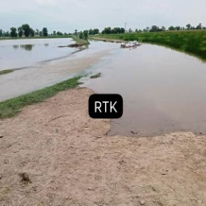
2 | Okara | Riverine Flood | Rd.2+000 to 6+400 of 1L- Noor Shah Minor | Public | 1-No. Fully Damaged | 2.5 Million | 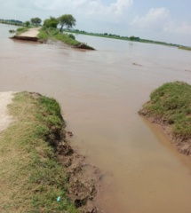
3 | Okara | Riverine Flood | Rd.0+000 to 5+600 of Fazilka Drain | Public | 1-No. Fully Damaged | 4.5 Million | 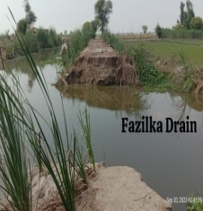
4 | Okara  30.386726, 73.869533 | Riverine Flood | Nose of Right Guide Bund (RGB) | Public | 1-No. Fully Damaged | 11.567 Million | 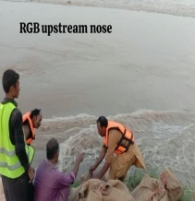
5 | Vehari | Riverine Flood | RD.58+012 to 64+660of Jamlera Disty | Public | 2-No. Partially Damaged | 3.95 Million | 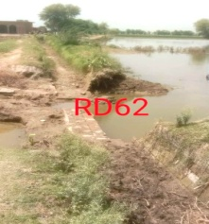

FLOOD RESTORATION WORKS

Sr. | Name of Work | Length  (ft) | Estimated Cost  (Million) | Remarks
1 | Restoration of Jamlera Flood Bund from RD.0+000 to RD.41+500 | 41500 | 152.23 | Raising / Restoration of flood bund as per HFLs of flood 1988 and approved L-Section.
2 | Restoration of Ferozepur Flood Bund from RD.0+000 to RD.28+672 | 28672 | 58.665 | It exists along right bank of Ferozpur Disty. Raising/ Restoration of flood bunds as per HFLs of flood 1988 and approved L-Section.
3 | Restoration of Mari Amb Flood Bund from RD.0+000 to RD.16+035 | 16035 | 39.846 | Raising /Restoration of flood bund needed as per HFLs of flood 1988 and approved L-Section.
4 | Strengthening / Repairing of LMB from RD.0+000 to RD.44+000 | 44000 | 34.647 | Due to army 52- army bunkers, Bank was damaged and not in position to sustain flood.
5 | Strengthening / Repairing of Jhangar Spur from RD.0+000 to RD.2+902 | 2902 | 2.324 | Part of LMB as it off-takes from RD 13+000 of LMB and no repair carried due to reluctance from Pak Army for security reasons.
6 | Strengthening of Vulnerable Reaches of Right Marginal Bund (RMB) from Rd.6+000 to 35+500 | 29500 | 26.584 | During flood 2023, when flood approached RMB, leakage was observed from different location of RMB due to exposure of HGL.
7 | Restoration of Malleki Spur from RD.0+000 to RD.1+200 | 1200 | 1.655 | Due to stacking of stones, patrolling on bunds was not possible and also design parameters of spur were disturbed.
8 | Restoration of Jodheki Spur from RD.0+000 to RD.1+500 | 1500 | 2.826 | Just like malleki spur due to stacking of stones, patrolling on bunds was not possible and also design parameters of spur were disturbed.
9 | Shifting and stacking of stone of spur along Pakpattan Canal upper | - | 3.136 | To carry our repair of spurs, stones stacks shifted along Pakpattan canal.

CHAPTER – 7

FLOOD FIGHTING WATCHING ARRANGEMENTS

7.1 PRE FLOOD ARRANGEMENTS

A flood control center will be established in canal telegraph office Suleimanki and responsible staff will be available round the clock. One base high range wireless set will be installed at canal Telegraph Office, Suleimanki by the Police Department. 2 Nos. mobile Motorola sets of 30 kilometer range will be provided for installing in the vehicles of Executive Engineer, Suleimanki Division NBC, Sub Divisional Officer, Headworks Sub Division, Pakpattan to keep them vigilant all the time.
Three number Mobile wirelesses set (hand set) will be provided under acute emergency during very high flood at different vulnerable points. These arrangements should be made well in time by the telecommunication of Wing Police Department.
All the flood protection and river training works are required to be inspected during the month of May so as to identify weak points and if necessary after repairing such sites, the certificate regarding hydraulic fitness of bunds is to be submitted. The Flood embankments are inspected by a Committee constituted by the Secretary Irrigation Department in May every year. Fitness / health of bunds is ensured before the flood season; keeping in view the priorities are fixed according to resources.

FLOOD WARNING SYSTEM
The flood warning at Suleimanki Headworks is received from Ganda Singh Wala downstream Ferozepur Headworks through wireless installed or other wise on telephone etc. The flood condition of the dams and Headworks on Sutlej in India is also received through Flood Warning Center Lahore. On receipt of flood warning about the stages of flow below Ferozepur Headworks, the District Coordination Officer Okara and Army Engineer Battalion will be informed by the Executive Engineer / SDO Suleimanki Headworks to cope with the flood situation close liaison will be kept by the committee members during the flood emergency. The Chief Engineer Irrigation Sahiwal Zone will also be kept informed about the flood constantly.

The flood warning gauges will be received from the following centers:-
- Flood warning center Lahore
- Ganda sing wala

Police wireless control is responsible to collect these gauges 3 hourly in case of high flood and above and 6 hourly in case of low flood to medium flood. These gauges will be conveyed to Irrigation flood warning center at Suleimanki Canal Office and will be supplied promptly to Executive Engineer, Suleimanki.
During rainy / monsoon season, the organization of Suleimanki Division will remain very vigilant throughout the monsoon season. Staff of the Division will be set on alert during day and night from 15th June to 15th October. The flood / watching camps will be established at vulnerable points.
7.2 WATCHING ESTABLISHMENT

The normal strength of patrolling for the Right Marginal Bunds (RMB) and its allied spurs consists of 8 Beldars and 1 Mate from 16th April to 15th June, which will be enhanced during the flood season to 16 Beldars and 2 Mates from 16th June to 15th October. Similarly the normal strength of patrol for the Left Marginal Bund (LMB) and its allied spurs consists of 8 Beldars and 2 Mates during the flood season.
The normal patrolling with the help of this additional labour will be able to fill up rain cuts gharas and holes of burrowing animals for ensuring the safety against floods.
In addition to above patrol, 2 Beldars for the guide bunds are regularly posted. During the flood season 2 extra Beldars and 1 Mate will be employed on the guide bunds, during flood season only, 6 Nos. Beldars on Jamlera flood bund and 3 Nos. Beldars for Ferozepur & Mari Amb Flood embankment will be employed for maintenance.

LABOR ARRANGEMENT DURING EMERGENCY (VULNERABLE SITES).

Sr. No. | Working Site R.D | Length | River / Canal | Labour
 |  |  |  | Beldar | Mate
1 | RMB 000+000 to 63+000 | 63000 | Sutlej | 8 | 1
2 | LMB 000+000 to 47+500 | 47500 | Sutlej | 8 | 1

7.3 ARRANGEMENT AT SENSITIVE SITES

i. The normal strength for watching at sensitive sites along flood protection and River training works will be doubled during high flood / exceptionally high flood.
ii. The establishment can be increased after consultation with Executive Engineer, Suleimanki Division / Director Technical (Suleimanki) PMO for Punjab Barrages, Lahore in emergency & in accordance with site requirements.

The same establishment will be responsible for maintenance of flood bunds and Spurs Shank. It will arrange Minor repairs to bank top, side slopes, removal of Sarkanda etc. as shanks and on pitched part of spurs. Establishment will also be responsible for filling ghares / porcupine holes / rain cuts etc. as occurred due to rains during the monsoon season.
- POSITION OF RESERVE STOCK STONE ON EACH RIVER TRAINING COMPONENTS
Quantity in Lac Cft
Sr. | Name Of Structure | Reserve Stock Limit  (as per Yard Stick) | Minimum Required 70% | Quantity  Available | Balance Quantity Required
1 | Dharanga Spur | 1.000 | 0.700 | 0.360 | 0.640
2 | Station Spur | 1.000 | 0.700 | 0.580 | 0.420
3 | Suleimanki Spur | 0.500 | 0.350 | 0.530 | 0.000
4 | Malleki Spur | 0.500 | 0.350 | 0.262 | 0.260
5 | Jodheki Spur | 0.000 | 0.000 | 0.040 | 0.000
6 | Sujeki Spur | 0.500 | 0.350 | 0.355 | 0.180
7 | Tulleki Spur | 1.500 | 1.050 | 0.710 | 0.700
8 | Left Guide Bund Upstream | 1.500 | 1.050 | 0.990 | 0.510
9 | Left Guide Bund Downstream | 1.000 | 0.700 | 1.030 | 0.000
10 | Right Guide Bund Upstream & UPC Right | 1.500 | 1.050 | 1.010 | 0.490
11 | Right Guide Bund Downstream | 1.000 | 0.700 | 0.870 | 0.135
Total |  | 10.00 | 7.00 | 6.737 | 3.335

B. CONSOLIDATED STATUS OF RESERVE STOCK STONE.
Quantity in Lac Cft
Sanctioned Reserve Stock Limit | Minimum Quantity Required 70% | Available Quantity of Stone | Balance Quantity Required | Remarks
10.0 | 7.0 | 6.737 | 3.335 | Balance quantity of reserve stock of stone will be procured before start of flood 2024.

7.4 WATCHING MATERIAL SITE NO. 2 LMB RD. 8+000 TO 10+000

Sr. | Item | Unit | Required Qty | Qty Available | Balance to be arranged
1. | G.I Buckets. | No. | 40 | 0 | 40
2. | Empty Gunny Bags | No. | 2000 | 1100 | 900
3. | Swiss cottage Tent | No. | 2 | 2 | --
4. | Chouldaries | No. | 4 | 2 | 2
5. | Sutli | Kg. | 5 | 2 | 3
6. | Needles. | No. | 12 | 2 | 10
7. | Torches | No. | 16 | 16 | --
8. | Kassaies | No. | 1000 | 45 | 955
9. | Axes | No. | 20 | 4 | 16
10. | Manila Rope | Kg | 200 | -- | 200
11. | Generator | No | 1 | 1 | --
12. | Electric Cable 7/0029 | Roll | 5 | -- | 5
13. | Electric Cable 3/0029 | Roll | 5 | -- | 5
14. | Energy Saver 23-W | No. | 50 | -- | 50
15. | Bamboos 8’o 10’ long (For Lighting arrangements) | No. | 100 | -- | 100
16. | Petrol for Running Generator | Ltr | 2000 | -- | 2000
17. | Steel Charpoy | No. | 12 | 12 | --
18. | Folding Table | No. | 1 | 1 | --
19. | Folding Chair | No. | 6 | 6 | --
20. | Khaji Mates | No. | 2000 | 500 | 1500
21. | Life Jackets | No. | 25 | 25 | --
22. | Wheel Barrow | No. | 3 | 3 | --
Note: Balance quantity of flood fighting material will be procured before the start of flood season 2024 and material stored in flood fighting store Suleimanki.
7.5 ARRANGEMENT OF SOUNDING AND PROBING

In case of any situation on flood protection and River training works, sounding and probing arrangement will be made for which proper equipment are already available in of Division.

7.6 LIGHTING ARRANGEMENT

All the gates of the barrage and off-taking canals have electrically operated Local Control Panels in addition to the Provision of Mechanically operation which is provided under the Rehabilitation and Up gradation Project. The 11 KVA Transmission line have been laid to energize the installation provided at barrage. LESCO – WAPDA will ensure proper power supply to the headwork. A well-equipped squad of electrician will be directed to be present at Headworks for maintaining the proper lighting arrangement and to deal with any emergency related to the eclectic supply at the barrage.
Lighting arrangement is in good condition, 2 No. 50 KVA generators are also available to cope with the load shedding problem. Revolving lights are installed and lights are fixed on the gauge wells.

7.7 RATION ARRANGEMENT

The area along right side of River Sutlej entering from Ganda Sing wala to Suleimanki Barrage falls in two District, i – Kasur, ii- Okara. In case of high flood in River Sutlej a separate plan will be prepared by the concerned Distract Administration and Food department will mobilize their sources for supplying food for Human and cattle population.

7.8 POL ARRANGEMENT FOR VEHICLE

P.O.L facilities / arrangement will be made by the Irrigation Department through Civil Administration.

7.9 TRANSPORTATION

Transportation facilities will be provided by the Civil Authorities

7.10 LAW AND ORDER
Law and order situation will be tackled by the Civil Administration with the help of Police Department.
7.11 MEDICAL ARRANGEMENT FOR LABOUR

Health Department will responsible for mobilizing their sources for carrying out necessary operation for providing medical facilities to the labour.

7.12 LIAISON WITH OTHER DEPARTMENT

The Executive Engineer, Suleimanki Division, Suleimanki will perform following functions within his administration jurisdiction.

- Periodic review of structural integrity of flood infrastructure over river Sutlej in order to ensure that no breach occurs in the event of heavy discharge of water. The Executive Engineer will share his observation with his supervisory officer as well as District Administration, well before on set of Flood season for necessary action to be taken accordingly.
- Identification of vulnerable points on river training works and flood protection works where breach may occur and specification of locations for positioning of requisite machinery / material near the vulnerable points.
- Maintenance and repair to flood protection and river training works infrastructures.
- Joint inspection of Flood protection infrastructure with District Administration.
- Collection and sharing of information regarding discharge in Sutlej, with the Military Authorities as well as District Administration on daily basis.
- Collection of information on discharge, from monitoring check points on River Sutlej as well as control centre at Suleimanki.
- Improvement of existing instruction / gauges used for determination of water discharge (Cusecs) in Sutlej.
- Development of more effective early warning system.
- Liaison with flood forecasting centre Lahore for collection of flood related information.
- Briefing of authorities concerned on Flood protection arrangements and development of an integrated departmental strategy, to be able to combat any situation during Floods.
- Stock piling of essential articles to combat any flood related contingency and arrangements of sufficient funds beforehand, for such purposes.
- Arrangements of labour along with machinery / equipments for proper maintenance of the vulnerable pints on flood protections arrangements.
- Identification of points on road or otherwise, where breaches / cuts are required to be made to further facilitate discharge of water in order to avert larger catastrophe.
- Ascertainment of extent of damage caused to the protection bunds and other installation after flood water subsides.
- Initiation of criminal proceeding against elements involved in will full breach in flood protection arrangements on any canal, with consent of competent authority.
- Assistance and coordination with other departments for providing early relief to the public in emergency situation.
7.13 ROLE OF ARMY

During flood emergency, Deputy Commissioner, Okara in consultation with Executive Engineer, Suleimanki will inform 4-Corp Engineer Regiment Lahore about flood situation. Upon intimation, 4-Corp Engineer Regiment Lahore along with District Administration will perform activities to fight flood emergency during flood 2024.

7.14 DUTIES OF TELEPHONE ATTENDANT

The duty of telephone attendant is to apprise the Department / Civil Administration about the flood situation during the rain / flood season i.e. 15.06.2024 to 15.10.2024.

7.15 WIRELESS ARRANGEMENTS

Wireless system / arrangement will be made for the vehicles under use of Officers of Suleimanki Division of Nili Bar Circle during the period of 15 June 2024 to 15 October 2024.
CHAPTER – 8

DETAIL OF ENCROACHMENT

There is no encroachment on flood protection works and river training works as well as water ways in the jurisdiction of Suleimanki Headworks Division to hinder the movement of flood fighting machinery on or along the flood protection structures during any flood emergency.
Type of Encroachments | Total No of Encroachments | Encroachments Removed | Balance to be Removed | Action to be taken
Ordinary | NIL
Critical | NIL

CHAPTER – 9

DUTY ROSTER / FLOOD FIGHTING PROGRAMME

Duty establishment required for watching arrangements in 3 shifts round the clock will be under the control of in-charge Sub Engineer Headworks Section & Sub Engineer Mechanical Section. Sub Divisional Officer Headworks and Pakpattan will be overall in-charge and will exercise surprise check in their respective jurisdiction.

A. HEADWORKS UPSTREAM/DOWNSTREAM PROTECTION BUND

Camp Location | Name of Officer / Designation and Cell No. | Duty of Official | No of Shifts / Time | Flood  Situation.
Control Room at L/S of Barrages | Syed Qasim Raza  Sub Divisional officer  0311-3356484 | Sub Engr=2 No  Mate = 1 No.  Beldar = 4 No &  Regulation staff. | 1/  08-16 hrs | Medium  Flood
Control Room at L/S of Barrages | Syed Qasim Raza  Sub Divisional officer  0311-3356484 | Sub Engr=3 No  Mate = 1No.  Beldar = 4No &  Regulation staff. | 2/  08-16 hrs  16-24 hrs | High Flood
Control Room at L/S of Barrages | 1. Ali Raza Executive Engineer  0301-1302162  2. Syed Qasim Raza  Sub Divisional officer  0311-3356484 | Sub Engr=3 No  Mate = 1No.  Beldar = 4No &  Regulation staff. | 3/  08-16 hrs  16-24 hrs  00-08 hrs | Very High Flood
Control Room at L/S of Barrages | 1. Ali Raza  Executive Engineer  0301-1302162  2. Syed Qasim Raza  Sub Divisional officer  0311-3356484 | Sub Engr=3 No  Mate = 1No.  Beldar = 4No &  Regulation staff. | 3/  08-16 hrs  16-24 hrs  00-08 hrs | Exceptionally  Flood

B. LEFT MARGINAL BUND AND ITS ALLIED SPURS
Camp Location | Name of Officer / Designation and Cell No. | Duty of Official | No of Shifts / Time | Flood  Situation.
Control Room at L/S of Barrages | Syed Qasim Raza  Sub Divisional officer  0311-3356484 | Sub Engr=1 No  Mate =3  Beldar =24 | 2/  08-16 hrs  16-24 hrs | Medium
Control Room at L/S of Barrages | Syed Qasim Raza  Sub Divisional officer  0311-3356484 | Sub Engr=1 No  Mate =3  Beldar =24 | 2/  08-16 hrs  16-24 hrs | High
RD: 10 of LMB | 1. Ali Raza  Executive Engineer  0301-1302162  2. Syed Qasim Raza  Sub Divisional officer  0311-3356484 | Sub Engr=4 No  Mate =7  Beldar =56 | 3/  08-16 hrs  16-24 hrs  00-08 hrs | Very High
RD: 10 of LMB | 1. Ali Raza  Executive Engineer  0301-1302162  2. Syed Qasim Raza  Sub Divisional officer  0311-3356484 | Sub Engr=4 No  Mate =10  Beldar =80 | 3/  08-16 hrs  16-24 hrs  00-08 hrs | Exceptionally

C. RIGHT MARGINAL BUND AND ITS ALLIED SPURS
Camp Location | Name of Officer / Designation & Cell No. | Duty of Official | No of Shifts / Time | Flood  Situation.
Canal Colony  Suleimanki  RD: 10 of RMB | Mian Muhammad Hanif  Sub Divisional officer  0300-6869519 | Sub Engr=1 No  Mate =3  Beldar =24 | 2/  08-16 hrs  16-24 hrs | Medium
RD 16 – 34 of R.M.B | Mian Muhammad Hanif  Sub Divisional officer  0300-6869519 | Sub Engr=1 No  Mate =3  Beldar =24 | 2/  08-16 hrs  16-24 hrs | High
RD 16 – 34 of R.M.B | 1. Ali Raza  Executive Engineer  0301-1302162  2. Mian Muhammad Hanif  Sub Divisional officer  0300-6869519 | Sub Engr=4 No  Mate =7  Beldar =54 | 3/  08-16 hrs  16-24 hrs  00-08 hrs | Very High
RD 16 – 34 of R.M.B | 1. Ali Raza  Executive Engineer  0301-1302162  2. Mian Muhammad Hanif  Sub Divisional officer  0300-6869519 | Sub Engr=4 No  Mate = 10  Beldar =84 | 3/  08-16 hrs  16-24 hrs  00-08 hrs | Exceptionally
Note:-
* Executive Engineer Suleimanki is over all In-charge of the whole operation during very high and exceptionally high flood.
* All the Sub Engineer will perform their duties assigned above along with their establishment with necessary T & P.
* However the duties of remaining Sub Engineers with their establishment would be called any time any where and at any point as desired and required by the SDO’s In-charge under intimation to Executive Engineer Suleimanki the In-charge of whole operation.
* Payment for work charge employees subject to verification by Third Party Monitoring / Departmental Committee.
CHAPTER – 10

EMERGENCY TELEPHONE NUMBERS

Sr.# | Name of Officers | Office | Residence
1 | Secretary Irrigation Department Lahore | 042-99212117  042-99212118  Fax-042-99212116 | 042-99200954
2 | Deputy Secretary Operation Irrigation Lahore. | 042-99112127 | 042-9212129
3 | Chief Monitoring (PMIU) Lahore. | 042-99213595  042-99213597 | Toll Free No.  0800-11333
4 | Chief Engineer Drainage & Flood Lahore | 042-99230602
5 | Head / Project Director, PMO Punjab Barrages, Lahore. | 042-99250351-52 | -
6 | Chief Engineer Irrigation Sahiwal. | 040-9200221 | -
7 | Chief Engineer Irrigation Multan. | 061-9200144
8 | Chief Engineer Irrigation Bahawalpur | 0621-9250333 | 0621-9250334
9 | Director Technical, PMO-Punjab Barrages, Lahore. | 042-99250343
10 | Superintending Engineer Nili Bar Circle, Sahiwal. | 040-9200217 | 040-9200216
11 | Director Flood Lahore | 042-99231614
12 | Deputy Director Flood Lahore | 042-99230282
13 | Flood Warning Center Lahore. | 042-99205157 | 042-99205158
14 | Flood Control Center Okara. | 044-9200251 | 044-9200251
15 | Executive Engineer Suleimanki. | 0327-4168941 | 0301-1302162
16 | Executive Engineer Balloki | 049-4610300
17 | Executive Engineer Eastern Bar Division Pakpattan. | 0457-373878
18 | Executive Engineer Western Bar Division Thingi. | 067-3788114
19 | Executive Engineer Sadiqia Division | 0631-9240223
20 | Executive Engineer Fordwah Division Bahawalnagar: | 0631-9240225
21 | Sub Divisional Officer Suleimanki Headworks |  | 0313-3356484  0311-3356484
22 | Sub Divisional Officer Pakpattan | 045-7373178 | 0300-6869519
23 | Sub Engineer, Headworks. |  | 0346-4880096
24 | Sub Engineer, Station. |  | 0301-7998773

DISTRICTS ADMINISTRATION

Sr.# | Address | Office | Residence
1 | Commissioner  Sahiwal Division | 040-9200491  Fax-040-9200492
2 | Deputy Commissioner  Okara | 044-9200025  044-2521925 | 044-9200144
3 | Deputy Commissioner  Pakpattan | 0457-374198 | 0457-373033
4 | District Officer Revenue  Okara | 044-9200025 | 044-9200027  044-9200028
5 | Deputy District Officer Revenue  Depalpur. | 044-4540425 | 044-4542601
6 | District Police Officer  Okara. | 044-9200351 | 044-9200352
7 | District Police Officer  Pakpattan. | 0457-374016 | 0457-374265
8 | District Police Officer  Bahawalnagar | 0631-73723 | 0631-74724  0631-73723
9 | Deputy Commissioner  Vehari | 067-3363488 | 067-3362122
10 | Deputy Commissioner  Bahawal Nagar | 0631-9240201-02 | 0631-9240203
11 | NTO Dealing Official  D.C Office Okara | 0322-6943840
12 | RESCUE | 1122
CHAPTER – 11

STANDARD OPERATING PROCEDURE (SOP)
FOR BREACHING SECTION

11.1 HISTORY OF THE BREACHING SECTION

During 1955 an unprecedented flood was experienced when 4.22 Lac Cusecs passed through the weir at R.L. 572.50 against a designed H.F.L of 572.0. Flood levels along marginal bunds exceeded the designed limits and the Bunds failed and caused huge devastation. During 1955 flood the RMB. Breached at RD 20 and the area pocketed by Shahamad disty, Pakpattan Canal and RMB was inundated. About 14 No. breaches / cuts occurred on Pakpattan Canal and the water was disposed off into the Sutlej River. During 1973 only a medium flood was experienced which did not cause any damage to the Headworks and other river training works except that the reach RD 17-25 of RMB was hit as usual. In case of higher floods, RMB breach in reach RD 30-63, the inundation is expected up to the left bank of lower Sohag Branch.

To keep the damages due to inundation minimum the breaching section is required to be relocated for passing extra discharge. For this purpose the site at R.D. 18+000-18+500 R.M.B has been finally approved. It is decided that a cut will be made at R.D 18+000 of R.M.B when water level attained the value of R.L 575.00 and river is rising at up stream nose of LGB or discharge through the weir exceeds 3.25 Lac Cusecs which ever occurs earlier.
About 500 ft. Length of bund will have to be cut for releasing discharge of about 50,000 Cfs as per calculation given below:

N.S.L. at RD 16 572.00
N.S.L. at RD 18 571.00
N.S.L. at RD 20 568.00
N.S.L. at RD 22 570.00
Average N.S.L. 569.00
H.F.L. at RD 18 580.60

Depth of water -11.60

Mean velocity of flow in high flood-6.0 ft. per second
Q = A x V or 50000 = A x 6

A = 50000/6 = 8333

Area of Flow =8333 ft²
Average Depth of Breach =11.6 ft
Width of Breaching Section required =8333/11.6
=720 ft
The water will go back to the river along the route shown on the plan. Pakpattan Canal will be cut between R.D 25-50 to lead the water to Sutlej River. Every 1000 ft. of cut in Pakpattan Canal will pass 2000 Cfs. Suitable heading up will be arranged in Pakpattan Canal at bridge R.D 34100, 43000 and 52000 to minimize the damages to Pakpattan Canal of the main line R.D.18 R.MB, and U/s nose of LGB will be connected with Headwork by telephone for prompt: communication of information about water levels and action regarding mark a cut. The possibility of connecting Jawaya Baloch or Shahamad disty with Pakpattan Canal to avoid large scale inundation needs to be explained.

The following in addition that will be strictly observed by all concerned that are connected with the maintenance and operation of the Headworks and the marginal bunds.

* The Executive or the Sub Division Officer whoever is present at site will be required to make the cut at the proposed site as soon as the flood level reaches the approved critical level at specified control site along the L.G.B. provided the river is expected to raise future.
* The deputy Commissioner or his representative is to be informed about the intended relief cut for the timely evacuation of people from the area to be affected.
* The Executive Engineer and his higher Officers will have the discretion to make relief cuts anywhere if so required for the safety of the Barrage and the Marginal Bunds. Particularly the L.M.B. but in all cases, the Deputy Commissioner or his representative in to be informed about intended relief cut/cuts/for the purpose of evacuation.
* The length of cuts proposed to be made in R.M.B. should cater for the extra discharge to be passed through them.
* Explosives should be made for the maximum length of the cuts that may have to be made if the record flood was to repeat itself. For this the concerned Army authorities are being approached to arrange the requisite amount of explosive and keep the same ready for blowing up the bund at the appropriate moment.
11.2 LOCATION, DESIGN, QUANTITY AND VARIETY OF THE EXPLOSIVE REQUIRED FOR DETONATION .

Location of breaching section is located at RD.18000-18500 of Right Marginal Bund of Suleimanki Head Works.

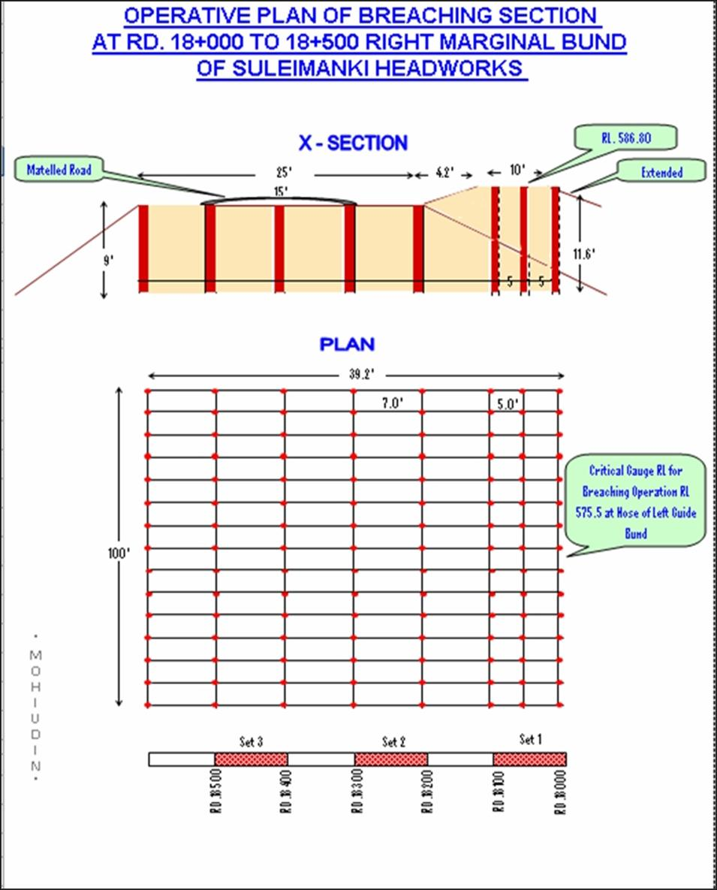

QUANTITY AND VARIETY OF THE EXPLOSIVE REQUIRED FOR DETONATION

The explosive store is situated in canal colony Suleimanki near by Pak Army cantonment at distance of 5-Km from breaching section. The explosive articles lying in the explosive store of Suleimanki Headworks are as under:-

Sr. | Article | Unit | Required Qty | Available Qty | Balance  Qty | Location
1. | Wabox 80%(23+32mm) | Kg | 4416 | 4416 | -- | As discussed during inspection of Army Officers, some items of explosive have become expired. So after clearance of Survey Report detail may change.
2. | Wobonite | Kg | 7481 | 7481 | --
3. | Wabo Card | Meter | 6850 | 6850 | --
4. | DET No 8 Electric | No. | 53 | 53 | --
5. | M.S Electric Delay D.T | No. | 12 | 12 | --
6. | Safety fuse | Meter | 322 | 322 | --
7. | Det No 8 plan I & II | No. | 53 | 53 | --
8. | Det No. 8/33 Elec | No. | 12 | 12 | --
9. | E-I Cable | Meter | 1980 | 1980 | --
10. | Electric Detonator 25 Millisecond | No. | 10 | 10 | --
11. | Det instant | No | 158 | 158 | --
12. | Det 25 Micro | No. | 80 | 80 | --
13. | Explosive PE 3A | Kg. | 10133 | 9981 | -152
NOTE:
As discussed with the Army Officers, There is already sufficient quantity of explosive material and accessories available at Suleimanki and there is o further need of explosive to be procured for purpose of breaching operation.

11.3 ARRANGEMENTS OF EXPLOSIVE AND SECURITY OF EXPLOSIVE STORES

The explosive material for activation of breaching section of Suleimanki Headworks is lying in the explosive store in Canal Colony Suleimanki. At the time of activation of breaching section, 4-Core Regiment Lahore. Pak Army is responsible to mobilize the explosive from explosive store to breaching section site and fix in the boring holes of breaching section according to their procedure. 2-No. security guards are employed (on work charge basis) as requirement of Pak Army Authorities and 2-No regular departmental persons are deputed on the explosive store for security purpose round the clock.

11.4 LIST OF THE SECURITY STAFF ALONG WITH DETAIL OF THEIR TRAINING etc.

The explosive store is being watched round the clock through regular/work charge establishment and they are trained as per instructions received from time to time in this behalf. The explosive store is situated in the boundary of Pak Army Cantt: Suleimanki and the departmental staff is also deployed at explosive store for watching under the supervision of Army Formations.

11.5 DETAIL OF MECHANICAL MEANS AS A STANDBY ARRANGEMENTS IN CASE OF DETONATION FAILURE

Two No. Dozers will be kept ready as stand by arrangement for breaching Right Marginal Bund at the breaching site. 50-No. Kassi Labours will also help for speedy operation and activation of the breaching section. The Dozers will be arranged through requisition from the Agriculture Department Distt: Okara and labour will be hired locally. In addition 3-No. Dozers will be kept ready for breaching of Pakpattan Canal at different sites from RD. 24 to 25.

11.6 DUTY ROSTER IN CASE OF CRITICAL SITUATION

A. HEADWORKS UPSTREAM/DOWNSTREAM PROTECTION BUND

Camp Location | Name of Officer / Designation and Cell No. | Duty of Official | No of Shifts / Time | Flood  Situation.
Control Room at L/S of Barrages | Syed Qasim Raza  Sub Divisional officer  0311-3356484 | Sub Engr=2 No  Mate = 1 No.  Beldar = 4 No &  Regulation staff. | 1/  08-16 hrs | Medium  Flood
Control Room at L/S of Barrages | Syed Qasim Raza  Sub Divisional officer  0311-3356484 | Sub Engr=3 No  Mate = 1No.  Beldar = 4No &  Regulation staff. | 2/  08-16 hrs  16-24 hrs | High Flood
Control Room at L/S of Barrages | 1. Ali Raza Executive Engineer  0301-1302162  2. Syed Qasim Raza  Sub Divisional officer  0311-3356484 | Sub Engr=3 No  Mate = 1No.  Beldar = 4No &  Regulation staff. | 3/  08-16 hrs  16-24 hrs  00-08 hrs | Very High Flood
Control Room at L/S of Barrages | 1. Ali Raza  Executive Engineer  0301-1302162  2. Syed Qasim Raza  Sub Divisional officer  0311-3356484 | Sub Engr=3 No  Mate = 1No.  Beldar = 4No &  Regulation staff. | 3/  08-16 hrs  16-24 hrs  00-08 hrs | Exceptionally  Flood

B. LEFT MARGINAL BUND AND ITS ALLIED SPURS
Camp Location | Name of Officer / Designation and Cell No. | Duty of Official | No of Shifts / Time | Flood  Situation.
Control Room at L/S of Barrages | Syed Qasim Raza  Sub Divisional officer  0311-3356484 | Sub Engr=1 No  Mate =3  Beldar =24 | 2/  08-16 hrs  16-24 hrs | Medium
Control Room at L/S of Barrages | Syed Qasim Raza  Sub Divisional officer  0311-3356484 | Sub Engr=1 No  Mate =3  Beldar =24 | 2/  08-16 hrs  16-24 hrs | High
RD: 10 of LMB | 1. Ali Raza  Executive Engineer  0301-1302162  2. Syed Qasim Raza  Sub Divisional officer  0311-3356484 | Sub Engr=4 No  Mate =7  Beldar =56 | 3/  08-16 hrs  16-24 hrs  00-08 hrs | Very High
RD: 10 of LMB | 1. Ali Raza  Executive Engineer  0301-1302162  2. Syed Qasim Raza  Sub Divisional officer  0311-3356484 | Sub Engr=4 No  Mate =10  Beldar =80 | 3/  08-16 hrs  16-24 hrs  00-08 hrs | Exceptionally

C. RIGHT MARGINAL BUND AND ITS ALLIED SPURS
Camp Location | Name of Officer / Designation & Cell No. | Duty of Official | No of Shifts / Time | Flood  Situation.
Canal Colony  Suleimanki  RD: 10 of RMB | Mian Muhammad Hanif  Sub Divisional officer  0300-6869519 | Sub Engr=1 No  Mate =3  Beldar =24 | 2/  08-16 hrs  16-24 hrs | Medium
RD 16 – 34 of R.M.B | Mian Muhammad Hanif  Sub Divisional officer  0300-6869519 | Sub Engr=1 No  Mate =3  Beldar =24 | 2/  08-16 hrs  16-24 hrs | High
RD 16 – 34 of R.M.B | 1. Ali Raza  Executive Engineer  0301-1302162  2. Mian Muhammad Hanif  Sub Divisional officer  0300-6869519 | Sub Engr=4 No  Mate =7  Beldar =54 | 3/  08-16 hrs  16-24 hrs  00-08 hrs | Very High
RD 16 – 34 of R.M.B | 1. Ali Raza  Executive Engineer  0301-1302162  2. Mian Muhammad Hanif  Sub Divisional officer  0300-6869519 | Sub Engr=4 No  Mate = 10  Beldar =84 | 3/  08-16 hrs  16-24 hrs  00-08 hrs | Exceptionally
11.7 BREACHING COMMITTEE WITH THEIR ACTION PLAN

The breaching committee notified by the Secretary Irrigation (Section Officer Floods), Notification No. SO (FLOODS) VI-33/97 dated 15th July 2015. Comprising of the following persons:
a. Responsibility for the maintenance and operation section shall rest upon the department owning the structure at which the breaching section is located.
b. Breaching section shall be operated on the orders of following committee:-

i. Deputy Commissioner, Okara Convener
ii. Deputy Commissioner, Bahawalnagar & Pakpattan Member
iii. Executive Engineer Suleimanki Division Member
iv. Executive Engineer C&W Department Member
v. Executive Engineer Eastern Bar Division Pakpattan Member
vi. L.T. Colonel Pak Army Member

c. The decision to operate a breaching section shall be taken by the committee keeping in view the technical advice of the Executive Engineer concerned of the Irrigation department. In case of any difference of opinion among the members, the final decision shall rest with the Deputy Commissioner.
d. In case of unavailability of the Deputy Commissioner or his inability to take decision, or in case of a difference of opinion between the Deputy Commissioner of the district in which the breaching section is located and the district which is likely to be affected by the operation of the breaching section, the decision to operate a breaching section shall be taken by the respective Commissioner.
e. Breaching section shall be operated when one or more of the following conditions are met:-
i. The discharge capacity of the structure for which breaching section is located is exceeded and the safety of structure is threatened.
ii. The critical gauge as indicated in the relevant Flood Fighting Plan is achieved or exceeded and is rising.
iii. The safety of major population center-(s) is threatened due to high flood levels and in view of the Executive Engineer concerned of the Irrigation Department, operation of breaching section can help in reduction of flood levels.
f. Where, in view of the Executive Engineer concerned of the Irrigation department or the representative of the department owning the structure at which the breaching section is located, the aforesaid criteria is expected to be met after due consideration of all available technical and hydrological conditions, the aforesaid committee may operate the breaching section before the critical gauge is achieved or exceeded. In every such case, the view of the Executive Engineer concerned of the department or the representative of the department owning the structure shall be expressed in writing and shall be based on flood forecast by Pakistan Meteorological Department or other reliable sources, the trend of discharge in the relevant river at upstream locations, the lag times, estimated attenuation and expected inflows form tributaries, nullahs and streams en-route. Where advance breaching is planned, the committee may also consult professional experts and seek advice from the Superintending Engineer or Chief Engineer concerned of the Irrigation Department.

g. Breaching section shall be operated by the 4-Corp Engineer Regiment Lahore deputed by the Engineering-in-Chief Pakistan Army as indicated in the Flood Fighting Plan. Explosive method shall be preferred method for operation of breaching section. However, the department owning the structure on which the breaching section is located and in case of their failure to do so, Irrigation Department shall make available, in advance, necessary earth moving machinery and other equipment for affecting the breach through mechanical means in the shortest possible time.
h. The Deputy Commissioner concerned and all other relevant agencies shall ensure all necessary arrangements for the safety and if required evacuation of population likely to be effected by the operation of breaching section.

11.8 LIST OF THE VILLAGE LIKELY TO BE INUNDATED IN CASE OF BREACH

Sr.# | Name of village | Population | Detail of Infrastructure
Sr.# | Name of village | Population | Boys School | Girls School | Health Center
1 | Waso Salam Ka | 1121 | - | 1 | -
2 | Sujeke | 1300 | 1 | 1 | -
3 | Mallay Kay | 898 | - | - | -
4 | Judhe ke | 921 | - | - | -
5 | Dona Mathela Salam Ka | 735 | - | - | -
6 | Kutab Saru | 535 | 1 | 1 | -
7 | Qila Bhagela | 315 | - | - | -
8 | Nathu Kay Abdal | 1300 | 1 | 1 | -
9 | Kund Sardar Propia | 325 | - | - | -
10 | Walla Sheikhu Ka | 540 | 1 | - | -
11 | Tali Jamal | 920 | 1 | - | -
12 | Sharin Rohela | 950 | - | - | -
13 | Rakh Abdal kay | 530 | - | - | -
14 | Abdal Kay | 510 | 1 | - | -
15 | Daraz Kay | 450 | - | - | -
16 | Nama Jinde Ka | 1600 | 1 | 1 | 1
17 | Kund Ameer Singh | 300 | - | - | -
18 | Qaim Jinde Ka | 1100 | 1 | 1 | 1
19 | Rakh Thakra | 1325 | 1 | 1 | 1
20 | Mallu Sheikhu Ka | 1112 | 1 | - | -
21 | Ezzat Kay Kala | 750 | - | - | -
22 | Molia Chisti | 1120 | 1 | 1 | 1
23 | Noor Shah | 840 | - | - | -
24 | Mohib Ali Utaar | 1525 | 1 | 1 | 1
25 | Ratte Kay | 850 | 1 | 1 | -
26 | Chor Mahtam | 450 | - | - | -
27 | Sojan Singh Wala | 500 | - | - | -
28 | Lalu Guddar | 560 | 1 | - | -
29 | Chak Lalu | 360 | - | - | -
30 | Mahar Sona | 300 | - | - | -
31 | Mohammad Yar Chisti | 200 | - | - | -
32 | Gunj Bukhsh Sani | 220 | - | - | -
33 | Thakar Kay Manga | 320 | 1 | - | -
34 | Kund Thakar Kay Jagvera | 370 | 1 | - | -
35 | Dara | 340 | 1 | - | -
36 | Chak Dara | 320 | - | - | -
37 | Kandar Kay | 150 | 1 | - | -
38 | Jhangar | 120 | - | - | -
39 | Pana Mahar | 1200 | 1 | 1 | -
40 | Jamsher Mahar | 750 | - | - | -
41 | Ali Kay | 850 | 1 | 1 | -
42 | Dullay Kay Mahar | 750 | 1 | - | -
43 | Qasim Kay Mahar | 620 | - | - | -
44 | Nehal Mahar | 525 | 1 | 1 | -
45 | Ali Kay Rohela | 630 | - | - | -
46 | Moazzam | 300 | - | - | -
47 | Menay Wali | 350 | - | - | -
48 | Sattia Jhangar | 150 | - | - | -
49 | Bhai Khan | 480 | - | - | -
50 | Gunj Bukhsh Bodla | 150 | - | - | -
51 | Ameera Tejay Ka | 160 | 1 | - | -
52 | Thakar Kay Banda | 600 | 1 | - | -
53 | Dharanga | 5500 | 3 | 1 | --
54 | Nikki Maneki | 980 | 1 | 1 | 1
55 | Mehtab Garh | 1200 | 1 | 1 | --
56 | Rakh Bholewal | 300 | -- | -- | --
57 | Bholewal | 1100 | 1 | 1 | Union council
58 | Churra Maneka | 1500 | 1 | 1 | --
59 | Mahnant Darshan | 1183 | 1 | 1 | 1
60 | Mathela Bhidal | 1551 | 1 | 1 | --
61 | Bukan Guddar Ka | 738 | 1 | 1 | --
62 | Bhidal Uttar | 2829 | 1 | 1 | --
63 | Chak Devi Datta | 200 | -- | -- | --
64 | Rakh Jawaya Blouch | 335 | -- | -- | --
65 | Bula Chisti | 933 | 1 | 1 | --
66 | Kalu Wah | 915 | 1 | 1 | --
67 | Noor Shah | 833 | 1 | 1 | --
68 | Wan Nama Jindeka | 448 | -- | -- | --
69 | Mohib Ali Uttar | 2763 | 1 | 1 | --
700 | Pir Ghani | 8038 | 1 | 1 | 1
71 | 39/Sp | 3365 | 1 | 1 | --
72 | Frid Kot | 3100 | 1 | 1 | --
73 | Rakh Abdal Ky | 709 | 1 | 1 | --
74 | Izzat ky kala | 763 | 1 | 1 | --
75 | Molia Chisti | 965 | 1 | 1 | --
76 | Nama Jindeka | 523 | 1 | 1 | --
77 | Billi Mar | 908 | 1 | 1 | --
78 | Chak Dogar | 818 | 1 | 1 | --
79 | Jalil Maneka | 1500 | 1 | 1 | --
Total |  | 77594 | 49 | 36 | 8
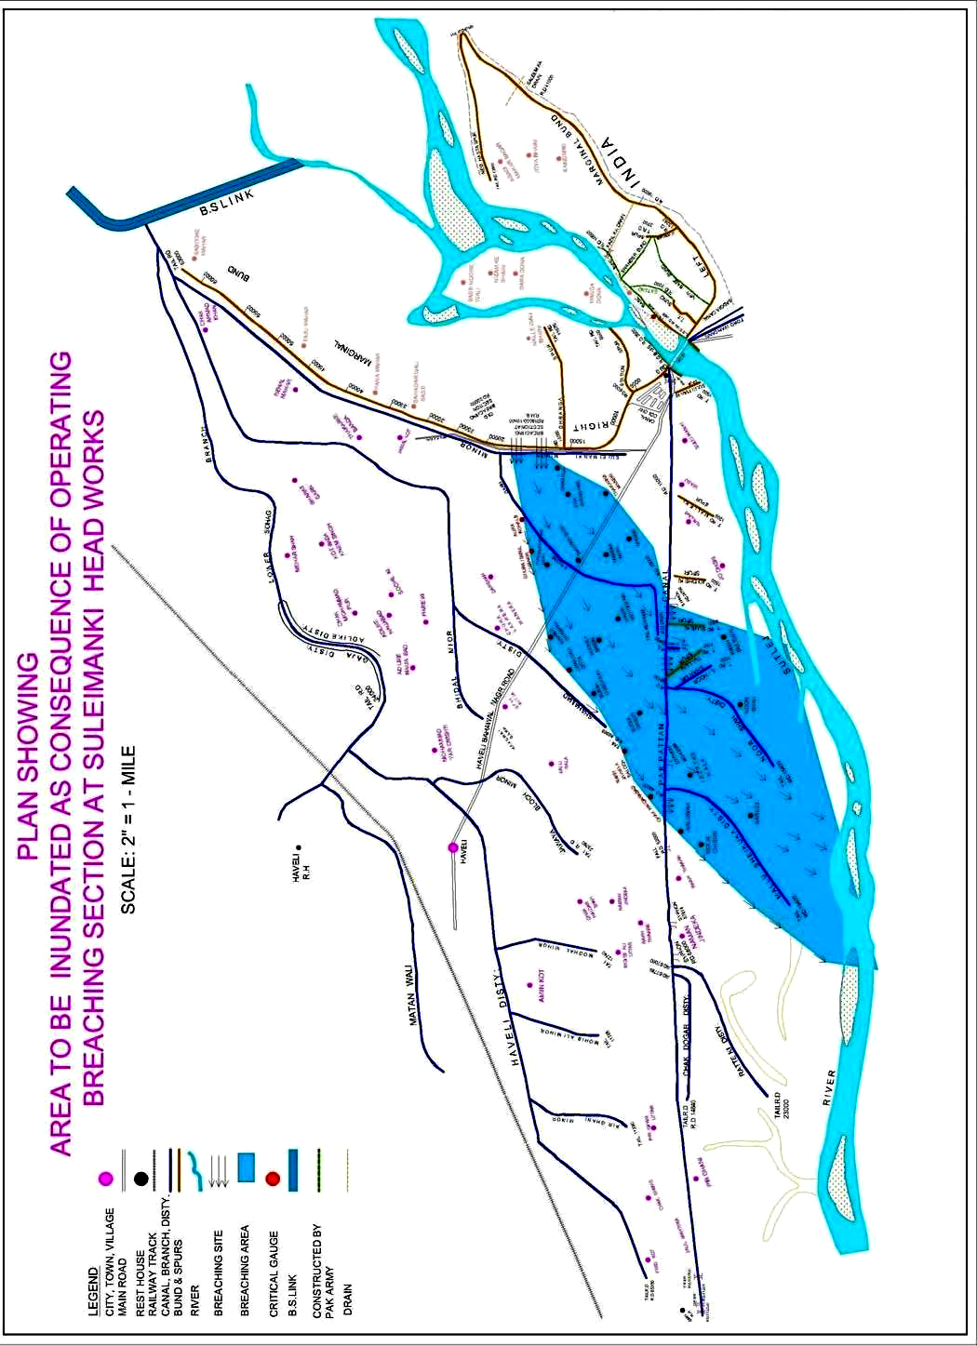
11.9 ANNOUNCEMENT AND DETAIL OF EVACUATION ARRANGEMENTS

Announcement for activation of breaching section will be made through siren installed in Canal Colony Suleimanki. Announcement will also be made through loud Speakers, Mega Phones etc in the villages likely to be inundated by flood water. Evacuation will be made though local arrangements by the respective District Government, Army Units & Civil Defense persons. This task will mainly be accomplished by the District Government & Army authorities as the Irrigation staff will be busy in regulation of Headworks and watching of Bunds.

11.10 DETAILS OF COORDINATION WITH CIVIL / PAK ARMY AUTHORITIES

Flood monitoring cell will be maintained in the Executive Engineer office and in DCO office Pakpattan / Okara and the police staff will perform the duty to intimate daily gauges to all concerned authorities and related persons. Now the information through SMS on mobiles will be given to all concerned corner on every critical movement, Irrigation Department Suleimanki Division has a liaison with Army Authorities and Rangers. Engineer Corps of Army also will inform about the bridges and infrastructure condition of bunds / spurs. Meeting with Civil Authorities will be arranged as required and according to flood situation.

11.11 PARALLEL COMMUNICATION ARRANGEMENTS

The communication arrangements will be supplemented through police wireless network installation at various Headworks linked up with flood warning center, Lahore. The communication will help to receive the latest flood situation of all the respective sites. The information will be communicated to the District formation and Army authorities.

Executive Engineer
Suleimanki Headworks Division
Suleimanki

11.12 INDEX PLAN

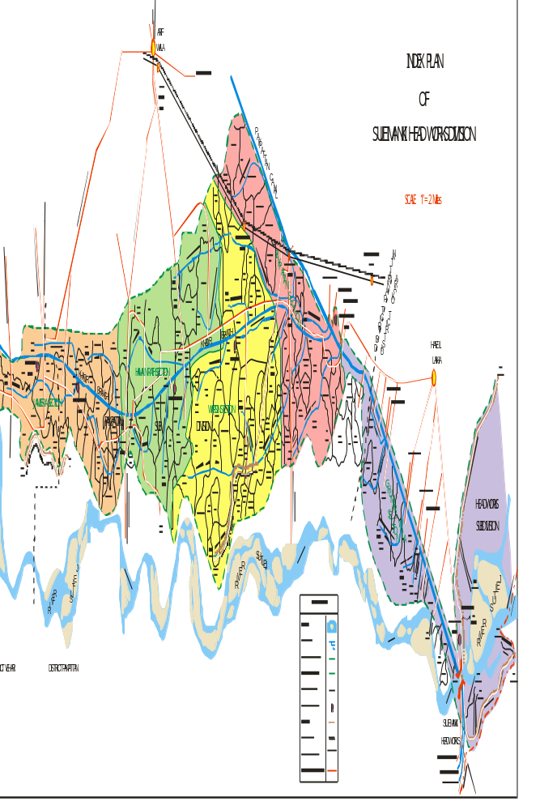

CHAPTER - 12

VULNERABLE SITES ON FLOOD BUNDS / STRUCTURE

12.1 APPREHENDED BREACHES IN FLOOD BUNDS / STRUCTURES.

- Right Marginal Bund from RD: 33000-35000
Vulnerable Sites
- Left Marginal Bund from RD:8000-10000

12.2 OPERATION OF BREACHING SECTION.

Operation of breaching section has been discussed in detail in Chapter No.11.

12.3 BREACHES DUE TO RISE OF FLOOD WATER, DETERIORATION OF FLOOD BUNDS.

No high / exceptionally flood has been experienced after 1995 and the flood bunds at Suleimanki Headworks are safe and sound.
CHAPTER - 13

EMERGENCY CONTINGENCY / PLAN FOR VULNERABLE SITES

PLAN
A

EMERGENCY CONTINGENCY PLAN FOR VULNERABLE REACH RD. 33000-35000 RIGHT MARGINAL BUND

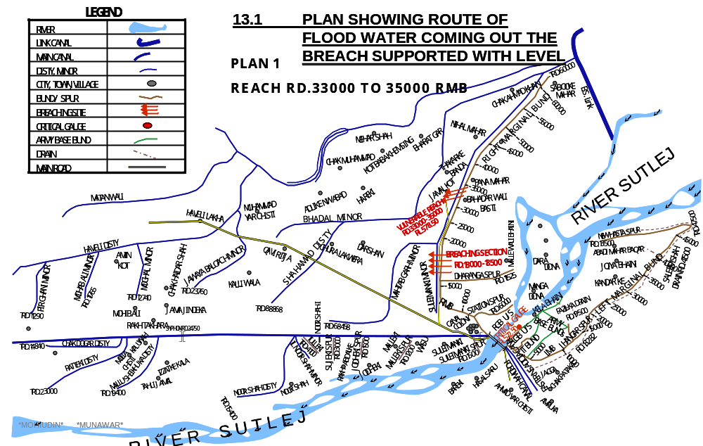
PAKPATTAN CANAL UPPER
13.2 DETAIL OF VILLAGE ABADIES LIKELY TO BE AFFECTED AND THIS ALSO BE SHOWN ON THE PLAN

Pana Mahar, Jamal Kot, Jamal Kot, Bulleh Wal, Gudderke, Kili piran wali, Thakarka Maneki, Stia Jhangha, Dharanga, Alika Rohals, Rakh Bulewal, Mehtab Garh, Meneka Nikki, Gurwala Mehtab Garh, Mathila, Bhidal, Mahant darshan, Maneki, Ghura Ismail Maneki, Ghura Mehtab Rai, Chak Davi Ditta, Bukkan Guddar Ka, Boola Chishti, Rakh Jawaya Baluch, Kaluwah, Noor Shah, Chak Haiderabad, Bareet,

13.3 STRATEGY AND ACTION TAKEN, EXPLAINED IN DETAIL. THIS MAY INCLUDE

In case of breach occur in Right Marginal Bund of Suleimanki Headworks alert will be issued to Assistant Commissioner, Depalpur and Executive Engineer, Khanwah Division cuts will be made in road from Haveli to Suleimanki Headworks and Pakpattan Canal Upper to route flood water that to River Downstream of Suleimanki Headworks.

13.3.1 ARRANGEMENTS.

A flood control center will be established in canal telegraph office Suleimanki and responsible staff will be available round the clock. One base high range wireless set will be installed at canal Telegraph Office, Suleimanki by the Police Department. 2 Nos. mobile Motorola sets of 30 kilometer range will be provided for installing in the vehicles of Executive Engineer, Suleimanki Division NBC, Sub Divisional Officer, Headworks Sub Division, Pakpattan to keep them vigilant all the time.
Three No. Mobile wirelesses set (hand set) will be provided under acute emergency during very high flood at different vulnerable points. These arrangements will be made by the telecommunication of Wing Police Department.

13.3.2 ESTABLISHMENT OF FLOOD FIGHTING CAMPS

The Flood Fighting camps will be arranged at RD.33+000 of Right Marginal Bund as per requirements according to flood situation.

13.3.3 DUTIES OF OFFICER / OFFICIALS AND THEIR CAMP SITES

Camp Location | Duty of Officer | Duty of Official | No of Shifts / Time | Flood  Situation.
Control Room at L/S of Barrages | Syed Qasim Raza  Sub Divisional officer  0311-3356484 | Sub Engr=2-No.  Mate = 1No.  Beldar = 4No &  Regulation staff. | 1/  08-16 hrs | Medium  Flood
Control Room at L/S of Barrages | Syed Qasim Raza  Sub Divisional officer  0311-3356484 | Sub Engr=3-No.  Mate = 1No.  Beldar = 4No &  Regulation staff. | 2/  08-16 hrs  16-24 hrs | High Flood
Control Room at L/S of Barrages | 1. Faheem Fareed  Executive Engineer  0320-4101301  2. Syed Qasim Raza  Sub Divisional officer  0311-3356484 | Sub Engr=3-No.  Mate = 1No.  Beldar = 4No &  Regulation staff. | 3/  08-16 hrs  16-24 hrs  00-08 hrs | Very High Flood
Control Room at L/S of Barrages | 1. Faheem Fareed  Executive Engineer  0320-4101301  2. Syed Qasim Raza  Sub Divisional officer  0311-3356484 | Sub Engr=3-No.  Mate = 1No.  Beldar = 4No &  Regulation staff. | 3/  08-16 hrs  16-24 hrs  00-08 hrs | Exceptionally  Flood

Note:-
* Executive Engineer Suleimanki will be the over all In-charge of the whole operation during very high and exceptionally high flood.
* All the Sub Engineer will perform their duties assigned above along with their establishment with necessary T & P.
* However the duties of remaining Sub Engineers with their establishment would be called any time any where and at any point as desired and required by the Sub Divisional Officer In-charge under intimation to Executive Engineer Suleimanki the In-charge of whole operation.

13.3.4 DEPARTMENTAL MACHINERY AVAILABLE

One number Tractor with hydraulic Trolley & One number Tractor with Boozer, 1-No. Hooper-funnel, and 1-No. sand filling machine available.

13.3.5 MACHINERY AVAILABLE FROM PRIVATE SOURCE.

Machinery will be arranged if required from enlisted Government Contractors.

13.3.6 & 13.3.7 DETAIL OF FLOOD FIGHTING MATERIAL FOR VULNERABLE SITE NO.1 (R.M.B)

Sr. | Item | Unit | Qty | Qty Available | Balance Quantity
1. | G.I Buckets. | No. | 40 | -- | 40
2. | Empty Gunny Bags | No. | 2000 | 500 | 1500
3. | Swiss cottage Tent | No. | 1 | 1 | --
4. | Chouldaries. | No. | 4 | 2 | 2
5. | Sutli | Kg | 5 | 3 | 2
6. | Needles. | No. | 12 | 3 | 9
7. | Killas | No. | 1000 | 300 | 700
8. | Torches | No. | 16 | 14 | 2
9. | Kassaies | No. | 1000 | 45 | 955
10. | Axes | No. | 20 | 5 | 15
11. | Manila Rope | Kg | 200 | 200 | --
12. | Generator | No. | 1 | 1 | --
13. | Electric Cable 7/0029 | Roll | 5 | -- | 5
14. | Electric Cable 3/0029 | Roll | 5 | -- | 5
15. | Energy Saver 23 W | No. | 50 | -- | 50
16. | Bamboos 8’o 10’ long | No. | 100 | -- | 100
17. | Petrol for Running Generator | Ltr | 2000 | -- | 2000
18. | Steel Charpoy | No. | 12 | 12 | --
19. | Folding Table | No. | 1 | 1 | --
20. | Folding Chair | No. | 6 | 6 | --
21. | Khaji Mates | No | 2000 | 500 | 1500
22. | Life Jackets | No. | 25 | 25 | --
23. | Wheel Barrow | No. | 3 | 3 | --

NOTE:-

Balance quantity of flood fighting material will be procured before the start of flood season 2024.
13.4 DETAIL OF OTHER INFRASTRUCTURE LIKE ELECTRICITY, SUI GAS, TELEPHONE INSTALLATION, ROAD NETWORK, OTHER BUILDING, CANAL AND DRAINAGE NETWORK

RIGHT MARGINAL BUND
The following Irrigation and roads networks shall be affected in case of breach on Right Marginal Bund.

DETAIL OF IRRIGATION NETWORK ON RIGHT SIDE
Sr.# | Name of Channel | From RD. | To RD.
1 | Shahamid Disty | 39000 | 88868
2 | Matab Garh Minor | 25000 | 68458
3 | Suleimanki Sub Minor | 0 | 16000
4 | Bhidal Minor | 0 | 13000
5 | Haveli Disty | 18000 | 65000
6 | Jawaya Blouch Minor | 8000 | 23750
7 | Mughal Minor | 6000 | 12745
8 | Mohib Ali Minor | 3000 | 11765
9 | Pir Ghani Minor | 2000 | 11290
10 | Musewal Disty |  | Tail Reach
11 | Noor Shah I Disty | 0 | 1500 Tail
12 | Noor Shah II Disty | 0 | 15500 Tail
13 | Mallushekuka Disty | 0 | 19700 Tail
14 | Ratteki Disty | 7000 | 23000 Tail
15 | Chack Dogar Disty | 5000 | 14840 Tail

DETAIL OF ROAD NETWORK
Sr.# | Name of Village | Population | Detail of Infrastructure
Sr.# | Name of Village | Population | Boys school | Girl school | Health Centers | Tel: Exchange | Misc: | Road
1 | Dharanga | 5500 | 3 | 1 | -- | -- | -- | 1
2 | Nikki Maneki | 980 | 1 | 1 | 1 | 1 | -- | 1
3 | Mehtab Garh | 1200 | 1 | 1 | -- | -- | -- | 1
4 | Rakh Bholewal | 300 | -- | -- | -- | -- | -- | 1
5 | Bholewal | 1100 | 1 | 1 | -- | -- | U.C. | 1
6 | Churra Maneka | 1500 | 1 | 1 | -- | -- | -- | 1
7 | Mahnant Darshan | 1183 | 1 | 1 | 1 | -- | -- | 1
8 | Mathela Bhidal | 1551 | 1 | 1 | -- | -- | -- | 1
9 | Bukan Guddar Ka | 738 | 1 | 1 | -- | -- | -- | 1
10 | Bhidal Uttar | 2829 | 1 | 1 | -- | -- | -- | 1
11 | Chak Devi Datta | 200 | -- | -- | -- | -- | -- | 1
12 | Rakh Jawaya Blouch | 335 | -- | -- | -- | -- | -- | 1
13 | Bula Chisti | 933 | 1 | 1 | -- | -- | -- | 1
14 | Kalu Wah | 915 | 1 | 1 | -- | -- | -- | 1
15 | Noor Shah | 833 | 1 | 1 | -- | -- | -- | 1
16 | Wan Nama Jindeka | 448 | -- | -- | -- | -- | -- | 1
17 | Mohib Ali Uttar | 2763 | 1 | 1 | -- | -- | -- | 1
18 | Pir Ghani | 8038 | 1 | 1 | 1 | 1 | -- | 1
19 | 39/Sp | 3365 | 1 | 1 | -- | -- | -- | 1
20 | Frid Kot | 3100 | 1 | 1 | -- | -- | -- | --
21 | Rakh Abdal Ky | 709 | 1 | 1 | -- | -- | -- | 1
22 | Izzat ky kala | 763 | 1 | 1 | -- | -- | -- | 1
23 | Molia Chisti | 965 | 1 | 1 | -- | -- | -- | 1
24 | Nama Jindeka | 523 | 1 | 1 | -- | -- | -- | 1
25 | Billi Mar | 908 | 1 | 1 | -- | -- | -- | 1
26 | Chak Dogar | 818 | 1 | 1 | -- | -- | -- | 1
27 | Jalil Maneka | 1500 | 1 | 1 | -- | -- | -- | --
Total |  | 43997 | 25 | 23 | 3 | 2 | 0 | 25

CHAPTER - 13

EMERGENCY CONTINGENCY / PLAN FOR VULNERABLE SITES

PLAN
B

EMERGENCY CONTINGENCY PLAN FOR VULNERABLE REACH RD. 8000-10000 LEFT MARGINAL BUND

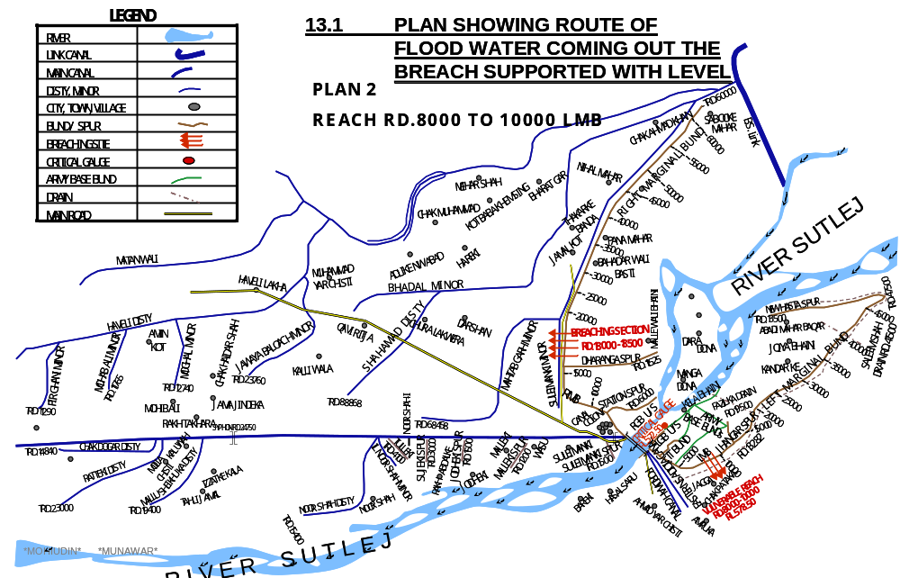
PAKPATTAN CANAL UPPER

13.2 DETAIL OF VILLAGE ABADIES LIKELY TO BE AFFECTED AND THIS ALSO BE SHOWN ON THE PLAN

Gung bukhsh sani, Jhanger, Ahmad yar Chisti, Suleimanki, Avanah wali Bhani, Hasal Saru, Kutab Saru, Dona, Chak Pataka, Tibhu, Amruke, Bary ke

13.3 STRATEGY AND ACTION TAKEN, EXPLAINED IN DETAIL. THIS MAY INCLUDE

In case Left Marginal Bund Breaches flood water will rush toward Eastern Sadiqia Canal and Fordwah Canal and may enter in canals by breaching their banks. In this situation alert will be issued to Executive Engineers, Sadiqia & Fordwah Canal Division. These both sister divisions will make necessary arrangements for the safety of canals and to drain flood water back to river downstream of Suleimanki Headworks.

13.3.1 ARRANGEMENTS.

A flood control center will be established in canal telegraph office Suleimanki and responsible staff will be available round the clock. One base high range wireless set will be installed at canal Telegraph Office, Suleimanki by the Police Department. 2 Nos. mobile Motorola sets of 30 kilometer range will be provided for installing in the vehicles of Executive Engineer, Suleimanki Division NBC, Sub Divisional Officer, Headworks Sub Division, Pakpattan to keep them vigilant all the time.
Three number Mobile wirelesses set (hand set) will be provided under acute emergency during very high flood at different vulnerable points. These arrangements will be made by the telecommunication of Wing Police Department.

13.3.2 ESTABLISHMENT OF FLOOD FIGHTING CAMPS

The Flood Fighting camps will be arranged at RD.8+000 of Left Marginal Bund as per requirements according to flood situation.

13.3.3 DUTIES OF OFFICER / OFFICIALS AND THEIR CAMP SITES

Camp Location | Duty of Officer | Duty of Official | No of Shifts / Time | Flood  Situation.
Control Room at L/S of Barrages | Syed Qasim Raza  Sub Divisional officer  0311-3356484 | Sub Engr =2-No  Mate =3  Beldar =24 | 2/  08-16 hrs  16-24 hrs | Medium
Control Room at L/S of Barrages | Syed Qasim Raza  Sub Divisional officer  0311-3356484 | Sub Engr =2-No  Mate =3  Beldar =24 | 2/  08-16 hrs  16-24 hrs | High
RD: 10 of LMB | 1. Ali Raza  Executive Engineer  0301-1302162  2. Syed Qasim Raza  Sub Divisional officer  0311-3356484 | Sub Engr =4-No  Mate =7  Beldar =56 | 3/  08-16 hrs  16-24 hrs  00-08 hrs | Very High
RD: 10 of LMB | 1. Ali Raza  Executive Engineer  0301-1302162  2. Syed Qasim Raza  Sub Divisional officer  0311-3356484 | Sub Engr =4-No  Mate =10  Beldar =80 | 3/  08-16 hrs  16-24 hrs  00-08 hrs | Exceptionally

13.3.4 DEPARTMENTAL MACHINERY AVAILABLE

One number Tractor with hydraulic trolley & Boozer is available.

13.3.5 MACHINERY AVAILABLE FROM PRIVATE SOURCE.

Machinery will be arranged if required from enlisted Government Contractors.

13.3.6 & 13.3.7 FLOOD FIGHTING MATERIAL REQUITED & AVAILABLE FOR VENERABLE SITE NO.2.

Sr. | Item | Unit | Qty | Qty Available | Balance Quantity
1. | G.I Buckets. | No. | 40 | -- | 40
2. | Empty Gunny Bags | No. | 2000 | 500 | 1500
3. | Swiss cottage Tent | No. | 1 | 1 | --
4. | Chouldaries. | No. | 4 | 2 | 2
5. | Sutli | Kg | 5 | 3 | 2
6. | Needles. | No. | 12 | 3 | 9
7. | Killas | No. | 1000 | 300 | 700
8. | Torches | No. | 16 | 14 | 2
9. | Kassaies | No. | 1000 | 45 | 955
10. | Axes | No. | 20 | 5 | 15
11. | Manila Rope | Kg | 200 | 200 | --
12. | Generator | No. | 1 | 1 | --
13. | Electric Cable 7/0029 | Roll | 5 | -- | 5
14. | Electric Cable 3/0029 | Roll | 5 | -- | 5
15. | Energy Saver 23 W | No. | 50 | -- | 50
16. | Bamboos 8’o 10’ long | No. | 100 | -- | 100
17. | Petrol for Running Generator | Ltr | 2000 | -- | 2000
18. | Steel Charpoy | No. | 12 | 12 | --
19. | Folding Table | No. | 1 | 1 | --
20. | Folding Chair | No. | 6 | 6 | --
21. | Khaji Mates | No | 2000 | 500 | 1500
22. | Life Jackets | No. | 25 | 25 | --
23. | Wheel Barrow | No. | 3 | 3 | --
Note: Balance quantity of flood fighting material will be procured before the start of
flood season 2024 and material is stored old building of Divisional Office in canal colony Suleimanki.
13.4 DETAIL OF OTHER INFRASTRUCTURE LIKE ELECTRICITY, SUI GAS, TELEPHONE INSTALLATION, ROAD NETWORK, OTHER BUILDING, CANAL AND DRAINAGE NETWORK.

LEFT MARGINAL BUND

The following Irrigation and roads networks shall be affected in case of breach on Left Marginal Bund.

DETAIL OF IRRIGATION NETWORK ON RIGHT SIDE

Sr.# | Name of Channel | From RD. | To RD.
1 | Fordwah Canal | 4000 | 6000
2 | Sadiqia Canal | 4000 | 6000
3 | Saru Minor | 0000 | Tail
4 | Awami Canal | 2000 | 4000

DETAIL OF ROAD NETWORK

Sr | Name of Village | Population | Detail of Infrastructure
Sr | Name of Village | Population | Boys school | Girl school | Health Centers | Tel: Exchange | Misc: | Road
1 | Bareke | 5500 | 2 | 1 | 1 | 1 | -- | -
2 | Hasal Saru | 980 | 1 | 1 | -- | -- | -- | -
3 | Kutab Saru | 1200 | 1 | -- | -- | -- | -- | -
4 | Dona | 300 | 1 | -- | -- | -- | -- | -
5 | Amru ke | 1800 | 1 | 1 | 1 | -- | Union Council | -
6 | Chak Pataka | 950 | 1 | 1 | -- | -- | -- | -
7 | Ahmad yar Chisti | 800 | -- | -- | -- | -- | -- | -
8 | Ganj Bukhsh Sani | 500 | -- | -- | -- | -- | -- | -
9 | Suleimanki | 738 | 1 | -- | -- | -- | -- | -
10 | Awana wali Bhani | 2829 | 1 | 1 | -- | -- | -- | -
Total |  | 15597 | 9 | 5 | 2 | 1 | -- | --

Note:-
These villages fall in district Bahawalnagar as well as canal network falls in Bahawalnagar Canal Circle of Bahawalpur Zone. Sister Division Sadiqia & Fordwah of Bahawalnagar Circle will assist in case of emergency on Left side.

CHAPTER - 14

ACTION PLAN

14.1 RE-SHUFFLING / RECOUPING PLAN OF RESERVE STOCK OF STONE DEPARTMENTALLY.

POSITION OF RESERVE STOCK STONE ON EACH RIVER TRAINING COMPONENTS

Quantity in Lac Cft
Sr. | Name Of Structure | Reserve Stock Limit  (as per Yard Stick) | Minimum Required 70% | Quantity  Available | Balance Quantity Required
1 | Dharanga Spur | 1.000 | 0.700 | 0.360 | 0.640
2 | Station Spur | 1.000 | 0.700 | 0.580 | 0.420
3 | Suleimanki Spur | 0.500 | 0.350 | 0.530 | 0.000
4 | Malleki Spur | 0.500 | 0.350 | 0.262 | 0.260
5 | Jodheki Spur | 0.000 | 0.000 | 0.040 | 0.000
6 | Sujeki Spur | 0.500 | 0.350 | 0.355 | 0.180
7 | Tulleki Spur | 1.500 | 1.050 | 0.710 | 0.700
8 | Left Guide Bund Upstream | 1.500 | 1.050 | 0.990 | 0.510
9 | Left Guide Bund Downstream | 1.000 | 0.700 | 1.030 | 0.000
10 | Right Guide Bund Upstream & UPC Right | 1.500 | 1.050 | 1.010 | 0.490
11 | Right Guide Bund Downstream | 1.000 | 0.700 | 0.870 | 0.135
Total |  | 10.00 | 7.00 | 6.737 | 3.335

14.2 DETAIL OF INLET AND OUTLET CROSSING ALONGWITH CLOSING METHODOLOGY.

Sr. | Name of Bund / Spur | RD | Outlet / Inlet | Existing position | Closing Methodology
1 | Left Marginal Bund | 1+575 | Inlet | Feeding pondage scheme by Pak Army | Will be closed on receipt of Flood Emergency with regulation karries, groves are provided in the structure
2 | Left Marginal Bund | 4+500 | Inlet | Feeding pondage scheme by Pak Army | Will be closed on receipt of Flood Emergency with regulation karries, groves are provided in the structure
3 | Right Marginal Bund | 2+500 | Tube well Water course crossing | 18" dia pipe fixed by Pak Army for feeding fish pond | Will be closed on receipt of Flood Emergency with gunny bags which are available on stock for Flood Fighting Purpose.
4 | Right Marginal Bund | 4+500 | Tube well Water course crossing | 12" dia pipe fixed for irrigate to flower garden / grassy plot of rest house, residence of SDO, XEN & Divisional Office. | Will be closed on receipt of Flood Emergency with gunny bags which are available on stock for Flood Fighting Purpose.
5 | Right Marginal Bund | 6+500 | Tube well Water course crossing | 18" dia pipe fixed by Pak Army for feeding fish pond | Will be closed on receipt of Flood Emergency with gunny bags which are available on stock for Flood Fighting Purpose.
6 | Right Marginal Bund | 12+390 | Tube well Water course crossing | 12" dia pipe fixed for irrigate to land of land owners. | Closed with earth.
7 | Right Marginal Bund | 12+500 | Tube well Water course crossing | 12" dia pipe fixed for irrigate to land of land owners. | Closed with earth.
Sr. | Name of Bund / Spur | RD | Outlet / Inlet | Existing position | Closing Methodology
8 | Right Marginal Bund | 13+593 | Nikki Nalah culverts | As per departmental design parameters | Closed by force.
9 | Right Marginal Bund | 14+610 | Outlet Water course crossing | 12" dia pipe fixed for irrigate to land of land owners. | Closed with earth.
10 | Right Marginal Bund | 28+050  Shifted from original 27+935 | Outlet Water course crossing | 12" dia pipe fixed for irrigate to land of land owners. | Closed with earth.
11 | Right Marginal Bund | 40+390 | Outlet Water course crossing | 12" dia pipe illegally fixed for irrigate to land of land owners. | Closed with earth.
12 | Right Marginal Bund | 46+150 | Outlet Water course crossing | 12" dia pipe illegally fixed for irrigate to land of land owners. | Closed with earth.
13 | Right Marginal Bund | 50+340 | Outlet Water course crossing | 12" dia pipe fixed for irrigate to land of land owners. | Closed with earth.
14 | Right Marginal Bund | 57+500 | Outlet Water course crossing | 12" dia pipe fixed for irrigate to land of land owners. | Closed with earth.
15 | Dharanga Spur | 1+040 | Nikki Nalah culverts | As per departmental design parameters | Closed by force.
.

14.3 DEPLOYMENT OF MACHINERY (Low to Medium Flood).

Name of Structure | Length in Mile | Vulnerable Reach | Camp Location | Site In-charge by name & Cell No. | Machinery Deployed
 |  |  |  |  | Excavator | Dozer | Trolleys / Dumpers | Tractor with front blade | Labour (Beldar + Mate) | Availability of Stone Cft
2 | 3 | 4 | 5 | 6 | 7 | 8 | 9 | 10 | 11 | 12
RMB RD 0+000 to 63+000  (and allied spur) | 12.6 | RD.33+000 to 35+000 of RMB | RD.33+000 of RMB | Sub Engineer Station Section | 1 | -- | 2 | 1 | 12+1 | 0.68 Cft (RD.0+000 to 11+525 Dharanga Spur)  0.26 Cft (RD.0+000 to 6+000 of Station Spur)
LMB RD.0+000 to 47+500 (and allied spur) | 9.5 | RD.8+000 to 10+000 of LMB | RD.8+000 of LMB | Sub Engineer Headworks Section | 1 | -- | 2 | 1 | 12+1 | 1.63 Lac Cft  LGB U/S & D/S
Total | 22.1 |  |  |  | 2 | -- | 4 | 2 | 24+2

14.3 DEPLOYMENT OF MACHINERY (Medium to High Flood).

Name of Structure | Length in Mile | Vulnerable Reach | Camp Location | Site In-charge by name & Cell No. | Machinery Deployed
 |  |  |  |  | Excavator | Dozer | Trolleys / Dumpers | Tractor with front blade | Labour (Beldar + Mate) | Availability of Stone Cft
2 | 3 | 4 | 5 | 6 | 7 | 8 | 9 | 10 | 11 | 12
RMB RD 0+000 to 63+000  (and allied spur) | 12.6 | RD.33+000 to 35+000 of RMB | RD.33+000 of RMB | Sub Engineer Station Section | 2 | -- | 4 | 1 | 24+3 | 0.68 Cft (RD.0+000 to 11+525 Dharanga Spur)  0.26 Cft (RD.0+000 to 6+000 of Station Spur)
LMB RD.0+000 to 47+500 (and allied spur) | 9.5 | RD.8+000 to 10+000 of LMB | RD.8+000 of LMB | Sub Engineer Headworks Section | 1 | -- | 2 | 1 | 24+3 | 1.63 Lac Cft  LGB U/S & D/S
Total | 22.1 |  |  |  | 3 | -- | 6 | 2 | 48+6

14.4 DEPLOYMENT OF MACHINERY (High to Very High Flood).

Name of Structure | Length in Mile | Vulnerable Reach | Camp Location | Site In-charge by name & Cell No. | Machinery Deployed
 |  |  |  |  | Excavator | Dozer | Trolleys / Dumpers | Tractor with front blade | Labour (Beldar + Mate) | Availability of Stone Cft
2 | 3 | 4 | 5 | 6 | 7 | 8 | 9 | 10 | 11 | 12
RMB RD 0+000 to 63+000  (and allied spur) | 12.6 | RD.33+000 to 35+000 of RMB | RD.33+000 of RMB | Sub Engineer Station Section | 2 | -- | 4 | 1 | 56+7 | 0.68 Cft (RD.0+000 to 11+525 Dharanga Spur)  0.26 Cft (RD.0+000 to 6+000 of Station Spur)
LMB RD.0+000 to 47+500 (and allied spur) | 9.5 | RD.8+000 to 10+000 of LMB | RD.8+000 of LMB | Sub Engineer Headworks Section | 1 | -- | 2 | 1 | 56+7 | 1.63 Lac Cft  LGB U/S & D/S
Total | 22.1 |  |  |  | 3 | -- | 6 | 2 | 112+14

14.5 DEPLOYMENT OF MACHINERY (High to Exceptionally High Flood).

Name of Structure | Length in Mile | Vulnerable Reach | Camp Location | Site In-charge by name & Cell No. | Machinery Deployed
 |  |  |  |  | Excavator | Dozer | Trolleys / Dumpers | Tractor with front blade | Labour (Beldar + Mate) | Availability of Stone Cft
2 | 3 | 4 | 5 | 6 | 7 | 8 | 9 | 10 | 11 | 12
RMB RD 0+000 to 63+000  (and allied spur) | 12.6 | RD.33+000 to 35+000 of RMB | RD.33+000 of RMB | Sub Engineer Station Section | 2 | 1 | 6 | 2 | 80+10 | 038 Cft (RD.0+000 to 11+525 Dharanga Spur)  0.26 Cft (RD.0+000 to 6+000 of Station Spur)
LMB RD.0+000 to 47+500 (and allied spur) | 9.5 | RD.8+000 to 10+000 of LMB | RD.8+000 of LMB | Sub Engineer Headworks Section | 2 | 1 | 4 | 2 | 80+10 | 1.63 Lac Cft  LGB U/S & D/S
Total | 22.1 |  |  |  | 4 | 2 | 10 | 4 | 160+20

Note:-
Payment for machinery and work charge employees subject to verification by Third Party Monitoring / Departmental Committee.

LIST OF LOCAL CONTRACTORS

Name of Govt. Contractor | Contact Number | Remarks
Mohammad Iqbal | 0333-6974306 | Excavators and other machinery may be made available through these contractors.
Muhammad Rafique | 0303-2169786
Muhammad Amin Tahir | 0300-8698471
Mudassar Rehman | 0308-8082918

14.6 POLICE DEPLOYMENT PLAN
Proforma – 1
Sr. | Site of Breaching Section | Concerned Canal Division | Concerned Police Station and District | Police Persons Deployed |  | Remarks (if any)
 |  |  |  | Inspector / Sub Inspector / A.S.I | Constable | Remarks (if any)
1 | RMB  RD.18+000 to 18+500 | Suleimanki | Haveli Lakha Police Station  Distt: Okara | ASI=1 | 2 | --

Proforma – 2
Sr. | Vulnerable sites used for illegal cuts during floods | Concerned Canal Division | Concerned Police Station and District | Police Persons Deployed |  | Remarks (if any)
 |  |  |  | Inspector / Sub Inspector / A.S.I | Constable | Remarks (if any)
1 | RMB  RD.35-36  36-37 | Suleimanki | Haveli Lakha Police Station  Distt: Okara | ASI=1 | 2 | --

Proforma – 3
Sr. | Name of Barrage | Concerned Canal Division | Concerned Police Station and District | Police Persons Deployed |  | Remarks (if any)
 |  |  |  | Inspector / Sub Inspector / A.S.I | Constable | Remarks (if any)
1 | Suleimanki | Suleimanki | Haveli Lakha Police Station  Distt: Okara | ASI=1 | 4 | --

14.7. DETAIL OF SYNTHETIC BAGS WITH CAPACITY OF 500 KG AND 1000 KG.

Sr. | Synthetic Bags | Quantity Required | Available Quantity | Balance Quantity | Remarks
1 | Capacity  500 KG | 3000 No. | -- | 3000 No. | Will be procured before onset of Flood Season 2024
2 | Capacity  1000 Kg | 1500 No. | -- | 1500 No. | Will be procured before onset of Flood Season 2024

14.8 DETAIL OF POLYTHENE SHEETS OF BLACK COLOUR TO PROTECT upstream SLOPE AGAINST WAVE ACTION AND TO CONTROL SEEPAGE THROUGH EMBANKMENT.

Sr. | Polythene Sheet | Quantity Required | Available Quantity | Balance Quantity | Remarks
1 | Average 20 ft width | 196647 Rft | -- | 196647 Rft | Will be procured before onset of Flood Season 2023

CHAPTER - 15

BACK UP DIVISIONS
(IN CASE OF BREACH)

In case of emergency Easter Bar Canal Division of Nili Bar Canal Circle and Khanwah Canal Division of Sukhrawa Canal Circle will be back-up divisions for Right Flank of River Sutlej at Suleimanki Headworks while Eastern Sadiqia Canal Division and Fordwah Canal Division of Bahawalnagar Canal Circle will be back-up divisions for Left Flank of River Sutlej at Suleimanki Headworks.

Executive Engineer
Suleimanki Headworks Division
Suleimanki

