FLOOD FIGHTING PLAN 2024

OKARA CANAL DIVISION, LBDC
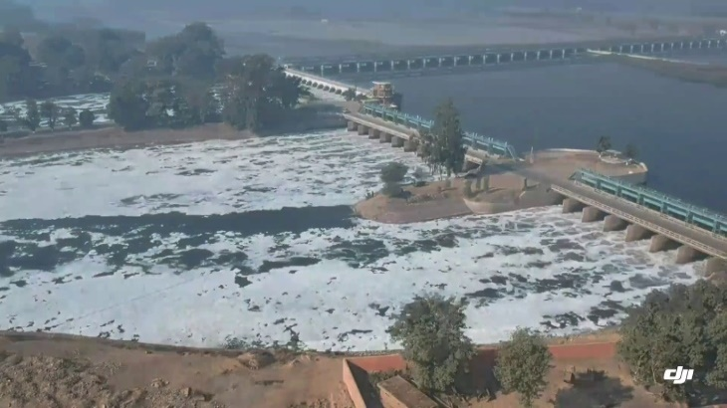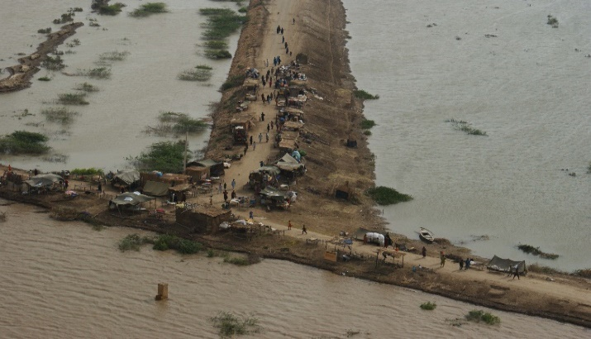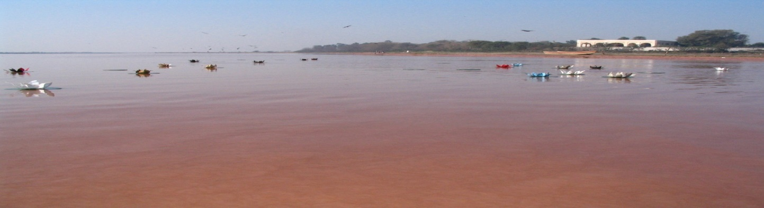OKARA

PUNJAB IRRIGATION DEPARTMENT

Contents
PART - A
1 SALIENT FEATURES 1
1.1 Location 1
1.2 General Description 1
1.3 Administrative Setup 2
2 FLOOD PROTECTIOB AND RIVER TRAINING WORKS OF OKARA CANAL DIVSION 3
2.1 Design Parameter of River Training Works 3
2.2 Location Map/Index Plan 4
3 BRIEF HISTORY OF PAST FLOOD EVENTS 5
4 DESIGN DATA, HISTORIC PEAK FLOOD DATA AND PREVIOUS FIVE YEARS FLOOD DATA OF HEAD WORKS/BARRAGES AND OR OTHER CONTROL POINTS 6
4.1 Flood Limits 6
4.2 Time Lags of Floods 6
4.3 Highest Floods 6
4.4 Peak Discharges 7
5 FLOOD FIGHTING STRATEGY FOR RIVER RAVI D/S BALLOKI IN OKARA 9
6 FLOOD DAMAGES RESTORATION WORKS 10
7 FLOOD WATCHING ARRANGEMENT 11
7.1 Pre-Flood Arrangements 11
7.2 Watching Establishment 12
7.3 Arrangement at Sensitive Sites 13
7.4 Watching Material 14
7.5 Arrangement for sounding & probing 14
7.6 Lighting Arrangement 15
7.7 Ration Arrangement 15
7.8 P.O.L Arrangement for Vehicle 15
7.9 Transportation 15
7.10 Law and Order 15
7.11 Medical Arrangement for labor 15
7.12 Liaison with other Departments 15
7.13 Role of the Army 15
7.14 Duties of Telephone Attendant 16
7.15 Wireless Arrangements 16
8 DETAIL OF ENCROACHMENTS 17
9 DUTY ROSTER/FLOOD FIGHTING PROGRAM 18
10 EMERGENCY TELEPHONE NUMBERS 19
11 STANDARD OPERATING PROCEDURE (SOP) FOR BREACHING SECTIONS 21
11.1 History of Breaching Section 21
11.2 Location, Design, Quantity and Variety of the explosive required for detonation 21
11.3 Arrangement of explosives and security of explosive stores 21
11.4 List of The Security Staff Along with Detail of Their Training Etc. 21
11.5 Detail of Mechanical Means as a Stand by Arrangements in Case of Detonation Failure 21
11.6 Duty Roster in Case of Critical Situation 21
11.7 Breaching Committee with Their Action Plan 21
11.8 List of The Villages Likely to Be Inundated in Case of Breach 21
11.9 Announcement and Detail of Evacuation Arrangements 21
11.10 Details of Coordination with Civil/Army Authorities 21
11.11 Parallel Communication Arrangements 22
11.12 Index Plan of Breaching Sections 22
PART - B
12 VULNERABLE SITES ON FLOOD BUND/STRUCTURES 23
12.1 Apprehended Breaches in Flood bund/structures 23
12.2 Operation of breaching sections 23
12.3 Breaches Due to Rising of Flood Water, Deterioration Of Flood Bunds Etc. 23
13 EMERGENCY CONTINGENCY PLAN FOR VULNERABLE SITE (SITES) 24
13.1 Plan Showing Route of Flood Water Coming Out of the Breach Supported with Levels 24
13.2 Detail of villages/ abadies likely to be affected and this should also be shown on the plan 24
13.3 Strategy and action 24
13.3.1 Arrangements 24
13.3.2 Establishment of Flood Fighting Camps 24
13.3.3 Duties of Officers/Officials and their Camp Sites 25
13.3.4 Available Departmental Machinery 25
13.3.5 Machinery Available from Private Source 25
13.3.6 Flood Fighting Material Required & Available (Camp/Site Wise) 26
13.4 Detail of other infrastructure like Electric, Sui Gas, Telephone installations, road network other buildings, Canals and drainage network 26
14 ACTION PLAN 27
14.1 Re-Shuffling / Recouping Plan of Reserve Stone Departmentally 27
14.2 Detail of Inlet / Outlet Crossing Along with Closing Methodology 27
14.3 Deployment of Machinery (Medium to high flood) 27
14.4 Deployment of Machinery (High to very high flood) 27
14.5 Deployment of Machinery (High to exceptionally high flood) 27
14.6 Police Deployment Plan 27
14.7 Details of Synthetic Bags with Capacity of 500 Kg and 1000 Kg 28
14.8 The Details of Polythene Sheet of Black Color to Protect Upstream Slope Against Wave Action and to Control Seepage Through Embankments 28
15 BACK UP DIVISIONS (IN CASE OF BREACH) 29

(CHAPTER # 1)

SALIENT FEATURES

Location
The Concerned area lies in District Okara from latitude 300-18’ to 310-08’ North and Longitudes 730-14’ to 740-09’ East.

General Description
Okara Canal Division was created during 1995 vide Government of the Punjab notification No. SO (OPI&P) 10-3/90-9 dated 17-01-1995. The area of responsibilities is as under: -
- LBDC Canal = RD 111+800 to RD 255+000 with its off takes.
- Gugera Branch = RD 32+500 to RD 88+250 with its off takes.
- Gugera Disty = RD 88+250 to RD 224+500 with its off takes.
The Lower Bari Doab Canal off-takes from left bank of Balloki Headwords situated at Ravi River. LBDC was constructed in 1911-17 as a part of triple canal project. The canal was originally designed for a discharge 6500 Cs. This canal was remodeled from time to time for a discharge 6900 Cs, 7670 Cs, 8740 Cs and finally 9841 Cs during 2014, Salient features of Okara Canal Division are as under:

Total Mileage of Canals
Type / Category | Length (Miles)
Main Canal (LBDC) | 29.21
Branch Canal (Gugera) | 11.15
Escape Channels | 0.00
Distributaries | 177.72
Minor & Sub Minor | 114.61
Total | 332.69
Lined Channels | 272.73
Unlined Channels | 59.96
Total | 332.69

Detail of GCA / CCA, Water Allowance etc.
Type / Category | Length (Miles)
GCA | 3,68,523 Acres
CCA | 3,36,705 Acres
Discharge | 1583 Cs.
Water Allowance  - Channel Other than Gugera Branch  - Gugera Branch | 3.33 Cs Per 1000 acres  3.0 Cs Per 1000 acres

Detail of Structures
Type | No.
Outlets | 770
Falls | 87
Bridges | 204

Rest Houses
There are 09 no. rest houses in the Command of Okara Canal Division.

Administrative Setup
Okara Canal Division with its head quarter at Okara is headed by an Executive Engineer. There are following three Sub Divisions.
- Okara Sub Division at Okara
- Renala Sub Division at Renala
- Gugera Sub Division at Okara
An organizational Chart given further details is as under: -
Organizational Setup
`

(CHAPTER # 2)

FLOOD PROTECTION AND RIVER TRAINING WORKS OF OKARA CANAL DIVISION

2.1 Design Parameter of River Training Works

Sr.  No. | Type Of Work | Structure | Design Data
 |  |  | Length  (mile) | Top Width  (ft) | FREE BOARD  (ft) | Side slope
 |  |  |  |  |  | River | Country
A. | Flood Protection works | Jandraka Flood Bund. | 18.05 | 20.0 | 6.0 | 3:1 | 2:1
B. | River Training Works | Jandraka  J – Head Spur | 0.75 | 25.0 | 5.0 | 3:1 | 2:1
 |  | Kund Bohar  J- Head spur  No .1 | 0.60 | 25 | 5.0 | 3:1 | 2:1
 |  | Kund Bohar  J- Head spur  No .2 | 0.50 | 25 | 5.0 | 3:1 | 2:1
 |  | Mari Pattan  J-Head Spur | 1.07 | 25 | 5.0 | 3:1 | 2:1
 |  | Nota Khichi  J- Head Spur | 0.50 | 25 | 5.0 | 3:1 | 2:1
 |  | Miran shah  J- Head Spur | 1.42 | 25.0 | 5.0 | 3:1 | 2:1
C. | Stone Stud | 11 NOS STONE STUD NEAR VILLAGE CHAKERKEY

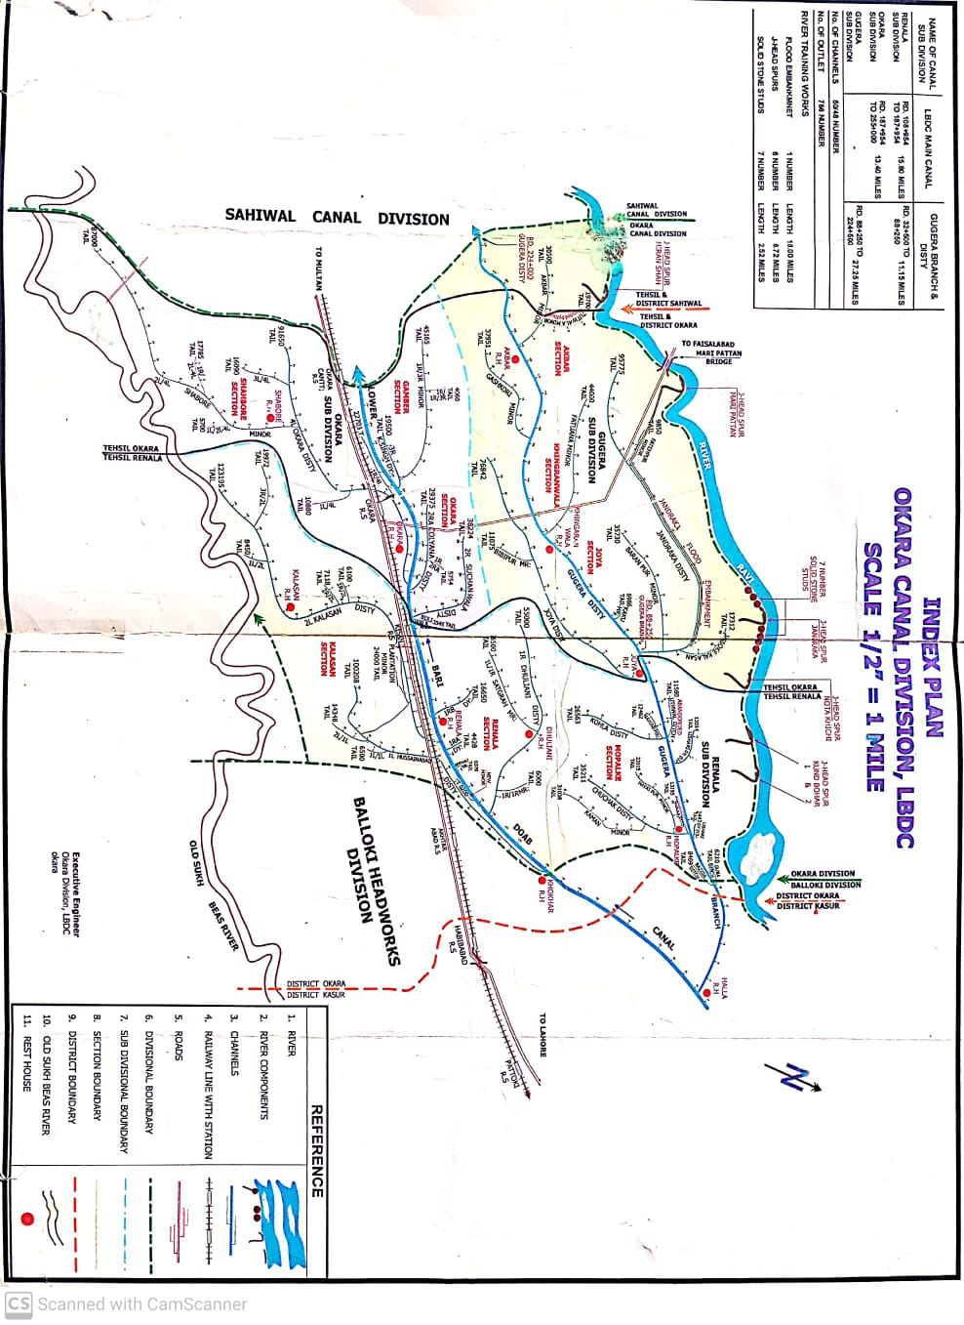
2.2 Location Map/Index Plan

(CHAPTER # 3)

BRIEF HISTORY OF PAST FLOOD EVENTS
Flood damages in this area have an old history which starts from the year 1955. During the year 1955, a heavy flood in river Ravi at Balloki Headwords was recorded as 204360 Cs. A huge area and infrastructure was damaged in Okara and Renala Tehsils.
Similarly, in 1975, the river Ravi with its discharge of 180205 Cusecs at Balloki badly affected various villages in Okara District. Again in 1988, an unprecedented discharge of about 389345 Cusecs in Ravi at Balloki Headworks caused heavy damages to human, animal lives, crops and houses. The town of Renala and Bastilal Shah were also affected due to breach in LBDC.
In 2010, 2011 & 2012 no flood damages occurred. In 2013 the river Ravi with its discharge of 1,17,770 Cs at D/S Balloki Head Works affected many villages/abadies & damaged the river training structures i.e. Kund Bohar Spur No.2 & Miran shah J-Head Spur.
Similarly, in 2014, the river Ravi with its discharge of 131800 Cs at D/S Balloki Head Works affected various villages and damaged the Miran shah J-Head Spur.

(CHAPTER # 4)

4- DESIGN DATA, HISTORIC PEAK FLOOD DATA AND PREVIOUS FIVE YEARS FLOOD DATA OF HEAD WORKS/BARRAGES AND OR OTHER CONTROL POINTS

4.1 Flood Limits
Point | Low Flood (Cs)  1st Stage | Medium Flood (Cs)  2nd Stage | High Flood (Cs)  3rd Stage | VERY High Flood (Cs)  4th Stage | Exceptionally High Flood (Cs)  5th Stage
Jassar | 50000-75000 | 75000-100000 | 100000-150000 | 150000-200000 | Above 200000
Shahdra | 40000-65000 | 65000-90000 | 90000-135000 | 135000-180000 | Above 180000
Balloki | 40000-65000 | 65000-90000 | 90000-135000 | 135000-180000 | Above 180000

4.2 Time Lags of Floods
Location |  | Distance (Miles) | Time Lag ( Hours)
From | To |  | Low | High
Balloki | Jandraka | 40 | 12 Hours | 10 Hours
Jandraka | Miran shah | 17 | 8 Hours | 6 Hours

4.3 Highest Floods
Year | U/S Discharge at Balloki  Head Works | D/S Discharge at Balloki  Head Works
1973 | 298000 Cs | 183000 Cs
1975 | 180205 Cs | 180205 Cs
1976 | 255974 Cs | 234474 Cs
1988 | 389345 Cs | 240854 Cs
1995 | 222800 Cs | 222800 Cs
1996 | 222000 Cs | 220000 Cs

4.4 Peak Discharges Year wise
Year | U/S Discharge at Balloki  Head Works | D/S Discharge at Balloki  Head Works
1950 | 275540 Cs | 125540 Cs
1954 | 175000 Cs | 175000 Cs
1955 | 204360 Cs | 144360 Cs
1957 | 168700 Cs | 168700 Cs
1973 | 298000 Cs | 183000 Cs
1975 | 180205 Cs | 180205 Cs
1976 | 255974 Cs | 234474 Cs
1988 | 389345 Cs | 240854 Cs
1996 | 222000 Cs | 220000 Cs
1997 | 173500 Cs | 173500 Cs
1998 | 90470 Cs | 68470 Cs
1999 | 74780 Cs | 43980 Cs
2000 | 71530 Cs | 46400 Cs
2001 | 76240 Cs | 61020 Cs
2002 | 54880 Cs | 54880 Cs
2003 | 64440 Cs | 40237 Cs
2004 | 70045Cs | 38145 Cs
2005 | 48275Cs | 16125 Cs
2006 | 55020Cs | 22020 Cs
2007 | 64145Cs | 36645 Cs
2008 | 81285Cs | 57735 Cs
2009 | 45500Cs | 14000 Cs
2010 | 62155Cs | 33455 Cs
2011 | 72642Cs | 43942 Cs
2012 | 60764 Cs | 29264 Cs
2013 | 117770 Cs | 97970 Cs
2014 | 131800 Cs | 118000 Cs
2015 | 70650 Cs | 53650 Cs
2016 | 60425 Cs | 27325 Cs
2017 | 68140 Cs | 35345 Cs
2018 | 53595 Cs | 21995 Cs
2019 | 53200 Cs | 34900 Cs
2020 | 63250 Cs | 37250 Cs
2021 | 60879 Cs | 32200 Cs
2022 | 52435 Cs | 35235 Cs
2023 | 74270 Cs | 58870 Cs

(CHAPTER # 5)

FLOOD FIGHTING STRATEGY FOR RIVER RAVI D/S BALLOKI IN OKARA

STAGE-I: Discharge from 0.40 LAC CS to 0.65 LAC Cs
During low flood, watching staff & Sub Engineer concerned section will supervise operation of the left flank of river in this jurisdiction. Sub Divisional Officer concerned will act as the officer in charge of watching operation.

STAGE-II: Discharge from 0 .65 LAC Cs to 0.90 LAC Cs
During medium flood, watching staff shall be deployed one man per mile. Supervisory staff shall be the regular employees and same as in Stage-I.

STAGE-III: Discharge from 0.90 LAC Cs to 1.35 LAC Cs
Watching establishment shall be increased to three times than that of Stage-2 i.e. all establishment of respective Sub Division and work charge establishment shall be engaged at site as required.
Sub Divisional Officer Renala and Gugera will be the officers in-charge of watching operation on the left flank.

STAGE-IV: Discharge from1.35 LAC Cs to 1.80 LAC Cs
At this stage watching establishment will be increased to five times than that of stage No. 2 i.e. all establishment of concerned Sub Division and work charge establishment shall be engaged at site as per requirements. Sub Divisional Officer Renala and Gugera will be the officers in charge of watching operation on left flank, over all supervision of all operations will be done by the Executive Engineer Okara.

STAGE-V: Discharge Exceeding 1.80 LAC Cs
At this stage all staff of Okara Division comprising of regular and work charge establishment including volunteer laborers brought by Civil Administration as well as Army will also help in watching operation. Police guards will be deputed on vulnerable points to guard against any mishap/sabotage. Overall the engineer in charge will be Executive Engineer Okara who will supervise this operation.

(CHAPTER # 6)

FLOOD DAMAGES RESTORATION WORKS
No flood damages occurred during flood season 2023.

(CHAPTER # 7)

FLOOD WATCHING ARRANGEMENT
All the river training works have been checked and found in satisfactory condition. Camp sites have been identified and available flood fighting material has also been checked. Request for funds to replenishing the flood fighting material has been placed.

7.1 Pre-Flood Arrangements

Updated Status of Reserve Stock of Stone
Sanctioned Reserve Stock of stone | Available Quantity | deficient Quantity | Remarks
4.600 Lac cft | 4.058 Lac cft | 0.590 Lac cft | Balance will be arranged in current financial year

Reserve Stock Limits
Sr.  No. | Description | Designed Approved | Total Quantity Required During YEAR  2023-24 | Available Quantity of Reserve Stock | Balance Quantity  Required | Remarks
1 | 11no Solid Stone Studs near Village Chaker Key | 1.1 Lac Cft | 1.1 Lac Cft | 1.1 Lac Cft | Nill
2 | J-Head spur Kund Bohar (Old) | 0.500 Lac Cft | 0.500 Lac Cft | 0.475 Lac Cft | 0.025 Lac Cft.
3 | J-Head spur Kund Bohar (New) | 0.500 Lac Cft | 0.500 Lac Cft | 0.447 Lac Cft | 0.053 Lac Cft.
4 | J-Head spur Nota Khichi | 0.500Lac Cft. | 0.500 Lac Cft | 0.548 Lac Cft | Nill
5 | J-Head spur Jandraka | 0.500 Lac Cft | 0.500Lac Cft | 0.496 Lac Cft | 0.004 Lac Cft
6 | J-Head spur Mari Pattan | 0.500 Lac Cft. | 0.500Lac Cft. | 0.376 Lac Cft. | 0.124 Lac Cft
7 | J-Head spur Miran Shah | 1.000 Lac Cft.. | 1.000Lac Cft | 0.616 Lac Cft. | 0.384 Lac Cft
 | Total | 4.600 Lac Cft. | 4.600 Lac Cft. | 4.058 Lac Cft | 0.590 Lac Cft | 88% reserve stock available against 70%

7.2 Watching Establishment
Site | Flood Limits
 | Low |  | Medium |  | High |  | Very High |  | Exceptionally high
 | Men | Shift | Men | Shift | Men | Shift | Men | Shift | Men | Shift
11 No Solid Stone Studs near Village Chaker Key
Kund Bohar # 1 | 4 | 2 | 6 | 3 | 8 | 3 | 10 | 3 | 12 | 3
Kund Bohar # 2 | 4 | 2 | 6 | 3 | 8 | 3 | 10 | 3 | 12 | 3
J- Head Spur Nota Khichi | 4 | 2 | 6 | 3 | 8 | 3 | 10 | 3 | 12 | 3
J – Head Jandraka Spur | 4 | 2 | 6 | 3 | 8 | 3 | 10 | 3 | 12 | 3
Jandraka Flood Bund. | 8 | 2 | 12 | 3 | 14 | 3 | 16 | 3 | 30 | 3
J-Head Spur Mari Pattan | 6 | 2 | 8 | 3 | 6 | 3 | 10 | 3 | 12 | 3
J- Head Spur Miran Shah | 6 | 2 | 8 | 3 | 6 | 3 | 10 | 3 | 14 | 3

Note:
- The Executive Engineer Okara Division may employ further work charge establishment as per site situation.
- S.D.O Gugera and Renala will employ watching establishment as per strength mentioned above subject to approval from competent authority.
- In case of very high flood, the strength of establishment will be increased with the permission of Executive Engineer.

7.3 Arrangement at Sensitive Sites
- Camp site has been identified as under and necessary watching material will be placed at each camp sites
Structure | Reach | Length (Miles) | Camp Site
11 no Solid Stone Stud | -- | 1.00
Kund Bohar No. 1 | RD 0+000 to RD: 3+000 | 0.60 | At RD: 3+000
Kund Bohar No. 2 | RD: 0+000 to RD: 2+500 | 0.50 | AT RD: 2+500
J-Head Spur Nota Khichi | RD: 0+000 to RD: 2+500 | 0.50 | At RD: 2+500
J-Head Spur Jandraka | RD: 0+000 to RD: 0+770 | 0.75 | At RD: 3+500
Jandraka Flood Bund | RD: 0+000 to RD: 90+250 | 18.05 | At RD: 54+000
J-Head Spur Mari Pattan | RD: 0+000 to RD: 5+360 | 1.07 | At RD: 4+360
J-Head Spur Miran Shah | RD: 0+000 to RD: 7+500 | 1.42 | At RD: 7+500

- The Sub Divisional officer Renala Sub Division will be over all In-charge of all operation on river training works in his jurisdiction.

- 11Nos Solid Stone Studs near Village Chaker Key
- J-Head Spur Kund Bohar No. 1
- J-Head Spur Kund Bohar No. 2

- The Sub Divisional officer Gugera Sub Division will be the overall In-charge of all operation on river training work in this jurisdiction.

- Nota Khichi J-Head Spur
- 11 No. Stone Stud
- J-Head Spur Jandraka
- Jandraka Flood Bund
- J-Head Spur Mari Pattan
- J-Head Spur Miran Shah

- There will be the provision for engagement of work charge establishment to supplement the efforts through regular establishments.

- Sub Divisional Officers will remain in touch with flood control officer at Okara & Renala during flood period.

- S.D.O Okara, with his Sub Engineers, will be ready to associate the S.D.O Gugera for assistance in case of emergency.

- The Executive Engineer Okara is fully competent to change duty of any officer/officials.

- The Executive Engineer Okara Division will be overall In-charge and will stay at Head Quarter during flood days. He will take appropriate action according to the severity of the emergency.

7.4 Watching Material
Sr. No. | Name of Articles | Required | Available | Balance | Location | Remarks
1 | Kassies with handle | 40 No. | 40 No. | 0 No. | All material is Available at Joya Canal Rest house. | Balance Material will be arranged before the starting of Flood Season 2024
2 | Buckets | 25 No. | 07 No. | 18 No.
3 | Torches | 30 No. | 08 No. | 22 No.
4 | Dry Batteries | 10 Dozens | - | 10 Dozen
5 | Lanterns | 20 No. | 08 No. | 12 No.
6 | Toot Basket | 100 No. | 14 No. | 86 No.
7 | Chimney for lanterns | 44 No. | - | 44 No.
8 | Gunny bags/Jute | 500 No. | 50 No. | 450 No.
9 | Hammer with handle | 06 No. | 04 No. | 01 No.
10 | K-oil | 200 Liters | - | 200 No.
11 | Motor Boats | 02 No. | - | 02 No.
12 | Tents | 6 No. | 04 No. | 02 No.
13 | Manila Rope | 300 Meters | - | 300 Meters
14 | Sounding Rod | 04 No. | - | 04 No.
15 | Tables | 10 No. | 03 No. | 07 No
16 | Chairs | 20 No. | 18 No. | 02 No.
17 | Generatorwith petrol | 1 No | 01 No. | 0
18 | Diesel | 1000 Letr | - | 1000 Letr

7.5 Arrangement for sounding & probing
Necessary arrangement for Sounding and probing will be made accordingly before the start of coming flood season.

7.6 Lighting Arrangement
Two No Generators are already available and will be shifted at sites according to the requirement. Torch lights/emergency lights for each camp site have also been purchased and will be shifted as per requirement.

7.7 Ration Arrangement
Necessary arrangement will be made at site for establishment as per requirement during the emergency period.

7.8 P.O.L Arrangement for Vehicle
Grant under Head POL has already been received from the Higher Office for running Government vehicles but it is insufficient for extensive touring/watching in flood days.

7.9 Transportation
All the watching Labor will be engaged locally as well as through contractor. The entire regular establishment will be mobilized by motor cycles. All officers have their own Government Vehicles which are in good running condition. If more transport is required, the Civil Administration will be requested to arrange the transport.

7.10 Law and Order
Maintenance of law and order is the core responsibility of District Administration and Police for which both the agencies will be requested ensure to Law and Order situation.

7.11 Medical Arrangement for labor
District Health Officer will be requested to establish a medical camp for the labor during the flood season as per site condition.

7.12 Liaison with other Departments
Necessary liaison with all the District Heads will be made during flood situation. Telephone numbers of all Departments are attached at page No. 19.

7.13 Role of the Army
All the evacuation plans will be executed by the Pakistan Army during flood emergency. The flood bunds have also been checked by the army before the coming flood season.

7.14 Duties of Telephone Attendant
Detail of Telephone attendants are as under: -
Sr.  No. | Name of Person | Period | Time
 |  |  | From | To
1 | Muhammad Khaliq and Shamaila Yousaf (Telephone attendant), with Shahbaz Ahmed NaibQasid. | 15-06-2024 to 15-10-2024 | 6:00 A.M | 3:00 P.M
2 | Muhammad Afzal T.A | 01-07-2024 to 31-07-2024 | 3:00 P.M | 6:00 A.M
3 | Muhammad Arif T.A | 01-08-2024 to 31-08-2024 | 3:00 P.M | 6:00 A.M
4 | Abdul Ghaffar T.A Shahbore | 01-09-2024 to 30-09-2024 | 3:00 P.M | 6:00 A.M
5 | Muhammad Aslam T.A Kalassan | 01-10-2024 to 15-10-2024 | 3:00 P.M | 6:00 A.M

7.15 Wireless Arrangements
Wireless sets will be installed in the Officers vehicles i.e. Executive Engineer, Sub Divisional Officers before the commencement of flood season by Police Department during 1st week of June.

(CHAPTER # 8)

DETAIL OF ENCROACHMENTS
Total Encroachments | Removed | Remaining | Action to be taken
Nil | Nil | Nil | Nil

(CHAPTER # 9)

DUTY ROSTER/FLOOD FIGHTING PROGRAM
The flood area under the control of this Division is divided into three sectors. Each sector is assigned to one Sub Divisional officer who will shift his headquarter in field. Detail of sectors is given below: -

Sector | Officer incharge | Staff | Reach to be controlLed
1 | Sub Divisional Officer Renala Sub Division. | - Sub Engineer Mopalke Section  - Sub Engineer Renala Section | 11 Nos stone stud  J- Head Spur Kund Bohr No.1.  J- Head Spur Kund Bohr No.2.
2 | Sub Divisional Officer Gugera Sub Division. | - Sub Engineer Joya Section  - Sub Engineer Khingranwala Section  - Sub Engineer Akbar Section | Jandraka Flood Bund.  J- Head Spur Jandraka.  J- Head Spur Nota Khichi.  J- Head Spur Mari Pattan  J- Head Spur Miran Shah.
3 | Sub Divisional Officer Okara Sub Division. | Sub Engineers of  Okara Sub Division | Will assist Sub Divisional Officer Gugera Sub Division, if required.

The Sub Divisional Officer Gugera Sub Division, Sub Divisional Officer Renala Sub Division, Sub Engineer Mopalke, Sub Engineer Renala, Sub Engineer Joya, Sub Engineer Khingranwala and Sub Engineer Akbar Section will be the representatives of Department in the field and are entrusted with the job of supervision of flood works. The Sub Divisional Officer Okara Sub Division, with his headquarter at Okara, will be responsible to implement the instructions received from the higher authorities for flood protection measures during flood. He will give the information via mobile phone, from telegraph office Okara and through police wireless at Okara to the following officers stationed at Sahiwal, Okara and Lahore.
- Superintending Engineer LBDC Circle Sahiwal.
- District Coordination Officer Okara.
- Flood emergency officer, Office of the Chief Engineer Irrigation Department, Sahiwal Zone, Sahiwal.

(CHAPTER # 10)

EMERGENCY TELEPHONE NUMBERS

Irrigation Department
Sr. No. | Designation | Office | Telephone
 |  |  | Office | Residence | Mobile
1 | Chief Engineer | Sahiwal | 040-9200221 |  | 0300-4810150  0320-4810150
2 | Superintending Engineer | LBDC Circle Sahiwal | 040-9200210 |  | 0311-3221066
3 | Executive Engineer | Okara Division | 044 -9330009 |  | 0303-4937504
4 | Flood Emergency Officer | SDO Gugera | 044 -9330009 |  | 0300-5019395
5 | Sub Divisional Officer | Renala Sub Division | 044 -9330009 |  | 0345-7490533
6 | Sub Divisional Officer | Gugera Sub Division | 044 -9330009 |  | 0300-5019395
7 | Sub Divisional Officer | Okara Sub Division | 044 -9330009 |  | 0344-6399447
8 | Sub Engineer | Mopalkey Section | 044 -9330009 |  | 0347-6749234
9 | Sub Engineer | Renala Section | 044 -9330009 |  | 0304-4467197
10 | Sub Engineer | Kalasa Section | 044-9330009 |  | 0302-7397664
11 | Sub Engineer | Joya Section | 044 -9330009 |  | 0306-6939414
12 | Sub Engineer | Khingranwala Section | 044 -9330009 |  | 0300-4156345
13 | Sub Engineer | Akbar Section | 044 -9330009 |  | 0349-4787707
14 | Sub Engineer | Gamber Section | 044 -9330009 |  | 0303-7703952
15 | Sub Engineer | Shahbore Section | 044 -9330009 |  | 0344-6811147

Civil Administration
S.No | Designation | Office | Telephone
 |  |  | Office | Residence | Mobile
1 | D.C. Okara | D.C. Okara | 044-9200025 | 044-9200026 | 0341-0922063
2 | A.C Okara | D.D.O (R) Okara | 044-9200252 | 0442-521929 | 0322-4921371
3 | D.P.O Okara | D.P.O Okara | 044-9200351 | 044-9200353 | 0332-1600777
4 | Inspector | Wireless Control Okara | 044-9200093 |  | 0345-7015027

Army Authority
Sr.No. | Designation | Office
1 | Okara Cantt | 61117
2 | 14-Division Okara Cantt | 61117-3127
3 | 40- Division | 61117-3227
4 | 105- Brigade Okara Cantt | 61117-4164
5 | 116-Engineer Okara | 61117-5184

(CHAPTER # 11)

STANDARD OPERATING PROCEDURE (SOP) FOR BREACHING SECTIONS

11.1 History of Breaching Section
There is no breaching section on any site of the flood infrastructure in Okara Canal Division LBDC. Hence no need of any arrangements.

11.2 Location, Design, Quantity and Variety of the explosive required for detonation
Not relevant

11.3 Arrangement of explosives and security of explosive stores
Not relevant

11.4 List of the Security Staff Along with Detail of Their Training Etc.
Not relevant

11.5 Detail of Mechanical Means as a Stand by Arrangements in Case of Detonation Failure
Not relevant

11.6 Duty Roster in Case of Critical Situation
Not relevant

11.7 Breaching Committee with Their Action Plan
Not relevant

11.8 List of the Villages Likely to Be Inundated in Case of Breach
Not relevant

11.9 Announcement and Detail of Evacuation Arrangements
Not relevant
11.10Details of Coordination with Civil/Army Authorities
Not relevant

11.11 Parallel Communication Arrangements
Not relevant

11.12 Index Plan of Breaching Sections
Not relevant

Executive Engineer Superintending Engineer Chief Engineer
Okara Division LBDC Lower Bari Doab Canal Circle Irrigation Sahiwal Zone
Okara Sahiwal Sahiwal

(CHAPTER # 12)

VULNERABLE SITES ON FLOOD BUND/STRUCTURES

12.1 Apprehended Breaches in Flood bund/structures
Jandraka Flood Bund is vulnerable to breach in reach from RD 75+000 to RD 90+250 during exceptionally high flood

Operation of breaching sections
NIL

12.3 Breaches Due to Rising of Flood Water, Deterioration of Flood Bunds Etc.
There is no vulnerable site on Flood Bund in Canal Division Okara and all the River Training Structures are in satisfactory condition during medium-high flood. However, Jandraka Flood Bund is vulnerable to breach in reach from RD 75+000 to RD 90+250 during exceptionally high flood.

(CHAPTER # 13)

EMERGENCY CONTINGENCY PLAN FOR VULNERABLE SITE (JANDRAKA FLOOD BUND RD 75+000 to RD 90+250)

13.1 Plan Showing Route of Flood Water Coming Out of the Breach Supported with Levels
Plan showing route of water coming out of the breach is attached at Page No. 04. Water Level at breach site will be 580 ft during the exceptionally high flood.

13.2 Detail of villages/ abadies likely to be affected and this should also be shown on the plan
Details of villages and abadies are as under: -
Thatha Channu, Faisalabad Road, Jandraka Disty, Thatha Tahir, Shareen, Mari, Baig Key.

13.3 Strategy and action

13.3.1 Arrangements
All Flood Fighting Material along with watching establishments will be arranged before the commencement of flood period.

13.3.2 Establishment of Flood Fighting Camps
Special Flood Fighting camp will be established during high flood along with necessary flood fighting material and watching arrangements as under: -
Site | Flood Limits
 | Low Flood |  | Medium Flood |  | High Flood |  | Very High Flood |  | Exceptionally high Flood
 | Men | Shift | Men | Shift | Men | Shift | Men | Shift | Men | Shift
Jandraka flood bund | 8 | 2 | 12 | 3 | 14 | 3 | 16 | 3 | 30 | 3

13.3.3 Duties of Officers/Officials and their Camp Sites
Sub Engineer Khingranwala along with regular establishment will reside at this camp. Sub Divisional Officer and Executive Engineer will watch this camp site regularly along with other camp sites. Duties of Officers/Officials is as under: -
Sector | Officer In-charge | Staff | Reach to be controlled /Location
1 | Muhammad Saeed  SDO Gugera Sub Division.  Cell: 0300-5019395 | Sajawal Rehman  Sub Engineer of  Mopalkey Section.  Cell: 0347-6749234 | 11 no stone stud  Kund Bohar no. 1  Kund Bohar no. 2
 |  | Ahmad Saeed  Sub Engineer of  Joya Section.  Cell: 0306-6934414 | Jandraka flood bund  J-Head spur Nota Khichi  J-Head spur Jandraka
 |  | Zaheer Ahmed Baber  Sub Engineer of  Khingranwala Section.  Cell: 0300-4156345 | Jandraka flood bund  J- Head spur Mari Pattan
 |  | Ghulam Mustafa  Sub Engineer of Akbar Section.  Cell: 0349-4787707 | J- Head spur Miran Shah

13.3.4 Available Departmental Machinery
No departmental machinery is available but as per requirement it can be arranged from Agriculture Department and Army with the help of Civil Administration.

13.3.5 Machinery Available from Private Source
Tractor Trolley, Excavators, Front blade Tractors etc. can be arranged from the private source.

13.3.6 & 13.3.7 Flood Fighting Material Required & Available (Camp/Site Wise)
Detail of flood fighting material required is as under: -
Sr. No. | Name of Articles | Required | Available | Balance | Location | Remarks
1 | Kassies with handle | 40 No. | 10 No. | 30 No. | All material is Available at Joya Canal Rest house. | Balance Material will be arranged before the starting of Flood Season 2024
2 | Buckets | 25 No. | 0 No. | 25 No.
3 | Torches | 30 No. | 08 No. | 22 No.
4 | Dry Batteries | 10 Dozens | - | 10 Dozen
5 | Lanterns | 20 No. | 12 No. | 08 No.
6 | Toot Basket | 100 No. | 0 No. | 100 No.
7 | Chimney for lanterns | 44 No. | 06 No. | 38 No.
8 | Gunny bags | 500 No. | 0 No. | 500 No.
9 | Hammer with handle | 06 No. | 0 No. | 06 No.
10 | K-oil | 200 Liters | - | 200 No.
11 | Motor Boats | 02 No. | - | 02 No.
12 | Tents | 6 No. | - | 06 No.
13 | Manila Rope | 300 Meters | - | 300 Meters
14 | Sounding Rod | 04 No. | - | 04 No.

13.4 Detail of other infrastructure like Electric, Sui Gas, Telephone installations, road network other buildings, Canals and drainage network
Detail of other infrastructure is as under: -
The major installations like electric transmission lines, Sui gas, telephone lines, road networks, other buildings, canals and drainage network, Jandraka Distributary and system, Okara-Faisalabad Road, Electric poles, Telephone, Petrol Pumps, Schools, Dispensaries, private houses etc in flood area.

Executive Engineer Superintending Engineer Chief Engineer
Okara Division LBDC Lower Bari Doab Canal Circle Irrigation Sahiwal Zone,
Okara Sahiwal Sahiwal

(CHAPTER # 14)

ACTION PLAN

14.1 Re-Shuffling / Recouping Plan of Reserve Stone Departmentally
No re-shuffling/Recouping Plan of reserve stone departmentally as the stone is available on flood bund / spurs.

14.2 Detail of Inlet / Outlet Crossing Along with Closing Methodology
There is no inlet / outlet crossing with closing methodology in this Division.

14.3 Deployment of Machinery (Medium to high flood)
Machinery Deployed
Excavator | Dozer | Trolleys / Dumpers | Tractor with front blade | Labour (Beldar + Mate)
1 | -- | 1 | 1 | 12+1

14.4 Deployment of Machinery (High to very high flood)
Machinery Deployed
Excavator | Dozer | Trolleys / Dumpers | Tractor with front blade | Labour (Beldar + Mate)
2 | -- | 2 | 2 | 24+2

14.5 Deployment of Machinery (High to exceptionally high flood)
Machinery Deployed
Excavator | Dozer | Trolleys / Dumpers | Tractor with front blade | Labour (Beldar + Mate)
4 | 2 | 4 | 4 | 36+3

Note: Payment for machinery and work charge employing subject to verification by TPM / Department.

14.6 Police Deployment Plan
Sr. No | Vulanerable sites used for Illegal cuts during floods | Concerned Canal Division | Concerned Police Station and District | Police Persons Deployed |  | Remarks
 |  |  |  | Inspector/S.I /A.S.I | Constable
1 | - | Okara Canal Division | Thana Ravi | Adnan Rafiq A.S.I | Muhabat Khan
 |  |  |  |  | Ghulam Dastgeer

14.7 Details of Synthetic Bags with Capacity of 500 Kg and 1000 Kg
Not required for this Division.

14.8 The Details of Polythene Sheet of Black Color to Protect Upstream Slope against Wave Action and to Control Seepage through Embankments
Not required for this Division.

(CHAPTER # 15)

BACK UP DIVISIONS (IN CASE OF BREACH)
In case of Breach and any mishap Balloki Division will be back up Division.

