PART----A

CHAPTER-1
SALIENT FEATURE OF THE TRIMMU HEADWORKS DIVISION TRIMMU

1.1 LOCATION

Trimmu Headworks is located at a distance of about 25 Kilometres from Jhang Sadar. Its precise location is 72.1465⁰ Latitude and 31.1448⁰ Longitude. It falls in semi arid zone with desert on its right and Rechna Doab on its left.

1.2 GENERAL DESCRIPTION

Trimmu Headworks was constructed in 1937–1939 as a part of the Haveli Project. It is located just below the confluence point of the river Jhelum and Chenab. The main features of the barrage are as under:

Length between the abutments | = | 3937 ft
Total No. of bays / gates with LCPs (51+13) | = | 64 Nos.
No. of bays / gates with LCPs Left under sluice | = | 08 No. (30’ clear width each
Total No. of bays / gates with LCPs Main Weir | = | 37 (60’ clear width each)
No. of bays/gates with LCPs Right Under sluice | = | 6 No. (30’ clear width each)
Additional Bays / gates with LCPs (right side) | = | 13 No. (11 No. 60’ and 2 No. 30’ width)
Pond level (Summer) | = | 491.50 Ft
(Winter) | = | 490.00 Ft
RL of the crest of main weir | = | 477.50 Ft
RL of the crest of Left under sluice | = | 472.00 Ft
RL of Additional Bays | = | 471.00 Ft

DESIGNED CAPACITY
Main Weir | = | 491,500 Cusecs
Left under sluice | = | 70,500 Cusecs
Right under sluice | = | 65,000 Cusecs
Discharge Through Additional Bays | = | 248,000 Cusecs
Total |  | 875,000 Cusecs

Three canals – Haveli Main Line, Trimmu Sidhnai Link (TS Link) and Rangpur Canal are off taking from the Headworks. Haveli main Line and TS Link off take from the left flank whereas the Rangpur off-takes from the right flank of the Headworks. Brief description of the canals is as under:

Haveli Main Line

Designed discharge =5170 Cusecs
Crest RL = 481.00 Ft
No. of bays = 5 Nos bays / gates with LCPs with width of 24 feet
each (5×24=120 Feet)
Design F.S level = 489.00

Silt Ejector RD 1200
Maximum Discharge = 1200 Cusecs
Crest RL = 477.40
Waterway = 24 ft

Silt Ejector RD 2000
Maximum discharge = 1000 Cusecs
Crest RL = 477.35
Waterway = 20 ft

Trimmu Sidhnai Link

Designed discharge =12500 Cusecs
Crest RL = 481.00 Ft
No. of bays = 10 Nos bays / gates with LCPs with width of 24 feet
each (10×24=240 Feet)

Rang Pur Canal (New Head Regulator)

Designed discharge =2710 Cusecs
Crest RL = 483.50 Ft
No. of bays = 3 Nos bays / gates with LCPs with width of 24 feet
each ( 3×24 = 72 Feet )

1.3 ADMINISTRATIVE SETUP

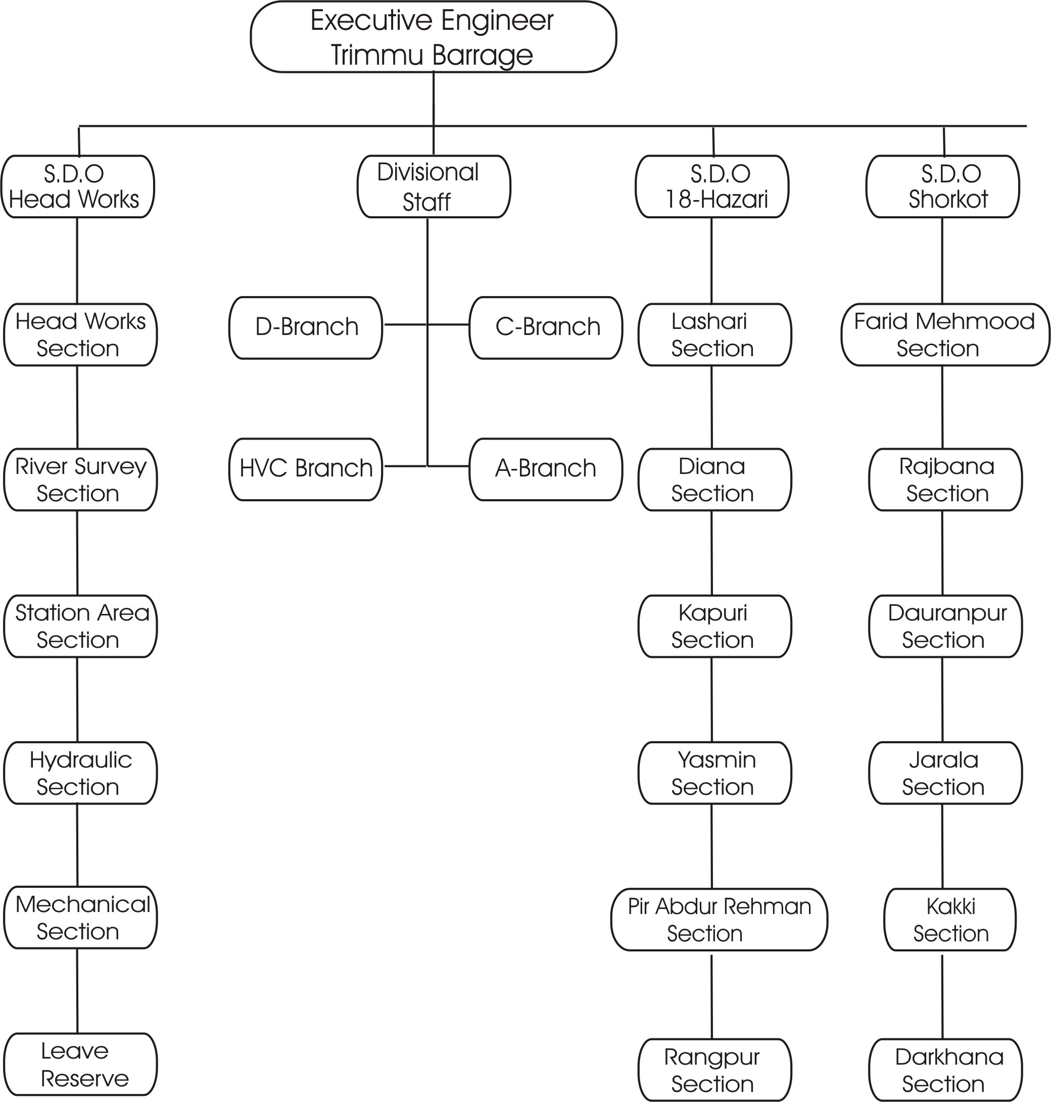

CHAPTER-2
FLOOD PROTECTION AND RIVER TRAINING WORKS
2.1 DESIGN PARAMETERS OF TRAINING WORKS
Sr.  No | Name of Flood Bund | Length |  | Top Width | Side Slope |  | Free board | Remarks
Sr.  No | Name of Flood Bund | Feet | Miles | Feet | River  Side | Country Side | Feet | Remarks
HEAD WORKS SUB DIVISION
1.-A | Left Marginal Bund | 46000 | 9.2 | 30 | 1:3 | 1:2 | 7 | Free board with respect to anticipated HFL for 875,000 Cs.
 | Wetting channel along LMB | 46000 | 9.2 | 6 | 3:1 | 2:1 | 7
B | Length of x-spurs at RD: 8900,10000,13000,11900,  16900,17900,18600,23000,28500.  29500 & 34350  Length = 950+950+950+1100  +700+860+355+360+290+  400+400 | 7315 | 1.68 | 25 | 3:1 | 2:1 | 6
C | Guide Wall No. I  (Connected with LMB RD 20+000)
C | Length of Shank | 3772 | 0.75 | 30 | 3:1 | 3:1 | 6
C | Length of Head | 1150 | 0.23 | 30 | 2:1 | 3:1 | 6
C | Total | 4922 | 0.98
D | Guide Wall No. II  (Connected with LMB RD 15+000)
D | Length of Shank | 576 | 0.12 | 30 | 3:1 | 3:1 | 6
D | Length of Head | 1100 | 0.22 | 30 | 2:1 | 2:1 | 6
D | Total | 1676 | 0.34
E | Inverted Hockey spur in between 17+900 & 20+400 connected with Guide wall No. I RD 20+440
E | Length of Shank | 600 | 0.12 | 25 | 3:1 | 3:1 | 6
E | Length of Curve portion | 200 | 0.04 | 25 | 2:1 | 2:1 | 6
E | Total | 800 | 0.16
F | Guide wall at RD 17+900 of LMB |  |  |  |  |  |  | Free board with respect to anticipated HFL for 875,000 Cs.
F | Length of Shank | 1186 | 0.23 | 30 | 3:1 | 3:1 | 7
F | Length of Head | 1295 | 0.25 | 30 | 2:1 | 2:1 | 7
F | Total | 2481 | 0.48
 | TOTAL | 64894 | 13.18
2-A | Right Marginal Bund | 57765 | 11.55 | 25 | 3:1 | 2:1 | 7 | Free board with respect to anticipated HFL for 875,000 Cs.
A | Wetting Channel along R.M.B | 16000 | 3.20 | 6 | 3:1 | 2:1 | 7
B | J-Head Spur at RD: 4597 RMB | 9250 | 1.85 | 25 | 3:1 | 2:1 | 6
C | X-spurs at RD: 23590 & 28815, Length= 900+1200 | 2100 | 0.42 | 25 | 3:1 | 2:1 | 6
 | TOTAL | 69115 | 13.82
3 | Left Guide Bank U/S | 4500 | 0.90 | 30 | 3:1 | 2:1 | 6
 | TOTAL | 4500 | 0.90 | 30 | 3:1 | 2:1 | 6

Sr.  No | Name of Flood Bund |  | Length |  |  |  | Top Width |  | Side Slope |  |  | Free board | Remarks
Sr.  No |  |  | Feet |  | Feet |  | Feet |  | River  Side |  | Country Side | Feet | Remarks
4 | Right Guide Bank U/S |  | 4520 |  | 0.90 |  | 30/60 |  | 2:1 |  | 3:1 | 7 | Free board with respect to anticipated HFL for 875,000 Cs.
4-A | Right Guide Bank D/S |  | 810 |  | 0.16 |  | 30/60 |  | 2:1 |  | 3:1 | 7 | Free board with respect to anticipated HFL for 875,000 Cs.
 | TOTAL |  | 4520 |  | 0.90 |  | 30/60 |  | 2:1 |  | 3:1 | 7
1 | Colony Ring Bund |  | 9600 |  | 1.93 |  | 25 |  | 3:1 |  | 2:1 | 6
A | T-Headed Spur No. 1 |  | 4704 |  | 0.94 |  | 25 |  | 3:1 |  | 2:1 | 6
B | X-spur |  | 700 |  | 0.14 |  | 25 |  | 3:1 |  | 2:1 | 6
C | T-Headed Spur No. 2 |  | 6582 |  | 1.32 |  | 25 |  | 3:1 |  | 2:1 | 6
D | X-spur |  | 1400 |  | 0.28 |  | 25 |  | 3:1 |  | 2:1 | 6
 | TOTAL |  | 22986 |  | 4.61 |  | 125 |  | 3:1 |  | 2:1 | 6
SHORKOT SUB DIVISION
7 | Hassuwali Flood Bund | 72000 |  | 14.4 |  | 25 |  | 3:1 |  | 1.5:1 |  | 6
8 | Rajbana Flood Bund | 22750 |  | 4.55 |  | 25 |  | 3:1 |  | 2:1 |  | 6
9 | Connecting Tail Rajbana Bund with Lakhi Flood Bund RD: (0-11400) | 11400 |  | 2.28 |  | 25 |  | 3:1 |  | 2:1 |  | 6
10-A | Lakhi Flood Bund RD(25-70000) | 45000 |  | 9 |  | 20 |  | 3:1 |  | 1.5:1 |  | 6
B | Mole Head | 100
C | Stone studs 1,2&3 | 400 |  | 0.6
D | Protection Bund | 18500 |  |  |  | 10 |  | 1.5:1 |  | 1.5:1
E | Defence Bund Dabkalan | 650 |  |  |  | 10 |  | 1.5:1 |  | 1.5:1
 | Total | 170800 |  | 30.83
18-HAZARI SUB DIVISION
11-A | Dadal Flood Bund
B | RD 0+000 to 11+000 | 11000 |  | 2.20 |  | 20 |  | 3:1 |  | 1½:1 |  | 6
C | RD 11+000 to 69+629 | 58629 |  | 11.72 |  | 25 |  | 3:1 |  | 2:1 |  | 6
D | X –spur at RD: 53,56,60 & 66  Length=540+800+250+1000+450 | 3040 |  | 0.60 |  | 10 |  | 2:1 |  | 2:1 |  | 6
E | J-Head Spur at RD 54+500 | 2300 |  | 0.46 |  | 30 |  | 3:1 |  | 2:1 |  | 6
 | Total | 74969 |  | 14.98
12-A | Rangpur Flood embankment along left bank of Rangpur Canal
B | RD 260+000 to 308+000 | 48000 |  | 9.6 |  | 20 |  | 3:1 |  | 2:1 |  | 6
C | RD 308+000 to 318+000 | 10000 |  | 2.0 |  | 25 |  | 3:1 |  | 2:1 |  | 6
D | Like inverted hockey spur RD 292+500 | 2654 |  | 0.53 |  | 30 |  | 3:1 |  | 2:1 |  | 6
E | J-Head Spur at RD 302+000 | 6455 |  | 1.2 |  | 30 |  | 3:1 |  | 2:1 |  | 6
 | TOTAL | 70959 |  | 14.10
 | GRAND TOTAL | 145928 |  | 29.08

2.2 LOCATION MAP

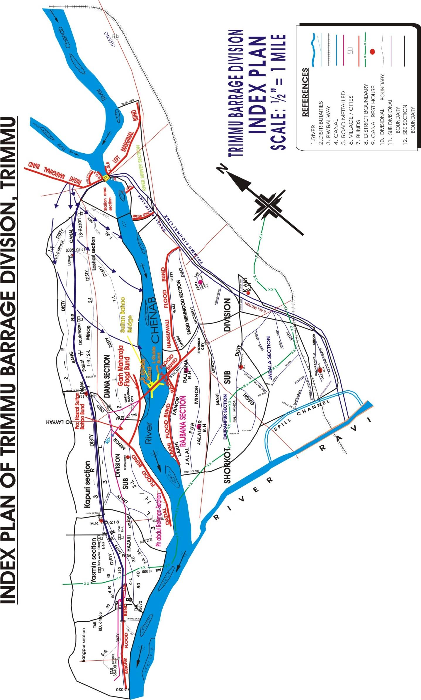
CHAPTER-3
BRIEF HISTORY OF PAST FLOOD EVENTS
YEAR | DISCHARGE |  | BREACHED REACHES
1959 | Through Barrage  Through Breach  Total | 718,255 Cs  225,000 Cs  943,255 Cs | 6 Nos Breaches  in Right Marginal Bund RD: 16-18
1973 | Through Barrage  Through Breach  Total | 666,910 Cs  66,000 Cs  732,910 Cs | 4 Nos Breaches  in Right Marginal Bund RD: 16-18
1976 | Through Weir | 704,633 Cs | -
1992 | Through Barrage  Through Breach  Total | 683,117 Cs  205,000 Cs  888,117 Cs | 6 Nos Breaches  in Right Marginal Bund RD: 16-18
2014 | Through Barrage  Through Breach  Total | 626,006 Cs  77,000 Cs  703,006 Cs | 6 Nos Breaches  in Right Marginal Bund RD: 16-18
Events Flood 2014
Sr No. | Date of occurrence | Time | Nature of incidents | Place of incidents | Efforts made for controlling incidents | Remarks
1 | 08-09-2014 | 5 :00 PM | Right pocket become non-modular | Barrage | By effective watching and exercising timely protective measure with the help of deployed machinery and flood fighting material, leakages, even of dangerous nature were controlled | Public property saved
2 | 09-09-2014 | 7 :20 PM | Leakage of dangerous nature | RD:44+360 LMB |  | Public property saved
3 | 10-09-2014 | 1 :00 AM | Main Weir + Right Pocket Gates become free | Barrage |  | Public property saved
4 | 10-09-2014 | 2:25 AM | Seepage of dangerous nature | RD:44+450 LMB |  | Public property saved
5 | 10-09-2014 | 4:10 AM | Very serious leakage | RD:20+000 LMB |  | Public property saved
6 | 10-09-2014 | 5:00 AM | All gates of barrage become free | Barrage |  | Public property saved
7 | 10-09-2014 | 6:40 AM | Serious Seepage | RD:44+650 LMB |  | Public property saved
8 | 10-09-2014 | 7:30 AM | Seepage of dangerous nature occurred | RD:44+500 LMB |  | Public property saved
9 | 10-09-2014 | 8:15 AM | Seepage of dangerous nature was occurred | RD:25+940 LMB |  | Public property saved
10 | 10-09-2014 | 10:30 PM | Seepage of dangerous nature was occurred | RD:44+450 LMB |  | Public property saved

CHAPTER-4
DESIGN DATA, HISTORIC PEAK FLOOD DATA AND PREVIOUS FIVE YEARS FLOOD DATA OF HEAD WORKS / BARRAGES AND OR OTHER CONTROL POINTS

4.1 FLOOD LIMITS IN TRIMMU HEADWORKS DIVISION, TRIMMU

DESCRIPTION | FLOOD LIMITS (LAC CUSECS)
Low Flood | 1.50 to 2.00
Medium Flood | 2.00 to 3.00
High Flood | 3.00 to 4.50
Very High Flood | 4.50 to 6.00
Exceptionally High Flood | Above 6.00

4.2 TIME LAG OF FLOODS

The time lag of the peaks for river Jhelum and Chenab based upon study of actual Hydrograph for data of many years is tabulated as under:-

Sr. No. | Stage | River Chenab |  |  | River Jhelum
Sr. No. | Stage | Marala to Khanki  39 Miles | Marala to Qadirabad 57 Miles | Qadirabad to Trimmu 163 Miles | Mangla to Rasool 43 Miles | Rasool to Trimmu 178 Miles
 |  | Hours | Hours | Hours | Hours | Hours
1 | 0.5 to 1 lac Cusecs | 10 | 12 | 40 | 16-20 | 48
2 | Low Flood | 12 | 15 | 48 | 15 | 54
3 | Medium Flood | 14 | 16 | 60 | 12 | 60
4 | High Flood | 15 | 18 | 66-72 | 10 | 66-72
5 | Exceptionally High Flood | 15 | 18 | 78 | 8 | 72-78
6 | As approved by the federal Flood Commission for the months of July and August | - | 48 | 48 | 24 | 48

4.3 HIGHEST FLOODS
The history of highest floods is as under:-
Year | Flood Level |  | Through Head Works | Through Breaches in embankments |  | Total
Year | U/S | D/S | Through Head Works | Left Side | Right Side
1959 | 492.10 | 489.50 | 71,8255 | - | 225,000 | 943,255
1960 | 490.00 | 488.50 | 605,132 | - | - | 605,132
1973 | 494.30 | 491.15 | 666,910 | - | 66,000 | 732,910
1976 | 493.6 | 489.7 | 70,4633 | - | - | 704,633
1992 | 494.40 | 490.80 | 683,117 | - | 205,000 | 888,117
1995 | 494.30 | 493.50 | 629,561 | - | - | 629,561
1997 | 494.50 | 491.95 | 677,417 | - | - | 677,417
2014 | 494.60 | 494.20 | 626,003 | - | 77,000 | 703,006
4.4 PEAK DISCHARGES
The history of peak discharges of last 30-years is as under: -
Year | Date | Discharge
1995 | 01-08-1995 | 629,561
1996 | 27-08-1996 | 543,708
1997 | 01-09-1997 | 677,417
1998 | 13-07-1998 | 148,668
1999 | 22-07-1999 | 61,476
2000 | 25-07-2000 | 116,179
2001 | 18-08-2001 | 72,431
2002 | 17-08-2002 | 108,627
2003 | 08-08-2003 | 122,892
2004 | 21-08-2004 | 42,756
2005 | 11-07-2005 | 162,097
2006 | 07-09-2006 | 266,270
2007 | 15-03-2007 | 173,532
2008 | 07-08-2008 | 54,234
2009 | 21-08-2009 | 46,765
2010 | 11-08-2010 | 323,026
2011 | 26-09-2011 | 127,790
2012 | 07-08-2012 | 67,694
2013 | 21-08-2013 | 267,609
2014 | 10-09-2014 | 703,006
2015 | 29-07-2015 | 150,865
2016 | 10.08.2016 | 153,339
2017 | 05.08.2017 | 89,345
2018 | 17.08.2018 | 81,680
2019 | 22.08.2019 | 93,021
2020 | 01.09.2020 | 196,077
2021 | 31.07.2021 | 106,867
2022 | 18.08.2022 | 122,115
2023 | 25.07.2023 | 116,786
2024 | 19.08.2024 | 87,030
CHAPTER-5

FLOOD FIGHTING STRATEGY

The following precautionary measures are adopted before flood season to face any alarming situation at Trimmu Headworks but even then, arrangements are necessary to avoid heavy damages and flood fighting strategy is adopted in such a way that flood water passes safely through Barrage, up to its limit.
In low flood, river water remains within the deep channel and does not cause any problem if regulation of gates is done as per rules. Watching establishment employed for this purpose will remain busy in removing jungle, filling gharas and percupine holes if any.
- MEDIUM FLOOD

When river water enters into Medium Flood i.e 2 to 3 Lacs, it will start spreading on adjoining area and also touching the toe of bunds. Then it becomes necessary to be more vigilant. The Flood bunds will be fully watched to avoid any leakage from bunds. Sub Engineers will shift their camps to sites as per duty roaster. Hourly gauges and discharge will be conveyed to Civil Administration and flood warning centers to inform public accordingly.
- HIGH FLOOD

When river water enters into high flood range i.e 3 to 4.5 Lacs, Sub Divisional Officer Head Works will shift his camp at Trimmu Headworks to supervise staff working on L.M.B and D/S Spurs. In whole period, regulation will be done in such a way that silt deposit in front of canals may be washed D/S of the river to minimize silt entry in to canals. Silt contents in water will be checked thrice a day and if it exceeds, the permissible limit, canals will be closed accordingly.
- VERY HIGH FLOOD

When river water enters into very high flood range i.e 4.5 to 6 Lacs, Executive Engineer alongwith Sub Divisional Officer Head Works will shift his camp at Trimmu Barrage to supervise staff working on L.M.B, RMB and D/S Spurs and to check any leakage if any. Critical gauge will be checked on hourly basis round the clock. If discharge is in rising position then breaching section is activated in consultation with Civil Administration and Pak Army.
- EXCEPTIONALLY HIGH FLOOD

Gauges of different sites especially gauge at RD: 15000 of L.M.B will be noted regularly and recorded. Executive Engineer will inform all agencies especially civil administration as well as Army about flood situation in rising position. In case of very high flood or exceptionally high flood, meeting will be held in field office with Army and Civil Administration to face the situation.
Two dozers will be kept ready at RD: 16000 to 18000 R.M.B for making cuts and closing breaches as and when required according to circumstances. When gauge at RD: 15000 L.M.B touches level 500.00 Ft and is found in rising position it will be the duty of Executive Engineer to request Army for operation of breach section for the safety of Barrage. When water subsides, the breaching sections will be closed (if operated) as soon as possible.

CHAPTER-6

FLOOD RESTORATION WORKS LIKELY TO BE EXECUTED
BEFORE FLOOD 2025

Sr No. | Name of work | Amount  (Rs. In Million)
1 | Repairing and maintaining Rangpur Flood Embankment from RD 0+000 to 50+000 | 33.20
2 | Repairing and maintaining dadal flood bund from RD 0+000 to 69+500. | 39.00
3 | Installation of new well pumps along newly constructed wetting channel of RMB RD 0+000 to 15+000. | 8.000
4 | Repairing apron of Guide Wall No.2 RD 14+900 of LMB of Trimmu | 7.460
5 | Repairing apron of inverted hockey spur connected with Guide Wall No.1 RD 20+440 of LMB Trimmu | 4.000
6 | Strengthening wetting channel at RD 16+900 to RD 21+000 of LMB. | 2.960
7 | Repairing and maintaining Makori flood bund Trimmu Headworks Sub Division, Trimmu | 6.000
8 | Maintaining of Service track of Rangpur Flood Bund from RD 260+000 to 318+000 | 1.500
9 | Rehabilitation of approach road & Structure of like Hockey Spur at RD 292+500. | 45.000
10 | Filling Rain Cuts on Dadal Flood Bund Between RD 0+000, RD 45+000 in Pir Abdul Rehman Section | 0.956
11 | Filling Rain Cuts on J Head Spur at Rd 54+500 in Pir Abdul Rehman Section | 0.500
12 | Maintaining / replacing Breaching Section for the capacity of 875000 Cs. | 20.00

CHAPTER-7
FLOOD FIGHTING WATCHING ARRANGEMENTS

7.1 PRE-FLOOD ARRANGEMENTS
The watching establishment on marginal bunds is required to be employed as per following scale in accordance with the approval given by Superintending Engineer Haveli Canal Circle Multan vide his letter No. 6272-73/170-W dated 31.05.1974 (Duty Roaster attached). In addition to previous mentioned material, which will be placed at different camp sites, an additional material will be also be required in order to meet with extraordinary worst situation and to recoup the site situation.
As a guide the following scale is assumed to be sufficient. The Executive Engineer with the consultation of the Superintending Engineer, Haveli Canal Circle, Multan / Director Technical / DPD PMO Punjab Barrages, Lahore can increase the scale:
Flood Management Strategy for Flood Season 2022
- Weak sites of flood bund / river training works have been attended / being attended.
- Data boards / gauges, RD Marks have been updated.
- Deficient reserve stock of stone has been recouped. 17.24 Lac cft reserve stock of stone is available to face any emergent situation during flood.
Sr.  No. | Name of structure | Sanctioned  Quantity | Available  Quantity | Remarks
1 | LGB U/S AND D/S | 5.00 | 4.87 | The available quantity is more than minimum requirement.
2 | RGB U/S AND D/S | 5.00 | 4.76 | The available quantity is more than minimum requirement.
3 | J-HEAD SPUR RD 5500 OF RMB | 1.50 | 1.57 | The available quantity is more than minimum requirement.
4 | SLOPING SPUR ALONG COLONY RING BUND | 1.00 | 0.32 | The available quantity is more than minimum requirement.
5 | T-1 SPUR ALONG COLONY RING BUND | 1.50 | 0.81 | The available quantity is more than minimum requirement.
6 | T-2 SPUR D/S TRIMMU BARRAGE | 1.50 | 0.79 | The available quantity is more than minimum requirement.
7 | J-HEAD SPUR MAKORI | 1.50 | 0.90 | The available quantity is more than minimum requirement.
8 | DAB KALAN (Relates to SDO Shorkot) | 1.25 | 0.89 | The available quantity is more than minimum requirement.
9 | GUIDE WALL NO.1 ALONG LMB | 1.50 | 0.76 | The available quantity is more than minimum requirement.
10 | GUIDE WALL NO.2 ALONG LMB | 1.50 | 0.76 | The available quantity is more than minimum requirement.
11 | GUIDE WALL NO.3 ALONG COLONY RING BUND | 1.50 | 0.59 | The available quantity is more than minimum requirement.
12 | X-SPUR RD 23000 OF RMB | 0.25 | 0.21 | The available quantity is more than minimum requirement.
 | TOTAL (LACS CFT) | 23.00 | 17.24 | The available quantity is more than minimum requirement.

- Flood Fighting material is available to fight and pass the flood safely.
- Gates and gearing system of the Barrage have been checked and is functioning properly.
- Critical reaches of flood bunds are being attended to avoid any mishap.
- Breaching section has been restored.
- On receipt of flood warning, watching establishment will immediately be deployed on flood bunds as per flood fighting plan. Critical reaches of flood bund will be focused with much more care. The scale of watching material approved in Flood Fighting plan prepared after Flood of 1975 will be followed which is given below:-
Sr. No. | Item | Scale
1 | Lamps Hurricane | 1 per beldar, 1 per mate and 20% extra of total only for the night shift
2 | Wicks | 9 inch per lamp
3 | Chimneys | 1 spare for each lamp
4 | Burners & caps | 1 spare for each lamp
5 | Torches – 3 cell | 1 for Executive Engineer, 1 for Sub Divisional Officer, 1 for Sub Engineer 1 one spare
6 | Cells for Torches | 1 full and six spare sets
7 | Petromax lamp | At depressions, old breach sites and dangerous sites each lamp with 2 spare chimneys, 2 nozzles, 2 funnels fitted with wire gauze
8 | Fuel for lighting fire | To be collected by beldar establishment
9 | Kerosene Oil | As per practice 1/3 bottle per lantern per night and one bottle per patromax per night (22 nights per month)
10 | Match Boxes | 1 match box per month
11 | Spirit | 1 bottle per patromax per month
12 | Funnels | 2 No. per watching hut
13 | Oil Extractor (Ordinary) | 2 No. per watching hut
14 | Spirit cans | 1 per petromax
15 | Larmal 50 feet long | 50 per watching hut
16 | Mallets wooden | 5 mallets per watching hut
17 | Tranger wire | 1 roll of 14 BSW gauge at each bund
18 | Gunny bags | 100 bags per mile
19 | Axes | 2 No per mile
20 | Kassies with handles | 1 for each beldar + 10% (for one shift only)
21 | Hammer 2.5 lbs | 1 per mile
22 | Hammer 10 lb | 2 per mile
23 | Buckets (12 inch size) | 5 No. per mile
24 | Sledge hammer 14 lbs | 1 per mile
25 | Bhan (Cow Dung) in EC bags | 20 bags per mile for dangerous portions
26 | Sand | Collection of 200 cft. Every mile for dangerous portions
27 | Stacks (6-8 feet) long | 100 stacks per mile
28 | Khajji mats 3’*4’ | 50 Nos per mile
29 | Baskets | 1 toot/2 Pilchi baskets per beldar of shift twice a month
30 | Sutli | 1 lb per 100 bags
31 | Needles | 4 Nos per beldar huts
32 | Kassi Handles | 50% of the no. of kassies as spare
33 | Munj/Patha/Pees/ Taranger 3 cft capacity of Stone. | 500 Nos for each structure.
34 | Tooth basket | 100 Nos each Sub Engineer
Flood camps will be established during the flood season at vulnerable sites of embankment for the storage of the watching material and shelter for staff on or off duty. The watching material will be shifted into these camps at the start of the flood season.
Officer in-charge will issue the material as and when emergency arises. Some balance material will be obtained / received back as issued during last year during Flood season only balance will be procured to meet the requirement of this year.
7.2 WATCHING ESTABLISHMENT
Site | Flood Limit
Site | Low |  | Medium |  | High |  | Very High |  | Excep: High
Site | Men | Shift | Men | Shift | Men | Shift | Men | Shift | Men | Shift
Left Marginal Bund | -- | -- | 67 | 2 | 132 | 3 | 199 | 3 | 264 | 3
Right Marginal Bund | -- | -- | 72 | 2 | 144 | 3 | 216 | 3 | 288 | 3
Colony Ring Bund | -- | -- | 13 | 2 | 24 | 3 | 35 | 3 | 48 | 3
Hassuwali Flood Bund | -- | -- | 130 | 2 | 202 | 3 | 274 | 3 | 346 | 3
Rajbana Flood Bund | -- | -- | 41 | 2 | 82 | 3 | 123 | 3 | 164 | 3
Rangpur Flood Bund | -- | -- | 102 | 2 | 167 | 3 | 232 | 3 | 297 | 3

The watching establishment is deployed according to Flood stage. The following statement depicts strength of establishment required during flood season in addition to regular establishment.

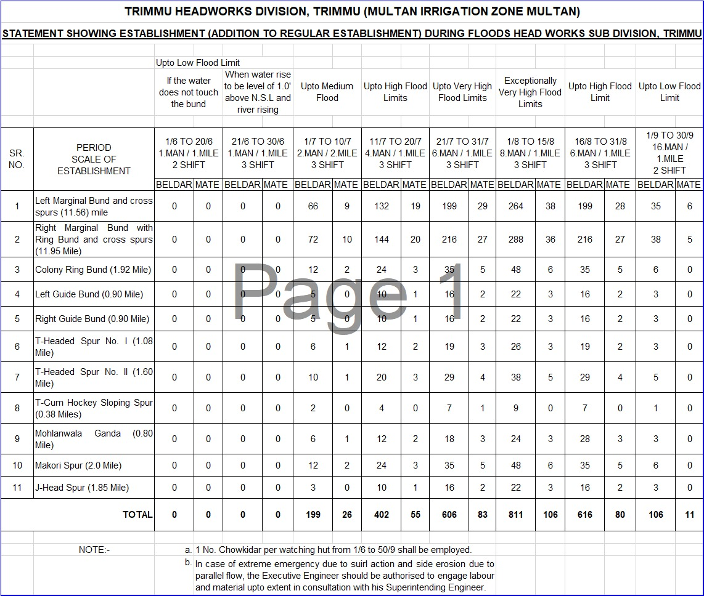

7.3 ARRANGEMENT AT SENSITIVE SITES.

ARRANGEMENT AT SENSITIVE SITES

Extra machinery and watching labour will be deployed at the sensitive sites. In addition to extra machinery & watching labour, a sufficient quantity of reserve stock of stone is present to meet with any emergency. The limit of reserve stock of stone was approved by Chief Engineer, Irrigation Multan Zone, Multan vide his No. 301/ B&A/ 2015/ 5885-89/ A/292/68 dated 06.04.2015 at site. Detail is given below:-
CONSOLIDATED STATUS OF RESERVE STOCK OF STONE

Sr. No. | Sanctioned Reserve stock Limit  (Lac Cft) | Available Quantity  (Lac Cft) | Balance required with respect to Sanctioned limit  (Lac Cft) | Minimum Quantity Available  (Lac Cft) | Remarks
1 | 23 | 17.24 | 5.76 | 16.10 | However, as per minimum requirement, there is no deficiency of stone.
DETAIL OF SANCTIONED RESERVE STOCK
SR NO. | NAME OF SITE | SANCTIONED LIMIT (LACS CFT) | AVAILABLE AT SITE (LACS CFT) | BALANCE QUANTITY (LAC CFT) | Remarks
1 | LGB U/S AND D/S | 5.0 | 4.87 | 0.13 | 74% quantity against minimum threshold of 70% is available which is sufficient to combat any untoward situation.
2 | RGB U/S AND D/S | 5.0 | 4.76 | 0.24
3 | J-HEAD SPUR RD 5500 OF RMB | 1.5 | 1.57 | 0
4 | SLOPING SPUR ALONG COLONY RING BUND | 1.0 | 0.32 | 0.68
5 | T-1 SPUR ALONG COLONY RING BUND | 1.5 | 0.81 | 0.69
6 | T-2 SPUR D/S TRIMMU BARRAGE | 1.5 | 0.79 | 0.71
7 | J-HEAD SPUR MAKORI | 1.5 | 0.90 | 0.6
8 | DAB KALAN (Relates to SDO Shorkot) | 1.25 | 0.89 | 0.36
9 | GUIDE WALL NO.1 ALONG LMB | 1.5 | 0.76 | 0.74
10 | GUIDE WALL NO.2 ALONG LMB | 1.5 | 0.76 | 0.74
11 | GUIDE WALL NO.3 ALONG COLONY RING BUND | 1.5 | 0.60 | 0.9
12 | X-SPUR RD 23000 OF RMB | 0.25 | 0.21 | 0.04
 | TOTAL (LACS CFT) | 23.0 | 17.24 | 5.76
7.4 WATCHING MATERIAL
It was agreed in the meeting held in the office of the Chief Engineer, Irrigation Zone Multan at Multan on 18-06-1978 that the scale of watching material approved in the Flood Fighting Plan prepared after the floods of 1975 will be followed. The scale was approved by the Superintending Engineer, Haveli Canal Circle, Multan No 6272-73/170-W/ Floods/1973-74 dated 31-05-1974.
Watching material will be provided in ample quantity as the experience shows that presence of watching material is very necessary. The particular care would be taken to ensure that there is adequate quantity of the required material shown as to be readily available everywhere particularly at vulnerable / critical sites. (Watching material)
Sr# | Description | Unit | Quantity Required | Quantity Available | Balance Quantity required | Remarks
1 | Axes | No. | 200 | 47 | 153 | Balance quantity will be recouped during flood season 2025
2 | Baskets (Water uses) | No. | 5082 | 1677 | 3405 | Balance quantity will be recouped during flood season 2025
3 | Buckets (earth filling) | No. | 726 | 26 | 700 | Balance quantity will be recouped during flood season 2025
4 | Cell for Torches | No. | 723 | 33 | 690 | Balance quantity will be recouped during flood season 2025
5 | Cow Dung in EC | No. | 837 | 50 | 787 | Balance quantity will be recouped during flood season 2025
6 | Funnel (Ordinary) | No. | 138 | 32 | 106 | Balance quantity will be recouped during flood season 2025
7 | Funnel with W.G | No. | 58 | 10 | 48 | Balance quantity will be recouped during flood season 2025
8 | Gas Lamp | No. | 29 | 10 | 19 | Balance quantity will be recouped during flood season 2025
9 | Gunny Bags | No. | 10503 | 2434 | 8069 | Balance quantity will be recouped during flood season 2025
10 | Hammer 2.5 lb | No. | 76 | 16 | 60 | Balance quantity will be recouped during flood season 2025
11 | Hammer 10 lb | No. | 137 | 35 | 102 | Balance quantity will be recouped during flood season 2025
12 | Kassi with handles | No. | 957 | 100 | 857 | Balance quantity will be recouped during flood season 2025
13 | Kerosene Oil | Liter | 2324 | 250 | 2074 | Balance quantity will be recouped during flood season 2025
14 | Khajji Mate | No. | 5792 | 300 | 5492 | Balance quantity will be recouped during flood season 2025
15 | Lanterns | No. | 864 | 40 | 824 | Balance quantity will be recouped during flood season 2025
16 | Larmal 50 Ft | No. | 3374 | 171 | 3203 | Balance quantity will be recouped during flood season 2025
17 | Mallet wooden (use in Killa pushing) | No. | 322 | 74 | 248 | Balance quantity will be recouped during flood season 2025
18 | Match Box | No. | 796 | 100 | 696 | Balance quantity will be recouped during flood season 2025
19 | Mental | No. | 796 | 100 | 696 | Balance quantity will be recouped during flood season 2025
20 | Needles | No. | 66 | 10 | 56 | Balance quantity will be recouped during flood season 2025
21 | Needles for sewing bags | No. | 259 | 15 | 244 | Balance quantity will be recouped during flood season 2025
22 | Nozzles | No. | 61 | 10 | 51 | Balance quantity will be recouped during flood season 2025
23 | Oil Extractor | No. | 133 | 10 | 123 | Balance quantity will be recouped during flood season 2025

24 | Sledge Hammer 14 lb | No. | 150 | 10 | 140
25 | Spare handle for kassies | No. | 489 | 25 | 464
26 | Siprit | No. | 75 | 10 | 65
27 | Spirit Can | No. | 30 | 10 | 20
28 | Sticks (6-8) | No. | 3635 | 574 | 3061
29 | Sutli | No. | 181 | 38 | 143
30 | Torch 3 Cell | No. | 52 | 10 | 42
31 | Tranger Wire | No. | 25 | 10 | 15
32 | Washers | No. | 61 | 10 | 51
33 | Wicks | No. | 429 | 145 | 284
34 | Munj Patha Taranger | No. | 1600 | 1600 | 0
35 | Petrol for generator | Liter. | 3960 | 100 | 3860
36 | Diesel for Petroling | Liter | 300 | 300 | 0
37 | Empty Drum | No. | 3 | 3 | 0
38 | Manila rope ½” to 1” | Ft | 500 | - | 500
39 | Water Supply | No. | 10 | - | 10
40 | Water set | No. | 8 | - | 8
41 | Plastic Chair Set | No. | 8 | - | 8
42 | Steel wire 10 No. | Ft | 100 | - | 100
43 | Bamboos 8’ to 12’ | No. | 500 | - | 500

Note: Full quantum of material will be purchased before flood season on receipt of funds. The balance / deficient watching material will be purchase of before flood season.
7.5 ARRANGEMENT FOR SOUNDING AND PROBING

The arrangement for sounding and probing will be taken up with the boat. An extra boat equipped with bathymetric arrangements is also available for drawing of sounding and probing by using software.
7.6 LIGHTING ARRANGEMENT

All the gates of Trimmu Barrage, additional bays and off-taking canals have electrically operated local control panels in addition to provision of mechanically operation which are provided under the ongoing Rehabilitation and Up-gradation project.
Independent 11-Kv transmission line have been laid to the energize the installations provided at Barrage. FESCO – WAPDA will ensure proper power supply to the head works. A well-equipped squad of electricians will be directed to be present at Head works for maintaining the proper lighting arrangement and to deal with any emergency related to the electric supply at the barrage.
2 Nos. generators of 100 KVA capacity & 1 No. portable 50 KVA capacity generator are available at Trimmu Barrage and will be used in case of electricity failure at Barrage and at the most vulnerable point under the river attack. Whereas at other vulnerable points, small generators as well as torches and lamps will be used for the lighting / watching arrangement.
7.7 RATION ARRANGEMENT

Ration is provided by the Irrigation Department to the watching establishment deployed along flood bunds during flood days. However ration for displaced persons from the flood area is provided by District Administration and NGOs.
7.8 P.O.L ARRANGEMENT FOR VEHICLE.

(Attention D.C Jhang)
Efforts will be made to stock some POL before the start of the flood season. The Deputy Commissioner, Jhang will order to reserve 5000 liters of Petrol and 10000 liters of Diesel at each of the following Petrol Pumps.
- M/S M B Ahmad and Sons At Athara Hazari
2. P.S.O Patrolling Mahloana More
3. M/S Ateeq Shorkot city
4. P.S.O Garh More

7.9 TRANSPORTATION

(Attention – Superintending Engineer, Trimmu Canal Circle, Trimmu
(Attention – Executive Engineer, Trimmu Headworks Division, Trimmu)
(Attention – D.C. Jhang)

There is one Toyota Hilux available with the Executive Engineer and one Pickup double cabin case with the Sub Divisional Officer, Trimmu Headworks which will be used for the shifting of material, human resources and patrolling. There are One No. Pickup Double Cabin and One No. Suzuki Jeep Photohar under the use of the SDO Athara Hazari and Shorkot Sub division located on each side of the River Chenab on D/S of Trimmu Barrage. For further preparation in this regard, the SE Trimmu Canal Circle Trimmu and Deputy Commissioner Jhang will be requested to keep one Jeep on the standby basis for dealing with the situation if the emergency arises.
Executive Engineer, Sidhnai Headworks Division, Sidhnai / Superintending Engineer, Trimmu Canal Circle, Trimmu will be requested to provide Trucks/ Pickups in tip top condition to deal with the Emergency if required. The supervisory staff will be directed to arrange for the transport themselves as far as possible.
7.10 LAW AND ORDER

(Attention: Deputy Commissioner & District Police Officer Jhang)
Police guard at right and left side of Trimmu Headworks would be available round the clock and the D.C Jhang will be requested to increase the strength so that the flood emergency measures are not interrupted. Police will be particularly requested to quell any effort made by the public to cut or breach any bund or embankment. In case miscreants try to cut any flood bund, the officer incharge will immediately call for the help of police. In case of any other type of law and order situation, the call for police will be made to deal with the situation, so that the flood emergency measure may go un-interrupted. The police will also be responsible for the protection of the installations at the Headworks. Furthermore, security guards are also hired for protection of Trimmu Headworks. The canal guards equipped with weapons will also available with the Executive Engineer and Sub Divisional Officers of Trimmu Headworks Division.
7.11 MEDICAL ARRANGEMENT FOR LABOUR

(Attention: Chief Executive Officer Health, Jhang)
There is one Dispensary available at Trimmu Headworks to deal any emergency labour working at Rehabilitation Project of Trimmu Headworks. The Chief Executive Officer, Jhang will be requested to set up a medical facility at Trimmu Headworks having trained and experienced staff along with the sufficient medicine during the flood season. The staff will remain present for 24 hours to meet with the emergency during the extreme flood at Trimmu.
7.12 LIAISON WITH ANOTHER DEPARTMENT

(Attention: Irrigation/Civil/Police department)
Executive Engineer Trimmu and Sub Divisional Officer, Trimmu Headworks will have close liaison with their counterparts of other departments and will call for any support they deem fit from them. Close contact will be maintained with civil authorities and police departments for all emergency measures. They will be constantly kept informed of the flood situation at Trimmu Headworks.
7.13 ROLE OF THE ARMY
The army authorities do the pre-flood inspection of the explosive store and breaching section. The breaching section is activated with the help of Pakistan Army by using the explosive material. In case this method fails, the breaches are made by using the dozers / excavator / labour. The Pakistan Army keeps on visiting the site from time to time.
7.14 DUTIES OF TELEPHONE ATTENDANT

Sr No. | Name of Official | Period | Time
Sr No. | Name of Official | Period | From | To
1 | Muhammad Usman | 15.06.2025  To  15.10.2025 | 06:00 A.M | 02:00 P.M
2 | Amir Iqbal | 15.06.2025  To  15.10.2025 | 02:00 P.M | 10:00 P.M
3 | Qayoum Khan | 15.06.2025  To  15.10.2025 | 10:00 P.M | 06:00 A.M

7.15 WIRELESS ARRANGEMENTS

There are two wireless sets working in Trimmu Headworks Division. One is working in Telegraph office Trimmu, and second with police is working at the Headworks. The wireless sets in vehicles will be provided by the DPO concerned before the coming flood.

Chapter - 08
S.  No. | Name of Canal Division | Name of District | Total No. of Encroachments | No. of Encroachments removed so far | No. of Encroachments to be removed
1 | Trimmu Headworks Division, Trimmu | Jhang | 54 | 4 | 50
DETAIL OF ENCROACHMENT
CONSOLIDATED UPDATED STATUS OF REMOVAL OF ENCROACHMENTS
Status of encroachment of Trimmu Barrage division
Sr.No. | Name of  infrastructure | Nature of  encroachments | Total No of  encroachments | No. of encroachments removed | Tehsil | District | Remarks
1 | 3 | 4 | 5 |  | 6 | 7 | 8
1 | Colony Ring Bund | Katcha  Houses | 4 No. | 1 | Jhang | Jhang | Few encroachments where there was not much resistance have been removed. District Administration has been requested to help in removal of encroachments.
2 | Right Marginal Bund | Katcha  Houses | 28 No. | 2 | 18-Hazari | Jhang
3 | Left Marginal Bund | Katcha  Houses | 20 No. | 1 | Jhang | Jhang
Detail of Encroachment
Sr No. | Name of Bund / Spur | RD | Name of Encroachee
1 | Right Marginal Bund | 12000-13000 | Mr, Muhammad Aslam Caste Muslim Sheikh
2 | Right Marginal Bund | 12000-13000 | Mst: Nooran caste Muslim Sheikh
3 | Right Marginal Bund | 12000-13000 | Mr, Muhammad Nawaz Sial
4 | Right Marginal Bund | 12000-13000 | Mr, Farid S/O Pehlwan
5 | Right Marginal Bund | 12000-13000 | Mr, Bilal Sindhi
6 | Right Marginal Bund | 12000-13000 | Mr, Suleman Sindhi
7 | Right Marginal Bund | 12000-13000 | Mr, Ghulam Akbar Sindhi
8 | Right Marginal Bund | 13000-14000 | Mr, Ghulam Akbar Sindhi
9 | Right Marginal Bund | 13000-14000 | Mr, Muhammad Shafi Sindhi
10 | Right Marginal Bund | 13000-14000 | Mr, Mastoo Sindhi
11 | Right Marginal Bund | 13000-14000 | Mr, Hameed Sindhi
12 | Right Marginal Bund | 20000-21000 | Mr, Muhammad Sharif Jhabail
18 | Right Marginal Bund | 20000-21000 | Mr, Allah Bakhsh Piraien
19 | Right Marginal Bund | 24000-25000 | Mr, Muhammad Hayat S/O Sher Muhammad Umrana
20 | Right Marginal Bund | 24000-25000 | Mr, Lal S/O Saluh Umrana
21 | Right Marginal Bund | 27000-28000 | Mr, Zulifqar S/O Muhammad ramzan Umrana
22 | Right Marginal Bund | 28000-29000 | Mr, Muhammad Riaz S/O Allah Bukhsh Umrana
23 | Left Marginal Bund | 15000 | Mr, Alam Sher S/O Shameer Caste Diraj
24 | Left Marginal Bund | 19000 | Mr, Farid S/O Haji
25 | Left Marginal Bund | 20000 | Mr, Hakim Ranjha
26 | Left Marginal Bund | 32000 | Mr, Akbar S/O Allah Yar
27 | Left Marginal Bund | 35000 | Mr, Sarfaraz S/O Muhammad
28 | Left Marginal Bund | 35000 | Mr, Ijaz S/O Muhammad
29 | Left Marginal Bund | 35000 | Mr, Sarfaraz S/O Dalmir
30 | Left Marginal Bund | 35000 | Mr, Islam Mochi
31 | Left Marginal Bund | 38000 | Mr, Dalmir S/O Gahran
32 | Left Marginal Bund | 38000 | Mr, Riaz S/O Noor Muhammad
33 | Left Marginal Bund | 38000 | Mr,Sarfaraz
34 | Left Marginal Bund | 41000-42000 | Mr, Muhammad Aslam S/O Nawab
35 | Left Marginal Bund | 41000-42000 | Mr, Bashir Ahmed S/O Allah Ditta
36 | Left Marginal Bund | 41000-42000 | Mr, shammas Dhirkhan
37 | Left Marginal Bund | 41000-42000 | Mr,Ghulam Haider Noon
38 | Left Marginal Bund | 41000-42000 | Mr, Noor Khan Noon
39 | Left Marginal Bund | 41000-42000 | Mr, Ghulam Farid Noon
40 | Left Marginal Bund | 41000-42000 | Mr, Nazeer S/O Abdul Ghani
41 | Left Marginal Bund | 41000-42000 | Mr, Bilal S/O Abdul Ghani
42 | Left Marginal Bund | 41000-42000 | Mr, Muhammad Aslam Caste Oad
43 | Left Marginal Bund | 41000-42000 | Mr, Munir Ahmed Oad
44 | Colony Ring Bund | 2-3/R | Mr, M. Rafique S/O Bahadar Caste Dingrach R/O Mouza Dhoin
45 | Colony Ring Bund | 2-3/R | Muammad Rafique S/O Bahadar Qaum Dingrach
46 | Colony Ring Bund | 2-3/R | Ghulam Muhammad S/O Sultan Qaum Dingrach
47 | Colony Ring Bund | 2-3/R | Zafar S/O Sultan Qaum Dingrach
48 | Colony Ring Bund | 2-3/R | Muzafar S/O Sultan Qaum Dingrach
49 | Colony Ring Bund | 3-4/R | Begam Zouja Sultan Dingrach Mouza
50 | Colony Ring Bund | 3-4/R | Khuda Baksh S/O Muhammad Baksh Malang
51 | Colony Ring Bund | 3-4/R | Mushtaq S/O Ghulam Fareed
52 | Colony Ring Bund | 3-4/R | Arif S/O Nawaz Mouza Dhuin Muhammad
53 | Colony Ring Bund | 5-6/R | Abdul Rasheed /Ramzan Muslim Sheikh
54 | Colony Ring Bund | 5-6/R | Ilyas So/ Mummad Waryam Qaum Changar
55 | Colony Ring Bund | 5-6/R | Waris S/O Allah Bakhsh Qaum Changar
56 | Colony Ring Bund | 5-6/R | Manzoor S/O Maji Muhammad Qaum Changar
57 | Colony Ring Bund | 5-6/R | Palwan S/O Ghulam Muhammad Qaum Rabani
58 | Colony Ring Bund | 6-7/R | Haji Dalmeer S/O Maji Muhammad Qaum Changar
59 | Colony Ring Bund | 7-8/R | Muhammad Riaz / Muhammad Nawaz
60 | Colony Ring Bund | 7-8/R | Saeed S/O Muhammad Bukhsh Cast Jhatta
61 | Colony Ring Bund | 7-8/R | Shabbir Caste Jhatta
62 | Colony Ring Bund | 7-8/R | Ghazanfer Abbas S/O Jewan Raja
63 | Colony Ring Bund | 7-8/R | Liaqat Raja S/O Talib Hussain
64 | Colony Ring Bund | 7-8/R | Muhammad Ilyas Caste Khokha
65 | Colony Ring Bund | 2-3/R | Iqbal S/O Allah Yar
66 | Rangpur Flood Bund | 268500/L | Mr, Khizer Kumhar, Ahmed Nawaz, Pappu Machi & Naeem Kharal
67 | Rangpur Flood Bund | 283-284/L | Mr, Iqbal S/O Haider caste Jhatial 3-L Ali Sarwani
68 | Rangpur Flood Bund | 299-300/L | Mr, Sher Muhammad Mulana Mouza Mulana
69 | Rangpur Flood Bund | 307-308 | Mr, M.Ismail S/O Allah Yar Kheera Mouza Fatu Halkana
70 | Dadal Flood Bund | 0-1000/L | Mr, Bashir Ahmed S/O Pehlwan Near Adda Ghayalpur
71 | Dadal Flood Bund | 3000-4000/L | Mr, Mustafa S/O Manzoor Hussain Cast Baloach
72 | Dadal Flood Bund | 9-10/L | Mr, Ramzan S/O Ameer Caste Khokhar
73 | Dadal Flood Bund | 14-15/L | Mr, Mustafa S/O Shafi Caste Khokhar Mouza Daraz
74 | Dadal Flood Bund | 14-15/R | Mr, Riaz S/O Allah Bukhsh Caste Thiraj Mouza Daraz
75 | Dadal Flood Bund | 16-17/L | Mr, Akram S/O Allah Ditta Caste Arayein Mouza PAR
76 | Dadal Flood Bund | 19-20/L | Sharif S/O Daim Caste Choan Pir Abdur Rehman
77 | Dadal Flood Bund | 20-21/R | Mr, Haq Nawaz S/O Makal Caste Bharwana PAR
78 | Dadal Flood Bund | 21-22/L&R | Mr, Maznoor Hussain S/O Sher Caste Luck Pir Abdur Rehman
79 | Dadal Flood Bund | 21-22/L&R | Mr, Muhammad Hussain S/O Ramzan Caste Luck PAR
80 | Dadal Flood Bund | 21-22/L&R | Mr, Allah Ditta S/O Shamma Caste Luck Pir Abdur Rehman
81 | Dadal Flood Bund | 22-23/L&R | Mr, Iqbal S/O Ramzan Caste Luck Pir Abdur Rehman
82 | Dadal Flood Bund | 22-23/L&R | Mr, Khan S/O Gul Muhammad Caste Luck Pir Abdur Rehman
83 | Dadal Flood Bund | 22-23/L&R | Mr, Mushtaq Ahmed S/O Pathan Caste Luck PAR
84 | Dadal Flood Bund | 22-23/L&R | Mr, Bahali S/O Nawaz Caste Luck Pir Abdur Rehman
85 | Dadal Flood Bund | 27-28/R | Mr, Irshad S/O Ameer Caste Maitla Pir Abdur Rehman
86 | Dadal Flood Bund | 28-29/R | Mr, Ramzan S/O Rajab Caste Choan Pir Abdur Rehman
87 | Dadal Flood Bund | 28-29/R | Mr, Manzoor Hussain S/O Sher Caste Luck Pir Abdur Rehman
88 | Dadal Flood Bund | 29-30/L&R | Mr, Kazim S/O Ahmed caste Choan Pir Abdur Rehman
89 | Dadal Flood Bund | 29-30/L&R | Mr, Qaiser S/O Nawaz caste Choan Pir Abdur Rehman
90 | Dadal Flood Bund | 29-30/L&R | Mr, Ghulam,Ramzan S/O Baig Caste Sanmpal
91 | Dadal Flood Bund | 29-30/L&R | Mr, Hayat S/O Allah Bukhsh Pir Abdur Rehman
92 | Rajbana Flood Bund | 1-2/R | Mumtaz S/O Nawab
93 | Rajbana Flood Bund | 2-3/R | Tahir Mehdi S/O Rab Nawaz
94 | Rajbana Flood Bund | 2-3/R | Iqbal S/O Talib Hussain
95 | Rajbana Flood Bund | 2-3/R | Tasawar S/O Mulazim Hussain
96 | Rajbana Flood Bund | 2-3/R | Mumtaz Hussain S/O Rab Nawaz
97 | Rajbana Flood Bund | 2-3/R | M.Murad S/O Hasta
98 | Rajbana Flood Bund | 12-13/R | Mumtaz S/O Ghulam
99 | Link Flood Bund | 6-7/L | M.Imran S/O Khadim Hussain
100 | Link Flood Bund | 6-7/L | Bashir Ahmad S/O Sher
101 | Link Flood Bund | 6-7/R | Ahmad S/O Sultan
102 | Link Flood Bund | 7-8/R | Mazhar Abbas S/O Allah Bakhsh
103 | Link Flood Bund | 7-8/R | Safdar Abbas S/O Muhammad Zafar
104 | Link Flood Bund | 7-8/R | Ramzan S/O Allah Ditta
105 | Link Flood Bund | 7-8/L | Safdar Abbas S/O Muhammad Zafar
106 | Link Flood Bund | 7-8/L | Bashir Ahmad S/o Muhammad Fazal
107 | Link Flood Bund | 7-8/L | Allah Ditta S/O Haq Nawaz
108 | Link Flood Bund | 7-8/L | Bashir S/O Abdul Rehman
109 | Link Flood Bund | 8-9/L | Allah Ditta S/O Sultan
110 | Link Flood Bund | 9-10/L | Mahar Noor S/O Mahar Allah Ditta
111 | Link Flood Bund | 9-10/L | M.Nawaz S/O Mahar Nusrat
112 | Link Flood Bund | 10-11/L | Bashir S/O Ghulam
113 | Link Flood Bund | 11-400/R | Gull Muhammad S/O Allah Bakhsh
114 | Link Flood Bund | 11-400/L | Mahar Ijaz S/O Pehlwan
115 | Lakhi Flood Bund | 28-29/R | Noor S/O Ghulam Fareed
116 | Lakhi Flood Bund | 40-41/R | Ghulam Shabir S/O Ghulam Fareed
117 | Lakhi Flood Bund | 42-43/R | Sarang Ali S/O Haji Baig
118 | Lakhi Flood Bund | 54-55/R | Riaz S/O M. Shafi
119 | Hassuwali Flood Bund | 26-27/L | Ansar S/O Sultan
120 | Hassuwali Flood Bund | 26-27/R | Malang s/O Bahadar Ali
121 | Hassuwali Flood Bund | 26-27/R | Haji Bashir S/O Noor Muhammad
122 | Hassuwali Flood Bund | 28-29/R | Sharafat Ali S/O Bashir
123 | Hassuwali Flood Bund | 26-27/R | Mumtaz S/O Shahmand
124 | Hassuwali Flood Bund | 32-33/R | Nasir S/O Hashim
125 | Hassuwali Flood Bund | 38-39/R | Afzal S/O Jaffar Sial
126 | Hassuwali Flood Bund | 63-64/R | Ghulam Abbas S/O Haji

Chapter - 09
DUTY ROSTER / FLOOD FIGHTING PROGRAM

Phase I - (Pre-Flood Period)
This phase covers the pre-flood period starting from start of the flood season upto the time the flood water raises upto 1 foot above general Natural Surface Level (NSL) along the flood bunds.

WATCHING: Flood watching establishment will be arranged according to flood scales / stages after consultation with the concerned authority and other essential need at site.
Stage | Strength
Water level is 1 foot above NSL or below along the flood bund | 1 watchman per mile per shift in two shifts during 24 hours on Marginal and other flood bunds
Water level is more than1 foot above NSL along the flood bund | 1 watchman per mile per shift in three shifts during 24 hours on Marginal and other flood bunds

During this phase the Sub Divisional officers of the bunds and respective Sub Engineers of the sections of the bunds will be the controlling officers under the overall supervision of the Executive Engineer, Trimmu Headworks Division, Trimmu.
Phase II – (Low Flood i.e. 1.50 to 2.00 Lac cusecs)
This phase starts when the discharge at the Trimmu Headworks is between 1.5 to 2 Lac cusecs. The details of the actions to be taken during this phase are as follows:
Activity | Action
Shifting of watching & necessary flood material to watching huts | Respective Sub Engineers, SDO, XEN.

Stage | Strength
The discharge ranges between 1.5 to 2.0 lac cusecs | 2 persons per mile per shift in three shifts during 24 hours on Marginal and other flood bunds  1 Chowkidar per watching hut for round the clock duty till the time watching material is taken back from the watching huts after recession of the flood to a level 1 foot above NSL.
Supervisory Staff
The duty roster during this phase of the flood, officers/officials duties are tabulated below. The officials under the overall control of the sub-divisional officers concerned will perform the duties.

Sr. No. | Location | Duty of Officer/Official
1 | Barrage and Headworks | Sub Engineer Headworks
2 | Right Marginal Bund ( RD 0 – 54 )  J Head Spur ( RD 0 – 10 ) | Sub Engineer Headworks
3 | Left Marginal Bund (RD 0 – 46) along with wetting Channel & Guide Wall No.1 & 2 | Sub Engineer River Survey
4 | Colony Ring Bund along with  - T- Cum Hockey Spur  - T Head No I and II Spur  - Makori Spur.  - Guide Wall No.3 | Sub Engineer Station Area
5 | Hassuwali Flood Bund (RD 0-24 )  Hassuwali Flood Bund (RD 24-48 )  Hassuwali Flood Bund (RD 48-72 Tail) | Zilladar, Shorkot  Sub Engineer, Jarala  Sub Engineer, Farid Mehmood
6 | Rajbana Flood Bund (0 – tail)  Link Bund (0 – tail) | Sub Divisional officer Shorkot  Sub Engineer, Dauranpur  Sub Engineer, Kakki
7 | Lakhi Flood Bund (13 – 45)  Lakhi Flood Bund (45 – 68 tail) | Sub Engineer Rajbana  Zilladar Dauranpur
8 | Dadal Flood Bund & Embankment of 1L/3L  Dadal Flood Bund (RD 0 – 25 )  Dadal Flood Bund (RD 25 – tail )  Embankment of 1L/3L (RD 5 – 15380) | Sub Divisional Officer, 18-Hazari Sub Division (Overall Incharge)  Sub Engineer Pir Abdur Rehman  Zilladar Ahmad pur  Sub Engineer Kapuri Section
9 | Rangpur Flood Bund  Rangpur Flood Bund ( RD 260 - 320)  Rangpur Flood Bund ( RD 304 - 318) | Executive Engineer, Trimmu Headworks Division, Trimmu (Overall Incharge)  Sub divisional Officer Athara Hazari Subdivision (Head quarter at RD 292)  Sub Engineer Rangpur  Sub Engineer Diana
10 | Head Mohlanwala Creek | Sub Engineer River Survey
11 | Mole Head Gryne with 3 No. Solid Stone Studs at Dab Kalan including protection bund and defence bund | Sub Engineer, Rajbana.
Phase III – (Medium Flood i.e. 2.00 to 3.00 Lac cusecs)
This phase starts when the discharge at the Trimmu Barrage crosses the medium level and is upto high level flood i.e. between 2.00 to 3.00 Lac cusecs. The details of the actions to be taken during this phase are as follows:
Stage | Strength
The discharge ranges between 2.0 to 3.0 lac cusecs | 4 persons per mile per shift in three shifts during 24 hours on Marginal and other flood bunds.  1 Chowkidar per watching hut for round the clock duty till the time watching material is taken back from the watching huts after recession of the flood to a level 1 foot above NSL.

Supervisory Staff
The duty roster during this phase of the flood, officers/officials duties are tabulated below. The officials under the overall control of the concerned Sub Divisional officers will perform the duties.

Sr. No. | Location | Duty of Officer/Official
1 | Barrage and Headworks/Guide Bunds | Sub Divisional Officer, Headworks  Sub Engineer, Headworks
2 | Right Marginal Bund ( RD 0 – 54 )  J Head Spur ( RD 0 – 10 ) | Sub Engineer, Headworks.
3 | Left Marginal Bund (RD 0 – 46)  along with wetting Channel & Guide Wall No. 1 & 2 | Sub Engineer, River Survey
4 | - Colony Ring Bund along with  i) T- Cum Hockey Spur  ii) T Head No I and II Spur  iii) Guide Wall No.III  - Makori Spur | Sub Engineer, Station Area  Sub Engineer, Station Area  Sub Engineer, Station Area  Sub Engineer, Station Area  Sub Engineer, River Survey
5 | Hassuwali Flood Bund (RD 0-72 Tail) | Sub Enginerr Farid Mehmood
6 | Rajbana Flood Bund (0 – tail)  Link Bund (0 – tail) | Sub Engineer, Dauranpur
7 | Lakhi Flood Bund (0 – tail) | Sub Engineer Rajbana  Zilladar Shorkot
8 | Dadal Flood Bund (RD 0 – 25 )  Dadal Flood Bund (RD 25 – tail )  Embankment of 1L/3L (RD 5 – 15380) | Sub Engineer Pir Abdur Rehman  Sub Engineer Lashari  Sub Engineer Lashari
9 | Head Mohlanwala Creek | Sub Engineer River Survey

10 | Rangpur Flood Bund ( RD 292)  Rangpur Flood Bund ( RD 260 - 320)  Rangpur Flood Bund ( RD 304 - 318) | Sub divisional Officer AtharaHazari  Sub Engineer Rangpur  Sub Engineer Diana
11 | Mole Head Gryne with 3 No. Solid Stone Studs at Dab Kalan including protection bund and defence bund | Sub Engineer, Rajbana

Phase IV – ( High Flood i.e. 3.00 to 4.50 Lac cusecs)
This phase starts when the discharge at the Trimmu Barrage is between 3.00 to 4.50 Lac cusecs. The details of the actions to be taken during this phase are as follows:
Activity | Action
Requisition for 100 Army Jawans | XEN

Stage | Strength
The discharge ranges between 3.0 to 4.5 lac cusecs | 6 persons per mile per shift in three shifts during 24 hours on Marginal and other flood bunds  1 Chowkidar per watching hut for round the clock duty till the time watching material is taken back from the watching huts after recession of the flood to a level 1 foot above NSL.

Supervisory Staff
The duty roster during this phase of the flood, officers/officials duties are tabulated below. The officials under the overall control of the Sub Divisional Officers concerned will perform the duties.
Sr. No. | Location | Duty of Officer/Official
1 | Barrage and Headworks/ Guide Bunds | Executive Engineer  Sub Divisional Officer, Headworks  Sub Engineer, Headworks
2 | Right Marginal Bund ( RD 0 – 30 )  - J Head Spur ( RD 0 – 10 )  Right Marginal Bund ( RD 30 – 54 ) | Sub Engineer, Leave Reserve (Head Quarter at RD 23)  Sub Engineer, Kapuri (Head Quarter at RD 45)
3 | Left Marginal Bund along with wetting Channel ( RD 0 - 20 )  Left Marginal Bund along with wetting Channel ( RD 20 - 46 ), Guide Wall No.I&II | Sub Engineer River Survey (Head quarter at RD 20)  Sub Engineer, Hydraulic (Head quarter at RD 36)
4 | 1. Colony Ring Bund along with  - T- Cum Hockey Spur  - T Head No I and II Spur  - Guide Wall No.III  2. Makori Spur | Clerical Staff of Trimmu Division  Deputy Collector, Trimmu  Sub Engineer, Station Area  Sub Engineer, River Survey
5 | Hassuwali Flood Bund (RD 0-72 Tail) | Sub Enginerr Farid Mehmood
6 | Rajbana Flood Bund (0 – tail)  Link Bund (0 – tail) | Sub Engineer, Dauranpur
7 | Lakhi Flood Bund (0 – tail) | Sub Engineer Rajbana  Zilladar Shorkot
8 | Dadal Flood Bund (RD 0 – 25 )  Dadal Flood Bund (RD 25 – tail )  Embankment of 1L/3L (RD 5 – 15380) | Sub Engineer Pir Abdur Rehman  Sub Engineer Lashari  Sub Engineer Lashari
9 | Rangpur Flood Bund ( RD 292)  Rangpur Flood Bund ( RD 260 - 320)  Rangpur Flood Bund ( RD 304 - 318) | Subdivisional Officer AtharaHazari  Sub Engineer Rangpur  Sub Engineer Diana
10 | Head Mohlanwala Creek | Sub Engineer River Survey
11 | Mole Head Gryne with 3 No. Solid Stone Studs at Dab Kalan including protection bund and defence bund | Sub Engineer, Rajbana

Phase V – (Very High Flood i.e. 4.50 to 6.00 Lac cusecs)
This phase starts when the discharge at the Trimmu Barrage is in very high flood stage i.e. between 4.50 to 6.00 Lac cusecs. During this phase special attention will be given to watch most vulnerable reaches of the bunds, concerned officer incharge is responsible that these points are especially watched. The details of the actions to be taken during this phase are as follows:
Activity | Action
Requisition for 200 Army Jawans | XEN

Watching
Stage | Strength
The discharge ranges between 4.50 to 6.00 lac cusecs | 8 persons per mile per shift in three shifts during 24 hours on Marginal and other flood bunds  1 Chowkidar per watching hut for round the clock duty till the time watching material is taken back from the watching huts after recession of the flood to a level 1 foot above NSL.

Supervisory Staff
The duty roster during this phase of the flood, officers/officials’ duties are tabulated below. The officials under the overall control of the Sub Divisional Officers concerned will shift their headquarters and will perform the duties.
Sr. No. | Location | Duty of Officer/Official
1 | Barrage and Headworks/ Guide Bunds | Executive Engineer  Sub Divisional Officer, Headworks  Sub Engineer, Headworks
2 | Right Marginal Bund  Right Marginal Bund ( RD 0 – 54 )  - J Head Spur ( RD 0 – 10 ) | Sub Divisional Officer, T.S. Link Overall Incharge (Headquarter at RD 37)  Sub Engineer, Leave Reserve  Sub Engineer, Leave Reserve
3 | Left Marginal Bund  Left Marginal Bund along with wetting Channel ( RD 0 - 20 ), Guide Wall No.I&II  Left Marginal Bund along with wetting Channel ( RD 20 - 46 ) | Sub Divisional Officer, Old Sidhnai,  Overall Incharge (Headquarter at RD 42)  Sub Engineer River Survey  Sub Engineer, Hydraulic
4 | 1. Colony Ring Bund along with  - T- Cum Hockey Spur  - T Head Spur No I  iii) T Head Spur No II  iv) Guide Wall No.III  - Makori Spur | Clerical Staff of Trimmu Division  Deputy Collector, Trimmu  Silt Analyst  Sub Engineer, Station Area  Sub Engineer, Station Area  Sub Engineer, River Survey
5 | Hassuwali Flood Bund (RD 0-72 Tail) | Sub Enginerr Farid Mehmood
6 | Rajbana Flood Bund (0 – tail)  Link Bund (0 – tail) | Sub Engineer, Shorkot
7 | Lakhi Flood Bund (0 – tail) | Sub Engineer Rajbana  Zilladar Shorkot
8 | Dadal Flood Bund (RD 0 – 25 )  Dadal Flood Bund (RD 25 – tail )  Embankment of 1L/3L (RD 5 – 15380) | Sub Engineer Pir Abdur Rehman  Sub Engineer Lashari  Sub Engineer Lashari
9 | Rangpur Flood Bund ( RD 292)  Rangpur Flood Bund ( RD 260 - 320)  Rangpur Flood Bund ( RD 304 - 318) | Subdivisional Officer AtharaHazari  Sub Engineer Rangpur  Sub Engineer Diana
10 | Head Mohlanwala Creek | Sub Engineer River Survey
11 | Mole Head Gryne with 3 No. Solid Stone Studs at Dab Kalan including protection bund and defence bund | Sub Engineer, Rajbana

Phase VI – (Exceptionally High Flood i.e. more than 6.00 Lac cusecs)
This phase commences when the discharge at the Trimmu Barrage is in exceptionally high flood stage i.e. more than 6.00 Lac cusecs. The details of the actions to be taken during this phase are as follows:
Activity | Action to be taken by
Deputy Commissioner is informed to make arrangement for the evacuation of the marooned public within LMB and RMB  Military Authorities to keep ready for emergent operation  Police to watch that no un authorized cut is made by public especially all along LMB, RD 0 – 15 of RMB.  Engineers 4 Corps for energizing the breaching section, when water level approaches R.L 500 mark at the emergency  gauge installed at RD 15 of LMB.  Arrangement for 200 Volunteers to cut RMB at Breaching section in case the blasting arrangement doesn’t work. | Executive Engineer  Executive Engineer  Executive Engineer  Executive Engineer  District Administration & Zilladar 18 Hazari Sub division.

Watching
Stage | Strength
The discharge more than 6.0 Lac cusecs | 8 persons per mile per shift in three shifts during 24 hours on Marginal and other flood bunds  1 Chowkidar per watching hut for round the clock duty till the time watching material is taken back from the watching huts after recession of the flood to a level 1 foot above NSL.
Supervisory Staff
The duty roster during this phase of the flood, officers/officials’ duties are tabulated below. The officials under the overall control of the Sub Divisional Officers concerned will shift their headquarters and will perform the duties.
Sr. No. | Location | Duty of Officer/Official
1 | Barrage and Headworks/ Guide Bunds | Executive Engineer, Trimmu Barrage  Sub Divisional Officer, Headworks  Sub Engineer, Headworks
2 | Right Marginal Bund  Right Marginal Bund ( RD 0 – 30 )  - J Head Spur ( RD 0 – 10 )  Right Marginal Bund ( RD 0 – 30 )  Right Marginal Bund ( RD 30 – 54 ) | Sub Divisional Officer, T.S. Link Overall Incharge (Headquarter at RD 37)  Sub Engineer, Yasmin  Sub Engineer, Yasmin  Sub Engineer, Leave Reserve  Sub Engineer, Kapuri
3 | Left Marginal Bund along with wetting channel  Left Marginal Bund along with wetting Channel ( RD 0 - 20 )  Left Marginal Bund along with wetting Channel ( RD 20 – 46 ) | Sub Divisional Officer, Old Sidhnai, Overall Incharge (Headquarter at  RD 42)  Sub Engineer River Survey  Sub Engineer, Hydraulic
4 | - Colony Ring Bund along with  - T- Cum Hockey Spur  - T Head Spur No I  - T Head Spur No II  - Guide Wall No.I&2  - Makori Spur | Clerical Staff of Trimmu Division  Deputy Collector, Trimmu  Silt Analyst  Sub Engineer, Station Area  Sub Engineer, River Survey
5 | Hassuwali Flood Bund (RD 0-24 )  Hassuwali Flood Bund (RD24-48 )  Hassuwali Flood Bund (RD 48-72 Tail) | Zilladar, Shorkot  Sub Engineer, Jarala  Sub Engineer, Farid Mehmood
6 | Rajbana Flood Bund (0 – tail)  Link Bund (0 – tail) | Sub Divisional officer Shorkot  Sub Engineer, Dauranpur  Sub Engineer, Kakki
7 | Lakhi Flood Bund (13 – 45)  Lakhi Flood Bund (45 – 68 tail) | Sub Engineer Rajbana  Zilladar Shorkot
8 | Dadal Flood Bund & Embankment of 1L/3L  Dadal Flood Bund (RD 0 – 25 )  Dadal Flood Bund (RD 25 – tail )  Embankment of 1L/3L (RD 5 -15380) | Sub Divisional Officer, 18-Hazari Sub Division Garh More (Overall Incharge)  Sub Engineer Pir Abdur Rehman  Zilladar Ahmad pur  Sub Engineer Kapuri Section
9 | Rangpur Flood Bund  Rangpur Flood Bund ( RD 260 - 320)  Rangpur Flood Bund ( RD 304 - 318) | Executive Engineer, Trimmu Headowkrs Division Trimmu (Overall Incharge)  Sub divisional Officer Athara Hazari Sub Division (Head quarter at  RD 292)  Sub Engineer Rangpur  Sub Engineer Diana
10 | Head Mohlanwala Creek | Sub Engineer River Survey
11 | Mole Head Gryne with 3 No. Solid Stone Studs at Dab Kalan including protection bund and defence bund | Sub Engineer, Rajbana

In case of breach in the Right Marginal bund, Sub Engineer Lashari will look after the Rangpur Canal and manage cuts and cross bunds in Rangpur canal at RD 20-30, 40-46 and 70-80. Sub Engineer Dharkana will watch Haveli main Line from RD 184 – tail.

Breach Closing Squad
When the discharge will exceed 4.00 Lac cusecs, the mobile units consisting of following items are to be raised in each sub division. The Tip Top condition of Pick up and Tractor Trolley will be ensured.
Stack ballies 16-foot-long = 140 No.
Killas = 200 No.
Munj Ban Course = 140 Kg
Showels = 50 No.
Gunny bags = 700 No.
Sutli = 3 Kg
Needles = 28 No.
Baskets = 350 No.
In Headworks Sub Division, one unit will be kept on Left Marginal Bund and one at Right marginal Bund. In Shorkot Sub division, one unit will be kept at Lakhi Flood Bund, one at Hassuwali Flood Bund along with Rajbana Flood Bund and connecting tail Rajbana Flood Bund.Whereas in 18 Hazari Sub division two units will be deployed – one at Dadal Flood Bund and one at Rangpur Flood Bund.
A gang of 10 persons and a mate will move along with the unit at a moment notice. At the same time the Army Authorities will also be requested to provide manpower for closing leakage/breach.

CHAPTER-10
EMERGENCY TELEPHONE NUMBERS

# | DESIGNATION | OFFICE |  | RESIDENCE
1. | Secretary to Government of the Punjab, Irrigation Department, Lahore. | 042-99212117  042-99212118 |  | 042-35731116
2 | Secretary South Punjab Irrigation Department Bahawal pur | 062-9250544 |  | -
3. | P.S. to Secretary IRR: Lahore. | 042-99212116  042-99212117  042-99212118 |  | 042-5821839
4. | Additional Secretary (Tech:) IRR Department Lahore. | 042-99212128 |  | 042-37841123
5. | Additional Secretary (Admn) IRR department Lahore. | 042-99212119 |  | 042-7561576
6. | Deputy Secretary (Admn) | 042-99212126 |  | 042-7575766
7. | Deputy Secretary (General) | 042-99212125 |  | 042-5725896
8. | Deputy Secretary Development) | 042-99212129 |  | 042-7586597
9. | Deputy Secretary (Power) | 042-99212129 |  | 042-6826748
10. | Deputy Secretary (Operation) | 042-99212127 |  | 042-891579
11. | Officer on Special Deputy | 042-99212130 |  | 042-7573504
12. | U.S/S.O, (Floods) flood Emergency Officer | 042-99212134
13. | Deputy Director, P & D under Secretary | 042-99212131 |  | 042-6853264
14. | S.O. General | 042-99212133
15. | S.O. (V) | 042-99214021
16. | Telegraph office Irrigation LHR | 042-99212166
17. | Chief Engineer D & F Zone Lahore. | 042-99230602  Fax: 042-35862081 |  | 0300-4877257
18 | Director Flood D&F Zone LHR | 042-99231614
19. | Executive Engineer, Irrigation Jhang. | 047-9200300 |  | 0321-6095101
20. | XEN Rasool Barrage | 0546/553211 |  | 0340-7159459
21. | XEN Qadirabad Barrage | 054-7550190 |  | 0300-1030530
22. | Chief Engineer Mangla Dam | 054-4639161  Fax 639162
23 | XEN Marala | 052-3502102 |  | 0346-4132454
24 | XEN Khanki | 055-6266239 |  | 0331-8484303
25. | D.C. Jhang. | 047-9200081 |  | 047-7625881  047-7612437
26. | District Session Judge Jhang |  | 047-9200092
27. | Addl Distt Session, Jhang |  | 5372
28. | Senior Civil Judge, Jhang. |  | 047-9200333
29. | Divisional Engineering phones |  | 622999 & 624299
30. | Superintending Engineer, WAPDA, Jhang |  | 047-9200228
31 | XEN WAPDA Jhang. |  | 047-9200224 | 03701813310
32 | S.D.O. WAPDA Jhang |  | 047-9200227 | 03701813342

33. | Executive District Officer  (Revenue Jhang) | 047-7612010 |  | 047-7624420
34. | District Officer Revenue Jhang. | 047-920012 |  | 047-7612010
35. | Deputy District Officer  (Revenue Jhang) | 047-9200433 |  | 047-7612697
36. | 314-Assault Engineers Battalion Gujranwala Cantt: | 055-269-35188 |  | 0321-2200314
37. | 25 Engineers Battalion Gujranwala Cant. | 055-2694146 |  | 055-2694144  055-2695184
38. | Head Quarter Engineers 1 Crops Kharian Cantt (Tel: Miltary) | 05771-592353 |  | 05771-592353
39. | XEN Balloki Barrage Division | 049-4610300
40. | Assistant Agricultural Engineering | 625668
41. | Sub Divisional Officer T.S. Link Shorkot Cantt:. | 047-5501954 |  | 047-5501954
42. | XEN operation office of the Chief Engineer, Faisalabad Irrigation Zone Faisalabad | 041-9200270
43. | Chief Engineer, Sargodha Zone Sargodha | 048-9230446
44. | Chief Engineer, Bhalwalpur Zone Bahawalpur | 062-9250265  Fax: 9250263
45. | Chief Engineer, Research Punjab Lahore. | 042-9212091 & 9212092  Fax 9212094
46. | Director Flood Forecasting Bearue | 7586479
47. | Deputy Director Advertisement Lahore. | 042-9201395 , 9201396  9201397
48. | Relief Commissioner Lahore | 042-9210780 & 9210781  Fax 9210555
49. | Chairman, Federal Flood Commission, Lahore. | 042-9206589  042-9221805
50. | Director Flood / Sec: Punjab Flood Commission | 042-99231614 |  | 0300-8442724
51. | Flood warning Center 46-Jail Road, Lahore. | 042-7572091-93
52 | Assistant Commissioner Ahmed Pur Sial | 047-534111
53 | Assistant Commissioner 18-Hazari | 047-7645732
54 | Assistant Commissioner Jhang | 047-9200733
50 | Assistant Commissioner SKT | 047-5310171

CHIEF ENGINEER, IRRIGATION MULTAN ZONE MULTAN
1. | Chief Engineer | 061-9200144 |  | -
2. | Executive Engineer Operation | 061-9200139  Fax 9200133 |  | 061-584303
3. | Assistant Design Engineer | 061-9200143 |  | -
4. | Administrative officer | 061-9200141 |  | -
5. | Zonal Accounts Officer | 061-9200140 |  | -
6. | Telegraph office | 061-9200922 |  | -

TRIMMU CANAL CIRCLE, TRIMMU
1. | Superintending Engineer Trimmu Canal Circle, Trimmu | 0300-8696527 |  | 047-7647051
2. | XEN, Trimmu Headworks Division, Trimmu | 047-7647200 |  | 0300-0762038
3. | XEN, Sidhnai Headworks Division, Sidhnai | 0312-7823014 |  | -
4. | XEN, Northern Tubewell Division (NTD),Multan | 0333-7057024
5. | S.D.O, Head works Sub Division, Trimmu | 0316-6224684
6. | S.D.O, Shorkot Sub Division, Shorkot | 0318-4611878
7. | S.D.O, 18-Hazari Sub Division, Garh More | 0304-7879774

HAVELI CANAL CIRCLE MULTAN
1. | Superintending Engineer Haveli Canal Circle, Multan |  | 061-9200136 | 061-9200300
2. | XEN, Multan Canal Division Multan |  | 061-9200679
3 | XEN, Shujabad Canal Division Multan. |  | 061-9200699 | 061-580184

MAILSI CANAL CIRCLE MULTAN
1. | Superintending Engineer |  | 9200134 Fax: 9200934 | 061-9200142
2. | XEN, Lodhran Division |  | 06089200174 | 0608-511549
3. | XEN, Lower Western Bar
4 | XEN, Mailsi Syphon

OTHERS
1 | XEN ,C.J. Link Kundian |  | 045202-41289
2 | District Attorney Jhang |  | 047-9200076
3 | Deputy Commissioner Jhang |  | 047-79200081
4 | District Police Officer, Jhang |  | 047-9200444
5 | A.S.P. Jhang |  | 047-9200446
6 | D.S.P Sadar Jhang |  | 047-9200060 | 047-7613402
7 | P.D.S.P Jhang |  | 047-9200060
8 | Police Station (Saddar) Jhang |  | 047-9200313
9 | D.S.P (H.Q) |  | 047-9200082

CHAPTER-11

STANDARD OPERATION PROCEDURE (SOP) FOR BREACHING SECTIONS

11.1 HISTORY OF THE BREACHING SECTION

In order to protect the Trimmu Barrage and its allied training works from the on slaught of the floods, a breaching section was proposed on Right Marginal Bund between RD: 16000-18000 in the first instance. However, keeping in view the breaches made during the previous floods, a working paper was prepared and submitted to the Punjab Flood Commission embodying therein information regarding stages for activation of the breaching section and other physical factors relevant to the flood. The Punjab Flood Commission in its 55th meeting held on 17.06.1974 deliberated on the issue in detail and decided to activate the breaching section with water level at RD: 15000 Left Marginal Bund R.L 501. Subsequently Punjab Flood Commission in its meeting held on 30.06.1977 revised the R.L at RD: 15000 of Left Marginal Bund from R.L 501 to R.L 500 authorizing the Executive Engineer, Trimmu Headworks Division Trimmu to order the activation of the breaching section in case of sound and valid reasons for the protection of the Barrage. However, the project of Rehabilitation and up-gradation of Trimmu Headworks is going underway since 1st June 2016 to enhance the design capacity of Trimmu Barrage from 645000 to 875000 Cs to minimize the chances of activation of Breaching section. The previous history of operation of breaching section is tabulated below.

Year | Discharge through Barrage  (Cusecs) | Discharge through Relief Cut  (Cusecs) | Total Discharge  (Cusecs)
1959 | 718,255 | 225,000 | 943’255
1973 | 666,910 | 66,000 | 732,910
1992 | 683,117 | 205,000 | 888,117
2014 | 626,006 | 77,000 | 703,006

11.2 LOCATION, DESIGN, QUANTITY AND VARIETY OF THE EXPLOSIVE REQUIRED FOR DETONATION.

The breaching section of Trimmu Barrage is located at RD 16 to 18 of R.M.B. The detail of breaching section is shown in figure below.

Breaching section At Trimmu Barrage

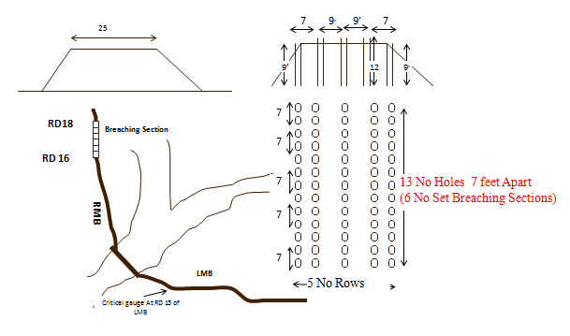

11.3 ARRANGEMENT OF EXPLOSIVE & SECURITY OF EXPLOSIVE
Explosive store has been shifted under the supervision of army authority at 1-Core Engineering Batalian Kharian Cantt, which will be shifted at site during the flood season as per schedule. The detail of explosive requirement as well as available is tabulated below.
CURRENT STATUS OF EXPLOSIVE / ACCESSORIES

S. No. | Name of explosive / accessories | Quantity required | Quantity available | Balance quantity required | When balance quantity will be arranged | Any previous Pending / outstanding payment
1 | PE3A | 6886 Kg | 6886 Kg | - | - | No outstanding payment
2 | Vabo Card | 9100 Mtr | 9100 Mtr | - | - | No outstanding payment
3 | Safety Fuze No.11 | 750 Mtr | 750 Mtr | - | - | No outstanding payment
4 | Detonating card | 6000 Mtr | 6000 Mtr | - | - | No outstanding payment
5 | Primer CE | 2940 No. | 2940 No. | - | - | No outstanding payment
6 | Ceiling compound | 60 Kgs | 60 Kgs | - | - | No outstanding payment
7 | Liner 12 Ft | 156 Nos | 156 Nos | - | - | No outstanding payment
8 | Jute | 150 Mtr | 150 Mtr | - | - | No outstanding payment
9 | Liner 9 Ft | 108 Nos | 108 Nos | - | - | No outstanding payment

11.4 LIST OF SECURITY STAFF ALONG WITH DETAIL OF THEIR TRAINING ETC
The explosive material for operation of Breaching section of Trimmu Barrage lies with Engineering Corps-I Stationed at Gujranwala Cantt. Army personal has been deputed for the security with the specialized training.
11.5 DETAIL OF MECHANICAL MEANS AS STANDBY ARRANGEMENTS IN CASE OF DETONATION FAILURE
The breaching section is activated with the help of the Army personal with explosive materials available at site. In case of the failure of this method, two No. Bulldozers and one No. excavator will be deployed to cause cuts in the Right Marginal Bund. For this purpose standby labour is also deployed. Furthermore six bulldozers have been requested to be arranged by the Deputy Commissioner, Jhang.
In the event of the activation of the breaching section, the flood waters spread surround 18-Hazari Town and travels in 3 directions as enunciated below:-
1. Main current hits Rangpur Canal between RD: 21000-23000.

2. Another current flows in creek cuts through 1-R Disty between RD: 3000 and 4000 then hits to Rangpur Canal between RD: 44000-45000.

3. 3rd current flows in depression along sand dunes and 2-R Disty up to RD: 13000 and then hits to Rangpur Canal between RD: 74000-75000 being a natural depression.

11.6 DUTY ROSTER IN CASE OF CRITICAL SITUATION
In case of critical situation, the Executive Engineer Trimmu Barrage Division and Sub Divisional Officer Head Works Sub Division will be available at the Barrage site for the coordination and Sub Divisional Officer, T.S. Link Sub Division will be available at R.M.B site as overall incharge of the site. However, the Secretary to Government of the Punjab Irrigation Department Lahore will depute officers on the flood bunds of Trimmu Barrage Division as per SOP’s during Flood days.
11.7 BREACHING COMMITTEE WITH THEIR ACTION PLAN
Breaching section shall be operated on the orders of the following committee constituted by Government of the Punjab Irrigation Department vide notification No. SO(FLOODS)VI-33-97 dated 15-07-2015.
i) Deputy Commissioner Jhang (Convener).
ii) Deputy Commissioner, Muzaffar Garh (Member).
iii) Executive Engineer, Trimmu Headworks Division, Trimmu (Member).
iv) Representative from C & W Department not below the rank of as Executive Engineer.
v) Executive Engineer concerned of the Irrigation Department.
vi) Representative from Pakistan Army not below the rank of a Lt. Colonol.
(c) The decision to operate a breaching section shall be taken by the committee keeping in view the technical advice of the Executive Engineer Trimmu Headworks Division, Trimmu. In case of any difference of opinion among the members, the final decision shall rest with the Deputy Commissioner Jhang.
(d) In case of unavailability of the Deputy Commissioner, Jhang or his inability to take decision, or in case of a difference of opinion between the Deputy Commissioner, Jhang in which the breaching section is located and the district which is likely to be affected by the operation of the breaching section, the decision to operate a breaching section shall be taken by the respective Commissioner.
(e) Breaching section shall be operated when one or more of the following conditions are met:-
(i) The discharging capacity of the structure for which breaching section is located is exceeded and the safety of structure is threatened.
(ii) The critical gauge i.e R.L 500 Ft as indicated in the relevant Flood Fighting Plan is achieved or exceeded and is rising.
(iii) The safety of major population center-(s) is threatened due to high flood levels and in view of the Executive Engineer concerned of the Irrigation Department, operation of breaching section can help in reduction of flood levels.
(f) Where, in view of the Executive Engineer concerned of the Irrigation Department or the representative of the department owning the structure at which the breaching section is located, the aforesaid criteria is expected to be met after due consideration of all available technical and hydrological conditions, the aforesaid committee may operate the breaching section before the critical gauge is achieved or exceeded. In every such case, the view of the Executive Engineer concerned of Irrigation Department or the representative of the department owing the structure shall be expressed in writing and shall be based on flood forecast by Pakistan Meteorological Department or other reliable sources, the trend of discharges in the relevant river at upstream locations, the lag times, estimated attenuation and expected inflows from tributaries, nullahs and streams en-route. Where advance breaching is planned, the committee may also consult professional experts and seek advice from the Superintending Engineer or the Chief Engineer concerned of the Irrigation Department.
(g) Breaching section shall be operated by the contingent plan by the Chief Engineer and Pakistan Army as indicated in the Flood Fighting Plan. Explosive method shall be the preferred method for operation of breaching section. However, the Department owning the structures on which the breaching section is located, and in case of their failure to do so, Irrigation Department shall make available, in advance, necessary earth moving machinery and other equipment for affecting the breach through mechanical means in the shortest possible time.
(h) The Deputy Commissioner concerned and all other relevant agencies shall ensure all necessary arrangements for the safety and if required evacuation of population likely to be effected by the operation of breaching section.
11.8 LIST OF VILLAGES LIKELY TO BE INUNDATED IN CASE OF BREACH / HIGH FLOOD
The water escaping through the activated breaching section will flow along Right Bank of Rangpur Canal crossing Jhang-Muzaffar Garh Road at 30 KM from Jhang. The flood water traveling along Rangpur Canal crosses through cuts at Rangpur Canal at RD: 22000, 44000 and 80000 and remaining water spreads between Right Bank of Rangpur Canal and sand dunes up to a distance of about 100 K.M from Trimmu Barrage.
The area likely to be affected / inundated by the spills. The villages / abadies and other infrastructures like road, canals etc inundated / damaged are detailed here under:-
S# | Tehsil | Villages
1 | Tehsil Jhang | Dhoin Muhammad , Mansoor Sial , Diraj , Kot Khera, Mohal, Guniana, Wijhlana. Total Villages = 7 Nos.
2 | Tehsil 18-Hazari | Mari Shakir, Kot Shakir, Machiwal, Sajhran , Kot Maldave, Munday Syed, Dosa, Dabi, Umran Janubi, Kamra, Baila Chotra , Lateef Shah, Basti Sanga, Loaharan Wala, Kharal Sipra, Kotla Naik Ahmed, Kotli Baqir Shah, Gari Fateh Ullah, Sheroana, Loha Bhir, Johiya, Ahmed Abas, Bela Shar, Bolla Patwana. Rashid Pur , Jbanoana, Dhan Miani, Pahar Pur, Kot Murad, Rodo Sultan, Taror, Kot Rustum, Basti Nusrat , Dhoin Muhammad, Lashari, Malkana,  Total Villages = 36
3 | Tehsil Ahmed Pur Sial | Sultan Bahoo, Dull, Diraj, Pir Abdul Rehman , Samanduana. Naikokara Kotli, Mehmood Shah, Garh Maharaja , Chak 5/2-L, Tiba Gehli, Fateh Pur, Jusa, Fateh Pur Pariti, Islam Pur Nashaib, Islam Pur faraz, Chak Norang Shah, Kot Mupal, Inayat Shah. Saiwa Sadhana.  Total Villages =23
4 | Tehsil Muzaffar Garh | Maqsoodpur , Dera Fazil ,Bahadaur, Amir Pur, Sargana, Kirari Ali Mardan , Kacha Nashaibi, Behram Pur ,Chbootra Mamil, Fatoo Fanaka, Dera Hayat, Bahli Shumali, Sadi Pur, Makoo Jamal  Total Villages = 13
TOTAL VILLAGES |  | 79 Nos

11.9 ANNOUNCEMENT AND DETAIL OF EVACUATION ARRANGEMENTS
The time lag between Qadirabad Barrage and Trimmu Barrage is 72 hours and Rasul Barrage to Trimmu Barrage is 72 hours. Thus, Irrigation Department has ample time to inform Civil Administration and other concerned agencies about the flood situation for warning the civil population, arranging their evacuation and adopting other protective measures. A critical gauge stands fixed at RD: 15000 of Left Marginal Bund depicting the trend of the flood heights and when the R.L. of the critical gauge touches the value as R.L. 500 if the river is still in rising position, the necessity operation of the Barrage is established on the basis of 3 hourly gauges of the upper Barrages.
The gauges received from Qadirabad Barrage and Rasul Barrage are calculated / assessed at the Barrage keeping in view the time lag and flood situation is brought to the notice of Army, Civil Administration and other relevant agencies for informing the public about the quantum of flood and its affect for making arrangement of evacuation. The operation of the breaching section will be intimated to the Army at least 12 hours in advance for making arrangements to shift the explosive to the breaching site.
Similar Civil Administration is to be informed about the operation of breaching section at least 12 hours in advance.
- The Deputy Commissioner Jhang to make arrangement for the evacuation of the public within LMB and RMB and the population coming on route of spill water.
- Military authorities to keep ready for emergency operation.
- Police to watch that no unauthorized cuts be made by public especially along LMB & RMB.
- Engineering 1-Corp for energizing the breaching section, when water level approaches 500.00 Mark at the emergency gauge installed at RD: 15000 Left Marginal Bund.
11.10 DETAIL OF COORDINATION WITH CIVIL / ARMY AUTHORITIES
There is breaching section located at RD: 16000-18000 Right Marginal Bund. A critical gauge fixed at RD: 15000 of Left Marginal Bund when its level reaches to 500.00 and is in rising position, the hourly flood gauges are passed to Civil Administration as well as Army authorities. These three Departments remain in touch through telephonic and wireless system. The breaching section will be operated with the help of Army as per standing instructions.
In the event of the activation of the breaching section, the flood waters spread surround 18-Hazari Town and travels in 3 directions as enunciated below:-
1. Main current hits Rangpur Canal between RD: 21000-23000.
2. Another current flows in creek cuts through 1-R Disty between RD: 3000 and 4000 then hits to Rangpur Canal between RD: 44000-45000.
3. 3rd current flows in depression along sand dunes and 2-R Disty up to RD: 13000 and then hits to Rangpur Canal between RD: 74000-75000 being a natural depression.
4. Metalled Road linking Trimmu Barrage to Tehsil 18-Hazari head quarter will be disconnected. Jhang- Muzaffar Garh Road, Jhang-Bhakkar Road can be disconnected.
5. Telephone exchanges 18-Hazari , Rodu Sultan and 2 Nos Suger Mills, Rice Mills , Petrol pumps, Government colleges, Middle and High Schools, basic health units, grid station are likely to be disturbed.
The following officers will be informed before operating the breaching section and it is the duty of Executive Engineer, Trimmu Barrage to inform.

- The Secretary, Government of the Punjab, Irrigation Department, Lahore.
- The Chief Engineer, Irrigation Multan Zone, Multan.
- The Superintending Engineer, Trimmu Canal Circle, Trimmu.
- The Superintending Engineer, Haveli Canal Circle, Multan.
- The Chief Engineer, Drainage & Flood Zone, Lahore.
- The Flood Relief Commissioner, Lahore.
- The Chief Engineering Adviser, Chairman Federal Flood Commission, 6-Ataturk Avenue G-5/1,Islamabad.
- The Commissioner, Faisalabad Division, Faisalabad.
- The Deputy Commissioner, District Muzaffargarh.
- The Deputy Commissioner, District Jhang.
- The Head Quarter 1-Corp Engineer, Battlion, Kharian Cantt:
- The Deputy District Officer (Revenue) Jhang/ Shorkot / 18-Hazari/Ahmedpur Sial and Muzaffar Garh.
- The District Police offcer’s Jhang / Muzaffar Garh.
- The Sub Divisional Officer’s on watching.
- All Sub Engineer’s on duty.
- Concerned Executive Engineer of FESCO.
- The Chief Executive Officer’s Jhang / Muzaffar Garh
11.11 PARALLEL COMMUNICATION ARRANGEMENT
In addition to installation of Wireless set at Trimmu Barrage some temporary connections will be arranged at left side of the Barrage as well as field office where all the Officers / Officials will meet together to chalk out further programs. One supervisor of T & T Department will remain available at site for proper control and operation of all this system.
11.12 INDEX PLAN

Executive Engineer, Superintending Engineer, Chief Engineer,
Trimmu Headworks Division Trimmu Canal Circle, Trimmu Irrigation Multan Zone
Trimmu Multan.

Part – B

CHAPTER-12
VULNERABLE SITES ON FLOOD BUND / STRUCTURES

12.1 APPREHENDED BREACHES IN FLOOD BUNDS / STRUCTURES

Sr. No. | Name of Flood Bund | Reach
Sr. No. | Name of Flood Bund | From RD | To RD
1 | Right Marginal Bund | 20+000 | 27+000
2 | Left Marginal Bund | 14+000 | 21+000
3 | Rangpur Flood Bund | 290+000 | 293+000
4 | Hassu Wali Flood Bund | 49+000 | 50+000
5 | Rajbana Flood Bund | 0+000 | 6+500

12.2 OPERATION OF BREACHING SECTION
The Breaching section of Trimmu Barrage was approved on Right Marginal Bund between RD 16000-18000. The Punjab Flood Commission in its 55th meeting held on 17.06.1974 deliberated on the issue in detail and decided to activate the breaching section with water level at RD: 15000 Left Marginal Bund R.L 501. Subsequently Punjab Flood Commission in its meeting held on 30.06.1977 revised the R.L at RD: 15000 of Left Marginal Bund from R.L 501 to R.L 500 authorizing the Executive Engineer, Trimmu Barrage Division Trimmu to order the activation of the breaching section in case of sound and valid reasons for the protection of the Barrage. They history of operation of breaching section is tabulated below.
Year | Discharge through Barrage  (Cusecs) | Discharge through Relief Cut  (Cusecs) | Total Discharge  (Cusecs)
1959 | 718,255 | 225,000 | 943,255
1973 | 666,910 | 66,000 | 732,910
1992 | 683,117 | 205,000 | 888,117
2014 | 626,006 | 77,000 | 703,006

12.3 BREACHES DUE TO RISING OF FLOOD WATER, DETERIORATION FLOOD BUNDS ETC. R.R.E, Route plans attached at Pages

No such occurrence.

CHAPTER-13

EMERGENCY CONTINGENCY PLAN FOR VULNERABLE SITE (SITES) LISTED ABOVE EMERGENCY CONTINGENCY PLAN MUST INCLUDE

PLAN NO. 1

RD: 20+000 – 27+000 RIGHT MARGINAL BUND

13.1 PLAN SHOWING ROUTE OF FLOOD WATER COMING OUT OF THE BREACH SUPPORTED WITH LEVELS.

Plan Attached

13.2 DETAIL OF VILLAGES ABADIES LIKELY TO BE AFFECTED AND THIS SHOULD ALSO BE SHOWN ON THE PLAN.

- 18-Hazari
- Behllar.
- Chowkan Janpur
- Malkana
13.3 STRATEGY AND ACTION TAKEN BE EXPLAINED IN DETAIL. THIS MAY INCLUDE.

The employed labour, Flood Fighting Material and available machinery will be deployed on the breach for control of spilling water coming out from the breach. All efforts will be made to control the breach.
13.3.1 ARRANGEMENTS

The necessary arrangements will be made in case of breach at vulnerable sites.

13.3.2 ESTABLISHMENT OF FLOOD FIGHTING CAMPS

Flood fighting camp will be established at RD: 20+000 of R.M.B

13.3.3 DUTIES OF OFFICERS / OFFICIALS AND THEIR CAMP SITES

Sub Engineer Head Works Section will be incharge of the camp site. The following staff will be at the camp site.
Sub Engineer = 1 No.
Mate = 2 No.
Beldar = 16 Nos

13.3.4 DEPARTMENTAL MACHINERY AVAILABLE
- Government Tractor Trolly
13.3.5 MACHINERY AVAILABLE FROM PRIVATE SOURCE
The following machinery can be made available through private source i.e Government contractors.
- Excavator.
- Showal.
- Tractor with Trolleys
- Dozers
- Tractor with front blade.
The numbers of machinery will increase or decrease as per flood stage.

MERGE TOGETHER 13.3.6 & 13.3.7 STATUS OF FLOOD FIGHTING MATERIAL FOR VULNERABLE SITE NO. I

S.# | Description | Total Quantity Required |  | Total Quantity Available | Deficient Quantity | Remarks
1 | Axes | 1 | No. | 1 | - | There is no deficient Flood fighting material.
2 | Baskets | 15 | No. | 15 | - | There is no deficient Flood fighting material.
3 | Buckets | 2 | No. | 2 | - | There is no deficient Flood fighting material.
4 | Cell for Torches | 3 | No. | 3 | - | There is no deficient Flood fighting material.
5 | Cow Dung in EC | 5 | Bags | 5 | - | There is no deficient Flood fighting material.
6 | Funnel (Ordinary) | 1 | No. | 1 | - | There is no deficient Flood fighting material.
7 | Funnel with W.G | 1 | No. | 1 | - | There is no deficient Flood fighting material.
8 | Gas Lamp | 1 | No. | 1 | - | There is no deficient Flood fighting material.
9 | Gunny Bags | 44 | No. | 44 | - | There is no deficient Flood fighting material.
10 | Hammer 2.5 lb | 1 | No. | 1 | - | There is no deficient Flood fighting material.
11 | Hammer 10 lb | 1 | No. | 1 | - | There is no deficient Flood fighting material.
12 | Kassi with handles | 5 | No. | 5 | - | There is no deficient Flood fighting material.
13 | Kerosene Oil | 11 | Ltr | 11 | - | There is no deficient Flood fighting material.
14 | Khajji Mate | 22 | No. | 22 | - | There is no deficient Flood fighting material.
15 | Lanterns | 3 | No. | 3 | - | There is no deficient Flood fighting material.
16 | Larmal 50 Ft | 18 | No. | 18 | - | There is no deficient Flood fighting material.
17 | Mallet wooden | 2 | No. | 2 | - | There is no deficient Flood fighting material.
18 | Match Box | 9 | No. | 9 | - | There is no deficient Flood fighting material.
19 | Mental | 6 | No. | 6 | - | There is no deficient Flood fighting material.
20 | Needles | 1 | No. | 1 | - | There is no deficient Flood fighting material.
21 | Needles for sewing bags | 2 | No. | 2 | - | There is no deficient Flood fighting material.
22 | Nozzles | 1 | No. | 1 | - | There is no deficient Flood fighting material.
23 | Oil Extractor | 1 | No. | 1 | - | There is no deficient Flood fighting material.
24 | Sledge Hammer 14 lb | 1 | No. | 1 | - | There is no deficient Flood fighting material.
25 | Spare handle for kassies | 2 | No. | 2 | - | There is no deficient Flood fighting material.
26 | Spirit | 1 | Bottles | 1 | - | There is no deficient Flood fighting material.
27 | Spirit Can | 1 | No. | 1 | - | There is no deficient Flood fighting material.
28 | Sticks (6-8) | 44 | No. | 44 | - | There is no deficient Flood fighting material.
29 | Sutli | 1 | Lb | 1 | - | There is no deficient Flood fighting material.
30 | Torch 3 Cell | 1 | No | 1 | - | There is no deficient Flood fighting material.
31 | Tranger Wire | 1 | CWT | 1 | - | There is no deficient Flood fighting material.
32 | Washers | 1 | No | 1 | - | There is no deficient Flood fighting material.
33 | Wicks | 1 | Yards | 1 | - | There is no deficient Flood fighting material.

13.4 DETAIL OF OTHER INFRASTRUCTURE LIKE ELECTRIC SUI GAS TELEPHONE INSTALLATION, ROAD NETWORK, OTHER BUILDING, CANAL AND DRAINAGE NETWORK.

- Grid Station Wassu Astana
- Telephone Exchange 18-Hazari
- Basic Health Centers 18-Hazari
- Tehsil council 18-Hazari
- Jhang-Bhakkar Road
- Jhang-Muzaffar Garh Road
- Rangpur Canal & its system
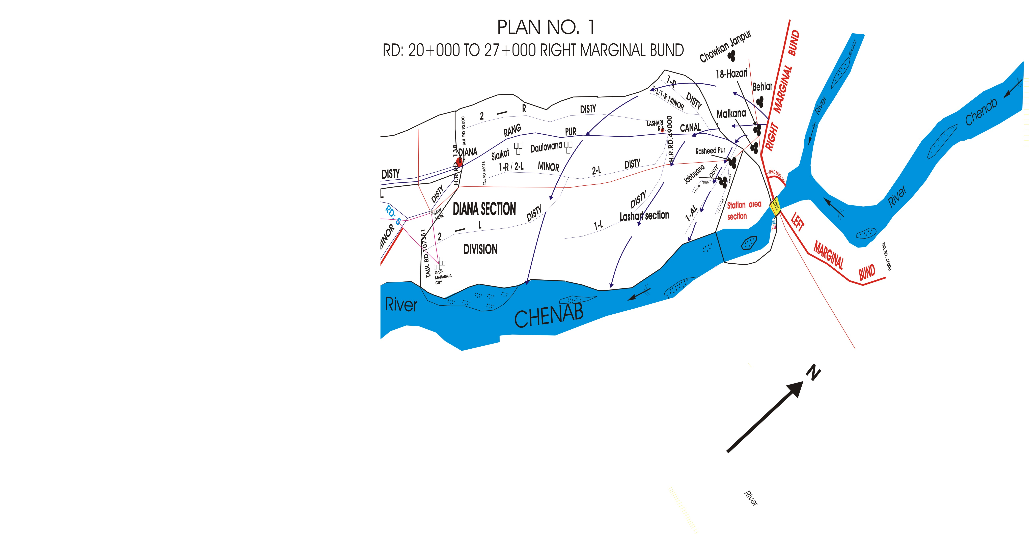

PLAN NO. 2
RD: 14+000 – 21+000 LEFT MARGINAL BUND

13.1 PLAN SHOWING ROUTE OF FLOOD WATER COMING OUT OF THE BREACH SUPPORTED WITH LEVELS.

Plan Attached

13.2 DETAIL OF VILLAGES ABADIES LIKELY TO BE AFFECTED AND THIS SHOULD ALSO BE SHOWN ON THE PLAN.

- Sumandari Kalan
- Mansoor Sial
- Mahloana
- Kot Dewan
- Haveli Bahadar Shah
- Mahranwala
13.3 STRATEGY AND ACTION TAKEN BE EXPLAINED IN DETAIL. THIS MAY INCLUDE.

The employed labour, Flood Fighting Material and available machinery will be deployed on the breach for control of spilling water coming out from the breach. All efforts will be made to control the breach.

13.3.1 ARRANGEMENTS

The following arrangements will be made.

13.3.2 ESTABLISHMENT OF FLOOD FIGHTING CAMPS

Flood fighting camp will be established at RD: 16+000 of L.M.B

13.3.3 DUTIES OF OFFICERS / OFFICIALS AND THEIR CAMP SITES

Sub Engineer River Survey Section will be incharge of the camp site. The following staff will be at the camp site.

Sub Engineer = 1 No.
Mate = 2 No.
Beldar = 16 Nos

13.3.4 DEPARTMENTAL MACHINERY AVAILABLE

- Government Tractor Trolly

13.3.5 MACHINERY AVAILABLE FROM PRIVATE SOURCE

The following machinery can be made available through private source i.e Government contractors.
- Excavator.
- Showal.
- Tractor with Trolleys
- Dozers
- Tractor with front blade.
The numbers of machinery will increase or decrease as per flood stage.

MERGE TOGETHER 13.3.6 & 13.3.7 STATUS OF FLOOD FIGHTING MATERIAL FOR VULNERABLE SITE NO. II

S.# | Description | Total Quantity Required |  | Total Quantity Available | Deficient Quantity | Remarks
1 | Axes | 2 | No. | 2 | - | There is no deficient Flood fighting material.
2 | Baskets | 29 | No. | 29 | - | There is no deficient Flood fighting material.
3 | Buckets | 4 | No. | 4 | - | There is no deficient Flood fighting material.
4 | Cell for Torches | 6 | No. | 6 | - | There is no deficient Flood fighting material.
5 | Cow Dung in EC | 10 | Bags | 10 | - | There is no deficient Flood fighting material.
6 | Funnel (Ordinary) | 1 | No. | 1 | - | There is no deficient Flood fighting material.
7 | Funnel with W.G | 1 | No. | 1 | - | There is no deficient Flood fighting material.
8 | Gas Lamp | 1 | No. | 1 | - | There is no deficient Flood fighting material.
9 | Gunny Bags | 87 | No. | 87 | - | There is no deficient Flood fighting material.
10 | Hammer 2.5 lb | 1 | No. | 1 | - | There is no deficient Flood fighting material.
11 | Hammer 10 lb | 2 | No. | 2 | - | There is no deficient Flood fighting material.
12 | Kassi with handles | 9 | No. | 9 | - | There is no deficient Flood fighting material.
13 | Kerosene Oil | 23 | Ltr | 23 | - | There is no deficient Flood fighting material.
14 | Khajji Mate | 44 | No. | 44 | - | There is no deficient Flood fighting material.
15 | Lanterns | 6 | No. | 6 | - | There is no deficient Flood fighting material.
16 | Larmal 50 Ft | 36 | No. | 36 | - | There is no deficient Flood fighting material.
17 | Mallet wooden | 4 | No. | 4 | - | There is no deficient Flood fighting material.
18 | Match Box | 18 | No. | 18 | - | There is no deficient Flood fighting material.
19 | Mental | 12 | No. | 12 | - | There is no deficient Flood fighting material.
20 | Needles | 1 | No. | 1 | - | There is no deficient Flood fighting material.
21 | Needles for sewing bags | 3 | No. | 3 | - | There is no deficient Flood fighting material.
22 | Nozzles | 1 | No. | 1 | - | There is no deficient Flood fighting material.
23 | Oil Extractor | 1 | No. | 1 | - | There is no deficient Flood fighting material.
24 | Sledge Hammer 14 lb | 1 | No. | 1 | - | There is no deficient Flood fighting material.
25 | Spare handle for kassies | 5 | No. | 5 | - | There is no deficient Flood fighting material.
26 | Spirit | 1 | Bottles | 1 | - | There is no deficient Flood fighting material.
27 | Spirit Can | 1 | No. | 1 | - | There is no deficient Flood fighting material.
28 | Sticks (6-8) | 87 | No. | 87 | - | There is no deficient Flood fighting material.
29 | Sutli | 1 | Lb | 1 | - | There is no deficient Flood fighting material.
30 | Torch 3 Cell | 1 | No | 1 | - | There is no deficient Flood fighting material.
31 | Tranger Wire | 1 | CWT | 1 | - | There is no deficient Flood fighting material.
32 | Washers | 1 | No | 1 | - | There is no deficient Flood fighting material.
33 | Wicks | 1 | Yards | 1 | - | There is no deficient Flood fighting material.

13.4 DETAIL OF OTHER INFRASTRUCTURE LIKE ELECTRIC SUI GAS TELEPHONE INSTALLATION, ROAD NETWORK, OTHER BUILDING, CANAL AND DRAINAGE NETWORK.

- PARCO Pipe Line
- Telephone Exchanges
- Grid Station
- Petrol Pumps
- Jhang-Multan Road.
- Jhang-Bhakkar Road
- Rice Mills.
- Basic Health Centers
- T.S.Link Canal.
- Haveli Main Line.
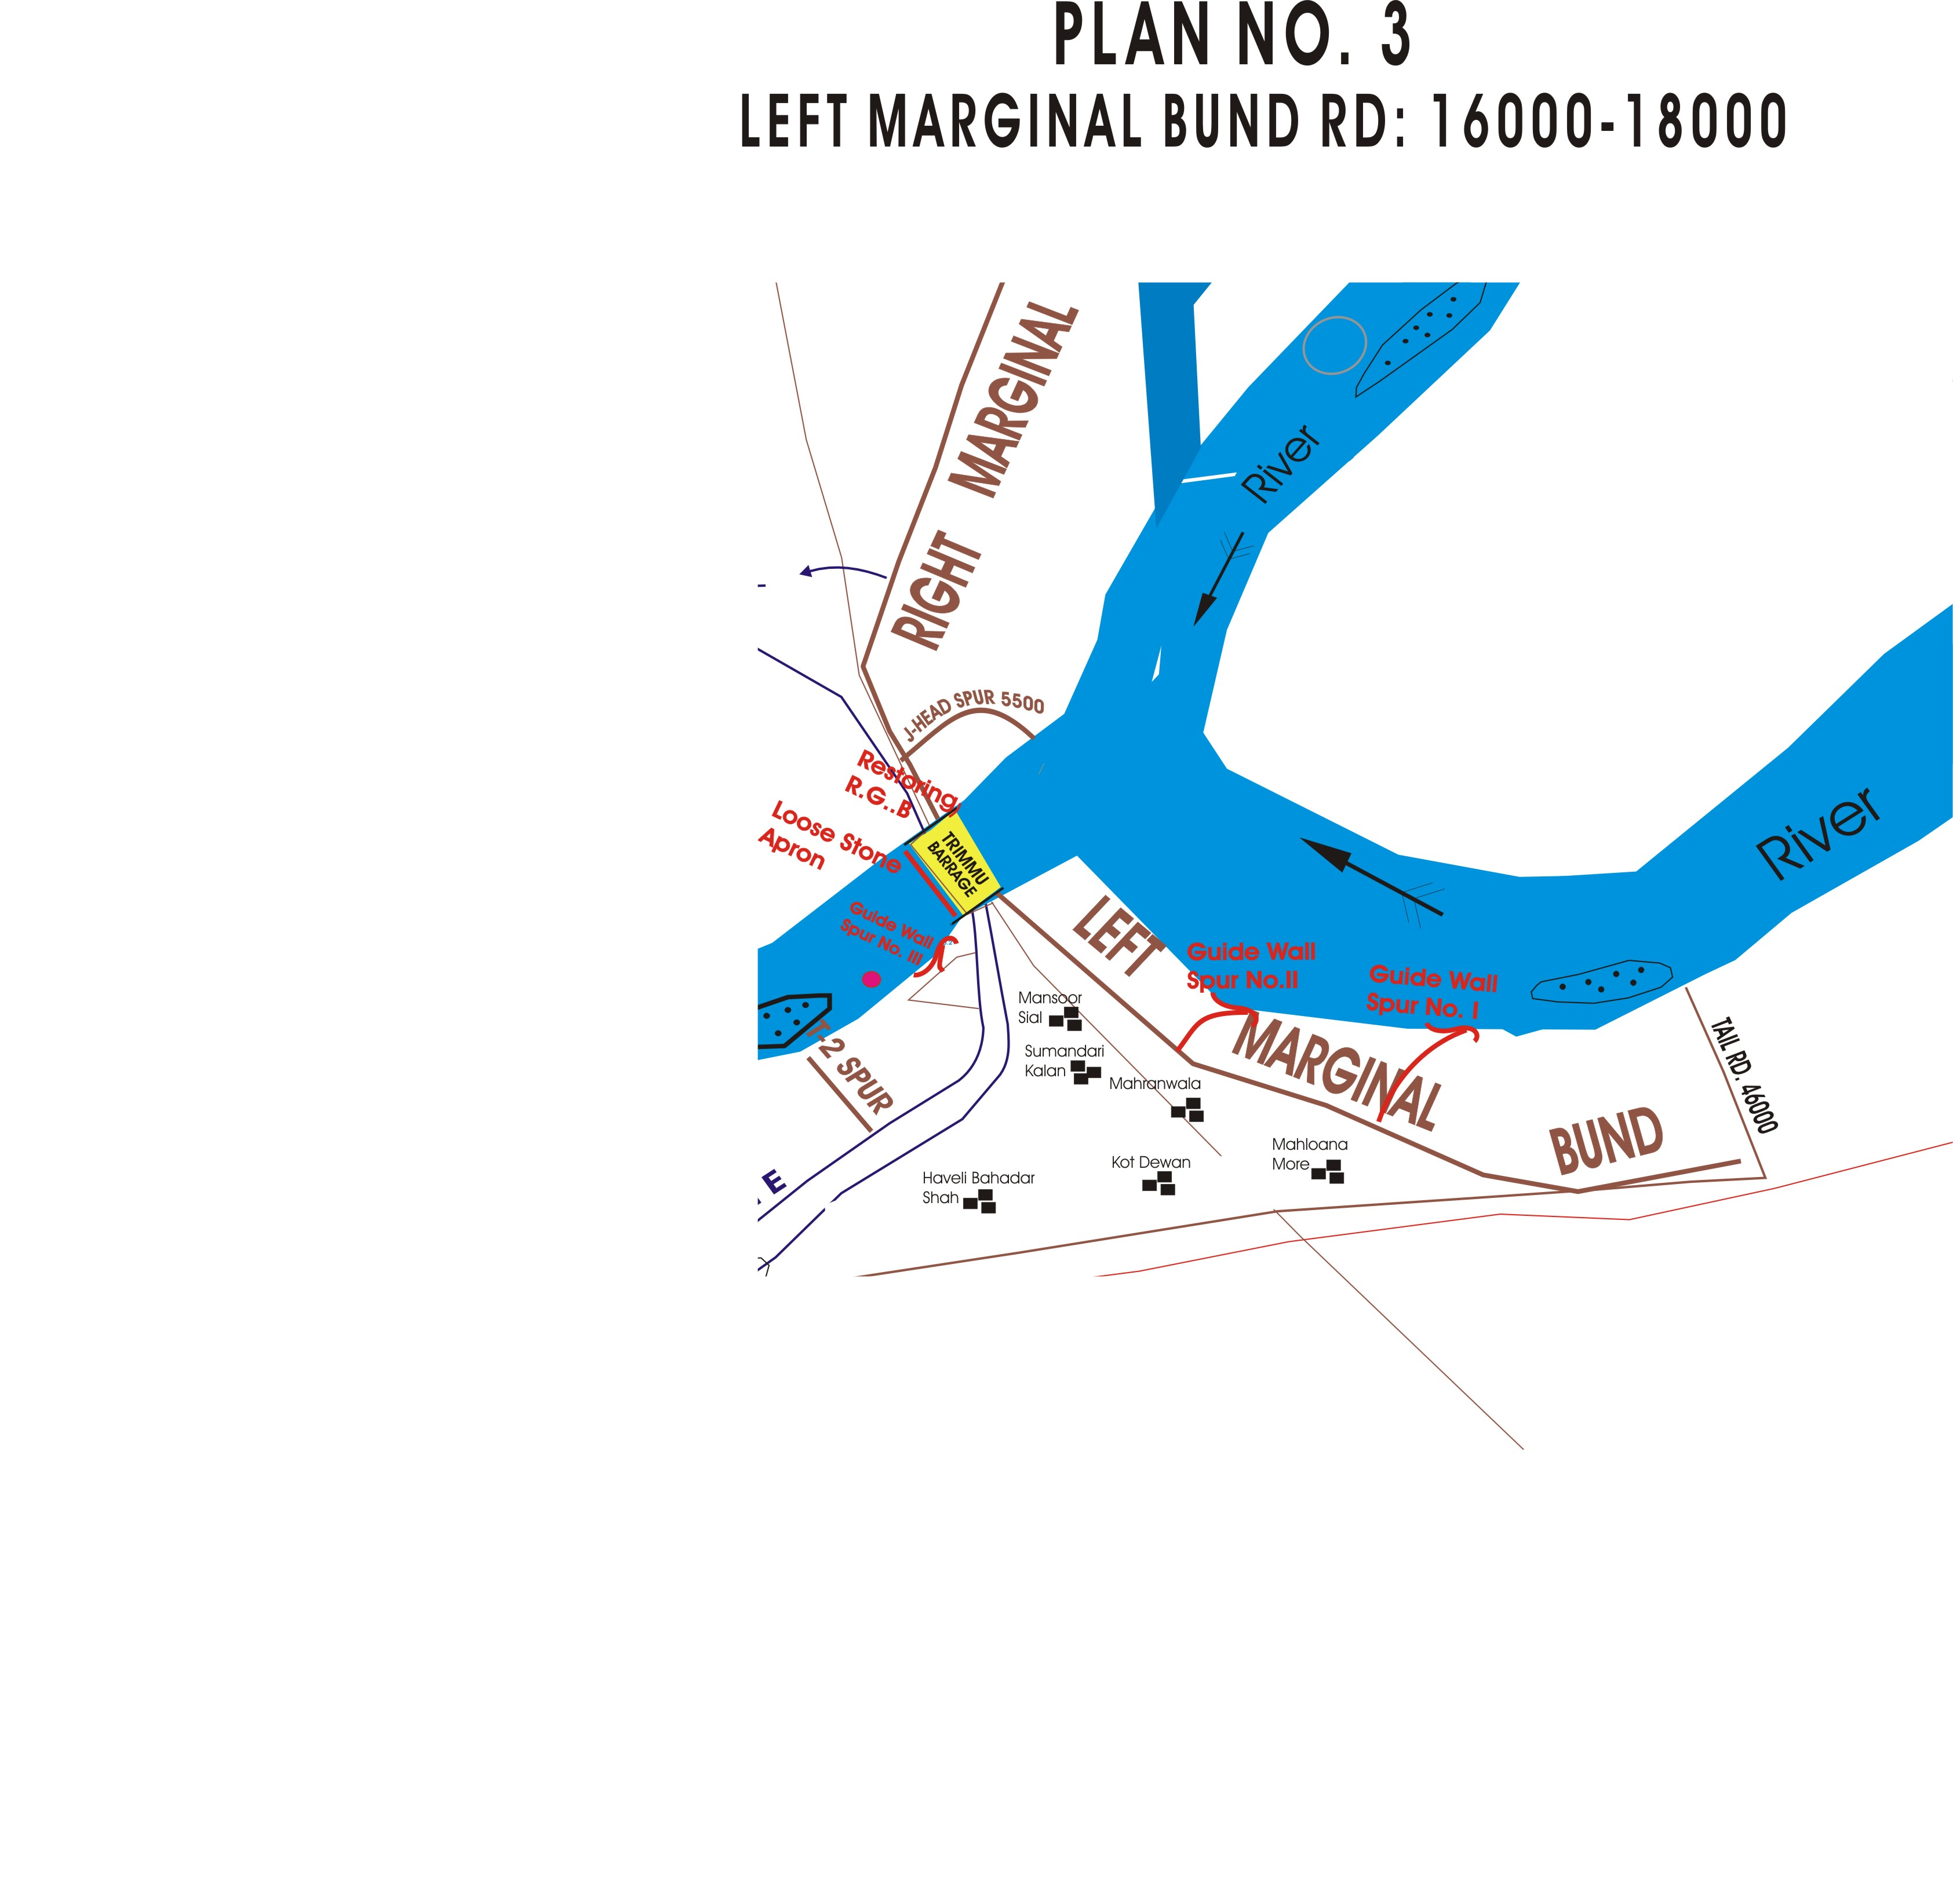
RD 21

CHAPTER-13

EMERGENCY CONTINGENCY PLAN FOR VULNERABLE SITE (SITES) LISTED ABOVE. EMERGENCY CONTINGENCY PLAN MUST INCLUDE

PLAN NO. 3

RD: 290+000 – 293+000 Rangpur Flood Bund

13.1 PLAN SHOWING ROUTE OF FLOOD WATER COMING OUT OF THE BREACH SUPPORTED WITH LEVELS.

Plan Attached
13.2 DETAIL OF VILLAGES ABADIES LIKELY TO BE AFFECTED AND THIS SHOULD ALSO BE SHOWN ON THE PLAN.

- Rangpur Town.
- Kaudi Wal
- Kari Ali Mardan
- Bahrampur
- Chabootra Kamal
- Dera Habit

13.3 STRATEGY AND ACTION TAKEN BE EXPLAINED IN DETAIL. THIS MAY INCLUDE.

The employed labour, Flood Fighting Material and available machinery will be deployed on the breach for control of spilling water coming out from the breach. All efforts will be made to control the breach.
13.3.1 ARRANGEMENTS
The following arrangements will be made.
13.3.2 ESTABLISHMENT OF FLOOD FIGHTING CAMPS
Flood fighting camp will be established at RD: 303+000 of Rangpur Flood Bund
13.3.3 DUTIES OF OFFICERS / OFFICIALS AND THEIR CAMP SITES
Sub Engineer Rangpur section will be incharge of the camp site. The following staff will be present at the camp site.
Sub Engineer = 1 No.
Mate = 4 No.
Beldar = 36 Nos

13.3.4 DEPARTMENTAL MACHINERY AVAILABLE
Not available
13.3.5 MACHINERY AVAILABLE FROM PRIVATE SOURCE
The following machinery can be made available through private source i.e Government contractors.
- Excavator.
- Showal.
- Tractor with Trolleys
- Dozers
- Tractor with front blade.
The numbers of machinery will increase or decrease as per flood stage.

13.3.6 FLOOD FIGHTING MATERIAL REQUIRED

S.# | Description | Quantity Required Site No. 4 |  |  |  | Remarks
S.# | Description | Qty | Unit |  | Total  Requirement | Remarks
1 | Axes | 2 |  | No. | 2 | Balance material will be recouped during flood season 2025
2 | Baskets | 38 |  | No. | 38 | Balance material will be recouped during flood season 2025
3 | Buckets | 6 |  | No. | 6 | Balance material will be recouped during flood season 2025
4 | Burner and Lamps | 1 |  | No. | 1 | Balance material will be recouped during flood season 2025
5 | Cell for Torches | 6 |  | No. | 6 | Balance material will be recouped during flood season 2025
6 | Chimnies | 10 |  | No. | 10 | Balance material will be recouped during flood season 2025
7 | Chimnies of Gas | 1 |  | No. | 1 | Balance material will be recouped during flood season 2025
8 | Cow Dung in EC | 6 |  | Bags | 6 | Balance material will be recouped during flood season 2025
9 | Funnel (Ordinary) | 2 |  | No. | 2 | Balance material will be recouped during flood season 2025
10 | Funnel with W.G | 1 |  | No. | 1 | Balance material will be recouped during flood season 2025
11 | Gas Lamp | 1 |  | No. | 1 | Balance material will be recouped during flood season 2025
12 | Gunny Bags | 160 |  | No. | 160 | Balance material will be recouped during flood season 2025
13 | Hammer 2.5 lb | 1 |  | No. | 1 | Balance material will be recouped during flood season 2025
14 | Hammer 10 lb | 2 |  | No. | 2 | Balance material will be recouped during flood season 2025
15 | Kassi with handles | 10 |  | No. | 10 | Balance material will be recouped during flood season 2025
16 | Kerosene Oil | 54 |  | Ltr | 54 | Balance material will be recouped during flood season 2025
17 | Khajji Mate | 60 |  | No. | 60 | Balance material will be recouped during flood season 2025
18 | Lanterns | 10 |  | No. | 10 | Balance material will be recouped during flood season 2025
19 | Larmal 50 Ft | 40 |  | No. | 40 | Balance material will be recouped during flood season 2025
20 | Mallet wooden | 4 |  | No. | 4 | Balance material will be recouped during flood season 2025
21 | Match Box | 17 |  | No. | 17 | Balance material will be recouped during flood season 2025
22 | Mental | 15 |  | No. | 15 | Balance material will be recouped during flood season 2025
23 | Needles | 1 |  | No. | 1 | Balance material will be recouped during flood season 2025
24 | Needles for sewing bags | 3 |  | No. | 3 | Balance material will be recouped during flood season 2025
25 | Nozzles | 1 |  | No. | 1 | Balance material will be recouped during flood season 2025
26 | Oil Extractor | 1 |  | No. | 1 | Balance material will be recouped during flood season 2025
27 | Sledge Hammer 14 lb | 1 |  | No. | 1 | Balance material will be recouped during flood season 2025
28 | Spare handle for kassies | 1 |  | No. | 1 | Balance material will be recouped during flood season 2025
29 | Spirit | 1 |  | Bottles | 1 | Balance material will be recouped during flood season 2025
30 | Spirit Can | 1 |  | No. | 1 | Balance material will be recouped during flood season 2025
31 | Sticks (6-8) | 170 |  | No. | 170 | Balance material will be recouped during flood season 2025
32 | Sutli | 1 |  | Lb | 1 | Balance material will be recouped during flood season 2025
33 | Torch 3 Cell | 1 |  | No | 1 | Balance material will be recouped during flood season 2025
34 | Tranger Wire | 1 |  | CWT | 1 | Balance material will be recouped during flood season 2025
35 | Washers | 1 |  | No | 1 | Balance material will be recouped during flood season 2025
36 | Wicks | 8 |  | Yards | 8 | Balance material will be recouped during flood season 2025
37 | Petrol for generator | 10 |  | Liter | 10 | Balance material will be recouped during flood season 2025
38 | Diesel for Petroling | 30 |  | Liter | 30 | Balance material will be recouped during flood season 2025
39 | Empty Drum | 0 |  | Each | 0 | Balance material will be recouped during flood season 2025
40 | Polythene Bag | 400 |  | Each | 400 | Balance material will be recouped during flood season 2025
41 | Bamboos | 100 |  | Each | 100 | Balance material will be recouped during flood season 2025

13.6.7 FLOOD FIGHTING MATERIAL AVAILABLE AT SITE NO.4
S.# | Description | Quantity Available
1 | Axes | 2
2 | Baskets | 38
3 | Buckets | 6
4 | Burner and Lamps | 1
5 | Cell for Torches | 6
6 | Chimnies | 10
7 | Chimnies of Gas | 1
8 | Cow Dung in EC | 6
9 | Funnel (Ordinary) | 2
10 | Funnel with W.G | 1
11 | Gas Lamp | 1
12 | Gunny Bags | 160
13 | Hammer 2.5 lb | 1
14 | Hammer 10 lb | 2
15 | Kassi with handles | 10
16 | Kerosene Oil | 54
17 | Khajji Mate | 60
18 | Lanterns | 10
19 | Larmal 50 Ft | 40
20 | Mallet wooden | 4
21 | Match Box | 17
22 | Mental | 15
23 | Needles | 1
24 | Needles for sewing bags | 3
25 | Nozzles | 1
26 | Oil Extractor | 1
27 | Sledge Hammer 14 lb | 1
28 | Spare handle for kassies | 1
29 | Spirit | 1
30 | Spirit Can | 1
31 | Sticks (6-8) | 170
32 | Sutli | 1
33 | Torch 3 Cell | 1
34 | Tranger Wire | 1
35 | Washers | 1
36 | Wicks | 8
37 | Petrol for generator | 10
38 | Diesel for Petroling | 30
39 | Empty Drum | 0
40 | Polythene Bag | 400
41 | Bamboos | 100

13.4 DETAIL OF OTHER INFRASTRUCTURE LIKE ELECTRIC SUI GAS TELEPHONE INSTALLATION, ROAD NETWORK, OTHER BUILDING, CANAL AND DRAINAGE NETWORK.

- PARCO Pipe Line
- Grid Station
- Telephone Exchange
- Rural Health Center
- Government Boys Degree College
- Vocational Institute.
- Government Schools
- Muzaffar Garh to Jhang Road.
- Rangpur to Chowk Sarwar Shaheed Road.
- 5-R Disty
- Rangpur Canal

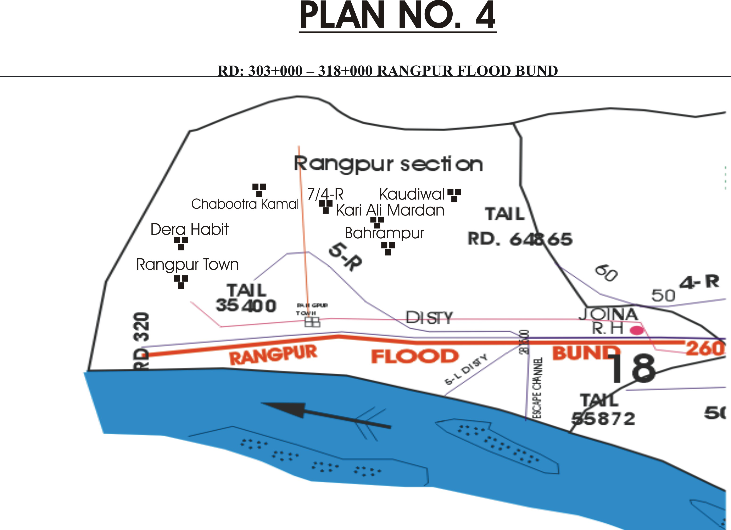
PLAN NO.4
RD.292+000 TO 318+000 RANGPUR FLOOD BUND

RD
318
RD
292

PLAN NO. 4

RD: 49+000 TO 50+000 OF HASSU WALI FLOOD BUND

13.1 PLAN SHOWING ROUTE OF FLOOD WATER COMING OUT OF THE BREACH SUPPORTED WITH LEVELS.

Plan Attached
13.2 DETAIL OF VILLAGES ABADIES LIKELY TO BE AFFECTED AND THIS SHOULD ALSO BE SHOWN ON THE PLAN.

- Budhuana.
- Qaim Bharwana
- Kakku Wala
- Shah Sadiq Niang
- Fouja Dhara
- Allah Yar Joota
- Meerak Sial
- Mouza Mangan
- Shorkot City

13.3 STRATEGY AND ACTION TAKEN BE EXPLAINED IN DETAIL. THIS MAY INCLUDE.

The employed labour, Flood Fighting Material and available machinery will be deployed on the breach for control of spilling water coming out from the breach. All efforts will be made to control the breach.

13.3.1 ARRANGEMENTS

The following arrangements will be made.

13.3.2 ESTABLISHMENT OF FLOOD FIGHTING CAMPS

Flood fighting camp will be established at RD: 22000 of Hassu Wali Flood Bund

13.3.3 DUTIES OF OFFICERS / OFFICIALS AND THEIR CAMP SITES

Sub Engineer Farid Mehmoood Section will be incharge of the camp site. The following staff will be at the camp site.
Sub Engineer = 1 No.
Mate = 1 No.
Beldar = 10 Nos

13.3.4 DEPARTMENTAL MACHINERY AVAILABLE

Not Available

13.3.5 MACHINERY AVAILABLE FROM PRIVATE SOURCE
The following machinery can be made available through private source i.e Government contractors.
- Excavator.
- Showal.
- Tractor with Trolleys
- Dozers
- Tractor with front blade.
The numbers of machinery will increase or decrease as per flood stage.

13.3.6 FLOOD FIGHTING MATERIAL REQUIRED

S.# | Description | Quantity Required Site No.5 |  |  |  | Remarks
S.# | Description | Qty | Unit |  | Total  Requirement | Remarks
1 | Axes | 4 |  | No. | 4 | Balance material will be recouped during flood season 2025
2 | Baskets | 25 |  | No. | 25 | Balance material will be recouped during flood season 2025
3 | Buckets | 4 |  | No. | 4 | Balance material will be recouped during flood season 2025
4 | Burner and Lamps | 1 |  | No. | 1 | Balance material will be recouped during flood season 2025
5 | Cell for Torches | 3 |  | No. | 3 | Balance material will be recouped during flood season 2025
6 | Chimnies | 6 |  | No. | 6 | Balance material will be recouped during flood season 2025
7 | Chimnies of Gas | 1 |  | No. | 1 | Balance material will be recouped during flood season 2025
8 | Cow Dung in EC | 3 |  | Bags | 3 | Balance material will be recouped during flood season 2025
9 | Funnel (Ordinary) | 1 |  | No. | 1 | Balance material will be recouped during flood season 2025
10 | Funnel with W.G | 1 |  | No. | 1 | Balance material will be recouped during flood season 2025
11 | Gas Lamp | 1 |  | No. | 1 | Balance material will be recouped during flood season 2025
12 | Gunny Bags | 72 |  | No. | 72 | Balance material will be recouped during flood season 2025
13 | Hammer 2.5 lb | 1 |  | No. | 1 | Balance material will be recouped during flood season 2025
14 | Hammer 10 lb | 4 |  | No. | 4 | Balance material will be recouped during flood season 2025
15 | Kassi with handles | 6 |  | No. | 6 | Balance material will be recouped during flood season 2025
16 | Kerosene Oil | 63 |  | Ltr | 63 | Balance material will be recouped during flood season 2025
17 | Khajji Mate | 36 |  | No. | 36 | Balance material will be recouped during flood season 2025
18 | Lanterns | 6 |  | No. | 6 | Balance material will be recouped during flood season 2025
19 | Larmal 50 Ft | 8 |  | No. | 8 | Balance material will be recouped during flood season 2025
20 | Mallet wooden | 1 |  | No. | 1 | Balance material will be recouped during flood season 2025
21 | Match Box | 12 |  | No. | 12 | Balance material will be recouped during flood season 2025
22 | Mental | 8 |  | No. | 8 | Balance material will be recouped during flood season 2025
23 | Needles | 1 |  | No. | 1 | Balance material will be recouped during flood season 2025
24 | Needles for sewing bags | 1 |  | No. | 1 | Balance material will be recouped during flood season 2025
25 | Nozzles | 1 |  | No. | 1 | Balance material will be recouped during flood season 2025
26 | Oil Extractor | 1 |  | No. | 1 | Balance material will be recouped during flood season 2025
27 | Sledge Hammer 14 lb | 1 |  | No. | 1 | Balance material will be recouped during flood season 2025
28 | Spare handle for kassies | 3 |  | No. | 3 | Balance material will be recouped during flood season 2025
29 | Spirit | 1 |  | Bottles | 1 | Balance material will be recouped during flood season 2025
30 | Spirit Can | 1 |  | No. | 1 | Balance material will be recouped during flood season 2025
31 | Sticks (6-8) | 72 |  | No. | 72 | Balance material will be recouped during flood season 2025
32 | Sutli | 1 |  | Lb | 1 | Balance material will be recouped during flood season 2025
33 | Torch 3 Cell | 1 |  | No | 1 | Balance material will be recouped during flood season 2025
34 | Tranger Wire | 1 |  | CWT | 1 | Balance material will be recouped during flood season 2025
35 | Washers | 1 |  | No | 1 | Balance material will be recouped during flood season 2025
36 | Wicks | 4 |  | Yards | 4 | Balance material will be recouped during flood season 2025

13.3.7 FLOOD FIGHTING MATERIAL AVAILABLE AT SITE NO.5

S.# | Description | Quantity  Available
1 | Axes | 4
2 | Baskets | 25
3 | Buckets | 4
4 | Burner and Lamps | 1
5 | Cell for Torches | 3
6 | Chimnies | 6
7 | Chimnies of Gas | 1
8 | Cow Dung in EC | 3
9 | Funnel (Ordinary) | 1
10 | Funnel with W.G | 1
11 | Gas Lamp | 1
12 | Gunny Bags | 72
13 | Hammer 2.5 lb | 1
14 | Hammer 10 lb | 4
15 | Kassi with handles | 6
16 | Kerosene Oil | 63
17 | Khajji Mate | 36
18 | Lanterns | 6
19 | Larmal 50 Ft | 8
20 | Mallet wooden | 1
21 | Match Box | 12
22 | Mental | 8
23 | Needles | 1
24 | Needles for sewing bags | 1
25 | Nozzles | 1
26 | Oil Extractor | 1
27 | Sledge Hammer 14 lb | 1
28 | Spare handle for kassies | 3
29 | Spirit | 1
30 | Spirit Can | 1
31 | Sticks (6-8) | 72
32 | Sutli | 1
33 | Torch 3 Cell | 1
34 | Tranger Wire | 1
35 | Washers | 1
36 | Wicks | 4

13.4 DETAIL OF OTHER INFRASTRUCTURE LIKE ELECTRIC SUI GAS TELEPHONE INSTALLATION, ROAD NETWORK, OTHER BUILDING, CANAL AND DRAINAGE NETWORK.

- Telephone Exchange
- Petrol Pumps
- Jhang-Multan Road.
- Rice Mills.
- Basic Health Centers
- Hassu Wali Disty.
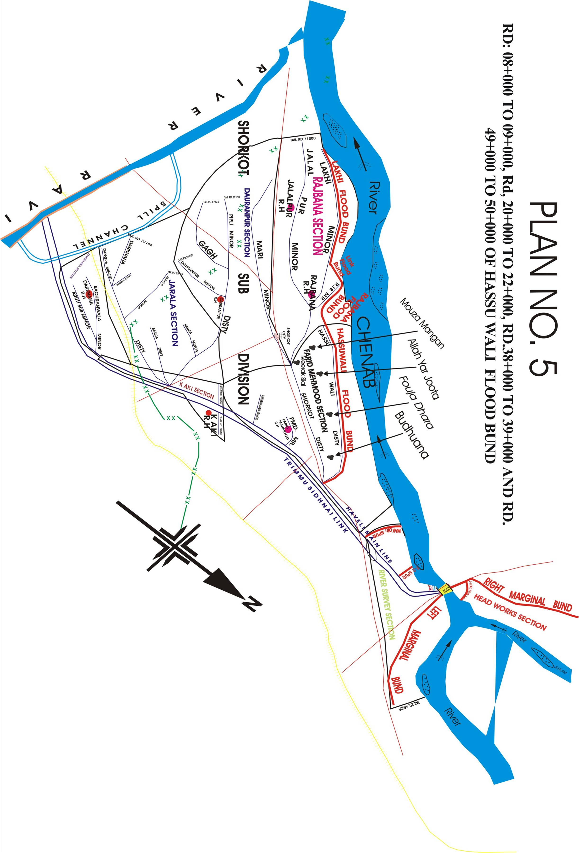
- Shorkot Disty.

PLAN NO. 5

RD: 0+000 – 6+500 RAJBANA FLOOD BUND

13.1 PLAN SHOWING ROUTE OF FLOOD WATER COMING OUT OF THE BREACH SUPPORTED WITH LEVELS.

Plan Attached

13.2 DETAIL OF VILLAGES ABADIES LIKELY TO BE AFFECTED AND THIS SHOULD ALSO BE SHOWN ON THE PLAN.

- Babal wala
- Yousaf Wala.
- Binda Sarbana
- Lakhi

13.3 STRATEGY AND ACTION TAKEN BE EXPLAINED IN DETAIL. THIS MAY INCLUDE.

The following arrangements / strategy will be adopted

13.3.1 ARRANGEMENTS

The following arrangements will be made.

13.3.2 ESTABLISHMENT OF FLOOD FIGHTING CAMPS

Flood fighting camp will be established at RD: 6+000 of Rajbana Flood Bund

13.3.3 DUTIES OF OFFICERS / OFFICIALS AND THEIR CAMP SITES

Sub Engineer Rajbana Section will be incharge of the camp site. The following staff will be at the camp site.

Sub Engineer = 1 No.
Mate = 1 No.
Beldar = 10 Nos

13.3.4 DEPARTMENTAL MACHINERY AVAILABLE

Not Available

13.3.5 MACHINERY AVAILABLE FROM PRIVATE SOURCE

The following machinery can be made available through private source i.e Government contractors.
- Excavator.
- Showal.
- Tractor with Trolleys
- Dozers
- Tractor with front blade.
The numbers of machinery will increase or decrease as per flood stage.
13.3.6 FLOOD FIGHTING MATERIAL REQUIRED

S.# | Description | Quantity Required at Site No. 6 |  |  |  | Remarks
S.# | Description | Qty. | Unit |  | Total  Requirement | Remarks
1 | Axes | 1 |  | No. | 1 | Balance material will be recouped during flood season 2025
2 | Baskets | 22 |  | No. | 22 | Balance material will be recouped during flood season 2025
3 | Buckets | 4 |  | No. | 4 | Balance material will be recouped during flood season 2025
4 | Burner and Lamps | 1 |  | No. | 1 | Balance material will be recouped during flood season 2025
5 | Cell for Torches | 6 |  | No. | 6 | Balance material will be recouped during flood season 2025
6 | Chimnies | 6 |  | No. | 6 | Balance material will be recouped during flood season 2025
7 | Chimnies of Gas | 1 |  | No. | 1 | Balance material will be recouped during flood season 2025
8 | Cow Dung in EC | 6 |  | Bags | 6 | Balance material will be recouped during flood season 2025
9 | Funnel (Ordinary) | 1 |  | No. | 1 | Balance material will be recouped during flood season 2025
10 | Funnel with W.G | 1 |  | No. | 1 | Balance material will be recouped during flood season 2025
11 | Gas Lamp | 1 |  | No. | 1 | Balance material will be recouped during flood season 2025
12 | Gunny Bags | 70 |  | No. | 70 | Balance material will be recouped during flood season 2025
13 | Hammer 2.5 lb | 1 |  | No. | 1 | Balance material will be recouped during flood season 2025
14 | Hammer 10 lb | 1 |  | No. | 1 | Balance material will be recouped during flood season 2025
15 | Kassi with handles | 6 |  | No. | 6 | Balance material will be recouped during flood season 2025
16 | Kerosene Oil | 61 |  | Ltr | 61 | Balance material will be recouped during flood season 2025
17 | Khajji Mate | 35 |  | No. | 35 | Balance material will be recouped during flood season 2025
18 | Lanterns | 6 |  | No. | 6 | Balance material will be recouped during flood season 2025
19 | Larmal 50 Ft | 15 |  | No. | 15 | Balance material will be recouped during flood season 2025
20 | Mallet wooden | 2 |  | No. | 2 | Balance material will be recouped during flood season 2025
21 | Match Box | 12 |  | No. | 12 | Balance material will be recouped during flood season 2025
22 | Mental | 15 |  | No. | 15 | Balance material will be recouped during flood season 2025
23 | Needles | 1 |  | No. | 1 | Balance material will be recouped during flood season 2025
24 | Needles for sewing bags | 1 |  | No. | 1 | Balance material will be recouped during flood season 2025
25 | Nozzles | 1 |  | No. | 1 | Balance material will be recouped during flood season 2025
26 | Oil Extractor | 1 |  | No. | 1 | Balance material will be recouped during flood season 2025
27 | Sledge Hammer 14 lb | 1 |  | No. | 1 | Balance material will be recouped during flood season 2025
28 | Spare handle for kassies | 3 |  | No. | 3 | Balance material will be recouped during flood season 2025
29 | Spirit | 1 |  | Bottles | 1 | Balance material will be recouped during flood season 2025
30 | Spirit Can | 1 |  | No. | 1 | Balance material will be recouped during flood season 2025
31 | Sticks (6-8) | 70 |  | No. | 70 | Balance material will be recouped during flood season 2025
32 | Sutli | 1 |  | Lb | 1 | Balance material will be recouped during flood season 2025
33 | Torch 3 Cell | 1 |  | No | 1 | Balance material will be recouped during flood season 2025
34 | Tranger Wire | 1 |  | CWT | 1 | Balance material will be recouped during flood season 2025
35 | Washers | 1 |  | No | 1 | Balance material will be recouped during flood season 2025
36 | Wicks | 4 |  | Yards | 4 | Balance material will be recouped during flood season 2025

13.3.7 FLOOD FIGHTING MATERIAL AVAILABLE AT SITE NO.6

S.# | Description | Quantity  Available
1 | Axes | 1
2 | Baskets | 22
3 | Buckets | 4
4 | Burner and Lamps | 1
5 | Cell for Torches | 6
6 | Chimnies | 6
7 | Chimnies of Gas | 1
8 | Cow Dung in EC | 6
9 | Funnel (Ordinary) | 1
10 | Funnel with W.G | 1
11 | Gas Lamp | 1
12 | Gunny Bags | 70
13 | Hammer 2.5 lb | 1
14 | Hammer 10 lb | 1
15 | Kassi with handles | 6
16 | Kerosene Oil | 61
17 | Khajji Mate | 35
18 | Lanterns | 6
19 | Larmal 50 Ft | 15
20 | Mallet wooden | 2
21 | Match Box | 12
22 | Mental | 15
23 | Needles | 1
24 | Needles for sewing bags | 1
25 | Nozzles | 1
26 | Oil Extractor | 1
27 | Sledge Hammer 14 lb | 1
28 | Spare handle for kassies | 3
29 | Spirit | 1
30 | Spirit Can | 1
31 | Sticks (6-8) | 70
32 | Sutli | 1
33 | Torch 3 Cell | 1
34 | Tranger Wire | 1
35 | Washers | 1
36 | Wicks | 4

13.4 DETAIL OF OTHER INFRASTRUCTURE LIKE ELECTRIC SUI GAS TELEPHONE INSTALLATION, ROAD NETWORK, OTHER BUILDING, CANAL AND DRAINAGE NETWORK.

- Shorkot-Garh Maharaja Road
- Basic Health Centre
- Union Council
- Vetrinary Hospital.
- Basic Health Unit
- Rajbana Minor.
- Jalalpur Minor

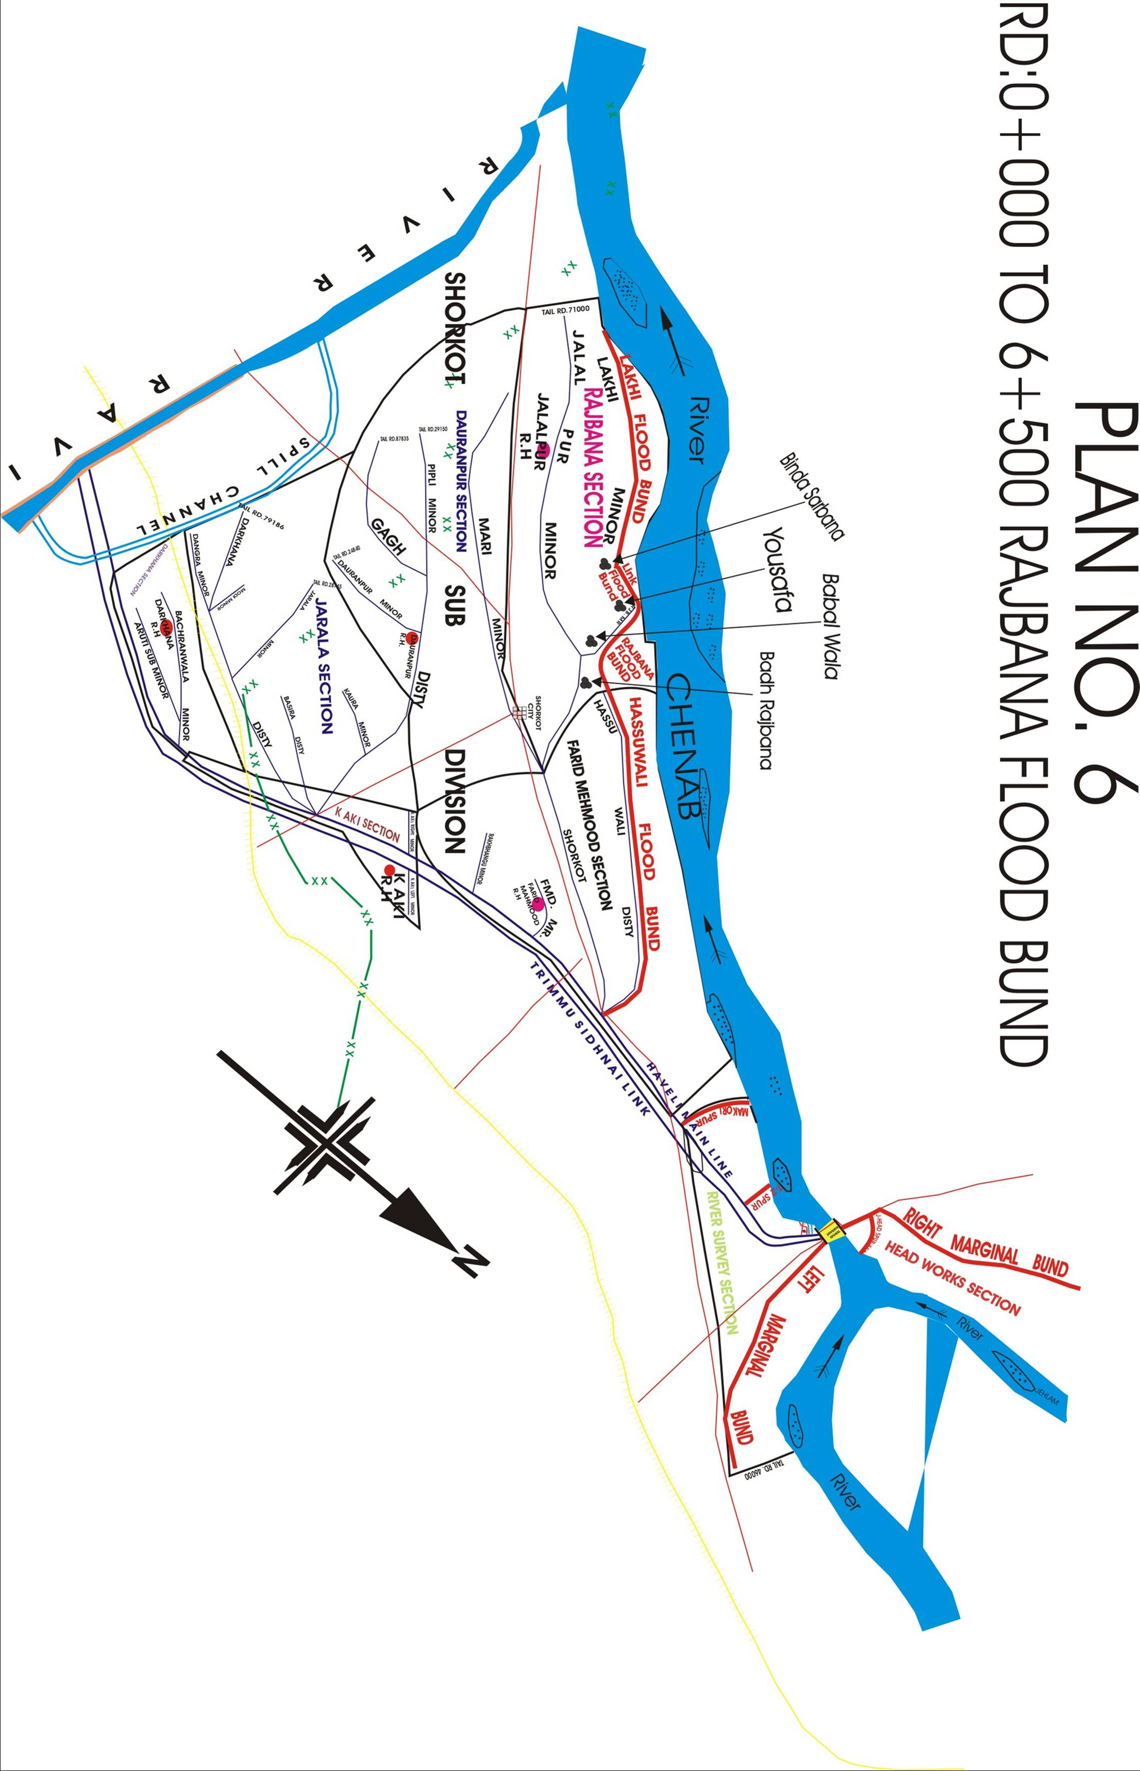

CHAPTER – 14
ADDITIONAL INFORMATION
ACTION PLAN

CONSOLIDATED STATUS OF RESERVE STOCK OF STONE

Sr. No. | Sanctioned Reserve stock Limit  (Lac Cft) | Available Quantity  (Lac Cft) | Balance required with respect to Sanctioned limit  (Lac Cft) | Minimum Quantity Available  (Lac Cft) | Remarks
1 | 23 | 17.24 | 5.76 | 16.10 | However, as per minimum requirement, there is no deficiency of stone.

14.1 – Re-Shuffling / Recouping Plan Of Reserve Stone Departmentally

Sr. No. | Name of Structure | Sanctioned Reserve stock Limit  (Lac Cft) | Available Quantity  (Lac Cft) | Balance required  (Lac Cft) | Remarks
1 | 2 | 3 | 4 | 5 | 6
1 | LGB U/S AND D/S | 5 | 4.87 | 0.13 | Minimum quantity i.e 16.10 Lac Cft is available. However, as per minimum requirement, there is no deficiency of stone.
2 | RGB U/S AND D/S | 5 | 4.76 | 0.24
3 | J-HEAD SPUR RD 5500 OF RMB | 1.5 | 1.57 | 0
4 | SLOPING SPUR ALONG COLONY RING BUND | 1 | 0.32 | 0.68
5 | T-1 SPUR ALONG COLONY RING BUND | 1.5 | 0.81 | 0.69
6 | T-2 SPUR D/S TRIMMU BARRAGE | 1.5 | 0.79 | 0.71
7 | J-HEAD SPUR MAKORI | 1.5 | 0.90 | 0.6
8 | DAB KALAN (relates to SDO Shorkot) | 1.25 | 0.89 | 0.36
9 | GUID WALL NO.1 ALONG LMB | 1.5 | 0.76 | 0.74
10 | GUID WALL NO.2 ALONG LMB | 1.5 | 0.76 | 0.74
11 | GUID WALL NO.3 ALONG COLONY RING BUND | 1.5 | 0.60 | 0.9
12 | X-SPUR RD 23000 OF RMB | 0.25 | 0.21 | 0.04
TOTAL |  | 23 | 17.24 | 5.76
Note:- However, in case of emergency and as per necessity of the quantity of stone in accordance with the requirement will be fulfilled by re-shuffling plan at vulnerable site likely to be affected.
14.2 – Detail of inlet / outlet crossing along with closing methodology.
There is no inlet / outlet crossing in flood bunds i.e Right Marginal Bund, Left Marginal Bund and Colony Ring Bund in the jurisdiction of Trimmu Barrage Division. The Inlet / Outlet crossing are on Hassuwali, Rajbana, Lakhi, Dadal Flood Bund. These Flood Bunds are now falls in the jurisdiction of Jhang Canal Division and Multan Canal Division Multan due to detachment from Trimmu Barrage Division.
14.3 – DEPLOYMENT MACHINERY (MEDIUM TO HIGH)
Sr. No. | Name of Structure |  | Length in Mile | Vulnerable Reach | Camp Location | Site Incharge by name & cell No. |  |  | Machinery Deployed |  |  |  | Availability of Stone  Lac Cft
 |  |  |  |  |  |  | Labour | Excavator |  | Dozer | Trolleys / Dumpers | Tractor with front blade | Availability of Stone  Lac Cft
1 | 2 |  | 3 | 4 | 5 | 6 | 7 | 8 |  | 9 | 10 | 11 | 12
1 | Left Marginal Bund RD 0-46000, Including 12 No. X-Spurs, Makori Spur, Guide Wall No.I & II |  | 14.89 | RD 14-21, RD 42-46 | RD 17000, RD 43000  LMB | Akhtar Hamid Sub Engineer River Survey Cell No.0302-3787027 | 132 | 1 |  | 0 | 4 | 1 | 2.42 Lac Cft (Guide Wall No.I, II Makori Spur)
2 | Right Marginal Bund RD 0-57765, Including X-Spur 2 No., Left Guide Bund, Right Guide Bund , J-Head Spur RD 4597 |  | 15.36 | RD 20-27 | R.M.B RD 25000, RGB RD 1200, LGB RD 1200 | Asif Rehman Sub Engineer Head Works Cell No.0333-6751933 | 144 | 1 |  | 0 | 4 | 1 | 11.38 Lac Cft (RGB, LGB, J-Head Spur 5500 & X-Spur RD 23000 along RMB
3 | Colony Ring Bund RD 0-9600, T-Headed Spur No.1, T-Headed Spur No.2, T-Cum Hockey sloping Spur, Guide Wall No.III |  | 5.04 |  | Hockey Spur | Saif ur Rehman Sub Engineer Station Area Cell No. 0300-7590043 | 24 | 0 |  | 0 | 0 | 1 | 2.53 Lac Cft (T-1, T-2, sloping spur) D/S Trimmu
Total length |  |  |  |  |  |  | 300 | 2 |  | 0 | 8 | 3
 |  | "payment for machinery & work charge employees subject to verification by TPM/Consultant"
14.4 – DEPLOYMENT MACHINERY (HIGH TO VERY HGIH)
Sr. No. | Name of Structure |  | Length in Mile | Vulnerable Reach | Camp Location | Site Incharge by name & cell No. |  |  | Machinery Deployed |  |  |  | Availability of Stone  Lac Cft
 |  |  |  |  |  |  | Labour | Excavator |  | Dozer | Trolleys / Dumpers | Tractor with front blade | Availability of Stone  Lac Cft
1 | 2 |  | 3 | 4 | 5 | 6 | 7 | 8 |  | 9 | 10 | 11 | 12
1 | Left Marginal Bund RD 0-46000, Including 12 No. X-Spurs, Makori Spur, Guide Wall No.I & II |  | 14.89 | RD 14-21, RD 42-46 | RD 17000, RD 43000  LMB | Akhtar Hamid Sub Engineer River Survey Cell No.0302-3787027 | 199 | 2 |  | 0 | 8 | 2 | 2.42 Lac Cft (Guide Wall No.I, II Makori Spur)
2 | Right Marginal Bund RD 0-57765, Including X-Spur 2 No., Left Guide Bund, Right Guide Bund , J-Head Spur RD 4597 |  | 15.36 | RD 20-27 | R.M.B RD 25000, RGB RD 1200, LGB RD 1200 | Asif Rehman Sub Engineer Head Works Cell No.0333-6751933 | 216 | 2 |  | 2 | 8 | 2 | 11.38 Lac Cft (RGB, LGB, J-Head Spur 5500 & X-Spur RD 23000 along RMB
3 | Colony Ring Bund RD 0-9600, T-Headed Spur No.1, T-Headed Spur No.2, T-Cum Hockey sloping Spur, Guide Wall No.III |  | 5.04 |  | Hockey Spur | Saif ur Rehman Sub Engineer Station Area Cell No. 0300-7590043 | 35 | 1 |  | 0 | 0 | 1 | 2.53 Lac Cft (T-1, T-2, sloping spur) D/S Trimmu
Total length |  |  |  |  |  |  | 300 | 5 |  | 2 | 16 | 5
 |  | "payment for machinery & work charge employees subject to verification by TPM/Consultant"

14.5 – DEPLOYMENT MACHINERY (EXCEPTIONALLY HIGH)
Sr. No. | Name of Structure |  | Length in Mile | Vulnerable Reach | Camp Location | Site Incharge by name & cell No. |  |  | Machinery Deployed |  |  |  | Availability of Stone  Lac Cft
 |  |  |  |  |  |  | Labour | Excavator |  | Dozer | Trolleys / Dumpers | Tractor with front blade | Availability of Stone  Lac Cft
1 | 2 |  | 3 | 4 | 5 | 6 | 7 | 8 |  | 9 | 10 | 11 | 12
1 | Left Marginal Bund RD 0-46000, Including 12 No.  X-Spurs, Makori Spur, Guide Wall No.I & II |  | 14.89 | RD 14-21, RD 42-46 | RD 17000, RD 43000  LMB | Akhtar Hamid Sub Engineer River Survey Cell No.0302-3787027 | 264 | 2 |  | 0 | 8 | 2 | 2.42 Lac Cft (Guide Wall No.I, II Makori Spur)
2 | Right Marginal Bund RD 0-57765, Including X-Spur 2 No., Left Guide Bund, Right Guide Bund , J-Head Spur RD 4597 |  | 15.36 | RD 20-27 | R.M.B RD 25000, RGB RD 1200, LGB RD 1200 | Asif Rehman Sub Engineer Head Works Cell No.0333-6751933 | 288 | 2 |  | 2 | 8 | 2 | 11.38 Lac Cft (RGB, LGB, J-Head Spur 5500 & X-Spur RD 23000 along RMB
3 | Colony Ring Bund RD 0-9600, T-Headed Spur No.1, T-Headed Spur No.2, T-Cum Hockey sloping Spur, Guide Wall No.III |  | 5.04 |  | Hockey Spur | Saif ur Rehman Sub Engineer Station Area Cell No. 0300-7590043 | 48 | 1 |  | 0 | 0 | 1 | 2.53 Lac Cft (T-1, T-2, sloping spur) D/S Trimmu
4 | Hassuwali Flood Bund |  | 14.4 | RD  8 to 9  20 to 22  38 to 39  49 to 50 | Camp at RD 22000 of Hassu Wali Flood Bund | Muzafar Ali Sajid  Farid Mehmood Section  Cell No.0300-6847593 | 346 | 2 |  | 0 | 8 | 2
5 | Rajbana Flood Bund, Connecting tail Rajbana Flood Bund with lakhi Flood Bund RD 0-11400, |  | 6.83 | RD 0-6500 | Camp at RD 6+000 of Rajbana Flood Bund | Asghar Ali Shah Sub Engineer Rajbana  Cell No.0301-7203509 | 164 | 1 |  | 0 | 4 | 1
6 | Rangpur Flood Embankment along left bank of Rangpur Canal RD 260-308 & 308-318 (Tiba) Range),left bank of escape channel RD 0-3850 |  | 12.88 | RD 292 to 318 | Camp at RD 303 of RGP Flood Bund | Muhammad Aslam Pervaiz Sub Engineer Rangpur  Cell No.0324-7008563 | 297 | 1 |  | 0 | 4 | 2
Total length |  |  |  |  |  |  | 1407 | 9 |  | 2 | 32 | 10
 |  | "payment for machinery & work charge employees subject to verification by TPM/Consultant"

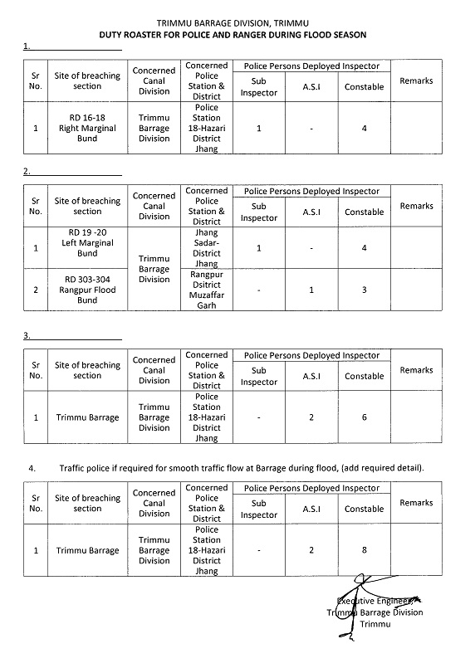
14.6 – POLICE DEPLOYMENT PLAN

14.7 – Detail Of Synthetic Bags With Capacity Of 500kg And 1000 Kg

Sr# | Name of Bund | Synthetic bags (500 Kg) | Synthetic bags (100 Kg) | Quantity Required | Quantity Available | Balance Quantity required
1 | Left Marginal Bund | 1000 | 500 | 1500 | - | 1500
2 | Right Marginal Bund | 1000 | 500 | 1500 | - | 1500
TOTAL |  | 2000 | 1000 | 3000 | - | 3000

The deficient quantity of Synthetic Bags with capacity of 500 Kg and 1000 Kg will be purchased before the start of Flood season.

14.8 – Details of polythene sheets of black color to protect upstream slope against wave action and to control seepage through embankments.

Sr# | Name of Bund | Polythene sheets | Quantity Required | Quantity Available | Balance Quantity required
1 | Left Marginal Bund | 40000 Ft | 40000 Ft | - | 40000 Ft
2 | Right Marginal Bund | 45000 Ft | 45000 Ft | - | 45000 Ft
TOTAL |  | 85000 Ft | 85000 Ft | - | 85000 Ft

The deficient quantity of Polythene sheets will be purchased before the start of Flood season.

CHAPTER NO. 15

BACK UP DIVISION (In case of Breach)

In case of breach, the staff of Executive Engineer, Sidhnai Headworks Division will provide backup to Trimmu Headworks Division Trimmu and in case of any flood emergency, the local contractors may also be engaged.

Executive Engineer, Superintending Engineer, Chief Engineer,
Trimmu Headworks Division Trimmu Canal Circle, Trimmu Irrigation Multan Zone
Trimmu Multan.

PART – A

PART - B

