**PART – ACHAPTER -1**

**SALIENT FEATURE OF PANJNAD HEADWORKS**

**1.1 LOCATION**

Panjnad Headworks is situated just below the confluence point of Sutlej and Chenab Rivers in the South - Eastern part of Muzaffargarh District. The Barrage was constructed during 1927-1932. The Barrage structure has Maximum Designed flood passing capacity of 8.65 Lac Cusecs

The Chenab joins at right side of Panjnad Headworks with the combined effect of its Tributaries i.e. Rivers Ravi and Jhelum.

The Chenab originates in Kulu and Kangra of Himachal Perdesh­Province of India. The river enters Pakistan territory in Sialkot District near DiavaraVillage. The ChenabRiver flows through the alluvial plain of Punjab Province for a distance of 633 K.M. It is joined by JhelumRiver upstream of Trimmu Barrage and 64 K.M. further downstream by the River Ravi and ultimately joins Sutlej just upstream of Panjnad Headworks.

River Sutlej joins thePanjnad Barrage at left side of the Barrage which is originating from Kailas Mountain range of Western Tibbet near the source of the Indus, the Ganges and BarmaPutraRiver. It travels through the Punjab and Siwalik Mountain ranges and enters the plains of Indian Punjab. The flows of this river along with its tributaries enter Pakistan boundary near Ferozepur adjoins the Chenab River 5 K.M. upstream of Panjnad Headworks. After passing through Panjnad Headworks, the flows ultimately join Indus River at downstream of Taunsa and just upstream of Guddu Barrage.

**1.2 GENERAL DESCRIPTION**

Objective of the flood fighting plan is to develop a framework to pass flood from Panjnad Headworks safely and to react against any contingency with a view to:

1. Protect Panjnad Headworks along with its allied structures as it is the life line for the agriculture of Districts Bahawalpur and Rahimyarkhan.
2. Protect FloodBundsagainst gushing effect of flood water to safeguard population and agriculture areas from flood inundation.
3. Protect River Trainings Works to train the river within river Khadir.
4. Save precious lives and properties.
5. Minimize human miseries and sufferings.

**OFF TAKING CANALS AT PANJNAD HEADWORKS**

1. **PanjnadCanal**

Panjnad Canal off-takes left bank of Panjnad Barrage having Maximum authorized discharge of 10484 Cs.Panjnad Canal Irrigates vast area of District Bahawalpur and District Rahimyarkhan.It carries non perennial supply of District Rahimyarkhan. Its length for RD. 0+000 to 10+000 lies within jurisdiction of Panjnad Headworks.

1. **AbbasiaCanal**

Abbasia Canal is the 2nd off-take from left side of Panjnad Headworks, its maximum authorized discharge capacity is 1394 Cs which has been reduced to 1064 Cs due to induction of Abbasia Link Canal. Abbasia Canal Irrigates area of Bahawalpur & Rahimyarkhan District. Its length for RD. 0+000 to 02+000 falls within the jurisdiction of Panjnad Headworks.

1. **AbbasiaLinkCanal**

Abbasia Link Canal is the 3rd off-take from left side of Panjnad Headworks, its capacity is 5600 Cs. It carries perennial supply of District Rahimyarkhan and flood supplies to Cholistan area in Tehsil Laiqatpur. Its length for RD. 0+000 to 10+000 falls within in the jurisdiction of Panjnad Headworks.

**1.3 ADMINISTRATIVE SETUP**

Administratively Panjnad Headworks Division consists two Sub Divisions and eight nos. of sub Engineers with their establishment.

**ORGANIZATION CHART**

3

2

1

Sub Divisional Officer

Bund Sub Division

Sub Engineer

Leave Reserve

Sub Divisional Officer

Panjnad H/W Sub Division

Sub Engineer

Flood Bund Section-3

Sub Engineer

Flood Bund Section-2

Sub Engineer

Flood Bund Section-1

Sub Engineer

Workshop Section

Sub Engineer

Station Area Section

Sub Engineer

Headworks

Section

Sub Engineer

Hydraulic

Section

**Executive Engineer**

**Panjnad Headworks Division**

**CHAPTER 2**

**FLOOD PROTECTION AND RIVER TRAINING WORKS**

**2.1 DESIGN PARAMETER OF RIVER TRAINING WORKS,**

Following river training works exist Panjnad Headworks division.

**a) RIGHT SIDE of HEADWORKS**

i) Right Marginal Bund RD: 0+000-70554 = 14.11 Miles

ii) Right Retired Embankment RD: 10+000-35230 = 5.046 Miles

**b) STRUCTURES ALONG R.M.B**

|  |  |  |  |  |
| --- | --- | --- | --- | --- |
| **Sr. No.** | **RD** | **Type of spur** | **Length** | |
| **RD** | **Miles** |
| **1** | 12+750 (R.M.B) | J-Head Spur | 0-7700 | 1.54 |
| **2** | 16+500 (R.M.B) | J-Head Spur | 0-5500 | 1.1 |
| **3** | 18+320 (R.M.B) | J-Head Spur | 0-5000 | 1.0 |
| **4** | 23+500 (R.M.B) | J-Head Spur | 0-5000 | 1.0 |
| **5** | 36+700 (R.M.B) | J-Head Spur | 0-1900 | 0.38 |
| **6** | 39+000 (R.M.B) | Sloping Spur | 0-431 | 0.0862 |
| **7** | 40+900 (R.M.B) | J-Head Spur | 0-1500 | 0.30 |
| **8** | 41+500 (R.M.B) | Stone Stud | 0-1500 | 0.30 |
| **9** | 42+200 (R.M.B) | Mole Head Spur | 0-435 | 0.47 |
| **10** | 43+000 (R.M.B) | Stone Stud | 0-565 | 0.113 |
| **11** | 48-49 (R.M.B)  48+600 | J-Head Spur | 0-5600 | 1.15 |
| **12** | 53+600 (R.M.B) | Stone Stud | 0-950 | 0.19 |
| **13** | 55+000 (R.M.B) | Sloping Spur | 0-900 | 0.18 |
| **14** | 56+000 (R.M.B) | Sloping Spur | 0-1300 | 0.26 |

**c) LEFT SIDE OF HEADWORKS.**

i) Left Marginal Bund RD: 0+000- 67+000 = 13.40 Miles

ii) Old Left Marginal Bund RD: 45+000 - 65+000 = 04.00 Miles

**d) STRUCTURES ALONG L.M.B**

|  |  |  |  |  |
| --- | --- | --- | --- | --- |
| **Sr. No.** | **RD** | **Type of spur** | **Length** | |
| **RD** | **Miles** |
| **1** | 6+500 (L.M.B) | J-Head Spur | 0-7100 | 1.42 |

**e) COLONY PROTECTION BUND (DOWNSTREAM SIDE)**

i) D/S Colony Protection Bund RD: 0 - 17600 = 3.52 Miles

**f) STRUCTURES ALONG C.P.B**

|  |  |  |  |  |
| --- | --- | --- | --- | --- |
| **Sr. No.** | **RD** | **Type of spur** | **Length** | |
| **RD** | **Miles** |
| **1** | 2+750 (C.P.B) | Guide wall spur | 0-1580’ | 0.299 |
| **2** | 5+500 (C.P.B) | Mole Head | 0-320’ | 0.064 |
| **3** | 6+700 (C.P.B) | Sloping Spur | 0-88’ | 0.0176 |
| **4** | 8+550 (C.P.B) | Sloping Spur | 0-150’ | 0.030 |
| **5** | 9+000 (C.P.B) | Sloping Spur | 0-176’ | 0.0352 |
| **6** | 10+000(C.P.B) | Sloping Spur | 0-270’ | 0.054 |

The detail of design parameter of all the river training works are described as under:-

**LEFT MARGINAL BUND, RIGHT MARGINAL BUND AND COLONY PROTECTION BUND**

L-Section of Left Marginal Bund, Right Marginal Bund and downstream Colony Protection Bund are attached to give complete data of these Bunds. Rehabilitation and upgrading of Panjnad Headworks project has been carried out by Punjab Irrigation Department through PMO for Punjab Barrages Lahore to enhance capacity of the barrage from 7.0 Lac cusecs to 8.65 Lac cusecs. Accordingly, to improve flood infrastructures as per new flood limit criteria, the Left and Right Guide Banks of Panjnad Barrage were rehabilitated in the project while the Left and Right Marginal Bunds i.e LMB & RMB were remodeled under Disaster and Climate Resilience Improvement Project (DCRIP) by Project Implementation Unit (PIU) of Irrigation Department during the year 2020-22. The prime motive for the remodeling of the Left marginal Bund and Right Marginal Bund along with River Training Works was to ensure safety of the flood embankments as per criteria of Federal Flood Commission and to ensure new design parameters of flood levels due to Panjnad Headworks improvement project. The wetting channels were restored as per design parameters. The Colony Protection Bund has been also rehabilitated to the latest design as 7Ft, free board above tail water level as per enhanced capacity of Panjnad Barrage. But it is pertinent to mention here that only shank of training works taken in scope of work and moved portion of J-Head spur or not attached by the PIU or remain under threat in high flood level. Additionally, All the river training works have not been raised as per enhanced capacity of Panjnad Barrage.

|  |  |
| --- | --- |
| **S. No.** | **Description** |
| **1.** | Designed Capacity of barrage. = 8.65Lacs Cs |
| **2** | Total Length of Weir /Width of Barrage (including width of pier) = 3400 ft.  Width of pier = 7 ft. |
| **3** | Total Length New divide wall is = 910 FtR.L=347.00 Ft |
| **4** | Total Nos. gates of Barrage = 50 No. |
| **5** | Span of Each gate. =60’ |
| **6** | Crest Level of Main weir&Annexe Weir = 325.0’ and Crest Levelof Additional bays =322.0’ |
| **7** | Upstream Floor Level. = 320.50’ |
| **8** | Downstream Floor Level. = 316.50’ for Main weir & 315.50’for Annexe weir&311.00’ for Additional bays. |
| **9** | Designed Summer Pond Level = 338.50’, Winter Pond Level = 337.50’. |
| **10** | Permissible Head Across of Barrage. = 338.50-320.50 =18.00’.  Afflux = 3.46. |
| **11** | Upstream Pond Level + Afflux = 338.5+3.46 = 341.86. |
| **12** | Maximum UpstreamFlood Level= 343.03’ |
| **13** | Maximum DownstreamFlood Level= 342.02’ |
| **14** | Pond Area of Barrage = 6868 Acres. |
| **15** | Length of upstream floor. = 95’ for Left Pocket,93’ for Main Weir,60.75’ for Additional Bays & 50’ for Annexe Weir.  Length of Downstream floor =106’ for Left Pocket &Annexe Weir,120’ for Additional Bays.  Total Length of glacis upstream = 18’ for Left Pocket, Main Weir&Annexe Weir,6.0’ for Additional Bays.  Total Length of glacis Downstream =42.50’ for Left Pocket, Main Weir & 47.50’ for Annexe Weir,55.0’ for Additional Bays.  Downstream concrete block (3x4x5) = 50 ft. |
| **17** | Length of Right Guide Bund (Upstream) = 3600 ft.  3:1  2:1  25’  3:1  2:1  25’  Top width =25 ft.  Length of Right Guide Bund (Downstream) = 487 ft  Top width =25 ft.  Length of Left Guide Bund (Upstream) = 3600 ft.  Top width =25 ft.  Length of Left Guide Bund (Downstream) = 545 ft.  Top width =25 ft.  Length of Right Marginal Bund= 70554 ft.(Hamzay Wali).  Top Width = 25 ft. river side slope = 3:1 country side slope 2:1. RD:0 351/439- RD: Tail 358/490  2:1  3:1  25’  Length of Retired Right Embankment (R.R.E) 25230 ft.  Retired Left Embankment (R.L.E) at RD:32+000, 44+000 and 55+000.  3:1  25’  Length of Left Marginal Bund. = 67000 ft.  2:1  Top Width = 25 ft. river side slope = 3:1 country side slope 2:1. RD:0 350/441- RD: Tail 344/414  Length of Colony Protection Bund. = 17600 ft.  Top Width = 25 ft. river side slope = 3:1 country side slope 2:1. RD:0 340/470- RD: Tail 338/444  3:1  25’  2:1  Free board (Tail Level) =7 ft.  No of spur on R.M.B. = 14 No. L=6.873 Mile  No of spur on L.M.B. = 1 No. L=1.42 Mile  No of spur on C.P.B. = 6 No. L=0.3294 Mile  **Shikrani Flood Bund**  Top Width = 25 ft. river side slope = 3:1 country side slope 2:1.  RD:0 +000 To : Tail RD:40+000  Length of Bund. = 40000 ft.  Free board =7 ft.  **Minchin Flood Bund**  Top Width = 25 ft. river side slope = 3:1 country side slope 2:1.  RD:6+700 To Tail RD: 122+000  Length of Bund. = 115300 ft.  Free board =7 ft. |
| **19** | Jurisdiction of Panjnad Headworks for 3 No. off-taking Channels  Panjnad Main Line (RD:0-10000) i-e Length=2.0 Mile,  Abbasia Canal (RD:0-1500) i-e Length=0.3 Mile and  Abbasia Link Canal. (RD: 0-10000)i-e Length =2.0 Mile. |
| **20** | Panjnad Main Line Designed Discharge. 7769/10484 Cs. Crest level=332.50 GCA/CCA=1564797/1374526  No. of gates = 12 Nos. (10 gates = 26 ft. span) 2 No. gates = 18 ft. span (Right to left). |
| **21** | AbbasiaCanal Designed Discharge. = 1064/1394 Cs. Crest level =330 ft.  No. of gates. = 2 No. Span of each gate = 20 ft. |
| **22** | Abbasia Link Canal Designed Discharge = 5600 Cs. Crest level =330 ft.  No. of gates = 6 No. span of each gate 25 ft. |

**EXISTING INFRASTRUCTURE**

**i) BARRAGE AND CANAL HEAD REGULATORS**

Panjnad Headworks is situated just below the confluence point of Chenab and Sutlej in the South-Eastern part of District Muzaffargarh. Rehabilitation and upgrading of Panjnad Headworks project has been carried out by Punjab Irrigation Department through PMO for Punjab Barrages Lahore to enhance capacity of the barrage from 7.0 Lac cusecs to 8.65 Lac. Three (03) Canals namely Panjnad Main Line, Abbasia Canal and Abbasia Link Canal are off-taking from left side of this barrage to irrigate the area of Bahawalpur and Rahimyar Khan Districts. The structures are satisfactory condition.

**ii) RIGHT GUIDE BUND**

The river Chenab is the only active part at Panjnad Headworks and Sutlej remain almost dead upto 2022. However, in Kharif 2024 about 70 thousand Cs Discharge Sutlejshare at barrage. Presenting a Bela formation along the RGB and River Chenab main stream is on left from the confluence period of Chenab and Sutlej.For the safety of the SAID structure, the structure has been rehabilitated to its original design under rehabilitation project andRGB is in satisfactory condition.

**iii) LEFT GUIDE BUND**

There is a shore formation from Abbasia Link Canal Head Regulator to X-section No.II on Sutlej upto line No. zero of Left Guide Bund. Site situation is safe upto this point and the remaining portion is also intact and safe. As per enhanced capacity of barrage, the design parameter of LGB has been changed accordingly in the rehabilitation project of Barrage andLGB is in satisfactory condition.

**iv) RIGHT MARGINAL BUND**

Right Marginal Bund of Panjnad Headworks is under persistence stresses of the river flow / current. River Chenab at Panjnad Headworks has high tendency of drifting towards right flank and has been threatening right marginal bund (RMB) since construction of the barrage. 07 No. of J-head spurs, 01 No. of mole head spur and 06 No. of stone and sloping studs have been constructed at different RDs of RMB of Panjnad Headworks to divert the river away from the RMB. At present, the main creek is flowing close to the RMB from RD 50 to 35. The remaining distance from the main creek edge to the toe of the bund in this reach is reduced to [160](tel:160)-[200](tel:200) ft. The only second defense line Retired Right Embankment (RRE) from RD 0-25+000 runs parallel from RD 10+000 to RD 35+000 of Right marginal bund. Right Retired Embankment is constructed since the construction of Panjnad Barrage and work as second defense line of RMB in case of any emergency, the reach RD: 35-43 is under direct hit of river flow. Necessary provision of stone pitching will be provided in this reach. The gradual shifting of main creek to the RMB is threatening the RMB and consequently its adjoining abadies

However, the raising and strengthening of RMB has been completed in implementation unit (PIU) under DCRIP.RMB in between the spur at RD: 36+700 and at RD: 40+900 is in a very dangerous condition. The main current after crossing spur at RD: 40+900 of R.M.B, returns back and forms a gullet parallel to reach RD: 36+700 to 40+900 of R.M.B. It not only impinges upon the nose of spur at RD: 36+700 but also erodes the venerable reach of R.M.B. The minimum ordinate of the foreshore left is 90 ft. at RD: 39+000 from the river edge. The Right Marginal Bund i.e. RMB were remodeled under Disaster and Climate Resilience Improvement Project (DCRIP) by Project Implementation Unit (PIU) of Irrigation Department during the year 2020-22 but the river training structures have not been raised as per enhanced capacity of Panjnad barrage and physically RMB is in satisfactory condition up high flood.

1. **LEFT MARGINAL BUND**

The Left Marginal Bundi.e. LMB was remodeled under Disaster and Climate Resilience Improvement Project (DCRIP) by Project Implementation Unit (PIU) of Irrigation Department during the year 2020-22. The soil of LMB is technically unstable which depicts swelling after absorbing moisture. Due to swelling and shrinkage of the soil particles, the small cracks appeared in the embankment resultantly, the infiltration galleries/ seepages path developed. The infiltration galleries further widened which results in the breaching of wetting channels.

The Geo-Technical as well as seepage and stability analysis ofLMB& RMB has been conducted by Physics Directorate Irrigation Research Institute (IRI) in August 2023 for productive opinion and technical advice regarding further economic measures and safety measures of marginal bunds of Panjnad Headworks. Accordingly, the estimate has been prepared dully checked by TPM and work not started due to paucity of funds. PhysicallyLMB is in satisfactory condition up to high flood.

**vi) DOWNSTREAM COLONY PROTECTION BUND**

The condition of downstream colony protection bund is satisfactory; this bund was firstly designed with freeboard of 5.00ft and top width 20ft, re-designed with the free board of 6.00ft and 25.00ft top width. However the river creek has developed severe loop downstream to spur RD 2750 and has attacked CP Bund in reach RD 4-5. In month of March 2015, there was erosion up to toe of CP Bund just upstream Spur RD 5500. The matter was reported to IRI for the Model Study, upon the recommendations of Expert Committee Meeting held on 05/01/2015. As per the result of the model study, the PIU constructed the guide wall as proposed in model study and handed over to Irrigation Department during the year 2018.

The competent authority has approved 25.0’ top width with 7.0 ft free board above the Tail level as per enhanced capacity of Panjnad Barrage keeping in view of latest criteria of Federal Flood commission vide Head/Project Director PMO-Punjab Barrages letter No.94/ DPD Panjnad /PMO dated: 24.05.2023.The strengthening of C.P Bund as per new capacity of Barrage is in process through machinery Division DG Khan physically CP Bund is in satisfactory condition.

**vii) J-HEAD SPUR AT RD: 12+750 R.M.B**

Hydraulic Model Study was conducted at Nandipur Research Institute. In the research report, this structure was recommended / proposed to divert the river flow away from the bank. It was constructed during the year 2008-09 and this spur is in satisfactory condition.

**viii) J-HEAD SPUR AT RD; 16+500 R.M.B**

During the freshet of March 2007, the earthen shank of J-Head Spur atRD: 16+500 was damaged. To mitigate the situation at site, the restoration of damaged site was done in 2008.Now Spur is in satisfactory condition.

**ix) J-HEAD SPUR AT RD; 18+320 R.M.B**

During the freshet of March 2007, the earthen shank of J-Head Spur at RD: 18+320 was damaged. To mitigate the situation at site, the restoration of damaged site was carried out in 2008.Now Spur is in satisfactory condition.

**x) J-HEAD SPUR AT RD. 23+500 R.M.B**

The shank and J-Head of this spur became under direct hit of river. The parallel flow has caused damage to this structure during the freshet of march 2007,Its prong was damaged and supplies crossed the prong and divided it into two parts. Restoration work has been completed in June 2007.The J-Head Portion of the spur came under attack of the river. The apron was launched and pitching was damaged. Restoration work was completed in 2016. However the spur is sensitive and may come under attack again. Special watching will be arranged.

**xi) RIVER TRAINING WORKS IN THE REACHRD. 32 TO 44 R.M.B**

The reach RD: 32-44 R.M.B is considered to be the most vulnerable reach. Hydraulic Model for the reach was run at Nandipur research institute. The committee inspected the site and recommended the following training works to check the further rightward drifting of Chenab River towards RMB:

1. Existing Sloping Stud at RD 43+[000](tel:000) of RMB extended & converted into Hockey Spur
2. Existing Sloping Stud at RD 39+[000](tel:000) of RMB extended & converted into Hockey Spur
3. Apron of Existing J-Head Spur RD 40+[900](tel:900) and 36+[700](tel:700) may be restored upto 30ft width.
4. The PC-I for the said proposal is submitted to admin department and same is also proposed for the ADP 2024-25. It is further added on the advice of admin department the case is also referred to IRI for model study. Payment for model study has been made to IRI in august 2024 and model study awaited.

**xii) SLOPING SPUR AT RD: 2750 DOWNSTREAM COLONY PROTECTION BUND**

The river after crossing the barrage has now adopted an oblique route towards left and has direct hit upon Colony Protection Bund on left flank. The Model Study of the problem was conducted during 2008 in IRI Lahore. In the study report, a Concavo-Convex Guide Wall Spur of 1000 Ft length was constructed in front of 2+750 sloping spur. Now Spur is in satisfactory condition

**xiii) MOLE HEAD SPUR AT RD: 5500 D/S COLONY PROTECTION BUND**

In fact, this spur bears the main current of the river attack after the flow crosses the barrage below spur at RD: 2750, so for it is functioning properly. But during the High Flood of 2013, apron and stone pitched slopes of the structure was damaged. Repair of these damages was carried out and was completed in month of June 2014 before flood. Now the condition is satisfactory and watching arrangement will be made as per flood stages.

**xiv) SLOPING SPUR AT RD: 6700 D/S COLONY PROTECTION BUND**

This was constructed in 1982 to correct the adverse river approach downstream the barrage and it is functioning properly. Spur is in satisfactory condition

**xv) SPUR NO. 9500 & 8500 DOWNSTREAM COLONY PROTECTION BUND**

The spur at RD 9500 being situated in the shadow of spur at RD 8500 does not come under action. Spur is in satisfactory condition

**xvi) SPUR RD: I0+000 DOWNSTREAM COLONYPROTECTION BUND**

This is the last spur in series of spurs along Colony Protection Bund downstream Panjnad Headworks. The sloping spurs are very effective in pushing the main Current away from the fore shore. As the river has created a deep channel in the middle of the course, there was no damage to this spur upto 2018. Over all condition is good.

**SHIKRANI BUND.**

Shikrani Bund starts from RD. 14+238 Panjnad Main Line(TAIL C.P Bund RD 17+600) and situated on the right bank of the Panjnad Main Canal upto RD.32 of Panjnad Main Line and then continues along right bank of Shikranidisty and ultimately joins Minchin Flood Bund at RD.6+700. The construction of Shikrani Bund was completed during the year 1982–83 to protect the Panjnad Main Line and agricultural areas from spill of Flood. No River Training works exist on this embankment.

The Design parameter of this bund is:-

i) Top width. = 25.0’

ii) Free board over = 07.0’

H.F.L. of 1976.

1. iii) SIDE SLOPES

River side. = 3 : 1

Country side. = 2: 1

The authority has approved 25.0’ top width as per present criteria of flood bunds with 7.0 ft free board as per latest criteria of Federal Flood commission vide Head/Project Director PMO-Punjab Barrages letter No.590/HPMO/PMO dated: 31.10.2023.A scheme namely “Preventing Erosion Of River Indus Along Minchin Flood Bund Rd 6+700 To Rd 122+000 (Taunsa-Guddu Reach D/S Panjnad Headworks)” has been reflected under financial window of FPSP-111.The PC-1 of above said scheme has been submitted, The strengthening of this bund according to approved design Parameter will be carried out accordingly.

**MINCHIN BUND.**

Minchin Bund originates near RD. 52 Panjnad Main Line and is abandoned upto RD.6+700, where it joins Shikrani Bund at Tail at RD.40+000. Minchin Bund from RD.6+700 – 122+000 falls in this Division and runs parallel to the left bank of River Chenab at a distance of 1.5 to 2.0 Miles. This Flood Bund falls in the jurisdiction of District Bahawalpur upto RD:32+000 and from RD:32+000 to RD:122+000 in Rahimyarkhan District.

The design parameters of the Flood Bund are as under:-

i) Top width. = 25.0’

1. Free board over = 07.0’

H.F.L. of 1992.

iii) SIDE SLOPES

River side. = 3 : 1

Country side. = 2 : 1

The authority has approved 25.0’ top width as per present criteria of flood bunds with 7.0 ft free board as per latest criteria of Federal Flood commission vide Head/Project Director PMO-Punjab Barrages letter No.591/HPMO/PMO dated: 31.10.2023..A scheme namely “Preventing Erosion Of River Indus Along Minchin Flood Bund Rd 6+700 To Rd 122+000 (TAUNSA-GUDDU REACH D/S PANJNAD HEADWORKS)” has been reflected under financial window of FPSP-111.The PC-1 of above said scheme has been submitted, The strengthening of this bund according to approved design Parameter will be carried out accordingly.

**GENERAL DESCRIPTION D/S PANJNAD HEADWORKS**

As explained above, this Division is maintaining the Shikrani & Minchin Flood Bund RD. 0+000 – 40+000 & RD. 6+700 – 122+000 respectively.

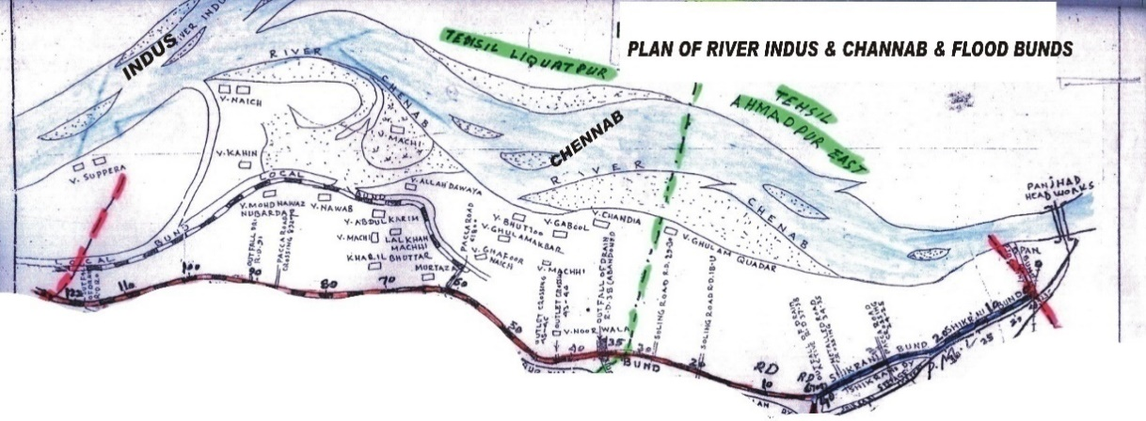**River Chenab** after passing Panjnad Head Works flows parallel to Shikrani Flood Bund and Minchin Flood Bund. The Flood water flows along this bund during high stage of floods. The confluence point River Indus and river Chenab is in front of reach RD: 108+000 – 122+000 of Minchin Flood Bund.

The river spill runs along the bund from RD: 108+000 – 122+000. The back water effect of River Indus comes upto RD:60+000 of Minchin Flood Bund during high flood stage when there is normal flow in River Chenab.

**INLETS**

There is 1 No. inlet of main seepage drain which cross the Shikrani Flood Bund at RD: 37-38. 3 No inlets of main seepage drains which cross the Minchin Flood Bund at RD: 62-63, 90-91 & 120-121. There are 2 No outlets of Noor Wala Distributary which also cross the Minchin Flood bund. These inlets are checked during flood season through departmental labour.

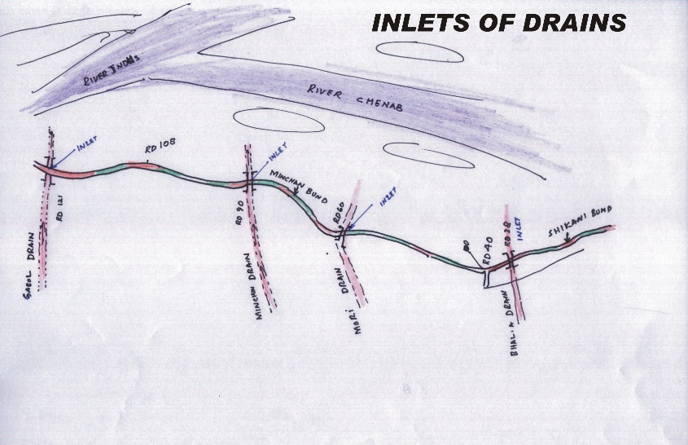**INFRASTRUCTURES**

Panjnad Main Canal and its off-taking i.e. Shikrani Disty, Bhalla Jhulan, Noorwala, Thulhamza & Gabol Distributaries are running parallel to the Shikrani & Minchin Flood Bunds and are main infrastructure. Panjnad Main Canal is about 05 Km to 06 Km away from these Flood Bunds. It is the other main infrastructure of the area.

**2.2 LOCATION MAP**

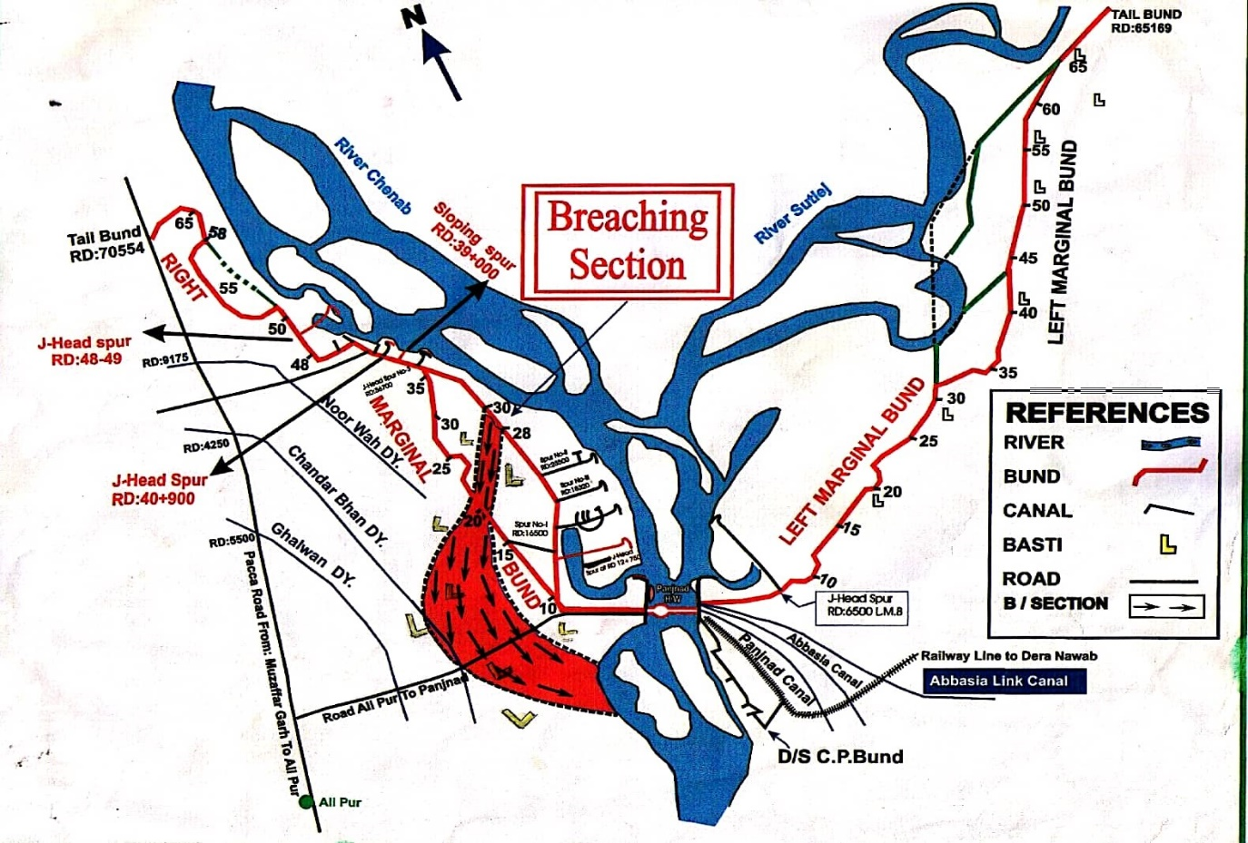

**PANJNAD HEADWORKS DIVISION**

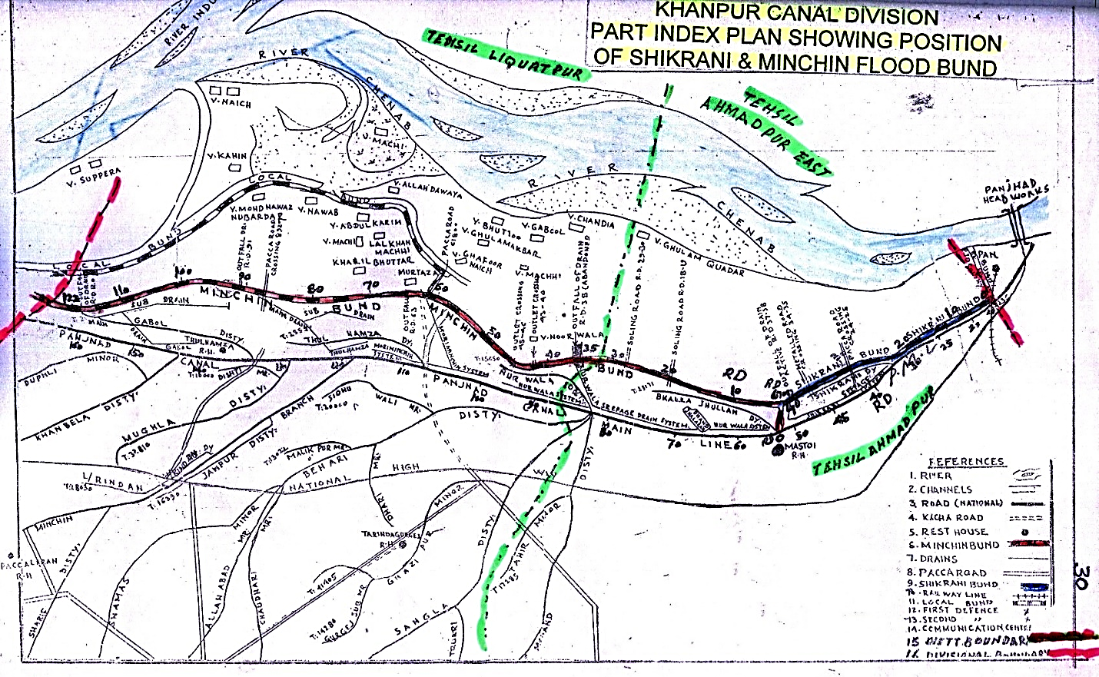

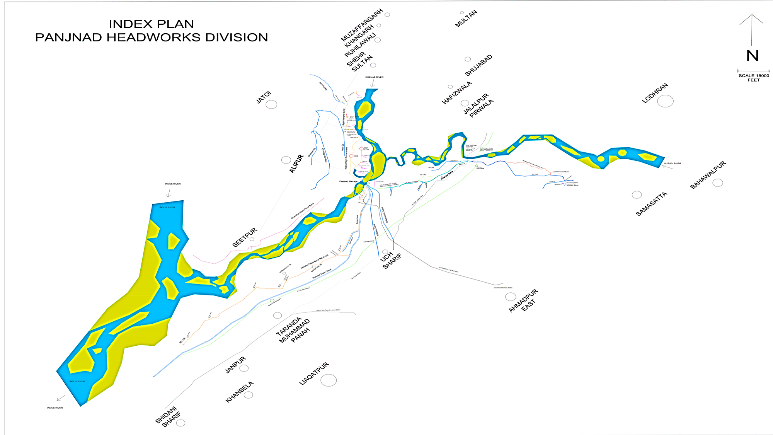

**CHAPTER 3**

**BRIEF HISTORY OF PAST FLOOD EVENTS**

The river highest discharge at Panjnad Headworks was 812152 Cs received during flood 1992. The breaching sections at RD: 28-30 at RMB and RD: 19-21 of RRE were operated. During flood 1973, a discharge of 802516 Cs was received. This discharge caused breaches in RMB and LMB. 3 No. breaches occurred at RD. 9-10, 19-20 and 34-35 of LMB resulting heavy damages to the Panjnad Main Line and Abbasia Canal as well as public property and area upto Rahimyarkhan District was inundated causing valuable loss to the precious Public / Private property. The discharge exceeded 5.0 lac Cs during the years 1950, 1955, 1957, 1988, 1995, 1996 and 1997. During flood 2014 when a discharge of 453570 Cs passed through the barrage, the spur at RD: 48-49 of RMB was damaged at its J-Head and the same was restored. During flood 2015, when a discharge of 139366 Cs passed, the spur at RD: 23+500 of RMB experienced damages of apron and pitching at J-Head. The work of restoration of damages was taken up and completed before flood 2016. It has also been observed that the capacity of barrage hasreduceddue to raising of D/S water level. The capacity worked out in the latest model study is 625000 Cs instead of 7.00 Lac Cs. This capacity has been worked out on the basis of latest model study conducted by the IRI for the implementation of Rehabilitation and Modernization of Panjnad Headwork sand report was issued vide IRR-1311vide No. 75/868/PROCH dated 09/04/2015, whereas the present water levels are higher than the water levels during 1992 at the corresponding discharges.

Rehabilitation and upgrading of Panjnad Headworks project has been carried out by Punjab Irrigation Department through PMO for Punjab Barrages Lahore to enhance capacity of the barrage from 7.0 Lac cusecs to 8.65 Lac cusecs. It is pertinent to mention here that Bela formation cause reduction of barrage capacity as per IRI report dated 09/04/2015.The same is not attended in main scope of work by PMO barrage. For correcting approach of main stream and removing Bela in front of main barrage. The case is referred to IRI for model study and was purpose scheme in ADP 2024-2025 but could not reflected.

Accordingly, to improve flood infrastructures as per new flood limit criteria, the Left and Right Guide Banks of Panjnad Barrage were rehabilitated in the project while the Left and Right Marginal Bunds i.e LMB & RMB were remodeled under Disaster and Climate Resilience Improvement Project (DCRIP) by Project Implementation Unit (PIU) of Irrigation Department during the year 2020-22. The prime motive for the remodeling of the Left marginal Bund and Right Marginal Bund along with River Training Works was to ensure safety of the flood embankments as per criteria of Federal Flood Commission and to ensure new design parameters of flood levels due to Panjnad Headworks improvement project. The wetting channels were restored as per design parameters

During flood 2010, the back water of river Indus affected the Minchin Bund RD: 122+000 to 60+000 and seepages occurred at different locations which were controlled / protected by providing earthen pushta. During 2013 & 2015, the flood water touched from RD: 19+000 – 40+000 of Shikrani Flood Bund, from RD:6+700 to 45+000 and RD:60+000 – 122+000 of Minchin Flood bund but no damages occurred. After that during flood 2016, 2017, 2018, 2019 up to 2024 no flood water touched the flood bunds

**CHAPTER 4**

**DESIGN DATA, HISTORIC PEAK FLOOD DATA AND PREVIOUS FIVE YEARS FLOOD DATA OF HEADWORKS / BARRAGES ANDOTHER CONTROL POINTS**

**4.1 FLOOD LIMITS**

Flood Limits at Panjnad Headworks fixed in the 55th meeting of the Punjab Flood Commission are as under:­-

|  |  |  |
| --- | --- | --- |
| **Sr. No.** | **Flood Stage.** | **Discharge.** |
| **1.** | Low Flood. | 1.5 Lac. To 2.50 Cusecs: |
| **2.** | Medium Flood. | 2.5 Lac. To 4.0 Cusecs: |
| **3.** | High Flood. | 4.0 Lac. To 5.50 Cusecs: |
| **4.** | Very High Flood. | 5.50 Lac. To 7.0 Cusecs: |
| **5.** | Exceptionally High Flood. | Above 7.00 Lac. Cs: |

Gauges and discharge from low, medium and high flood is measured at Head Ganda Singh Wala which is tabulated below:-

|  |  |  |  |
| --- | --- | --- | --- |
| **Gauge (ft)** | **Discharge (Cs)** | **Gauge (ft)** | **Discharge (Cs)** |
| 6.00 | 3000 |  |  |
| 7.00 | 5000 |  |  |
| 8.00 | 10000 |  |  |
| 9.00 | 15000 |  |  |
| 10.00 | 20000 |  |  |
| 11.00 | 26000 |  |  |
| 12.00 | 31000 |  |  |
| 13.00 | 28000 |  |  |
| 14.00 | 45000 |  |  |
| 15.00 | 50000 |  |  |
| 16.00 | 55000 |  |  |
| 17.00 | 60000 |  |  |
| 18.00 | 67000 | 19.50 (Low Flood) | 70000 |
| 19.00 | 72000 | 21.50 (Medium Flood) | 150000 |
| 20.00 |  | 23.50 (High Flood) | 300000 |
|  |  | 25.50 (Very High Flood) | 425000 |
|  |  | 26.00 (Very Very High Flood) | Not Measure |

**4.2 TIME LAGS OF FLOODS**

The distances and time lags for different stages of floods from U/S Headworks upto Panjnad Headworks are tabulated below:­-

|  |  |  |  |
| --- | --- | --- | --- |
| **REACH** | **TRIMU TO PANJNAD** | **SIDHNAI TO PANJNAD** | **ISLAM TO PANJNAD** |
| Distance in Canal Miles. | 165 Miles. | 145 Miles. | 130 Miles. |
| **STAGE OF FLOOD** |  |  |  |
| Low Supplies. | 160 Hrs. | 100 Hrs. | 93 Hrs. |
| Low Floods. | 93 Hrs. | 90 Hrs. | 75 Hrs. |
| Medium Flood. | 80 Hrs. | 75 Hrs. | 60 Hrs. |
| High Flood. | 60 Hrs. | 55 Hrs. | 44 Hr. |
| Very High Flood. | 55 Hrs. | 50 Hrs. | 36 Hrs. |
| Supper Flood as in 1973. | 50 Hrs. | 45 Hrs. | 30 Hrs. |
| Supper Flood as in 1992. | 78 Hrs. | 60 Hrs. | 30 Hrs. |
| Very High Flood 2014 | 121 Hrs. | 82 Hrs. | - |

**4.3 HIGHEST FLOODS**

Prior to 1992, the highest discharge recorded at Panjnad Headworks was 8.02 Lacs Cs. in 1973 but in 1992, a Super Flood of 8.12 Lac Cs. was received at Panjnad, out of which 7.44 Lac Cs. passed through the barrage and the balance forced its way down through breaching section. The histogram of previous years shows that the floods at Panjnad Headworks rarely exceeded 5.00 Lac Cs.

|  |  |  |  |  |
| --- | --- | --- | --- | --- |
| **Sr.No** | **Flood Category** | **Year** | **Date** | **Discharge** |
| **1** | Super Flood | 1973. | 17/08/1973 | 8.03 Lac. Cs: |
| **2** | Super Flood | 1992. | 21/10/1992 | 8.12 Lac. Cs: |
| **3** | High Flood | 2010. | 14/08/2010 | 3.12 Lac. Cs. |
| **4** | Low Flood | 2011 | 23/09/2011 | 1.53 Lac. Cs |
| **5** | High Flood | 2013 | 26/08/2013 | 3.17 Lac Cs |
| **6** | Very High Flood | 2014 | 16/09/2014 | 4.53 Lac Cs |

High Flood Levels recorded along Minchin Bund during the past Floods are as under:-

|  |  |  |  |  |  |  |  |  |
| --- | --- | --- | --- | --- | --- | --- | --- | --- |
| R.D. | **HIGHEST FLOOD LEVEL.** | | | | | | | |
| 1973 | 1988 | 1992 | 2010 | 2012, 13 | 2014 | 2015 | 2016 to 2024 |
| 6+700 | 332.84 | 331.74 | 332.94 | - | - | 331.11 | 329.26 | - |
| 10 | 332.58 | 331.48 | 332.61 | - | - | 330.92 | 329.07 | - |
| 15 | 332.03 | 330.93 | 332.11 | - | - | 330.37 | 328.52 | - |
| 20 | 323.10 | 330.44 | 331.61 | - | - | 329.82 | 327.97 | - |
| 25 | 321.05 | 329.95 | 331.11 | - | - | 329.27 | 327.42 | - |
| 30 | 320.40 | 329.74 | 330.61 | - | - | 328.72 | 326.87 | - |
| 35 | 330.05 | 338.98 | 330.11 | - | - | 328.27 | 326.42 | - |
| 40 | 329.68 | 328.58 | 329.71 | - | - | 327.82 | 325.97 | - |
| 45 | 329.88 | 328.28 | 329.41 | - | - | 327.42 | 325.57 | - |
| 50 | 329.07 | 327.97 | 329.10 | - | - | 326.82 | 324.97 | - |
| 55 | 328.76 | 327.66 | 328.79 | - | - | 326.52 | 324.67 | - |
| 60 | 328.40 | 327.36 | 328.49 | 326.52 | - | 326.33 | 324.43 | - |
| 65 | 325.80 | 325.80 | 325.93 | 325.96 | - | 325.55 | 324.05 | - |
| 70 | 324.90 | 323.00 | 325.26 | 325.29 | - | 324.66 | 323.96 | - |
| 75 | 322.90 | 321.80 | 324.59 | 324.62 | - | 323.97 | 323.27 | - |
| 80 | 322.39 | 321.24 | 323.92 | 323.95 | - | 323.24 | 322.54 | - |
| 85 | 325.40 | 320.30 | 323.25 | 323.28 | - | 322.49 | 321.79 | - |
| 90 | 319.50 | 318.40 | 322.58 | 322.61 | - | 321.72 | 321.02 | - |
| 95 | 319.08 | 317.98 | 321.97 | 322.00 | - | 320.97 | 320.27 | - |
| 100 | 317.03 | 316.93 | 321.24 | 321.27 | - | 320.19 | 319.49 | - |
| 105 | 316.95 | 315.55 | 300.57 | 300.60 | - | 319.27 | 318.57 | - |
| 110 | 316.40 | 315.30 | 319.90 | 219.93 | - | 318.32 | 317.62 | - |
| 115 | 316.32 | 315.22 | 319.23 | 319.26 | - | 317.37 | 316.67 | - |
| 120 | 316.32 | 315.22 | 318.56 | 318.59 | - | 316.42 | 316.30 | - |
| 122 | 316.32 | 315.22 | 318.33 | 318.35 | - | 315.47 | 315.28 | - |

**MAXIMUM FLOOD LEVEL RECORDED AT MINCHIN FLOOD BUND RD:60**

|  |  |  |  |  |  |  |  |  |  |  |  |  |  |  |  |  |
| --- | --- | --- | --- | --- | --- | --- | --- | --- | --- | --- | --- | --- | --- | --- | --- | --- |
| **FLOOD LEVEL** | 330 |  |  |  |  |  |  |  |  |  |  |  |  |  |  |  |
|  |  |  |  |  |  |  |  |  |  |  |  |  |  |  |  |
| 329 |  |  |  |  |  |  |  |  |  |  |  |  |  |  |  |
|  | **328.40** |  |  |  | **328.49** |  |  |  |  |  |  |  |  |  |  |
| 328 |  |  |  |  |  |  |  |  |  |  |  |  |  |  |
|  |  | **327.36** |  |  |  |  |  |  |  |  |  |  |  |
| 327 |  |  |  |  |  |  |  |  |  |  |  |  |  |
|  |  |  |  | **326.52** |  |  |  | **326.33** |  |  |  |  |
| 326 |  |  |  |  |  |  |  |  |  |  |  |
|  |  |  |  |  |  |  |  |  |  |  |
| 325 |  |  |  |  |  |  |  |  |  |  |
|  |  |  |  |  |  |  |  | **324.43** |  |  |
| 324 |  |  |  |  |  |  |  |  |  |  |
|  |  |  |  |  |  |  |  |  |  |
| 323 |  |  |  |  |  |  |  |  |  |
|  |  |  |  |  | **NIL** |  |  |  | **NIL** |
| 322 |  |  |  |  |  |  |  |
|  |  |  |  |  |  |  |  |
| 321 |  |  |  |  |  |  |  |
|  |  |  |  |  |  |  |  |
| 320 |  |  |  |  |  |  |  |
| **YEAR** | **1973** |  | **1988** |  | **1992** |  | **2010** |  | **2012 & 2013** |  | **2014** |  | **2015** |  | **2016 TO 2024** |

**4.4 PEAK DISCHARGES**

|  |  |  |
| --- | --- | --- |
| **Sr. No.** | **Year** | **Discharge** |
| **1** | 2005 | 1.02 Lacs Cs. |
| **2** | 2006 | 2.3 Lacs Cs. |
| **3** | 2007 | 1.53 Lacs Cs. |
| **4** | 2008 | 0.53 Lacs Cs. |
| **5** | 2009 | 0.33 Lacs Cs. |
| **6** | 2010 | 3.12 Lacs Cs. |
| **7** | 2011 | 1.53 Lacs Cs. |
| **8** | 2012 | 0.65 Lacs Cs. |
| **9** | 2013 | 3.17 Lacs Cs. |
| **10** | 2014 | 4.53 Lacs Cs. |
| **11** | 2015 | 1.39 Lacs Cs. |
| **12** | 2016 | 1.30 Lacs Cs. |
| **13** | 2017 | 0.78 Lacs Cs. |
| **14** | 2018 | 0.57 Lacs Cs |
| **15** | 2019 | 0.87 Lacs Cs |
| **16** | 2020 | 1.34 Lacs Cs |
| **17** | 2021 | 0.59 Lacs Cs |
| **18** | 2022 | 1.21 Lacs Cs |
| **19** | 2023 | 1.59 Lacs Cs |
| **20** | 2024 | 0.064 Lacs Cs |

**CHAPTER 5**

**FLOOD FIGHTING STRATEGY**

The aim for flood fighting is to pass any flood safely without causing any damage to the hydraulic structure (Barrage) and river training works. Flood Fighting is also carried out against any river action detrimental to the safety of flood bunds and other river training works. The flood fighting may also be required to check river erosive action near to flood protection bunds. Such flood fighting is aimed out to control advancement of the river towards flood bunds / structures.

In order to effectively handle any flood related situation, the day and night watching of total length of flood bunds and river training infrastructure is carried out.

Teams at each stage of flood will remain present in the area of their responsibility for day and night watching of flood bunds as per duty roaster attached. These teams will have strong coordination with each other in work of safety of bunds and flood infrastructure.

The watching establishments may be hired through Govt. contractor because in flood emergency labour cannot be arranged as local people become busy to save their own properties, families and other belongings. Each item of the watching and protection operation is discussed below:­-

**i) CAMP SITES**

Shelter huts and store rooms already constructed have become deteriorated. Temporary camps/tents/soldieries will be fixed at site with lighting arrangements. Detail as under:

**a) LEFT SIDE L.M.B.**

RD 5, 10, 15, 20, 25, 30, 35, 40, 45, 50, 55, 60 & 65. =13 Nos.

**b) RIGHT SIDE R.M.B.**

RD 5, 10, 15, 20, 25,30, 35, 40, 45, 50, 55, 60, 65 &70

Site RD: 30 is located at breaching section.

Temporary shoulder will be provided at this place=14 Nos.

**c) R.R.E.**

RD 20 temporary camp at breaching section= 1 Nos.

d)**DOWN STREAM PROTECTION BUNDS**

Temporary camp at RD: 5&10of colony protection bund = 2Nos.

f) Spur at RD: 48-49, RD: 42+200, RD: 40+900, RD: 39+000, RD: 36+700, 23+500 andRD: 12+750 of RMB= 7 No.

g) RGB, LGB, Divide wall = 3 No.

1. Spur RD: 6+500 of LMB = 1 No.
2. Spur RD: 2+700 D/S Headworks at CP Bund =1 No.

j) RD: 37-38 of Shikrani Flood Bund (Mouza Sadiqabad) = 1 No.

k) RD: 30-31 of Shikrani Flood Bund (Mouza Rasool Pur)= 1 No.

l) RD: 114-115 of Minchin Flood Bund (Unnaran)= 1 No.

m) RD: 98-99 of Minchin Flood Bund (Bana Roya)= 1 No.

n) RD: 60-61 of Minchin Flood Bund (Gull Muhammad Langah) = 1No.

**G. Total:­- =47 Nos.**

**LOW STAGE**

When flood reaches at low stage the water spread out and inundates in pond area. The Sub Engineer Headworks & Station Area Section will arrange watching through their regular establishment at LMB &RMB. Similarly, when water inundates along Minchin Bund in reach RD: 100+000 -122+000 of Panjnad Headworks Division, Sub Engineer Section-3 of Bund Sub Division will arrange watching through establishment hired through contractors. Special attention will be paid by watching staff at reach RD:110-122 in case, river advise the bund.

**MEDIUM STAGE**

When flood reaches at medium stage the water spread out and inundates the flood plain. The Sub Engineer Headworks & Station Area Section establishes flood watching camp as per duty roaster at page No. 57. Similarly at medium stage, the water spills out of River and starts to touch at various reach of Minchin Bund, at this stage, Sub Engineer Section-3 will establish a flood watching camp at RD: 110 of Minchin Flood Bund. Sub Divisional Officer Bund Sub Division will call Sub Engineer Section 2, to help Sub Engineer Section- 3 of Bund Sub Division for watching arrangements at reach RD:100-122, while Sub Engineer Workshop Section will watch the reach RD, 60 – 100.

**HIGH STAGE**

The off taking canals at Panjnad Headworks will be closed at 3.0 Lac cusecs discharge at upstream Panjnad Headworks, and all establishment of the Division will be spared for watching the flood embankments. The watching arrangements will therefore, be revised according to the duty roster, as per duty roaster mentioned at page# 58. Similarly the watching arrangement at Shikrani & Minchin Flood Bund will be as per duty roaster at page# 61.The official of Revenue and Police Department along with their staff will reach in their beats if it is anticipated that the discharge is going to touch the high stage.

**VERY HIGH STAGE**

During this stage, the Revenue Department will arrange Civil Labored Sipah-Khidm at as provided in the duty roster at page# 61. The Agriculture Department will also have to supply the dozer as provided in the District Flood Plan to meet any eventuality. 8 Nos. Jeeps and 4 Nos. Pickups will also have to be requisitioned for efficient watching and patrolling of the bund. The Deputy Commissioner Muzaffargarh, Bahawalpur & Rahimyarkhan shall be specially requested to direct the District Machinery pool officer to arrange the same well in time.

**EXCEPTIONALLY HIGH STAGE**.

This stage is very dangerous, the Bunds and Structures i.e Spurs, Studs & Guide Walls are likely to give way under the pressure of flood water unless very adequate watching and patrolling arrangements are not made. Emergency would have to be declared by the Civil Administration. Not only the Civil Labour will be helpful to safe guard the situation but Army will also have to be called for efficient watching and maintenance of Bund. The strength of Civil Labour will also have to be doubled to meet with this emergency and all efforts by the Co-operation of local public will be needed through Civil and Police Department. A comprehensive flood fighting has been prepared by each Divisions of the Circle to face the difficulties/critical situation during the coming flood. When the critical gauge at RD: 15 of LMB touches the level 348.80ft, the breaching section of RMB at RD: 28-30 will be operated as per SOPs.

**CHAPTER 6**

**FLOOD DAMAGES RESTORATION WORKS**

**No damages to the flood infrastructure occurred during flood season 2024. Hence there is no need for restoration of damages.**

**CHAPTER 7**

**FLOOD FIGHTING WATCHING ARRANGEMENT**

**7.1 PRE-FLOOD ARRANGEMENT**

Wireless station at Panjnad Headworks is available for communication which is connected with Flood Warning Center at Lahore. After knowing flood forecasting, necessary pre flood arrangements will be ensured by the Executive Engineer, Panjnad Headworks Division. The flood fighting material will be made available at the shelter huts / temporary camps established by the Panjnad Headworks Division. All establishment of the Division will be deputed on the flood embankments to ensure watching around the clock. It must be ensured that before start of flood season, the establishment shall be placed at all flood embankments one man per two miles of the embankment in order to ensure maintenance of flood infrastructure before the start of the flood season. Furthermore, the during flood season, proper establishment with the same ratio as mentioned above shall be placed for ensuring maintenance and preparation of flood embankments. During Monsoon/ rainy season, special establishment may be hired on the embankments. The Rain cuts and Gharas shall be opened and filled properly as and when occur. The special emphasis shall be laid down on removing rat holes/ porcupine holes as and when detected at any side of the embankment. Such cavities shall be properly opened and checked and tested with water pumps etc. and proper checking arrangements shall be made on.

**7.2 WATCHING ESTABLISHMENT**

**a) Phase- I**

The phase will be operative when the discharge at Panjnad Headworks will be in the range 1.50 to 2.50 Lac Cs.

**i) Watching Establishment**

Watching establishment will be provided at 2 men per mile per shift for three shifts of 8 hours each. Where water touches the bund, one mate will head 8 to 16 Beldar and one Mistry will head 2 mates and its gang in their reach depending upon the concentration of establishment required per 8 hours shift.

**Extra Establishment** for the most dangerous reaches will be as under:-

Left Marginal Bund 10 men per 8 hours shift.

Left Guide Bank outside 10 men per 8 hours shift.

Breaching sites RD.9-11 LMB 2 men per 8 hours shift.

Breaching sites RD.19-21 LMB 2 men per 8 hours shift.

Breaching sites RD.31-33LMB 2 men per 8 hours shift.

**RMB**

1. Breaching Section RD: 28-30 of RMB:2 men per 6 hours shift.
2. Breaching Section RD: 19-21 of RRE: 2 men per 6 hours shift.
3. Reach RD: 32-45 of RMB: 2 men per 6 hours shift.
4. Spur RD: 48-49, 42200, 39000, 36700, 23500, 12750 of RMB: 12 men per 8 hour shift for spurs.

**SHIKRANI FLOOD BUND**

RD: 37-40 3 men per 08 hours shift

**MINCHIN FLOOD BUND**

RD: 110-122 4 men per 08 hours shift

**ii) Emergency Gangs**

At important and dangerous sites, emergency gangs in strength of 20 beldars with one or two mates may be maintained from the time the river rises above 3.50 Lac Cs Finally drops below that discharge. These gangs will be used fully on bunds and will shift to portions where leakage, slips or wave wash is giving trouble for emergent action as deemed necessary.

In addition to the above, the Executive Engineer, Panjnad Headworks Division will employ additional labour locally as and when required in emergency keeping in view the site situation during flood season. Deployment of Supervisory staff will be as under:-

**a)** Sub Divisional Officer, Panjnad Headworks Sub-Division will be in-charge of the watching operations in Headworks Sub Division.

**b)** Sub Divisional Officer, Panjnad Bund Sub-Division will be in-charge of the watching operations in Bund Sub Division.

**c)** Duties of Sub-Engineers will be as under:­-

1) Sub-Engineer, Hydraulic Section RD 0-70 R.M.B. including SpursNo.I, II, III& other allied structures.

2) Sub-Engineer, Headworks at Headworks.

3) Sub-Engineer, Station Area reach RD 0-65/LM.B.

4) Sub-Engineer, Workshop RD 0-15 Downstream Colony protection bund.

5) Sub-Engineer, Flood Bund Section-1 at RD: 0-40 of Shikrani Flood Bund.

6) Sub-Engineer, Flood Bund Section-2 at 0-50 of Minchin Flood Bund

7) Sub-Engineer, Flood Bund Section-3 at RD: 50-122 of Minchin Flood Bund.

|  |  |  |  |  |  |  |  |  |  |  |
| --- | --- | --- | --- | --- | --- | --- | --- | --- | --- | --- |
| **WATCHING ESTABLISHMENT FOR FLOOD FIGHTING PLAN FOR THE YEAR 2024-25** | | | | | | | | | | |
| Site | Low | Medium | | | High | | Very High | | Exceptionally High | |
| Men | Shift | Men | Shift | Men | Shift | Men | Shift | Men | Shift |
| Left Marginal Bund | watching will be manage by the Departmental establishment |  | 61 | 3 | 74 | 3 | 134 | 3 | 134 | 3 |
| Left Guide Bank outside |  | 6 | 3 | 6 | 3 | 10 | 3 | 10 | 3 |
| Old Breach site RD.9-11 LMB |  | 6 | 3 | 6 | 3 | 10 | 3 | 10 | 3 |
| Old Breach site RD.19-21 LMB |  | 5 | 3 | 5 | 3 | 10 | 3 | 10 | 3 |
| Old Breach site RD.31-33LMB |  | 6 | 3 | 6 | 3 | 10 | 3 | 10 | 3 |
| Breaching Section RD: 28-30 of RMB |  | 6 | 3 | 6 | 3 | 10 | 3 | 10 | 3 |
| Breaching Section RD: 19-21 of RRE |  | 6 | 3 | 6 | 3 | 10 | 3 | 10 | 3 |
| Right Marginal Bund RMB |  | 61 | 3 | 74 | 3 | 134 | 3 | 134 | 3 |
| Spur RD: 48-49 |  | 6 | 3 | 6 | 3 | 10 | 3 | 10 | 3 |
| Spur RD:42+200 of RMB |  | 6 | 3 | 6 | 3 | 10 | 3 | 10 | 3 |
| Spur RD:39+000 of RMB |  | 5 | 3 | 5 | 3 | 10 | 3 | 10 | 3 |
| Spur RD:36+700 of RMB |  | 5 | 3 | 5 | 3 | 10 | 3 | 10 | 3 |
| Spur RD:23+500 of RMB |  | 5 | 3 | 5 | 3 | 10 | 3 | 10 | 3 |
| Spur RD:12+750 of RMB |  | 6 | 3 | 6 | 3 | 10 | 3 | 10 | 3 |
| RD: 110-122 Of Minchin FB |  | 6 | 3 | 6 | 3 | 10 | 3 | 10 | 3 |
| RD: 37-40 of Shikrani FB |  | 6 | 3 | 6 | 3 | 10 | 3 | 10 | 3 |
| Colony Protection Bund |  | 19 | 3 | 19 | 3 | 28 | 3 | 28 | 3 |
| Shikrani Flood Bund |  | 38 | 3 | 42 | 3 | 56 | 3 | 56 | 3 |
| Minchin FB |  | 108 | 3 | 117 | 3 | 117 | 3 | 117 | 3 |
| Army Persons |  |  |  |  | 60 | 3 | 150 | 3 | 700 | 3 |
|  |  |  | **367** |  | **406** |  | **609** |  | **609** |  |

**Note:-** The deployment of machinery and work charge employees is subjected to the verification by the TPM/Consultants

**b) Phase- II**

The phase will be operative when the discharge exceeds 2.50 Lac and upto 4.50 Lac.

**i) Watching establishment**

Watching Establishment will be doubled i.e. 04 men per mile and 52 Nos. for sensitive sites so workout total length of the embankments (90.4x4=361) and total 361+52=413Beldars, 16-Mates and 8 Nos. Mysteries will be required per 8hours shift. The additional requirement will have to be met with by Panjnad Headworks Division by local requirement.

**ii) Supervisory Staff**

The deployment of supervisory staff i.e. Sub Engineers and Sub Divisional Officer will be the same as per Phase- I.

**C) Phase- III**

This phase will operative when the discharge exceeds 4.50 Lac and up to 7.0 Lac Cs.

**i) Watching Establishment**

The watching establishment in this phase will be 5 men per mile which works out as per total length of embankment (90.4x5=452No.)30 Mates and 15 Mistaries. Watching, establishment for the most vulnerable reaches will be doubled that of phase-II. 96 men will be required for these sites. In addition, strength 8 men per shift will be deployed on every dangerous reach referred to above as per 8 hours shift. 83 additional men with 8 mates & 5 mistaries will be deployed in these reaches in one shift of 8 hours.

Total establishment required 452+96+83 =631 Men

Mate per 8 hours shift 30+8 = 38 Men

Mistry 15+5 = 20 Men

**Total:­- =689 Men**

The additional establishment required for phase-III will be trained beldars of the department because watching operations during this phase will be very crucial.

**ii) Supervisory Staff**

Entire supervisory staff will be summoned from other divisions. The set up will be as under:­-

**1) Executive Engineer**

One Executive Engineer will be in charge of Left Marginal Bund and one for Right Marginal Bund, one for Shikrani & Minchin Flood Bund. Their Headquarters will preferably be at RD: 20 L.M.B and at RD: 28 RMB, Minchin RD: 120.

**2) Sub Divisional Officer**

12 No. SDO,s will be deputed in this phase. Each Sub Divisional Officer will perform duties for 12 Hours in two shifts of 6 hours each. Their Headquarters and reaches have been shown on the organizational charts.

**3) Sub Engineers**

25 Sub-Engineers will be required. Each Sub-Engineer will perform duty for 12 Hours in two shifts of 6 hours each. Their Headquarters and reaches have been shown on the organizational charts.

**Note: -**Chief Engineer Bahawalpur and Superintending Engineer, Panjnad Canal Circle, will earmark watching establishment and supervisory staff required for phase-III from different divisions. This staff will be ready to move to Panjnad Headworks at one day's notice.

**D) PHASE-IV**

This phase starts as discharge exceeds 7.0 lacs cusecs. Under this phase DCs of Districts Muzaffargarh and Bahawalpur will be requested to provide 400 volunteers for watching while Army authorities will also be requested to depute 700 army men at bunds and Headworks for flood fighting purpose.

**7.3 ARRANGEMENT AT SENSITIVE SITES**

All sensitive sites on Flood Embankments / Structures will be given special attention and all necessary arrangements regarding watching of the structures will be ensured for flood fighting.

**7.4 WATCHING/FLOOD FIGHTINGMATERIAL**

|  |  |  |  |  |  |
| --- | --- | --- | --- | --- | --- |
| **Sr.No** | **Items** | **Quantity Required** | **Quantity Available** | **Balance** | **Remarks** |
| **1** | Lanterns | 500 Nos. | 15 Nos. | 485 Nos. | Balance Quantity be procured before flood season on availability of funds by administrative department.  Balance Quantity be procured before flood season on availability of funds by administrative department. |
| **2** | Kerosene Oil | 1000 gallons | 50 Gallons | 950 Gallons |
| **3** | Wicks | 330 yards | 90 Yards | 240 Yards |
| **4** | Lantern Chimneys | 330 Nos. | 25 Nos. | 305 Nos. |
| **5** | Gas lamp | 50 Nos. | 10 Nos. | 40 Nos. |
| **6** | Mentals | 500 Nos. | 100 Nos. | 400 Nos. |
| **7** | Washers for gas lamp. | 100 Nos. | 25 Nos. | 75 Nos. |
| **8** | Nozzles for gas lamp. | 100 Nos. | 20 Nos. | 80 Nos. |
| **9** | Chimneys for gas lamps | 100 Nos. | 15 | 85 Nos. |
| **10** | Torches of 2 cells | 17 Nos. | 7 Nos. | 10 Nos. |
| **11** | Cell for Torches | 100 Nos. | 50 Nos. | 50 Nos. |
| **12** | Gunney bags | 3000 Nos. | 500 Nos. | 2500 Nos. |
| **13** | Suttli | 100 Lbs. | 60 Lbs. | 4Lbs. |
| **14** | E.C. Bags/Jute Bags | 8000 Nos. | 8000 Nos. | 0 |
| **15** | Sewing needles | 50 Doz. | 8 Doz. | 42 Doz. |
| **16** | Axes | 100 Nos. | 7 Nos. | 93 Nos. |
| **17** | Kassies with Handles | 5000 Nos. | 100 Nos. | 4900 Nos. |
| **18** | Handle of Kassies | 5000 Nos. | 100 Nos. | 4900 Nos. |
| **19** | Killas | 5000 Nos. | 2000 Nos. | 3000 Nos. |
| **20** | Ballies | 300 Nos. | 200 Nos. | 100 Nos. |
| **21** | Baskets | 15000 Nos. | 100 Nos. | 14900 Nos. |
| **22** | Khaji Mats | 1000 Nos. | 100 Nos. | 900 Nos. |
| **23** | Spirite | 100 Bottle | 10 Bottle | 90 Bottle |
| **24** | Match Box | 2000 Nos. | 100 Nos. | 1900 Nos. |
| **25** | Oil extractor | 2000 Nos. | 100 Nos. | 1900Nos. |
| **26** | Munj Ban | 25 Mds. | 11 Mds. | 14 Mds. |
| **27** | Wooden mallets | 500 Nos: | 100 Nos: | 400 Nos. |
| **28** | Funnels | 150 Nos. | 72 Nos. | 78 Nos. |
| **29** | Trangers | 2000 Nos. | 1000 Nos. | 1000 Nos. |
| **30** | Tents | 25 Nos. | 10 Nos. | 15 Nos. |
| **31** | Flood Lights | 100 Nos | 10 Nos. | 90 Nos. |
| **32** | Bamboos | 5000 Nos. | 0 | 5000 Nos. |
| **33** | Hand Pumps | 2 Nos | 0 | 2 Nos. |
| **34** | Peter Pumps with Accesories | 12Nos. | 06 Nos. | 6 Nos. |
| **35** | Emergency Lights | 50 nos | 0 | 50 Nos. |
| **39** | Portable Generator Set | 12 Nos | 4 Nos. | 8 Nos. |
| **40** | Generator 10-20 kv | 10 Nos | 0 | 10 Nos. |
| **41** | Electric Bulb Holder | 100 Nos | 0 | 100 Nos |
| **42** | Electric Boards | 100 nos | 0 | 100 nos |
| **43** | Electric Bulb 100 watt/ Energy Saver/ LED Lights | 300 Nos | 0 | 300 Nos |
| **44** | Electric Cable 7/29 | 10000 Rft | 0 | 10000 Rft |
| **45** | Life Jackets | 100 nos | 0 | 100 nos |
| **46** | Motor Lanch | 3 no | 0 | 3 no |
| **47** | Synthetic Bags with a capacity of 50kg | 10000 Nos. | 0 | 10000 Nos. |
| **48** | Synthetic Bags with a capacity of 100kg | 5000 Nos. | 0 | 5000 Nos. |
| **49** | Polythene Roll Black Colour (50 ft Length) | 824000 sft | 0 | 824000 sft |
| **500** | Polythene Roll (50 feet length) | 100 rolls | 0 | 100 rolls |
| **51** | Swiss Cottage | 10 nos | 0 | 10 nos |
| **52** | Hammer | 40 nos3 | 0 | 40 nos3 |
| **53** | Wheel Barrow | 30 nos | 0 | 30 nos |
| **54** | Plastic Table Chair Set | 50 Nos | 0 | 50 Nos |
| **55** | Glass Set | 100 Nos | 0 | 100 Nos |
| **56** | Cutlary Set Complete in all respect (incl. pots/kettles/plates/spoons/glass/jugs/hotpots/knives/etc. | 20 Nos | 0 | 20 Nos |
| **57** | Water Cooler Set | 50 Nos | 0 | 50 Nos |
| **58** | Pedestal Fans | 20 Nos | 0 | 20 Nos |
| **59** | Charpai | 50 Nos | 0 | 50 Nos |
| **60** | Tapai | 100 Nos. | 0 | 100 Nos. |
| **61** | Briefing Boards with Stick | 10 Nos | 0 | 10 Nos |
| **62** | Solar Plates with Batteries | 10 Nos | 0 | 10 Nos |
| **63** | Jacket and Caps for Establishment | 500 Nos | 0 | 500 Nos |
| **64** | POL for Generators | 3000 Ltrs | 0 | 3000 Ltrs |
| **65** | Killas 6'-8' | 300 Nos | 0 | 300 Nos |
| **66** | Peg 4.5' | 300 nos | 0 | 300 nos |
| **67** | Hand Saw | 40 Nos | 0 | 40 Nos |
| **68** | Steel Wire Rope 1/8" dia | 3500 RFT | 0 | 3500 RFT |
| **69** | Karries (2.5" X 3" X 6') | 500 Nos. | 0 | 500 Nos. |
| **70** | Ballies (4" X 6" X 8') | 500 Nos. | 0 | 500 Nos. |

**(ii) DETAIL OF RESERVE STOCK STONE**

|  |  |  |  |  |  |  |  |
| --- | --- | --- | --- | --- | --- | --- | --- |
| **S. No.** | **Name of structure** | |  | **Quantity in (lac Cft.)** | | |  |
| **Sanctioned Reserve Stock Limit** | **Minimum Requirements 70% of Reserve stock** | **Available** | **Deficient**  **Qty** | **Remarks** |
| **1** | J-Head spur RD:16500 R.M.B. | | 2.65 | 1.855 | 2.65 | - | **1-**Over all quantity is greater than minimum requirement 70% of reserve  2- This at junction Grayone stock is shifted along Abbasia Link & Abbasia Canal at RD 0-1stock. |
| **2** | J-Head spur RD:18320 R.M.B. | | 0.131 | 0.0917 | 0.131 | - |
| **3** | J-Head spur RD:23500 R.M.B. | | 1.85 | 1.295 | 1.523 | 0.327 |
| **4** | RD:0-3000 R.M.B. | | 0.62 | 0.434 | 0.62 | - |
| **6** | J-Head spur RD:36700 R.M.B. | | 0.5 | 0.35 | 0.5 | - |
| **7** | J-Head spur RD:40900 R.M.B. | | 0.4 | 0.28 | 0.4 | - |
| **8** | RD:41000, 43000 R.M.B. | | 0.55 | 0.385 | 0.55 | - |
| **9** | Sloping spur RD:41500 R.M.B. | | 0.09 | 0.063 | 0.09 | - |
| **10** | Stone Stud RD:43000 R.M.B. | | 0.06 | 0.042 | 0.06 | - |
| **11** | Stone Stud RD:53600 R.M.B. | | 0.355 | 0.2485 | 0.355 | - |
| **12** | RD:53000, 55000 R.M.B. | | 0.15 | 0.105 | 0.15 | - |
| **13** | Stone Stud RD:55000 R.M.B. | | 0.33 | 0.231 | 0.33 | - |
| **14** | RD:55000, 56000 R.M.B. | | 0.46 | 0.322 | 0.46 | - |
| **15** | Stone Stud RD:56000 R.M.B. | | 0.78 | 0.546 | 0.78 | - |
| **16** | L.G.B u/s Panjnad Headworks. | | 1.38 | 0.966 | 1.38 | - |
| **17** | L.G.B d/s Panjnad Headworks. | | 0.09 | 0.063 | 0.09 | - |
| **18** | Junction Groyne u/s Panjnad Headworks. | | 0.51 | 0.357 | 0.51 | - |
| **19** | Junction Groyne d/s Panjnad Headworks. | | 0.19 | 0.133 | 0.19 | - |
| **20** | R.G.B U/S Panjnad Headworks. | | 1.84 | 1.288 | 1.84 | - |
| **21** | Stack Yard NalkaAdda + near new regulation colony | | 7.66 | 5.362 | 7.66 | - |
| **22** | J-Head spur RD:6+500 L.M.B. | | 2.74 | 1.918 | 2.74 | - |
| **23** | Mole Head spur RD:5+500 C.P.B. | | 0.145 | 0.1015 | 0.145 | - |
| **24** | Stack Yard Colony Area. | | 2.65 | 1.855 | 2.65 | - |
| **25** | RD:37-39 R.M.B. | | 0.58 | 0.406 | 0.58 | - |
| **26** | J-Head Spur at RD:48-49. | | 1.5 | 1.05 | 1.5 | - |
| **27** | J-Head Spur at RD: 12+750 | | 1.24 | 0.868 | 1.24 | - |
|  | | **Total** | **29.451** | **20.616** | **29.124** | **0.327** |  |

**7.5 ARRANGEMENT FOR SOUNDING & PROBING**

All equipments including Boats, Sounding Rods, Leveling Instruments, Arrows etc. will be made available to perform Sounding and Probing during the flood.

**7.6 LIGHTING ARRANGEMENT**

Necessary Lighting arrangements will also be made on LMB / RMB of Panjnad Headworks and on other critical infrastructures for flood fighting by hiring generator through Government Contractor.

**7.7 RATION ARRANGEMENT**

Ration arrangements for the deployed labour are the responsibility of Irrigation Department, Panjnad Headworks Division Panjnad. However, this activity will also be taken into account at all levels during the floods. Special arrangements/ resources shall be arranged.

**7.8 POL ARRANGEMENT FOR VEHICLE**

Necessary arrangements to facilitate earth moving machinery including POL will also be ensured by PID as well as by the Civil Department.

**7.9 TRANSPORTATION**

There two No. tractor trolley in Panjnad Headworks Division which are in working condition. Three trucks will have to be requisitioned through Deputy Commissioner, Muzaffargarh and Bahawalpur for working during phase-I & II.In phase III-IV, 6 Nos. Trucks/Tractor Trolleys and 2 Nos. Pick-ups will be required.

**7.10 LAW AND ORDER**

1. Deputy Commissioner, Bahawalpur / Muzaffargarh/ Rahimyarkhan Districts (DC BWP/MZG/RYK) will provide adequate police assistance in all sectors /relief centers/flood affected areas, during any flood related emergency, for security purpose and maintenance of law & order.

2. The DC BWP/MZG/RYK will render operational support to assist XEN, SDO and SBEs of Panjnad Headworks and will also ensure maintenance of law and order in flood hit areas/relief centers.

3. The DC BWP/MZG/RYK will deploy adequate police force at Panjnad Headworks as well as River Chenab and Sutlej for evacuation of people / livestock from low-lying areas along the River bed in collaboration with revenue departments well as military authorities.

4. The DC BWP/MZG/RYK will put all District Police force in state of high alert and instruct them to collect and disseminate any flood related information to higher authorities as well as general public.

5. The District Police Officer MZG / BWP/ RYK will make alternate arrangements for traffic, in case of suspension of normal routes, on account of floods.

6. Executive Engineer Panjnad Headworks will keep inform the Deputy Commissioner BWP/MZG/RYK about any flood related situation.

7. The DC BWP/MZG/RYK shall issue directions for use of public wireless system, for communication purposes, during the emergency

**7.11 MEDICAL ARRANGEMENT FOR LABOUR**

CEO (H) MZG / BWP/RYK will perform the following functions inter alia:

1. Provision of first aid /Medicare facilities during flood related emergency in District Muzaffargarh.

2. Extensive preventive vaccination/inoculation before, during and after the flood season.

3. Provision of necessary medicines, antibiotic, drug, ORS and anti-snake biting and other necessary vaccines, in adequate quantities in addition to necessary first aid articles.

4. Planning and organization of Emergency centers and establishment of emergency cells as well as special medical teams, for centralized planning and coordination, during actual emergency and carrying out mass inoculations/vaccination of the affected population, in targeted areas/relief centers.

5. Provision of clean sanitary conditions in affected areas. Activation of mobile units with medical officer and staff, for provision of medical facilities in remotely located areas.

**7.12 LIAISON WITH OTHER DEPARTMENT**

**ADC (R)** Muzaffargarh, Bahawalpur, Rahimyarkhan / Assistant Commissioner Alipur, Ahmadpur East, Khanpur and Liaqatpur shall be responsible for:

1. Collection and distribution of relief foods/donations.
2. Motivating the general public, including Trade Association i.e. Anjuman-e-Tajran & Shehriyan, Rice Sheller Association, petrol pump association, Brick Kiln (Bhatta) association, private Schools association, Private Hospital association, Bus Stand operators, Contractor association and the philanthropists, for donations in cash or kind, for relief related operations.
3. Distribution of blankets, clothes and other relief articles to the affected population. Priority amongst effected people will be focused to widows, orphans and landless tenants.
4. Maintaining a central inventory of all items collected through private sources or B.O.R.
5. Maintaining proper accounts pertaining to distribution of relief items.

**SE Highways M&R**

SE (Highways) DG Khan/BWP will ensure all possible precautionary measures prior to onset of flooding season. He will make arrangements of protection and repair of bridges/roads and necessary infrastructure. He will be responsible inter alia, for:

1. Mobilization of all resources of District works Department including machinery and manpower, in aid and assistance of District Government /Irrigation Department.

2. Tabulating data of all excavator /trolleys in the District during the flood season required for repair of breach.

3. Improving road breaches/cuts on directions of competent authority, in order to facilitate discharge of water and to prevent larger damages / losses.

4. Repair and rehabilitation of damaged roads, bridges or essential infrastructure, ensuring swift restoration of communication infrastructure, particularly to be used for relief operations.

**XEN PROVINCIAL HIGH WAY DEPARTMENT M&R**

Provincial Highway Department Muzaffargarh, Bahawalpur, Rahimyarkhan Divisions will muster up all resources in aid of District Government in order to ensure that:

1. Roads are in satisfactory state and normal flow of traffic is maintained before and after flood emergency situation.

2. Comprehensive survey of damaged roads is conducted and repair works start immediately as soon as flood is over.

3. Any other operation as the District Government authorities may direct, in aid and assistance of XEN Highways and XEN Irrigation.

**CEO (HEALTH).**

CEO (H) BWP/MZG/RYK will be expected to perform the following functions inter alia:

1. Provision of first aid /Medicare facilities during flood related emergency in District Muzaffargarh, Bahawalpur, Rahimyarkhan.

2. Extensive preventive vaccination/inoculation before, during and after the flood season.

3. Provision of necessary medicines, antibiotic, drug, ORS and anti-snake biting and other necessary vaccines, in adequate quantities in addition to necessary first aid articles.

4. Planning and organization of Emergency centers and establishment of emergency cells as well as special medical teams, for centralized planning and coordination, during actual emergency and carrying out mass inoculations/vaccination of the affected population, in targeted areas/relief centers.

5. Provision of clean sanitary conditions in affected areas. Activation of mobile units with medical officer and staff, for provision of medical facilities in remotely located areas.

6. Mobilization of disaster management unit and provision of essential articles e.g. blankets, stoves, tents in the relief centers, upon advice of District Government.

**CEO (AGRICULTURE).**

CEO Agriculture MZG / BWP / RYK are expected to perform following functions inter alia:

* + 1. He will ensure that /equipment of agriculture department is in well maintained condition and upon requisitions of XEN Panjnad, he will shift it to required site.

2. The supply of fodder for cattle during emergency is properly managed, by the Agriculture Department.

3. He will launch a rigorous campaign in the District through loudspeaker announcements, regarding time and points of availability of fodder and wheat bhoosa /hay. Farmers will be educated as to how they can protect their crops from flood/rain water.

4. He will ensure that at least three mobiles teams headed by the DDOAEs Muzaffargarh, Alipur and Uch-Sharif, Ahmadpur East, Liaqatpur, Khanpur, may remain available throughout the flood seasons for monitoring of flood sectors and provision of assistance in targeted areas.

5. He will manage the workforce in order to effectively combat any natural calamity and render assistance in all Flood Sectors/Relief Camps on need basis

**DIRECTOR LIVESTOCK**

It has been noticed that many people prefer to stay back to protect their livestock even in desperate times. Such a dispensation not only endangers their own lives but also makes it extremely difficult for the rescue teams to be able to extract the marooned in case situation aggravates. In view therefore, DO Livestock will be expected to perform the following functions?

1. A Relief Cell at the District level is established under supervision of District Livestock Officer MZG/BWP/RYK in their offices, which is manned round the clock.

2. DO (Livestock) will be responsible for vaccination of animals of flood affected areas. For this purpose, banners regarding flood relief activities will be displayed at conspicuous places in all flood relief centers, in order to apprise flood affecters about facilities available for vaccination and treatment of animals.

3. In case of flood emergency, emergency field units will be activated for necessary measures pertaining to mass vaccination against spread of diseases. For this purpose, DO (Livestock) will organize sector wise mobile teams, for the purpose of providing treatment and vaccination. The teams will maintain active presence in flood-affected areas and render all possible assistance to the affected communities.

4. DO (Livestock) shall report to emergency centers about the extent of damages to live stock, after flood emergency is over.

**CEO (EDUCATION)**

The CEO (Edu) MZG / BWP/ RYK shall be expected to perform the following functions inter alia:

1. He will make available all school premises along the vulnerable areas for establishment of relief camps, in order to be able to accommodate displaced people. He will detain in requisite staff and will ensure that all school buildings remain readily available round the clock, for the purpose of accommodating the displaced people, throughout the entire flooding season.

2. He will ensure presence of boy scouts and senior class students at relief camps and will be overall in charge and focal person for this activity.

**EDO (COMMUNITY DEVELOPMENT)**

He shall assist in collection of donations in cash/kind of arranging relief activities within and outside the District. He will also motivate local philanthropists/volunteers as well as NGOs in integrating their efforts with those of the status apparatus. He will maintain a complete record of volunteers/philanthropists, keen to extend assistance in relief activities and will also maintain an inventory of all articles collected and distributed in this regard.

**DISTRICT FOOD CONTROLLER**

District Food Controller will ensure that:

1. In case of emergency, sufficient stocks of wheat /sugar remains available in flood affected areas.

2. Will prepare a scheme for opening of temporary ration depots in the areas likely to be affected by flood /rain

3. Will depute requisite staff with District Flood relief Officer, during and after flood emergency.

4. Will arrange for emergency ration packets comprising of necessary available food items.

5. Will arrange for immediate supply and distribution of food through ADC (R) concerned.

6. Will immediately setup a centralized cell for affective coordination.

**XEN WAPDA /MEPCO**

WAPDA Officer at Alipur / Ahmadpur East / Liaqatpur / Khanpur will prepare necessary contingency plan to ensure that:-

1. No breakdown in electricity is allowed to happen in flood affected areas.
2. A Survey of electrical installation is conducted, particularly in flood /rain affected areas and appropriate arrangements are made for uninterrupted supply of electricity.
3. Uninterrupted electricity is supplied to sector offices, relief camps, as well as important installations.

**DIVISIONAL ENGINEER, PTCL**

He will ensure uninterrupted communication in the District and will provide telephone lines immediately. He will also be responsible for immediate restoration of telephonic linkages in case of damage to any PTCL installation, during and after flooding season.

**INCHARGE RESCUE 1122**

In-charge Rescue 1122 will maintain close liaison with District Flood Rescue Operation and will promptly dispatch his rescue teams, at the call of District Flood Relief Officer, for rescue of marooned people. The 1122 service will remain in a state of high alert throughout the flooding season and will be fully equipped with all gadgets as well as first aid equipment’s. Rescue 1122 will provide specialist swimmers, for extracting people from flood affected areas.

**DISTRICT OFFICER (CIVIL DEFENCE)**

1. The Civil Defense Officer in consultation with District Flood Rescue Operation, shall formulate a plan for rescue and relief operation in case of any contingency.

2. Arrange for training of Civil Defense contingent staff in handling any flood related situation.

3. Provide adequate number of volunteers for coordination of rescue activities and management of relief centers.

4. Will provide for motorboat and flood fighting equipment, on emergency basis.

5. Will setup an emergency cell for coordination amongst all departments, in case there is a high flood warning.

6. Will make available requisite number of Civil Defense personnel/volunteers & material/equipment with District Flood relief officer Muzaffargarh, Bahawalpur and Rahimyarkhan, for performance of duties during and after flood situation.

7. Will monitor and train volunteers, for meaningful assistance in flood fighting operations.

8. Will arrange training workshops for staff of different departments, for meaningful assistance in flood fighting operations.

**DISTRICT POLICE OFFICER**

1. Will provide adequate police assistance in all sectors /relief centers/flood affected areas, during any flood related emergency, for security purpose and maintenance of law & order.

2. Will render operational support to assist DFO/DFRO/TFRO/sector officers in discharging of their duties and maintenance of law order in flood hit areas/relief centers.

3. Will deploy adequate police force at Panjnad Headworks as well as River Chenab and Sutlej for evacuation of people / livestock from low lying areas along the River bed in collaboration with revenue department as well as military authorities.

4. Put all District Police force in state of high alert and instruct them to collect and disseminate any flood related information to higher authorities as well as general public.

5. Make alternate arrangements for traffic, in case of suspension of normal routes, on account of floods.

6. Will keep the Deputy Commissioner abreast of any flood related situation.

7. Will issue directions for use of public wireless system, for communication purposes, during the emergency.

**7.13 ROLE OF THE ARMY**

Constitution of Islamic Republic of Pakistan imposes upon the armed forces, to aid and assist the civil administration in times of need. Accordingly, army may be requisitioned for aid of civil administration, as and when necessary, depending upon the nature and gravity of the situation. Headquarter 2 Corps Multan /31CorpsBahawalpur 8 Div. shall nominate liaison Officers, who will coordinate with the Deputy Commissioner and the DFRO Muzaffargarh / Bahawalpur, during times of emergency. The military officers will be expected to maintain constant liaison with the District Govt. and to provide troops as well as flood fighting equipment/boats, to the District Government. Upon requisition, the District Government will arrange for accommodation of Army Troops and will provide all necessary facilities e.g. telephone lines etc. for communication/ operational purposes forward requests through proper channel and secure requisite number of TMO Muzaffargarh, Ali Pur, Liaqatpur, Khanpur and Ahmadpur East will be responsible for transportation of boats. In addition to troops from 2 Corps 8 Div, already deputed at Muzaffargarh / Bahawalpur, may also be called to further assist the civil administration, during all rescue, relief and rehabilitation operations.

1. Will provide adequate police assistance in all sectors /relief centers/flood affected areas, during any flood related emergency, for security purpose and maintenance of law & order.

2. Will render operational support to assist DFO/DFRO/TFRO/sector officer in charge of their duties and maintenance of law order in flood hit areas/relief centers.

**7.14 DUTIES OF TELEPHONE ATTENDANT**

|  |  |  |  |  |  |
| --- | --- | --- | --- | --- | --- |
| **Sr. No.** | **Name of official** | **Mobile Number** | **Period** | **Time** | |
|  | **From** | **To** |
| 1 | Mumtaz Hussain | 0301-4328801 | 15/06/2025  To  15/10/2025 | 08:00 AM | 04:00 PM |
| 2 | Hussain Raza | 0300-6831748 | 04:00 PM | 12:00 AM |
| 3 | Muhammad Yousuf | 0301-7516465 | 12:00 AM | 08:00 AM |

**Dak Running**

Six Dak Runners will be appointed 3 for Left Marginal Bund and 3 for Right Marginal Bund. A pair of Dak Runners will run on each bund for fetching morning and evening gauges of bunds. They will also carry dak too from supervisory staff on bunds. The other two dak runners will remain at Headworks and will be utilized for emergency message, in any emergency, they will be running between Colony and Headworks.

**Telephone Attendants**

6 Nos. Telephone attendants will be required, 3 for Telephone Office in Colony & 3 for telephone at Headworks so that telephone line may be run round the clock. These telephone attendants will have to be called from other divisions or recruited locally. There is one telephone attendant at Panjnad whose Headquarter will be at Headworks for compiling morning and evening gauges of bunds and Headworks.

**Signalers**

At present, there are 3 Signalers at Panjnad. It will require two additional signalers from other divisions to help the existing establishment because the work load during flood season is very much.

**7.15 Wireless Arrangements**

Wireless station at Panjnad Headworks is out of order since 8 years and not connected with Flood Warning Center at Lahore and barrages on the rivers upstream of Panjnad Headworks. Flood warnings are received through the mobile phones. However, Executive Engineer, Panjnad Headworks, SDO Headworks and Bund Sub Division will be facilitated with wireless mounted on Jeep supplied by the Police Headquarters and District Civil Administration Muzaffargarh.

**CHAPTER 8**

**DETAIL OF ENCROACHMENT**

The list of encroachment have been reported to civil administration for its removal vide this office letter No.238-we dated 20.02.2024

1. **LEFT MARGINAL BUND**

|  |  |  |  |  |  |
| --- | --- | --- | --- | --- | --- |
| **Sr. No.** | **Name of Encroacher** | **S/O** | **COST** | **Area Encroachment** | **Category** |
| 1 | Muhammad Siddique | Fida Hussain | Kaheeri | 15 | Residential |
| 2 | Bashir Ahmad | Muhammad Ramzan | Heer | 10 | Residential |
| 3 | Gul Sher | Bashir Ahmad | Heer | 10 | Residential |
| 4 | Muhammad Zaman | Bashir Ahmad | Heer | 10 | Residential |
| 5 | Ejaz Ahmad | Bashir Ahmad | Heer | 10 | Residential |
| 6 | Altaf Hussain | Ghulam Qadir | Heer | 10 | Residential |
| 7 | Bashir Ahmad | Ghulam Qadir | Heer | 10 | Residential |
| 8 | Siraj Ahmad | Bashir Ahmad | Heer | 3 | Residential |
| 9 | Muhammad Amjad | Mukhtar Ahmad | Heer | 2 | Residential |
| 10 | Bashir Ahmad | Muhammad Ramzan | Heer | 6 | Residential |
| 11 | Mukhtar Ahmad | Muhammad Ramzan | Heer | 7 | Residential |
| 12 | Ajmal Khan | Nobat Khan | Baloch | 1 Kanal | Residential |
| 13 | Muneer Ahmad | Allah Wasaya | Baloch | 15 | Residential |
| 14 | Bagu Khan | Mahiwal Khan | Baloch | 20 | Residential |
| 15 | Sarwar Khan | Fazal Khan | Baloch | 15 | Residential |
| 16 | Mangal Khan | Noor Ahmad | Baloch | 15 | Residential |
| 17 | Bashir Ahmad | Allah Dittah | Baloch | 8 | Residential |
| 18 | Deen Muhammad | Allah Dittah | Baloch | 12 | Residential |
| 19 | Manzoor Ahmad | Sher Muammad | Baloch | 7 | Residential |
| 20 | Fazal | Shaarey Khan | Baloch | 15 | Residential |
| 21 | Muhammad Aslam | Shaarey Khan | Baloch | 1 Kanal | Residential |
| 22 | Khalil Ahmad | Ghulam Sarwar | Baloch | 10 | Residential |
| 23 | Ameer Khan | Ghulam Sarwar | Baloch | 10 | Residential |
| 24 | Jahangir | Ghulam Sarwar | Baloch | 10 | Residential |
| 25 | Shabla Khan | Sarwar Khan | Baloch | 10 | Residential |
| 26 | Maloo | Mureed Ahmad | Baloch | 15 | Residential |
| 27 | Riaz Ahmad | Mureed Ahmad | Baloch | 15 | Residential |
| 28 | Kaley Khan | Bilal Khan | Baloch | 15 | Residential |
| 29 | Jind Waddah | Aashiq Hussain | Baloch | 1 Kanal | Residential |
| 30 | Muneer Ahmad | Allah Dittah | Baloch | 10 | Residential |
| 31 | Ajmal Kham | Mukhtar Khan | Baloch | 12 | Residential |
| 32 | Sajjad Bloch | Kalay Khan | Baloch | 8 | Residential |

1. **RIGHT MARGINAL BUND**

|  |  |  |  |  |  |
| --- | --- | --- | --- | --- | --- |
| **Sr. No.** | **RD** | **Name of Encroacher** | **Area Encroached** | | **Category** |
| 1 | 0-1 | Ghulam Rasool S/O Ameer Bux | 3 | Marla | Residential |
| 2 |  | Nazeer Ahmed S/O Walo | 5 | Marla | Residential |
| 3 |  | Rajab Ali S/O Noor Muhammad | 5 | Marla | Residential |
| 4 |  | Muhammad Ashraf S/O Mahiwal | 8 | Marla | Residential |
| 5 |  | Darvaish Hussain S/O Karim Bux | 10 | Marla | Residential |
| 6 | 1-2 | Ameer Bux S/O Allah Ditta | 15 | Marla | Residential |
| 7 | 2-3 | Peer Bux S/O Hussain Bux | 3 | Marla | Residential |
| 8 | 3-4 | Muhammad Abbas S/O Ghulam Hussain | 6 | Marla | Residential |
| 9 |  | Abdul Aziz S/O Nazar | 7 | Marla | Residential |
| 10 |  | Muhammad Hussain S/O Gaman | 9 | Marla | Residential |
| 11 |  | Javed S/O Khadim Hussain | 3 | Marla | Residential |
| 12 |  | Hazoor Bux S/O Peerin Ditta | 20 | Marla | Residential |
| 13 | 51-52 | Saleem S/O Ahmad Bux | 5 | Marla | Residential |
| 14 |  | Ashiq Hussain Malana | 10 | Marla | Residential |
| 15 |  | Haji Nawaz Malana | 12 | Marla | Residential |
| 16 |  | Hazoor Bux Malana | 20 | Marla | Residential |
| 17 |  | Dildar Hussain Malana | 10 | Marla | Residential |
| 18 |  | Faqir Bux Malana | 15 | Marla | Residential |
| 19 |  | Altaf Hussain Malana | 12 | Marla | Residential |
| 20 |  | Peerin Ditta Malana | 14 | Marla | Residential |
| 21 |  | Muhamamd Bilal S/O Ghulam Sadiq | 9 | Marla | Residential |
| 22 |  | Kaora S/O Ameer Bux | 7 | Marla | Residential |
| 23 |  | Hazoor Bux Malana | 12 | Marla | Residential |
| 24 |  | Ghulam Haidar S/O Rasool Bux | 15 | Marla | Residential |
| 25 |  | Ghulam Abbas S/O Ghulam Nabi | 20 | Marla | Residential |
| 26 | 55-56 | Allah Ditta Dung | 5 | Marla | Residential |
| 27 |  | Ramzan Sial | 8 | Marla | Residential |
| 28 | 56-57 | Ghulam Akbar S/O Hayat Muhammad | 2 | Marla | Commercial |
| 29 |  | Rasheed Hajam S/O Hussain Bux | 10 | Marla | Residential |
| 30 |  | Hussain Bux Khulung | 2 | Marla | Commercial |
| 31 |  | Ghulam Hussain Dung | 15 | Marla | Residential |
| 32 | 58-59 | Jam Allah Ditta Dung | 3 | Marla | Commercial |
| 33 |  | Jam Allah Ditta Dung | 1 | Marla | Commercial |
| 34 |  | Jam Umer Wadda Dung | 2 | Marla | Commercial |
| 35 |  | Saifal Dung | 2 | Marla | Commercial |
| 36 | 65-66 | Nazeer Hussain Balouch | 10 | Marla | Residential |
| 37 |  | Haji Allah Bux Balouch | 8 | Marla | Residential |
| 38 |  | Ghulam Nazik Balouch | 15 | Marla | Residential |
| 39 | 70-70+500 | Abudul Latif Balouch | 20 | Marla | Residential |
| 40 |  | Ahmad Yar Balouch | 2 | Marla | Commercial |
| 41 |  | Sajjad Khan Balouch | 5 | Marla | Residential |
| 42 |  | Mumtaz Khan Balouch | 10 | Marla | Residential |
| 43 |  | Allah Ditta Balouch | 12 | Marla | Residential |
| 44 |  | Fida Hussain Balouch | 10 | Marla | Residential |
| 45 |  | Zulfiqar S/O Fida Hussain Balouch | 15 | Marla | Residential |
| 46 |  | Ghafar S/O Fida Hussain | 8 | Marla | Residential |
| 47 |  | Muktar Bhindi Wala | 20 | Marla | Residential |
| 48 |  | Tahir Hussain S/O Allah Wasaya | 15 | Marla | Residential |
| 49 |  | Nazar Hussain S/O Allah Wasaya | 12 | Marla | Residential |
| 50 |  | Ashiq Hussain S/O Bagu Khan | 10 | Marla | Residential |
| 51 |  | Fazlu Khan Bhindi Wala | 8 | Marla | Residential |
| 52 |  | Amir Khan S/O Fazlu Khan | 9 | Marla | Residential |
| 53 |  | Imdad Khan S/O Fazlu Khan | 14 | Marla | Residential |
| 54 |  | Mulazim Hussain S/O Fazlu Khan | 10 | Marla | Residential |

1. **HEADWORKS**

|  |  |  |  |  |
| --- | --- | --- | --- | --- |
| **Sr.#** | **Name with Parentage** | **Cast** | **Area Encroachment** | **Category** |
|
| **Main Road Side** | | | | |
| **1** | Muhammad Suleman S/o Haji Ahmad | Katpal | 3 | cottage |
| **2** | Mushtaq Ahmad S/o Abdul Hameed | Machi | 1 | cottage |
| **3** | Ghulam Haider S/o Muhammad Sajawul | Katpal | 2 | cottage |
| **4** | Naeem-ullah S/o Habib-ullah | Lishari | 2 | cottage |
| **5** | Allah Dad S/o Rab Nawaz | Lishari | 2 | cottage |
| **6** | Saif-ullah S/o Abdul Rehman | Lishari | 1 | cottage |
| **7** | Fayyaz Hussain S/o Basheer Shah | Qureshi | 10*10 | cabun |
| **8** | Muhammad Shahid S/o Nazeer Ahmad | Lishari | 1 | cabun |
| **9** | Muhammad Latif S/o Abdul Aziz | Lishari | 2 | cottage |
| **10** | Muhammad Farhan S/o Abdul Ghafar | Gopang | 12*10 | cabun |
| **11** | Muhammad Imran S/o Ameer Bakhsh | Lishari | 2 | cottage |
| **12** | Ashiq Hussain S/o Peer Bakhsh | Mukhrali | 8*5 | cottage |
| **13** | Abdul Shakoor S/o Abdul Rehman | Machi | 2 | cottage |
| **14** | Abdul Rasheed | Qureshi | 1 | cottage |
| **15** | Muhammad Amir S/o Khuda Bakhsh | Lishari | 9*8 | cottage |
| **16** | Shaukat Hussain S/o Muhammad Aslam | Siyal | 3 | cabun |
| **17** | Shaukat Ali S/o Haji Ahmad Ranjha | Lishari | 2 | cottage |
| **18** | Saeed Ahmad S/o Allah Dita | Lishari | 1 | cottage |
| **19** | Muhammad Yousif S/o Abdul Kareem | Lishari | 1 | cottage |
| **20** | Muhammad Rashid S/o Abdul Aziz | Lishari | 1 | cottage |
| **21** | Abdul Majeed S/o Ghulam Sawar | Lishari | 2 | cottage |
| **22** | Falak Sheer S/o Muhammad Nazim | Lishari | 2 | cottage |
| **23** | Ghulam Fareed S/o Allah Dita | Lishari | 1 | cottage |
| **24** | Muhammd UsmanS/o Abdul Ghafar | Gopang | 2 | cabun |
| **25** | Muneer Ahmad S/o Faiz Bakhsh | Lishari | 3 | cottage |
| **26** | Muhammad Yousif S/o Hazoor Bakhsh | Mohana | 3 | cottage |
| **27** | Shah Nawaz S/o Jan Muhammad | Lishari | 1 | cottage |
| **Nalka Adda Road Side** | | | | |
| **28** | Abdul Razaq | Gopang | 1 | cottage |
| **29** | Ali S/o Abdul Sattar | Gopang | 2 | cottage |
| **30** | Ali Amran S/o Ria Hussian | Gopang | 2 | cottage |
| **31** | Muhammd Iqbal S/o Abdul Majeed Khan | Gopang | 10*10 | cabun |
| **32** | Sheer Ahmad | Gopang | 2 | cottage |
| **33** | Abdul Aziz Khan | Gopang | 2 | cottage |
| **34** | Muhammd Bilal S/o Azeem Bakhsh | Gopang | 10 | cabun |
| **35** | Fayyaz Ahmad S/o Azeem Bakhsh | Gopang | 2 | cottage |
| **36** | Muhammad Sajjad S/o Khalil Ahmad | Gopang | 2 | cottage |
| **37** | Muhammad Shahid S/o Allah Divaya Khan | Lishari | 1 | cottage |
| **38** | Ghulam Yaseen S/o Basheer Ahmad | Doli | 1.5 | cottage |
| **39** | Ghulam Shabeer S/o Abdul Aziz Khan | Gopang | 10*10 | cabun |
| **40** | Muhammad Javed S/o Khadim Hussian | Malah | 3 | cottage |
| **41** | Muhammad Faisal S/o Abdul Aziz | Gabool | 1.5 | cottage |
| **42** | Muhammd Jawad S/o Abdul Majeed | Gabool | 2 | cottage |
| **43** | Faiz Bakhsh | Gopang | 2 | cottage |
| **44** | Muhammd Aslam | Machi | 2 | cottage |
| **45** | Muhammd Nawaz | Muhana | 1 | cottage |
| **46** | Muhammad Mujahid S/o Ghulam Qadir | Gabool | 1.5 | cottage |
| **47** | Muhammad Zafar S/o Ghulam Muhammad | Kasae | 2 | cottage |
| Control Room Side | | | | |
| **48** | Muhammad Bakhsh S/o Allah Dita | Katpal | 10*8 | cabun |
| **49** | Khan Muhammad S/o Bahawul Bakhsh | Katpal | 2 | cottage |
| **50** | Muhammad Nawaz S/oMuhammad Zaman | Katpal | 2 | cottage |
| **51** | Muhammd Tahir S/o Muhammad Ramzan | Katpal | 2 | cottage |
| **52** | Allah Dita S/o Muhammad Bakhsh | Katpal | 2.5 | cottage |
| **53** | Muhammad Hashim S/o Muhammad Ramzan | Katpal | 1.5 | cottage |
| **54** | Talib Hussain S/o Muhammad Nawaz | Katpal | 1 | cottage |
| **55** | Muhammd Dilshad S/o Abdul Majeed | Gabol | 1 | cottage |
| **56** | Muhammd Bilal S/o Muhammad Bakhsh | Lishari | 3 | cottage |
| **57** | Jam Ghulam Shabir S/o Jam Jumma | Jhabail | 2 | cottage |
| **58** | Muhammd Waseem S/o Ghulam Yaseen | Lishari | 2 | cottage |
| **59** | Qazi Muhammad Akram | Thaheem | 2 | cottage |
| **60** | Muhammad Ilyas S/o Habib-ullah | Lishari | 2 | cottage |
| **61** | Muhammad Irshad S/o Abdul Ghafoor Khan | Doli | 3 | cottage |
| **62** | Sajjad Ahmad S/o Allah Bakhsh | Lishari | 3 | cottage |
| **63** | Muhammad Farman S/o Ghulam Qadir | Malah | 3 | cottage |
| **64** | Abdul Majeed | Bili mar | 2.5 | cottage |
| **65** | Muhammad Akram | Muhana | 2.5 | cottage |
| **66** | Jam Muhammad Rafique S/o Jam Juma | Jhabail | 2.5 | cottage |
| **67** | Muhammad Arif S/o Jam Mulazim Hussain | Jhabail | 2 | cottage |
| **68** | Muhammad Shahid S/o Ghulam Qadir | Ghabol | 2 | cottage |
| **69** | Jam Khalid S/o Muhammad Aslam | Jhabail | 1.5 | cottage |
| **70** | Muhammad Jumma | Machi | 1 | cottage |
| **71** | Mohsin S/o Abdul Majeed | Lishari | 2 | cottage |
| **72** | Muhammad Ijaz S/o Allah Bachaya | Lishari | 2 | cottage |
| **73** | Muhamamd Asif S/o Ghulam Qasim | Lishari | 3 | cottage |
| **74** | Muhammad Dilshad | Hashmeer | 2 | cottage |
| **75** | Khuda Bakhsh S/o Ghulam Muhammad | Katpal | 2 | cottage |

**Detail of normal encroachment**

|  |  |  |  |
| --- | --- | --- | --- |
| **Total No. of encroachments** | **Removed** | **Balance** | **Action to be taken** |
| 169 | 15 | 154 | letter has been sent to AC Alipur for removal of these encroachments |

**Detail of critical encroachment**

|  |  |  |  |
| --- | --- | --- | --- |
| **Total No. of encroachments** | **Removed** | **Balance** | **Action to be taken** |
| 47 | 47 | 0 | All encroachments have been removed. |

**CHAPTER 9**

**DUTY ROSTER / FLOOD FIGHTING PROGRAM**

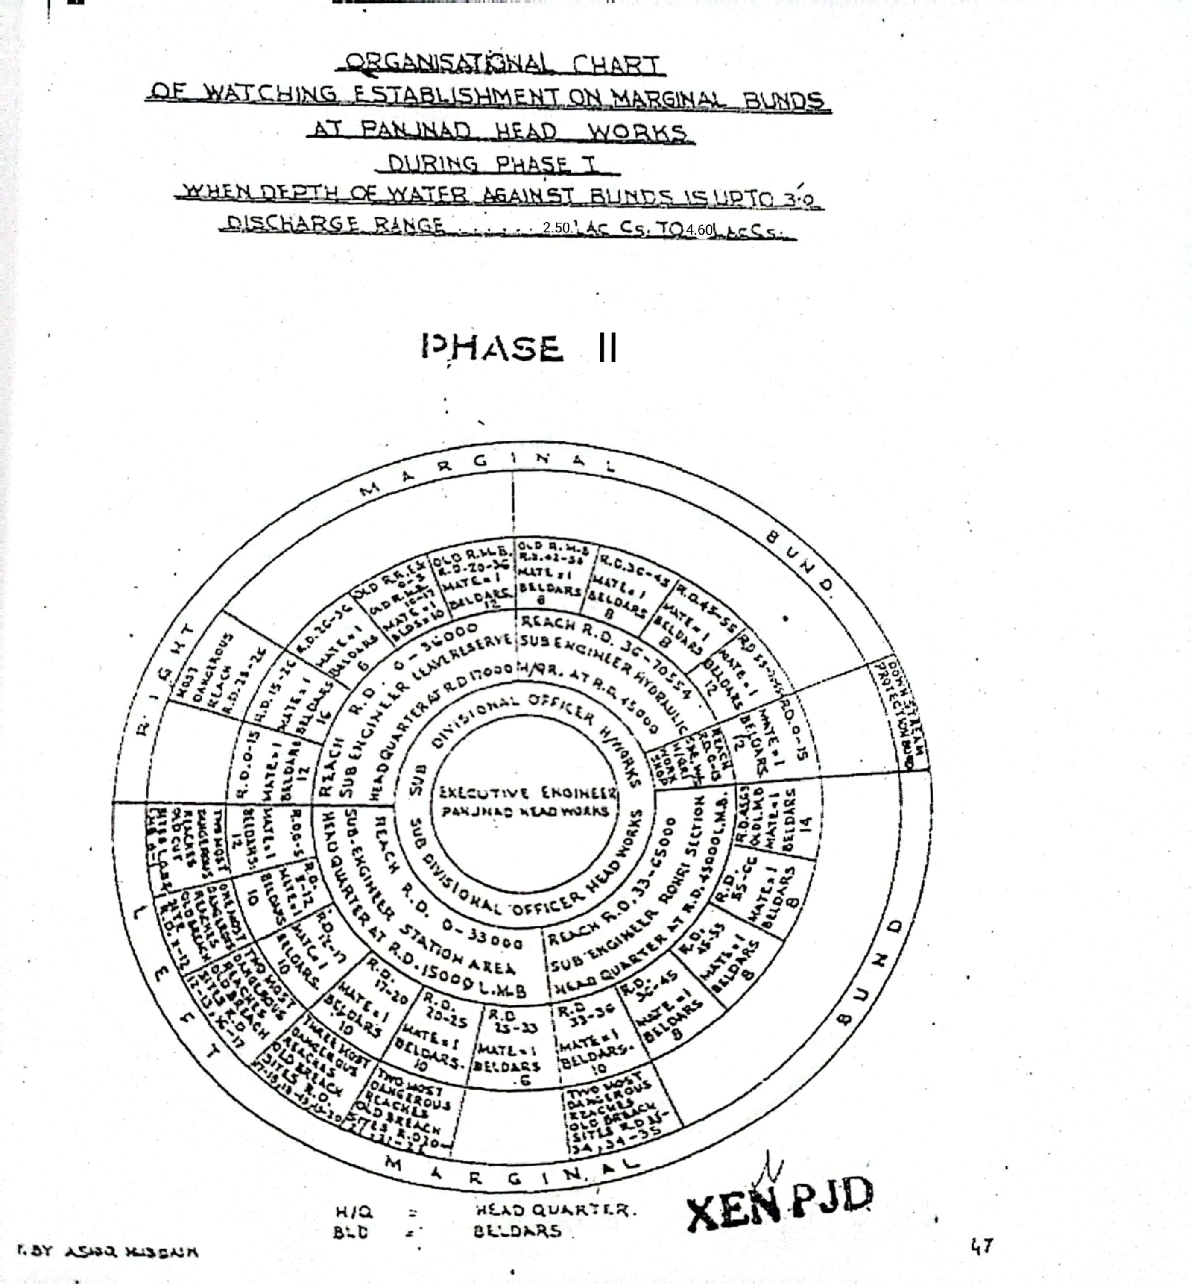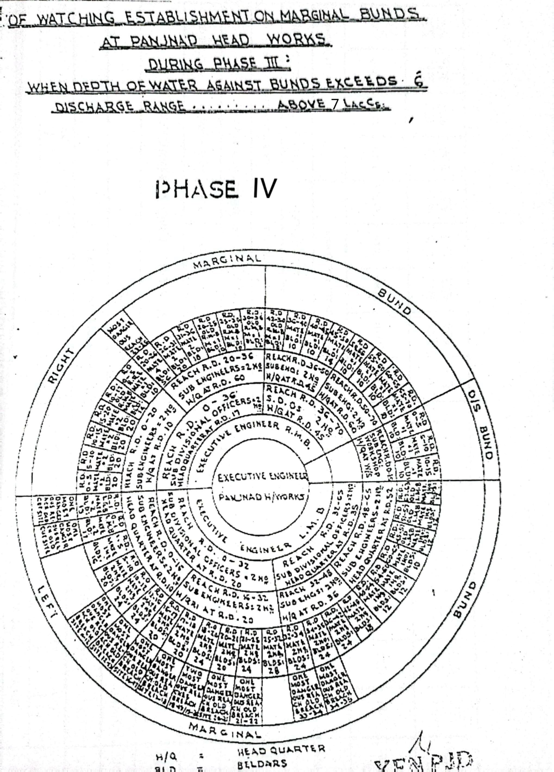

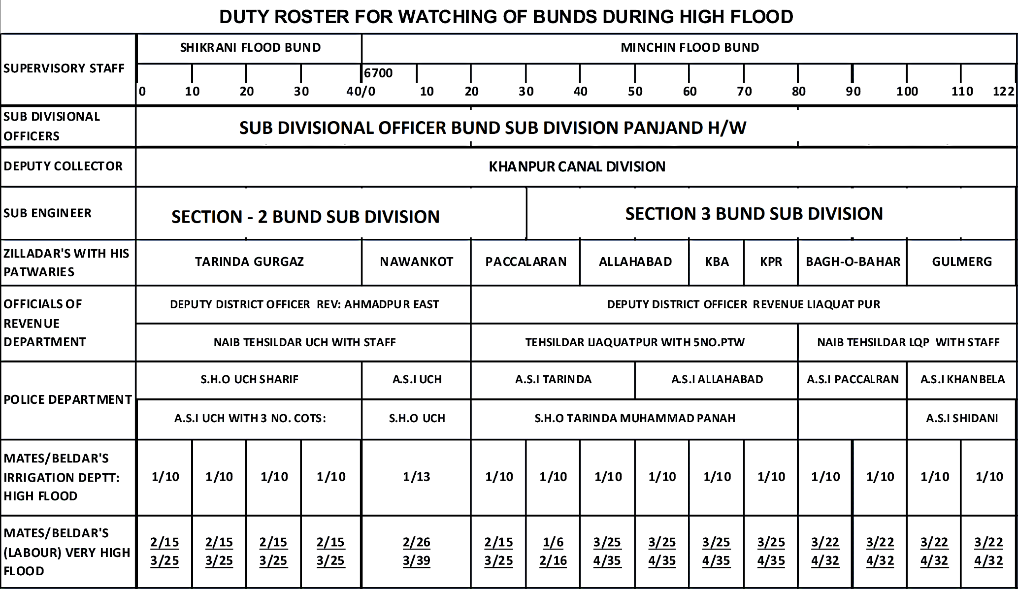

**CHAPTER 10**

**EMERGENCY TELEPHONE NOS.**

|  |  |  |  |
| --- | --- | --- | --- |
| **SR.No.** | **Designation.** | **Office** | **Residence.** |
| **1.** | Secretary I&P Deptt: Lahore. | 042-99212117 042-99212118 | 042-99200228 |
| **2.** | Chief Engineer Drainage & flood Zone  I&P Deptt: Lahore. | 042-99230602  Fax #  042-99230731 | - |
| **3.** | Director Flood / Secretary  Punjab Flood Commission Lahore. | 042-99231614 | - |
| **4.** | Chief Engineer, Irrigation, Bahawalpur. | 062-9250333 | 062-9250333 |
| **5.** | Superintending Engineer, Panjnad Canal Circle Panjnad | 0300-7246895 | 0300-7246895 |
| **6.** | Flood Emergency Officer, Bahawalpur (XEN Operation). | 062-9250265 | 062-9250275 |
| **7.** | Executive Engineer, Panjnad Headworks Division, Panjnad. | 03006702694/  03008595495 | - |
| **8.** | Deputy Commissioner, Bahawalpur. | 062-9250061 062-9260063, 062- 9250492 | 062-9250062 |
| Deputy Commissioner, Rahimyar Khan | 068-9230266 | 068-9230287 |
| **9.** | Commissioner,  Dera Ghazi Khan. | 064-9260340 | 064-9260341 |
| **10.** | Deputy Commissioner, Muzaffargarh. | 066-9200251  066-9200252  066-9250254 | - |
| **11.** | Superintendent of Police, Muzaffargarh. | 066-9200311 | - |
| **12.** | S.H.O. Police Sadar, Alipur. | 066-2700639 | - |
| **13.** | Flood warning Centre Lahore. | 042-997572091 0429-97572093 | Fax:  042-997572092 |

**CHAPTER 11**

**STANDARD OPERATING PROCEDURES (SOP) FOR BREACHING SECTIONS**

In order to ensure timely flood fighting and relief measures / activities Irrigation Department and other agencies as Civil Administration, Police, Army, etc, strictly adhere to their functions delineated in the SOP, which explicitly indicates the roles and responsibilities of each functionary of the concerned Department.

**RESPONSIBILITIES OF EXECUTIVE ENGINEER, PANJNAD HEADWORKS DIVISION.**

The Flood Protection arrangements at Flood Bunds/ infrastructure of Panjnad Headworks fall under the administrative jurisdiction of Executive Engineer, Panjnad Headworks Division, Sub Divisional Officer, Panjnad Headworks Sub Division and Sub Divisional Officer, Bund Sub Division Panjnad Headworks. Primarily, it is their responsibility to maintain and supervise the all Flood Infrastructure during Flood. However, the following will also be taken in to account as Standard Operating Procedures.

1. Periodic Review of structural integrity of Flood Protection Infrastructures on Panjnad Headworks, in order to ensure that no breach occurs in the event heavy discharge of water. It will be expected that being In-charge of the Flood Bund, Executive Engineer may share his observations with his supervisory officers for necessary action to be taken in case of any emergency.

2. Identification of vulnerable points on protective embankments (Bunds) where breach could occur and specification of location for positioning of requisite machinery / material near the vulnerable points.

3. Maintenance and repair of protective bunds / embankments, well before commencement of flood season.

4. Joint Inspection of flood protection infrastructure with the Army and Administration Authorities well before the flood season.

5. Collection and sharing of information on discharge of water at Panjnad Headworks on daily basis.

6. Improvement of existing instruments / gauges used for determination of water discharge at Panjnad Headworks.

7. Development of more affective Early Warning Station.

8. Liaison with IRSA Authorities, Ministry Water and Power as well as Flood Forecasting Lahore for collection of flood related information.

9. Briefing of Authorities concerned on flood protection arrangements and development of an integrated strategy, to be able to combat any situation during floods.

10. Stockpiling of essential articles to combat any flood related contingency and arrangement of sufficient funds before and for such purposes.

11. Arrangement of labour along with machinery / equipment for proper maintenance of the vulnerable points, on flood protection arrangements.

12. Identification of points on roads or otherwise, where breaches / cuts are required to be made, to further facilitate discharge of water, in order to avert larger catastrophe.

13. Ascertainment of extent of damaged cost to the protection bunds and other installation, after flood water subsides.

14. Initiation of criminal proceeding against elements involved in willful breach in flood protection arrangements without consent of competent authority.

15. Assistance and coordination in emergency repairs in public services.

**11.1 HISTORY OF THE BREACHING SECTION**

The explosive store for breaching section was constructed at RD.16+500 on Right Marginal Bund upstream of the barrage during 1976 to safeguard Panjnad Headworks structure. The explosive store is abundant now a days. The explosive material is in the custody of the 22-Engineer Company at Bahawalpur. In 1973 and 1992 the breaching section was operated when the flood level exceeded the critical gauge at RD.15 LMB.**THE CRITICAL LEVEL OF THE GAUGE IS 349.25FEET**. Breaching section is operated by the committee as per Notification No.1806/59/Engr-1-RPA2W dated 27/11/2014.

**11.2 LOCATION, DESIGN, QUANTITY AND VARIETY OF THE EXPLOSIVE REQUIRED FOR DETONATION.**

The total quantity of explosive material with all accessories have been stored in Army ammunition stores at Bahawalpur Cant 90Kms apart from Panjnad Headworks. The explosive material is also stored in ammunition depot Bahawalpur in custody of Engineer Corps 31Bahawalpur. Upon requisition of XEN Panjnad, Engineering 31 Corps Bahawalpur is responsible to shift this all explosive material to site, of breaching section. PVC liner 4” dia with the length of 12ft and 9ft install with interval of 7ft. Three (03) lines 12ft long pipe fixed on top of bund and two (02) lines 9ft long pipe fixed on both side slopes.

**DETAIL OF EXPLOSIVE MATERIAL FOR THE BREACHING SECTIONS**

Due to enhanced capacity of Panjnad Barrage from 7.0 Lac cusecs to 8.65 Lacs cusecs, the LMB and RMB of Panjnad barrage have been raised accordingly. The breaching site of RMB has been raised about 3.0 ft. Pak Army Engineering core Bahawalpur inspected the site during flood season 2023 and submitted estimate amounting to Rs.8671748/= regarding purchase of short Explosive material required to meet with the quantity required due to raising of RMB. The said payment has been made to the concerned quarter of Pak Army last year 2023.Therefore the total quantity rest with Pak Army Bahawalpur.

|  |  |  |  |  |  |  |
| --- | --- | --- | --- | --- | --- | --- |
| **Sr. No** | **Items** | **AU** | **Required Qty** | **Available Qty** | **Deficient Qty** | **Remarks** |
| 1 | PE3A (450 gm) | Kg | 2667.381 | 2667.381 | Nil | The condition of explosive material is asked to controlling agency  22-Engineering Corps Bahawalpur |
| 2 | PE3A (225 gm) | KG | 1199 | 1199 | Nil |
| 3 | Wabox cord | Mtr | 3563 | 3563 | Nil |
| 4 | Primer E1OZ | Nos | 997 | 997 | Nil |
| 5 | Safety Fuze No.11 | Mtr | 143 | 143 | Nil |
| 6 | Det elec Inst | Nos | 177 | 177 | Nil |
| 7 | Det Elec MS Delay | Nos | 614 | 614 | Nil |
| 8 | Wabox | Mtr | 5129 | 5129 | Nil |
| 9 | TwinJute | Kg | 3.6 | 3.6 | Nil |
| 10 | El Cable | Mtr | 1000 | 1000 | Nil |
| 11 | Blasting Machine | Nos | 01 | 01 | Nil |
| 12 | Det No.8 non-Elec | Now | 868 | 868 | Nil |

**11.3 ARRANGEMENT OF EXPLOSIVES AND SECURITY OF EXPLOSIVE STORES**

The explosive material is in the custody of PAK ARMY and they are responsible of the security of explosive material.

**11.4 LIST OF SECURITY STAFF ALONGWITH DETAIL OF THEIR TRAINING ETC.**

The liners at the breaching section site are fixed by skilled Irrigation Staff and on the alarming condition, the site is taken over by the PAK Army and they fill the explosive material for any emergency and will activate breaching section in case of emergency. Pak Army is responsible of the security of explosive material.

**11.5 DETAIL OF MECHANICAL MEANS AS A STANDBY ARRANGEMENTS IN CASE OF DETONATION FAILURE**

In case of failure of explosive material, two No. dozers and two No excavators (long boom) at each breaching section either from agriculture / irrigation Department or private source will remain available at site for breaching operation.

**11.6 DUTY ROSTER IN CASE OF CRITICAL SITUATION**

The detail of duty roster of officers / officials and establishment has been mentioned in Chapter No. 9

**11.7 BREACHING COMMITTEE WITH THEIR ACTION PLAN**

Breaching Operating committee consists of the following members vide Notification No.1806/59/Engr-1-RPA2W dated 27/11/2014amendedas per latest notification.

1. Deputy Commissioner concerned final authority to decide activation of breaching section.**(Convener)**
2. Executive Engineer, Barrages / Headworks / Flood Bund.**(Member)**
3. Representative of respective Army Corps not below Lt: Col. **(Member)**
4. Representative of Highway Department / Railway not below the   
   rank of BS-18.**(Member)**

**ACTION PLAN**

|  |  |  |  |  |
| --- | --- | --- | --- | --- |
| **S.#** | **Name of Infrastructure** | **Action to be taken** | **Action to be taken by** | |
| **1.** | Breaching section at RD 28-30 of R.M.B and at  RD 19-20 R.R.E. | Before the operation of breaching section 2 No. dozers are to be made available by the District Administration Muzaffargarh and explosive material is to be provided by the Army. Decision regarding operation of the Breaching Section is taken by the Vigilant / Breaching Operating Committee. | **1)** | When the information regarding expected high flood i.e. 3.0 Lac Cs. is received (72 Hrs. before the actual receipt of flood at Panjnad Headworks), the Vigilant / Breaching Operating Committee will meet and issue the 1st warning to all concerned Departments / Agencies will become alert, vigilant and remain in contact with the committee to receive the next warning at any moment. |
|  |  |  | **2)** | When the information regarding expected very high flood i.e. 4.5 Lac Cs. is received (72 Hrs. before the actual receipt of flood at Panjnad Headworks), the Vigilant / Breaching Operating Committee will again meet and issue the second warning to concerned Departments / Agencies to complete all the arrangements as laid down in the Contingency Plan to receive flood water consequent upon the operation of the breaching section. |
|  |  |  | **3)** | When the information regarding expected exceptionally High flood i.e. 5.0 Lac Cs. is received (72 Hrs. before the actual receipt of flood at Panjnad Headworks), the Committee will issue the final warning to all the concerned Departments / Agencies. This warning will warrant for making cuts in the K.L.P. Road, disconnecting 11-K.V. Distribution Power Line and evacuation of the expected in-undated area. The decision of the activation of the breaching section shall then be taken by the committee at any time and announced through available communication system. Time for operating the breaching section will also be communicated to all the concerned. |
| **2.** | K.L.P Road. | K.L.P Road Panjnad Alipur Section will be cut at two places at K.M. 3.0 and 6.25 from Panjnad Headworks to drain-out the flood water coming from the Breaching Section back into the River Chenab. 2 No. dozers will be provided by the District Administration. | Executive Engineer Highway, Muzaffargarh. | |
| **3.** | 11-K.V.  Distribution Power Line. | After issue of the final warning by the Committee, MEPCO authorities will immediately disconnect the supply of 11-K.V. Distribution Line to safe any mishap in the in-undated area. | Executive Engineer Distribution Division, MEPCO Alipur / Bahawalpur. | |

**11.8 LIST OF THE VILLAGES LIKELY TO BE INUNDATED IN CASE OF BREACH**

The following villages / public property can be affected due to activation of Breaching Section RD. 28-30 RMB of Panjnad Headworks in extreme emergency. DC Muzaffargarh shall ensure clearance of water way during operation of the breaching section.

|  |  |  |  |  |  |
| --- | --- | --- | --- | --- | --- |
| **Sr. No.** | **Villages** | **Houses** | | **Population** | |
| **1.** | Darkhan | 8 | Nos. | 30 | Nos. |
| **2.** | Ghajan | 35 | Nos. | 200 | Nos. |
| **3.** | Jalbani | 35 | Nos. | 175 | Nos. |
| **4.** | Jattuwala | 40 | Nos. | 250 | Nos. |
| **5.** | Arain | 6 | Nos. | 50 | Nos. |
| **6.** | Chandie | 11 | Nos. | 75 | Nos. |
| **7.** | Pauli | 20 | Nos. | 140 | Nos. |
| **8.** | Mochi and Nai | 11 | Nos. | 50 | Nos. |
| **9.** | Baluch | 28 | Nos. | 300 | Nos. |
| **10.** | Lashari Baluch | 17 | Nos. | 250 | Nos. |
| **11.** | Moger | 10 | Nos. | 70 | Nos. |
| **12.** | Chandie | 8 | Nos. | 66 | Nos. |
| **13.** | Lashari | 15 | Nos. | 150 | Nos. |
| **14.** | Baluch | 20 | Nos. | 120 | Nos. |
| **15.** | Oalak | 10 | Nos. | 70 | Nos. |
| **16.** | Gazer | 8 | Nos. | 60 | Nos. |
| **17.** | Makwal | 25 | Nos. | 400 | Nos. |
| **18.** | Rongha | 45 | Nos. | 400 | Nos. |
| **19.** | Shah | 10 | Nos. | 60 | Nos. |
| **20.** | Mahesar | 12 | Nos. | 70 | Nos. |
| **21.** | Gopang | 70 | Nos. | 600 | Nos. |
| **22.** | Larr | 50 | Nos. | 430 | Nos. |
| **23.** | Ghallu | 35 | Nos. | 400 | Nos. |
| **24.** | Bobore | 30 | Nos. | 180 | Nos. |
| **25.** | Muhajir | 8 | Nos. | 48 | Nos. |
| **26.** | Babbare | 40 | Nos. | 224 | Nos. |
| **27.** | Kakreji | 10 | Nos. | 60 | Nos. |
| **28.** | Chot | 10 | Nos. | 60 | Nos. |
| **29.** | Nag | 20 | Nos. | 120 | Nos. |
| **30.** | Johr | 20 | Nos. | 120 | Nos. |
| **31.** | Billimar | 40 | Nos. | 160 | Nos. |
| **32.** | Chajan | 25 | Nos. | 100 | Nos. |
| **33.** | Ronghe | 25 | Nos. | 100 | Nos. |
| **34.** | Mohana | 20 | Nos. | 120 | Nos. |
| **35.** | Moochi | 15 | Nos. | 72 | Nos. |
| **Total:-** | | **766** | **Nos.** | **5636** | **Nos.** |

**11.9 ANNOUNCEMENT AND DETAIL OF EVACUATION ARRANGEMENTS**

Civil authorities will make the announcement of flood hazard and plan to evacuate the area with help of its lower formation and Civil Defense Department.

**11.10 DETAILS OF COORDINATION WITH CIVIL / ARMY AUTHORITIES**

When the flood warning received, Civil Administrations / Army authorities will coordinate for handling of any critical situation.

**11.11 PARALLEL COMMUNICATION ARRANGEMENTS**

Wireless station at Panjnad Headworks is out of order since 10 years and not connected with Flood Warning Center at Lahore and barrages on the rivers upstream of Panjnad Headworks. Flood warnings are received through the mobile phones. However, Executive Engineer & Sub Divisional Officer Panjnad Headworks and Sub Divisional Officer, Bund Sub Division Panjnad Headworks will be facilitated with wireless mounted on Jeep supplied by the Police Headquarters and District Civil Administration Muzaffargarh, Bahawalpur & Rahimyar Khan.

**FLOOD CONTROL CENTERS**

This center will be opened at Headworks. One Head Signaler will be in-charge of this center. He will work under the supervision of Executive Engineer, Headworks. Copy of daily flood situation report and other orders by the authorities will be available at flood control center, where it will be properly recorded. This center will also help the people coming from outside as they need information about flood etc.

**FLOOD WARNING SYSTEM**

|  |  |  |  |
| --- | --- | --- | --- |
| **Sr. No.** | **Name Flood Warning Centre** | **Center In-charge** | **Sources of Information** |
| **1** | Headworks | Syed Hassan Abbas Bukhari  Sub Divisional Officer  Panjnad Headworks  Cell # 0300-8595495 | Imran Rafi  Sub Engineer  Headworks Section.  Cell # 0300-4908438 |
| **2** | Mudwala | Sheikh Haseeb Ullah  Sub Divisional Officer  Bund Sub Division Panjnad  Cell # 03041416358 | Farhan Zahid  Sub Engineer  Hydaulics Section.  Cell # 0305-6684400 |
| **3** | Dhoor Kot | Syed Hassan Abbas Bukhari  Sub Divisional Officer  Panjnad Headworks  Cell # 0300-0115033 | Hamza Ali  Sub Engineer  Station Area Section.  Cell # 0300-6818101 |
| **4** | Tele Office Panjnad Headworks | Muhammad Ashraf  Head Signaler Tele Office Panjnad Headworks  Cell # 0300-4255671 | Divisional Flood Control Room |
| **5.** | Tele Office Bahawalpur | Masood Hashmi  Head Signaler  Telegraph Office Bahawalpur | Zonal Flood Control Room  062-9250273 |

**11.12 INDEX PLAN**

|  |  |  |
| --- | --- | --- |
|  |  |  |
| **2. RD 19-21 (Retired Right Embankmant)** |  | ***Head Project Director***  ***PMO-Punjab Barrages***  ***Lahore*** |

***Executive Engineer***

***Panjand Headworks Division***

***Panjnad***

**PART – BCHAPTER 12**

**VULNERABLE SITES ON FLOOD BUND / STRUCTURES**

**12.1 APPREHENDED BREACHES IN FLOOD BUNDS / STRUCTURES.**

1. RD. 32-45 RMB of Panjnad Headworks.
2. RD. 11-34 LMB of Panjnad Headworks.
3. RD. 37-38 of Shikrani Flood Bund.
4. RD. 90-100 of Minchin Flood Bund.

**12.2 OPERATION OF BREACHING SECTIONS.**

On the alarming by the flood warning center Lahore the Executive Engineer Panjnad Headworks will arrange the meeting of breaching committee notified by the Govt. No. 1806/59/Engr:IRPA-2w dated 27/11/2014 and in the case of necessity the matter is handed over to PAK Army who is already responsible for explosive material for breaching section. The breaching section operation will depend upon the peak flow at Trimmu where the time log is 50 hours in exceptionally high flood.

Critical Gauge level at LMB RD 15 = 349.25 Ft.

**12.3 BREACHES DUE TO RISING OF FLOOD WATER, DETERORATION OF FLOOD BUNDS ETC.**

In the history of Panjnad Headworks due to rising of flood water the LMB was breached in 1973. Rehabilitation and upgrading of Panjnad Headworks project has been carried out by Punjab Irrigation Department through PMO for Punjab Barrages Lahore to enhance capacity of the barrage from 7.0 Lac cusecs to 8.65 Lac cusecs. Accordingly, to improve flood infrastructures as per new flood limit criteria, the Left and Right Guide Banks of Panjnad Barrage were rehabilitated in the project while the Left and Right Marginal Bunds i.e. LMB & RMB were remodeled under Disaster and Climate Resilience Improvement Project (DCRIP) by Project Implementation Unit (PIU) of Irrigation Department during the year 2020. The wetting channel along the LMB and RMB are soaked annually to check the any borrowing hole. However, in case of the exceptionally high flood, Machinery & labour will be arranged on daily basis as per approved yard stick in flood fighting plan.

**CHAPTER 13**

**EMERGENCY CONTINGENCY PLAN FOR VULNERABLE SITE (SITES) LISTED ABOVE.**

**VULNERABLE SITE – 1- RD: 32-45 R.M.B RIVER CHENAB**

**13.1 PLAN SHOWING ROUTE OF FLOOD WATER COMING OUT OF THE BREACH SUPPORTED WITH LEVELS AT RD. 32-45 OF RMB PANJNAD HEADWORKS**

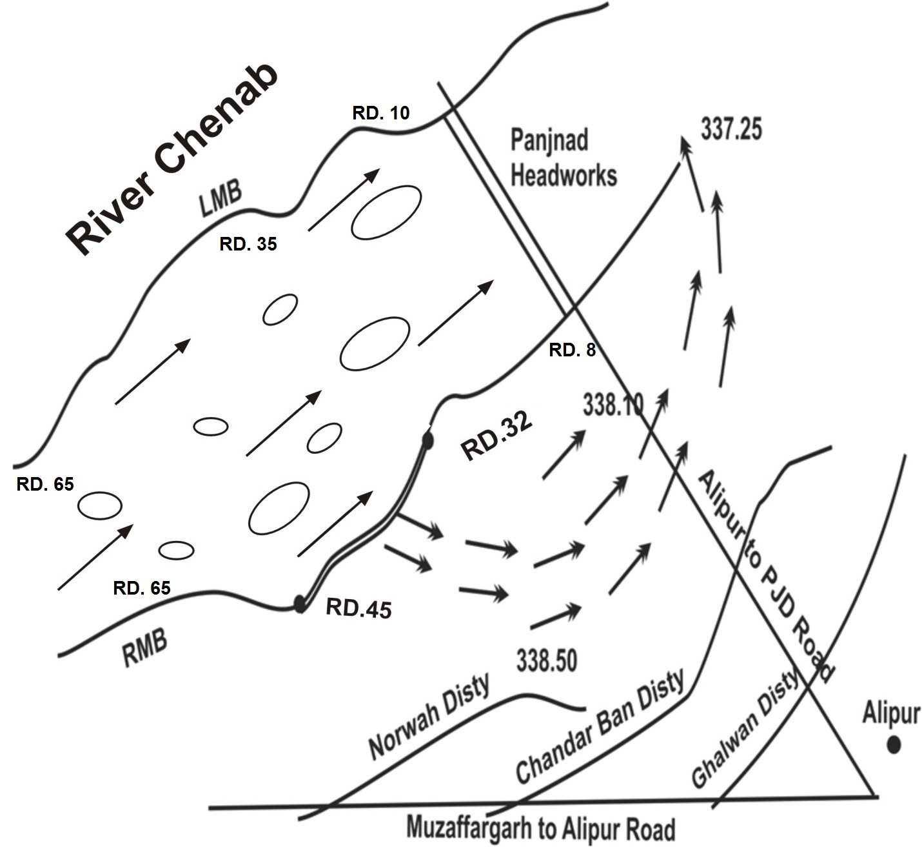

**13.2 DETAIL OF VILLAGES /ABADIES LIKELY TO BE AFFECTED AND THIS SHOULDALSO BE SHOWN ON THE PLAN**.

**32**

**LIST OF VILLAGES LIKELY TO BE INUNDATED IN CASE OF BREACHES**

The following villages / public property can be affected if breach occurs between RD. 32-45 of RMB of Panjnad Headworks.

|  |  |  |  |
| --- | --- | --- | --- |
| **Sr. No.** | **Villages** | **Houses 3%**  **(Nos.)** | **Population 5%**  **(Nos.)** |
|  | Basti Madwala | 240 | 16800 |
|  | Basti Mahser | 103 | 850 |
|  | Basti Ubaichar | 31 | 230 |
|  | Basti Dumber | 154 | 9500 |
|  | Basti Dino | 47 | 2200 |
|  | Darkhan | 8 | 350 |
|  | Ghajan | 36 | 2200 |
|  | Jalbani | 36 | 1850 |
|  | Jattuwala | 42 | 2700 |
|  | Arain | 6 | 550 |
|  | Chandie | 11 | 850 |
|  | Pauli | 21 | 1500 |
|  | Mochi and Nai | 9 | 500 |
|  | Baluch | 29 | 3300 |
|  | Lashari Baluch | 17 | 2600 |
|  | Doger | 8 | 650 |
|  | Chandie | 8 | 660 |
|  | Lashari | 16 | 1600 |
|  | Baluch | 21 | 1300 |
|  | Oalak | 21 | 250 |
|  | Gazer | 21 | 250 |
|  | Makwal | 26 | 500 |
|  | Rongha | 47 | 520 |
|  | Shah | 15 | 80 |
|  | Mehesar | 15 | 80 |
|  | Gopang | 73 | 650 |
|  | Laar | 52 | 500 |
|  | Ghallu | 36 | 450 |
|  | Bobrey | 31 | 220 |
|  | Muhajir | 10 | 60 |
|  | Babbar | 42 | 300 |
|  | Kakreji | 15 | 100 |
|  | Chot | 15 | 100 |
|  | Nag | 21 | 150 |
|  | Johr | 21 | 150 |
|  | Billimar | 42 | 200 |
|  | Chajan | 26 | 150 |
|  | Ronghe | 26 | 150 |
|  | Mohana | 21 | 150 |
|  | Mochi | 10 | 100 |
| **Total:-** | | **1435** | **71950** |

**Location Plan of Villages**

**RD.32**

**RD.45**

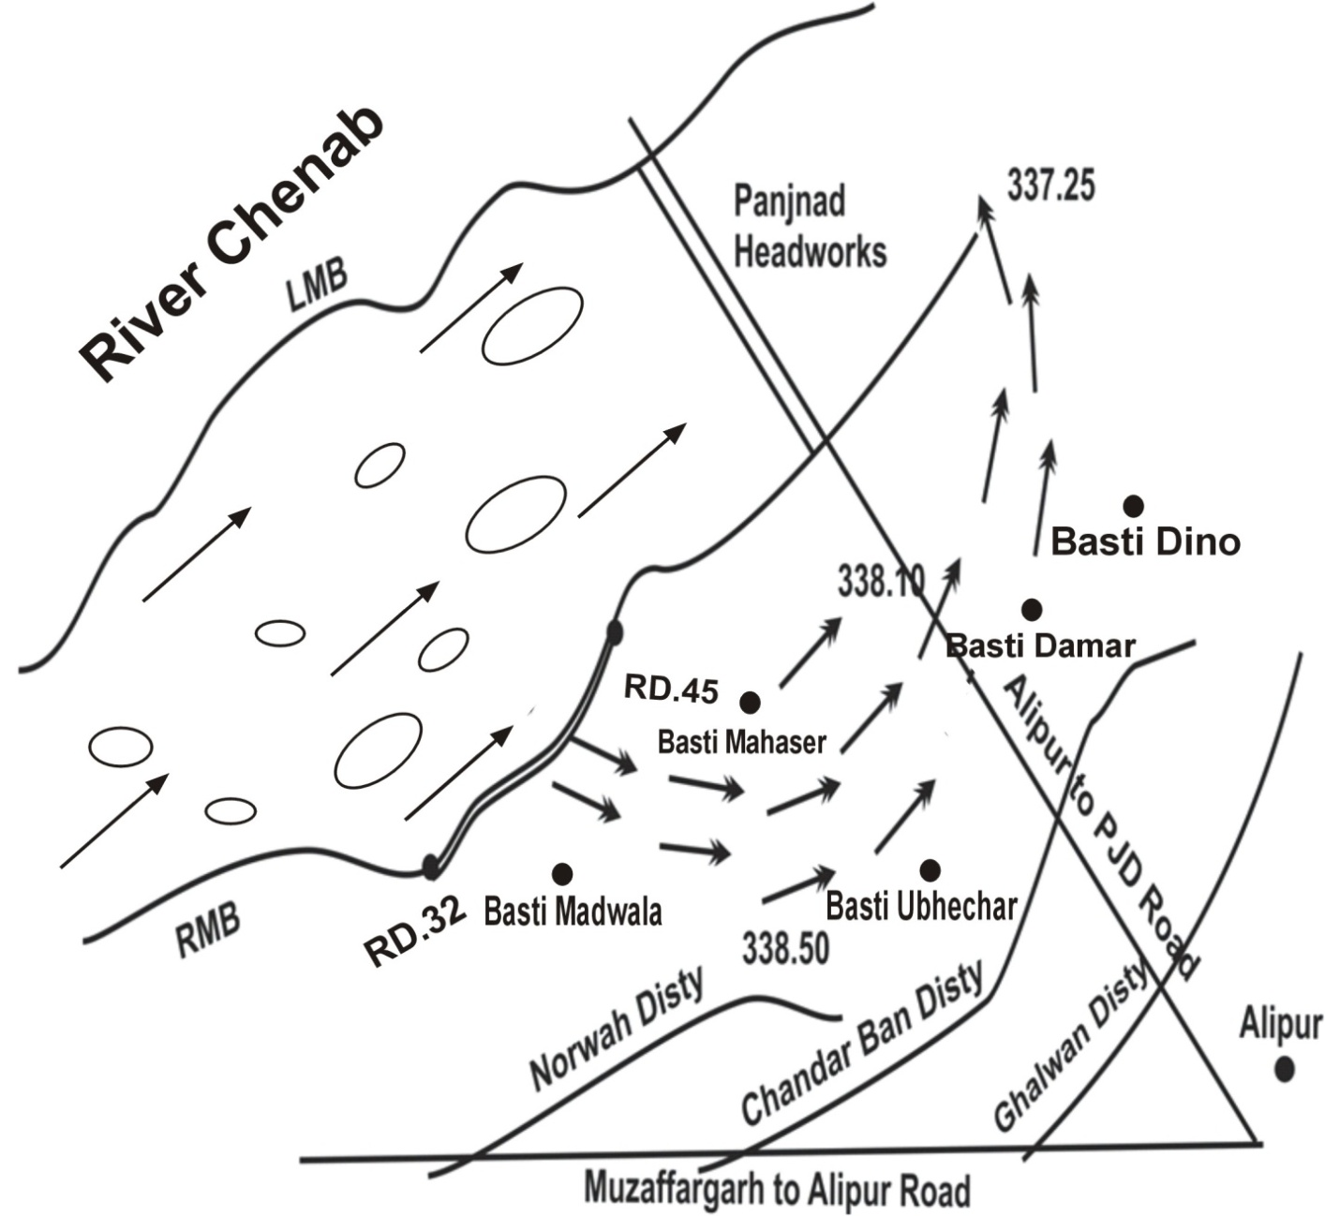

**13.3 STRATEGY AND ACTION TAKEN BE EXPLAINED IN DETAIL. THIS MAY INCLUDE**

**13.3.1 ARRANGEMENTS**

Guny bags, Plastic sheets, baskets, Belchas & machinery are available to control the breach / vulnerable site.

**13.3.2 ESTABLISHMENT OF FLOOD FIGHTING CAMPS**

**Started at low flood**

Flood Fighting Camps at vulnerable site Panjnad Headworks will be established for watching round the clock as mentioned in Ch# 5 Page# 25

**13.3.3 DUTIES OF OFFICERS / OFFICIALS AND THEIR CAMP SITES**

|  |  |  |  |  |
| --- | --- | --- | --- | --- |
| **Sr. No.** | **Name of camp** | **Camp Supervisor** | **Camp In-charge** | **Overall In-charge** |
| 1 | RD. 34 RMB | Imran Rafi  Sub Engineer  Headworks Section.  Cell # 0300-4908438 | Syed Hassan Abbas Bukhari  Sub Divisional Officer  Panjnad Headworks  Cell # 0300-8595495 | Faisal Nadeem  Executive Engineer  Panjnad Headworks Division Panjnad  Cell # 0333-7483658 |
| 2 | RD. 35 RMB |
| 3 | RD. 42 RMB | Farhan Zahid  Sub Engineer  Hydraulic Section.  Cell # 0305-6684400 |
| 4 | RD. 43 RMB |
|  | RD: 37-38 of Shikrani Flood Bund (Mouza Sadiqabad) | Hamza Ali  Sub Engineer  Station Area Section.  Cell # 0300-6818101 | Sheikh Haseeb Ullah  Sub Divisional Officer  Bund Sub Division Panjnad  Cell# 0304-1416358 |
|  | RD: 114-115 of Minchin Flood Bund (Unnaran) | Umar Farooq  Sub Engineer  Cell # 0304-3129799  Section-2&3 |

**13.3.4 DEPARTMENTAL MACHINERY AVAILABLE**

Tractor with trolley = 2 No

**13.3.5 Machinery available from private sources**

Nearest cities are Alipur and Uch-sharif. Heavy machinery is available from contractors of Irrigation Department and from private personals. Which will be procured as and when desired under the Government policy.

**13.3.6 FLOOD FIGHTING MATERIAL REQUIRED**

**13.3.7 FLOOD FIGHTING MATERIAL AVAILABLE**

|  |  |  |  |  |  |
| --- | --- | --- | --- | --- | --- |
| **Sr.No** | **Items** | **Quantity Required** | **Quantity Available** | **Balance** | **Remarks** |
| **1** | Lanterns | 500 Nos. | 400 Nos. | 100 Nos. | Balance Quantity be procured before flood season on availability of funds by administrative department.  Balance Quantity be procured before flood season on availability of funds by administrative department.  Balance Quantity be procured before flood season on availability of funds by administrative department. |
| **2** | Wicks | 500 yards | 500 Yards | 0 Yards |
| **3** | Lantern Chimneys | 1000 Nos. | 35 Nos. | 765 Nos. |
| **4** | Gas lamp | 150 Nos. | 150 Nos. | 0 Nos. |
| **5** | Mentals | 100 Nos. | 92 Nos. | 8 Nos. |
| **6** | Washers for gas lamp. | 300 Nos. | 50 Nos. | 250 Nos. |
| **7** | Nozzles for gas lamp. | 300 Nos. | 40 Nos. | 260 Nos. |
| **8** | Gunney bags | 1000 Nos. | 18 Nos. | 982 Nos. |
| **9** | Suttli | 610 Lbs. | 610 Lbs. | 0Lbs. |
| **10** | E.C. Bags/Jute Bags | 2700 Nos. | 2500 Nos. | 200 |
| **11** | Sewing needles | 10 Doz. | 10 Doz. | 0 Doz. |
| **12** | Axes | 30 Nos. | 10 Nos. | 20 Nos. |
| **13** | Kassies with Handles | 1000 Nos. | 900 Nos. | 100 Nos. |
| **14** | Killas | 2400 Nos. | 100 Nos. | 2300Nos. |
| **15** | Ballies | 100 Nos. | 40 Nos. | 60 Nos. |
| **16** | Baskets | 5000 Nos. | 3000Nos. | 2000 Nos. |
| **17** | Khaji Mats | 1100 Nos. | 1000 Nos. | 100 Nos. |
| **18** | Munj Ban | 1600Mds. | 1500Mds. | 100Mds. |
| **19** | Wooden mallets | 170 Nos: | 25 Nos: | 145 Nos. |
| **20** | Funnels | 50 Nos. | 30 Nos. | 20 Nos. |
| **21** | Trangers | 2500 Nos. | 2500 Nos. | 0 Nos. |
| **22** | Tents | 5 Nos. | 5 Nos. | 0 Nos. |
| **23** | Bamboos | 500 Nos. | 320 | 180 Nos. |
| **24** | Hand Pumps | 5 Nos | 04 | 1 Nos. |
| **25** | Peter Pumps with Accessories | 6Nos. | 6 Nos. | 0 Nos. |
| **26** | Emergency Lights | 5nos | 2 No | 3 Nos. |
| **27** | Portable Generator Set | 4 Nos | 2 Nos. | 2 Nos. |
| **28** | Generator 10-20 kv | 4Nos | 0 | 4 Nos. |
| **29** | Swiss Cottage | 3nos | 03 No. | 0 |
| **30** | Plastic Table Chair Set | 5 Nos | 0 | 5 Nos |
| **31** | Glass Set | 05 Nos | 0 | 05 Nos |
| **32** | Cutlary Set Complete in all respect (incl. pots/kettles/plates/spoons/glass/jugs/hotpots/knives/etc. | 3 Nos | 0 | 3 Nos |
| **33** | Water Cooler Set | 5 Nos | 0 | 5 Nos |
| **34** | Pedestal Fans | 2 Nos | 0 | 2 Nos |
| **35** | Charpai | 5 Nos | 0 | 05 Nos |
| **36** | Tapai | 30 Nos. | 0 | 30 Nos. |
| **37** | Briefing Boards with Stick | 2 Nos | 02 No. | 0 |
| **38** | Jacket and Caps for Establishment | 150 Nos | 0 | 150 Nos |
| **39** | POL for Generators | 1000 Ltrs | 0 | 1000 Ltrs |
| **40** | Killas 6'-8' | 100 Nos | 0 | 100 Nos |
| **41** | Peg 4.5' | 100 nos | 0 | 100 nos |
| **42** | Hand Saw | 13 Nos | 0 | 13 Nos |
| **43** | Steel Wire Rope 1/8" dia | 1000 RFT | 150 | 850 RFT |
| **44** | Karries (2.5" X 3" X 6') | 170 Nos. | 0 | 170 Nos. |
| **45** | Ballies (4" X 6" X 8') | 170 Nos. | 0 | 170 Nos. |

**13.4 DETAIL OF OTHER INFRASTRUCTURE LIKE ELECTRIC, SUI GAS, TELEPHONE INSTALLATIONS, ROAD NETWORK, OTHER BUILDINGS, CANALS AND DRAINAGE NETWORKS.**

* **ROADS / INFRASTRUCTURES LIKELY TO BE AFFECTED IN CASE OF BREACHES**

1. Noorwah Disty (Muzaffargarh Canal Division)
2. Chandarban Disty (Muzaffargarh Canal Division)
3. Ghalwan Disty (Muzaffargarh Canal Division)
4. Pacca Road from Muzaffargarh to Alipur
5. Pacca Road from Alipur to Panjnad

* **SCHOOLS / COLLEGES / OTHER EDUCATIONAL INSTITUTIONS**

1. Government High School Changan

2. Government High School Mudwala

3. Government Primary School Ubaicharr

4. Government Primary School Nazroowali Hatti

5. Government Primary School Masser

* **OTHER BUILDING ETC.**

1. RHC Mudwala
2. Veterinary Hospital Mudwala
3. BHU Changan
4. Veterinary Hospital Changan
5. Veterinary Hospital Nazroowali Hatti
6. Electric Pools 11KVA
7. Communication Towers
8. 66000 highly transmission

**VULNERABLE SITE – 2 – RD: 11-34 L.M.B RIVER SUTLEJ**

**13.1 PLAN SHOWING ROUTE OF FLOOD WATER COMING OUT OF THE BREACH SUPPORTED WITH LEVELS AT RD. 11-34 OF LMB PANJNAD HEADWORKS**

In August 1973, a highest ever recorded flood of 802516 Cfs was experienced due to combined high flood conditions in all rivers i.e the River Chenab and Sutlej. It caused breaches in the left marginal bunds at various locations between RD. 11-34 of LMB which was the main reason for immense losses to human life and property, irrigation system, roads and railways. To save the important city of Khanpur, Rahimyarkhan, cuts were made in the main railway line, Sadiq Branch and other distributaries to spread the flood water in comparatively less developed areas. The flood water damaged the entire D/S floor of Abbasia Canal regulator, the divide wall and bays No. 9 to 12 of Panjnad Canal Head Regulator due to the swirling action of backflow. Above mentioned situation was created only during 1973.

**Location-Plan**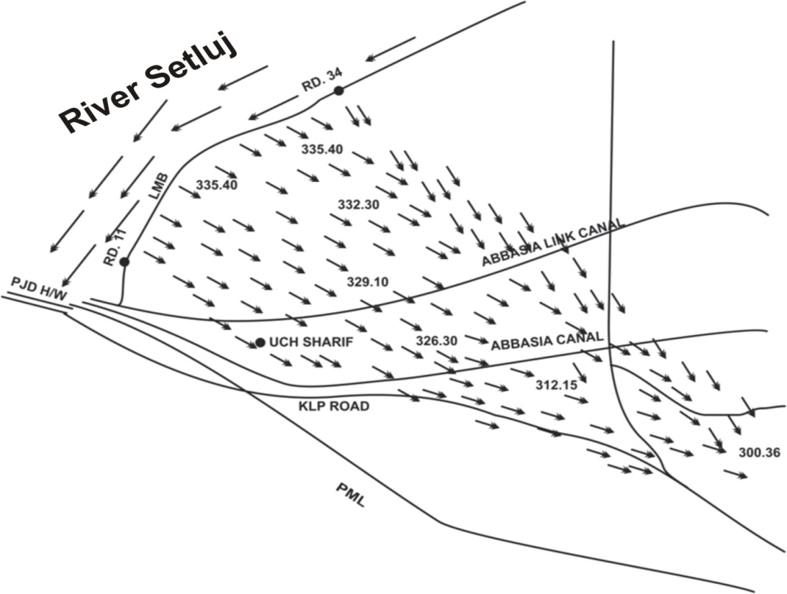

**13.2 DETAIL OF VILLAGES / ABADIES LIKELY TO BE AFFECTED AND THIS SHOULD ALSO BE SHOWN ON THE PLAN**.

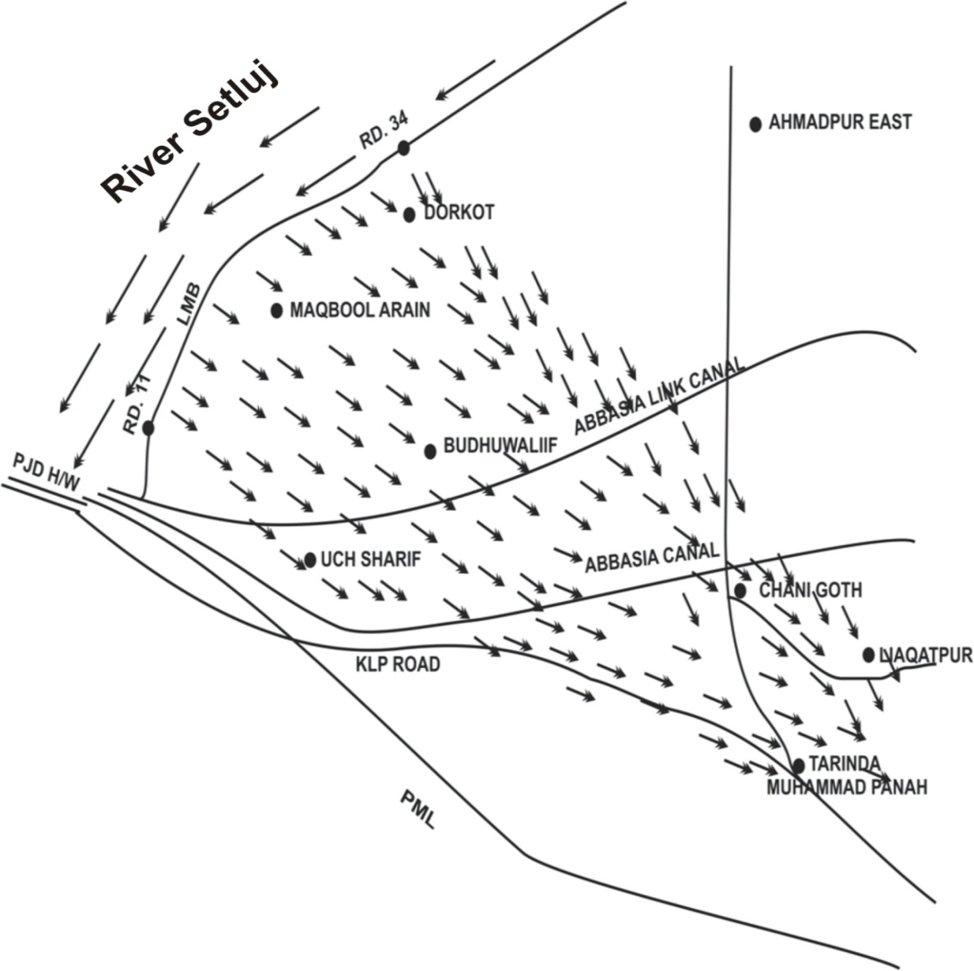

**13.3 STRATEGY AND ACTION TAKEN BE EXPLAINED IN DETAIL. THIS MAY INCLUDE**

**13.3.1 ARRANGEMENTS**

Gunny bags, Plastic sheets, baskets, Belches& machinery are available to control the breach / vulnerable site.

**13.3.2 ESTABLISHMENT OF FLOOD FIGHTING CAMPS**

Flood Fighting Camps at vulnerable site i.e. RD. 11-34 of LMB Panjnad Headworks will be established for watching round the clock.

**13.3.3 DUTIES OF OFFICERS / OFFICIALS AND THEIR CAMP SITES**

|  |  |  |  |  |
| --- | --- | --- | --- | --- |
| **Sr. No.** | **Name of camp** | **Camp Supervisor** | **Camp In-charge** | **Overall In-charge** |
| 1 | RD. 11 | Hamza Ali  Sub Engineer  Station Area Section.  Cell # 0300-6818101 | Syed Hassan Abbas Bukhari  Sub Divisional Officer  Panjnad Headworks  Cell # 0300-8595495 | Faisal Nadeem  Executive Engineer  Panjnad Headworks Division Panjnad  Cell # 0333-7483658 |
| 2 | RD. 18 |
| 3 | RD. 25 | Hamza Ali  Sub Engineer  Station Area Section.  Cell # 0300-6818101 |
| 4 | RD. 34 |

**13.3.4 DEPARTMENTAL MACHINERY AVAILABLE**

Tractor with trolley = 2 No

1**3.3.5 MACHINERY AVAILABLE FROM PRIVATE SOURCE**

Nearest cities are Alipur and Uch-sharif private machineries are available to handle any critical situation as well as heavy machinery of contractor of the project.

**13.3.6 FLOOD FIGHTING MATERIAL REQUIRED (Side No. 2)**

**13.3.7 FLOOD FIGHTING MATERIAL REQUIRED (Side No. 3)**

|  |  |  |  |  |  |
| --- | --- | --- | --- | --- | --- |
| **Sr.No** | **Items** | **Quantity Required** | **Quantity Available** | **Balance** | **Remarks** |
| **1** | Lanterns | 500 Nos. | 400 Nos. | 100 Nos. | Balance Quantity be procured before flood season on availability of funds by administrative department.  Balance Quantity be procured before flood season on availability of funds by administrative department.  . |
| **2** | Wicks | 500 yards | 500 Yards | 0 Yards |
| **3** | Lantern Chimneys | 1000 Nos. | 35 Nos. | 765 Nos. |
| **4** | Gas lamp | 150 Nos. | 150 Nos. | 0 Nos. |
| **5** | Mentals | 100 Nos. | 92 Nos. | 8 Nos. |
| **6** | Washers for gas lamp. | 300 Nos. | 50 Nos. | 250 Nos. |
| **7** | Nozzles for gas lamp. | 300 Nos. | 40 Nos. | 260 Nos. |
| **8** | Gunney bags | 1000 Nos. | 18 Nos. | 982 Nos. |
| **9** | Suttli | 610 Lbs. | 610 Lbs. | 0Lbs. |
| **10** | E.C. Bags/Jute Bags | 2700 Nos. | 2500 Nos. | 200 |
| **11** | Sewing needles | 10 Doz. | 10 Doz. | 0 Doz. |
| **12** | Axes | 30 Nos. | 10 Nos. | 20 Nos. |
| **13** | Kassies with Handles | 1000 Nos. | 900 Nos. | 100 Nos. |
| **14** | Killas | 2400 Nos. | 100 Nos. | 2300Nos. |
| **15** | Ballies | 100 Nos. | 40 Nos. | 60 Nos. |
| **16** | Baskets | 5000 Nos. | 3000Nos. | 2000 Nos. |
| **17** | Khaji Mats | 1100 Nos. | 1000 Nos. | 100 Nos. |
| **18** | Munj Ban | 1600Mds. | 1500Mds. | 100 Mds. |
| **19** | Wooden mallets | 170 Nos: | 25 Nos: | 145 Nos. |
| **20** | Funnels | 50 Nos. | 30 Nos. | 20 Nos. |
| **21** | Trangers | 2500 Nos. | 2500 Nos. | 0 Nos. |
| **22** | Tents | 5 Nos. | 5 Nos. | 0 Nos. |
| **23** | Bamboos | 500 Nos. | 320 | 180 Nos. |
| **24** | Hand Pumps | 5 Nos | 04 | 1 Nos. |
| **25** | Peter Pumps with Accessories | 6Nos. | 6 Nos. | 0 Nos. |
| **26** | Emergency Lights | 5nos | 2 No | 3 Nos. |
| **27** | Portable Generator Set | 4 Nos | 2 Nos. | 2 Nos. |
| **28** | Generator 10-20 kv | 4Nos | 0 | 4 Nos. |
| **29** | Swiss Cottage | 3nos | 03 No. | 0 |
| **30** | Plastic Table Chair Set | 5 Nos | 0 | 5 Nos |
| **31** | Glass Set | 05 Nos | 0 | 05 Nos |
| **32** | Cutlary Set Complete in all respect (incl. pots/kettles/plates/spoons/glass/jugs/hotpots/knives/etc. | 3 Nos | 0 | 3 Nos |
| **33** | Water Cooler Set | 5 Nos | 0 | 5 Nos |
| **34** | Pedestal Fans | 2 Nos | 0 | 2 Nos |
| **35** | Charpai | 5 Nos | 0 | 05 Nos |
| **36** | Tapai | 30 Nos. | 0 | 30 Nos. |
| **37** | Briefing Boards with Stick | 2 Nos | 02 No. | 0 |
| **38** | Jacket and Caps for Establishment | 150 Nos | 0 | 150 Nos |
| **39** | POL for Generators | 1000 Ltrs | 0 | 1000 Ltrs |
| **40** | Killas 6'-8' | 100 Nos | 0 | 100 Nos |
| **41** | Peg 4.5' | 100 nos | 0 | 100 nos |
| **42** | Hand Saw | 13 Nos | 0 | 13 Nos |
| **43** | Steel Wire Rope 1/8" dia | 1000 RFT | 150 | 850 RFT |
| **44** | Karries (2.5" X 3" X 6') | 170 Nos. | 0 | 170 Nos. |
| **45** | Ballies (4" X 6" X 8') | 170 Nos. | 0 | 170 Nos. |

**VULNERABLE SITE – 3 – RD: 90-100 MINCHIN FB RIVER INDUS**

**13.1 PLAN SHOWING ROUTE OF FLOOD WATER COMING OUT OF THE BREACH SUPPORTED WITH LEVELS.**

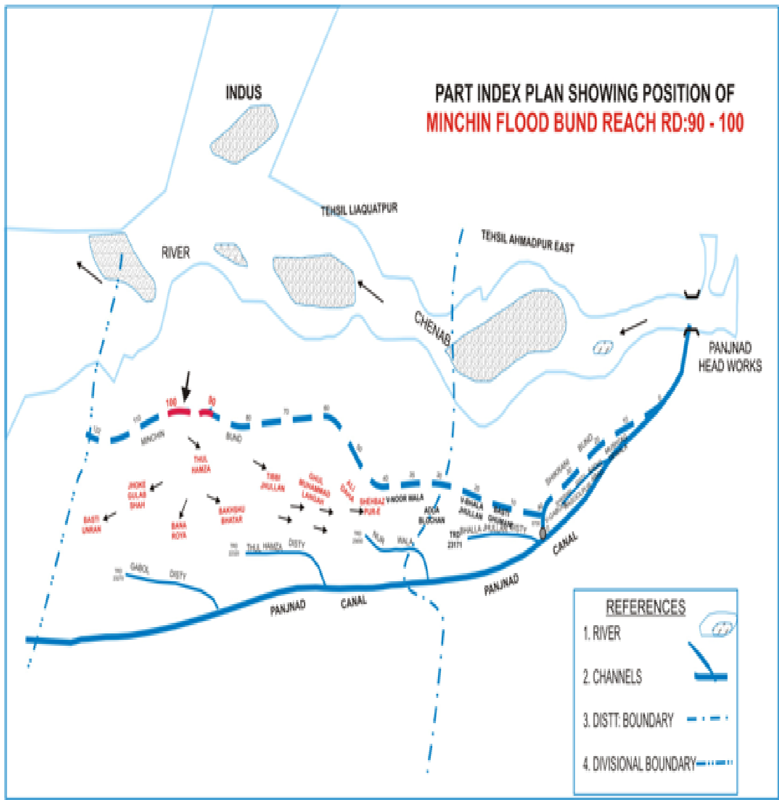

**13.2 DETAIL OF VILLAGES ABADIES LIKELY TO BE AFFECTED AND THIS SHOULD ALSO BE SHOWN ON THE PLAN.**

Detail has been given as,

**Detail of Basti/ Village Detail of infrastructure R.L.S**

Noor Wala 327.30

Adda Blochan 325.20

Ali Daha 320.20

Ghul Muhammad Langah 322.20

Tibi Jhulan 319.50

Bakhshu Bhatar 316.40

Thulhamza Hospital & School=1+4=5 Nos. 317.30

Bana Roya 317.20

Jhoke Ghulab 311.90

Unran 312.50

**13.3 STRATEGY AND ACTION TAKEN BE EXPLAINED IN DETAIL. THIS MAY INCLUDE:**

In case of breach, Administrative Department/ Pak Army will be asked to make evacuation arrangement for public and to cut the roads/ distributaries/ water courses which are making hindrance in flow of flood water through breaches on lower level sites.

**13.3.1 ARRANGEMENTS**

In case of breach, Irrigation Flood camps will be shifted on 2nddefense line i.e. Panjnad Main Line and necessary arrangement will also be made to avoid further damages of the public and other infrastructures.

**13.3.2 ESTABLISHMENT OF FLOOD FIGHTING CAMPS**

|  |  |  |  |  |
| --- | --- | --- | --- | --- |
| S. NO. | Name of Structure | Location of Camp Site | No. of Beldar | No. of Mate |
| 1 | Minchin Flood Bund | RD:98 – 99 Bana Roya | 12 | 2 |

**13.3.3 DUTIES OF OFFICERS / OFFICIALS AND THEIR CAMP SITES**

|  |  |  |  |  |
| --- | --- | --- | --- | --- |
| **Sr. No.** | **Name of camp** | **Camp Supervisor** | **Camp In-charge** | **Overall In-charge** |
| 1 | RD:98 – 99 Bana Roya | Umar Farooq  Sub Engineer  Section-3.  Cell # 0304-3129799 | Sheikh Haseeb Ullah  Sub Divisional Officer  Panjnad Bund Sub Division  Cell # 03041416358 | Faisal Nadeem  Executive Engineer  Panjnad Headworks Division Panjnad  Cell # 0333-7483658 |
| 2 |

**13.3.4 DEPARTMENTAL MACHINERY AVAILABLE**

Not Available and engaged through the Govt. contractor.

**13.3.5 MACHINERY AVAILABLE FROM PRIVATE SOURCE**

The Agriculture Department will have to supply the dozer as provided in the District Flood Plan to meet any emergency. The District Coordination Officer Rahimyarkhan will be requested to direct the District Machinery pool officer to arrange the same well in time. In case of non-availability of required machinery through the District Govt. then the Machinery will be engaged through Govt. contractor i.e. excavator, front blade Tractor/ Trolley etc.

**13.3.6 FLOOD FIGHTING MATERIAL REQUIRED**

**13.3.7 FLOOD FIGHTING MATERIAL AWAILABLE.**

|  |  |  |  |  |  |
| --- | --- | --- | --- | --- | --- |
| **Sr.No** | **Items** | **Quantity Required** | **Quantity Available** | **Balance** | **Remarks** |
| **1** | Lanterns | 1500 Nos. | 0 | 1500 Nos. | Balance Quantity be procured before flood season on availability of funds by administrative department. |
| **2** | Kerosene Oil | 3000 gallons | 0 | 3000 gallons |
| **3** | Wicks | 1000 yards | 0 | 1000 yards |
| **4** | Lantern Chimneys | 1000 Nos. | 0 | 1000 Nos. |
| **5** | Gas lamp | 150 Nos. | 0 | 150 Nos. |
| **6** | Mentals | 1500 Nos. | 0 | 1500 Nos. |
| **7** | Washers for gas lamp. | 300 Nos. | 0 | 300 Nos. |
| **8** | Nozzles for gas lamp. | 300 Nos. | 0 | 300 Nos. |
| **9** | Chimneys for gas lamps | 300 Nos. | 0 | 300 Nos. |
| **10** | Torches of 2 cells | 50 Nos. | 0 | 50 Nos. |
| **11** | Cell for Torches | 300 Nos. | 0 | 300 Nos. |
| **12** | Gunney bags | 10000 Nos. | 0 | 10000 Nos. |
| **13** | Suttli | 300 Lbs. | 0 | 300 Lbs. |
| **14** | E.C. Bags/Jute Bags | 8000 Nos. | 0 | 8000 Nos. |
| **15** | Sewing needles | 50 Doz. | 0 | 50 Doz. |
| **16** | Axes | 100 Nos. | 0 | 100 Nos. |
| **17** | Kassies with Handles | 5000 Nos. | 0 | 5000 Nos. |
| **18** | Handle of Kassies | 5000 Nos. | 0 | 5000 Nos. |
| **19** | Killas | 5000 Nos. | 0 | 5000 Nos. |
| **20** | Ballies | 300 Nos. | 0 | 300 Nos. |
| **21** | Baskets | 15000 Nos. | 0 | 15000 Nos. |
| **22** | Khaji Mats | 1000 Nos. | 0 | 1000 Nos. |
| **23** | Spirite | 100 Bottle | 0 | 100 Bottle |
| **24** | Match Box | 2000 Nos. | 0 | 2000 Nos. |
| **25** | Oil extractor | 2000 Nos. | 0 | 2000 Nos. |
| **26** | Munj Ban | 25 Mds. | 0 | 25 Mds. |
| **27** | Wooden mallets | 500 Nos: | 0 | 500 Nos: |
| **28** | Funnels | 150 Nos. | 0 | 150 Nos. |
| **29** | Trangers | 2000 Nos. | 0 | 2000 Nos. |
| **30** | Tents | 25 Nos. | 0 | 25 Nos. |
| **31** | Flood Lights | 100 Nos | 0 | 100 Nos |
| **32** | Bamboos | 5000 Nos. | 0 | 5000 Nos. |
| **33** | Hand Pumps | 2 Nos | 0 | 2 Nos |
| **34** | Peter Pumps with Accesories | 12Nos. | 0 | 12Nos. |
| **35** | Emergency Lights | 50 nos | 0 | 50 Nos |
| **39** | Portable Generator Set | 12 Nos | 0 | 12 Nos |
| **40** | Generator 10-20 kv | 10 Nos | 0 | 10 Nos |
| **41** | Electric Bulb Holder | 100 Nos | 0 | 100 Nos |
| **42** | Electric Boards | 100 nos | 0 | 100 Nos |
| **43** | Electric Bulb 100 watt/ Energy Saver/ LED Lights | 300 Nos | 0 | 300 Nos |
| **44** | Electric Cable 7/29 | 10000 Rft | 0 | 10000 Rft |
| **45** | Life Jackets | 100 nos | 0 | 100 Nos |
| **46** | Motor Lanch | 3 no | 0 | 3 no |
| **47** | Synthetic Bags with a capacity of 50kg | 10000 Nos. | 0 | 10000 Nos. |
| **48** | Synthetic Bags with a capacity of 100kg | 5000 Nos. | 0 | 5000 Nos. |
| **49** | Polythene Roll Black Colour (50 ft Length) | 824000 sft | 0 | 824000 sft |
| **500** | Polythene Roll (50 feet length) | 100 rolls | 0 | 100 rolls |
| **51** | Swiss Cottage | 10 nos | 0 | 10 Nos |
| **52** | Hammer | 40 nos3 | 0 | 40 Nos |
| **53** | Wheel Barrow | 30 nos | 0 | 30 Nos |
| **54** | Plastic Table Chair Set | 50 Nos | 0 | 50 Nos |
| **55** | Glass Set | 100 Nos | 0 | 100 Nos |
| **56** | Cutlary Set Complete in all respect (incl. pots/kettles/plates/spoons/glass/jugs/hotpots/knives/etc. | 20 Nos | 0 | 20 Nos |
| **57** | Water Cooler Set | 50 Nos | 0 | 50 Nos |
| **58** | Pedestal Fans | 20 Nos | 0 | 20 Nos |
| **59** | Charpai | 50 Nos | 0 | 50 Nos |
| **60** | Tapai | 100 Nos. | 0 | 100 Nos. |
| **61** | Briefing Boards with Stick | 10 Nos | 0 | 10 Nos |
| **62** | Solar Plates with Batteries | 10 Nos | 0 | 10 Nos |
| **63** | Jacket and Caps for Establishment | 500 Nos | 0 | 500 Nos |
| **64** | POL for Generators | 3000 Ltrs | 0 | 3000 Ltrs |
| **65** | Killas 6'-8' | 300 Nos | 0 | 300 Nos |
| **66** | Peg 4.5' | 300 nos | 0 | 300 Nos |
| **67** | Hand Saw | 40 Nos | 0 | 40 Nos |
| **68** | Steel Wire Rope 1/8" dia | 3500 RFT | 0 | 3500 RFT |
| **69** | Karries (2.5" X 3" X 6') | 500 Nos. | 0 | 500 Nos. |
| **70** | Ballies (4" X 6" X 8') | 500 Nos. | 0 | 500 Nos. |

**ACTION PLAN Chapter 14**

**14.1 Re-shuffling / Recouping plan of reserve stone departmentally**

|  |  |  |  |  |  |  |  |
| --- | --- | --- | --- | --- | --- | --- | --- |
| **S. No.** | **Name of structure** | |  | **Quantity in (lac Cft.)** | | |  |
| **Sanctioned Reserve Stock Limit** | **Minimum Requirements 70% of Reserve stock** | **Available** | **Deficient**  **Qty** | **Remarks** |
| **1** | J-Head spur RD:16500 R.M.B. | | 2.65 | 1.855 | 2.65 | - | **1-**Over all quantity is greater than minimum requirement 70% of reserve  2- This at junction Grayone stock is shifted along Abbasia Link & Abbasia Canal at RD 0-1stock. |
| **2** | J-Head spur RD:18320 R.M.B. | | 0.131 | 0.0917 | 0.131 | - |
| **3** | J-Head spur RD:23500 R.M.B. | | 1.85 | 1.295 | 1.523 | 0.327 |
| **4** | RD:0-3000 R.M.B. | | 0.62 | 0.434 | 0.62 | - |
| **6** | J-Head spur RD:36700 R.M.B. | | 0.5 | 0.35 | 0.5 | - |
| **7** | J-Head spur RD:40900 R.M.B. | | 0.4 | 0.28 | 0.4 | - |
| **8** | RD:41000, 43000 R.M.B. | | 0.55 | 0.385 | 0.55 | - |
| **9** | Sloping spur RD:41500 R.M.B. | | 0.09 | 0.063 | 0.09 | - |
| **10** | Stone Stud RD:43000 R.M.B. | | 0.06 | 0.042 | 0.06 | - |
| **11** | Stone Stud RD:53600 R.M.B. | | 0.355 | 0.2485 | 0.355 | - |
| **12** | RD:53000, 55000 R.M.B. | | 0.15 | 0.105 | 0.15 | - |
| **13** | Stone Stud RD:55000 R.M.B. | | 0.33 | 0.231 | 0.33 | - |
| **14** | RD:55000, 56000 R.M.B. | | 0.46 | 0.322 | 0.46 | - |
| **15** | Stone Stud RD:56000 R.M.B. | | 0.78 | 0.546 | 0.78 | - |
| **16** | L.G.B u/s Panjnad Headworks. | | 1.38 | 0.966 | 1.38 | - |
| **17** | L.G.B d/s Panjnad Headworks. | | 0.09 | 0.063 | 0.09 | - |
| **18** | Junction Groyne u/s Panjnad Headworks. | | 0.51 | 0.357 | 0.51 | - |
| **19** | Junction Groyne d/s Panjnad Headworks. | | 0.19 | 0.133 | 0.19 | - |
| **20** | R.G.B U/S Panjnad Headworks. | | 1.84 | 1.288 | 1.84 | - |
| **21** | Stack Yard NalkaAdda + near new regulation colony | | 7.66 | 5.362 | 7.66 | - |
| **22** | J-Head spur RD:6+500 L.M.B. | | 2.74 | 1.918 | 2.74 | - |
| **23** | Mole Head spur RD:5+500 C.P.B. | | 0.145 | 0.1015 | 0.145 | - |
| **24** | Stack Yard Colony Area. | | 2.65 | 1.855 | 2.65 | - |
| **25** | RD:37-39 R.M.B. | | 0.58 | 0.406 | 0.58 | - |
| **26** | J-Head Spur at RD:48-49. | | 1.5 | 1.05 | 1.5 | - |
| **27** | J-Head Spur at RD: 12+750 | | 1.24 | 0.868 | 1.24 | - |
|  | | **Total** | **29.451** | **20.616** | **29.124** | **0.327** |  |

* 1. **DETAIL OF INLET AND OUTLET CROSSING ALONGWITH CLOSING METHODOLOGY.**

|  |  |  |  |
| --- | --- | --- | --- |
| **Sr. No.** | **Division** | **Name of Flood Bund / Structure** | **RD. of Inlet / Outlet** |
| 1 | Panjnad | Shikrani Flood Bund | RD: 38 – 39 |
| Minchin Flood Bund | RD: 45 – 46  RD:62 – 63,  RD:90 – 91,  RD: 120 – 121 |

**CLOSING INLET AND OUTLET METHODOLOGY**

As per usual previous practice machinery i.e. excavator and dumpers etc from Govt. Contractor are arranged under (O&M grant for maintenance / repairing of flood bunds) and to close inlets / Outlets. However, all inlets / outlets will be plugged before flood water reach.

* 1. **DEPLOYMENT OF MACHINERY (MEDIUM TO HIGH FLOOD)**

|  |  |  |  |  |  |  |  |  |  |
| --- | --- | --- | --- | --- | --- | --- | --- | --- | --- |
| **Sr. No.** | **Name of structure** | **Vulnerable site** | **Camp Location** | **Site In-charge Name and Cell No.** | **Machinery will be Deployed** | | | | **Labour** |
| **Excavator** | **Dozer** | **Trolleys/ Dumpers** | **Tractor with front blade** | **Mate&Beldar** |
| **1** | **2** | **4** | **5** | **6** | **7** | **8** | **9** | **10** | **11** |
| **1** | Right Marginal Bund including 14 Nos. Spurs and studs | RD 36+000 to 43+000 | RD 17000 | Farhan Zahid  Sub Engineer  Hydraulic Section. | 2 | 2 | 5 | 1 | Mate=02  Beldar=18 |
| RD 45000 | Farhan Zahid  Sub Engineer  Hydraulic Section. | 1 | 1 | 2 | 1 | Mate=01  Beldar=08 |
| **2** | Left Marginal Bund including J-Head Spur RD 6+500 | RD 11+000 to 34+000 | RD 15+000 | Farhan Zahid  Sub Engineer  Hydraulic Section | 1 | 1 | 3 | 1 | Mate=01  Beldar=11 |
| RD 4+000 | Hamza Ali  Sub Engineer Station Area | 1 | 1 | 3 | 1 | Mate=01  Beldar=11 |
| **3** | Colony Protection Bund including 6 Nos. Spurs & Studs | RD 4+000 to 5+500 | RD 5+500 | Hamza Ali  Sub Engineer Station Area | 1 | 1 | 2 | 1 | Mate=01  Beldar=08 |
| **4** | Left Guide Bund |  | Headworks | Hamza Ali  Sub Engineer Station Area | 1 | 1 | 2 | 1 | Mate=01  Beldar=08 |
| **5** | Right Guide Bund |  | Headworks | Imran Rafi  Sub Engineer Headworks  03004908438 | 1 | 1 | 2 | 1 | Mate=01  Beldar=08 |
| **6** | Shikrani FB | 32-40 | 37-38 | Umar Farooq  Sub Engineer  Section-3  0304-3129799 | 1 |  | 1 | 1 | Mate=01  Beldar=08 |
| **7** | Minchin FB | 55-65 | 60-61 | 1 |  | 1 | 1 | Mate=01  Beldar=08 |
| 90-100 | 98-99 | 1 | 1 | 2 | 2 | Mate=01  Beldar=08 |
| 110-122 | 114-115 | 1 | 1 | 2 | 2 | Mate=01  Beldar=08 |
| **Sum Up** | | | | | **12** | **10** | **25** | **13** |  |

**Note:-The deployment of machinery and work charge employees is subjected to the verification by the TPM/Consultants**

* 1. **DEPLOYMENT OF MACHINERY (HIGH TO VERY HIGH FLOOD)**

|  |  |  |  |  |  |  |  |  |  |
| --- | --- | --- | --- | --- | --- | --- | --- | --- | --- |
| **Sr. No.** | **Name of structure** | **Vulnerable site** | **Camp Location** | **Site Incharge Name and Cell No.** | **Machinery will be Deployed** | | | | **Labour** |
| **Excavator** | **Dozer** | **Trolleys/ Dumpers** | **Tractor with front blade** | **Mate&Beldar** |
| **1** | **2** | **4** | **5** | **6** | **7** | **8** | **9** | **10** | **11** |
| **1** | Right Marginal Bund including 14 Nos. Spurs and studs | RD 36+000 to 43+000 | RD 17000 | Sub Engineer Farhan Zahid | 2 | 2 | 6 | 3 | Mate=02  Beldar=23 |
| RD 45000 | Farhan Zahid  Sub Engineer  Hydraulic Section | 2 | 2 | 6 | 3 | Mate=02  Beldar=23 |
| **2** | Left Marginal Bund including J-Head Spur RD 6+500 | RD 11+000 to 34+000 | RD 15+000 | Hamza Ali  Sub Engineer Station Area | 2 | 2 | 6 | 2 | Mate=02  Beldar=23 |
| RD 43+000 | Hamza Ali  Sub Engineer Station Area | 2 | 2 | 6 | 2 | Mate=02  Beldar=23 |
| **3** | Colony Protection Bund including 6 Nos. Spurs & Studs | RD 4+000 to 5+500 | RD 5+500 | Imran Rafi  Sub Engineer Headworks  03004908438 | 1 | 1 | 6 | 1 | Mate=01  Beldar=11 |
| **4** | Left Guide Bund |  | Headworks | Imran Rafi  Sub Engineer Headworks  03004908438 | 1 | 1 | 6 | 1 | Mate=01  Beldar=11 |
| **5** | Right Guide Bund |  | Headworks | Imran Rafi  Sub Engineer Headworks  03004908438 | 1 | 1 | 6 | 1 | Mate=01  Beldar=11 |
| **6** | Shikrani FB | 32-40 | 37-38 | Umar Farooq  Sub Engineer  Section-3  0304-3129799 | 1 | 1 | 6 | 2 | Mate=02  Beldar=12 |
| **7** | Minchin FB | 55-65 | 60-61 | 1 | 1 | 6 | 2 | Mate=02  Beldar=12 |
| 90-100 | 98-99 | 2 | 1 | 6 | 2 | Mate=02  Beldar=23 |
| 110-122 | 114-115 | 2 | 1 | 6 | 2 | Mate=02  Beldar=23 |
|  | **Sum Up** | | | | **17** | **15** | **66** | **21** |  |

**Note:-** The deployment of machinery and work charge employees is subjected to the verification by the TPM/Consultants

|  |  |  |  |  |  |  |  |  |  |  |  |
| --- | --- | --- | --- | --- | --- | --- | --- | --- | --- | --- | --- |
| **14.5 DEPLOYMENT MACHINERY (HIGH TO EXCEPTIONALLY HIGH FLOOD)** | | | | | | | | | | | |
| **Sr. No.** | **Name of structure** | **Vulnerable site** | **Camp Location** | **Site Incharge Name and Cell No.** | **Machinery will be Deployed** | | | | **Labour** |
| **Excavator** | **Dozer** | **Trolleys/ Dumpers** | **Tractor with front blade** | **Mate&Beldar** |
| **1** | **2** | **4** | **5** | **6** | **7** | **8** | **9** | **10** | **11** |
| **1** | Right Marginal Bund including 14 Nos. Spurs and studs | RD 36+000 to 43+000 | RD 17000 | Sub Engineer Farhan Zahid | 2 | 2 | 6 | 3 | Mate=02  Beldar=23 |
| RD 45000 | Farhan Zahid  Sub Engineer  Hydraulic Section | 2 | 2 | 6 | 3 | Mate=02  Beldar=23 |
| **2** | Left Marginal Bund including J-Head Spur RD 6+500 | RD 11+000 to 34+000 | RD 15+000 | Hamza Ali  Sub Engineer Station Area | 2 | 2 | 6 | 2 | Mate=02  Beldar=23 |
| RD 43+000 | Hamza Ali  Sub Engineer Station Area | 2 | 2 | 6 | 2 | Mate=02  Beldar=23 |
| **3** | Colony Protection Bund including 6 Nos. Spurs & Studs | RD 4+000 to 5+500 | RD 5+500 | Imran Rafi  Sub Engineer Headworks  03004908438 | 1 | 1 | 6 | 1 | Mate=01  Beldar=11 |
| **4** | Left Guide Bund |  | Headworks | Imran Rafi  Sub Engineer Headworks  03004908438 | 1 | 1 | 6 | 1 | Mate=01  Beldar=11 |
| **5** | Right Guide Bund |  | Headworks | Imran Rafi  Sub Engineer Headworks  03004908438 | 1 | 1 | 6 | 1 | Mate=01  Beldar=11 |
| **6** | Shikrani FB | 32-40 | 37-38 | Umar Farooq  Sub Engineer  Section-3  0304-3129799 | 1 | 1 | 6 | 2 | Mate=02  Beldar=12 |
| **7** | Minchin FB | 55-65 | 60-61 | 1 | 1 | 6 | 2 | Mate=02  Beldar=12 |
| 90-100 | 98-99 | 2 | 1 | 6 | 2 | Mate=02  Beldar=23 |
| 110-122 | 114-115 | 2 | 1 | 6 | 2 | Mate=02  Beldar=23 |
|  | **Sum Up** | | | | **17** | **15** | **66** | **21** |  |

**Note:-The deployment of machinery and work charge employees is subjected to the verification by the TPM/Consultants**

* 1. **POLICE DEPLOYMENT PLAN**

|  |  |  |  |  |  |  |
| --- | --- | --- | --- | --- | --- | --- |
| **Traffic Police will be required for smooth traffic flow at Barrages during flood** | | | | | | |
| **Sr. No.** | **Name of Barrage** | **Concerned Canal Division** | **Concerned Police Station &District** | **Traffic Police to be deployed** | | **Remarks (if any)** |
| **Inspector / SI / ASI** | **Constables** |
| 1 | Panjnad Headworks | Panjnad Headworks Division | Alipur Saddar / Muzaffargarh | SI =02  ASI = 04 | 10 No. | Police required at Headworks |
| Uch / Bahawalpur | SI =02  ASI = 04 | 10 No. | Police required at Left Marginal Bund |
| 2 | Taranda Muhammad Panah | SI =02  ASI = 04 | 10 No. | Police required at Left Marginal Bund |

**DETAIL OF PLAN**

**14.7 SYNTHETIC BAGS WITH CAPACITY OF 500 Kg AND 1000 Kg.**

|  |  |  |  |  |
| --- | --- | --- | --- | --- |
| **Sr. No** | **No. of Bags required**  **1000 Kg Capacity** | **Available** | **No. of Bags required**  **500 Kg Capacity** | **Available** |
|  | **5000** | **Nil** | **10000** | **400** |

Note:- The balance required plastic bags of 500 kg and 1000 kg shall be procured before coming flood 2025.

**14.8 DETAIL OF POLYTHENE SHEETS OF BLACK COLOUR TO PROTECT U/S SLOPES AGAINST WAVE ACTION AND TO CONTROL SEEPAGE THROUGH EMBANKMENT**

Polythene sheet of black colour 824000 sft in quantity will be required to protect river side slope of bunds in 20000 ft length.

**Chapter 15**

**BACK UP DIVISION (IN CASE OF BREACH)**

The Executive Engineer Abbasia Link Canal Division, Executive Engineer Panjnad Canal Division& Executive Engineer Tube well Operation Division (TOD) respectively will work as back up division on LMB, RMB, Shikrani & Minchin Flood Bunds.

|  |  |  |
| --- | --- | --- |
|  | ***C:\Users\Asad computers\Downloads\WhatsApp Image 2025-01-07 at 2.06.47 AM.jpeg*** |  |
|  |  | ***C:\Users\Abbas\Desktop\WhatsApp Image 2025-04-10 at 3.02.13 AM (2).jpeg*** |