FLOOD FIGHTING PLAN – 2025

PART – A

Chapter – 1

Salient Feature of Rachna Drainage Division, Sheikhupura.

  - Location

The jurisdiction of Rachna Drainage Division, Sheikhupura falls within Gujranwala and Sheikhupura Districts.
The fertility of area of these districts is directly related to the efficiency of the drainage facilities provided to these districts. The area of Sheikhupura District is the outfall area of the Rachna Doab. It has to carry the surface run off and the inter-flows of the Upper Districts i.e. Gujranwala, Sialkot and Narowal.

  - General Description

The important natural Nullah in the jurisdiction of Rachna Drainage Division Sheikhupura viz Deg Nullah (D/S Muridke Narowal Road to outfall). This Nullah enter in to Pakistan from Indian held Kashmir. During monsoon season, this Nullah spill over at different locations creating havoc for human life and property
Apart from this arrangement, a comprehensive drainage system has been provided to these areas, which cater for the drainage of approximately 1275 Sq: miles of the catchment area. This drainage network mainly comprises: -
- Mangoki Drainage System.
- Warn Drainage System
- Isherke Drainage System
- Gujranwala Drainage System.
- Chichoki Mallian Drainage System
- Nikki Deg Drainage System
- Main Deg Drainage System
- Independent Drains.

The above drainage systems outfall into Main Deg Nullah, Nikki Deg Drain and Q.B. Link. This Division has 75 No drains, large and small, having a total length of 917.64 miles cater for carrying 73075 Cs, of authorized discharge. These drainage systems act as a backbone for the riverian Districts, which are bounded by the Q.B. Link Canal, Muridke Narowal Road and River Ravi.
After construction of Lahore – Islamabad section (M-2) Motorway, the natural flow lines in District Sheikhupura have been interrupted causing heading up of surface runoff along Motorway (M-2). The surface runoff (sheet flow) goes into the natural or man-made drainage networks and causes overflow / spillage from drains situated in the vicinity of Sheikhupura City. Worst situation was experienced during monsoon 1997.
Three bunds along drains were constructed in District Sheikhupura in order to save the important towns and other public infrastructure of vital importance from major inundation to drains. These are tabulated as below: -

- Flood Embankment along Sheikhupura bund drain to protect Sheikhupura City.
After construction of embankment of Lahore-Islamabad section (M-2) Motorway, Towns & abadies of Sheikhupura city have been established on both sides of Sheikhupura bund drain and this bund became inactive. The City District Government Administration Sheikhupura had constructed a carpet / metal road on the alignment of Sheikhupura bund during 2011 for early approach to Lahore and Gujranwala Roads. Now there is sign of bund at site & bund drain is working as sewerage Nullah / drain to cater the sewerage water of adjoining abadi area.

- Flood Embankment along Rachna Outfall Drain to protect Farooqabad City.
The Farooqabad Flood Protection Bund exists at site & functioning properly.

- Deg Diversion Flood protection Bund along Deg Diversion Channel to protect Adjoining abadies.
The Deg Diversion flood protection bund transferred from the sister Division i.e. Sheikhupura Canal Division UCC Sheikhupura by the Competent Authority vide Chief Engineer, Irrigation Lahore order No. 2131/Works.(II)/LHR/2023/19976-95/173/84 dated 09.08.2023. The Deg Diversion flood protection bund exists at site & functioning properly.

1.3 Administrative setup
The Administrative setup of the Division is as under.
ADMINISTRATIVE SETUP / ORGANIZATIONAL CHART OF RACHNA DRAINAGE DIVISION SHEIKHUPURA.
Executive Engineer,
Rachna Drainage Division Sheikhupura.

SDO  Rachna Outfall  Drainage  Sub Division  Sheikhupura. |  | SDO  Mangoki Drainage  Sub Division  Sheikhupura.
  SDO
  Muridke
  Drainage
  Sub Division
  Muridke.
1. Sheikhupura Section |  | 1. Jhamke Section |  | 1. Muridke Section
2. Chichoki Mallian Section |  | 2. Farooqabad Section |  | 2. Kala Shah Kaku Section
3. Joyanwala Section |  | 3. Noushera Section |  | 3. Narang Section
4. Harpoki Section |  | 4. Argan Section
 |  | 5. Bupra Section

Chapter – 2
Flood protection and River Training Works
2.1 Design parameter of Training Works / Flood Embankments
Sr. No. | Name of Bunds/Embankment |  | H.F.L. | Reach |  | Length  (In miles) |  | Top  width |  | Slope |  | Top RL  at source |  | Top RL  at outfall
1 | 2 |  | 3 | 4 |  | 5 |  | 6 |  | 7 |  | 8 |  | 9
1 | Flood Embankment along Rachna outfall Drain Farooqabad. |  | 681.00  (In 1975) | 106-123 |  | 3.40 |  | 10.0' |  | 1.5:1 |  | 684.00 |  | 684.00
2 | Deg Diversion Bund |  | 669.32  (In 1988) | 0-89300 |  | 17.86 |  | 25.0’ |  | 2:1 |  | 684.65 |  | 674.32
 |  |  |  | Total: - |  | 21.26

Farooqabad Flood Embankment along Right Bank of Rachna Outfall Drain.

A protection bund has been constructed along right bank of Rachna Outfall drain from the point where it joins Mangoki drain i.e. RD 106,000 and extends to RD 123,000 to provide protection to Sheikhupura – Sargodha Road and Farooqabad Town. Top width is 10 ft and side slope 1.5:1 on either side. The highest flood level was recorded 681.00 ft. during the year 1975.
Deg Diversion Flood protection Bund along Deg Diversion Channel to protect Adjoining abadies.

A protection bund has been constructed along right bank of Deg Diversion Channel from RD 0+000 – 87+300 and extend up to River Rave from R.D 89+300 to provide protection of adjoining abadies, standing crops net economy yields along with other infrastructures. Top width is 25 ft and side slope 2:1 on both sides. The highest flood level was recorded 669.32 ft. during the year 1988.

2.2 Location Map

Location Map Showing Bund Along Rachna Outfall Drain in
Mangoki Drainage Sub Division.

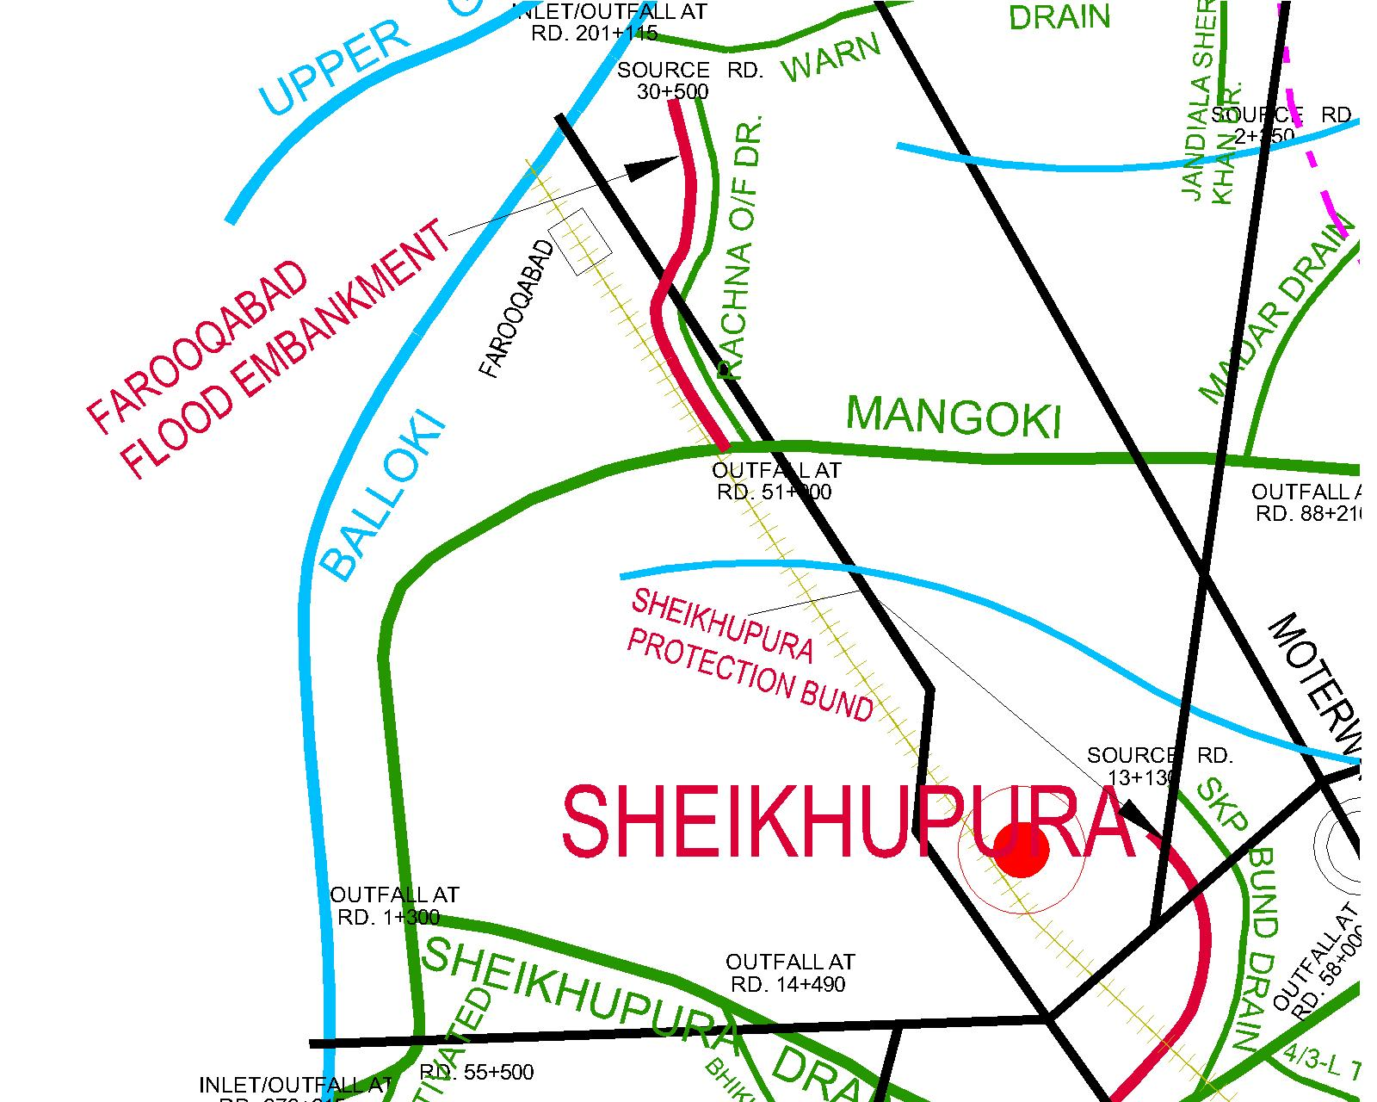

2.2 Location Map

Location Map Showing Deg Diversion Bund along Deg Diversion Channel in
Rachna Outfall Drainage Sub Division.

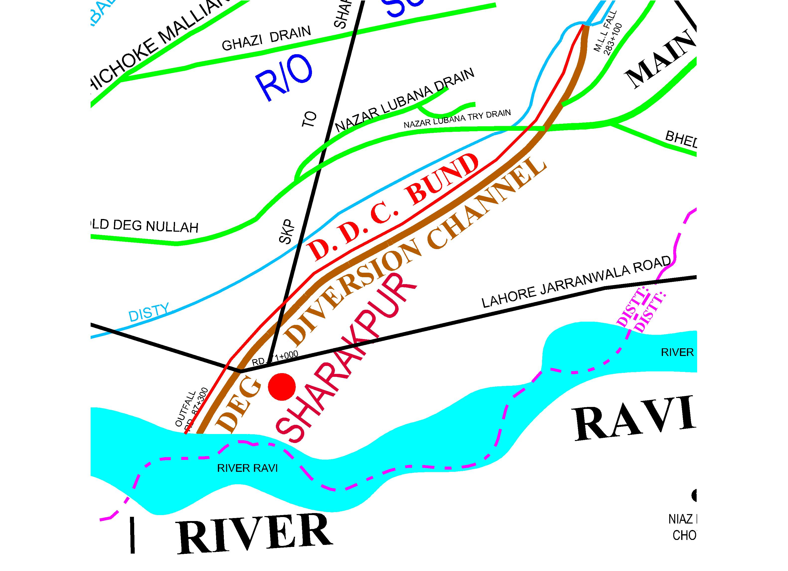

Chapter – 3

Brief History of Past Flood Events

Sheikhupura District had experienced worst flood during the year 1959. Drains in the area over flew and floodwater entered into Sheikhupura City causing devastation. Other high floods had been faced during 1973 and 1976, damaging the crops badly and human settlements. In 1988, exceptionally high flood in the River Ravi threatened the humen life and property of inhabitants of Sheikhupura District, especially Tehsil Ferozewala. During 1997, the area received heavy downpour to the extent of 283 mm within 48 hours in the last week of August, created havoc in the entire District due to newly constructed Motorway, which erupted the natural flood plain, causing heading up of the surface run off and inundated vast area and was alarmed to human life. Accumulative surface run off found its way through the drains, which had lost their carrying capacity due to deferred maintenance for the last couple of years. The drains flow all along Motorway to their outfalls and floodwater entered into the abadies of Sheikhupura City. This flood water damaged Sheikhupura – Faisalabad Road badly.

FLOOD 2014.

DEG NULLAH
On 6th September morning, exceptional high discharge of 75102 Cs was recorded in the Deg Nullah at Kingra Bridge but the full effect of this flood could not approach the reach of Nullah under the jurisdiction of this Division due to occurrence of breaches in the upper reach of Narowal. Flood water passed without making any considerable damages through the channelized reach of Nullah having capacity of 12000 Cs from BRBD canal to Muridke-Narowal road. Upstream of BRBD canal and downstream of Muridke-Narowal road up to its outfall where Nullah is not channelized, flood water spilled over and huge damages were occurred. Vast area of Tehsil Muridke, Ferozwal and Sheikhupura inundated not only due to this flood water but sheet flow from breached sites of Narowal contributes much to make the conditions more worst and developed breaches in the Deg.

FLOOD 2015.
No emergency has been experienced during flood 2015. All the structures, embankments remained quite safe against flood.

FLOOD 2016.
During rainy / flood season 2016, mostly normal rain fall was observed except on July 28, & August 7, 2016. The sheet flow / rainy water in the Nullahs & drains was received too enough due to the rain fall in the catchment area and in Jammu & Kashmir on July 28 & August 7, 2016. The discharge in Deg Nullah was observed at Kingra Bridge 35948 Cusec.
.
FLOOD 2017.
During rainy / flood season 2017, mostly normal rain fall was observed in District Sheikhupura and heavy rain fall observed in District Gujranwala and Narowal and Rachna Drainage Division effected excessive discharge of District Sialkot Drains and Nullahs which ultimately entered in to the Jurisdiction of Rachna Drainage Division Sheikhupura and the sheet flow / rainy water in the Nullahs & drains was received too enough due to the rain fall in the catchment area in Jammu & Kashmir on July & August 2017.
The highest discharge in Deg Nullah was observed 15900 Cs on 02-08-2017 and it resulted out flanked water from various places and it timely controlled.
The highest discharge in Nikki Deg Drain was observed 6800 Cs on 02-08-2017 it resulted out flanked water from various places and damages to crops by out flanked water Nikki Deg Drain from R.D 186+000 – 187+000/R near Village Ladhawala Virkan and Tamboli but it timely controlled. The existing full capacity level of the drain is higher side to NSL. Due to normal rains in area of District Sheikhupura Laila & Bhed Drain flows normally and smoothly.
FLOOD 2018
The highest discharge in Deg Nullah was observed 19170 Cs on 23-09-2018 at Kingra Bridge and it resulted out flanked water from various places in villages Changi, Kotli Baba Heera, Mianwali Bangla, Satrah and khery Sokin Wind in District Sialkot which was timely controlled and no damage occurred in District Gujranwala & Sheikhupura.
Remodelling of Nikki Deg Drain is in progress and critical reaches were taken up so the flood water passes safely during flood season.
Due to normal rains in area of District Sheikhupura Laila & Bhed Drain flows normally and smoothly.

FLOOD 2019.
No emergency has been experienced during flood 2019. All the structures, embankments remained quite safe against flood.

FLOOD 2020.
No emergency has been experienced during flood 2020. All the structures, embankments remained quite safe against flood.

FLOOD 2021.
No emergency has been experienced during flood 2021. All the structures, embankments remained quite safe against flood.

FLOOD 2022.
No emergency has been experienced during flood 2022. All the structures, embankments remained quite safe against flood.

FLOOD 2023.
No emergency has been experienced during flood 2023. All the structures, embankments remained quite safe against flood.

FLOOD 2024.
No emergency has been experienced during flood 2024. All the structures, embankments remained quite safe against flood.
Chapter – 4

Design Data, Historic Peak Flood Data & Previous Five Years Flood Data of Head Works / Barrages and Other Control Points

  - Flood Limits

Not Related

  - Time Lags of Floods

Not Related

  - Highest Floods

Not Related

4.4 Peak discharges

Not Related

Chapter – 5

Flood Fighting Strategy

Flood Embankments / Protection Bunds

Bunds along drains are not designed to provide protection against the rivers but to check spills from drains. Accordingly, less watching arrangement are required as compared to that on rivers.

Farooqabad Flood Embankment
Sub Divisional Officer, Mangoki Drainage Sub Division, Sheikhupura along with Sub Engineer, Farooqabad Drainage section will be In-charge of watching operation. A camp will be established at crossing point of Rachna Outfall Drain at Sargodha road and will have necessary watching material. Day & night watching operation will be exercised during heavy rains.

Deg Diversion Flood Protection Bund
Sub Divisional Officer, Rachna Outfall Drainage Sub Division, Sheikhupura along with Sub Engineer, Chichoki Mallian Drainage section will be In-charge of watching operation. A camp will be established at R.D 39+000 Crossing of Sheikhupura – Sharqpur Road and will have necessary watching material. Day & night watching operation will be exercised during heavy rains.

Nikki Deg Drain
Sub Divisional Officer, Rachna Outfall Drainage Sub Division along with Sub Engineer Harpoke Drains section from Outfall to G.T Road Gujranwala will be in-charge of watching operation. One number watching camp will be established at Sakham Village and will have necessary watching material. Day & night watching operation will be exercised during floods.

Main Deg Nullah
Sub Divisional Officer, Rachna Outfall Drainage Sub Division & Sub Divisional Officer Muridke Drainage Sub Division Muridke along with concerned Sub Engineer’s from Outfall to Muridke – Narowal Road will be in-charge of watching operation. One number watching camp will be established near village Shamke and will have necessary watching material. Day & night watching operation will be exercised during floods.

Drains
While the construction of Motorway, Lahore – Islamabad section (M-2), surface runoff accumulates along Motorway and finds its way through existing drains having less carrying capacity which resulted into overflowing at weak points. Worst situation was faced during heavy rains in monsoon of 1997, Sheikhupura drain was over flowed at many places and storm water entered in Sheikhupura City and damaged public property. To avoid such situation, the abandoned Rachna outfall drain was reactivated to give relief at outfall point of Sheikhupura drain.
For watching arrangement, a camp will be established at Sheikhupura – Faisalabad Pacca Road crossing under the supervision of Sub Divisional officer, Mangoki Drainage Sub Division, Sheikhupura and Sub Engineer, Jhamke section. Necessary watching material such as lanterns, Axes, Torches, Kassi etc, will be arranged. Day & night watching will be arranged in 3 shifts in case of heavy rainfall and heading up of flow in Sheikhupura drain. Civil Administration of Sheikhupura City will be informed accordingly well in time for assistance by Sub Divisional Officer In-charge.
To improve the outfall capacity of the Mangoki Main Drain, the abandoned Rachna out fall Drain was activated during the year 2003 to avoid the situation that happened during the year 1997.

General
All the Sub Divisional Officers will keep a close liaison with Executive Engineer, Rachna Drainage Division, Sheikhupura and Civil Administration. They being responsible for respective jurisdiction will take proper action to cope with the alarming situation. They will arrange communication of rainfall / flood position and colossal damages, to all concerned quarters. The rain gauges and flow position in various drains especially Sheikhupura and Mangoki drains below Motorway will be regularly recorded under their supervision through regular establishment in normal season and through work charge gauge readers in case of flood / rains. Sub Divisional Officer In-charge may direct other Sub Engineers to shift their camps at vulnerable points along with their establishment.
Municipal Committee Sheikhupura will be responsible for checking overflow from Sheikhupura drain, passing through the City area, by making necessary arrangements such as raising bank level along right bank of drain and arranging earth filled jute bags during rainy season. Local bodies will consult drainage staff for technical guidance and hydrological data required for fixing optimum top level of right bank along Sheikhupura Drain.

Chapter – 6

Flood Damages Restoration Works

There are no major damages to Farooqabad flood embankment and Deg Diversion Bund in the Division. No flood restoration work regarding bund has, therefore, been undertaken during the current financial year.

Chapter – 7

Flood Fighting Watching Arrangement

  - Pre-Flood Arrangement

- Only one flood Embankment i.e. Farooqabad Flood Embankment in the Division will be inspected by the field formation and Executive Engineer Rachna Drainage Division Sheikhupura to check the condition of bund.

- Arrangements for the establishment of flood centres in the office of Executive Engineer, Rachna Drainage Division, Sub Divisional Officer Mangoki Drainage Sub Division, Sub Divisional Officer Muridke Drainage Sub Division Muridke and Sub Divisional Officer R/O Drainage Sub Division will be finalized.

- All flood fighting material and work charge establishment arrangements will be framed well before the flood season.

- No reserve stock for stone is sanctioned, hence no stone available.

7.2 Watching Establishment

Flood watching establishment will be employed as per site requirements and weather conditions from 15/07/2025 to 15/10/2025.

Farooqabad Flood Bund

R.D. 106+000 – RD. 123+000

3 No. watchmen per mile for day and night for a shift of 12 hours.

Deg Diversion Bund

R.D. 0+000 – RD. 89+300

3 No. watchmen per mile for day and night for a shift of 12 hours.

Outfall of Mangoki Drain
Sheikhupura – Faisalabad Pacca Road Crossing.
3 No. watchmen per mile for day and night watching length 3 miles. 1 No. Mate for one shift of 12 hours.
Requirement of Establishment for Flood Embankment & Mangoki Drain
Beldars 9 x 2 = 18
Mate 2 x 2 = 4
Gauge Reader One per shift for camp site
1 x 2 = 2
Dak Runner One per shift for camp site
1 x 2 = 2
Chowkidars One per shift for camp site.
1 x 2 = 2
Requirement of Establishment for Deg Diversion Bund
From R.D 0+000 - 89+300 Length = 17.86 miles

Beldars 18 x 3 = 54
Mate One per Eight mile per shift. 3 x 2 = 6
Gauge Reader One per shift for camp site
1 x 2 = 2
Dak Runner One per shift for camp site
1 x 2 = 2
Chowkidars One per shift for camp site.
1 x 2 = 2

Nikki Deg Drain
From R.D 0+000 - 149+578 Length = 30 miles
2 No. Beldar for Night watching and 1 No for Day watching per mile.
Beldar. 30x3 = 90
Mate One per Eight mile per shift.
4 x 2 = 8
Gauge Reader One per shift for camp site
1 x 2 = 2
Dak Runner One per shift for camp site
1 x 2 = 2
Chowkidars One per shift for camp site.
1 x 2 = 2

Deg Nullah
From R.D 0+000 - 191+920 Length = 38 miles
2 No. Beldar for Night watching and 1 No for Day watching per mile.
Beldar. 38x3 = 114
Mate One per Eight mile per shift.
14 x 2 = 28
Gauge Reader One per shift for camp site
1 x 2 = 2
Dak Runner One per shift for camp site
1 x 2 = 2
Chowkidars One per shift for camp site.
1 x 2 = 2

Sheikhupura Drain
From R.D 50+000 - 58+000 Length = 2 miles
2 No. Beldar for Night watching and 1 No for Day watching per mile.
Beldar. 2x3 = 6
Mate One per Eight mile per shift.
1 x 2 = 2
Gauge Reader One per shift for camp site
1 x 2 = 2
Dak Runner One per shift for camp site
1 x 2 = 2
Chowkidars One per shift for camp site.
1 x 2 = 2
7.3 Arrangement at Sensitive Sites.

- The normal strength for watching along flood bund and site of relief cut for Mangoki drain during floods / rains (quoted above) will be made double during high floods / rain.
- The establishment can be increased after consultation with Executive Engineer, Rachna Drainage Division, Sheikhupura / Superintending Engineer, Lahore Drainage Circle, Lahore in emergency and in accordance with the site requirements.
- The establishment employed will be responsible for protection of flood Embankment / Banks of Drains etc. They will carry out minor repairs to bund / drains banks top, side slopes, removal of weed growth, opening / filling rat holes etc. it will also be responsible for filling gharas / rain cuts etc as occurred due to rains during monsoon season.
In the jurisdiction of Rachna Drainage Division, Sheikhupura District Sheikhupura and Gujranwala, no flood bund exists to check the River flood water, so there is no need of pitching stone at any structure / bund.

7.4 Watching Material
Sr.  No. | Description | Mangoki  Sub  Division | R/O Sub  Division | Muridke Sub  Division | Total  Quantity | Available | Balance
1 | Kassies with handle | 50 No | 250 No | 250 No | 550 No. | - | 550 No.
2 | Toot Baskets | 50 No | 600 No | 1550 No | 2200 No. | - | 2200 No.
3 | Nylon bags | 1000 No | 16000 No | 13000 No | 20000 No. | - | 20000 No.
4 | Torches 3 Cells | 5 No | 15 No | 15 No | 35 No. | - | 35 No.
5 | Handles for Kassies (Extra) | 50 No | 250 No | 250 No | 550 No. | - | 550 No.
6 | Iron Charpaies | 2 No | 6 No | 6 No | 14 No | - | 14 No
7 | Plastic Chair | 6 No | 24 No | 18 No | 48 No. | - | 48 No.
8 | Table | 1 No. | 4 No. | 3 No. | 8 No. | - | 8 No.
9 | Shouldaries | 1 No. | 4 No. | 3 No. | 8 No. | - | 8 No.
10 | Bamboos 12’ – 14’ long 2.5” to 5” dia | 100 No | 10000 No | 3000 No | 13100 No | - | 13100 No
11 | Panji with long handle | 30 No | 100 No | 80 No | 210 No | - | 210 No
12 | Generator | 1 No | 3 No | 3 No | 7 No | - | 7 No
13 | Bucket | 10 No | 60 No | 50 No | 120 No | - | 120 No
14 | Water Cooler | 1 No | 4 No | 5 No | 10 No | - | 10 No
15 | Water Set | 1 No | 4No | 5 No | 10 No | - | 10 No
16 | Steel Wire Rope | - | 3000 Ft | 3000 Ft | 6000 Ft | - | 6000 Ft
17 | Rope ¾” to 1” dia | 150 ft | - | - | 150 Ft | - | 150 Ft

Note:- Quantity will be procured before flood season 2025.

7.5 Arrangement for Sounding & Probing

Not related.

7.6 Lighting Arrangement

Detail given in the list of watching material at sr. No. 7.4 above.

7.7 Ration Arrangement

The Food Department will mobilize their sources for supplying foods for Human and cattle population.

  - P.O.L Arrangement for Vehicle
P.O.L facilities / arrangements will be made by the Civil Administration.

7.9 Transportation
Transportation facilities will be provided by the Civil Authorities

7.10 Law and order
Law and order situation will be tackled by the Civil Administration with the help of Police Department.

7.11 Medical arrangement for Labour

Health Department will be responsible for mobilizing their sources to carrying out necessary operation for providing medical facilities to the labour.

  - Liaison with other Departments

All the flood embankments / bunds are required to be inspected during the month of March, so as to identify weak points and if necessary after repairing such sites, the Certificate regarding hydraulic fitness of bunds is to be submitted.
The flood embankments are inspected by a Committee constituted by the Secretary Irrigation Department in May every year. Fitness of bunds is ensured before the flood season, keeping in view the priorities are fixed according to resources.
The Executive Engineer, Rachna Drainage Division, Sheikhupura and Sub Divisional Officer Mangoki Drainage Sub Division Sheikhupura will keep close liaison with the District Administration of Sheikhupura District during flood season.

7.13 Role of the Army
Army shall be deployed through District Administration if deemed necessary.

7.14 Duties of Telephone Attendant
The duties of telephone attendant are to apprise the Department / Civil Administration about the flood situation during the rain / flood season i.e 15-07-2025 to 15-10-2025.

7.15 Wireless Arrangements

Wireless system / arrangement will be made available for the vehicles under use of Officers of Rachna Drainage Division during the period of 15th July 2025 to 15th October 2025.

Chapter – 8

Detail of Encroachment

There is no encroachment on flood bunds / embankments in the jurisdiction of Rachna Drainage Division Sheikhupura.

Total No. of  Encroachment | Removed | Balance | Action to be  taken
Nil | Nil | Nil | Nil

Chapter – 9

Duty Roster/ Flood Fighting Program

Staff of Rachna Drainage Division Sheikhupura, looking after flood bunds and drains, has to be very vigilant throughout the monsoon season and set on alert during day and night from 15th July up to 15th October. The flood watching camps are to be established with the onset of monsoon season at vulnerable points with adequate materials and arrangements to cope with any flood / rain emergency. The concerned Sub Divisional officers are responsible for reporting about any mishaps to the Executive Engineer, Superintending Engineer, Chief Engineer and Secretary Irrigation Department. It is also the duty of Sub Divisional officer to deliver written messages well in time, to the District Administration concerned about the flood / weather forecast, flood situation and any other mishaps.

Mangoki Drainage Sub Division
1. Sub Divisional Officer Sheikhupura – Faisalabad Pacca Road
Crossing on Q.B. Link Canal.
2. Sub Engineer Jhamke -do-
3. Sub Engineer Farooqabad -do-

Additional daily labour will be employed as and when necessary according to requirement. The Camp sites have been shown on index plan.
An additional strength of nearly 300 voluntary labour is required to be made available by Assistant Commissioner Sheikhupura in case of emergency on following bunds / drains.

- Sheikhupura drain to check spill from drain and human settlements of Sheikhupura City.
- Bund along Rachna Outfall Drain near Farooqabad Town for its protection against rain / flood water.

These labours will be arranged from Sheikhupura City, Farooqabad Town and Factories along Sheikhupura – Faisalabad Road respectively. One Assistant Sub Inspector of Police with four Constables are required to be made available for arranging voluntary labours on above mentioned sites and to assist in watching operation as and when required.
Sub Divisional Officers Rachna Outfall Drainage Sub Division and Mangoki Drainage Sub Division will maintain close liaison with Civil Administration, Sheikhupura and keep them informed about the rain / flood position on bunds and drains and ask them for voluntary labour as and when required. They will also make arrangements for the stores required at camp sites.
Sub Divisional Officers will also inform the Civil Administration for any flood / rain emergency and damages. Civil Administration and revenue field staff will require facilitating evacuation of the area likely to be submerged due to spillage of drains.
Similarly, health and live Stock & Dairy Development Departments will also mobilize their resources for carrying out necessary operation for the health hazard likely to be created by the rains / flood for human and live stock. Food Departments will be responsible to cater for food requirement of flood / rain affected people. Police and revenue staff will coordinate the staff of Drainage Division for the purpose of timely evacuation of the public.

Communication & Works Department (Highways Division Sheikhupura) will also be required to keep the bridges and other cross Drainage works clean well before the onset of monsoon season, to provide free, without interruption, speedy disposal of storm / flood water.
WAPDA staff will also be required to be very vigilant in case of floods / rains to take care against accidents and break downs in the affected areas.

Chapter – 10

Emergency Telephone Nos.

SR. NO. | DESIGNATION | OFFICE | RESIDENCE
1 | Secretary, Irrigation Punjab | 042-99212117-18  Fax: 042-99212116 | 042-99200954
2 | Chief Engineer, Irrigation Lahore Zone | 042-99212085-86  Fax: 042-99212084 | 042-35182339
3 | Chief Engineer, D&F Punjab, Lahore. | 042-99230602  Fax: 042-99230731
4 | Superintending Engineer, L.D.C. Lahore | 042-99250309 | 0300-4283627
5 | Executive Engineer, U.C.C. Division Sheikhupura | 056-9200253 | 056-9200253
6 | Wireless Control, Sheikhupura | 056-9200110 | -
7 | Executive Engineer, Rachna Drainage Division Sheikhupura. | 056-9200250 | M. Zain Malik  0300-9633388
8 | District Co-ordination Officer, Sheikhupura. | 056-9200150-51 | 056-9200152  056-9200153
9 | Sr. Superintendent of Police, Sheikhupura. | 056-9200101  056-9200104 | 056-9200105
10 | Assistant Commissioner, Sheikhupura. | 056-9200165 | 0345-9262102
11 | Assistant Commissioner, Ferozewala. | 042-7930777 | 0345-9262103
12 | District Headquarters Hospital, Sheikhupura. | 056-9200234 | -
13 | Medical Superintendent, District Hospital S.K.P. | 056-9200231 | 0300-4258938
14 | Executive Engineer, Highway Div: S.K.P. | 056-9200058 | 056-9200192
15 | Executive Engineer, WAPDA Div: S.K.P. | 056-9200244 | -
16 | Executive Engineer, Building Sheikhupura. | 056-9200061-62 | 0323-4266823
17 | Director Flood, D&F Punjab, Lahore. | 042-99231614 | 0300-6999490
18 | Flood Warning Centre Lahore. | 042-7572091-4 | -
19 | Flood Warning Centre of Irrigation, S.K.P. | 056-9200252 | 056-9200253
20 | Sub Divisional Officer Rachna Out Fall Drainage Sub Division, Sheikhupura. | 056-9200250 | Haroon Shabir  0333-4261693
21 | Sub Divisional Officer Mangoki Drainage Sub Division, Sheikhupura. | 056-9200250 | Muaaz Bashir  0305-6123892
22 | Sub Divisional Officer Muridke Drainage Sub Division Muridke. | - | Miraj Din  0307-4915529
23 | District Co-ordination Officer, Gujranwala. | 055-9200051-52 | 055-9200024-25
24 | Assistant Commissioner, Gujranwala. | 055-9200056 | -

Chapter – 11
Standard operating procedure (SOP) for Breaching Sections

  - History of the Breaching Section

There is no approved breaching section in the jurisdiction of Rachna Drainage Division Sheikhupura.

  - Location, Design, Quantity and Variety of the explosive required for detonation.

Not Related.

  - Arrangement of explosives and security of explosive stores

Not Related.

  - List of security staff along with detail of their training etc

Not Related.

  - Detail of Mechanical means as a standby arrangement in case of detonation failure.

Not Related.

  - Duty Roster in case of critical situation

Not Related.

  - Breaching Committee with their action plan

Not Related.

  - List of the villages likely to be inundated in case of breach

Not Related.

  - Announcement and detail of evacuation arrangements

Not Related.

  - Details of coordination with Civil/ Army Authorities

Not Related.

  - Parallel Communication arrangements

Not Related.

  - Index Plan

Index plan of the Rachna Drainage Division Sheikhupura is attached.

Superintending Engineer, Executive Engineer,
Lahore Drainage Circle, Rachna Drainage Division,
Lahore. Sheikhupura.

Chief Engineer,
Irrigation Lahore Zone,
Lahore.

PART – B

Chapter – 12
Vulnerable Sites on Flood Bund / Structures.

  - Apprehended breaches in Flood Bunds/ Structures.

The following are the sites of Drains in District Sheikhupura.

District Sheikhupura.
Site No. 1 Mangoki Drain in Outfall Reach RD 0+000 – RD 15+000.
Site No. 2 Deg Diversion Bund R.D 0+000 – 89+300.
Site No. 3 Nikki Deg Drain RD 0+000 – RD 149+578.
Site No. 4 Main Deg Nullah R.D 0+000 – 191+920.
Site No. 5 Sheikhupura Drain R.D 50+000 – 58+000.

  - Operation of breaching sections.

There is no breaching section exist in this Division.

12.3 Breaches due to rising of flood water, deterioration of flood bunds etc.

Not related.

Chapter – 13 (Site # 1)

NAME OF SITE:- MANGOKI DRAIN AT OUTFALL POINT R.D 0+000

Emergency Contingency Plan for vulnerable site.

  - Plan showing route of flood water coming out of the breach supported with levels.

Plan Attached

  - Detail of villages abadies likely to be affected and this should also be shown on the plan.

Site No. 1

Mangoki Drainage Sub Division

- Village = Bhikhi
Abadi = 15000 person

  - Strategy and action taken be explained in detail.

Strategy to be adopted has been explained in detail in chapter 5 of flood fighting plan.

13.3.1 Arrangements

13.3.2 Establishment of Flood Fighting Camps

The following camps are various places:-

TEMPORARY CAMP SITES.

Following are the camps sites at Mangoki Drain
1. Outfall point at R.D 0+000.

13.3.3 Duties of Officer / Officials and Their Camp Sites.

Camp  No. | Location | Officer  (Name/Designation/  Mobil No.) | Official  (Name/Designation/  Mobil No.)
1. | R.D 0+000 Mangoki Drain | Ghulam Abbas  Sub Engineer  0334-4959080 | Mohammad Adeel  Beldar  0310-4193970

13.3.4 Departmental Machinery available

Required Machinery has been intimated.

13.3.5 Machinery available from Private Source.

Site No. 1 Mangoki Drainage Sub Division

- Name of owner: - Mian Naveed
Contact No: - 0308-4516061
Location: - Sheikhupura
Excavator Machine 2 Nos
Tractor with Front Blade 02 Nos
Tractor with Trollies 04 Nos

    - Flood Fighting Material required.

Sr.  No. | Description | Quantity
1 | Kassies with handle | 50 No
2 | Toot Baskets | 50 No
3 | Nylon bags | 1000 No
4 | Torches 3 Cells | 5 No
5 | Handles for Kassies (Extra) | 50 No
6 | Iron Charpaies | 2 No
7 | Plastic Chair | 6 No
8 | Table | 1 No.
9 | Shouldaries | 1 No.
10 | Bamboos 12’ – 14’ long 2.5” to 5” dia | 100 No
11 | Panji with long handle | 30 No
12 | Generator | 1 No
13 | Bucket | 10 No
14 | Water Cooler | 1 No
15 | Water Set | 1 No
16 | Rope ¾ ‘ to 1” dia | 150 ft

    - Flood Fighting Material available.

Sr.  No. | Description | Location | Quantity
1 | Kassies with handle | SDO Mangoki Office at Sheikhupura | -
2 | Baskets | SDO Mangoki Office at Sheikhupura | -
3 | Nylon bags | SDO Mangoki Office at Sheikhupura | -
4 | Torches 3 Cells | SDO Mangoki Office at Sheikhupura | -
5 | Handles for Kassies (Extra) | SDO Mangoki Office at Sheikhupura | -
6 | Iron Charpaies | SDO Mangoki Office at Sheikhupura | -
7 | Plastic Chair | SDO Mangoki Office at Sheikhupura | -
8 | Table | SDO Mangoki Office at Sheikhupura | -
9 | Shouldaries | SDO Mangoki Office at Sheikhupura | -
10 | Bamboos 12’ – 14’ long 2.5” to 5” dia | SDO Mangoki Office at Sheikhupura | -
11 | Panji with long handle | SDO Mangoki Office at Sheikhupura | -
12 | Generator | SDO Mangoki Office at Sheikhupura | -
13 | Bucket | SDO Mangoki Office at Sheikhupura | -
14 | Water Cooler | SDO Mangoki Office at Sheikhupura | -
15 | Water Set | SDO Mangoki Office at Sheikhupura | -
16 | Rope ¾ ‘ to 1” dia | SDO Mangoki Office at Sheikhupura | -

Note: - The material will be procured before start of flood season.

EXPECTED ROUTE OF THE FLOOD WATER IN CASE OF FAILUR-E OF STRUCTURE

(Site # 1, Mangoki Drain)

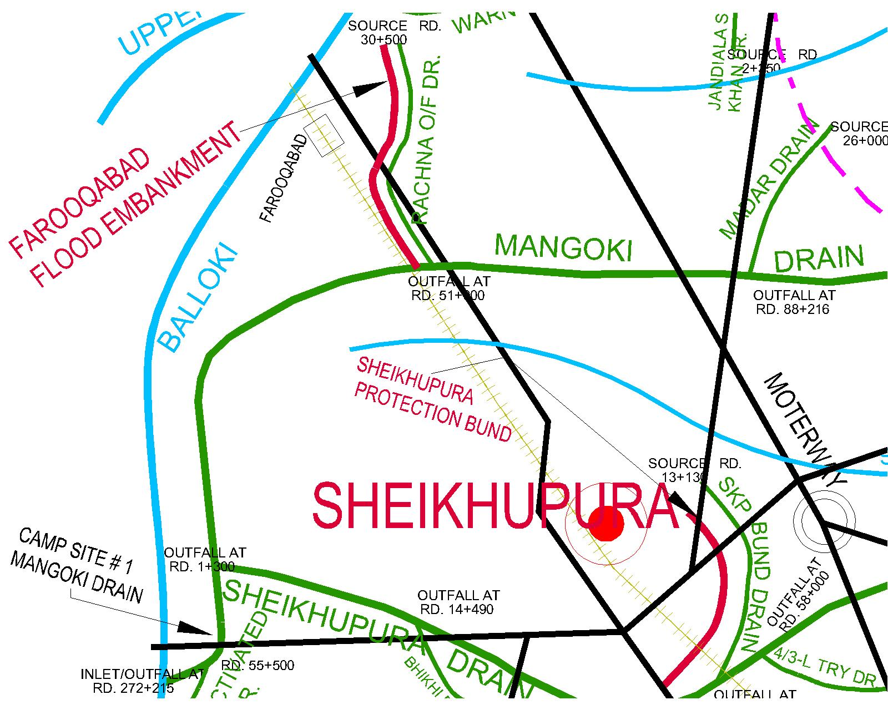
13.4 Detail of other infrastructure like Electric, Sui Gas, Telephone installations, Road network, other Buildings, Canals and Drainage network.

Canals
- Qadirabad Balloki Link Canal.

Roads
- Sheikhupura – Faisalabad Road.

Health Centre
- Rural Health Centre Sheikhupura.

Police Station
Bhikhi

Telephone Exchange
- -

Army infrastructure
-

Grid Station.

Chapter – 13 (Site # 2)

NAME OF SITE:- DDC BUND AT R.D 39+000 CROSSING SHEIKHUPURA – SHARQPUR ROAD.

Emergency Contingency Plan for vulnerable site.

  - Plan showing route of flood water coming out of the breach supported with levels.

Plan Attached

  - Detail of villages abadies likely to be affected and this should also be shown on the plan.

Site No. 2

Rachna Outfall Drainage Sub Division

- Village = Nazar Lubana, Kot Mehmood, Khan Bazigar, Nazam Pura, Noor Pur Arrainian, Faiz Pur & Badoke etc:

ii) Abadi = 35000 person

  - Strategy and action taken be explained in detail.

Strategy to be adopted has been explained in detail in chapter 5 of flood fighting plan.

13.3.1 Arrangements

13.3.2 Establishment of Flood Fighting Camps

The following camps are various places:-

TEMPORARY CAMP SITES.

Following are the camps sites at DDC Bund.
1. R.D 39+000.

13.3.3 Duties of Officer / Officials and Their Camp Sites.

Camp  No. | Location | Officer  (Name/Designation/  Mobil No.) | Official  (Name/Designation/  Mobil No.)
1. | R.D 39+000 DDC Bund. | Imdad Hussain  Sub Engineer  0323-4161416 | Mohammad Ashraf  Beldar  0312-5969984

13.3.4 Departmental Machinery available

Required Machinery has been intimated.

13.3.5 Machinery available from Private Source.

Site No. 2 Rachna Outfall Drainage Sub Division

- Name of owner: - Muhammad Bashir
Contact No: - 0300-7432434
Location: - Gujranwala
Excavator Machine 3 Nos
Tractor with Front Blade 03 Nos
Tractor with Trollies 05 Nos

    - Flood Fighting Material required.

Sr.  No. | Description | Quantity
1 | Kassies with handle | 75 No
2 | Toot Baskets | 150 No
3 | Nylon bags | 4000 No
4 | Torches 3 Cells | 5 No
5 | Handles for Kassies (Extra) | 75 No
6 | Iron Charpaies | 2 No
7 | Plastic Chair | 6 No
8 | Table | 1 No.
9 | Shouldaries | 1 No.
10 | Bamboos 12’ – 14’ long 2.5” to 5” dia | 2500 No
11 | Panji with long handle | 25 No
12 | Generator | 1 No
13 | Bucket | 15 No
14 | Water Cooler | 1 No
15 | Water Set | 1 No
16 | Steel Wire Rope | 1000 Ft

13.3.7 Flood Fighting Material available.

Sr.  No. | Description | Location | Quantity
1 | Kassies with handle | SDO R/O Office at Sheikhupura | -
2 | Baskets | SDO R/O Office at Sheikhupura | -
3 | Nylon bags | SDO R/O Office at Sheikhupura | -
4 | Torches 3 Cells | SDO R/O Office at Sheikhupura | -
5 | Handles for Kassies (Extra) | SDO R/O Office at Sheikhupura | -
6 | Iron Charpaies | SDO R/O Office at Sheikhupura | -
7 | Plastic Chair | SDO R/O Office at Sheikhupura | -
8 | Table | SDO R/O Office at Sheikhupura | -
9 | Shouldaries | SDO R/O Office at Sheikhupura | -
10 | Bamboos 12’ – 14’ long 2.5” to 5” dia | SDO R/O Office at Sheikhupura | -
11 | Panji with long handle | SDO R/O Office at Sheikhupura | -
12 | Generator | SDO R/O Office at Sheikhupura | -
13 | Bucket | SDO R/O Office at Sheikhupura | -
14 | Water Cooler | SDO R/O Office at Sheikhupura | -
15 | Water Set | SDO R/O Office at Sheikhupura | -
16 | Steel Wire Rope | SDO R/O Office at Sheikhupura | -

Note: - The material will be procured before start of flood season.

EXPECTED ROUTE OF THE FLOOD WATER IN CASE OF FAILUR-E OF STRUCTURE

(Site # 2, DDC Bund)

Camp Site
R.D 39+000
13.4 Detail of other infrastructure like Electric, Sui Gas, Telephone installations, Road network, other Buildings, Canals and Drainage network.

Canals
Sikhanwala Disty: Lower.

Roads
Lahore – Jaranwala Road.

Health Centre
Rural Health Centre Shaqpur.

Police Station
Sharqpur

Telephone Exchange
- -

Army infrastructure
-

Grid Station.

-

Chapter – 13 (Site # 3)

NAME OF SITE:- NIKKI DEG DRAIN NEAR VILLAGE SAKHAM AT R.D 97+000.
Emergency Contingency Plan for vulnerable site.

  - Plan showing route of flood water coming out of the breach supported with levels.

Plan Attached

  - Detail of villages abadies likely to be affected and this should also be shown on the plan.

Site No. 3

Rachna Outfall Drainage Sub Division

i) Village = Sakham
ii) Abadi = 12000 person

  - Strategy and action taken be explained in detail.

Strategy to be adopted has been explained in detail in chapter 5 of flood fighting plan.

13.3.1 Arrangements

    - Establishment of Flood Fighting Camps

The following camps are various places:-

TEMPORARY CAMP SITES.

Following are the camps sites at Nikki Deg drain.
1. R.D 97+000.

13.3.3 Duties of Officer / Officials and Their Camp Sites.

Camp  No. | Location | Officer  (Name/Designation/  Mobil No.) | Official  (Name/Designation/  Mobil No.)
1. | R.D 97+000 Nikki Deg Drain. | Mohsin Fareed  Sub Engineer  0323-4551669 | Mohammad Sajid  Beldar  0317-4878780

13.3.4 Departmental Machinery available

Required Machinery has been intimated.

13.3.5 Machinery available from Private Source.

Site No. 3 Rachna Outfall Drainage Sub Division

- Name of owner: - Muhammad Bashir
Contact No: - 0300-7432434
Location: - Gujranwala
Excavator Machine 3 Nos
Tractor with Front Blade 03 Nos
Tractor with Trollies 05 Nos

    - Flood Fighting Material required.

Sr.  No. | Description | Quantity
1 | Kassies with handle | 75 No
2 | Toot Baskets | 150 No
3 | Nylon bags | 4000 No
4 | Torches 3 Cells | 5 No
5 | Handles for Kassies (Extra) | 75 No
6 | Iron Charpaies | 2 No
7 | Plastic Chair | 6 No
8 | Table | 1 No.
9 | Shouldaries | 1 No.
10 | Bamboos 12’ – 14’ long 2.5” to 5” dia | 2500 No
11 | Panji with long handle | 25 No
12 | Generator | 1 No
13 | Bucket | 15 No
14 | Water Cooler | 1 No
15 | Water Set | 1 No
16 | Steel Wire Rope | 1000 Ft

13.3.7 Flood Fighting Material available.

Sr.  No. | Description | Location | Quantity
1 | Kassies with handle | SDO R/O Office at Sheikhupura | -
2 | Baskets | SDO R/O Office at Sheikhupura | -
3 | Nylon bags | SDO R/O Office at Sheikhupura | -
4 | Torches 3 Cells | SDO R/O Office at Sheikhupura | -
5 | Handles for Kassies (Extra) | SDO R/O Office at Sheikhupura | -
6 | Iron Charpaies | SDO R/O Office at Sheikhupura | -
7 | Plastic Chair | SDO R/O Office at Sheikhupura | -
8 | Table | SDO R/O Office at Sheikhupura | -
9 | Shouldaries | SDO R/O Office at Sheikhupura | -
10 | Bamboos 12’ – 14’ long 2.5” to 5” dia | SDO R/O Office at Sheikhupura | -
11 | Panji with long handle | SDO R/O Office at Sheikhupura | -
12 | Generator | SDO R/O Office at Sheikhupura | -
13 | Bucket | SDO R/O Office at Sheikhupura | -
14 | Water Cooler | SDO R/O Office at Sheikhupura | -
15 | Water Set | SDO R/O Office at Sheikhupura | -
16 | Steel Wire Rope | SDO R/O Office at Sheikhupura | -

Note: - The material will be procured before start of flood season.

EXPECTED ROUTE OF THE FLOOD WATER IN CASE OF FAILUR-E OF STRUCTURE

(Site # 3, Nikki Deg Drain)

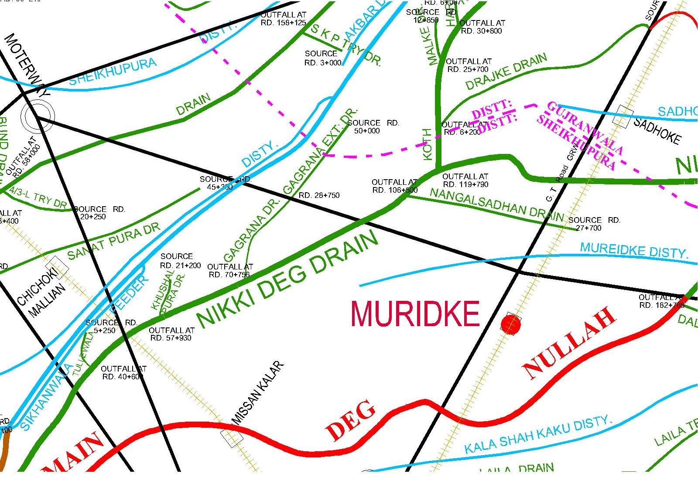
Camp Site RD 97+000
13.4 Detail of other infrastructure like Electric, Sui Gas, Telephone installations, Road network, other Buildings, Canals and Drainage network.

Canals
U.C.C Canal.

Roads
Sheikhupura – Muridke Road.

Health Centre
Rural Health Centre Sakham.

Police Station
Shakham

Telephone Exchange
- -

Army infrastructure
-

Grid Station.

-

Chapter – 13 (Site # 4)
NAME OF SITE:- DEG NULLAH NEAR VILLAGE SHAMKE AT R.D 93+000.

Emergency Contingency Plan for vulnerable site.

  - Plan showing route of flood water coming out of the breach supported with levels.

Plan Attached

  - Detail of villages abadies likely to be affected and this should also be shown on the plan.

Site No. 4

Rachna Outfall Drainage Sub Division

- Village = Village Noon
Abadi = 15000 person

  - Strategy and action taken be explained in detail.

Strategy to be adopted has been explained in detail in chapter 5 of flood fighting plan.

13.3.1 Arrangements

    - Establishment of Flood Fighting Camps

The following camps are various places:-

TEMPORARY CAMP SITES.

Following are the camps sites at Deg Nullah.
1. R.D 93+000.

13.3.3 Duties of Officer / Officials and Their Camp Sites.

Camp  No. | Location | Officer  (Name/Designation/  Mobil No.) | Official  (Name/Designation/  Mobil No.)
1. | R.D 93+000 Deg Nullah. | Amjad Hussain Quraishi  Sub Engineer  0301-4157474.  Malik Mohammad Afzal.  Sub Engineer  0300-4754925 | Mohammad Younas  Beldar  0345-6291554  Mohammad Abbas  Beldar  0304-4003824

13.3.4 Departmental Machinery available

Required Machinery has been intimated.

13.3.5 Machinery available from Private Source.

Site No. 4 Rachna Outfall Drainage Sub Division & Muridke Drainage Sub Division.

- Name of owner: - Muhammad Bashir
Contact No: - 0300-7432434
Location: - Gujranwala
Excavator Machine 3 Nos
Tractor with Front Blade 03 Nos
Tractor with Trollies 05 Nos

    - Flood Fighting Material required.

Sr.  No. | Description | Quantity  R/O Sub Division | Quantity  Muridke Sub Division | Total Quantity
1 | Kassies with handle | 75 No | 75 No | 150 No
2 | Toot Baskets | 150 No | 150 No | 300 No
3 | Nylon bags | 4000 No | 4000 No | 8000 No
4 | Torches 3 Cells | 5 No | 5 No | 10 No
5 | Handles for Kassies (Extra) | 75 No | 75 No | 150 No
6 | Iron Charpaies | 2 No | 2 No | 4 No
7 | Plastic Chair | 6 No | 6 No | 12 No
8 | Table | 1 No. | 1 No. | 2 No.
9 | Shouldaries | 1 No. | 1 No. | 2 No.
10 | Bamboos 12’ – 14’ long 2.5” to 5” dia | 2500 No | 2500 No | 5000 No
11 | Panji with long handle | 25 No | 25 No | 50 No
12 | Generator | 1 No | 1 No | 2 No
13 | Bucket | 15 No | 15 No | 30 No
14 | Water Cooler | 1 No | 1 No | 2 No
15 | Water Set | 1 No | 1 No | 2 No
16 | Steel Wire Rope | 1000 Ft | 1000 Ft | 2000 Ft

13.3.7 Flood Fighting Material available.

Sr.  No. | Description | Location | Quantity
1 | Kassies with handle | SDO R/O Office at Sheikhupura | -
2 | Baskets | SDO R/O Office at Sheikhupura | -
3 | Nylon bags | SDO R/O Office at Sheikhupura | -
4 | Torches 3 Cells | SDO R/O Office at Sheikhupura | -
5 | Handles for Kassies (Extra) | SDO R/O Office at Sheikhupura | -
6 | Iron Charpaies | SDO R/O Office at Sheikhupura | -
7 | Plastic Chair | SDO R/O Office at Sheikhupura | -
8 | Table | SDO R/O Office at Sheikhupura | -
9 | Shouldaries | SDO R/O Office at Sheikhupura | -
10 | Bamboos 12’ – 14’ long 2.5” to 5” dia | SDO R/O Office at Sheikhupura | -
11 | Panji with long handle | SDO R/O Office at Sheikhupura | -
12 | Generator | SDO R/O Office at Sheikhupura | -
13 | Bucket | SDO R/O Office at Sheikhupura | -
14 | Water Cooler | SDO R/O Office at Sheikhupura | -
15 | Water Set | SDO R/O Office at Sheikhupura | -
16 | Steel Wire Rope | SDO R/O Office at Sheikhupura | -

Note: - The material will be procured before start of flood season.

EXPECTED ROUTE OF THE FLOOD WATER IN CASE OF FAILUR-E OF STRUCTURE

(Site # 4, Deg Nullah)

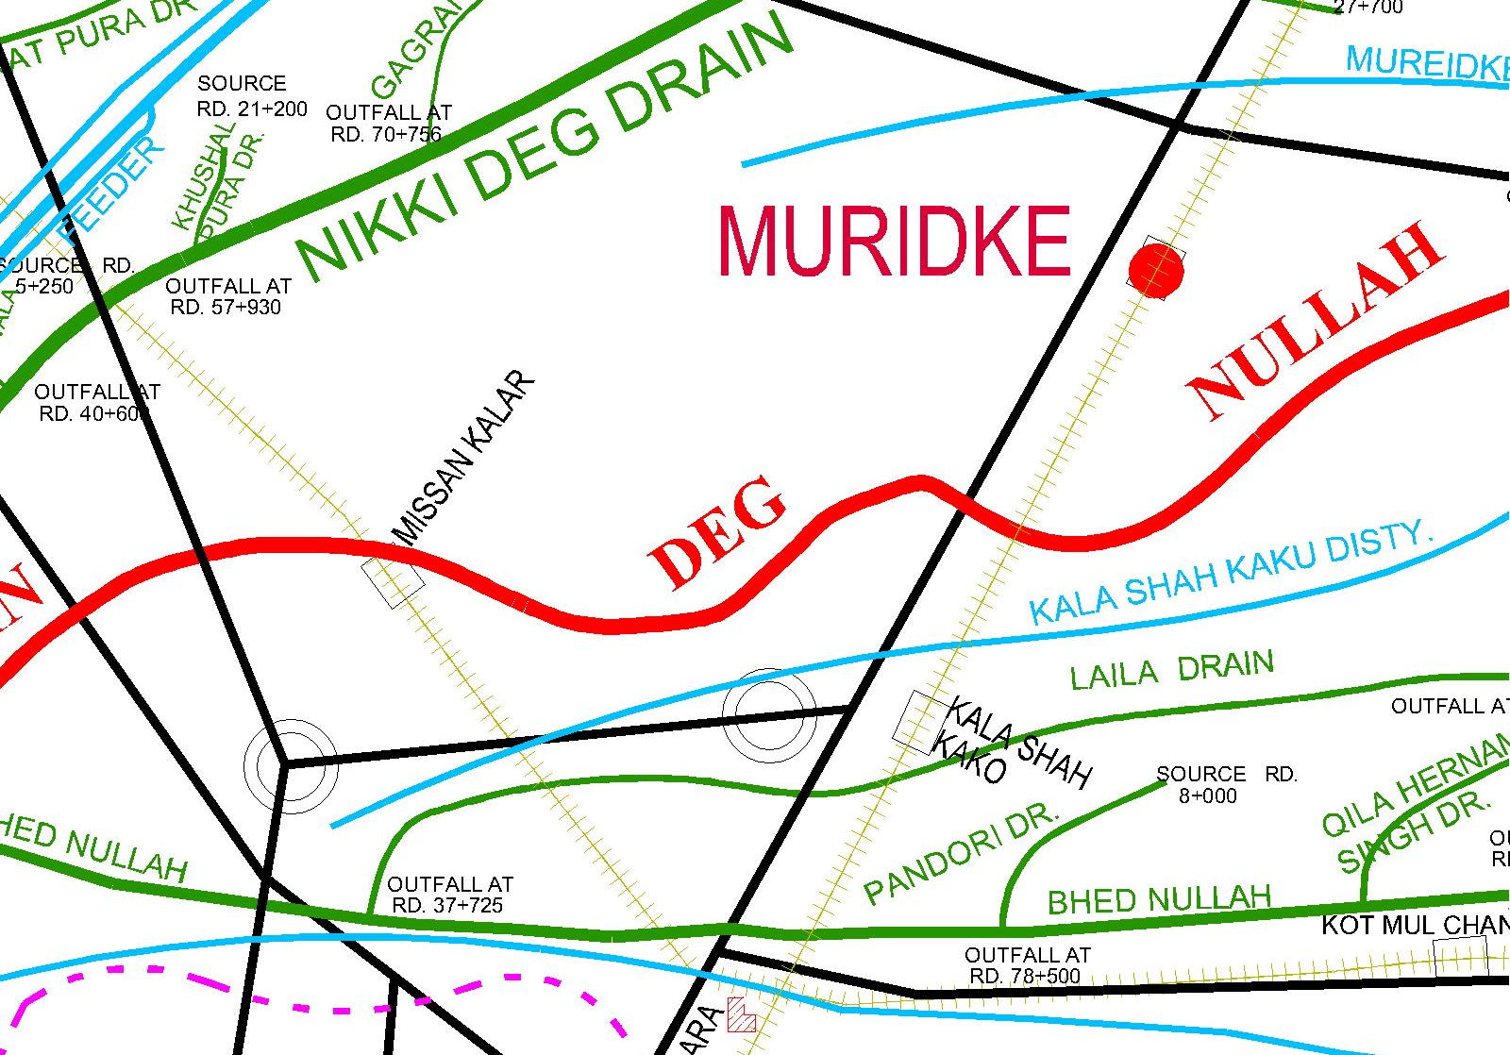
Camp Site RD 93+000
13.4 Detail of other infrastructure like Electric, Sui Gas, Telephone installations, Road network, other Buildings, Canals and Drainage network.

Canals
Muridke Disty.

Roads
Lahore – Gujranwala G.T Road.

Health Centre
Rural Health Centre Kala Shah Kaku.

Police Station
Kala Shah Kaku.

Telephone Exchange
- -

Army infrastructure
-

Grid Station.

Chapter – 13 (Site # 5)

NAME OF SITE:- SHEIKHUPURA DRAIN NEAR SHERAZ GARDEN AT R.D 57+000

Emergency Contingency Plan for vulnerable site.

  - Plan showing route of flood water coming out of the breach supported with levels.

Plan Attached

  - Detail of villages abadies likely to be affected and this should also be shown on the plan.

Site No. 5

Rachna Outfall Drainage Sub Division

- Village = Sheraz Garden
Abadi = 25000 person

  - Strategy and action taken be explained in detail.

Strategy to be adopted has been explained in detail in chapter 5 of flood fighting plan.

13.3.1 Arrangements

    - Establishment of Flood Fighting Camps

The following camps are various places:-

TEMPORARY CAMP SITES.

Following are the camps sites at Sheikhupura Drain.
1. R.D 57+000.

13.3.3 Duties of Officer / Officials and Their Camp Sites.

Camp  No. | Location | Officer  (Name/Designation/  Mobil No.) | Official  (Name/Designation/  Mobil No.)
1. | R.D 57+000 SKP Drain. | Qaisar Farooq  Sub Engineer  0323-6003682 | Mohammad Afzal  Beldar  0309-7802463

13.3.4 Departmental Machinery available

Required Machinery has been intimated.

13.3.5 Machinery available from Private Source.

Site No. 5 Rachna Outfall Drainage Sub Division

- Name of owner: - Muhammad Bashir
Contact No: - 0300-7432434
Location: - Gujranwala
Excavator Machine 3 Nos
Tractor with Front Blade 03 Nos
Tractor with Trollies 05 Nos

13.3.6 Flood Fighting Material required.

Sr.  No. | Description | Quantity
1 | Kassies with handle | 75 No
2 | Toot Baskets | 150 No
3 | Nylon bags | 4000 No
4 | Torches 3 Cells | 5 No
5 | Handles for Kassies (Extra) | 75 No
6 | Iron Charpaies | 2 No
7 | Plastic Chair | 6 No
8 | Table | 1 No.
9 | Shouldaries | 1 No.
10 | Bamboos 12’ – 14’ long 2.5” to 5” dia | 1000 No
11 | Panji with long handle | 25 No
12 | Generator | 1 No
13 | Bucket | 20 No
14 | Water Cooler | 1 No
15 | Water Set | 1 No

13.3.7 Flood Fighting Material available.

Sr.  No. | Description | Location | Quantity
1 | Kassies with handle | SDO R/O Office at Sheikhupura | -
2 | Baskets | SDO R/O Office at Sheikhupura | -
3 | Nylon bags | SDO R/O Office at Sheikhupura | -
4 | Torches 3 Cells | SDO R/O Office at Sheikhupura | -
5 | Handles for Kassies (Extra) | SDO R/O Office at Sheikhupura | -
6 | Iron Charpaies | SDO R/O Office at Sheikhupura | -
7 | Plastic Chair | SDO R/O Office at Sheikhupura | -
8 | Table | SDO R/O Office at Sheikhupura | -
9 | Shouldaries | SDO R/O Office at Sheikhupura | -
10 | Bamboos 12’ – 14’ long 2.5” to 5” dia | SDO R/O Office at Sheikhupura | -
11 | Panji with long handle | SDO R/O Office at Sheikhupura | -
12 | Generator | SDO R/O Office at Sheikhupura | -
13 | Bucket | SDO R/O Office at Sheikhupura | -
14 | Water Cooler | SDO R/O Office at Sheikhupura | -
15 | Water Set | SDO R/O Office at Sheikhupura | -

Note: - The material will be procured before start of flood season.

EXPECTED ROUTE OF THE FLOOD WATER IN CASE OF FAILUR-E OF STRUCTURE

(Site # 5, Sheikhupura Drain)

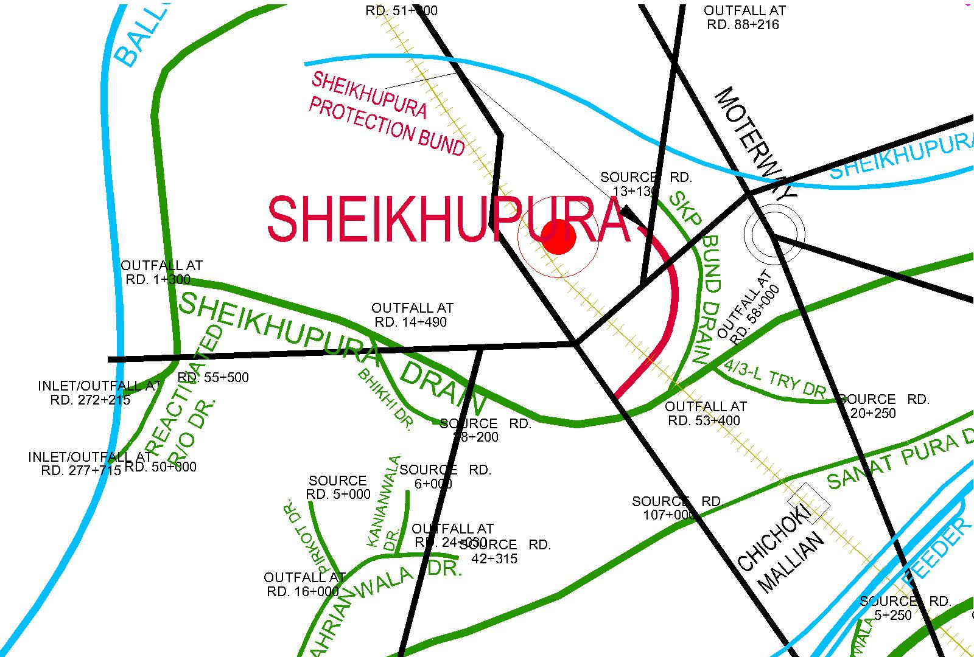
Camp Site RD 57+000
13.4 Detail of other infrastructure like Electric, Sui Gas, Telephone installations, Road network, other Buildings, Canals and Drainage network.

Canals
Aya Minor.

Roads
Lahore – Sheikhupura Road.

Health Centre
Rural Health Centre City Sheikhupura.

Police Station
Sadar Sheikhupura.

Telephone Exchange
- City Sheikhupura

Army infrastructure
-

Grid Station.
- City Sheikhupura.

Chapter – 14

action plan

14.1 Re-shuffling/recouping plan of reserve stone departmentally
No reserve stone sanctioned in respect of Rachna Drainage Division Sheikhupura.

14.2 Detail of inlet/outlet crossing along with closing methodology
There is no inlet / outlet crossing the flood embankments.
14.3 Deployment of Machinery (medium to high flood)
Attached at Page No.64.
14.4 Deployment of Machinery (high to very high flood)
Attached at Page No.65.
14.5 Deployment of Machinery (high to exceptionally high flood)
Attached at Page No.66.
14.6 Police deployment plan
Sr. No. | Vulnerable sites used for illegal cuts during floods | Concerned Canal Division | Concerned Police Station and District | Police Personnel to be deployed |  | Remarks (If any)
 |  |  |  | Inspection / SI/ASI | Constables | Remarks (If any)
1. | 5 No Vulnerable sites falls in RDD SKP | - | - | - | - | -

14.7 Detail of synthetic bags with capacity of 500 kg and 1000 kg
there is no requirement of 500kg or 1000 kg bags.
14.8 Detail of polythene sheets of black color to protect Upstream slop against wave action and to control seepage through embankments
not required as there is no river embankment in the divsion.

Chapter-15

15 backup divisions

The Sheikhupura Division UCC Sheikhupura is allied canal Division and the Jurisdiction of both Divisions i.e Rachna Drainage Division Sheikhupura and Sheikhupura Division UCC is parallel District Gujranwala as well as Sheikhupura.

Superintending Engineer, Executive Engineer,
Lahore Drainage Circle, Rachna Drainage Division,
Lahore. Sheikhupura.

Chief Engineer,
Irrigation Lahore Zone,
Lahore.

ACTION FOR DEPLOYMENT OF MACHINERY AND LABOUR AT CAMP SITES
(MEDIUM TO HIGH STAGE)

Sr.  No. | Name of Structure | Length  (Mile) | Vulnerable  Reach | Camp  Location | Site in-charge  By Name and  Cell No. | Machinery / Labour Deployed |  |  |  |  | Availability  of stone Cft.
 |  |  |  |  |  | Excavator | Dozers | Trolleys /  Dumpers | Tractor with front blade | Labour  Beldar +  Mate | Availability  of stone Cft.
1 | 2 | 3 | 4 | 5 | 6 | 7 | 8 | 9 | 10 | 11 | 12
1 | Mangoki  Drain | 43.29 | R.D 0-15 | R.D 0-1 | Ghulam Abbas  Sub Engineer  0334-4959080 | 1 | - | 6 | 2 | 18+4 for 2 shifts | -
2 | DDC Bund | 17.86 | 0-89300 | RD 89+300 | Imdad Hussain  Sub Engineer  0323-4161416 | 2 | 1 | 6 | 2 | 54+6 for 2 shifts | -
3 | Nikki Deg Drain | 29.92 | 0-149 | R.D 97+000 | Mohsin Fareed  Sub Engineer  0323-455169 | 2 | - | 6 | 2 | 51+8 for 2 shifts | -
4 | Main Deg Nullah | 36.78 | 0-191 | R.D 93+000 | Amjad Hussain Quraishi  Muhammad Hassnain  Sub Engineer  0301-4157474  0342-2444826 | 4 | - | 8 | 4 | 111+26 for 2 shifts | -
5 | Sheikhupura Drain | 32.80 | 50-58 | R.D 57+000 | Qaisar Farooq  Sub Engineer  0323-6003682 | 1 | - | 6 | 2 | 6+2 for 2 shifts | -
Total:- |  | 160.65 |  |  |  | 10 | 1 | 32 | 12 | 240+46 for 2 shift | -

Note:- Payment of machinery and work charge employee subject to verification by TPM Consultants.
ACTION FOR DEPLOYMENT OF MACHINERY AND LABOUR AT CAMP SITES
(high to very high flood)

Sr.  No. | Name of Structure | Length  (Mile) | Vulnerable  Reach | Camp  Location | Site in-charge  By Name and  Cell No. | Machinery / Labour Deployed |  |  |  |  | Availability  of stone Cft.
 |  |  |  |  |  | Excavator | Dozers | Trolleys /  Dumpers | Tractor with front blade | Labour  Beldar +  Mate | Availability  of stone Cft.
1 | 2 | 3 | 4 | 5 | 6 | 7 | 8 | 9 | 10 | 11 | 12
1 | Mangoki  Drain | 43.29 | R.D 0-15 | R.D 0-1 | Ghulam Abbas  Sub Engineer  0334-4959080 | 1 | - | 6 | 2 | 18+4 for 2 shifts | -
2 | DDC Bund | 17.86 | 0-89300 | RD 89+300 | Imdad Hussain  Sub Engineer  0323-4161416 | 3 | 2 | 8 | 4 | 54+6 for 2 shifts | -
3 | Nikki Deg Drain | 29.92 | 0-149 | R.D 97+000 | Mohsin Fareed  Sub Engineer  0323-455169 | 3 | - | 9 | 3 | 51+8 for 2 shifts | -
4 | Main Deg Nullah | 36.78 | 0-191 | R.D 93+000 | Amjad Hussain Quraishi  Muhammad Hassnain  Sub Engineer  0301-4157474  0342-2444826 | 6 | - | 16 | 8 | 111+26 for 2 shifts | -
5 | Sheikhupura Drain | 32.80 | 50-58 | R.D 57+000 | Qaisar Farooq  Sub Engineer  0323-6003682 | 1 | - | 6 | 2 | 6+2 for 2 shifts | -
Total:- |  | 160.65 |  |  |  | 14 | 2 | 45 | 19 | 240+46for 2 shift | -

Note:- Payment of machinery and work charge employee subject to verification by TPM Consultants.
ACTION FOR DEPLOYMENT OF MACHINERY AND LABOUR AT CAMP SITES
(high to exceptionally high flood)

Sr.  No. | Name of Structure | Length  (Mile) | Vulnerable  Reach | Camp  Location | Site in-charge  By Name and  Cell No. | Machinery / Labour Deployed |  |  |  |  | Availability  of stone Cft.
 |  |  |  |  |  | Excavator | Dozers | Trolleys /  Dumpers | Tractor with front blade | Labour  Beldar +  Mate | Availability  of stone Cft.
1 | 2 | 3 | 4 | 5 | 6 | 7 | 8 | 9 | 10 | 11 | 12
1 | Mangoki  Drain | 43.29 | R.D 0-15 | R.D 0-1 | Ghulam Abbas  Sub Engineer  0334-4959080 | 1 | - | 6 | 2 | 18+4 for 2 shifts | -
2 | DDC Bund | 17.86 | 0-89300 | RD 89+300 | Imdad Hussain  Sub Engineer  0323-4161416 | 12 | 4 | 20 | 12 | 108+6 for 2 shifts
3 | Nikki Deg Drain | 29.92 | 0-149 | R.D 97+000 | Mohsin Fareed  Sub Engineer  0323-455169 | 6 | - | 10 | 5 | 102+8 for 2 shifts | -
4 | Main Deg Nullah | 36.78 | 0-191 | R.D 93+000 | Amjad Hussain Quraishi  Muhammad Hassnain  Sub Engineer  0301-4157474  0342-2444826 | 10 | - | 20 | 12 | 222+26 for 2 shifts | -
5 | Sheikhupura Drain | 32.80 | 50-58 | R.D 57+000 | Qaisar Farooq  Sub Engineer  0323-6003682 | 1 | - | 6 | 2 | 6+2 for 2 shifts | -
Total:- |  | 160.65 |  |  |  | 29 | 4 | 62 | 33 | 456+46 for 2 shift | -

Note:- Payment of machinery and work charge employee subject to verification by TPM Consultants.

