

**GOVERNMENT OF THE PUNJAB**

**IRRIGATION DEPARTMENT**

**FLOOD FIGHTING PLAN**

**2025**

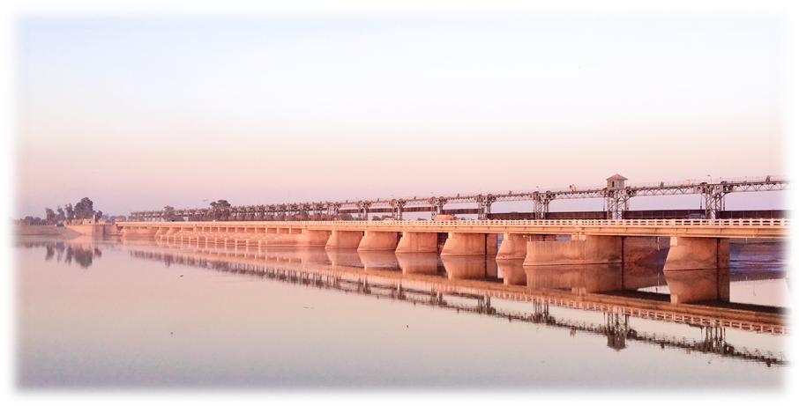

**ISLAM HEADWORKS DIVISION PALLAH**

**DEPUTY PROJECT DIRECTOR**

**PMO PUNJAB BARRAGES LAHORE.**

**SOP’s FOR FLOOD FIGHTING PLANS**

**PART-A**

**Chapter-1 Salient feature of the Islam Headworks Division**

* 1. Location
  2. General Description
  3. Administrative setup

**Chapter-2 Flood Protection and River Training Works**

* 1. Design parameter of River Training Works
  2. Location Map

**Chapter-3 Brief history of past flood events**

**Chapter-4 Design Data, Historic peak flood data and previous five years flood data of Head Works/Barrages and or other control points**

* 1. Flood Limits
  2. Time Lags of Floods
  3. Highest Floods
  4. Peak discharges

**Chapter-5 Flood Fighting Strategy**

**Chapter-6 Flood Damages Restoration Works**

**Chapter-7 Flood Fighting Watching Arrangement**

7.1 Pre-Flood Arrangement

7.2 Watching Establishment

7.3 Arrangement at Sensitive sites

7.4 Watching Material

7.5 Arrangement for Sounding & Probing

7.6 Lighting Arrangement

7.7 Ration Arrangement

7.8 P.O.L. Arrangement for Vehicle

7.9 Transportation

7.10 Law and order

7.11 Medical Arrangement for Labor

7.12 Liaison with other Department

7.13 Role of the Army

7.14 Duties of Telephone Attendant

7.15 Wireless Arrangements

**Chapter-8 Detail of Encroachment**

**Chapter-9 Duty Roster/Flood Fighting Program**

**Chapter-10 Emergency Telephone Nos.**

**Chapter-11 Standard Operating Procedure (SOP) for Breaching Sections**

* 1. Description
  2. Operation of Breaching section
  3. Location, Design, Quantity and Variety of the explosive required for detonation.
  4. Arrangement of explosives and security of explosive stores
  5. List of the security staff along with detail of their training etc.
  6. Detail of mechanical means as a standby arrangement in case of detonation failure
  7. Duty Roster in case of critical situation
  8. Breaching Committee with their action plan
  9. List of the villages likely to be inundated in case of breach
  10. Announcement and detail of evacuation arrangements
  11. Details of coordination with Civil/Army Authorities
  12. Parallel communication arrangements
  13. Index Plan

**PART-B**

**Chapter-12 Vulnerable sites on Flood Bund/Structures:**

* 1. Apprehended breaches in Flood Bunds/Structures.
  2. Operation of breaching sections.
  3. Breaches due to rise of flood water, deterioration of flood bunds etc.

**Chaper-13 Emergency Contingency Plan for vulnerable site (sites) Emergency Contingency Plan:-**

* 1. Plan showing route of Flood Water coming out of the breach supported with levels.
  2. Detail of villages abadies likely to be affected and this should also be shown on the plan.
  3. Strategy and action taken be explained in detail
     1. Arrangements
     2. Establishment of Flood Fighting Camps
     3. Duties of Officers/Officials and their camp sites
     4. Departmental Machinery available

13.3.5 Machinery available from Private Source

* + 1. Flood Fighting Material required

13.3.7 Flood Fighting Material available

* 1. Detail of other infrastructure like electric, Sui gas, Telephone installations, road network, other buildings, Canals and drainage network.

**Chaper-14 Action Plan**

14.1 Re-shuffling/ Recouping plan of reserve stone departmentally

14.2 Detail of inlet/ outlet crossing along with closing methodology

14.3 Deployment Machinery (Medium to high flood)

14.4 Deployment Machinery (High to very high flood)

14.5 Deployment Machinery (high to exceptionally high flood)

14.6 Police deployment plan

14.7 Details of synthetic bags with capacity of 500 kg and 1000kg

14.8 Details of polythene sheet of black colour to protect upstream slope against wave action and to control seepage through embankments

**Chaper-15 Back up Divisions (In case of breach)**

PART "A"

**PART -A**

**Chapter - 1.**

**SALIENT FEATURE OF ISLAM HEADWORKS DIVISION.**

* 1. **Location**

Islam Headwork was constructed under Sutlej valley project during 1922-27.It was designed for a maximum discharge of 3.0 Lac cusecs with 18 Nos. bays having 60 ft width and 11 Nos. bays having 29 ft width . The Division administers the control of regulation of Canal supplies of Islam Headworks, maintenance of Headworks structure and its allied River Training works to provide Canal Irrigation to vast fertile tract of District Bahawalpur.

* 1. **General Description**

Three main Canals, namely abandoned/old Mailsi Canal (4883-Cs), Bahawal (2740-Cs) and Qaim Canal (483-Cs) off-take from this Head Works. Later on, Mailsi Canal was closed during 1965 due to construction of SMB Link. This Headworks is located 36-KM from District Vehari and 15 KM from Tehsil Hasilpur District Bahawalpur and is very important for its irrigation as well as strategic value.

The Headworks along with its allied structures, Canal network and related building structures is maintained by the Islam Headworks Division, headed by the Executive Engineer Islam Headworks Division. The details of the Headworks, its allied components and canal network maintained by this Division are as under: -

Design Capacity of Islam Headworks. =3,00,000-Cs.

Total Length of Bunds and Spurs. =33.748-Miles.

It consists of three Sub Divisions, namely Headworks Sub Division Pallah, P.I Link Sub Division and Qaimpur Canal Sub Division (currently attached with Bahawalpur Canal Division).

Headworks Sub Division is responsible for regulation and maintenance of the Headworks, Canals off taking from Islam Headworks i.e. Qaim Canal RD 0+000 to RD 10,000 and Upper Bahawal Canal RD 0+000 to RD12+000. This Sub Division also maintains the Headworks, its allied structures and River training works.

Two main Canals off take from Islam Headworks with total discharge of 3223 Cusecs and Irrigate 52599 Acres of land. After partition of Indo-Pak and as consequence of Indus Water treaty, the supply at Islam Head works is maintained through Pakpattan Islam Link Canal. P.I. Link Canal joins the river Sutlej with its out fall structure 18 Kilometers upstream of Islam Head works..

Area irrigated by the Islam Division falls in Bahawalpur District as under:-

|  |  |  |  |
| --- | --- | --- | --- |
| **Sr.#** | **Name of District** | **G.C.A (Acres)** | **C.C.A (Acres)** |
| 1 | Bahawalpur | 56383 | 52599 |

Major Crops in the command area are wheat, Cotton, Maize, Rice and Sugar cane etc.

Zamindars are taking keen interest in laser leveling of land and making Pacca water courses to bring more area under command by using modern technique and as a result, irrigation is increasing day by day.

|  |  |
| --- | --- |
| Headworks | 1. No.   Islam Headworks |
| Main Canals | 2.No |
| Bahawal Canal  1. Qaim Canal | 2.40 Canal Miles  2.00 Canal Miles |
| Total: - | **4.40 Canal Miles** |
|  | |
| Total length of Flood Bunds | 33.748 Miles |

**SALIENT FEATURES OF ISLAM HEAD WORKS.**

|  |  |  |  |
| --- | --- | --- | --- |
| 1 | Total design capacity of Head works. | 3.00 | Lac Cs |
| 2 | Design discharge of Bahawal Canal. | 2740 | Cusecs. |
| 3 | Design discharge of Qaim Canals. | 483 | Cusecs. |
| 4 | Highest flood level of 1988/Discharge. | 456.90  456426 | Feet.  Cs. |
| 5 | Crest level of Head Regulator of Bahawal Canal. | 446.00 | Feet. |
| 6 | Crest level of weir. Gate 1-29 | 441.00 | Feet. |
| 7 | Crest level of head Regulator of Qaim Canal. | 449.65 | Feet. |
| 8 | Upstream floor level of weir. | 438.25 | Feet. |
| 9 | Downstream floor level of weir. | 435.75 | Feet. |
| 10 | Total width of the Head works between abutments. | 1621 | Feet. |
| 11 | Water Way. | 1399 | Feet. |
| 12 | Number of bays of main weir. | 29 | Nos. |
| 13 | Width of each Bay 1-10 & 22-29  Bay 11-21 | 60  29 | Feet.  Feet. |
| 14 | Type of Gate (Vertical Stony Gates) | 29x10 | -- |
| 15 | Width of Pier of Weir. | 7 | Feet. |
| 16 | Divide Wall Width | 5 | Feet. |
| 17 | Divide Wall Length. | 450 | Feet. |
| 18 | Crest level of Sub Weir | 440.00 | Feet. |

**1.3 ADMINISTRATIVE SETUP**

|  |
| --- |
| **HEAD/ PROJECT DIRECTOR PMO BARRAGES LAHORE** |

|  |
| --- |
| **DEPUTY PROJECT DIRECTOR PMO BARRAGES LAHORE** |

|  |
| --- |
| **EXECUTIVE ENGINEER ISLAM HEADWORKS DIVISION PALLAH** |

|  |  |
| --- | --- |
| 1. **SUB DIVISIONAL OFFICER ISLAM HEADWORKS SUB DIIVISION.** | 1. **SUB DIVISIONAL OFFICER P.I LINK**   **SUB DIVISION.** |

|  |
| --- |
| 1. **SUB ENGINEER HEADWORKS SECTION.** |
| 1. **SUB ENGINEER STATION AREA SECTION.** |
| 1. **SUB ENGINEER HYDRAULIC SECTION.** |
| 1. **SUB ENGINEER MECHANICAL SECTION.** |
| 1. **SUB ENGINEER LEAVE RESRVE SECTION.** |

|  |
| --- |
| 1. **SUB ENGINEER P.I.LINK SECTION.** |

**Chapter 2**

**FLOOD PROTECTION AND RIVER TRAINING WORKS**

**2.1**

**DESIGN PARAMETER OF RIVER TRAINING WORKS / FLOOD EMBANKMENT.**

|  |  |  |  |  |  |  |  |  |  |
| --- | --- | --- | --- | --- | --- | --- | --- | --- | --- |
| Sr.  No. | Name of Bund / Embankment | H.F.L | Reach | Length  in Mile | Top width | Slopes  River / country side | Top RL at source | Top RL at Tail | Free board / flood level |
| 1 | Upstream Right  Guide Bank. | 458.00 | RD 0+000 – RD 3+850 | 0.77 | 30 | 2:1/3:1 | 463.00 | 463.00 | 05/1988 |
| 2 | Upstream  Left Guide Bank. | 458.00 | RD 0+000 – RD 3+850 | 0.77 | 30 | 2:1/3:1 | 463.00 | 463.00 | 05/1988 |
| 3 | Down Stream Right Guide Bank. | 454.00 | RD 0+000 – RD 0+920 | 0.184 | 60 | 2:1/3:1 | 459.00 | 459.00 | 05/1988 |
| 4 | Down Stream Left Guide Bank. | 454.00 | RD 0+000 – RD 0+920 | 0.184 | 60 | 2:1/3:1 | 459.00 | 459.00 | 05/1955 |
| 5 | Right Retired Embankment. | 471.38 | RD 0+000 – RD 67+000 | 13.40 | 25 | 3:1/2:1 | 462.00 | 476.38 | 05/1988 |
| 6 | Left Retired Embankment. | 465.80 | RD 0+000 – RD 50+000 | 10.00 | 25 | 3:1/2:1 | 462.00 | 470.80 | 05/1955 |
| 7 | Colony Protection Bund. | 451.75 | RD 0+000 – RD 9+500 | 1.9 | 20 | 3:1/2:1 | 456.75 | 456.75 | 05/1988 |
| 8 | 2ndDefence bund. | 464.00 | RD 0+000 – RD 11+700 | 2.34 | 20 | 3:1/2:1 | 466.60 | 469.00 | 05/1988 |
| 9 | G.H. Spur. | 462.64 | RD 0+000 – RD 6+885 | 1.37 | 15 | 3:1/3:1 | 467.64 | 467.64 | 05/1955 |
| 10 | Murphy Spur. | 462.50 | RD 0+000 – RD 9+500 | 1.90 | 20 | 3:1/3:1 | 467.50 | 467.50 | 05/1988 |
| 11 | T.H. Spur. | 462.50 / 1955 | RD 0+000 – RD 4+650 | 0.93 | 20 | 3:1/3:1 | 467.50 | 467.50 | 05/1955 |
|  | **Total** |  |  | **33.748** |  |  |  |  |  |

LOCATION MAP

**2.2**

**LOCATION MAP**

**&**

**INDEX PLAN**

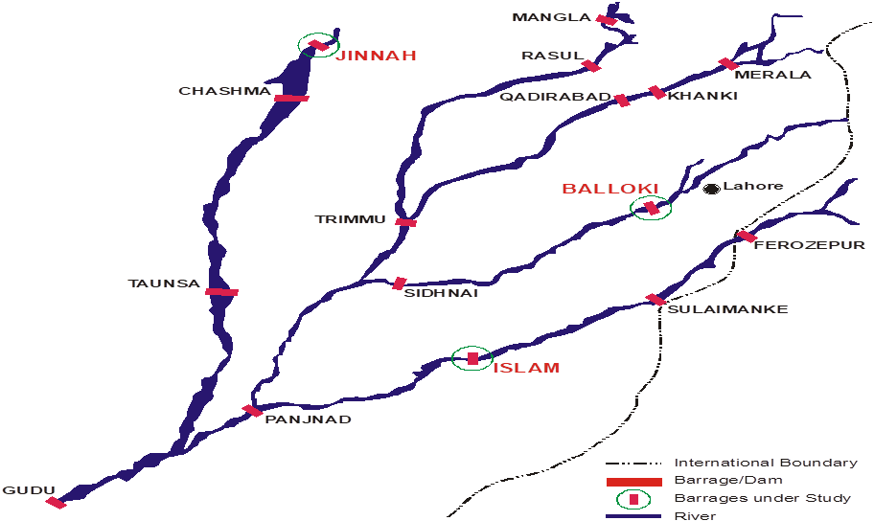

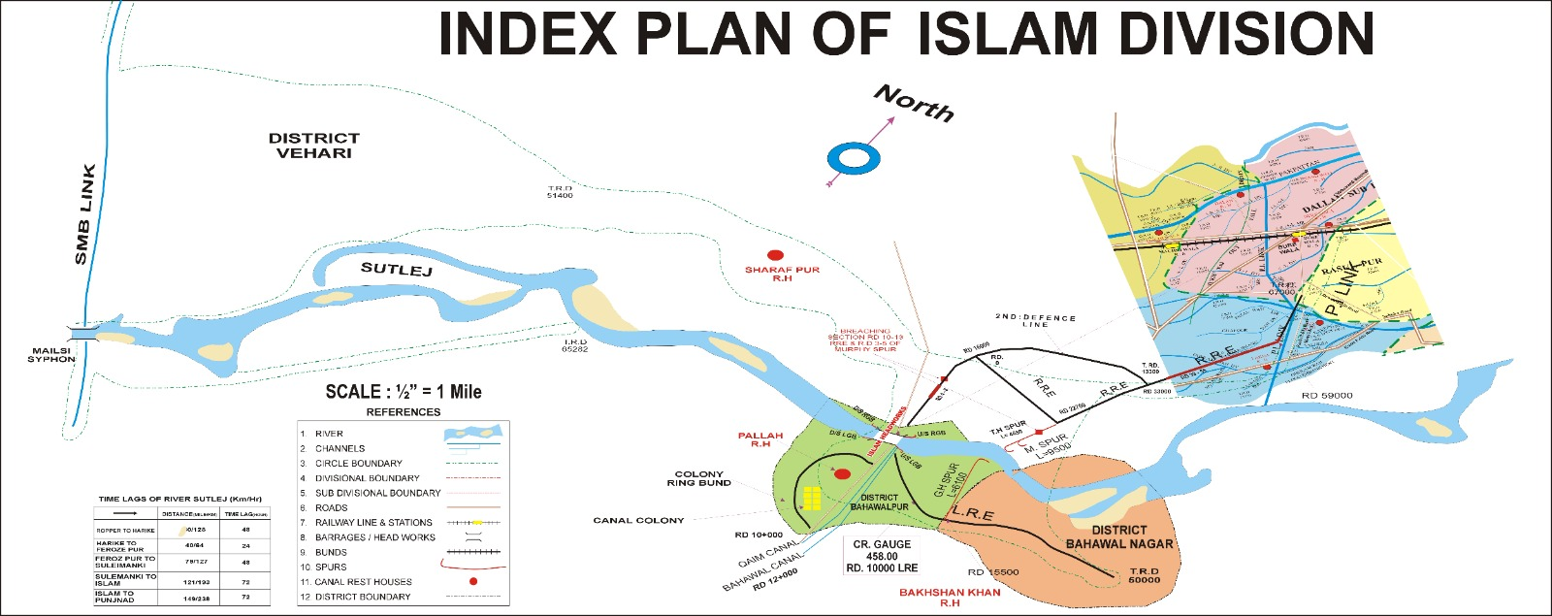

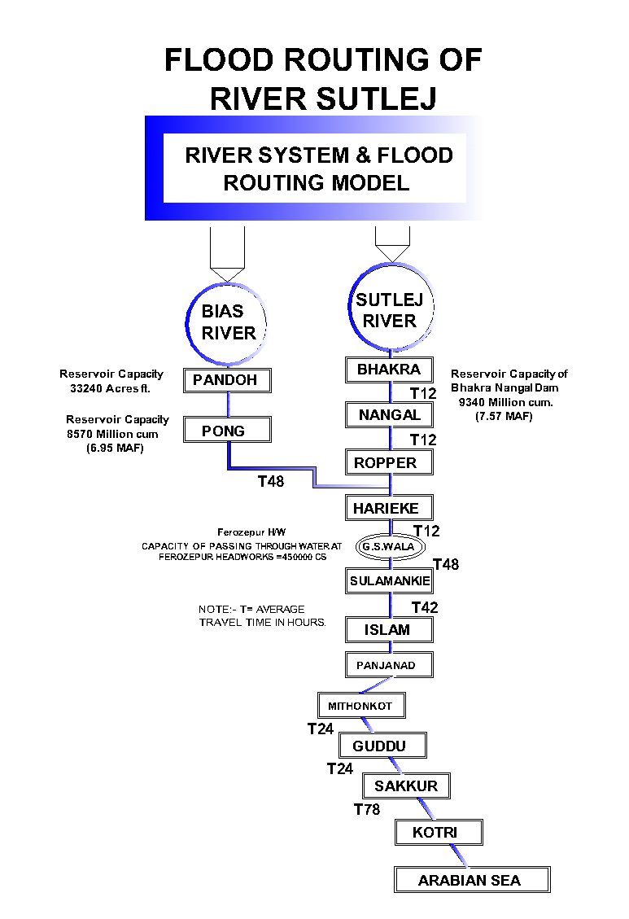

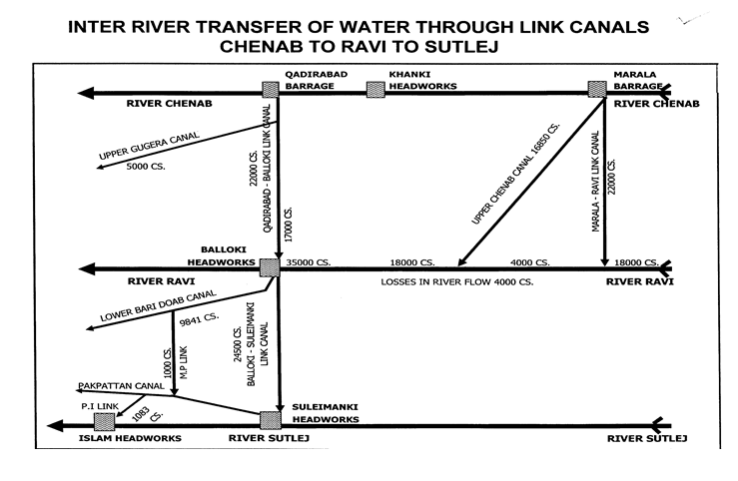

**Chapter - 3.**

**BRIEF HISTORY OF PAST FLOOD EVENTS.**

This Head works experienced maximum flood, shown as under:-

|  |  |  |  |  |
| --- | --- | --- | --- | --- |
| **Year** | **Through Weir**  **(Cusecs)** | **Through Breaches**  **in flood Embankments (Cusecs)** | **Total (Cusecs)** | **Remarks** |
| 1955 | 342851 | 150000 | 492581 | Exceptionally High Flood |
| 1988 | 306426 | 150000 | 456426 | Exceptionally High Flood |
| 1992 | 182637 | NIL | 182637 | Very High Flood |
| 1995 | 183902 | NIL | 183902 | Very High Flood |
| 2023 | 151904 | NIL | 151904 | High Flood |

**Chapter – 4**

**DESIGN DATA, HISTORIC PEAK FLOOD DATA AND PREVIOUS FIVE YEARS FLOOD DATA OF HEAD WORKS / BARRAGES AND OR OTHER CONTROL POINTS**

**4.1 FLOOD LIMITS**

Flood limits of Islam Head works as approved by the Flood commission in its 72nd Meeting the limit as under:-

Upto 50000 Normal

50000 to 80000 Low Flood.

80000 to 120000 Medium Flood.

120000 to 175000 High Flood.

175000 to 225000 Very High Flood.

225000 and above Exceptionally High Flood

**4.2 TIME LAG STATEMENT OF SUTLEJ RIVER**

The time lag depends on many factors such as flood intensity weather Condition set, however approximate the time lags for the main stations on River Sutlej which experienced in past are given as below.

|  |  |  |  |
| --- | --- | --- | --- |
| **Sr.#** | **REACH** | **DISTANCE (Mile/Km)** | **TIME LAG (Hour)** |
| 01 | Ropper to Harike | 80/128 | 48 |
| 02 | Harike to FerozePur | 40/64 | 24 |
| 03 | FerozePur to Suleimanki. | 79/127 | 48 |
| 04 | Suleimanki to Islam | 121/193 | 72 |
| 05 | Islam to Punjnad. | 149/238 | 78 |

**DISCHARGE AT GANDA SINGH WALA**

|  |  |  |
| --- | --- | --- |
| **Sr. No.** | **Gauge at G.S. W. (Ft).** | **Discharge (Cs).** |
| 01 | 6.5 | 2000-2200 |
| 02 | 7.5 | 2500-3000 |
| 03 | 8.5 | 3500-4000 |
| 04 | 10.5 | 5500-6000 |
| 05 | 11.5 | 7000-8000 |
| 06 | 12.5 | 8900-10000 |
| 07 | 13.5 | 12000-14000 |
| 08 | 14.5 | 15000-17000 |
| 09 | 19.5 (low flood) | 65000-70000 |
| 10 | 21.5 (Medium Flood) | 140000-150000 |
| 11 | 23.5 (High Flood) | 275000-300000 |
| 12 | 25.5 (High Flood) | 325000-400000 |
| 13 | 26.5 (Exceptionally High Flood) | 450000-500000 |

* 1. **HIGHEST FLOODS**

|  |  |  |  |
| --- | --- | --- | --- |
| Sr. No | Year | DISCHARGE | |
| SULEMANKI HEADWORKS | ISLAM HEAD WORKS |
| 1 | 18-8-1955 | 5,50,000 Cs | 4,92,581Cs |
| 2 | 4-10-1988 | 5,01,000 Cs | 4,56,426 Cs |
| 3 | 24-08-2023 | 2,10,847 Cs | 1,49,266 Cs |

**4.4**

**PEAK DISCHARGES (2020-2024)**

|  |  |
| --- | --- |
| **YEAR** | **Islam Headworks**  **( Discharge cs)** |
| 18-09-2020 | 15151 |
| 18-09-2021 | 5221 |
| 23-07-2022 | 12501 |
| 26-08-2023 | 151904 |
| 18-08-2024 | 11145 |

**Chapter-5**

**FLOOD FIGHTING STRATEGY**

Through all precautionary measures are adopted before flood season to face any alarming situation at Islam Headworks, even then arrangements are necessary to avoid heavy damages and flood fighting strategy is adopted in such a way that flood water pass safely through Headworks, up to its limit.

***LOW FLOOD CONDITION: (50,000 Cs to 80,000Cs)***

In low flood, river water remains within the deep channel and does not cause any problem if regulation of gates is done as per rules. Watching establishment employed for this purpose will remain busy in removing jungle, filling gharas and porcupine holes if any.

***MEDIUM FLOOD CONDITION: (80,000 Cs to 120,000Cs)***

When water increases beyond Eighty thousand cusecs, it will start spreading on adjoining area. Then it becomes necessary to be vigilant and watching of bunds will be started to avoid any leakage from bunds. Sub Engineers will shift their camps to sites as per duty roaster. Hourly gauges and discharges will be conveyed to civil administration and flood warning centers to inform public accordingly.

***HIGH FLOOD CONDITION: (120,000 Cs to 175,000Cs)***

When river water enters into high flood range, Sub Divisional Officer Headworks will shift his camp at Islam to supervise staff working on LRE, RRE and allied spurs. In whole period, regulation will be done in such a way that silt deposit in front of canals may be washed D/S of the river to minimize silt entry in to canals. Silt contents in water will be checked thrice a day and if it exceeds the permissible limit, canals will be closed accordingly. Gauges of different sites especially gauge at RD 10 of LRE will be noted regularly and recorded. Executive Engineer will inform all agencies especially to civil administration as well as Army about flood situation in rising position.

***VERY HIGH / EXCEPTIONALLY HIGH FLOOD CONDITION: (175,000 Cs to 225,000Cs)/ (225,000 Cs and above)***

In case of very high flood or exceptionally high flood, meeting will be held in field office with Army and Civil Administration to face the situation. Two dozers will be kept ready at RD 10000 to 13000 RRE to cut off the road to pass the flood in case of activation of breaching section. When gauge RD 10000 of LRE touches level 458.00 and is found in rising position, it will be the duty of Executive Engineer to request Army for operation of breaching section for the safety of Headworks. When water subsides, the breaching sections will be closed (If operated) as soon as possible.

**DETAIL OF WORKS WHICH WILL BE EXECUTED IN THIS YEAR**

|  |
| --- |
| Rehabilitation Barrage started by PMO Barrages Lahore. |

1. **PROPOSED CAMPS TO FIGHT BACK ANY EVENTUALITY**

The detail of camps to be established by Islam Headworks Division along with SOPs is discussed below:-

|  |  |  |  |  |
| --- | --- | --- | --- | --- |
| **Sr.**  **No.** | **Description** | **In charge of Camp** | **Location of Camp** | **Contact No:** |
| 1 | CAMP  No. 1 | Muhammad Javed Rasool  (EXECUTIVE ENGINEER) | AT HEADWORKS | 0300-6882004 |
| 2 | CAMP  No. 2 | Muhammad Arshad  (SDO HEADWORKS) | RIGHT RETIRED EMBANKMENT  AT RD 34+000 | 0300-6302173 |
| 3 | CAMP  No. 3 | Zaka Ullah  (SDO P.I Link Sub Division) | LEFT RETIRED EMBANKMENT  AT RD 15+700 | 0308-4739117 |

***CAMP NO. 1***

**INCHARGE OF CAMP: Muhammad Javed Rasool**

Executive Engineer, Islam Headworks is overall in charge of Flood fighting activities at Islam Headworks. He will be available at Camp No. 1 and will keep close liaison with all other department like Civil Administration, Pak Army and Police etc. He will also control regulation at Barrage.

|  |  |  |  |  |  |
| --- | --- | --- | --- | --- | --- |
| **Sr. No.** | **Description** | **Incharge of Sub – Camp** | **Location of Sub – Camp** | **Contact No.** | **Area of Responsibility** |
| 1 | Sub  Camp – 1 | Mudasar Majeed | Headworks | 0300-4810231 | To watch the Hoisting Machinery of Headworks, Guide bunds and Colony Protection Bund. |
| 2 | Sub  Camp – 2 | Mujahid Hussain | Mechanical Section | 0300-9008535 | Lighting arrangement for Headworks and Breaching section with 2 No. Generators. |

***CAMP NO;2.***

**INCHARGE OF CAMP: SUB DIVISIONAL OFFICER HEADWORKS SUB DIVISION**

Sub Divisional Officer, Headworks Sub Division along with his three Sub Engineers will be in-charge of watching and operation of Right Retired Embankment from RD: 0+000-RD 67+000 including Murphy Spur, TH Spur and 2ndDefence Bund. He will camp at RD 34+000 of Right Retired Embankment. He will keep close liaison with his Executive Engineer and District Administration, Vehari. He will keep up dating about all flood activities, in his area of responsibility. He will supervise the sub camps of his 3 Sub Engineers according to need and necessity of the site. Probable sub camps of Sub Engineers will be at following vulnerable sites;-

**Detail of Sub – Camps.**

|  |  |  |  |  |  |
| --- | --- | --- | --- | --- | --- |
| **Sr. No.** | **Description** | **Incharge of Sub – Camp** | **Location of Sub – Camp** | **Contact No.** | **Area of Responsibility** |
| 1 | Sub Camp – 1 | Sajid Hafiz Sub Engineer Station Area Section | At RD 34+000 of RRE | 0300-  9444079 | RD 0+000 - RD 22+000, Murphy Spur and TH Spur. |
| 2 | Sub Camp – 2 | Mudassar Sub Engineer PI Link Section | RD 44+000 of RRE | 0300-4810231 | RD 22+000 – RD 44+000 and 2ndDefence bund |
| 3 | Sub Camp – 3 | Mudassar Majeed | RD 55+000 of RRE | 0300-4810231 | RD 44+000 - RD 67+000  RRE |

These Sub camp sites can be changed by the Sub Divisional Officer, In charge according to flood situation in consultation with XEN Islam. In charge Sub Divisional Officer will be responsible to ensure all requisite floods fighting material at flood camps in his charge and he will maintain a register of all vulnerable sites / points along with road maps, major villages/ towns and addresses of all notable from who me volunteers will be available to him. Further, he will work out requirement of machinery according to critical, points and shall ensure addresses of Govt. departments with contact No. and kind of machinery available with them. Further, he will prepare list of excavators and tractors available in his area of charge with address and contact No. of locals, so as same may be called upon on urgency. He will be responsible for prompt delivery of flood related available in his area of charge with address and contact No. of locals, so as same may be called upon on urgency. He will be responsible for prompt delivery of flood related activities at main flood camp established at Executive Engineer Islam Headworks Division Pallah office and high ups of the Department as well as District Administration. He will also submit proposals for any change be observed in his area for best interest in Govt: and public.

**CAMP NO: 3**

**INCHARGE OF CAMP: SUB DIVISIONAL OFFICER ISLAM HEADWORKS SUB DIVISION PALLAH**

Sub Divisional Officer, Sub Division, along with two Sub Engineers will be in charge of watching operation for Left Retired Embankment and GH Spur. He will camp at LRE bund RD: 15+700. He will keep close liaison with Executive Engineer and District Administration, Bahawalpur and Bahawalnagar for updating them regarding flood situation in his area of control. He will further establish Sub Camps of his Sub Engineers at following vulnerable points.

|  |  |  |  |  |  |
| --- | --- | --- | --- | --- | --- |
| **Sr. No.** | **Description** | **In charge of Sub – Camp** | **Location of Sub – Camp** | **Contact No.** | **Area of Responsibility** |
| 1 | Sub Camp – 1 | Aziz Ur Rehman Sub Engineer, Hydraulic Section | At RD 15+700 of LRE | 0306-7967839 | RD 0+000 – RD 25+000 LRE and GH Spur. |
| 2 | Sub Camp – 2 | Mujahid Hussain Sub Engineer, Mechanical Section | At RD 26+500 of LRE | 0300-9008535 | RD 26+500 – Tail LRE and GH Spur. |

The camp sites can be liable to change by Sub Divisional Officer, in consultation with XEN Islam as deemed fit according situation. He will further make arrangements as described in duties of in-charge of camp - 2.

**GENERAL**

All the Sub Divisional Officers, will keep a close liaison with the Executive Engineer, Islam Headworks Division Pallah. They are being responsible for respective jurisdiction and will take proper action to cope with the alarming situation. They will arrange communication of flood position. The flood gauges will be regularly recorded under their direct supervision for which the gauge reader will be employed on work charge basis as per requirement. The Sub Engineers will shift their camps along with their establishment, keeping in view the supply of channels in their respective sections.

**Executive Engineer,**

Islam Headworks Division,

Pallah

**Chapter-6**

**FLOOD DAMAGES RESTORATION WORKS**

**1. DETAIL OF FLOOD DAMAGES 2024**

|  |  |
| --- | --- |
| **Sr. No** | **NAME OF WORK** |
| No flood damage occurred in 2024. | |

**2. DETAIL OF WORKS WHICH ARE IN PROGRESS AS UNDER:-**

|  |  |
| --- | --- |
| **Sr. No** | **NAME OF WORK** |
| 1 | ***_____________NiL_______________*** |

**3. DETAIL OF WORKS FOR WHICH TENDERS CALLED:**

|  |  |
| --- | --- |
| **Sr. No** | **NAME OF WORK** |
| 1 | ---------------------NIL------------------ |

**4.**

|  |  |
| --- | --- |
| **Sr. No** | **NAME OF WORK** |
| **1** | Rehabilitation Barrage started by PMO Punjab Barrages Lahore. |

**Chapter-7**

**FLOOD FIGHTING / WATCHING ARRANGEMENT**

**7.1 Pre-Flood Arrangement**

**Flood Control Center /Wireless Communication**

A flood control center will be established in Divisional office Islam Headworks and responsible staff will be available round the clock. One base station high range wireless set will be installed in Regulation Building with Police Guard at Islam Headworks by the Police Department.2 Nos. mobile Motorola sets of 30 kilometer range will be installed in the vehicles of Executive Engineer, Islam Headworks Division Pallah, and Sub Divisional Officer, Headworks Sub Division to keep them vigilant all the time.

Three Nos. Mobile wirelesses set (hand set) will be provided under acute emergency during very high flood to be observed at different vulnerable points. These arrangements will be made well in time by the telecommunication wing of Police Department.

**Flood Warning System**

The flood warning gauges will be received from the following centers:-

* Flood Control center Lahore
* Sulemanki Headworks

Police wireless control is responsible to collect these gauges 3 hourly in case of high flood and above and 6 hourly in case of low flood to medium flood. These gauges will be conveyed to Irrigation flood warning center at Lahore and PMO Barrages Lahore. and will be supplied promptly to the Executive Engineer, Islam Headworks and Sub Divisional Officer Headworks Sub Division

**List of Local Contractors Falling In Breach Affected Area Holding Earth Moving Machinery Whose Services Can Be Availed In Wake of Immediate Flood Emergency**

|  |  |
| --- | --- |
| **Name of Govt. Contractor** | **Contact Number** |
| Zawar Hussain Shah | 0308-7284275 |
| Al Noor Traders | 0302-7245197 |
| Syed Ghous Shah | 0302-7943880 |

|  |  |
| --- | --- |
| **Name of Machinery Holders** | **Contact Number** |
| Zawar Shah | 0308-7284275 |
| Al Noor Traders | 0302-7245197 |
| Syed Ghous Shah | 0302-7943880 |

**Watching Arrangements**

During rainy / monsoon season, the organization of Islam Headworks Division Pallah will be very vigilant throughout the monsoon season. Work charge establishment will be employed from 15-6-2024 to 15-10-2024 to repair the rain cuts, removing sarkanda growth along flood bunds during moon soon period. Consequently, flood watching camps will be established at vulnerable points.

**Structure wise detail of Reserve Stock**

**(LAC CFT)**

|  |  |  |  |  |  |
| --- | --- | --- | --- | --- | --- |
| **Sr. No.** | **Name of Structure** | **Sanctioned Qty** | **Available Qty** | **Balanced Qty** | **Remarks** |
| 1 | L.G.B. Spur U/S | 1.25 | 1.04 | 0.21 | More than 80% quantity of stone is available to meet any critical situation. |
| 2 | L.G.B. Spur D/S | 1.25 | 1.04 | 0.21 |
| 3 | R.G.B Spur U/S | 1.25 | 1.04 | 0.21 |
| 4 | R.G.B Spur D/S | 1.25 | 1.25 | 0 |
| 5 | Murphy Spur | 1.50 | 1.08 | 0.42 |
| 6 | T.H. Spur | 1.50 | 1.25 | 0.25 |
| Total (Lac Cft) | | 8.00 | 6.70 | 1.3 |  |

* 1. **WATCHINGESTABLISHMENT**

Flood watching establishment will be employed as per limit of floods already fixed for various Magnitude of discharge in the river from 15 June to 15 October 2025 as per following:-

**A RIGHT RETIRED EMBANKMENT**

|  |  |  |
| --- | --- | --- |
| RD: 0+000 – 59+500 | 12 MILE | 4 Nos. Watchman for watching day |
| Watchmen Required | 12X4X3 | 144 No. |
| Mate Required | 1 No. | 144/8 |
| Beldars Required | 8 No. | 18 Nos. |

**B 2ND DEFENCE BUND**

|  |  |  |
| --- | --- | --- |
| RD: 0-11700 | 4 Nos. | per mile during day & night (Per shift i.e. for 8 hours) |
| Total Length | 11700 RFT | (11700/5000) = 2.34 |
| Watchman required | (2.34 x 4 x 3) | 28 Nos. |
| Mate required | 28/ 8 | 3 Nos. |

**C MURPHY SPUR**

|  |  |  |
| --- | --- | --- |
| RD: 0-9500 | 2 Nos. | per mile during day & night (Per shift i.e. for 8 hours) |
| Total Length | 9500 RFT | (9500/5000) = 1.9 |
| Watchman required | (1.9 x 2 x 3) | 11 Nos. |
| Mate required | 11/ 8 | 1 No. |

**D T. HEAD SPUR**

|  |  |  |
| --- | --- | --- |
| RD: 0-4650 | 2 Nos. | per mile during day & night (Per shift i.e. for 8 hours) |
| Total Length | 4650 RFT | (4650/5000) = 0.93 |
| Watchman required | (0.93 x 2 x 3) | 5 Nos. |
| Mate required | 5/ 8 | 1 No. |

**E LEFT RETIRED EMBANKMENT**

|  |  |  |
| --- | --- | --- |
| RD: 0-50000 | 3 Nos. | per mile during day & night (Per shift i.e. for 8 hours) |
| Total Length | 50000 RFT | (50000 /5000) = 10.0 |
| Watchman required | (10x 3 x 3) | 90 Nos. |
| Mate required | 90 / 8 | 11 Nos. |

**F G.H. SPUR**

|  |  |  |
| --- | --- | --- |
| RD: 0-6100 | 2 Nos. | per mile during day & night (Per shift i.e. for 8 hours) |
| Total Length | 6100 RFT | (6100/5000) = 1.22 |
| Watchman required | (1.22 x 2 x 3) | 7 Nos. |
| Mate required | 7 / 8 | 1 No. |

**G LEFT GUIDE BUND**

|  |  |  |
| --- | --- | --- |
| RD: 0-3850+920 = 4770 | 4 Nos. | per mile during day & night (Per shift i.e. for 8 hours) |
| Total Length | 4770 RFT | (4770 /5000) = 1 |
| Watchman required | (1x 4x 3) | 12 Nos. |
| Mate required | 12/ 8 | 2 Nos. |

**H RIGHT GUIDE BUND**

|  |  |  |
| --- | --- | --- |
| RD: 0-3850+920 = 4770 | 4 Nos. | per mile during day & night (Per shift i.e. for 8 hours) |
| Total Length | 4770 RFT | (4770 /5000) = 1 |
| Watchman required | (1x 4x 3) | 12 Nos. |
| Mate required | 12/ 8 | 2 Nos. |

**I COLONY PROTECTION BUND**

|  |  |  |
| --- | --- | --- |
| RD: 0-3850 = 3850 | 4 Nos. | per mile during day & night (Per shift i.e. for 8 hours) |
| Total Length | 3850RFT | (3850/5000) = 0.77 |
| Watchman required | (0.77x4x 3) | 10 Nos. |
| Mate required | 10 / 8 | 2 Nos. |
| Gauge Reader required | One No. for per shift | 3x3 = 9 Nos. |
| Chowkidars required | One No. per site for day & one for night | 6x2 = 12 Nos. |

**7 Watching Establishment for Spurs will be arranged at the following scale.**

|  |  |  |  |  |  |  |
| --- | --- | --- | --- | --- | --- | --- |
| **Period Flood range**  15.6.2025 to 15.10.2025 (Normal Maintenance) | **Murphy Spur** | | **T.H Spur** | | **G.H Spur** | |
| **Men** | **Shift** | **Men** | **Shift** | **Men** | **Shift** |
| Low flood | 1 | 3 | 1 | 3 | 1 | 3 |
| Medium flood | 4 | 3 | 4 | 3 | 4 | 4 |
| High flood | 6 | 3 | 6 | 3 | 6 | 3 |
| Very high flood | 8 | 3 | 8 | 3 | 8 | 3 |
| Exception all high flood | 12 | 3 | 12 | 3 | 12 | 3 |

Note: -

Payment for machinery and work charge employee subject to verification of TPM Nespak Consultant.

**Executive Engineer,**

Islam Headworks Division,

Pallah.

* 1. **ARRANGEMENT AT SENSITIVE SITES**

1. The normal strength for watching at sensitive sites along flood protection and River training works will be doubled during high flood / exceptionally high flood.
2. The establishment can be increased after consultation with Executive Engineer, Islam Headworks Division Pallah / Superintending Engineer, Bahawalpur Canal Circle, Bahawalpur in emergency & in accordance with site requirements. The same establishment will be responsible for maintenance of flood bunds and Spurs Shank etc. during flood season 2025. It will arrange Minor repairs to bank top, side slopes, removal of Sarkanda etc. as shanks and on pitched part of spurs.

**Executive Engineer,**

Islam Headworks Division,

Pallah.

.

7.4 **WATCHING MATERIAL**

|  |  |  |  |  |  |  |
| --- | --- | --- | --- | --- | --- | --- |
| **Sr. No.** | **Name of Article** | **Quantity Required** | **Quantity available** | **Balance** | **Unit** | **Remarks** |
| 1 | Kassies with handles | 20 | 20 | - | No | Balance quantity will be procured before starting of flood season  2025. Subject to approval of Competent Authority. |
| 2 | Handle for Kassies (Extra) | 50 | 50 | - | No |
| 3 | Baskets | 50 | 50 | - | No |
| 4 | Axes | 6 | 6 | - | No |
| 5 | Gunny Bages | 1000 | 1000 | - | No |
| 6 | Plastic bags | 1000 | 1000 | - | No |
| 7 | Sutli | 5 | 5 | - | Kg |
| 8 | Killas | 150 | 0 | 150 | No |
| 9 | WoddenMallats | 10 | 0 | 10 | No |
| 10 | Bomboos | 500 | 250 | 250 | No |
| 11 | MunjTrangers | 1000 | 300 | 700 | No |
| 12 | Lanterns | 10 | 50 | - | No |
| 13 | Wick for lanterns | 10 | 0 | 10 | Rft |
| 14 | Kerosene oil | 50 | 0 | 50 | Liters |
| 15 | Generator | 1 | 4 | - | No |
| 16 | Petrol for Generator | 200 | 0 | 200 | No |
| 17 | Energy saver 85 watt | 4 | 16 | - | No |
| 18 | Energy saver 25 watt | 10 | 30 | - | No |
| 19 | Patro Lamps | 2 | 2 | 0 | No |
| 20 | Mantal for lamps | 2 | 0 | 2 | Dozen |
| 21 | Needles | 1 | 0 | 1 | Dozen |
| 22 | Chimney for Gas lamp | 50 | 0 | 50 | No |
| 23 | Torches three cells | 5 | 15 | - | No |
| 24 | Shouldari | 1 | 7 | - | No |
| 25 | Tents | 1 | 2 | - | No |
| 26 | G.I.Buckets | 6 | 12 | - | No |
| 27 | Iron Charpies | 2 | 10 | - | No |
| 28 | Steel chairs | 3 | 24 | - | No |
| 29 | Table | 1 | 0 | 1 | No |
| 30 | Wire / Cable 3/29 | 4 | 3 | 1 | Coil |
| 31 | Water Set | 1 | 0 | 1 | No |
| 32 | Synthetic bags with a capacity of 500 kg | 100 | 0 | 100 | No |
| 32 a | Synthetic bags with a capacity of 1000 kg. | 100 | 0 | 100 | No |
| 33 | Polythene sheets of black color 15’ wide. | 5000 | 0 | 5000 | Rft |

* 1. **ARRANGEMENT FOR SOUNDING AND PROBING.**

In case of any situation on flood protection and River training works, sounding and probing arrangement will be made.

* 1. **LIGHTING ARRANGEMENT**

**Lighting material available each camp as under:-**

1 Wire crates 0 No.

2 Lanterns 10 No.

3 Wick for lanterns 10 Rft

4 Kerosene oil 50 Liters.

5 Generator 1 Nos.

6 Petrol for Generator 50 Liter.

7 Energy saver 85 watt 4 Nos.

8 Energy saver 25 watt 10 Nos.

9 Petro Lamps 2 Nos.

10 Mental for lamps . 2 Dozens

11 Needles 1 Dozens

12 Chimney for Gas lamp 50 Nos.

13 Torches three cells 5 Nos.

* 1. **RATION ARRANGEMENT**

The area on right side of Sutlej River falls in District **Vehari**. The area on Left side of Sutlej River is situated in two Districts i.e. **Bahawalnagar** and **Bahawalpur.** In case of high flood in Sutlej River, a separate evacuation plan has been prepared by the concerned Distract Administration and Food department shall mobilize their sources for supplying food for Human fodder for livestock will be provided by respective livestock Department.

* 1. **P.O.L ARRANGEMENT FOR VEHICLE**

P.O.L facilities / arrangement will be made by the Irrigation Department as well as Civil Administration.

* 1. **TRANSPORTATION**

Transportation facilities will be provided by the Civil Authorities

* 1. **LAW AND ORDER**

Law and order situation will be tackled by the Civil Administration with the help of Police Department.

* 1. **MEDICAL ARRANGEMENT FOR LABOUR**

Health Department will be responsible for mobilizing their sources to carry out necessary operation for providing medical facilities to the labor.

* 1. **LIAISON WITH OTHER DEPARTMENT**

All the flood protection and river training works will be inspected during the month of May so as to identify weak points and if necessary, after repairing such sites, the certificate regarding hydraulic fitness of bunds will be submitted. The Flood embankments are inspected by a committee constituted by the Secretary Irrigation Department in May every year. Fitness of bunds is ensured before the flood season; keeping in view the priorities are fixed according to resources.

The Executive Engineer, Islam Headworks Division Pallah, has to perform following functions within his administrative jurisdiction.

1. Periodic review of structural integrity of flood infrastructure over Sutlej River in order to ensure that no breach occurs in the event of heavy discharge of water. The Executive Engineer will share his observations with his supervisory officers as well as District Administration well before on set of flood season for necessary action.
2. Identification of vulnerable points on River training works and flood protection works where breach could occur and specification of locations for positioning of requisite machinery / material near the vulnerable points.
3. Maintenance and repair to flood protection and river training works infrastructures with District Administration.
4. Joint inspection of Flood protection infrastructure with District Administration.
5. Collection and sharing of information on discharge of water in Sutlej River with the military authorities as well as District Administration on daily basis.
6. Collection of information on discharge of water, from monitoring check points on control center at Suleimanki Headworks.
7. Improvement of existing well / gauges used for determination of water discharge (Cs) in Sutlej River.
8. Development of more effective early warning system.
9. Liaison with flood forecasting center Lahore, for collection of flood related information.
10. Briefing of authorities concerned on Flood protection arrangements and development of an integrated departmental strategy, to be able to combat any situation during Floods.
11. Stock piling of essential articles to combat any flood related contingency and arrangements of sufficient funds beforehand, for such purposes.
12. Arrangements of labor along with machinery / equipment for proper maintenance of the vulnerable points on flood protections arrangements.
13. Identification of points on road or otherwise, where breaches / cuts are required to be made to further facilitate discharge of water in order to avert larger catastrophe.
14. Ascertainment of extent of damage caused to the protection bunds and other installation after flood water subsides.
15. Initiation of criminal proceeding against elements involved in will full breach in flood protection arrangements on any canal, without consent of competent authority.
16. Assistance and coordination in emergency repair of public service.
    1. **ROLE OF THE ARMY**

31-Engineer Corp Bahawalpur will perform activities to fight flood emergency During Flood 2024.

* 1. **DUTY OF TELEPHONE ATTENDANT**

The duties of telephone attendant for apprising the Department / Civil Administration about the flood situation during the rain / flood season i.e. 15-6-2025 to 15-10-2025. Bit detail is as under:-

|  |  |  |  |
| --- | --- | --- | --- |
| **S.#** | **Shift** | **Duty staff** | **Time** |
| 1 | General shift | Ghulam Hussain SDC | 8.00 AM to 3.00 PM |
| 2 | Shift No 1 | Afaq Ahmad Junior Clerk. | 3.00PM to 10.00 PM |
| 3 | Shift No 2 | Syed Naeem-ul- Hassan Camp Clerk | 10.00PM to 8.00 AM |

* 1. **WIRELESS ARRANGEMENTS**

Wireless system / arrangement will be made for the vehicles under use of Officers of Islam Headworks Division Pallah during the period of 15-6-2025 to 15-10-2025.

**Executive Engineer,**

Islam Headworks Division,

Pallah.

**CHAPTER-8**

**Detail of Encroachment**

There is no encroachment on water ways in the jurisdiction of Islam Headworks Division Pallah which may hinder the smooth flow of flood water.

|  |  |  |  |  |
| --- | --- | --- | --- | --- |
| **Sr.**  **No.** | **Total Encroachments** | **Removed** | **Remaining** | **Remarks** |
| **1** | NIL | - | NIL | . |

**Executive Engineer,**

Islam Headworks Division,

Pallah

**Detail of Critical Encroachment**

|  |  |  |  |  |
| --- | --- | --- | --- | --- |
| **Sr.**  **No.** | **Total Critical Encroachments** | **Removed** | **Remaining** | **Remarks** |
| **1** | NIL | - | NIL |  |

**Executive Engineer,**

Islam Headworks Division,

Pallah

**Chapter-9**

**DUTY ROSTER / FLOOD FIGHTING PROGRAM**.

Duty Roster for main Flood control center Divisional office at Islam Headworks and connected with Phone No. 0300-7725695. Overall in charge of Flood warning center at Division level Head Clerk of this Division.

|  |  |  |  |
| --- | --- | --- | --- |
| **S#** | **Shift** | **Duty staff** | **Time** |
| 1 | General shift | Ghulam Hussain SDC. | 8.00 AM to 3.00 PM |
| 2 | Shift No 1 | Muhammad Afaq Ahmad Junior Clerk. | 3.00 PM to 10.00 PM |
| 3 | Shift No 2 | Syed Naeem-UL-Hassan Camp Clerk | 10.00 PM to 8.00 AM |

Staff of Islam Headworks Division Pallah, looking after flood protection/ River training works and canal network falling in the jurisdiction of Islam Headworks Division Pallah, has to be very vigilant throughout the monsoon season and set on alert during day and night from 15 June up to 15 October. The flood watching camps will be established with the onset of monsoon season at vulnerable points with adequate materials and arrangements to cope with any flood/rain emergency. The concerned Sub Divisional officers are responsible for reporting about any mishap to the Executive Engineer, Superintending Engineer, Chief Engineer and Secretary Irrigation. It is also the duty of Sub Division officer to deliver written messages well in time to the District Administration concerned about the flood/ weather forecast, flood situation and any other mishaps.

|  |  |  |  |  |
| --- | --- | --- | --- | --- |
| **Sr.**  **No.** | **Description** | **In charge of Camp** | **Location of Camp** | **Contact No:** |
| 1 | CAMP No. 1 | Muhammad Javed Rasool  (Executive Engineer) | AT HEADWORKS | 0300-6882004 |
| 2 | CAMP No. 2 | Muhammad Arshad  (Sub Divisional officer Headworks) | Right Retired Embankment  at RD 34+000 | 0300-6302173 |

Additional daily labor will be engaged as and when necessary, according to requirement. Sub Engineers will assist the Sub Divisional Officers at their area of responsibility mentioned above.

An additional strength of nearly 300 voluntary laborer's is required to be made available by the concerned Assistant Commissioner in case of emergency on each bund / river training works.

These labors will be arranged from adjoining cities, town, villages & abadies. One Assistant Sub Inspector of Police with four Constables are required to be made available for arranging voluntary labors on above mentioned sites and to assist in watching operation as and when required. Sub Divisional Officers Headworks and PI Link Sub Division will maintain close liaison with Civil Administration District Vehari, Bahawalnagar& Bahawalpur and keep them informed about the rain / flood position on bunds / spurs and channels and ask them for voluntary labor as and when required. They will also make arrangement for the stores required at camp sites.

Sub Divisional Officer will also inform the Civil Administration for any flood / rain emergency and damages. Civil Administration and revenue field staff will facilitate the evacuation of the area likely to be submerged due to spillage of River Sutlej.

Similarly, Health Department, Live Stock and Dairy Development Department will also mobilize their resources for carrying out necessary operation for the health hazard likely to be created by the rains / flood for human and livestock. Food Department will be responsible to cater for food requirement of flood / rain affected people. Police and revenue staff will coordinate the staff of Islam Headworks Division for the purpose of timely evacuation of the public.

Communication & works Department (Highways Division Vehari, Bahawalnagar & Bahawalpur ) will control over the bridges and other road network well before then set of monsoon season to provide free without interruption, speedy disposal of storm / flood water.

WAPDA staff will also be required to be very vigilant in case of floods / rains to take care against accidents and break downs in the affected areas.

**Executive Engineer,**

Islam Headworks Division,

Pallah**Chapter – 10**

**Emergency Telephone Nos.**

|  |  |  |  |
| --- | --- | --- | --- |
| **Sr.#** | **Name of Officers** | **Office** | **Residence** |
| 1 | Secretary Irrigation Department Lahore. | 042-99212117  042-99212118 | 042-99200950 |
| 2 | Additional Secretary Technical Irrigation department Lahore. | 042-99212128 | 042-5170035 |
| 3 | Chief Monitoring (PMIU) Lahore. | 42-99213595  42-99213597 | Toll Free No.  080011333 |
| 4 | Chief Engineer Drainage & Flood Lahore | 042-99230602 | 042-99239044 |
| 5 | Chief Engineer Irrigation Multan. | 061-9200144 | 0313-9190684 |
| 6 | Chief Engineer Irrigation Bahawalpur | 062-9250333 | 0301-6714174 |
| 7 | Superintending Engineer Bahawalpur Canal Circle, Bahawalpur. | 062-9250300 | 0322-4153448 |
| 8 | Director Flood Lahore | 042-99231614 | 042-35080267 |
| 9 | Deputy Director Flood Lahore | 042-35880700 | - |
| 10 | Flood Warning Center Lahore. | 042-99205157 | 042-99205158 |
| 11 | Flood Control Center Vehari. | 067-3362122 | 067-3363477 |
| 12 | Executive Engineer Islam. | **0673-024990** | **0300-6882004** |
| 13 | Executive Engineer Operation Bahawalpur Zone | 062-9250333 | 0300-9544773 |
| 14 | Executive Engineer Suleimanki. | 0444-4780155 | 0333-8082206 |
| 15 | Sub Divisional Officer Islam Headworks | **0673-024990** | 0300-6302173 |
| 16 | Sub Engineer, Headworks. | **-** | **0300-4810231** |
| 17 | Sub Engineer, Station area. | **-** | **0300-9444079** |
| 18 | Telegraph Office Islam. | 0673-024990 | 0300-7725695 |
| 19 | Sub Engineer, Hydraulic | **0306-7967839** | **0306-7967839** |
| 20 | Sub Engineer, Mechanical | **0300-9008535** | **0300-9008535** |

**DISTRICT ADMINISTRATION VEHARI**.

|  |  |  |  |
| --- | --- | --- | --- |
| **Sr.#** | **Address** | **Office** | **Residence** |
| 1 | Deputy Commissioner Vehari | 067-3662122  067-3363488  Fax:067-3363688 | 067-3363477 |
| 2 | Commissioner Bahawalpur | 062-9250061 | 062-9250538 |
| 3 | Deputy Commissioner Bahawalpur | 062-9250492 | 062-9250063 |
| 4 | Deputy Commissioner Bahawalnagar | 063-9240201 | 063-9240201 |
| 5 | Additional District Collector Revenue Vehari | 067-3364063 | 067-3360347 |
| 6 | Distt: Police Officer Vehari. | 067-3363244 | 067-3363246 |
| 7 | Distt: Police Officer Bahawalpur. | 062-9250364 | 0622730200 |
| 8 | D.S.P. Hasilpur | 062-2442836 | 0300-6762806 |
| 9 | D.H.O Vehari | 067-3362195 | 067-3362195 |
| 10 | District Officer Agri Vehari  Deputy Director Agri Multan | 067-3362603  061-9201185 | 067-3363570 |
| 11 | O.C. 31 -Engineering corp. at Bahawalpur | - | - |

**Chapter - 11**

**STANDARD OPERATING PROCEDURE (SOP) FOR BREACHING SECTIONS**

**11.1 DESCRIPTION**

There are two breaching sections

1. At RD 10+000 to 13+000 of Right Retired Embankment having 220 liners.

2. At RD 3+000 to 5+000 of Murphy Spur having 220 liners.

**11.2 OPERATION OF BREACHING SECTION:-**

Breaching section will be operated when

1. Gauges at Rd 10+000 of LRE touches critical level 458.00 and found in rising position OR

2. Discharge through Headworks reaches 3.00 Lac Cs. whichever is earlier.

**11.3 LOCATION, DESIGN, QUANTITY AND VARIETY OF THE EXPLOSIVE REQUIRED FOR DETONATION.**

The explosive is lying with O.C. 31-Engineering corp at Bahawalpur is as under:-

|  |  |  |  |  |  |
| --- | --- | --- | --- | --- | --- |
| **S. No.** | **Article** | **Unit** | **Qty Required** | **Qty Available** | **Deficient Qty** |
| 1. | Wabox | Kg | 4416 | 4416 | The explosive material is lying in custody of O.C. 31 -Engineering Corp at Bahawalpur.No deficiency in explosive material has been declared by Army authorities up till now. |
| 2. | Wobonite | Kg | 7481 | 7481 |
| 3. | Wabo Card | Meter | 6850 | 6850 |
| 4. | DET No 8 Electric | No. | 53 | 53 |
| 5. | M.S Electric Delay D.T | No. | 12 | 12 |
| 6. | Safety fuse | Meter | 322 | 322 |
| 7. | Detonator No 2 | No. | 6 | 6 |
| 8. | Det No 8 plan | No. | 17 | 17 |
| 9. | E-I Cable | Meter | 1980 | 1980 |
| 10. | Det No 8 plan | No. | 40 | 40 |
| 11. | Electric Detonator 25 Mili Sec | No. | 10 | 10 |
| 12. | Det instant | No | 158 | 158 |
| 13. | Det 25 Micro | No. | 80 | 80 |

**11.4 ARRANGEMENT OF EXPLOSIVES AND SECURITY OF EXPLOSIVE STORES.**

The explosive store is lying at Bahawalpur Cant in safe custody of O.C. 31 -Engineering corps at Bahawalpur.

**11.5 LIST OF SECURITY STAFF ALONGWITH DETAIL OF THEIR TRAINING ETC.**

No need as the explosive is lying with O.C. 31-Engineering corps at Bahawalpur.

**11.6 DETAIL OF MECHANICAL MEANS AS A STAND BY ARRANGEMENT IN CASE OF DETONATION FAILURE.**

Breaching section will be operated with the help of dozer and excavator Machine.

**11.7 DUTY ROSTER IN CASE OF CRITICAL SITUATION.**

Detail of roster is as under:-

|  |  |  |  |  |  |
| --- | --- | --- | --- | --- | --- |
| **Sr. No.** | **Description** | **In charge of Sub – Camp** | **Location of Sub – Camp** | **Contact No.** | **Area of Responsibility** |
| 1 | Sub Camp – 1 | Sajid Hafeez Sub Engineer Station Area Section | At RD 34+000 of RRE | 03009444079 | RD 0+000 - RD 34+000, Murphy Spur and TH Spur. |
| 2 | Sub Camp – 2 | Mudassar Majeed Sub Engineer Headworks Section | RD 44+000 of RRE | 03004810231 | RD 28+000 – RD 67+000 and 2nd Defense bund |

**11.8 BREACHING COMMITTEE WITH THEIR ACTION PLAN.**

|  |  |
| --- | --- |
|  | Action to be taken by |
| The flood warning at Islam Headworks is received from Suleimanki Headworks downstream through wireless installed or otherwise on telephone etc. The flood condition of the dams and Headworks on Sutlej in India is also received through Flood Warning Center Lahore. On receipt of flood warning about the stages of flow below Suleimanki Headworks the District Coordination Officer Vehari / Bahawalpur and Army Engineer Battalion will be informed by the Executive Engineer / SDO Islam Headworks to coop with the flood situation close liaison will be kept by the committee members during the flood emergency. The Chief Engineer Irrigation Bahawalpur Zone will also be kept informed about the flood regularly.  Notification notified by the Secretary Irrigation Department Lahore vide No. SO (FLOOD) VI-33/97 dated 15-7-2015   1. Responsibility for maintenance and operation of each breaching section shall rest upon the department owing the structure at which the breaching section is located. 2. Breaching section shall be operated on the order of following committee:- 3. District Coordination officer, Vehari (Convener) 4. District Coordination Officer Bahawalpur. 5. Executive Engineer, Islam Headworks Division Pallah. 6. Executive Engineer, C&W Department Vehari. 7. Lt. Col. 31-OC Corp Bahawalpur.   This committee will activate the breaching section.  Breaching section will be operated by the Army Unit in the presence of Executive Engineer Islam and Member of the breaching section. Breaching will be done by exploding the bank. Two number dozers will however, be kept ready as stand by arrangement for breaching Right Retired Bund at the breaching site. 50 No. Kassi labor will also help for speedy operation and activation of the breaching section. The dozers will be arranged through requisition from the Agriculture Department District Vehari and labor will be hired locally. | The decision to operate a breaching section shall be taken by the committee keeping in view the technical advice of the Executive Engineer, concerned of the Irrigation Department. In case of any difference of opinion among the members the final decision shall rest with the District Coordination Officer.  In case of unavailability of the District Coordination Officer or his inability to take decision or in case of a difference opinion between the District Coordination officers of the District in which the breaching section is located and the district which is likely to be affected by the operation of the breaching section, the decision to operate a breaching section shall be taken by the respective Commissioner;  Breaching section shall be operated when one or more of the following conditions are met:-   1. The discharge capacity of the structure for which breaching section is located is exceeded and the safety of structure is threatened; 2. The critical gauge as indicated in the relevant Flood Fighting Plan is achieved or achieved or exceeded and is rising; 3. The safety of major population center (s) is threatened due to high flood levels and in view of the Executive Engineer concerned of the Irrigation Department, operation of breaching section can help in reduction of flood levels.   Where, in view of the Executive Engineer, concerned of the Irrigation Department or the representative of the Department owning the structure at which the breaching section is located, the aforesaid criteria is expected to be met after due consideration of all available technical and hydrological conditions, the aforesaid committee may operate the breaching section before the critical gauges is achieved or exceeded. In every such case, the view of the Executive Engineer concerned of Irrigation Department or the Representative of the department owing the structure shall be expressed in writing and shall be based on flood forecast by Pakistan meteorological Department or other reliable sources, the trend of discharges in the relevant river at upstream location, the lag times, estimated attenuation and expected in flows form tributaries, naulahs and streams en-route. Where advance breaching planned, the committee may also consult professional Experts and seek advice from the Superintending Engineer, or chief Engineer, concerned of the Irrigation Department.  Breaching section shall be operated by the contingent deputed by the Engineering in Chief, Pakistan Army as indicated in the Flood fighting plan Explosive method shall be the preferred method for breaching section. However, the department owing the structure on which the breaching section is located, and in case of their failure to do so, Irrigation Department shall make available, in advance necessary earth moving machinery and other equipment for affecting the breach through mechanical means in the shortest possible times.  The District Coordination Officer, concerned and all other relevant agencies shall ensure all necessary arrangements for the safety and if required evacuation of population likely to be effected by the operation of breaching section. |

**11.9 LIST OF THE VILLAGE LIKELY TO BE INUNDATED IN CASE OF BREACH.**

Mouza kot Muhammad Husain, Mouza Dadu kamer, Mouza Bunga Azam , Mouza Todar Kot Hakim Ali Tajwan, Mouza Luddan. Mouza Shah Zakira, Mouza Alauddin,

**11.10 ANNOUNCEMENT AND DETAIL OF EVACUATION ARRANGEMENTS.**

Announcement & Evacuation of flood affected people will be responsibility of Civil Administration District Vehari.

**11.11 DETAILS OF COORDINATION WITH CIVIL / ARMY AUTHORITIES.**

Executive Engineer Islam Division Pallah will keep liaison with the Civil and Army Authorities and will also keep the Deputy Project Director fully apprised of the flood situation in Islam Division Pallah.

**11.12 PARALLEL COMMUNICATION ARRANGEMENTS.**

Communication arrangement through PTCL, Mobile phone, E-mail through internet and wireless set installed in vehicles by Police Department.

**11.13 Index Plan**

**Index Plan of Breaching Sections Attached.**

**Executive Engineer,**

Islam Headworks Division

,Pallah.

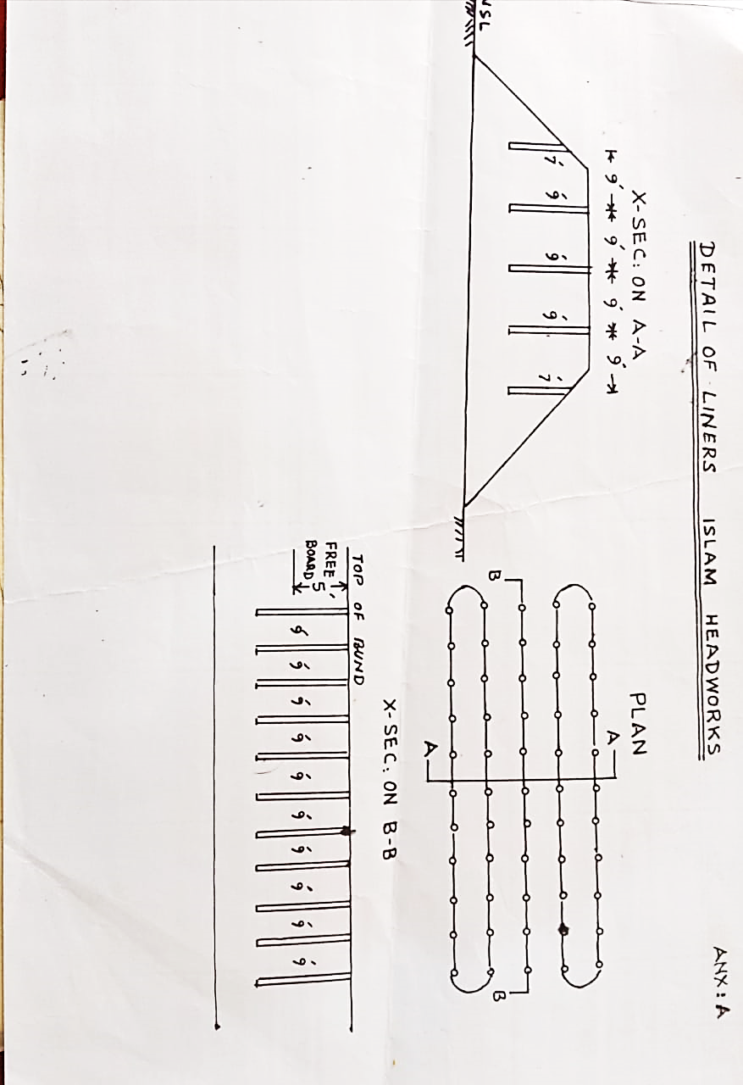**DETAIL OF BREACHING SECTIONS AND LINERS**

**PART-B**

**Chapter – 12**

**VULNERABLE SITES ON FLOOD BUND/ STRUCTURES**

**12.1 APPREHENDED BREACHES IN FLOOD BUNDS / STRUCTURES.**

**DETAIL GIVEN AS UNDER:-**

|  |  |  |  |
| --- | --- | --- | --- |
| **Sr**  **No.** | **Name of Structure** | **Location of vulnerable site** | **Reference of contingency plan** |
| **1** | Right Retired Embankment | 33+000 to 57+000 | Old breach during 1988 |

**Chapter-13**

**EMERGENCY CONTINGENCY PLAN FOR VULNERABLE SITE**

**SITE NO.1RIGHT RETIRED EMBANKMENT FROM RD 33+000-RD 57+000.**

**13.1 PLAN SHOWING ROUTE OF FLOOD WATER COMING OUT OF**

**THE BREACHSUPPORTED WITH LEVELS.**

**(PLAN ATTACHED ON PAGE No. 49)**

**13.2 DETAIL OF VILLAGE ABADIES LIKELY TO BE AFFECTED AND THIS SHOULD ALSO BE SHOWN ON THE PLAN.**

Mouza Kot Muhammad Hussain Mouza Dadu Kameer Mouza Bunga Azam Mouza Todar. Mouza Kot Muhammad Ali Tajwan. Mouza Luddan Mouza Shah Zakiria. Mouza Khan Sar Mouza Alauddin

**13.3 STRATEGY AND ACTION TAKEN BE EXPLAINED IN DETAIL THIS MAY INCLUDE.**

Though all precautionary measures are adopted before flood season to face any alarming situation at Islam Headworks, even then arrangements are necessary to avoid heavy damages and flood fighting strategy is adopted in such a way that flood water passes safely through Headworks, up to its limit.

In low flood, watching establishment employed for this purpose will remain busy in removing jungle, filling gharas and porcupine holes if any.

When water increases beyond Eighty thousand cusecs then it becomes necessary to be vigilant and to avoid any mishap. Sub Engineers will shift their camps to sites as per duty roaster.

When river water enters into high flood range, Sub Divisional Officer Headworks will shift his camp at Islam to supervise staff working on LRE, RRE and allied spurs and whole period regulation will be done wisely.

Gauges of different sites especially gauge at RD 10 of LRE will be noted regularly and recorded. Executive Engineer will inform all agencies especially Civil Administration as well as Army about flood situation. In case of very high flood, meeting will be held in field office with Army and Civil Administration to face the situation.

**13.3.1 ARRANGEMENTS.**

There will be establishment of flood fighting camps along with the flood fighting material to cope up with the any adverse situation.

**13.3.2ESTABLISHMENT OF FLOOD FIGHTING CAMPS.**

Establishment of flood fighting camps, sub camp No.1 of Camp No. 2 at RD 34+000 will watch the above said vulnerable reach with the following additional establishment.

Mate 1 x 3 = 3 Nos.

Beldar 6 x 3 = 18 Nos.

1 No. mate and 6 No. beldars will be required for one shift (8 hours).

**13.3.3DUTIES OF OFFICER / OFFICIALS AND THEIR CAMP SITES.**

|  |  |  |  |
| --- | --- | --- | --- |
| **Camp No.** | **Location** | **Officer (Name + Designation + Mob No)** | **Official (Name + Designation + Mob No)** |
| **Camp No.1** | RIGHT RETIRED EMBANKMENT  AT RD 34+000 | Muhammad Arshad  Sub Divisional officer  Islam Headworks Sub Division  0300-6302173 | Muhammad Nawaz Mate 0306-7549291  Muhammad Ramzan Mate 0306-8364028 |
| **Sub Camp No. 2** | At RD 44+000 RRE | Sajid Hafiz  Sub Engineer S/Area Section  (0300-9444079) |

**13.3.4 DEPARTMENTAL MACHINERY AVAILABLE.**

No Departmental machinery is available.

**13.3.5 MACHINERY AVAILABLE FROM PRIVATE SOURCE.**

Machinery will be arranged from private source if required.

**13.3.6 FLOOD FIGHTING MATERIAL REQUIRED**

***At Camp RD 4+000 to 8+000 at RRE***

|  |  |  |  |  |  |  |
| --- | --- | --- | --- | --- | --- | --- |
| **Sr. No.** | **Item** | **Unit** | **Quantity Required** | **Quantity available** | **Balance** | **Remarks** |
| 1 | Kassies with handles | No | 20 | 20 | - | Balance quantity will be procured before starting of flood season  2025. Subject to approval of Competent Authority. |
| 2 | Handle for Kassies (Extra) | No | 50 | 50 | - |
| 3 | Baskets | No | 50 | 50 | - |
| 4 | Axes | No | 6 | 6 | - |
| 5 | Gunny Bages | No | 1000 | 1000 | - |
| 6 | Plastic bags | No | 1000 | 1000 | - |
| 7 | Sutli | Kg | 5 | 5 | - |
| 8 | Killas | No | 150 | 0 | 150 |
| 9 | WoddenMallats | No | 10 | 0 | 10 |
| 10 | Bomboos | No | 500 | 250 | 250 |
| 11 | MunjTrangers | No | 1000 | 300 | 700 |
| 12 | Lanterns | No | 10 | 50 | - |
| 13 | Wick for lanterns | Rft | 10 | 0 | 10 |
| 14 | Kerosene oil | Liters | 50 | 0 | 50 |
| 15 | Generator | No | 1 | 4 | - |
| 16 | Petrol for Generator | No | 200 | 0 | 200 |
| 17 | Energy saver 85 watt | No | 4 | 16 | - |
| 18 | Energy saver 25 watt | No | 10 | 30 | - |
| 19 | Patro Lamps | No | 2 | 2 | 0 |
| 20 | Mantal for lamps | Dozen | 2 | 0 | 2 |
| 21 | Needles | Dozen | 1 | 0 | 1 |
| 22 | Chimney for Gas lamp | No | 50 | 0 | 50 |
| 23 | Torches three cells | No | 5 | 15 | - |
| 24 | Shouldari | No | 1 | 7 | - |
| 25 | Tents | No | 1 | 2 | - |
| 26 | G.I.Buckets | No | 6 | 12 | - |
| 27 | Iron Charpies | No | 2 | 10 | - |
| 28 | Steel chairs | No | 3 | 24 | - |
| 29 | Table | No | 1 | 0 | 1 |
| 30 | Wire / Cable 3/29 | Coil | 4 | 3 | 1 |
| 31 | Water Set | No | 1 | 0 | 1 |
| 32 | Synthetic bags with a capacity of 500 kg | No | 100 | 0 | 100 |
| 32(a) | Synthetic bags with a capacity of 1000 kg. | No | 100 | 0 | 100 |
| 33 | Polythene sheets of black color 15’ wide. | Rft | 5000 | 0 | 5000 |

**13.3.7FLOOD FIGHTING MATERIAL AVAILABLE.**

***At Camp RD 4+000 to 8+000 at RRE***

|  |  |  |  |  |  |  |
| --- | --- | --- | --- | --- | --- | --- |
| **Sr. No.** | **Item** | **Unit** | **Quantity Required** | **Quantity available** | **Balance** | **Remarks** |
| 1 | Kassies with handles | No | 20 | 20 | - | Balance quantity will be procured before starting of flood season  2025. Subject to approval of Competent Authority. |
| 2 | Handle for Kassies (Extra) | No | 50 | 50 | - |
| 3 | Baskets | No | 50 | 50 | - |
| 4 | Axes | No | 6 | 6 | - |
| 5 | Gunny Bages | No | 1000 | 1000 | - |
| 6 | Plastic bags | No | 1000 | 1000 | - |
| 7 | Sutli | Kg | 5 | 5 | - |
| 8 | Killas | No | 150 | 0 | 150 |
| 9 | WoddenMallats | No | 10 | 0 | 10 |
| 10 | Bomboos | No | 500 | 250 | 250 |
| 11 | MunjTrangers | No | 1000 | 300 | 700 |
| 12 | Lanterns | No | 10 | 50 | - |
| 13 | Wick for lanterns | Rft | 10 | 0 | 10 |
| 14 | Kerosene oil | Liters | 50 | 0 | 50 |
| 15 | Generator | No | 1 | 4 | - |
| 16 | Petrol for Generator | No | 200 | 0 | 200 |
| 17 | Energy saver 85 watt | No | 4 | 16 | - |
| 18 | Energy saver 25 watt | No | 10 | 30 | - |
| 19 | Patro Lamps | No | 2 | 2 | 0 |
| 20 | Mantal for lamps | Dozen | 2 | 0 | 2 |
| 21 | Needles | Dozen | 1 | 0 | 1 |
| 22 | Chimney for Gas lamp | No | 50 | 0 | 50 |
| 23 | Torches three cells | No | 5 | 15 | - |
| 24 | Shouldari | No | 1 | 7 | - |
| 25 | Tents | No | 1 | 2 | - |
| 26 | G.I.Buckets | No | 6 | 12 | - |
| 27 | Iron Charpies | No | 2 | 10 | - |
| 28 | Steel chairs | No | 3 | 24 | - |
| 29 | Table | No | 1 | 0 | 1 |
| 3 | Wire / Cable 3/29 | Coil | 4 | 3 | 1 |
| 31 | Water Set | No | 1 | 0 | 1 |
| 32 | Synthetic bags with a capacity of 500 kg | No | 100 | 0 | 100 |
| 32(a) | Synthetic bags with a capacity of 1000 kg. | No | 100 | 0 | 100 |
| 33 | Polythene sheets of black color 15’ wide. | Rft | 5000 | 0 | 5000 |

**13.4 DETAIL OF OTHER INFRASTRUCTURE LIKE ELECTRIC, SUI GAS, TELEPHONE INSTALLATIONS, ROAD NETWORK, OTHER BUILDINGS, CANALS AND DRAINAGE NETWORK.**

On breaching of River Training / Flood Protection Works of Islam Headworks Division Pallah, the following Irrigation and roads networks will be affected.

**ROADS.**

* Vehari Hasilpur Road
* Mehrabad, LalDeh Road.

**SUI GAS PIPE LINE.**

* Sui Gas Pipe Line Vehari Hasilpur.

**TELEPHONE EXCHANGE**

* Telephone Exchange Luddan
* Telephone Line Vehari Hasilpur.

**SCHOOLS**

* Government Higher Secondary School, Luddan.
* Government Girls College Luddan.

**IRRIGATION NETWORK.**

* GhulamWahDisty.
* Tajwana Minor.
* LalDeh Minor.
* Sub LalDeh Minor.
* KarimWah Minor.
* HussainwahDisty.

**HEALTH CENTER**

* Rural Health Center Luddan.

**REACH NO. 1**

**ISLAM HEADWORKS DIVISION PALLAH**

**(INDEX PLAN SHOWING FLOOD PROTECTION BUNDS/SPURS RD 33+000 TO RD 57+000 (RRE)**

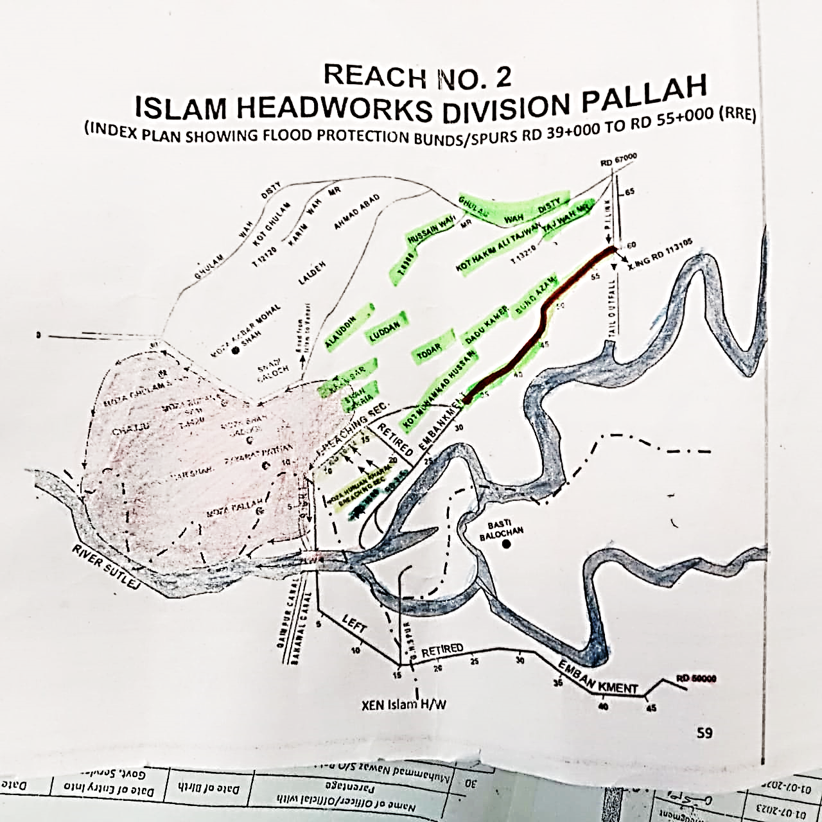

**13.3 STRATEGY AND ACTION TAKEN BE EXPLAINED IN DETAIL. THIS MAY INCLUDE**

Through all precautionary measures are adopted before flood season to face any alarming situation at Islam Headworks, even then arrangements are necessary to avoid heavy damages and flood fighting strategy is adopted in such a way that flood water passes safely through Headworks, up to its limit.

In low flood, watching establishment employed for this purpose will remain busy in removing jungle, filling gharas and porcupine holes if any.

When water increases beyond Eighty thousand cusecs then it becomes necessary to be vigilant and to avoid any mishap. Sub Engineers will shift their camps to sites as per duty roaster.

When river water enters into high flood range, Sub Divisional Officer Headworks will shift his camp at Islam to supervise staff working on LRE, RRE and allied spurs and whole period regulation will be done wisely.

Gauges of different sites especially gauge at RD 10 of LRE will be noted regularly and recorded. Executive Engineer will inform all agencies especially civil administration as well as Army about flood situation. In case of very high flood, meeting will be held in field office with Army and Civil Administration to face the situation.

**13.3.1 ARRANGEMENTS**

**13.3.2 ESTABLISHMENT OF FLOOD FIGHTING CAMPS**

Establishment of flood fighting camps, sub camp No.3 of Camp No. 2 at RD 44+000 will watch the above said vulnerable reach with the following additional establishment.

Mate 2 x 3 = 6 Nos.

Beldar 9 x 3 = 27 Nos.

2 No. mates and 9 No. beldars will be required for one shift (8 hours).

**13.3.3 DUTIES OF OFFICER / OFFICIALS AND THEIR CAMP SITES**

|  |  |  |  |
| --- | --- | --- | --- |
| **Camp No.** | **Location** | **Officer (Name + Designation + Mob No)** | **Official (Name + Designation + Mob No)** |
| **Camp No.2** | RIGHT RETIRED EMBANKMENT  AT RD 34+000 | Muhammad Arshad  Sub Divisional officer  Islam Headworks Sub Division  0300-6302173 | Muhammad Imtiaz Material Mistri 0309-5482185  Abdul Rehman Mate 0300-7853157 |
| **Sub Camp No. 3** | Rd 44+000 of RRE` | Mudassar Majeed Sub Engineer,  Headworks section  (0300-4810231) |

**13.3.4DEPARTMENTAL MACHINERY AVAILABLE.**

No Departmental machinery is available.

**13.3.5MACHINERY AVAILABLE FROM PRIVATE SOURCE.**

Machinery will be arranged from private source if required.

**13.3.6 FLOOD FIGHTING MATERIAL REQUIRED.**

***At RD 39+000 to 55+000 of RRE***

|  |  |  |  |  |  |  |
| --- | --- | --- | --- | --- | --- | --- |
| **Sr. No.** | **Item** | **Unit** | **Quantity Required** | **Quantity available** | **Balance** | **Remarks** |
| 1 | Kassies with handles | No | 20 | 20 | - | Balance quantity will be procured before starting of flood season  2025 |
| 2 | Handle for Kassies (Extra) | No | 50 | 50 | - |
| 3 | Baskets | No | 50 | 50 | - |
| 4 | Axes | No | 6 | 6 | - |
| 5 | Gunny Bages | No | 1000 | 1000 | - |
| 6 | Plastic bags | No | 1000 | 1000 | - |
| 7 | Sutli | Kg | 5 | 5 | - |
| 8 | Killas | No | 150 | 0 | 150 |
| 9 | WoddenMallats | No | 10 | 0 | 10 |
| 10 | Bomboos | No | 500 | 250 | 250 |
| 11 | MunjTrangers | No | 1000 | 300 | 700 |
| 12 | Wire crates | No | 500 | 0 | 0 |
| 13 | Lanterns | No | 10 | 50 | - |
| 14 | Wick for lanterns | Rft | 10 | 0 | 10 |
| 15 | Kerosene oil | Liters | 50 | 0 | 50 |
| 16 | Generator | No | 1 | 4 | - |
| 17 | Petrol for Generator | No | 200 | 0 | 200 |
| 18 | Energy saver 85 watt | No | 4 | 16 | - |
| 19 | Energy saver 25 watt | No | 10 | 30 | - |
| 20 | Patro Lamps | No | 2 | 2 | 0 |
| 21 | Mantal for lamps | Dozen | 2 | 0 | 2 |
| 22 | Needles | Dozen | 1 | 0 | 1 |
| 23 | Chimney for Gas lamp | No | 50 | 0 | 50 |
| 24 | Torches three cells | No | 5 | 15 | - |
| 25 | Shouldari | No | 1 | 7 | - |
| 26 | Tents | No | 1 | 2 | - |
| 27 | G.I.Buckets | No | 6 | 12 | - |
| 28 | Iron Charpies | No | 2 | 10 | - |
| 29 | Steel chairs | No | 3 | 24 | - |
| 30 | Table | No | 1 | 0 | 1 |
| 31 | Wire / Cable 3/29 | Coil | 4 | 3 | 1 |
| 32 | Water Set | No | 1 | 0 | 1 |
| 33 | Stone | (Lac)cft | 8.00 | 6.70 | 1.30 |
| 34 | Synthetic bags with a capacity of 500 kg | No | 100 | 0 | 100 |
| 34(a) | Synthetic bags with a capacity of 1000 kg. | No | 100 | 0 | 100 |
| 35 | Polythene sheets of black color 15’ wide. | Rft | 5000 | 0 | 5000 |

**13.3.7FLOOD FIGHTING MATERIAL AVAILABLE.**

***At RD 39+000 to 55+000 of RRE***

|  |  |  |  |  |  |  |
| --- | --- | --- | --- | --- | --- | --- |
| **Sr. No.** | **Item** | **Unit** | **Quantity Required** | **Quantity available** | **Balance** | **Remarks** |
| 1 | Kassies with handles | No | 20 | 20 | - | Balance quantity will be procured before starting of flood season  2025 |
| 2 | Handle for Kassies (Extra) | No | 50 | 50 | - |
| 3 | Baskets | No | 50 | 50 | - |
| 4 | Axes | No | 6 | 6 | - |
| 5 | Gunny Bages | No | 1000 | 1000 | - |
| 6 | Plastic bags | No | 1000 | 1000 | - |
| 7 | Sutli | Kg | 5 | 5 | - |
| 8 | Killas | No | 150 | 0 | 150 |
| 9 | WoddenMallats | No | 10 | 0 | 10 |
| 10 | Bomboos | No | 500 | 250 | 250 |
| 11 | MunjTrangers | No | 1000 | 300 | 700 |
| 12 | Wire crates | No | 500 | 0 | 0 |
| 13 | Lanterns | No | 10 | 50 | - |
| 14 | Wick for lanterns | Rft | 10 | 0 | 10 |
| 15 | Kerosene oil | Liters | 50 | 0 | 50 |
| 16 | Generator | No | 1 | 4 | - |
| 17 | Petrol for Generator | No | 200 | 0 | 200 |
| 18 | Energy saver 85 watt | No | 4 | 16 | - |
| 19 | Energy saver 25 watt | No | 10 | 30 | - |
| 20 | Patro Lamps | No | 2 | 2 | 0 |
| 21 | Mantal for lamps | Dozen | 2 | 0 | 2 |
| 22 | Needles | Dozen | 1 | 0 | 1 |
| 23 | Chimney for Gas lamp | No | 50 | 0 | 50 |
| 24 | Torches three cells | No | 5 | 15 | - |
| 25 | Shouldari | No | 1 | 7 | - |
| 26 | Tents | No | 1 | 2 | - |
| 27 | G.I.Buckets | No | 6 | 12 | - |
| 28 | Iron Charpies | No | 2 | 10 | - |
| 29 | Steel chairs | No | 3 | 24 | - |
| 30 | Table | No | 1 | 0 | 1 |
| 31 | Wire / Cable 3/29 | Coil | 4 | 3 | 1 |
| 32 | Water Set | No | 1 | 0 | 1 |
| 33 | Stone | (Lac)cft | 8.00 | 6.70 | 1.30 |
| 34 | Synthetic bags with a capacity of 500 kg | No | 100 | 0 | 100 |
| 34(a) | Synthetic bags with a capacity of 1000 kg. | No | 100 | 0 | 100 |
| 35 | Polythene sheets of black color 15’ wide. | Rft | 5000 | 0 | 5000 |

**13.4 DETAIL OF OTHER INFRASTRUCTURE LIKE ELECTRIC, SUI GAS, TELEPHONE INSTALLATIONS, ROAD NETWORK, OTHER BUILDINGS, CANALS AND DRAINAGE NETWORK.**

On breaching of River Training / Flood Protection Works of Islam Headworks Division Pallah, the following Irrigation and roads networks will be affected.

**ROADS.**

* Vehari Hasilpur Road
* Mehrabad, Lal Deh Road.

**SUI GAS PIPE LINE.**

* Sui Gas Pipe Line Vehari Hasilpur.

**TELEPHONE EXCHANGE**

* Telephone Exchange Luddan
* Telephone Line Vehari Hasilpur.

**SCHOOLS**

* Government Higher Secondary School, Luddan.
* Government Girls College Luddan.

**IRRIGATION NETWORK.**

* Ghulam Wah Disty.
* Tajwana Minor.
* Lal Deh Minor.
* Sub Lal Deh Minor.
* Karim Wah Minor.
* Hussain Wah Disty.

**HEALTH CENTER**

* Rural Health Center Luddan.

**Chapter-14**

**Action Plan**

* 1. **Re-shuffling / recouping plan of reserve stone departmentally**

|  |  |  |  |  |  |  |  |  |  |  |
| --- | --- | --- | --- | --- | --- | --- | --- | --- | --- | --- |
| **Sr.  No.** | **Name of Zone** | **Name of District** | **Name of Important  structure** | **Reach** | | **Length  (In Mile)** | **Sanctioned  limit of Reserve stock of stone (Lac Cft).** | **Minimum Quantity  Required (Lac Cft)** | **Stone available at site  (Lac Cft).** | **Remarks** |
| **From** | **To** |
| 1 | 2 | 3 | 4 | 5 | 6 | 7 | 8 | 9 | 10 | More than 80% quantity of stone is available to meet any critical situation hence no reshuffling / recouping is required. |
| **Tehsil Chistian District Bahawalnagar.** | | | |  |  |  |  |  |  |
|  | PMO Barrages Lahore | Bahawalnagar | Left Retired Embankment | 15+000 | 50+000 | 6.90 | 0.00 | 0.00 | 0.00 |
|  | Total |  |  |  |  | 6.90 | 0.00 | 0.00 | 0.00 |
| **Tehsil Hasilpur District Bahawalpur** | | | |  |  |  |  |  |  |
| 1 | PMO Barrages Lahore | Bahawalpur | Left Retired Embankment | 0+000 | 15+500 | 3.10 | 0.00 | 0.00 | 0.00 |
| 2 | Colony Protection Bund | 0+000 | 12+500 | 2.50 | 0.00 | 0.00 | 0.00 |
| 3 | G.H. Spur | 0+000 | 6+100 | 1.22 | 0.00 | 0.00 | 0.00 |
| 4 | L.G.B. Spur U/S | 0+000 | 3+850 | 0.77 | 1.25 | 1.04 | 1.04 |
| 5 | L.G.B. Spur D/S | 0+000 | 0+920 | 0.184 | 1.25 | 1.04 | 1.04 |
| 6 | R.G.B Spur U/S | 0+000 | 3+850 | 0.77 | 1.25 | 1.04 | 1.04 |
| 7 | R.G.B Spur D/S | 0+000 | 0+920 | 0.184 | 1.25 | 1.04 | 1.04 |
|  | Total |  |  |  |  | 8.728 | 5.00 | 4.16 | 4.16 |
| **Tehsil Vehari District Vehari** | | | |  |  |  |  |  |  |
| 1 | PMO Barrages Lahore | Vehari | Right Retired Embankment | 0+000 | 67+000 | 13.40 | 0.00 | 0.00 | 0.00 |
| 2 | Vehari | Murphy Spur | 0+000 | 9+500 | 1.90 | 1.50 | 1.25 | 1.25 |
| 3 | Vehari | T.H. Spur | 0+000 | 4+650 | 0.93 | 1.50 | 1.25 | 1.29 |
| 4 | Vehari | 2nd Defense Bund | 0+000 | 11+700 | 2.34 | 0.00 | 0.00 | 0.00 |
|  | Total |  |  |  |  | 18.57 | 3.00 | 2.507 | 2.54 |
|  | **G. Total** |  |  |  |  | **33.748** | **8.00** | **5.60** | **6.70** |

* 1. **DETAIL OF OUTLET/INLET CROSSING ALONG WITH CLOSING METHODOLOGY**

|  |  |  |  |  |  |
| --- | --- | --- | --- | --- | --- |
| **Sr. No.** | **Name of bund** | **Spur** | **Name of structure with location** | **Problem** | **Bottlenecks occurred during flood 2018.** |
| 1 | RRE (Embankment) |  | Inlet crossing at RD 56-57 RRE |  |  |
| 2 | RRE (Embankment) |  | Inlet crossing at RD 57-58 RRE |  |  |
| 3 | RRE (Embankment) |  | Inlet crossings at RD, 19-20, 25-26, 30-31, 37-38, 40-41, 50-51 RRE |  |  |

Note:-

**METHODOLOGY.**

After receipt of warning of each crossing will be closed through gunny bags or brick masonry which consider

to be necessary and certificate of closing will be taken from Sub Engineers and Sub Divisional officer, concerned.

* 1. **Deployment Machinery (Medium to high flood). 120000 to 175000 Cs**

|  |  |  |  |  |  |  |  |  |  |  |  |
| --- | --- | --- | --- | --- | --- | --- | --- | --- | --- | --- | --- |
| **Sr. No.** | **Name of Structure** | **Length in Mile** | **Vulnerable Reach** | **Camp Location** | **Site In charge by name & Cell No.** | **Machinery Deployed** | | | | | **Availability of Stone Lac Cft** |
| **Excavator** | **Dozer** | **Trolleys / Dumpers** | **Tractor with front blade** | **Labor Beldar + Mate** |
| **1** | **2** | **3** | **4** | **5** | **6** | **7** | **8** | **9** | **10** | **11** | **12** |
| 1 | Islam Head works Bridge | - | - | At Headworks | Mudassar Majeed, Sub Engineer Headworks Section (0300-4810231) | - | - | - | - | 20 + 4 | - |
| 2 | L.G.B. Spur U/S | 0.77 | 1.04 |
| 3 | L.G.B. Spur D/S | 0.184 | 1.04 |
| 4 | R.G.B Spur U/S | 0.77 | 1.04 |
| 5 | R.G.B Spur D/S | 0.184 | 1.25 |
| 6 | Right Retired Embankment | 13.4 | - | RD.34+000 of RRE | SajidHafeez Sub Engineer Station Area Section  (0300-9444079) | 1 | 1 | 3 | 1 | 155+17 | - |
| 7 | Murphy Spur | 1.90 | 1.25 |
| 8 | T.H. Spur | 0.93 | 1.08 |
| 9 | 2nd Defense Bund | 2.34 | - |
| 10 | Left Retired Embankment | 10 | - | RD.15+700 of LRE | Aziz ur Rehman Sub Engineer Hydraulic Section  (0306-7967839) | 1 | 1 | 2 | 1 | 88+10 | - |
| 11 | G.H. Spur | 1.22 | - |
| **Total** | | **31.70** |  |  |  | **2** | **2** | **5** | **2** | **263+31** | **6.7** |

**Note: -**

Payment for machinery and work charge employee subject to verification of TPM Nespak Consultant.

**14.4 Deployment Machinery (High to very high flood) 175000 to 225000 Cs**

|  |  |  |  |  |  |  |  |  |  |  |  |
| --- | --- | --- | --- | --- | --- | --- | --- | --- | --- | --- | --- |
| **Sr. No.** | **Name of Structure** | **Length in Mile** | **Vulnerable Reach** | **Camp Location** | **Site In charge by name & cell No.** | **Machinery Deployed** | | | |  | **Availability of Stone Lac Cft** |
| **Excavator** | **Dozer** | **Trolleys / Dumpers** | **Tractor with front blade** | **Labor Beldar + Mate** |
| **1** | **2** | **3** | **4** | **5** | **6** | **7** | **8** | **9** | **10** | **11** | **12** |
| 1 | Islam Head works Bridge | - | - | At Head works | Mudassar Majeed, Sub Engineer Headworks Section (0300-4810231) | - | - | - | - | 24+4 | - |
| 2 | L.G.B. Spur U/S | 0.77 | 1.04 |
| 3 | L.G.B. Spur D/S | 0.184 | 1.04 |
| 4 | R.G.B Spur U/S | 0.77 | 1.04 |
| 5 | R.G.B Spur D/S | 0.184 | 1.25 |
| 6 | Right Retired Embankment | 13.4 | - | RD.34+000 of RRE | Sajid Hafeez Sub Engineer Station Area Section  (03009444079) | 3 | 1 | 6 | 2 | 160+20 |  |
| 7 | Murphy Spur | 1.90 | 1.25 |
| 8 | T.H. Spur | 0.93 | 1.08 |
| 9 | 2nd Defense Bund | 2.34 |  |
| 10 | Left Retired Embankment | 10 | - | RD.15+700 of LRE | Aziz ur Rehman Sub Engineer Hydraulic Section  (0306-7967839) | 2 | 1 | 5 | 2 | 90+11 | - |
| 11 | G.H. Spur | 1.22 | - |
| **Total** | | | | | | **5** | **2** | **11** | **4** |  | **6.7** |

**Note: -**

Payment for machinery and work charge employee subject to verification of TPM Nespak Consultant.

* 1. **Deployment of Machinery (high to exceptionally high flood) 225000 Cs and above.**

|  |  |  |  |  |  |  |  |  |  |  |  |
| --- | --- | --- | --- | --- | --- | --- | --- | --- | --- | --- | --- |
| **Sr. No.** | **Name of Structure** | **Length in Mile** | **Vulnerable Reach** | **Camp Location** | **Site In charge by name & cell No.** | **Machinery Deployed** | | | |  | **Availability of Stone Lac Cft** |
| **Excavator** | **Dozer** | **Trolleys / Dumpers** | **Tractor with front blade** | **Labor Beldar + Mate** |
| **1** | **2** | **3** | **4** | **5** | **6** | **7** | **8** | **9** | **10** | **11** | **12** |
| 1 | Islam Headworks Bridge | - | - | At Headworks | Mudassar Majeed, Sub Engineer Headworks Section (0300-4810231) | - | - | - | - | 30+4 | - |
| 2 | L.G.B. Spur U/S | 0.77 | 1.04 |
| 3 | L.G.B. Spur D/S | 0.184 | 1.04 |
| 4 | R.G.B Spur U/S | 0.77 | 1.04 |
| 5 | R.G.B Spur D/S | 0.184 | 1.25 |
| 6 | Right Retired Embankment | 13.4 | - | RD.34+000 of RRE | Sajid Hafeez Sub Engineer Station Area Section  (03009444079) | 4 | 1 | 9 | 4 | 180+21 |  |
| 7 | Murphy Spur | 1.90 | 1.25 |
| 8 | T.H. Spur | 0.93 | 1.08 |
| 9 | 2nd Defense Bund | 2.34 |  |
| 10 | Left Retired Embankment | 10 | - | RD.15+700 of LRE | Aziz ur RehmanSub Engineer Hydraulic Section  (0306-7967839) | 3 | 1 | 6 | 3 | 98+11 | - |
| 11 | G.H. Spur | 1.22 | - |
| **Total** | | | | | | **7** | **2** | **15** | **7** |  | **6.7** |

**Note: -**

Payment for machinery and work charge employee subject to verification of TPM Nespak Consultant.

* 1. **Police deployment plan**

**Performa-1**

|  |  |  |  |  |  |  |
| --- | --- | --- | --- | --- | --- | --- |
| **Sr. No.** | **Site of Breaching Section** | **Concerned Canal Division** | **Concerned Police Station and District** | **Police Persons Deployed** | | **Remarks (if any)** |
| **Inspector / Sub Inspector / A.S.I** | **Constable** |
| 1 | Right Retired Embankment (RRE) RD 11-12 (One breaching section) | Islam Head Works Division Pallah | PS Luddan District Vehari | 1 | 4 |  |
| 2 | Murphy Spur RD 4-5 (One breaching section) | 1 | 4 |  |

**Performa-2**

|  |  |  |  |  |  |  |
| --- | --- | --- | --- | --- | --- | --- |
| **Sr. No.** | **Vulnerable sites used for illegal cuts during floods** | **Concerned Canal Division** | **Concerned Police Station and District** | **Police Persons Deployed** | | **Remarks (if any)** |
| **Inspector / Sub Inspector / A.S.I** | **Constable** |
| 1 | - | - | - | - | - | - |

**Performa-3**

|  |  |  |  |  |  |  |
| --- | --- | --- | --- | --- | --- | --- |
| **Sr. No.** | **Name of Barrage** | **Concerned Canal Division** | **Concerned Police Station and District** | **Police Persons Deployed** | | **Remarks (if any)** |
| **Inspector / Sub Inspector / A.S.I** | **Constable** |
| 1 | Islam Headworks | Islam Headworks Division Pallah | Police Station Saddar Hasilpur | 2 | 8 |  |

* 1. **Details of synthetic bags with capacity of 500kg and 1000kg.**

|  |  |  |  |  |
| --- | --- | --- | --- | --- |
| **Sr. No.** | **No of Synthetic Bags** | **Required** | **Available** | **Balance** |
| 1 | 500 Kg Bags | 50 | 0 | 50 |
| 2 | 1000 Kg Bags | 50 | 0 | 50 |

* 1. **Details of polythene sheets of black color to protect upstream slope against wave action and to control seepage through embankments**

|  |  |  |  |  |
| --- | --- | --- | --- | --- |
| **Sr. No.** | **Detail of polythene sheets** | **Required** | **Available** | **Balance** |
| 1 | In Rft with 15ft width | 5000 | 0 | 5000 |

Synthetic bags will be procured before commencing flood season 2024.Polythene sheets of black color is required against wave action and to control seepage through embankment which will be procured before starting flood season.

**Chapter-15**

**BACK UP DIVISION**

In case of emergency **Bahawalpur Canal Division of Bahawalpur Canal Circle Bahawalpur and Fordwah Canal Division of Bahawalnagar Canal Circle Bahawalnagar** will be acting as backup Divisions respectively for Right Flank of River Sutlej at Islam Head Works Division, while Malik Canal Division Bahawalnagar will be acting as back up division for Left Flank of River Sutlej at Islam Head Works.

Sub Divisional Officer,

Islam Headworks Sub Division

Pallah.

Executive Engineer

Islam Headworks Division

Pallah.

Deputy Project Director (Tech)

PMO Barrages,

Lahore

Head Project Director

PMO For Barrages,

Lahore.