GOVERNMENT OF THE PUNJAB



IRRIGATION DEPARTMENT

FLOOD FIGHTING PLAN
FOR THE YEAR 2025

QADIRABAD BARRAGE DIVISION QADIRABAD
Q.B. LINK CIRCLE FAROOQABAD - IRRIGATION ZONE FAISALABAD

EXECUTIVE ENGINEER  QADIRABAD BARRAGE DIVISION  QADIRABAD | SUPERINTENDING ENGINEER  Q.B. LINK CIRCLE  FAROOQABAD | CHIEF ENGINEER  IRRIGATION FAISALABAD ZONE  FAISALABAD

I N D E X

Chapter No. | Description | Page No.
PART-A
 | Title Page | 1
 | Index | 2-4
1 | Salient Features of Qadirabad Barrage.
1.1 | Location. | 5
1.2 | General Description. | 5
1.3 | Administration Setup. | 6
2 | Flood Protection and River Training Works.
2.1 | Design parameter of river training works. | 7 - 11
2.2 | Location Map. | 12
3 | Brief History of Past Flood event. | 13-16
4 | Design data, Historic peak flood data and previous five year flood data of Qadirabad Barrage and other control points. | 17
4.1 | Flood limits. | 17
4.2 | Time Lags of Flood. | 17
4.3 | Highest Floods. | 18
4.4 | Peak Discharges. | 18
5 | Flood Fighting Strategy. | 19 – 21
6 | Flood Damages Restoration works. | 22
7 | Flood Fighting Watching Arrangement.
7.1 | Pre-flood Arrangement. | 23
7.2 | Watching Establishment. | 24-25
7.3 | Arrangement at Sensitive sites. | 26
7.4 | Watching Material. | 26-27
7.5 | Arrangement for Sounding & Probing. | 28
7.6 | Lighting Arrangement. | 28
7.7 | Ration Arrangement. | 28
7.8 | P.O.L Arrangement for Vehicles. | 28
7.9 | Transportation. | 28
7.10 | Law and Order. | 28
7.11 | Medical Arrangement for Labour. | 28
7.12 | Liaison with other Department. | 28
7.13 | Role of Army. | 29
7.14 | Duties of Telephone Attendant. | 29
7.15 | Wireless Arrangements. | 29
8 | Detail of Encroachment. | 30
9 | Duty Roster / Flood Fighting Program. | 31
10 | Emergency Telephone No. | 32-34
11 | Standard Operating Procedure (SOP) for Breaching section. | 35
11.1 | History of Breaching section. | 35
11.2 | Location, Design, Quantity and Variety for the Explosive required for detonation. | 35-36
11.3 | Arrangement of Explosives and Security of explosive stores. | 37
11.4 | List of the security staff with detail of their training etc. | 37
11.5 | Detail of mechanical means as a standby arrangement in case of detonation failure. | 37
11.6 | Duty Roster in case of critical situation. | 37
11.7 | Breaching Committee with their action plan. | 37
11.8 | List of the villages likely to be inundated in case of breaching. | 38
11.9 | Announcement and detail of evacuation arrangements. | 38
11.10 | Detail of coordination with Civil / Army authorities. | 38
11.11 | Parallel Communication arrangements. | 38
11.12 | Index plan | 39-40
PART-B
12 | Vulnerable site on Flood Bund / Structure.
12.1 | Apprehended Breaches in Flood Bunds / structures. | 41
12.2 | Operation of Breaching Section. | 41
12.3 | Breaches due to rising of flood water , Deterioration of Flood Bunds etc. | 41
13 | Emergency Contingency Plan for vulnerable site No. 1.
13.1 | Plan showing route of Flood water coming out of the breach supported with levels. | 42-43
13.2 | Detail of villages abadies likely to be affected and this should also be shown on the plan. | 44
13.3 | Strategy and action taken by explained in detail. This may include:- | 44
 | (13.3.1) Arrangements. | 44
 | (13.3.2) Establishment of Flood fighting Camps. | 44
 | (13.3.3) Duties of officers / officials and their camp sites. | 44
 | (13.3.4) Departmental Machinery available. | 44
 | (13.3.5) Machinery available from Private Sources. | 44
 | Plan showing Flood water route through expected Breach at RD. 27-31 RMB of Qadirabad Barrage Site No.1 | 45
 | (13.3.6) Flood Fighting Material required. | 46
 | (13.3.7) Flood Fighting Material available. | 47
 | Emergency Contingency Plan for vulnerable site No. 2.
13.1 | Plan showing route of Flood water coming out of the breach supported with levels. | 48
13.2 | Detail of villages abadies likely to be affected and this should also be shown on the plan. | 49
13.3 | Strategy and action taken by explained in detail. This may include:- | 49
 | (13.3.1) Arrangements. | 49
 | (13.3.2) Establishment of Flood fighting Camps. | 49
 | (13.3.3) Duties of officers / officials and their camp sites. | 49
 | (13.3.4) Departmental Machinery available. | 49
 | (13.3.5) Machinery available from Private Sources. | 49
 | Plan showing Flood water route through expected Breach at RD. 13-25 LMB of Qadirabad Barrage Site No.2 | 50
 | (13.3.6) Flood Fighting Material required. | 51
 | (13.3.7) Flood Fighting Material available. | 52
 | Emergency Contingency Plan for vulnerable site No. 3.
13.1 | Plan showing route of Flood water coming out of the breach supported with levels. | 53
13.2 | Detail of villages abadies likely to be affected and this should also be shown on the plan. | 54
13.3 | Strategy and action taken by explained in detail. This may include:- | 54
 | (13.3.1) Arrangements. | 54
 | (13.3.2) Establishment of Flood fighting Camps. | 54
 | (13.3.3) Duties of officers / officials and their camp sites. | 54
 | Plan showing Flood water route through expected Breach at RD. 30+000 to 50+000 of Qadirabad Barrage Site No.3 | 55
 | (13.3.4) Departmental Machinery available. | 56
 | (13.3.5) Machinery available from Private Sources. | 56
 | (13.3.6) Flood Fighting Material required. | 56
 | (13.3.7) Flood Fighting Material available. | 57
13.4 | Detail of other infrastructure like Electric, Sui Gas, Telephone installation, Road network, Other Building, Canals and Drainage network. | 57
14 | ACTION PLAN
14.1 | Re-shuffling/recouping plan of reserve stone departmentally. | 58
14.2 | Detail of inlet/outlet crossing along with closing methodology. | 59-61
14.3 | Deployment Machinery (medium to high flood). | 62
14.4 | Deployment of Machinery (High to very high flood). | 63
14.5 | Deployment of Machinery (high to exceptionally high flood). | 64
14.6 | Police deployment plan. | 65
14.7 | Details of synthetic bags with capacity of 500kg and 1000kg. | 66
14.8 | Details of polythene sheets of black color to protect upstream slope against wave action and to control seepage through embankments. | 67
15 | Back Up Division (In case of breach) | 68

CHAPTER NO. 1

SALIENT FEATURES OF QADIRABAD BARRAGE.

1. 1 Location:

Qadirabad Barrage derives its name from a village named “Qadirabad 21 K.M. downstream on the Right Bank of River Chenab in Tehsil Phalia District Mandi Baha-ud-Din. The Barrage itself is located in Wazirabad District at 16 K.M. from Alipur Chattha Town and 32 K.M. Downstream of Khanki Weir”.
1.2 General Description:
Qadirabad Barrage is one of the Major Engineering Components of Indus Basin Project. It was constructed as a part of Rasul – Qadirabad – Balloki – Sulemanki Link Canal System.
The Barrage length between the abutments is 3376 and consists of 50 No. spans, each of 60 feet length, between the piers. The Barrage has a designed capacity of 9.00 lac cusecs. The Head Regulator of the Q.B. Link has a capacity of passing 25000 cusecs discharge located on the Left Flank of the Barrage, where Under Sluice Pocket and Divide Wall has been provided to facilitate the regulation. The last two Bays adjacent to the Canal Head Regulator have been provided with silt Excluder Tunnels. A Fish Ladder has also been added in the divide Wall.
The Barrage was designed by M/S COODE and PARTNERS of Victoria Street, London who were engaged by the WAPDA as Consulting Engineers.
The Contract for the construction of this Barrage was awarded on 04-05-1964 to M/S Mails phone, a consortium consisting of 3 Firms viz Christiani Nielse (Denmark), Companies Francoise Enterprise (France) and Gammons (Pakistan). The stipulated date of completion of the project was 31-03-1968, but the project was completed almost one year before and Qadirabad Balloki Link Canal was opened for the first time on 17-07-1967. Qadirabad Barrage along Q.B. Link was handed over to the Irrigation Department on 16-12-1968 for further operation and maintenance.
The River Chenab is bounded by Marginal Bunds between Khanki Headworks and Qadirabad Barrage. The river while flowing in the alluvial khaddar meanders widely between the Marginal Bunds. To cope with the Situation River Training Works had been provided.
Qadirabad Balloki Link Canal off takes from its left flank and is the central part of the Rasul Balloki Link Canal System. The object of which is to transfer Mangla releases to River Ravi for its utilization in the areas which were previously irrigated by the River Ravi and Sutlej. The Q.B. Link falls into Ravi at about 16 K.M. upstream of Balloki Headworks. It supplies irrigation water to approximately 6 million acres of culture able area.
  - ADMINISTRATIVE SETUP.

Executive Engineer,
Qadirabad Barrage Division,
Qadirabad Canal Colony.
Adnan Yousaf
Office No. 0547-550190
Mobile. 0300-1030530
Sub Divisional Officer  Headworks Sub Division,  Qadirabad Barrage  Sami Abbas  Mob: 0304-1242773 | Sub Divisional Officer,  Colony & Workshop Sub Division,  Qadirabad Canal Colony.  Abdul Ghaffar  Mob: 0300-7685049
Sub Engineer Headworks Civil.  Awais Ghulam Jalani  Mob: 0303-7930491 | Sub Engineer Colony Civil.  Farukh Khalid  Mob: 0302-4903763  (Additional Charge)
Sub Engineer, Headworks Mechanical.  Muhammad Arslan  0301-3577565 | Sub Engineer Colony Mechanical.  Muhammad Arslan  0301-3577565  (Additional Charge)
Sub Engineer, RMB-I.  Farukh Khalid  Mob: 0302-4903763 | Sub Engineer, Q.B. Link Section.  Muhammad Jahangir  Mob:0343-4316937
Sub Engineer, RMB-II  Ameer Hamza  Mob:0320-2187500 | Sub Engineer, (Drainage Section)  Faisal Arabi  Mob: 0313-7858351
Sub Engineer, LMB  Khurram Rafiqui  Mob:0300-6297612 | Sub Engineer,  Pindi Bhattian Flood Protection Bund.  Awais Ghulam Jalani  Mob: 0303-7930491  (Additional Charge)

Chapter No. 2

FLOOD PROTECTION AND RIVER TRAINING WORKS.

  - Design Parameters of Training works.

Qadirabad Barrage.

No. of Bays | Clear water way of Bay. | Crest Level. | No. of Gates | Height of Gates. | Top Level of Gates.
Normal Gates | 60’ | 684.50 | 45 | 18.50’ | 703.00
Under Sluice Gates. | 60’ | 680.00 | 5 | 23.00’ | 703.00
Head Regulator Gates. | 40’ | 690.00 | 6 | 13.00’ | 703.00

LEFT MARGINAL BUND

Length. 64938 Feet (20.42 K.M)
Top Width. 25 Feet
Slopes:-
River Side 3:1
Country Side 3:1
Free Board. 6.00 Feet above (H.F.L. 1973).
SPURS

S. No. | R.D. | Type of Spurs | Top width | Length | Sides slopes
1 | 13+300 | L-Type | 25.00 Feet | 7155 Feet | 3:1
2 | 28+600 | M-Type | 25.00 Feet | 1450 Feet | 3:1
3 | 35+200 | J-Head | 25.00 Feet | 3000 Feet | 3:1
4 | 37+500 | J-Head | 25.00 Feet | 1912 Feet | 3:1
5 | 45+500 | J-Head | 25.00 Feet | 1300 Feet | 3:1
 |  |  | Total | 14817 Feet = 4.65 K.M.

RIGHT MARGINAL BUND

Length. 106300 Feet (33.42 K.M)
Top Width. 25 Feet
Slopes. RD. 0-40 = 3:1 (both sides)
RD 40-106+300 2:1 Country side 3:1 River side
Free Board. 6.00 Feet above H.F. Level 1973.

SPURS

S. No. | R.D. | Type of Spurs | Top width | Length | Sides slopes both sides
1 | 2+500 | J-Head | 25.00 Feet | 5200 Feet | 3:1
2 | 14+700 | J-Head | 25.00 Feet | 4500 Feet | 3:1
3 | 20+814 | Mole Head | 25.00 Feet | 1000 Feet | 3:1
4 | 23+000 | J-Head | 25.00 Feet | 3410 Feet | 3:1
5 | 25+966 | J-Head | 25.00 Feet | 1000 Feet | 3:1
6 | 28+850 | Mole Head | 25.00 Feet | 3500 Feet | 3:1
7 | 42+635 | Mole Head | 25.00 Feet | 3500 Feet | 3:1
8 | 48+000 | Mole Head | 25.00 Feet | 1700 Feet | 3:1
9 | 51+000 | J-Head | 25.00 Feet | 2500 Feet | 3:1
10 | 69+000 | J-Head | 25.00 Feet | 4166 Feet | 2:1
11 | 76+600 | J-Head | 25.00 Feet | 4605 Feet | 2:1
12 | 85+500 | Mole Head | 25.00 Feet | 2500 Feet | 2:1
 |  |  | Total | 37581 Feet = 11.81 K.M.

GUIDE BUNDS

S. No. | R.D. | Type of Spurs | Top width | Length | Sides slopes both sides
1 | U/S Left Guide | Mole Head. | 40.00 feet | 5200 feet | 2:1
2 | D/S Left Guide | Mole Head. | 40.00 feet | 500 feet | 2:1
3 | U/S Right Guide Bund. | Mole Head | 40.00 “ | 5200 “ | 2:1
4 | D/S Right Guide Bund. | Mole Head | 40.00 “ | 500 “ | 2:1
5 | Chocking Bund |  | 25.00 “ | 1000 “ | 3:1& 2:1
6 | Ring Bund. |  | 25.00 “ | 2000 “ | 3:1 & 2:1

PINDI BHATTIAN FLOOD PROTECTION BUND

- REACH PINDI BHATTIAN TO JALAL PUR RD. 0+000 to 74+650.

Top Width

RD. 0+000 - 18+000 Abandoned
RD. 18+000 – 40+000 25 Ft
RD. 40+000 – 74+650 25 Ft.
SIDE SLOPES
River Side 3:1
Country Side 2:1
Free Board 6.00 Ft Above H.L.F 1973

2. REACH JALAL PUR BHATTIAN TO RD. 85 VAGH DRAIN (METALLED ROAD ON TOP BUND)

RD. 74+650 to RD. 137+000

Top Width 32.00 Ft.

SIDE SLOPES
River Side 3:1
Country Side 2:1
Free Board 5.00 Ft above H.L.F 1973

Width of metaled road. 35.00 Ft

GENERAL DATA
The Bays are numbered from Right Hand side. Bays 1 - 45 are Normal weir while Bays 46 to 50 are under sluices. Width of each Bay is 60.00 feet.

UPSTREAM IMPERVIOUS FLOOR.

R.L. of Weir Crest. 684.50 feet

R.L of Under Sluice Crest. 680.00 feet

R.L. of Upstream Floor. 674.00 feet

LENGTH OF IMPERVIOUS FLOOR.

Bays. 1-45 76.00 feet with minimum thickness 2.0’

Bays. 46-48 313.00 feet which extended 72.00 feet ahead of upstream end of
Divide Wall.
Bays. 49-50 353.30 feet which extended up to 70.00’
upstream of the regulator.

DOWNSTREAM IMPERVIOUS FLOOR.

Bays 1-50 92.00 feet Long with a thickness of
9 - 10.00 feet.
R.L. of Floor

Weir Portion 671.00’

Under Sluices
portion 666.00’

CENTRAL RAFT PORTION.

Length of R.C.C. 97.00’ With thickness varies from
Raft measured 06.75’ to 10.00’
Horizontally.

BLOCK AND STONE APRONS.

Length of Block Apron Upstream 20.00 feet Plus 2.00 feet
Curtain Wall. .
Downstream. 75.00 feet plus 2.00 feet
Curtain Wall.

Size of Blocks 5’ x 5’ x 4’
Width of Joint between
Blocks. 2 Inch.

Thickness of inverted Upstream. 1 Feet .
Filter. Downstream. 2 Feet.

Length of Stone Apron. Upstream. 57.00 feet.
Downstream 126.00 feet.

Thickness of Stone Apron. 4.00 feet.

PIERS.

Length of Piers. 95.00 feet.
Width of Pier. 7.00 “

ABUTMENTS.

These are R.C.C. Retaining Walls.

DIVIDE WALL.

Upstream Length. 365.00 feet.
Downstream Length. 137.00 feet.
Width of Divide Wall beyond
U/S end of Fish Ladder. 9.60 feet.
Designed Head Across. 6.00 feet.

FISH LADDER.

The Structure is designed to operate satisfactorily over the following range of water levels.
1. Upstream water level. 698-703
2. Downstream water level. 678-694
It comprised of two portions, a Ladder and a Supply Channel. Total width of Fish Ladder is 40 Feet inclusive of divide Wall.
BARRAGE AND REGULATOR ROAD BRIDGE.

Clear Width of Bridge. 24.00 feet with 4.00 feet
Foot Way on U/S side and
2 Feet Kerb.
Width of Service Bridge. 5.00 feet.
Bottom R.L. of Bridge. 705.75 “
Top of Road Bridge. 710.65 “
Top R.L. of Service Bridge. 710.50 “
Bottom R.L. of Service Bridge. 706.75 “

LOADING

Carriage Way. Class AA 70 Tons.
Foot Way. 85 Lbs/Sft.

CANAL HEAD REGULATOR

Full Supply Discharge. 25,000 Cs. (remodeled).
Existing Capacity. 19,525 Cs.
Full Supply Level. 698.50 feet.
No. of Bays. 6
Width of each Bays. 40.00 feet.
Top of Upstream Floor. 686.50 feet.
(Silt Excluder).
Crest level of Regulator. 690.00 feet.
Downstream Floor Level. 681.00 feet.
Top Level of Lip Wall. 682.00 feet.
Length of Downstream 45.00 feet.
Impervious Floor.
Downstream Block Apron. 35.00 feet Horizontal with 3:1 slope
To Joins existing pit.
Downstream Stone Apron. 50.00 feet.
Crest R.L. of Tail Regulator
of R.Q. Link. 692.55 feet.

DESIGNED HEAD ACROSS.
Regulator. 22.30 feet.
Barrage. 32.00 “
Divide Wall 6.00 ”

SILT EXCLUDERS. (in front of bays 49 and 50).

Top Level of Tunnels. 686.50 feet.
No. of Tunnels in Front of one gate. 4 Nos.
Total No. of Tunnels. 8 Nos.
Size of Tunnel. 6 feet x 10 feet.

GATE AND GEARING

Manufactured and fitted by. M./S Hitachi Zosen of Japan.
Type of Gates. Tainter Type, Radial Gates.

Description Barrage. Canal Regulator.
Normal Under Sluice.

No of Gates. 45 No. 5 No. 6 No.
Width between Piers. 60 Feet 60 Feet 40 Feet
Height of Gates. 18.50 “ 23 “ 13 “
Radius. 25.00 “ 27 “ 20 “
Top R.L. of Gates. 703 “ 703 “ 703 “

Diesel generator have been provided as a substitute for shut down of electricity.

Designed Pond Level. 701.00 Feet.
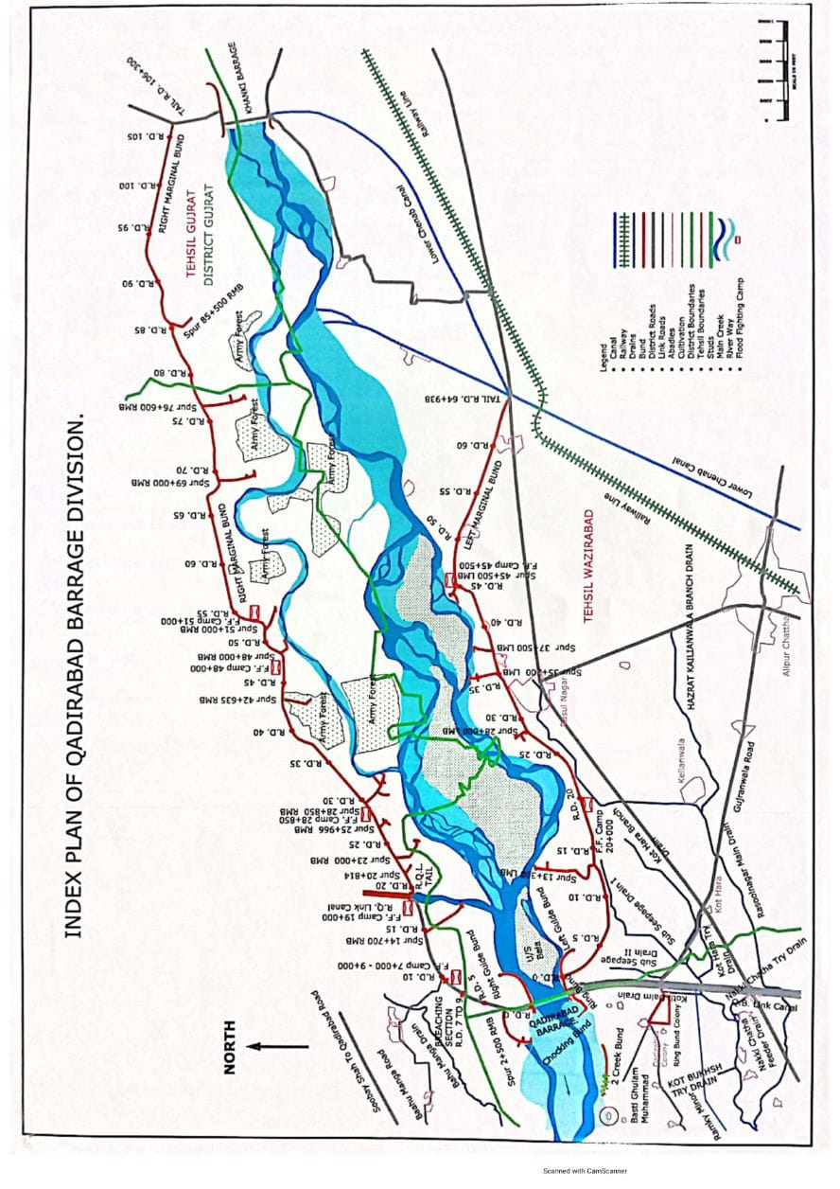
Chapter No. 3.

BRIEF HISTORY OF PAST FLOOD EVENTS.

River Chenab is completely bounded by Marginal Bunds between Khanki Head and Qadirabad Barrage. The river while flowing in alluvial khadir, meanders widely in order to stabilize itself by completing its length in accordance with load etc. The construction of Marginal Bunds and Barrage itself prevents this opportunity and destabilize the river and endanger their safety. Thus in order to hold the river at the designed location, construction of Training works was essential requirement. Therefore to cope with the situation arising after different flood eventualities, river training works as explained below were constructed.
In first instance 3 Nos. spurs at RD. 13+300, 28+600 and 45+500 along Left Marginal Bund and 4 Nos. spurs at RD. 14+700, 20+814, 25+966 and 42+635 along Right Marginal Bund were constructed to cater for the river action at that time. The river regime was quite unstable and it was decided to train the river as and when need arises.
After the super flood of 1973, the magnitude of which was a little short of the designed capacity of the weir, River Chenab Upstream of the Barrage developed loops and changes. The river was attacking along Right Marginal Bund in reach RD. 20+000 to 55+000. The matter was referred to Irrigation Research Institute for Model Studies and the following Training works were constructed from time to time on their recommendation.
Sr.# | Location of Spurs. | Marginal Bund | Year of Construction
1- | RD. 29+500 | Right | 1974
2- | RD. 48+000 | Right | 1976
3- | RD. 51+000 | Right | 1976
4- | RD. 23+000 | Right | 1977
Since, almost, all the creeks were flowing along the Right Marginal Bund, it was rightfully thought to bring the river in central position. In order to achieve this objective, an untied X-Bund was tried across the Main Creek on the recommendation of Irrigation Research Institute Lahore during the year 1978 and the river developed its course away from the Right Marginal Bund during Low Flood.
SUPER FLOOD OF 1988
This flood ever received at Qadirabad Barrage was almost equal to its designed capacity and it passed very safely without any induced breaches. The main flow remained along Left Marginal Bund and was declared the most vulnerable site. It remained under severe hit of the river attack. The stone apron was washed away and reduced to 70 ft against 80 ft design.
Only 25 ft width of apron was restored during the flood season. Subsequently under a scheme of “Restoration Flood Damages” 50% designed width of the apron was replenished during the year 1989-90. Although the flood discharge of 1988 was higher than that of 1973, but the flood heights remained lower which was a healthy trend of the river from regime point of view.
SUPER FLOOD 1992
The Super Flood with discharge of 9,48,000 Cusecs passed safely from the Barrage during 09/1992 although the discharge was 48,000 Cs higher than designed capacity i.e. 9.00 lac cusecs. The pressure of river remained on Left Marginal Bund and, damaged the stone apron of Spur RD. 35+200 L.M.B and Right Guide Bund on upstream side. The top and side slopes of L.M.B, R.M.B and Spurs etc were damaged by the rains and super floods discharge.
EXCEPTIONALLY HIGH FLOOD 1995
An exceptionally high flood with a discharge of 6,44,397 cusecs passed safely from Qadirabad Barrage during 07/1995. The main flow of the river remained along Left Marginal Bund. The Main Creek was flowing at a distance of only 2000’ from toe of Bund at RD. 20+900 L.M.B which threatened the safety of bund. The stone aprons of spur RD. 48+000, Spur RD. 51+000 of R.M.B, Right Guide Bund and Spur RD. 35+200 of L.M.B were damaged during the flood. Restoration of top and side slope of L.M.B RD. 0+000 to 2+000, 5+000 to 13+000, 35+000 to 62+000 and 50+000 to 69+000 have since been completed.
SUPER FLOOD 1996
Eight waves of floods passed through the Barrage during the flood season of 1996. The Super Flood with a discharge of 8,53,231 cusecs passed safely from the Barrage during 08/1996 without any accident or induced breaches.
SUPER FLOOD 1997
During Flood Season of 1997 eight floods of different magnitudes form low to exceptionally high range were passed. The river started rising in July 1997. The Super Flood with downstream discharge of 8,73,447 cusecs passed safely from the Barrage during 08/1997 without any accident or induced breaches.
From 2006 to 2011 high flood has been passed through the Qadirabad Barrage. All the weir bays and under sluices were operated successfully as per regulation rule to pass these high floods. None of the river training work became under direct hit except the Right Guide Bund which was damaged during 2013 at discharge around 4 Lac Cs. The apron was partially restored but was again damaged during 2014.
SUPER FLOOD 2014
A Super flood with discharge of 9,03,504 Cs. passed safely from the Barrage. Before the highest peak discharge a peak of 6,56,666 Cs. Passed for 18 Hours. The two peaks were passed safely without operation of Breaching section. The main pressure of flood remained along RGB damaging the apron, pitching and the bund between RD 3+000 to 4+000. In the present upstream river morphology and bela formation between the right guide bunds, it is suspected that in future the river’s attack will continue at the right guide bund.
Downstream Qadirabad Barrage, two new creeks developed a few miles down the chocking bund inundating vast area downstream. The creeks were plugged by construction a bund called 2-Creek Bund. Ten Nos. breaches occurred at Pindi Bhattian Flood Protection Bund.
MEDIUM FLOOD 2015
During the year 2015, medium flood was passed with peak discharge of 1.75 lac Cs. and 1.69 lac Cs. on 13-07-2015 at 10.00 hours and 24-09-2015 at 02:00 hours respectively. The peak flow was passed safely without any damage to any flood protection structure.
HIGH FLOOD 2016
During the year 2016, very high flood was passed with peak Discharge of 4.00 Lac cusec for 10.00 hours respectively. The peak flow was passed safely without any damage to any flood protection.
MEDIUM FLOOD 2017
During the year 2017, medium flood was passed with peak discharge of 186,660 cusecs 19.07.2017 at 14.00 hours. The peak flow was passed safely without any damage to any flood protection structure.
LOW FLOOD 2018
During the year 2018, Low flood was passed with peak discharge of 103,400 cusecs on 24.09.2018 at 21.00 hours. The peak flow was passed safely without any damage to any flood protection structure.

MEDIUM FLOOD 2019
During the year 2019, Medium flood was passed with peak discharge of 159,544 cusecs on 01.08.2019 at 21.00 hours. The peak flow was passed safely without any damage to any flood protection structure except damaging 500 ft tail portion of 2-creek bund.

HIGH FLOOD 2020
During the year 2020, high flood was passed with peak discharge of 267,540 cusecs on 20.08.2020 at15.00 hours. The peak flow was passed safely without any damage to any flood protection structure except launching of stone on the upstream side of hockey stud constructed at RD. 3+000 of 2-Creek bund.

MEDIUM FLOOD 2021
During the year 2021, medium flood was passed with peak discharge of 167,812 cusecs on 29.07.2021. The peak flow was passed safely without any damage to any flood protection structure.

HIGH FLOOD 2022
During the year 2022, high flood was passed with peak discharge of 202,149 cusecs on 12.08.2022 at 22:00 hours. The peak flow was passed safely without any damage to any flood protection structure except launching of stone apron of RGB and damaging already existing studs of 2- Creek bund.
MEDIUM FLOOD 2023
During the year 2023, medium flood was passed with peak discharge of 185,749 cusecs on 20.07.2023 at 10:00 hours. The peak flow was passed safely without any damage to any flood protection structure except launching of stone apron of RGB, bottle neck in front of RGB and damaging existing stone studs of 2- Creek bund 2 mile downstream Qadirabad Barrage.

MEDIUM FLOOD 2024
During the year 2024, medium flood was passed with peak discharge of 166,323 cusecs on 16.08.2024 at 07:00 hours. The peak flow was passed safely without any damage to any flood protection structure except launching of stone of Mole head spur at RD 45+500 of LMB.

Chapter No. 4

Design Data & Historic Peak flood Data and previous 5 years flood data of Headworks & Barrages and or other control points.

Design Discharge of Qadirabad Barrage = 9.00 Lac Cs.

Previous Five Years Flood Data

Sr. No. | Date | Discharge Cs. | Flood Stage.
1 | 20.08.2020 | 267,540 | High Flood
2 | 29.07.2021 | 167,812 | Medium Flood
3 | 12.08.2022 | 202,149 | High Flood
4 | 20.07.2023 | 185,749 | Medium Flood
5 | 16.08.2024 | 166,323 | Medium Flood

4.1 Flood Limits of River Chenab.

1 | Low Flood | 1.00 - 1.50 lac cusecs
2 | Medium Flood | 1.50 - 2.00 lac cusecs
3 | High Flood | 2.00 - 4.00 lac cusecs
4 | Very High Flood | 4.00 - 6.00 lac cusecs
5 | Exceptionally High Flood | 6.00 - 8.00 lac cusecs
6 | Super Flood | 8.00 lac Cs. and above

4.2 Time Lags of Floods of River Chenab.

Limits | Range in Lac Cs. | Time Lag from Khanki to Qadirabad (Hrs) | Time Lag from Marala to Qadirabad (Hrs)
Low | 1.00 - 1.50 | 8.00 | 20.00
Medium | 1.50 - 2.00 | 7.00 | 17.00
High | 2.00 - 4.00 | 6.00 | 15.00
Very High | 4.00 - 6.00 | 5.00 | 13.00
Exceptionally High | Above 6.0 | 4.00 | 11.00

4.3 HIGHEST FLOODS.

Sr. No. |  | Date | Discharge Cs. | Critical Gauge at R.D. 15+000 L.M.B. | Flood Stage.
1 |  | 10.08.1973 | 8,54,341 | 712.32 | Super Flood
2 | 26.09.1988 |  | 8,92,299 | 711.4 | Super Flood
3 | 11.09.1992 |  | 9,48,530 | 713.40 | Super Flood
4 | 24.08.1996 |  | 8,53,231 | 711.70 | Super Flood
5 | 28.08.1997 |  | 8,73,442 | 711.90 | Super Flood
6 | 07-09-2014 |  | 9,03,504 | 712.30 | Super Flood

4.4 PEAK DISCHARGES.

Sr. No. |  | Date | Discharge Cs. | Critical Gauge at R.D. 15+000 L.M.B. | Flood Stage.
1 |  | 10.08.1973. | 854,341 | 712.32 | Super Flood
2 |  | 17.07.1975. | 698,228 | 710.00 | Exceptionally High
3 |  | 02.08.1976. | 628,228 | 709.60 | Exceptionally high
4 | 26.09.1988 |  | 892,299 | 711.40 | Super Flood
5 | 11.09.1992 |  | 948,530 | 713.40 | Super Flood
6 | 29.07.1995 |  | 644,794 | 706.30 | Exceptionally High
7 | 24.08.1996. |  | 853,231 | 711.70 | Super Flood
8 | 28.08.1997 |  | 873,442 | 711.90 | Super Flood
9 | 08.07.2005 |  | 369,847 | 697.00 | High Flood
10 | 04.09.2006 |  | 443,206 | 699.10 | Very High Flood
11 | 15.08.2013 |  | 403,403 | 698.05 | Very High Flood
12 | 07-09-2014 |  | 903,504 | 712.30 | Super Flood
13 | 13-07-2015 |  | 175,054 | 703.40 | Medium Flood
14 | 08-08-2016 |  | 405,455 | 700.00 | Very High Flood
15 | 19-07-2017 |  | 186,660 | 700.00 | Medium Flood
16 | 24.09.2018 |  | 103,400 | 700.00 | Low Flood
17 | 01.08.2019 |  | 159,544 | 700.00 | Medium Flood
18 | 20.08.2020 |  | 267,540 | 700.00 | High Flood
19 | 29.07.2021 |  | 167,812 | 700.00 | Medium Flood
20 | 12.08.2022 |  | 202,149 | 700.00 | High Flood
21 | 20.07.2023 |  | 185,749 | 700.00 | Medium Flood
22 | 16.08.2024 |  | 166,323 | 700.00 | Medium Flood

Chapter No. 5

Flood Fighting Strategy.

- STAGE - I (Low Flood)

When discharge ranges between 1.0 to 2.0 lac Cusecs, Sub Divisional Officer, Headworks will be the Incharge of overall watching operation and the Sub Engineer Incharge of their Sections at Left Marginal Bund and Right Marginal Bund will perform watching duties in their respective jurisdictions. No special watching is required.
- STAGE - II (Medium Flood)

When the discharge ranges between 2.0 to 4.0 Lac Cusecs, the Executive Engineer, Qadirabad Barrage Division will be the overall Incharge of watching operation. In addition the Sub Divisional Officer, Headworks will be the Incharge of watching operation of L.M.B along with supervisory staff of Sub Engineer, L.M.B Sub Engineer Colony Civil Section along with their watching gangs as listed in duty roster at page 19. The Sub Divisional Officer, Hafizabad Link Sub Division will be the Incharge of watching operation along with supervisory staff of Sub Engineer R.M.B-I and R.M.B-II Sections along with their watching gangs as listed in duty roster at page 18. The Sub Engineer, Headworks Civil Section will perform duty at Headworks to control the regulation strictly as per Regulation Rules.

- STAGE - III (High Flood)

When discharge ranges between 4.0 to 6.0 Lac Cusecs, the Executive Engineer, Qadirabad Barrage Division will be the overall Incharge of watching operation. The Sub Divisional Officer, Headworks will be the incharge of watching operation of L.M.B along with supervisory staff of Sub Engineer, L.M.B, Sub Engineer Colony Civil and Mechanical along with their watching gangs listed in duty roster at Page 19, on Right Marginal Bund, the Sub Divisional Officer, Hafizabad Link Sub Division will be the Incharge of watching operation along with supervisory staff of Sub Engineer R.M.B-I and R.M.B-II Sections and sub Engineer, Q.B. Link Section as listed in duty roster at Page 18. The Sub Engineer, Headworks Civil Section will perform duty at Headworks to control the regulation as per Regulation Rules.

- STAGE - IV (Exceptionally High Flood)

This stage will commence when the discharge downstream Qadirabad Barrage exceeds 6.00 Lac cusecs and the river is rising at Marala Barrage and Khanki Headworks. At this stage the Executive Engineer, Qadirabad Barrage Division will be the overall Incharge of watching operation. In addition to above the following officers/ officials will be the Incharge of the reaches mentioned as under:-

1. LEFT MARGINAL BUND.

Sub Divisional Officer, Headworks will be the Incharge of watching operation on Left Marginal Bund with supervisory staff of Sub Engineer, Colony, Sub Engineer, LMB, LCC. Feeder and Sub Engineer, Bhikhi as listed in duty roster at Page 19.
2. RIGHT MARGINAL BUND.

Sub Divisional Officer, Hafizabad Link Sub Division will be the Incharge of watching operation on R.M.B. with supervisory staff of Sub Engineer RMB-I, Sub Engineer RMB-II, Sub Engineer, Q.B. Link and Sub Engineer, Colony Hafizabad as listed in duty roster as Annexure-II. The spurs at RD. 35+200 LMB 2+500 downstream R.M.B. and RD. 48+000 RMB while under direct hit of river flow, emergency camps will be installed and watching of these spurs will be done strictly round the clock.
3. BARRAGE.

The Sub Engineer, Headworks Civil Section will perform duty on Headworks to control regulation as per Regulation Rules.

4. POWER ARRANGEMENTS.

It will be ensured that at least one No. generator is in working order and ready for feeding the Barrage in case of any power failure. The concerned staff will always remain present to start the generators in case of any emergency. This is the single most important precautionary measure and will be very strictly observed. The Sub Engineer, Mechanical Headworks will be responsible for keeping adequate quantity of Diesel available during Flood Season and for proper lightening arrangement existing at Barrage during floods.

5. REGULATION OF FLOOD DISCHARGE THROUGH THE BARRAGE.

Regulation of Barrage will be done strictly according to the regulation rules. The Executive Engineer, Qadirabad Barrage Division however may change the regulation pattern in case of any emergency if certain structure is under attack or due to concentration of flow taking place in certain days. Any departure from Regulation Rules in case of any emergency or other equally compelling factor will be made only for the safety of the Barrage and its allied works.
6. FLOOD INUNDATION

In low and medium flood stages, the flood water meanders with in the limits of river bed width. Villages of District Hafizabad and Mandi Bahau-din are likely to be inundated during very high and exceptionally high flood.

7. FLOOD FIGHTING EMERGENCY CAMPS

When the discharge downstream Qadirabad Barrage is more than 4.00 Lac, emergency camps will be setup at proposed sites.

There are 9 No. Camp sites at following locations.

Right Marginal Bund

      - RD. 7+000 – 9+000,
      - RD.19+000
      - RD 28+850,
      - RD. 48+000
      - RD. 51+000.

Left Marginal Bund

- RD. 20+000
- RD. 45+500

PINDI BHTTAIN FLOOD BUND

- RD. 45+000 (Talhi Goraya)
- RD. 74+650 (Jalalpur Bhattian).

Chapter No. 6

FLOOD DAMAGES RESTORATION WORKS

The Mole head spur at RD 45+500 of LMB has been restored during year 2024-25, as per the recommendations of Team of Experts dated 29.07.2024 issued vide No. 1673/PRO(H)/838/I/CAMP dated 29.07.2024.

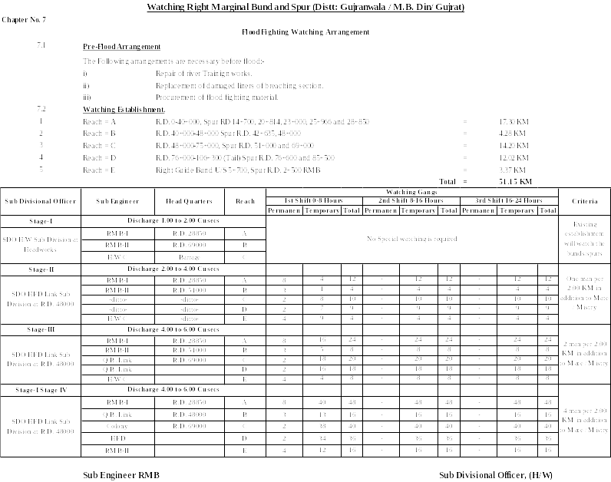

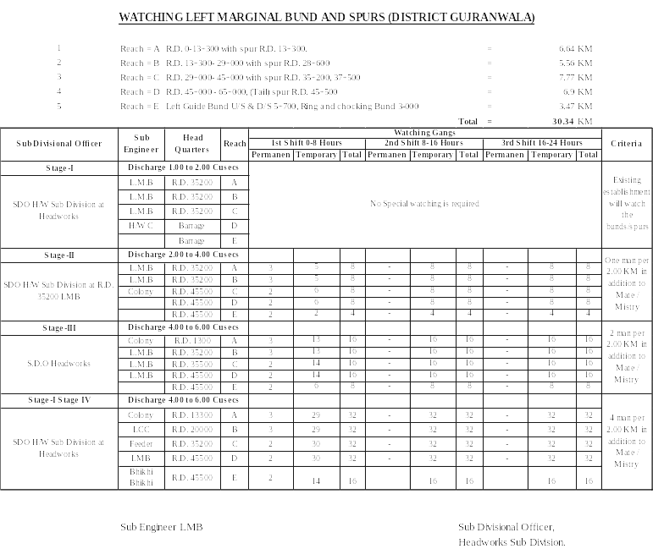
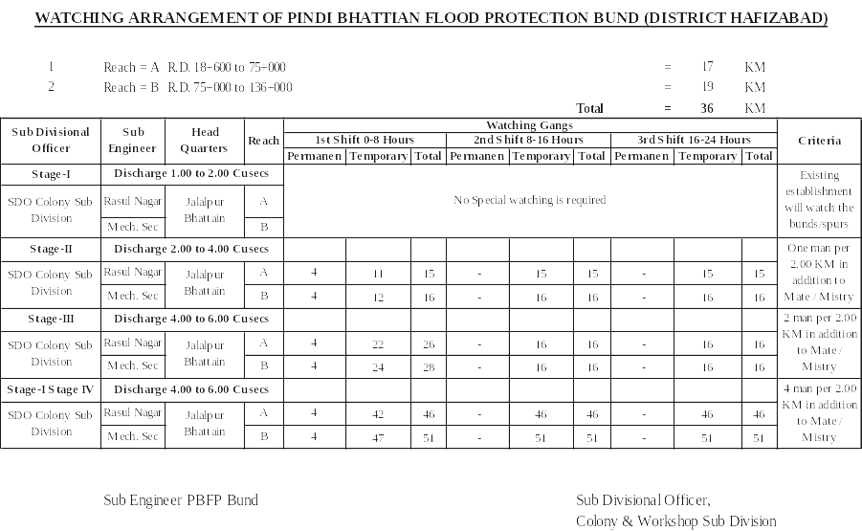

7.3 Arrangement at Sensitive sites

To meet with any emergency on sensitive sites during flood season, the following items / machinery will be arranged:-
- Flood fighting material & watching material.
- Machinery / Dozer.
- Stone.

7.4 Watching Material.

The detail of watching material is as under:-
Sr. No. | Items | Unit | Quantity required for each Camp. | Total Quantity required for 9 Nos. Camps | Quantity Available | Balance Required
1 | Chargeable Torches | No. | 5 | 45 | 12 | 33
2 | Baskets | No. | 8 | 72 | 12 | 60
3 | E.G. Bags | No. | 100 | 900 | 150 | 750
4 | Sutli. | Kg | 12 | 108 | 2 | 106
5 | Needles | No. | 3 | 27 | 12 | 15
6 | Kassi with Handles. | No. | 7 | 63 | 6 | 57
7 | Axes. | No. | 3 | 27 | 3 | 24
8 | Handle for Kassi /Axes. | No. | 9 | 81 | 13 | 68
9 | Buckets | No. | 3 | 27 | 8 | 19
10 | Hand Saws. | No. | 3 | 27 | 2 | 25
11 | Chouldaries Tent | No. | 1 | 9 | 1 | 8
12 | Manila Rope | Kg | 19 | 171 | 50 | 121
13 | Umbrella. | No. | 9 | 81 | 0 | 81
14 | Rain Coats. | No. | 5 | 45 | 2 | 43
15 | Generator 3500 Watt. | No. | 1 | 9 | 0 | 9
16 | Petrol | Ltr | 100 | 900 | 0 | 900
17 | M. Oil | Ltr | 3 | 27 | 2 | 25
18 | Wires 7/0.29 | ft | 53 | 477 | 150 | 327
19 | Wooden Boards.  10 x 12 | No. | 1 | 9 | 1 | 8
20 | Switch / Plugs. | No. | 3 | 27 | 6 | 21
21 | LED Energy Savers.  (25 Watt) | No. | 3 | 27 | 4 | 23

NOTE: Balance quantity will be procured before start of flood season 2025.

B. Reserve Stock available.

RESERVE STOCK OF STONE OF QADIRABAD BARRAGE DIVISION

Sr. No. | Name of Structure | Sanctioned Qty  (In Lac cft) | Available Qty  (In Lac cft) | Balanced Qty  (In Lac cft) | Remarks
1 | Headworks Civil section (District Hafizabad)
i) | U/S Left Guide Bund | 2.000 | 2.410 | -0.410
ii) | U/S Right Guide Bund | 2.000 | 1.537 | 0.463
iii) | D/S Left Guide Bund | 0.500 | 0.590 | -0.090
iv) | D/S Right Guide Bund | 0.500 | 0.244 | 0.256
v) | Emergent Stock | 2.000 | 2.830 | -0.830
vi) | Head Regulator of Q.B. Link | 1.000 | 0.000 | 1.000
 | Sub Total | 8.000 | 7.611 | 0.389
2 | Left Marginal Bund (District Gujranwala)
i) | Spur at RD. 13+300 | 1.500 | 1.530 | -0.030
ii) | Spur at RD. 28+600 | 1.000 | 0.264 | 0.736
iii) | Spur at RD. 35+200 | 1.000 | 0.350 | 0.650
iv) | Spur at RD. 37+500 | 1.000 | 1.000 | 0.000
v) | Spur at RD. 45+500 | 1.000 | 0.646 | 0.354
 | Sub Total | 5.500 | 3.790 | 1.710
3 | Right Marginal Bund-I Section (District Mandi Baha-Ud-Din)
i) | Spur at RD. 2+500 D/S | 2.250 | 1.770 | 0.480
ii) | Spur at RD. 14+700 | 1.500 | 1.260 | 0.240
iii) | Spur at RD. 20+814 | 0.500 | 0.430 | 0.070
iv) | Spur at RD. 23+000 | 1.500 | 1.596 | -0.096
v) | Spur at RD. 25+966 | 0.500 | 0.500 | 0.000
vi) | Spur at RD. 28+850 | 2.000 | 1.775 | 0.225
vii) | D/D at Stone yard H/W Civil sec. | 0.000 | 0.790 | -0.790
 | Sub Total | 8.250 | 8.121 | 0.129
4 | Right Marginal Bund-II Section (District Gujrat)
i) | Spur at RD. 42+635 | 1.000 | 0.110 | 0.890
ii) | Spur at RD. 48+000 | 1.000 | 0.160 | 0.840
iii) | Spur at RD. 51+000 | 1.500 | 0.820 | 0.680
iv) | Spur at RD. 69+000 | 1.000 | 0.990 | 0.010
v) | Spur at RD. 76+000 | 1.000 | 0.990 | 0.010
vi) | Spur at RD. 85+500 | 1.000 | 1.010 | -0.010
 | Sub Total | 6.500 | 4.080 | 2.420
 | G. Total | 28.250 | 23.602 | 4.648
Sufficient quantity of stone, more than 70% is available.

7.5 Arrangement for Sounding & Probing.

Arrangement for sounding and probing will be arranged if needed.

7.6 Lighting Arrangement.

Sub Engineer Headworks Mechanical will keep all the flood lights and other lighting arrangements in proper working condition with the help of electrician and other staff.

7.7 Ration Arrangement.

The establishment and the Supervisory staff will have their own flood arrangement. The Civil Authority shall arrange the supply of ration for at least 500 men when required during emergency.

7.8 P.O.L Arrangement for Vehicles.

In order to close & strengthen the breach / cut sites & operate breaching sections, some reserve of petrol and diesel is required for use in excavators, dozer & generators. Before the start of flood season, the Deputy Commissioner Gujranwala, Hafizabad, Gujrat and Mandi Baha-ud-Din will get oil reserved at any nearest petrol pump. Executive Engineer Qadirabad Barrage will be informed of the arrangements.

7.9 Transportation.

Tractor Trollies are available with the local contractors which will arrange these on call in emergency for transportation of labour and material. The Civil Administration of Gujranwala, Hafizabad, Gujrat and Mandi Baha-ud-Din Districts will be requested to provide transport for carriage of emergent material if not available from local sources in case of emergency.

7.10 Law and Order.

Concerned Deputy Commissioners will engage the necessary Security to control the law and order situation.

7.11 Medical Arrangement for Labour.

No first Aid facility is available at Qadirabad Barrage. District Heath Officers Gujranwala, Hafizabad, Gujrat and Mandi Baha-ud-Din will be requested to make arrangements during flood season at Barrage.

7.12 Liaison with other Department.

Executive Engineer Qadirabad Barrage and Sub Divisional Officer Headworks will keep liaison with their counter parts in other departments. Higher Authorities of other Departments will be approached, if needed through Superintending Engineer Q.B. Link Circle Farooqabad and Chief Engineer Faisalabad Irrigation Zone Faisalabad.

7.13 Role of Army.

At least strength of about 300 Army men is required to deal with any emergency when the discharges expected to exceed 500000 Cusecs. On request of Executive Engineer Qadirabad Barrage Division, the Commander Engineers Headquarter 30 Corp Gujranwala Cantonment will provide necessary assistance.

7.14 Duties of Telephone Attendant.

Telephone at Telegraph office Qadirabad Barrage Division is attended by Signaler on duty. The telephone at Barrage flood office is attended by the Shift Incharge / Jamadar on duty.

7.15 Wireless Arrangements.

The wireless station in the flood warning centre located in Police Guards building Right side of Qadirabad Barrage will be installed by the telecommunication wing of the Punjab Police Department before the flood season. Two Mobile wireless set will be fixed in the vehicle Executive Engineer Qadirabad Barrage Division and Sub Divisional Officer Headworks Qadirabad Barrage. The flood warning, flood gauges, discharge and other information regarding flood are received and transmitted by the flood warning station at Lahore. The mobile units in the vehicle help the touring offices in keeping the flood officers informed.

Chapter No. 8

DETAIL OF ENCROACHMENT.

There is no encroachment on Flood embankments in Qadirabad Barrage Division.

Sr No. | Total Encroachments | Removed | Remaining | Remarks
-- | --- | -- | -- | --

Critical encroachment

Sr No. | Total Critical Encroachments | Removed | Remaining | Remarks
-- | -- | -- | -- | --

There is no encroachment along flood protection infrastructure, river training works or flood plain / water way.

Chapter No. 9

DUTY ROSTER / FLOOD FIGHTING PROGRAM.

Sr. No. | Name of Structure | Location of vulnerable site | Reference of contingency plan
1 | Right Marginal Bund | RD 27+000 to 31+000 | Sub Divisional Officer Headworks is overall incharge with concern Sub Division and their field staff.
2 | Left Marginal Bund | RD. 13+000 to 25+000
3 | Pindi Bhattian Flood Protection Bund | RD. 40+000 to 74+000 | Sub Divisional Officer C&W is overall incharge with concern Sub Division and their field staff.

Already explained in Chapter No. 7 at page No. 19-21

Chapter No. 10

EMERGENCY TELEPHONE NUMBERS.

Sr. No. | Name of Officers & Designation with Office Address. | Code | Office Phone No. | Residence Phone. No. | Fax | Mobile
1 | Secretary Irrigation, Irrigation Secretariat, Lahore | 042 | 99212117  99212118 | 99200954 | 99212117
2 | Rashid khan  Chief Engineer, Irrigation, Faisalabad. | 041 | 9200268 | 9239377 | 9200277 | 0300-4242838
3 | Executive Engineer (OP), Faisalabad Irrigation, Faisalabad. | 041 | 9200270 | 9201140 | 9200277 | 0345-8639436
4 | Canal Telegraph Office, Flood Emergency Center Irrigation Departt: Faisalabad. | 041 | 9200774 | - | - | -
5 | Flood Warning Center Jail Road Lahore. | 042 | 99205175-58 | 7572091-93 | 99200209 | --
6 | Chief Engineer,  D&F Zone, Lahore. | 042 | 99230602 | -- | 99230731 | -
7 | Director Flood,  D&F Zone Lahore | 042 | 99231614 | - | 99230731 | --
8 | Flood Emergency Officer, I&P Secretariat, Lahore | 042 | 9212134 | 5432545 | 9212132 | -
9 | Abdul Jabbar  Superintending Engineer,  Q.B. Link Circle, Farooqabad. | 056 | 3874046 | 3876222 | 3876430 | 0331-6952040
10 | Adnan Yousaf  Executive Engineer, Qadirabad Barrage Division, Qadirabad Canal Colony Distt: Hafizabad. | 054 | 7550190 | 7550198 | 7550198 | 0300-1030530
11 | Canal Telegraph Office, Qadirabad Barrage Division. | 054 | 7550490 | - | - | 0307-6291091  0323-6168137
12 | Qasim Ali  Executive Engineer, Q.B. Link Division, Farooqabad. | 056 | 3874045 | - | - | 0331-6353645
13 | Muhammad Jaffar  Executive Engineer, Marala Barrage Division, Marala. | 052 | 3502102 | 3502102 | 3502121 | 0346-4132454
14 | Telegraph Office, Marala. | 052 | 3502102 |  |  | --
15 | Adeel Anjum  Executive Engineer, Khanki Headworks Division, Khanki. | 055 | 6266227 | 6266239 | 6266239 | 0331-8484303
16 | Sammi Abbas  Sub Divisional Officer, Headworks Sub Division, Qadirabad. | 054 | 7550490 | - | 7550198 | 0304-1242773
17 | Abdul Ghaffar  Sub Divisional Officer, C&W Sub Division, Qadirabad. | 054 | 7550490 | - | 7550198 | 0300-7685049
18 | Commissioner Gujranwala Division Gujranwala | 055 | 9201240 | - | 3734000 | --
19 | DC Gujranwala /Wazirabad | 055 | 9200052 | 9200024-25 | 9200043 | --
20 | DC Hafizabad. | 054 | 7920111 | 7920012 |  | 03040920069
21 | DC Gujrat. | 053 | 9260010 | 9260011 | 9260009 | --
22 | District Police Officer,  Gujrat | 053 | 9260026 | - | 9260029 | --
23 | DC Mandi Baha-ud-Din. | 0546 | 504220 | 506488 | 504100 | 03040920068
24 | City Police Officer,  Gujranwala | 055 | 9200606 | 9200603 | 9200605 | --
25 | District Police Officer,  Mandi Baha-ud-Din. | 0546 | 502324 | 505155 | 503068 | --
26 | District Police Officer, Hafizabad. | 054 | 7521777 | 7521777 | 7523232 | --
27 | Army Flood Office, Gujranwala Cantt. | 055 | 2692105 | - | - | --
28 | Chief Engineer / Advisor Federal Flood Commission, Islamabad. | 051 | 9206589 | 9266059 | 9201805 | --
29 | Chief Engineer, Floods, Islamabad. | 051 | 9201365 | 9202316 | 9221805 | --
30 | Director Flood/ Secretary Punjab Commission, Lahore. | 042 | 9231614 | 6653943 | 35862081 | --
31 | Police Station, Ali Pur Chatha. | 055 | 6332910 | - | - | --
32 | District Police Officer,  Gujranwala / Wazirabad | 055 | 9200606 | - | 9200605 | --

EMERGENCY TELEPHONE NUMBERS
Sr. No |  | Name of Office | Phone # | Fax | Mobile
1 |  | 2 | 3 | 4 | 5
RESCUE 1122
1 | Gujranwala / Wazirabad |  | 055-9201386 | 9201389 | (Engr. Taimoor Ahmed Chatha)  0347-6126394 (Gujranwala)  Fayyaz Ahmed Qamar  0333-8290461 (Wazirabad)
2 | Hafizabad. |  | 0547-920119 | 506013 | 0333-8646254  (Engr. Adnan Nawaz)  DEO
3 | M.B. Din. |  | 0546-513633 | 509837 | 0321-5141122  (Engr. Imran Khan)  (DEO)
4 | Gujrat. |  | 053-3536788 | 9260368 | Umar Akbar Ali DEO  0333-6517115
Fire Brigade. (16)
5 | Gujranwala / Wazirabad |  | 055-3861111 | - | 0333-8771064  Muhammad Malik
6 | Hafizabad |  | 0547-920119 | -
7 | Gujrat |  | 053-3536788 |  | Umar Akbar Ali DEO  0333-6517115
8 | M.B. Din |  | 0546-513633 | -

 | D.H.O
 | Ali Pur | 055 | 9200115 | - | -
 | Gujranwala / Wazirabad | 055 | 9200110 | - | - | -
 | Mandi Baha-u-din | 054 | 6508820 | - | - | -
 | Hafizabad. | 0547 | 9200119 | - | - | -
 | Bomb Disposal Hafizabad  DO Civil Defense | 0547 | 9200119
 | Grid Station (Alipur Chatha) | 055 | 6333614
 | Local Police Station (Alipur) | 055 | 6332910

Chapter No. 11

STANDARD OPERATING PROCEDURE (SOP) FOR BREACHING SECTION.

11.1 History of Breaching section.

Qadirabad Barrage was constructed during year 1963-68. At that time there was no breaching section. After the flood of 1973 Federal flood Commission in its 55th Meeting held on 17-06-1974 approved the Breaching Section of Qadirabad Barrage, located between R.D. 7-9 of R.M.B. It has never been operated since its construction.

11.2 Location, Design, Quantity and Variety for the Explosive required for detonation.

- The site of breaching section is located between RD. 7+000 to 9+000 of Right Marginal Bund.
- It has been designed in four section of 98 ft in length and 402 ft apart. Each section consists of 9 rows, six on top of bund, one on country side slope and two on river side slope. Each row contains 15 liners

Sr. # | Name / Nomenclature of explosive materials / Accessories | Unit | Required Quantity / Nos. | Available Quantity / Nos. | Deficient Quantity / Nos. | Remarks
1 | Wabo Card lot No. 6A/1906-02 | MTR | 1800 | 1800 | 0 | Sufficient explosive material is available at site.
2 | M-S Electric detonator (3.5) | No. | 540 | 540 | 0 | Sufficient explosive material is available at site.
3 | M-S Non Electric delay det (3.5) | No. | 832 | 832 | 0 | Sufficient explosive material is available at site.
4 | Deto No. 8 Plain (Non) Electric | No. | 936 | 936 | 0 | Sufficient explosive material is available at site.
5 | PE-3A (450 Gras slab | KG | 1130 | 1130 | 0 | Sufficient explosive material is available at site.
6 | Primer CE oz | No. | 120 | 120 | 0 | Sufficient explosive material is available at site.
7 | Wabox 8% -25MM | KG | 13657 | 13657 | 0 | Sufficient explosive material is available at site.
8 | Wabonite bulk | KG | 4110 | 4110 | 0 | Sufficient explosive material is available at site.
9 | M-S Electric delay dets, 3M | No. | 252 | 252 | 0 | Sufficient explosive material is available at site.
10 | Leather Detonator. Non Elec: length 5m delay No. 01-10 | No. | 320 | 320 | 0 | Sufficient explosive material is available at site.
11 | Wabonite 90 mm. | No. | 420 | 420 | 0 | Sufficient explosive material is available at site.
12 | Safety Fuse (Lot No. NK) | No. | 375 | 375 | 0 | Sufficient explosive material is available at site.

11.3 Arrangement of Explosives and Security of explosive stores.

The Explosive Store Building is located along Right Bank of Q.B. Link R.D. 1-3 to store Explosive Materials required for operation of the Breaching Section in hour of need. Pre-flood and post flood survey board inspects the explosives every year. The unserviceable able explosive is destroyed and fresh explosive is recouped as the recommendation of concerned army authorities.

11.4 List of the security staff with detail of their training etc.

Three No. ex-military men security guard has been deployed for security of explosive store.

11.5 Detail of mechanical means as a standby arrangement in case of detonation failure.

One No. Dozer from Agriculture Department Mandi Baha-ud-Din is engaged at the breaching section as a stand by arrangement in case of detonation failure.

11.6 Duty Roster in case of critical situation.

Independent Sub Divisional officer and Sub Engineer will be deputed at the breaching section.

11.7 Breaching Committee with their action plan.

OPERATING COMMITTEE

The committee will decide the operation of breaching section. The following are the members of this Committee Notification No. SO (FLOODS) VI-33/97. Dated 15-07-2015

1- Deputy Commissioner, Mandi Baha-ud-Din : Convener

2. Executive Engineer, Qadirabad Barrage. : Member

3- Representative of 30 Corps (Pak Army) : Member
(Not Below Lt. Col.)

4- Representative of Highway Department : Member
(Not below the rank of Executive Engineer)

This committee will operate the breaching section if the safe limit discharges exceed i.e. 9.0 Lac Cs. or the critical gauge at RD. 15+000 LMB reach at level of 712.00 and river is in rising condition.

11.8 List of the villages likely to be inundated in case of breaching at RD. 7+000 to 9+000.

1. Bahu. 2. Manga. 3. Murid. 4. Randiali. 5. Burjwali. 6. Channi Ghullah.
11.9 Announcement and detail of evacuation arrangements.

In case of emergency, the District Government is alert and issues warning regarding evacuation of villages through local announcement.

11.10 Detail of coordination with Civil / Army authorities.

In case of high flood hourly flood gauges are passed to Civil as well as Army authorities. These three departments remain in touch through Telephone and wireless system.

11.11 Parallel Communication arrangements.

Telephone and wireless system are the parallel arrangements for communication.

11.12 Index plan

Index plan of breaching section is attached.

Executive Engineer,  Qadirabad Barrage Division,  Qadirabad | Superintending Engineer,  Q.B. Link Circle,  Farooqabad.
Chief Engineer,
Faisalabad Irrigation Zone,
Faisalabad.

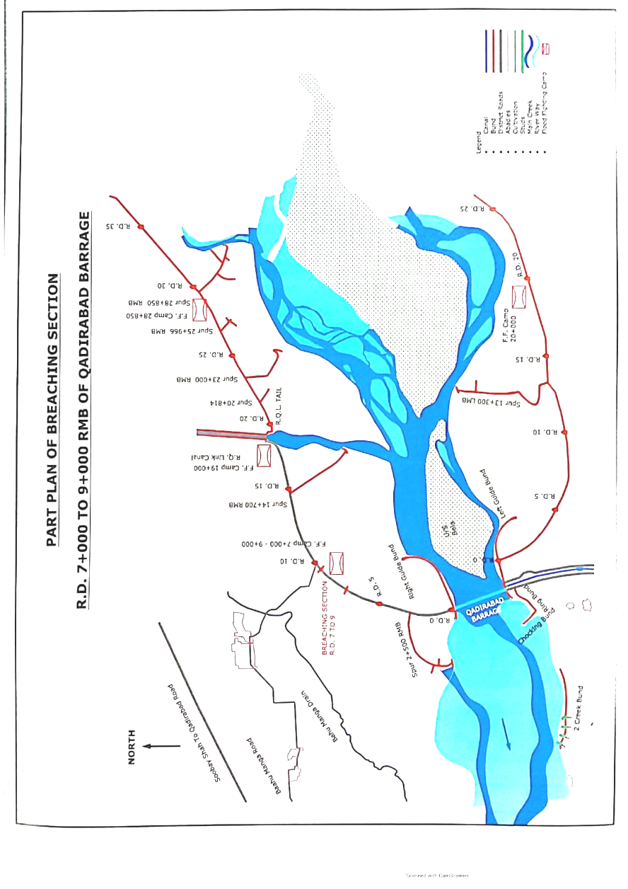
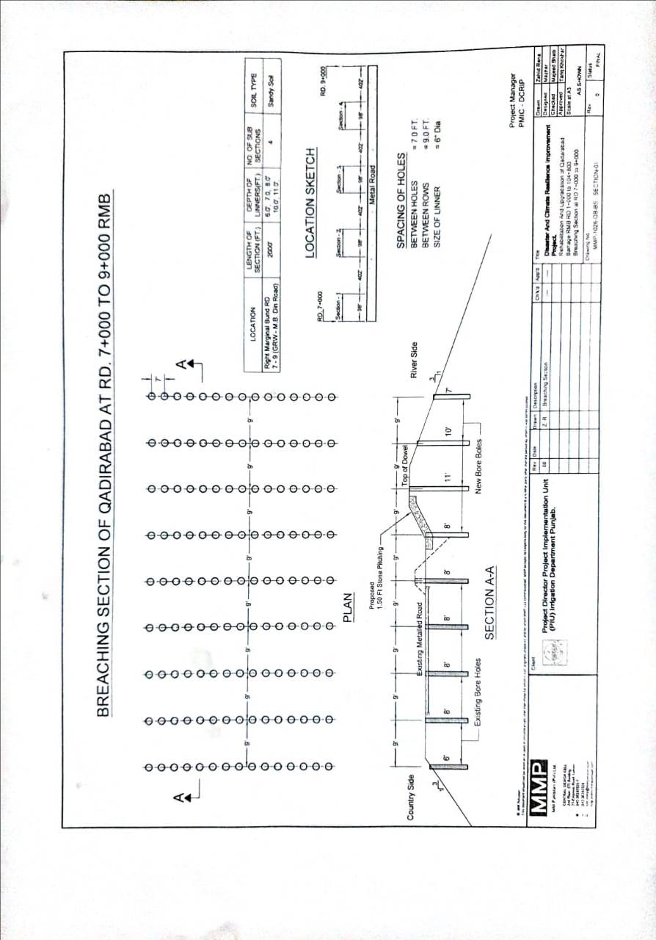
PART “B”
Chapter No. 12

VULNERABLE SITES ON FLOOD BUND / STRUCTURES.

12.1 Apprehended Breaches in Flood Bunds / structures.

The following reaches are under direct hit of parallel flow that requires extra arrangement of watching and flood fighting material at the following sites:-
1) Right Marginal Bund.

RD. 27+000 to 31+000
Vulnerable village / settlements:

- Left Marginal Bund.

RD. 13+000 to 25+000

3) Pindi Bhattain Flood Protection Bund.

RD. 30+000 to 50+000
4) Right Guide Bund.

RD. 2+700 to 4+400

12.2 Operation of Breaching Section.

The breaching section will be operated if the safe limit discharge exceeds i.e. 9.0 Lac Cs or the critical gauge at RD. 15+000 LMB reaches at level of 712.00 and river in rising condition. The decision will be taken by the Breaching Committee as explained earlier vide chapter 11 at page 33.

12.3 Breaches due to Rising of Flood Water, Deterioration of Flood Bunds etc.

The machinery will be deployed as per Flood Fighting Plan if the High, very High and exceptionally High Flood is forecasted by the Meteorological Department at the critical sites to avoid breaches due to rising of flood water and deterioration of flood bunds.

Chapter No. 13

EMERGENCY CONTINGENCY PLAN FOR VULNERABLE SITE NO. 1 RD. 27+000 TO 31+000 RMB.

13.1 Plan showing route of Flood water coming out of the breach.

Plan showing route of Flood water coming out of the breach is attached at page No. 39.

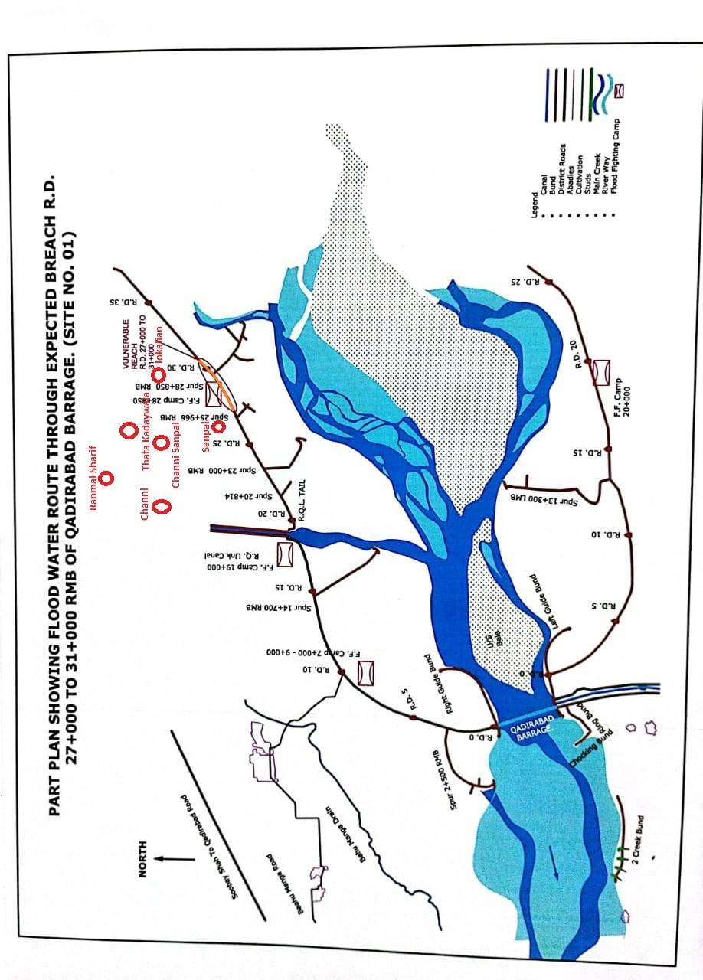
13.2 Detail of villages abadies likely to be affected at RD. 27+000 to 31+000 RMB and this should also be shown on the plan.

1. Channi 2. Channi Sanpal
3. Thatha Kadaywala 4. Jokolian
5. Sanpal 6 Ranmal Sharif
13.3 Strategy and action taken by explained in detail. This may include:-

13.3.1 Arrangements.

Strategy and arrangement in case of any emergency during flood passing arrangements would be made if any damage occurs during flood.

13.3.2 Establishment of Flood fighting Camps.

There are 5 No. Camps sites at various places.
Right Marginal Bund.
- RD. 7+000 – 9+000,
- RD.19+000,
- RD. 28+850,
- RD. 48+000
- RD. 51+000.
13.3.3 Duties of officers / officials and their camp sites.

Camp No. | Location | Officer  (Name + Designation + Mob No) | Official  (Name + Designation + Mob No)
1 | RD 7-9 | Sami Abbas  SDO H/W (0300-1242773) | Farukh Khalid  Sub Engineer RMB-I  (0302-4903763)
2 | RD. 19 | -do- | -do-
3 | RD. 28+850 | -do- | -do-
4 | RD. 48+000 | -do- | Ameer Hamza  Sub Engineer RMB-II  (0323-2187500)
5 | RD. 51+000 | -do- | -do-

13.3.4 Departmental Machinery available.

No departmental machinery is available at Qadirabad Barrage Division.

13.3.5 Machinery available from Private Sources.

Tractor Trollies and other machinery like Dozer, Excavator Machine etc are available with the local contractors who will arrange these on call in emergency for transportation of labour and material. The Civil Administration of Gujrat and Mandi Baha-ud-Din Districts will be asked to requisite transport for carriage of emergent material if not available from local sources in case of emergency.

13.3.6 Flood Fighting Material required for Site No. 1 at RD. 27+000 to 31+000 RMB.

Sr. No. | Items | Quantity Required
1 | Chargeable Torches | 8 Nos.
2 | Baskets | 12 Nos.
4 | E.G. Bags | 150 Nos.
5 | Sutli. | 1 Kg
6 | Needles | 10 Nos.
7 | Kassi with Handles. | 12 Nos.
8 | Axes. | 6 Nos.
9 | Handle for Kassi /Axes. | 12 Nos.
10 | Buckets | 10 Nos.
11 | Hand Saws. | 6 Nos.
12 | Chouldaries Tent | 3 Nos.
13 | Manila Rope | 500 ft
14 | Umbrella. | 6 Nos.
15 | Rain Coats. | 7 Nos.
16 | Generator 2000 Watt. | 1 No.
17 | Petrol | 100 Ltr
18 | M. Oil | 2 Ltr
19 | Wires 7/0.29 | 27 ft
20 | Wooden Boards.  10 x 12 | 2 Nos.
21 | Switch / Plugs. | 4 Nos.
22 | LED Energy Savers.  (25 Watt) | 1 No.

13.3.7 Flood Fighting Material available at Site No. 1 at RD. 27+000 to 31+000 RMB.

Sr. No. | Items | Unit | Required QTY | Quantity Available | Balance | Remarks
1 | Chargeable Torches | No. | 8 | 0 | 8 | Material will be purchase very soon.
2 | Baskets | No. | 12 | 0 | 12 | Material will be purchase very soon.
4 | E.G. Bags | No. | 150 | 0 | 150 | Material will be purchase very soon.
5 | Sutli. | Kg. | 1 | 0 | 1 | Material will be purchase very soon.
6 | Needles | No. | 10 | 0 | 10 | Material will be purchase very soon.
7 | Kassi with Handles. | No. | 12 | 0 | 12 | Material will be purchase very soon.
8 | Axes. | No. | 6 | 0 | 6 | Material will be purchase very soon.
9 | Handle for Kassi /Axes. | No. | 12 | 0 | 12 | Material will be purchase very soon.
10 | Buckets | No. | 10 | 0 | 10 | Material will be purchase very soon.
11 | Hand Saws. | No. | 6 | 0 | 6 | Material will be purchase very soon.
12 | Chouldaries Tent | No. | 3 | 0 | 3 | Material will be purchase very soon.
13 | Manila Rope | ft. | 500 | 0 | 500 | Material will be purchase very soon.
14 | Umbrella. | Nos. | 6 | 0 | 6 | Material will be purchase very soon.
15 | Rain Coats. | Nos. | 7 | 0 | 7 | Material will be purchase very soon.
16 | Generator 2000 Watt. | No. | 1 | 0 | 1 | Material will be purchase very soon.
17 | Petrol | Ltr | 100 | 0 | 100 | Material will be purchase very soon.
18 | M. Oil | Ltr | 2 | 0 | 2 | Material will be purchase very soon.
19 | Wires 7/0.29 | ft | 27 | 0 | 27 | Material will be purchase very soon.
20 | Wooden Boards.  10 x 12 | No. | 2 | 0 | 2 | Material will be purchase very soon.
21 | Switch / Plugs. | No. | 4 | 0 | 4 | Material will be purchase very soon.
22 | LED Energy Savers.  (25 Watt) | No. | 1 | 0 | 1 | Material will be purchase very soon.

EMERGENCY CONTINGENCY PLAN FOR VULNERABLE SITE NO. 2 RD. 13+000 TO 25+000 LMB.

13.1 Plan showing route of Flood water coming out of the breach.

Plan showing route of Flood water coming out of the breach is attached at page No.46.

13.2 Detail of villages abadies likely to be affected and this should also be shown on the plan.

1. Noor Pur (RD. 13-25) 2. Marajke (RD. 13-25)
3. Kot Hara (RD. 13-25) 4. Burj Tasha (RD. 13-25)
5 Thatha Shamsa (RD. 13-25) 6. Rukh Kalan (RD. 45-50) 7. Burj Chatha (RD. 45-50) 8. Saloki Chatha (RD 45-50)

13.3 Strategy and action taken by explained in detail. This may include:-

13.3.1 Arrangements.

Strategy and arrangement in case of any emergency during flood passing arrangements would be made if any damage occurs during flood.

13.3.2 Establishment of Flood fighting Camps.

There are two No. camps sights at

Left Marginal Bund
- RD. 20+000
- RD. 45+500

13.3.3 Duties of officers / officials and their camp sites.

Camp No. | Location | Officer (Name + Designation + Mob No) | Official  (Name + Designation + Mob No)
1 | RD 20+000 | Sami Abbas  SDO H/W (0300-1242773) | Khurram Rafiqui, Sub Engineer LMB  Mob:0300-6297612
2 | RD. 45+500 | -do- | -do-

13.3.4 Departmental Machinery available.

No departmental machinery is available at Qadirabad Barrage Division.

13.3.5 Machinery available from Private Sources.

Tractor Trollies and other machinery like Dozer, Excavator Machine etc are available with the local contractors who will arrange these on call in emergency for transportation of labour and material. The machinery will be deployed as per plan attached as Annexure-A. The Civil Administration of Gujranwala Districts will be asked to requisite transport for carriage of emergent material if not available for local sources in case of emergency.
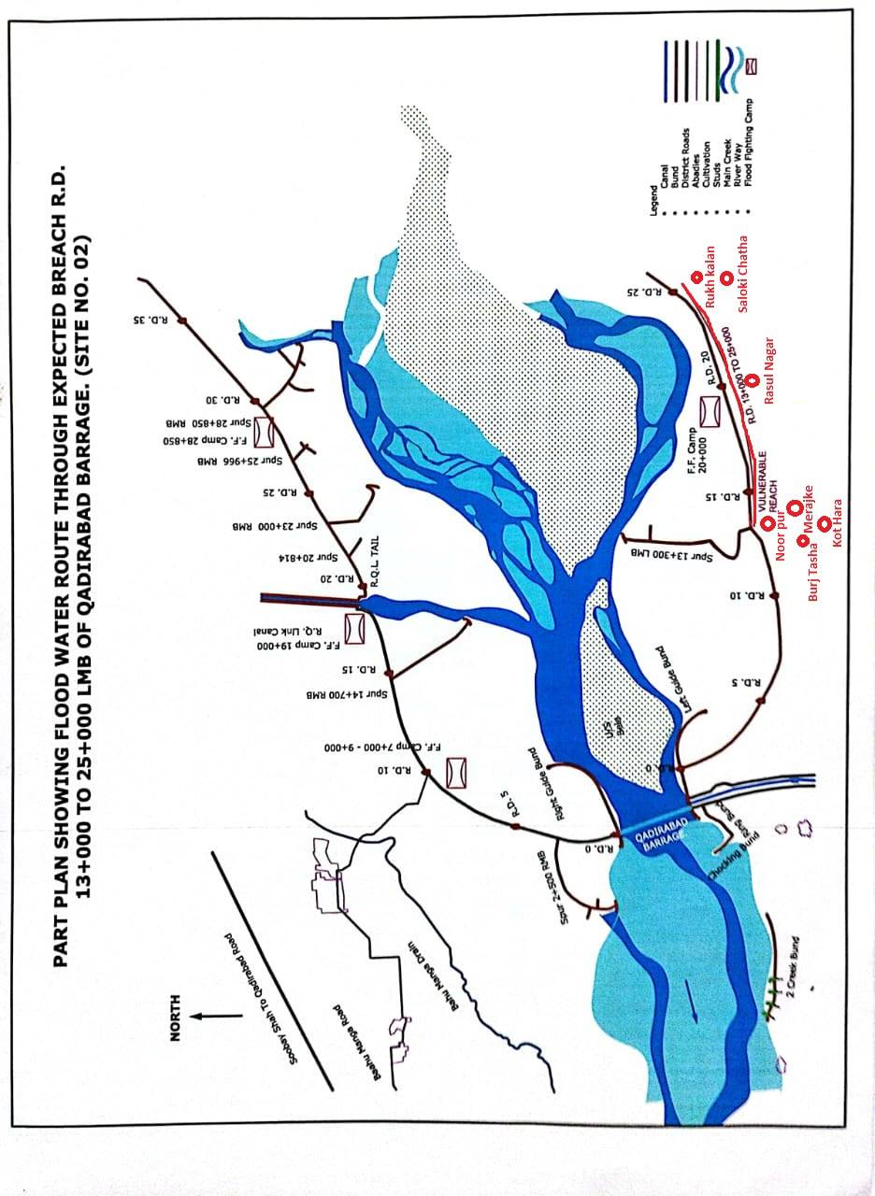

13.3.6 Flood Fighting Material required for Excepted Site No. 2 at RD. 13+000 to 25+000 LMB.

Sr. No. | Items | Quantity Required
1 | Chargeable Torches | 25 Nos.
2 | Baskets | 30 Nos.
4 | E.G. Bags | 500 Nos.
5 | Sutli. | 1 Kg
6 | Needles | 10 Nos.
7 | Kassi with Handles. | 50 Nos.
8 | Axes. | 10 Nos.
9 | Handle for Kassi /Axes. | 50 Nos.
10 | Buckets | 10 Nos.
11 | Hand Saws. | 10 Nos.
12 | Chouldaries Tent | 02 Nos.
13 | Manila Rope | 500 ft
14 | Umbrella. | 20 Nos.
15 | Rain Coats. | 30 Nos.
16 | Generator 2000 Watt. | 2 No.
17 | Petrol | 200 Ltr
18 | M. Oil | 10 Ltr
19 | Wires 7/0.29 | 100 ft
20 | Wooden Boards.  10 x 12 | 2 Nos.
21 | Switch / Plugs. | 10 Nos.
22 | LED Energy Savers.  (25 Watt) | 10 No.

13.3.7 Flood Fighting Material available at Excepted Site No. 2 at RD. 13+000 to 25+000 LMB.

Sr. No. | Items | Unit | Required QTY | Quantity Available | Balance | Remarks
1 | Chargeable Torches | No. | 25 | 0 | 25 | Material will be purchased before flood season.
2 | Baskets | No. | 30 | 8 | 22 | Material will be purchased before flood season.
4 | E.G. Bags | No. | 500 | 0 | 500 | Material will be purchased before flood season.
5 | Sutli. | Kg. | 1 | 0 | 1 | Material will be purchased before flood season.
6 | Needles | No. | 10 | 0 | 10 | Material will be purchased before flood season.
7 | Kassi with Handles. | No. | 50 | 3 | 47 | Material will be purchased before flood season.
8 | Axes. | No. | 10 | 0 | 10 | Material will be purchased before flood season.
9 | Handle for Kassi /Axes. | No. | 50 | 0 | 50 | Material will be purchased before flood season.
10 | Buckets | No. | 10 | 0 | 10 | Material will be purchased before flood season.
11 | Hand Saws. | No. | 10 | 0 | 10 | Material will be purchased before flood season.
12 | Chouldaries Tent | No. | 02 | 0 | 2 | Material will be purchased before flood season.
13 | Manila Rope | Kg. | 500 | 0 | 500 | Material will be purchased before flood season.
14 | Umbrella. | Nos. | 20 | 0 | 20 | Material will be purchased before flood season.
15 | Rain Coats. | Nos. | 30 | 0 | 30 | Material will be purchased before flood season.
16 | Generator 2000 Watt. | No. | 2 | 0 | 2 | Material will be purchased before flood season.
17 | Petrol | Ltr | 200 | 0 | 200 | Material will be purchased before flood season.
18 | M. Oil | Ltr | 10 | 0 | 10 | Material will be purchased before flood season.
19 | Wires 7/0.29 | ft | 100 | 0 | 100 | Material will be purchased before flood season.
20 | Wooden Boards.  10 x 12 | No. | 2 | 0 | 2 | Material will be purchased before flood season.
21 | Switch / Plugs. | No. | 10 | 0 | 10 | Material will be purchased before flood season.
22 | LED Energy Savers.  (25 Watt) | No. | 10 | 0 | 10 | Material will be purchased before flood season.

EMERGENCY CONTINGENCY PLAN FOR VULNERABLE SITE NO. 3 RD. 30+000 TO 50+000 OF PINDI BHATTIAN FLOOD PROTECTION BUND.

13.1 Plan showing route of flood water coming out of the breach.

Plan showing route of flood water coming out of the breach is attached at page No. 51.

13.2 Detail of villages abadies likely to be affected and this should also be shown on the plan.

1. Jalalpur Bhattian (RD. 75-80) 2. Tahli Gorya (RD. 46-49)
3. Chodho Ahmed Yar (RD. 32-33) 4. Sadho key (65-69)
5 Thatha Asalat (RD. 34-44) 6. Chodho Khuda yar
(RD 28-30)

7. Bhattain Wala (RD. 50-55) 8. Dera Cheema (RD. 21-18)

BACK WAY OF FLOOD WATER.

1. Inlet RD. 33+000 to 34+000
2- // RD. 39+460
3- // RD. 42+000
4- // RD. 49+090
5- // RD. 56+000.
13.3 Strategy and action taken by explained in detail. This may include:-

13.3.1 Arrangements.

Strategy and arrangement in case of any emergency during flood passing arrangements would be made if any damage occurs during flood.

13.3.2 Establishment of Flood fighting Camps.

There are two No camps sites at

RD. 45+000 (Talhi Goraya) and RD. 74+650 (Jalalpur Bhattain)

13.3.3 Duties of officers / officials and their camp sites.

Camp No. | Location | Officer  (Name + Designation + Mob No) | Official  (Name + Designation + Mob No)
1 | RD 45+000 | Abdul Ghaffar  SDO C&W (0300-7685049) | Awais Ghulam Jalani, Sub Engineer  Mob: 0303-7930491
2 | RD. 74+650 | -do- | -do-

EMERGENCY CONTINGENCY PLAN FOR VULNERABLE SITE NO. 3 RD. 30+000 TO 50+000 OF PINDI BHATTIAN FLOOD PROTECTION BUND.
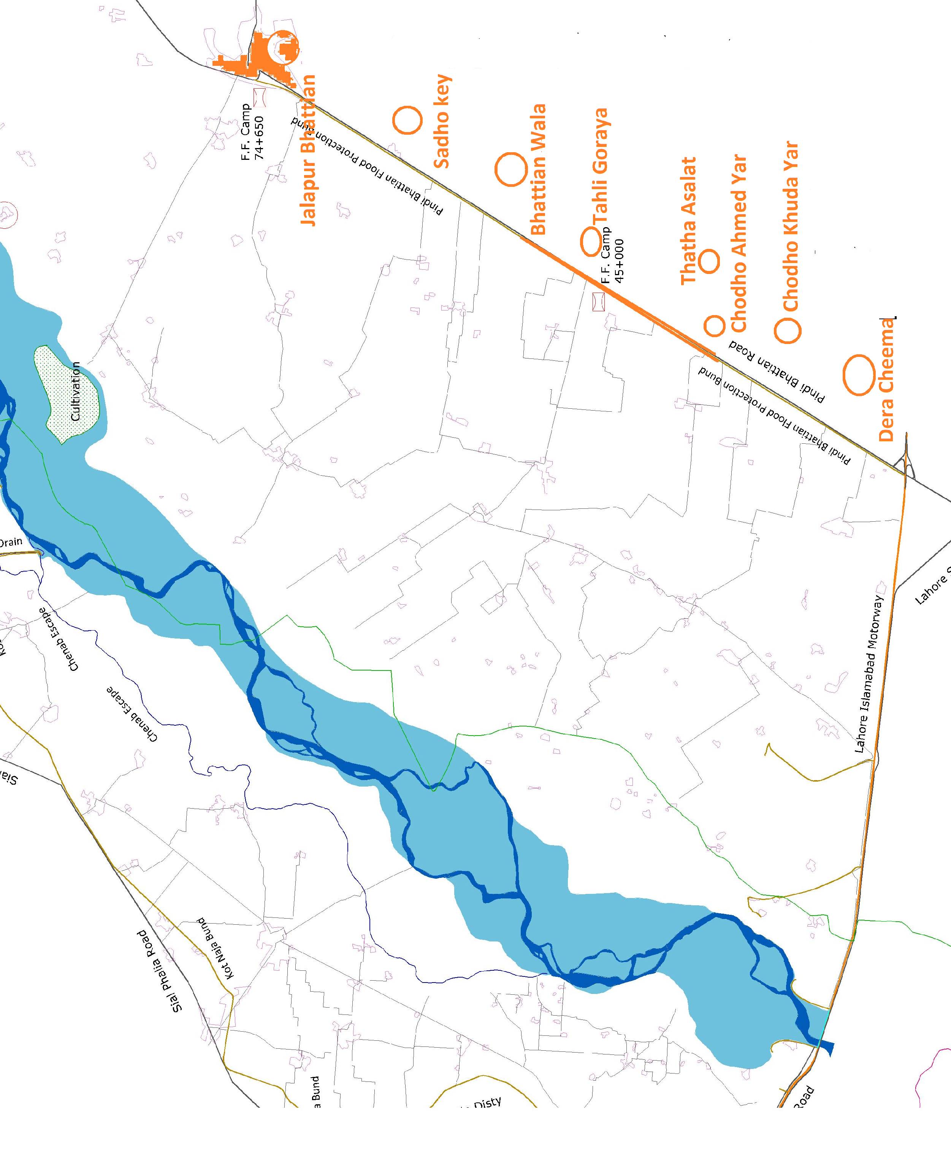

13.3.4 Departmental Machinery available.

No departmental machinery is available at Qadirabad Barrage Division.

13.3.5 Machinery available from Private Sources.

Tractor Trollies and other machinery like Dozer, Excavator Machine etc are available with the local contractors who will arrange these on call in emergency for transportation of labour and material. The machinery will be deployed as per plan attached at page No. 58-60. The Civil Administration of Hafizabad Districts will be asked to requisite transport for carriage of emergent material if not available for local sources in case of emergency.

13.3.6 Flood Fighting Material required for Site No. 3 RD. 30+000 to 50+000 of Pindi Bhattian Flood Protection Bund.

Sr. No. | Items | Quantity Required
1 | Chargeable Torches | 8 Nos.
2 | Baskets | 25 Nos.
4 | E.G. Bags | 50 Nos.
5 | Sutli. | -
6 | Needles | -
7 | Kassi with Handles. | -
8 | Axes. | -
9 | Handle for Kassi /Axes. | 10 Nos.
10 | Buckets | -
11 | Hand Saws. | -
12 | Chouldaries Tent | -
13 | Manila Rope | 50 Kg
14 | Umbrella. | -
15 | Rain Coats. | -
16 | Generator 2000 Watt. | 1 No.
17 | Petrol | 200 Ltr
18 | M. Oil | 10 Ltr
19 | Wires 7/0.29 | 27 ft
20 | Wooden Boards.  10 x 12 | -
21 | Switch / Plugs. | 4 Nos.
22 | LED Energy Savers.  (25 Watt) | 10 Nos.

13.3.7 Flood Fighting Material available at Site No. 3 RD. 30+000 to 50+000 of Pindi Bhattian Flood Protection Bund.

Sr. No. | Items | Unit | Required QTY | Quantity Available | Balance | Remarks
1 | Chargeable Torches | No. | 8 | 0 | - | Material will be purchase very soon.
2 | Baskets | No. | 25 | 0 | 25 | Material will be purchase very soon.
4 | E.G. Bags | No. | 50 | 20 | 30 | Material will be purchase very soon.
5 | Sutli. | Kg. | - | 0 | - | Material will be purchase very soon.
6 | Needles | No. | - | 0 | - | Material will be purchase very soon.
7 | Kassi with Handles. | No. | - | 0 | - | Material will be purchase very soon.
8 | Axes. | No. | - | 0 | - | Material will be purchase very soon.
9 | Handle for Kassi /Axes. | No. | 10 | 10 | - | Material will be purchase very soon.
10 | Buckets | No. | - | 0 | - | Material will be purchase very soon.
11 | Hand Saws. | No. | - | 0 | - | Material will be purchase very soon.
12 | Chouldaries Tent | No. | - | 0 | - | Material will be purchase very soon.
13 | Manila Rope | Kg. | - | 0 | - | Material will be purchase very soon.
14 | Umbrella. | Nos. | 50 | 0 | 50 | Material will be purchase very soon.
15 | Rain Coats. | Nos. | 2 | 0 | 2 | Material will be purchase very soon.
16 | Generator 2000 Watt. | No. | 1 | 0 | 1 | Material will be purchase very soon.
17 | Petrol | Ltr | 200 | 0 | 200 | Material will be purchase very soon.
18 | M. Oil | Ltr | 10 | 0 | 10 | Material will be purchase very soon.
19 | Wires 7/0.29 | ft | 27 | 0 | 27 | Material will be purchase very soon.
20 | Wooden Boards.  10 x 12 | No. | - | 0 | - | Material will be purchase very soon.
21 | Switch / Plugs. | No. | 4 | 0 | 4 | Material will be purchase very soon.
22 | LED Energy Savers.  (25 Watt) | No. | 10 | 0 | 10 | Material will be purchase very soon.

13.4 Detail of other infrastructure like Electric, Sui Gas, Telephone Installation, Road Network, Other Building, Canals and drainage network.

There are no infrastructures like electric, Sui Gas, Telephone installation, Roads, Building, Canal etc on downstream of Breaching section.

CHAPTER – 14

  - RESHUFFLING / RECOUPING PLAN OF RESERVE STOCK OF STONE DEPARTMENTALLY.

The reserve stock of stone for Qadirabad Barrage is available at site / camps. The sufficient quantity of stone at available at sites.

 |  |  |  |  |  | Annexure-B
QADIRABAD BARRAGE DIVISION QADIRABAD
14.2 Information About Inlet / Outlet Crossing is Flood Embankments of Qadirabad Barrage During flood 2025
Sr. No. | Name of Embankment | Location of Crossing /outlet | Discharge capacity  (Cs) | Methodology applied for crossing during flood | Detail of crossing /outlet such B.C be the type of construction | Watching done during Flood
1 | Right Marginal Bund | R.D 42+500 | 34 | Controlled by Gates and earth filling in bags | Gated Control | Being Closed By using earth filled bags
2 |  | R.D 43+759 | 34 | Controlled by Gates and earth filling in bags | Gated Control | Being Closed By using earth filled bags
3 |  | R.D 45+750 | 34 | Controlled by Gates and earth filling in bags | Gated Control | Being Closed By using earth filled bags
4 |  | R.D 51+500 | 34 | Controlled by Gates and earth filling in bags | Gated Control | Being Closed By using earth filled bags
5 |  | R.D 56+218 | 34 | Controlled by Gates and earth filling in bags | Gated Control | Being Closed By using earth filled bags
6 |  | R.D 64+258 | 34 | Controlled by Gates and earth filling in bags | Gated Control | Being Closed By using earth filled bags
7 |  | R.D 66+860 | 34 | Controlled by Gates and earth filling in bags | Gated Control | Being Closed By using earth filled bags
8 |  | R.D 67+500 | 34 | Controlled by Gates and earth filling in bags | Gated Control | Being Closed By using earth filled bags
9 |  | R.D 73+600 | 34 | Controlled by Gates and earth filling in bags | Gated Control | Being Closed By using earth filled bags
10 |  | R.D 82+100 | 34 | Controlled by Gates and earth filling in bags | Gated Control | Being Closed By using earth filled bags
11 |  | R.D 88+200 | 34 | Controlled by Gates and earth filling in bags | Gated Control | Being Closed By using earth filled bags
12 |  | R.D94+770 | 34 | Controlled by Gates and earth filling in bags | Gated Control | Being Closed By using earth filled bags
 | Left Marginal Bund
13 |  | R.D 26+125 | 34 | Controlled by Gates and earth filling in bags | Gated Control | Being Closed By using earth filled bags
14 |  | R.D 33+542 | 35 | Closed | Closed | Closed
15 |  | R.D 40+241 | 34 | Controlled by Gates and earth filling in bags | Gated Control | Being Closed By using earth filled bags
16 |  | R.D 45+294 | 34 | Controlled by Gates and earth filling in bags | Gated Control | Being Closed By using earth filled bags
17 |  | R.D 50+938 | 34 | Controlled by Gates and earth filling in bags | Gated Control | Being Closed By using earth filled bags
18 |  | R.D 59+381 | 34 | Controlled by Gates and earth filling in bags | Gated Control | Being Closed By using earth filled bags
1 | Pindi Bhattian Flood Bund | RD. 33+600 | 7 | 238 | Gated Control | Being Closed By using earth filled bags
2 |  | RD. 39+460 | 1 | 34 | Gated Control | -do-
3 |  | RD. 49+090 | 2 | 68 | Gated Control | -do-
4 |  | RD. 56+095 | 1 | 34 | Gated Control | -do-
5 |  | RD. 71+555 | 1 | 34 | Gated Control | -do-
6 |  | RD. 76+000 | 7 | 238 | Gated Control | -do-
7 |  | RD. 102+560 | 3 | 102 | Gated Control | -do-
9 |  | RD. 112+900 | 1 | 34 | Gated Control | -do-
10 |  | RD. 124+700 | 3 | 102 | Gated Control | -do-
11 |  | RD. 126+000 | 1 | 34 | Gated Control | -do-

QADIRABAD BARRAGE DIVISION.
ACTION PLAN DURING FLOOD 2025 ON RIVER CHENAB
MEDIUM TO HIGH STAGE IN FAISALABAD ZONE
14.3 INFORMATION REGARDING DEPLOYMENT OF MACHINERY AT FLOOD EMBANKMENTS / BARRAGE DURING FLOODS 2025
Sr. No. | Name of Structure | Length  (In Mile) | Vulnerable Reach | Camp Location | Site Incharge by Name & Cell No. | Machinery and Labour to be deployed |  |  |  |  |  | Availability of Stone  (Lac Cft)
 |  |  |  |  |  | Excavator | Dozer | Front Blade Tractors | Dump Trucks | Tractor Trolleys | Labour  (Beldar + Mate) | Availability of Stone  (Lac Cft)
1 | Left Marginal Bund, Qadirabad Barrage. | 12.99 | RD.13-25 | RD. 20+000 | Sami Abbas, SDO Headworks Sub Division  0300-1242773 | 1 | 0 | 1 | 0 | 4 | 12 | 2.50
2 | Right Marginal Bund, Qadirabad Barrage. | 21.26 | RD. 7-9 | RD. 8+000 | Farukh Khalid  Sub Engineer EMB-I  0302-4903763 | 1 | 1 | 1 | 0 | 4 | 12 | 1.77
2 | Right Marginal Bund, Qadirabad Barrage. | 21.26 | RD. 48-55 | RD. 51+000 | Ameer Hamza  Sub Engineer RMB-II  0320-2187500 | 1 | 0 | 1 | 0 | 4 | 12 | 1.00
3 | 2 Creeks D/S Qadirabad Barrage. | 0.62 | RD. 0-3 | RD. 2+000 | Awais Ghulam Jilani  Sub Engineer H/W Civil  0303-7930941 | 1 | 0 | 1 | 0 | 4 | 12 | 0
4 | Pindi Bhattian Flood Protection Bund. | 11.21 | RD. 30-50 | RD. 45+000 | Abdul Ghaffar  SDO  C&W Sub Division  0300-7685049 | 1 | 0 | 1 | 0 | 4 | 12 | 0
 |  |  |  |  | Total:- | 5 |  | 5 | - | 20 | 60 | 5.27
The machinery and labour shall be procured subject to verification of the TPM consultants and as per Departmental policy.
QADIRABAD BARRAGE DIVISION.
ACTION PLAN DURING FLOOD 2025 ON RIVER CHENAB
HIGH TO VERY HIGH STAGE IN FAISALABAD ZONE
14.4 INFORMATION REGARDING DEPLOYMENT OF MACHINERY AT FLOOD EMBANKMENTS / BARRAGE DURING FLOODS 2025
Sr. No. | Name of Structure | Length  (In Mile) | Vulnerable Reach | Camp Location | Site Incharge by Name & Cell No. | Machinery and Labour to be deployed |  |  |  |  |  | Availbility of Stone  (Lac Cft)
 |  |  |  |  |  | Excavator | Dozer | Front Blade Tractors | Dump Trucks | Tractor Trolleys | Labour  (Beldar + Mate) | Availbility of Stone  (Lac Cft)
1 | Left Marginal Bund, Qadirabad Barrage. | 12.99 | RD.13-25 | RD. 20+000 | Sami Abbas, SDO Headworks Sub Division  0300-1242773 | 2 | 0 | 2 | 0 | 8 | 24 | 2.50
2 | Right Marginal Bund, Qadirabad Barrage. | 21.26 | RD. 7-9 | RD. 8+000 | Farukh Khalid  Sub Engineer EMB-II  0302-4903763 | 1 | 1 | 1 | 0 | 4 | 24 | 1.77
2 | Right Marginal Bund, Qadirabad Barrage. | 21.26 | RD. 48-55 | RD. 51+000 | Ameer Hamza  Sub Engineer RMB-I  0320-2187500 | 2 | 0 | 2 | 0 | 8 | 24 | 1.00
3 | 2 Creeks D/S Qadirabad Barrage. | 0.62 | RD. 0-3 | RD. 2+000 | Awais Ghulam Jilani  Sub Engineer H/W Civil  0303-7930941 | 1 | 0 | 1 | 0 | 4 | 24 | 0
4 | Pindi Bhattian Flood Protection Bund. | 11.21 | RD. 30-50 | RD. 45+000 | Abdul Ghaffar  Sub Divisional Officer  C&W Sub Division  0300-7685049 | 2 | 0 | 2 | 0 | 8 | 24 | 0
 |  |  |  |  | Total:- | 8 |  | 8 | - | 32 | 120 | 5.27

The machinery and labour shall be procured subject to verification of the TPM consultants and as per Departmental policy.

QADIRABAD BARRAGE DIVISION.
ACTION PLAN DURING FLOOD 2025 ON RIVER CHENAB
VERY HIGH TO EXCEPTIONALLY HIGH STAGE IN FAISALABAD ZONE
14.5 INFORMATION REGARDING DEPLOYMENT OF MACHINERY AT FLOOD EMBANKMENTS / BARRAGE DURING FLOODS 2025
Sr. No. | Name of Structure | Length  (In Mile) | Vulnerable Reach | Camp Location | Site Incharge by Name & Cell No. | Machinery and Labour to be deployed |  |  |  |  |  | Availbility of Stone  (Lac Cft)
 |  |  |  |  |  | Excavator | Dozer | Front Blade Tractors | Dump Trucks | Tractor Trolleys | Labour  (Beldar + Mate) | Availbility of Stone  (Lac Cft)
1 | Left Marginal Bund, Qadirabad Barrage. | 12.99 | RD.13-25 | RD. 20+000 | Sami Abbas, SDO Headworks Sub Division  0300-1242773 | 2 | 0 | 2 | 0 | 8 | 30 | 2.50
2 | Right Marginal Bund, Qadirabad Barrage. | 21.26 | RD. 7-9 | RD. 8+000 | Farukh Khalid  Sub Engineer EMB-II  0302-4903763 | 1 | 1 | 1 | 0 | 4 | 30 | 1.77
2 | Right Marginal Bund, Qadirabad Barrage. | 21.26 | RD. 48-55 | RD. 51+000 | Ameer Hamza  Sub Engineer RMB-I  0320-2187500 | 2 | 0 | 2 | 0 | 8 | 30 | 1.00
3 | 2 Creeks D/S Qadirabad Barrage. | 0.62 | RD. 0-3 | RD. 2+000 | Awais Ghulam Jalani  Sub Engineer H/W Civil  0303-7930941 | 1 | 0 | 1 | 0 | 4 | 24 | 0
4 | Pindi Bhattian Flood Protection Bund. | 11.21 | RD. 30-50 | RD. 45+000 | Abdul Ghaffar  Sub Divisional Officer  C&W Sub Division  0300-7685049 | 2 | 0 | 2 | 0 | 8 | 30 | 0
 |  |  |  |  | Total:- | 8 |  | 8 | - | 32 | 144 | 5.27

The machinery and labour shall be procured subject to verification of the TPM consultants and as per Departmental policy.

14.6 POLICE DEPLOYMENT PLAN
QADIRABAD BARRAGE DIVISION, QADIRABAD
Performa-1
Sr. | Site of Breaching section | Concerned Canal Division | Concerned Police station & District | Police person to be deployed |  | Remarks  (if any)
 |  |  |  | Inspector /  S.I / A.S.I | Constables | Remarks  (if any)
1 | RD. 7+000 - 9+000 of RMB | Qadirabad Barrage Division | Ranmal Sharif, M.B. Din | Sub Inspector = 01 Nos. | 6 Nos.
Performa-2
Sr. | Vulnerable sites used for illegal cuts during floods | Concerned Canal Division | Concerned Police station & District | Police personal to be deployed |  | Remarks  (if any)
 |  |  |  | Inspector /  S.I / A.S.I | Constables | Remarks  (if any)
1 | RD. 20+000 to 48+000 of Q.B. Link Canal | Qadirabad Barrage Division | Vanike Tarar, Hafizabad | Sub Inspector = 02 Nos. | 8 Nos.
2 | Pindi Bhattian Flood Bund RD. 18+600 to 74+650 | Qadirabad Barrage Division | Pindi Bhattian, Hafizabad | Sub Inspector = 02 Nos. | 8 Nos.
Performa-3
Sr. | Name of Barrage | Concerned Canal Division | Concerned Police station & District | Police personal to be deployed |  | Remarks  (if any)
 |  |  |  | Inspector /  S.I / A.S.I | Constables | Remarks  (if any)
1 | Qadirabad Barrage | Qadirabad Barrage Division | Alipur Chatha, Gujranwala | Sub Inspector = 02 Nos. | 8 Nos.
4-
Traffic police if required for smooth traffic flow at Barrage during flood. (add required detail)
04 Nos. Traffic Police constables will be required during flood.
5-
Any other suggestions.
NIL
PROVISION OF ADDITIONAL FLOOD FIGHTING MATERIAL
QADIRABAD BARRAGE DIVISION

  - SYNTHETIC BAGS WITH CAPACITY OF 500 KG

- LEFT MARGINAL BUND
Sr. No. | Site | Total Bags Required | Total Bag Available | Balance Required
1 | Vulnerable site RD 13000 to 25000 | 300 | 50 | 250

- RIGHT MARGINAL BUND
Sr. No. | Site | Total Bags Required | Total Bag Available | Balance Required
1 | Vulnerable site RD 20000 to 28000 | 200 | - | 200
2 | Vulnerable site RD 51000 to 62000 | 200 | - | 200

- PINDI BHATIAN FLOOD PROTECTION BUND
Sr. No. | Site | Total Bags Required | Total Bag Available | Balance Required
1 | Vulnerable site RD 47700 to 74600 | 300 | 220 | 80

Balance quantity shall be procured before flood season 2025.

Sub Divisional Officer,  Headworks Sub Division,  Qadirabad Barrage. | Sub Divisional Officer,  C&W Sub Division,  Qadirabad
Executive Engineer
Qadirabad Barrage Division
Qadirabad

PROVISION OF ADDITIONAL FLOOD FIGHTING MATERIAL
QADIRABAD BARRAGE DIVISION

  - GEO MEMBRANE SHEET (PLASTIC SHEET)
- LEFT MARGINAL BUND
Sr. No. | Site | Total Plastic Sheet Required | Total Plastic Sheet Available | Balance Required
1 | RD. 13000 TO 20000 (7000 x 60) | 450,000 Sft | Nil | 450,000 Sft
2 | RD. 45+500 to 50+000  (4500 x 60) | 280,000 Sft | Nil | 280,000 Sft

- RIGHT MARGINAL BUND
Sr. No. | Site | Total Plastic Sheet Required | Total Plastic Sheet Available | Balance Required
1 | RD. 25000 to 28000: (3000 x 20) | 65,000 Sft | Nil | 65,000 Sft
2 | RD. 51000 to 56000: (5000 x 20) | 110,000 Sft | Nil | 110,000 Sft
3 | RD. 95000 to 106000: (11000 x 20) | 250,000 Sft | Nil | 250,000 Sft

- PINDI BHATIAN FLOOD PROTECTION BUND
Sr. No. | Site | Total Plastic Sheet Required | Total Plastic Sheet Available | Balance Required
1 | RD 47000 to 70000: (23000 x 20) | 50,000 Sft | Nil | 50,000 Sft

Balance quantity shall be procured before flood season 2025.

Sub Divisional Officer,  Headworks Sub Division,  Qadirabad Barrage. | Sub Divisional Officer,  C&W Sub Division,  Qadirabad
Executive Engineer
Qadirabad Barrage Division
Qadirabad

Chapter-15

BACK UP DIVISION

In case of any emergency during flood situation, the Q.B. Link Division, Farooqabad is backup to Qadirabad Barrage Division.

Executive Engineer,  Qadirabad Barrage Division,  Qadirabad | Superintending Engineer,  Q.B. Link Circle,  Farooqabad.
Chief Engineer,
Faisalabad Irrigation Zone,
Faisalabad.

