**CHAPTER-1**

**SALIENT FEATURES OF MIANWALI CANAL DIVISION MIANWALI.**

* 1. **LOCATION**

Mianwali Canal Division is situated at District Head Quarter Mianwali.

### 1.2 GENERAL DESCRIPTION

Mianwali Canal Division has been established since 01.07.2012 due to splitting of Khushab Canal Division into two Divisions.

1:- Mianwali Canal Division at Mianwali.

2:- Khushab Canal Division at Khushab.

From 01.10.2012, Kundian Canal Sub Division of Kalabagh Division has been attached with this Division. Mianwali Canal division is responsible for regulation of Thal Canal Main Line Lower, Escape Channel, Mohajir Branch, Dullewala Branch, Kundian Disty &Tibbi Disty off-taking from RD: 157+662 (Tail) of Thal Canal Main Line Upper. Moreover, maintenance and repair of 4-No. Lift Irrigation Schemes, Namal Dam and River Training Works Downstream Chashma Barrage to Mussiwali village are also under the control of Executive Engineer, Mianwali Canal Division. It comprises of four Sub Divisions, detail as under:-

1. Dullewala Canal Sub Division, Mianwali.
2. Tubewell Sub Division, Mianwali.
3. Kundian Canal Sub Division, Kundian.
4. Namal Canal Sub Division, Mianwali.

Main infrastructure of Mianwali Canal Division comprises of:-

1. River Training Works D/S Chashma in District Mianwali. 13-No.
2. Thal Canal (Main Line Lower). 26.20 Canal Miles
3. Dullewala Branch 21.60 Canal Miles
4. Escape channel 3.85 Canal Miles
5. Distys, Minors & Sub Minors. 457.14 Canal Miles
6. Nos. of Outlets. 1103 Nos.
7. G.C.A. 5.04 Lac acre
8. C.C.A. 4.34 Lac acre

### 1.3 ADMINISTRATIVE SETUP

**A.** **DULLEWALA SUB DIVISION**

This Sub Division controls:

1. Dullewala Branch RD: 0+000-108+019 (Tail) and its System.
2. Tibbi Disty.
3. **KUNDIANSUB DIVISION**
   1. 13-No. River Training Works on Left side of river Indus D/S Chashma Barrage to Mussiwali village (Tehsil Piplan).
   2. Thal Canal Main Line Lower RD 0+000 to RD 131+000 and its off takes.
   3. Escape Channel RD: 0+000-19+250 (Tail).
   4. Kundian Disty system.
4. **TUBEWELL SUB DIVISION**
   1. Pumping Machinery of Samandwala Lift Irrigation Scheme.
   2. Pumping Machinery at Pump House “A” and Pump House “B” of Mianwali Lift Irrigation Scheme.
   3. Pumping Machinery of Gulmiri Lift Irrigation Scheme.
   4. Pumping machinery of Mochh Lift Irrigation scheme.
   5. 40-No. Tubewells along C.J Link.
      * 1. Village Adhi Kot = 25-No.
        2. Village Chan = 15-No.
5. **NAMAL CANAL SUB DIVISION**

i. Namal Dam and Canal System.

ii. Channels of Samandwala Lift Irrigation Scheme.

iii. Channels of Mianwali Lift Irrigation Scheme.

iv. Channels of Gulmiri Lift Irrigation Scheme.

**E. ORGANIZATION CHART**

Copy attached.

**SDO Namal**

**at Mianwali**



Sub Engineer

(2)



**Executive Engineer**



**Deputy**

**Collector**



**SDO**

**Tubewell**

**at Mianwali**



**SDO Dullewala**

**at Mianwali**



**SDO**

**Kundian**

**at**

**Kundian**

ORGANIZATION CHART OF

MIANWALI

CANAL DIVISION

M

IANWALI



**Head Clerk**

**(1)**



Sub Engineer

(

6

)



Z

illadar

(

4

)



**Head Draftsman**

**(1)**



Sub Engineer

(

1

)



Head vernacular

Clerk

(1)



Assessment

Clerk

(1)



Sub Engineer

(

6

)



Zilladar

(

3

)



Accounts

Clerk

(2)



Draftsman

(1)



Tra

cer

(1)



J/Clerk

(

7

)



**Divisional Accounts Officer**



Z

illadar

(1)

**CHAPTER-2**

**FLOOD PROTECTION AND RIVER TRAINING WORKS**

The river training works on Indus River Downstream Chashma Barrage are as under:-

#### RIVER TRAINING WORKS ON INDUS RIVER.

|  |  |
| --- | --- |
| 1 | J-Head spur at Village Kahloon |
| 2 | J-Head Spur at Bhakra |
| 3 | Guide Spur at Alluwali |
| 4 | Guide Head Spur at Alluwali (shank portion) |
| 5 | Guide Head Spur at RD: 29+000 village Dhingana |
| 6 | J-Head Spur at RD: 35+600 near village Doaba |
| 7 | J-Head Spur at Piplan |
| 8 | Guide wall Piplan |
| 9 | Guide Spur at Mussiwali |
| 10 | Protection wall at Alluwali |
| 11 | Solid stone stud near village Doaba |
| 12 | Protection wall at Dhingana |
| 13 | Protection Wall village Bhakra, Ding and Shah Nawaz Wala |

### 2.1 DESIGN PARAMETERS OF TRAINING WORKS

|  |  |  |  |  |  |
| --- | --- | --- | --- | --- | --- |
| **Sr. No.** | **Name of Structure** | **Length** | **Designed Top R.L.** | **TopWidth.**  **(Ft).** | **Side Slopes** |
| 1 | J-Head spur at Village Kahloon | 2120-Ft | 636.00 | 30-Ft | 1:3Country side  1:2 River side |
| 2 | J-Head Spur at Bhakra | 2500-Ft | 634.00 | 30-Ft | 1:3 Country side  1:2 River side |
| 3 | Guide Spur at Alluwali | 2200-Ft | 634.00 | 30-Ft | 1:3 Country side  1:2 River side |
| 4 | Guide Head Spur at Alluwali (shank portion) | 1400-Ft | 630.00 | 30-Ft | 1:3 Country side  1:2 River side |
| 5 | J-Head Spur at Piplan | 3514-Ft | 631.00 | 30-Ft | 1:3 Country side  1:2 River side |
| 6 | Guide wall Piplan | 1410-Ft | 631.00 | 30-Ft | 1:3 Country side  1:2 River side |
| 7 | Guide Spur at Mussiwali | 2000-Ft | 630.00 | 30-Ft | 1:3 Country side  1:2 River side |
| 8 | Protection wall at Alluwali | 2250-Ft | 616.00 | 10-Ft | 1:1 River side |
| 9 | Solid stone stud near village Doaba | 1840-Ft | 627.00 | 15-Ft | 1:1 River side |
| 10 | Protection wall at Dhingana | 1000-Ft | 610.00 | 20-Ft | 1:1 River side |
| 11 | Guide Head Spur at RD: 29+000 village Dhingana | 3514-Ft | 630.00 | 30-Ft | 3:1Country side  2:1 River side |
| 12 | J-Head Spur at RD: 35+600 near village Doaba | 3400-Ft | 630.00 | 30-Ft | 3:1Country side  2:1 River side |
| 13 | Protection Wall village Bhakra, Ding and Shah Nawaz Wala | 4400-Ft | 625.00 | 20-Ft | 2:1 River side |

### LOCATION MAP OF TRAINING WORKS

Location of river training works is marked on index plan of Mianwali Canal Division, Mianwali at page 05.

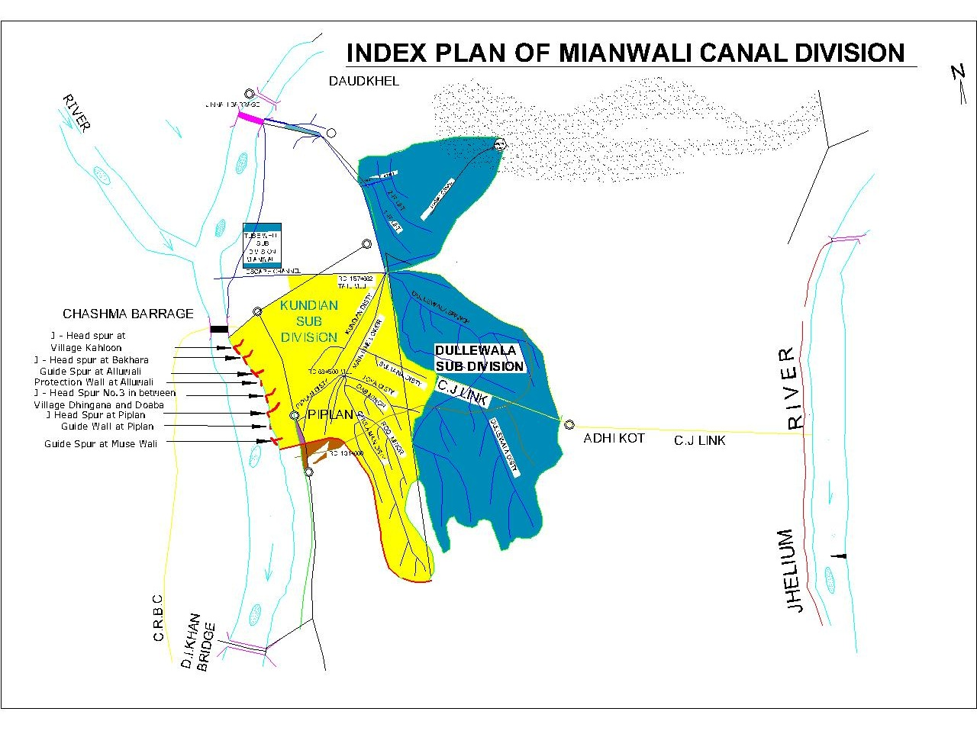

**CHAPTER-3**

**BRIEF HISTORY OF PAST FLOOD EVENTS.**

1. During flood season 2019 river changed its course D/S Chashma Barrage right side near village Bhakkra Tehsil Piplan. The inhabitants of Mouza Bhakkra, Ding, Balochi Khel, Shah Nawazwala, Kholaah, Katcha Gujrat and adjoining abadies at Chashma, Noshera Billote Road Tehsil Piplan District Mianwali on right bank of river Indus approached to the District Administration for protection of their houses, agricultural land and other infrastructure from river erosion during the month of august 2019. On directions of Deputy Commissioner Mianwali Technical Committee of Irrigation Zone Sargodha visited erosion site on 01.09.2019 and matter was referred to Departmental Expert Committee of Irrigation Department for suitable technical remedial measures to be adopted at site to avoid any untoward situation. Meeting of Departmental Expert Committee of irrigation Department was held on 25.09.2019; “The committee suggested / recommended that revetment may be used for the protection of Local abadies along the problematic right side of Indus river just D/S Chashma Power House”. The length of stone revetment from 8+800 to 13+200 (4400-ft) was suggested / recommended by Departmental Expert Committee. The detailed estimate amounting to Rs. 109.695-Million was prepared by Irrigation Department Mianwali in light of recommendation of Expert Committee and accordingly submitted to the Deputy Commissioner, Mianwali vide No.1274/49-W(Bhakra) dated 10.10.2019 and updated cost estimate was submitted to Deputy Commissioner Mianwali on 25.01.2021 for Rs. 116.422-Million. Scheme namely "Flood Protection Walls at Villages Bhakra, Ding, Shah Nawazwala and Blochi Khel Right Side of River Indus D/S Chashma Barrage" was included in Annual Development Program 2021-22 at General Sr. No. 5519. Scheme was Administratively approved vide Government of the Punjab Secretary Irrigation No. SO(FLOODS)VI-10/2021 dated 06.09.2021 for Rs. 116.484-Million. Estimate was technically sanctioned vide Chief Engineer, Irrigation Sargodha No. 18189/W-II/XI-2 dated 29.10.2021 for amounting to Rs: 114.066-Million. Tender for the work was opened on 30.11.2021 and the work physically 100% completed at site in June 2022.
2. During flood season 2022 due to parallel flow of water in between RD 7+000 to 15+000 the abadies and infrastructures like Government schools and HT Lines etc of Mouza Shah Nawaz Wala and Mouza Bhakra remained under threat. Due to construction of Guide wall in financial year 2021-22 Mouza Bhakra abadies and infrastructures remained well protected. However in between RD 13+000 to 15+000 and RD 7+000 to 9+000 erosive action of river Indus were noticed. The Executive Engineer, Mianwali Canal Division inspected the site on 12.08.2022 and reported the alarming site condition of river Indus as the abadies and infrastructures of Mouza Bhakra and Shah Nawaz Wala were under threat due to erosive action of river Indus. The site was inspected by the Superintending Engineer, Thal Canal Circle, Mianwali on 23.08.2022 and the report was submitted to Deputy Commissioner, Mianwali and Chief Engineer, Irrigation Sargodha Zone on 25.08.2022 and clearly reported that there is no irrigation infrastructure is under threat due to river erosive action. The Chief Engineer, Irrigation Sargodha Zone referred the case to Secretary Irrigation Punjab for arranging the Departmental Expert Committee. Departmental Expert Committee meeting held on 02.09.2022 recommended that "The members of Departmental Expert Committee unanimously suggested that the stone revetment in a length of 1000 ft on upstream side in between RD 7+800 to 8+800 and Three No solid stone studs in a length of 50-ft may be constructed in between RD 13+000 to 15+000 to deflect the river flow away from end protection of river erosive action at downstream as per flood policy. However, the concerned Chief Engineer may change the length of solid stone studs according to site prevailing condition". The Chief Engineer, Irrigation Sargodha Zone, Sargodha along with Superintending Engineer, Thal Canal Circle, Mianwali, Resident Engineer NESPAK Consultants and Executive Engineer, Mianwali Canal Division, Mianwali visited the site on 09.09.2022 and vide canal wire No. 2241 dated 10.09.2022, keeping in view the decision of Departmental Expert Committee dated 02.09.2022 and current prevailing river site conditions at that time directed that in addition of Departmental Expert Committee decision to place the 03-No Solid Stone Studs with Top R.L 620.00-Ft with Side Slopes 1:1, Sloping Nose 1:5 having Top width 15-Ft and key length 25-Ft, Solid Stone of 50-Ft length may be placed at RD 13+600, whereas 2nd & 3rd Solid Stone Studs of 75-Ft length may be placed at RD 14+100 and 14+800, respectively at deflecting angle to protect the river bank as temporary measure. On recommendation of Departmental Expert Committee Irrigation Department and direction of Chief Engineer, irrigation Sargodha Zone the estimate amount to Rs: 136.046-Million was framed and submitted through proper channel to PDMA Punjab on 13.09.2022.
3. During flood season 2023 medium flood was observed in river Indus and maximum discharge downstream Chashma Barrage was 415651-Cs: (medium flood) on 25.07.2023.

All the structures remained safe during flood season of 2023 except "Protection Wall Village Bhakra, Ding and Shah Nawaz Wala", where stone revetment wall between RD 11+360 and 13+200 in a length of 500-Ft and 250-Ft completely washed away and revetment wall in a length of 1320-Ft partially damaged owing to fluctuation of river discharge and right ward drifting trend of river Indus parallel to the stone apron. After reporting damages to higher offices, Superintending Engineer, Thal Canal Circle recommended that a Technical Committee may be constituted with immediate effect in order to conduct site visit of stone revetment wall where erosive action of river is taking place and causing huge damage to irrigation infrastructure. Therefore, Chief Engineer, Irrigation Sargodha, Zone Sargodha constituted Technical Committee vide his office letter No.10315-18/PACE/WII/11-01 dated 08.08.2023 in accordance with Administrative Department letter No. SO(Floods)VII-03/2004 dated 03.06.2019 and 12.07.2019. Keeping in view the prevailing site situation at that time and detailed deliberations to cope with emergent situation technical committee visited the site on 08.08.2023 and recommended that *"In order to avoid bypassing and for safety of existing structure, solid stone stud of length 50 ft. with top width and key length of 15 ft. may be provided with immediate effect as temporary measure and same may be placed approximately between 200 to 300 ft. upstream of start point of protection wall keeping top level RL 623. Moreover, exposed end of remaining wall may be protected by stone dumping"*. Furthermore negotiated tender by invoking clause 59-D(II) was approved by the Chief Engineer, Irrigation Sargodha Zone letter No. 10638/Budget/2023-24 dated 11.08.2023 and consequently work was awarded to M/S Al-Abbas Construction Company by Executive Engineer, Mianwali Canal Division, Mianwali vide acceptance letter No. 2030/27-AI(G) dated 11.08.2023. This emergent work was executed under the resident supervision of Third Party Consultants M/S NESPAK-RHC(JV) deputed by the Administrative Department.

1. During flood season-2024 medium flood was observed in river Indus and maximum discharge downstream Chashma Barrage was 419211-Cs (medium) on 09.08.2024.
2. All the structures remained safe during flood season except “GUIDE HEAD SPUR RD 29+000 D/S CHASHMA BARRAGE” at village Dhinghana, where apron was partially launched and pitching was partially damaged in length of 250-ft on river side at U/S curved portion between RD 0+350 to 0+600 and “GUIDE WALL RD 25+000 TO 27+000 D/S CHASHMA BARRAGE” near village Mandan Wala and Keetan Wala where apron was launched in length of 1500-ft. Furthermore, apron and pitching in length of 50-ft washed away at start point of Guide wall. The damages were reported to higher office with a request to constitute Technical Committee for viable solution. Thereafter, in pursuance to the Notification issued by the Government of Punjab, Irrigation Department vide No. SO(FLOODS)VII-03/2004 dated 03.06.2019 & 12.07.2019, Technical Committees were constituted to assess the necessity of flood emergent works vide Chief Engineer, Irrigation Sargodha Zone letter No.8043/WII/44/2008 dated 03.07.2024 and No.10399/WII/44/2008 dated 02.09.2024 respectively. The Technical Committee visited the site of Guide Head Spur RD 29+000 on 06.07.2024 and observed the river behavior and erosive action taking place at site, and there is a chance that erosion will further damage the structure. After observing river behavior, river-bed soundings and detailed deliberations made with the concerned Superintending Engineer and field officers / officials during site inspection on 06.07.2024, the Technical Committee suggested following measures.
3. With the aim to control erosive action of river and to avoid further damage, the structure be held at present position as a temporary measure by dumping stone using reserve stock.
4. The execution of above work may be taken up by invoking clause 59-D (iii) of PPRA Rules 2014.
5. The temporary protective work may be carried out after observing baseline data jointly with the third-party monitoring consultants and further executed under their resident supervision as per instructions of Administrative Department.
6. The regular restoration of the structure be taken up after flood season.
7. The expedite the Model Study of this problematic reach.

After the recommendations of technical committee, the work was taken up on emergent basis under clause 59-D (iii) of PPRA Rules 2014 to save the structure.

1. The Technical Committee visited the site of Guide Wall at RD 25+000 to 27+000 D/S Chashma Barrage on 03.09.2024, the committee examined that there is a chance erosion will further damage the structure, so immediate remedy is required. Therefore, the Technical Committee has suggested following measures:
2. With the aim to control the erosive action of river and to avoid further damage, the structure be held at present position as a temporary measure by dumping of stone.
3. The execution of above work may be taken up by invoking clause 59 D-(iii) of PPRA Rules 2014.
4. The temporary protective work may be carried out after observing baseline data jointly with the third-party monitoring consultants and further executed under their resident supervision as per instructions of Administrative Department.
5. The regular restoration of the structure be taken up after flood season.
6. The construction of incomplete structure at RD: 22+000 (Guide Head Tied at the Existing Shank of Alluwali Village) appears to be useful for diverting flow away from left flank, the same may be placed before Departmental Expert Committee to evolve sustainable solution of the problem in view of prevailing river morphology.

As per recommendations the structure was withheld during the flood season by dumping of stone and wire crates as temporary measures.

**CHAPTER-4**

**DESIGNED DATA, HISTORIC PEAK FLOOD DATA AND PREVIOUS FIVE YEAR FLOOD DATA OF HEAD WORKS / BARRAGES AND OR OTHER CONTROL POINTS**

***Not applicable.***

### 4.1 FLOOD LIMITS OF RIVER INDUS AT CHASHMA BARRAGE

Limits of flood fixed by the Punjab Flood Commission are as under:-

Normal. = upto2.5Lac Cs.

Low Flood = 2.5 to 3.75 Lac Cs.

Medium Flood = 3.75 to 5.0 Lac Cs.

High Flood = 5.0 to 6.50 Lac Cs.

Very High Flood = 6.50 to 8.0 Lac Cs.­

Exceptionally High Flood = 8.00 to 10.0 Lac Cs.

Super Flood = above 10.0 Lac Cs.

### 4.2 TIME LAGS OF FLOODS

|  |  |  |
| --- | --- | --- |
| **DISTANCE** | | **TIME LAG** |
| From Attock to Jinnah Barrage. | = 106 Miles | 48 Hours |
| From Jinnah Barrage to Chashma Barrage. | = 41 Miles | 18 Hours |
| From Chashma Barrage to D.I.Khan/ Darya Khan Bridge | = 71 Miles | 30 Hours |

### 4.3 HIGHEST FLOODS AT JINNAH BARRAGE

Histogram of highest floods at Jinnah Barrage is given below:

| **Year** | **Date** | **U/s gauges** | **D/s gauges** | **D/s discharge** | **Remarks** |
| --- | --- | --- | --- | --- | --- |
| 1947 | 9/8/47 | 690.20 | 686.0 | 526799 | High |
| 1948 | 14/8/48 | 691.45 | 690.65 | 769262 | Very High |
| 1949 | 20/7/49 | 689.95 | 689.6 | 698166 | Very High |
| 1950 | 2/8/50 | 691.25 | 690.75 | 743757 | Very High |
| 1951 | 12/8/51 | 690.80 | 688.95 | 445973 | Medium |
| 1952 | 21/7/52 | 691.50 | 6.88.90 | 463038 | Medium |
| 1953 | 12/7/53 | 692.05 | 691.25 | 689661 | Very High |
| 1954 | 3/8/54 | 691.50 | 686.3 | 416768 | Medium |
| 1955 | 19/8/55 | 692.10 | 687.75 | 520622 | High |
| 1956 | 18/7/56 | 691.90 | 688.15 | 566657 | High |
| 1957 | 20/7/57 | 691.60 | 687.2 | 443088 | Medium |
| 1958 | 16/7/58 | 693.30 | 690.4 | 776311 | Very High |
| 1959 | 4/7/59 | 692.00 | 688.4 | 598304 | High |
| 1960 | 13/7/60 | 692.00 | 689.1 | 529400 | High |
| 1961 | 30/7/61 | 692.00 | 688.3 | 523144 | High |
| 1962 | 22/7/62 | 692.00 | 685.55 | 422239 | Medium |
| 1963 | 31/7/63 | 692.10 | 687.1 | 463718 | Medium |
| 1964 | 16/7/64 | 691.60 | 690 | 555933 | High |
| 1965 | 27/7/65 | 691.20 | 687.9 | 466850 | Medium |
| 1966 | 26/6/66 | 691.50 | 689.2 | 500099 | High |
| 1967 | 30/7/67 | 692.00 | 688.85 | 541835 | High |
| 1968 | 15/8/68 | 692.00 | 687.05 | 476166 | Medium |
| 1969 | 13/8/69 | 692.0 | 687.2 | 465346 | Medium |
| 1970 | 13/8/70 | 692.50 | 685 | 408067 | Medium |
| 1971 | 29/6/71 | 692.50 | 686.25 | 428431 | Medium |
| 1972 | 20/7/72 | 692.50 | 686.3 | 397700 | Medium |
| 1973 | 30/8/73 | 692.50 | 689.2 | 545917 | High |
| 1974 | 2/8/74 | 693.00 | 685.7 | 373854 | Low |
| 1975 | 2/8/75 | 692.60 | 689.1 | 602541 | Very High |
| **1976** | **2/8/76** | **693.00** | **690.7** | **861965** | **Exceptionally High** |
| 1977 | 17/7/77 | 692.50 | 688.25 | 574391 | High |
| 1978 | 6/8/78 | 692.50 | 689 | 639790 | High |
| 1979 | 10/8/79 | 692.50 | 684.65 | 456840 | Medium |
| 1980 | 26/8/80 | 692.50 | 683.7 | 331197 | Low |
| 1981 | 3/7/81 | 692.50 | 683.8 | 369944 | Low |
| 1982 | 17/8/82 | 692.50 | 684.8 | 474231 | Medium |
| 1983 | 4/9/83 | 692.50 | 685.2 | 499793 | Medium |
| 1984 | 15/8/84 | 692.50 | 683.9 | 491280 | Medium |
| 1985 | 2/8/85 | 692.50 | 682.1 | 313340 | Low |
| 1986 | 5/8/86 | 692.50 | 684.3 | 471073 | Medium |
| 1987 | 28/7/87 | 692.50 | 683.3 | 351268 | Low |
| 1988 | 2/8/88 | 692.50 | 684.3 | 598303 | High |
| 1989 | 1/8/89 | 692.50 | 685.65 | 557811 | High |
| 1990 | 10/8/90 | 692.50 | 685.1 | 546260 | High |
| 1991 | 15/7/91 | 692.50 | 682.8 | 445847 | Medium |
| **1992** | **10/9/92** | **692.50** | **688.4** | **846040** | **Exceptionally High** |
| 1993 | 23/7/93 | 692.50 | 680.6 | 355569 | Low |
| 1994 | 13/7/94 | 692.50 | 683.4 | 491375 | Medium |
| 1995 | 27/7/95 | 692.50 | 684 | 544663 | High |
| 1996 | 16/8/96 | 692.50 | 682 | 441410 | Medium |
| 1997 | 28/8/97 | 692.00 | 684.9 | 654179 | Very High |
| 1998 | 14/7/98 | 692.50 | 682.1 | 473221 | Medium |
| 1999 | 10/8/99 | 692.50 | 682.1 | 456146 | Medium |
| 2000 | 2/8/2000 | 692.50 | 678.3 | 261141 | Low |
| 2001 | 24/7/2001 | 693.00 | 681.7 | 412238 | Medium |
| 2002 | 14/8/2002 | 693.00 | 681.3 | 395589 | Medium |
| 2003 | 3/8/2003 | 692.50 | 683 | 399352 | Medium |
| 2004 | 11/7/2004 | 693.00 | 679.7 | 245067 | Normal |
| 2005 | 2/7/2005 | 693.00 | 685.8 | 515073 | High |
| 2006 | 6/8/2006 | 692.50 | 684.50 | 489606 | Medium |
| 2007 | 16/8/2007 | 693.00 | 682.10 | 359912 | Low |
| 2008 | 5/8/2008 | 693.00 | 681.00 | 336530 | Low |
| 2009 | 17/8/2009 | 693.50 | 681.20 | 348320 | Low |
| **2010** | **30/7/2010** | **695.50** | **690.10** | **937453** | **Super flood** |
| 2011 | 26/7/2011 | 692.50 | 668.80 | 306983 | Low |
| 2012 | 19/7/2012 | 693.00 | 679.10 | 252169 | Low |
| 2013 | 13/8/2013 | 694.00 | 682.50 | 472403 | Medium |
| 2014 | 25/7/2014 | 694.00 | 681.00 | 249992 | Normal |
| 2015 | 2/8/2015 | 692.00 | 685.30 | 528698 | High |
| 2016 | 17/7/2016 | 693.00 | 681.70 | 343962 | Low |
| 2017 | 3/8/2017 | 693.00 | 684.40 | 419460 | Medium |
| 2018 | 15/8/2018 | 693.00 | 681.60 | 311154 | Low |
| 2019 | 15/8/2019 | 693.00 | 683.80 | 354830 | Low |
| 2020 | 03/09/2020 | 693.00 | 685.20 | 453212 | Medium |
| 2021 | 31/07/2021 | 693.00 | 682.00 | 290354 | Low |
| 2022 | 28/08/2022 | 693.50 | 683.60 | 433910 | Medium |
| 2023 | 25/07/2023 | 693.50 | 683.00 | 365549 | Low |
| 2024 | 09/08/2024 | 693.50 | 683.70 | 393739 | Medium |

### 4.5 HIGHEST FLOODS AT CHASHMA BARRAGE

Histogram of highest floods at Chashma Barrage is given below:

| **Year** | **Date** | **U/s gauges** | **D/s gauges** | **D/s discharge** | **Remarks** |
| --- | --- | --- | --- | --- | --- |
| 2010 | 01.08.2010 | 640.00 | 625.20 | 1000972 | Super Flood |
| 2011 | 28.07.2011 | 648.50 | 617.00 | 349666 | Low Flood |
| 2012 | 08.07.2012 | 647.50 | 617.20 | 285547 | Low Flood |
| 2013 | 14.08.2013 | 643.50 | 619.80 | 630689 | High Flood |
| 2014 | 22.06.2014 | 645.30 | 616.00 | 271817 | Low Flood |
| 2015 | 28.07.2015 | 642.00 | 619.20 | 587340 | High Flood |
| 2016 | 05.07.2016 | 644.80 | 618.20 | 378512 | Medium Flood |
| 2017 | 04.08.2017 | 645.40 | 618.20 | 449353 | Medium Flood |
| 2018 | 11.08.2018 | 641.10 | 616.50 | 269875 | Low Flood |
| 2019 | 03.08.2019 | 641.00 | 617.70 | 370873 | Low Flood |
| 2020 | 03.09.2020 | 639.00 | 619.10 | 491189 | Medium Flood |
| 2021 | 02.08.2021 | 639.50 | 617.30 | 344907 | Low Flood |
| 2022 | 28.08.2022 | 640.50 | 620.50 | 523937 | High Flood |
| 2023 | 25.07.2023 | 639.50 | 618.50 | 415651 | Medium Flood |
| 2024 | 09.08.2024 | 639.90 | 617.50 | 417763 | Medium Flood |

**CHAPTER-5**

* 1. **FLOOD FIGHTING STRATEGY FOR RIVER INDUS DOWNSTREAM CHASHMA BARRAGE**

**STAGE-1**

**DISCHARGE FROM 3.75 LACCS to 5.0 LAC. CS (MEDIUM FLOOD).**

When river discharge ranges between these limits, watching establishment will be deployed at the rate of one man per thousand feet. Sub Engineer, Kundian & Piplan Sections will supervise the entire watching operation of the Left flank of river, Sub Divisional Officer Kundian will act as the officer in charge of watching operation.

Establishment of Kundian section comprising 1 Mate with 6 beldars will be available round the clock. The Sub Engineer, Kundian & Piplan Sections will not leave the River Training Works area without permission of Sub Divisional Officer Kundian. He will be authorized by the Divisional Officer to employee 6 seasonal coolies to make up deficiency caused by stationing 6 regular beldars coolies at River Training Works so that normal operations may not suffer.

**STAGE II**

**DISCHARGE FROM 5.0 LAC Cs TO 6.50 LAC Cs (HIGH FLOOD).**

When the discharge range between these limits, the watching establishment will be increased to three times of that provided in stage-1. Supervisory staff will be the same as in stage 1. In addition, Sub Engineer Joiya Section will shift his headquarter at site.

**STAGE III**

**DISCHARGE FROM 6.50 LAC Cs TO 8.0 LAC Cs (VERY HIGH FLOOD).**

Watching establishment shall be increased to six times that of stage-1. All establishment of Kundian Sub Division will be summoned to the River Training Works and deployed as detailed below:-

Sub Divisional Officer, Kundian Sub Division will be the officer in-charge of watching operation on the left flank. Sub Engineer of Kundian & Piplan Sections will supervise the relevant River Training Works:-

|  |  |
| --- | --- |
| Sub Engineer, Kundian Section | J-Head Spur Kahloon, J-Head Spur Bakhara, Guide Spur Alluwali and protection wall Alluwali. |
| Sub Engineer, Ghulaman Section | J-Head spur Alluwali and Protection wall Alluwali RD: 23+500 to 24+500. |
| Sub Engineer, Randhore Section | J-Head Spur No. 3 Dhingna & Doaba. |
| Sub Engineer, Piplan Section | J-Head Spur Piplan, Guide Wall Piplan and Guide Spur Musewali. |
| Sub Divisional Officer, Kundian Sub Division Kundian. | Sub Divisional Officer Kundian shall be Officer In charge of watching operation on the left flank of River Indus D/S Chashma Barrage to Musewali. |

**STAGE-IV**

**DISCHARGE EXCEEDING 8.0 LAC CS (EXCEPTIONALLY HIGH FLOOD)**

At this stage, volunteer labour arranged by Civil Administration and Army will help the watching operation. Police guards will be deputed on vulnerable points such as critical reaches between Alluwali Guide Spur & Doaba Dhingana J-Head Spur to safe guard against any mishap.

**CHAPTER-6**

**FLOOD DAMAGES & RESTORATION WORKS**

The detail of flood damages & restoration works proposed after flood **2024** are as under:-

During flood season-2024 medium flood was observed in river Indus and maximum discharge downstream Chashma Barrage was 419211-Cs (medium) on 09.08.2024. All the structures remained safe during flood season except “GUIDE HEAD SPUR RD 29+000 D/S CHASHMA BARRAGE”at village Dhinghana, where apron was partially launched and pitching was partially damaged in length of 250-ft on river side at U/S curved portion between RD 0+350 to 0+600 and “GUIDE WALL RD 25+000 TO 27+000 D/S CHASHMA BARRAGE**”** near village Mandan Wala and Keetan Wala where apron was launched in length of 1500-ft. Furthermore, apron and pitching in length of 50-ft washed away at start point of Guide wall. The damages were reported to higher office with a request to constitute Technical Committee for viable solution. Thereafter, in pursuance to the Notification issued by the Government of Punjab, Irrigation Department vide No. SO(FLOODS)VII-03/2004 dated 03.06.2019 & 12.07.2019, Technical Committees were constituted to assess the necessity of flood emergent works vide Chief Engineer, Irrigation Sargodha Zone letter No.8043/WII/44/2008 dated 03.07.2024 and No.10399/WII/44/2008 dated 02.09.2024 respectively. The Technical Committee visited the site of Guide Head Spur RD 29+000 on 06.07.2024 and observed the river behavior and erosive action taking place at site, and there is a chance that erosion will further damage the structure. After observing river behavior, river-bed soundings and detailed deliberations made with the concerned Superintending Engineer and field officers / officials during site inspection on 06.07.2024, the Technical Committee suggested following measures.

1. With the aim to control erosive action of river and to avoid further damage, the structure beheld at present position as a temporary measure by dumping stone using reserve stock.
2. The execution of above work may be taken up by invoking clause 59-D (iii) of PPRA Rules 2014.
3. The temporary protective work may be carried out after observing baseline data jointly with the third-party monitoring consultants and further executed under their resident supervision as per instructions of Administrative Department.
4. The regular restoration of the structure be taken up after flood season.
5. The expedite the Model Study of this problematic reach.

After the recommendations of technical committee, the work was taken up on emergent basis under clause 59-D (iii) of PPRA Rules 2014 to save the structure. Work was allotted to contractor M/S MRA Construction Government Contractor vide Executive Engineer, Mianwali office letter No. 15/8-12/27A-IG dated 08.07.2024 and work has been executed under the resident supervision of TPM, NESPAK-RHC(JV). Furthermore, after utilizing the accessible reserve stone, an additional quantity of stone was sourced from the Chashma quarry and 100 No wire crates have been dumped to hold the structure after getting concurrence from Chief Engineer, Irrigation Sargodha vide No. 9937/Wll/44/2008 dated 20.08.2024.

The Technical Committee visited the site of Guide Wall Chashma Barrage on 03.09.2024, the committee examined that there is a chance erosion will further damage the structure, so immediate remedy is required. Therefore, the Technical Committee has suggested following measures:

1. With the aim to control the erosive action of river and to avoid further damage, the structure be held at present position as a temporary measure by dumping of stone.
2. The execution of above work may be taken up by invoking clause 59 D-(iii) of PPRA Rules 2014.
3. The temporary protective work may be carried out after observing baseline data jointly with the third-party monitoring consultants and further executed under their resident supervision as per instructions of Administrative Department.
4. The regular restoration of the structure be taken up after flood season.
5. The construction of incomplete structure at RD: 22+000 (Guide Head Tied at the Existing Shank of Alluwali Village) appears to be useful for diverting flow away from left flank, the same may be placed before Departmental Expert Committee to evolve sustainable solution of the problem in view of prevailing river morphology.

As per recommendations the structure was withheld during the flood season by dumping of stone and wire crates as temporary measures.

**CHAPTER-7**

**FLOOD FIGHTING / WATCHING ARRANGEMENTS**

During floods, Sub Divisional officers, in absence of Executive Engineer will not hesitate to adopt protective measures for the safety of the River Training Works in real emergency, under intimation to higher hierarchy, through quickest means of Communication. Similarly, Sub Engineers in the absence of the Sub Divisional Officer will act accordingly.

* 1. **PRE-FLOOD ARRANGEMENTS**

During the month of June, the watching establishment will work for making pre-flood arrangements till the river spills out.

For River Training Works in the 2nd defence line the same pre-flood arrangements will continue throughout the flood season unless any of these River Training Works come under action.

Flood watching material will be arranged in sample quantities. Particular care will be taken to ensure that adequate quantity of the required material is distributed and placed at all the watching huts especially at all dangerous sites and that all the articles / material are in good condition. The scale of watching material is given in duty roster.

The Sub Engineers will inspect all the structures under their charge on foot. They will walk along the river side toe of the structures and locate the rat or porcupine holes on the slope and get it opened, refilled and compacted in his presence. Similarly SDO will inspect all the vulnerable reaches of the Spurs/Studs on foot and act in similar manner. Executive Engineer is also expected to see certain reaches of the Spurs/Studs here and there on foot to ensure that no rat / porcupine hole is left un-attended. The SDO will personally check that:

* All lamps, actuator, and torches, kassies and baskets etc. are in good working condition and lightening arrangements at important points of the Spurs/Studs and at vulnerable reaches of the structures are satisfactory.
* Adequate arrangements are made for communication of urgent messages from any part of the Spur or Stud to the Executive Engineer in case of any emergency. If there is no telephonic, telegraphic or wireless link, special messenger will be kept ready at all time for this purpose.
* The entire watching establishment will be properly trained. Dry rehearsals for flood fighting by the end of June will be carried out and any short coming noticed will immediately be got rectified.

During pre-flood period, the watching staff will be engaged on the following works:-

1. All jungle growth from the outer and inner toe of all Spurs up to five feet width will be cleared.
2. Rats/porcupines, and other burrowing animals through fumigation and closing their holes after opening and paddling them thoroughly.
3. Repairing temporary watching huts.

**CONSOLIDATED STATUS OF RESERVE STOCK OF STONE**

|  |  |  |  |
| --- | --- | --- | --- |
| **Sanction Quantity** | **Available Quantity** | **Balance Quantity** | **Remarks** |
| 7.50 Lac Cft | 4.18 Lac Cft | 3.32 Lac Cft | Tenders opened on 25.02.2025 and are under process of approval. |

**Structure wise detail of reserve stock stone is as under:-**

|  |  |  |  |  |  |
| --- | --- | --- | --- | --- | --- |
| **Sr. No.** | **Name of Structure** | **Sanctioned limit of reserve stock**  **(Lac Cft:)** | **Qty of stone available as site**  **(Lac Cft:)** | **Balance qty of stone required**  **(Lac Cft:)** | **Remarks** |
| 1. | J-Head Spur at village Kahloon | 1.25 | 0.75 | 0.50 | Total reserve stock stone limit for all structures is 7.50 Lac Cft. 4.18 Lac Cft qty of stone is available at site. Estimate for recoupment of balance reserve stock has been sanctioned by the S.E Thal Mwi.. |
| 2. | J-Head Spur at village Bhakra | 1.25 | 0.22 | 1.03 |
| 3. | Guide Spur at village Alluwali  RD 20+000 | 1.50 | 0.56 | 0.94 |
| 4. | Guide Head Spur at Alluwali (shank portion) RD 22+000 | 0.00 | 0.00 | - |
| 5. | J-Head Spur at Piplan | 1.50 | 0.645 | 0.86 |
| 6. | Guide wall Spur Piplan | 1.00 | 0.75 | - |
| 7. | Guide Spur at Village Musewali RD 20+000 | 1.00 | 1.30 | - |
| 8. | Protection wall at Alluwali  RD 22+000 | 0.00 | 0.00 | - |
| 9. | Solid stone stud near village Doaba RD 31+350 | 0.00 | 0.00 | - |
| 10. | Protection wall at Dhingana  RD 25+000 to 27+000 | 0.00 | 0.00 | - |
| 11. | Guide Head Spur at RD: 29+000 village Dhingana | 0.00 | 0.00 | - |
| 12. | J-Head Spur at RD: 35+600 near village Doaba | 0.00 | 0.00 | - |
| 13 | Protection Wall village Bhakra, Ding and Shah Nawaz Wala  RD 8+800 to 13+200 | 0.00 | 0.00 | - |
| **Total:-** | | **7.50** | **4.18** | **3.32** |  |

* 1. **WATCHING ESTABLISHMENT**

The scale of watching establishment, in addition to regular establishment will be as under.

* 1. During low flood, one man per 1000 feet will be deployed in 3-shift of 8 hours.
  2. During medium flood, strength will be increased by 3 times.
  3. During high flood, strength will be increased by 6 times.
  4. During exceptionally high flood, strength of manpower will be at the discretion of Executive Engineer, Mianwali Canal Division, Mianwali.

Detail of watching Establishment is as under:-

|  |  |  |  |  |  |  |  |  |
| --- | --- | --- | --- | --- | --- | --- | --- | --- |
| **Site** | Flood Limits | | | | | | | |
| **Medium**  **(3.75 to 5.0 Lac)** | | **High**  **(5.0 to 6.50 Lac)** | | **Very High**  **(6.50 to 8.0 Lac)** | | **EXCP: high**  **(8.0 to 9.50 Lac)** | |
| **Men**  **Mate + Beldar** | **Shift** | **Men**  **Mate + Beldar** | **Shift** | **Men**  **SDO+ SEN+Mate + Beldar** | **Shift** | **Men**  **SDO+ SEN+Mate + Beldar** | **Shift** |
| J-Head Spur Kahloon | 0 + 2 | Per Shift | 1 + 6 | Per Shift | 1+1+1+10 | Per Shift | 1+1+1+12 | Per Shift |
| J-Head Spur Bhakra | 0 + 3 | Per Shift | 1 + 9 | Per Shift | 1+1+2+15 | Per Shift | 1+1+2+18 | Per Shift |
| Guide Spur Alluwali | 0 + 2 | Per Shift | 1 + 6 | Per Shift | 1+1+1+10 | Per Shift | 1+1+1+12 | Per Shift |
| Protection Wall Alluwali | 0 + 2 | Per Shift | 1 + 6 | Per Shift | 1+1+1+4 | Per Shift | 1+1+1+6 | Per Shift |
| Protection Wall AlluwaliDhingana | 0 + 2 | Per Shift | 1 + 6 | Per Shift | 1+1+1+4 | Per Shift | 1+1+1+6 | Per Shift |
| Guide Head Spur at RD: 29+000 village Dhingana | 0 + 2 | Per Shift | 1 + 6 | Per Shift | 1+1+1+10 | Per Shift | 1+1+1+12 | Per Shift |
| J-Head Spur near village Doaba | 0 + 2 | Per Shift | 1 + 6 | Per Shift | 1+1+1+10 | Per Shift | 1+1+1+12 | Per Shift |
| Solid Stone Stud Doaba | 0 + 2 | Per Shift | 1 + 6 | Per Shift | 1+1+1+4 | Per Shift | 1+1+1+6 | Per Shift |
| J-Head Spur Piplan | 0 + 4 | Per Shift | 1 + 6 | Per Shift | 1+1+2+20 | Per Shift | 1+1+2+24 | Per Shift |
| Guide Wall Piplan | 0 + 2 | Per Shift | 1 + 6 | Per Shift | 1+1+1+10 | Per Shift | 1+1+1+12 | Per Shift |
| Guide Spur Musawali | 0 + 2 | Per Shift | 1 + 6 | Per Shift | 1+1+1+10 | Per Shift | 1+1+1+12 | Per Shift |
| Protection Wall village Bhakra, Ding and Shah Nawaz Wala | 0 + 2 | Per Shift | 1 + 6 | Per Shift | 1+1+1+10 | Per Shift | 1+1+1+12 | Per Shift |

* 1. **ARRANGEMENTS AT SENSITIVE SITES**

At all vulnerable reaches / sites such as from Alluwali Guide   
Spur to Doaba Dhingana J-Head Spur on the left bank of River Indus, 10 beldars, and one mate will be available round the clock when river rises above low flood level.A reason able quantity of machinery will be readily available at this place throughout the flood season to combat any sort of emergency.

* 1. **WATCHING MATERIAL**

The detail of watching material is as under:-

| **Sr. No.** | **Name of article** | **Quantity required** | **Quantity available** | **Balance Quantity** | **Remarks** |
| --- | --- | --- | --- | --- | --- |
| 1 | Kassies with Handle | 40-No. | 40-No. | - | Balance Quantity will be purchased before upcoming flood season 2025. |
| 2 | Shawl | 40-No. | 40-No. | - |
| 3 | Basket (Toot) | 400-No. | 260-No. | 140-No. |
| 4 | Jute Bag (4-5 Cft) | 900-No. | 900-No. | - |
| 5 | Polly propylene Bag (2-3 Cft) | 2000-No. | 940-No. | 1060-No. |
| 6 | Bamboo | 540-No. | 96-No. | 444-No. |
| 7 | Soldiery | 4-No. | 4-No. | - |
| 8 | Axes | 33-No. | 33-No. | - |
| 9 | Torch Electric | 37-No. | 20-No. | 17-No. |
| 10 | Life Jacket | 37-No. | 20-No. | 17-No. |
| 11 | Umbrella small | 32-No. | 20-No. | 12-No. |
| 12 | Umbrella large | 20-No. | 10-No. | 10-No. |
| 13 | Seba | 32-Kg. | 12-Kg. | 20-Kg. |
| 14 | Emergency light | 16-No. | 12-No. | 4-No. |
| 15 | Generator | 1-No. | - | 1-No. |
| 16 | Petrol for Generator | 300-Litre | - | 300-Litre |
| 17 | Cable 7/29 | 150-Meter | - | 150-Meter |
| 18 | Energy Sever | 10-No. | - | 10-No. |
| 19 | Electric Board | 2-No. | - | 2-No. |

* 1. **ARRANGEMENT FOR SOUNDING AND PROBING**

For every spur/stud site and vulnerable serious location the arrangements will be made for sounding/probing, on need basis.

* 1. **LIGHTING ARRANGEMENT**

For lighting arrangements generators will be fixed on need basis.

* 1. **RATION ARRANGEMENT**

The establishment and supervisory staff will make their own food arrangement. Deputy Commissioner, Mianwali and District Food Controller, Mianwali will be requested to keep a reserve stock of the articles at Alluwali village for supply to the labourers whenever flood emergency occurs.

* 1. POL **ARRANGEMENTS FOR VEHICLES**

2-No.Petrol Pumps (one at Chashma/Kundian and other at Alluwali) are located at the distance of 10-km and 01-Km respectively. Supply order will be placed on start of flood season. However POL will be brought to site on need basis.

* 1. TRANSPORTATION **ARRANGEMENTS**

Mianwali Canal Division has 01-No. Jeep, 03-No. Double Cabin Pickup and 01-No. Tractor with Trolley/ front blade loader as well as sand bag filler machine. During emergency,3 Pick Ups will be hired on receipt of information of discharge above the range of low flood. During acute emergency Deputy Commissioner, Mianwali and District Police Officer, Mianwali will be requested to arrange vehicles as per requirements.

**7.10** LAW AND ORDER

Law and order situation may arise if erosion occurs between critical reaches on left bank of River Indus from Alluwali Guide Spur to Doaba Dhingana Spur (God forbid) and right side of river Indus in between RD 6+000 to 15+000. In such a situation, Civil Administration and Police will provide the necessary cover.

7.11 MEDICAL ARRANGEMENTS FOR LABOUR

District Health Officer, Mianwali will set up a mobile dispensary at the Alluwali village with sufficient medical staff and medicines required against epidemics, snake bites, cholera, dysenteries etc. In case of any eventuality, a mobile dispensary will be kept on wheels at short notice. Executive Engineer, Mianwali Canal Division will inform Civil Administration as well as District Health Officer in such case.

* 1. LIAISON WITH OTHER DEPARTMENTS

Executive Engineer, Mianwali Canal Division, Sub Divisional Officers, Kundian Sub Division and Dullewala Sub Division will keep liaison with their counter parts in other Departments. Higher Authorities of other Departments will be approached if needed through Superintending Engineer, Thal Canal Circle, Mianwali. At site, Sub Engineers, Kundian & Piplan Sections will coordinate inspections of visiting officers of Civil and Army if no other higher officer is available at spot.

7.13 ROLE OF THE ARMY

In case of extreme emergency, on request by Executive Engineer, the Deputy Commissioner, Mianwali will be obliged to call the Army for immediate help and rescue. It will also be appropriate to ask for 100 Army men to station at the Barrage as and when discharge exceeds 6.50 lac Cusecs.

7.14 DUTIES OF TELEPHONE ATTENDANT AND SIGNALLERS

Telephone & Telegraph offices are located in the Canal Colony, Mianwali and in Canal Colony, Kundian. Telegraph Office at canal colony, Mianwali is facilitated with PTCL No. 0459-920130. Signallers and Telephone Attendants shall be available round the clock in order to collect and provide information regarding flood situation.

Detail of duties is as under:-

|  |  |  |  |  |
| --- | --- | --- | --- | --- |
| **Sr. No.** | **Name of Employee** | **Period** | **Time** | |
| **From** | **To** |
| 1 | Muhammad Uzair Shah Signaller  Imran Khan Signaller  Qudratullah Naib Qasid | Flood Season  2025 | 08:00 | 16:00 |
| 2 | Hamza Khan Signaller  Obaid-ur-Rehman Naib Qasid | Flood Season  2025 | 16:00 | 12:00 |
| 3 | Zubair Malik Signaller  Muhammad Bilal Telephone Attendant | Flood Season  2025 | 12:00 | 08:00 |

* 1. COMMUNICATION / WIRELESS ARRANGEMENTS

All concerned officers and officials will be facilitated with mobile sets. This arrangement will be ensured before onset of forth coming flood. All the official vehicles will also be equipped with the mobile / wireless sets. In addition to above 1-No. Thuraya Set (Satellite Phone) lies with Executive Engineer, Mianwali Canal Division. These units will help the officers while on tour to remain in touch with flood situation.

**CHAPTER-8**

**DETAIL OF ENCROACHMENT**

There is no encroachment along spurs of Mianwali Canal Division. A certificate is added in this respect.

**Detail of Encroachments:**

|  |  |  |  |  |
| --- | --- | --- | --- | --- |
| **Sr. No.** | **Total Encroachments** | **Removed** | **Remaining** | **Remarks** |
| NIL | NIL | NIL | NIL | NIL |

**Detail of Critical Encroachments:**

|  |  |  |  |  |
| --- | --- | --- | --- | --- |
| **Sr. No.** | **Total Encroachments** | **Removed** | **Remaining** | **Remarks** |
| NIL | NIL | NIL | NIL | NIL |

### CERTIFICATE

Certified that no encroachment exist on River Training Works in the Jurisdiction of Mianwali Canal Division, Mianwali.

|  |  |  |
| --- | --- | --- |
| Sub Divisional OfficerKundian Canal Sub DavisonKundian |  | Executive Engineer Mianwali Canal Division  Mianwali |

|  |  |  |  |  |  |  |  |  |  |  |  |  |  |  |  |  |
| --- | --- | --- | --- | --- | --- | --- | --- | --- | --- | --- | --- | --- | --- | --- | --- | --- |
| **CHAPTER-9** | | | | | | | | | | | | | | | | |
| **DUTY ROSTER / FLOOD FIGHTING PROGRAM** | | | | | | | | | | | | | | | | |
| **DUTY ROSTER OF KEY PERSONAL DURING FLOOD SEASON 2025** | | | | | | | | | | | | | | | | |
| **SITE** | **LENGTH ft.** | **STAGE-I DISCHARGE** | **LABOUR REQUIRED** | **LABOUR FOR WATCHING BE DEPUTED** | | **STAGE-II DISCHARGE** | **LABOUR REQUIRED** | **LABOUR FOR WATCHING BE DEPUTED** | | **STAGE-III DISCHARGE** | **LABOUR REQUIRED** | **ESTABLISHMENT TO BE DEPUTED** | | | | **STAGE-IV DISCHARGE EXCEEDING 8-LAC** |
| **(PER SHIFT)** | | **(PER SHIFT)** | | **(PER SHIFT)** | | | |
| **MATE** | **BELDAR** | **MATE** | **BELDAR** | **SDO** | **SUB ENGINEER** | **MATE** | **BELDAR** |
| J-Head Spur Kahloon | 2120 | 3.75 Lac Cs to 5.0 Lac Cs | 1-Man per 1000-Ft | - | 2 | 5.0 Lac Cs to 6.0 Lac Cs | Three times | 1 | 6 | 6.0 Lac Cs to 8.0 Lac Cs | Six times | SDO KDN | SEN KDN | 1 | 12 | Establishment will be deputed as per stage-III |
| J-Head Bhakra | 2500 | - | 3 | 1 | 9 | SDO KDN | SEN KDN | 2 | 18 |
| Guide Spur Alluwali | 2000 | - | 2 | 1 | 16 | SDO KDN | SEN KDN | 1 | 12 |
| Protection wall Alluwali | 2250 | - | 2 | 1 | 6 | SDO KDN | SEN KDN | 1 | 6 |
| Protection wall Alluwali (Dhingana) | 1000 | - | 2 | 1 | 6 | SDO KDN | SEN GHN | 1 | 6 |
| Guide Head Spur at RD: 29+000 village Dhingana | 3514 | - | 2 | 1 | 6 | SDO KDN | SEN RDR | 1 | 6 |
| J-Head Spur at RD: 35+600 near village Doaba | 3400 | - | 2 | 1 | 6 | SDO KDN | SEN RDR | 1 | 6 |
| Solid Stone Stud Doaba | 1840 | - | 2 | 1 | 6 | SDO KDN | SEN RDR | 1 | 6 |
| J-Head Spur Piplan | 3514 | - | 4 | 1 | 12 | SDO KDN | SEN PIPLAN | 2 | 24 |
| Guide Wall Piplan | 1410 | - | 2 | 1 | 6 | SDO KDN | SEN PIPLAN | 1 | 12 |
| Guide Spur Musewali | 2000 | - | 2 | 1 | 6 | SDO KDN | SEN PIPLAN | 1 | 12 |
| Protection Wall village Bhakra, Ding and Shah Nawaz Wala | 4400 | - | 2 | 1 | 6 | SDO KDN | SEN KDN | 1 | 6 |

**CHAPTER-10**

**EMERGENCY TELEPHONE NUMBERS**

|  |  |  |  |  |  |
| --- | --- | --- | --- | --- | --- |
| **Sr. No.** | **Name of post/Designation** | **Station/ Headquarter** | **Telephone No** | | |
|
| **Office** | **Residence** | **Mobile** |
|
| **LAHORE** | | | | | |
| 1 | Flood warning Center | Lahore | 042/3752091-93 | - |  |
| 2 | Deputy Secretary (Op) | Lahore | 042/99212126  042/99212127 | - |  |
| 3 | Secretary Irrigation Department | Lahore | 042/99212117-18 | 042/99200951 |  |
| 4 | Chief Engineer, Drainage & Flood. | Lahore | 042/99230602 | 042/35900049 |  |
| 5 | Director Flood. | Lahore | 042/99231614 | 042/36653943 |  |
| 6 | Deputy Director Flood. | Lahore | 042/35880700 | 042/99230282 |  |
| 7 | Telegraph Office | Lahore | 042/99212166 | - |  |
| 8 | Director Regulation. | Lahore | 042/99212147 | - |  |
| **SARGODHA** | | | | | |
| 1 | Chief Engineer, Irrigation Zone, | Sargodha | 048/9230445 | 048/9230451 | 0333-4445706 |
| 2 | Flood emergency office | Sargodha | 048/9230456 | - |  |
| 3 | Executive Engineer Operation Irrigation | Sargodha | 048/9230446 | 048/9230414 | 0302-9079639 |
| **MIANWALI** | | | | | |
| 1 | Superintending Engineer, Thal Circle | Mianwali. | 0459/920181 | 0459/920183 | 0333-5901500 |
| 2 | Executive Engineer, Mianwali | Mianwali | 0459/920137 | 0459/920154 | 0301-4585765 |
| 3 | Sub Divisional Officer, Dullewala | Mianwali | 0459/920137 | - | 0333-6635103 |
| 4 | Sub Divisional Officer, Kundian | Kundian | 0459/920137 | - | 0300-6079962 |
| 5 | Deputy Commissioner Office Mianwali | Mianwali. | 0459/234300 | 0459/232595 |  |
| 6 | Project Director Chashma Barrage | Chashma Barrage | 0459 /923285  0459/241473 | 0459 /923285 |  |
| 7 | Canal Telephone Officer | Mianwali. | 0459 /920130 | - | 0331-7232407 |
| 8 | Assistant Engineer Agriculture | Mianwali. | 0459 /920219-20 | - |  |
| 9 | District Police Office | Mianwali. | 0459/232704  0459 /920092 | - |  |
| 10 | Flood Emergency of D.C.Office | Mianwali. | 0459/230360  0459/920152 | 0459/232555 |  |
| 11 | D.H.O. Mianwali. | Mianwali. | 0459 /920128  0459-920111 | - |  |
| 12 | Medical Superintendent. | Mianwali. | 0459/232888  0459/920128 | - |  |
| 13 | District Flood Controller. | Mianwali. | 0459 /233641 | - |  |
| 14 | Sub Divisional officer, Telephone. | Mianwali. | 0459 /232260  0459 /920000 | 0459/920000-18 |  |

|  |  |  |  |  |  |
| --- | --- | --- | --- | --- | --- |
| **MISCELLANEOUS** | | | | | |
| 1 | Executive Engineer, Kalabagh | Daudkhel | 0459/236969 | 0459/388036 | 0336-5223335 |
| 2 | Executive Engineer, Khansar | KallurKot | - | - | 0321-6636904 |
| 3 | Executive Engineer Bhakkar | Bhakkar | 0453/9200016 | - | 0306-1577172 |
| 4 | Executive Engineer Layyah | Layyah | 0606/412435 | - | 0300-6371952 |
| 5 | SDO, Headworks | Daudkhel | 0301-3315402 | - | 0301-3335402 |

**CHAPTER-11**

**STANDARD OPERATING PROCEDURE FOR BREACHING SECTION**

**11.1 HISTORY OF THE BREACHING SECTION**

There is no breaching section exist in Mianwali Canal Division.

**11.2 LOCATION, DESIGN, QUANTITY AND VARIETY OF THE EXPLOSIVE REQUIRED FOR DEFORMATION**

Not applicable.

**11.3 ARRANGEMENT OF EXPLOSIVES AND SECURITY OF EXPLOSIVE STORES**

Not Applicable.

**11.4 LIST OF THE SECURITY STAFF WITH DETAIL OF THEIR TRAINING ETC**

Not Applicable.

11.5 DETAIL OF MECHANICAL MEANS AS A STAND BY ARRANGEMENTS IN CASE OF DETONATION FAILURE

Not Applicable.

**11.6 DUTY ROSTER IN CASE OF CRITICAL SITUATION**

Not Applicable.

**11.7 BREACHING COMMITTEE WITH THEIR ACTION PLAN**

Not Applicable.

**11.8 LIST OF VILLAGES LIKELY TO BE INUNDATED IN CASE OF BREACH**

Not Applicable.

**11.9 ANNOUNCEMENT & DETAIL OF EVACUATION ARRANGEMENTS**

Not Applicable

**1110 DETAIL OF COORDINATION WITH CIVIL/ARMY AUTHORITIES**

Not Applicable

**11.11 PARALLEL COMMUNICATION ARRANGEMENT**

Not Applicable.

**11.12 INDEX PLAN**

Not Applicable.

|  |  |  |
| --- | --- | --- |
| **Executive Engineer**  Mianwali Canal Division  Mianwali | **Superintending Engineer**  Thal Canal Circle  Mianwali | **Chief Engineer**  Sargodha Irrigation Zone  Sargodha |

**CHAPTER-12**

**VULNERABLE SITES ON FLOOD BUND / STRUCTURES.**

Emergencies and disasters of any type can be experienced by any infrastructure anywhere, anytime and it is therefore essential to have an emergency preparedness plan available to start corrective / supportive works immediately on occurrence of forestalling uncertainties and indecision to minimize the damaging effects of an emergency and to avoid irreparable losses through catastrophes generated by uncontrolled emergencies. The magnitude and seriousness of an emergency is directly related to the causative natural elements and the type / importance / sensitivity of the structure.

The following are the vulnerable sites.

1. Alluwali Guide Spur (Site No. 1)
2. Reach between Alluwali Guide Spur and Guide Head Spur RD 29+000 Dhingana. (Site No. 2)
3. J-Head Spur RD 35+600Doaba. (Site No. 3)
4. Protection wall village Bhakra (Site No. 4)

**12.1 APPREHENDED BREACH SITES IN FLOOD BUNDS / STRUCTURES.**

Not applicable, as there is no breach section situated in the jurisdiction of Mianwali Canal Division.

**12.2 OPERATION OF BREACHING SECTION.**

Not applicable, as there is no breach site situated in the jurisdiction of Mianwali Canal Division.

**12.3 BREACHES DUE TO RISING OF FLOOD WATER, DETORIATION OF FLOOD BUND ETC.**

Not applicable, as the N.S.L of the left bank of River Indus from D/S Chashma Barrage to Musewali village is very high from the abadi.

**CHAPTER-13**

**EMERGENCY CONTINGENCY PLAN FOR VULNERABLE SITES**

Emergencies and disasters of any type can be experienced by any infrastructure anywhere, anytime and it is therefore essential to have an emergency preparedness plan available to start corrective / supportive works immediately.

**ALLUWALI GUIDE SPUR (SITE NO. 1).**

**13.1 PLAN SHOWING ROUTE OF FLOOD WATER COMING OUT OF THE BREACH SUPPORTED WITH LEVELS**

Plan showing route of water coming out of breach from Alluwali Guide Spur site # 1 is attached at page # 31.

**13.2 DETAIL OF VILLAGES ABADIES LIKELY TO BE AFFECTED AND THIS SHOULD ALSO BE SHOWN ON THE PLAN**

**A) NAME OF ABADIES / VILLAGES EFFECTED ALSO SHOWN ON THE PLAN**

**Name of Village**

Alluwali Village

The village abadies likely to be effected due to breach has been shown on the plan attached at page # 35.

**13.3 STRATEGY AND ACTION TAKEN BE EXPLAINED IN DETAIL THIS MAY INCLUDE ARRANGEMENTS**.

Such situation may not arise, as all abadies exist on high edge of the River Indus.

**13.3.1 ARRANGEMENTS.**

Necessary arrangements will be done on need basis.

**13.3.2 ESTABLISHMENT OF FLOOD FIGHTING CAMPS.**

Field Office at Alluwali village

**13.3.3 DUTIES OF OFFICERS / OFFICIALS AND THEIR CAMP SITES**

|  |  |  |  |
| --- | --- | --- | --- |
| **Camp No** | **Location** | **Officer Name / Designation / Mobile No.** | **Official Name / Designation / Mobile No.** |
| Camp No. 1 | Field Office at Alluwali Village | Abdul Khaliq / SDO Kundian / 0300-6079962 | Syed Farhat Abbas Shah /  SEN Kundian / 0333-9081632 |

**13.3.4 DEPARTMENTAL MACHINERY AVAILABLE**

Mianwali Canal Division has No machinery, however Machinery will be arranged on need basis from Machinery Circle of Irrigation Department.

**13.3.5 MACHINERY AVAILABLE FROM PRIVATE SOURCE**

PAEC & WAPDA located about 10-K.M away from Alluwali village will be requested for logistic support and to provide Machinery in any emergency.

**13.3.6 FLOOD FIGHTING MATERIAL REQUIRED.**

**13.3.7 FLOOD FIGHTING MATERIAL AVAILABLE.**

| **Sr. No.** | **Name of article** | **Total required Qty** | **Available Qty** | **Balance Qty** | **Remarks** |
| --- | --- | --- | --- | --- | --- |
| 1 | Kassies with Handle | 10-No. | 10-No. | - | Balance Quantity of material will be purchased before upcoming Flood season 2025. |
| 2 | Shawl | 10-No. | 10-No. | - |
| 3 | Basket (Toot) | 100-No. | 65-No. | 35-No. |
| 4 | Jute Bag (4-5 Cft) | 200-No. | 200-No. | - |
| 5 | Polly propylene Bag (2-3 Cft) | 500-No. | 220-No. | 280-No. |
| 6 | Bamboo | 135-No. | 24-No. | 111-No. |
| 7 | Soldiery | 1-No. | 1-No. | - |
| 8 | Axes | 10-No. | 10-No. | - |
| 9 | Torch Electric | 10-No. | 5-No. | 5-No. |
| 10 | Life Jacket | 10-No. | 5-No. | 5-No. |
| 11 | Umbrella small | 10-No. | 5-No. | 5-No. |
| 12 | Umbrella large | 5-No. | 3-No. | 2-No. |
| 13 | Seba | 8-Kg. | 3-Kg. | 05-Kg. |
| 14 | Emergency light | 4-No. | 3-No. | 1-No. |

**13.4 DETAIL OF OTHER INFRASTRUCTURE LIKE ELECTRIC, SUI GAS TELEPHONE INSTALLATIONS, ROAD NETWORK, OTHER BUILDINGS, CANALS AND DRAINAGE NETWORK**

**A) IN CASE OF SEVERE EROSIVE ACTION ON LEFT BANK OF RIVER INDUS NEAR ALLUWALI VILLAGE. FOLLOWING INFRASTRUCTURE WILL BE EFFECTED.**

i Abadies.

ii Sher shah soorimetalled road from Alluwali to Piplan.

iii Veterinary Hospital Alluwali

iv Girls High School Alluwali

v Boys High School Alluwali

vi Railway Station Alluwali

vii Communication System Alluwali

viii Rural Health Centre Alluwali

ix Water Supply Scheme/ Electric Supply Scheme Alluwali.

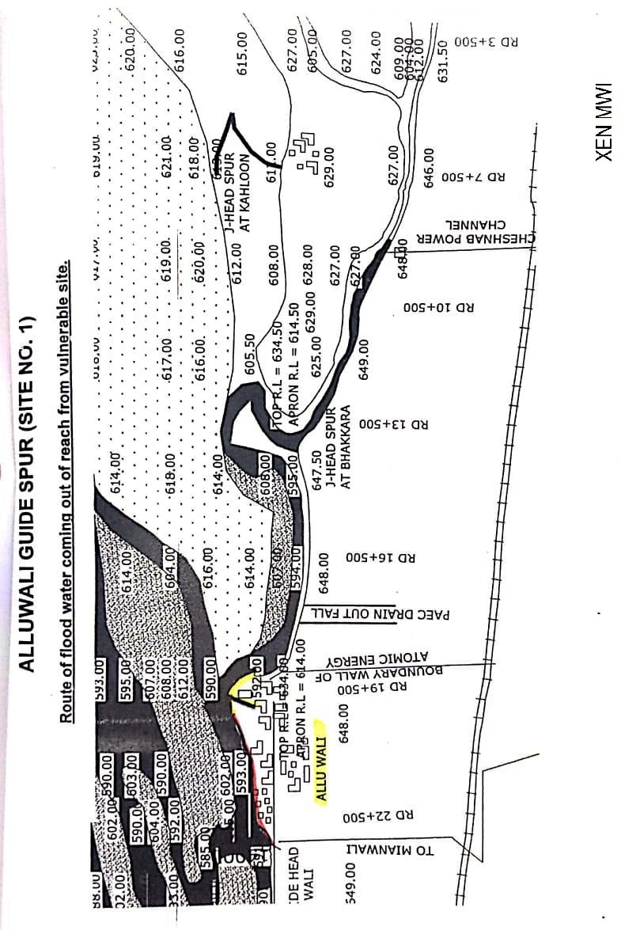

**ALLUWALI GUIDE SPUR AND GUIDE HEAD SPUR RD 29+000 DHINGANA.**

**(SITE NO. 2)**

**13.1 PLAN SHOWING ROUTE OF FLOOD WATER COMING OUT OF THE BREACH SUPPORTED WITH LEVELS.**

Plan showing route of water coming out of breach from reach between Alluwali Guide Spur and Guide Head Spur RD 29+000Dhinganais attached at page # 34.

**13.2 DETAIL OF VILLAGES ABADIES LIKELY TO BE AFFECTED AND THIS SHOULD ALSO BE SHOWN ON THE PLAN**

**A) NAME OF ABADIES / VILLAGES EFFECTED ALSO SHOWN ON THE PLAN**

**Name of Village**

Alluwali, Dhingana, Doaba & Jal.

The village abadies likely to be effected due to breach has been shown on the plan attached at page # 38.

**13.3 STRATEGY AND ACTION TAKEN BE EXPLAINED IN DETAIL THIS MAY INCLUDE ARRANGEMENTS**.

Such situation may not arise, as all abadies exist on high edge of the River Indus.

**13.3.1 ARRANGEMENTS.**

**[[[** Necessary arrangements will be done on need basis.

**13.3.2 ESTABLISHMENT OF FLOOD FIGHTING CAMPS.**

Field Office at Alluwali village

**13.3.3 DUTIES OF OFFICERS / OFFICIALS AND THEIR CAMP SITES**

|  |  |  |  |
| --- | --- | --- | --- |
| **Camp No.** | **Location** | **Officer Name / Designation / Mobile No.** | **Official Name / Designation / Mobile No.** |
| Camp No. 2 | Field Office at Guide Head Spur RD 29+000 | Abdul Khaliq / SDO Kundian / 0300-6079962 | Malik Aman Ullah Khan /  SEN Joiya / 0300-7605605 |

**13.3.4 DEPARTMENT MACHINERY AVAILABLE**

Mianwali Canal Division has No machinery, however Machinery will be arranged on need basis from Machinery Circle of Irrigation Department.

**13.3.5 MACHINERY AVAILABLE FROM PRIVATE SOURCE**

PAEC & WAPDA located about 10-K.M away from Alluwali village will be requested for logistic support and to provide Machinery in any emergency.

**13.3.6 FLOOD FIGHTING MATERIAL REQUIRED.**

**13.3.7 FLOOD FIGHTING MATERIAL AVAILABLE.**

| **Sr. No.** | **Name of article** | **Total required Qty** | **Available Qty** | **Balance Qty** | **Remarks** |
| --- | --- | --- | --- | --- | --- |
| 1 | Kassies with Handle | 10-No. | 10-No. | - | Balance Quantity of material will be purchased before upcoming Flood season 2025. |
| 2 | Shawl | 10-No. | 10-No. | - |
| 3 | Basket (Toot) | 100-No. | 65-No. | 35-No. |
| 4 | Jute Bag (4-5 Cft) | 200-No. | 200-No. | - |
| 5 | Polly propylene Bag (2-3 Cft) | 500-No. | 230-No. | 270-No. |
| 6 | Bamboo | 135-No. | 24-No. | 111-No. |
| 7 | Soldiery | 1-No. | 1-No. | - |
| 8 | Axes | 10-No. | 10-No. | - |
| 9 | Torch Electric | 10-No. | 5-No. | 5-No. |
| 10 | Life Jacket | 10-No. | 5-No. | 5-No. |
| 11 | Umbrella small | 10-No. | 5-No. | 5-No. |
| 12 | Umbrella large | 5-No. | 3-No. | 2-No. |
| 13 | Seba | 8-Kg. | 3-Kg. | 5-Kg. |
| 14 | Emergency light | 4-No. | 3-No. | 1-No. |

**13.4 DETAIL OF OTHER INFRASTRUCTURE LIKE ELECTRIC, SUI GAS TELEPHONE INSTALLATIONS, ROAD NETWORK, OTHER BUILDINGS, CANALS AND DRAINAGE NETWORK**

**A) IN CASE OF SEVERE EROSIVE ACTION ON LEFT BANK OF RIVER INDUS NEAR ALLUWALI VILLAGE. FOLLOWING INFRASTRUCTURE WILL BE EFFECTED.**

i Abadies.

ii Sher Shah Soori metalled road from Alluwali to Piplan.

iii Communication System Dhingana

iv Electric Supply system Dhingana

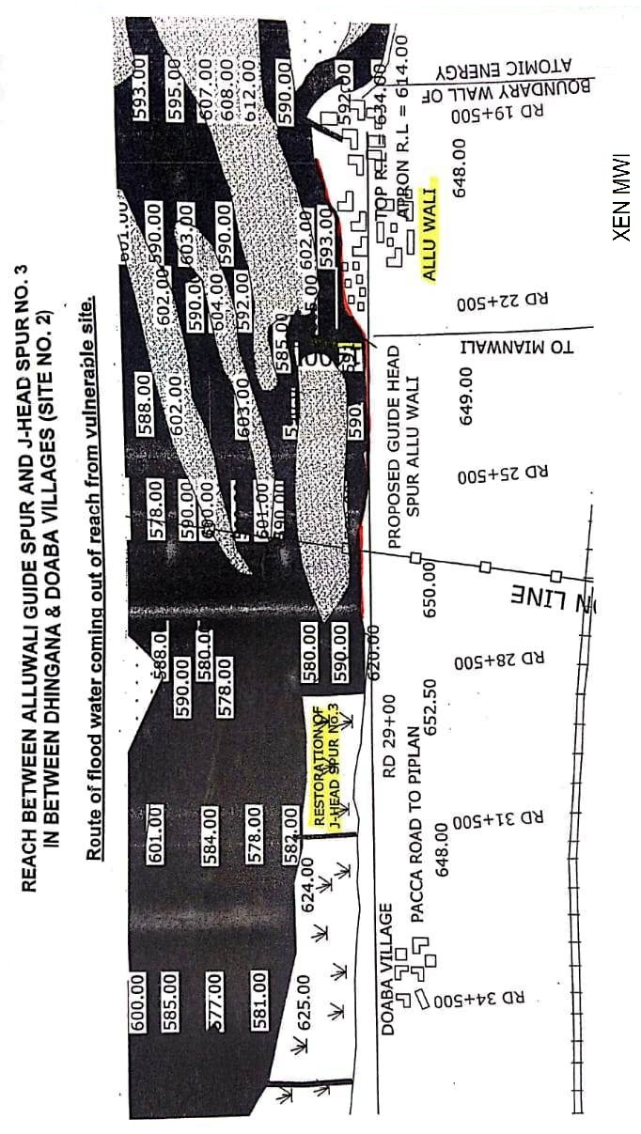

**J-HEAD SPUR RD 35+600 DOABA (SITE NO. 3)**

**13.1 PLAN SHOWING ROUTE OF FLOOD WATER COMING OUT OF THE BREACH SUPPORTED WITH LEVELS**

Plan showing route of water coming out breach from J-Head Spur RD 35+600 Doaba is attached at page # 37.

**13.2 DETAIL OF VILLAGES ABADIES LIKELY TO BE AFFECTED AND THIS SHOULD ALSO BE SHOWN ON THE PLAN**

**A) NAME OF ABADIES / VILLAGES EFFECTED ALSO SHOWN ON THE PLAN**

**Name of Village**

Dhingana & Doaba.

The village abadies likely to be effected due to breach has been shown on the plan attached at page # 41.

**13.3 STRATEGY AND ACTION TAKEN BE EXPLAINED IN DETAIL THIS MAY INCLUDE ARRANGEMENTS**.

Such situation may not arise, as all abadies exist on high edge of the River Indus.

**13.3.1ARRANGEMENTS.**

Necessary arrangements will be done on need basis.

**13.3.2 ESTABLISHMENT OF FLOOD FIGHTING CAMPS.**

Field Office at J-Head Spur No.3

**13.3.3 DUTIES OF OFFICERS / OFFICIALS AND THEIR CAMP SITES**

|  |  |  |  |
| --- | --- | --- | --- |
| **Camp No** | **Location** | **Officer Name / Designation / Mobile No.** | **Official Name / Designation / Mobile No.** |
| Camp No. 3 | Field Office at  J-Head Spur RD 35+600 Doaba | Abdul Khaliq / SDO Kundian / 0300-6079962 | Muhammad Faheem /  SEN Randhore / 0302-4820197 |

**13.3.4 DEPARTMENTAL MACHINERY AVAILABLE**

Mianwali Canal Division has No Machinery however; Machinery will be arranged on need basis from Machinery Circle of Irrigation Department.

**13.3.5 MACHINERY AVAILABLE FROM PRIVATE SOURCE**

PAEC & WAPDA located about 10-K.M away from Alluwali village will be requested for logistic support and to provide Machinery in any emergency.

**13.3.6 FLOOD FIGHTING MATERIAL REQUIRED.**

**13.3.7 FLOOD FIGHTING MATERIAL AVAILABLE.**

| **Sr. No.** | **Name of article** | **Total required Qty** | **Available Qty** | **Balance Qty** | **Remarks** |
| --- | --- | --- | --- | --- | --- |
| 1 | Kassies with Handle | 10-No. | 10-No. | - | Balance Quantity of material will be purchased before upcoming Flood season 2025. |
| 2 | Shawl | 10-No. | 10-No. | - |
| 3 | Basket (Toot) | 100-No. | 65-No. | 35-No. |
| 4 | Jute Bag (4-5 Cft) | 300-No. | 300-No. | - |
| 5 | Polly propylene Bag (2-3 Cft) | 500-No. | 240-No. | 260-No. |
| 6 | Bamboo | 135-No. | 24-No. | 111-No. |
| 7 | Soldiery | 1-No. | 1-No. | - |
| 8 | Axes | 7-No. | 7-No. | - |
| 9 | Torch Electric | 10-No. | 5-No. | 5-No. |
| 10 | Life Jacket | 10-No. | 5-No. | 5-No. |
| 11 | Umbrella small | 6-No. | 5-No. | 1-No. |
| 12 | Umbrella large | 5-No. | 3-No. | 2-No |
| 13 | Seba | 8-Kg. | 3-Kg. | 5-Kg. |
| 14 | Emergency light | 4-No. | 3-No. | 1-No. |
| 15 | Generator | 1-No. | - | 1-No. |
| 16 | Petrol for Generator | 300-Litre | - | 300-Litre |
| 17 | Cable 7/29 | 150-Meter | - | 150-Meter |
| 18 | Energy Sever | 10-No. | - | 10-No. |
| 19 | Electric Board | 2-No. | - | 2-No. |

**13.4 DETAIL OF OTHER INFRASTRUCTURE LIKE ELECTRIC, SUI GAS TELEPHONE INSTALLATIONS, ROAD NETWORK, OTHER BUILDINGS, CANALS AND DRAINAGE NETWORK**

**A) IN CASE OF SEVERE EROSIVE ACTION ON LEFT BANK OF RIVER INDUS NEAR ALLUWALI VILLAGE. FOLLOWING INFRASTRUCTURE WILL BE EFFECTED.**

i Abadies.

ii Sher shah soori metalled road from Alluwali to Piplan.

iii Communication System Dhingana / Doaba

iv Electric Supply system Dhingana / Doaba

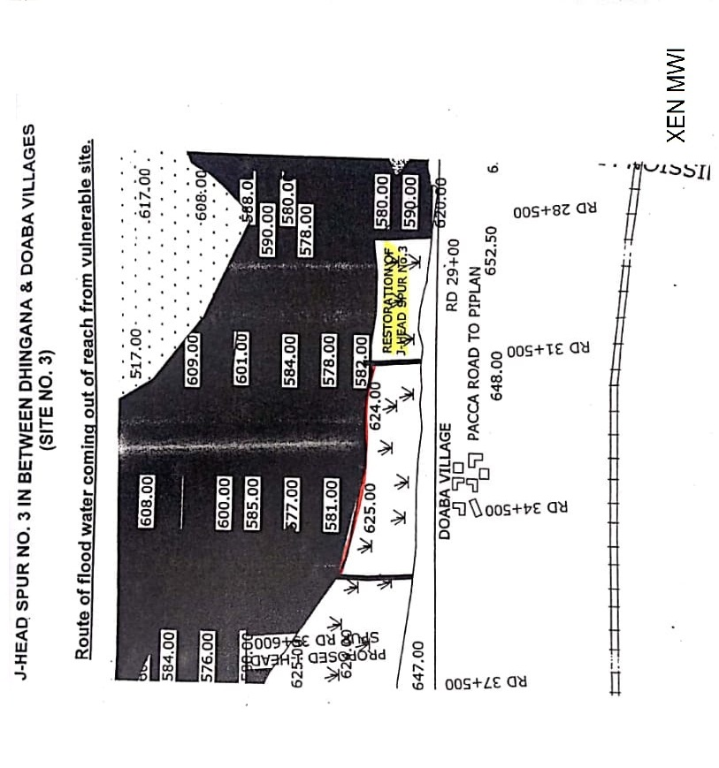

**PROTECTION WALL VILLAGE BHAKRA (SITE NO. 4).**

**13.1 PLAN SHOWING ROUTE OF FLOOD WATER COMING OUT OF THE BREACH SUPPORTED WITH LEVELS**

Plan showing route of water coming out of breach from protection wall village Bhakra site # 4 is attached at page # 44.

**13.2 DETAIL OF VILLAGES ABADIES LIKELY TO BE AFFECTED AND THIS SHOULD ALSO BE SHOWN ON THE PLAN**

**A) NAME OF ABADIES / VILLAGES EFFECTED ALSO SHOWN ON THE PLAN**

**Name of Village**

Bhakra, Ding and Shah Nawaz Wala

The village abadies likely to be effected due to breach has been shown on the plan attached at page # 44.

**13.3 STRATEGY AND ACTION TAKEN BE EXPLAINED IN DETAIL THIS MAY INCLUDE ARRANGEMENTS**.

Such situation may not arise, as all abadies exist on high edge of the River Indus.

**13.3.1ARRANGEMENTS.**

**[[[** Necessary arrangements will be done on need basis.

**13.3.2 ESTABLISHMENT OF FLOOD FIGHTING CAMPS.**

Field Office at Protection Wall Bhakra

**13.3.3 DUTIES OF OFFICERS / OFFICIALS AND THEIR CAMP SITES**

|  |  |  |  |
| --- | --- | --- | --- |
| **Camp No.** | **Location** | **Officer Name / Designation / Mobile No.** | **Official Name / Designation / Mobile No.** |
| Camp No. 4 | Field Office Protection Wall Bhakra | Abdul Khaliq / SDO Kundian / 0300-6079962 | Syed Farhat Abbas Shah /  SEN Kundian / 0333-9081632 |

**13.3.4 DEPARTMENTAL MACHINERY AVAILABLE**

Mianwali Canal Division has No machinery, however Machinery will be arranged on need basis from Machinery Circle of Irrigation Department.

**13.3.5 MACHINERY AVAILABLE FROM PRIVATE SOURCE**

Machinery will be arranged from private sources on need basis.

**13.3.6 FLOOD FIGHTING MATERIAL REQUIRED.**

**13.3.7 FLOOD FIGHTING MATERIAL AVAILABLE.**

| **Sr. No.** | **Name of article** | **Total required Qty** | **Available Qty** | **Balance Qty** | **Remarks** |
| --- | --- | --- | --- | --- | --- |
| 1 | Kassies with Handle | 10-No. | 10-No. | - | Balance Quantity of material will be purchased before upcoming Flood season 2025. |
| 2 | Shawl | 10-No. | 10-No. | - |
| 3 | Basket (Toot) | 100-No. | 65-No. | 35-No. |
| 4 | Jute Bag (4-5 Cft) | 200-No. | 200-No. | - |
| 5 | Polly propylene Bag (2-3 Cft) | 500-No. | 250-No. | 250-No. |
| 6 | Bamboo | 135-No. | 24-No. | 111-No. |
| 7 | Soldiery | 1-No. | 1-No. | - |
| 8 | Axes | 6-No. | 6-No. | - |
| 9 | Torch Electric | 7-No. | 5-No. | 2-No. |
| 10 | Life Jacket | 7-No. | 5-No. | 2-No. |
| 11 | Umbrella small | 6-No. | 5-No. | 1-No. |
| 12 | Umbrella large | 5-No. | 1-No. | 4-No. |
| 13 | Seba | 8-Kg. | 3-Kg. | 5-Kg. |
| 14 | Emergency light | 4-No. | 3-No. | 1-No. |

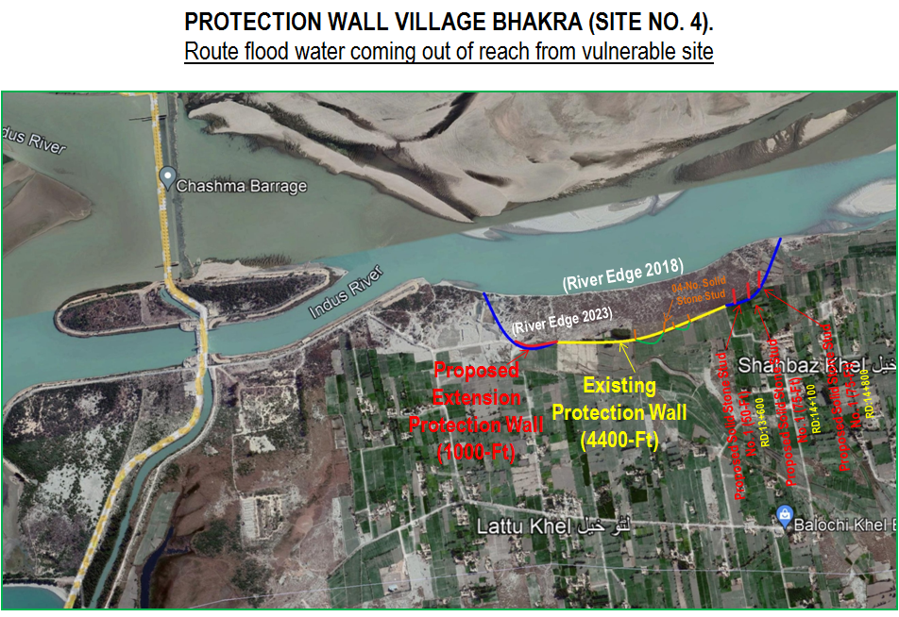

**13.4 DETAIL OF OTHER INFRASTRUCTURE LIKE ELECTRIC, SUI GAS TELEPHONE INSTALLATIONS, ROAD NETWORK, OTHER BUILDINGS, CANALS AND DRAINAGE NETWORK**

**A) IN CASE OF SEVERE EROSIVE ACTION ON LEFT BANK OF RIVER INDUS NEAR ALLUWALI VILLAGE. FOLLOWING INFRASTRUCTURE WILL BE EFFECTED.**

i Abadies.

ii Sher shah soori metalled road from Piplan to Musewali.

iii Communication System Piplan to Musewali.

iv Electric Supply system Piplan to Musewali.

|  |  |  |
| --- | --- | --- |
| **Executive Engineer**  Mianwali Canal Division  Mianwali | **Superintending Engineer**  Thal Canal Circle  Mianwali | **Chief Engineer**  Sargodha Irrigation Zone  Sargodha |

**14.6 Police Deployment Plan**

|  |  |  |  |
| --- | --- | --- | --- |
| **Sr. No.** | **Name of Site.** | **Concerned Police Station** | **Police personal to be deployed.** |
| 1 | Base Camp # 1 at Guide Spur Alluwali | Piplan District Mianwali | Constables=2 No. |
| 2 | Base Camp # 1 at Guide Spur Alluwali | Piplan District Mianwali | Constables=2 No. |
| 3 | Base Camp # 1 at Guide Spur Alluwali | Piplan District Mianwali | Constables=2 No. ASI =1 No. |
| 4 | Base Camp # 2 at Village Dhingana | Piplan District Mianwali | Constables=2 No. ASI =1 No. |
| 5 | Base Camp # 2 at Village Dhingana | Piplan District Mianwali | Constables=2 No. ASI =1 No. |
| 6 | Base Camp # 3 at  J-Head Spur Doaba | Piplan District Mianwali | Constables=2 No. |
| 7 | Base Camp # 3 at  J-Head Spur Doaba | Piplan District Mianwali | Constables=2 No. |
| 8 | Base Camp # 4 at  Protection wall village Bhakra | Kundian District Mianwali | Constables=2 No. |
| 9 | Base Camp # 4 at  Protection wall village Bhakra | Kundian District Mianwali | Constables=2 No. ASI =1 No. |
| 10 | Base Camp # 4 at  Protection wall village Bhakra | Kundian District Mianwali | Constables=2 No. |

**CHAPTER-15**

**Back up Division (In case of breach)**

Kalabagh Headworks Division will be backup Division in case of any damage/breach of structures / bunds.

|  |  |  |
| --- | --- | --- |
| **Sub Divisional Officer**  Kundian Canal Sub Division  Kundian |  | **Executive Engineer**  Mianwali Canal Division  Mianwali |